SOLID WASTE MANAGEMENT AND COMMUNITY PARTICIPTAION IN PANDAV NAGAR, GHAZIABAD;A STUDY ON THE ROLE OF SOCIAL MEDIA
ABSTRACT

Rapid urbanisation has intensified solid waste management (SWM) challenges in cities like Ghaziabad, driven by increasing consumerism and the widespread use of non-biodegradable materials. Effective waste management requires not only institutional efforts but also active community participation, as waste generation is a shared responsibility. In this context, social media has emerged as a significant tool for information dissemination, awareness generation and behavioural influence. This study examines the role of social media in enhancing community participation in SWM, with a focus on Pandav Nagar, Ghaziabad. It aims to assess the level of public involvement in waste management practices, analyse the influence of social media on awareness and behaviour, and identify challenges in adopting sustainable practices. A mixed-method approach was employed, combining quantitative and qualitative techniques. Primary data were collected through surveys, questionnaires, and interviews with residents, while secondary data were obtained from government reports and academic sources. The findings indicate that social media platforms such as WhatsApp, Facebook, and Instagram play a crucial role in spreading awareness about waste segregation, recycling, and cleanliness initiatives. However, their impact on actual participation remains limited. A notable gap exists between awareness and practice, influenced by inadequate infrastructure, inconsistent municipal support, and the nature of online engagement.
The study highlights that while social media has strong potential to promote sustainable waste management practices, its effectiveness depends on better integration with policy frameworks and community-level implementation strategies. Strengthening collaboration between digital platforms and municipal authorities is essential to translate awareness into meaningful action.

INTRODUCTION
Solid waste refers to garbage, trash material comes from household, industries, etc. Solid waste is a major problem because it affects our health and environment. Management of solid waste cannot be achieved solely by government and municipal authorities it requires full attention of community members because waste belongs to everyone. The success of waste management lies in the hands of community members. Earlier this was not a big issue because the population was low and the production and consumerism was also less, but nowadays the use of non-biodegradable substances has increased. Despite people being aware of the harmful consequences of open dumping, efforts to manage waste remain insufficient
Ghaziabad faces lots of challenges related to solid waste management due to its high population density. Large amount of waste generated daily and left uncollected in vacant plots, areas, etc. Inadequate collection, poor segregation, and frequent waste burning have led to pollution and rising health risks for local communities. Social media has emerged as a powerful tool for awareness, change in citizen’s behaviour, etc.
Social media will help in raising more awareness among citizens and this will also help in maintaining collection of waste, processing of waste schedules, data, real time monitoring of waste etc. With the help of WhatsApp, Instagram, Facebook, we can share the information of waste management. With the help of twitter citizens can reports about the garbage, the bad condition of bins with the help of photos, videos, etc so that the waste managing authorities will respond quickly. Social media effects in behavioural change and community engagement are not well studied, even with the progress made. Challenges such as information spread, digital inequality and low community participation are a few among many. The contribution of social media on awareness, governance and technological innovation towards SWM and its drawbacks must be investigated. This study seeks to find out the above mention aspects by reviewing literature and investigating the use of social media on enhancement of the solid waste management system.

PHOTO 1
CONDITION OF WASTE COLLECTION
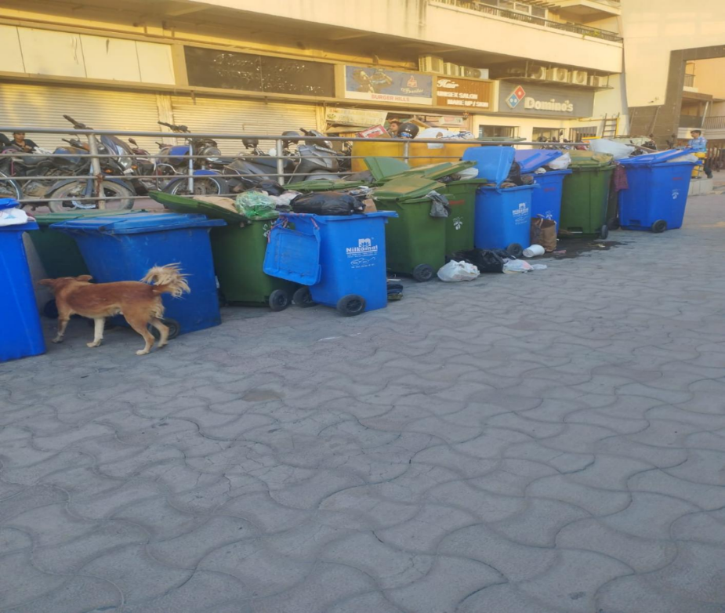
SOURCE: PRIMARY SURVEY (March, 2026)
Statement of Problem
Efficient waste management in India has been quite unsuccessful. Several problems include ineffective waste segregation, low public participation, lack of infrastructure at the municipal level and inconsistency in implementing SWM rules.
Awareness strategies used at the moment (posters, pamphlets, traditional campaigns) is ineffective; they have limited reach, high costs and do not bring sustainable behaviour changes to citizens.
Social media has proved to be effective but still its usage at the municipal level is haphazard, unorganized and not embedded into municipal frameworks. However, with the use of Instagram, WhatsApp, Facebook, Twitter and YouTube the effectiveness can vary largely.
Misinformation through social media is becoming an issue.

Scope of Research
In this study, I will investigate how social media facilitates the increase of community participation in solid waste management in Pandav Nagar, Ghaziabad. Social media applications such as Facebook, Instagram, WhatsApp, and YouTube are often mentioned in various studies as significant platforms for awareness generation and citizen engagement. Most of the studies had outlined the potential of social media in generating awareness and increasing participation, however, very few of the studies had provided with quantitative results regarding the same. The scope is limited to the examination of the level of community participation and the role of social media in the promotion of citizen awareness, attitudes and behaviour. Furthermore, it also addresses the various challenges being faced by the residents of Pandav Nagar in their attempt to incorporate improved waste management behaviours into their lifestyles. It is primarily based on primary data (obtained through questionnaires and interviews) and backed by secondary data (from various municipal and government documents and other relevant literature sources). Most of the studies concentrate on the awareness creation part rather than analyzing the effects of social media usage in changing the actual lifestyle of citizens. The study is limited to urban context only and not for rural areas. Thus, in short, this research is conducted to know about the level of awareness, accountability, participation etc using social media in the urban solid waste management.
Aim of the Study
The aim of this study is to examine the role of social media in enhancing community participation in solid waste management and the causes, impacts, and community response to solid waste management and community participation in Pandav Nagar, Ghaziabad
Research Objectives
- To assess the community participation in solid waste management
- To study the role of Social media in waste management activities
- Identifying the challenges faced by communities in adopting modern technologies
Research Questions
1) What is the level of community participation in solid waste management in Pandav Nagar, Ghaziabad?
2) How does social media influences awareness and community participation in solid waste management in Pandav Nagar, Ghaziabad?
3) What are the major challenges faced by community in using modern technologies/digital platforms for solid waste management in Pandav Nagar, Ghaziabad?
Hypothesis
- Social media has a positive influence on community participation in solid waste management activities
- Higher community awareness about SWM leads to better participation
- Social media platforms helps in improving the people’s awareness and complaint reporting related solid waste management
- Lack of digital literacy reduce the effectiveness of social media in promoting community participation in solid waste management
Research Methodology
- Research design
The study will follow mixed method approach (quantitative and qualitative)
Qualitative-interviews and literature reviews
Quantitative-survey, questionnaire
- Data collection
Primary data-questionnaire, survey(regarding use of social media for waste related info, awareness and participation, preference between social media and traditional methods)
Interviews(waste workers, municipal officers)
Secondary data-published reports, government documents, articles
- Sampling
Sample size-50-60respondents and Sampling method-stratified random sampling
- Data analysis

Study area
The research conducted in Pandav Nagar, Ghaziabad, Uttar Pradesh
PHOTO 2
GEO TAGGED PANDAV NAGAR, GHAZIABAD

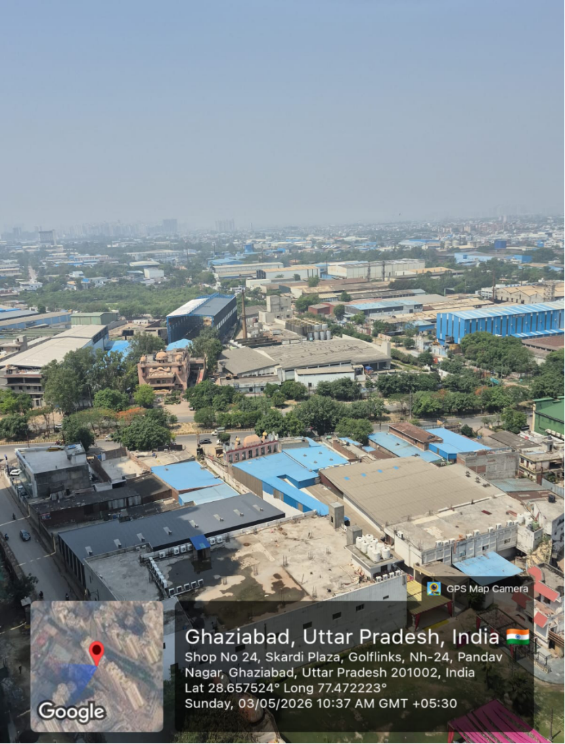
SOURCE- PRIMARY SURVEY(MARCH, 2026)
Ghaziabad district, lies in the western part of Uttar Pradesh. It is adjacent to National Capital Territory of Delhi. This district was formed on the 14 November 1976. It covers approximately 777.9 km (2011 census).Ghaziabad is divided into three tehsils (Ghaziabad, Modinagar and Loni) and four blocks(Rajapur, Muradnagar, Bhojpur, and Loni). It has a large population of about 4.6 million (2011 census).
Ghaziabad Nagar Nigam is divided into 80 wards under 5 zones. Each ward is managed by sanitary supervisors, sweepers and collection staff. However, many wards do not have proper permanent ward offices.
Ghaziabad Municipal Corporation is divided into 80 wards and grouped into 5 zones. These 5 zones are: -
- City Zone
- Kavi Nagar Zone
- Vijay Nagar Zone
- Mohan Nagar Zone
- Vasundhra Zone
Pandav Nagar does not have a separately listed ward name in Ghaziabad Nagar Nigam records. Based on location near industrial bet and NH- 24, Pandav Nagar is generally considered to fall in Kavi Nagar Zone. Pandav Nagar is located in ward 24 of Kavi Nagar Zone. This ward includes a mix of planned residential colonies, high rise apartments, and peri-urban settlement, leading to diverse waste generation patterns and management challenges.
LITERATURE REVIEW
Ghaziabad district, lies in the western part of Uttar Pradesh. It is adjacent to National Capital Territory of Delhi. This district was formed on the 14 November 1976. It covers approximately 777.9 km (2011 census). Ghaziabad is divided into three tehsils (Ghaziabad, Modinagar and Loni) and four blocks(Rajapur, Muradnagar, Bhojpur, and Loni). It has a large population of about 4.6 million (2011 census). Ghaziabad faces significant challenges in managing its waste. It is a fastest growing urban and industrial district. Rapid urbanization, industrial expansion, and rising population pose a significant challenge on Ghaziabad Municipal Corporation(GMC) in managing its large volume of solid waste.
Solid waste refers to garbage, trash material comes from household, industries, etc. Solid waste is becoming a major problem day by day because it affects our health and environment. Earlier this was not a big issue because the population was low and the production and consumerism was also less, but nowadays the use of non-biodegradable substances has increased. Despite people being aware of the harmful consequences of open dumping, efforts to manage waste remain insufficient. This literature Review is related to the role of social media in raising awareness in solid waste management and community participation. The reviewed articles highlight how the various social media platform such as whatsapp, Instagram, facebook, twitter are being used to raise awareness among citizens, facilitate community participation, etc. I took help from various sources such as Google Scholar, Web of Science, Scorpus and Du library. The findings emphasize that social media is not only a tool for information dissemination but also a medium for citizens participation, data collection, etc. The rapid development in Ghaziabad has led to increase in the waste generation from around 850metric tons per day (MT/day) in 2018 to nearly 1,400–1,500 MT/day in 2024, according to Ghaziabad Municipal Corporation.
Sharma, R. & Patel, D. (2021), Solid waste is a major problem because it affects our health and environment. As there are many challenges in managing waste, the researchers, government, policymakers they are working hard in order to enhance the efficiency of waste management and to increase the community participation but still the outcomes are far from satisfactory. Management of solid waste cannot be achieved solely by government and municipal authorities it requires full attention of community member because waste belongs to everyone. Among all these challenges social media has emerged as a powerful tool for raising awareness, and most important the participation of citizens.
According to several studies (e.g., Sharma, 2021), emphasize on the difference between traditional campaign and online campaign. Traditional campaign methods comprise of posters, pamphlets etc., and online campaign methods comprise of you tube, Instagram, twitter, facebook etc. Traditional campaign methods help build trust among citizens and to make citizens aware about segregation, collection etc. However, they are time-consuming and expensive, thus their impact is slow and not long lasting, just a short-term awareness creation whereas online campaign methods through various social platforms such as Facebook, Twitter, Instagram and WhatsApp help to communicate at a much faster rate to larger audiences and at less cost. It also encourages public participation, creates faster feedback and makes way to disperse information very quickly among people by the officials.
According to Patel and Sharma (2021), Instagram plays a key role in spreading environmental awareness through visuals, hashtags, and influencer-led campaigns., Instagram plays an important role in raising awareness in solid waste management. Instagram helps in spreading awareness through images, short reels, and posts. NGO’s and other government official accounts on Instagram provide authentic information and educate people on collection of waste, segregation of waste, recycling, zero-waste lifestyle. Hashtags such as #SwachhBharatMission and #BeatPlasticPollution have successfully attract public attention, especially among youth.
Singh, P. (2022), examine that WhatsApp helps in providing real time information. The Ghaziabad Municipal Corporation (GMC), for example, operates WhatsApp helplines to receive public complaints about uncollected waste and quick response. This platform helps in daily communication among community members where they receive reminders about segregation, collection, disposing of waste. This interaction encourages consistent participation and strengthens community involvement.
Ahmed & Khan, 2021, social media helps in spreading awareness about technology innovation such as smart bins. Improvement in technology have transformed modern solid waste management (SWM) systems by making collection of waste, monitoring of waste, and disposal of waste more efficiently. Smart bins have sensors, GPS technology that detect the level of waste, temperature and types of material deposited. Smart bins help in promoting community participation and behavioural change. They use indicators (like lights or mobile alerts) to guide community members regarding the segregation of biodegradable and non-biodegradable waste.
Kumar, A., Gupta, S. & Mehta, R. (2020), explains how digital platforms and online communication have contributed to increased citizen engagement with urban waste management systems. The report states that online communication has made it simpler for individuals to report issues of waste collection using social media and municipal applications. Furthermore, access to waste collection schedules and the provision of waste management information such as segregation practices is more available due to the online platform.
Chatterjee, A. & Singh, V. (2021), They explain about how visual media platforms plays an important role in providing information about solid waste. The authors talk about how images, reels, etc attract people attention towards this sensitive topic. They also highlight some national movements such as #PlasticFreeIndia and #SwachhBharatMission, shows how posts, reels, have significantly influenced urban population especially the youth ones.
Mehta, R. & Joshi, K. (2020), They explores that how Facebook, Twitter are used by municipal corporation to increase public awareness and enhance the participation of community members in waste management. This study explains that how social media provide information about waste segregation, collection, etc. The authors found that digital communication increases transparency and accountability between the public and authorities.
Rao, D. & Das, S. (2021), this study explains that how community participation plays an essential role to control solid waste in their areas. The authors discuss several cities case study showing that grassroot awareness programs, local leadership, and social media engagement helps in building long term behavioural change
Gupta, P. & Mehra, D. (2020), this article explores that how twitter is being used by municipal corporation to improve transparency and accountability in managing waste. The article highlights that how people use their twitter handles to post something about waste in their surroundings and share real time updates on waste collection, dumping, etc
Das & Bhattacharya, 2022 , study examine how educational programs and local media campaigns contribute to raising public awareness about environmental protection and solid waste management. The study highlights the role of schools, community organizations, and radio, TV channels in educating citizens about segregation, recycling, and responsible disposal practices. The author in his article said that when education of environment integrate with school activities and supported by media coverage then it leads to greater participation of community members and leads to long term behavioural change. In addition to the above, their research shows that the local media campaign has received very little coverage as compared to the social activities. They further suggest that traditional methods of education should be complemented with new methods of communication such as social media.
Rana, P. & Chatterjee, D. (2020), The authors analyse the difference between policy formulation and on-ground implementation of Solid Waste Management (SWM) Rules, 2016 in India. The paper states that a number of municipalities have insufficient infrastructure, insufficient trained manpower and lack coordination between departments. They explain that poor monitoring system and lack of participation of public is causing difficulty to the success of the policy. In order to success the solid waste management, the following measures should be adopted- Enhanced institutional strength, Public-Private Partnership and regular public participation.
Kaur, M. & Verma, R. (2021), the author asserts that informational videos, tutorials, and documentaries produced by environmental organizations, experts, and influencers enable the public to comprehend even sophisticated concepts of waste management. The article acknowledges certain challenges which include disparity of digital access, inconsistent reliability of the content, and limited audience attention span.
Fernandes, L. & D’Costa, J. (2023), Research on misinformation and false content in social media regarding solid waste management. The research highlight social media platforms are efficient media for dissemination of information but it is susceptible to false content that will misinform, lead to doubt and lack of credibility in online information.
Chakraborty, S., & Gaur, P. (2020), discusses how to leverage the usage of WhatsApp for the purpose of intercommunication between citizen and authority in municipal solid waste management by making integration with the e-governance system. The challenges like overloading of the messages, absence of a record-keeping, and inability of reaching non-smart phone users are listed few. Authors concluded that WhatsApp based system can complement the existing e-governance portals in better management and can made waste management more interactive, transparent, and accountable.
Nanda, S. & Pradhan, S. (2020), analysis of the impact of Instagram on the use of digital visual activism for environmental consciousness is conducted. According to the authors, "visual characteristics like photographs, infographics, short videos" that appear on Instagram can "create an emotional appeal to people, thus making the environment feel closer and more relevant." The paper points out that visually attractive visuals encouraged individuals to engage in cleanups, recycling projects and zero-waste living movements. In conclusion, this work stressed that visual messages plus trendy hashtags plus celebrities/influencers help to make the campaigns successful and wide reaching.
Khatri, R., & Patel, M. (2021), analyse the effective use of WhatsApp as a community- based tool to raise awareness about waste management within housing societies. The article describes that WhatsApp groups can effectively disseminate information about daily reminders for waste segregation, composting techniques and proper recycling ways to the members.
Roy, T., & Banik, A. (2021), WhatsApp-based grievance redressal mechanism, investigate how WhatsApp as an intermediary helps improve urban sanitation and waste management by providing a more effective and open communication channel between citizens and municipal officials. The results show that residents are able to immediately report waste not collected, illegally dumped, or any sanitation problem to municipal units via text, images or videos, and the rapid, two-way, real-time communication is effective in enabling municipal units to address citizen complaints more quickly than conventional channels such as telephones or physical visit to offices.
Rao, S., & Malik, H. (2021), analyse the emerging issues of misinformation in environmental communication on social media platforms. Authors discuss that social media has proven to be a highly effective way of spreading environmentally-related information, but simultaneously "it has been inundated with misleading environmental claims" and environmental misinformation.
Meena, K. & Srivastava, T. (2023), Social media platforms as governance tools in cleaning the urban space. This is especially true in the context of the Swachh Bharat Mission. It is indicated that websites of local self-government and their online feedback and reporting mechanisms on cleanliness drive and complaints redress are more extensively employed.
RESEARCH GAP
While previous research has broadly looked at problems concerning solid waste management, and at how social media raises awareness, few studies have really delved into how social media is actually contributing towards community participation and behaviour change in waste management. Very little has been documented about Pandav Nagar in particular, and particularly about the role that the digital space plays in developing public awareness, as well as encouraging participation, in solid waste management. The studies that have existed merely consider awareness generation and are not able to address challenges faced like digital illiteracy, the problem of differential access to technology, spread of misinformation, and the discrepancy between awareness and actual participation. Hence this research aims to address the gap of research concerning how social media helps towards increased community participation in solid waste management within the study area.
FINDINGS
The study reveals that solid waste management in Pandav Nagar, Ghaziabad facing many challenges, but community participation and digital awareness are playing a significant role in improving local waste practices.
The survey results show that most of the households generate a moderate quantity of daily waste, mainly consists of kitchen waste, plastic waste, paper and sanitary waste. A large proportion of residents reported that they dispose waste through municipal collection (door-to-door service), but the waste segregation practice is still limited. Although residents are aware of the harmful impacts of open dumping but still there efforts to manage waste is insufficient.
The house survey showed that 100% of households produce waste on a daily basis. Composition of house hold waste: From the total house hold waste 52% consisted of Biodegradable waste; this shows organic substances like food waste, gardening waste are the most frequently generated kind of household waste. Plastic waste account for around 28% and the remaining waste comprises of sanitary & other waste and paper waste, that stands 8% and 12% respectively.
Social media and the practices of segregation & composting:
From the house survey, it was observed that the social media has a moderate role to play in spreading awareness on practices of segregation & composting in households, around 49% of household got to know about practices of segregation and composting from social media. But there were 35.5% of households who have stated to learn these practices occasionally through social media and 15.5% of household does not get to know about the practices at all.
House hold and the door to door collection service:
From the house survey, it was found that most of the household get services from the door to door collection services, the survey results shows that around 76% people get it on regular basis while 24% household reported that they did not have regular services on daily bases. As far as the service satisfaction is concerned 58% household are happy with the timings and arrangement while other half expressed it to be a gap, the service actually does not provide services with appropriate timings. But as per secondary data reported that the service is there covering 76% house hold but still it needs to be implemented at the ground level and the results from survey show that not even half of it gets the service at a correct time.
Public bin collection:
survey data show that around 46% of public bin are not picked regularly that means bin are over filling, 31% public bin was poorly maintained showing the neglect or poor implementation of waste collection services. While 23% of public bin is broken/ damaged, so not usable for dumping waste properly. Although the primary survey reflects the existence of infrastructure but implementation and proper maintenance are lacking at ground level.
Community participation:
Around 29% respondent actively participated in cleanliness drive, and rest of the 44% respondent participates occasionally while 27% respondents participate in cleanliness drive at all. Hence it can be concluded that people participates in drive at the basic level and need more awareness and motivation to actively involve in these activities.
Awareness versus Behaviour:
Although it is claimed that due to national programs like Swachh Bharat Abhiyan, awareness about environment have reached every house in the nation, however it is realized that the practical aspect has been ignored. The highest gap of study is found when comparing awareness with the behaviours or action of people toward environmental protection and management.
Youth participation in Digital Waste Governance
Around 74% actively engage with digital content related to waste awareness, showing the growing importance of online platforms in spreading environmental information. Additionally, 61% of respondents stated that they share or forward waste related information, reflecting a active participation. Nearly, 49% of respondents stated that they participated in at least one online/offline cleanliness initiatives. Secondary data identify youth as key drivers of environmental participation and digital engagement. Youth play the strongest role in linking digital awareness with community actions.
Data clearly indicates that WhatsApp groups, Instagram Posts, and digital sharing are important tools for awareness, issue reporting, and mobilization. Secondary literature also supports the growing role of social media in urban environmental governance. Both datasets strongly agree that digital media is emerging as an effective support system for community based waste management.
A key results from the comparison is that awareness levels are relatively high in both primary and secondary findings. People know about waste problems, are familiar with Government promotion, also shows that awareness on environmental is increasing. But from the primary data indicates that awareness do not have effect on regular practice in segregation and disposal.
In addition, according to the study findings, social media is a powerful platform to raise awareness, increase communication, and promote public involvement in solid waste management in Pandav Nagar, Ghaziabad. It has proven to be influential in dissemination of information related to environment and boosting of public participation in community level problems concerning the waste.
The results indicate that social media has emerged as a tool of prime importance for promoting public awareness and involvement in waste management in Pandav Nagar. In comparison with traditional means of information dissemination the social networking sites such as WhatsApp, Instagram, You Tube etc. Are found to have played an important role to improve the flow of information and participation of people, particularly youth. The effectiveness, however lies in raising public awareness and very minimally in a long term change in their behavior which can be ensured only with combined efforts from municipality as well as citizens participation.
Community participation, the study showed, has an immense impact on an efficient system for solid waste management. The findings also revealed that the process of solid waste management depends not only on municipal services provided, but also on the citizen participation at the local level and various other factors like local commitment etc.
The study indicates that social media are among the most favoured channels through which residents obtain information regarding waste management. Significant majority of residents get news about waste segregation, cleanliness drive and recycling methods from various sites.
WhatsApp turned out to be the most preferred and functional platform to access waste related information. Residents utilize the WhatsApp groups to voice grievances and report uncollected waste among other things. The network was found to be efficient and swift to communicate in a local level.
Increased public awareness among the citizens because social media makes the issues visible was one of the most important findings. Images, posts or updates shared about local problems regarding waste bring issues to attention of a large group of citizens.
As per the findings, 68% of residents use WhatsApp as the preferred channel to gain access to waste related information. In comparison, 21% of respondents admitted using You Tube and Instagram and only 11% use offline communication channels such as newspaper notices, face-to-face conversation and meetings to collect information related to solid waste management which indicates that modern sources of information are much preferred than traditional one for propagating awareness regarding the issues of environment.
Attitude of people at the local level seems to significantly determine the state of waste management in the locality. Neighbourhood where community showed good ownership of the waste problem were much cleaner and manageable compared to others in which it was perceived only as the job of the municipality. Even though many residents do support cleanliness and neighbourhood ownership, real participation in day-to-day waste management activities remain low.
The findings shows that although modern technology especially social media and digital platforms tools has improved awareness and participation in solid waste management, communities in Pandav Nagar face several challenges in adopting these technologies. These challenges are social, economic, technical in nature, and the limit the use of modern technology in community-based waste management.
The study found that older residents use less social media, mobile applications, or digital communication platforms for waste-related information. Many depends more on traditional communication methods such as face-to-face interaction, and local meetings which limit their participation in digital media governance.
The study found that many residents are not aware about the availability of digital tools related to waste management, such as online grievance systems, municipal apps, complaint portals, and digital reporting platforms. As a result, the use of technology and the use of digital platforms remain limited.
The study concluded with that better solid waste management in Pandav Nagar depends on community member participation and proper use of technology. Community participation is important because cleaner areas are those where respondents itself take responsibility and work together. Social media has also become useful in spreading awareness, sharing updates and helping people in reporting the issues related to waste. Moreover, the equal usage of digital technologies and tools among the community members is not feasible since the issues such as low digital literacy and lack of trust in digital infrastructure still persists. In conclusion, the community effort, social media utilization, and municipal support were combined to produce an effective and equitable waste management in a pragmatic approach, according to the findings of the research.

SUGGESTIONS
These suggestions are targeted towards enhance and robust community participation, effective utilization of social media in waste governance and also consider the limitations that the community members faced while learning new technologies. These suggestions are intended towards making waste management more effective, sustainable and inclusive.
- Community participation should be properly organized at all levels. Residents should be encouraged to take shared responsibility through regular meetings and cleanliness campaigns.
- Emphasis should be placed on source waste segregation, each household should be educated to segregate biodegradable and non-biodegradable waste regularly.
- Municipal waste collecting service should be enhanced, a specified time should be allocated for waste collection with more monitoring and supervising systems in place.
- Social media should be employed to improve governance of waste management, WhatsApp groups should be utilized for timely updates and awareness.
- The residents should be taught digital literacy to maximize the benefits from modern tools, a basic training in mobile applications, online complaint and reporting portal utilization for waste related issues should be conducted.
- The youth should be encouraged to actively participate in waste management campaigns and activities; school and college students should organize various social media campaigns and cleaning activities to bolster youth initiative.
- Awareness campaigns should incorporate eye-catching and simplified visual representations such as posters and short videos; these visual representations attract masses more effectively than text.
- Special attention should be given to make the advantages of digital tools available to all communities and sections of the society; older citizens should be provided with basic training and offline support; digital literacy should be implemented inclusive of meetings.

CONCLUSION

Overall, solid waste management in Pandav Nagar, Ghaziabad is characterized by community engagement and the increasing dominance of social media. Despite a rise in the awareness of waste management practices in the study area, there is still a relatively low participation of community members in practices such as waste segregation, recycling and cleanliness campaigns. Social media (especially WhatsApp and Instagram) plays an influential role in the communication and awareness spreading processes as well as problem reporting with regards to waste. Nonetheless, the study identifies critical barriers such as digital literacy, lack of facilities, uneven waste collection services and lack of behavioural change that hinder the effectiveness of the waste management practices. Thus, effective communication and coordination among the municipal bodies, community members and digital platforms will be indispensable to manage solid waste in the study area sustainably and efficiently.

