Evaluating Federated Learning Under Data Heterogeneity: Failure Modes and Practical Mitigations

Abstract— Federated Learning (FL) allows for collaborative model training across decentralized clients while maintaining data privacy; yet, real-world deployments always include heterogeneous and non-identically distributed (non-IID) client data. Existing FL research primarily assesses system performance using aggregate metrics like global or average accuracy, which can hide differences in client behavior. This study provides a thorough empirical evaluation of federated learning under controlled data heterogeneity, with a major emphasis on worst-client performance as a measure of client-level robustness. Experiments are carried out on MNIST and CIFAR-10 utilizing normal FedAvg training and commonly accepted baselines, such as FedProx and q-FedAvg, at various levels of Dirichlet-based label skew. The results show that, as heterogeneity increases, worst-client accuracy falls quickly, revealing silent errors that were previously disguised by aggregate evaluation. A comparison of mitigation options reveals that server-side client re-weighting improves worst-case performance under modest heterogeneity but becomes unstable and damaging under strong non-IID situations. In contrast, simple client-side data balancing reliably improves worst-client accuracy across all heterogeneity regimes without requiring additional infrastructure or algorithmic complexity. These findings emphasize the limitations of aggregate evaluation in federated learning, as well as the need of client-aware metrics and mitigation measures that increase local update quality while dealing with client-level inequalities in the face of true data heterogeneity.
Keywords—Federated Learning, Client Heterogeneity, Non-IID Distributions, Client-Level Evaluation, Worst-Client Performance

Introduction
Federated Learning (FL) allows multiple decentralized clients to collaboratively train a model without compromising their data privacy, which makes it well suited for large-scale privacy-critical applications such as mobile devices and distributed services [1]. In these deployments, client data are by nature heterogeneous, both in terms of dataset size, label distribution, and data generation process. The non-identical and non-independent (non-IID) data distributions are a common feature of real-world federated systems, rather than the exception [2].
The study of Federated Averaging (FedAvg) shows competitive global model performance even with non-IID and unbalanced data [1]. Later work studies the impact of data heterogeneity on convergence behavior and optimization stability and proposes algorithmic modifications, e.g. proximal regularization, variance reduction and control variates, to mitigate these effects [3], [4]. These approaches improve convergence or restore global accuracy, but the assessment practices in federated learning are often aggregate-focused, focusing on global test accuracy or the average correctness of clients.
However, aggregate measures may not reflect performance differences among individual clients. Several works acknowledge that heterogeneity might hurt training stability or convergence, but per-client performance distributions and worst-case client performance are rarely reported [2], [5]. Even studies that exploit Dirichlet-based label skew to systematically reduce the heterogeneity analyze results in terms of global accuracy recovery, which may hide substantial performance degradation of a small number of clients.
Recent theory work focuses on the mismatch between maximizing average risk and providing acceptable worst-case client performance in federated settings [6]. The data indicates that good aggregate accuracy does not necessarily translate into good or fair client behavior, especially in the presence of large heterogeneity. At the same time, several proposed mitigation strategies require additional algorithmic complexity, server-side state, or tuning, restricting their utility in lightweight or resource-constrained environments [7].
In this work, we examine the client-side empirical assessment of federated learning systems. The objective is to systematically investigate how data heterogeneity impacts individual customers and find failure modes that are overlooked when evaluation is restricted to aggregate measures, as opposed to creating novel optimization strategies. We examine the difference between average and worst-case client performance, as well as the situations in which conventional methods are successful or unsuccessful, using controlled heterogeneity settings and popular mitigation techniques. By emphasizing diagnostic evaluation above algorithmic uniqueness, this study seeks to expose the shortcomings of existing assessment approaches and provide a clearer understanding of federated learning behavior under realistic non-IID data distributions.

Related Works
McMahan et al. [1] formalized federated learning by introducing the Federated Averaging (FedAvg) method and proving its efficacy on unbalanced, decentralized, and non-IID data. Although their work established federated optimization as a useful paradigm, global accuracy and convergence behavior were the main metrics used to assess performance.

The effect of statistical heterogeneity on federated optimization stability was investigated in later research. FedProx, which uses a proximal regularization term to reduce client drift under non-IID data, was introduced by Li et al. [2]. FedProx increases convergence stability, but its assessment is still mostly aggregate-focused and lacks a thorough examination of client-level failure behavior.

In order to lessen gradient variance brought on by heterogeneous local updates, Karimireddy et al. [3] devised SCAFFOLD, which introduced control variates. While SCAFFOLD enhances convergence in non-IID environments, its assessment focuses on global goals and does not methodically examine measures related to fairness or worst-client performance.

Additionally, fairness-aware federated optimization has been investigated. In order to improve worst-case client performance, Mohri et al. [4] presented Agnostic Federated Learning (AFL), which frames federated learning as a minimax optimization issue. Although theoretically motivated, AFL's application in lightweight contexts is limited since it adds extra optimization complexity and necessitates careful adjustment.

In order to highlight underperforming clients, Li et al. [5] developed q-FedAvg, which reweights client updates based on local loss values. Despite the fact that q-FedAvg aims for fairness, empirical assessments mostly concentrate on average performance gains and do not methodically look at instability or failure modes under high heterogeneity.

Dirichlet-based label skew is used in a number of studies to control the severity of heterogeneity in non-IID data simulation [6]. These studies frequently ignore performance differences between individual clients and instead assess recovery of global accuracy as heterogeneity grows.
Realistic evaluation conditions are crucial for federated learning, according to recent surveys and benchmark-oriented research [7]. Nevertheless, the majority of current benchmarks still place a strong emphasis on aggregate metrics, paying little attention to failure characterisation or worst-client behavior.
Unlike previous work, this article explicitly analyzes worst-client performance and failure mechanisms, focusing on systematic client-level evaluation across growing variability. In order to determine when and why federated learning systems fail at the client level under realistic non-IID settings, the paper assesses popular baselines and straightforward mitigation techniques rather than suggesting new algorithms.

III. Problem Setup and Evaluation Framework

Decentralized clients, whose local datasets can differ in size and statistical characteristics, are the foundation of federated learning systems. Aggregate metrics like global or average client accuracy are often used to assess performance in a variety of contexts. These metrics, however, do not take into consideration how each client's performance varies.

Situations where one or more clients show notable performance decline despite adequate aggregate accuracy are referred to in this study as client-level failure. Worst-client accuracy is used as the main evaluation criterion to highlight such shortcomings. Worst-client accuracy evaluates the lowest possible accuracy for each participating client, exposing performance disparities that would go unnoticed by an overall assessment. By looking at both average and worst-case client accuracy under controlled data heterogeneity, this paradigm provides a more pertinent description of federated learning behavior.

IV. Experimental Setup
A. Execution Environment and Codebase Flow
Every experiment is carried out utilizing CPU-only computation on a single local system. By dividing datasets into several logical clients, each with a private local dataset, federated learning is emulated in a centralized setting. There is no usage of specialized accelerators, parallel devices, or distributed infrastructure.
The following steps make up the modular pipeline used by the codebase: (i) Data partitioning: Using Dirichlet-based label skew, central datasets are divided into client-specific subgroups to mimic statistical heterogeneity. (ii) Local client training: Every client uses a private dataset to train a model. (iii) Server-side aggregation: Depending on the baseline, either bespoke aggregation rules or standard Federated Averaging are used to integrate client updates. (iv) Client-level evaluation: To ascertain average and worst-client accuracy, model performance is evaluated separately for each customer after training.
Every client participates synchronously in every communication cycle. Because client dropout and partial participation are not taken into account, statistical heterogeneity effects can be identified without system-level confounding.
B. Model Architecture and Training Configuration
Two model architectures are used, depending on the dataset:
1) MNIST
The effects of architectural complexity and data heterogeneity are separated using a lightweight multilayer perceptron (MLP). The model consists of an output layer with softmax logits across ten classes, a single hidden layer with 128 units with ReLU activation, and an input layer with flattened 28x28 grayscale images.
2) CIFAR-10
CIFAR-10 uses a lightweight convolutional neural network (CNN) to mimic a more realistic vision scenario. The model consists of a fully connected classification head with ten classes, max-pooling layers for spatial downsampling, and two convolutional layers with ReLU activations.
Stochastic gradient descent (SGD) with a fixed learning rate is used to train the models during the trials. Every client uses mini-batch updates to train the received global model for a single local epoch throughout each communication round. In order to ensure that apparent performance variations are primarily caused by data heterogeneity rather than optimization depth, limited local training is purposefully used.
C. Federated Learning and Data Heterogeneity Setup
Statistical heterogeneity is introduced using Dirichlet-based label skew. For each class c, client proportions are sampled as:
p_{c} ∼Dirichlet(α) (1)
where smaller values of α correspond to stronger non-IID behavior. Experiments are performed using a fixed heterogeneity grid α ∈ {10.0, 1.0, 0.5, 0.1}, spanning from near-IID to extreme non-IID conditions, as described in Table I.

Heterogeneity Parameter (α) | Interpretation
10.0 | Near-IID
1.0 | Moderate heterogeneity
0.5 | Strong heterogeneity
0.1 | Extreme heterogeneity
Table I: Interpretation of the different heterogeneity parameters
All experiments are run for a fixed number of communication rounds with full client participation. For CIFAR-10 experiments, the dataset is partitioned into ten logical clients using the same Dirichlet-based label skew procedure to maintain consistency across datasets.
D. Evaluation Metrics and Baseline
Two metrics are employed to document client-level and aggregate activity: The average accuracy of all clients is known as the mean client accuracy. Worst-Client Accuracy: The least accurate of all the clients. The primary diagnostic metric is worst-client accuracy, which exposes failure modes at the client level that may be concealed by aggregate evaluation.

V. Baseline Results and Failure Analysis
This section evaluates baseline federated learning behavior under increasing heterogeneity without mitigation
A. Aggregate vs Client-Level Performance
Without using any mitigating techniques, this section assesses how standard Federated Averaging (FedAvg) behaves when data heterogeneity increases. The goal is to determine whether client behavior across diverse, federated systems is appropriately reflected by aggregate performance indicators.
Figure 1 illustrates the relationship between average customer accuracy and the Dirichlet heterogeneity parameter (α). With very slight changes as α falls, client accuracy is constant across heterogeneity levels. According to this result, federated learning seems to be able to adjust to growing data heterogeneity.

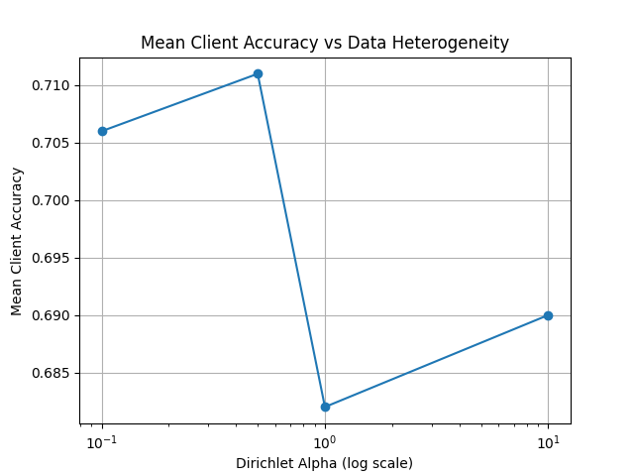Fig.1: Mean client accuracy under increasing data heterogeneity
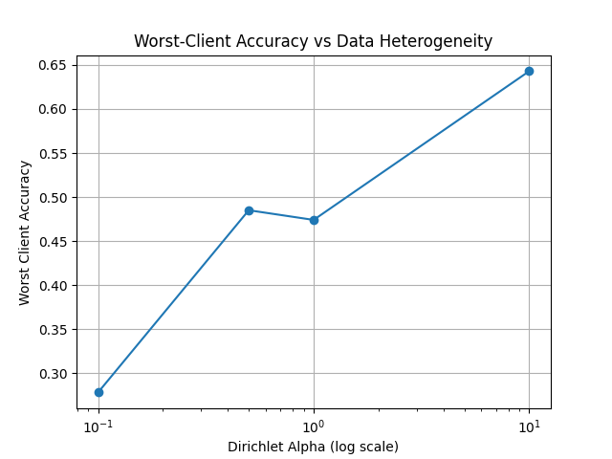Fig.2: Worst-client accuracy under increasing data heterogeneity
The worst-client accuracy under the identical testing conditions is shown in Figure 2. The worst-client accuracy significantly declines as heterogeneity increases (lower α values). The performance of the weakest client declines under significant and extreme heterogeneity, whereas mean accuracy essentially stays the same. This discrepancy indicates that a portion of clients suffer from significant performance deterioration that is not reflected in overall metrics.
A quiet failure scenario in federated learning is shown in Figures 1 and 2, where notable client-level disparities can coexist with good average performance. These results show that, especially when using real non-IID data distributions, depending solely on aggregate correctness may conceal serious errors impacting individual clients.
B. Statistical Analysis Across Random Seeds
All results are averaged over five independent random seeds. Performance is reported as mean ± standard deviation, and 95% confidence intervals are computed for worst-client accuracy.
α | Method | Mean | Std | 95% CI
10.0 | FedAvg | 0.482 | 0.009 | [0.474, 0.490]
10.0 | FedProx | 0.482 | 0.009 | [0.474, 0.490]
10.0 | q-FedAvg | 0.481 | 0.010 | [0.472, 0.490]
1.0 | FedAvg | 0.422 | 0.015 | [0.409, 0.435]
1.0 | FedProx | 0.420 | 0.015 | [0.407, 0.433]
1.0 | q-FedAvg | 0.438 | 0.016 | [0.424, 0.452]
0.5 | FedAvg | 0.392 | 0.017 | [0.377, 0.407]
0.5 | FedProx | 0.392 | 0.016 | [0.378, 0.406]
0.5 | q-FedAvg | 0.355 | 0.027 | [0.331, 0.379]
Table II. Worst-client accuracy statistics on CIFAR-10
The overlapping confidence intervals under near-IID conditions indicate no statistically significant difference between baselines. Under strong heterogeneity, q-FedAvg exhibits increased variance and lower worst-client performance, confirming instability.

VI. Mitigation Strategies

Client Re-weighting
Increasing the influence of underrepresented clients during server-side aggregation is an obvious way to address client-level performance differences in federated learning. When uniform averaging is used in heterogeneous circumstances, clients with smaller local datasets could contribute less to the global model, exacerbating worst-case degradation. By giving clients with fewer local samples greater aggregation weights, client reweighting seeks to mitigate this effect.
The Federated Averaging aggregation method is modified in this evaluation to weight client updates in inverse proportion to the size of the local dataset, so achieving client re-weighting. The model design, communication protocol, and local training procedure remain unchanged. This architecture maintains the federated learning workflow while separating the effects of aggregate reweighting.
Client re-weighting changes the FedAvg aggregation rule so that client updates are weighted inversely proportional to local dataset size:
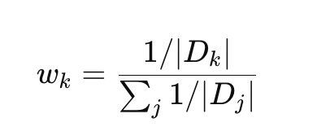 (2)
where |D_{k}| denotes the number of local samples held by client k, and K is the total number of participating clients.
α | Mean Accuracy | Worst-Client Accuracy
10.0 | 0.734 | 0.683
1.0 | 0.724 | 0.544
0.5 | 0.486 | 0.119
0.1 | 0.477 | 0.015
Table III. Client Re-weighting accuracies for different value of heterogeneity parameters
While Figure 3 shows the pertinent trends in mean and worst-client accuracy, Table II shows client re-weighting performance at different heterogeneity levels. Client re-weighting increases worst-client accuracy over baseline in near-IID and slightly variable scenarios (α = 10.0 and α = 1.0). This demonstrates how engaging disadvantaged clients can lessen performance gaps. The average client accuracy slightly improves in these situations.
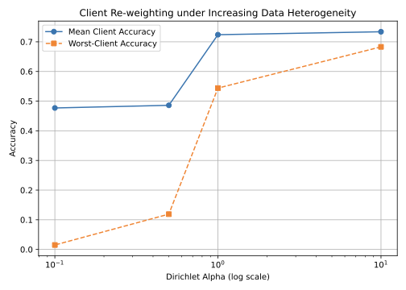Fig. 3: Client Re-weighting under Increasing Data Heterogeneity
However, client re-weighting causes significant performance losses as heterogeneity rises (α = 0.5 and α = 0.1). After a significant drop in average accuracy, worst-client accuracy plummets, as Fig. 3 illustrates. Some clients behave almost randomly under these circumstances, which suggests that the learnt global model is unstable.

Local Data Balancing
Local data balancing addresses client-level performance discrepancies by enhancing the quality of local training data before model updates, as opposed to changing server-side aggregation. Small or underrepresented clients frequently have highly skewed local datasets in heterogeneous federated systems, which leads to noisy and biased gradient updates. By rebalancing class distributions in each client's local dataset prior to training, local data balancing seeks to lessen this impact.
Local data balancing is used as a small client-side preprocessing step in this test. Each client does basic class-level oversampling of its local dataset prior to starting local training. Standard Federated Averaging is preserved, and the global aggregation rule, learning process, and communication protocol remain unaltered. This architecture maintains the overall federated learning workflow while isolating the impact of enhancing update quality at the source.
Figure 4 shows changes in mean and worst-client accuracy, while Table III shows the performance of local data balancing under various degrees of data heterogeneity. Local data balancing outperforms both the baseline and client re-weighting techniques, greatly improving worst-client performance across all heterogeneity levels. Both mean and worst-client accuracy increase under near-IID conditions (α = 10.0), suggesting that local balancing does not adversely affect performance under ideal conditions. The worst-client accuracy increases from 0.474 to 0.756 with significant heterogeneity (α = 1.0), while the mean accuracy increases to 0.808.
α | Mean Accuracy | Worst-Client Accuracy
10.0 | 0.755 | 0.743
1.0 | 0.808 | 0.756
0.5 | 0.800 | 0.742
0.1 | 0.720 | 0.495
Table IV. Local Data Balancing accuracies for different value of heterogeneity parameters
When there is substantial variability (α = 0.5), local data balancing performs better than client re-weighting. Local balancing produces consistent performance, with worst-client accuracy remaining above 0.74, but server-side re-weighting leads to training instability and worst-client collapse. Local data balancing avoids catastrophic failure but does not totally eliminate performance loss in extreme heterogeneity (α = 0.1). After reweighting, mean accuracy remains acceptable while worst-client accuracy rises near-random performance to about 0.50.
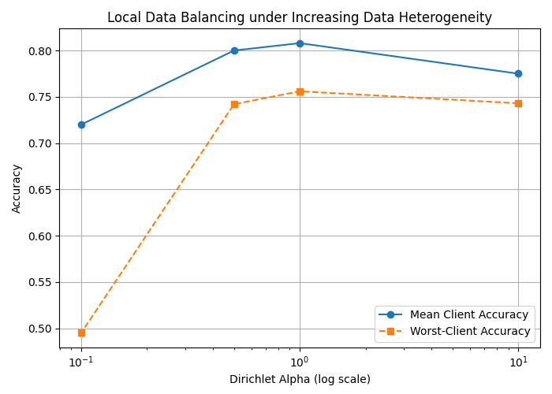Fig. 4: Local Data Balancing under Increasing Data Heterogeneity
These results imply that improving local update quality is more beneficial than changing the total weight. While local data balancing reduces update noise prior to training, client re-weighting attempts to correct differences once biased updates are generated. The observed stability of local balancing under strong non-IID conditions can be explained by this distinction. All things considered, local data balancing is a simple, useful, and efficient mitigation technique that enhances worst-case client performance without necessitating additional infrastructure or computational complexity.

VII. Comparative Discussion
Aggregate and client-level robustness in federated learning under data heterogeneity differ significantly, according to the results of baseline training and mitigation studies. The worst-client performance sharply declines as heterogeneity rises, despite the fact that classic Federated Averaging maintains a fairly constant mean accuracy. This indicates that aggregate metrics by themselves are not adequate to characterize system behavior in heterogeneous federated environments.
Increasing the weight of underrepresented clients during aggregate is a natural server-side method for resolving client-level inconsistencies. According to empirical findings, this approach enhances worst-client accuracy without compromising mean performance in near-IID and fairly diversified scenarios. However, client re-weighting destabilizes training when there is large and extreme heterogeneity, leading to a collapse in both mean and worst-client accuracy. This behavior highlights a fundamental flaw in server-side weighting strategies: increasing the contribution of clients with highly skewed local data amplifies noisy and misaligned updates, which reduces global model consistency instead of increasing fairness.
Conversely, local data balancing functions as a client-side mitigation to enhance the quality of local updates prior to their aggregation. Local balancing reliably maintains steady mean performance while improving worst-client accuracy across all heterogeneity levels. Local data balancing prevents collapse and yields far more equitable results, even in extreme non-IID settings where client reweighting and baseline training fail catastrophically. These results demonstrate that reducing local data skew at the source is more effective than changing aggregate weights after biased updates have been produced.
These results highlight a crucial trade-off between optimization stability and fairness-oriented interventions in federated learning. When there is moderate heterogeneity, aggregation-level techniques can improve fairness; but, when client updates are highly skewed, they can be harmful. Lightweight client-side preprocessing, on the other hand, significantly reduces update variance without increasing infrastructure, algorithmic complexity, or coordination costs.
All things considered, our comparison study highlights the need of client-aware assessment in comprehending federated learning behavior under actual data heterogeneity. While aggregation-based solutions might not work in the very situations they are intended to address, improving local update quality seems to be a more reliable strategy for robust worst-client performance. This distinction explains why local data balancing has been shown to be stable in robust non-IID situations and validates its use as a straightforward, useful, and robust mitigation technique.

VIII. Limitations
There are certain limits to this study, which focuses on the empirical assessment of federated learning under controlled statistical heterogeneity. Relatively lightweight architectures, such as a multilayer perceptron and a shallow convolutional neural network, are used in experiments on MNIST and CIFAR-10. Although this option makes it possible to clearly distinguish between client-level failure modes and data heterogeneity effects, the results can differ for larger datasets or more intricate systems. Additionally, federated learning is shown in a centralized environment with synchronous client participation and no system-level heterogeneity, such as adversarial behavior, communication delays, or client dropout. Lastly, simple class-level oversampling is used to provide local data balancing; alternate balancing or adaptive procedures may yield different trade-offs. Despite these constraints, the experimental setting is adequate for revealing key evaluation gaps and mitigation strategies under realistic non-IID data distributions.

IX. Conclusion
A methodical empirical assessment of federated learning under controlled data heterogeneity is presented in this study, with a focus on client-level behavior that goes beyond overall performance measurements. Even when aggregate accuracy stays constant, worst-client accuracy drastically deteriorates with more non-IID input, as experimental results across various heterogeneity regimes show that average accuracy alone is insufficient to describe federated learning performance. This reveals client-level faults that go unnoticed by traditional review procedures.
The limitations of aggregation-based techniques are evident when mitigation strategies are analyzed. Under modest heterogeneity, server-side client re-weighting can enhance worst-client performance; but, under significant non-IID conditions, it becomes unstable and harmful, magnifying noisy and misaligned updates. On the other hand, without adding more infrastructure needs or algorithmic complexity, straightforward client-side data balancing consistently increases worst-client accuracy across all heterogeneity levels. These results suggest that when resolving client-level discrepancies, enhancing the quality of local updates is more successful than changing the aggregate of weights.
Overall, this work highlights the necessity of client-aware evaluation for understanding federated learning behavior under realistic data heterogeneity and demonstrates that robust federated learning system design must account for client-level risk rather than relying solely on aggregate metrics. The results provide practical guidance for building more reliable federated learning systems and motivate future work on client-centric mitigation strategies and evaluation frameworks.

References
- H. B. McMahan, E. Moore, D. Ramage, S. Hampson, and B. A. y Arcas, “Communication-efficient learning of deep networks from decentralized data,” in Proc. 20th Int. Conf. Artificial Intelligence and Statistics (AISTATS), Fort Lauderdale, FL, USA, 2017, pp. 1273–1282.
- Y. Zhao, A. K. Sahu, A. Talwalkar, and V. Smith, “Federated Optimization in Heterogeneous Networks,” Proceedings of the 2nd MLSys Conference, 2020.
- S. P. Karimireddy, S. Kale, M. Mohri, S. Reddi, S. Stich, and A. T. Suresh, “SCAFFOLD: Stochastic Controlled Averaging for Federated Learning,” Proceedings of the 37th International Conference on Machine Learning (ICML), 2020.
- M. Mohri, G. Sivek, and A. T. Suresh, “Agnostic Federated Learning,” Proceedings of the 36th International Conference on Machine Learning (ICML), 2019.
- T. Li, M. Sanjabi, A. Beirami, and V. Smith, “Fair Resource Allocation in Federated Learning,” International Conference on Learning Representations (ICLR), 2020.
- Y. Zhao, M. Li, L. Lai, N. Suda, D. Civin, and V. Chandra, “Federated Learning with Non-IID Data,” arXiv preprint arXiv:1806.00582, 2018.
- P. Kairouz et al., “Advances and Open Problems in Federated Learning,” Foundations and Trends® in Machine Learning, vol. 14, no. 1–2, pp. 1–210, 2021.

IEEE conference templates contain guidance text for composing and formatting conference papers. Please ensure that all template text is removed from your conference paper prior to submission to the conference. Failure to remove template text from your paper may result in your paper not being published.

