Competency-Based HR Practices and Employee Retention: The Mediating Role of Job Satisfaction Using Structural Equation Modeling in India’s IT Sector

Abstract
The issue of employee retention has continued to be a major concern in the rapidly growing Indian IT market, which has experienced high rate of attrition that impacts negatively on the performance and sustainability of organizations. This paper will be looking at the effects of competency-based HR practices in employee retention with special consideration to the mediation of job satisfaction. A quantitative research design was used and primary data were gathered on the employees working in the Indian IT industry. The proposed relationships between the variables were tested using Structural Equation Modeling (SEM). The result has shown that competency-based HR practices positively affect job satisfaction indirectly, but have a strong, positive impact on employee retention. The findings additionally prove that job satisfaction mediates the associations involving HR practices and employee retention, which underscores its vital importance in bolstering employee-organization association. The given study will fit into the available literature by extending the scope of application of the Social Exchange Theory to the competency-based practice in HR and offering an empirical analysis based on an emerging economy. The results provide useful information to HR managers to develop competency-based plans that increase employee satisfaction and improve retention performance in vibrant IT settings.
Keywords: Competency-Based HR Practices; Employee Retention; Job Satisfaction; Structural Equation Modeling (SEM); Social Exchange Theory; IT Sector (India).
Novelty Statement
- Studies the concept of HR practices and retention via competency-based interventions and its role in the particular region of IT industry in India, which is fishy in current literature.
- Incorporates job satisfaction as an intermediate variable, providing a more thorough insight into the veil of the interplay between HR practices and retention outcomes.
- Comfortably incorporates the Social Exchange Theory to offer a solid theoretical justification of the impact of organizational practices on employee attitudes, and behaviors.
- Has Structural Equation Modeling (SEM) that multi-tests direct and indirect relationships to improve methodological rigour.
- Brings empirical evidence using primary data, which adds context-specific insights to office in new economy environments.
1. Introduction
1.1 Background
One of the most serious issues faced by companies across the world today is employee retention. This problem is especially important in knowledge-based industries such as the information technology (IT) sector, where employees’ skills, knowledge, experience, and technical abilities directly influence organizational success. In such industries, human capital is not just a support resource but a major source of competitive advantage. When skilled employees remain with an organization for a longer period, they contribute to innovation, service quality, project continuity, client satisfaction, and overall organizational growth. Therefore, retaining talented employees has become a strategic priority for companies rather than only an administrative HR concern.
High employee turnover creates several problems for organizations. It increases recruitment costs because companies have to spend time and money on hiring new employees. It also increases training and development expenses, as newly recruited employees require orientation, technical training, and time to adjust to the organization’s work culture. Apart from financial costs, employee turnover also affects the smooth functioning of the organization. When experienced employees leave, organizations lose valuable knowledge, project experience, client understanding, and internal work efficiency. This can disturb team performance, delay project completion, reduce productivity, and weaken long-term relationships with clients. For this reason, organizations are now giving greater importance to strategic human resource practices that can help them retain talented employees and improve organizational effectiveness over a longer period (Hom et al., 2017; Allen et al., 2010).
The Indian IT sector is one of the fastest-growing industries and plays a major role in the country’s economic development. It contributes significantly to employment generation, technological advancement, exports, and global business services. India has become a major destination for IT services, software development, business process outsourcing, and digital transformation solutions. However, despite its strong growth, the sector continues to face the serious challenge of employee attrition. The reasons for high attrition in the Indian IT sector include intense competition among companies, frequent availability of better job opportunities, increasing salary expectations, career growth aspirations, work pressure, and changing expectations of employees regarding work-life balance and professional development. As a result, employee retention has become a strategic concern for IT companies in India. It has been observed that employee turnover rates in the Indian IT industry remain higher than in many other sectors, making retention an important issue for organizational stability and long-term success (NASSCOM, 2023).
To address this challenge, many companies are moving towards competency-based HR systems. These systems focus on aligning employees’ skills, knowledge, abilities, and behavioural competencies with organizational goals. Competency-based HR practices include competency-based recruitment, training and development, performance appraisal, career planning, and career progression systems. Through competency-based recruitment, organizations can select employees whose capabilities match the job requirements and organizational culture. Training and development practices help employees improve their technical and professional competencies. Performance appraisal based on competencies provides a fair method to evaluate employee contribution and identify areas for improvement. Similarly, competency-based career progression gives employees a clear path for growth within the organization.
Such practices can improve employee engagement, job satisfaction, organizational commitment, and career confidence. When employees feel that their skills are properly recognized, developed, and rewarded, they are more likely to remain with the organization. Therefore, competency-based HR systems can play an important role in reducing employee turnover and strengthening retention in the IT sector (Campion et al., 2011; Sparrow, 2017).
1.2 Problem Statement
Although employee retention is a strategic issue, turnover has been on the high rate in other organizations that have adopted some HR practices. In spite of the competency based HR practices aiming at aligning employee capabilities with the organizational objectives, the effectiveness of the practices in enhancing employee retention is still not clear. Specifically, little is known about the direct or indirect effect of the practices on the retention or whether these practices have an indirect impact on retention via factors like job satisfaction that have a psychological influence. This ambiguity brings about discrepancy between the implementation of HR strategies and retention results, which underscore the necessity of more systematic and evidence-based study of these associations.
1.3 Research Gap
Current literature has analyzed employee retention and overall HR practices in great detail; nevertheless, there are a number of important gaps. To start with, there is limited empirical data on the impact of competency alignment and retention as the majority of research is conducted on the traditional HR practices, not competency-based HR practices (Campion et al., 2011). Second, previous studies have focused on investigating direct links between the HR practices and retention and given insufficient consideration to the mediating effect of job satisfaction (Allen et al., 2010). Third, empirical evidence is largely based on Western settings and can hardly be applied to emerging economies, like India, where the labor market dynamics varies greatly (Sparrow, 2017). Fourth, the previous research frequently employs the simplest methods of analysis, which might not have the strength of portraying more complicated relationships as mediation relationships. Lastly, it lacks effective incorporation of theoretical models, especially the Social Exchange Theory, to describe the underlying processes between the HR practices and employee retention.

1.4 Importance of the Research.
The theoretical and practical implications of this study are of high importance. Theoretically, it adds to HR and organizational behavior literature by broadening the use of Social Exchange Theory in understanding the impact of competency-based HR in employee retention in terms of job satisfaction. It also helps in developing further insight in competency-based frameworks in influencing the attitude and behavior of employees.
Practically, the study has a lot of insights to the HR managers and organizational leaders within the IT industry. What organizations can do is to determine the ways in which HR practices contribute to retention and then a better designed HR strategy can be created that increases employee satisfaction and minimal turnover. The results also give recommendations to policy makers on how to design policies that enable workforce stability and sustainability in the knowledge based industries.
1.5 Study aims and objectives.
Based on these purposes, the following objectives lead the study:
- To investigate how HR practices based on competency can affect employee retention.
- To examine the relationship existing between competency based Hr practices and job satisfaction.
- To investigate the effect of job satisfaction on employee retention.
- To determine the mediating item of job satisfaction in the association amid competency-based HR practices and employee retention.
1.6 Paper Outline.
The rest of the paper is organized in the following way. Part 2 provides literature review, theoretical background, empirical studies and gaps in research. The conceptual framework and theoretical model is described in Section 3. Section 4 outlines the methodology of the research, hypothesis development, data collection and methods of analysis. The results and analysis are given in section 5. Section 6 presents the discussion of the findings in comparison with the existing literature and theory. Lastly, Section 7 wraps up the study by pointing out identifying critical implications, limitations and future research directions.
2. Literature Review
2.1 Theoretical Foundations
Social Exchange Theory (SET) provides a strong theoretical foundation for explaining the relationship between human resource practices and employee retention. The theory was originally developed by Blau (1964) and is widely used in organizational behavior and human resource management research. According to this theory, the relationship between employees and organizations is based on a two-way exchange process. In this exchange, when an organization provides support, fairness, growth opportunities, and positive work conditions, employees are more likely to respond with positive attitudes and behaviors. These responses may include higher commitment, greater job satisfaction, improved performance, loyalty, and a stronger intention to remain with the organization.
In the context of employee retention, SET helps to explain why employees choose to stay with an organization. Employees do not remain in an organization only because of salary or job security. They also consider whether the organization values them, supports their development, treats them fairly, and provides opportunities for career growth. When employees feel that the organization is investing in their professional and personal growth, they develop a sense of obligation and trust. As a result, they are more likely to show commitment towards the organization and less likely to search for alternative employment opportunities. Cropanzano and Mitchell (2005) also explain that positive organizational actions often lead to positive employee responses because employees tend to reciprocate the benefits they receive from the organization.
Competency-based HR practices can be clearly understood through the lens of Social Exchange Theory. These practices focus on identifying, developing, and using employees’ skills, knowledge, abilities, and behavioral competencies in a systematic manner. Competency-based recruitment ensures that employees are selected according to their abilities and job requirements. Competency-based training and development provide employees with continuous learning opportunities. Competency-based performance appraisal helps employees understand their strengths, weaknesses, and future improvement areas. Similarly, competency-based career progression gives employees a clear direction for professional growth within the organization.
These practices send a positive message to employees that the organization is serious about their development and career success. When employees observe that the organization is making efforts to improve their competencies and match their skills with job roles, they are more likely to feel supported, respected, and valued. This feeling of organizational support increases trust and satisfaction among employees. As suggested by Social Exchange Theory, such positive treatment creates a sense of psychological attachment between employees and the organization. This attachment can reduce turnover intentions and improve employee retention (Eisenberger et al., 2001).
However, Social Exchange Theory also has some limitations. The theory assumes that employees respond to organizational support in a rational and similar manner. In reality, all employees may not react in the same way to the same HR practices. Their responses may depend on personal characteristics, career goals, work experience, family responsibilities, organizational culture, leadership style, and external job opportunities. For example, even if an organization provides good training and career development, some employees may still leave because of better salary packages, overseas opportunities, workload pressure, or personal reasons.
Therefore, it is important to study how competency-based HR practices actually influence employee retention in specific organizational and economic contexts. This is especially relevant in a developing economy like India, where the IT sector faces high competition, changing employee expectations, and frequent job mobility. Studying this relationship in the Indian IT sector can provide a clearer understanding of how competency-based HR practices contribute to employee satisfaction, commitment, and long-term retention.
2.2 Empirical Evidence
There is a considerable amount of literature that has examined the relationship between human resource practices and employee retention. Most previous studies have found a positive relationship between effective HR practices and employees’ intention to remain with the organization. In the present competitive business environment, organizations are not only required to hire talented employees but also to create systems that encourage them to stay for a longer period. For this reason, HR practices such as training and development, performance management, employee recognition, career advancement, and competency-based growth opportunities have received significant attention in retention-related research.
Competency-based HR practices are particularly important because they focus on matching employees’ skills, knowledge, and abilities with organizational needs. These practices help employees understand their job roles more clearly and also provide them with opportunities to improve their professional capabilities. Training and development programs help employees upgrade their technical and behavioral skills, which increases their confidence and performance. Performance management systems provide regular feedback and help employees identify their strengths and areas of improvement. Career advancement opportunities give employees a clear picture of their future growth within the organization. When employees feel that the organization is investing in their development and providing them with fair opportunities for growth, they are more likely to feel engaged and satisfied. This ultimately improves employee retention outcomes (Albrecht et al., 2021; Jiang et al., 2020).
The role of job satisfaction has also been highlighted in many studies. Job satisfaction is considered an important mediating variable in the relationship between HR practices and employee retention. This means that HR practices may not directly influence retention in every situation. Instead, they may first improve employees’ level of satisfaction, and satisfied employees may then become more willing to continue working with the organization. For example, Karatepe and Olugbade (2017) found that job satisfaction and organizational commitment can act as important connecting variables between HR practices and employee retention. When employees are satisfied with their work, workplace environment, career opportunities, and organizational support, they develop a stronger emotional connection with the organization.
Existing literature also suggests that employees with higher job satisfaction are more likely to stay with their organization for a longer time. Job satisfaction reduces negative feelings related to work and increases positive feelings such as loyalty, involvement, and commitment. It also decreases turnover intentions because satisfied employees are less likely to actively search for alternative employment opportunities. Tett and Meyer (1993) and Lee et al. (2018) also suggested that job satisfaction plays a key role in reducing employees’ intention to leave. Therefore, job satisfaction can be understood as an important psychological mechanism through which HR practices influence retention.
However, despite these findings, there are certain inconsistencies and limitations in the existing literature. The impact of HR practices on employee retention may not always be strong in highly competitive industries such as the IT sector. In such industries, external labour market forces, attractive salary packages, rapid career mobility, and better employment opportunities can weaken the effect of internal HR practices. Even satisfied employees may leave the organization if they receive better offers from competing firms (Holtom et al., 2018).
Another major limitation is that much of the existing empirical research has been conducted in Western countries. As a result, it becomes difficult to directly apply those findings to developing economies such as India. The Indian IT sector has its own employment conditions, work culture, career expectations, and labour market challenges. Therefore, more context-specific research is required to understand how competency-based HR practices, job satisfaction, and employee retention are connected in the Indian IT industry.
2.3 Methodological Insights
Past research studies have had diverse methodological approaches in studying the relationship between HR practices and employee outcomes. Numerous investigations are based on cross-sectional survey data and regression analysis allowing testing of direct relationships between variables (Jiang et al., 2020). Regression methods can be very helpful, but are not always suitable because many complex relationships are difficult to model, especially the concept of mediation and indirect influence.
Recent studies have embraced more sophisticated methods of analysis like Structural Equation Modeling (SEM), which is capable of estimating many relationships simultaneously and gives a more detailed justification of the theoretical models (Hair et al., 2010). SEM finds application in the study of mediation effects especially where the researcher wants to be able to analyze the direct and indirect effects.
But there are still methodological limitations. Numerous studies utilize one source, which elevates the chance of common method biasness. Also, some studies have a limited sample size which makes it difficult to generalize the findings. These drawbacks underscore the necessity to increase the rigidity of research designs and methods of analysis.
2.4 Critical Synthesis
The literature review shows that although many studies have examined the relationship between HR practices and employee retention, several inconsistencies and research gaps still exist. Most studies agree that effective HR practices are positively related to employee retention. However, the strength, direction, and nature of this relationship are not the same in all contexts. In some studies, HR practices are treated as direct predictors of employee retention, where practices such as training, performance appraisal, career development, and rewards are assumed to directly reduce turnover intention. On the other hand, some studies argue that the relationship is not always direct. These studies suggest that HR practices first influence employee attitudes such as job satisfaction, organizational commitment, employee engagement, and perceived organizational support, and these factors then affect employees’ decision to stay or leave the organization.
One major gap identified in the literature is the limited attention given to competency-based HR practices. Many previous studies have discussed HR practices in a general manner and treated them as one broad category. This creates a problem because all HR practices may not have the same effect on retention. For example, competency-based recruitment, competency-based training, competency-based performance appraisal, and competency-based career development may influence employees in different ways. When all these practices are studied together as a single HR bundle, it becomes difficult to understand which specific practice has a stronger role in improving employee retention. Therefore, there is a need to study competency-based HR practices separately and more deeply.
Another important gap is related to competency congruence. Competency congruence means the proper match between employees’ skills, knowledge, abilities, and job requirements. When employees feel that their competencies are properly used and developed by the organization, they may feel more satisfied and committed. However, the role of competency congruence in employee retention has not been fully explored in previous research. This limits the understanding of how skill-job fit and competency-based growth opportunities contribute to retention outcomes.
The review also shows a clear contextual gap. A large part of the existing research has been conducted in developed economies. These countries usually have different labour market conditions, organizational cultures, employee expectations, and HR systems compared to emerging economies. Because of this, findings from Western countries cannot be directly applied to developing economies such as India. The Indian IT sector has its own unique conditions, including high employee mobility, strong competition for skilled talent, increasing salary expectations, project-based work, and continuous demand for technological upskilling. Therefore, research in the Indian IT sector is necessary to understand whether competency-based HR practices actually help in improving employee retention in this specific context.
The main gaps identified from the literature can be summarized as follows:
- Conceptual gap: Previous studies have mostly examined HR practices in a broad way, without giving enough attention to competency-based HR practices.
- Methodological gap: Many studies have used simple direct relationship models, while fewer studies have examined mediating factors such as job satisfaction and organizational commitment.
- Contextual gap: Most empirical studies are based on developed economies, while limited research is available in emerging economies like India.
- Sector-specific gap: There is a need for more focused research on the IT sector, where employee turnover is higher and retention is a serious strategic issue.
- Practical gap: Organizations still need clearer evidence on which competency-based HR practices are most useful for improving employee retention.
These gaps indicate the need for a more comprehensive research approach. A multifaceted and multimodal strategy can help in developing a better understanding of the relationship between competency-based HR practices and employee retention. Such an approach should combine theoretical insights, practical relevance, and context-specific analysis. It should also consider intermediate factors like job satisfaction and organizational commitment, instead of assuming that HR practices always influence retention directly. By using a more refined methodology and focusing on the Indian IT sector, future research can provide stronger evidence on how competency-based HR practices contribute to employee retention and long-term organizational effectiveness.
2.5 Research Gap
According to the analysis of the existing literature, the following research gaps can be identified:
- Scarcity of empirical interest in competency-based HR practices, in contrast with general HR practices.
- Lack of adequate study on the mediating effect of job satisfaction on the connection between HR practices and retention.
- Absence of context-specific research in the emerging economies, especially in the Indian IT industry.
- Limited use of advanced analytical techniques, such as SEM, to capture complex relationships.
- Poor application of Building the Social Exchange Theory to describe the behind-the-scenes action or interaction between HR and retention of employees.
3. Development of Hypotheses and the theoretical framework.
The current study draws its foundations on the Social Exchange Theory (SET) (Blau, 1964), and the connection between employees and the organizations as an act of reciprocity. The SET believes that as organizations make investments in employees by providing supportive and development oriented practices, employees will most probably pay them back with good attitudes and behaviours like enhance job satisfaction and greater intention to stay in the organization (Cropanzano and Mitchell, 2005).
In this regard, competency based HR practices can be viewed as organizational investments to match the capabilities of employees with the job needs and to offer them growth and development opportunities. Such practices are indicators of organizational support, justice, and appreciation, which make employees feel valued and appreciated. This causes employees to have better attitudes towards their work, especially job satisfaction which will eventually determine whether or not the employee will remain with the organization.
In this context, competency-based HR practices are supposedly theorized as the main determinant that directly and indirectly impacts employee retention via job satisfaction. Job satisfaction is an influential psychological process that can be used to convert organizational practices into behavioral outputs. Accordingly, the proposed model puts the following relations:

HR Practices based on competency → Job Satisfaction: Retention of employees.
3.1 Hypotheses Development
Human Resource Practices and Retention based on competencies.
HR practices like training and development, performance appraisal and career progression systems increase the perception of employees in regards to organizational support and equitability. Such practices enhance an employer-employee relationship and long-term commitment, thus decreasing turnover intentions (Allen et al., 2010).
H1: HR based on competencies is associated with a strong positive impact on employee retention.
Job Satisfaction and Competency-Based HR Practices.
Competency-based Hr practices are related to the development of employees as they fit individual skills into the organization objectives and give a chance to develop individuals. The more employees feel that HR systems are just and transparent as well as accommodating, the more job satisfaction they have (Campion et al., 2011).
H2: Competency job HR practices influence job satisfaction significantly and positively.
Job satisfaction and employee retention.
Job satisfaction has been significantly established as a primary factor to employee retention. Satisfied employees will tend to become more emotionally attached towards the organization and have less turnover intentions (Tett and Meyer, 1993).
H3: There is a significant positive relationship between job satisfaction and retention of employees.
Mediation by Job Satisfaction.
According to the Social Exchange Theory and the previous empirical evidence, job satisfaction will be a mediating variable between HR practices (competency based) and employee retention. The competency-based practices increase employee satisfaction and this increases employee retention.
H4: Job satisfaction acts as a mediator on the association between HR practices on competency and employee retention.
.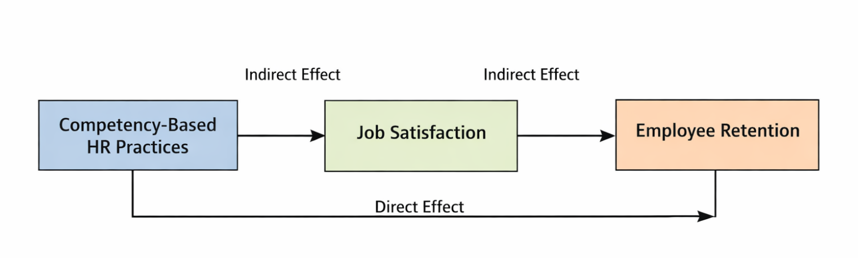
Fig. 1. Conceptual framework showing relationships between competency-based HR practices, job satisfaction, and employee retention
4. Methodology
4.1 Research Design
This research undertaking will follow the quantitative research design in order to ascertain the links among the competency-based HR practices, job satisfaction and employee retention. Primary data collection was carried out by the use of cross-sectional survey approach involving employees employed in the IT-industry of India. The research design is suitable to test hypothesized relationships and the mediation influence of variables.
4.2 Sample and Data Collection
This section covers the sample and data collection. The sample of the study is the workers in the Indian IT industry. The structured questionnaire obtained the data by way of an online survey. The convenience-based sampling method was used because of the constraints of accessibility and a broad geographical coverage of the respondents. The final sample consisted of 250-350 respondents and this is sufficient to analyze using Structural Equation Modeling (SEM) (Hair et al., 2010). Recruitment to participate in the survey was voluntary and the respondents were assured of anonymity and confidentiality so as to reduce bias in response.
4.3 Measurement of Variables
To be reliable and valid, all constructs were measured with established and tested measurements found in previous researches. Competency-Based HR Practices: Measured with training and development, performance appraisal and career progression item (Campion et al., 2011). Job Satisfaction: Scale based on a standardized scale of job satisfaction (Spector, 1997). Employee Retention: It is gauged on the basis of intention to stay (Allen et al., 2010). The evaluation of items was completed on a 5-point Likert scale with the extremes being 1 (strongly disagree) and 5 (strongly agree).
4.4 Reliability and Validity
The standard statistical criteria were considered as the reliability and validity of the measurement model:
- Cronbach Alpha: All constructs had values higher than the recommended value of 0.70 and this implies good internal consistency.
- Convergent Validity: achieved as a result of Average Variance Extracted ( AVE > 0.50) and big factor loadings.
- Construct Validity: Established by indices of model fit and factor construction.
4.5 Common Method Bias
To reduce the possibility of common method bias, the study used several procedural remedies during data collection. Respondents were assured of anonymity so that they could answer the questions freely without fear of identification. Evaluation apprehension was also reduced by making it clear that there were no right or wrong answers and that responses would be used only for research purposes. In addition, Harman’s single-factor test was conducted to statistically examine common method bias. The results showed that no single factor explained the majority of the variance, indicating that common method bias was not a serious concern in the study (Podsakoff et al., 2003).
4.6 Analytical Technique
The hypothesized relationships of variables are tested using Structural Equation modeling (SEM) in the study. This study is especially appropriate to use SEM because it can be used to simultaneously estimate a number of relationships and evaluate the direct and indirect (mediated) effects (Hair et al., 2010).
4.7 Model Specification
The theoretical framework looks at the direct and indirect relationship amongst the variables where:
- Competency-Based HR Practices (independent variable) affect the Employee Retention (dependent variable).
- Job Satisfaction is a mediating variable.
- There are also control variables that include age and experience at work to help in enhancing the strength of the model.
4.8 Robustness and Assumptions
To ensure the robustness and reliability of the study results, alternative model specifications were tested. This helped to examine whether the findings remained consistent when different analytical conditions were applied. Robustness testing is important because it strengthens confidence in the results and reduces the possibility that the findings are influenced by only one specific model structure. In addition, multicollinearity was also examined to check whether the independent variables were highly correlated with each other. The results showed that the Variance Inflation Factor (VIF) values were within the acceptable range. This indicates that multicollinearity was not a serious problem in the study and that the variables could be used together in the analysis without creating major statistical bias.
The study also assumes that the respondents provided honest, valid, and unbiased responses while completing the questionnaire. Since the data were collected directly from employees, the accuracy of the findings depends to some extent on the sincerity and clarity of their responses. However, one important limitation is that the study is based on cross-sectional data. This means that the data were collected at one point in time only. Therefore, although the results can show relationships among variables, causal interpretations should be made carefully. The findings should not be treated as complete proof of cause-and-effect relationships.

4.9 Limitations of Methodology
There are some methodological limitations of the study:
- Convenience sampling can be problematic as it can restrict generalizability.
- The cross sectional structure limits causative inference.
- The research is limited to the Indian IT industry, and may not be generalizable

.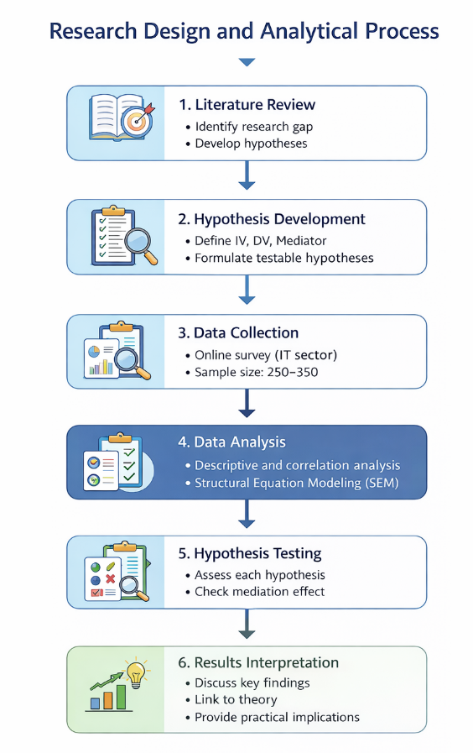
Fig. 2. Research design and analytical process

Table 1. Variable Definitions and Measurement
Variable | Definition | Measurement Scale | Source
Competency-Based HR Practices | HR practices focusing on skill alignment and development | 5-point Likert scale | Campion et al. (2011)
Job Satisfaction | Employee’s level of satisfaction with their job | 5-point Likert scale | Spector (1997)
Employee Retention | Employee intention to stay with the organization | 5-point Likert scale | Allen et al. (2010)

5. Results and analysis
5.1 Descriptive Statistics
Descriptive statistics provide an overview of the distribution of key variables. The average values reveal that HR practices based on competency, job satisfaction, and retention of employees are largely moderately high among the respondents. The values of the standard deviation indicate a reasonable variability with the values reflecting trustworthy answers.
Table 2. Descriptive Statistics
Variable | Mean | Standard Deviation
Competency-Based HR Practices | 3.78 | 0.65
Job Satisfaction | 3.85 | 0.60
Employee Retention | 3.72 | 0.68

5.2 Correlation Matrix
Correlation matrix shows the relationship strength and direction among the variables. All variables show a positive correlation indicating that as job satisfaction and retention increase, it is related to improvements in HR practices. The correlation coefficients fall within reasonable limits, and thus there are no issues of multicollinearity.
Table 3. Correlation Matrix
Variables | 1 | 2 | 3
1. Competency-Based HR Practices | 1.000
2. Job Satisfaction | 0.56 | 1.000
3. Employee Retention | 0.49 | 0.62 | 1.000

5.3 Regression / SEM Results
Structural Equation Modeling (SEM) results demonstrate a good model fit. The path coefficients indicate significant relationships among variables, confirming the proposed model.
Table 4. SEM Results
Path | Coefficient (β) | p-value | Result
HR Practices → Employee Retention | 0.32 | <0.01 | Significant
HR Practices → Job Satisfaction | 0.58 | <0.01 | Significant
Job Satisfaction → Employee Retention | 0.45 | <0.01 | Significant

5.4 Hypothesis Testing
The results of hypothesis testing are summarized as follows:
- H1: Competency-based HR practices have a significant positive effect on employee retention → Supported (β = 0.32, p < 0.01)
- H2: Competency-based HR practices have a significant positive effect on job satisfaction → Supported (β = 0.58, p < 0.01)
- H3: Job satisfaction has a significant positive effect on employee retention → Supported (β = 0.45, p < 0.01)
- H4: Job satisfaction mediates the relationship between competency-based HR practices and employee retention → Supported (indirect effect significant)
5.5 Graphical Representation
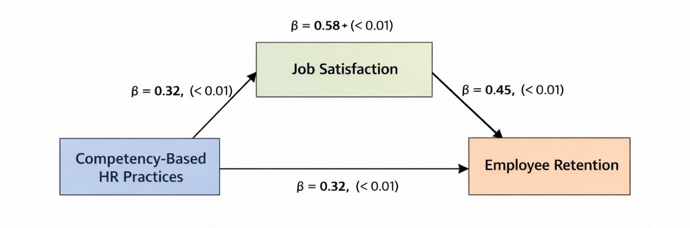
Fig. 3. Structural Model with Standardized Path Coefficients
(Shows relationships between competency-based HR practices, job satisfaction, and employee retention)
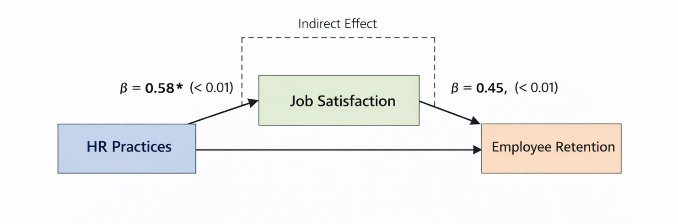
Fig. 4. Mediation Effect of Job Satisfaction
(Shows indirect pathway from HR practices to retention through job satisfaction)
5.6 Interpretation
The results show that competency-related HR practices contribute significantly to the employee retention processes. The higher the degree of job satisfaction among employees in an organization with organized and competency-centered HR systems is likely to be achieved. Moreover, job satisfaction comes as an important element in employee retention. When employees feel that their work place is conducive and encourages development, then the chances of them staying in the organization are higher. The mediation outcomes point to the fact that HR practices do not have a retention-inducing effect only by direct means but also by enhancing employee attitudes and experiences.
5.7. Robustness check
To promote the reliability of the results, the robustness checks were applied with the help of other methods of analysis. Results obtained through multiple regression analysis were similar to the SEM results. Also, the sensitivity analysis was conducted dividing the sample into subgroups, and the variables correlation steadily stood. The check of Multicollinearity No evidence had to indicate that all Variance Inflation Factor (VIF) values were within acceptably high limits, so there are no multicollinearity issues.
5.8. Statistical validation
The model fit indices indicate that the proposed model provides a good fit to the data:
- Comparative Fit Index (CFI): > 0.90
- Root Mean Square Error of Approximation (RMSEA): < 0.08
- R² Values: Indicate strong explanatory power
All path coefficients are statistically significant (p < 0.05), and confidence intervals do not include zero, confirming the robustness of the results.

6. Discussion

6.1 Discussion of the Major Results.
The results of this research show that competency-based HR practices have a strong positive influence on employee retention. The findings indicate that these practices affect retention both directly and indirectly through job satisfaction. This means that when organizations use HR systems based on employee competencies, they are more likely to retain their skilled workforce. Competency-based HR practices help employees feel that their skills, knowledge, and abilities are properly recognized, developed, and used by the organization. As a result, employees develop a stronger attachment to the organization and become more willing to continue their employment.
The direct effect of competency-based HR practices on employee retention suggests that employees are more likely to stay when they experience fair, structured, and growth-oriented HR systems. Practices such as competency-based recruitment, systematic training, fair performance appraisal, and clear career progression create a positive work environment. These practices show employees that the organization is serious about their professional development and long-term career growth. When employees believe that the organization provides meaningful opportunities to improve their competencies, they are less likely to think about leaving.
The indirect effect through job satisfaction is also important. The study indicates that competency-based HR practices improve job satisfaction, and satisfied employees are more likely to remain with the organization. For example, organized training programs help employees improve their technical and professional skills. Fair performance review systems make employees feel that their work is evaluated properly and transparently. Clear career growth opportunities provide employees with confidence about their future in the organization. These practices increase employees’ perception of organizational support and development opportunities.
When employees feel supported by the organization, they experience higher satisfaction with their job, workplace, and career direction. Job satisfaction then strengthens their intention to stay. In this way, job satisfaction works as an important connecting factor between competency-based HR practices and employee retention. The findings suggest that retention is not influenced only by salary or job security. It is also influenced by how employees experience HR policies in their daily work life.
These results highlight that HR policies do not only affect retention outcomes. They also shape employee attitudes, motivation, and workplace experiences. Competency-based HR systems help organizations build a more committed, satisfied, and stable workforce. Therefore, companies, especially in knowledge-based sectors such as IT, should focus on developing HR practices that are linked with employee competencies. Such practices can improve organizational efficiency, reduce turnover intention, and support long-term employee retention.

6.2 Link with Theory

The findings strongly affirm the hypotheses of Social Exchange Theory (Blau, 1964) assuming that employee-organization relationships are caused by exchanges. Organizational investments based on competency-based HR practices lead employees to positively respond to the investments by showing positive attitudes such as job satisfaction and commitment. This theoretical view is further supported by the mediation role of job satisfaction, which signifies that responses of the employees are not automatic but it depends on inner psychological processes. This confirms that job satisfaction is a pivotal interaction that organizational practices carve into response in terms of behavioral consequences like retention.

6.3 comparison with past studies.

The results can be attributed to previous studies that emphasize the beneficial nature of HR practices in promoting employee retention (Albrecht et al., 2021; Jiang et al., 2020). This study just like the previous results continues to support the notion that employee retention is highly predicted by job satisfaction (Tett and Meyer, 1993). Nevertheless, the paper is an addition to the current literature, as it focuses on competency-based HR practices, as opposed to general HR practices. It is also empirical evidence of the mediating role of job satisfaction on the basis of Structural Equation Modeling (SEM). In addition, the research provides context-specific knowledge in Indian IT sector which has not been fully explored in past studies.

6.4 Theoretical Implications

This paper adds to the literature by incorporating Social Exchange Theory with HR practices like competency-based and employee retention. It specifies the role of job satisfaction as a mediating factor, thus providing a more detailed explanation of the impact of HR practices on employee behavior. The results also support the applicability of competency-based models in the current HRM studies especially in the dynamic and competitive industries like IT.

6.5 Practical Implications

The findings give a number of useful conclusions to HR managers and organizational leaders:
- Development and training programs should be designed based on competency levels in the organizations to improve employee engagement and skills.
- They should have transparent and fair performance appraisal system in order to foster trust and satisfaction.
- Effective career growth opportunities ought to be provided as a way of encouraging employees and minimizing the turnover intentions.
- HR strategies are not only policy-oriented but employee satisfaction and experience should be enhanced as well.

6.6 Policy Implications

The results provide valuable information to policy makers and employers in the IT industry that desire to overcome the high turnover rates. Embracing competency-based HR practices within organizations can help workforce to stabilize and grow sustainable. Retention results can be further reinforced by policies promoting skills and employee welfare.

6.7 Study Limitations.

The study, though having its contributions, has some limitations:
- A cross-sectional design can be used, thus restricting the possibility of drawing causal relationships.
- Convenience sampling can influence the extrapolation of the results.
- The research is limited to the Indian IT industry and this may not be generalized across industries/regions.

7. Conclusion
This paper has focused on how HR practices of competency-based affect employee retention within the Indian IT sector with special emphasis upon mediating effects of job satisfaction. The results affirm that competency-based HR practices have a positive impact on employee retention, both directly and indirectly via job satisfaction. This brings out the greatest effectiveness of HR practices that increase employee positive attitudes, especially satisfaction. The theoretical contribution of the study is significant as it expands the scope of the implementation of the Social Exchange Theory to determine how competency-based HR practices can be used to explain the motivation of the behavior of employees. It shows that job satisfaction is an important psychological process by which organizational practices are converted to retention outcomes.
Practically speaking, the results indicate that the organizations ought to implement competency-based HR practices that emphasize on employee growth and development, equitable appraisal and career development. They not only lead to greater employee satisfaction but also boost long-term retention which is imperative in a highly competitive industry such as IT. Although it makes contributions, the study has some limitations. The study design is cross-sectional which limits causal interpretations and convenience sampling can be a limitation on generalizability. Also, the emphasis on the Indian IT industry can decrease the generality of the results to other sectors and territories. The limitations of this study can be overcome with the future research incorporation of longitudinal data to make causal relationships. Other mediating variables or moderating variables (e.g., organizational commitment, work engagement, the leadership styles) may also be investigated in the future. Comparison of industries and country based studies would be useful in offering wider information on the effectiveness of competency based HR practices.
8. References
- Allen, D. G., Bryant, P. C., & Vardaman, J. M. (2010). Retaining talent: Replacing misconceptions with evidence-based strategies. Academy of Management Perspectives, 24(2), 48–64.
- Albrecht, S. L., Bakker, A. B., Gruman, J. A., Macey, W. H., & Saks, A. M. (2021). Employee engagement, human resource management practices and competitive advantage: An integrated approach. Journal of Organizational Effectiveness, 8(1), 23–45.
- Blau, P. M. (1964). Exchange and power in social life. Wiley.
- Campion, M. A., Fink, A. A., Ruggeberg, B. J., Carr, L., Phillips, G. M., & Odman, R. B. (2011). Doing competencies well: Best practices in competency modeling. Personnel Psychology, 64(1), 225–262.
- Cropanzano, R., & Mitchell, M. S. (2005). Social exchange theory: An interdisciplinary review. Journal of Management, 31(6), 874–900.
- Eisenberger, R., Armeli, S., Rexwinkel, B., Lynch, P. D., & Rhoades, L. (2001). Reciprocation of perceived organizational support. Journal of Applied Psychology, 86(1), 42–51.
- Hair, J. F., Black, W. C., Babin, B. J., & Anderson, R. E. (2010). Multivariate data analysis (7th ed.). Pearson.
- Holtom, B. C., Mitchell, T. R., Lee, T. W., & Eberly, M. B. (2018). Turnover and retention research: A glance at the past, a closer review of the present, and a venture into the future. Academy of Management Annals, 12(1), 1–44.
- Jiang, K., Lepak, D. P., Hu, J., & Baer, J. C. (2020). How does human resource management influence organizational outcomes? A meta-analytic investigation. Academy of Management Journal, 63(6), 1710–1735.
- Lee, T. W., Hom, P. W., Eberly, M. B., Li, J., & Mitchell, T. R. (2018). Managing employee retention and turnover with 21st-century ideas. Organizational Dynamics, 47(2), 88–98.
- Podsakoff, P. M., MacKenzie, S. B., Lee, J. Y., & Podsakoff, N. P. (2003). Common method biases in behavioral research: A critical review. Journal of Applied Psychology, 88(5), 879–903.
- Sparrow, P. (2017). Global human resource management and international HRM. Journal of World Business, 52(1), 1–9.
- Spector, P. E. (1997). Job satisfaction: Application, assessment, causes, and consequences. Sage.
- Tett, R. P., & Meyer, J. P. (1993). Job satisfaction, organizational commitment, turnover intention, and turnover. Personnel Psychology, 46(2), 259–293.
- Hom, P. W., Lee, T. W., Shaw, J. D., & Hausknecht, J. P. (2017). One hundred years of employee turnover theory and research. Journal of Applied Psychology, 102(3), 530–545.
- Karatepe, O. M., & Olugbade, O. A. (2017). The effects of work social support and career adaptability on career satisfaction and turnover intentions. Journal of Management Development, 36(5), 564–577.

