Generation and Immunofluorescence-Based Cellular Recognition of Rabbit-Derived Polyclonal Anti-KMT2D Antibodies in HeLa Cervical Cancer Cells
Abstract
Introduction: Cervical cancer remains a major cause of morbidity and mortality among women worldwide, including in Indonesia. Beyond high-risk HPV infection, its oncogenesis involves complex genetic and epigenetic mechanisms. Histone-Lysine N-Methyltransferase 2D (KMT2D), an epigenetic regulator maintaining transcriptional activation through H3K4 methylation, plays a key role. Loss or mutation of KMT2D enhances oncogenic PI3K/AKT and MAPK signaling, making it a potential molecular target for epigenetic-based immunotherapy. This study evaluated the immunogenicity and target recognition of rabbit-derived polyclonal antibodies against KMT2D in HeLa cervical cancer cells.
Method: Immunofluorescence assays were performed using Alexa Fluor 488-conjugated secondary antibodies and DAPI nuclear staining. Fluorescence images were analyzed with ImageJ to quantify Mean Fluorescence Intensity (MFI).
Result: Post-immunization serum produced a reproducible intracellular fluorescence signal predominantly localized to the nuclear and perinuclear regions of HeLa cells, consistent with the known subcellular localization of KMT2D. In contrast, pre-immune serum and secondary antibody–only controls exhibited minimal background fluorescence. Quantitative analysis revealed a marked MFI increase after immunization (161.04) compared with control (69.71) and pre-immune serum (69.87), indicating successful antibody generation and cellular target recognition.
Conclusion: This study demonstrates that rabbit-derived polyclonal antibodies against KMT2D are capable of recognizing intracellular KMT2D in HeLa cervical cancer cells. While functional and mechanistic effects were not evaluated, these findings provide foundational cellular-level validation and support the feasibility of further antibody optimization and downstream functional investigations targeting epigenetic regulators in cervical cancer.
Keywords: Cervical cancer; KMT2D; polyclonal antibody; immunofluorescence; epigenetic regulation

INTRODUCTION
Cervical cancer remains a major health problem for women in Indonesia and around the world. According to data from the Global Cancer Observatory (GLOBOCAN) 2020, there are more than 36,000 new cases of cervical cancer in Indonesia each year, with a mortality rate of 23,000¹. These figures show that despite various prevention efforts through HPV vaccination, early detection, and conventional treatment, the burden of disease remains high. Contributing factors include delayed diagnosis, resistance to therapy, and limited access to effective and affordable treatment².
Most cases of cervical cancer are caused by high-risk Human Papillomavirus (HPV) infections, particularly types 16 and 18, which express the viral proteins E6 and E7. These two proteins inactivate the tumor suppressor genes p53 and Rb, leading to uncontrolled cell proliferation³. However, the carcinogenesis process of cervical cancer does not only depend on viral infection, but also on complex genetic and epigenetic changes. One gene that plays an important role in epigenetic regulation is Histone-Lysine N-Methyltransferase 2D (KMT2D)⁴.
KMT2D belongs to the histone methyltransferase family that catalyzes the addition of a methyl group to lysine 4 of histone H3 (H3K4). This modification is closely related to gene transcription activation. KMT2D plays a role in regulating the expression of genes involved in differentiation, energy metabolism, and cell proliferation and migration. Mutations or loss of function of KMT2D cause deregulation of epigenetic pathways, including activation of the PI3K/AKT and MAPK pathways, which contribute to tumor growth and spread⁵. In cervical cancer, KMT2D mutations are found in 12–33% of cases and correlate with tumor aggressiveness and resistance to therapy⁶.
Recent studies show that KMT2D not only functions as a tumor suppressor gene but also as a potential target for epigenetic therapy. Loss of KMT2D can increase sensitivity to PI3Kα inhibitors and other epigenetic pathway modulators⁷. Thus, therapeutic approaches targeting the KMT2D protein are attractive for further research. One emerging strategy is the use of antibodies specific to tumor target proteins as a form of targeted therapy or molecular immunotherapy⁸.
Antibody-based immunotherapy has revolutionized the treatment of various types of cancer, such as melanoma, lung cancer, and lymphoma. This approach works by stimulating the immune system to recognize and destroy tumor cells selectively without damaging normal tissue. However, to date, there has been little research exploring the potential of antibodies against KMT2D as a treatment for cervical cancer, particularly in Indonesia. In fact, the development of this therapy has high strategic value because it can produce innovative research-based products that are relevant to the local population.
Based on this background, this study aims to explore the KMT2D protein and its immunogenicity as a cervical cancer therapy agent, as well as the effects of antibodies against KMT2D in HeLa cervical cancer cells in vitro. Additionally, this study is expected to serve as the basis for the development of more effective, affordable, and accessible biomolecular-based precision immunotherapy for the Indonesian population.

METHODS
Research Design
This study is a true experimental study with a Randomized Group Post-Test Only Design conducted in vitro using HeLa cervical cancer cell cultures. Rabbits (Oryctolagus cuniculus) were immunized with KMT2D antigen (Cloud-Clone Corp, Lot#RPL737Hu01, Wuhan, China) emulsified in CFA/IFA for 12 weeks. Immunofluorescence was conducted using HeLa cells incubated with primary anti-KMT2D antibody, followed by fluorophore-conjugated secondary antibody and nuclear counterstaining with DAPI. Fluorescence intensity was quantified using ImageJ software.

Research Location and Time
The research was conducted at the Central Biomedical Laboratory of the Faculty of Medicine, Brawijaya University (FKUB) and the Biochemistry Laboratory of the Faculty of Mathematics and Natural Sciences, Brawijaya University. All stages of the research were conducted between May 2025 and November 2025.
Ethical Approval
This research has been approved by the Health Research Ethics Committee of Malang State University (Number: 27.03.05/UN32.14.2.8/LT/2025), which covers the use of rabbits (Oryctolagus cuniculus) for the production of antibodies against KMT2D and the use of HeLa cell cultures.
Production of KMT2D Polyclonal Antibodies
KMT2D polyclonal antibodies are produced through immunization of 10–16-week-old white rabbits (Oryctolagus cuniculus). Three rabbits were included in the study: two rabbits were immunized with the KMT2D antigen according to a standard vaccination protocol, while one rabbit served as an unvaccinated control. The animals were immunized with recombinant human KMT2D antigen emulsified using Complete Freund’s Adjuvant (CFA) for the first immunization and Incomplete Freund’s Adjuvant (IFA) for subsequent immunizations.
The immunization protocol was carried out over 12 weeks with a schedule of injections and periodic serum collection (bleeding). After the third immunization, serum was collected, then purified immunoglobulin (IgG) was obtained using the Salt Ammonium Sulfate (SAS) precipitation method to obtain pure antibodies.
HeLa Cell Culture
HeLa cells (ATCC, VA, USA) were obtained from the Biomedical Laboratory, Faculty of Medicine, Universitas Brawijaya, Indonesia culture collection and maintained in Dulbecco’s Modified Eagle Medium (DMEM) supplemented with 10% fetal bovine serum (FBS) and 1% penicillin–streptomycin. Cells were cultured at 37 °C in a humidified atmosphere containing 5% CO₂.
For immunofluorescence analysis, HeLa cells were seeded onto sterile 12-mm glass coverslips placed in 24-well culture plates at a density of 1.8 × 10⁵ cells per well and grown to approximately 60–70% confluency. Cells were assigned to experimental conditions based on the source of rabbit serum used as the primary antibody, as follows:
- Negative Control Serum: Cells incubated with serum obtained from an unvaccinated rabbit, used to assess background fluorescence and non-specific binding.
- Pre-Immune Serum: Cells incubated with serum collected from immunized rabbits prior to KMT2D antigen administration, serving as a baseline antibody-negative control.
- Post-Primary Immunization Serum: Cells incubated with serum collected after the initial KMT2D antigen immunization (week 2).
- Post-First Booster Serum: Cells incubated with serum collected after the first booster immunization (week 4).
- Post-Second Booster Serum: Cells incubated with serum collected after the second booster immunization (week 12).

Immunofluorescence experiments were performed using two technical replicates (two wells) for each experimental condition. For the negative control group, both wells were incubated with serum obtained from a single unvaccinated rabbit. For the pre-immune, post-primary immunization, post-first booster, and post-second booster conditions, each experimental group consisted of two wells incubated with serum samples derived from two different immunized rabbits (two biological replicates)

Immunofluorescence Assay
An immunofluorescence assay (IFA) was performed to evaluate the binding of rabbit-derived polyclonal anti-KMT2D antibodies to endogenous KMT2D in HeLa cells. Cells from each designated group were washed three times with phosphate-buffered saline (PBS) and fixed with 4% paraformaldehyde for 15 minutes at room temperature. Cell membranes were permeabilized using 0.1% Triton X-100 in PBS for 10 minutes, followed by three PBS washes. Non-specific binding sites were blocked with 3% bovine serum albumin (BSA) in PBS for 30 minutes at room temperature. Cells were then incubated with rabbit serum serving as the primary antibody (diluted 1:500 in PBS containing 1% BSA) overnight at room temperature in a humidified, dark chamber. After washing three times with PBS, cells were incubated for 1 hour at room temperature with a Alexa Fluor 488-conjugated secondary antibody (Rockland, Cat. No. 611-1002, PA, USA) at a dilution of 1:1000. Nuclei were counterstained with DAPI (Biotium, Cat. No. 40011, CA, USA) for 5 minutes. Coverslips were mounted using entellan and examined using an epifluorescence microscope (Olympus IX71, Japan). Imaging parameters, including exposure time, gain, and magnification, were kept constant across all groups to enable direct comparison of fluorescence intensity.
Data Analysis
Data analysis of immunofluorescence results was performed by taking 5–10 random fields of view in each serum group to obtain a reliable representation of the distribution of fluorescence signal intensity. Measurements were performed using ImageJ software to determine the Mean Fluorescence Intensity (MFI) of the cell area, particularly in the cell nucleus, after background removal to minimize image noise. The MFI values were then compared between groups.

Antibody Production against KMT2D Protein
In this study, three white Oryctolagus cuniculus rabbits were used as research subjects, all male and 10–16-week-old. Two rabbits were used to obtain KMT2D immunization treatment in this study and one rabbit as a control.
A total of 300 µL of KMT2D antigen was added to 100 µL of CFA adjuvant (3:1 ratio) and vortexed at full speed for ± 2 hours to form a perfect emulsion. The injection volume for each rabbit was 400 µL. At this time, the actions that had been carried out in week I included: pre-immunization bleeding, CFA immunization, IFA 1, and bleeding 1, which would later be continued until week 12.

RESULTS
Immunofluorescence Results
Immunofluorescence analysis demonstrated distinct differences in fluorescence intensity and subcellular localization among the experimental groups (Figure 1). HeLa cells incubated with serum from unvaccinated rabbits and pre-immune serum exhibited low-intensity, diffuse fluorescence with minimal nuclear signal, indicating background staining and non-specific antibody binding. In contrast, cells treated with post-primary immunization serum showed a marked increase in fluorescence intensity, predominantly localized within the nucleus. Quantitative analysis confirmed a significant increase in fluorescence intensity in the post-primary immunization group compared with both the control and pre-immune groups (p<0.0001), consistent with the presence of antibodies capable of recognizing nuclear KMT2D.
Following the first booster immunization, fluorescence intensity was reduced relative to the post-primary immunization group, although nuclear localization of the signal was preserved, suggesting continued antigen-specific binding. A similar pattern was observed in the post-second booster group, with fluorescence intensity remaining lower than that observed after primary immunization. Notably, the post-second booster group exhibited a higher intensity and more homogeneous nuclear staining pattern compared with the first booster group (p<0.0001).

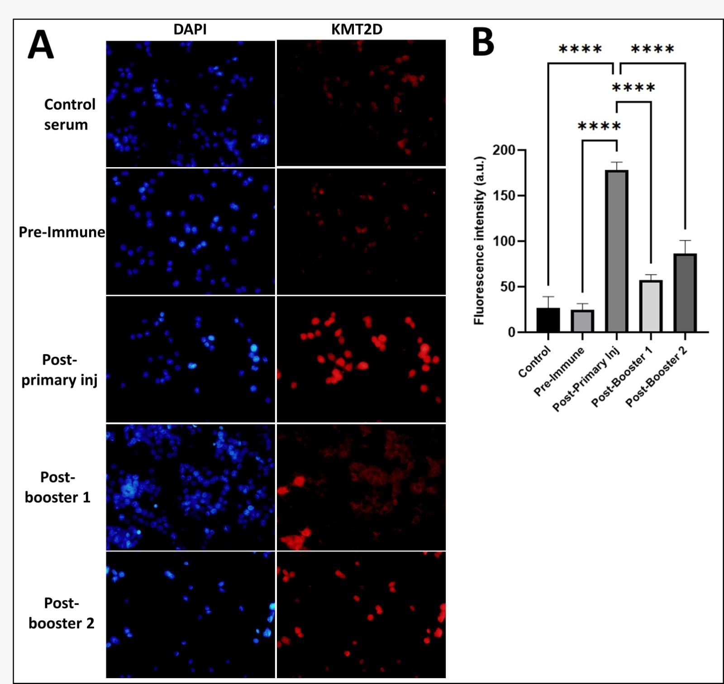
Figure 1. Immunofluorescence analysis of KMT2D expression using rabbit-derived polyclonal antibodies
(A) Representative immunofluorescence images of HeLa cervical cancer cells stained with DAPI (blue) for nuclei and anti-KMT2D antibody (red) derived from rabbit sera at different immunization stages. Minimal fluorescence was observed in the control and pre-immune sera, while a marked increase in red fluorescence intensity appeared after the primary immunization, indicating specific recognition of intracellular KMT2D. Meanwhile, decrease in fluorescence signal was observed after the first and second booster, compared to the post-primary immunization.
(B) Semi-quantitative analysis of mean fluorescence intensity showing a significant increase in KMT2D-specific fluorescence in post-primary, post-booster 1, and post-booster 2 sera compared with control and pre-immune groups. ****p < 0.0001 indicates significant difference between respective groups. Data are presented as mean ± SD of five images obtained from two technical (control group) and two biological (the remaining groups) replicates.

DISCUSSION
This study aimed to evaluate the immunogenicity and cellular target recognition of a rabbit-derived polyclonal antibody directed against Histone-Lysine N-Methyltransferase 2D (KMT2D) in HeLa cervical cancer cells using an immunofluorescence-based approach. The principal finding of this work is that serum obtained after KMT2D immunization produces a reproducible intracellular fluorescence signal, predominantly localized to the nucleus and perinuclear region, consistent with the known subcellular localization of KMT2D as a chromatin-associated epigenetic regulator¹,². In contrast, pre-immune serum and secondary antibody–only controls demonstrated minimal fluorescence, indicating low background and limited non-specific binding.

The observed increase in mean fluorescence intensity (MFI) following primary immunization and booster administration indicates successful induction of a humoral immune response against the KMT2D antigen. This pattern aligns with established immunological principles, whereby primary antigen exposure generates antigen-specific antibodies that are subsequently enhanced in stability and detectability following booster immunization³. Importantly, the persistence of detectable fluorescence signals across post-immunization stages supports the feasibility of generating antibodies capable of recognizing intracellular KMT2D in a cancer cell context.

KMT2D is a large histone methyltransferase responsible for catalyzing H3K4 mono- and di-methylation at enhancer regions, thereby maintaining transcriptional programs involved in cellular differentiation, metabolism, and proliferation⁴,⁵. Alterations in KMT2D expression or function have been implicated in multiple malignancies, including cervical cancer, where dysregulation of KMT2D-associated epigenetic networks contributes to aberrant activation of signaling pathways such as PI3K/AKT and MAPK⁶,⁷. The nuclear-associated fluorescence pattern observed in this study is therefore biologically plausible and consistent with prior reports describing KMT2D localization and function in chromatin regulation⁴,⁸.

It is important to emphasize that the present study was not designed to evaluate functional consequences of antibody binding, such as apoptosis induction, proliferation inhibition, or signaling pathway modulation. No functional assays (e.g., Annexin V staining, caspase activation, cell viability assays) or mechanistic analyses were performed.
Antibody specificity in this study was evaluated using immunofluorescence combined with multiple negative controls, including pre-immune serum and secondary antibody–only conditions. These controls demonstrated minimal background fluorescence, supporting antigen-dependent signal detection. Nevertheless, comprehensive antibody validation typically requires additional orthogonal approaches, such as Western blot analysis to confirm molecular weight specificity, peptide competition assays, or genetic perturbation models (e.g., knockdown or knockout)¹⁰,¹¹. The absence of these validation methods constitutes a limitation of the present work and should be addressed in future studies.
From a methodological perspective, immunofluorescence was selected as an initial validation tool because it enables visualization of intracellular antigen recognition within the native cellular architecture. While this approach does not provide molecular size confirmation, it offers valuable spatial information regarding antigen localization and antibody accessibility¹². In the context of KMT2D, which functions as a nuclear epigenetic regulator, the observed nuclear-associated signal provides biologically relevant support for antibody–antigen interaction at the cellular level.

The novelty of this study lies not in demonstrating functional or therapeutic efficacy, but in the local generation and initial cellular validation of a polyclonal anti-KMT2D antibody within an Indonesian research setting. To our knowledge, this represents the first report describing the production and immunofluorescence-based target recognition of anti-KMT2D antibodies in cervical cancer cells from Indonesia. As such, this work provides a foundational platform for subsequent studies involving functional assays, mechanistic interrogation, and antibody optimization, including affinity purification or monoclonal antibody development¹³.
Several limitations should be acknowledged. First, the study was conducted using a single cervical cancer cell line, which limits generalizability across different molecular subtypes of cervical cancer¹⁴. Second, quantitative fluorescence analysis was performed as a descriptive measure and should not be interpreted as definitive evidence of antibody affinity or functional potency. Third, in vivo relevance cannot be inferred from the present in vitro data. Addressing these limitations will require expanded validation across additional cell models, orthogonal specificity assays, and functional studies¹⁵.

In summary, this study demonstrates that rabbit-derived polyclonal antibodies raised against KMT2D can recognize intracellular KMT2D in HeLa cervical cancer cells, as evidenced by consistent immunofluorescence localization and quantitative signal enhancement following immunization. While functional implications were not assessed, these findings establish a necessary preliminary step toward future mechanistic and translational investigations targeting epigenetic regulators in cervical cancer.

Acknowledgements
The author would like to thank the Faculty of Medicine, State University of Malang, for funding this research through the Faculty of Medicine UM's Decentralized Research program. Thanks are also extended to the Biomedical and Bioscience Laboratory, Brawijaya University, for their cooperation and facilitation in the use of laboratory equipment, as well as to the research assistants who helped in the implementation of this research.
Conflict of Interest
The author declares that there is no conflict of interest in the implementation or publication of this research.

References
- Dhar SS, Lee MG. Cancer-epigenetic functions of the histone methyltransferase KMT2D and therapeutic opportunities. Oncotarget. 2021;12(13):1296–1308. doi:10.18632/oncotarget.27988. PMID:34194626.
- Froimchuk E, Jang Y, Ge K. Histone H3 lysine 4 methyltransferase KMT2D. Gene. 2017;627:337–342. doi:10.1016/j.gene.2017.06.056.
- Murphy K, Weaver C. Janeway’s Immunobiology. 9th ed. Garland Science; 2017.
- Rao RC, Dou Y. Hijacked in cancer: the KMT2 (MLL) family of methyltransferases. Nat Rev Cancer. 2015;15(6):334–346. doi:10.1038/nrc3929.
- Wang L, et al. Enhancer remodeling promotes tumor-initiating activity in NRF2-activated non-small cell lung cancers. Nat Commun. 2016;7:13712. doi:10.1038/ncomms13712. PMID:27922077.
- Cho SJ, et al. KMT2D deficiency promotes proliferation and metastasis in cancer cells through PI3K/AKT signaling. Cell Death Dis. 2021;12:921. doi:10.1038/s41419-021-04217-3. PMID:34608218.
- Noorolyai S, et al. The role of PI3K/AKT signaling pathway in cervical cancer. Biomed Pharmacother. 2019;109:892–898. doi:10.1016/j.biopha.2018.10.135. PMID:30481710.
- Rao RC, et al. An epigenetic reader links H3K4 methylation to breast cancer cell proliferation and tumorigenesis. Nature. 2012;482(7383):246–250. doi:10.1038/nature10820. PMID:22286061.
- Uhlen M, et al. A proposal for validation of antibodies. Nat Methods. 2016;13(10):823–827. doi:10.1038/nmeth.3995.
- Bordeaux J, et al. Antibody validation. Biotechniques. 2010;48(3):197–209. doi:10.2144/000113382.
- Bradbury A, Plückthun A. Reproducibility in antibody validation. Nat Biotechnol. 2015;33:882–884. doi:10.1038/nbt.3352.
- Lichtman JW, Conchello JA. Fluorescence microscopy. Nat Methods. 2005;2(12):910–919. doi:10.1038/nmeth817.
- Bellati F, Napoletano C, Gasparri ML, et al. Monoclonal antibodies in gynecological cancer: a critical point of view. Clin Dev Immunol. 2011;2011:890758. doi:10.1155/2011/890758. PMID:22235224.
- Xu Y, et al. Identification of Potential Driver Genes Based on Multi-Genomic Data in Cervical Cancer. Front Genet. 2021;12:598304. doi:10.3389/fgene.2021.598304.
- Ferrall L, Lin KY, Roden RBS, Hung CF, Wu TC. Cervical cancer immunotherapy: facts and hopes. Clin Cancer Res. 2021;27(18):4953–4973. doi:10.1158/1078-0432.CCR-20-2833. PMID:34172541.

