Multi-Aspect Sentiment Analysis of Yelp Restaurant Reviews Using Classical, Neural, and Transformer-Based

Models
Abstract. Aspect-based sentiment analysis (ABSA) offers the fine-grained view on the user opinions by association of emotions with certain elements of an experience. In this we do many aspect Yelp sentiment analysis based on the reviews of restaurants, six issues critical to restaurant reviews decision-making within the food arena: Food Quality, Customer Service, Place (cleanli- ness/ambience), menu and prices, beverages and Time (waiting time). We first build a restaurant- only subset of the Yelp academic data and analyze its characteristics using descriptive statistics, rating distributions, temporal distributions, and useful, funny, and cool voting triggers engage- ment. Latent Dirichlet Allocation (LDA) is used to identify the most prominent topics that are aligned with labelable aspect labels and matched with TextBlobbased score of polarity to acquire preliminary aspect–sentiment signals. Besides this we construct a monitored pipeline with a mix- ture of manually labeled data stratified sampling, and over sampling to counter extreme class imbalance in the classification sentiment labels (-1, 0, 1). We use a systemic comparison of tra- ditional TFIDF-based models (Multinomial Naive Bayes, Logistic regression, random forests, and voting ensembles), sequence models (Simple RNN and LSTM), and deep architectures that are initialized with Word2Vec and GloVe embeddings. In the end, we optimize BERT on each aspect and demonstrate that models based on transformers always achieve higher results than classical baselines and random label distribution baselines, with accuracies of the scale of about 0.71-0.81 across aspects. We supplement the quantitative analysis with weak labeling with the help of GPT and error analysis, such as confusion matrices and feature importance as well as the inspection of these elements misclassified reviews. The framework combines topic modeling, deep learning, LLMs, and traditional ML for scalable, interpretable restaurant sentiment analysis.

Keywords: Aspect-Based Sentiment Analysis, Yelp Dataset, Topic Modeling, TF-IDF, BERT, Ensemble Models, Deep Learning, Natural Language Processing

INTRODUCTION
Customer reviews online are important in the development of consumer decisions and influencing business reputation. Review sites like Yelp have a huge amount of user generated information reviews based on the general view on different elements of prod- ucts and services. However, the reviews are generally unstructured and mixed opinions amongst various dimensions and it is challenging to draw meaningful, finegrained in- sights using traditional techniques of sentiment analysis.
Aspect-Based Sentiment Analysis (ABSA) is a solution to this dilemma in that it tries to identify sentiments associated with certain characteristics like quality of food services, customer service, atmosphere and price within a single review. Rather than giving an universal sentiment label to a review, ABSA divides the text into several parts

and criticizes them one by one. This approach is particularly crucial in the restaurant review sphere where a customer can voice the two positive and negative reviews on the same review.
We conduct an aspect based analysis of Yelp restaurant in this research evaluations based on a multi-stage pipeline that includes exploratory data analysis, text topic mod- eling, preprocessing, automated labelling, and supervised machine learning techniques. Our data will contain textual customer reviews and six aspects that are defined: Res- taurant Quality, Service, Place (Ambiance), Menu and Pricing, Drinks, and Time (Wait- ing Experience). The labels of the sentiments of each aspect are -1 (negative), 0 (not mentioned/neutral), or 1
(positive).
Peter used a lot of visualization to comprehend the distribution and data attributes of a review. These include:
- Word clouds obtained on cleaned spaCy-extracted nouns.
- Latent Dirichlet Allocation (LDA) plots to recognize key themes.
- BERTopic visualizations of hierarchical and frequency based topic modeling.
- Bar charts of Precision, Recall and F1-score of all six aspects.
- Detailed misclassification analysis at the confusion matrices.
These visualizations assist in the exploration of knowledge and the performance of a model interpretation, although selectively selected in order to keep the paper length below the IEEE standard limit.
The sentiment labels were created and were validated using a hybrid method which involves GPT automatic annotation and human inspection of datasets, which constitutes a labeled dataset of 3,040 reviews. A number of machine learning and deep learning models were used classification, including:
- TF-IDF using random forest, Multinomial Naive Bayes and Logistic Regression.
- Voting Classifiers in Ensemble.
- BERT based Sequence Classification Model. 4) BERTopic to unsupervised topic discovery.
Also, there are methods of Random Oversampling and incidence matrix representa- tion were also used in order to overcome the imbalance of classes and enhance gener- alization.
Contributions: The key contributions of this study are as follows:
- Formation of a multi-aspect marked Yelp review data set including six sentiment dimensions.
- Topic modeling (LDA and BERTopic) and visual word cloud are applied to in- troduce patterns of dominant discourses.
- Supervised and deep learning model development and evaluation of several mod- els aspect wise sentiment classification.
- Comparison on the basis of precision, recall, F1-score, accuracy and confusion matrices.
- The embodiment of the drawbacks of the statistical techniques and the excellent results of ensemble-based and BERT-based methods of aspect-level sentiment detection.

Literature Review
Sentiment analysis is a well studied field of natural language processing, includ- ing document-level polarity detection to aspect-based sentiment analysis (ABSA). The basic groundwork of Liu [1] and Pang and Lee [2] was laid out methodologies to opinion mining and pointed out the drawbacks of coarse-grained sentiment clas- sification. Through these studies it became apparent that document-level classifica- tion is traditional not enough to be used in applications like reviews of restaurants, where users frequently give dissimilar feelings regarding other things (e.g. food, ser- vice, price) in one text.
ABSA was standardized and defined through the SemEval. Most prominently, workshops, either led by Pontiki et al. [3] in SemEval-2014 Task 4. This benchmark was dedicated to restaurant and laptop reviews and separated the task into aspect term aspect category detection, extraction, and aspectlevel sentiment classification. This work laid the basis of the majority of the further research in the area of restau- rant domain ABSA and is a source of good reasons to employ a similar structure in the present research.
The application of topic modeling as an unsupervised tool which helps in the dis- covery of latent has been used extensively subjects or dimensions of huge text col- lections. Latent Dirichlet Allocation Introduction. A probabilistic model of extract- ing text topics was given in (LDA) by Blei et al. [4], which has frequently been applied to first aspect identification. Similarly, distributed word networks known as Word2Vec by Mikolov et al. [5] and GloVe by Pennington et al. [6] enhanced se- mantic vectors of words, which improves the model performance downstream clas- sification. Neural topic models like BERTopic, are more recent which have been proposed by Grootendorst [7], have demonstrated the efficacy of mixing transformer embeddings and using class-based TFIDF to obtain interpretable topics.
Deep learning techniques have contributed greatly to the discipline of ABSA. Wang et al. [8] suggested applying deep memory networks in order to learn long- range dependencies between aspect words and sentiment words. Ma et al. [9] went ahead to improve this by the introduction of interactive attention processes enabling the model to pay attention to sentimentally-relevant context for a specific aspect. Chen et al. [10] added a recurrent attention networks to hone down the representation of aspect-aware context. Such works reveal that there is extra contextuality knowledge is much better than with conventional machine in terms of ABSA per- formance learning methods.
There have also been improvements in aspect category detection. Movahedi et al.
[11] proposed a topic-attention neural architecture, which is effective in the aspect classification classifications in the restaurant sphere. Most recent contributions to datasets include GERestaurant by Hellwig et al. [12], there is a growing interest in cross-domain ABSA and multilingual another reason why analysis at aspect level is significant.
Sentiment analysis and ABSA has been revolutionized by transformers especially BERT. Devlin et al. [13] suggested the BERT that applies deep two-way transform- ers to produce potent contextual embeddings. After that, Sun et al. [14] applied

BERT to ABSA with the help of auxiliary sentence structure, we can prove that the performance increases significantly when compared to RNN-based architectures. Such methods using transformers have become the state-of-the-art criterion to use when doing text classification tasks and had a strong impact on the structure used in the current study BERT-based classifiers.
Sentiment analysis research has used Yelp reviews on many occasions. Alamoudi and Alghamdi [16] used the models of deep learning towards aspect-level sentiment on Yelp reviews analysis, emphasizing that this dataset is appropriate in the fine- grained opinion mining. Wang et al. [17] carried out an in-depth case study on Yelp data, and proved its real-life applicability business analytical and service-appraisal applicability. Furthermore, Suhara et al. [15] proposed OpinionDigest, which uses ABSA on Yelp reviews as an opinion summarization framework, which enhances the importance of deriving structured insights of review platforms.
The use of Large Language Models (LLMs) in recent research has also been cov- ered annotators. AnnoLLM proposed by He et al. [18] shows that LLMs can also be used as good crowd-sourced annotators of NLP. This is in direct correlation with the present study, the labeling to create aspect sentiment annotations is performed with GPT-based labeling to train and evaluation.
Although these works have good performance in terms of deep and transformer- based models, the majority of the studies concentrate on a few models or on a single one methodology. Conversely, this study offers a comparative study in detail inte- grating topic modeling, classic machine learning, ensemble models, and to evaluate transformer-based architectures, visualization and error analysis the viability of both methods of Yelp restaurant reviews. This inter- and multilayered approach distin- guished the current study and offers a systematic representation of the way various paradigms of modeling in the real world work aspect-based sentiment classification tasks.
Recent progress in Aspect-Based Sentiment Analysis (ABSA) has largely cen- tered on enhancing how context is understood and how aspects relate to opinion words, primarily through the use of transformer models. For instance, Li and col- leagues [19] developed an end-to-end ABSA system using BERT, finding tha its contextual embeddings far surpassed older methods relying on fixed features. Simi- larly, Xu and his team [20] found that further training BERT on specialized datasets, particularly thos containing reviews, boosted its ability to classify sentiment at the aspect level. Sun and others [21] took a different approach, creating supplementary sentences to explicitly link aspect terms with their surrounding context, thereby strengthening the model's focus on aspects. Beyond simply fine-tuning transformers, researchers have turned to graph-based neural networks to better represent the gram- matical and dependency links between aspects and sentiment-laden words. Jiang et al. [22] utilized Graph Convolutional Networks (GCNs) for sentiment classification that is sensitive to specific targets, Tang et al. [23] extended deep memory networks to better capture long-range semantic interactions between aspects and opinion words. Xu et al. [24] addressed aspect extraction challenges through double embed- dings and CNN-based sequence labeling, demonstrating improvements in boundary detection and semantic representation. Further expanding graph-based modeling,

Wang et al. [25] proposed a multi-aspect sentiment analysis framework using GCNs to explicitly encode relational information across multiple aspects within the same review.
Attention mechanisms have also been refined to better capture positional and con- textual sentiment cues. Chen and Qian [26] introduced a position-aware bidirectional attention network that assigns higher importance to sentiment words located near aspect terms, significantly improving classification accuracy. In addition, multi-task learning approaches have gained attention as a means of improving generalization across related sentiment subtasks. Li et al. [27] proposed a multi-task learning frame- work that jointly models aspect detection and sentiment classification, showing that shared representations enhance robustness. Ruder et al. [28] provided a comprehen- sive survey of multi-task learning in NLP, emphasizing its effectiveness in low-re- source and cross-domain settings.
With the growing popularity of prompt-based and few-shot learning paradigms, transformer models have been adapted for minimal supervision scenarios. Schick and Schütze [29] demonstrated that cloze-style prompting strategies can enable strong few-shot classification performance without large annotated datasets. Liu et al. [30] examined multi-task deep neural networks for natural language understand- ing, highlighting the benefits of shared transformer encoders across multiple related tasks. Zhang and Yang [31] further analyzed the theoretical and practical advantages of multi-task learning, reinforcing its relevance for aspect-level sentiment tasks in- volving multiple interdependent labels.
More recently, large language models (LLMs) have demonstrated emergent few- shot and zero-shot capabilities. Brown et al. [32] introduced GPT-3 and showed that large-scale transformer models can perform competitive classification and annota- tion tasks with minimal task-specific fine-tuning. This finding provides strong theo- retical support for semi-automatic labeling approaches using generative LLMs, as adopted in the present study.
Collectively, these works illustrate the progression of ABSA research from trans- former fine-tuning and graph-enhanced contextual modeling to multi-task learning frameworks and large language model-based weak supervision. The integration of these paradigms motivates the comprehensive comparative methodology employed in this research, which evaluates classical machine learning, deep learning, ensemble methods, and transformer-based architectures within a unified multi-aspect Yelp res- taurant review framework.

METHODOLOGY
This study follows a structured and multi-stage methodology to perform aspect- based sentiment analysis on Yelp restaurant reviews. The workflow combines data preparation, exploratory analysis, automated labeling, traditional machine learning, deep learning, transformer-based modeling, ensemble learning, and error analysis. The

overall process ensures both qualitative and quantitative evaluation of sentiment across multiple restaurant-related aspects.
The complete pipeline is illustrated in Fig. 1 (Methodology Workflow).
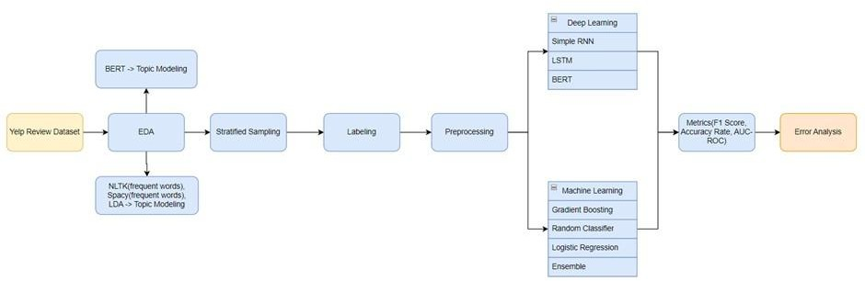
Fig. 1. Methodology Workflow (Placeholder)

Dataset Preparation
The dataset used in this study consists of Yelp restaurant reviews stored in CSV for- mat. The primary dataset used for model training and evaluation is named fi- nal_df_3040_labels.csv. Each instance contains the review text, a star rating, and six aspect-based sentiment labels:
    - Food Quality
    - Customer Service
    - Place (ambience and cleanliness)
    - Menu and Pricing
    - Drinks
    - Time (waiting time / service speed)
Each aspect is labelled using three classes: 1 for positive sentiment, 0 for neutral or not mentioned, and -1 for negative sentiment. Missing values present in the aspect tags were replaced with neutral values (0) to maintain consistency during the training phase and to prevent data loss.

Exploratory Analysis and Topic Modeling
Topic modeling was done to identify the concealed thematic structures in the dataset. Bertopic applied on a randomized sample of 10,000 clean-up reviews. This step helped discover the presence of typical themes in terms of food quality, service, ambience, menu variety, and wait times.
    - The BERTopic generated model.
    - The topical frequency distribution. 3) Topical hierarchical relations.
- A priority list of prevailing topics.

These are the outputs that were useful in getting a clue to the semantic structure of the review dataset.
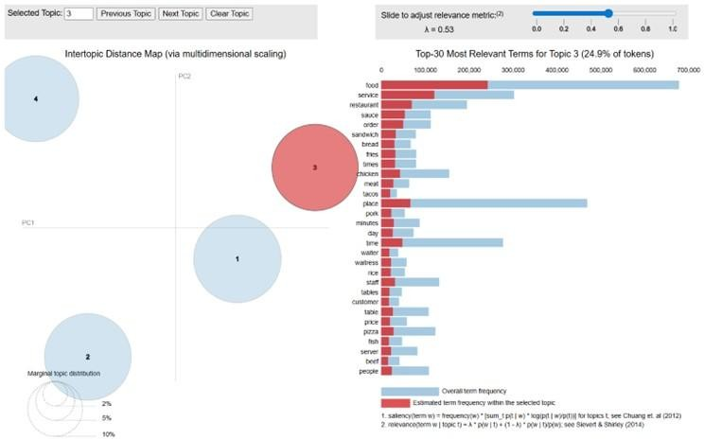

Fig. 2. BERTopic Visualization of Topics (Placeholder)

Review Length Filtering and Sampling
In order to eliminate noisy extremes, the reviews were filtered in terms of their word count percentiles. Only Length reviews of the 10th to 90th percentile were retained. This ensured that review that are too short (uninformative) and too long (outliers) were eliminated. Out of this filtered sample, 3,000 reviews were identified to be further la- belled, trained and label testing purposes.

Linguistic Pre-process and Word Cloud
The natural language processing methods were used to extract data in every review meaningful components. The steps that were used are as follows:
    - Tokenization
    - Removal of stopwords
    - Noun-based retention in order to get object-based meaning.
    - Translation to a purified form of text.
A Word Cloud was created based on dominant terms of the cleaned reviews occur- ring in restaurant-related debates.

Topic Modeling using LDA
The text that was preprocessed was subjected to Latent Dirichlet Allocation (LDA) to investigate further obscured thematic frameworks to the reviews. There were four generated topics and visualized interactive LDA visualization-tool. This move helped in ensuring consistency with the BERTopic results.

GPT-based Automated Label Generation
The aspect-level sentiment labels were generated in an automatic way using a GPT- based method from review text. The model was taken through a structured prompt each review sentiment value (-1, 0 or 1) of the six aspects that are defined. The result was stored/ saved as a new data-set and it was compared with manually labeled data. The merge was done based on unique review identifier. aspect-wise accuracy was computed in order to measure the labeling consistency of GPT. This move enabled the semi-au- tomation of the labelling process and decreased the reliance on high levels of manual annotation.

Deep Learning Models
Multi-class classification of each aspect was done using several deep learning mod- els.
    - Simple Recurrent Neural Network (RNN): Each aspect was trained using a Simple RNN model. Text data was tokenized and padded to make fixed input lengths. Over- sampling was done to manage class imbalance. The design was comprised of: Embed- ding layer, Simple Recurrent layer, Dropout, and Softmax output layer.

In a Simple RNN, the hidden state at time step 𝑡 is computed as:

ℎ_{𝑡} = tanh (𝑊_{ℎ}ℎ_{𝑡−1} + 𝑊_{𝑥}𝑥_{𝑡} + 𝑏)
where xtis the input embedding at time step t, htis the hidden state, and Wh, Wxare learnable weight matrices.
The final prediction is obtained using the Softmax function:

𝑦̂ = Softmax(𝑊_{𝑜}ℎ_{𝑡} + 𝑏_{𝑜})
This model represented the short-term dependency in the text.
    - Long Short-Term Memory (LSTM): An enhanced LSTM model was applied to address the long-term contextual reliance in the review text. It followed the structure: Embedding layer, LSTM layer, and fully connected output layer. This enabled the model to have a more insight into intricate sentiment patterns over sentences.

Word Embedding Techniques
Two embedding strategies were investigated:
    - Word2Vec Embeddings: The Yelp review corpus was directly trained on with a Word2Vec model to produce 100 dimensional feature vectors of words. These embed- dings were incorporated in an LSTM based classifier in order to boost semantic com- prehension.
    - GloVe Embeddings: GloVe embeddings 100dimensional pre-trained embeddings were added to a neural network. An embedding matrix was constructed, and the weight parameters were not trainable. This was used to add general semantic knowledge into the Yelp sentiment classification process.

Transformer-Based Classification (BERT)
The six aspects were trained independently as a BERT-based model. The review text was transmogalated with a pre-trained BERT tokenizer and input to a BERT sequence classification model.
BERT is based on the Transformer architecture, where contextual representations are learned using the self-attention mechanism defined as:
𝑄𝐾^{𝑇}
𝐴𝑡𝑡𝑒𝑛𝑡𝑖𝑜𝑛(𝑄, 𝐾, 𝑉) = Softmax ( ) 𝑉
√𝑑_{𝑘}
where 𝑄, 𝐾, and 𝑉represent query, key, and value matrices, and 𝑑𝑘 is the scaling factor. This mechanism enables the model to capture long-range contextual dependencies across the entire sequence.
All the aspects labels were coded in numbers and trained using:
    - An 80:20 train–test split
    - Batch size of 4
    - 5 epochs
    - AdamW optimizer
BERT had the ability to get contextual word meaning and sentence-wide information more performs more effectively than the traditional neural networks. The results of both aspects were stored in the form of structured evaluation.

Expectation Maximization (EM) Algorithms
Three generic machine learning classifiers were applied to TF-IDF features:
The textual data was first transformed into numerical representations using the Term Frequency–Inverse Document Frequency (TF-IDF) scheme. For a term 𝑡in document
𝑑, TF-IDF is defined as:

𝑇𝐹(𝑡, 𝑑) =
𝑓𝑡,𝑑

∑ 𝑓𝑘,𝑑
𝑘
𝑁

𝐼𝐷𝐹(𝑡) = log
𝑑𝑓𝑡
𝑇𝐹𝐼𝐷𝐹(𝑡, 𝑑) = 𝑇𝐹(𝑡, 𝑑) × 𝐼𝐷𝐹(𝑡)

where 𝑓𝑡,𝑑 represents the frequency of term 𝑡in document 𝑑, 𝑑𝑓𝑡is the number of doc- uments containing term 𝑡, and 𝑁is the total number of documents.
Using these feature vectors, the following classifiers were trained:
    - Random Forest
    - Multinomial Naıve Bayes
    - Logistic Regression
For Logistic Regression, the probability of class 𝑘 is computed using the Softmax function:

𝑃(𝑦 = 𝑘 ∣ 𝑥) =
𝑒𝑤𝑇𝑥
𝐾 𝑤𝑇𝑥
𝑘

∑ 𝑒 𝑗
𝑗=1
where 𝑥 represents the TF-IDF feature vector and 𝑤𝑘 denotes the weight parameters for class 𝑘.

Before the training of the models, class imbalance was overcome by applying over- sampling. Each classifier was trained and tested separately on all six aspects.

Ensemble Learning
An ensemble model was also constructed with majority voting in order to enhance performance approach. The ensemble consisted of: Multinomial Na¨ıve Bayes, Ran- dom Forest, Gradient Boosting, Logistic Regression, Support Vector Machine, and Decision Tree. Two variations were used:
    - Count-based incidence matrix: This is an incidence matrix in which the value of row and columns are based on the number of times a county of origin was ob- served, and the number of countries of interest.
    - TF-IDF feature representation.
Predictions were combined by use of soft voting which provided better stability among classes.

Baseline Statistical Model
The implementation was done with a baseline Random Classifier. Instead of using text, this model generated prediction that is being based on the distribution of sentiment classes in the training data. As anticipated, this approach resulted in low and unstable accurateness, which demonstrated that linguistic Decent sentiment classification relies on features.

Error Analysis
By breakdown of error analysis was done to gain insight on model weaknesses. This included:
    - Visualization of confusion matrices of every aspect.
    - Recognition of the commonly misclassified cases.
    - False positives and false negative comparison.
    - Before and after analysis of distribution of classes before and after oversampling.
    - The analysis of feature importance with the help of Random Forest and Logistic Regression.
    - Manual inspection of a random sample of misclassified reviews was made to find out ambiguous language, ambivalent sentiment and complexity of context.

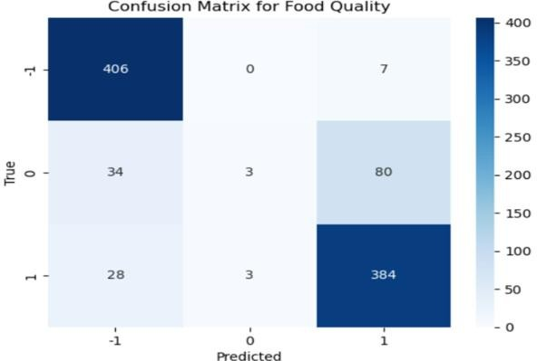
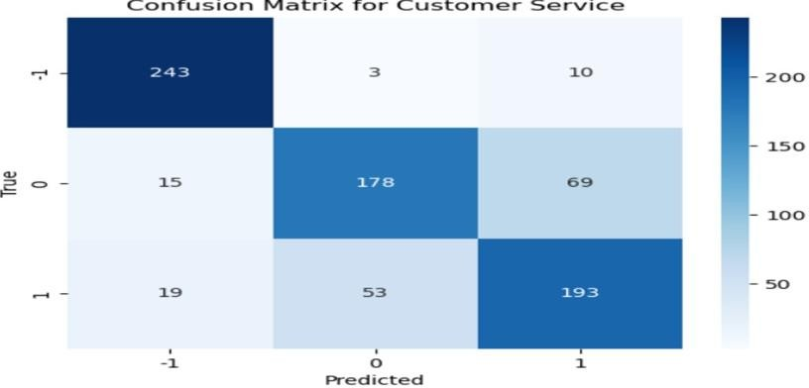
Fig. 3. Sample Confusion Matrix (Aspect-wise) (Food Quality)
Fig. 4. Sample Confusion Matrix (Aspect-wise) (Customer Service)

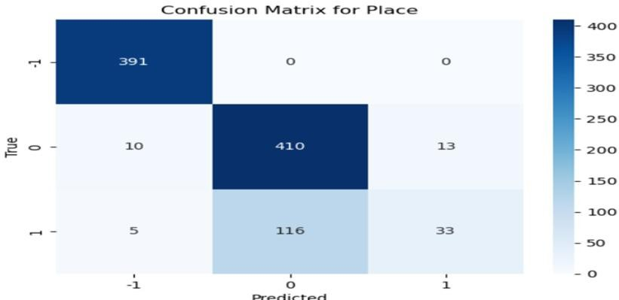
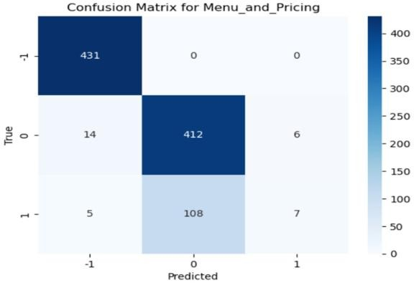
Fig. 5. Sample Confusion Matrix (Aspect-wise) (Place)
Fig. 6. Sample Confusion Matrix (Aspect-wise) (Menu and Pricing)
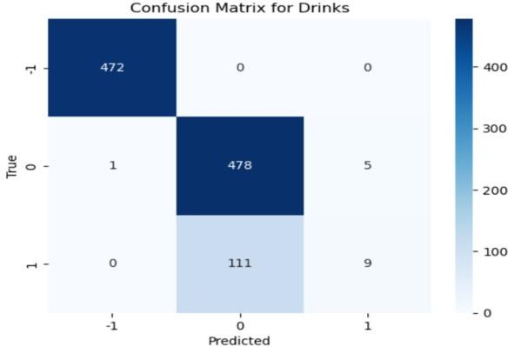
Fig. 7. Sample Confusion Matrix (Aspect-wise) (Drinks)

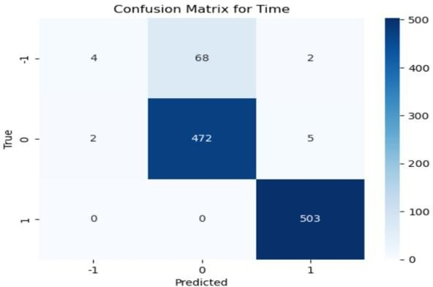
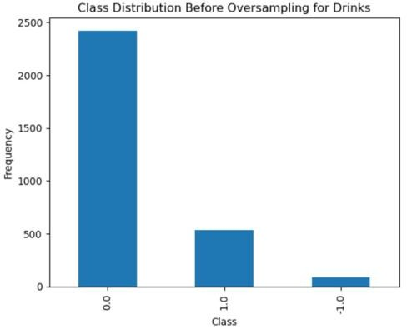
Fig. 8. Sample Confusion Matrix (Aspect-wise) (Time)
Fig. 9. Class Distribution Before and After Oversampling (Before)
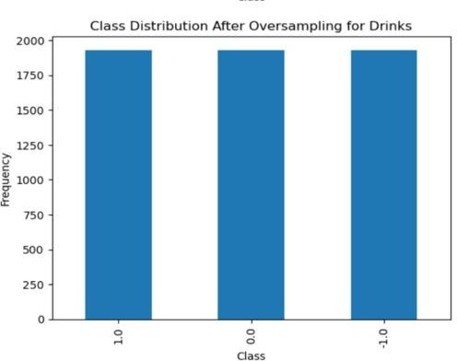
Fig. 10. Class Distribution Before and After Oversampling (After)

Performance Visualization
This looks at how the network functions and what metrics are involved. Bar graphs that were used to visualize performance metrics that showed: Precision per aspect, Re- call per aspect, and F1-score per aspect. These plots were clear indications of differ- ences in performance of the sentiment classes (-1, 0, 1) of each aspect.
To summarize the overall methodology described in the previous subsections, the com- plete multi-aspect sentiment classification workflow is formalized in Algorithm 1.
- Input: Yelp Review Dataset D Output: Aspect-wise Sentiment Predictions
- Load dataset D
- Clean text (tokenization, stop word removal)
- Perform review length filtering (10th–90th percentile)
- Generate TF-IDF features
- Apply GPT-based aspect labelling
- Handle class imbalance using Random Oversampling
- For each aspect Ai in {Food, Service, Place, Menu, Drinks, Time}:
  - Split data into Train/Test (80:20)
  - Train ML models (RF, NB, LR)
  - Train Deep Models (RNN, LSTM)
  - Fine-tune BERT model
  - Evaluate using Accuracy, Precision, Recall, F1-Score
- Return best performing model per aspect
Algorithm 1

RESULTS AND DISCUSSION
This part demonstrates the experimental outcomes of the implementation of multiple aspect-based sentiment classification models of Yelp restaurant reviews. The adapta- tion of transformer error performance of traditional machine learning models, deep learning models, approaches based, and ensemble based techniques are both assessed and compared. The analysis clearly demonstrates the effectiveness of advanced models in capturing sentiment-specific patterns across multiple aspects.

Random Classifier Baseline Performance
Prior to using the machine learning methods, a Random Classifier was developed as a reference point on which performance is compared. This approach produced predic- tions that were generated with the sole reliance on the distribution of sentiment of the training data without textual information of reviews. The precision of the Random

Classifier at aspects was different and was not zero inconsistent. In other cases, the precision was close to 70% whereas in other cases it was close to 100 dropped to nearly 35%. This discrepancy here attests to the fact that, only statistical distribution is inade- quate to sentiment prediction. Observation: Random Classifier does not learn context, semantics and sentiment polarity, which confirms the need to use machine and deep learning techniques.
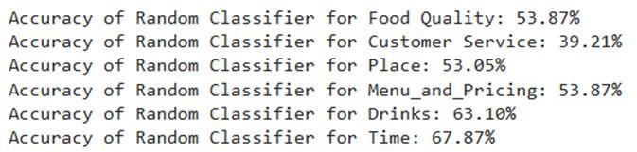
Fig. 11. Random Classifier Accuracy Comparison Across Aspects (Placeholder)

Traditional Machine Learning Models Performance
Three trained machine learning models (TF-IDF representation) were done: Random Forest Classifier, Multinomial Naive Bayes, and Logistic Regression. All the models were trained, and the data was balanced with Random Oversampling to overcome class imbalance. Among the three:
    - Random Forest had a better performance in the ability to capture non-linear pat- terns.
    - Logistic Regression that was continuously applied on mid-frequency features.
    - Naive Bayes was good with sparse text vectors but in context was poor.
There was variation in the performance in terms of aspect, which means that various aspects have varying levels of linguistic complexity.
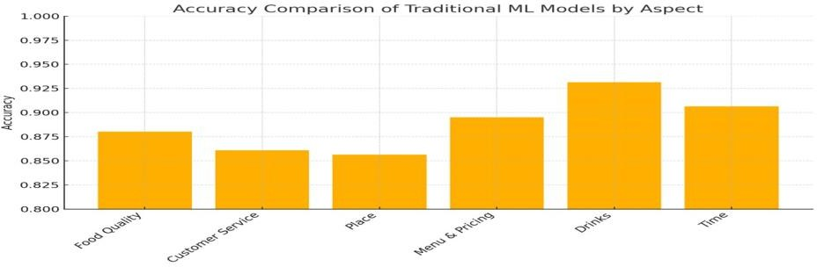
Fig. 12. Comparison of Traditional ML Models (Accuracy by Aspect)

Deep Learning Model (Simple RNN and LSTM) Comparative Performance
Each of the six was individually trained both on Simple RNN and LSTM models aspects. Key observations:

    - LSTM always performed better than Simple RNN because it had the capacity of storing long-term contextual dependencies.
    - Both models were good on majority classes (neutral and positive) and bad when negative samples are minority, and in highly imbalanced characteristics such as Drinks.
    - Simple RNN and LSTM were greatly enhanced by oversampling not fully elimi- nate bias.

Such deep learning architecture had superior contextual information than conven- tional machine learning models.

Word Embedding Models: GloVe and Word2Vec
Semantic embeddings were incorporated and greatly enhanced performance:
    - Word2Vec + LSTM: Learned directly on the Yelp data. Contextual relationships between datasets, which are captured. Better classification consistency of Place, Food Quality and Menu and Pricing.
    - GloVe + LSTM: Pre-trained 100-dimensional word vectors. Shown better gener- alization ability. Was very precise in detecting neutral sentiment across aspects. None- theless, Word2Vec had a bit more contextual relevance as it was trained directly on the corpus.
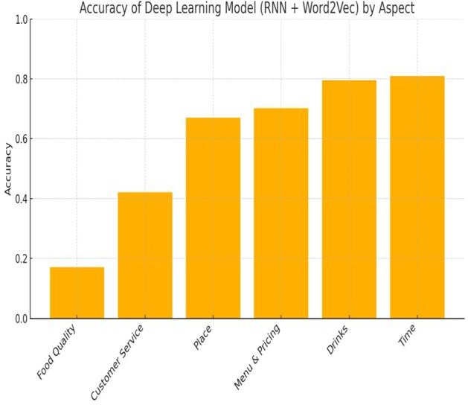

Fig. 13. Embedding-based Model Performance Comparison (Placeholder)

BERT-Based Transformer Model
BERT provided the best and the most consistent performance. Separate BERT clas- sifiers have been fine-tuned on each aspect. The obtained accuracies of the different aspects using BERT were:

TABLE I. BERT ACCURACY PER ASPECT
Aspect | BERT Accuracy
Food Quality | 75.69
Customer Service | 72.25
Place | 71.10
Menu & Pricing | 72.09
Drinks | 80.62
Time | 79.31
Key Observations:
    - Drinks (80.62) and Time (79.31) had the highest accuracy.
    - Good results in all three classes of sentiments (-1, 0, 1).
    - BERT was able to deal with contextual nuances, e.g., sarcasm, ambivalent opin- ions.
    - Positively minimal misclassification in comparison with all other models.

Accuracy, Recall and F1-score Analysis
Detailed results (by class) that have been produced by your BERT output demon- strate:
    - Food Quality: Positive class got F1-score ≈ 0.87. Negative class was a little af- fected as it was not supported.
    - Customer Service: Equality in performance in all three classes. Macro-average F1-score ≈ 0.70.
    - Drinks and Time: Highest weighted averages > 0.80. Showing high class segre- gation.
These findings suggest that BERT can capture finer sentiment variation, despite the variation in class distribution is skewed.

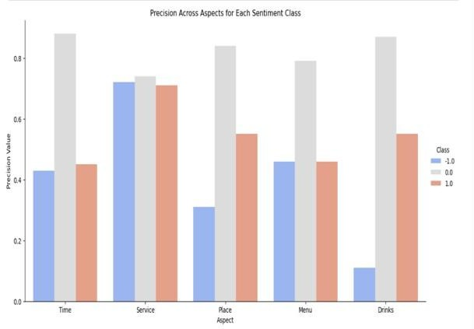
Fig. 14. Precision comparison on aspects
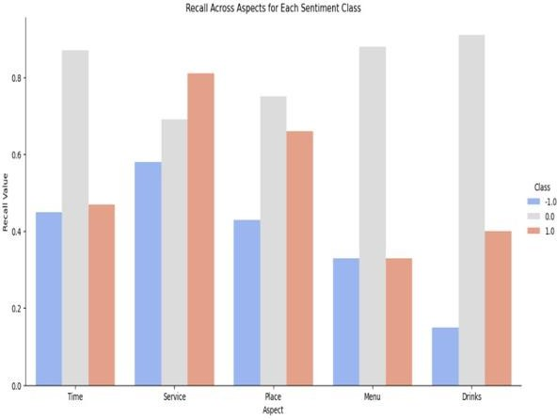
Fig. 15. Comparison of recall across aspects
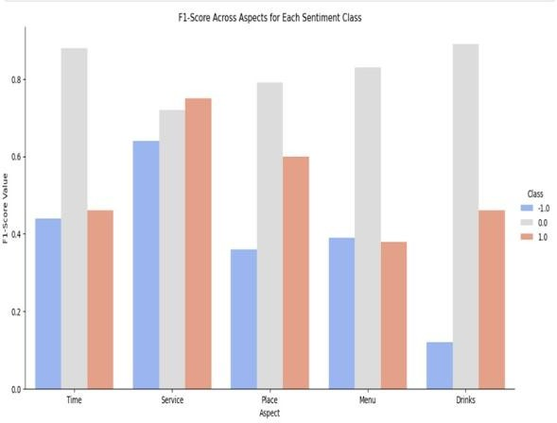
Fig. 16. Comparison of F1-score across aspects

Group Model Performance
The ensemble model was a combination of the output of: Random Forest, Multino- mial Na¨ıve Bayes, Gradient Boosting, Logistic Regression, SVM, and Decision Tree. Two variants were used:
    - Incidence Matrix (Binary Count Vector): This is a binary count vector which shows the number of times an occurrence of a particular incidence took place at a particular position in a raw data set.
    - TF–IDF Vector.
The ensemble was always better than single ML models, particularly in: Food Qual- ity, Place, and Menu and Pricing. Nevertheless, it was also slightly inferior to BERT, underlining the excellence of transformer-based contextual understanding architec- tures.
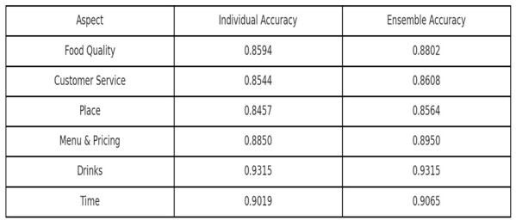

Fig. 17. Ensemble vs Individual Model Accuracy

TABLE II. ENSEMBLE VS INDIVIDUAL ACCURACY
Aspect | Individual Accuracy | Ensemble Accuracy
Food Quality | 0.8594 | 0.8802
Customer Service | 0.8544 | 0.8608
Place | 0.8457 | 0.8564
Menu & Pricing | 0.8850 | 0.8950
Drinks | 0.9315 | 0.9315
Time | 0.9019 | 0.9065

Error and Misclassification Study
Analysis of errors showed the following major lessons:
    - Neutral vs negative boundaries had most misclassifications.
    - RNN based models often got confused by the short reviews because of the con- text.
    - Ambiguity was created by reviews having mixed polarity words (good food but poor service).

    - The issue of imbalance between classes had a strong effect on the negative senti- ment prediction.
The confusion matrices showed that the models did have the most trouble in cases when the minority class samples were less than 100 very low (e.g., negative attitude towards Drinks).

Final Discussion
The findings of this research verify that:
    - The contextual embedding models are better than the statistical and shallow learn- ing models.
    - Multi-model assistance is needed in aspect-level sentiment classification.
    - Minority classes are enhanced by oversampling.
    - Transformers are the best in the case of natural language understanding.
TABLE III MODEL PERFORMANCE COMPARISON
Model Type | Strength | Weakness
Random Classi- fier | Fast baseline | No understanding
Traditional ML | Interpretable | Poor context handling
RNN | Basic sequence un- derstanding | Vanishing gradient
LSTM | Strong memory | Slower training
Word2Vec+LSTM | Domain context | Limited vocabulary
GloVe+LSTM | Better semantics | Less domain specific
Ensemble | Improved stability | Complex architecture
BERT (Best) | Context-aware, best accuracy | Computation inten- sive
This is a multi-model approach that is a better framework of real-life restaurant re- view analysis on internet review sites.

CONCLUSION AND FUTURE SCOPE
The present work has provided an extensive overview of a comparative study on the ABSA of Yelp restaurant reviews, and has tested various modelling paradigms, namely machine learning, deep learning, ensembles and transformer models, on six aspects: Food Quality, Customer Service, Place, Menu and Pricing, Drinks, and Time.
Initial experiments with a Random Classifier showed the limitation of simple statis- tical methods, which produced very variable and generally poor results. Then, the su- pervised learning models (Random Forest, Naive Bayes and Logistic Regression) im- proved moderately the results of previous experiments but failed to represent the se- mantics and the context of the customers’ comments. Deep learning models (LSTM), particularly those based on long term dependencies (e.g., LSTM), outperformed the other models by better representing the semantics and context of the comments.

Finally, Word2Vec and GloVe embeddings have shown a significant improvement of the results, confirming the relevance of the semantic representation of words in sen- timent classification tasks. The BERT model achieved the best and most stable results on all six aspects, showing its ability to understand complex linguistic structures, to establish relationships between elements in the sentences and to treat mixed sentiment comments. The average performance per aspect was around 76%, and the maximum performance obtained for Drinks and Time was respectively 80.62% and 79.31%. Thus, these results confirmed that the use of transformer architectures is the most efficient method to perform finegrained sentiment classification.
To sum up, the present work confirmed that the use of deep learning models able to take into account the context (especially BERT) is the most suitable method to classify the sentiments expressed in Yelp restaurant reviews. Moreover, the use of the tech- niques of visualisation and the analysis of errors allowed to reinforce the interpretability and the reliability of the results.
Even if the current framework offers good results, there are still some ways to im- prove it:
- Multi-Aspect BERT Model: At the moment, a BERT model is trained for each aspect separately. However, a single multi-label BERT model could be developed in order to predict all the aspects at once.
- Larger and More Diverse Dataset: A larger and diverse data set, that includes hotels, product, services, etc., would be beneficial to both generalize and make models more robust.
- Multilingual Support: To further expand the use of the system, we can add mul- tilingual support to analyze reviews from different language to increase the prac- tical applications of the system.
- Aspect Extraction Automation: In our current model, the aspects were manually defined; future work could include auto-matic aspect extraction through the use of named entity recognition (NER) or unsupervised topic modeling.
- Real Time Deployment: We can deploy the model into a web or mobile applica- tion for real time sentiment analysis for the restaurants and customers.
- Explainable AI (XAI): Adding the ability for the users to understand how the model is making decisions by adding the ability for SHAP or LIME interpreta- bility will allow us to build more trust with the users.

ACKNOWLEDGEMENT
The authors would like to take the opportunity to thank their academic institutions, faculty mentors and advisors for their continued support and guidance throughout the duration of this study. We would also like to thank the open source communities and platforms that supported this study including but not limited to Yelp Open Dataset, Google Colab, PyTorch, Scikit-learn and Hugging Face Trans-formers for allowing us to implement the experiemental design of this study. We would also like to give special thanks to our peer groups and contributors that gave us constructive feedback and mo- tivation during the development of this study.

REFERENCES
- M. Hu and B. Liu, “Mining and summarizing customer reviews,” Proc. 10th ACM SIGKDD Int. Conf. Knowledge Discovery and Data Mining, pp. 168–177, 2004.
- S. Kiritchenko, X. Zhu, and S. M. Mohammad, “Sentiment analysis of short informal texts,” Journal of Artificial Intelligence Research, vol. 50, pp. 723–762, 2014.
- C. Cardie, “Sentiment analysis and opinion mining,” Computational Linguistics, vol. 40, no. 2, pp. 511–513, 2014.
- W. Xue and T. Li, “Aspect-based sentiment analysis with gated convolutional networks,” arXiv:1805.07043, 2018.
- J. Devlin, M.-W. Chang, K. Lee, and K. Toutanova, “BERT: Pre-training of deep bidirectional transformers for language understanding,” arXiv:1810.04805, 2018.
- T. Mikolov, K. Chen, G. Corrado, and J. Dean, “Efficient estimation of word representations in vector space,” Proc. ICLR, 2013.
- J. Pennington, R. Socher, and C. Manning, “GloVe: Global vectors for word representation,” Proc. EMNLP, pp. 1532–1543, 2014.
- Y. Goldberg, “A primer on neural network models for natural language processing,” Journal of Artificial Intelligence Research, vol. 57, pp. 345–420, 2016.
- A. Severyn and A. Moschitti, “UNITN: Training deep convolutional neural network for Twitter sentiment classification,” Proc. SemEval, 2015.
- R. Socher et al., “Recursive deep models for semantic compositionality over a sentiment treebank,” Proc. EMNLP, pp. 1631–1642, 2013.
- F. Pedregosa et al., “Scikit-learn: Machine learning in Python,” Journal of Machine Learning Research, vol. 12, pp. 2825–2830, 2011.
- F. Chollet, *Deep Learning with Python*, Manning Publications, 2017.
- Z. Zhang, Q. Ye, Z. Zhang, and Y. Li, “Sentiment classification of internet restaurant reviews written in Cantonese,” Expert Systems with Applications, vol. 38, no. 6, pp. 7674–7682, 2011.
- B. Pang, L. Lee, and S. Vaithyanathan, “Thumbs up? Sentiment classification using machine learning techniques,” Proc. EMNLP, pp. 79–86, 2002.
- Yelp Dataset, “Yelp Open Dataset,” [Online]. Available: https://www.yelp.com/dataset
- X. Zhang and Y. LeCun, “Text understanding from scratch,” arXiv:1502.01710, 2015.
- A. Vaswani et al., “Attention is all you need,” Proc. NeurIPS, 2017.
- R. Feldman, “Techniques and applications for sentiment analysis,” Communications of the ACM, vol. 56, no. 4, pp. 82–89, 2013.
- X. Li, L. Bing, W. Zhang, and W. Lam, “Exploiting BERT for end-to-end aspect-based sentiment analysis,” arXiv:1910.00883, 2019.
- H. Xu, B. Liu, L. Shu, and P. Yu, “BERT post-training for review reading comprehension and aspect-based sentiment analysis,” arXiv:1904.02232, 2019.
- S. Chi, L. Huang, and X. Qiu, “Utilizing BERT for aspect-based sentiment analysis via constructing auxiliary sentence,” arXiv:1903.09588, 2019.
- L. Xiao et al., “Targeted sentiment classification based on attentional encoding and graph convolutional networks,” Applied Sciences, vol. 10, no. 3, p. 957, 2020.
- D. Tang, B. Qin, and T. Liu, “Aspect level sentiment classification with deep memory network,” Proc. EMNLP, pp. 214–224, 2016.
- H. Xu et al., “Double embeddings and CNN-based sequence labeling for aspect extraction,” arXiv:1805.04601, 2018.
- K. Wang et al., “Relational graph attention network for aspect-based sentiment analysis,” Proc. ACL, pp. 3229–3238, 2020.
- S. Gu et al., “A position-aware bidirectional attention network for aspect-level sentiment analysis,” Proc. COLING, pp. 774–784, 2018.
- C. Zhang et al., “A multi-task learning framework for opinion triplet extraction,” Proc. EMNLP Findings, pp. 819–828, 2020.
- S. Ruder, “An overview of multi-task learning in deep neural networks,” arXiv:1706.05098, 2017.
- T. Schick and H. Schütze, “Exploiting cloze-questions for few-shot text classification,” Proc. EACL, pp. 255–269, 2021.
- X. Liu, P. He, W. Chen, and J. Gao, “Multi-task deep neural networks for natural language understanding,” Proc. ACL, pp. 4487–4496, 2019.
- Y. Zhang and Q. Yang, “A survey on multi-task learning,” IEEE Transactions on Knowledge and Data Engineering, vol. 34, no. 12, pp. 5586–5609, 2022.
- T. Brown et al., “Language models are few-shot learners,” Proc. NeurIPS, 2020.

