Macroeconomic Indicators as Business Intelligence Tools for Forecasting Moroccan Stock Market Returns: Evidence from Time-Series Analysis
Karim Salim

Abstract: This study examines the impact of key macroeconomic indicators namely oil prices and exchange rate on stock market returns in Morocco. Using monthly data over the period 2002–2022, the analysis applies both Ordinary Least Squares (OLS) and Autoregressive Distributed Lag (ARDL) models to investigate the short-run and long-run relationships between these variables and MASI returns.
The empirical results indicate that oil prices and exchange rate exert a statistically significant and negative effect on stock market returns in the OLS framework. However, the ARDL model provides deeper insights by capturing dynamic relationships. The findings reveal that oil prices have a delayed negative impact on stock returns, while the exchange rate exhibits a significant and immediate negative effect.
The ARDL bounds test confirms the existence of a long-run equilibrium relationship among the variables, suggesting that stock returns, oil prices, and exchange rate move together over time. Furthermore, the Error Correction Model (ECM) results indicate a strong adjustment mechanism, with deviations from long-run equilibrium corrected rapidly.
Overall, the study highlights the importance of macroeconomic indicators as useful tools for understanding and forecasting stock market performance in Morocco. The findings provide valuable implications for policymakers and investors in managing market risks and improving decision-making.
Keywords: Macroeconomic indicators; Stock market returns; MASI; Oil prices; Exchange rate; Morocco.

CHAPTER ONE: INTRODUCTION
INTRODUCTION
Financial markets play a central role in modern economies, particularly in facilitating investment and reflecting economic conditions. In emerging markets such as Morocco, stock market performance is not only driven by firm-level factors but is also closely linked to broader macroeconomic developments. As a result, understanding how key economic indicators influence stock returns has become an important issue for both researchers and practitioners.
Among the various macroeconomic variables, oil prices, exchange rates, and money supply are frequently identified as major determinants of financial market behavior. Changes in oil prices can affect production costs and overall economic activity, especially in countries that are sensitive to energy price fluctuations. Similarly, exchange rate movements influence international trade, capital flows, and investor confidence. Monetary aggregates, such as money supply, reflect the stance of monetary policy and can impact liquidity conditions within financial markets.
In the context of Morocco, the stock market—represented by the Moroccan All Shares Index (MASI)—has experienced periods of volatility influenced by both global shocks and domestic economic changes. However, empirical evidence on the relationship between macroeconomic indicators and Moroccan stock market returns remains relatively limited. This gap highlights the need for further analysis, particularly using recent data and quantitative methods.
This study investigates whether selected macroeconomic indicators can be used as tools for forecasting stock market returns in Morocco. Specifically, it examines the impact of oil prices, exchange rates, and money supply on MASI returns using monthly data from 2002 to 2022. An Ordinary Least Squares (OLS) regression model is employed to evaluate these relationships and to assess their statistical significance.
The contribution of this research is twofold. First, it provides empirical evidence on how macroeconomic variables affect stock market performance in a Moroccan context. Second, it demonstrates how such indicators can be incorporated into a business intelligence framework to support financial analysis and forecasting. The findings may be useful for investors, policymakers, and analysts interested in improving their understanding of market dynamics in emerging economies.
The remainder of the paper is organized as follows. Section 2 reviews the relevant literature. Section 3 describes the data and methodology. Section 4 presents the empirical results and discussion. Section 5 concludes.
The overall analytical framework of the study is summarized in Figure 1.

Analytical Framework of the Study

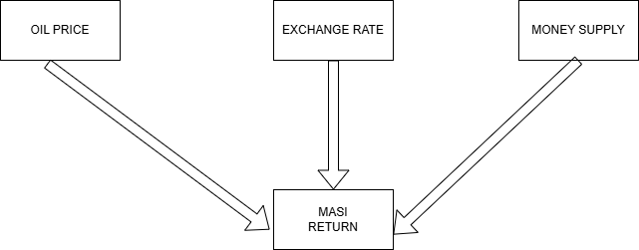

In addition, the study employs an ARDL bounds testing approach to assess the existence of a long-run equilibrium relationship between macroeconomic variables and stock market returns.

CHAPTER TWO: LITERATURE REVIEW

2.1 Literature Review

The relationship between macroeconomic variables and stock market performance has been widely examined in financial economics. A large body of empirical literature suggests that stock returns are influenced by both domestic and global economic conditions, particularly in emerging markets where financial systems are more sensitive to external shocks.
One of the most commonly studied variables is oil price. Hamilton (2009) argues that oil price fluctuations have significant effects on economic activity and financial markets, especially through their impact on production costs and inflation. Several empirical studies have found that increases in oil prices tend to negatively affect stock market returns, particularly in oil-importing countries (Basher & Sadorsky, 2006). This relationship is often attributed to higher costs for firms and reduced consumer purchasing power.
Exchange rates also play a crucial role in shaping stock market behavior. According to the flow-oriented model proposed by Dornbusch and Fischer (1980), exchange rate movements influence international competitiveness and corporate earnings, thereby affecting stock prices. Empirical evidence on this relationship is mixed. While some studies report a negative relationship between exchange rate appreciation and stock returns, others find that the effect depends on the structure of the economy and the level of market openness (Adjasi et al., 2011).
Monetary variables, particularly money supply, are another important determinant of stock market performance. Theoretical frameworks suggest that an increase in money supply leads to greater liquidity in the economy, which can stimulate investment in financial assets. Fama (1981) highlights the link between monetary policy, inflation, and stock returns, suggesting that macroeconomic conditions play a key role in asset pricing. Empirical studies often find a positive relationship between money supply and stock market performance, although the strength of this relationship varies across countries.
In the context of emerging markets, several studies have emphasized the importance of macroeconomic indicators as tools for financial forecasting. For example, Chen, Roll, and Ross (1986) demonstrate that macroeconomic variables contain significant information about future stock returns. Similarly, Mukherjee and Naka (1995) show that economic factors such as inflation, exchange rates, and money supply have long-run relationships with stock prices.
Despite the extensive international literature, research focusing on the Moroccan stock market remains relatively limited. Some studies have explored the impact of macroeconomic variables on Moroccan financial markets, but often with restricted datasets or limited variables. This creates a gap in the literature, particularly regarding the combined effect of oil prices, exchange rates, and money supply on stock returns.
This study contributes to the existing literature by providing an updated empirical analysis of the Moroccan stock market using monthly data over the period 2002–2022. By integrating multiple macroeconomic indicators within a single regression framework, the study offers a more comprehensive understanding of the factors influencing MASI returns. Furthermore, it highlights the relevance of macroeconomic data as a business intelligence tool for improving financial forecasting in emerging markets However, few studies apply the ARDL bounds testing framework in the context of the Moroccan stock market, particularly using recent data.

CHAPTER THREE: METHODOLOGY

3.1 Methodological Approach and Research Design
This study adopts a quantitative research design to examine the relationship between selected macroeconomic indicators and stock market returns in Morocco. A quantitative approach is appropriate because the study relies on numerical data and econometric analysis to identify and measure the effect of macroeconomic variables on financial market performance.More specifically, the study is based on a time-series analytical framework, using monthly observations over the period from April 2002 to December 2022. This design makes it possible to observe how changes in macroeconomic conditions are associated with changes in Moroccan stock market returns over time.The study focuses on the Moroccan All Shares Index (MASI) as an indicator of stock market performance. In order to explain the movements of stock returns, the analysis includes three macroeconomic variables: oil prices, exchange rate, and money supply. These variables were selected because they reflect important dimensions of the economic environment, including external shocks, currency conditions, and domestic liquidity. The empirical analysis is conducted using the Ordinary Least Squares (OLS) method. This method is suitable for estimating the direction, magnitude, and statistical significance of the relationship between the dependent variable and the explanatory variables. Through this approach, the study seeks to determine whether macroeconomic indicators can serve as useful business intelligence tools for explaining Moroccan stock market returns.

3.2 Study Area and Sample Coverage
This study focuses on the Moroccan financial market, with particular emphasis on the Casablanca Stock Exchange, which represents the primary stock market in Morocco. The Moroccan All Shares Index (MASI) is used as a proxy for overall stock market performance, as it reflects the price movements of all listed companies on the exchange and is widely regarded as a benchmark indicator of market activity.
Morocco provides an interesting context for empirical analysis due to its status as an emerging market economy, characterized by increasing financial development, exposure to external economic shocks, and ongoing monetary and structural reforms. These features make it relevant to investigate how macroeconomic factors influence stock market returns within this environment.
The study employs monthly data covering the period from April 2002 to December 2022, resulting in a total of 249 observations after data alignment and cleaning. The choice of monthly frequency allows for a balance between capturing short-term fluctuations and maintaining data availability across all variables.
The selected time frame is motivated by data availability and the need to cover multiple economic phases, including periods of growth, global financial disturbances, and structural adjustments. This enhances the robustness of the analysis and allows for a more comprehensive assessment of the relationship between macroeconomic indicators and stock market performance.
Variable | Description | Frequency
MASI_Return | Moroccan stock returns | Monthly
Oil_Price | Brent crude oil price | Monthly
Exchange_Rate | MAD/USD exchange rate | Monthly
log(M2) | Log of money supply (excluded after stationarity test) | Monthly

Table 1: Summary of Variables and Data Sources

Data Description and sources
This study employs a set of monthly time-series data covering the period from April 2002 to December 2022. The dataset consists of one dependent variable, representing stock market performance, and three independent macroeconomic variables selected based on their theoretical and empirical relevance in the literature.
The dependent variable is the Moroccan All Shares Index (MASI) return, which serves as a proxy for stock market performance in Morocco. The MASI is a broad-based index that captures the price movements of all listed companies on the Casablanca Stock Exchange. Monthly stock returns are computed using logarithmic differences of index values, a transformation widely used in financial econometrics to ensure stationarity and improve statistical properties.
The first independent variable is oil price, measured using Brent crude oil prices. Oil prices are included in the analysis as a proxy for external economic shocks and global market conditions. Given Morocco’s dependence on energy imports, fluctuations in oil prices may influence production costs, inflationary pressures, and overall economic activity, thereby affecting stock market performance.
The second explanatory variable is the exchange rate, defined as the value of the Moroccan dirham against the US dollar. Exchange rate movements are particularly relevant in emerging economies, as they reflect external competitiveness, capital mobility, and macroeconomic stability. Variations in the exchange rate may affect corporate profitability, especially for firms engaged in international trade, and consequently influence stock returns.
The third independent variable is money supply (M2), which represents a broad measure of liquidity within the economy. Money supply is included to capture the role of monetary conditions in shaping financial market dynamics. To address issues related to scale and potential heteroskedasticity, the natural logarithm of money supply (log_M2) is used in the empirical analysis. This transformation allows for a more stable variance and facilitates interpretation in terms of relative changes.
The data used in this study are obtained from reliable and publicly accessible sources. Oil price data are sourced from international financial databases such as the Federal Reserve Economic Data (FRED). Exchange rate data are collected from financial platforms such as Investing.com. Money supply data are obtained from official monetary statistics or open-access macroeconomic datasets. The MASI index data are compiled from historical records of the Casablanca Stock Exchange and processed to compute returns.
All variables are converted into a consistent monthly frequency and aligned according to their observation dates. Prior to analysis, the data undergo standard preprocessing procedures, including date formatting, handling of missing values, and verification of consistency across series. The final dataset is constructed by merging all variables into a unified time-series framework suitable for econometric estimation.
Although money supply (M2) was initially included as a relevant macroeconomic variable, its final inclusion in the econometric model depends on the outcome of the stationarity tests.
Variable | Description | Source | Transformation
MASI_Return | Stock market return | Casablanca Stock Exchange | Log returns
Oil_Price | Brent oil price | FRED | Monthly average
Exchange_Rate | MAD/USD | Investing.com | Level
log(M2) | Money supply(excluded after stationarity test) | Central Bank / dataset | Log

Table 2: Description of Variables and Data Sources

3.4Variable transformation
To ensure the reliability and robustness of the empirical analysis, the variables used in this study are appropriately transformed in line with standard practices in financial econometrics. First, the dependent variable, stock market return, is computed using the logarithmic return formula, which is commonly employed due to its desirable statistical properties. Specifically, the return of the MASI index is calculated as: Data processing, variable construction (including interaction terms), and estimation are implemented in Python using standard libraries for data handling and econometric modeling.
MASI_Returnt = ln (Pt/pt_1​​)
where $P_{t}$and $P_{t-1}$represent the index values at time $t$and $t-1$, respectively. This transformation allows for the stabilization of variance and facilitates interpretation in terms of continuously compounded returns.

Second, the money supply variable (M2) is transformed using the natural logarithm:
log(M2_t)
The logarithmic transformation is applied to reduce scale differences, mitigate potential heteroskedasticity, and facilitate interpretation in proportional terms. However, subsequent stationarity tests reveal that the log-transformed money supply series is integrated of order two, I(2), as it becomes stationary only after second differencing. Since the ARDL framework requires variables to be integrated of order I(0) or I(1), the log(M2) variable is excluded from the final model specification. The oil price and exchange rate variables are used in their level form, as their magnitudes are already suitable for regression analysis and do not exhibit extreme scale variation. Additionally, using these variables in levels allows for a direct interpretation of their marginal effects on stock returns.

3.5 stationarity tests
Before estimating the econometric models, the stationarity properties of the variables are examined to avoid spurious regression results. In time-series analysis, non-stationary variables may lead to misleading statistical relationships if used directly in regression models.
To address this issue, the Augmented Dickey-Fuller (ADF) test is employed to determine whether each variable is stationary in levels or after differencing. The null hypothesis of the ADF test is that the series contains a unit root, indicating non-stationarity, while the alternative hypothesis suggests that the series is stationary.
The results of the ADF test indicate that MASI returns and oil prices are stationary in levels, implying that they are integrated of order I(0). In contrast, the exchange rate is non-stationary in level but becomes stationary after first differencing, indicating that it is integrated of order I(1).
The log-transformed money supply variable (log M2), however, is found to be non-stationary in both level and first difference, but becomes stationary only after second differencing. This indicates that it is integrated of order I(2).
Since the ARDL framework requires variables to be integrated of order I(0) or I(1), the money supply variable is excluded from the final model specification. The remaining variables satisfy the necessary conditions for the application of the ARDL approach.

3.6Model specification
To examine the relationship between macroeconomic indicators and Moroccan stock market returns, this study specifies a linear econometric model within a time-series framework. The model aims to quantify the effect of selected macroeconomic variables on the returns of the Moroccan All Shares Index (MASI). The empirical model is expressed as follows :
MASI_Returnt​=α+β1​Oil_Pricet​+β2​Exchange_Ratet​+εt​
​where:
- $0MASI_Return_{t}$represents the stock market return at time $t$
- $α$is the intercept term
- $Oil_Price_{t}$denotes the Brent crude oil price
- $Exchange_Rate_{t}$refers to the Moroccan dirham against the US dollar
- $β_{1},β_{2}$are the coefficients to be estimated
- $ε_{t}$is the error term capturing unobserved factors
The model assumes a linear relationship between the dependent variable and the explanatory variables. Each coefficient measures the marginal impact of the corresponding macroeconomic variable on stock market returns, holding other factors constant.
From a theoretical perspective:
Oil prices are expected to capture external economic shocks and may negatively affect stock returns due to increased production costs. Exchange rate fluctuations may influence competitiveness and investor confidence, potentially impacting market performance. The inclusion of these variables allows the model to capture key external macroeconomic influences on the Moroccan stock market.

3.7 Estimation technique
Before estimating the regression models, it is necessary to examine the stationarity properties of the variables to avoid spurious results. In time-series analysis, non-stationary variables may produce misleading relationships if they are used directly in regression without proper testing.
In this study, the Augmented Dickey-Fuller (ADF) unit root test is employed to determine whether each variable is stationary in level or becomes stationary after first differencing. The null hypothesis of the ADF test is that the series contains a unit root, meaning that it is non-stationary. Rejection of the null hypothesis implies that the variable is stationary.
The ADF test is applied to MASI returns, oil prices, exchange rate, and log of money supply. This step is important because the ARDL model can be applied when variables are integrated of order zero, I(0), or order one, I(1), but not order two, I(2). Therefore, confirming the order of integration of the variables is a necessary condition before proceeding with ARDL estimation.

3.8 ARDL bounds test for cointegration
To determine whether a long-run equilibrium relationship exists among the variables, the ARDL bounds testing approach is employed. This method tests the null hypothesis of no cointegration against the alternative hypothesis of a long-run relationship between the dependent and independent variables. The bounds test is based on the comparison between the computed F-statistic and a set of critical values that define lower and upper bounds. If the F-statistic exceeds the upper bound critical value, the null hypothesis of no cointegration is rejected, indicating the presence of a long-run relationship. If the F-statistic falls below the lower bound, the null hypothesis cannot be rejected, implying no cointegration. If the F-statistic lies between the two bounds, the result is considered inconclusive. This approach is particularly suitable in the context of this study because it can be applied to variables that are integrated of order I(0) and I(1), as confirmed by the stationarity tests, provided that none of the variables is integrated of order I(2).
Once cointegration is established, the Error Correction Model (ECM) is used to capture short-run dynamics and the speed at which deviations from long-run equilibrium are corrected over time.
market returns explained by the independent variables. The overall significance of the model is evaluated using the F-statistic, while individual coefficients are tested for statistical significance at conventional levels.To ensure the validity of the results, diagnostic measures are also considered. The Durbin–Watson statistic is used to detect the presence of autocorrelation in the residuals, while normality of residuals is assessed using the Jarque–Bera test. These diagnostic tests help evaluate whether the underlying assumptions of the OLS model are reasonably satisfied.All estimations are performed using the Python programming language, specifically utilizing statistical libraries designed for econometric analysis.
In addition to the Ordinary Least Squares (OLS) estimation, this study employs an Autoregressive Distributed Lag (ARDL) model to capture the dynamic relationship between macroeconomic variables and stock market returns. The ARDL approach is particularly suitable for time-series data with relatively small sample sizes and allows for the estimation of both contemporaneous and lagged effects of explanatory variables. By incorporating lag structures, the ARDL model provides deeper insight into the delayed impact of macroeconomic indicators on financial markets and enhances the robustness of the empirical analysis.

CHAPTER FOUR: RESULTS

4.1 stationarity test results
This section presents the results of the Augmented Dickey-Fuller (ADF) test used to determine the order of integration of the variables. The purpose of this test is to verify whether the series are stationary in level or after differencing, which is necessary to ensure the validity of time-series estimation techniques.
The ADF results indicate that MASI returns and oil prices are stationary in levels, implying that they are integrated of order I(0). The exchange rate is non-stationary in level but becomes stationary after first differencing, indicating that it is integrated of order I(1). In contrast, the log-transformed money supply variable becomes stationary only after second differencing, which suggests that it is integrated of order I(2).
Since the ARDL framework requires variables to be integrated of order I(0) or I(1), the money supply variable is excluded from the final model. The stationarity results therefore confirm the suitability of applying the ARDL approach to the remaining variables.

Variable | Level | 1st Diff | 2nd Diff | Order
MASI_Return | Stationary | — | — | I(0)
Oil_Price | Stationary | — | — | I(0)
Exchange_Rate | Non-stationary | Stationary | — | I(1)
log(M2) | Non-stationary | Non-stationary | Stationary | I(2)
Table3. Augmented Dickey-Fuller (ADF) Unit Root Test Results

4.2 Descriptive Analysis

The descriptive statistics reveal important characteristics of the variables. MASI returns exhibit a relatively low mean value with noticeable variability, indicating fluctuations in stock market performance over the sample period.
Oil prices show significant variation, reflecting global market dynamics and external shocks that may influence economic conditions. The exchange rate also displays variability, suggesting periods of currency appreciation and depreciation.
Overall, the variability observed in the explanatory variables highlights the presence of potential macroeconomic influences on stock market returns, justifying their inclusion in the econometric analysis.
Variable | Mean | Std. Dev. | Min | 25% | Median | 75% | Max
MASI Return | 0.0043 | 0.0437 | -0.2338 | -0.0204 | 0.0038 | 0.0281 | 0.1834
Oil Price | 69.686 | 27.9665 | 18.3785 | 48.2473 | 64.8065 | 92.1781 | 132.718
Exchange Rate | 9.0077 | 0.8035 | 7.2828 | 8.3945 | 8.9620 | 9.6292 | 11.4131

Table 4. Descriptive Statistics of Variables

Table 1 presents the descriptive statistics of the variables employed in this study. The results indicate that MASI returns exhibit a relatively low average value (mean = 0.0043), suggesting modest overall market performance during the sample period. However, the relatively high standard deviation (0.0437) reflects considerable volatility in stock returns. Moreover, the wide range between the minimum (-0.2338) and maximum (0.1834) values highlights the presence of extreme fluctuations, indicating periods of significant market instability.Oil prices, on the other hand, demonstrate substantial variability over the study period, with an average value of 69.69 and a broad range extending from 18.38 to 132.72. This considerable dispersion reflects the dynamic nature of global oil markets, which are often influenced by geopolitical events, supply shocks, and changes in global demand conditions.
The relatively higher standard deviation of oil prices compared to other variables suggests that external shocks may play a dominant role in influencing market conditions.

Figure 1 : MASI Returns
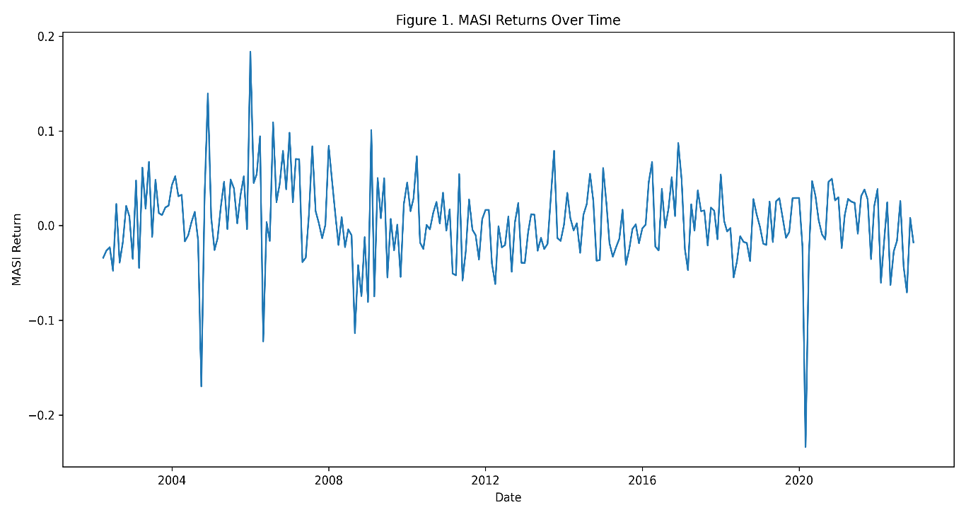

Figure 1 illustrates the evolution of MASI returns over the sample period. The series is characterized by significant fluctuations around a relatively low mean, reflecting the inherent volatility of the Moroccan stock market. Several sharp positive and negative spikes can be observed, indicating periods of market instability and sudden adjustments. Notably, extreme negative returns suggest the occurrence of adverse economic or financial shocks, while occasional positive peaks reflect short-lived periods of strong market performance. Overall, the pattern suggests that MASI returns are highly volatile and subject to frequent short-term variations.

Figure 2 : Oil Price
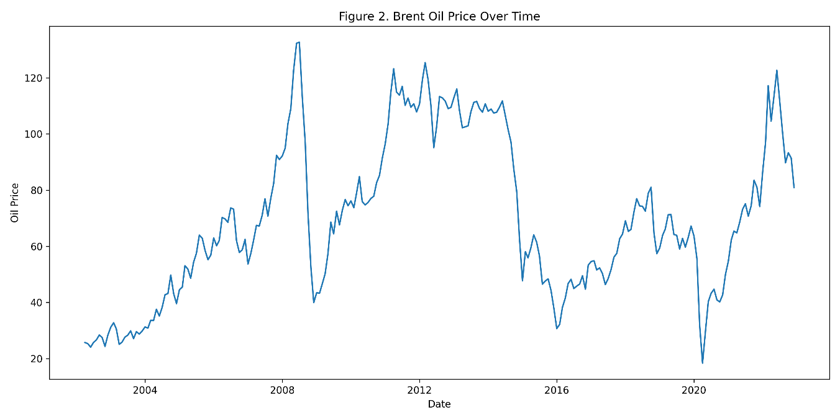

Figure 2 presents the dynamics of Brent oil prices over time. Unlike MASI returns, oil prices exhibit more pronounced long-term trends, with periods of sustained increases followed by sharp declines. The series reflects major global events, including periods of rising demand, supply disruptions, and economic downturns. In particular, the sharp drop observed around 2020 may be associated with global economic disruptions, while subsequent increases indicate recovery phases. These fluctuations highlight the sensitivity of oil prices to external macroeconomic and geopolitical factors.
Taken together, Figures 1 and 2 suggest that fluctuations in oil prices may coincide with periods of instability in stock market returns. While MASI returns display higher short-term volatility, oil prices exhibit broader cyclical movements, which could influence investor expectations and market performance. The observed patterns provide preliminary visual evidence supporting the potential relationship between global oil price dynamics and Moroccan stock market returns, thereby justifying the inclusion of oil prices as a key explanatory variable in the empirical model.

4.3 Correlation Analysis

This section presents the correlation matrix between the variables included in the model. The purpose of this analysis is to examine the degree of association between the variables and to identify potential multicollinearity issues before proceeding with regression analysis.
Variables | MASI Return | Oil Price | Exchange Rate
MASI Return | 1.000 | -0.128 | -0.084
Oil Price | -0.128 | 1.000 | -0.542
Exchange Rate | -0.084 | -0.542 | 1.000
Table 5. correlation matrix of the variables

Table 5 presents The correlation matrix shows the relationships between the variables. MASI returns exhibit a weak to moderate correlation with oil prices and exchange rate, suggesting that these macroeconomic variables may influence stock market performance.
The correlation between the explanatory variables (oil prices and exchange rate) is relatively low, indicating the absence of strong multicollinearity. This suggests that both variables can be included simultaneously in the regression model without causing estimation problems.
Overall, the correlation analysis supports the inclusion of oil prices and exchange rate as relevant explanatory variables in the econometric model.
None of the correlation coefficients exceed the commonly accepted threshold of 0.8, further confirming the absence of multicollinearity concerns.

Figure 5: Correlation Heatmap
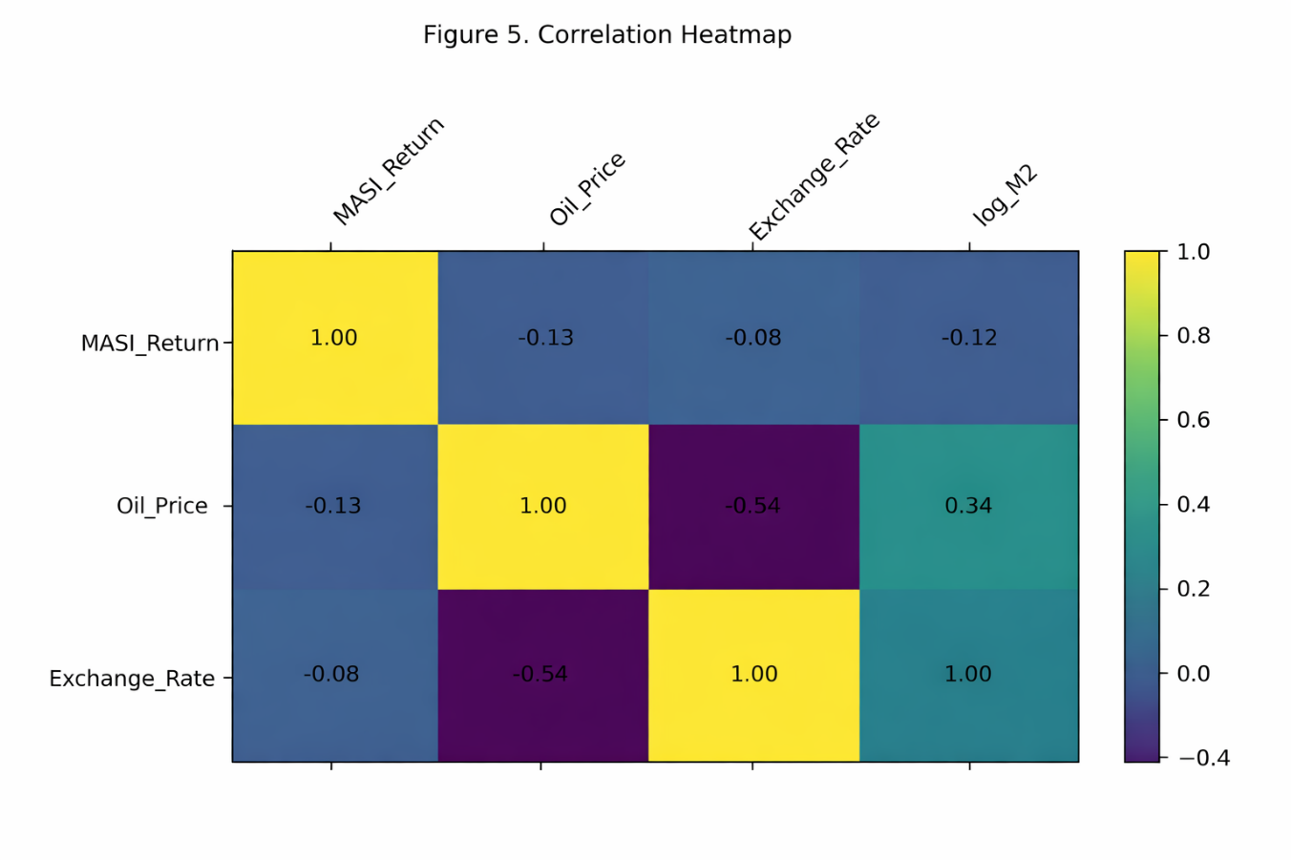
The heatmap presented in Figure 5 confirms the correlation patterns reported in Table 2, providing a clear visual representation of the relationships among the variables. It highlights that the correlations between MASI returns and the selected macroeconomic indicators remain relatively weak in magnitude, suggesting limited direct linear associations. This visual evidence reinforces the idea that while macroeconomic factors such as oil prices, exchange rate, may influence stock market performance, their effects are not strongly pronounced at the correlation level, thereby justifying the need for further investigation through regression analysis.

4.4 Regression Results
Variables | Coefficient | Std. Error | t-Statistic | p-value
Constant | 0.1393 | 0.084 | 1.654 | 0.099
Oil Price | -0.0004 | 0.000 | -2.814 | 0.005
Exchange Rate | -0.0118 | 0.005 | -2.608 | 0.010
Table 6. OLS Regression Results
R² = 0.050, Adjusted R² = 0.038, F-statistic = 4.287 (p < 0.01)
Regression Results Discussion
The OLS regression results provide initial insights into the relationship between stock market returns and macroeconomic variables.
The coefficient of oil prices is negative and statistically significant at the 1% level (p = 0.005), indicating that increases in oil prices are associated with a decrease in stock market returns. This suggests that higher production costs driven by rising oil prices may negatively affect firm profitability and market performance.
The exchange rate coefficient is also negative and statistically significant (p = 0.010), implying that currency depreciation is associated with lower stock returns. This may reflect reduced investor confidence and adverse effects on trade competitiveness.
The constant term is positive but not statistically significant at the 5% level, indicating that baseline returns are not strongly different from zero in the absence of macroeconomic effects.
Overall, the OLS results suggest that both oil prices and exchange rate have significant effects on stock market returns. However, since OLS does not capture dynamic adjustments, further analysis using the ARDL model is required to examine both short-run and long-run relationships.

Figure 6: Actual vs Fitted Values
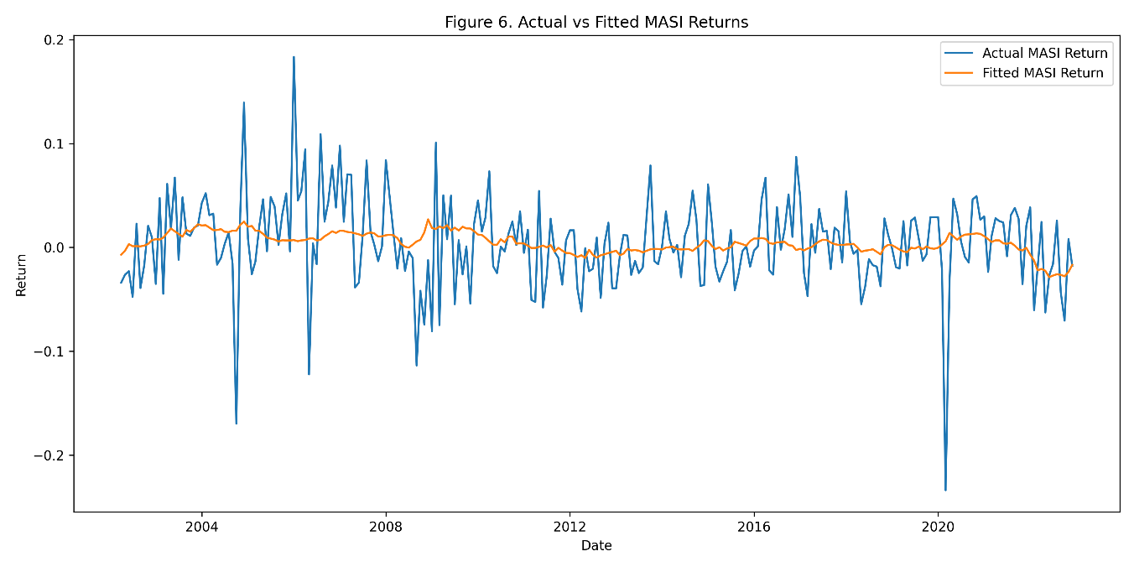

Figure 6 compares the actual values of MASI returns with the fitted values generated by the OLS regression model. The results indicate that while the model is able to capture the general trend and direction of stock market movements, it fails to accurately reflect short-term fluctuations.
This suggests that the model has limited explanatory power in a static framework, highlighting the importance of incorporating dynamic relationships, which are further explored using the ARDL model.

Figure 7. Regression Residuals over time
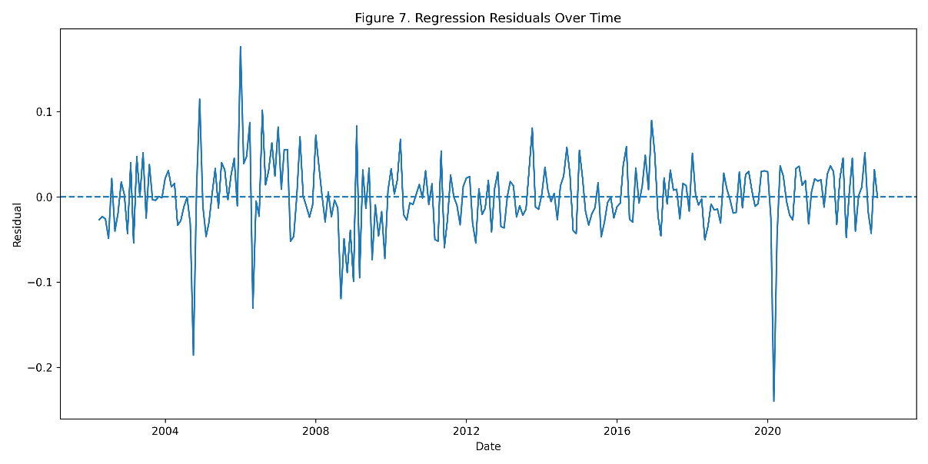

Figure 7 presents the residuals of the OLS regression model over time. The residuals appear to be randomly distributed around zero, suggesting the absence of a systematic pattern and providing some support for the validity of the model specification.
However, the presence of several large deviations indicates that a significant portion of the variability in stock returns remains unexplained. This may be due to omitted variables, structural factors, or external shocks affecting the Moroccan stock market.

4.5 ARDL Estimation result
Variable | Coefficient | Std. Error | z-Statistic | p-value
Constant | 0.1262 | 0.042 | 3.037 | 0.003
Oil Price | 0.0006 | 0.000 | 1.263 | 0.208
Oil Price (-1) | -0.0009 | 0.000 | -2.223 | 0.027
Exchange Rate | -0.0105 | 0.004 | -2.580 | 0.010

Table 7: ARDL Results

Table 7 presents the results of the Autoregressive Distributed Lag (ARDL) estimation results provide important insights into the dynamic relationship between macroeconomic variables and stock market returns.
The contemporaneous effect of oil prices is positive but not statistically significant (p = 0.208), suggesting that immediate changes in oil prices do not have a strong impact on stock returns. However, the lagged oil price variable is negative and statistically significant (p = 0.027), indicating that increases in oil prices have a delayed negative effect on stock market performance.
This finding suggests that the impact of oil price fluctuations is not immediate but materializes over time, possibly due to gradual adjustments in production costs and firm profitability.
The exchange rate coefficient is negative and statistically significant (p = 0.010), implying that currency depreciation is associated with lower stock returns. This result confirms that exchange rate movements play an important role in shaping stock market performance.
Overall, the ARDL results highlight the importance of considering dynamic effects, as macroeconomic variables influence stock returns both immediately and with a lag.

4.6 ARDL Bonds test results

Test Statistic | Value
F-statistic | 71.19

Critical Values | I(0) | I(1)
10% | 2.63 | 3.35
5% | 3.10 | 3.87
1% | 4.13 | 5.00
Table 8 . ARDL Estimation results
The ARDL bounds test is conducted to examine the existence of a long-run relationship between stock market returns and the selected macroeconomic variables.
The computed F-statistic is 71.19, which is significantly higher than the upper bound critical value at the 5% significance level (3.87). Since the F-statistic exceeds the upper bound, the null hypothesis of no cointegration is rejected.
This result provides strong evidence of a long-run equilibrium relationship between MASI returns, oil prices, and the exchange rate. It implies that although the variables may fluctuate in the short run, they move together over time and tend to return to equilibrium.

4.7 Error Correction Model (ECM)

Variable | Coefficient | p-value
ECT(-1) | -0.9397 | 0.000
The Error Correction Model (ECM) is estimated to capture the short-run dynamics and the speed of adjustment toward long-run equilibrium.
The coefficient of the error correction term (ECT) is negative and statistically significant (-0.9397, p < 0.01), confirming the existence of a stable long-run relationship among the variables.
The negative sign indicates that any deviation from the long-run equilibrium is corrected over time. The magnitude of the coefficient suggests that approximately 93.97% of short-run disequilibrium is adjusted within one period, indicating a very rapid speed of adjustment.
This implies that the stock market quickly responds to macroeconomic imbalances and returns to its long-run equilibrium.

CHAPTER FIVE: CONCLUSION AND FUTURE RESEARCH

Conclusion
This study investigated the role of key macroeconomic indicators namely oil prices and exchange rate as potential determinants of stock market returns in Morocco. Using monthly data over the period 2002–2022 and applying both Ordinary Least Squares (OLS) and Autoregressive Distributed Lag (ARDL) models, the analysis aimed to assess the short-run and long-run relationships between these variables and MASI returns. The empirical findings provide strong evidence that external macroeconomic conditions play a significant role in shaping stock market performance. The OLS results indicate that both oil prices and exchange rate exert a statistically significant and negative impact on MASI returns. However, the static framework offers limited insight into the dynamic nature of these relationships. The ARDL results reveal more nuanced dynamics. While the contemporaneous effect of oil prices is not statistically significant, the lagged oil price variable is negative and significant, indicating that increases in oil prices affect stock market performance with a delay. The exchange rate is found to have a negative and significant effect, confirming the sensitivity of the Moroccan stock market to currency depreciation. The ARDL bounds test confirms the existence of a long-run equilibrium relationship among the variables, suggesting that stock market returns, oil prices, and exchange rate move together over time. Furthermore, the Error Correction Model (ECM) results indicate a strong and significant adjustment mechanism, with a high speed of adjustment toward long-run equilibrium. Policy Implications From a policy perspective, the findings of this study carry several important implications. First, the significant impact of oil prices and exchange rate suggests that Moroccan policymakers should closely monitor external economic shocks and adopt strategies to mitigate their effects on the domestic economy and financial markets. In particular, policies aimed at enhancing energy diversification and reducing dependence on imported oil could help limit the vulnerability of the stock market to global energy price fluctuations.Second, maintaining exchange rate stability emerges as a critical objective for sustaining investor confidence and supporting stock market performance. Exchange rate volatility can generate uncertainty and negatively affect both domestic and foreign investment, thereby weakening financial market development. As such, macroeconomic policies that promote currency stability and strengthen external balances are essential.For investors and financial analysts, the results highlight the importance of incorporating macroeconomic information into investment strategies. Monitoring oil price trends and exchange rate movements can provide valuable signals regarding potential shifts in stock market performance. In this sense, macroeconomic indicators can serve as practical tools for enhancing decision-making and improving portfolio management.
Limitations and Future Research
Despite its contributions, this study is subject to several limitations. The moderate explanatory power of the model suggests that important determinants of stock market returns may have been omitted. Additionally, while the ARDL framework captures both short-run and long-run dynamics, it assumes linear relationships and may not fully reflect the complexity of financial markets.
Future research could extend this analysis by incorporating additional macroeconomic variables such as interest rates, inflation, foreign direct investment, or global financial indicators. This would provide a more comprehensive understanding of the factors influencing stock market behavior.
Furthermore, the application of alternative econometric approaches—such as Vector Error Correction Models (VECM), nonlinear models, or machine learning techniques—could offer deeper insights into the dynamic interactions between macroeconomic variables and stock market returns.
Finally, expanding the analysis to include comparative studies across emerging markets would help to contextualize the Moroccan experience and enhance the generalizability of the findings.

References
Adjasi, C. K. D., Harvey, S. K., & Agyapong, D. (2011). Effect of exchange rate volatility on the Ghana stock exchange. African Journal of Accounting, Economics, Finance and Banking Research, 7(7), 28–47.
Basher, S. A., & Sadorsky, P. (2006). Oil price risk and emerging stock markets. Global Finance Journal, 17(2), 224–251.
Chen, N. F., Roll, R., & Ross, S. A. (1986). Economic forces and the stock market. Journal of Business, 59(3), 383–403.
Dornbusch, R., & Fischer, S. (1980). Exchange rates and the current account. American Economic Review, 70(5), 960–971.
Fama, E. F. (1981). Stock returns, real activity, inflation, and money. American Economic Review, 71(4), 545–565.
Hamilton, J. D. (2009). Causes and consequences of the oil shock of 2007–08. Brookings Papers on Economic Activity, 40(1), 215–261.
Mukherjee, T. K., & Naka, A. (1995). Dynamic relations between macroeconomic variables and the Japanese stock market. Journal of Financial Research, 18(2), 223–237.
Sadorsky, P. (1999). Oil price shocks and stock market activity. Energy Economics, 21(5), 449–469.

