SMART HOMES AND THE FUTURE OF INTERIOR DESIGN

Abstract
The rapid advancement of smart technology has significantly transformed the field of interior design, leading to the development of smart homes that combine functionality, comfort, sustainability, and aesthetics. This research paper explores the impact of smart home technologies on the future of interior design and examines how digital innovation is reshaping residential spaces. The study focuses on the integration of automated systems such as smart lighting, climate control, security systems, voice assistants, and Internet of Things (IoT)-based devices within modern interiors. It also highlights the role of interior designers in creating adaptive, user-centered, and technologically efficient living environments.
The paper discusses the growing demand for energy-efficient and sustainable design solutions, emphasizing how smart homes contribute to improved energy management and enhanced quality of life. Furthermore, the research analyzes the challenges faced in implementing smart technologies, including high installation costs, privacy concerns, technological dependency, and the need for continuous upgrades. Through case studies and current industry trends, the paper demonstrates how smart homes are influencing space planning, furniture design, material selection, and user interaction within residential interiors. The findings suggest that the future of interior design will increasingly depend on the successful integration of technology with creativity and human comfort. Smart homes are no longer limited to luxury living but are becoming an essential aspect of contemporary residential design. The study concludes that interior designers must adapt to technological advancements and develop interdisciplinary knowledge to meet the evolving needs of modern users and create intelligent, sustainable, and aesthetically pleasing living spaces.
1.INTRODUCTION
The way people experience and use residential spaces has changed significantly over the past few decades. Traditionally, homes were designed mainly to provide shelter, comfort, privacy, and protection. Interior design focused largely on aesthetics, furniture arrangement, and the efficient use of available space. However, with rapid advancements in digital technology, automation, and internet connectivity, the concept of home has transformed from a passive physical environment into an active and intelligent living system. Today, homes are increasingly becoming smart homes, where technology is integrated into daily living to improve comfort, convenience, security, and efficiency.
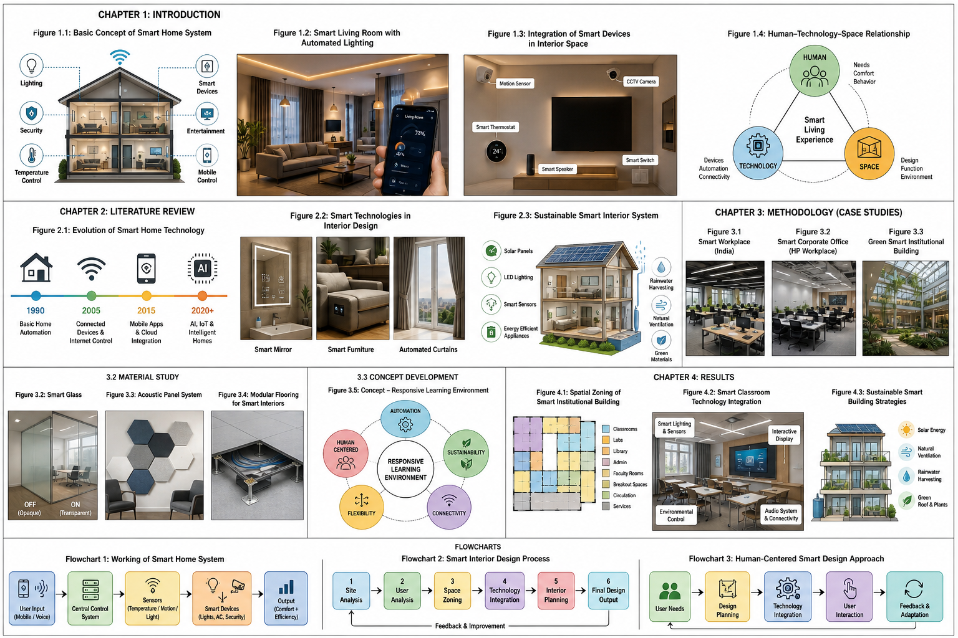
Image1: Smart Technology & Home
A smart home can be understood as a living environment where various devices, systems, and appliances are connected through digital networks and can communicate with each other. These systems use sensors, automation tools, wireless communication, and artificial intelligence to respond to user needs automatically. This transformation has introduced a new dimension to interior design, where spaces are no longer static or fixed but interactive, adaptable, and responsive to human behavior. As a result, interior designers are now required to think beyond traditional design principles and incorporate technology into the spatial planning process. Modern lifestyles, particularly in urban areas, demand greater flexibility, speed, and convenience. People today seek homes that support their dynamic routines, work-from-home culture, and digitally connected lifestyles. Smart homes answer these needs by offering intelligent systems such as automated lighting, climate control, voice-activated appliances, and remote security management. These innovations reduce physical effort, save time, and improve the overall quality of life.
At the same time, global environmental concerns have increased the need for sustainable living solutions. Buildings consume a large amount of energy and natural resources, contributing significantly to environmental challenges. Smart technologies help address this issue by monitoring energy usage in real time, reducing waste, and supporting efficient resource management. Therefore, smart homes not only improve convenience but also contribute to sustainability and environmental responsibility. The future of interior design depends greatly on how effectively these technologies can be integrated into living spaces while maintaining emotional comfort and human well-being.
Image2: Living Space & Technology

1.2 Smart Homes and Interior Design
Smart homes are residential spaces equipped with automated systems designed to manage daily household functions such as lighting, ventilation, security, entertainment, and energy management. These systems operate through a combination of sensors, wireless networks, centralized controls, and intelligent software that allows devices to communicate and function efficiently.
In the field of interior design, the rise of smart homes has introduced a major shift in design thinking. Designers are no longer responsible only for visual appearance and furniture arrangement; they are now expected to create environments where technology is integrated seamlessly into the built space. This requires careful planning of electrical systems, device placement, wiring routes, and control interfaces so that technological components remain visually unobtrusive while functioning effectively.
For example, smart kitchens may include automated appliances, sensor-based faucets, and intelligent storage systems that improve efficiency and convenience. Living rooms can be designed with mood-responsive lighting and integrated entertainment systems. Bedrooms may feature automated curtains, temperature control, and sleep-monitoring technologies that enhance comfort and wellness. Such applications demonstrate how smart technology is reshaping the role of interior designers from decorators to creators of intelligent living environments. The goal of smart interior design is not simply to add gadgets to a home but to create a balanced environment where technology supports daily life naturally and efficiently.

1.3 Role of Technology in Interior Spaces
Technology has become an essential element in shaping contemporary interior spaces. Devices such as motion sensors, smart thermostats, voice assistants, automated lighting systems, and digital control panels have transformed ordinary rooms into intelligent and interactive environments. One of the most important roles of technology is improving convenience. Automated systems reduce the need for manual effort by performing routine tasks automatically. For example, lights can turn on when a person enters a room, temperature settings can adjust according to weather conditions, and home appliances can be operated remotely through mobile applications. These features make daily activities easier and more efficient.
Technology also plays a vital role in safety and security. Smart smoke detectors, surveillance cameras, door sensors, and alarm systems provide real-time protection against accidents and security threats. These systems can send alerts directly to users, offering greater control and peace of mind. Additionally, technology supports better environmental management. Smart energy systems monitor electricity consumption and optimize the use of lighting, heating, and cooling systems. This reduces energy waste and promotes sustainable living practices.
For interior designers, the challenge is to ensure that these technologies are integrated without disrupting the visual and emotional quality of the space. Technology should enhance interiors rather than making them appear mechanical or overcrowded.

1.4 Human Technology Space Connection
The relationship between humans, technology, and space is central to successful smart home design. A technologically advanced home is only successful when it supports human comfort, usability, and emotional well-being. Human centred design focuses on creating systems that are simple, accessible, and easy to use. Not all users interact with technology in the same way; therefore, interfaces must be intuitive and user-friendly. This is especially important for elderly users, children, and individuals who may not be comfortable with complex digital systems.
Interior spaces also have a strong emotional impact on users. Lighting, materials, furniture, and spatial organization influence how people feel within a room. When technology is thoughtfully integrated into these elements, it enhances comfort and satisfaction. For example, concealed lighting systems, hidden sensors, and integrated control panels can maintain the beauty of a space while delivering advanced functionality. On the other hand, poorly integrated technology can create visual clutter and user frustration. Therefore, designers must understand both human behavior and digital systems to ensure a balanced relationship between people and smart environments. A successful smart interior should feel natural, comfortable, and welcoming where technology works quietly in the background to support everyday life.
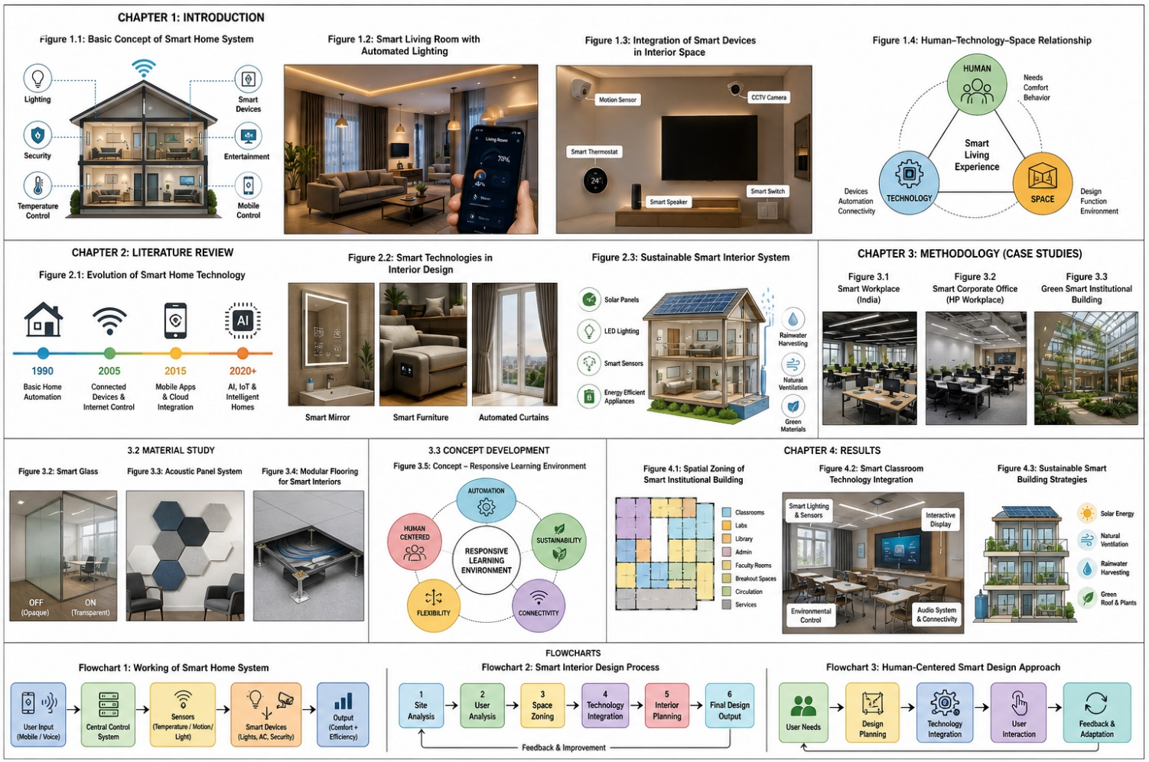
Image3: Smart Living Experience

1.5 Aim of the Study
The aim of this study is to explore how smart home technology can be effectively integrated with interior design to create living spaces that are efficient, comfortable, sustainable, and user friendly. The study focuses on understanding how intelligent systems such as automated lighting, climate control, security systems, and smart appliances can be incorporated into residential interiors without affecting visual harmony or human comfort. It also aims to examine the relationship between technology and user experience by analyzing how people interact with smart environments in their daily lives. Special attention is given to designing spaces that are simple, accessible, and emotionally satisfying.
Furthermore, the study seeks to highlight the importance of combining aesthetics, functionality, and technological innovation in interior design practice. By doing so, it proposes an approach where smart technology enhances living environments rather than dominating them. Overall, the study aims to contribute to the development of future-ready interiors that respond to changing lifestyles, environmental challenges, and technological advancements while maintaining a strong focus on human well-being.
1.6 Objectives
The objectives of this research are to understand the role of smart technology in residential interiors, to examine design strategies that support automation and connectivity, to study user comfort in smart environments, and to develop a conceptual smart home design that demonstrates future interior possibilities.
1.7 Scope of Study
The scope of this study includes the analysis of smart home technologies, interior planning methods, and sustainable materials used in modern residential spaces in India. The research focuses on interior design aspects such as lighting, furniture layout, automation systems, space planning, and environmental comfort. The study also examines the relationship between technology and user experience, emphasizing energy efficiency and environmental sustainability. It considers the application of smart systems in residential and institutional interiors, particularly in urban Indian settings.
By this study explores various interior planning methods that support the integration of smart systems. This includes space planning, furniture arrangement, and the placement of devices in a way that ensures ease of use and smooth movement within the space. Attention is given to lighting design, both natural and artificial, to understand how it can work with automation to improve comfort and energy use. Furniture is also considered not just as a functional element, but as a medium to conceal or incorporate technological components in a subtle manner.
2. LITERATURE REVIEW

2.1 Evolution of Smart Homes
The concept of smart homes has evolved significantly over the past few decades, reflecting the rapid development of technology and changing human lifestyles. Initially, smart homes were limited to basic automation systems designed to control simple household functions such as lighting, security alarms, and temperature settings. These early systems were mostly mechanical or programmed with fixed commands and were focused primarily on convenience and reducing manual effort. Their main purpose was to simplify everyday household tasks and improve user comfort. As technology advanced, particularly with the development of the internet and wireless communication systems, smart homes began to transform into more intelligent and connected environments. Devices became capable of communicating with each other through wireless networks, creating interconnected systems rather than isolated automation tools. This allowed homeowners to remotely control appliances, security systems, and lighting through mobile applications and digital interfaces. The introduction of cloud computing further enhanced this process by enabling data storage, real-time monitoring, and remote accessibility.
Image 4:Data Smart Monitoring
In recent years, smart home technology has moved beyond simple automation toward intelligent decision-making. Artificial intelligence and machine learning now allow systems to learn user preferences and adapt automatically. For example, thermostats can learn daily routines and adjust room temperature accordingly, while lighting systems can respond to occupancy patterns and natural daylight levels. This shift has made homes more responsive, personalized, and energy efficient. Research in this field has also changed over time. Early studies focused mainly on convenience and automation, while recent literature emphasizes broader issues such as sustainability, accessibility, user well-being, and energy management. Smart homes are now seen not only as technologically advanced spaces but also as solutions for modern urban lifestyles and environmental challenges. This evolution clearly shows how homes are adapting to support the digital habits and expectations of contemporary society.

2.2 Smart Technologies in Interior Design
The integration of smart technology into interior design has become an important area of research and professional practice. Interior design literature increasingly highlights the use of smart systems such as automated lighting, intelligent furniture, climate control systems, digital mirrors, voice-controlled assistants, and automated window treatments. These technologies are changing how interior spaces are designed, used, and experienced.
One of the most significant developments in smart interiors is smart lighting. Advanced lighting systems allow users to adjust brightness, color temperature, and mood settings according to their needs and preferences. Lighting can also be programmed to change automatically throughout the day, improving both comfort and energy efficiency. Similarly, automated curtains and blinds help regulate natural light, reduce energy consumption, and improve user convenience. Smart furniture is another emerging trend in interior design. Adjustable workstations, foldable storage systems, and multi-functional furniture are increasingly used in modern homes, especially in compact urban spaces. These innovations support flexible living and maximize space efficiency while maintaining visual simplicity.
Researchers emphasize that technology should not be treated as an afterthought in interior design. Instead, it should be considered from the earliest design stages. Proper planning ensures that wires, sensors, and digital devices are integrated into walls, ceilings, and furniture in a way that preserves the visual harmony of the space. This makes interiors cleaner, more organized, and more user-friendly. The growing use of smart technology in interior design demonstrates a clear shift from traditional decoration toward intelligent spatial planning, where design and technology work together to create functional and responsive environments.

2.3 Psychology of Smart Living Spaces
The psychological impact of smart living spaces has become an important focus in recent literature. Smart environments influence human emotions, comfort, and behavior by simplifying daily activities and reducing stress. Automated systems improve convenience by managing routine tasks such as adjusting lights, controlling indoor temperature, and operating appliances without constant manual effort. Lighting and temperature control are particularly important in shaping emotional responses. Research shows that warm lighting and comfortable room temperatures contribute to relaxation and emotional well-being, while cooler lighting supports concentration and productivity. Smart systems can personalize these settings according to individual preferences, creating environments that feel more comfortable and supportive.
Image5:Smart Furniture & Living Space
Another important psychological factor is trust. Users feel more comfortable when technology operates reliably and predictably. If systems work smoothly and consistently, people develop confidence in them and become more willing to depend on automation. However, poorly designed or confusing systems can create frustration and discomfort. Visual simplicity also contributes to mental comfort. Clean layouts, organized furniture arrangements, and hidden technological elements reduce visual clutter and create calm environments. Studies suggest that interiors where technology is well integrated appear more welcoming and less stressful than spaces where devices dominate the visual environment. Overall, smart living spaces have the potential to improve psychological well-being, but their success depends on thoughtful design that prioritizes user comfort, trust, and emotional balance.

2.4 Sustainable and Energy Efficient Smart Interiors
Sustainability has become a central concern in modern interior design, and smart technology plays a major role in achieving energy-efficient environments. Buildings consume a large portion of global energy, making it necessary to develop systems that reduce unnecessary consumption and improve environmental responsibility.
Smart homes contribute to sustainability through automated energy management systems. Lighting systems can switch off automatically when rooms are unoccupied, while appliances can operate only when needed. These automated controls help reduce electricity waste and lower environmental impact. Smart thermostats are another major feature of sustainable interiors. These systems can learn user habits and adjust heating or cooling based on occupancy and weather conditions. Instead of running continuously, they provide targeted comfort while saving energy.
Material selection also supports sustainable interior design. Energy-efficient lighting such as LED fixtures, eco-friendly materials, proper insulation, and recycled finishes all contribute to reduced environmental impact. When combined with smart technology, these materials create interiors that are both environmentally responsible and comfortable for users. Research shows that the future of sustainable interior design depends on balancing technology with thoughtful material selection. Smart interiors should not only improve convenience but also promote long-term environmental well-being.
Image6:Sustainable Interior

2.5 Human-Cantered Smart Design
Human-centred design focuses on creating spaces that respond to the needs, behaviours, and comfort of users. In smart interiors, this means designing technology that supports people rather than controlling them. The goal is to create environments where technology feels natural and easy to use.
Simple and intuitive interfaces are essential in this approach. Whether through touch panels, mobile applications, or voice commands, controls must be easy to understand and accessible to all users. This reduces confusion and improves confidence in using smart systems. Another important factor is personalization. Smart interiors should respond to daily routines and individual preferences. For example, lighting may adjust based on morning and evening activities, while climate systems may respond to sleep patterns or seasonal changes. This creates a more personalized and comfortable experience. Accessibility is also a major concern. Smart homes should be usable by people of all ages and abilities. Features such as voice commands, remote controls, and automation are especially beneficial for elderly users and individuals with mobility limitations, promoting independence and comfort. The literature suggests that successful smart design depends on understanding human behavior and designing technology around real user needs. A smart home should enhance life quietly and naturally, without creating complexity.

2.6 Problem Statement
Although smart technologies are widely available and increasingly affordable, many residential spaces still fail to integrate them effectively within interior design. In many cases, smart devices are added only after construction or interior finishing has been completed. This results in poor device placement, visible wires, mismatched systems, and visual clutter. Such poor integration affects not only aesthetics but also system performance. Sensors may not function efficiently if installed in incorrect locations, lighting automation may become less effective, and users may find systems difficult to operate. Instead of improving daily life, poorly planned technology can create confusion and frustration.
This problem highlights the lack of coordination between technology planning and interior design. Many projects treat these two areas separately, resulting in spaces that are visually attractive but technologically inefficient or technologically advanced but visually uncomfortable. Therefore, there is a clear need for an integrated design approach where smart technology is considered from the earliest stages of interior planning. Combining spatial design, technological systems, user comfort, and aesthetics can create smart interiors that are efficient, visually harmonious, and truly responsive to modern living needs.

3.METHODOLOGY

3.1 Case Studies
To understand the practical application of smart technologies in institutional and workplace interiors, three relevant case studies were selected and analyzed. These case studies helped identify successful design strategies, technology integration methods, and spatial planning approaches used in smart environments.

Case Study 1: Smart Intelligent Workplace (Nirwana Head Office, Gurgaon, India)
The Nirwana Head Office in Gurgaon represents a modern smart workplace designed as an intelligent office environment. The project demonstrates how contemporary office interiors can respond automatically to user needs through integrated technology systems. The building uses a centralized automation system that controls lighting, temperature, security, and audio visual functions through one digital platform. Lighting adjusts automatically according to occupancy, while climate systems respond to human presence, helping improve user comfort and reduce energy consumption. Key Smart Features: Centralized automation system, Smart lighting control, Occupancy-based temperature control, integrated security systems and automated meeting room systems Interior Design Features: Flexible workstations, Collaborative meeting spaces, Sensor-based lighting zones, Acoustic design integration and Modular interior planning Learning from Case Study: Centralized control improves building efficiency, Smart lighting enhances both aesthetics and functionality and Flexible planning supports future technological upgrades.

Case Study 2: Smart Corporate Office (HP Workplace, Gurgaon, India)
The HP smart corporate office in Gurgaon demonstrates how technology can improve workplace productivity and employee collaboration. This office was designed using intelligent building systems to create a flexible and adaptive work environment. The project integrates IoT-based lighting systems, smart HVAC controls, and digital access systems. Different work zones such as collaboration spaces focus zones, and meeting rooms are supported through automated environmental controls. Key Smart Features: IoT-based lighting systems, Smart HVAC control, Digital access control, Smart meeting rooms and Automated workspace environment Interior Design Features: Open-plan workspaces, Breakout zones, Digital conference rooms and Adaptive lighting systems Learning from Case Study: Smart technology improves workplace efficiency, Automation supports collaborative environments and Flexible layouts enhance productivity.

Case Study 3: Green Smart Institutional Building (Paharpur Business Centre, New Delhi, India)
The Paharpur Business Centre is a globally recognized example of a sustainable smart institutional building. It focuses on environmental sustainability, energy efficiency, and user well-being. The building incorporates smart ventilation systems, energy-efficient technologies, and healthy indoor environmental strategies. Its design emphasizes sustainable materials and green certified interiors. Key Smart Features: Energy efficient systems, Indoor air quality monitoring, Smart ventilation and Resource efficient materials Interior Design Features: Green-certified materials, Sustainable lighting systems, Natural ventilation planning and Healthy workspace design. Learning from Case Study: Sustainable interiors improve occupant health ,Smart monitoring increases operational efficiency. Green design supports long-term sustainability.
3.2 Material Study
Material selection plays a critical role in designing smart institutional interiors because materials must support technology integration, durability, and sustainability. For this project, both smart and sustainable materials were studied. Smart glass changes its transparency when electrical signals are applied, allowing control of privacy and natural light. Applications: Conference rooms, Meeting spaces and Institutional cabins Benefits: Reduces heat gain, Improves energy efficiency and Enhances privacy
Acoustic materials help control noise levels and improve speech clarity in institutional spaces Materials Used-Fabric-wrapped panels, Recycled fiber boards and perforated gypsum boards Applications: Lecture rooms, Conference halls and Offices Benefits: Reduces noise pollution, Improves acoustic comfort
Low VOC (Volatile Organic Compound) paints improve indoor air quality and support healthier interiors. Benefits: Reduced toxic emissions, Better indoor environment and Sustainable interior finish Modular flooring supports easy installation of wiring and future technology upgrades. Examples: Raised flooring, Vinyl flooring, Carpet tiles Benefits: Easy maintenance, Flexible technology integration and Supports concealed wiring.

3.3 Concept Development
The concept development phase focused on creating a smart institutional environment that balances technology, comfort, and sustainability. Project Title: Smart Institutional Building Design for Bhopal Concept Name: Responsive Learning Environment The main idea is to create a building that adapts to user needs while improving educational performance and environmental efficiency. The design integrates: Smart lighting systems, Climate control, Digital learning technologies, Energy-efficient materials, Flexible interior layouts Concept Keywords: Automation, Sustainability, Flexibility, Connectivity and Human cantered design this concept ensures that the building remains responsive, efficient, and user-friendly.
Image7: Responsive Learning Environment

3.4 Design and Planning Process
The design process followed a systematic approach to integrate smart technologies into the interior environment.

Step 1: Site Selection (Bhopal)
Bhopal was selected because of its growing educational infrastructure and urban development potential. Factors Considered: Accessibility, Climate, Urban surroundings and Infrastructure availability Since Bhopal has a composite climate with hot summers and moderate winters, energy-efficient strategies such as shading and natural ventilation were considered essential.

Step 2: User Analysis
The primary users identified for the institutional building include: Students, Faculty, Administrative staff and Visitors User Needs Identified: Comfortable learning spaces, Smart classrooms, Collaborative zones and Digital connectivity Understanding user requirements helped in planning functional and technology-enabled spaces.

Step 3: Space Zoning
The building was divided into functional zones for better space management. Main Zones Include: Reception, Smart classrooms, Faculty rooms, Library, Digital laboratory, Conference hall, Breakout spaces and Server/control room Proper zoning improves movement, efficiency, and user experience.

Step 4: Technology Integration
Technology integration was planned from the beginning of the design process. Smart Systems Included: Smart lighting, Smart HVAC systems, Security systems, Digital display systems and IoT sensors. These systems monitor temperature, lighting, and occupancy to maintain comfort and reduce energy consumption.

Step 5: Interior Planning
Interior planning focused on functionality, aesthetics, and technology compatibility. It included: Furniture layout planning, Lighting design, Electrical layout, Material selection The objective was to ensure that all smart systems blend seamlessly into the interior design while maintaining visual harmony and efficient circulation. This methodology provides a structured framework for designing a smart institutional building that integrates technology, sustainability, and user-centred interior design principles.
4. RESULT AND DISCUSSION
4.1 Spatial Outcomes
The spatial outcomes of the Smart Institutional Building are developed around the central concept of a "Responsive Learning Environment," where architectural planning supports flexibility, adaptability, and improved educational performance. The institutional layout is designed to respond to the dynamic needs of students, faculty, and administrative staff by creating interconnected zones that support learning, collaboration, and social interaction. The spatial organization begins with a clearly defined entrance and reception area that functions as an orientation point for visitors and students. This area is designed with digital information displays and controlled access systems, ensuring both efficiency and security in daily operations.
Academic zones such as classrooms, laboratories, seminar halls, and resource centers are planned in clusters to improve accessibility and reduce unnecessary movement. Each classroom is designed with optimal proportions to allow flexible furniture arrangements that support both traditional teaching and collaborative learning methods. Circulation corridors are widened to accommodate group interactions and integrated with informal learning niches where students can engage in peer discussions. The spatial layout also includes dedicated zones for faculty offices, administrative spaces, and meeting rooms, ensuring clear separation between public and private functions while maintaining efficient connectivity.

Specialized learning areas such as digital labs, smart classrooms, and multimedia rooms are positioned strategically to minimize noise interference and maximize technological efficiency. Open courtyards and breakout spaces are introduced within the institutional block to provide natural ventilation and visual relief, improving mental comfort and reducing monotony. The integration of vertical circulation elements such as staircases and elevators is carefully planned to ensure accessibility for all users, including individuals with physical limitations. Overall, the spatial outcomes demonstrate how responsive planning enhances movement efficiency, supports diverse educational activities, and creates a learning environment that adapts to modern academic requirements.
4.2 Technological Outcomes
The technological outcomes of the Responsive Learning Environment highlight the effective integration of intelligent systems that support educational activities, building management, and user safety. Smart classroom technology forms the core of the institutional design, enabling digital teaching methods through interactive display panels, wireless connectivity, and centralized control systems. Each classroom is equipped with automated lighting systems that adjust brightness levels based on occupancy and daylight availability. These lighting controls not only enhance visual comfort but also contribute to energy efficiency within the building.

Environmental control systems play a major role in maintaining indoor comfort across different zones of the institution. Smart sensors monitor temperature, humidity, and air quality, enabling automated climate control systems to regulate ventilation and cooling based on occupancy levels. This technology ensures consistent indoor conditions that support concentration and reduce fatigue among students. In addition, integrated security systems including biometric access control, surveillance cameras, and emergency alert mechanisms provide a safe and secure academic environment. These systems enable real-time monitoring of entry and exit points, preventing unauthorized access and ensuring campus safety.
Building wide automation systems also support operational efficiency through centralized management platforms. Facility managers can monitor energy usage, water consumption, and equipment performance from a single interface. Digital notice boards and wayfinding systems improve communication within the institution by providing real-time updates about schedules, announcements, and navigation routes. Smart infrastructure such as automated attendance systems and network-enabled learning tools further enhances academic productivity. These technological outcomes demonstrate how digital systems transform educational spaces into intelligent environments that support both teaching and administration.
4.3 User Experience Findings
User experience findings from the Responsive Learning Environment indicate significant improvements in comfort, engagement, and satisfaction among students and faculty members. The integration of smart technologies with thoughtful spatial planning creates an environment that supports focused learning and interactive communication. Students experience greater convenience through automated systems that simplify daily routines, such as digital attendance recording, responsive lighting, and temperature-controlled classrooms. These features reduce distractions and create a consistent learning environment that supports academic performance.
The psychological impact of the spatial environment is also evident in the way students interact with learning spaces. Informal breakout areas, open courtyards, and collaborative zones encourage social interaction and knowledge sharing, contributing to a more engaging educational experience. Faculty members benefit from technologically equipped teaching environments that support multimedia presentations and real-time student interaction. The presence of intuitive control interfaces ensures that users can operate systems without technical difficulty, reducing anxiety associated with unfamiliar technology. Accessibility features integrated within the design enhance inclusivity and ensure equal participation for all users. Ramps, elevators, and automated entry systems improve mobility for individuals with physical challenges, creating a supportive educational environment. Acoustic comfort within classrooms and lecture halls is improved through sound-absorbing materials and controlled noise levels, enabling clear communication between instructors and students. Overall, the user experience findings demonstrate that responsive institutional environments improve learning efficiency, reduce physical and mental fatigue, and promote positive behavioral outcomes within academic spaces.
4.4 Sustainability Outcomes
Sustainability outcomes form a fundamental component of the Responsive Learning Environment, ensuring that the institutional building operates efficiently while minimizing environmental impact. The integration of smart building technologies significantly reduces energy consumption through automated lighting and climate control systems. Daylight-responsive lighting sensors ensure that artificial lighting is used only when necessary, reducing electricity usage during daytime hours. Similarly, occupancy sensors prevent energy wastage by turning off lights and equipment in unoccupied rooms. Passive design strategies further enhance environmental performance within the building. The orientation of classrooms and circulation spaces maximizes natural daylight and cross-ventilation, reducing reliance on mechanical cooling systems. Courtyards and green spaces introduced within the institutional layout contribute to improved air quality and thermal comfort. The use of energy-efficient materials such as insulated glazing, reflective roofing systems, and eco-friendly finishes supports long-term sustainability goals while improving indoor environmental quality.
Water conservation strategies are also incorporated through smart plumbing systems that monitor water usage and detect leakages. Rainwater harvesting systems and water-efficient fixtures reduce dependency on external water sources and promote responsible resource management. In addition, renewable energy solutions such as rooftop solar panels provide supplementary power for lighting and essential building functions. These sustainability outcomes demonstrate how intelligent design strategies support environmental responsibility, reduce operational costs, and create long-lasting institutional infrastructure suited to the climatic conditions of Bhopal.
CONCLUSION
This study highlights that smart homes are becoming an important direction for the future of interior design. By combining technology with thoughtful design, living spaces can become more comfortable, efficient, and responsive to user needs. Smart systems help simplify everyday activities, improve safety through monitoring and alerts, and support sustainability by reducing energy use. These benefits show that technology, when used correctly, can enhance both the function and experience of interior spaces. The role of the interior designer is becoming more dynamic in this context. Designers are no longer only responsible for aesthetics but also for understanding how technology fits within a space. Planning for smart systems from the early design stage allows better placement, smoother integration, and a cleaner overall look. When technology is considered as part of the design process, it becomes less visible but more effective, supporting daily life without disturbing the visual quality of the interior. Another key finding of the study is the importance of adaptability in future interiors. As lifestyles continue to change, spaces must be flexible enough to respond to new needs. Smart technologies make this possible by allowing environments to adjust based on user behavior, time of day, or specific activities. This creates spaces that are not fixed but can evolve over time, offering greater comfort and usability.
At the same time, designers need to stay updated with ongoing technological developments. Since new systems and devices are introduced regularly, continuous learning becomes essential. Understanding how these innovations work and how they can be applied in design helps in creating better and more practical solutions. Creativity is also important, as designers must find ways to integrate technology without making spaces feel complex or overly mechanical. In conclusion, smart homes are not only about automation or advanced devices. They represent a shift towards more thoughtful and user-focused design. The true value of smart interiors lies in their ability to improve the overall quality of life by creating spaces that are comfortable, efficient, and easy to live in. When technology and design are balanced properly, the result is an environment that supports both practical needs and human well-being.
References
1.http://ecsdev.org/ojs/index.php/ejsd/article/view/908
2.https://www.sciencedirect.com/science/article/pii/S0378778816300859
3.https://www.sciencedirect.com/science/article/pii/S1364032113002747
4.https://www.wiley.com/en-5.in/Building+Information+Modelinghttps://www.sciencedirect.com/science/article/pii/S0378778815303677
6https://www.sciencedirect.com/science/article/pii/S0926580511000385
7https://www.sciencedirect.com/science/article/pii/S2090447921002641
8 https://dl.acm.org/doi/abs/10.1145/3495018.3495315
9.https://avesis.omu.edu.tr/yayin/3e26819e-228e-455f-affd-c50bbf6a827c/smart-homes-10,for-the-elderly-and-the-role-of-interior-designers

