Clutter and Spatial Underutilization in Compact Residential Washrooms: A Study of Storage Planning and User Behavior

ABSTRACT
Compact residential washrooms often experience clutter, inefficient storage usage, restricted movement, and underutilised spaces despite the inclusion of storage units and planned layouts. The increasing compactness of residential interiors has created a growing need for functional, accessible, and user-oriented washroom design solutions. This research investigates the relationship between storage planning, user behaviour, and spatial underutilisation in compact residential washrooms under 50 sq.ft. The study adopted a qualitative and observational research approach focused on understanding everyday user experiences, storage habits, accessibility issues, hygiene concerns, and movement patterns within compact washroom environments. Data collection methods included observational study, Google Form survey, and face-to-face informal interactions with homeowners, apartment residents, homemakers, working individuals, and family members regularly using compact residential washrooms.
The findings revealed that clutter formation was strongly influenced by user convenience behaviour, inaccessible storage systems, poor wet and dry zoning, and inefficient spatial planning rather than lack of storage quantity alone. Basin and vanity areas emerged as the most clutter-prone zones due to the concentration of frequently used products. Users commonly preferred keeping daily-use items outside storage units for quick accessibility, resulting in visual congestion and reduced functional efficiency. The study also identified issues such as water splash affecting nearby surfaces, restricted movement due to floor clutter, partial usage of available storage spaces, and hygiene-related discomfort caused by exposed utility items and difficult-to-clean areas. The research highlights the importance of behaviour-responsive and user-centred storage planning within compact washroom environments. Proposed design interventions include vertical storage utilisation, accessible storage systems, improved wet and dry zoning, concealed utility storage, and flexible combinations of open and closed storage. The study concludes that efficient compact washroom design depends not only on storage quantity but also on understanding actual user behaviour, accessibility needs, and everyday usability requirements.

INTRODUCTION:
Residential washrooms are among the most functionally demanding spaces within interior environments, requiring efficient organisation, accessibility, hygiene maintenance, and smooth circulation within limited spatial dimensions. In contemporary residential settings, especially apartments, studio units, and compact homes, washroom spaces are becoming increasingly smaller due to urban density, space limitations, and changing housing patterns. As a result, compact washrooms are expected to accommodate multiple daily activities while maintaining usability, cleanliness, and organised storage within restricted areas.
Despite the inclusion of storage units and planned layouts, many compact residential washrooms continue to experience clutter accumulation, restricted movement, inefficient storage usage, and underutilised spaces. Daily-use products such as toiletries, skincare items, towels, cleaning accessories, and utility products are frequently left outside designated storage areas, creating visual congestion and reducing functional efficiency. In several cases, storage units remain partially unused because of difficult accessibility, impractical placement, or inconvenience during everyday activities. User behaviour also plays a significant role in influencing washroom organisation and spatial efficiency. People often prioritise quick accessibility and convenience over concealed organisation systems, especially in high-frequency activity zones such as vanity and basin areas. This creates a mismatch between designed storage systems and actual behavioural practices. Micro-level usability issues such as wet countertops, water splash affecting nearby products, exposed cleaning tools, difficult-to-clean corners, and floor clutter further contribute to discomfort and reduced hygiene perception within compact washroom environments.
Previous studies have highlighted the importance of user-centred planning, efficient spatial organisation, storage optimisation, and behavioural understanding in residential interiors. Research by Watson et al. (2018), Lau (2011), and Sunmi Kim & Youngho Han (2017) demonstrated that functionality, accessibility, and efficient storage planning significantly influence user comfort and usability in compact spaces. Similarly, studies by Marco (2022) and Williams (2009) emphasised that poor storage planning often results in clutter and inefficient use of residential environments. In response to these concerns, this research focuses on understanding clutter and spatial underutilisation in compact residential washrooms through the analysis of storage planning and user behaviour. The study aims to identify recurring usability issues, behavioural storage patterns, and spatial inefficiencies while proposing practical and behaviour-responsive design interventions that improve accessibility, organisation, hygiene, and overall functionality within compact washroom spaces.

LITERATURE REVIEW:

Watson R, Mukheibir P, Falletta J & Fane S (2018) The study explored how future bathroom designs can become more efficient through smart technologies, improved control systems, and user-centered planning. The authors highlighted the importance of functionality, hygiene, water management, and spatial organisation in modern bathrooms. This relates to the present research by supporting the idea that compact residential washrooms require better planning and integrated storage solutions to improve usability, reduce clutter, and enhance user comfort in everyday activities. Lau, S.S. (2011) The study explored the spatial and environmental challenges faced in compact high-rise residential buildings, especially in densely populated urban areas. It highlighted issues such as restricted circulation, limited ventilation, reduced comfort, and inefficient use of compact spaces due to poor planning and dense layouts. The study emphasized the importance of efficient spatial organisation and user-centered planning in improving functionality and comfort within residential interiors. This supports the present research by showing how compact residential environments require better planning strategies to reduce spatial inefficiency, improve accessibility, and enhance usability in compact washrooms.
Gürel, M. Ö. (2008) The study examined how bathrooms evolved from purely functional spaces into symbols of modern lifestyle, hygiene, and social identity. The author discussed how bathroom layouts, fixtures, and spatial organisation reflect changing user habits and contemporary living standards. The research supports the present study by highlighting that bathroom design is closely connected to user behaviour, spatial planning, and everyday practices. It also emphasizes the importance of functional layouts and organised bathroom spaces, which relate to issues of clutter, accessibility, and spatial efficiency in compact residential washrooms. Jha, P.C. and Aggarwal, R. (2024,The study focused on improving bathroom functionality through efficient space planning, organised layouts, and aesthetic integration. It highlighted the importance of storage optimisation, circulation space, and fixture arrangement in compact bathrooms. The research relates to the present study by supporting the idea that thoughtful spatial planning and functional storage solutions can reduce clutter, improve accessibility, and enhance the usability of compact residential washrooms.
Trabucco, D., Costa, M., & Tatano, V. (2026) The study examined user preferences regarding toilet layouts, fixture arrangements, and functional features in restroom spaces. The authors highlighted that user comfort, accessibility, and convenience are strongly influenced by spatial organisation and design planning. The research supports the present study by showing that user behaviour and daily usage patterns play an important role in determining the efficiency and usability of bathroom spaces. It also reinforces the need for better layout planning and organised storage solutions in compact residential washrooms to minimise clutter and improve functionality.Evgeny Orlov (2020) The study analysed the planning of sanitary facilities in modern residential apartments and identified issues related to limited space, poor furniture placement, lack of storage, and uncomfortable circulation. The author emphasized that compact bathroom layouts often fail to support daily activities due to insufficient usable space and inefficient fixture arrangement. This research supports the present study by highlighting how inadequate storage planning and poor spatial organisation in compact washrooms contribute to clutter, accessibility problems, and reduced user comfort in everyday use.
Marco, E. (2022) The study explored how insufficient and poorly planned storage affects spatial organisation, user comfort, and everyday living in residential spaces. The authors emphasized that modern housing often overlooks practical storage needs, leading to clutter and inefficient use of space. This research supports the present study by highlighting that even when storage is available, poor planning and lack of user-centered design can result in overcrowded and underutilised spaces. The findings are particularly relevant to compact residential washrooms, where limited storage and daily-use items often contribute to clutter and reduced usability. CHOI, Jungmin & WANG, Yake. (2026) The study analysed 1,500 contemporary residential bathroom designs to identify common layout patterns, fixture arrangements, and object-design characteristics in modern bathrooms. The authors highlighted how contemporary bathroom spaces often prioritise aesthetics and minimalism, sometimes at the cost of functionality and efficient storage planning. This research supports the present study by emphasizing the importance of balancing visual design with usability in compact residential washrooms. It also relates to issues of clutter, spatial underutilisation, vanity planning, and organisation of daily-use items within limited bathroom spaces. Sunmi Kim, Youngho Han (2017) The study examined contemporary trends in residential bathroom storage cabinets and analysed how storage systems are integrated within modern bathroom designs. The authors emphasized the importance of efficient cabinet planning, organised storage, and functional use of limited bathroom space. The research highlighted that poorly designed storage systems often lead to countertop clutter, inefficient space utilisation, and inconvenience during daily activities. This study supports the present research by demonstrating how storage planning directly influences usability, organisation, and spatial efficiency in compact residential washrooms.
Williams, K. (2009) The study explored how storage practices influence the functionality and usability of residential spaces. The authors argued that housing design often overlooks the everyday storage needs and behavioural patterns of users, resulting in cluttered and inefficient interiors. The research emphasized that storage should be considered an essential part of spatial planning rather than an additional feature. This study supports the present research by highlighting how inadequate and poorly planned storage systems contribute to clutter and spatial underutilisation, especially in compact residential washrooms where daily-use items require organised and accessible storage solutions.

AIM, SCOPE AND CONTEXT OF STUDY:
  - Aim
The aim of this research is to examine clutter and spatial underutilisation in compact residential washrooms through the analysis of storage planning and user behaviour. The study further aims to explore practical and user-oriented design interventions that can improve spatial efficiency, accessibility, hygiene, and overall functionality within limited washroom spaces.
  - Objectives
3.2.1To identifies common factors contributing to clutter formation in compact residential washrooms.
3.2.2.To analyse the relationship between storage planning and spatial usability in limited washroom areas.
    - To study user behaviour patterns that influence organisation, accessibility, and space utilisation.
    - To investigate micro-level functional issues affecting movement, hygiene, and daily usability in compact washrooms.
3.2.5To propose practical design strategies for improving storage efficiency and reducing clutter.
  - Scope of Study
This research focuses on compact residential washrooms with limited spatial dimensions, particularly spaces requiring efficient planning and multifunctional usage. The study is confined to the analysis of storage systems, user interaction with space, accessibility, circulation, and daily-use patterns within washroom interiors. The research does not include technical plumbing systems or structural modifications, but concentrates primarily on interior spatial planning and user-centred functionality.
  - Context of Study
Compact washrooms are among the most frequently used spaces in residential interiors and require a high level of functional efficiency within restricted areas. Despite the inclusion of storage units and planned layouts, these spaces often experience visible clutter, inefficient storage usage, restricted movement, and underutilised spatial zones. Everyday activities, frequent water interaction, accessibility limitations, and user habits significantly influence the functionality of such spaces. Micro-level issues such as wet surfaces affecting stored items, exposed cleaning tools, countertop congestion, and inefficient vanity organisation contribute to reduced usability and spatial discomfort. As residential spaces continue to become more compact, the need for practical, hygienic, and behaviour-oriented storage solutions becomes increasingly important. This study therefore attempts to understand the relationship between storage planning, user behaviour, and spatial efficiency in compact residential washrooms.

METHODOLOGY:
  - Introduction to Methodology
This research followed a qualitative and observational approach to study clutter and spatial underutilisation in compact residential washrooms. The methodology focused on understanding how storage planning and user behaviour affected the usability, organisation, hygiene, and functionality of compact washroom spaces. The study aimed to identify recurring spatial issues through observation, participant interaction, visual analysis, and behavioural assessment.
  - Research Approach
The study adopted a qualitative, user-centred, and observational research approach. Rather than focusing only on numerical data, the research emphasised everyday user experiences, behavioural patterns, storage habits, and practical usability issues within compact residential washrooms. The research analysed how small design decisions and daily-use practices contributed to clutter formation and inefficient utilisation of space.
  - Sample Selection
The study focused on compact residential washrooms less than 50 sq. commonly found in apartments, flats, and residential homes. Both shared family washrooms and individual residential washrooms were considered to understand different storage patterns, user habits, and space utilisation conditions within residential settings. The selected washrooms will include variations in: Layout planning, Storage design, Family size, Frequency of usage and Shared and individual usage patterns
  - Participant Selection
Participants were selected based on their regular use of compact residential washrooms. The study included: Homeowners, Family members, Apartment residents, Housewives and Working individuals within residential households. The inclusion of different participant groups helped in understanding varied user habits, accessibility concerns, storage preferences, and behavioural patterns associated with compact washroom usage.
  - Data Collection Methods
4.6.1 Observational Study
An observational study was conducted to identify clutter zones, underutilised spaces, inefficient storage areas, movement restrictions, and frequently used surfaces within compact washrooms. Particular attention was given to: Vanity counters, Basin areas, Shower spaces ,WC surroundings and Vertical storage areas. The observation also focused on micro-level usability issues such as:Water splashes making nearby items wet ,Daily-use products remaining outside storage and Toilet cleaning tools placed in unhygienic position

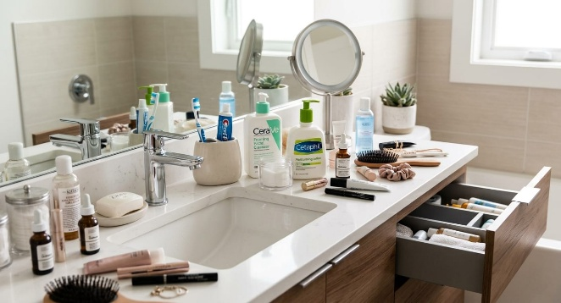
Figure 1. Water splash near washbasin area Figure 2. Cluttered vanity countertop

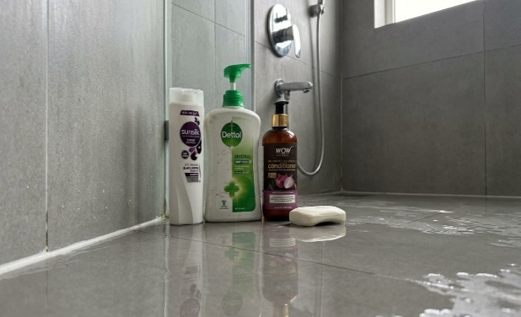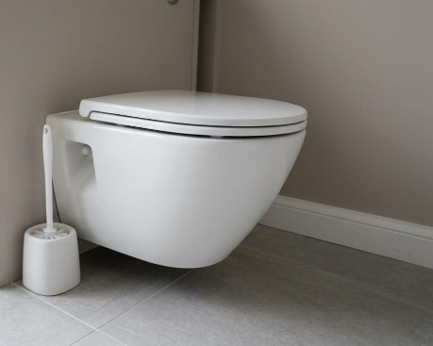
Figure 3. Inadequate shower storage area Figure 4. Accessibility issue near WC
    - A Google Form Survey
Google Form survey was conducted to collect user opinions and experiences regarding storage efficiency, clutter formation, accessibility, and washroom usability.The questionnaire included topics such as: Frequently cluttered areas ,Commonly used storage spaces ,Daily-use items kept outside storage ,Accessibility concerns ,Hygiene and cleaning difficulties and User satisfaction with available storage. The survey responses helped identify common behavioural patterns and recurring user concerns.
    - Face-to-Face Informal Interaction
Face-to-face informal interactions were conducted with selected participants to understand personal experiences, daily discomforts, storage habits, and usability challenges in compact washrooms. These discussions helped identify behavioural factors that were often not visible through observation alone, such as: Preference for keeping items outside storage ,Avoidance of difficult-to-access cabinets ,Convenience-based placement habits ,Hygiene concerns during cleaning activities.
    - Data Analysis
The collected data were analysed through observational interpretation, comparative assessment, behavioural analysis, and visual evaluation. Recurring clutter patterns, inefficient storage conditions, accessibility issues, and underutilised spaces were identified and categorised to understand their relationship with storage planning and user behaviour.

KEY ISSUE IDENTIFIED:

The observational study, survey analysis, comparative analysis, and visual documentation helped identify several recurring issues in compact residential washrooms. These issues affected usability, hygiene, storage efficiency, accessibility, and overall spatial functionality.
  - Clutter Accumulation Around Vanity Areas
The vanity and basin zones were identified as the most clutter-prone areas due to the placement of frequently used products such as toothbrushes, skincare items, soaps, towels, and grooming accessories. Limited countertop organisation and insufficient accessible storage resulted in visual congestion and reduced usable surface area.
  - Underutilisation of Vertical Spaces
Several compact washrooms showed inefficient utilisation of vertical wall surfaces. Large wall areas above WC units, beside mirrors, and near shower zones remained unused despite limited floor space availability.
  - Inaccessible Storage Planning
Many storage units, particularly under-sink cabinets and lower storage compartments, were found to be difficult to access. Users often avoided these areas due to bending discomfort and inconvenient reach, leading to partial usage of available storage.
  - Open Visibility of Daily-Use Products
Frequently used products were commonly kept outside storage units for convenience and accessibility. This created continuous visual clutter and reduced the organised appearance of the washroom environment.
  - Water Splash Affecting Nearby Items
Water splashes around basin and shower areas frequently affected nearby products, tissues, towels, and storage surfaces. Lack of proper wet-dry zoning contributed to damp conditions and hygiene-related discomfort.
  - Restricted Movement and Circulation
Floor clutter caused by buckets, stools, cleaning tools, and openly placed utility items reduced circulation efficiency within compact washrooms. Limited movement space affected user comfort and ease of cleaning.
  - Inefficient Wet and Dry Zoning
Several washrooms lacked clear separation between wet and dry areas, causing water spread across circulation and storage zones. This affected maintenance, usability, and long-term material performance.
  - Poor Cleaning Tool Organisation
Cleaning accessories such as toilet brushes, mops, wipers, and buckets were often left openly visible due to the absence of designated utility storage. This created visual clutter and reduced hygiene perception.
  - Lack of Behaviour-Responsive Storage
Storage systems were often designed based on ideal organisation rather than actual user habits. Users preferred accessible and visible storage for frequently used products, resulting in open clutter despite the availability of concealed storage.
  - Partial Usage of Existing Storage Spaces
The study revealed that users only partially utilised available storage spaces. Closed cabinets, corner shelves, and lower storage units were frequently ignored due to accessibility issues and inconvenient placement.
  - Poor Spatial Prioritisation in Compact Layouts
In several cases, fixture placement and storage positioning reduced the efficiency of compact washroom layouts. Essential activities such as movement, cleaning, and daily product access became difficult due to poor spatial planning.
  - Hygiene and Maintenance Challenges
Wet surfaces, difficult-to-clean corners, exposed utility items, and clutter accumulation increased maintenance difficulties and reduced overall hygiene comfort within compact washrooms.

RESULT AND ANALYSIS:
  - Overview Of Data Analysis
The collected data were analysed through survey responses, observational findings, and face-to-face informal interactions. The analysis focused on identifying recurring patterns related to clutter formation, storage usage, accessibility issues, hygiene concerns, and user behaviour in compact residential washrooms. The survey data helped in understanding common user experiences and preferences through quantitative responses, while the informal interactions provided deeper qualitative insights into everyday habits, frustrations, and practical usability concerns. Comparative interpretation of both methods helped establish the relationship between storage planning and spatial underutilisation within compact washrooms. The analysis revealed that clutter was not caused solely by limited space, but also by user convenience behaviour, inaccessible storage systems, poor zoning, and ineffective utilisation of available storage areas.
  - Google Survey Results
The Google survey was conducted with 50 participants consisting of homeowners, apartment residents, working professionals, homemakers, students living in PGs/flats, and family members using compact residential washrooms. The survey focused on clutter formation, storage behaviour, accessibility issues, hygiene concerns, movement restrictions, and user preferences related to storage systems.
6.2.1Key Findings:
- 82% of participants reported that their washrooms felt cluttered either frequently or sometimes during daily use.
- 44% identified the basin and vanity area as the most cluttered zone within the washroom.
- More than 70% of participants stated that frequently used products such as toothbrushes, skincare items, towels, and buckets remained outside storage units.
- 48% reported that items were mainly kept outside storage for easy accessibility and convenience.
- 52% of participants only partially used the available storage spaces in their washrooms.

- 84% experienced water splashes affecting nearby surfaces or stored items either frequently or sometimes.
- More than 75% reported movement discomfort due to floor clutter and compact layouts.
- 48% preferred a combination of open and closed storage systems for better functionality and organisation.
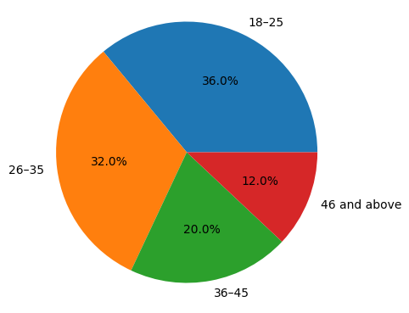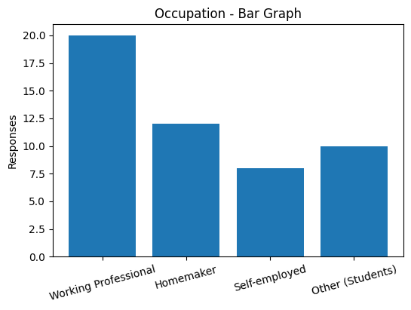
Fig. 5. Age Group Fig. 6. Occupation

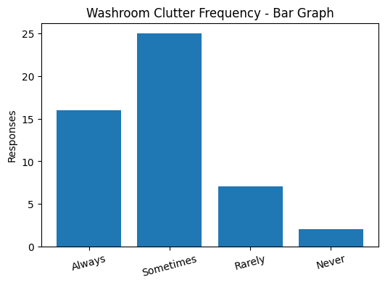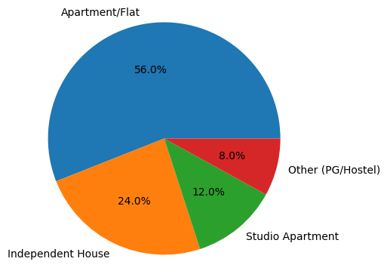
Fig.7. Washroom Clutter Frequency Fig. 8. Residence Type

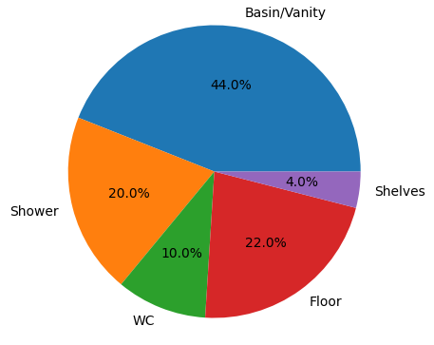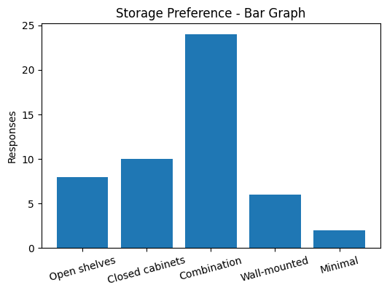
Fig. 9. Most Cluttered Area Fig.10. Storage Preference
The survey results indicated that clutter in compact residential washrooms was strongly influenced by user convenience behaviour and inefficient storage planning rather than lack of storage quantity alone. The concentration of clutter around vanity areas highlighted the importance of accessibility in daily routines. The findings also revealed that inaccessible storage systems, poor wet-dry zoning, and movement restrictions reduced the usability of compact washrooms. The strong preference for combined open and closed storage systems validated the need for user-centred, accessible, and behaviour-responsive storage solutions in compact washroom design.
  - Informal Interaction Results
Face-to-face informal interactions were conducted with homeowners, apartment residents, working professionals, homemakers, and family members using compact residential washrooms. The interactions focused on understanding everyday storage habits, behavioural patterns, usability concerns, hygiene discomforts, and user expectations from washroom spaces.
Key Findings:
- Most participants associated clutter with daily routines and repeated use of frequently accessed products.
- The basin and vanity area were consistently identified as the primary clutter accumulation zones.
- Users commonly preferred keeping daily-use items outside storage units for quick accessibility and convenience.
- Several participants stated that enclosed cabinets were either difficult to access, impractical, or uncomfortable for regular use.
- Water splash around the basin area was repeatedly identified as a major issue affecting nearby items and surfaces.
- Participants highlighted hygiene concerns related to toilet brush placement, wet countertops, and difficult-to-clean corners.
- Many users reported movement discomfort caused by floor-level storage items and open cabinet shutters in compact layouts.
- Most participants preferred practical improvements such as vertical storage, concealed utility storage, accessible shelving, and better organisation systems.

Sr. No. | Question | Participant Type | Response
1 | Does your washroom feel cluttered during daily use? | Homeowner | Yes, especially during busy morning hours when multiple products are used together.
 |  | Housewife | Daily-use products increase over time, so the vanity area gets cluttered quickly.
 |  | Working Individual | The washroom feels cluttered because there is not enough organized storage for quick access.
2 | Which area of the washroom feels the most cluttered? | Apartment Resident | The basin and vanity area feel the most cluttered because frequently used products are kept there.
 |  | Family Member | The floor area becomes cluttered due to buckets, mugs, and cleaning items.
3 | Which items usually remain outside storage units? | Housewife | Toothbrushes, skincare products, soaps, and hair products usually remain outside.
 |  | Working Individual | Daily-use items stay outside because repeatedly opening cabinets feels inconvenient.
4 | Why do you think items are kept outside instead of inside storage? | Homeowner | Mostly because they are easier to access quickly.
 |  | Apartment Resident | The storage units are either too small or difficult to reach regularly.
 |  | Family Member | Sometimes the inside storage becomes wet, so items are kept outside.
5 | Do you use all the storage spaces available in your washroom? | Housewife | No, some shelves are difficult to reach and not practical for daily use.
 |  | Working Individual | Only the easily accessible storage areas are used regularly.
6 | Do water splashes affect nearby items or surfaces? | Homeowner | Yes, tissues and products near the basin often become wet.
 |  | Family Member | The countertop remains wet most of the time, affecting nearby products.
7 | Are there any areas in the washroom that feel uncomfortable or unhygienic? | Apartment Resident | The toilet brush placement feels uncomfortable because it is too close to the WC.
 |  | Housewife | Cleaning corners below the sink feels difficult and unhygienic.
8 | Do you feel there is enough movement space inside the washroom? | Working Individual | Movement becomes difficult when multiple items are placed on the floor.
 |  | Family Member | The washroom feels tight when cabinet shutters remain open.
9 | Which storage type do you prefer and why? | Homeowner | A combination of open and closed storage works best.
 |  | Housewife | Closed storage looks organised, but open shelves are easier for daily use.
 |  | Apartment Resident | Wall-mounted storage helps save floor space.
10 | What improvement would you most like in your washroom? | Working Individual | Better organization for daily-use products.
 |  | Housewife | Less water splash around the basin and more practical storage.
 |  | Homeowner | Better use of vertical space and concealed storage for cleaning items.

Informal Interaction Responses Table
The informal interactions revealed that user behaviour and convenience-based habits significantly influenced clutter formation and spatial inefficiency in compact washrooms. The findings demonstrated that users naturally prioritised quick accessibility over concealed organisation, especially during daily routines. Accessibility limitations, poor storage placement, and inadequate zoning encouraged alternative storage behaviours that contributed to visible clutter. The responses also highlighted the importance of hygiene-sensitive detailing and movement-friendly layouts. Overall, the interactions validated the need for flexible, accessible, and user-oriented storage planning that responds to actual behavioural patterns rather than purely aesthetic storage arrangements.

7. DISCUSSION:
The study explored the relationship between storage planning, user behaviour, clutter formation, and spatial underutilisation in compact residential washrooms. The findings from the survey analysis, observational study, and informal interactions collectively revealed that clutter in compact washrooms is not caused solely by limited space availability, but also by the mismatch between designed storage systems and actual user behaviour.The survey results demonstrated that most users experienced clutter frequently during daily use, particularly around the basin and vanity areas. This indicated that these areas function as primary activity zones where users naturally prefer to keep frequently accessed products within immediate reach. The findings suggested that accessibility and convenience strongly influence storage behaviour, often more than the quantity of storage provided.
The informal interactions further supported this observation, as participants repeatedly expressed discomfort with inaccessible cabinets, impractical shelf heights, and inconvenient enclosed storage systems. Users tended to develop convenience-based habits by placing daily-use products openly on countertops or near activity zones. This behavioural tendency contributed significantly to visible clutter accumulation and reduced spatial organisation.The research also highlighted that several existing storage areas remained partially unused or underutilised, particularly under-sink cabinets and enclosed lower storage units. These findings suggested that storage planning in compact washrooms often prioritises visual organisation or aesthetic appearance without fully considering user accessibility and everyday behavioural patterns.
Water splash emerged as another recurring usability issue within the study. Participants reported that wet countertops, damp tissues, and moisture-affected products contributed to discomfort, hygiene concerns, and clutter formation. The lack of proper wet-dry zoning around basin areas reduced both functional efficiency and maintenance convenience. This demonstrated that small detailing decisions within compact spaces can significantly affect user experience. Movement restriction was also identified as a major issue in compact washrooms. Floor-level storage items such as buckets, mugs, and cleaning products reduced circulation space and created discomfort during movement. In several cases, open cabinet shutters further obstructed circulation within narrow layouts. These findings indicated that poor spatial planning can negatively impact usability even when storage is technically available.
The study additionally revealed that users preferred flexible and practical storage systems rather than completely concealed or visually minimal storage solutions. The majority of participants favoured a combination of open and closed storage systems, allowing both accessibility and visual organisation. Vertical wall-mounted storage and concealed utility storage were also identified as preferred design interventions. Overall, the discussion highlighted that successful compact washroom design depends not only on increasing storage quantity but also on understanding user behaviour, accessibility needs, movement patterns, hygiene concerns, and daily routines. The research demonstrated the importance of user-centred and behaviour-responsive storage planning in improving usability, organisation, and spatial efficiency within compact residential washrooms.

8. DESIGN INTERVENTIONS:
The design interventions focused on improving usability, storage efficiency, hygiene, circulation, and spatial utilisation in compact residential washrooms. The interventions were developed based on observational findings, user behaviour analysis, and recurring clutter-related issues identified during the study. The proposed interventions aimed to create user-responsive washroom environments that balanced accessibility, organisation, and movement within limited spatial conditions.
8.1 Vanity and Counter Organisation
The vanity and basin areas were identified as the most clutter-prone zones due to the accumulation of frequently used products such as toothbrushes, skincare items, towels, and grooming accessories. Open countertop usage reduced functional working space and contributed to visual clutter. The intervention proposed: recessed mirror storage, divided vanity drawers, floating vanities ,dry ledges beside basin areas ,combination storage systems with both open and concealed compartments These interventions aimed to improve accessibility while reducing surface congestion.
8.2 Wet and Dry Zoning
Water splash and wet surface conditions affected nearby products, movement comfort, and hygiene maintenance. In compact washrooms, improper separation between wet and dry areas contributed to clutter accumulation and cleaning difficulties. The intervention proposed: glass partitions , splash-resistant zoning ,improved floor slope planning , drain channel integration and elevated dry storage zones These strategies aimed to improve spatial organisation and reduce water spread across circulation areas.
8.3 Vertical Storage Utilisation
The study observed that several vertical surfaces within compact washrooms remained underutilised despite limited floor area availability. The intervention proposed: wall-mounted storage units recessed niches floating shelves ,mirror cabinets and overhead storage above WC zones These interventions increased storage capacity without affecting movement space
8.4 Accessible Storage Planning
Several users avoided lower cabinets and concealed storage due to bending discomfort and difficult accessibility. Frequently used items were therefore kept outside storage units for convenience. The intervention proposed: pull-out storage trays ,sliding organisers ,category-based storage compartments ,easy-access shelving ,open storage for frequently used products The interventions aimed to align storage planning with actual user behaviour patterns
8.5 Shower Area Organisation
The shower area often experienced clutter due to bottles, soaps, buckets, and utility items placed on the floor. This reduced circulation space and increased cleaning difficulty. The intervention proposed: recessed shower niches ,corner-mounted shelves wall-mounted dispensers and compact hanging storage systems These interventions aimed to reduce floor obstruction while improving accessibility.
8.6 Hygiene-Oriented Interventions
Micro-level usability issues such as wet tissues, exposed cleaning tools, difficult-to-clean corners, and unhygienic placement of toilet accessories affected user comfort and maintenance. The intervention proposed: concealed cleaning-tool storage , wall-mounted holders, floating units for easier cleaning, ventilated storage systems, anti-splash detailing near basin zones.These interventions focused on improving hygiene maintenance and reducing visual discomfort.
  - Circulation and Movement Optimisation
Restricted movement due to floor clutter and compact layouts reduced washroom usability and comfort.The intervention proposed: floor-free storage solutions ,wall-mounted accessories ,compact fixture alignment ,defined circulation clearances, integrated utility storage These strategies aimed to improve movement efficiency within compact spaces.
8.8 Behaviour-Responsive Storage Design
The research indicated that users prioritised convenience and accessibility over completely concealed organisation. Frequently used products were intentionally kept visible and easily reachable despite available storage. Therefore, the intervention proposed: mixed open and closed storage systems ,accessible daily-use zones ,behaviour-responsive storage placement and simplified storage organisation .The interventions acknowledged real user habits and focused on designing spaces according to practical daily behaviour patterns rather than idealised organisation systems.
8.9 Reference Washroom Layouts Supporting the Proposed Interventions
Some residential washroom designs that align with the identified spatial issues and proposed interventions are illustrated below. These layouts demonstrate compact planning approaches, zoning strategies, circulation management, and opportunities for improved storage integration within limited washroom spaces.
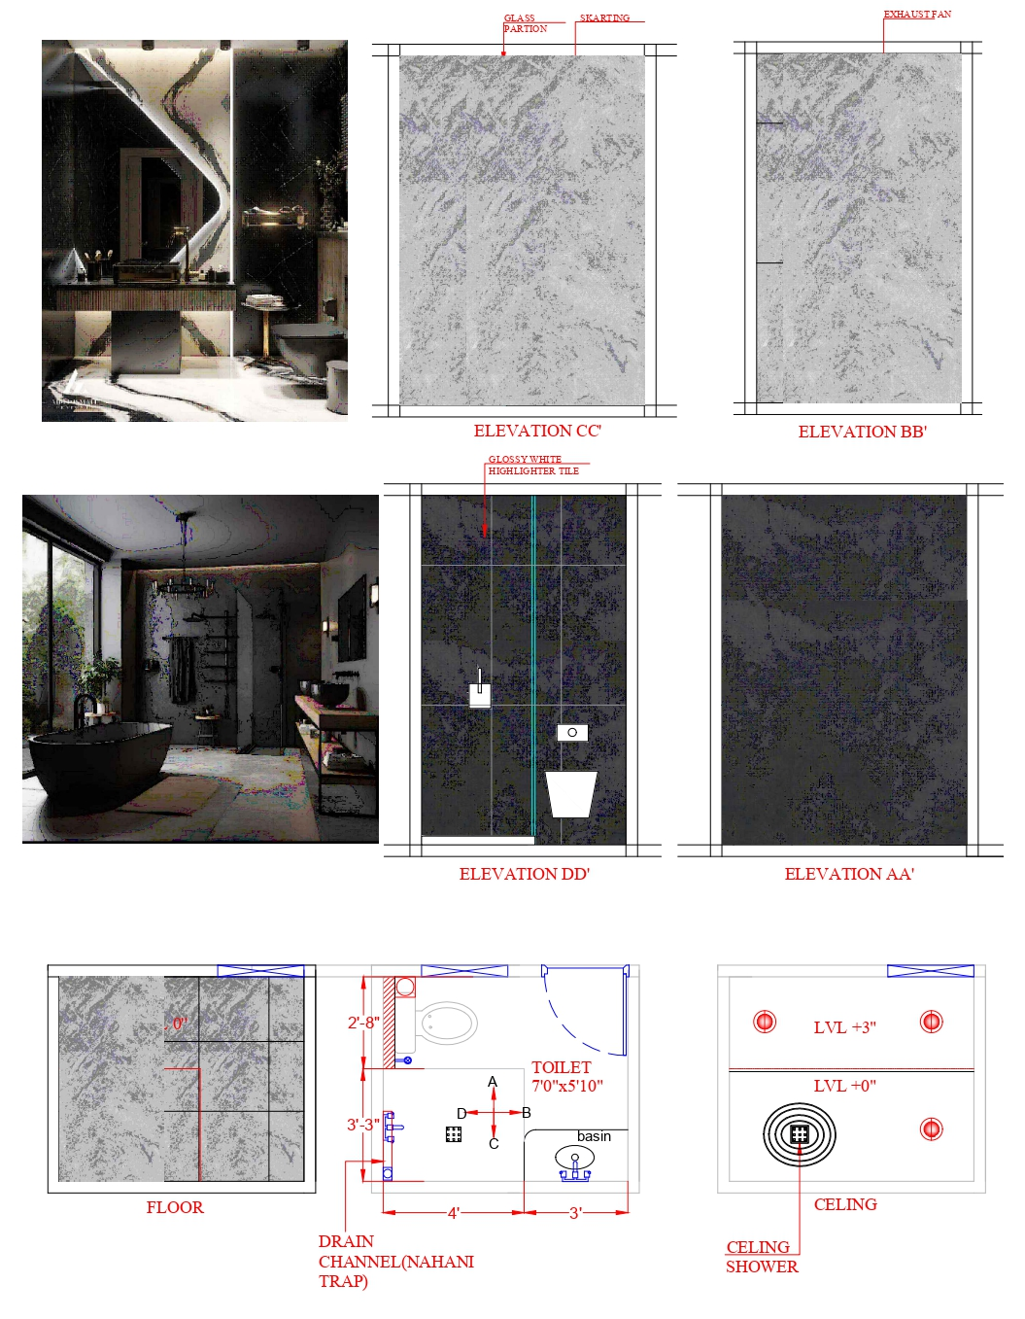Option 1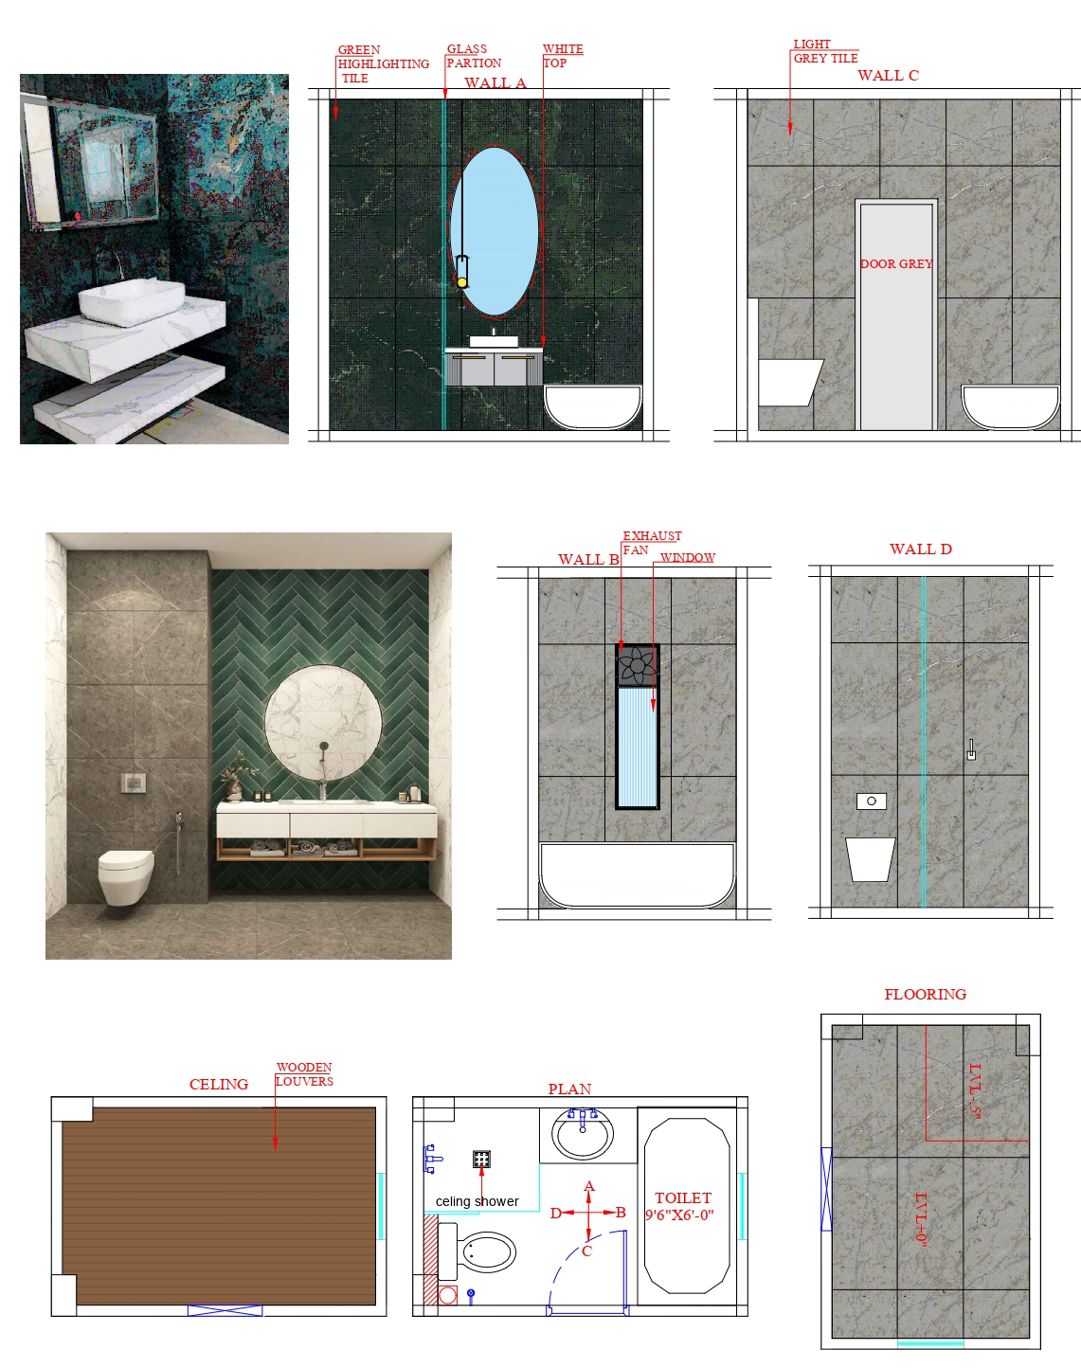
Option 2
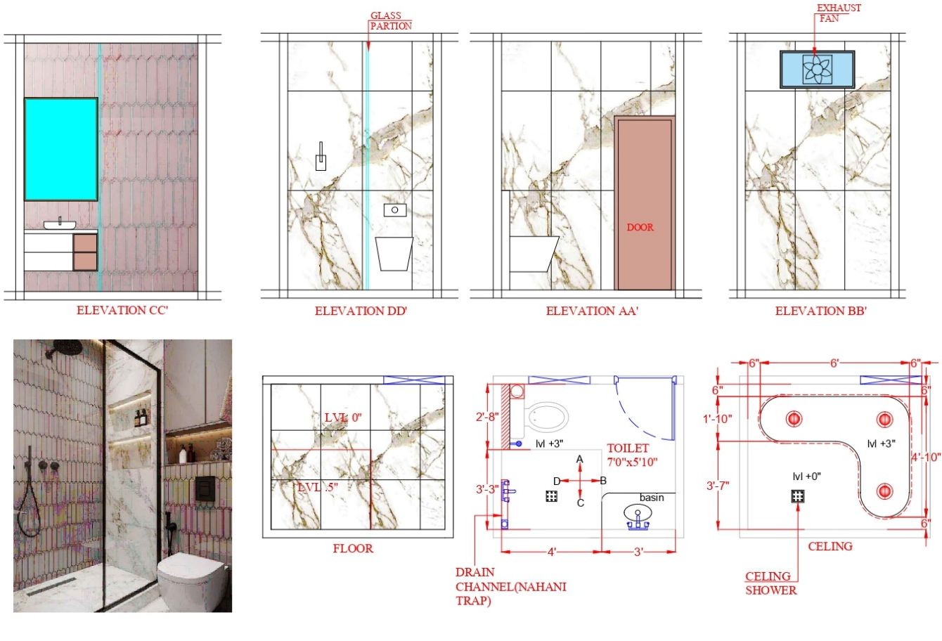Option 3

9. RESULTS:
The research findings revealed that clutter and spatial underutilisation in compact residential washrooms were strongly influenced by both storage planning and user behaviour. The study demonstrated that the presence of storage alone did not ensure functional organisation or efficient space utilisation.
The survey analysis showed that most participants experienced clutter frequently during daily use, particularly around basin and vanity areas where frequently accessed products accumulated. Items such as toothbrushes, skincare products, towels, cleaning supplies, and buckets were commonly kept outside storage units for convenience and quick accessibility.
The study also revealed that many existing storage spaces remained partially unused due to accessibility limitations, impractical placement, and inconvenient cabinet design. Under-sink cabinets and enclosed lower storage areas were identified as some of the least utilised storage spaces within compact washrooms.
Water splash around basin areas emerged as a recurring usability issue affecting nearby products, surfaces, and hygiene conditions. Wet countertops, damp tissues, and moisture accumulation contributed to discomfort and increased maintenance requirements. The findings indicated that insufficient wet-dry zoning negatively affected both usability and spatial organisation.
Movement restriction was another significant issue identified during the research. Floor-level storage items, cleaning products, buckets, and open cabinet shutters reduced circulation space and created discomfort within compact layouts. The research demonstrated that even minor spatial obstructions significantly impacted movement efficiency in limited spaces.
The informal interactions further revealed that users naturally prioritised convenience and accessibility over concealed organisation systems. Frequently used products were intentionally kept visible and within immediate reach, regardless of available storage capacity. This highlighted the gap between intended storage functionality and actual behavioural practices.
The study additionally found that users preferred flexible and accessible storage systems that combined both open and closed storage elements. Vertical storage solutions and wall-mounted storage systems were also perceived as more efficient in compact washroom environments.
Overall, the results established that clutter formation and spatial inefficiency in compact residential washrooms were not solely caused by limited area but by inadequate user-centred storage planning, accessibility issues, movement restrictions, and behavioural convenience patterns. The findings emphasised the need for behaviour-responsive and function-oriented design strategies to improve usability and spatial efficiency in compact washroom spaces.

REFERENCES:
1.Watson R, Mukheibir P Falletta J & Fane S (2018). The Bathroom of the Future – Prospects for Information and Control, prepared by the Institute for Sustainable Futures (UTS) for the GWA Bathrooms and Kitchens Group. http://hdl.handle.net/10453/128777
2.Lau, S.S. (2011). Physical Environment of Tall Residential Buildings: The Case of Hong Kong. In: Yuen, B., Yeh, A. (eds) High-Rise Living in Asian Cities. Springer, Dordrecht. https://doi.org/10.1007/978-90-481-9738-5_3
3.Gürel, M. Ö. (2008). Bathroom as a modern space. The Journal of Architecture, 13(3), 215–233.https://doi.org/10.1080/13602360802214943
4.Jha, P.C. and Aggarwal, R. (2024). Short Communication: Optimising Bathroom Space, Design and Aesthetics. Educational Quest: An Int. J. Edu. Appl. Soc. Sci., 15(02): 61-64. 10.30954/2230-7311.2.2024.3
5.Trabucco, D., Costa, M., & Tatano, V. (2026). User Preferences on Toilet Features and Layout: Observations from a Homogeneous Sample of Users in a University Building. Buildings, 16(5), 919.https://doi.org/10.3390/buildings16050919
6.Evgeny Orlov (2020). IOP Conf. Ser.: Mater. Sci. Eng. 869 042010 https://doi.org/10.1088/1757-899X/869/4/042010
7.Marco, E. (2022). Stuff and space in the home: space for storage as the forgotten design and well-being dimension in standardised housing. The Journal of Architecture, 27(5–6), 708–733. https://doi.org/10.1080/13602365.2022.2142269
8.CHOI, Jungmin & WANG, Yake. (2026). Quantitative Analysis of Contemporary Residential Bathroom Design Through AI Visual Recognition: Object-Design Characteristic Mapping of 1,500 Cases. Journal of South Architecture. 3. 10.33142/jsa.v3i1.18732. 10.33142/jsa.v3i1.18732
9.Sunmi Kim, Youngho Han (2017). A Study on Residential Bathroom Storage Cabinet Trends with Focus on Storage Space in the Bathroom Package of Domestic Companies. Journal of Korea Institute of Spatial Design, 12(3), 11 - 23.10.35216/kisd.2017.12.3.11
10.Williams, K. (2009). Space per person in the UK: A review of densities, trends, experiences and optimum levels. Land Use Policy, 26(1), S83–S92. https://doi.org/10.1016/j.landusepol.2009.08.024

