Integrating Inferential Statistics and Machine Learning for Customer Churn Prediction: A Comparative Study of Model Performance and Influencing Factors

Abstract — Customer churn affects business growth significantly. This study addresses the limitation that centers mainly on either predictive accuracy or statistical interpretability by introducing a unified framework. By integrating inferential statistics (t-test) with machine learning (logistic regression, SVM, random forest, decision tree) and explainability tools (SHAP), the study identified the key churn influencing factors. The result shows that support calls and total spend are the main causes of churn, while SVM and logistic regression achieve an effective discrimination balance (ROC-AUC of 0.770) and recall.
Keywords—Customer Churn, Machine Learning, Inferential Statistics, Logistic Regression, SVM, Explainable AI
I. INTRODUCTION
Customer churn can be defined as the process where customers discontinue their paid services, this causes widespread problems across business domains such as telecommunications, banking and digital platforms, influencing low revenue, profitability and long-term sustainability [1]. Market competition is majorly driven by the quest to acquire new customers which is more cost intensive than retaining existing ones, highlighting the need for effective customer churn plans [2]. Organizations where data is readily available leverage on it to derive insights, analyze customer patterns and predict churn behaviour. Statistical methods have been employed traditionally to model customer behaviour and predict churn outcomes, among these logistic regression has been used on many occasions by researchers due to its interpretability in predicting churn outcomes based on explanatory variables [3]. The approach is classified under the wider domain of inferential statistics, which encompasses drawing conclusions about a population based on sample data, mostly through hypothesis testing and estimation techniques [4]. Inferential statistics is extremely important in identifying significant factors influencing churn, such as customer tenure, service usage patterns and structured pricing. In recent times, machine learning has gained widespread attraction by transforming predictive analytics with models that can learn patterns from data without being explicitly programmed. Machine learning can be defined as a subfield in artificial intelligence where models learn complex patterns heuristically [5]. Machine learning techniques such as decision tree, random forest, and support vector machine are able to capture non-linear relationships and interactions among variables, improving predictions [6]. Despite the increased prediction power of machine learning models, it lacks interpretability where many advanced models operate as black boxes, making it hard to understand the factors influencing the prediction. This poses a serious challenge in business domains where transparency and explainability are demanded for decision making and regulatory compliance[7]. In contrast, statistical inference provides meaningful insights but is limited in the ability to model complex relationships in high-dimensional data. Recent studies have suggested the importance of integrating inferential statistics techniques with machine learning approaches to achieve both reliable prediction and interpretability. Such combination will enable researchers to perform accurate prediction while identifying the key variable relationships influencing customer churn, however existing literature often focuses either on model performance comparison or statistical significance analysis, failing to capture both approaches holistically in a unified framework. This study aims to address that limitation by conducting a comparative analysis of machine learning model performance alongside inferential statistical methods to analyze and predict customer churn behaviour. Specifically, this work will evaluate the performance of multiple machine learning algorithms while actively identifying the key variables influencing customer churn. By integrating these methods, the research will provide valuable insights, contributing to effective customer retention strategies.
II. LITERATURE REVIEW
Customer churn prediction has become a vital part of research due to its impact on profits in organizations, especially services that require subscriptions such as telecommunications, banking and digital services. The demand for large customer-based data has also grown exponentially because of its useful importance for analysis ranging from statistical models to advanced machine learning techniques.
Statistical and probabilistic approaches
Early works in churn prediction were majorly done by statistical and probabilistic models, especially those grounded in survival analysis and stochastic processes, most models like Pareto/NBD and BG/NBD frameworks gained widespread use in estimating customer lifetime value and predicting churn probabilities based on transaction patterns [15]. These models assume that the activities of a customer follow probability distributions, enabling the modelling of purchase frequency and attrition rates over time. Bayesian extensions of these models make it better, increasing the predictive performance by incorporating previous knowledge and dynamically updating probabilities as new data becomes available [8]. However, these models are limited by strong assumptions regarding customer behavioural patterns and may find it difficult to adapt to challenging real-world environments which are marked by irregular activity patterns and external influences such as seasonality. While statistical methods thrive due to strong interpretability and theoretical grounding, they lack flexibility to handle high-dimensional data, which has led to broader adoption of machine learning.
Machine Learning Approaches to Churn Prediction
The adoption of machine learning in churn prediction has had enormous impact, enhancing predictive capabilities while actively modelling complex patterns within large datasets. Churn prediction is typically formulated as a binary classification problem where customers are regarded as either a churner or non-churner based on past records [14], machine learning algorithms have been applied, which include logistic regression, decision tree, support vector machines and ensemble methods like random forest and gradient boosting [12]. Most ensemble techniques particularly demonstrate strong performance due to their ability to reduce overfitting and improve generalization. Present research has also introduced deep learning architectures capable of modelling complex behavioural patterns. Neural networks demonstrate enhanced predictive power in different churn prediction tasks [18], however despite predictive power it has been criticized due to the drawback in interpretability, as it is regarded as a black-box system.
Explainable models and feature importance
To tackle interpretability and feature importance, recent research tends to focus more on explainable artificial intelligence techniques, introducing methods such as SHAP which allow the identification of important features and provide insight into the influence of individual variables on model predictions [10], [11]. Hybrid frameworks which combine ensemble learning with explainability techniques have been shown to improve both predictive performance and transparency. These methods are invaluable in business settings where understanding the drivers of churn is key to its prediction [10].
Evaluation Metrics and Business Relevance
An important limitation in churn prediction research lies in the evaluation of model performance. Most traditional metrics such as accuracy, precision, recall and F1 score are prevalent but may not adequately capture business impact [9]. Recent studies state the vitality of using business-oriented metrics such as customer lifetime value and retention costs in model evaluation [13]. Additionally, the problem of imbalanced classes in datasets has been addressed widely by using techniques such as oversampling and cost-sensitive learning [17].
Research Gap
Although many studies have worked extensively on churn prediction, several gaps exist. Statistical models provide explainability but lack flexibility, while machine learning excels in improved predictions but has limited explainability. Furthermore, most studies fail to capture the two fields in one unified framework. Also, there is limited research in the examination of the relationship between statistically significant variables and features identified by machine learning models. This makes churn prediction less applied in real-world decision making.
This study will address these limitations by combining inferential statistical analysis with machine learning techniques under a unified framework. The study compares multiple machine learning algorithms to identify the model with the best outcome while identifying the key variables influencing customer churn.
III. METHODOLOGY
- Data selection and description
This study used a secondary dataset sourced from Kaggle, a large online dataset repository, and anonymised which makes it suitable for academic research. The dataset met all the ethical and legal requirements and does not contain any personal information regarding a person or group. Therefore, satisfying the GDPR requirement of ethical regulations and privacy protection. Customer churn is defined as the discontinuation of a paid service. In the dataset, churn is represented as a binary variable where one value signifies the customer discontinuation of the service and the other shows retention. The dataset contains churn-related attributes which are key in building an effective customer retention strategy. The features contain information such as service usage patterns, account-related features such as tenure and pricing structure. Also, the presence of explanatory variables and a well-defined target variable makes it more relevant for performing inferential statistical analysis and machine learning modelling.
- Research Question and Hypothesis
This study is guided by the below research question.
How good can the integration of inferential statistical methods and machine learning models improve customer retention strategy? To answer this question, the following hypothesis is formulated. The null hypothesis states that no relationship exists between customer characteristics and churn behaviour, while the alternative hypothesis states otherwise that a relationship exists between customer characteristics and churn behaviour.
- Analytical Framework
The method used in this research integrates inferential statistical analysis and machine learning in a unified framework, this is to obtain explanatory insights and prediction accuracy.
- Inferential Statistical Analysis
Inferential statistics methods were employed to examine the relationship between independent variables and customer churn. To further conduct an investigation between two groups, sample t-tests were employed to compare the means of key variables between churned and non-churned customers. This makes it easy to identify significant differences in features such as tenure or service usage. In These interval ensures robustness of the conclusion drawn from data. Logistic regression served as both inferential and predictive statistical model
- Machine Learning Modelling
Several machine learning models were implemented to predict customer churn, logistic regression serves as the baseline model. Decison tree model were employed to capture non-linear relatioship. Random forest was also used as an ensemble machine learning method to improve prdictive outcomes by reducing overfitting and improvoing training stability. Support vector machine was adopted to adapt to high dimesonality of the dataset and optimised decision boundaries. The choice of these models its because of their abbilty to handle structured dataset and capture complex relatioship additonally the model perfomance is evaluated using various metrics to ensure statisitcal and business relevance metrics such as accuracy,precision, recall, f1 score, and ROC-AUC are used to check classification perfomance, also misclassification cost was not considered particulary false negaitves where churned customes are not noted due to its impact on customer retention stratgies. Lastly class imbalance were adressed using resampling techniques to reduce bais.
- Model interpratbility and intergration
To close the gap between statitcal inference and machine learning interpretability methods such as feature selction were used to identify the most influential features while model agnostic methods like SHAP explained predictions indivually . the combine approach eanbles effective validation of results providing predictive insights and therorical grounding.
IV. RESULT AND DISCUSSION
This chapter presents the results of the methodology used in the unified machine learning and inferential statistics framework to analyze customer churn behavior. The methodology evaluated variable independence against customer churn to answer the core research question. The study combined statistical hypothesis testing (t-test) with advanced predictive modelling. This section shows the main factors influencing customer churn while measuring the effectiveness of varying algorithm approaches.
- Inferential Statistical Analysis
To identify the baseline features between retained and churned customer groups, independent sample t-tests were conducted across continuous variables. Specifically, the study reviewed the difference between customer tenure, total spend and support calls.
Table I
T-Test Results for Key Churn Variables
Variable | Churn Mean | Non-Churn Mean | T-Stat | P-Value
Tenure | 30.4736 | 32.2818 | -34.586 | 0.0
Total Spend | 541.2855 | 749.9531 | -338.9106 | 0.0
Support Calls | 5.1449 | 1.5864 | 512.5523 | 0.0

Customer Tenure
The result from the t-test for customer tenure showed that a statistically significant difference between groups exists. Customers who terminated the service had a tenure of 30.47 months on average, whereas retained customers showed a higher average tenure of 32.28 months (t = -34.58, p < 0.001). This indicates that new customers are more likely to churn, whereas long-term engagement builds loyalty.
Total Spend
In total spend, there was a huge financial variation (t = -338.91, p < 0.001). Retained customers spend $749.95 on average, while customers who churned spent less, $541.28 on average. This shows low financial commitment or engagement level which correlates strongly with churn possibility.
Support Calls
Increase in support calls showed the most distinct separation between classes (t = 512.55, p < 0.001). Churners made 5 to 14 support calls on average, while 1.58 calls were made by non-churners. This trend shows regular interaction with support services signifies dissatisfaction or abandoned technical issues leading to termination.
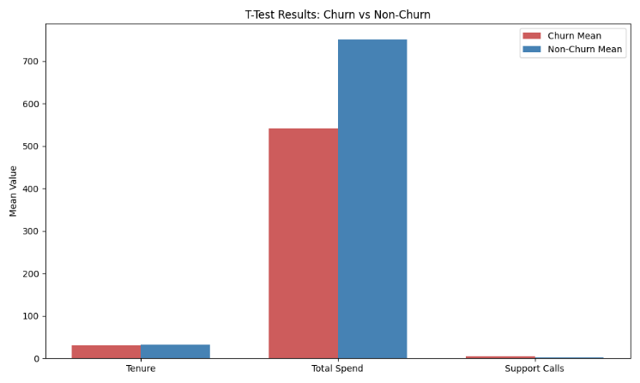
Fig. 2. T-Test Results Churn vs Non churn .

- Machine Learning Modelling Performance
Four distinct machine learning algorithms were trained to enable predictive analysis. Logistic regression (serving as the baseline model), decision tree, random forest and support vector machine (linear SVC) were trained. Also, random undersampling methods were applied to address class imbalance with strong prioritization for recall to reduce false negatives drastically. The models performance were measured using the metrics in the table below:
Table II
Machine Learning Evaluation Metrics
Model | Accuracy | Precision | Recall | F1-Score | ROC-AUC
Logistic Regression | 60.06% | 54.37% | 97.48% | 69.81% | 0.770
Support Vector Machine | 60.31% | 54.54% | 97.36% | 69.91% | 0.770
Random Forest | 51.16% | 49.23% | 99.81% | 65.94% | 0.695
Decision Tree | 50.87% | 49.08% | 99.82% | 65.81% | 0.533

- Model Evaluation
The model was trained to minimize false negatives which is critical in customer retention strategies. Recall was optimized strongly across all models (97%–99%). This trade-off decreased global accuracy and precision between the evaluated algorithms. Logistic regression and SVM showed the strongest ability to discriminate, reaching a leading ROC-AUC score of 0.770 with SVM slightly outperforming logistic regression accuracy (60.31%) with an F1 score of (69.91%), while ensemble models aggressively identified churners (99.81% recall) but showed weaker ability to distinguish true positives from false alarms with a decreased ROC-AUC of 0.695. Consequently, the linear models logistic regression and SVM were proven to be the most effective architectures for identifying churners while maintaining critical statistical decision boundaries on this specific dataset.
- Model Interpretability and Feature Importance
To get rid of the black-box dilemma in machine learning model explainability, Gini feature importance (derived from random forest) alongside Shapley Additive Explanation (SHAP) logic were integrated to achieve theoretical grounding.
- Primary Driver of Churn
Both interpretability methods aligned on identifying that support calls and total spend are the main dominant predictive indicators of customer churn. Support calls showed the highest predictive influence (Random Forest importance: 0.33, SHAP impact: 0.18). This aligns with the inferential statistics phase, showing regular support calls is a major setback leading to churn.
Total spend followed as the second most pivotal variable (Random Forest importance: 0.24; SHAP impact: 0.13), indicating that increased volume of monetary flow translates to account retention probabilities.
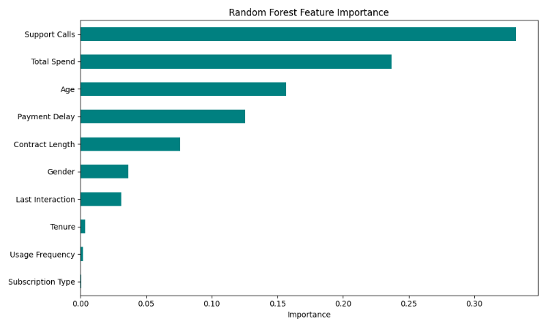
Fig. 2. Random Forest feature importance ranking for churn prediction.

- Secondary Influence
Variables like payment delay and age showed minimal influence on predictive decision boundaries. Conversely, demographic factors like gender and subscription type contributed minimal variance to the predictive splits, mathematically making them less important for proactive churn intervention strategies.
V. CONCLUSION
The results strongly rejected the null hypothesis, establishing that a powerful statistically significant relationship exists between customer characteristics and churn behaviour. The integration of inferential statistics validated machine learning outputs seamlessly. The identification of support calls and total spend as highly divergent variables via t-test aligned perfectly with the machine learning SHAP and feature importance metrics. This unified framework validates that businesses should prioritize retention interventions toward improving technical support resolution while monitoring spend reduction carefully. Using calibrated support vector machines or logistic regression allows for effective prediction in real time.
REFERENCES
[1] W. Verbeke, K. Dejaeger, D. Martens, J. Hur, and B. Baesens, “New insights into churn prediction in the telecommunication sector,” European Journal of Operational Research, vol. 218, no. 1, pp. 211–229, 2012.

[2] E. W. T. Ngai, L. Xiu, and D. C. K. Chau, “Application of data mining techniques in customer relationship management,” Expert Systems with Applications, vol. 36, no. 2, pp. 2592–2602, 2009.

[3] D. W. Hosmer, S. Lemeshow, and R. X. Sturdivant, Applied Logistic Regression, 3rd ed. New York: Wiley, 2013.

[4] G. Casella and R. L. Berger, Statistical Inference, 2nd ed. Pacific Grove: Duxbury, 2002.

[5] T. M. Mitchell, Machine Learning. New York: McGraw-Hill, 1997.

[6] L. Breiman, “Random forests,” Machine Learning, vol. 45, no. 1, pp. 5–32, 2001.

[7] C. Rudin, “Stop explaining black box machine learning models,” Nature Machine Intelligence, vol. 1, pp. 206–215, 2019.

[8] A. Bhatnagar and S. Srivastava, “Customer churn prediction using machine learning approach: A comprehensive study,” Journal of Information Systems Engineering and Management, 2025.

[9] R. Chaudhary, N. Sharma, and A. G. Pal, “Customer churn prediction using AI and big data analytics,” 2025.

[10] A. El Attar and M. El-Hajj, “Explainable AI-driven customer churn prediction: a multi-model ensemble approach with SHAP-based feature analysis,” Frontiers in Artificial Intelligence, 2026.

[11] J. Maan and H. Maan, “Customer churn prediction model using explainable machine learning,” 2023.

[12] A. Manzoor, M. A. Qureshi, E. Kidney, and L. Longo, “A review on machine learning methods for customer churn prediction,” IEEE Access, 2024.

[13] A. Velu, “Customer churn management using predictive modeling – a machine learning approach,” 2021.

[14] H. Wu, “A high-performance customer churn prediction system based on self-attention,” 2022.

[15] D. Zammit and C. Zerafa, “A simplified and numerically stable approach to the BG/NBD churn prediction model,” 2025.

[16] X. Chen et al., “A comprehensive analysis of churn prediction in telecommunications using machine learning,” 2025.

[17] L. Wang et al., “Time-sensitive customer churn prediction based on PU learning,” 2018.

[18] A. Sherill and R. Porkodi, “Customer churn prediction using deep learning,” 2025.

[19] S. Singh et al., “Advanced machine learning methods for churn prediction in telecom sector,” 2025.

