ARDUINO-BASED MULTI-SENSOR SMART HOME AUTONOMOUS SECURITY SYSTEM

Abstract: Home security has become more important day by day because there are many cases of people getting into the house without permission . It's not just a basic need nowadays it becomes almost necessary. This paper describes a low budget system that uses facial recognition to control the door . We can easily build this system with basic hardware and software. This system runs on open CV and local binary pattern histogram (LBPH) algorithm. A python program is used to recognise faces .A servo motor opens or closes the door based on the result. If any person is found , a buzzer and LED will go off. An email with the captured images sent to the user at the same time. This system also has voice control, we can control things like fan, light, doors, with our voice. This feature makes things easier, but it might not work in all situations. The system was almost 90% accurate during the test . There were no falls positives during the test. Most of the time the response time is around 0.06-1. The result shows that the low cost part can be used to make the system work .
Index Terms—Arduino Uno, face recognition, LBPH, Haar Cascade, voice control, home automation, smart home security, Internet of Things.

I. INTRODUCTION
The increasing demand for safety, convenience and energy efficiency has driven rapid growth in Smart home Technology. traditional security systems and manual appliance control are often inconvenient and limited in functionality. this paper proposes and autonomous Smart home security and automation system that combines biometric security with voice control automation using low cost components.
The system offers two primary functionalities: (1) voice based control for home appliances (like fan and lights) and (2) face recognition base door access with intruder alert capability. a webcam continuously monitors the entrance area. upon detection of an authorised face, servo Motor unlock the door. unknown face trigger image capture and email notification to the home owner. All heavy computation is handle by Python on laptop while Arduino UNO manage real time activate all control through UART serial communication.

II. LITERATURE REVIEW

2.1 Smart Home Automation System Using Arduino and IoT

Authors: S. S. Patil, P. A. Patil, and S. S. Kulkarni
Publication Year: 2020
The paper presents Smart home automation system using arduino and iot for remote control of house appliance. the authors develop a system that allows user to control lights and fan through a mobile application the study highlights the limitation of traditional manual switching system and demonstrate how IOT integration can improve convenience and energy efficiency.
Research Gap: The system legs advance security features like facial recognition. this paper concludes that low-cost embedded platform can play a major role in developing affordable Smart home solution.

2.2 Face Recognition Based Smart Door Lock System Using OpenCV and Arduino

Authors: R. Kumar and S. Sharma Publication
Year: 2022
This work purposes face recognition based automatic door lock system using open CV and Arduino. the system user uses Haar cascade for fish direction and LBPH algorithm for recognition. when an authorised face is detected the sarvo motor unlocked the door. the author reported good accuracy under normal lightning condition. [8]
Research Gap: The system does not include voice control or automatic email alerts. this paper provided valuable insights for the security module of the purpose work.

2.3 Voice Controlled Home Automation System Using Python and Arduino

Authors: A. Singh, R. Gupta, and P. Verma
Publication Year: 2019
The author developed a voice control home automation system that uses python speech recognition library and Arduino for controlling appliances. the system successfully controls light, fan and other devices through voice command. the paper discusses the challenges of speech recognition in noisy environments.[9]
Research Gap: Although the automation part is strong, the system lacks biometric security features. this study helped in designing the voice command module of the current project.

2.4 Intelligent Home Security System Using Face Recognition and Email Alert

Authors: M. A. Khan
Publication Year: 2022
This thesis presence and intelligent door lock system based on face recognition with email notification. the system captures an image and sends an alert to the owner when an unknown person is detected. the author used open CV and raspberry Pi for implementation.
Research Gap: While the security feature are strong the system does not support voice command automation the concept of email alert known face detection has been adopted in the purpose system.

2.5 Integration of Face Recognition and Home Automation Using Arduino and OpenCV

Authors: P. R. Suresh, K. Suresh, and M. Babu
Publication Year: 2023
This paper describe the integration of face recognition for Door access along with basic automation. the system provides automatic door unlocking for known faces. This work is highly relevant as it combines automation and security using low-cost components.
Research Gap: Voice control and email notification features were not included.

2.6 Real-Time Face Detection and Recognition for Smart Home Security

Authors: T. Ahonen, A. Hadid, and M. Pietikainen
Publication Year: 2006
This foundational paper introduces local binary pattern histogram (LBPH) method for face recognition. the author explain how LBPH is effective for texture face description and works well under wearing light condition. Although this is an older study the LBPH algorithm is still widely used in embedded systems due to its simplicity and efficiency the concept for this paper have been directly implemented in the purpose system.
Research Gap: The paper mainly focuses on the algorithm development and does not address real time implementation challenges in embedded hardware. it also lacks discussion on voice command integration and automatic alert mechanism.

2.7 IoT Based Smart Home Automation and Security System

Authors: K. B. M. R. M. B. Shubham and N. Mahalakshmi
Publication Year: 2016
This research focuses on IOT based smart home system with device-to-device communication. the author highlighted how traditional system suffers from latency and centralised dependency. the experiment result showed improve performance using distributed communication.
Research Gap: The paper focuses more on IOT the idea of Smart security and automation has been useful for the current project.

2.8 Smart Door Lock System Using Face Recognition with Raspberry Pi

Authors: V. Sharma and A. Patel
Publication Year: 2021
This paper proposes a smart door lock system using face recognition on Raspberry Pi. the system uses open CV for image processing and provide high accuracy in face detection. the author implemented email and buzzer alerts for unauthorised excess.
Research Gap: The system is more expensive compared to Arduino base solutions and does not support voice command. The study helps to understand the advantages and limitation of using more powerful signal board computers.

2.9 Voice and Gesture Controlled Home Automation System

Authors: S. K. Reddy, M. Kumar, and R. Singh
Publication Year: 2020
The author developed a home automation system that supports both voice and gesture control using arduino and sensors. the system can control multiple appliance effectively. the paper shows the importance of user friendly interface for elderly and disable people.
Research Gap: The system lacks proper is security features like biometric authentication. this work provide useful ideas for the voice control part of the proposed project.

2.10 Comparative Study of Smart Home Automation and Security Systems

Authors: P. Rizwan, K. Suresh, and M. R. Babu
Publication Year: 2023
This paper presents comparative study of various smart Home automation and security system using different Technologies. the authors analyse system based on Arduino, raspberry Pi and iot platforms.
Research Gap: They concluded that most system focuses on either automation or security but very few integrated both features effectively. the study also highlighted the need for low-cost reliable solution suitable for real world deployment. this people strongly supports the objective of proposed work.

Table .1 Comparison Table
SL No | Title / Author(s) & Year | Key Features / Technology Used | Limitations | Relevance to Proposed Work
1 | Development of a Face Recognition Door Lock System with OpenCV Integration (Haque et al., 2024) | OpenCV, Face Recognition, Door Lock, Security | Limited to security only, no voice control | High – Uses similar OpenCV + door lock mechanism
2 | Face Recognition (Image Processing) based Door Lock using OpenCV, Python and Arduino (Tawde et al., 2022) | OpenCV + Python + Arduino, Servo Control | No voice control, no email alert | Very High – Almost identical hardware & face recognition approach
3 | Home Automation System using OpenCV and Arduino (2024) | OpenCV for computer vision + Arduino for control | Limited automation features | High – Combines OpenCV and Arduino for home automation
4 | Intelligent Security System based on Face Recognition and IoT (Bagchi et al., 2022) | Face Recognition, IoT, Door Locking | Uses Raspberry Pi, higher cost | High – Focuses on face-based security with alert system
5 | Smart Home Security using IoT and Face Recognition (Pawar et al., 2020) | IoT + Face Recognition, Email/SMS Alert | No voice control of appliances | High – Similar security feature (alert on unknown face)
6 | Voice Controlled Home Automation System using Arduino and Python (Kumar & Sharma, 2019) | Voice Recognition (Python) + Arduino | No face recognition / security | High – Voice control part is very similar
7 | Smart Home Automation Using Facial Recognition (JETIR, 2023) | OpenCV + Dlib, Face Recognition for automation | Uses Raspberry Pi, complex setup | Medium-High – Combines face recognition with automation
8 | A Voice Controlled Smart Home Automation System using AI and IoT (2022) | Voice Commands, NLP, Arduino/  Raspberry Pi | No biometric security | Medium – Strong on voice-controlled automation
9 | Enhancing Smart Home Security with Face Recognition using Deep Learning (IJRASET, 2023) | Deep Learning (CNN), Raspberry Pi | High computational requirement | Medium – Advanced face recognition approach
10 | Smart Door Lock Using Face Recognition Sharma & Patel (2021) | Raspberry Pi, OpenCV, Email + Buzzer Alert | Expensive, No voice control | Inspired buzzer + email alert mechanism

III. SYSTEM ARCHITECTURE
The purpose Smart home security and automation system adopts architecture that leverages the competition strength of a laptop for intensive tax like computer vision and speech processing and the real time control capabilities of Arduino Uno for hardware actuation.
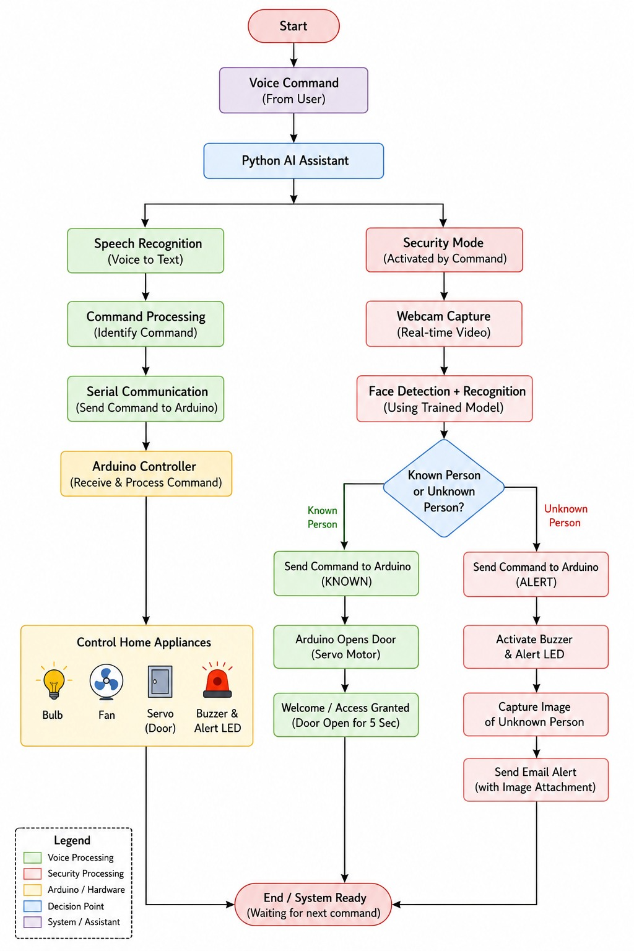

Fig. 1. System architecture of the proposed smart home security system

A. Overall System Architecture
Figure. 1 illustrate the complete system block diagram. a USB webcam continuously capture video frames. the Python base processing unit perform face detection, recognition and voice command processing. recognised commands and decision are transmitted to the Arduino UNO via UART serial combination. the microcontroller than controls the server motor, DC motor, LED and buzzer accordingly.

B. Hardware Components
The hardware model consists of:
- Arduino UNO
- SG90 turbo motor for door control
- Toy DC motor
- L298N and moto driver for fan simulation
- LED representing room light
- Active bazar for local alerts
- USB camera for video inputs
All components are powered directly from the laptop USB port.
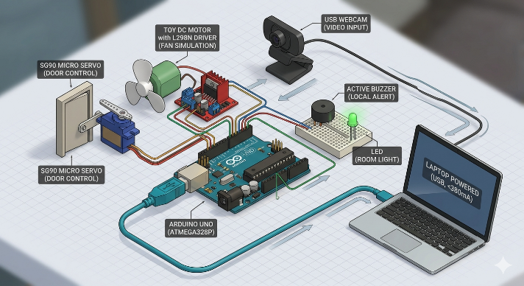

Fig. 2. Hardware Architecture

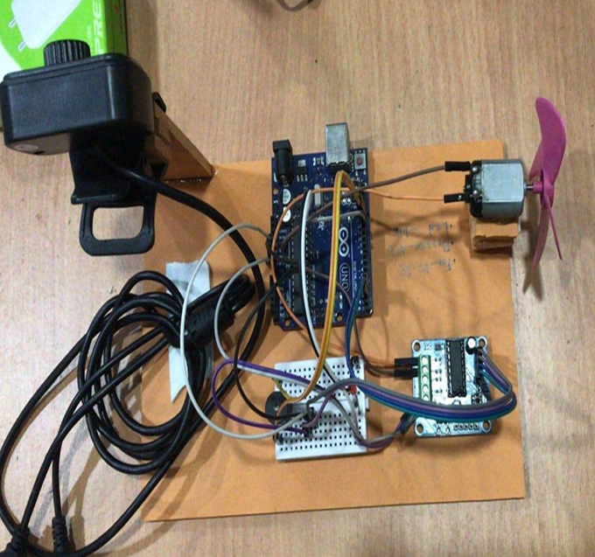

Fig. 3. Hardware Implementation

C. Software Requirement
For our project implementation we required some software components, libraries and algorithms. here all listed below:

Table .2 Software/Libraries list
Software/Library | Used
Python 3.10 | Main Programming Language
Arduino IDE | Upload code to Arduino
OpenCV | Face detection and recognition
opencv-contrib-python | Required for LBPH algorithm
numpy | Array conversion and model training
Pillow | Image reading
Pyttsx3 | Text-to-speech output
SpeechRecognition | Voice command recognition
PyAudio | Microphone input support
pyserial | Python to Arduino serial communication
smtplib | Sends email alert
Haar Cascade xml | Face detection model

C.1 Face Detection:
Face recognition is performed using local binary pattern histogram (LBPH) algorithm. After face detection of the region of interest (ROI) is converted to Greyscale image and its histogram is computed. during recognition, Chi-quare distance is calculated between the input histogram and train the model histograms.
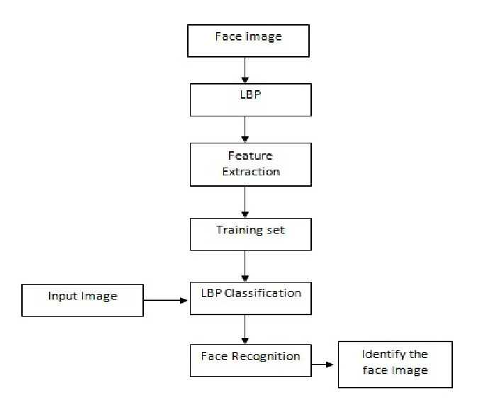

Fig. 4. LBPH face recognition process

The Chi-quare distance is given by:
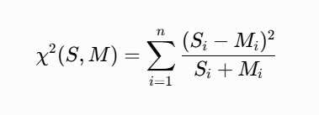
Where S is the sample histogram of detected face, M is the model histogram from the training set, and n the number of bins.
A face is classified as known if the confidence value satisfies:
Confidence ˂ 50
Otherwise, it is treated as an unknown person, triggering an email alert with the capture image.

C.2 Voice Command Processing
Voice command are captured using a microphone and converted to tax using the Google speech recognition API. pre divine commands such as fan on, bulb on, door open security activate, security deactivate are recognised converted into control signals for Arduino.

C.3 Communication and Control
Serial communication between Python and arduino is established using PySerial library. commands are send as a string (e.g., F_ON\n, L_OFF\n, KNOWN\n, ALERT\n).

IV. METHODOLOGY

A. Face Data Collection
First system will collect the face data then we will use a separate python script for this . This script collects 100 face images per person. Images were saved in grayscale, and then the persons ID number was told with image.
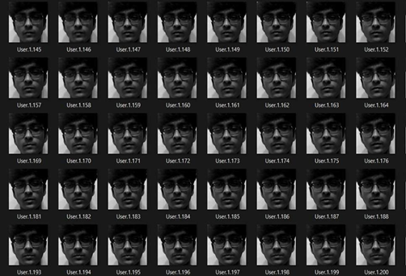
Fig. 5. Sample face images collected for LBPH training

B. Training the LBPH Model
Computer used the collected image to train the LBPH recognizer OpenCV,s face. LBPH FaceRecognzer_create() function was used. The trend model was saved as a .yml file . This file loaded when the main problem starts.
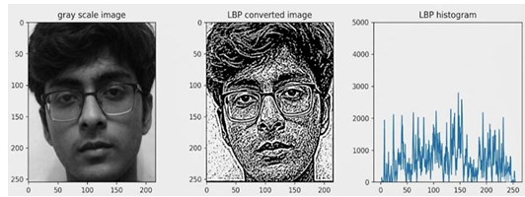
Fig. 6. LBPH feature extraction and histogram generation

C. Real-Time Recognition
The webcam was opened by the main program. Each frame converted to grayscale. Haar cascade detects face regions .LBPH compares detected faces with trained models .
A score is produced. If the score is less than 50 the faces are considered known, and the door opens . If the score is more than 50 or 50 the face is coincident considered unknown and alert system activates .

D. Serial Communication
Commands are sent python to arduino in text. For example DOOR_OPEN is sent when face is found known. And it sent ALERT when face is found unknown. Arduino controls the hardware after reading these commands.

E. Voice Control
The speech recognition library listen to the microphone . Recognised text is matched with known commands, Like fan on, fan of, bulb on ,bulb off, door open . This matching command is then sent to the Arduino.

F. Email Alert
When it detects a known face a photo is saved. A photo is sent using an email , which we used in the python code . The images sent to a registered address. This alert happens once every 15 seconds to avoid spam.

G. Pin Configuration
Pin 5 was used for server motor signal ,pin 6 was used for alert LED, pin 7 was used for the pulp relay, pin 8 was used for the fan relay, pin 9 was used for the Bazaar.

Table .3 Circuit Connection Table
Arduino Pin | Connected Component | Description
D12 | Relay/Bulb control | Turns bulb ON/OFF
D2 | Fan Motor Driver Input 1 | Fan forward/control signal
D3 | Fan Motor Driver Input 2 | Fan control signal
D13 | Buzzer | Security alarm
D6 | Alert LED | Visual warning
D9 | Servo Signal Pin | Door open/close
5V | Servo/Relay VCC | Power supply
GND | Common Ground | Must connect all grounds

V. RESULTS AND DISCUSSION
We tested multiple people , and we tested the system in an indoor environment different lighting conditions were tried.
The facial recognition accuracy was found 80-90% , this means 80/90 out of 100 times a system correctly identify the person. False positive rate was 0% . No unknown person was detected as known during testing.
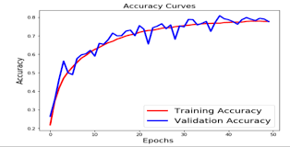

Fig. 7. Sample face images training Accuracy
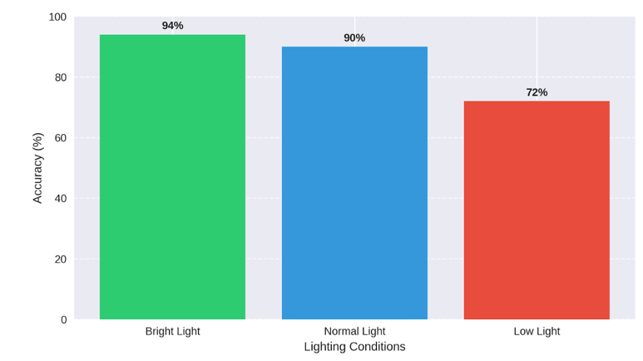

Fig. 8. Face recognition accuracy in different light condition

Response time was measured from fees reduction to door actuation. Average response time was around 0.60-1.2 sec . This is fast enough for practical use . But yes it can be improved more.
Voice control voice tested with different speakers . We used a normal speaker and we also used laptops speaker to test . Comments were recognised correctly most of the time. Sometimes background noise creates a problem but not a big problem , it reduces accuracy slightly.
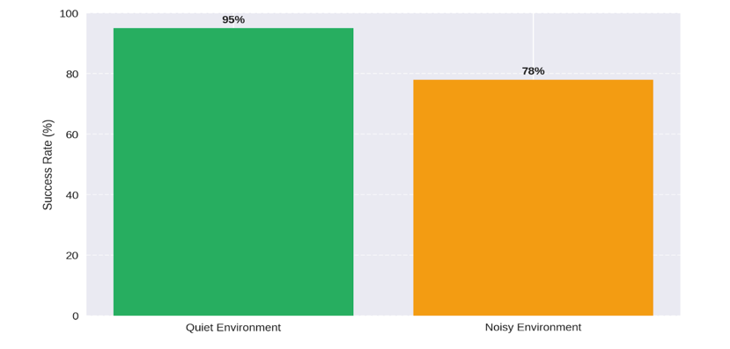

Fig. 9. Voice command success rate

Email where sent and received within few seconds (~10 seconds) of face detection . The image which is sent as an email clearly solves the face of an unknown person.
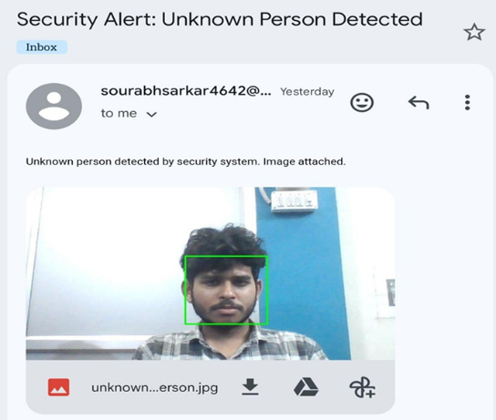

Fig. 10. Email alert received

The server motor opens and closes the door . We haven't seen any mechanical failures during the test . The LED and Buzzer respond properly and very fast when an unknown face is found.
The system was compared with similar low-cost security systems from literature. Most similar systems used RFID or PIN codes. Face recognition based systems were fewer. This system performed well compared to those systems in terms of accuracy and response time.

VI. CONCLUSION
With build and tested the low cost home security system. Facial recognition was used to control the door , a known face opens the door, and an unknown face gives an alert and sends an email with the person's face. LBPH was used because it works well with limited hardware. Control the hardware Arduino UNO was used and python was used for coding .
The system showed high accuracy during the testing . The false positive date was very low almost 0. Voice control and email alert were also included.
The system is not perfect. Sometimes it creates problems in dark conditions it means it works less well in dark . If the place is noisy the microphone sometimes misses commands. There are areas for future improvement .
We can also improve lighting issues . But now better lighting can improve the accuracy . The planning model can be added when better hardware is available.
This project shows that a low budget useful security system can be built by students. The cost of components was very low if we compared it with a commercial system . This makes it useful for the homes you don't have budget or one affordable home security.

REFERENCES
- P. Viola and M. Jones, "Rapid object detection using a boosted cascade of simple features," in Proc. IEEE CVPR, 2001.
- T. Ahonen, A. Hadid, and M. Pietikainen, "Face description with local binary patterns," IEEE Trans. Pattern Anal. Mach. Intell., vol.
28, no. 12, 2006.
- M. Turk and A. Pentland, "Eigenfaces for recognition," J. Cognitive Neuroscience, vol. 3, no. 1, pp. 71-86, 1991.
- S. Zhang et al., "Deep face recognition: A survey," Neurocomputing, vol. 429, pp. 215-244, 2021.
- N. Sriskanthan, F. Tan, and A. Karande, "Bluetooth based home automation system," Microprocessors and Microsystems, vol. 26, no. 6, 2002.
- D. Pavithra and R. Balakrishnan, "IoT based monitoring and control system for home automation," in Proc. GCCT, India, 2015.
- M. Asadullah and K. Ullah, "Smart home automation system using Bluetooth technology," in Proc. ICIEECT, 2017.
- A. Jacob, B. N. Das, and A. S. Nair, "Smart home automation with security using IoT," Int. J. Eng. Research Technology, vol. 6, no. 5, 2017.
- S. Tanwar et al., "An advanced IoT based security alert system for smart home," in Proc. Comptelix, 2017.
- G. Ho et al., "Smart locks: Lessons for securing commodity IoT devices," in Proc. ACM AsiaCCS, 2016.
- E. Fernandes, J. Jung, and A. Prakash, "Security analysis of emerging smart home frameworks," in Proc. IEEE S&P, 2016.
- C. Wilson, T. Hargreaves, and R. Hauxwell-Baldwin, "Smart homes and their users," Personal and Ubiquitous Computing, vol. 19, no. 2, 2015.
- A. Zanella et al., "Internet of Things for smart cities," IEEE Internet of Things Journal, vol. 1, no. 1, pp. 22-32, 2014.
- S. M. R. Islam et al., "IoT for health care," IEEE Access, 2015.
- Q. H. Mahmoud, "Smart home security issues," IEEE Systems Journal, 2020.
- R. Piyare and M. Tazil, "Bluetooth based home automation system using cell phone," in Proc. IEEE ISCE, 2011.
- K. Gill et al., "A Zigbee-based home automation system," IEEE Trans. Consumer Electronics, vol. 55, no. 2, 2009.
- H. Gharavi, "Smart grid and home automation," IEEE Proceedings,2011.

