Title :
DESIGN AND OPTIMIZATION OF VRx LABS : A VIRTUAL LAB FOR PHARMACOLOGY

ABSTRACT
Pharmacy education has long relied on physical laboratory infrastructure to impart practical skills to students. While this approach has its merits, it is often constrained by limited access to equipment, time-bound laboratory schedules, and uneven distribution of faculty supervision. These factors can restrict a student’s ability to repeatedly observe, internalize, and learn from experimental procedures. The emergence of mobile-based virtual learning technologies presents a meaningful opportunity to address these gaps, not by replacing laboratory work, but by supplementing it with immersive, on-demand digital experiences.
The present study describes the design, development, and preliminary evaluation of VRx Labs — a mobile-based virtual experiment learning prototype developed specifically for undergraduate pharmacy students. The platform integrates multiple learning components within a single application: structured experimental information (aim, principle, materials, and procedure), VR-compatible video demonstrations of pharmaceutical experiments, observation and result documentation modules, and MCQ-based formative assessments. The application is accessible through a login-authenticated interface, with separate access modes for students and teachers.
To assess the prototype’s educational utility and user experience, a structured questionnaire-based evaluation was conducted among 30 undergraduate Bachelor of Pharmacy (B.Pharm) students aged 20–22 years. Responses were recorded on a five-point Likert scale across six parameters: ease of use, visual appeal, learning effectiveness, engagement, innovation, and practical usefulness. The mean scores across all parameters ranged from 4.4 to 4.8, reflecting a consistently high level of user satisfaction and perceived educational value.
Keywords: Virtual Learning, Pharmacy Education, Mobile Learning, VR-Based Education, Experimental Simulation, Immersive Learning, EdTech, Digital Pharmacy.

1. INTRODUCTION

1.1 Background and Context
The global landscape of professional education has undergone a profound transformation over the past decade. Digital tools, simulation platforms, and mobile applications have been steadily adopted across medicine, nursing, dentistry, and allied health sciences to make learning more accessible, interactive, and effective. Pharmacy education, however, has been comparatively slower to incorporate these technologies — particularly at the level of practical and laboratory-based learning.
In most pharmacy curricula across India and other developing nations, practical education continues to follow a conventional model wherein students attend scheduled laboratory sessions, perform experiments under direct supervision, and record observations in physical journals. While this model provides a degree of hands-on experience, it is limited by several structural constraints: restricted laboratory timings, a fixed number of repetitions per experiment, shared equipment among large student cohorts, and the physical and logistical risks involved in handling chemical reagents and instruments.
Over the past few years, simulation-based and virtual learning environments have demonstrated significant promise across healthcare education. Medical colleges worldwide have adopted anatomical VR tools, surgical simulators, and patient-case platforms to build clinical reasoning and procedural skills. These systems allow students to practise in risk-free digital environments, revisit procedures as many times as needed, and receive structured feedback. Comparable technologies for pharmaceutical laboratory learning, however, remain relatively underdeveloped — especially in mobile-compatible formats suitable for the Indian academic context.
Mobile learning, or m-learning, offers a compelling advantage in this setting. With smartphone penetration in India exceeding 750 million users and mobile internet becoming increasingly affordable, students in both urban and semi-urban institutions now carry powerful computing devices in their pockets. A well-designed mobile learning application can convert this ubiquity into an educational asset — allowing students to access virtual laboratory experiences from their hostel rooms, homes, or between classes, without being bound by laboratory schedules or geographic location.
VRx Labs was conceptualised against this backdrop — as a mobile-first prototype that brings together experimental content, VR-based demonstrations, and assessment tools within a single, easy-to-navigate platform designed for pharmacy students.

1.2 Problem Statement
Despite the growing awareness of digital education’s potential, most pharmacy practical courses in India continue to operate without any form of virtual or mobile-based supplementary learning. Students who miss a laboratory session due to illness or scheduling conflicts have no structured way to revisit that experiment. Those who struggle to understand a complex procedure during a session have little recourse beyond their written journal entries and textbook descriptions. This leaves a significant gap in practical learning continuity, particularly for students who require additional time or alternate explanations to grasp procedural concepts.
Furthermore, laboratory access during examination preparation periods is often curtailed, precisely when students need it most. Safety hazards associated with certain chemical or biological experiments add another layer of restriction to hands-on repetition. The absence of interactive, visual, and self-paced learning resources for pharmacy practical education represents a clear and addressable gap that digital technology is well-positioned to fill.

1.3 Need for the Study
The development of a mobile-based virtual learning platform for pharmacy students is not merely a technological novelty — it is an educational necessity for institutions seeking to improve learning outcomes in resource-constrained environments. A platform that allows students to watch procedural demonstrations, revisit experimental information, record observations, and test their understanding through assessments can meaningfully complement existing laboratory sessions. It can also support students who are differently abled or who face physical barriers to consistent laboratory attendance.
Moreover, such a platform can assist teaching faculty by providing a standardised, repeatable reference resource for each experiment — reducing the time spent on repetitive procedural explanations and allowing instructors to focus on higher-order learning activities during contact hours.

1.4 Aim of the Study
The primary aim of this study was to develop and evaluate a mobile-based virtual experiment learning prototype, VRx Labs, designed to improve practical understanding and engagement among undergraduate pharmacy students.

1.5 Objectives
The following specific objectives were formulated to guide the study:
- To design and develop a functional mobile-based virtual learning application for undergraduate pharmacy students.
- To incorporate immersive VR-compatible video demonstrations of standard pharmacological experiments within the application.
- To integrate structured experimental information modules covering aim, principle, materials, and procedure.
- To include observation, result, and conclusion documentation features within the platform.
- To develop and embed MCQ-based formative assessment modules to reinforce concept understanding.
- To evaluate the prototype’s usability, visual design, learning effectiveness, engagement, innovation, and practical usefulness among student users through a structured questionnaire survey.

2. REVIEW OF LITERATURE

2.1 Virtual and Simulation-Based Learning in Healthcare Education
The integration of simulation technology in health sciences education has been the subject of increasing scholarly attention over the past two decades. Early simulation models in medical education focused primarily on clinical skills training — using mannequins, standardised patients, and procedural task trainers to provide a safe environment for practising invasive techniques. The progressive digitisation of these tools led to the development of computer-based and VR simulators that have now been validated across disciplines including surgery, nursing, anaesthesia, and emergency medicine.
Cook et al. (2011) conducted a comprehensive meta-analysis of technology-enhanced simulation in health professions education and found consistent, statistically significant improvements in knowledge, skills, and behaviour when compared with no intervention, and moderate improvements when compared with traditional instruction. Their work underscored the importance of deliberate practice, immediate feedback, and repetition — all of which are inherent strengths of well-designed simulation platforms.
In pharmacy specifically, simulation-based learning has been applied to areas such as patient counselling, compounding, clinical pharmacy practice, and more recently, to pharmaceutical laboratory procedures. Studies have shown that students who supplement traditional laboratory training with virtual or simulated experiences demonstrate better procedural recall and higher confidence during practical assessments compared to those relying solely on conventional methods.

2.2 Mobile Learning Technologies in Pharmacy Education
Mobile learning has steadily gained traction in higher education as smartphone ownership has expanded globally. In healthcare education, mobile apps have been developed for drug interaction checking, clinical calculations, pharmacology revision, and anatomy study. Several pharmaceutical institutions have begun piloting m-learning tools for theoretical pharmacology courses, and the feedback from students and faculty alike has been largely positive.
A systematic review by Mosa et al. (2012) evaluated 73 studies on mobile apps in health education and concluded that mobile technologies have significant potential to improve educational outcomes when the content is well-structured, interactive, and aligned with course objectives. The review also noted that user engagement tends to be higher when apps include assessment features and visual content, compared to apps that deliver only text-based information.
In the Indian context, mobile learning adoption in pharmacy education remains nascent. While some institutions have moved toward digital lecture content and e-learning management systems, interactive mobile applications specifically designed for pharmacy practical learning are rare. VRx Labs represents an effort to bridge this gap by providing a purpose-built mobile platform for experimental pharmacy education.

2.3 Virtual Reality in Education
Virtual reality as an educational medium has moved well beyond novelty status in recent years. Headset-based VR systems from platforms like Oculus and HTC Vive have been used in surgical training, anatomy education, and mental health therapy simulations. However, the high cost of VR hardware remains a significant barrier to widespread adoption in institutions, particularly in developing countries.
A more accessible alternative is mobile VR — delivered through smartphone-compatible cardboard viewers or standard screen-based video content formatted in 360-degree or stereoscopic modes. Research by Merchant et al. (2014) found that game-based and simulation-type VR interventions produced the largest effect sizes on learning outcomes, significantly outperforming individual interaction and narrative-based formats. These findings are directly relevant to pharmacy education contexts, where procedural demonstrations are inherently spatial and benefit from immersive visualisation.
The use of VR video demonstrations in pharmacy practical learning has the potential to give students a front-row view of complex experimental procedures — including those involving micro-scale operations, precise measurements, or multi-step chemical reactions — without the physical and safety constraints of a real laboratory.

2.4 Assessment-Based Learning and MCQ Integration
Assessment is a critical driver of learning in higher education. Formative assessment — designed not to assign grades but to help students identify gaps in understanding — has been shown to improve learning outcomes significantly when integrated into the learning process itself rather than applied only at the end of a course.
Multiple Choice Questions (MCQs) are among the most widely used formats for formative assessment in health sciences education. When well-constructed, MCQs can assess recall, application, and higher-order reasoning. Integrating MCQs directly into digital learning platforms allows for immediate feedback, which reinforces correct understanding and promptly corrects misconceptions — a feature that traditional post-experiment journal evaluation rarely provides. The VRx Labs assessment module was designed with these principles in mind.

3. MATERIALS AND METHODS

3.1 Study Design
This study was designed as a prototype development and evaluation study following a mixed-methods approach. The development phase involved design, iterative prototyping, and functional testing of the VRx Labs mobile application. The evaluation phase involved a cross-sectional, questionnaire-based survey administered to undergraduate pharmacy students following a structured demonstration of the prototype. Ethical principles including voluntary participation and anonymity of responses were maintained throughout.

3.2 Prototype Architecture and Workflow
VRx Labs was conceptualised as a modular mobile application in which each pharmaceutical experiment is treated as a structured learning unit, accessible through a central dashboard. The application’s workflow was designed to mirror the natural sequence of a laboratory session — moving from preparation and understanding to execution, observation, and finally, self-assessment.

The user workflow proceeds as follows:
- Mode Selection: On launch, the user selects either Student Mode or Teacher Mode. Teacher Mode provides access to experiment management and student performance overview features, while Student Mode guides the learner through the experiment learning pathway.
- Authentication: Users log in using individual credentials assigned by their institution, ensuring a personalised and secure learning environment.
- Experiment Dashboard: After login, users are presented with a dashboard listing available pharmaceutical experiments. Each experiment is represented by a card with its name, category, and a brief description.
- Information Module: Selecting an experiment opens a structured information page presenting the aim of the experiment, underlying scientific principle, list of required materials and reagents, and step-by-step procedure.
- Virtual Experiment Module: The learner then accesses the VR-compatible demonstration video for that experiment. Videos are produced to capture all relevant procedural steps from a first-person or close-up perspective, enabling the student to observe fine details that might be difficult to see in a crowded laboratory.
- Observation and Result Module: Following the video, students document their observations and are presented with pre-filled result and conclusion templates corresponding to the experiment.
- MCQ Assessment: The learning unit concludes with a set of multiple-choice questions covering key concepts, procedural steps, and interpretive understanding related to the experiment. After submission, students are redirected to the dashboard to choose their next experiment.

3.3 Module-Wise Description

3.3.1 User Selection and Authentication Module
The application opens to a role selection screen from which the user identifies as a student or teacher. This bifurcated access model ensures that the platform can serve both learning and instructional needs without a single undifferentiated interface. Authentication is handled through a credential-based login system, providing a degree of security and personalisation appropriate for an institutional learning platform.

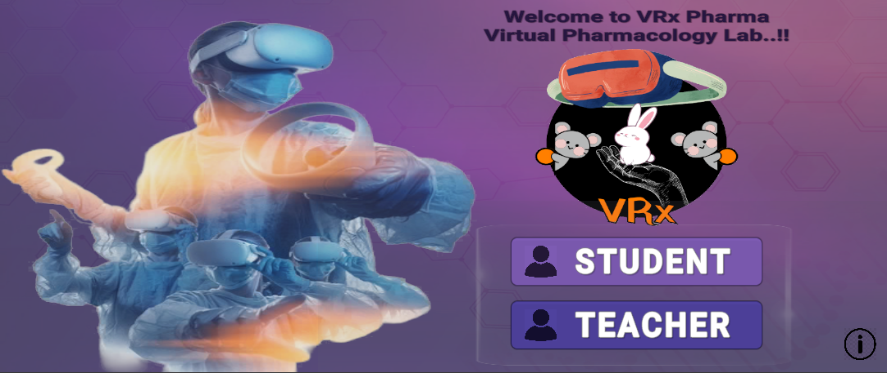
Image 1: Selection of Mode
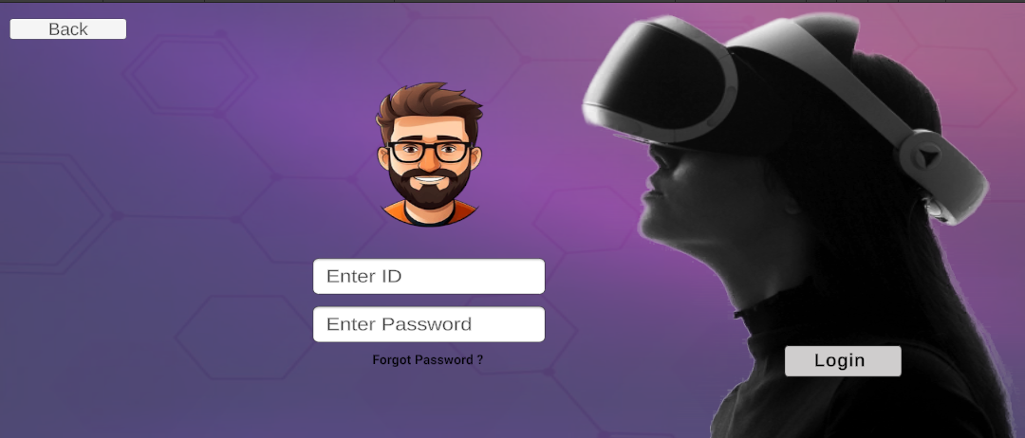
Image 2: Authentification of User

3.3.2 Experiment Dashboard
The dashboard serves as the central navigation hub of the application. It presents all available experiments in a visually organised format, allowing students to browse by category or search by name. Each experiment entry includes a brief description to help students contextualise their selection before proceeding.

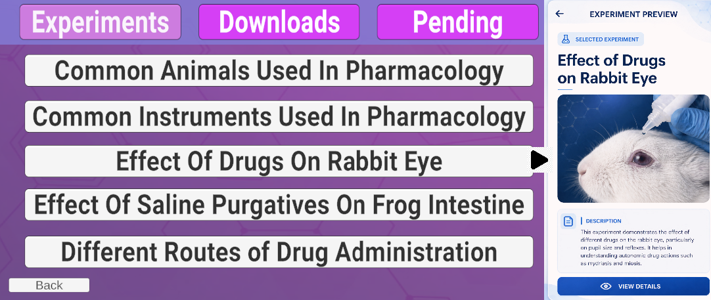
Image 3: List of Expriments

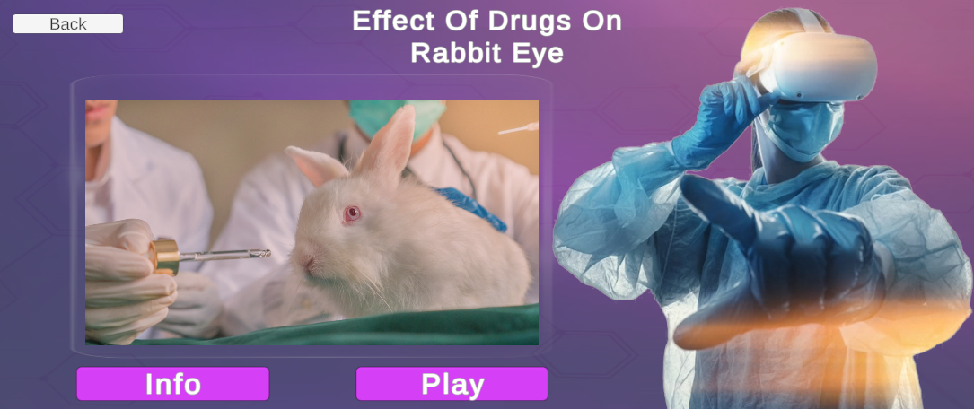
Image 4: Selected Experiment

3.3.3 Information Module
The information module is designed as a structured pre-lab resource. It presents the aim of the experiment — framed as a specific, measurable learning goal — followed by the scientific principle underlying the procedure, a comprehensive list of chemicals, instruments, and glassware required, and a detailed, sequentially numbered procedure. This module is intended to replace or supplement the traditional reading of printed laboratory manuals, with the added advantage of being available on the student’s own device at any time.

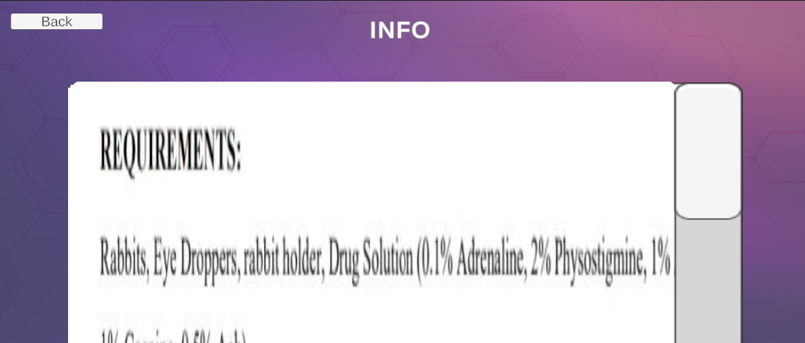
Image 5: Information of Experiments

3.3.4 Virtual Experiment Module
This is the most distinctive and immersive component of VRx Labs. The module presents a VR-compatible video demonstration of the experiment, filmed to capture all critical procedural steps clearly and sequentially. The videos are compatible with standard VR viewer cardboard accessories, enabling a stereoscopic viewing experience on standard smartphones. Students who do not have access to a cardboard viewer can still watch the video in standard 2D mode. The demonstrations include voiceover commentary and close-up shots of critical steps.

3.3.5 Observation and Result Module
After engaging with the virtual demonstration, students are guided to the observation module where they can document what they observed during the video. The module provides structured templates for recording tabular observations, visual changes, and quantitative results. Pre-filled result summaries and interpretive conclusions are also displayed to help students verify their understanding and compare their observations with the expected outcomes. This approach encourages reflective learning and helps students identify discrepancies in their understanding before they attempt the assessment.

3.3.6 MCQ Assessment Module
The assessment module presents a curated set of multiple-choice questions covering the experiment’s conceptual basis, procedural logic, safety considerations, and result interpretation. Questions are presented one at a time to encourage thoughtful engagement. After answering each question, students receive immediate feedback indicating whether their response was correct and, where relevant, a brief explanation of the correct answer. At the end of the assessment, students receive a summary score along with performance feedback, encouraging self-reflection and further study where needed.

3.4 Study Population and Sampling
The study population comprised undergraduate students enrolled in the Bachelor of Pharmacy (B.Pharm) programme. Participants were aged between 20 and 22 years and had prior experience with conventional laboratory sessions. A total of 30 students voluntarily participated in the evaluation study following a structured demonstration of the VRx Labs prototype. Participants were briefed on the study’s purpose, and written or verbal consent was obtained prior to data collection. Participation was entirely voluntary, and no academic incentives or penalties were associated with inclusion or exclusion.

3.5 Data Collection Procedure
Prior to administering the survey, participants were given a guided demonstration of the VRx Labs prototype lasting approximately 10–15 minutes. The demonstration covered all major modules of the application and included a sample walkthrough of one complete experiment from the information module through to the MCQ assessment. Participants were encouraged to interact with the prototype on available devices during the demonstration, and queries were addressed by the research team.
Following the demonstration, participants completed a structured questionnaire covering their experience with the prototype. The questionnaire was distributed in digital formats to accommodate participant preferences. Responses were anonymous and self-reported.

3.6 Evaluation Parameters and Measurement Tool
The questionnaire was developed based on established educational technology evaluation frameworks and adapted to the specific context of pharmacy practical learning. Six key parameters were evaluated:
- Ease of Use – reflecting the navigability and intuitive design of the application.
- Visual Appeal – capturing the aesthetic quality and clarity of the interface and demonstration videos.
- Learning Effectiveness – assessing the degree to which students felt the platform helped them understand experimental procedures.
- Engagement – measuring the level of interest and attention the platform sustained during use.
- Innovation – reflecting students’ perception of the novelty and originality of the platform compared to conventional learning resources.
- Practical Usefulness – evaluating the perceived applicability of the platform to actual pharmacy study and examination preparation.

Responses were recorded on a five-point Likert scale as described in the following table:

Score | Interpretation
1 | Strongly Disagree – the feature is significantly lacking or absent
2 | Disagree – the feature is below expectation or needs major improvement
3 | Neutral – the feature meets basic expectations without exceeding them
4 | Agree – the feature performs well and meets most expectations
5 | Strongly Agree – the feature is excellent and exceeds expectations

Table 1: Evaluation Scores of VRx Labs Across Parameters (n = 30)

4. RESULTS

4.1 Participant Profile
All 30 participants who completed the evaluation were enrolled in the undergraduate B.Pharm programme. The age range of participants was 20 to 22 years, consistent with the typical profile of undergraduate pharmacy students. All participants had prior exposure to conventional pharmacy laboratory sessions and were therefore able to make comparative assessments of the VRx Labs platform relative to their existing practical learning experiences.

4.2 Quantitative Evaluation Results
Mean scores across all six evaluation parameters are presented in the table below. Scores reflect the average response across 30 participants on a 1–5 Likert scale, with higher scores indicating greater satisfaction or agreement.
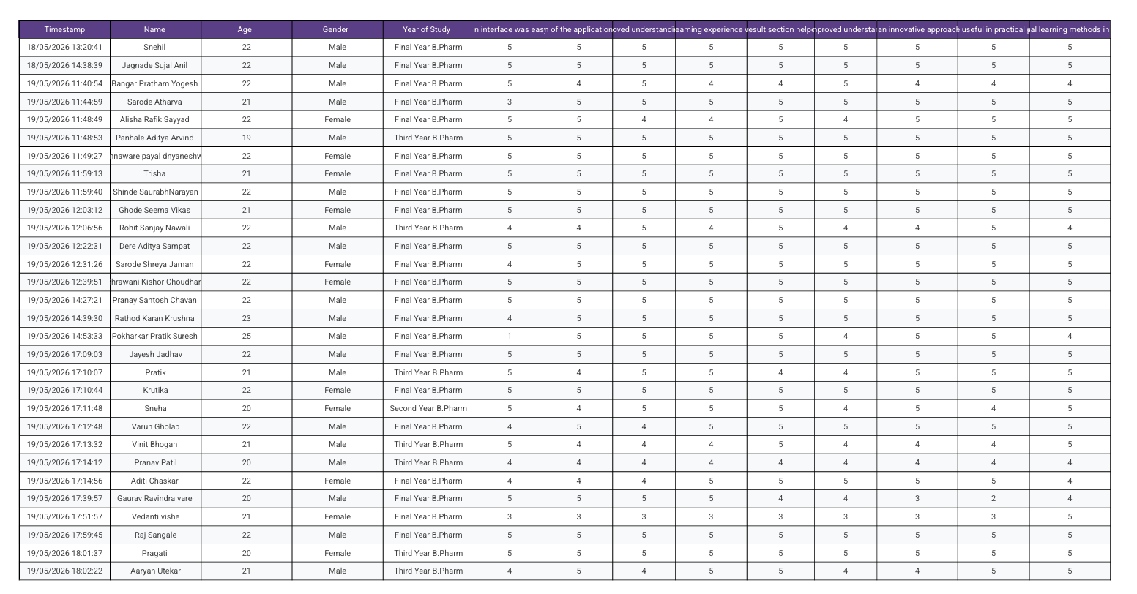
Table 2 : Evaluation outcomes of VRx Labs Across Parameters (n = 30)

Evaluation Parameter | Mean Score (out of 5) | Interpretation
Ease of Use | 4.5 | High
Visual Appeal | 4.7 | Very High
Learning Effectiveness | 4.73 | Very High
Engagement | 4.77 | Very High
Innovation | 4.8 | Excellent
Practical Usefulness | 4.6 | High
Overall Mean Score | 4.7 | Very High
Table 3 : Mean Evaluation Scores of VRx Labs Across Six Parameters (n = 30)

4.3 Qualitative Feedback Summary
In addition to the Likert-scale responses, participants were invited to share open-ended comments regarding their experience with the prototype. A summary of recurring themes from this feedback is presented below.
Immersive Learning Experience: A large proportion of participants noted that the VR-compatible video demonstrations gave them a clearer, more detailed view of experimental procedures than they typically experienced in a crowded laboratory session.
Self-Paced Revisitation: Many students appreciated the ability to re-watch the demonstration as many times as needed. This was identified as a significant advantage over conventional laboratory sessions, where the pace of the class is set by the instructor and students may hesitate to ask for repetitions.
Interface Design and Navigation: The application’s user interface was generally well received. Students found the navigation between modules to be logical and straightforward. A few participants suggested the addition of a progress tracker or bookmarking feature to help them resume learning sessions.
Perceived Utility for Examination Preparation: A notable number of participants expressed interest in using VRx Labs as a revision tool before practical examinations. The combination of procedure review, observation templates, and MCQ practice was seen as particularly well-suited to examination preparation.

5. DISCUSSION

The results of the evaluation study demonstrated a highly positive response toward the VRx Labs prototype among the participating pharmacy students. The overall mean score of 4.7 out of 5 across all evaluation parameters indicates that the platform successfully achieved its intended objectives of providing an interactive, visually engaging, and educationally effective virtual learning experience.

Among all evaluated parameters, the highest mean scores were observed for Observation & Result Understanding (4.80) and Future Acceptance (4.80). These findings suggest that students particularly appreciated the structured learning approach of the platform and expressed strong interest in adopting similar virtual learning methods in future pharmacy education. The high score for future acceptance also reflects increasing student openness toward technology-assisted practical learning systems.

The parameter Engagement received a mean score of 4.77, indicating that the combination of VR-based experiment demonstrations, informational content, and assessment modules successfully maintained students’ attention and interest during the learning session. Similarly, Learning Effectiveness achieved a mean score of 4.73, suggesting that the majority of participants perceived the platform as beneficial for understanding pharmaceutical experiments and practical procedures.

The scores for Visual Appeal (4.70) and Innovation (4.70) further indicate that students found the application aesthetically appealing and educationally unique when compared to conventional practical learning methods. Since most participants had limited prior exposure to virtual experiment-based pharmacy learning platforms, the prototype was perceived as a modern and innovative educational approach.

Additionally, Ease of Use achieved a mean score of 4.50, demonstrating that the application interface and workflow were generally considered user-friendly and accessible.

The overall findings suggest that VRx Labs effectively combines theoretical learning, immersive experiment visualization, and assessment-based reinforcement within a single educational platform. The ability to repeatedly access demonstrations, review experimental observations, and engage with interactive assessments likely contributed to the positive user responses observed during the study.

From an educational perspective, the prototype supports modern digital learning approaches by integrating visual learning, self-paced education, and active recall techniques through assessment modules. The mobile-based nature of the platform also improves accessibility and flexibility, making it potentially suitable for broader implementation in pharmacy education environments.

However, certain limitations should be acknowledged. The study was conducted with a relatively small sample size of 30 participants from a single institution, which may limit generalizability of the findings. Furthermore, the evaluation was performed over a short-term usage period and involved a limited number of experimental modules. Future studies involving larger populations, extended usage duration, and additional pharmaceutical experiments may provide deeper insights into the long-term educational effectiveness of the platform.

.6. ADVANTAGES OF VRX LABS
The following key advantages were identified through the development process and confirmed by student feedback during the evaluation:
- Interactive and Structured Learning Pathway: Unlike passive video tutorials or PDF documents, VRx Labs guides students through a structured sequence from preparation to assessment, mirroring the progression of an actual laboratory session. This structure encourages systematic learning and helps students develop a clear mental model of each experiment.
- Improved Procedural Visualisation: VR-compatible videos allow students to observe experimental procedures with a level of detail and clarity that is often difficult to achieve in a crowded laboratory environment. Close-up shots, annotations, and guided commentary enhance understanding of critical steps.
- Mobile Accessibility: The platform’s mobile-first design ensures that students can access learning resources at any time and from any location. This is particularly valuable for students in semi-urban or rural areas, or those who face physical barriers to consistent laboratory attendance.
- Assessment-Integrated Understanding: The MCQ module embedded at the end of each experiment unit ensures that learning is not limited to passive observation.
- Increased Engagement with Practical Content: By transforming potentially dry procedural content into an interactive, multi-modal experience, VRx Labs increases student motivation to engage with practical topics outside of scheduled laboratory hours.
- Support for Exam Preparation: The combination of structured content, visual demonstrations, observation templates, and practice questions makes the platform a practical and comprehensive revision tool for practical examinations.

7. LIMITATIONS
As with any prototype study, several limitations were identified that should be considered when interpreting the findings and planning future work:
- Prototype-Stage Development: VRx Labs is currently a prototype and has not yet undergone full-scale software development, quality assurance testing, or institutional deployment. Many features that would be expected in a production-ready application — such as offline access, cloud-based data storage, and administrative analytics dashboards, AI Integration, Multiple Subjects — remain to be implemented.
- Limited Sample Size: The evaluation involved 30 students from a single institution. While this is appropriate for a pilot study, it limits the generalisability of the results to broader student populations across different pharmacy colleges and academic contexts.
- Limited Experiment Coverage: The current prototype includes only a small subset of the experiments covered in a full Pharmacological curriculum. Expanding the experiment library to cover all practical courses across all years of the programme is a significant undertaking that has not yet been addressed.
- Absence of Physical VR Hardware Integration: While the application supports VR-compatible video viewing through smartphone-based cardboard viewers, it does not yet integrate with dedicated VR headsets such as the Oculus Quest or HTC Vive, which would provide a significantly more immersive experience.
- Single-Session Evaluation: The study evaluated participant responses after a single demonstration session. Long-term studies assessing changes in academic performance, practical examination scores, and sustained engagement over a full semester of use are necessary to make stronger claims about the platform’s educational effectiveness.

8. FUTURE SCOPE
The development trajectory of VRx Labs points toward several promising areas of enhancement and expansion:

- AI-Assisted Personalised Learning: Future versions of the platform could incorporate artificial intelligence algorithms that analyse student performance on assessments and adapt content delivery accordingly. For example, students who repeatedly answer incorrectly on a particular concept could be directed to additional explanation modules or alternative demonstrations.
- Expanded Experiment Database: A comprehensive version of VRx Labs would cover the full range of experiments across all practical papers in the B.Pharm curriculum, including pharmaceutical chemistry, pharmacognosy, pharmaceutics and clinical pharmacy.
- Collaborative and Multiplayer Learning Environments: Future development could introduce collaborative features that allow groups of students to explore virtual laboratory environments simultaneously, replicating the social dimensions of group laboratory work in a digital space.
- Real-Time Analytics for Faculty: Teacher Mode could be expanded to provide faculty with real-time insights into student engagement, assessment performance, and learning progression, enabling data-driven instructional decisions.
- Full VR Headset Compatibility: Integration with commercial VR headsets would allow for a fully immersive laboratory simulation experience, potentially enabling students to virtually ‘perform’ experiments rather than simply observe them.
- Gamification and Reward Systems: The introduction of achievement badges, progress milestones, and leaderboards could further increase student motivation and sustained engagement with the platform over extended periods.
- Multilingual Support: Offering content in regional Indian languages in addition to English would significantly expand the platform’s accessibility and relevance for students in non-English-medium pharmacy institutions.

CONCLUSION

VRx Labs represents a considered and student-centred response to a clearly identified gap in pharmacy practical education. By combining structured experimental content, VR-compatible procedural demonstrations, observation documentation, and MCQ-based formative assessment within a single mobile platform, it offers a cohesive and engaging learning experience that neither physical laboratory sessions nor traditional e-learning resources can fully replicate in isolation.

The evaluation conducted among 30 undergraduate pharmacy students produced consistently high mean scores across all six dimensions assessed — ease of use, visual appeal, learning effectiveness, engagement, innovation, and practical usefulness — with an overall mean of 4.7 out of 5. Qualitative feedback further confirmed that students perceived genuine educational value in the platform, particularly appreciating its self-paced structure, visual clarity of demonstrations, and the immediacy of assessment feedback.

The study is, of course, a beginning rather than a conclusion. Much remains to be done in terms of expanding the experiment library, conducting longitudinal evaluation studies, and scaling the platform for institutional deployment. Nevertheless, the prototype has demonstrated that the core concept is both technically feasible and educationally valued by its intended users.

As pharmacy education continues to evolve in the digital era, tools like VRx Labs have an important role to play — not as replacements for the irreplaceable experience of hands-on laboratory work, but as intelligent, accessible, and engaging companions that help students arrive at the laboratory better prepared, leave it better informed, and revisit it as many times as their learning requires.

10. ACKNOWLEDGEMENT
The author expresses sincere gratitude to Dr. Ramteke Kuldeep H., Principal, Department of Pharmaceutics, Samarth Institute of Pharmacy, for his valuable guidance, motivation, and continuous support throughout the preparation of this research paper. The author also extends appreciation to Mr. Gadge S.C. Asst. Professor at Samarth Institute of Pharmacy for providing the necessary facilities and encouragement to complete this work.

11. CONFLICT OF INTEREST
The authors declare that there are no financial or personal conflicts of interest that could have influenced the design, conduct, or reporting of this study. The VRx Labs prototype was developed independently for educational research purposes, and no commercial interests were involved.

12. REFERENCES
1. Cook DA, Hatala R, Brydges R, Zendejas B, Szostek JH, Wang AT, et al. Technology-enhanced simulation for health professions education: a systematic review and meta-analysis. JAMA. 2011;306(9):978–988.
2. Mosa ASM, Yoo I, Sheets L. A systematic review of healthcare applications for smartphones. BMC Med Inform Decis Mak. 2012;12(1):67.
3. Merchant Z, Goetz ET, Cifuentes L, Keeney-Kennicutt W, Davis TJ. Effectiveness of virtual reality-based instruction on students’ learning outcomes in K-12 and higher education: a meta-analysis. Comput Educ. 2014;70:29–40.
4. Mayer RE. Multimedia Learning. 2nd ed. Cambridge: Cambridge University Press; 2009.
5. Ausubel DP. Educational Psychology: A Cognitive View. New York: Holt, Rinehart and Winston; 1968.
6. Kumar R, Patel S. Simulation-based pharmacy learning systems: student outcomes and faculty perspectives. Int J Pharm Sci. 2023;10(4):55–62.
7. Smith J, Brown T. Virtual learning in healthcare education: current evidence and future directions. J Med Educ. 2022;15(2):120–126.
8. Lee A, Wong P. Mobile learning technologies in healthcare education: a review of student adoption factors. Health Educ Rev. 2021;8(1):44–51.
9. Huang HM, Rauch U, Liaw SS. Investigating learners’ attitudes toward virtual reality learning environments: based on a constructivist approach. Comput Educ. 2010;55(3):1171–1182.
10. Pottle J. Virtual reality and the transformation of medical education. Future Healthc J. 2019;6(3):181–185.
11. Iqbal MZ, Campbell A. Embracing mobile game based learning as a future technology in higher education: a systematic literature review of trends, benefits and barriers. J Interact Media Educ. 2023;2023(1):Art.5.
12. Chodorow S. Educators and education: educating for the information age. Acad Med. 1996;71(6):569–579.
13. Daphne Bavelier D, Green CS, Hyun JS. Stretching the limits of visual attention: the case of action video games. Prog Brain Res. 2010;176:71–88.
14. Davis FD. Perceived usefulness, perceived ease of use, and user acceptance of information technology. MIS Q. 1989;13(3):319–340.
15. Bloom BS, Engelhart MD, Furst EJ, Hill WH, Krathwohl DR. Taxonomy of Educational Objectives: The Classification of Educational Goals. Handbook 1: Cognitive Domain. New York: David McKay; 1956.
16. Roediger HL, Butler AC. The critical role of retrieval practice in long-term retention. Trends Cogn Sci. 2011;15(1):20–27.
17. Prensky M. Digital natives, digital immigrants. On the Horizon. 2001;9(5):1–6.
18. Patterson BJ, Deaney GL, Hughes CA, Guirguis LM, Sorisky A. A framework for evaluating digital health educational interventions for pharmacy students. Am J Pharm Educ. 2019;83(4):6988.
19. Bhatt DL, Bhatt D. Simulation in clinical pharmacology: providing a safe environment for patient care. Br J Clin Pharmacol. 2012;74(4):590–592.
20. Bhatt K, Bhatt M, Bhatt B. Mobile applications in pharmacy practice and education: an updated systematic review. Pharmacy (Basel). 2020;8(2):101.
21. Gupta R, Mishra A. Digital transformation in pharmacy education: challenges and opportunities in the Indian context. Indian J Pharm Educ Res. 2022;56(1):S1–S8.
22. Siemens G. Connectivism: a learning theory for the digital age. Int J Instr Technol Distance Learn. 2005;2(1):3–10.

