A PROPOSED WEB-BASED DOCUMENT REQUEST SYSTEM FOR TERTIARY STUDENTS AT ST. CLARE COLLEGE OF CALOOCAN

Background of the Study
In today’s digital age, many schools still depend on traditional methods for handling document requests, such as manual forms and face-to-face transactions. At St. Clare College of Caloocan, tertiary students are required to go to the school personally, complete request forms, and wait in long lines at the cashier. This process consumes a lot of time and can be inconvenient for tertiary students, especially those with busy schedules.

Because of this outdated system, delays in releasing requested documents often occur, which may cause students to miss deadlines, academic requirements, or important events. As technology continues to advance and online services become more common, relying on manual procedures limits efficiency, accessibility, and the quality of service provided.

To solve these problems. We, the researchers, propose developing an Online Document Request Website for St. Clare College of Caloocan. This system is designed to make the process faster, more convenient, and user-friendly. With features such as online account registration, document request submission, payment options, and request tracking, the system aims to reduce wait times, eliminate the need for physical queues, and enhance the overall experience for students and parents.

Statement of the Problem
At present, the existing process in our college is largely manual and time consuming. Tertiary students still have to physically visit different offices, pay fees and wait in long queues. And afterwards the documents are still not immediately available and may take several days to process. Because of these, there is the pressing need to develop a system that allows students to conveniently have their necessary documents easily. This study will be conducted to address the identified issues. Specifically, it seeks to answer the following questions:
1. How can the system allow students to request school documents online without needing to visit the registrar’s office physically?
2. How can the system provide students with real-time updates on the status of their requests to ensure transparency?
3. How can the system assist administrators in tracking, approving, and releasing requested documents with reduced errors and delays?
4. How can the system integrate a payment confirmation feature to verify student payments securely and efficiently?
5. To what extent can the system improve accessibility, efficiency, and accuracy compared to the existing manual process?

Objective of the Study

General

The general objective of this study is to design and develop a web-based document request system that simplifies and digitalizes the process of requesting, paying for, and releasing academic documents. This system will significantly reduce the time and effort required for these tasks, providing a more efficient and convenient experience for both the staff and tertiary students.

Specific
- To create a fast and reliable online requesting website to lessen the line-up of traditional cashiers.
- To create a user-friendly interface that simplifies the process of requesting documents online.
- To create an admin interface where staff can see the student’s payment and request.
- To provide a centralized system for storing all the request documents of the students in St. Clare College of Caloocan.
- Evaluate the system’s effectiveness in improving accessibility, accuracy, and operational efficiency compared to the current manual process.

Significance of the Study

The study “A proposed web-based document request system for St. Clare College of Caloocan
The result of the study will provide assistance to students, school staff, the institution, and future researchers.

Tertiary students will benefit from a faster and more convenient way to request school documents without physically going to the registrar. They will receive real-time updates regarding their request status, ensuring transparency and minimizing delays.

School Staff and Administrators, will benefit from a centralized and automated system for managing requests, verifying payments, tracking records, and approving documents, reducing manual workload and minimizing human error.

Educational Institutions will gain a more systematic and modernized approach to document management, improving service quality, operational efficiency and the school's digital transformation efforts.

Future researchers and Developers, may use this study as a reference for enhancing or creating similar web-based systems. It also provides insights and data that can contribute to further innovations in digital school services and administrative automation.

Scope and Delimitations of the Study
Scope
- The study focuses on the development of a web-based document request system for tertiary students of St. Clare College of Caloocan.
- The system allows students to request academic documents online without the need to visit the school physically.
- The system includes a document delivery feature, enabling students to receive their requested documents remotely.
- The system allows students to track the status of their requests in real time.
- The system provides notifications via SMS (text message) and email to inform students when their requested documents are ready.
- The study covers the design, development, and evaluation of the system in terms of usability, accessibility, and efficiency.

Delimitation
- The study is limited only to tertiary-level students and does not include other academic levels (e.g., senior high school, junior high school, elementary).
- The system is designed solely for document request processing and does not cover other institutional services.
- The implementation is limited to St. Clare College of Caloocan and may not be directly applicable to other institutions.
- The system requires users to have a stable internet connection, as it is web-based.
- The system only allows students and authorized individuals such as parents or guardians to make a request. External parties like companies or other schools are not included.
- The system can’t generate a student number for those who don’t have a student number.

Review of Related Literature
Local Literature Synthesis
A primary driver for digitalization in Philippine Higher Education Institutions (HEIs) is the need to streamline administrative workflows. Aliazas and Dela Cruz (2024) highlight that Electronic Document Management Systems (EDMS) significantly enhance document accessibility and university efficiency. This is further supported by Orloque et al. (2024), who demonstrated that automated processing leads to faster and more accurate handling of accreditation documents.
Manual processes in local institutions often result in "campus foot traffic" and long queues. Eusebio et al. (2022) and Casicas et al. (2025) both identified that manual workflows lead to repeat visits and increased staff workloads. Their findings advocate for real-time status tracking to improve student and staff satisfaction.
Similarly, in the public sector, Gonzales et al. (2023) observed high user satisfaction when civil registry requests (e.g., birth certificates) were migrated to mobile-optimized systems. For academic institutions like St. Clare College, the work of Santos et al. (2023) is particularly relevant; their dynamic queue management system directly addresses the chaos of manual queues by providing estimated release dates and pickup schedules.
Digitalization is often a defensive measure against the physical risks of manual record-keeping. Agpaoa et al. (2022) point out that paper-based systems are vulnerable to loss and damage, whereas digital systems offer robust audit trails.
The literature suggests that DMS solutions are becoming increasingly accessible and multi-functional. Castillo et al. (2024) demonstrated that even SMEs can achieve "digital maturity" through low-cost systems like "DigiFile," which reduce physical storage costs. Furthermore, Mendoza et al. (2023) suggest that the integration of helpdesk and ticketing features within a document platform can significantly reduce the administrative burden of answering repetitive inquiries—a feature that could be highly beneficial for the proposed system at St. Clare College.

Foreign Studies Synthesis
​A major theme in international research is the shift toward "Unified Systems." Studies from Imo State University (2019) and the University of Ibadan (2018) demonstrate that when registration, transcript processing, and verification are housed under a single centralized platform, operational efficiency increases exponentially. These findings suggest that fragmentation—where documents are handled by separate, independent offices—is a primary cause of administrative delays and that a unified digital interface is the most effective remedy.
​Automation is consistently cited as the primary solution to the "human error" inherent in manual systems. Research at the University of Port Harcourt (2019) and Sa'adatu Rimi College of Education (2019) proves that automating the input, storage, and retrieval of records not only speeds up processing but also serves as a critical fail-safe against document loss. This global perspective confirms that digital archival is a more reliable method for preserving the integrity of academic history than traditional paper filing.
​Foreign studies place a significant emphasis on "ubiquitous
access"—the ability for students to interact with the institution regardless of their physical location. The Mobile-Based Transcript Request Processing System (2015) at Adekunle Ajasin University highlights a crucial evolution: moving from desktop-only web applications to mobile-compatible systems. This shift reduces the administrative workload by allowing students to initiate and track requests via smartphones, making the document request process a flexible, 24/7 service.
​Ultimately, these foreign studies reveal a universal trend. Regardless of the geographic or institutional context, manual processes are documented as being globally "inefficient and error-prone." The recurring success of centralized, automated, and web-based solutions across various international universities provides a strong empirical foundation for the development of the SCC Document Request System, proving that such a system is not just a local preference, but a global academic standard.

Research Methodology
The research methodology employed in this study is a quantitative approach with a descriptive-evaluative research design, utilizing purposive convenience sampling to objectively assess the effectiveness and user satisfaction of the Proposed Web-Based Document Request System for St. Clare College of Caloocan. It focuses on collecting measurable numerical data through a structured survey questionnaire using a Likert scale, which quantifies how users rate the system's core quality attributes, including usability, reliability, efficiency, and accuracy.
All collected responses are then tallied and encoded. Data analysis will utilize the following simple descriptive statistical tools: frequency, percentage, and weighted mean. These tools will summarize the quantitative ratings to provide a clear, objective view of how users evaluate the developed system's performance.

The Research Design
A Descriptive Quantitative Research Design will be utilized by the researchers in evaluating the Web-Based Document Request System for St. Clare College of Caloocan. It focuses on numerical data that describes the level of usefulness, productivity, and effectiveness of the system from a student user perspective.

Pre-tested, structured survey questionnaires containing closed items and rating scales will be used to collect quantitative data. The surveys will measure experiences of students with the system and compare the online process with the existing manual method.

This work will therefore make use of statistical techniques like frequency counts, percentages, and mean scores to assess students' responses. From these, it shall be ascertained if the system enhances request processing by reducing delays and improves the general satisfaction of users.

The research will use a descriptive quantitative approach to ensure that the rating of the performance of the system is objective and measurable in nature, based only on numerical evidence from student users.

The Data Collection

To obtain the quantitative data necessary for the development of the proposed Web-Based Document Request System for St. Clare College of Caloocan, the researchers utilized a survey method as the primary data collection technique. Since the study focuses on understanding the experiences and needs of students, all data collection efforts were directed toward the student population.

1. Survey Method
A structured survey questionnaire was distributed to selected students of St. Clare College of Caloocan to assess their experiences with the current manual document request process. To ensure fair and proportional representation of each academic level, the researchers used stratified random sampling.

In this method, the student population was divided into strata based on their department or educational level—Alumni, College, Senior High School, Junior High School, and Basic Education. From each stratum, a proportionate number of students was randomly selected to ensure that every group was fairly represented in the sample.

The questionnaire consisted of close-ended and Likert-scale questions designed to gather information on:
- Frequency of document requests
- Challenges and delays experienced in the manual process
- Level of satisfaction with the current system
- Student expectations and the perceived need for an online document request platform

To improve accessibility, the survey was administered both in-person and online, allowing students with varying schedules and availability to participate. All responses were collected, organized, and prepared for statistical analysis.

2. Data Validation and Consolidation
After gathering the survey responses, the researchers carefully reviewed, cleaned, and validated the collected data. The responses were then tabulated and subjected to statistical treatment to identify common patterns, trends, and issues in the existing document request process.

The consolidated quantitative data served as the basis for determining the essential requirements and features needed in the proposed Web-Based Document Request System.

Statistical Treatment
The data collected from the student respondents were analyzed using descriptive statistics. Frequency and percentage were used to determine how often students requested certain school documents, the types of documents they commonly needed, and how frequently they experienced issues in the current system. The weighted mean was applied to interpret the responses to rating-scale questions regarding convenience, satisfaction, and overall experience with the existing document request process. Graphs and tables, such as bar charts and pie charts, were used to visually present the summarized data for easier interpretation. Descriptive statistics were chosen because the study focused on describing the perceptions and behaviors of students rather than comparing groups or making generalizations beyond the sample.
Frequency and Percentage Distribution
Frequency and percentage were used to determine how often students requested school documents, which documents were most commonly requested, their demographics and Overall Satisfaction.

Formula:
$Percentage = \frac{f}{N}×100$

Where:
P = Percentage
f = frequency and,
N = total number of respondents.

Weighted Mean
Weighted mean was used for Likert-scale questions such as:
- In part I: how often do they experience or agree with the situation.
- And in part II: Satisfaction and Service Quality

Weighted mean provides a numerical summary of students’ overall perceptions.
Formula:
$\underline{x} = \frac{Σfx}{N}$
Where:
- f = frequency of responses
- x = numerical value of the rating
- N = total number of respondents

Five-Point Likert Scale
Weighted Mean (WM) | Numerical Rating | Verbal Description
4.21 – 5.00 | 5 | Always
3.41 – 4.20 | 4 | Often
**2.61 – 3.40 | 3 | Sometimes
1.81 – 2.60 | 2 | Seldom
1.00 – 1.80 | 1 | Never

Table 1 : Five-Point Likert Scale

Graphical Presentation
To visually present the results, the following graphs and tables were used:
- Bar Graph → Most requested documents (Part I, Q2), Weighted mean comparison of multiple Likert-scale questions (Part I, Q3; Part II: Payment, Service Quality, Current Process)
- Pie Chart → Percentage of students requesting documents often (Part I, Q1), Overall satisfaction assessment (Part III: Satisfactory, Neutral, Not Satisfactory)
- Bar Graph / Pie Chart → Demographic profile of respondents:
  - Gender distribution
  - Enrollment status
  - Grade level
  - Senior High School strand (if applicable)
  - College course (if applicable)
- Stacked Bar Graph → Responses per Likert item to show distribution across the 5-point scale
- Data Tables → Frequency and percentage tables for all categorical data and checkbox responses
- Clustered Bar Graph → Comparison of ratings across different categories (e.g., Payment vs Service Quality vs Current Process)

Demographic Profile of respondents

Responses | Frequency | Percentage
Male | 53 | 53%
Female | 47 | 47%
Prefer not to say | 0 | 0%
Total |  | 100%

Table 2: Gender Distribution
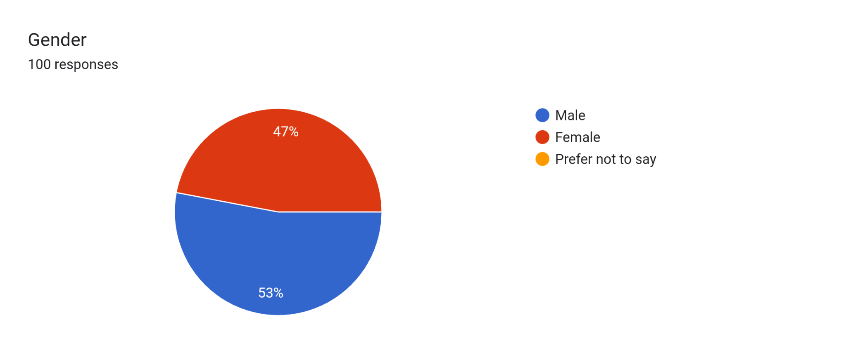

Figure 10: Gender Distribution Pie Graph

Out of 100 respondents, 53% are male and 47% are female. No respondents preferred not to disclose their gender. This indicates a slightly higher participation of males in the survey, but overall, the gender distribution is fairly balanced.

Enrollment Status

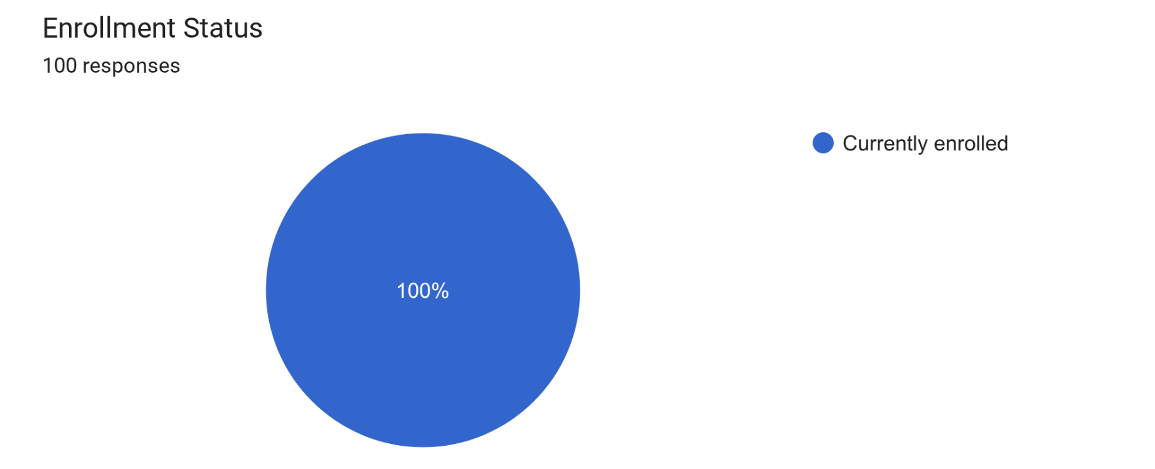
Figure 11: Enrollment Status Pie Graph

Out of 100 respondents, all of them are active students, making the survey results highly relevant to the current student population.

- Grade Level
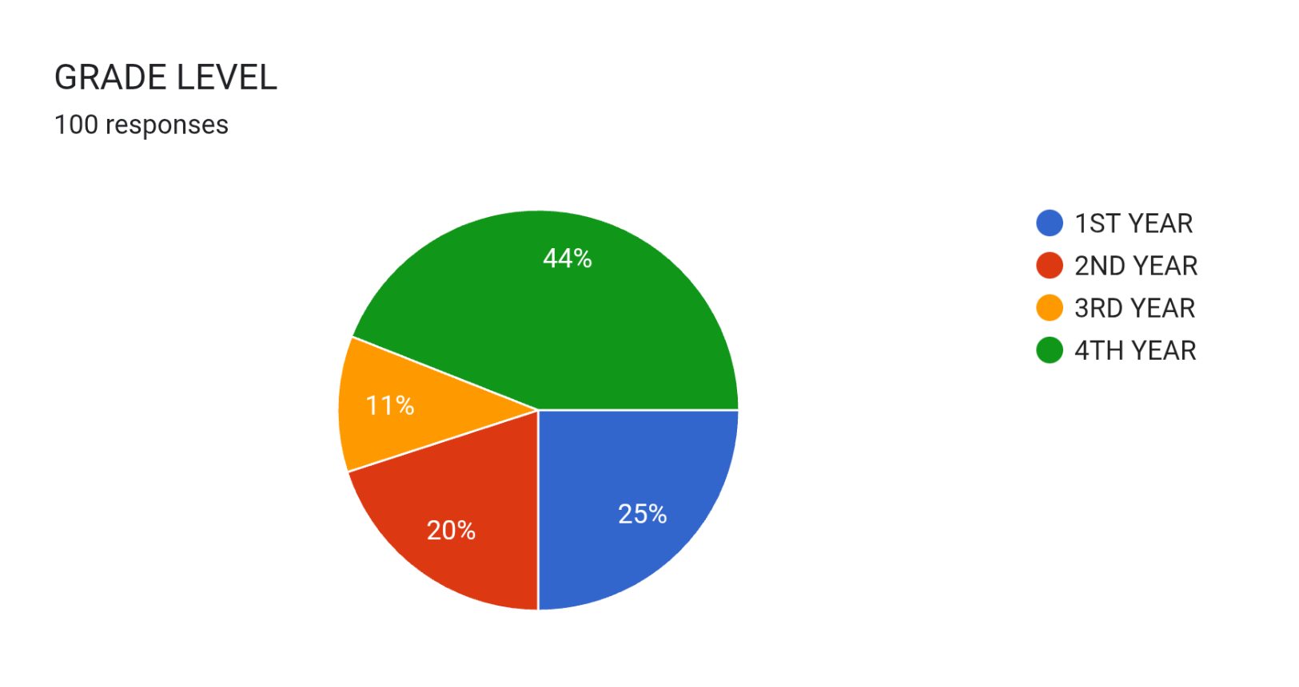

Figure 12: Grade Level Pie Chart

Out of 100 respondents, 44% are 4th-year students, 25% are 1st-year students, 20% are 2nd-year students, and 11% are 3rd-year students. This indicates that the majority of respondents are in their final year, suggesting that the survey results are largely influenced by the experiences and perspectives of senior students. Lower representation from 3rd-year students shows a smaller contribution from that group, while 1st- and 2nd-year students provide moderate input.

- College Course (if applicable)
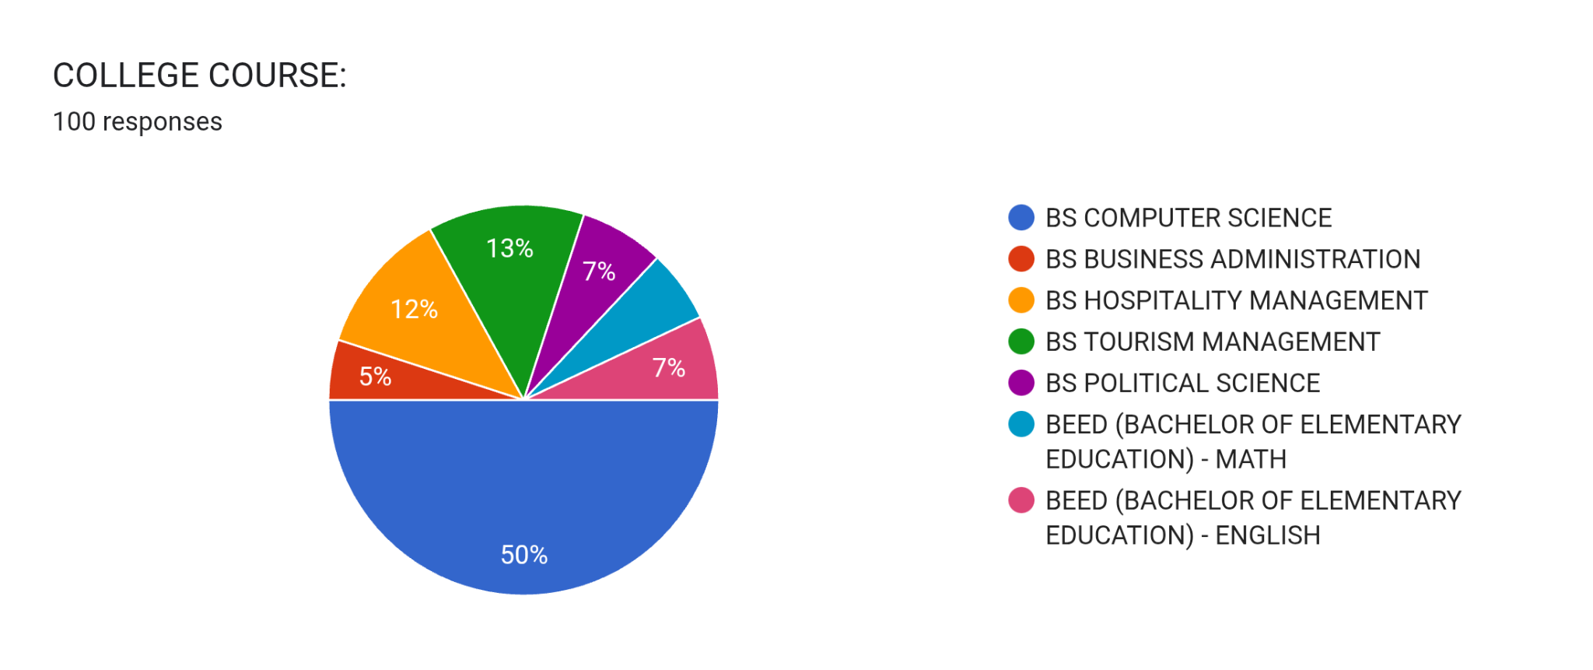
Figure 13: College Course Pie Chart

Out of the 100 respondents, 50% are from BS Computer Science, making it the dominant group. BS Tourism Management accounts for 13%, followed by BS Hospitality Management at 12%. BS Political Science and BEED – English each represent 7%, while BEED – Math also has 7%. BS Business Administration has the lowest share at 5%.
This shows that the survey results are largely influenced by BS Computer Science students, while the remaining courses contribute smaller but still meaningful proportions.

Part I. Current Document Request Process

1.1. Do you often request official documents (e.g., TOR, Good Moral Certificate, etc.) from the school?

Responses | Frequency | Percentage
Yes | 64 | 64%
No | 36 | 36%
Total | 100 | 100%
Table 3: Current Document Request Process
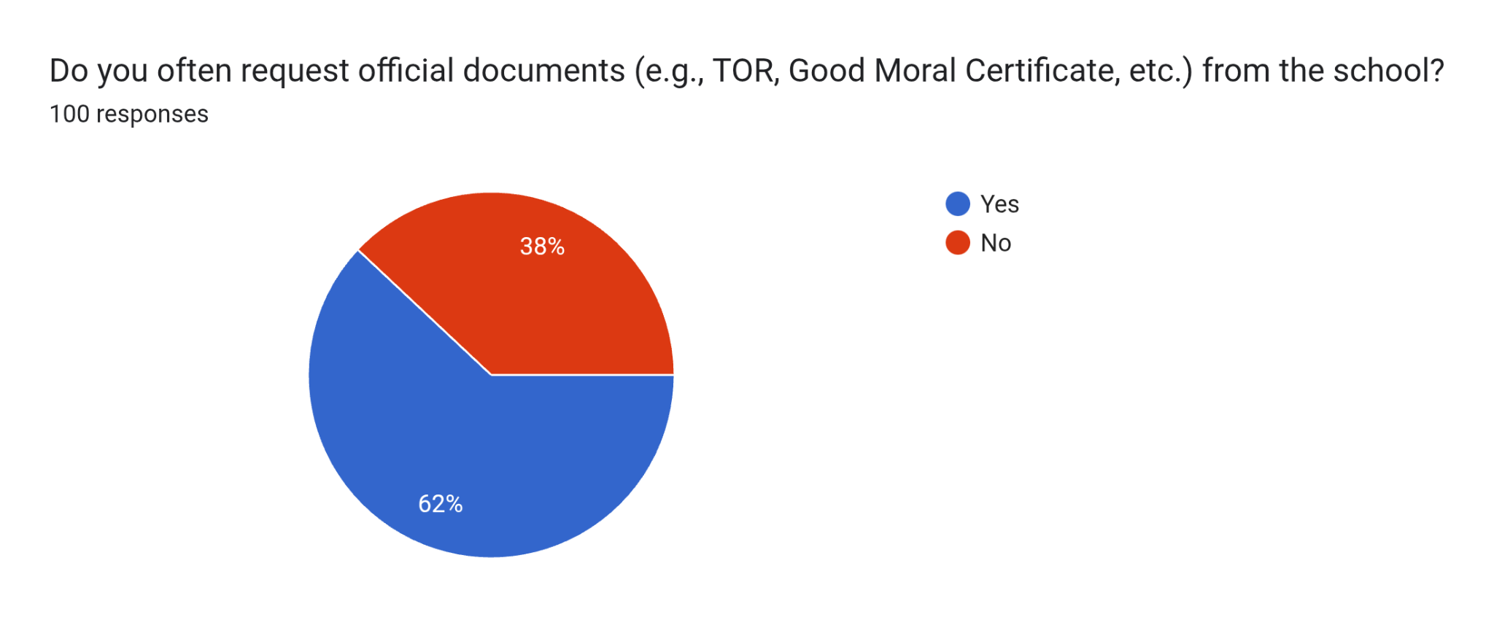
Figure 14 :Current Document Request Process Pie Graph

Most respondents 62% indicated that they request documents often, while 38% reported that they do not frequently request documents.

1.2. What Type of Documents?
Based on Question 1 where only 65 students Answered Yes

Data Table: Frequency and Percentage of Most Requested Documents (N = 64 students)

Document type | Frequency | Percentage
TRANSCRIPT OF RECORDS (TOR) | 15 | 24.2%
DIPLOMA | 12 | 19.4%
FORM 138 | 15 | 24.2%
FORM 137 (school to school transaction - request form) | 16 | 25.8%
HONORABLE DISMISSAL | 8 | 12.9%
CERTIFICATE OF GOOD MORAL CHARACTER | 19 | 30.6%
CERTIFICATE OF GRADES | 14 | 22.6%
CERTIFICATE OF ENROLLMENT | 17 | 27.4%
CERTIFICATE OF REGISTRATION (COR) | 5 | 8.1%
CERTIFICATE OF GWA | 2 | 3.2%
STATEMENT OF ACCOUNT (SOA) | 9 | 14.5
CERTIFICATION - COMPANY VERIFICATION | 0 | 0.0%
ENDORSEMENT LETTER | 1 | 1.6%
CERTIFICATE OF MEDIUM OF INSTRUCTION | 0 | 0.0%
NSTP CERTIFICATION | 1 | 1.6%
CTC DIPLOMA | 0 | 0.0%
CTC REGFORM | 0 | 0.0%
CERTIFICATE OF TRUE COPY | 2 | 3.2%
GRADUATION PICTURE/ YEARBOOK | 4 | 6.5%

Table 4: Document Type
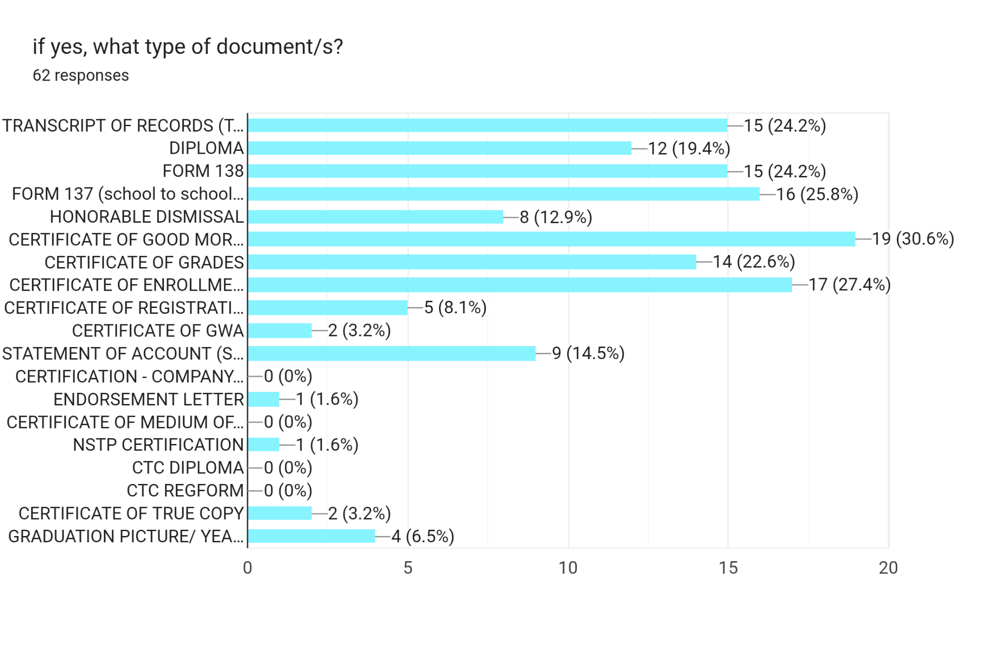

Figure 15: Document Type Bar Chart

Based on the bar chart with 62 responses, the most frequently requested document is the Certificate of Good Moral Character with 19 requests (30.6%), followed by the Certificate of Enrollment (COE) with 17 requests (27.4%). Form 137 has 16 requests (25.8%), while both the Transcript of Records and Form 138 have 15 requests each (24.2%).
Other commonly requested documents include the Certificate of Grades with 14 requests (22.6%) and the Diploma with 12 requests (19.4%). Meanwhile, documents such as the Honorable Dismissal (8 requests, 12.9%), Certificate of Registration (5 requests, 8.1%), and Graduation Picture/Yearbook (4 requests, 6.5%) show moderate demand.
Low-demand documents include the Certificate of True Copy and Certificate of GWA (2 requests each, 3.2%), while items such as Endorsement Letter and NSTP Certification have only 1 request each (1.6%). Some documents, including Certification – Company, Certificate of Medium of Instruction, CTC Diploma, and CTC Reform, recorded no requests.
Overall, the data indicates that students primarily request essential academic documents, particularly those needed for enrollment, transfer, and verification purposes.

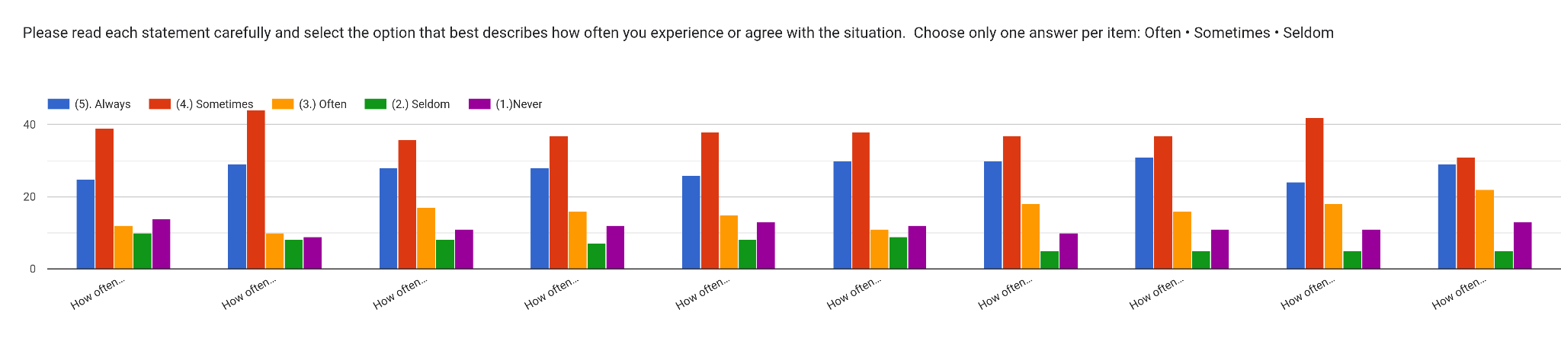

Figure 16: Current Document Request Process Bar Chart

- Current Document Request Process
I. Current Document Request | Mean | Verbal Interpretation | Ranking
1. How often do you find the current document request process time-consuming? | 3.51 | Often | 10
2. How often do you experience long waiting lines or delays when requesting documents, especially during peak times (start of semester, graduation season, end of school year)? | 3.85 | Often | 1
3. How often do you prefer a faster, online method over the manual process when requesting documents? | 3.62 | Often | 7
4. How often do you feel that an online system would make it easier for you to track the status of your document requests? | 3.62 | Often | 6
5. How often do you think a web-based system could help reduce errors or miscommunication in document processing? | 3.56 | Often | 9
6. How often do you feel comfortable using an online platform to submit and pay for your document requests? | 3.65 | Often | 4
7. How often do you believe an online document request system would improve overall service efficiency in the school? | 3.72 | Often | 2
8. How often would you support the school in adopting a web-based system for document requests? | 3.72 | Often | 3
9. How often do you find online document request systems more convenient and reliable than manual methods? | 3.63 | Often | 5
10. How often do you feel frustrated with the current manual document request process? | 3.58 | Often | 8

Table 5: Current Document Request Process

- Satisfaction and Service Quality
2.1 Satisfaction with the Current Document Request Process
2.1 Satisfaction | Mean | Verbal Interpretation | Ranking
1. I find the current process of requesting school documents convenient. | 3.33 | Neutral | 1
2. The instructions for requesting documents are clear and easy to follow. | 3.1 | Neutral | 5
3. The waiting time for document processing is reasonable. | 3.18 | Neutral | 2
4. The school staff handles document requests efficiently. | 3.14 | Neutral | 4
5. I am satisfied with the overall experience of requesting documents through the current system. | 3.16 | Neutral | 3

Table 6: Satisfaction

2.2 Quality of Service Provided by the School Staff
2.1 Quality | Mean | Verbal Interpretation | Ranking
1. The staff are polite and approachable when assisting with document requests. | 3.23 | Neutral | 2
2. My concerns or questions about document requests are addressed promptly. | 2.98 | Disagree | 5
3. The staff provide accurate information regarding requirements and processing times. | 3.11 | Neural | 4
4. The service I receive is consistent and reliable. | 3.65 | Neutral | 1
5. Overall, I am satisfied with the service quality of the school personnel handling document requests. | 3.18 | Neutral | 3

Table 7: Quality

2.3 Satisfaction with the Payment Process
2.3 Payment Process | Mean | Verbal Interpretation | Ranking
1. The payment process for document requests is easy and understandable. | 3.30 | Neutral | 1
2. The fees for requesting documents are reasonable. | 3.25 | Neutral | 2
3. I am comfortable with the available payment methods (e.g., cash, bank, online, etc.). | 3.21 | Neutral | 4
4. The receipt or proof of payment is provided promptly and correctly. | 3.25 | Neutral | 3
5. Overall, I am satisfied with how payments for document requests are handled by the school. | 3.20 | Neutral | 5

Table 8: Payment Process

III. Satisfactory Assessment
3. Payment Process | Mean | Verbal Interpretation | Ranking
1. My overall experience in requesting school documents at St. Clare College of Caloocan is: | 2.15 | Neutral | 3
2. The level of difficulty or challenges I encounter when requesting document is: | 2.53 | Satisfactory | 1
3. The amount of improvement needed for the current document request process is: | 2.05 | Neutral | 7
4. The time it takes to process and release my requested documents is: | 2.03 | Neutral | 9
5. The speed and convenience of the current document request process for students or staffs is: | 2.05 | Neutral | 8
6. The current payment methods for requested documents is: | 1.56 | Not Satisfactory | 10
7. The availability of features and functions in current document request system is: | 2.07 | Neutral | 6
8. The potential benefits of having an online document request system for students and staffs is: | 2.13 | Neutral | 4
9. The difficulty I experience when requesting documents while off-campus or overseas is: | 2.09 | Neutral | 5
10. The helpfulness of additional improvement to the school's document request and payment process is: | 2.37 | Satisfactory | 2

Table 9: Payment Process

CHAPTER IV
SUMMARY OF FINDINGS, CONCLUSIONS AND RECOMMENDATIONS

Summary of Findings
This study aimed to develop and evaluate a Web-Based Document Request System for St. Clare College of Caloocan to improve the efficiency, accessibility, and quality of document request services for tertiary students.
The findings revealed that the existing document request process in the institution is primarily manual and time-consuming. Tertiary students are required to personally visit the registrar’s office, fill out request forms, process payments, and wait in long queues before documents are released. This traditional process causes delays, inconvenience, and limited accessibility, especially for students with busy schedules or those who are off-campus.
To address these problems, the researchers developed a Web-Based Document Request System using HTML, CSS, JavaScript, PHP, and SQL, guided by the Agile Model as the software development methodology. The system enables students to request documents online, monitor the status of their requests in real time, and complete transactions digitally. It also provides administrators with a centralized platform for managing and monitoring requests more efficiently.
A total of 100 respondents participated in the study. In terms of demographic profile, 48% were male and 52% were female, indicating a balanced distribution of respondents. The largest group of respondents were 4th-year students (38%), followed by 2nd-year students (26%), 1st-year students (25%), and 3rd-year students (11%). Among the college programs represented, BS Computer Science students comprised the majority at 43%, followed by BS Tourism Management (17%) and BS Business Administration (16%).
The study also showed that 64% of respondents frequently request school documents. The most commonly requested documents were the Certificate of Good Moral Character (30.6%) and Certificate of Enrollment (27.4%), followed by Form 137 (25.8%), Transcript of Records, and Form 138 (24.2%).
Findings regarding the current document request process revealed that students often experience delays, long waiting lines, and inconvenience. Respondents strongly agreed that an online document request system would improve efficiency, reduce waiting time, and provide a more convenient alternative to the manual process.
The evaluation of the developed system showed positive results in terms of usability and accessibility. Most respondents agreed that the online registration process is easy and straightforward, the interface is user-friendly, and the instructions are clear and understandable. The system was also found to be accessible through both mobile devices and computers.
In terms of efficiency and service quality, the majority of respondents agreed that the system significantly reduced waiting time and made requesting documents more convenient than personally visiting the registrar’s office. The real-time tracking feature and automated notifications were also positively evaluated for improving transparency and communication.
Regarding payment and security, most respondents agreed that the online payment methods such as GCash and e-wallets are convenient and efficient. Many respondents also expressed confidence in the system’s ability to securely handle personal information, although some respondents remained neutral, indicating that further improvements in data privacy and security measures are still needed.
Overall, the system received positive feedback from the respondents. Results showed that 51% of respondents were satisfied and 21% were very satisfied with the system, while 24% remained neutral, 3% were dissatisfied, and only 1% were very dissatisfied. Furthermore, 79% of respondents recommended the continued implementation of the Web-Based Document Request System for all school document requests.
These findings indicate that the proposed Web-Based Document Request System significantly improves the document request process in terms of accessibility, efficiency, convenience, service quality, and user satisfaction.

Conclusions
Based on the findings of the study, it can be concluded that the current manual document request system at the tertiary level of St. Clare College of Caloocan is inefficient, time-consuming, and inconvenient for students.
The developed Web-Based Document Request System effectively addresses these issues by providing a more efficient and accessible platform for requesting documents. It enables tertiary students to complete transactions online, monitor request status, and avoid long waiting times associated with the manual process.
The system was positively evaluated by the respondents in terms of usability, efficiency, reliability, and overall performance. The high level of user satisfaction and the strong recommendation rate indicate that the system is acceptable and suitable for implementation.
However, certain areas such as system accessibility for all users and data security assurance require further enhancement to maximize user confidence and system effectiveness.

Recommendations
In light of the findings and conclusions of the study, the following recommendations are proposed:
- The institution should adopt and implement the Web-Based Document Request System to improve the efficiency, accessibility, and accuracy of document processing services.
- Continuous maintenance and updates of the system should be ensured to maintain its functionality, reliability, and security.
- Additional features such as SMS notifications, enhanced real-time tracking, and automated payment verification should be integrated to further improve user experience.
- The institution should consider enlarging the scope of the system by integrating document requests for Pre-school, Elementary, Junior High, and Senior High School levels; the school can establish a unified and centralized administrative process for all student records.
- The institution should provide proper orientation and training for both students and staff to ensure effective utilization of the system.
- Strong data security measures should be implemented and regularly evaluated to protect user information and increase trust in the system.
- Future researchers are encouraged to further enhance the system by integrating it with other institutional services or incorporating advanced technologies to improve performance and scalability.

