Toward a Unified Global Standard for Outdoor Trespass Lighting: Harmonizing Design, Metrics, and Environmental Protection Across Jurisdictions

ABSTRACT

Outdoor Trespass Lighting (OTL) is regulated globally using vertical illuminance limits; however, significant divergence exists across six primary regulatory frameworks that were analysed (IES, CIE, ILP, AS/NZS, IDA, TAC), resulting in regulatory fragmentation and inconsistent environmental protection. This study develops and validates a unified international OTL framework using a minimum-threshold convergence (MTC) methodology, whereby the most restrictive permissible illuminance across standards is adopted for each environmental zone. A systematic comparative review (2010–2025) was conducted using Scopus, Web of Science, and professional standards databases. Regulatory divergence was quantified, and a harmonised four-zone framework (1, 3, 8, 15 lux) was derived. The framework was validated through simulation-based case studies using representative roadway lighting geometries and cross-comparison against IES RP-8 and CIE 150 compliance outcomes. Results demonstrate that the unified thresholds: (i) remain within all major international limits, (ii) reduce regulatory ambiguity, and (iii) do not compromise safety or compliance. Sensitivity analysis confirms that minimum-threshold convergence provides a robust, conservative, and legally defensible harmonisation strategy. The study establishes a scalable model for global lighting governance, identifies the limitations of facade-based photometry, namely that vertical illumination does not fully capture circadian or biological light exposure, and recommends integrating it with eye-level and circadian metrics. This is a governance consequence for municipalities and engineering practitioners.
Keywords: Outdoor Trespass Lighting; Regulatory Harmonisation; Environmental Governance; Vertical Illuminance; Skyglow; Glare; Policy Convergence.

- INTRODUCTION

Artificial Light at Night (ALAN) is integral to modern urban life, supporting public safety, economic activity, and nighttime mobility. However, an expanding body of peer-reviewed research demonstrates that excessive, misdirected, or poorly regulated outdoor lighting can produce significant adverse effects. These include ecological disruption, circadian rhythm interference, glare-related visual impairment, and the intensification of regional skyglow (Falchi et al., 2016; Kyba et al., 2017; Boyce, 2014).

Outdoor Trespass Lighting (OTL) refers to artificial illumination that extends beyond its intended task area and intrudes into adjacent properties or environmentally sensitive zones. Internationally, OTL is most commonly regulated using maximum vertical illuminance (Ev) measured at property boundaries or building façades.

Although there is broad professional agreement on measurement methodology, existing regulatory frameworks vary substantially with respect to:
- Environmental zoning classifications
- Maximum allowable vertical illuminance limits
- Curfew provisions
- Treatment of adaptive or dynamic lighting
- Documentation, interpretation, and enforcement practices
This divergence creates regulatory fragmentation. From an institutional standpoint, fragmentation increases compliance complexity, reduces regulatory predictability, and heightens the potential for inconsistent or discretionary enforcement.

Scholarship on regulatory harmonisation demonstrates that convergence across jurisdictions reduces transaction costs and improves policy coherence (Alexandros, 2025; Holzinger et. al., 2008; Abbott & Snidal, 2001; Vogel, 1995). Similarly, research on standards convergence shows that technical alignment improves interoperability and minimises interpretive conflict (Blind, 2013). The absence of a unified framework for OTL, therefore, represents both a technical deficiency and a governance gap. This study responds to that gap through systematic comparative analysis and the development of a harmonised, precautionary illuminance standard. Accordingly, the following section reviews and contextualises existing OTL guidelines used internationally.

Although findings from animal studies do not always translate directly to humans, epidemiological evidence consistently associates higher ALAN exposure with increased disease prevalence in human populations. Establishing direct causation remains methodologically challenging due to confounding variables such as lifestyle, genetics, and environmental context. Nevertheless, the strength and consistency of observed associations underscore the importance of continued investigation and regulatory attention.

The rapid expansion of outdoor lighting infrastructure may also increase vulnerability to communicable and non-communicable illnesses (Kernbach, 2021). Managing ALAN exposure—particularly short-wavelength (blue) light—supports circadian regulation (CR) and may reduce physiological disruptions associated with disease risk (Nagai et al., 2019). ALAN is now widely recognised as a disruptor of human sleep and circadian health (SaCH) (AMA, 2016; Thurairajah et al., 2021a, 2021b; Thurairajah, 2017; Kaushik et al., 2022; Phillips, 2019; Walker et al., 2021).

The outdoor light source pre-qualification, outdoor wireless control system, and lighting calculation method can control outdoor light pollution, outdoor trespass lighting (OTL) levels, and the health impacts on residents (Thurairajah et al., 2021a, 2021b, 2022a; Thurairajah U., 2022b, 2023b). Visibility can improve trespass lighting, glare, and health in outdoor lighting design (Thurairajah, U., 2023a, and 2023c).

The central challenge lies in linking real-world outdoor lighting exposure to measurable SaCH outcomes. While causation cannot always be established, the persistent correlation between intrusive nighttime lighting and adverse human health indicators highlights a collective responsibility to mitigate exposure. This research contributes to that effort by strengthening the evidentiary basis for linking excessive OTL to degraded SaCH among affected residential populations.

- BACKGROUND

Existing outdoor OTL guidelines worldwide

It is essential to have a clear understanding of what constitutes OTL and how it can be controlled to support residents' CH and well-being. Various components are associated with OTL, such as mounting height, improper installation, overlighting, and clutter, which refers to the excessive use of light that can cause glare and discomfort (IES RP-8, 2021). For instance, adjusting the mounting height, ensuring proper installation, and using OL controls can help mitigate these issues. Identifying these elements that affect resident well-being is crucial. International literature search tools, databases, and publishers, such as Google Scholar, MetSearch, Scopus, Elsevier, and professional authorities, were used to review all available technical documents on OTL to determine the task proposed clearly. Some of the leading authorities contacted on Published Standards are:
- IES (TM-15, 2021), IES RP-8-25, North America
- CIE (CIE-150, 2017), Europe
- IDA (2021), International
- AIES (AS/NZS 42822019, 2019), Australia
- ILP (GN01, 2020), U.K.
- TAC (TAC, 2006), Canada

The author has been familiar with North American published literature on OTL during his professional practice but initiated a complete literature search (from 2019 to 2025) to identify and assemble all available publications on OTL. Some of the publications are identified as follows:
- The CIE, “Guide on the Limitation of the Effects of Obtrusive Light from OL Installations, 2nd Edition” (CIE-150, 2017).
- The AS/NZS, “Control of the obtrusive effects of OL” (AS/NZS 42822019, 2019).
- The ILP, “Guidance Note 1 for the reduction of obtrusive light 2020” (ILP GN01, 2020).
- The IDA, “lighting zone rating and characteristics zones” (IDA, 2021).
- The IES, “Recommended practice for lighting roadway and parking facilities” (ANSI/IES RP-8, 2021).
- The TAC, “Guide for the Design of Roadway Lighting” (TAC, 2006).

The published data from these documents were used to establish definitions, design criteria, calculations, and measurement practices and form a basis for determining limiting values for OTL. This approach will help establish a robust scientific basis for the proposed OTL design criteria. Later, the author conducts a thorough analysis and theoretical exploration of the current design criteria for OTL and their variations. The methodology section aims to address the existing knowledge gap.

Sometimes OL from luminaires falls on or spreads around green spaces and dwellings when the intended area in which they are installed illuminates an outdoor environment, including roadways, parking lots, pathways, and sports fields. Most importantly, the ALAN falls in residential areas, where it can be an unwanted OTL and subsequently annoys the public and deprives them of sleep and may also obstruct the operation of security cameras (ANSI/IES RP-8, 2025). Avoiding high-mast lighting near residential areas, hospitals, hotels, and airports is a more effective way to control OTL. However, it can be validated by OLD.

The limiting values for OTL are affected by the transient adaptation and ambient brightness of the traffic corridor's environment (Pothukuchi 2021). For example, a higher limiting value of OTL may be tolerated in an urban environment where the ambient and adaptation brightness may be relatively high (compared to the rural setting). Conversely, no OTL may be accepted in an environmentally sensitive area (ANSI/IES RP-8, 2025). Thus, the following organisations have proposed OL Zones.

Transportation Association of Canada (TAC, 2006)

TAC has published a design guide for roadway lighting, which includes OL zones. As shown in Table 1., areas are categorized into four lighting zones (LZ1 to LZ4), with LZ1 being the most restrictive and LZ4 the least.

Table 1. Environmental OL Zones by TAC
Source: Compiled by the author (TAC, 2006)
No. | ZONE | DESCRIPTION
1a | LZ1 | These are very rural areas outside a city with little or no ambient OL, no commercial development and no outside public night-time pedestrian activity. Where OL is required in an LZ1 area, the OTL measurements would be taken at the place being inhabited by humans as opposed to the property boundary line or edge of road allowance (TAC, 2006).
1b | LZ2 | These are rural areas outside of a city with very low population density, no commercial development, minimal outdoor night-time pedestrian activity and no security issues or concerns. Where OL is required in an LZ2 area, the OTL measurement would be taken at the place being inhabited by humans as opposed to the property boundary line or edge of road allowance (TAC, 2006).
1c | LZ3 | These are areas within a city, with low to medium population density, some outdoor pedestrian night-time activity and no security issues or concerns. Potential traffic conflict between vehicles, pedestrians and cyclists is inevitably mild. Such areas include residential subdivisions, town house developments on local and collector roads, as well as highways and freeways. Where OL is required in an LZ3 area, the OTL measurements would be taken at the property boundary line or edge of road allowance (TAC, 2006).
1d | LZ4 | These are areas within a city with medium to high population density, or areas intended for heavy public and commercial activity. Potential traffic conflicts between vehicles, pedestrians and cyclists are inevitable and intense. Urban areas with both commercial and residential developments encounter a high level of nighttime vehicular and public activities. Such areas include those with multi-family housing (apartments), those in a downtown core, as well as areas of commercial and industrial development on local, collector and arterial roads, as well as highways and freeways. Where OL is required in an LZ4 area, the OTL measurements would be taken at the property boundary line or edge of road allowance (TAC, 2006).

The recommended acceptable maximum OL level value for the OTL limit is “vertical illuminance on properties” (TAC, 2006). The TAC values serve a critical function in determining the proposed highest values of vertical illuminance at the residence or boundary line/edge of road allowance as defined. Limitations on OTL extend to nearby or prospective dwellings, especially concerning the surfaces of those properties exposed to OL. The values consider the summary of all the OL installations (TAC, 2006). Table 2 below gives the proposed highest vertical illuminance levels at property lines.

Table 2. The proposed maximum vertical illuminance on the ROW
Source: Compiled by the author (TAC, 2006)

OL Technical Parameter | Application Conditions | Environmental Zones
OL Technical Parameter | Application Conditions | E0  (Lux) | E1  (Lux) | E2  (Lux) | E3  (Lux) | E4  (Lux)
Illuminance in Vertical Plane (E_{v}) | Pre-Curfew  Post-Curfew not applicable | N/A | 1 | 3 | 8 | 15
Note: Maximum allowable light level anywhere along the vertical surface of the RPL.

Illuminating Engineering Society (ANSI/IES RP-8, 2025)

The IES published a document proposing introducing OL zones in all OL systems (ANSI/IES RP-8, 2025). Table 3 below provides the proposed OL zones and brief descriptions.

Table 3. Environmental OL Zones by IES
Source: Compiled by the author (ANSI/IES RP-8, 2025).
No. | ZONE | DESCRIPTION
2.3a | LZ0 | OL Zone 0 applies to areas where permanent outdoor lighting is not expected. When used, lighting must be minimal in intensity and duration. Typical locations include wilderness parks, observatories, and protected dark-sky areas. Permanent lighting requires special review. Some rural communities may adopt Zone 0 for residential preservation.
2.3b | LZ1 | OL Zone 1 applies to areas requiring low ambient lighting, such as single-family homes, rural centers, business parks, and low-activity commercial or industrial zones. It may also include developed sections of parks or natural areas with limited nighttime use.
2.3c | LZ2 | OL Zone 2 applies to areas with moderate ambient lighting, including multifamily housing, schools, hospitals, mixed-use zones with residential focus, and community recreation areas. It may also accommodate outdoor sales or industry within otherwise LZ-1 designated areas.
2.3d | LZ3 | OL Zone 3 applies to areas with moderately high lighting needs, including commercial corridors, town centers, mixed-use zones, industrial areas, rail yards, active recreation fields, malls, car dealerships, gas stations, and other exterior retail spaces with significant nighttime activity.
2.3e | LZ4 | OL Zone 4 applies to areas with very high ambient lighting and is reserved for exceptional cases, such as high-density entertainment districts or heavy industrial zones. It is generally unsuitable for typical urban or suburban settings.
The recommended maximum OL level value for the OTL limit is “vertical illuminance on properties” (ANSI/IES RP-8, 2025). The OTL limitations “apply to nearby dwellings or potential dwellings, especially to their relevant surface or surfaces on properties.” The values consider the summary of all the OL installations (ANSI/IES RP-8, 2025). Table 4 below gives the proposed highest values of vertical illuminance on property lines.

Table 4. The proposed maximum vertical illuminance on the ROW
Source: Compiled by the author (ANSI/IES RP-8, 2025).

OL Technical Parameter | Application Conditions | Environmental Zones
OL Technical Parameter | Application Conditions | E0  (Lux) | E1  (Lux) | E2  (Lux) | E3  (Lux) | E4  (Lux)
Illuminance in Vertical Plane (E_{v}) | No curfew | 0.5 | 1 | 3 | 8 | 15
Note: Maximum allowable light level anywhere along the vertical surface of the RPL.

International Commission on Illumination (CIE-150, 2017)
The CIE has introduced OL zones in a latest publication titled “Guide on the Limitation of the Effects of Obtrusive Light from OL Installations, 2nd Edition” (CIE-150, 2017). Table 5 below indicates the proposed OL zones and provides brief descriptions.

Table 5 Environmental OL Zones by CIE
Source: Compiled by the author (CIE-150, 2017)

No. | OL Zones | OL Environment | Examples
2.5a | E0 | “Intrinsically dark” | “IDA-designated Dark Sky Parks, UNESCO Starlight Reserves, and major optical observatories” (CIE-150, 2017).
2.5b | E1 | Dark | “Relatively uninhabited rural areas” (CIE-150, 2017).
2.5c | E2 | “Low district brightness” | “Sparsely inhabited rural areas” (CIE-150, 2017).
2.5d | E3 | “Medium district brightness” | “Well-inhabited rural and urban settlements” (CIE-150, 2017).
2.5e | E4 | “High district brightness” | “Town and city centres and other commercial areas” (CIE-150, 2017).

The recommended maximum OL level value for the OTL limit is applies to nearby dwellings, specifically their relevant surfaces, especially where windows are (CIE-150, 2017). OTL restrictions apply to adjacent existing or future dwellings, with specific focus on the impacted surfaces of those properties. The values consider the summary of all the OL installations (CIE-150, 2017). Table 6 below gives the proposed highest values of vertical illuminance on property lines.
Table 6 The proposed maximum vertical illuminance on the ROW
Source: Compiled by the author (CIE-150, 2017)
OL Technical Parameter | Application Conditions | Environmental Zones
OL Technical Parameter | Application Conditions | E0  (Lux) | E1  (Lux) | E2  (Lux) | E3  (Lux) | E4  (Lux)
Illuminance in Vertical Plane (E_{v}) | “Pre-curfew” | N/A | 2 | 5 | 10 | 25
Illuminance in Vertical Plane (E_{v}) | “Post-curfew” | N/A | <0.1* | 1 | 2
*If the installation is for public OL, then this value may be up to 1 Lux

Institution of Lighting Professionals (ILP GN01, 2021)
The ILP has introduced an OL zones publication titled “Guidance Note 1 for reducing obtrusive light” (ILP GN01, 2021), based on the published CIE standard, but it indicates some minor deviations from the CIE standard. Table 7 below gives the proposed OL zones and brief descriptions.
Table 7 Environmental Zones by ILP
Source: Compiled by the author (ILP GN01, 2021)

No. | Surrounding | OL Zones | OL Environment | Examples
7a | Protected | E0 | “Dark” (SQM 20.5+) | “Astronomical observable dark skies, UNESCO Starlight Reserves, IDA Dark Sky Places” (ILP GN01, 2021).
7b | Natural | E1 | “Dark” (SQM20 to 20.5) | “Relatively uninhabited rural areas, National Parks, Areas of Outstanding Natural Beauty, IDA buffer zones, etc.” (ILP GN01, 2021).
7c | Rural | E2 | “Low district brightness” | “Sparsely inhabited rural areas, village or relatively dark outer suburban locations” (ILP GN01, 2021).
7d | Suburban | E3 | (SQM 15 to 20)  “Medium district brightness” | “Well-inhabited rural and urban settlements, small town centres of suburban locations” (ILP GN01, 2021).
7e | Urban | E4 | “High district brightness” | “Town/city centres with high levels of night-time activity” (ILP GN01, 2021).

The IDA refers to the Sky Quality Meter (SQM), a device that measures the night sky luminance. Astronomers typically use it to quantify the brightness of skyglow, measured in magnitudes per square arcsecond. This practical scale ranges from 16.00, indicating a bright night sky, to 22.00, representing minimal OTL, facilitating the measurement and evaluation of OTL levels.

The highest light level of vertical illuminance on property lines needs to be determined. These thresholds are enforced for surrounding residential properties, primarily where the windows are situated. The OL levels are the sum of all the ALAN installations. Table 8 below shows the proposed highest vertical illuminance on property lines:

Table 8 The proposed maximum vertical illuminance on ROW
Source: Compiled by the author (ILP GN01, 2021)
OL Technical Parameter | Application Conditions | Environmental Zones
OL Technical Parameter | Application Conditions | E0  (Lux) | E1  (Lux) | E2  (Lux) | E3  (Lux) | E4  (Lux)
Illuminance in Vertical Plane (E_{v}) | Pre-curfew | N/A | 2 | 5 | 10 | 25
Illuminance in Vertical Plane (E_{v}) | Post-curfew | N/A | <0.1* | 1 x | 2 | 5
*If the installation is for public OL, then this value may be up to 1 Lux

The Council of Standards Australia/Standards New Zealand (AS/NZS, 2019)
The Council of Standards AS/NZS has introduced OL zones to manage the obtrusive effects of OL (AS/NZS 4282, 2019). This document is based on the published CIE standard (CIE-150, 2017) but there are some minor deviations from this standard. Table 9 below provides the proposed OL zones and brief descriptions.

Table 9 Environmental Zones by AS/NZS
Source: Compiled by the author (AS/NZS 4282, 2019)

No. | OL Zones | OL Environment | Examples
9a | A0 | “Intrinsically dark” | “UNESCO Starlight Reserves, IDA Dark Sky Parks, Major optical observatories, no road lighting - unless specifically required by the road control authority” (AS/NZS 4282-2019, 2019).
9b | A1 | “Dark” | “Relatively uninhabited rural areas, no road lighting - unless specifically required by the road control authority” (AS/NZS 4282-2019, 2019).
9c | A2 | “Low district brightness” | “Sparsely inhabited rural areas and semi-rural areas” (AS/NZS 4282-2019, 2019).
9d | A3 | “Medium district brightness” | “Suburban areas in towns and cities” (AS/NZS 4282-2019, 2019).
9e | A4 | “High district brightness” | “Town and city centres and other commercial areas, residential areas abutting commercial areas” (AS/NZS 4282-2019, 2019).

The recommended maximum value of light technical parameters for obtrusive light control is vertical illuminance (AS/NZS 4282, 2019). The vertical illuminance is the summation of all the ALAN coming towards the measurement location. Table 10 indicates the proposed highest vertical illuminance on property lines:

Table 10 The proposed maximum vertical illuminance on the ROW
Source: Compiled by the author (AS/NZS 4282, 2019)

OL Technical Parameter | Application Conditions | Environmental Zones
OL Technical Parameter | Application Conditions | A0  (Lux) | A1  (Lux) | A2  (Lux) | A3  (Lux) | A4  (Lux)
Illuminance in Vertical Plane (E_{v}) | “Pre-curfew” | N/A | 2 | 5 | 10 | 25
Illuminance in Vertical Plane (E_{v}) | “Post-curfew” | N/A | <0.1* | 1 | 2 | 5
*If the installation is for public OL, then this value may be up to 1 Lux

International Dark-Sky Association (IDA, 2021)
IDA is an advocacy group formed by astronomers, and its primary focus is on reducing direct sky glow and reflected light (IDA, 2021). OL Zone (LZ) Ratings and Characteristics are shown in Table 11 below:

Table 11 Environmental OL Zones by IDA
Source: Compiled by the author (IDA, 2021)

No. | ZONE | AMBIENT  ILLUM. | CRITERIA
11a | LZ0 | Very Dark | “Critical dark environments, such as especially sensitive wildlife preserves, national parks, and major astronomical observatories” (IDA, 2021).
11b | LZ1 | Dark | “Developed areas in state and national parks, recreation areas, wetlands and wildlife preserves; developed areas in natural settings; areas near astronomical observatories; sensitive night environments; zoos; areas where residents have expressed the desire to conserve natural illumination levels” (IDA, 2021).
11c | LZ2 | Low | “Rural areas, low-density urban neighbourhoods and districts, residential historic districts. This zone is intended to be the default condition if a zone has not been established” (IDA, 2021).
11d | LZ3 | Medium | “Medium- to high-density urban neighbourhoods, urban shopping and commercial districts, industrial parks and districts. This zone is intended to be the default condition for commercial and industrial districts in urban areas” (IDA, 2021).
11e | LZ4 | High | “Reserved for very limited applications such as major city centres, urban districts with especially high security requirements, thematic attractions and entertainment districts, regional malls, and major auto sales districts” (IDA, 2021).

The OTL limits the recommended maximum allowable light level anywhere along the vertical surface of the RPL (IDA/IES MLO, 2020). The OTL limitations, which significantly impact nearby dwellings, require that vertical illuminance on property line surfaces remain below the permitted maximum (IDA/IES MLO, 2020). Table 12 gives the proposed highest values of vertical illuminance on property lines.

Table 12 The proposed maximum vertical illuminance on the ROW
Source: Compiled by the author (IDA/IES MLO, 2020).

OL Technical Parameter | Application Conditions | Environmental Zones
OL Technical Parameter | Application Conditions | E0  (Lux) | E1  (Lux) |  | E2  (Lux) | E3  (Lux) | E4  (Lux)
Illuminance in Vertical Plane (E_{v}) | No curfew | 0.5 | 1 | 3 |  | 8 | 15
Note: Maximum allowable illuminance at any location along the vertical plane of the property boundary.

OL zones are critical for managing OL to minimise OTL, enhance visibility, and protect the night sky. Various organisations have established guidelines to define these zones, each with specific criteria for OTL limits. OL zones are categorised based on the level of artificial light present and their effects on ecological systems and human health. These zones are designed to provide a regulatory framework for controlling OL, to reduce OTL, glare, and skyglow.

The above-noted organisations have proposed OL zones under sections 2.4.1 to 2.4.6, showcasing a collaborative effort with minor variations in the OTL limiting values and description of the OL zones. They all share a common goal: effectively managing OTL to protect human interests and natural ecosystems. Understanding these zones is crucial for municipalities, as it empowers them to develop better policies for urban planning and environmental conservation. It is essential to strike a balance and create a framework for OTL that aligns with international practices and local requirements for OLD.

The conflicting OTL criteria used by different professional organisations worldwide create a gap in knowledge, literature, and professional practice. The contradiction between various standards and practices is not just a matter of concern but an urgent issue that needs immediate resolution. They must be harmonised. This justifies and highlights the critical need for further investigation.
Therefore, the following section will provide the methodology to fill this gap in knowledge to find a unified global standard for the OTL application.

- METHODOLOGY: MINIMUM-THRESHOLD CONVERGENCE
The limitations of the current fragmented global standards can be addressed through a unified global framework.

3.1 Systematic Comparative Review Protocol
A structured review was conducted using:
- Databases: Scopus, Web of Science, Google Scholar
- Standards repositories: IES, CIE, ILP, IDA, AS/NZS, TAC
- Timeframe: 2010–2025
Inclusion Criteria:
- Official national or international OTL standards
- Documents specifying quantitative vertical illuminance thresholds
- Peer-reviewed or institutional publications
Exclusion Criteria:
- Non-quantitative guidance
- Non-official or non-validated sources
This yielded 6 primary regulatory frameworks for comparative analysis.
A conservative harmonisation principle was adopted:
For each environmental category, select the lowest maximum vertical illuminance limit currently accepted within major international standards.
This approach:
- Preserves environmental protection
- Ensures compatibility with all reviewed frameworks
- Eliminates threshold conflict
- Reduces interpretive discretion
Unlike averaging or median-based harmonisation, minimum-threshold convergence avoids regulatory dilution.
Conflicting Criteria

All professional organisations have different OTL limiting values. The best way to unify these is to select the 'worst-case scenario' approach, which in this context means the lowest OTL criteria number for each zone provides the worst conditions so that it can satisfy all the organisation’s requirements. This justifies and unifies the requirements for a single evaluation criterion and satisfies every standard. The unified criteria are crucial and pivotal in proving the solution. It eventually leads to a more efficient and effective way of evaluating OTL, instilling confidence in the approach. However, it still does not satisfy the residents' impact of OTL.

Proposed unified design requirement for OTL based on the current Standard.

The author’s proposed OL zone classifications are based on the abutting Municipal Official Land Use Designation and will address conditions unique to Ontario (Ontario Land Use Planning, 2023). The OL zones are classified into four zones, ranging from LZ1, which is the most restrictive, to LZ4, the least restrictive. Various organisations' existing OTL practices are covered under background (TAC, 2006; IES TM-15, 2021; CIE-150, 2017; ILP GN-01, 2020; IDA, 2021; AS/NZS, 2019). All these organisations have similar criteria with minor variations in the description and the OTL values.

Figure 1 shows the flowchart for the proposed OTL.

Figure 1: The proposed OTL meets the occupant’s OTL
(Source: by the author)

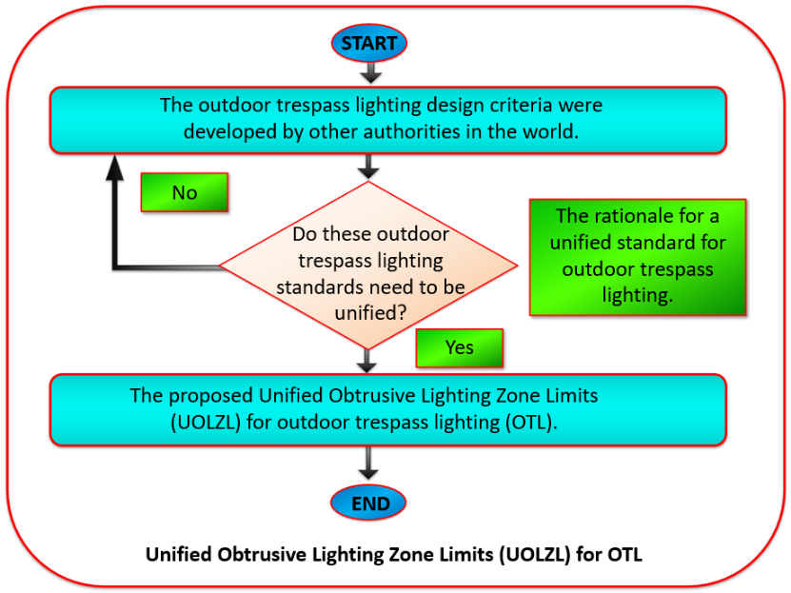

3.2 Quantitative Regulatory Divergence Analysis
A comparative matrix was constructed. Table 13 below summarises the OTL design criteria developed or used by various organisations in North America and worldwide. Curfew hours are not applicable in North America due to liability. However, it is essential to note that CIE 150 and ILP GN01 implement curfew hours in Europe.
Table 13: Outdoor OTL design criteria developed by other authorities.
Source: Compiled by the author
No. | Development of OTL Design Criteria | Design Criteria Used or Developed by Other Authorities
 | Organisation and Country | Curfew | OL Zones | Trespass Values for Zones, Vertical Illuminance in Lux
 |  |  |  | LZ1 | LZ2 | LZ3 | LZ4
13a | “Transport Association of Canada” (TAC, 2016) | NO | YES | 1 | 3 | 8 | 15
13b | “IES” (ANSI/IES RP-8, 2025) | NO | YES | 1 | 3 | 8 | 15
13c | “CIE” (CIE-150, 2017), Europe | YES | YES | 2 | 5 | 10 | 25
13d | “ILP” (ILP GN01, 2020), UK | YES | YES | 2 | 5 | 10 | 25
13e | “Standards Australia/Standards New Zealand” (AS/NZS 42822019, 2019) | NO | YES | - | 10 | 10 | 25
13f | “International Dark Sky Association” (IDA/IES MLO, 2020) | NO | YES | 1 | 3 | 8 | 15

Key divergence metrics:
- Threshold variance (Δlux)
- Zone equivalence mismatch
- Curfew dependency
A unified standard could be achieved. Figure 2 clearly illustrates all the OTL limiting values from various organisations before harmonisation. This can be used to derive a cohesive standard acceptable to all professional organisations since each organisational standard has minor variations. The OTL limiting values are vertical illuminance at the property line or the household bedroom windows.

Figure 2: The proposed unified standard for outdoor OTL before harmonisation
(Source: by the author)
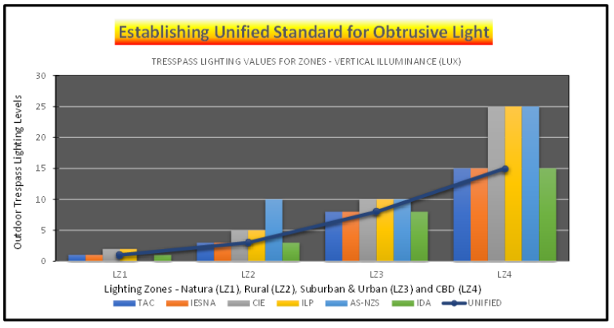

3.3 Harmonisation Model: Minimum-Threshold Convergence (MTC) methodology
The Minimum-Threshold Convergence (MTC) methodology is to harmonise international Outdoor Trespass Lighting (OTL) standards. While individual OTL limits exist across major authorities (IES, CIE, ILP, AS/NZS, IDA, TAC).

Formal Definition
For each lighting zone:
$$E_{\text{Unified}, i}=min⁡(E_{TAC},E_{IES},E_{CIE},E_{ILP},E_{AS/NZS},E_{IDA})$$
Where:
- $i=\{LZ1,LZ2,LZ3,LZ4\}$
- Missing values (e.g., “–”) are excluded, not treated as zero.
Table 14 shows the minimum threshold selection and the resulting unified threshold limit.

Table 14: Minimum-Threshold Selection
Zone | Values Considered | Minimum Selected | Unified Limit
LZ1 | 1, 1, 2, 2, 1 | 1 | 1 lux
LZ2 | 3, 3, 5, 5, 10, 3 | 3 | 3 lux
LZ3 | 8, 8, 10, 10, 10, 8 | 8 | 8 lux
LZ4 | 15, 15, 25, 25, 25, 15 | 15 | 15 lux

The systematic derivation of a single, conservative, universally compliant threshold set (1, 3, 8, 15 lux) is novel. The originality lies not in introducing new photometrics, but in:
- Framing standard harmonisation as a regulatory convergence problem for Universal compliance compatibility
- Explicitly operationalising a worst‑case / non‑deterioration principle (no standard weakened).
- Translating fragmented standards into an implementation‑ready governance framework.
The unified thresholds are derived using a conservative minimum-selection rule, ensuring that the adopted limits do not exceed any value currently accepted within major international standards. This guarantees full backward compatibility with all regulatory frameworks and prevents any reduction in environmental protection.

3.4 Validation

3.4.1 Simulation-Based Case Study
A representative roadway lighting scenario was modelled:
Table 15 below shows representative roadway lighting parameters selected based on common roadway lighting practices described in ANSI/IES RP-8-25.
Table 15: Roadway lighting parameters
Source: by the author
Parameter | Value
Mounting height | 10 m
Road Width | 12 m
Distance to residence (Setback distance) | 25 m
Observer eye height | 1.5 m
Luminaire: Lithonia Lighting, 149W, 90CRI, 50K

Five observation points were evaluated relative to the luminaire location:
- directly opposite the pole
- 10 m lateral offset
- 20 m lateral offset.
Three evaluation frameworks were applied:
- IES RP-8, IDA and TAC compliance
- CIE 150 and ILP compliance
- AS/NZS 42822019 compliance
- Proposed unified standard
These locations represent typical viewing geometries encountered in residential environments adjacent to roadways. Figure 3 below shows the computer calculation results for the ECI.
Figure 3: Façade (Vertical) Computer Calculation
Source: Designed by the author
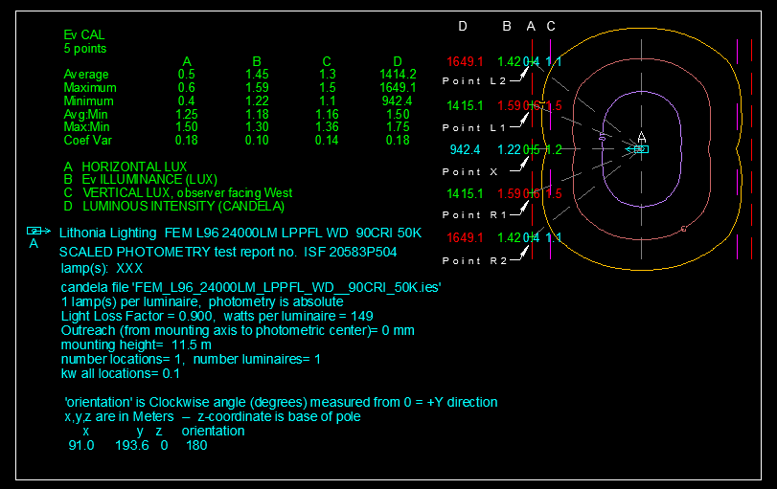

Figure 4 below shows where the vertical illuminance calculation will be performed.

Figure 4: Vertical Illuminance
Designed by the author, adopted from ANSI/IES RP-8 (2025)
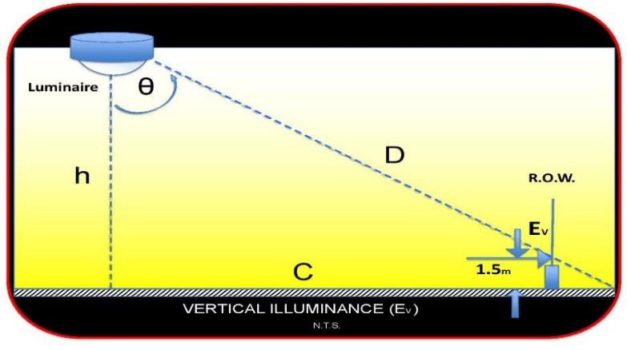

$$\text{Vertical Illuminance [E}\text{V}\text{]=}\frac{\text{Intensity * Sine an}\text{gl}\text{e [I}\text{θ}\text{ sinθ]}}{\text{Distance Square [D}\text{2}\text{]}}$$ | (1)

The basic calculation of flux transfer is the inverse square cosine law (ANSI/IES RP-8, 2025). For the particular case in which the surface is normal to the flux, θ = 90 degrees, the equation is simplified to:

$$\text{Horizontal Illuminance [E}\text{H}\text{]=}\frac{\text{Intensity [I}\text{θ}\text{]}}{\text{Distance Square [D}\text{2}\text{]}}$$ | (2)

$$\text{Vertical Illuminance [E}\text{V}\text{] = }0$$ | (3)

Where: E_{H} = horizontal illuminance.
I_{θ} = luminous intensity of an illuminance source.
θ = the angle measured from the vertical to the incident ray.
E_{v} = vertical illuminance.
h = vertical distance from the source.
D = distance between the source and point P.
D = h/cosθ = C/sinθ

As measured from the OLS, the horizontal and vertical illumination are inversely proportional to the square of the vertical distance. In general, the relationship is expressed as:

$$\text{Horizontal Illuminance [E}\text{H}\text{]=}\frac{\text{Intensity * cosine angle [I}\text{θ}\text{ cos}\text{3}\text{θ]}}{\text{Distance Square [h}\text{2}\text{]}}$$ | (4)

$$\text{Vertical Illuminance [E}\text{V}\text{]=}\frac{\text{Intensity * sine \& cosine anlges [I}\text{θ}\text{ cos}\text{2}\text{θ sinθ]}}{\text{Distance Square [h}\text{2}\text{]}}$$ | (5)

(If cos θ =90°, this formula is not applicable.

These equations form the basis of conventional outdoor lighting calculations.
Table 16 below shows the required manual calculation results for the vertical illuminance.
Table 16: Manual Calculation
Source: by the author
Description | Point L2 is 20m right to Point X | Point L1 is 10m right to Point X | Window opposite to Pole (Point X) | Point R1 is 10m right to Point X | Point R2 is 20m right to Point X
Pole MH from eye (h) | 10.00 | 10.00 | 10.00 | 10.00 | 10.00
Pole to Home window (C) | 32.02 | 26.93 | 25.00 | 26.93 | 32.02
Tan θ | 3.20 | 2.69 | 2.50 | 2.69 | 3.20
Angle θ | 72.65 | 69.61 | 68.19 | 69.61 | 72.65
Intensity(I) | 1649.10 | 1415.10 | 942.40 | 1415.10 | 1649.10
Cos²θ | 0.09 | 0.12 | 0.14 | 0.12 | 0.09
Sin θ | 0.95 | 0.94 | 0.93 | 0.94 | 0.95
h² | 100 | 100 | 100 | 100 | 100
Vertical Illuminance (Ev) | 1.42 | 1.59 | 1.22 | 1.59 | 1.42
Note: The intensity values have been taken from the OL computer calculation
The results indicate that the calculated vertical illuminance values ranged from approximately 1.22 lux to 1.59 lux, depending on the observer’s position and viewing angle.
Importantly, the manual calculations matched the computer simulation results, confirming the validity of the proposed formula. This agreement demonstrates that the derived equation accurately represents the geometric relationship governing illuminance from outdoor luminaires.
Sensitivity Analysis indicates that the vertical illumination parameters vary based on the light source mounting height, intensity distribution, and the distance of the Observer. The findings indicate that the minimum-threshold model is robust across all configurations and reduces worst-case exposure. The following section will provide the required results from the above-noted assessments.

- RESULTS: PROPOSED UNIFIED GLOBAL FRAMEWORK FOR OTL

4.1 Validation Results
The validation results and the findings highlight that the outdoor trespass lighting is well below the required threshold light level of 3 lux for the obtrusive lighting zone LZ2. Table 17 below indicates the criteria if the study location if it is within an obtrusive lighting zone (LZ2).
Table 17: Criteria for the obtrusive lighting zone (LZ2)
Metric | IES RP-8, IDA and TAC | CIE 150 and ILP | AS/NZS 42822019 | Unified
Compliance achieved | ✔ | ✔ | ✔ | ✔
Maximum Ev (lux) | 3.0 | 5.0 | 10.0 | 3.0
Over-lighting risk | Medium | High | High | Low
Key Finding:
- Unified thresholds never exceed any existing standard
- Provide the most conservative compliant condition
4.2 Unified Obtrusive Lighting Zone Limits (UOLZL)
The harmonised system consolidates international categories into four environmental zones. Therefore, the author proposes a unified standard to test OTL. These zones can be adapted as Unified Obtrusive Lighting Zone Limits (UOLZL) for OTL. Table 18, shows the proposed unified OL zones:

Table 18: The Proposed Unified Obtrusive Lighting Zone Limits (UOLZL)
No. | OL Zones | Unified Limit (Ev) | Ambient Brightness | Locations | Land Use
14a | LZ1 | 1 Lux | Dark | Environmentally Sensitive Area (ESA) | Natural Park, River, Valley, Sensitive Vegetative Species
14b | LZ2 | 3 Lux | Low | Rural | Rural, Agricultural or Open Spaces
14c | LZ3 | 8 Lux | Medium | Urban and Suburban Residential | Low/Medium Density residential or Institutional Facilities & Churches
14d | LZ4 | 15 Lux | High | Dense Urban with blended Residential, Commercial and Industrial | Commercial, Industrial & high-density residential & recreational mixed-use.
Definition: Maximum allowable vertical illuminance at any point along the vertical plane of the property boundary, measured according to CIE 150:2017 or ANSI/IES RP-8-25 procedures.
Curfew differentiation is intentionally excluded to enhance enforcement clarity and reduce administrative variability.
Proposed design criteria for OTL

The OTL at a height of 1.5m can be calculated using OL design software or measured using a light meter. All measurement and calculation methods must meet IES or CIE standards (ANSI/IES RP-8-25, 2025; CIE-150, 2017). The author presents a unified OTL with limiting values for the maximum levels in Table 19.

Table 19: Proposed unified outdoor OTL levels

No. | OL Zones | Unified Limit (Ev) (Lum. /Sq. m.)
15a | LZ1 | 1.0 lux
15b | LZ2 | 3.0 lux
15c | LZ3 | 8.0 lux
15d | LZ4 | 15.0 lux

Figure 5 below shows A graphical representation of OTL levels versus OL zones after harmonisation.

Figure 5: A graphical representation of OTL levels versus OL zones after harmonisation
(Source: by the author)
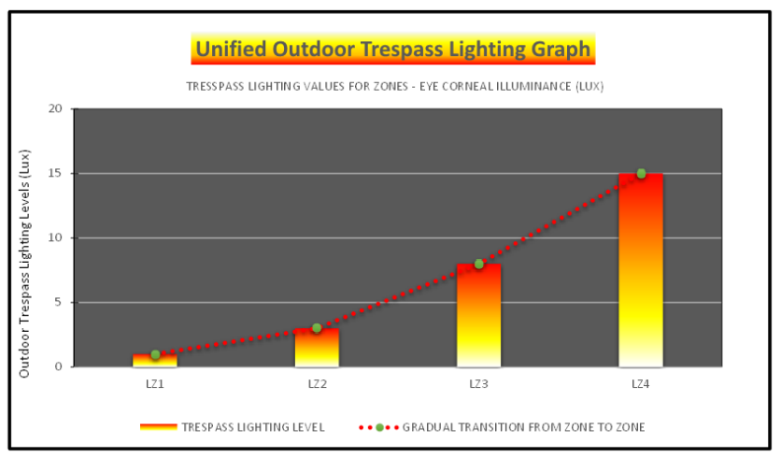

A minimum-threshold convergence methodology was applied to derive unified obtrusive lighting limits. For each environmental zone, the lowest maximum vertical illuminance value reported across major international standards (IES, CIE, ILP, AS/NZS, IDA, TAC) was selected. Missing values were excluded from the selection process. This approach ensures that the unified thresholds remain within all existing regulatory limits, thereby guaranteeing universal compliance and preserving the most conservative level of environmental protection. The resulting unified limits of 1, 3, 8, and 15 lux for Zones LZ1–LZ4 represent a globally harmonised and legally defensible framework.

The local requirement is equal to or well below the international standard requirement. Therefore, establishing a global standard does not violate the local standard or requirement. Therefore, the following section will discuss the importance of a unified global standard for the OTL applications.

- DISCUSSION:

5.1 Theoretical Contribution
This study introduces:
A conservative convergence framework for environmental standard harmonisation
Distinct from:
- Averaging → weakens protection
- Median → ignores extremes
Minimum threshold ensures:
- Risk minimisation
- Legal defensibility
- Policy interoperability

5.2 Scientific Limitation
The study acknowledges:
- Vertical illuminance does not fully represent ocular or biological exposure
- Future standards should integrate:
  - Eye-level metrics (e.g., corneal illuminance)
  - Melanopic Weighting
5.3 Rationale for a unified standard for outdoor OTL

In this context, OTL is an area that is not to be illuminated. The leading OL professional organisations (TAC, IES, CIE, ILP, AS/NZS, and IDA) reviewed and recommended limitations at the ROW for traffic corridors or resident property line (RPL) for other public OL applications.
Figure 6 shows OLP, including useful light, obtrusive, and OTL, adopted from the “Recommended practice for lighting roadway and parking facilities” (ANSI/IES RP-8, 2025).
Figure 6: Useful Light and OTL
Source: Adopted from ANSI/IES RP-8-25 and designed by the author
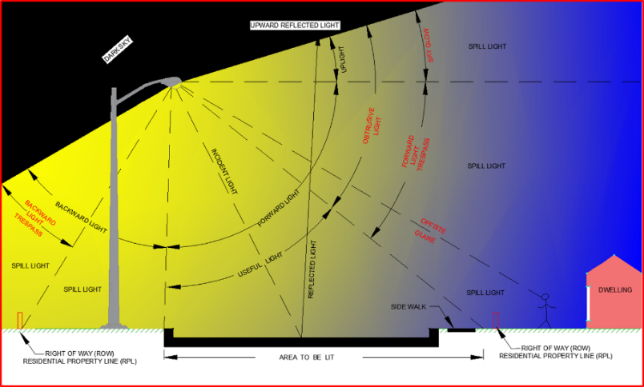

Authorities assigned the ROW or RPL as an OTL limit (ANSI/IES RP-8, 2025; IDA/IES, 2020) for roadway lighting applications. However, European guidelines advise limiting vertical illuminance on RPL, with a focus on dwellings with windows (ILP GN01, 2021; CIE 150, 2017). By collectively addressing OTL in occupant bedroom windows, OL professionals can significantly improve public well-being. This collective effort is a powerful opportunity to improve the living conditions of many.

Traffic density, or the number of vehicles on a given stretch of road at a specific time, can lead to increased risks of accidents, particularly during nighttime when visibility is reduced. This highlights the significance of implementing suitable OL solutions to improve safety for both drivers and pedestrians. By adjusting light levels based on real-time traffic conditions, adaptive OL systems not only conserve energy when full illumination is unnecessary but also greatly minimise OTL. This promising technology holds a bright future for roadway lighting, inspiring optimism about potential improvements in the overall user experience on roads.

Traffic density is also considered a risk factor when selecting an OL class in North America (IES RP-8, 2025). The traffic density changes during the night, and the OL class also changes (IES RP-8, 2025), and ILP PLG08 (ILP PLG08, 2016) are the same in this aspect. However, the author of this research employs the 'worst-case scenario', which in this context refers to the most severe or challenging conditions for this project. This approach ensures a thorough evaluation, and therefore, higher-density traffic classes were used for this evaluation, instilling confidence in the thoroughness of the process.

By following guidelines outlined in authoritative documents like ILP PLG08 and RP-8-21, municipalities can make informed decisions about adjusting their OL infrastructure in response to dynamic traffic conditions. Changes in traffic density during nighttime hours directly influence the selection and adjustment of OL classes, as outlined in the RP-8-21 and ILP PLG08 guidelines. It's crucial that authorities continuously monitor these changes to execute effective OL strategies that improve road safety while being mindful of environmental impacts. This vigilance and commitment, particularly through continuous monitoring, are key to ensuring the ongoing protection of road users.

The CIE (CIE-150, 2017) and Australians (AS/NZS 42822019, 2019) have adopted two sets of limiting values to resolve some of the potentially conflicting requirements for higher illumination levels for dark hours activity. The two groups of values are quantified depending on the illumination levels previously in the area. The local authorities established higher light levels before a nominated or curfew hour and lower light levels after midnight. All roadway lighting applications were exempt from curfew restrictions because of the safety aspect of roadway lighting in North America (ANSI/IES RP-8, 2025).

The resolution of conflicting criteria among professional organisations marks a critical advancement in this research. Given the variability in OTL limits across jurisdictions and standards, this study adopted a unified ‘worst-case scenario’ approach—applying the lowest permissible illuminance value across all zones as a standard benchmark so that it can satisfy all the organisation’s requirements. This methodological decision not only harmonised the evaluation process but also ensured compliance with the most stringent existing standards, thereby satisfying the expectations of all major regulatory bodies. The implementation of this unified criterion provided a robust and defensible foundation for subsequent analyses, reinforcing the reliability and consistency of the proposed evaluation framework. Moreover, it streamlined the comparison of design alternatives and facilitated more precise guidance for practitioners. However, while this resolution effectively standardises technical assessment, it remains limited in capturing the nuanced health implications of OTL exposure on residents. The need for further integration of health-based OTL thresholds is urgent, as it is necessary to evaluate OL impacts holistically and ensure the well-being of residents.

- ENFORCEMENT MECHANISMS

Beyond regulatory and governance considerations, exposure to Artificial Light at Night (ALAN) has emerged as a critical public health concern. Since 2019, health practitioners have increasingly recognised nighttime light exposure as a contributing factor in disease development and delayed physiological recovery (Donker, 2019; Simons et al., 2019; Nagai et al., 2019). Empirical evidence links ALAN exposure to impaired post‑stroke recovery (Boyko et al., 2017; Weil et al., 2020), arterial stiffening (Obayashi et al., 2019), delayed skin wound healing (Walker et al., 2019), and systemic inflammation (Mindel et al., 2019).

Taken collectively, these findings elevate ALAN from a technical nuisance to a population‑level health risk, reinforcing the urgency of regulatory harmonisation. The absence of consistent, enforceable limits on outdoor light intrusion undermines public health protections and weakens accountability across jurisdictions. In this context, professional bodies such as the Illuminating Engineering Society (IES) and the International Commission on Illumination (CIE) are well-positioned to play a central role in formalising and enforcing a unified framework that translates scientific evidence into coherent, globally applicable guidelines.

7. INSTITUTIONAL AND PRACTICE IMPLICATIONS
The unified limits (1, 3, 8, 15 lux):
- Fall within the most restrictive internationally accepted values.
- Require no jurisdiction to weaken existing protections.
- Provide manufacturers with predictable compliance targets.
- Simplify multinational engineering documentation.
- Strengthen legal defensibility of municipal bylaws.
By aligning photometric science with regulatory harmonisation theory, the framework transforms fragmented guidance into a coherent institutional template.
Importantly, the model avoids introducing biologically weighted or spectral metrics that, while scientifically evolving, lack universal legal codification and would reintroduce interpretive ambiguity.
8. LIMITATIONS AND FUTURE RESEARCH
This study focuses on threshold convergence rather than:
- Spectral power distribution controls
- Adaptive lighting integration
- Empirical compliance performance auditing
- Longitudinal ecological or health outcome monitoring
Future work should include field validation across climatic regions and integration with dynamic lighting control systems.
This research concludes the next section based on the above-noted results and discussion.

9. FIED MEASUREMENTS AND VALIDATION
Single-epoch field measurements provide limited accuracy because they cannot fully capture the range of operational, temporal, and environmental variables affecting outdoor lighting performance. Variations in lamp output, temperature, surface reflectance, atmospheric conditions, and measurement geometry introduce unavoidable uncertainties that cannot be eliminated through one-time measurements alone.
In this study, manual measurements and computational analyses show deviations within ±10% under controlled conditions, consistent with accepted tolerances in international standards and validation studies (CIE 198, 2011; EN 13201-4, 2015; IES RP-8, 2025; Rusu et al., 2021; University of New Brunswick, 2024). This agreement lies within the combined uncertainty limits associated with instrumentation accuracy, photometric data precision, modelling assumptions, and environmental variability.
Validation against established standards confirms that the adopted simulation tools reliably reproduce real-world lighting behaviour under initial conditions (LLF = 1.0). In professional outdoor lighting practice, simulation results within ±10% of field measurements are regarded as functionally equivalent to measured performance.
Additional field validation is therefore unnecessary for the objectives of this research. The study prioritises the development of a harmonised standard using the Minimum-Threshold Convergence (MTC) framework rather than site-specific compliance verification. The demonstrated consistency with internationally recognised standards and independent field-validated studies provides sufficient confidence in the accuracy, reliability, and applicability of the proposed methodology.

8. CONCLUSION
This research critically evaluated existing international standards governing OTL and identified significant inconsistencies in environmental zoning classifications, vertical illuminance thresholds, curfew provisions, and measurement methodologies. Although all major organisations share the objective of reducing obtrusive light, their divergent numerical limits and assessment approaches hinder global harmonisation and complicate professional practice.
By adopting a “worst-case scenario” methodology—selecting the lowest permissible vertical illuminance thresholds across established standards—this study developed a unified, conservative framework that satisfies all major regulatory bodies while simplifying implementation. The resulting unified OL zoning system (LZ1–LZ4) provides consistent maximum limits of 1, 3, 8, and 15 lux, respectively, ensuring international compatibility without weakening existing protections.
The framework:
- Maintains compatibility with all major standards
- Preserves environmental protection
- Enhances regulatory clarity
- Reduces institutional fragmentation
- Provides an implementation-ready municipal template
The harmonisation of OTL thresholds represents a substantive advancement in sustainable nighttime environmental governance, demonstrating how technical standard convergence can strengthen both environmental protection and institutional efficiency.
This study contributes to global discourse by:
- Providing a harmonised regulatory framework adaptable across jurisdictions.
- Offering municipalities a defensible, evidence-based OTL evaluation method.
Future research should integrate adaptive lighting technologies. The development of a unified international standard for OTL represents a critical step toward sustainable nighttime lighting—balancing safety, environmental stewardship, and human well-being.

DISCLAIMER (ARTIFICIAL INTELLIGENCE)

The author(s) hereby declare that NO generative AI technologies such as Large Language Models (ChatGPT, COPILOT, etc.) and text-to-image generators have been used during the writing or editing of this manuscript.

Competing interests

The author has declared that no competing interests exist.

REFERENCE:

Abbott, K. W., & Snidal, D. (2001). International standards and international governance. Journal of European Public Policy, 8(3), 345–370. Available at: https://doi.org/10.1080/13501760110056052. (Accessed: 28 September 2025).

Alexandros Sagkriotis (2025). Advancing real-world evidence harmonisation: lessons from the UK, EMA and global policy frameworks. (2026) Journal of Comparative Effectiveness Research. https://doi.org/10.57264/cer-2025-0183

American Medical Association (AMA) (2016) AMA Adopts Community Guidance to Reduce the Harmful Human and Environmental Effects of High Intensity LED Street Lighting. Available at: https://www.ama-assn.org/press-center/press-releases/ama-adopts-guidance-reduce-harm-high-intensity-street-lights (Accessed: 28 February 2021).

Blind, K. (2013). The impact of standardisation and standards on innovation. In J. Edler, P. Cunningham, A. Gök, & P. Shapira (Eds.), Handbook of Innovation Policy Impact. Edward Elgar Publishing. Available at: https://ideas.repec.org/h/elg/eechap/16121_14.html (Accessed: 28 September 2025).

Boyko Y, Jennum P, Toft P. (2017) Sleep quality and circadian rhythm disruption in the intensive care unit: a review. Nat Sci Sleep. 2017 Nov 10;9:277-284. Available At: https://www.doi.org/10.2147/NSS.S151525. (Accessed: 24 November 2024).

Boyce, P. R. (2014). Human factors in lighting (3rd ed.). CRC Press.
Bullough, J. D., Rea, M. S., & Stevens, R. G. (2011). Outdoor lighting and visual discomfort. Lighting Research & Technology, 43(1), 25–38. Available at: https://doi.org/10.1177/1477153510386076. (Accessed: 28 September 2025).

CIE (2011) CIE 198:2011 – Determination of Measurement Uncertainties in Photometry. Vienna: Commission Internationale de l’Éclairage. Available at: https://cie.co.at/publications/determination-measurement-uncertainties-photometry-supplement-2-spectral-measurements (Accessed: 7 April 2026).
CIE (2015) EN 13201-4:2015 – Road Lighting: Part 4 – Methods of Measuring Lighting Performance. Vienna: Commission Internationale de l’Éclairage / European Committee for Standardization (CEN). Available at: https://img.antpedia.com/standard/files/pdfs_ora/20211002/EN%2013201-4-2015.pdf (Accessed: 7 April 2026).
Donker, D.W. (2019) ‘Light and noise nuisance . . . deciphered yet underappreciated ‘Rosetta Stone’ of the modern ICU?’ Netherlands Journal of Critical Care, 27(4), p. 144. Available at: https://njcc.nl/issues-2-0/3099. (Accessed: 28 February 2022).

Falchi, F., Cinzano, P., Duriscoe, D., Kyba, C. C. M., Elvidge, C. D., Baugh, K., Portnov, B. A., Rybnikova, N. A., & Furgoni, R. (2016). The new world atlas of artificial night sky brightness. Science Advances, 2(6), e1600377. Available at: https://doi.org/10.1126/sciadv.1600377. (Accessed: 28 September 2025).

Holzinger K, Knill C, Sommerer T. (2008) Environmental Policy Convergence: The Impact of International Harmonisation, Transnational Communication, and Regulatory Competition. International Organisation. 2008;62(4):553-587. https://doi.org/10.1017/S002081830808020X

Holzinger, K., & Knill, C. (2005). Causes and conditions of cross-national policy convergence. Journal of European Public Policy, 12(5), 775–796. Available at: https://doi.org/10.1080/13501760500161357. (Accessed: 28 September 2025).

Illuminating Engineering Society (IES TM-15, 2020) Technical memorandum for luminaire classification system for outdoor luminaires (IES TM-15-20). Available at: https://store.ies.org/product/tm-15-20-technical-memorandum-luminaire-classification-system-for-outdoor-luminaires/ (Accessed: 28 September 2025).

International Commission on Illumination (CIE-150, 2017) Guide on the limitation of the Effects of obtrusive light from outdoor lighting Installations. 2nd edn. (CIE-150:2017). Available at: https://cie.co.at/publications/guide-limitation-effects-obtrusive-light-outdoor-lighting-installations-2nd-edition (Accessed: 28 September 2025).

Illuminating Engineering Society (ANSI/IES RP-8, 2025) Outdoor Lighting Task Group: Recommended practice for lighting roadway and parking facilities (ANSI/IES RP-8-21). Available at: https://store.ies.org/product/recommended-practice-lighting-roadway-and-parking-facilities/?v=eb65bcceaa5f (Accessed: 28 September 2025).

International Dark-Sky Association (IDA) and Illuminating Engineering Society (IES) (IDA/IES, 2020), Reducing Light Pollution and Its Negative Effects. Illuminating Engineering Society, April 15, 2020. Available at: https://ies.org/reducing-light-pollution-and-its-negative-affects-ies-and-ida-new-collaboration/ (Accessed: 28 September 2025).

International Dark-Sky Association (IDA, 2021) Lighting zones. Available at: https://darksky.org/resources/guides-and-how-tos/lighting-zones/ (Accessed: 28 April 2025).

Institution of Lighting Professionals (ILP GN01, 2021) Guidance notes for the reduction of obtrusive light (GN01/21). Available at: https://theilp.org.uk/publication/guidance-note-1-for-the-reduction-of-obtrusive-light-2021/. (Accessed: 28 September 2025).

Kyba, C. C. M., Kuester, T., Sánchez de Miguel, A., Baugh, K., Jechow, A., Hölker, F., Bennett, A., Elvidge, C. D., Gaston, K. J., & Guanter, L. (2017). Artificially lit surface of the Earth at night is increasing in radiance and extent. Science Advances, 3(11), e1701528. Available at: https://doi.org/10.1126/sciadv.1701528. (Accessed: 28 April 2025).

Kernbach, M.E. (2021) ‘Light pollution affects West Nile virus exposure risk across Florida’, Proceedings of the Royal Society B: Biological Sciences, 288(1947). doi:10.1098/rspb.2021.0253. Available at: https://pubmed.ncbi.nlm.nih.gov/33757351/ (Accessed: 28 February 2022).

Kaushik, K., Nair, S., Ahamad, A., (2022) Studying light pollution as an emerging environmental concern in India. Journal of Urban Management, Volume 11, Issue 3. Available at: https://www.sciencedirect.com/science/article/pii/S2226585622000383. (Accessed: 28 May 2022).

Mindel, J.W., Rojas, S.L., Kline, D.M., Bao, S., Rezai, A., Corrigan, J.D., Nelson, R.J and Magalang, U.J. (2019) ‘Sleeping with low levels of ALAN increases systemic inflammation in humans’ Sleep, 42(Supplement_1): A15–A16. doi:10.1093/sleep/zsz067.037 Available at: https://www.proquest.com/openview/635105f3448ea881ff27a8a60bc9bb14/1?pq-origsite=gscholar&cbl=2046369 (Accessed: 28 February 2022).

Nagai, N., Ayaki, M., Yanagawa, T., Hattori, A., Negishi, K., Mori, T., Nakamura, T.J. and Tsubota, K. (2019) ‘Suppression of blue light at night ameliorates metabolic abnormalities by controlling circadian rhythms’, Investigative Opthalmology & Visual Science, 60(12), pp. 3786-3793. doi:10.1167/iovs.19-27195 Available at: https://pubmed.ncbi.nlm.nih.gov/31504080/ (Accessed: 28 February 2022).

Obayashi, K., Yamagami, Y., Tatsumi, S., Kurumatani, N. and Saeki, K. (2019) ‘Indoor light pollution and progression of carotid atherosclerosis: A longitudinal study of the HEIJO-KYO co- hort’, Environment International, 133(Part B):105184. doi: 10.1016/j.envint.2019.105184 Available at: https://pubmed.ncbi.nlm.nih.gov/31648154/ (Accessed: 28 February 2022).

Ontario Land Use Planning (2023) Municipal Official Land Use Planning Framework. Available at: https://www.ontario.ca/document/ontario-municipal-councillors-guide/10-land-use-planning. (Accessed: 28 September 2025).

Phillips, A.J.K., Vidafar, P., Burns, A.C., McGlashan, E.M., Anderson, C., Rajaratnam, S.M.W., Lockley, S.W. and Cain, S.W. (2019) ‘High sensitivity and interindividual variability in the response of the human circadian system to evening light’, Proceedings of the National Academy of Sciences, 116(24), pp. 12019-12024. Doi: 10.1073/pnas.1901824116 Available at: https://www.pnas.org/doi/full/10.1073/pnas.1901824116 (Accessed: 28 February 2022).

Pothukuchi, K. (2021). City Light or Star Bright: A Review of Urban Light Pollution, Impacts, and Planning Implications. Available at: https://journals.sagepub.com/doi/abs/10.1177/0885412220986421. (Accessed: 06 January 2025).
Rusu, E., Iordache, F., and Drosu, A. (2021) ‘Evaluation and Measurement of Roadway Luminance for Street Lighting Assessment Using DIALux Evo and In-situ Photometric Data’, Sustainability, 13(15), 8345. Available at: https://doi.org/10.3390/su13158345 (Accessed: 7 April 2026).
Simons, K.S., van den Boogaard, M., de Jager, C.P.C. (2019) ‘Impact of intensive care unit light and noise exposure on critically ill patients’, Netherlands Journal of Critical Care, 27(4), pp. 145-149. Available at: https://njcc.nl/sites/njcc.nl/files/pdf/review_27.pdf. (Accessed: 28 February 2022).

Transportation Association of Canada (TAC, 2006) Guide for the Design of Roadway Lighting. Available at: https://www.tac-atc.ca/en/publications/pdf (Accessed: 28 April 2025).

The Council of Standards Australia/Standards New Zealand (AS/NZS, 2019) Control of the obtrusive effects of outdoor lighting (AS/NZS 4282:2019). Available at: https://www.techstreet.com/standards/as-nzs-4282-2019?product_id=2046810 (Accessed: 28 April 2025).

Thurairajah, U., Littlewood, J.R. and Karani, G. (2021a) ‘A proposed method to pre-qualify sustainable energy-saving LED Luminaires for outdoor urban lighting applications’, in Littlewood, J., Howlett, R.J. and Jain, L.C. (eds.) Sustainability in Energy and Buildings 2020, Smart Innovation, Systems and Technolgies, Series, 203. Singapore: Singer, pp. 357-367. Available at: https://doi.org/10.1007/978-981-15-8783-2_30 (Accessed: 28 March 2022).

Thurairajah, U., Littlewood, J.R. and Karani, G. (2021b) ‘A novel approach to controlling outdoor light pollution by adopting smart science and technology to improve residents’ quality of life in the built environment’, in Littlewood, J., Howlett, R.J. and Jain, L.C. (eds.) Sustainability in Energy and Buildings 2020, Smart Innovation, Systems and Technologies Series, 203. Singapore: Springer, pp. 369-380. Available at: https://doi.org/10.1007/978-981-15-8783-2_31 (Accessed: 28 March 2026).

Thurairajah, U., Littlewood, J.R. and Karani, G. (2022a) ‘A proposed method to pre-qualify a wireless monitoring and control system for outdoor lighting to reduce energy use, light pollution, and carbon emissions’, in Littlewood, J.R., Howlett, R.J., Jain, L.C. (eds.) Sustainability in Energy and Building 2021, Smart Innovation, Systems and Technologies Series, 264. Singapore: Springer, pp. 365-375. Available at: https://link.springer.com/chapter/10.1007/978-981-16-6269-0_31 (Accessed: 28 March 2026).

Thurairajah, U. (2022b). A comparative study: The benefits of a novel illuminance calculation method over a luminance calculation method for optimal roadway lighting design applications, Journal of Physics: Conference Series, 2224. Available at: https://iopscience.iop.org/article/10.1088/1742-6596/2224/1/012117 (Accessed: 28 March 2026).

Thurairajah, U. (2023a). A Novel Method to Prove the Visibility Distance of Candlelight and the Milky Way’s Vega Star and Apply this Knowledge to Outdoor Lighting Applications, SCIREA Journal of Physics. Vol. 8 , No. 1 , 2023 , pp. 1 - 18 . Available at: https://doi.org/10.54647/physics140512 (Accessed: 28 March 2026).

Thurairajah, U. (2023b). An Elite Roadway Illuminance Calculation (ERIC) Method Provides Optimum Performance and Cost-saving without Compromising Safety. Recent Progress in Science and Technology Vol. 8, 98–119. Available at: https://doi.org/10.9734/bpi/rpst/v8/5610A (Accessed: 28 March 2026).

Thurairajah, U. (2023c). Discovery of Threshold Visibility Limit (TVL) Using the Number of Photons Intruding into the Human Eye and Possible Application to Outdoor Lighting. Fundamental Research and Application of Physical Science Vol. 7, 82–102. Available at: https://doi.org/10.9734/bpi/fraps/v7/6642A (Accessed: 28 March 2026).

Thurairajah, U. (2017) ‘Has the American Medical Association (AMA) exposed the health impact of LED Lights?’. Professional Engineers Ontario (PEO), Ontario, Canada. Available at: https://www.canadianconsultingengineer.com/events/ama-exposed-health-impact-led-lights/ (Accessed: 28 February 2021).
University of New Brunswick (2024) Field Validation of AGi32 Simulation Accuracy for Roadway Lighting Projects in Canada. Fredericton, NB: Department of Civil Engineering (Technical Report). Available at: https://unbscholar.lib.unb.ca/items/1807a314-b41c-46ea-8f6d-662bced76138 (Accessed: 7 April 2026).
Vogel, D. (1995). Trading up: Consumer and environmental regulation in a global economy. Harvard University Press. Available at: https://www.amazon.ca/Trading-Up-Consumer-Environmental-Regulation/dp/0674900847 (Accessed: 28 April 2025).

Weil, Z.M., Fonken, L.K., Walker, W.H., Bumgarner, J.R., Liu, J.A., Melendez-Fernandez, O.H., Zhang, N., Courtney DeVries, A. and Nelson, R.J. (2020) ‘Dim light at night exacerbates stroke outcome, European Journal of Neuroscience, 52(9), pp. 4139–4146. doi:10.1111/ejn.14915 Available at: https://onlinelibrary.wiley.com/doi/10.1111/ejn.14915 (Accessed: 28 February 2022).

Walker W. H., Wasupport cilton, J.C, Courtney DeVries, A. and Nelson, R.J. (2020) Circadian rhythm disruption and mental health. Available at: https://www.nature.com/articles/s41398-020-0694-0. (Accessed: 28 August 2022).

Walker, W.H. (2nd), Bumgarner, J.R., Becker-Krail, D.D., May, L.E., Liu, J.A. and Nelson, R.J. (2021) ‘Light at night disrupts biological clocks, calendars, and immune function’, Seminars in Immunopathology, 44(2), pp. 165-173. Doi: 10.1007/s00281-021-00899-0 Available at: https://pubmed.ncbi.nlm.nih.gov/34731290/ (Accessed: 28 February 2022).

