Immunomodulator Potential of Phyllantus acidus Leaf Extract in Type 1 Diabetes Mellitus (T1DM) Models

ABSTRACT
Type 1 diabetes mellitus (T1DM) is characterized by high level of blood sugar, or hyperglycemia. The hyperglycemia condition in T1DM patients results in complication that made patients have higher chance to be infected with various infectious disease. Phyllantus acidus (P. acidus) is a local plant usually consumed for its fruit, but other parts of the plant still saw lack of use locally. This study was aimed to examine the potential of Phyllantus acidus leaf extract to be immunomodulator in T1DM-induced animal model. Leaves of P. acidus was extracted using maceration and its content was analyzed using LC-HRMS. T1DM was induced in mice models using alloxan. P. acidus leaf extract was given for 10 days and in the 11th day, mice were injected with Staphylococcus aureus. Phagocytic activity of peritoneal macrophages was evaluated from Giemsa-stained smear, while spleen was prepared into histological section using paraffin method and stained with hematoxylin-eosin, then examined of its structure. Results showed that phagocytic activity increased significantly in mice treated with extract compared to negative control, however extract did not significantly improve spleen structure in T1DM mice compared. The secondary metabolites identified in extract including sorbic acid, L(-)-Pipecolinic acid, and Υ-Aminobutyric acid (GABA). Sorbic acid contained in the extract mainly affected the innate response of mice models. Thus, it can be concluded that P. acidus leaf extract was able to increase immune response, specifically in T1DM mice models.

Keywords: Phyllantus acidus, diabetes, leukocytes, macrophage

- Introduction
Diabetes mellitus (DM) is a degenerative disease characterized by high level of blood glucose or known as hyperglycaemia. According to International Diabetes Federation (IDF), diabetes mellitus (DM) is currently the global health emergency with fastest development in the 21st century, including in Indonesia. Indonesia is ranked 5th in the world for the number of DM patients, with a total of 19.5 million patients in 2021 and an estimated 28.6 million in 2045 [1]. Generally, DM is categorized as type I DM (T1DM) which is caused by lack of insulin and type 2 DM (T2DM), characterized by insulin resistance.
Type 1 DM is characterized by low insulin levels due to damage to pancreatic beta cells. Damage to pancreatic beta cells in the pathogenesis of T1DM is still not fully understood to date, but it is suspected that this damage is caused by an autoimmune response initiated by a combination of genetics and environmental triggers, such as infection [1]. Under normal conditions, pancreatic beta cells are protected from autoimmune responses by the expression of regulatory T cells. However, based on previous research, inadequate immune regulation by regulatory T cells is thought to trigger an autoimmune reaction that induces destruction of pancreatic beta cells [2].
Diabetes mellitus patients are known to have a higher risk of contracting infectious diseases. Diabetes mellitus is also a risk factor that can cause severe infections and increase the risk of mortality from coronavirus disease 2019 (COVID 19) [3,4]. Both T1DM and T2DM patients are known to have an increased risk of infection, but this risk is twofold higher in T1DM patients [5]. Studies have shown that the levels of pro-inflammatory cytokines that can be produced by the immune system of T1DM patients are lower than normal. In addition, the primary antibody response to antigen-dependent T cells and the antigen-dependent T cell response to antigen proteins were also found to be reduced in T1DM patients [6,7].
The majority of foreign objects that enter the body are removed through the phagocytosis mechanism by macrophages which are part of the innate immune system. Macrophage phagocytosis is widely used as an immunological parameter to evaluate immune health/function [8]. On the other hand, the spleen is a lymphoid organ that functions to destroy old red blood cells and as a reservoir for white blood cells, especially T cells and B cells. When an infection occurs, antigens will be presented in the white pulp of the spleen which initiates the activation of T cells and B cells, initiating antibody production and adaptive immune responses [9].
The hyperglycaemic condition suffered by T1DM patients causes a decrease in the immune response, resulting susceptibility to infectious diseases. Immunomodulators are substances that can regulate the immune system and help increase the role of the immune system in overcoming infections. Various species from genus Phyllantus have been widely studied and found to have immunomodulatory properties due to their secondary metabolite contents, for example geraniin, gallic acid, and phyllanthin [10]. Phyllantus acidus or known as ceremei locally has been studied to regulate macrophage activity through downregulation of the release of nitric oxide (NO) which can induce excessive inflammatory responses [11] so that it has potential as an immunomodulator. In Indonesia, ceremei is widely planted by the community and is easy to find, but its use is still limited to the consumption of its fruit. In addition, no research has been conducted to see the effect of P. acidus leaf extract on the immune system of T1DM patients.

- Experiment
2.1. Animal model
The experimental animals used were male Mus musculus strain Balb/C aged between 3-4 months weighing 25-30 g. Before given treatment, the experimental animals were acclimated for 1 week. Feed and water were given daily ad libitum.
2.2 Phyllantus acidus leaf extraction
Extraction of P. acidus leaves were performed using maceration method. Leaves were dried and then ground into simplicia. A total of 500 g simplicia was macerated using ethanol, then the solvent was evaporated. The filtrate was stored at -20ºC until used. The filtrate was dissolved in 1% Na-CMC according to the dose concentration for administration to mice.
2.3 Induction of T1DM
Mice were induced T1DM with alloxan using a single-dose method. Alloxan was dissolved in 0.9% NaCl and injected with 130 mg/kg BW intraperitoneally. Glucose levels were measured 3 days after injection [20]. Mice with fasting blood glucose levels ≥120 mg/dL were used as a T1DM model.
2.4 Oral treatment of P. acidus leaf extract
The experimental animals were divided into 6 groups, consisting of negative control group (NC), diabetes control (DC), positive control using Metformin (MC), dose I extract of 215 mg/BW (D1), dose II extract of 230 mg/kg BW (D2), and dose III extract of 245 mg/kg BW (D3). Doses used in the experiment were based on previous study [11]. Extract was given to experimental animals for 10 days orally.
2.5 Evaluation of macrophage phagocytic activity
Immunomodulatory activity was determined based on the phagocytic activity of mouse peritoneal macrophage cells. The experimental animals were injected with 0.5 mL of Staphylococcus aureus suspension intraperitoneally on the 11th day of treatment, then incubated for 1 hour. After that, the mice were anesthetized and dissected. Intraperitoneal fluid was taken using syringe, smeared into object glass. The slides were fixed with methanol, then stained with Giemsa dye and observed under a microscope. The ratio of active to total macrophages was calculated. The proportion of active macrophages was calculated from observations of the number of active and inactive macrophages with a total of 300 macrophage cells per individual (n = 5 per group). Percentage of active macrophage was then analyzed statistically using one-way ANOVA and post-hoc Duncan.
2.6 Evaluation of spleen histopathology
Histological slides of spleen were made using the paraffin method. The spleen was fixed in 10% neutral buffer formalin fixative solution for 24 hours. The spleen samples were processed in graded ethanol starting from 70% to 100% for 30 minutes each and then cleared in xylene overnight. The spleen samples were then infiltrated and embedded in paraffin media, then sectioned with a thickness of 4 µm. Sections were stained with Hematoxylin-Eosin staining and covered with a cover slip using entellan mounting media. Evaluation of the structure of the spleen tissue slices was carried out based on scoring from previous studies [12] and analyzed statistically using Kruskal-Wallis test with post-hoc Mann-Whitney.
2.7 Analysis of P. acidus extract content
Leaf extract was analyzed using Liquid Chromatography–High Resolution Mass Spectrometry (LC-HRMS) (Thermo Scientific Dionex Ultimate 3000 RSLCnano). Extract diluted with ethanol was vortexed, then spun down. The supernatant was taken and filtered using a 0.22 μm syringe filter, then put into a vial. The sample was inserted into autosampler and then injected into LC-HRMS. A total of 10 μl of solution was injected into the column with temperature of 30oC. Separation was carried out on Hypersil GOLD aQ 50 x 1 mm x 1.9 u particle size. The mobile phase was 0.1% formic acid in water (v/v) (A) and 0.1% formic acid in Acetonitrile (v/v) (B). The elution gradient lasted for 30 min, at a flow rate of 40 μl/min.

- Results
3.1 Immune response of T1DM experimental models to P. acidus extract
The results of the evaluation of macrophage phagocytic activity and splenic tissue evaluation after induction of P. acidus leaf extract presented in Table 1. Based on the results, significant difference of phagocytic activity was found between DC and other groups. In addition, the group given P. acidus leaf extract with all three doses experienced an increase in the number of macrophage activities compared to DC. The results of statistical tests showed that the active macrophage activity of the extract treatment group was not significantly different from the NC or MC, indicating that P. acidus extract was able to increase the number of active macrophages in hyperglycemic immunocompromised animal models (Figure 1).

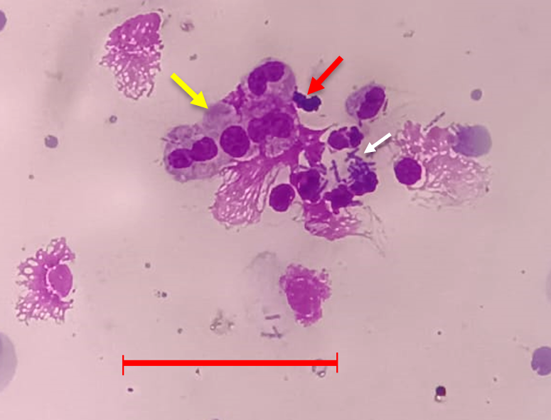
Figure 1. Phagocytic activity of intraperitoneal macrophages on S. aureus. Yellow arrows indicate active macrophages, red arrows indicate inactive macrophages, and white arrows indicate S. aureus bacteria. Scale bar = 25 µm.

Table 1. Immune response in T1DM experimental animals after administration of P. acidus leaf extract.
Group | Fasting blood sugar (mg/dL)* | Percentage of active macrophage (%)* | Splenic tissue structure*
NC | 81,40±26,29ª | 49.40±11.28ª | 0,2±0,45ª
DC | 152,40±26,48^{b} | 22.50±11.12^{b} | 2,4±0,89^{b}
MC | 143,80±14,45^{b} | 40.00±3.54ª | 1,6±0,89^{b}
D1 (extract 215 mg/kg bw) | 168,80±48,49^{b} | 37.80±5.59ª | 1,6±0,55^{b}
D2 (extract 230 mg/kg bw) | 143,40±14,88^{b} | 39.75±5.9ª | 1,4±0,55^{b}
D3 (extract 245 mg/kg bw) | 156,60±13,81^{b} | 39.80±7.50ª | 1,5±0,58^{b}
*) Different subscript indicate significant differences based on statistical test (α=0.05).

On the other hand, significant difference was found between NC and other groups in regards to splenic tissue structure. After given extract treatment of P. acidus leaf for 10 days, splenic tissue structure was found to have not improved yet back to its normal level (Figure 2).

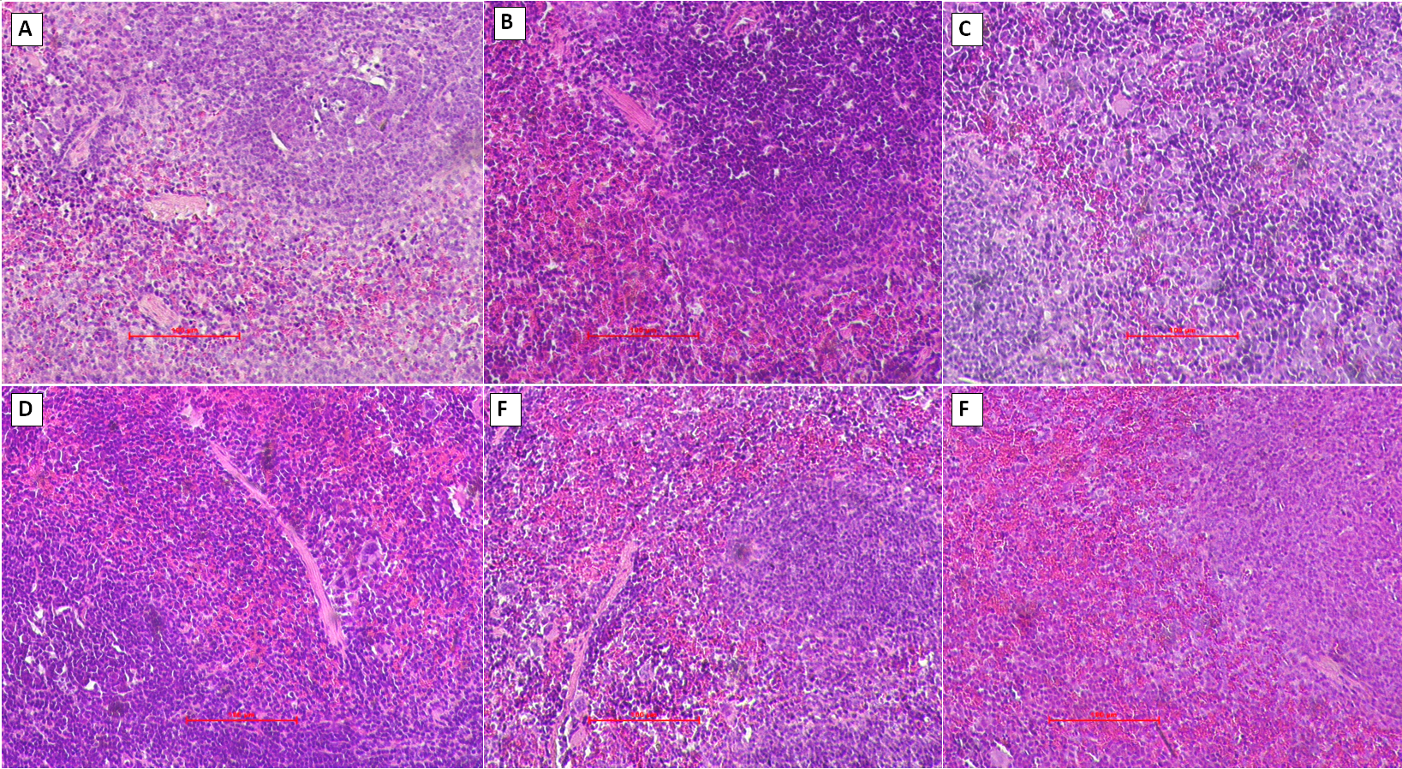
Figure 2. Histopathology of spleen from each treatment. A: Normal control. B: Diabetic group. C: Metformin control. D: D1 group (215 mg/kg bw Phyllantus leaf extract). E: D2 group (230 mg/kg bw Phyllantus leaf extract). F: D3 group (245 mg/kg bw Phyllantus leaf extract). Scale bar = 100 µm.

3.2. Identification of bioactive substances in P. acidus leaf.
Table 2 presents the results of LC-HRMS analysis of P. acidus leaf content with a best match limit above 90. From the results of this analysis, the most abundant content is sorbic acid, L(-)-pipecolinic acid, ɣ-Aminobutyric acid (GABA), choline, and L-phenylalanine.

Tabel 2. Secondary metabolites content of P. acidus leaf extracted using ethanol solvent
Name | Formula | Calc. MW | RT [min] | Total content (%) | Best Match
Sorbic acid | C6 H8 O2 | 112.0524 | 2.482 | 33% | 97.7
L(-)-Pipecolinic acid | C6 H11 N O2 | 129.07894 | 2.64 | 16% | 98.5
Υ-Aminobutyric acid (GABA) | C4 H9 N O2 | 103.06358 | 2.933 | 13% | 97.3
Choline | C5 H13 N O | 103.10002 | 3.343 | 12% | 98.1
L-Phenylalanine | C9 H11 N O2 | 165.07892 | 2.558 | 3% | 99.6
DL-Tryptophan | C11 H12 N2 O2 | 204.09041 | 3.47 | 1% | 99.2
Adenine | C5 H5 N5 | 135.05441 | 2.522 | 1% | 99.3
Adenosine | C10 H13 N5 O4 | 267.10089 | 2.471 | 1% | 99.1
Trigonelline | C7 H7 N O2 | 137.04761 | 2.457 | 1% | 99.6
D-(+)-Proline | C5 H9 N O2 | 115.06345 | 3.542 | 1% | 97.7

- Discussion
The hyperglycemic condition that characterizes DM causes activation of protein kinase C. Protein kinase C decreases neutrophil migration, phagocytic activity, superoxide production that helps degrade foreign cells, and the destruction of pathogenic microorganisms [13]. This causes a reduced immune response, including macrophage activation as observed in the diabetic control (Table 1), leading to increased susceptibility to infection. Metformin is more widely used for the treatment of T2DM as a drug that can increase sensitivity to insulin. However, research shows that metformin is able to regulate macrophage function in atherosclerosis [14] so that it can help control the immune system in hyperglycemic conditions. Macrophages play a role in the primary immune response that directly acts nonspecifically to destroy foreign objects that enter the body, one of which is by producing reactive oxygen species (ROS) to degrade foreign cells¹⁵. Macrophages also help regulate other immune cells by producing various important cytokines as a first line of defense [15].
Based on the results of the study, administration of P. acidus leaf extract was able to increase the number of active macrophages at similar level to NC and MC, and was significantly different from DC (Table 1). This is influenced by the extract content that has the potential to increase phagocytic responses, including sorbic acid which can increase IGF-1 [16], GABA, and various flavonoids and alkaloids. However, extract had not been able to improve the structure of spleen tissue. Although there was indication of amelioration in the spleen tissue after P. acidus leaf extract treatment, histopathological scores were not significantly different to DC, likely due to the short period of treatment.
Analysis of the content of ethanol extract of P. acidus carried out using LC-HRM showing that the highest content in the extract was sorbic acid (33%) (Table 2). Sorbic acid is generally known as a preservative and has antimicrobial activity that induces degradation of microorganism cells [17]. In previous studies, sorbic acid was indicated to be able to increase the concentration of insulin-like growth factor 1 (IGF-1) but reduce cortisol levels in the blood by regulating the expression of the IGF-1 gene in pigs [16]. IGF-1 signals were known to increase macrophage activation in compromised immunometabolic conditions, for example due to helminth worm infections [18].
On the other hand, pipecolinic acid content has been studied to be able to reduce fat accumulation, reduce oxidative stress and inflammation, and have anti-tumor activity. Pipecolinic acid has also been indicated to increase during pathogen infection and is associated with inherited systemic resistance [19]. Gamma-aminobutyric acid (GABA) is an inhibitory neurotransmitter that has biological activity as an anti-inflammatory by suppressing the production of pro-inflammatory cytokines to increase the activation of NF-kB which plays an important role in the immune system response in both animals and humans [20].
Other secondary metabolites identified including choline and L-phenylalanin. Choline supplementation has been studied to be able to increase the immune response of Sprague-Dawley rat offspring. Lymphocyte cells were observed to develop better, T cells expressed more activation markers, and a decrease in the number of B cells leading to improved T cell function [21]. The decrease in L-phenylalanine in the body results in suppression of T cell proliferation. L-phenylalanine also affects the production of oxidative H2O2 from phenylalanine oxidase. Phenylalanine oxidase itself is encoded by interleukin 4 induced gene 1 (IL4I1) which is expressed by antigen-presenting cell (APC) dendritic cells [22]. In addition, the extract also found to have alkaloid and flavonoid content which have been widely studied to have the ability as immunomodulators through various mechanisms [23].

Acknowledgements
Authors would like to thank Faculty of Mathematics and Natural Sciences, Universitas Negeri Surabaya for the funding of this study.

References
- International Diabetes Federation (2021). Diabetes Atlas. IDF.
- Roep, B. O., Thomaidou, S., van Tienhoven, R., & Zaldumbide, A. (2021). Type 1 diabetes mellitus as a disease of the β-cell (do not blame the immune system?). Nature Reviews Endocrinology, 17(3), 150–161.
- Milionis, C., & Milioni, S. O. (2020). A brief analysis and hypotheses about the risk of COVID-19 for people with type 1 and type 2 diabetes mellitus. Journal of Diabetes & Metabolic Disorders, 19(2), 2035–2039.
- Shang, L., Shao, M., Guo, Q., Shi, J., Zhao, Y., Xiaokereti, J., & Tang, B. (2020). Diabetes mellitus is associated with severe infection and mortality in patients with COVID-19: A systematic review and meta-analysis. Archives of Medical Research, 51(7), 700–709.
- Carey, I. M., Critchley, J. A., DeWilde, S., Harris, T., Hosking, F. J., & Cook, D. G. (2018). Risk of infection in type 1 and type 2 diabetes compared with the general population: A matched cohort study. Diabetes Care, 41(3), 513–521.
- Janssen, A. W. M., Stienstra, R., Jaeger, M., van Gool, A. J., Joosten, L. A. B., Netea, M. G., Riksen, N. P., & Tack, C. J. (2021). Understanding the increased risk of infections in diabetes: Innate and adaptive immune responses in type 1 diabetes. Metabolism, 121, 154795.
- Eibl, N., Spatz, M., Fischer, G. F., Mayr, W. R., Samstag, A., Wolf, H. M., Schernthaner, G., & Eibl, M. M. (2002). Impaired primary immune response in type-1 diabetes: Results from a controlled vaccination study. Clinical Immunology, 103(3), 249–259.
- Handayani, N., Wahyuono, S., Hertiani, T., & Murwanti, R. (2018). Uji aktivitas fagositosis makrofag ekstrak etanol daun suji (Dracaena angustifolia (Medik) Roxb.) secara in vitro. Pharmaceutical and Medical Journal, 1(1). [In Indonesian].
- Kapila, V., Wehrle, C. J., & Tuma, F. (2023). Physiology, spleen. In StatPearls. StatPearls Publishing. https://www.ncbi.nlm.nih.gov/books/NBK537307/
- Jantan, I., Haque, M. A., Ilangkovan, M., & Arshad, L. (2019). An insight into the modulatory effects and mechanisms of action of Phyllanthus species and their bioactive metabolites on the immune system. Frontiers in Pharmacology, 10, 878.
- Chakraborty, R., Biplab, D., Devanna, N., & Sen, S. (2012). Antiinflammatory, antinociceptive and antioxidant activities of Phyllanthus acidus L. extracts. Asian Pacific Journal of Tropical Biomedicine, 2(Suppl. 2), S953–S961.
- Ibrahim, K. E., Al-Mutary, M. G., Bakhiet, A. O., & Khan, H. A. (2018). Histopathology of the liver, kidney, and spleen of mice exposed to gold nanoparticles. Molecules, 23(8), 1848.
- Jafar, N., Edriss, H., & Nugent, K. (2016). The effect of short-term hyperglycemia on the innate immune system. The American Journal of the Medical Sciences, 351(2), 201–211.
- Feng, X. J., Chen, W. X., Ni, X. Y., Little, P. J., Xu, S. W., Tang, L. Q., & Weng, J. P. (2021). Metformin, macrophage dysfunction and atherosclerosis. Frontiers in Immunology, 12, 682853.
- Janeway, C., Paul, C., Travers, M., Walport, M., & Shlomchik, M. (2001). Immunobiology (5th ed.). Garland Science.
- Luo, Z. F., Fang, X. L., Shu, G., Wang, S. B., Zhu, X. T., Gao, P., Chen, L. L., Chen, C. Y., Xi, Q. Y., Zhang, Y. L., & Jiang, Q. Y. (2011). Sorbic acid improves growth performance and regulates insulin-like growth factor system gene expression in swine. Journal of Animal Science, 89(8), 2356–2364.
- Nemes, D., Kovács, R., Nagy, F., Tóth, Z., Herczegh, P., Borbás, A., Kelemen, V., Pfliegler, W. P., Rebenku, I., Hajdu, P. B., Fehér, P., Ujhelyi, Z., Fenyvesi, F., Váradi, J., Vecsernyés, V., & Bácskay, I. (2020). Comparative biocompatibility and antimicrobial studies of sorbic acid derivates. European Journal of Pharmaceutical Sciences, 143, 105162.
- Spadaro, O., Camell, C. D., Bosurgi, L., Nguyen, K. Y., Youm, Y. H., Rothlin, C. V., & Dixit, V. D. (2017). IGF1 shapes macrophage activation in response to immunometabolic challenge. Cell Reports, 19(2), 225–234.
- Luo, L., Cai, Y., Jiang, Y., Gong, Y., Cai, C., Lai, D., Jin, X., Guan,Z., & Qiu, Q. (2023). Pipecolic acid mitigates ferroptosis in diabetic retinopathy by regulating GPX4-YAP signaling. Biomedicine & Pharmacotherapy, 169, 115895.
- Ngo, D. H., & Vo, T. S. (2019). An updated review on pharmaceutical properties of gamma-aminobutyric acid. Molecules, 24, 2678.
- Richard, C., Lewis, E. D., Goruk, S., Wadge, E., Curtis, J. M., Jacobs, R. L., & Field, C. J. (2017). Feeding a mixture of choline forms to lactating dams improves the development of the immune system in Sprague-Dawley rat offspring. Nutrients, 9, 567.
- Sikalidis, A. K. (2015). Amino acids and immune response: A role for cysteine, glutamine, phenylalanine, tryptophan and arginine in T-cell function and cancer? Pathology and Oncology Research, 21(1), 9–17.
- Shivaprasad, H. N., Kharya, M. D., Rana, A. C., & Mohan, S. (2006). Preliminary immunomodulatory activities of aqueous extract of Terminalia chebula. Pharmaceutical Biology, 44, 32–34.

