Socio-Demographic and Access-Related Determinants of Untreated Hand-Dug Well Water Use in Urban Slums of Abuja, Nigeria: A Cross-Sectional Study
Abstract
Background:
Access to safe and reliable drinking water remains a critical public health challenge in urban slum settings across Nigeria. Despite the availability of alternative sources, many households continue to rely on untreated hand-dug wells, exposing them to significant waterborne health risks.
Objective:
To examine the socio-demographic and access-related determinants of untreated hand-dug well water use among households in selected urban slum communities in Abuja, Nigeria.
Methods:
A community-based cross-sectional study was conducted among 340 households across four urban slum communities in the Abuja Municipal Area Council. Data was collected using a structured, interviewer-administered questionnaire adapted from standard WASH survey tools. Descriptive statistics were used to summarize variables, while Chi-square tests assessed associations between categorical variables. Binary logistic regression was performed to identify independent predictors of untreated well water use. Statistical significance was set at p < 0.05.
Results:
The prevalence of untreated hand-dug well water use was 51.8%. Most households (61.8%) reported not treating water before consumption. Educational attainment was a significant predictor of water source choice, with respondents having a tertiary education significantly less likely to rely on untreated wells (AOR = 0.34; 95% CI: 0.21–0.56; p < 0.001). Household size showed a positive association, with households with 10 or more members more than twice as likely to rely on untreated wells (AOR = 2.32; 95% CI: 1.38–3.90; p = 0.001). Distance to water source was also significant, as households located more than 100 meters from a source were less likely to use untreated wells (AOR = 0.66; 95% CI: 0.46–0.95; p = 0.026).
Conclusion:
Reliance on untreated hand-dug well water remains high in urban slum communities in Abuja and is shaped by both socio-demographic and access-related factors. Interventions should prioritize equitable access to safe water infrastructure, promote household-level water treatment, and target larger and less-educated households to reduce exposure to unsafe water sources.
Keywords:
Untreated well water; urban slums; water access; WASH; household determinants; Nigeria
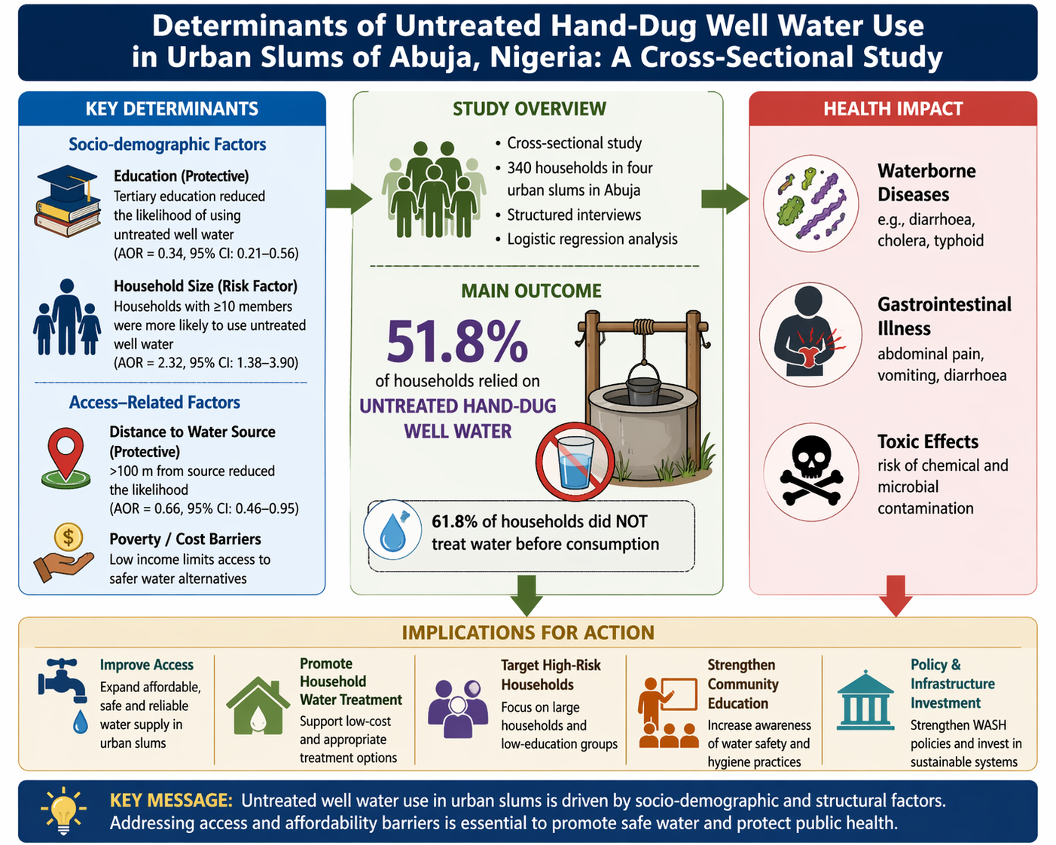
HIGHLIGHTS
• Untreated well use remains high (51.8%) in Abuja slum households
• Education reduces reliance on unsafe water sources significantly
• Larger households are more likely to depend on untreated wells
• Distance influences water choice, not always toward safer sources
• Awareness does not translate into safe water treatment practices
Introduction
Access to safe drinking water is essential for health and development yet remains limited in many urban slum settings in low- and middle-income countries. In Nigeria, rapid urbanization has led to the expansion of informal settlements where infrastructure development has not kept pace with population growth. As a result, residents often rely on alternative water sources, including hand-dug wells, which are frequently unprotected and vulnerable to contamination (1). Untreated hand-dug wells are widely used due to their accessibility and low cost; however, they are often located near sources of contamination, such as pit latrines and waste dumps. Consumption of untreated water from such sources contributes to the burden of waterborne diseases, including diarrhea, cholera, and typhoid fever (1). Previous studies have shown that water-use behavior is influenced by socio-demographic characteristics and access-related factors rather than water quality alone. Educational attainment, household size, and physical access to water sources can significantly shape household decisions. However, there remains limited context-specific evidence linking these factors to untreated well use in urban slum communities in Nigeria (2). This study, therefore, aimed to examine the socio-demographic and access-related determinants of untreated hand-dug well water use in selected urban slum communities in Abuja, Nigeria.
Methods
2.1 Study Area and Design
A cross-sectional survey was conducted in four urban slum communities—Nyanya, Karu, Karmo, and Mpape—within the Abuja Municipal Area Council. These communities are characterized by limited access to formal water supply systems and heavy reliance on unimproved water sources (Fig 1).
2.2 Sample Size and Sampling Technique
The study population consisted of households in the selected communities. A multi-stage sampling technique was used, involving purposive selection of communities, cluster sampling, and systematic random sampling of households. A total of 380 households were approached; 340 complete questionnaires were finally included (response rate: 89.5%). Inclusion Criteria include Households located within the identified slum communities, Households present at the time of data collection, and Respondents aged 18 years and above who had lived in the community for at least six months. Households in the selected communities were included regardless of water source, to allow comparison between users and non-users of untreated wells.
2.3 Data Collection
Data were collected using a structured, interviewer-administered questionnaire designed to capture information on socio-demographic characteristics, household water use patterns, and access-related determinants of untreated hand-dug well water use. The questionnaire was developed based on standard Water, Sanitation, and Hygiene (WASH) survey tools, including instruments from the WHO/UNICEF Joint Monitoring Programme (JMP) and previous studies conducted in similar settings (3, 4). The questionnaire was divided into four sections:
Section A: Socio-demographic characteristics
Included age, gender, marital status, educational attainment, and household size.
Section B: Water source and usage patterns
Assessed primary and secondary water sources, frequency of use, and household dependence on untreated hand-dug wells.
Section C: Access-related factors
Captured variables such as distance to water source, availability, reliability, and cost-related constraints influence water source selection.
Section D: Knowledge and perceptions of water safety. Evaluated awareness of waterborne diseases, perceived risks, and household water treatment practices.
    - Validity, Reliability Test, and Field Administration
The questionnaire was reviewed by experts in public health and environmental health to ensure content validity, relevance, and clarity. Necessary modifications were made based on their feedback. A pilot test was conducted among 30 households in a similar urban slum community outside the study area to assess clarity, comprehension, and cultural appropriateness of the questions. Feedback from the pilot study informed minor revisions to wording and structure. The internal consistency of the questionnaire, particularly items measuring perceptions and access-related factors, was assessed using Cronbach’s alpha coefficient. Data obtained from the pilot study (n = 30) were entered into SPSS version 26, and reliability analysis was performed. The overall Cronbach’s alpha coefficient for the relevant scale items was 0.78, indicating acceptable internal consistency. Subscale reliability coefficients were as follows: Perception of water safety items: α = 0.81, and access-related constraint items: α = 0.75. These values exceed the commonly accepted threshold of 0.70, suggesting that the instrument was reliable for measuring the constructs of interest. The questionnaire was administered through face-to-face interviews by trained enumerators to accommodate respondents with varying literacy levels. Enumerators were trained in the study objectives, ethical considerations, and standardized interviewing techniques to minimize interviewer bias (5, 6,7).
2.4 Data Analysis
Data was analysed using SPSS version 26. Descriptive statistics were used to summarize variables. Chi-square tests assessed associations between socio-demographic variables and untreated well use, while binary logistic regression identified independent predictors. Statistical significance was set at p < 0.05. Model fitness was assessed using the Hosmer–Lemeshow goodness-of-fit test (p > 0.05), indicating that the model predictions were consistent with observed outcomes.
2.5 Ethical Considerations
Ethical approval was obtained from the Federal Capital Territory Health Research Ethics Committee with the approval number FHREC/2026/01/34/24-02-2026. Informed consent was obtained from all participants, and confidentiality was maintained (Appendix 1)

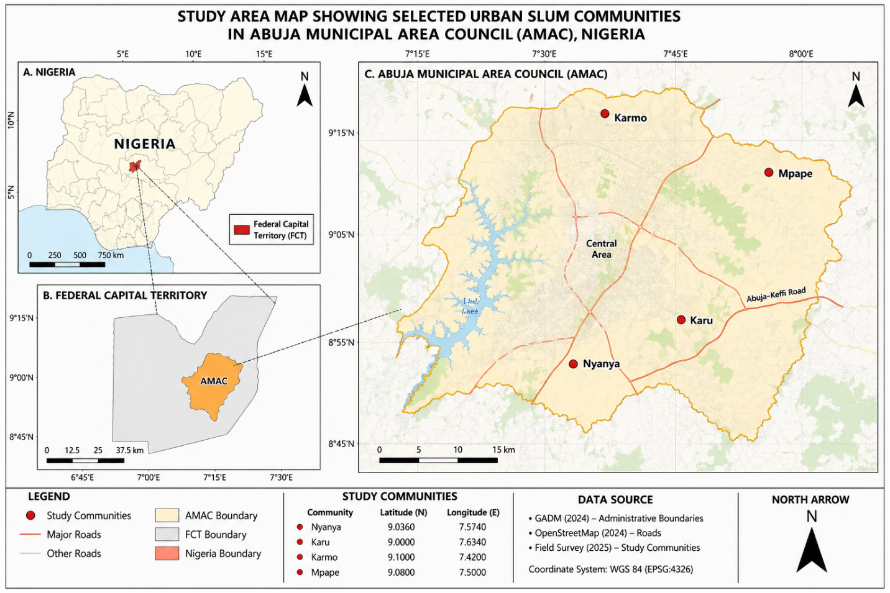
Fig 1. Map indicating the study area
Results
4.1 Sample Characteristics
A total of 380 households were approached, of which 340 completed the survey, yielding a response rate of 89.5%. Respondents were predominantly young adults, with 70.5% aged between 18 and 35 years. Females constituted a slight majority (53.5%). Over half of respondents had attained tertiary education (52.9%), while only 4.1% reported no formal education. Household sizes were generally moderate to large, with 45.3% comprising 4–6 members and 26.5% having seven or more members (Table 1).

Table 1: Socio-Demographic Characteristics of Respondents (n = 340)
Variable | Category | Frequency (n) | Percentage (%)
Age | 18–25 | 112 | 32.9%
 | 26–35 | 128 | 37.6%
 | 36–45 | 68 | 20.0%
 | 46+ | 32 | 9.5%
Gender | Male | 158 | 46.5%
 | Female | 182 | 53.5%
Marital Status | Single | 176 | 51.8%
 | Married | 142 | 41.8%
 | Widowed | 12 | 3.5%
 | Divorced | 10 | 2.9%
Education Level | No formal education | 14 | 4.1%
 | Primary | 38 | 11.2%
 | Secondary | 108 | 31.8%
 | Tertiary | 180 | 52.9%
Household Size | 1–3 persons | 96 | 28.2%
 | 4–6 persons | 154 | 45.3%
 | 7–9 persons | 66 | 19.4%
 | 10+ persons | 24 | 7.1%

4.2 Prevalence and Patterns of Untreated Well Water Use
Untreated hand-dug wells were the most reported primary source of drinking water, used by 51.8% of households. Boreholes (28.8%) and municipal supply (12.4%) were less frequently reported. Most households relied on shared or community-managed sources (54.1%), and more than half (57.6%) reported paying for water. Access to water was within short distances, with 42.4% of households located less than 50 meters from their primary water source. However, seasonal variability was evident, as 64.1% of respondents reported water shortages during the dry season (Table 2, Fig 2).

Table 2: Water Source and Access Among Respondents (n = 340)
Variable | Category | N | %
Primary drinking water source | Hand-dug well | 176 | 51.8%
 | Borehole | 98 | 28.8%
 | Municipal supply | 42 | 12.4%
 | Other sources | 24 | 7.0%
Distance to water source | Less than 50 m | 144 | 42.4%
 | 50–100 m | 118 | 34.7%
 | Over 100 m | 78 | 22.9%
Average daily consumption | Less than 20 L | 74 | 21.8%
 | 20–50 L | 188 | 55.3%
 | Over 50 L | 78 | 22.9%
Ownership of the water source | Private | 102 | 30.0%
 | Community/shared | 184 | 54.1%
 | Vendor | 54 | 15.9%
Pay for water? | Yes | 196 | 57.6%
 | No | 144 | 42.4%
Water shortage season | Dry season (Nov–Apr) | 218 | 64.1%
 | Rainy season months | 46 | 13.5%
 | No shortages reported | 76 | 22.4%
Note. Percentages may not sum to exactly 100% due to rounding.

Fig 2: Distribution of Primary Sources of Drinking Water among Respondents.
4.3 Water Handling and Treatment Practices
Water storage was dominated by plastic containers, including drums (42.9%) and jerry cans (32.4%), reflecting reliance on low-cost storage systems. While 46.5% of households consistently used storage containers, a notable proportion (17.0%) reported never using them. Despite the high reliance on potentially unsafe water sources, 61.8% of households did not treat water prior to consumption. Among those who practiced treatment, boiling was the most reported method (18.2%), followed by filtration (10.0%) and chlorination (6.5%) (Table 3).

Table 3: Water Handling and Storage Practices Among Respondents (n = 340)
Variable | Category | N | %
Storage container type | Plastic drum | 146 | 42.9%
 | Clay pot | 58 | 17.1%
 | Jerry can | 110 | 32.4%
 | Other | 26 | 7.6%
Cover storage containers? | Always | 158 | 46.5%
 | Sometimes | 124 | 36.5%
 | Never | 58 | 17.0%
Cleaning frequency | Daily | 84 | 24.7%
 | Weekly | 132 | 38.8%
 | Monthly | 76 | 22.4%
 | Rarely | 48 | 14.1%
Treat water before drinking? | Yes | 130 | 38.2%
 | No | 210 | 61.8%
Treatment method | Boiling | 62 | 18.2%
 | Filtration | 34 | 10.0%
 | Chlorination | 22 | 6.5%
 | Other | 12 | 3.5%
 | Not applicable | 210 | 61.8%
Knowledge source | Health worker | 96 | 28.2%
 | Media | 78 | 22.9%
 | School | 64 | 18.8%
 | Other sources | 102 | 30.1%
Note. Treatment method categories are not mutually exclusive of the 'Not applicable' row.
4.4 Perceptions of Water Safety and Health Risks
Perceptions of water safety were mixed. Although 43.5% of respondents rated their drinking water as unsafe, a substantial proportion (37.1%) considered it safe. More than half (51.2%) reported that untreated well water was not safe for drinking. Awareness of waterborne diseases was relatively high (72.9%); however, 40.6% of respondents reported having experienced water-related illnesses, most commonly diarrhea (21.8%) and typhoid (12.4%). These findings indicate a disconnect between risk awareness and protective behavior (Table 4).
Table 4: Perception of Water Safety Among Respondents (n = 340)
Variable | Category | n | %
Safety rating of drinking water | Safe | 126 | 37.1%
 | Unsafe | 148 | 43.5%
 | Don't know | 66 | 19.4%
Untreated well water safe to drink? | Yes | 102 | 30.0%
 | No | 174 | 51.2%
 | Not sure | 64 | 18.8%
Notice changes in taste/colour/smell? | Yes | 156 | 45.9%
 | No | 184 | 54.1%
Ever experienced water-linked illness? | Yes | 138 | 40.6%
 | No | 202 | 59.4%
Type of illness | Diarrhoea | 74 | 21.8%
 | Typhoid | 42 | 12.4%
 | Cholera | 10 | 2.9%
 | Other illnesses | 12 | 3.5%
 | Not applicable | 202 | 59.4%
Aware of water-borne diseases? | Yes | 248 | 72.9%
 | No | 92 | 27.1%
Note. Illness type is only reported among the 138 respondents who experienced illness.
4.5 Environmental and Sanitation Conditions
Environmental conditions surrounding water sources suggested significant contamination risks. Approximately 24.7% of water sources were located within 10 metres of sanitation facilities, and 41.8% were situated near waste dumpsites. Only 37.6% of water sources were reported to be fenced or otherwise protected. Animal access to water sources was common (48.2%), and a large majority of respondents (78.8%) had never reported unsafe water conditions to relevant authorities (Table 5).
Table 5: Environmental and Sanitation Factors Affecting Water Sources (n = 340)
Variable | Category | N | %
Distance: water source to nearest toilet/latrine | Less than 10 m | 84 | 24.7%
 | 10–30 m | 146 | 42.9%
 | Over 30 m | 110 | 32.4%
Water source fenced/protected? | Yes | 128 | 37.6%
 | No | 212 | 62.4%
Waste dumpsite near water source? | Yes | 142 | 41.8%
 | No | 198 | 58.2%
Animal access to a water source? | Yes | 164 | 48.2%
 | No | 176 | 51.8%
Drainage channels near the water source? | Yes | 138 | 40.6%
 | No | 202 | 59.4%
Reported unsafe water to authorities? | Yes | 72 | 21.2%
 | No | 268 | 78.8%
4.6 Knowledge and Awareness of Water Safety
Although 72.9% of respondents reported awareness of the health effects of unsafe water, only 36.5% attended community meetings on water safety. While 67.1% indicated knowledge of household water treatment methods, this did not consistently translate into practice. Awareness of organizations working on water safety was relatively low (34.7%), suggesting limited community engagement (Table 6).
Table 6: Knowledge and Awareness of Water Safety Among Respondents (n = 340)
Variable | Category | n | %
Attended community meetings on water safety? | Yes | 124 | 36.5%
 | No | 216 | 63.5%
Know how to treat water at home? | Yes | 228 | 67.1%
 | No | 112 | 32.9%
Can you identify signs of water contamination? | Yes | 206 | 60.6%
 | No | 134 | 39.4%
Know the health effects of unsafe water? | Yes | 248 | 72.9%
 | No | 92 | 27.1%
Government responsible for safe water? | Yes | 276 | 81.2%
 | No | 64 | 18.8%
Aware of NGOs working on water safety? | Yes | 118 | 34.7%
 | No | 222 | 65.3%

4.7 Community Preferences and Willingness to Act
More than half of respondents (58.2%) expressed willingness to pay for safer water, and 62.9% indicated willingness to participate in community water improvement initiatives. The preferred intervention was the protection of existing water sources (42.9%), followed by household water treatment (36.5%) and relocation of water sources (20.6%) (Table 7).
Table 7: Respondents' Recommendations for Improving Water Safety (n = 340)
Variable | Category | n | %
Willingness to pay for safer water | Yes | 198 | 58.2%
 | No | 142 | 41.8%
Preferred method to improve water quality | Water treatment | 124 | 36.5%
 | Protection of sources | 146 | 42.9%
 | Relocation of sources | 70 | 20.6%
Willing to join community water projects? | Yes | 214 | 62.9%
 | No | 126 | 37.1%

4.8 Association Between Socio-Demographic Factors and Untreated Well Water Use
Chi-square analysis revealed no statistically significant association between age and reliance on untreated hand-dug well water (χ² (3) = 4.62, p = .201). In contrast, educational attainment was significantly associated with untreated well use (χ² (3) = 16.85, p < .001). The proportion of households using untreated wells decreased progressively with increasing education, from 80.8% among respondents with no formal education to 47.7% among those with tertiary education. Household size was also significantly associated with untreated well use (χ² (3) = 18.47, p < .001). Larger households demonstrated substantially higher reliance, with usage increasing from 45.0% among households with 1–3 members to 79.2% among households with 10 or more members (Table 8.1, 8.2, 8.3).
Table 8.1: Chi-Square Analysis of Age and Use of Untreated Hand-Dug Well Water
Age Group | Used Untreated Well (Yes) | Used Untreated Well (No) | Total
18–25 | 48 | 32 | 80
26–35 | 72 | 38 | 110
36–45 | 52 | 28 | 80
46+ | 46 | 24 | 70
Total | 218 | 122 | 340
Note. χ² (3) = 4.62, p = .201. No statistically significant association was observed.

Table 8.2: Chi-Square Analysis of Educational Level and Use of Untreated Hand-Dug Well Water
Education Level | Used Untreated Well (Yes) | Used Untreated Well (No) | Total
No Formal Education | 42 | 10 | 52
Primary Education | 64 | 26 | 90
Secondary Education | 70 | 40 | 110
Tertiary Education | 42 | 46 | 88
Total | 218 | 122 | 340
Note. χ²(3) = 16.85, p < .001. A statistically significant association was observed between educational attainment and use of untreated well water.

Table 8.3: Chi-Square Analysis of Household Size and Use of Untreated Hand-Dug Well Water
Household Size | Used Untreated Well (Yes) | Used Untreated Well (No) | Total
1–3 persons | 36 | 44 | 80
4–6 persons | 82 | 48 | 130
7–9 persons | 62 | 20 | 82
10+ persons | 38 | 10 | 48
Total | 218 | 122 | 340
Note. χ²(3) = 18.47, p < .001. A statistically significant association was observed between household size and use of untreated well water.
4.9 Predictors of Untreated Well Water Use
Binary logistic regression analysis identified educational attainment, household size, and distance to water source as significant predictors of reliance on untreated hand-dug well water. Compared to respondents with no formal education, those with secondary education were significantly less likely to rely on untreated wells (AOR = 0.54, 95% CI: 0.36–0.81, p = .003), while those with tertiary education had an even lower likelihood (AOR = 0.34, 95% CI: 0.21–0.56, p < .001). Household size was strongly positively associated with untreated well use. Households with 7–9 members were nearly twice as likely to rely on untreated wells (AOR = 1.98, 95% CI: 1.28–3.08, p = .002), and those with 10 or more members were more than twice as likely (AOR = 2.32, 95% CI: 1.38–3.90, p = .001). Distance to the water source was inversely associated with the use of untreated wells. Households located more than 100 meters from their water source were significantly less likely to rely on untreated wells (AOR = 0.66, 95% CI: 0.46–0.95, p = .026). Age was not a significant predictor in the adjusted model (AOR = 1.27, p = .184) (Table 9).
Table 9: Binary Logistic Regression Predicting Reliance on Untreated Hand-Dug Well Water (n = 340)
Predictor Variable | B | SE | AOR | 95% CI | p-value
Age (26–35 vs. 18–25) | 0.24 | 0.19 | 1.27 | 0.88–1.83 | .184
Secondary education | -0.61 | 0.21 | 0.54 | 0.36–0.81 | .003*
Tertiary education | -1.08 | 0.24 | 0.34 | 0.21–0.56 | < .001*
Household size (7–9 persons) | 0.68 | 0.22 | 1.98 | 1.28–3.08 | .002*
Household size (≥10 persons) | 0.84 | 0.26 | 2.32 | 1.38–3.90 | .001*
Distance > 100 m from source | -0.42 | 0.18 | 0.66 | 0.46–0.95 | .026*
Note. AOR = Adjusted Odds Ratio; CI = Confidence Interval; Reference categories: Age (18–25 years), Education (No formal education), Household size (1–3 persons), Distance (< 50 m). *p < .05.
DISCUSSION
5.1 Overview of Key Findings
This study examined the socio-demographic and access-related determinants of reliance on untreated hand-dug well water in selected urban slum communities in Abuja, Nigeria. The findings reveal a high prevalence of untreated well use (51.8%), alongside a substantial gap between awareness of waterborne risks and adoption of protective behaviors. Educational attainment, household size, and distance to water sources emerged as significant predictors of untreated well reliance, while age was not significantly associated with water source choice. These findings reinforce the multidimensional nature of water access in informal urban settlements, where behavioral, structural, and environmental factors intersect.
5.2 Prevalence of Untreated Well Water Use
The finding that over half of households rely on untreated hand-dug wells underscores the persistence of unimproved water use in urban informal settlements. This aligns with evidence from sub-Saharan Africa showing that slum populations are disproportionately excluded from safely managed water services despite urban residence (1,3, 13). Similarly, studies in Nigeria and other African contexts have reported high dependence on informal water sources in peri-urban and slum communities (10, 11). For instance, a study in northern Nigeria found that over 60% of households relied on wells and vendor water due to unreliable municipal supply (18). However, the prevalence observed in this study is slightly higher than estimates reported in some urban settings where interventions have improved access (23), suggesting that infrastructural inequities remain particularly pronounced in Abuja’s informal settlements. This supports the argument that urbanization without inclusive service delivery perpetuates water insecurity (16).
5.3 Education as a Protective Factor
Educational attainment demonstrated a strong inverse association with reliance on untreated well water. This finding is consistent with extensive literature indicating that education enhances health literacy, risk perception, and adoption of preventive behaviors (17; 19). Studies in Ghana and Kenya similarly report that households with higher education levels are significantly more likely to use improved water sources and adopt treatment practices (9, 13). The present findings extend this evidence by showing that the effect persists even after controlling for other variables in regression analysis. However, some studies suggest that education alone may not be sufficient where structural barriers exist (20, 21). In line with this, the current study indicates that education likely operates through both cognitive pathways (awareness) and structural pathways (access and opportunity). This dual mechanism highlights the need for interventions that combine education with improved service availability.
5.4 Household Size and Economic Constraints
Household size was a strong positive predictor of untreated well use, with larger households significantly more likely to rely on unsafe sources. This finding aligns with studies across low-income settings demonstrating that larger households face greater economic pressure in meeting water needs (10, 11). In Ethiopia and Bangladesh, similar patterns have been observed, where increased household size correlates with reduced likelihood of accessing improved water due to cost constraints (13). Larger households tend to prioritize quantity over quality, opting for free or low-cost sources such as wells. Conversely, some studies have reported weaker associations between household size and water source choice when income is controlled (20, 1). The absence of direct income measurement in this study limits deeper interpretation, but the findings strongly suggest that resource constraints at the household level remain a key driver of unsafe water use.
5.5 Distance to Water Source and Behavioral Adaptation
An important and somewhat counterintuitive finding was that households located farther from water sources (>100 m) were less likely to rely on untreated wells. This contrasts with conventional WASH literature, which typically associates increased distance with reduced access to improved water (2,3). One possible explanation is that proximity to wells reinforces habitual use of readily available but unimproved sources, while a greater distance may encourage households to seek alternative sources perceived as safer, such as boreholes or vendor-supplied water. Similar patterns have been reported in studies where convenience strongly influences water source selection (15). This finding highlights that physical access does not equate to safe access, and interventions must prioritize quality alongside proximity. It also underscores the behavioral dimension of water use, where convenience can perpetuate unsafe practices (1).
5.6 The Awareness–Behavior Gap
Despite high awareness of waterborne diseases (72.9%), most households (61.8%) did not treat water before consumption. This reflects the well-documented “knowledge–practice gap” in public health (14). Previous studies have shown that awareness alone rarely translates into behavior change due to barriers such as cost, inconvenience, and lack of enabling resources (22). Similar findings have been reported in Nigerian slum settings, where households acknowledge risks but continue unsafe practices due to economic and practical constraints (11). This suggests that interventions should move beyond awareness campaigns to include behavioral nudges, subsidies, and access to low-cost treatment technologies.
5.7 Environmental Risk Factors
The environmental conditions observed in this study—including proximity of wells to latrines, presence of waste dumps, and lack of protective infrastructure—are consistent with known risk factors for groundwater contamination (12, 19). These findings align with studies that demonstrate high microbial contamination in shallow wells located near sanitation facilities in urban slums (13). The widespread exposure to these risk factors indicates that unsafe water use is structurally embedded, rather than solely behavior-driven. The low rate of reporting unsafe water conditions further reflects findings from other low-resource settings, where weak institutional trust and limited regulatory enforcement reduce community engagement (21).
5.8 Community Engagement and Demand for Improved Water Services
The relatively high willingness to pay for safer water (58.2%) and participate in community initiatives (62.9%) suggests latent demand for improved services. This aligns with evidence from community-based WASH interventions showing that households are willing to contribute financially when services are reliable and affordable (22). However, stated willingness does not always translate into actual payment behavior, particularly in low-income settings (13). Therefore, while community-driven models hold promise, they must be carefully designed to ensure affordability and sustainability.
5.9 Implications for Policy and Practice
The findings of this study reinforce several key policy implications. First, improving water access in urban slums requires more than infrastructure expansion; it must address the socio-economic and behavioral determinants of water use. This is consistent with global WASH frameworks emphasizing integrated approaches (2,3). Second, interventions should prioritize high-risk groups, particularly larger households and individuals with lower educational attainment. Third, behavior change strategies should incorporate practical support mechanisms, such as subsidized treatment options and improved service reliability. Finally, environmental protection of existing water sources—through improved sanitation, drainage, and infrastructure—should be prioritized to reduce contamination risks.
5.10 Study Limitations
This study has several limitations. First, its cross-sectional design limits causal inference regarding the relationship between socio-demographic factors and water-use behavior. Second, reliance on self-reported data introduces potential recall and social desirability bias. Third, the study did not include microbiological testing of water sources, limiting direct assessment of contamination levels. Finally, income and wealth indices were not quantitatively measured, which may have influenced water source choices.
Funding
This research did not obtain any specific grants from funding sources in the public, commercial, or non-profit sectors.
Author's contribution statement
Chinwe E. Okoli and Onwoamaka Miracle Oluchi conceived and designed the research, conducted the experiments, analyzed and evaluated the data, and authored the publication.
CRediT authorship contribution statement.
Chinwe E. Okoli and Onwoamaka Miracle Oluchi: Writing – original draft, Enid Godwin and Abdulrahman Musa Adeiza: Review and editing
Declaration of Competing Interest
The author acknowledges no conflicts of interest.
REFERENCE
- World Health Organization. (2022). Drinking water. https://www.who.int/news-room/fact-sheets/detail/drinking-water
- World Health Organization, & United Nations Children's Fund. (2023). Progress on household drinking water, sanitation, and hygiene 2000–2022: Special focus on gender. WHO/UNICEF Joint Monitoring Programme.
- United Nations Children's Fund. (2023). Water, sanitation, and hygiene (WASH) in Nigeria. https://www.unicef.org/nigeria
- Creswell, J. W., & Creswell, J. D. (2018). Research design: Qualitative, quantitative, and mixed methods approach (5th ed.). Sage Publications.
- Kothari C. R., C. R. (2004). Research methodology: Methods and techniques (2nd ed.). New Age International
- Tavakoli Mohsen, M., & Dennick, R. (2011). Making sense of Cronbach’s alpha. International Journal of Medical Education, 2, 53–55. https://doi.org/10.5116/ijme.4dfb.8dfd
- Nunnally Jum C., J. C., & Bernstein, I. H. (1994). Psychometric theory (3rd ed.). McGraw-Hill.
- Prüss-Ustün, Annette, Wolf, J., Bartram, J., Clasen, T., Cumming, O., Freeman, M. C., Gordon, B., Hunter, P. R., Medlicott, K., & Johnston, R. (2019). Burden of disease from inadequate water, sanitation, and hygiene for selected adverse health outcomes: An updated analysis. International Journal of Hygiene and Environmental Health, 222(5), 765–777. https://doi.org/10.1016/j.ijheh.2019.05.004
- Abubakar, I. R. (2023). Household access to water and sanitation in Nigeria: Implications for public health. Journal of Water, Sanitation and Hygiene for Development, 13(2), 120–131.
- Adams, E. A., Boateng, G. O., & Amoyaw, J. A. (2022). Socioeconomic inequalities in access to water, sanitation, and hygiene (WASH) in sub-Saharan Africa. International Journal of Environmental Research and Public Health, 19(3), 1–15.
- Adams, E. A., Thorp, J., & Boateng, G. O. (2021). Urban water insecurity and household water use behavior. Water Resources Research, 57(5), e2020WR028.
- Akpoborie, I. A., et al. (2021). Groundwater contamination in urban areas of Nigeria. Environmental Monitoring and Assessment, 193, 112.
- Bain, R., Johnston, R., Mitis, F., Chatterley, C., & Slaymaker, T. (2021). Establishing sustainable development goal baselines for drinking water. Science of the Total Environment, 767, 144.
- Dreibelbis, R., Winch, P. J., Leontsini, E., et al. (2013). The Integrated Behavioural Model for WASH. BMC Public Health, 13, 1015.
- Freeman, M. C., et al. (2017). The impact of sanitation on infectious disease. The Lancet Global Health, 5(4), e383–e393.
- Gandy, M. (2022). Urban infrastructure and inequality in the global South. Urban Studies, 59(3), 567–584.
- Nketiah-Amponsah, E., et al. (2021). Determinants of household water use in Ghana. Water Policy, 23(2), 345–360.
- Ocheri, M. I., & Ogwuche, J. A. (2022). Water supply challenges in Nigerian urban communities. African Journal of Environmental Science, 16(4), 215–224.
- Orebiyi, E. O., et al. (2020). Assessment of groundwater vulnerability in urban Nigeria. Environmental Earth Sciences, 79, 445.
- Pickering, A. J., et al. (2019). The effect of water access on health outcomes. PLoS Medicine, 16(3), e100.
- Sorenson, S. B., et al. (2021). Gender roles and water collection. Social Science & Medicine, 278, 113.
- Whittington, D., et al. (2020). Pricing water services in low-income settings. Water Economics and Policy, 6(1), 2050001.
- Maziya-Dixon, B., Achterbosch, T., Adelekan, D., Adeyemi, O., Ajieroh, V., Akerele, D., ... & Brouwer, I. D. (2021). Food systems for healthier diets in Nigeria: A research agenda.

