The Atipamezole Plays A Great Role in the Quick Recovery of the Male Rabbit Anesthetized for Neutering

ABSTRACT
Delay in recovery from general anesthesia is always hazardous for the safety of life. Therefore, the aim of this study is to evaluate the effect of atipamezole in the recovery of rabbits anesthetized with xylazine-ketamine undergoing neutering. Ten male rabbits were randomly assigned to two groups (n = 5 per group) where group XK was treated with xylazine (5 mg/kg bwt) and ketamine (30 mg/kg bwt) intramuscularly without atipamezole and group XKA was treated with xylazine (5 mg/kg bwt), ketamine (30 mg/kg bwt) and with atipamezole (0.5mg/kg bwt) intramuscularly. Atipamezole was administered intramuscularly 30 minutes post-injection of anesthetic combination. Physiological parameters, induction time, duration of anesthesia, recovery time, hematological and biochemical parameters were measured. In group XKA, heart rate, temperature and respiration that decreased during anesthesia, reached almost normalcy during recovery rather than group A. Significant differences in induction, duration of anesthesia and recovery periods were observed between two groups. Group XKA showed short recovery time compared to Group XK. The duration of anesthesia was longer in group A in comparison to group B. The recovery period was short in group B due to the atipamezole. There was no effect of atipamezole in healing. There were no significant differences in hematological parameters between two groups. Taken all together, we conclude that the atipamezole has a great role in reduction of recovery time of the rabbit with xylazine-ketamine induced anesthesia without significant adverse effects in clinical and blood parameters during neutering.
Keywords: Recovery, Atipamezole, Xylazine-ketamine, Male rabbits, Neutering

INTRODUCTION
Rabbits are extensively utilized as experimental models in biomedical research owing to their compact body size, manageable temperament, and the wide availability of organs and tissues suitable for scientific analysis. The domestic rabbit is also valued as a source of low-cholesterol animal protein and has recently gained popularity as a household pet. Consequently, veterinarians and researchers frequently manage rabbits requiring diagnostic, therapeutic, or surgical interventions that demand appropriate anesthetic management (Hassan et al., 2024) [1].
In the present research environment, anesthetic agents constitute the most commonly used class of drugs for the control of pain, particularly the pain associated with surgical interventions. In rabbits, neutering (ovariectomy/ovariohysterectomy in females and orchiectomy in males) is one of the most frequently performed surgical procedures in veterinary practice and biomedical research. The major indications for neutering in female rabbits include reproductive tract disorders such as uterine adenocarcinoma, pyometra, mammary neoplasia, uterine neoplasia, and endometrial hyperplasia. Additional indications involve the reduction of pregnancy- and parturition-related complications such as metritis, mastitis, dystocia, metrorrhagia, and glandular cystic uterine hyperplasia with secondary infections leading to chronic uterine inflammation. In male rabbits, neutering is indicated for population control, prevention of testicular disease, and reduction of sexually aggressive and marking behaviors (Coulter et al., 2011) [2].
The procedure should be undertaken only when the rabbit is in a physiologically stable condition and fit to withstand general anesthesia. However, certain contraindications exist, including hypothermia, dehydration, severe systemic illness, and excessive mydriasis, which may increase anesthetic risk (Raillard et al., 2019) [3].
Among injectable anesthetic protocols, the xylazine–ketamine combination is one of the most frequently applied regimens in rabbits due to its reliability, cost-effectiveness, and ease of administration. Xylazine is an alpha-2 adrenergic agonist that produces sedation, muscle relaxation, and analgesia by inhibiting the release of norepinephrine at presynaptic nerve terminals in the central nervous system. Ketamine is a dissociative anesthetic agent that induces profound analgesia and amnesia by blocking N-methyl-D-aspartate (NMDA) receptors. When used together, xylazine and ketamine produce balanced anesthesia characterized by sedation, analgesia, muscle relaxation, and sufficient surgical depth, making this combination highly suitable for rabbit neutering surgeries (Pennasilico et al., 2025) [4].
However, xylazine is associated with certain adverse effects such as bradycardia, hypotension, respiratory depression, and hypothermia, while ketamine may cause muscle rigidity and prolonged recovery when used alone. The duration of surgical anesthesia with xylazine–ketamine is generally limited, and recovery may be delayed in some animals (Irwin et al., 2023) [5].
To overcome these limitations, atipamezole, a highly selective alpha-2 adrenergic receptor antagonist, is used for the rapid and effective reversal of xylazine-induced sedation and cardiovascular depression. Atipamezole competitively blocks alpha-2 receptors and restores the release of norepinephrine, thereby improving heart rate, respiratory function, alertness, and thermoregulation. The administration of atipamezole significantly shortens recovery time and enhances postoperative safety and comfort in rabbits undergoing neutering (Coulter et al., 2011) [2].
The xylazine–ketamine–atipamezole anesthetic protocol therefore offers several advantages, including reliable surgical anesthesia, good muscle relaxation and analgesia, controlled and smooth induction, rapid and safe recovery with atipamezole reversal and reduced perioperative stress and mortality. Few research has been conducted but the role of atipamezole in the recovery is still not clear specially in the rabbit during surgery. That’s why the study on the role of atipamezole is important to get clear information. We hypothesize that atipamezole has the ability to reduce the recovery time in the rabbits during surgery. Therefore, the objective of this study is to assess the contribution of atipamezole in the recovery of rabbits anesthetized with xylazine–ketamine–induced undergoing neutering.
MATERIALS AND METHODS
Animals and Experimental Design
Our present study was designed to include 10 apparently healthy male rabbits weighing 1.31±0.1 kg and ageing of 10±2 month, purchased from the Bonder Bazar, Sylhet, Bangladesh. The research was conducted at the Laboratory of Department of Surgery and Theriogenology and at Professor Moshleh Uddin Ahmed Chowdhury Veterinary Teaching Hospital of Sylhet Agricultural University. Duration of the research work was allocated from December 2024 to November 2025. The rabbits were not required to be fasted overnight prior to induction of anesthesia. The rabbits were examined clinically to detect any pathological condition. Before starting the experiment, the body weight of each rabbit was taken by using weighting machine. The rabbit was then placed on the Operation Table in O.T. of Professor Moshleh Uddin Ahmed Chowdhury Veterinary Teaching Hospital of Sylhet Agricultural University. The anesthesia was always performed in the morning throughout the course of investigation. The area of injection was sterilized with 70% alcohol. The anesthetic agent was then administered into the muscle at the dose indicated in the experimental design. The agents were administered in the thigh muscle using insulin syringe. All drugs were administered consecutively in separate syringe. The experimental rabbits were randomly divided into two (2) groups, each group containing five (5) rabbits. One was the xylazine hydrochloride- ketamine hydrochloride (XK) group, serving as the control, where rabbits were injected with the xylazine (5 mg/kg body weight) and ketamine hydrochloride (30mg/kg body weight) combination (Supplementary figure 1) intramuscularly for neutering (Figure 1) and the other was the xylazine hydrochloride- ketamine hydrochloride and atipamezole (XKA) group, serving as the treatment, where rabbits were injected with the xylazine (5 mg/kg body weight) and ketamine hydrochloride (30mg/kg body weight) combination intramuscularly for neutering (Figure 1) and during 30 minutes of anesthesia atipamezole hydrochloride (0.5mg/kg body weight) (Supplementary figure 1) was injected intramuscularly. Before operation, the site of the operation was shaped, draped and prepared with povidone iodine.
Figure 1. The procedure of neutering step by step. A) making the incision on the tip of the testicle of the rabbit, B) pressing the scrotum to remove the testicle, C) exteriorizing the spermatic cord including testicle from the inside, D) ligation and excision of the testicle, E) crushing the cutting end of the spermatic cord and F) bring the cutting edge in apposition without suturing.
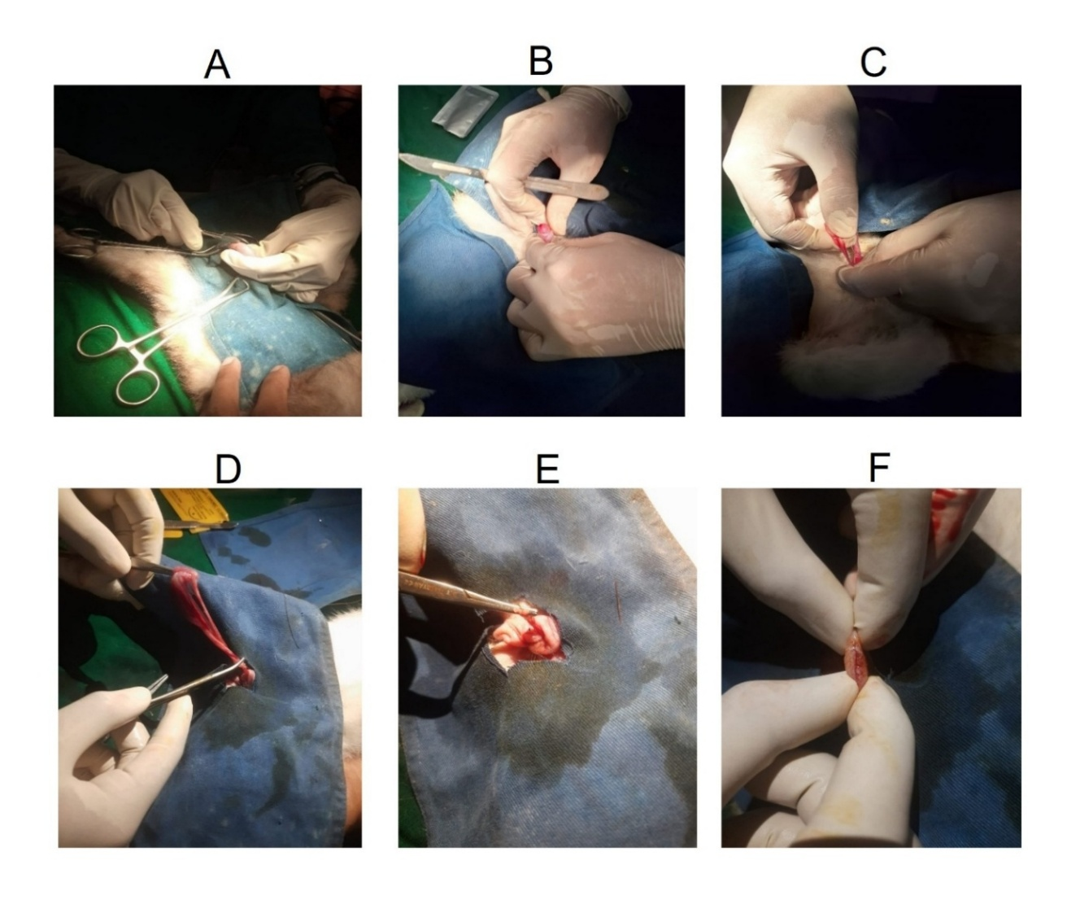
Ethical Statements
The authors confirms that the experiments were performed according to the standard animal welfare guideline with permission from the Animal Ethics Committee of Sylhet Agricultural University (Approval ID. #ARP2026099).
Materials
We purchased xylazine (Xyla, each ml contains xylazine hydrochloride 23.32 mg equivalent to 20 mg, Interchemie Werken Ltd, Holland, 50ml vial), ketamine (G-ketamine, each ml contains ketamine hydrochloride BP 50mg, Gonoshasthaya Pharmaceuticals Ltd, Bangladesh, 10ml vial) and atipamezole (Atipamezole hydrochloride, each ml contains Atipamezole Hydrochloride 5mg, lot no. SL3IJ-AL, Tokyo Chemical Industry Co. Ltd, 25mg) to use in the experiments. Thermometer, and stethoscope were used to observe the clinical parameters. Digital balance was used to weigh the body weight. We also used syringes (1ml, 3ml), 27G butterfly needle, timer, pen, scale, camera, record book etc. For blood collection, we used red and purple tube and tube rack. For surgical procedure, we used gloves, masks, surgical gauze, cotton, OT dress, surgical blade, BP handle, trimer, shaving Blade, soap, Chlorhexidine, alcohol pad, povidone iodine, draping towel, towel clamp, Allis tissue forceps, hemostatic forceps, needle holder, Catgut- 4/0, scissors etc. Antibiotic, antihistamine and NSAID were used after neutering and in post-operative care.
Period of Induction, Duration of Anesthesia and Recovery from Anesthesia
The period extending from time of injection up to the lateral recumbency with the reduction of different reflexes was mentioned as the period of induction. The duration of anesthesia starts from onset of anesthesia up to painless surgery. The recovery period extends from the stage of reappearance of consciousness up to the stage when the rabbits were in full sense and response to external stimuli.
Determination of Clinical Parameters
Respiration rate (per minute), heart rate (per minute) and rectal temperature (°F) of the experimental rabbits were recorded before the anesthesia and during the course of anesthetic period at 15 minutes, 30minutes and 45 minutes (Supplementary figure 3).
Respiration Rate
The respiration rate was recorded by counting respiration visually i.e, by watching and counting the movements of the abdomen. Care was taken not to excite the rabbits before and during monitoring.
Heart Rate
Heart rate was determined using a stethoscope. For this, the diaphragm of the stethoscope was placed over the chest region of rabbits.
Rectal Temperature
The rectal temperature was taken by inserting a clinical thermometer into the rectum. The bulb of the thermometer was moistened with Vaseline before insertion into the rectum. The position of the thermometer into the rectum was such that the bulb of the thermometer touched the rectal mucosa. The thermometer was held in position for 90 seconds.
Blood Sample Collection
For each rabbit, a blood sample was collected prior to administration of injectable anesthetic drugs. (pre-anesthetic sample), 45 minutes post-anesthesia and after recovery following completion of neutering under anesthetic agents (post-anesthetic sample). For sex hormonal test, the blood was collected before anesthesia and after 7 days of neutering. Each blood sample was collected from the marginal ear vein using an insulin syringes or butterfly needle attached to a plastic syringe (Supplementary figure 3). Blood was immediately transferred into an ethylenediaminetetraacetic acid (EDTA) micro-collection tube. Pre anesthetic sample and post-anesthetic samples were collected in all 10 rabbits.
Reflexes Monitored
The depth of anesthesia was monitored by measuring the withdrawal reflex, palpebral reflex, corneal reflex and pedal reflex.
Other Observations
The several miscellaneous parameters like defecation, urination, salivation, lacrimation was observed carefully during each experiment.
Hematological Analysis
A complete blood count (CBC) was performed on each blood sample on the day of blood collection at the Laboratory of Department of Surgery and Theriogenology of Sylhet Agricultural University using an automated hematology analyzer (Mythic-18 Automated Hematology Analyzer). Hematological values provided by the hematology analyzer included: Red blood cell (RBC) count; hemoglobin (Hb) concentration; hematocrit (HCT); mean red blood cell volume (MCV); mean corpuscular hemoglobin (MCH); mean corpuscular hemoglobin concentration (MCHC); red blood cell distribution width (RDW); total white blood cell (WBC) count, segmented Neutrophils (SEG) count; Eosinophils (EOS) count, Basophils (BASO) count; Lymphocyte (LYMPHO) count; Monocytes (MONO) count; and platelet (PLT) count. The parameters were counted as monocytes in percentage, Eosinophils in percentage, Basophils in percentage, MCV (fl) mean corpuscular volume in femtoliters, HB(gm/dl)- Hemoglobin in gram per deciliter, RBC(mil/ul) Red Blood Cell in million per micro liter, WBC(/cumm)- White Blood Cell in per cubic millimeter, Platelets(mil/mm)- Platelets in million per milliliters, Neutrophils in Percentage, RDW- red cell distribution width in percentages, MCHC mean corpuscular hemoglobin concentration in gram per deciliters, HCT- hematocrit count in percentages, MCH (pg)- mean corpuscular hemoglobin in picogram.
Biochemical Parameters
Random Blood Sugar (RBS), Testosterone, and Cortisol were examined in the diagnostic laboratory.
Statistical Analysis
The data were analyzed using statistical software program SPSS 20.0 for Windows 7. One-way ANOVA was performed to assess the significant difference among different groups in terms of physiological and hematological parameters. Data was expressed as mean ± standard deviation (SD). P<0.05 was considered as statistically significant.
RESULTS
Two groups of rabbits (n=10) were injected with two different anesthetic protocols following experimental design. In group XK, 30 minutes after administration of the xylazine and ketamine hydrochloride combination during neutering, no use of atipamezole hydrochloride and in group XKA, atipamezole was used after 30 minutes of xylazine-ketamine anesthesia with the aim of finding the effects of atipamezole on physiological and hematological parameters of the rabbits during neutering.
Clinical Parameters
The effects of anesthetic agents on physiological parameters in rabbits were presented from table 1 to table 3.
Effects of Anesthesia on Heart Rate in Rabbits
Table-1 shows that the mean values of heart rate per minute before anesthesia, 15 min, 30 min and 45 min post-injection in XK group were 230±15.81, 193±14.83, 166±24.08, and 195.2±12.5 min respectively indicating that the heart rate decreased gradually up to 30 min of anesthesia and almost regained at normal level at 45 min post-anesthesia. The mean values of heart rate per minute before anesthesia, at 15 min, 30 min and 45 min after post-injection in XKA group were 246±35.78, 190±15.81, 162±22.80, and 200±15.81 of respectively. It also indicates almost same changes in group XK except at 45 min the heart rate sharply regained at normalcy.
Table 1. Effects of anesthetic agents on heart rate (per min) in rabbits
Group | Before anesthesia | 15 min post-injection | 30 min post-injection | 45 min post-injection
XK | 230±15.81 | 190±15.81** | 162±22.80** | 200±15.81*
XKA | 246±35.78 | 193±14.83** | 166±24.08** | 195.2±12.5**
Effects of anesthesia on respiration rate in Rabbits
Table-2 shows that the mean values of respiration rate per minute before anesthesia, 15 min, 30 min and 45 min post-injection in XK group were 89.8±3.96, 53±10.9, 56±5.09, and 93.2±2.39 respectively indicating that the respiration rate decreased gradually up to 15 min of anesthesia and gradually increased from 30 min to 45 min post-anesthesia. The mean values of respiration rate per minute before anesthesia, at 15 min, 30 min and 45 min after post-injection in XKA group were 89±6.04, 64.6±2.2, 66±8.37, and 91±3.39 min respectively. It also indicates almost same changes in group XK.
Table 2. Effects of anesthetic agents on respiration rate (per min) in rabbits
Group | Before anesthesia | 15 min post-injection | 30 min post-injection | 45 min post-injection
XK | 89.8±3.96 | 53±10.9** | 56±5.09** | 93.2±2.39
XKA | 89±6.04 | 64.6±2.2** | 66±8.37** | 91±3.39
Effects of anesthesia on rectal temperature in Rabbits
Table-3 shows that the mean values of rectal temperature (ºF) before anesthesia, 15 min, 30 min and 45 min post-injection in XK group were 101.9±0.63, 100.3±0.93, 100.54±0.46, and 101.1±0.74 respectively indicating that the rectal temperature (ºF) decreased gradually up to 30 min of anesthesia and almost regained at normal level at 45 min post-anesthesia. The mean values of the rectal temperature (ºF) before anesthesia, at 15 min, 30 min and 45 min after post-injection in XKA group were102.2±0.91, 99.5±1.94, 99.2±2.17, 101±0.61°F respectively. It also indicates almost same changes in group XK.
Table 3. Effects of anesthetic agents on the rectal temperature (ºF) in rabbits
Group | Before anesthesia | 15 min post-injection | 30 min post-injection | 45 min post-injection
XK | 101.9±0.63 | 100.3±0.93 | 100.54±0.46** | 101.1±0.74
XKA | 102.2±0.91 | 99.5±1.94* | 99.2±2.17** | 101±0.61
Induction period, duration of anesthesia and recovery period from Anesthesia
Anesthetic agents were applied according to the body weight of the animals. Effects of anesthetic agents on induction period, duration of anesthesia and recovery from anesthesia without atipamezole and with atipamezole were recorded in rabbits. Table-4 shows that the induction period of anesthesia was 12.4±1.52 min and 13.2±2.17 min in group XK and XKA respectively. In group XKA, duration of anesthesia was shorter (45.7±0.84 min) than that in group XK (59.5±4.27 min) indicating that atipamezole reduced the duration of anesthesia. The longest recovery period of anesthesia (131±20.74min) was recorded in XK group and the shortest recovery period (67±5.7min) was recorded in XKA group indicating that atipamezole reduced the recovery period.
Table 4. Anesthetic doses, induction period, duration of anesthesia and Recovery period
Group | Induction period (min) | Duration of anesthesia (min) | Recovery period (min)
XK | 12.4±1.52 | 59.5±4.27 | 153±4.47
XKA | 13.2±2.17 | 45.7±0.84** | 86±9.6**
P-Value | 0.518 | 0.0001 | 0.00006
Effects of anesthesia on hematological parameters in rabbits
Figure 2 shows, before anesthesia the Hb levels were 9.92±0.896 and 10.3±0.55 in XK and XKA group respectively. After 45min the Hb levels were decreased to 9.22±0.66 (P ≤ 0.05) and 9.5±0.47 in both groups. The Hb levels were increased after recovery to 9.68±0.82 and 9.82±0.40 in XK and XKA groups respectively.
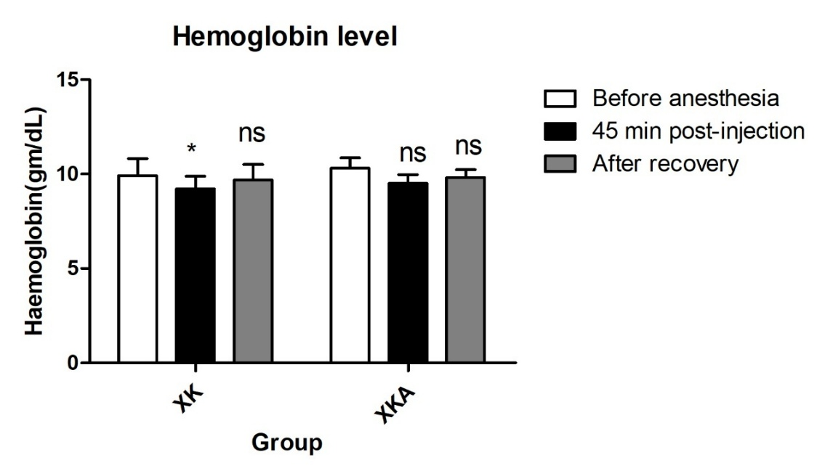
Figure 2. Comparison of hemoglobin levels(gm/dL) between group XK and XKA before and after induction of anesthesia. The data from two groups were analyzed using the compare means feature in IBM SPSS Statistics for Windows (IBM Corp., NY, USA) via One-way ANOVA test. All of the results are expressed as the mean ± SD. * indicates P ≤ 0.05 and ** indicates P ≤ 0.01. A P value of ≤ 0.05 between the two groups was considered significant.
Figure 3 shows, before anesthesia the RBC levels were 5.45±0.11 and 5.37±0.105 in group-XK and XKA respectively. After 45min of post-injection, the levels of RBC were 5.434±0.68 and 5.49±0.40 in group-XK and XKA respectively. After recovery, RBC levels was 5.02±0.35 and 5.61±0.31 in group-XK and XKA respectively. No significant changes were in the RBC level.
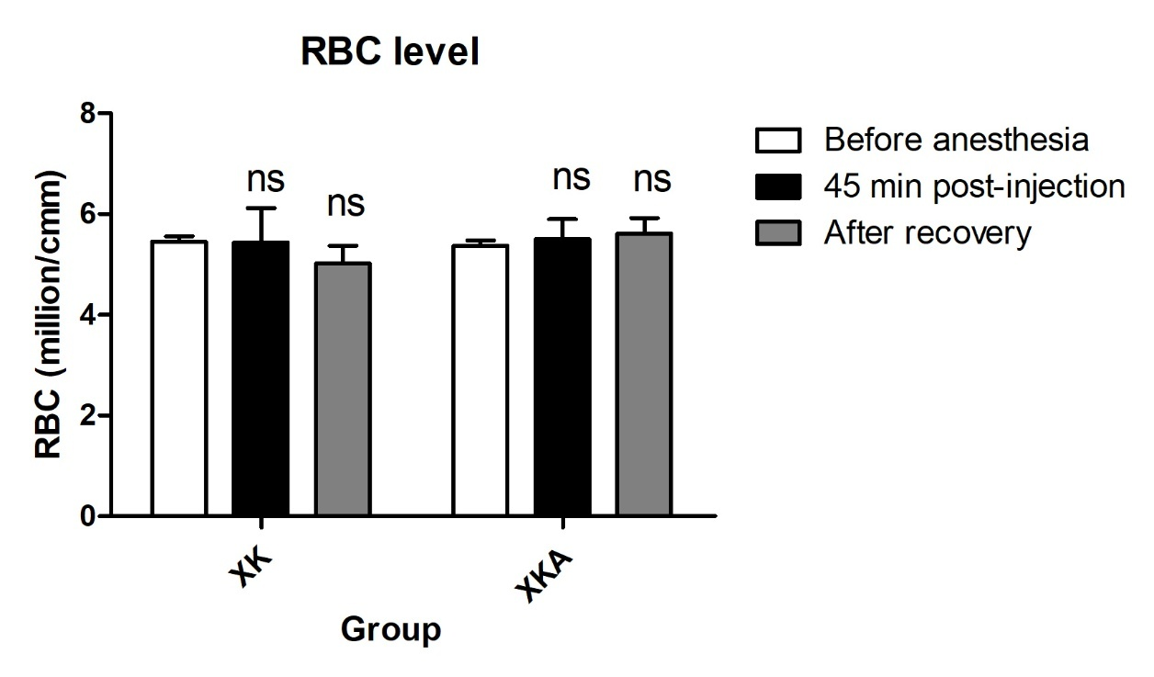
Figure 3. Comparison of RBC (million/cmm) between group XK and XKA before and after induction of anesthesia. The data from two groups were analyzed using the compare means feature in IBM SPSS Statistics for Windows (IBM Corp., NY, USA) via One-way ANOVA test. All of the results are expressed as the mean ± SD. * indicates P ≤ 0.05 and ** indicates P ≤ 0.01. A P value of ≤ 0.05 between the two groups was considered significant.
Figure 4 shows, before anesthesia the WBC levels were 11300±547and 11500±547 in group-XK and XKA respectively. After 45min, the levels of WBC were decreased in 8660±1952.7 (P ≤ 0.01) and 8260±2184.7 (P ≤ 0.01) in both group-A and B. The WBC levels were also decreased after recovery in 8482±211 (P ≤ 0.01) and 8359±456 (P ≤ 0.01) in group-XK and XKA respectively.
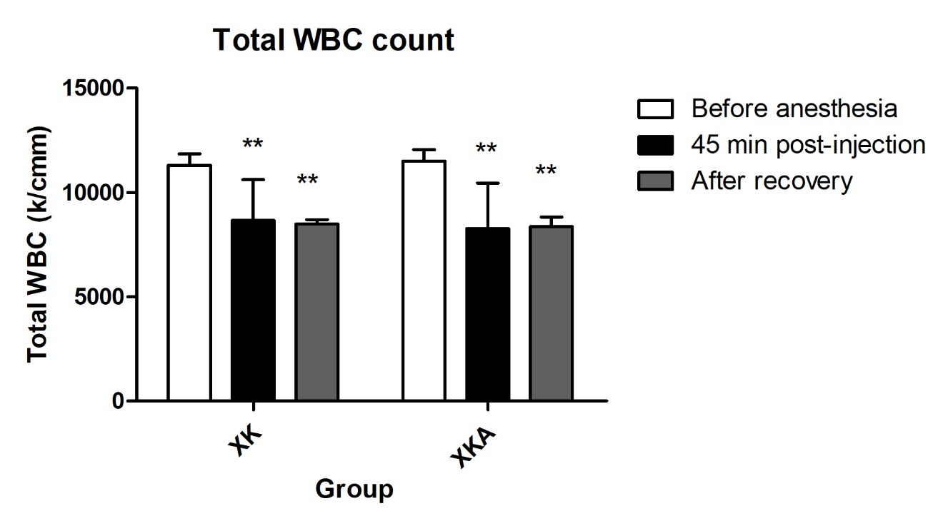
Figure 4. Comparison of Total WBC Count(k/cmm) between group XK and XKA before and after induction of anesthesia. The data from two groups were analyzed using the compare means feature in IBM SPSS Statistics for Windows (IBM Corp., NY, USA) via One-way ANOVA test. All of the results are expressed as the mean ± SD. * indicates P ≤ 0.05 and ** indicates P ≤ 0.01. A P value of ≤ 0.05 between the two groups was considered significant.
Figure 5 shows, before anesthesia, the neutrophil levels were 28.5±0.58and 28.25±0.96 in group-XK and XKA respectively. After 45min, the levels of neutrophil were 30.4±1.14 and 30±1.58 and after recovery, it was 30±3.8 and 30±2.23 in group-XK and XKA respectively. No significant changes were in the neutrophil level.
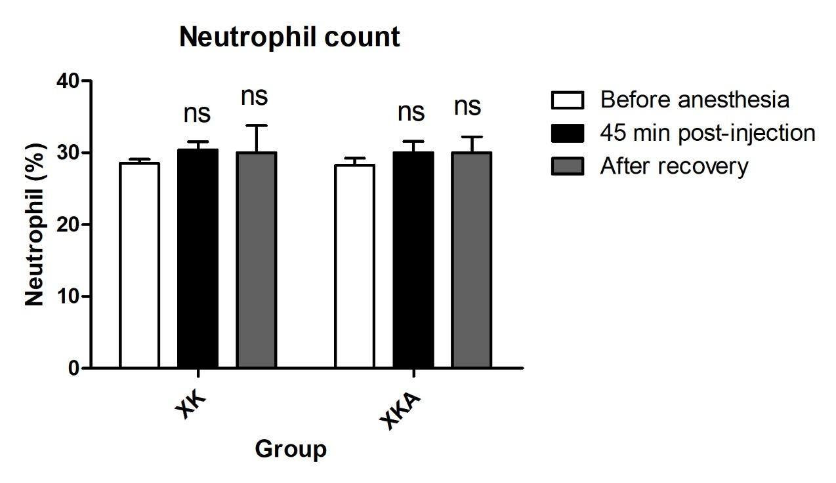
Figure 5. Comparison of Neutrophils (%) between XK and XKA groups before and after induction of anesthesia. The data from two groups were analyzed using the compare means feature in IBM SPSS Statistics for Windows (IBM Corp., NY, USA) via One-way ANOVA test. All of the results are expressed as the mean ± SD. * indicates P ≤ 0.05 and ** indicates P ≤ 0.01. A P value of ≤ 0.05 between the two groups was considered significant.
Figure 6 shows, before anesthesia, the lymphocytes levels were 79.6±1.34 and 80.01±1.0 in group-XK and XKA respectively. After 45min, the levels of lymphocytes were decreased to 50.4±5.59 (P ≤ 0.01) and 65.2±15.77 (P ≤ 0.01) in both groups. After recovery, it was 59.6±9.39 (P ≤ 0.05) and 48.6±6.54 (P ≤ 0.01) in group-XK and XKA respectively.
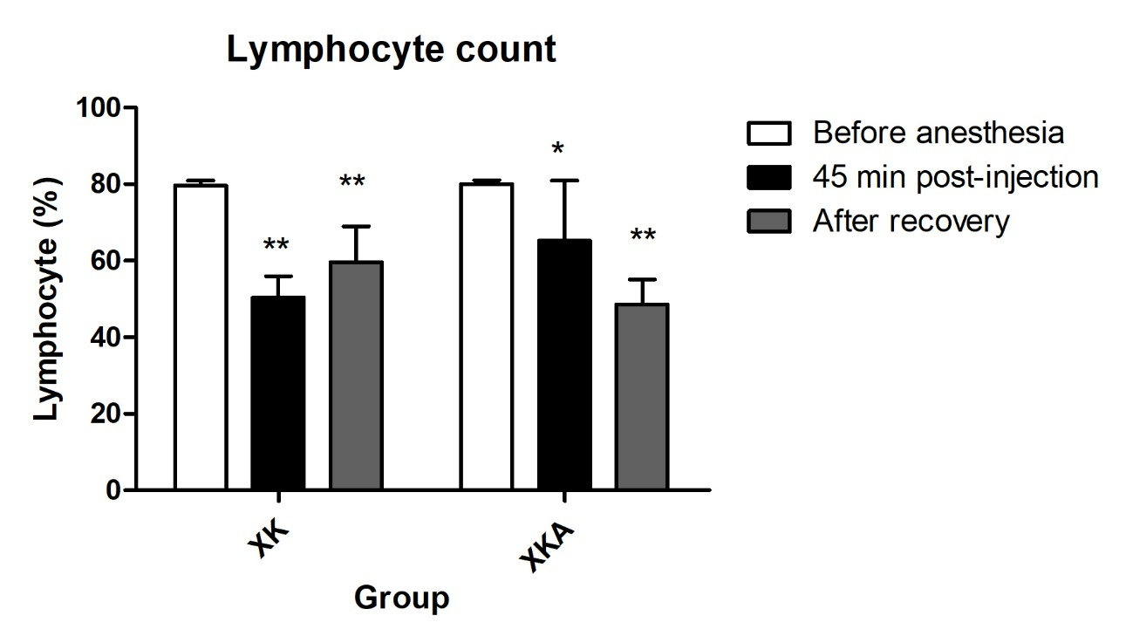
Figure 6. Comparison of Lymphocytes (%) between XK and XKA groups before and after induction of anesthesia. The data from two groups were analyzed using the compare means feature in IBM SPSS Statistics for Windows (IBM Corp., NY, USA) via One-way ANOVA test. All of the results are expressed as the mean ± SD. * indicates P ≤ 0.05 and ** indicates P ≤ 0.01. A P value of ≤ 0.05 between the two groups was considered significant.
Figure 7 shows, before anesthesia, the monocytes levels were 16.4±0.55 and 16.6±0.55 in group-XK and XKA respectively. After 45min, the monocytes levels were decreased to 15.8±0.84 and 15.8±1.09. The monocytes levels were increased after recovery of neutering at 16.2±2.58 and 16.4±2.5.

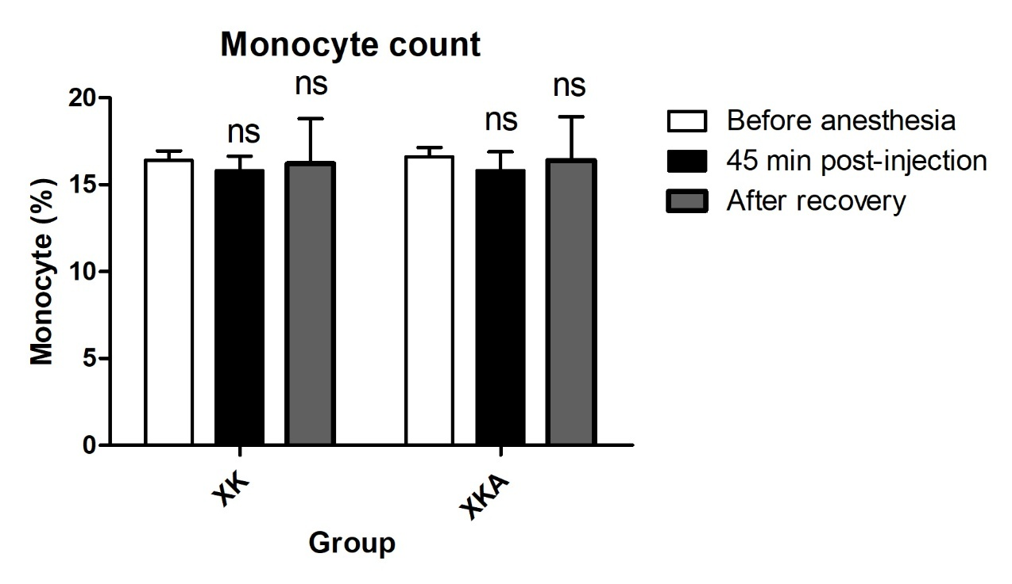
Figure 7. Comparison of Monocytes (%) between XK and XKA groups before and after induction of anesthesia. The data from two groups were analyzed using the compare means feature in IBM SPSS Statistics for Windows (IBM Corp., NY, USA) via One-way ANOVA test. All of the results are expressed as the mean ± SD. * indicates P ≤ 0.05 and ** indicates P ≤ 0.01. A P value of ≤ 0.05 between the two groups was considered significant.
Before anesthesia, the eosinophils levels were 3.0±0.00 and 3.0±0.00 in group-XK and XKA respectively. After 45min, the eosinophil level in XK group was 3.0±0.83 and in group XKA increased at 4.2±0.84 (P ≤ 0.05). The eosinophil levels were significantly increased after recovery of neutering at 3.8±0.83 and 4.4±1.14 (P ≤ 0.05) in group-XK and XKA respectively (Supplementary figure 5).
Table-8 shows, when before anesthesia, the PCV levels were 49.6.5±7.3 and 50.4±4.33 in group-XK and XKA respectively. After 45min, the PCV levels were increased at 55.2±1.3 and 52.0±5.24 in group-XK and XKA respectively. The PCV levels were increased after recovery from anesthesia to 58±3.16 (P ≤ 0.05) and 55±3.53 in group-XK and XKA respectively.
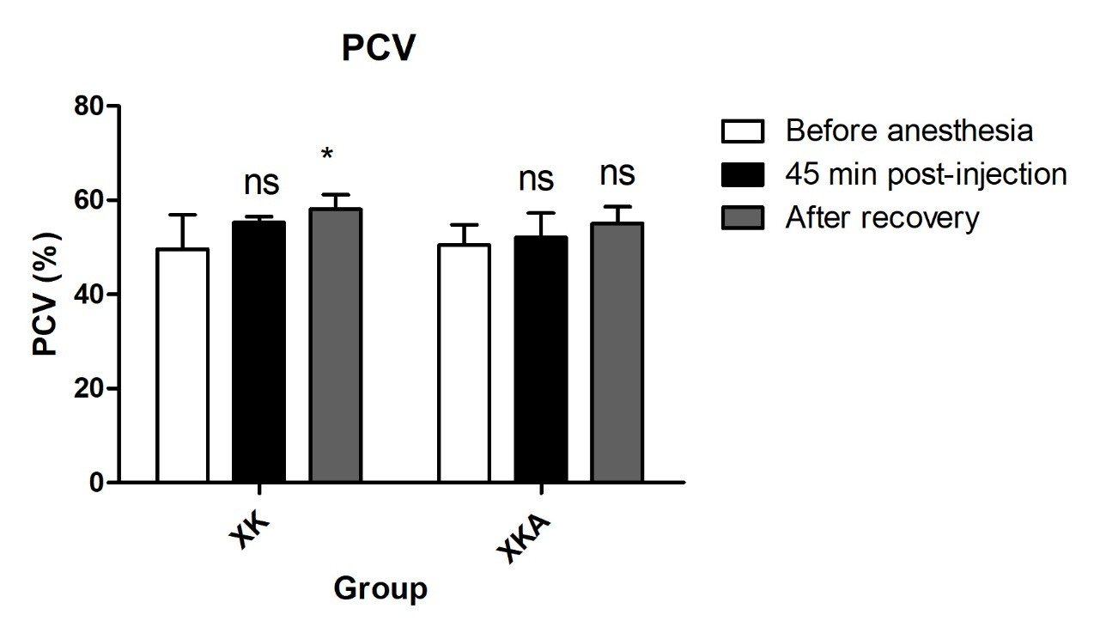
Figure 8. Comparison of PCV (%) between XK and XKA groups before and after induction of anesthesia. The data from two groups were analyzed using the compare means feature in IBM SPSS Statistics for Windows (IBM Corp., NY, USA) via One-way ANOVA test. All of the results are expressed as the mean ± SD. * indicates P ≤ 0.05 and ** indicates P ≤ 0.01. A P value of ≤ 0.05 between the two groups was considered significant.
Table 5 shows, before anesthesia, the RBS levels were 2.01±0.04 and 2.52±0.48 in group-XK and XKA respectively. After 45min, the RBS levels were decreased at 1.72±0.13 (P ≤ 0.01) and 1.65±0.10 (P ≤ 0.01) respectively. The RBS levels were 1.82±0.13 (P ≤ 0.05) and 1.76±0.27 (P ≤ 0.01) in group-XK and XKA respectively after recovery.
Table 5. Comparison of RBS (mmol/L) before and after induction of anesthesia
Group | Before anesthesia | 45min post-injection | After recovery
XK | 2.01±0 .04 | 1.72± 0.13** | 1.82±0.13*
XKA | 2.52±0. .48 | 1.65± 0.10** | 1.76±0.27**
Table 6 shows, before anesthesia, the cortisol levels were 3.98±0.19 and 3.89±0.16 in control and treatment group respectively. After 45min, the levels of cortisol were increased at 5.072±0.07 (P ≤ 0.01) and 5.79±0.35 (P ≤ 0.01) in group XK and XKA respectively. After recovery condition of rabbits, the levels of cortisol were 5.9±0.31(P ≤ 0.01) and 6.0±0.49 (P ≤ 0.01) in group XK and XKA respectively.
Table 6. Comparison of Cortisol(µg/dl) before and after induction of anesthesia
Group | Before Anesthesia | 45min post-injection | After Recovery
XK | 3.93±0.18 | 5.07±0.07** | 5.90±0.31**
XKA | 4.01±0.19 | 5.79±0.35** | 6.0±0.49**
Effects of anesthesia on male sex hormones in rabbits
Table 7 shows, during the normal condition of rabbits, the testosterone levels were 0.38±0.06 and 0.32±0.06 in group-XK and XKA respectively. After 45min, the levels of testosterone were increased at 1.74±0.85 (P ≤ 0.01) and 0.56±0.10 (P ≤ 0.01) in the control and target group respectively. After recovery, the levels of testosterone were 0.70±0.56 and 0.6±0.08 (P ≤ 0.01) in the respective groups.
Table 7. Comparison Testosterone (pg/ml) before and after induction of anesthesia
Group | Before Anesthesia | 45min post-injection | After Recovery
XK | 0.38±0.06 | 1.74±0.85** | 0.70±0.56^{ns}
XKA | 0.32±0.06 | 0.56±0.10** | 0.60±0.08**
Reflex monitored during the experiments
The depth of anesthesia was monitored by using of various reflexes. The palpebral reflex, corneal reflex and pedal reflexes were present in both groups at 05 min of anesthesia. In deep anesthetic periods at 15 min the pedal reflex becomes sluggish and almost absent within the period of anesthesia extended up to 20 to 25 min. The reflexes were become normal at recovery stage.
Observation of defecation, urination, salivation and lacrimation during the experiments
In this study there was no salivation and lacrimation in both groups. Defecation was observed in group XKA and urination were observed in group XK.
Observation of healing
On the second day, heat and swelling were observed at the site in the control group. On that day, few swellings were observed in the rabbits of the target group. On the third day, there was no heat at the site, and the swelling had decreased compared to the previous day in both groups. On the seventh day, healing was good in both groups (Supplementary figure 4).
Complications
There was no complication occurred such as- hemorrhage, infection, dehiscence, adhesions, stress-anxiety etc.
DISCUSSION
The present study was conducted to evaluate the effect of atipamezole on recovery of the rabbits from xylazine–ketamine induced anesthesia during neutering in male rabbits, with particular emphasis on recovery characteristics, physiological responses and blood parameters. Xylazine–ketamine is a commonly used anesthetic combination in rabbits; however, its use is often associated with prolonged recovery, cardiovascular depression and metabolic disturbances (Flecknell, 2020) [6]. The findings of the present study indicate that atipamezole significantly improves recovery quality and facilitates normalization of altered physiological and hematological parameters.
In the present study, rabbits treated with atipamezole showed significantly shorter recovery times compared to those recovering without a reversal agent. Time to regain righting reflex, sternal recumbency and standing was markedly reduced following atipamezole administration. Similar findings have been reported in rabbits and other laboratory animals, where atipamezole effectively reversed α₂-agonist induced sedation and hastened recovery (Bruniges & Yates, 2023) [7].
Xylazine produces sedation and muscle relaxation through stimulation of central α₂-adrenergic receptors, leading to suppression of sympathetic nervous activity (Grubb et al., 2020) [8].
Atipamezole, a selective α₂-adrenergic antagonist, competitively blocks these receptors, thereby reversing the sedative and cardiovascular effects of xylazine (Virtanen et al., 1988) [9]. Although ketamine is not directly antagonized, reversal of the xylazine component is sufficient to restore consciousness and mobility, as previously described by Hedenqvist et al., 2013 [10]. Rapid recovery is particularly advantageous in rabbits, which are highly sensitive to prolonged anesthesia and post-anesthetic stress. Delayed recovery may predispose rabbits to hypothermia, gastrointestinal stasis and respiratory compromise (Oglesbee & Lord, 2020) [11].
Xylazine–ketamine anesthesia in the present study caused a decrease in heart rate, respiratory rate and rectal temperature during the anesthetic period. These findings are consistent with earlier studies reporting bradycardia, respiratory depression and hypothermia following xylazine administration in rabbits (Gadelrab et al., 2025)[12]. Following administration of atipamezole, physiological parameters improved significantly and gradually returned toward baseline values. The increase in heart rate and respiratory rate observed during recovery can be attributed to restoration of sympathetic tone after α₂-receptor blockade (Madirazza et al., 2022)[13]. Similar improvements in cardiopulmonary function following atipamezole administration have been documented in rabbits and other species (Karin et al., 2006)[14].
Normalization of rectal temperature after reversal may be associated with increased muscular activity and metabolic rate during recovery. Hypothermia is a common complication of rabbit anesthesia, and faster recovery contributes to reduced heat loss and improved thermoregulation (Flecknell, 2020) [6].
The present study revealed differences in hematological parameters before and after administration of xylazine–ketamine anesthesia. In case of group XKA, a reduction in hemoglobin concentration, WBC, platelet, neutrophils, lymphocytes, monocytes, eosinophils, basophils, packed cell volume (PCV), RBC, MCV, MCH, MCHC, RDW, RBS was observed before and after anesthesia.
Similar reductions have been attributed to splenic sequestration of erythrocytes and hemodilution caused by peripheral vasodilation and altered vascular dynamics during anesthesia (Grover & Loegering, 1982; Green, 1981) [15,16].
Total leukocyte count and differential leukocyte values exhibited mild fluctuations, likely due to stress-induced endocrine responses. Surgical stress and anesthesia stimulate the release of corticosteroids and catecholamines, which influence leukocyte distribution, often resulting in neutrophilia and lymphopenia (Walther et al., 2024; Burdine, 2002) [17,18].
In case of group XK, Differences were also observed before and after application of the anesthetic agents. A reduction in hemoglobin concentration, WBC, platelet, lymphocytes, monocytes, eosinophils, basophils, packed cell volume (PCV), RBC, MCV, MCH, MCHC, RDW, RBS was observed before and after anesthesia. However, neutrophils, monocytes, eosinophils, basophils, packed cell volume (PCV), testosterone and cortisol levels increased after administration of the anesthetic agents.
Following administration of atipamezole, hematological parameters gradually returned toward pre-anesthetic values. Restoration of normal vascular tone and splenic contraction following α₂-antagonism may have facilitated redistribution of erythrocytes into the peripheral circulation (Talke et al., 2000; Vähä‐Vahe, 1990) [19,20]. These findings agree with previous reports demonstrating improved hematological stability following reversal of α₂-agonist effects (Ali, 2013) [21].
Xylazine–ketamine anesthesia resulted in a transient increase in blood glucose levels in the present study. Testosterone and cortisol levels were also increased after administration of the anesthetic agents.
This hyperglycemic effect is well documented and is primarily due to xylazine-induced inhibition of insulin secretion and increased hepatic glucose production (Khokhlova et al., 2022; Mohammed et al.,2012) [22,23]. Mild elevations in serum ALT and AST observed after anesthesia may reflect temporary hepatic stress or reduced hepatic perfusion rather than direct hepatocellular damage. Similar transient increases in liver enzyme activities following anesthesia have been reported in rabbits and other laboratory animals (Afaf et al., 2024; Oh et al., 2020) [24,25]. Minor fluctuations in serum urea and creatinine levels may be related to altered renal blood flow during anesthesia (Green, 1981; Saran et al., 2025) [16,26]. Anesthesia and surgical stress are known to influence endocrine function, including testosterone secretion. Injectable anesthetic agents such as xylazine–ketamine activate the hypothalamic–pituitary–adrenal (HPA) axis, resulting in increased secretion of stress hormones, particularly cortisol. Elevated cortisol levels can suppress the hypothalamic–pituitary–gonadal (HPG) axis, leading to alterations in luteinizing hormone (LH) release and subsequent changes in circulating testosterone concentrations.
Several studies have reported transient fluctuations in testosterone levels following anesthesia, which may include a short-term increase due to acute stress response, followed by a decline during the recovery phase (Meyer, 2017) [27]. These changes are generally temporary and depend on the type of anesthetic agent, duration of anesthesia, and intensity of surgical stress.
Neutering (orchiectomy) results in a marked and permanent reduction in testosterone levels due to removal of the testes, the primary source of androgen production. Following neutering, serum testosterone levels decline rapidly, leading to suppression of sexual behavior, reduced aggression, and decreased urine spraying in male rabbits (Nishiyama, 2014) [28].
The reduction in testosterone after neutering is considered beneficial for animal welfare and is one of the primary physiological outcomes evaluated in studies involving male rabbit castration (Rayner et al., 2025) [29].
Anesthesia, particularly injectable anesthetic protocols involving α₂-adrenergic agonists such as xylazine or medetomidine, induces activation of the hypothalamic–pituitary–adrenal (HPA) axis. Surgical stress and tissue manipulation during procedures like neutering further stimulate the release of corticotropin-releasing hormone (CRH) and adrenocorticotropic hormone (ACTH), resulting in elevated circulating cortisol levels (Ivascu et al., 2024; Cusack & Buggy, 2020) [30,31].
Several studies have demonstrated a significant increase in serum cortisol levels following xylazine–ketamine anesthesia, which is attributed to combined effects of anaesthetic stress, surgical trauma, and altered neuroendocrine regulation (Ali, 2013) [21].
Elevated cortisol levels during and after anesthesia reflect the intensity of stress experienced by the animal.
Neutering is a surgical intervention that induces acute stress, leading to a transient rise in cortisol levels in male rabbits. Increased cortisol concentrations observed immediately after neutering indicate activation of the stress response system. However, these elevations are generally short-lived and decline as recovery progresses and pain is adequately managed (Pieper et al., 2025) [32].
Surgical procedures such as neutering activate the hypothalamic–pituitary–adrenal (HPA) axis, leading to increased secretion of cortisol and catecholamines. These stress hormones promote gluconeogenesis and reduce peripheral glucose uptake, resulting in elevated RBS levels during the perioperative period (Rayner et al., 2025) [29].
Administration of atipamezole facilitated faster normalization of biochemical parameters, including blood glucose and liver enzyme levels. Restoration of sympathetic activity improves tissue perfusion and metabolic balance, contributing to recovery of normal biochemical profiles (Flecknell, 2020) [6].
The findings of the present study highlight the clinical benefits of using atipamezole as a reversal agent in xylazine–ketamine anesthesia protocols for rabbits. Faster recovery, improved physiological stability and normalization of blood parameters reduce post-anesthetic complications and enhance animal welfare. These advantages are particularly important during routine surgical procedures such as neutering, where rapid and smooth recovery is desirable (Ali, 2013) [21]. Proper timing and dosage of atipamezole are essential to avoid premature arousal during surgery. When administered after completion of the procedure, atipamezole appears to be safe and effective in rabbits (Green, 1981) [16].
CONCLUSION
The present study demonstrates that the xylazine–ketamine anesthetic protocol, followed by reversal with atipamezole, provides a safe, effective, and reversible anesthetic regimen for rabbits undergoing neutering surgery. Xylazine–ketamine produced adequate surgical anesthesia with predictable physiological alterations, while atipamezole effectively facilitated recovery by antagonizing alpha-2 adrenergic effects.
Hematological changes observed during anesthesia were transient and primarily associated with stress-related leukocyte redistribution and mild erythrocyte alterations, with no evidence of clinically significant compromise. The partial normalization of leukocyte profiles following atipamezole administration confirms its efficacy in reversing xylazine-induced immunomodulatory effects. Red blood cell indices showed minimal immediate response to reversal, indicating limited short-term influence of alpha-2 antagonism on erythrocyte parameters.
Biochemical parameters, including random blood glucose, remained within normal physiological limits throughout the study, reflecting metabolic stability during anesthesia and recovery. Endocrine evaluation revealed suppression of cortisol and testosterone concentrations during anesthesia, followed by partial restoration after atipamezole administration, highlighting the reversible neuroendocrine effects of alpha-2 agonists.
Overall, the findings support the use of xylazine–ketamine anesthesia with atipamezole reversal as a reliable protocol for rabbit neutering, offering adequate surgical depth, smooth recovery, and minimal adverse physiological effects. This protocol is particularly advantageous in both experimental and clinical settings where rapid recovery and improved animal welfare are priorities.
ACKNOWLEDGMENTS
The authors would like to acknowledge all the participants who directly or indirectly helped in the data collection process of this study.
Funding
The author(s) received no specific funding for this work.
AUTHOR CONTRIBUTIONS
ACR and SA designed outlines and drafted the manuscript. SA, MSR, SHL, CRD and AH performed the experiments and ACR and SA analyzed the data. SA and ACR wrote the initial draft of the manuscript. ACR, BP, SR and SA reviewed the scientific contents described in the manuscript. All authors read and approved the final submitted version of the manuscript.
CONFLICTS OF INTEREST
There is no conflict of interest among the authors.
SUPPLEMENTARY MATERIALS
Supplementary figure 1. The drugs used in the experiment; Supplementary figure 2. Preoperative preparation of the rabbits; Supplementary figure 3. Recording the clinical parameters and the procedure of blood collection; Supplementary figure 4. Healing condition day by day and Supplementary figure 5. Comparison of Eosinophils (%) between XK and XKA groups before and after induction of anesthesia.
REFERENCES
- Afaf, H., Fatma, A., Abdalrheem, A., Abdulwahhab, A., & Salah, A.A. (2024). Immediate Effects of anesthesia agents on liver function. Alq J Med App Sci, 26, 88-93.
- Ali, A.F. (2013). Evaluation of midazolam and ketamine preceding by xylazine as general anesthesia in rabbits. Iraqi J Vet Med, 37(2), 144-148.
- Bruniges, N., & Yates, D. (2020). Effects of atipamezole dosage and timing of administration on recovery time and quality in cats following injectable anaesthesia incorporating ketamine. J Feline Med Surg, 22(6), 589-597.
- Burdine, J.M. (2002). Complication rates of scalene regional anesthesia. J Bone Joint Surg Am. 84(10), 1891-1893.
- Coulter, C.A., Flecknell, P.A., Leach, M.C., & Richardson, C.A. (2011). Reported analgesic administration to rabbits undergoing experimental surgical procedures. BMC Vet Res, 21(7),12.
- Cusack, B,, & Buggy, D.J. (2020). Anaesthesia, analgesia, and the surgical stress response. BJA Educ, 20(9), 321-328.
- Flecknell, P. (2023). Laboratory Animal Anaesthesia: Anesthesia and Analgesia in Laboratory Animals. Academic Press: Amsterdam, Netherlands.
- Gadelrab, M., El-Sherif, M., Atiya, M., Senosy, W., S Salem, M., & Abdelkawi, M. (2025). Physiological effects of a pre-anesthetic single dose of gabapentin on Xylazine/Ketamine anesthesia in rabbits. BMC Vet Res, 21(1), 703.
- Green, C.J. (1981). Anaesthetic gases and health risks to laboratory personnel: a review. Lab Anim, 15(4), 397-403.
- Grover, G.J., & Loegering, D.J. (1982). Effect of splenic sequestration of erythrocytes on splenic clearance function and susceptibility to septic peritonitis. Infect Immun, 36(1), 96-102.
- Grubb, T., & Lobprise, H. (2020). Local and regional anaesthesia in dogs and cats: Overview of concepts and drugs (Part 1). Vet Med Sci, 6(2), 209-217.
- Hassan, M.A., Abdalla, M.A., Saber, M.S., Waleed, A., Nassif, M.W., & Elsherif M. (2024). Evaluation of xylazine ketamine anesthesia in rabbits undergoing tendon surgery: A prospective randomized controlled study. NVVJ, 4(1), 2786-0272.
- Hedenqvist, P., Edner, A., Fahlman, Å., & Jensen-Waern M. (2013). Continuous intravenous anaesthesia with sufentanil and midazolam in medetomidine premedicated New Zealand white rabbits. BMC Vet Res, 28(9), 21.
- Irwin, M.R., Curay, C.M., Choi, S., & Kiyatkin, E.A. (2023). Basic physiological effects of ketamine-xylazine mixture as a general anesthetic preparation for rodent surgeries. Brain Res, 1804, 148251.
- Ivascu, R., Torsin, L.I., Hostiuc, L., Nitipir, C., Corneci, D., & Dutu, M. (2024). The surgical stress response and anesthesia: A narrative review. J Clin Med, 13(10), 3017.
- Karin, S., & Kalchofner, S.K. (2006). Clinical assessment of anesthesia with isoflurane and medetomidine in 300 equidae. Pferdeheilkunde, 22(3), 301-308.
- Khokhlova, O.N., Borozdina, N.A. Sadovnikova, E.S., Pakhomova, I.A., Rudenko, P.A., Korolkova, Y.V., Kozlov, S.A., & Dyachenko, I.A. (2022). Comparative study of the aftereffect of CO2 inhalation or tiletamine–zolazepam–xylazine anesthesia on laboratory outbred rats and mice. Biomedicines, 10(2), 512.
- Madirazza, K., Pecotic, R., Pavlinac, D.I., Valic, M., & Dogas, Z. (2022). Blockade of alpha2-adrenergic receptors in the caudal raphe region enhances the renal sympathetic nerve activity response to acute intermittent hypercapnia in rats. Physiol Res, 71(1), 159-169.
- Meyer, G.E. (2017). Captive management of wild impala (Aepyceros Melampus) during intensive immobilization and general anesthesia study trials. J Zoo Wildl Med, 48(4), 1058-1071.
- Mohammed, A.A., Abdelnabi, M., & Modliński, J.A. (2012). Evaluation of anesthesia and reproductive performance upon diazepam and xylazine injection in rats. Anim. Sci. Pap. Rep, 30(3), 285-292.
- Nishiyama, T. (2014). Serum testosterone levels after medical or surgical androgen deprivation: a comprehensive review of the literature. Urol Oncol, 32(1), 38.e17-28.
- Oglesbee, B.L., & Lord B. (2020). Gastrointestinal Diseases of Rabbits. Ferrets, Rabbits, and Rodents, 29, 174–187.
- Oh, S.K., Lim, B.G., Kim, Y.S., & Kim, S.S. (2020). Comparison of the postoperative liver function between total intravenous anesthesia and inhalation anesthesia in patients with preoperatively elevated liver transaminase levels: A retrospective Cohort study. Ther Clin Risk Manag, 16, 223-232.
- Pennasilico, L., Serino, F., Galosi, M., Piccionello, A.P., Angorini, A., Dini, F., & Bella, C.D. (2025). Anesthetic effects of a mixture of xylazine, ketamine, and buprenorphine in laboratory rats subjected to short surgical procedures. Open Vet J, 15(3), 1370-1378.
- Pieper, E.G., Carter, J.E., Firestone, S.M., & Baron, H.R. (2025). A review of perioperative mortality in pet rabbits in Australia. Aust Vet J, 103(1-2), 3-12.
- Raillard, M., Detotto, C., Grepper, S., Beslac, O., Fujioka-Kobayashi, M., Schaller, B., & Saulacic, N. (2019). Anaesthetic and Perioperative Management of 14 Male New Zealand White Rabbits for Calvarial Bone Surgery. Animals, 9(11), 896.
- Rayner, E.L., Kumar, A., Airikkala-Otter, I., Sequeira, S., Mellanby, R., Gibson, A.D., Gamble, L., & Mazeri, S. (2025). Evaluation of the longer-term impacts on working practices of veterinarians in India after attending a canine surgical neutering training programme. Anim Welf, 34, e32.
- Saran, S., Kharat, A., Reddy, G.H.V., Madhavan, B., Bhattacharjee, A., Thomas, M.P. (2025). Anaesthesia challenges in patients with chronic kidney disease: A clinical approach from internal medicine. Cureus, 17(9), e91694.
- Talke, P.O., Traber, D.L. Richardson, C.A., Harper, D.D., & Traber, L.D. (2000). The effect of alpha (2) agonist-induced sedation and its reversal with an alpha (2) antagonist on organ blood flow in sheep. Anesth Analg, 90(5), 1060-6.
- Vähä‐Vahe, A.T. (1990). The clinical effectiveness of atipamezole as a medetomidine antagonist in the dog. J Vet Pharmacol Ther, 13(2), 198-205.
- Virtanen, R., Savola, J.M., Saano, V., & Nyman, L. (1988). Characterization of the selectivity, specificity and potency of medetomidine as an alpha 2-adrenoceptor agonist. Eur J Pharmacol, 150(1-2), 9-14.
- Walther, L.M., Gideon, A., Sauter, C., Leist, M., & Wirtz, P.H. (2024). Peripheral blood leukocyte subpopulation changes in reaction to an acute psychosocial stressor as compared to an active placebo-stressor in healthy young males: mediating effects of major stress-reactive endocrine parameters. Cells, 13(23), 1941.

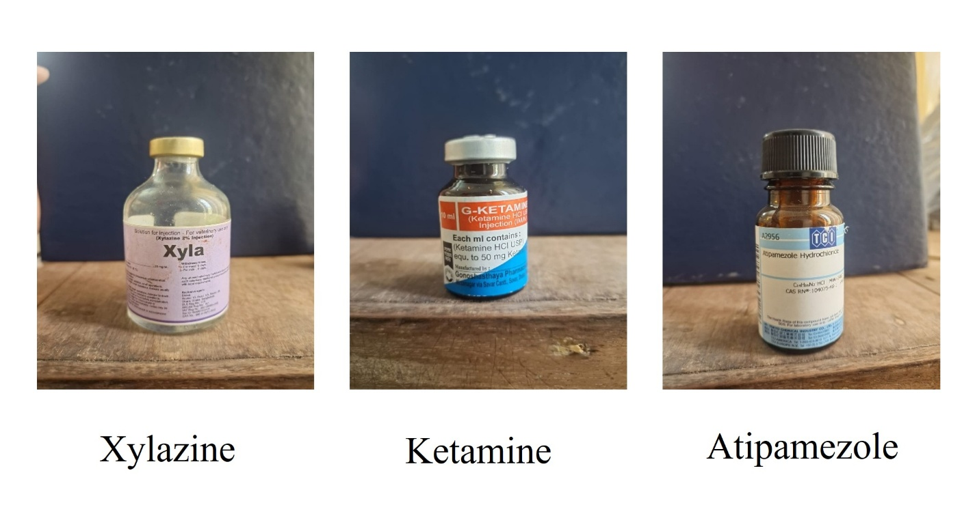
Supplementary figure 1. The drugs used in the experiment. Xylazine Hcl and ketamine Hcl were used for anesthesia of rabbits and atipamezole was used to observe the effect on the recovery of the rabbits.
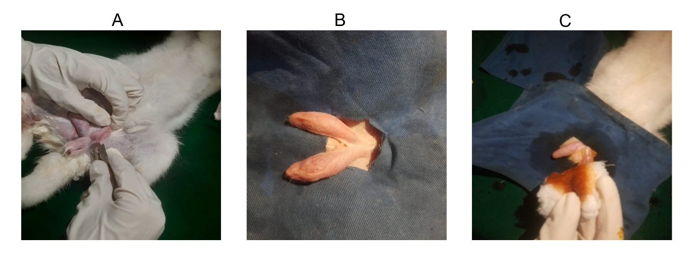
Supplementary figure 2. Preoperative preparation of the rabbits. A) Shaving the site of operation, B) Draping the rabbits and C) site preparation with povidone iodine.

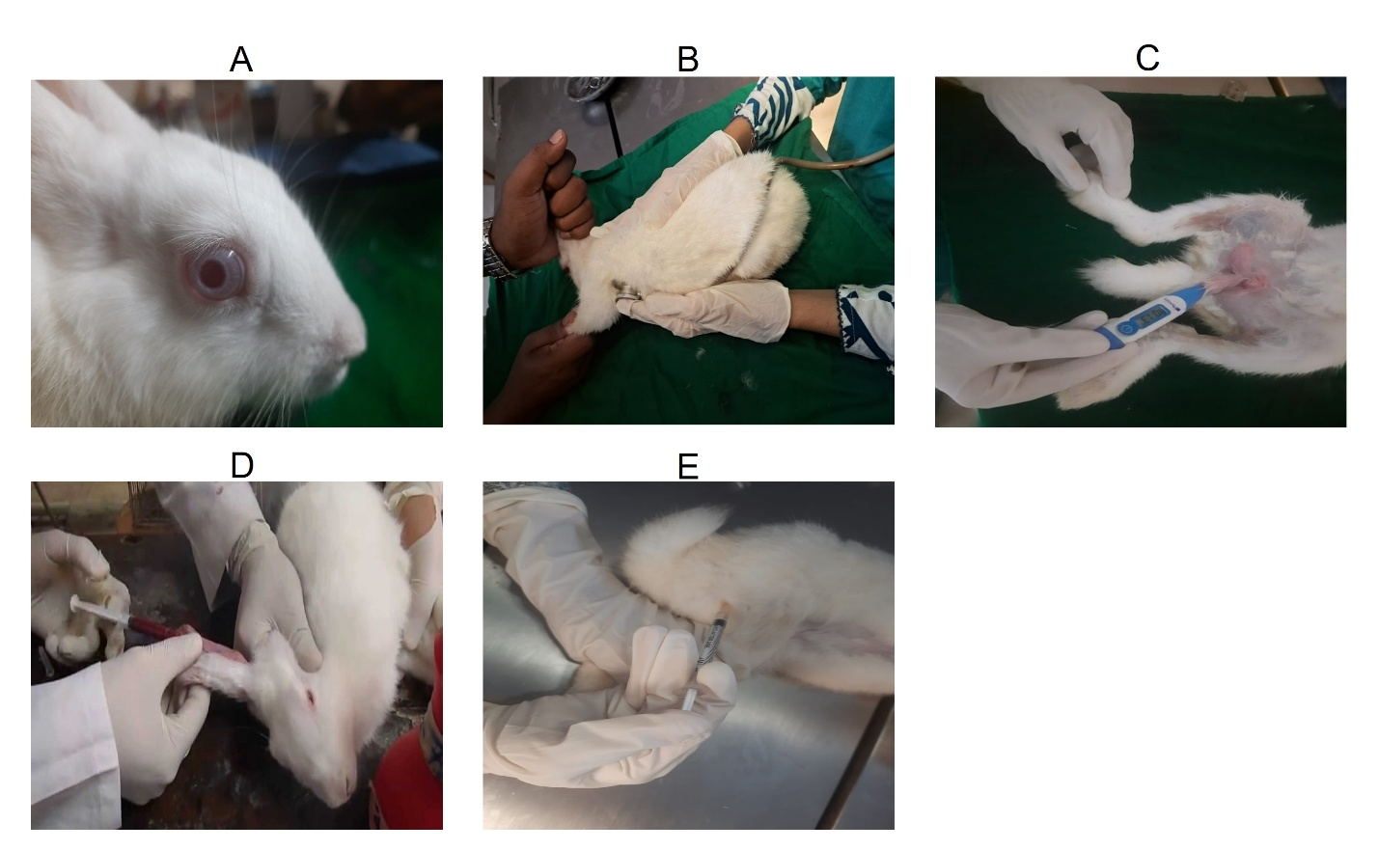
Supplementary figure 3. Recording the clinical parameters and the procedure of blood collection. A) a healthy male rabbit, B) Recording of heart rate by using stethoscope, C) Recording the rectal temperature using the digital thermometer, D) Collection of blood from the ear vein and E) Injection of anesthetic agent intramuscularly.

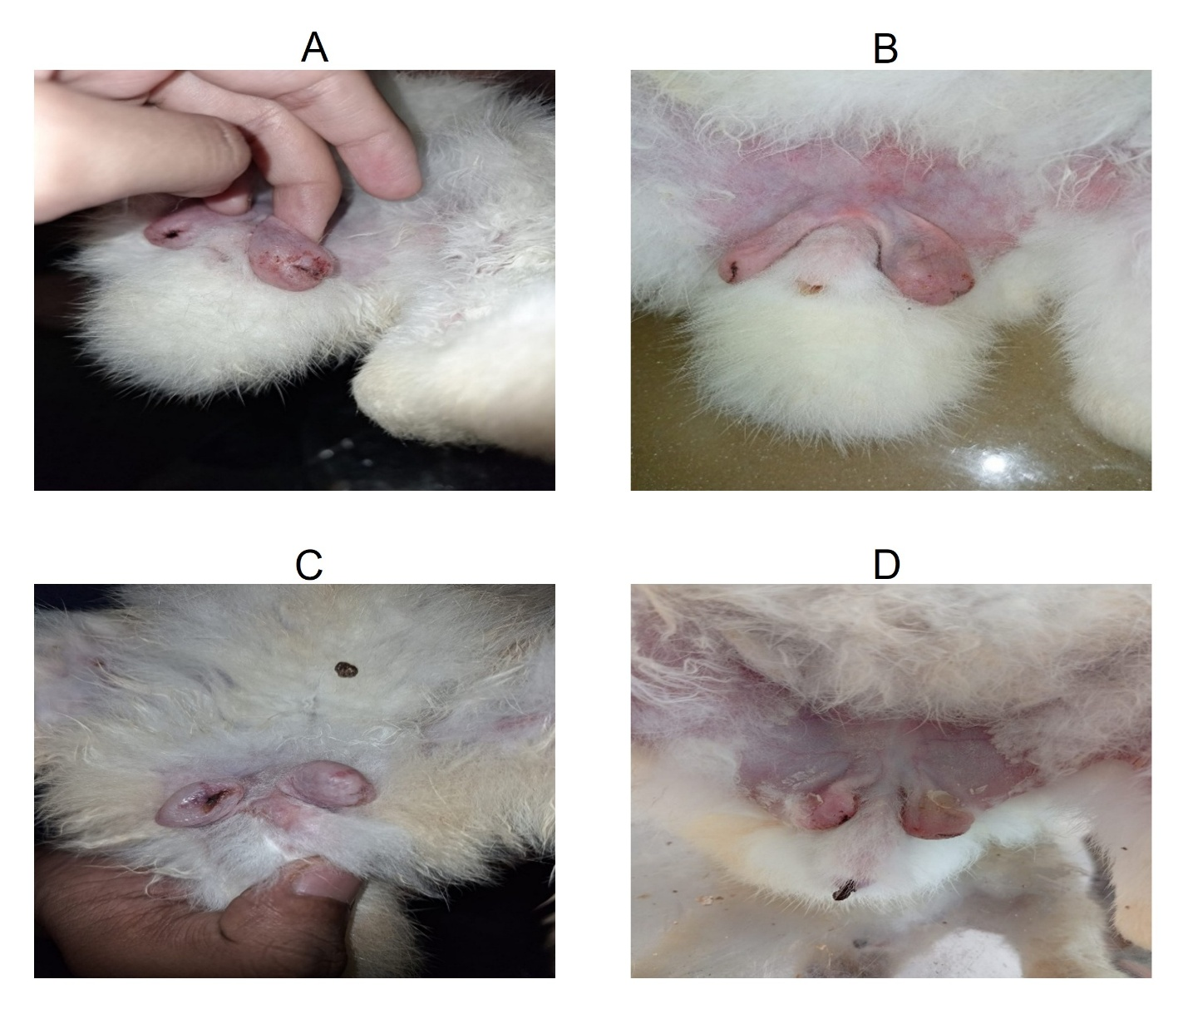
Supplementary figure 4. Healing condition day by day. A) Healing status on 1st day, B) Healing status on 3rd day, C) Healing status on 5th day and D) Healing status on 7th day.
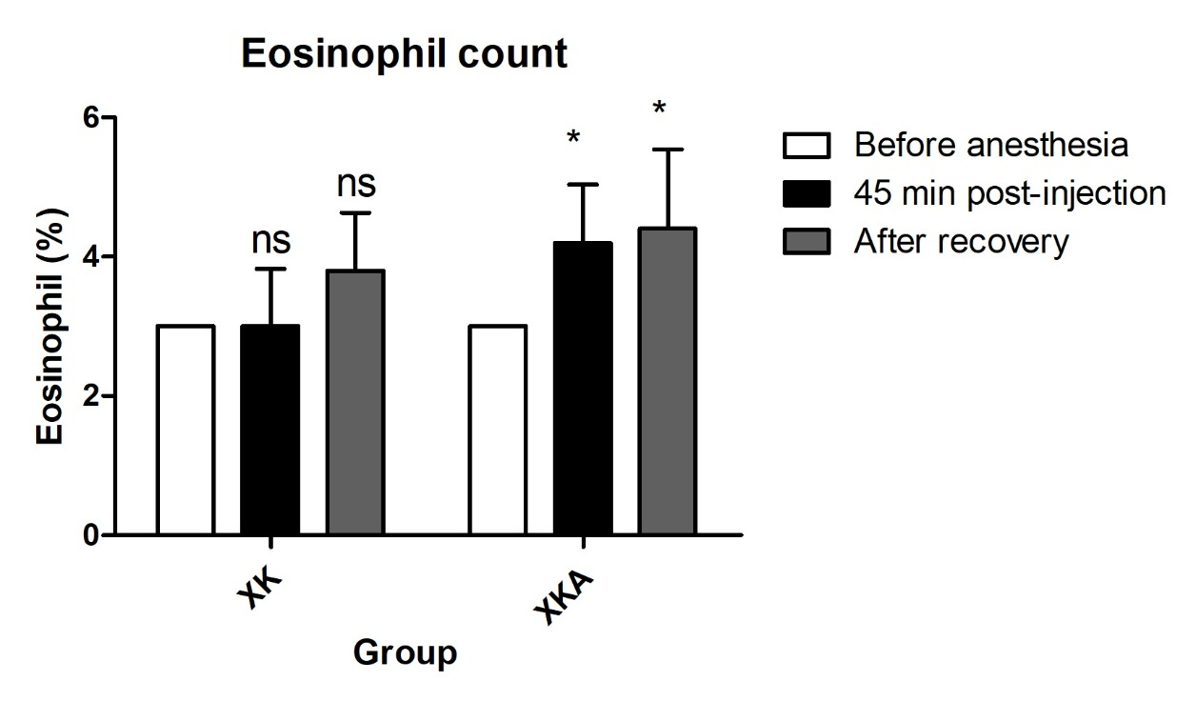
Supplementary figure 5. Comparison of Eosinophils (%) between XK and XKA groups before and after induction of anesthesia. The data from two groups were analyzed using the compare means feature in IBM SPSS Statistics for Windows (IBM Corp., NY, USA) via One-way ANOVA test. All of the results are expressed as the mean ± SD. * indicates P ≤ 0.05 and ** indicates P ≤ 0.01. A P value of ≤ 0.05 between the two groups was considered significant.

