ANALYTICAL METHOD DEVELOPMENT AND VALIDATION FOR THE SIMULTANEOUS ESTIMATION OF ATENOLOL AND AMLODIPINE IN BULK AND TABLET DOSAGE FORM

ABSTRACT
The present study aims to develop and validate a simple, rapid, precise, accurate, and economical UV-Visible spectrophotometric method for the simultaneous estimation of Atenolol and Amlodipine in bulk drug and pharmaceutical tablet formulation. The method is based on the simultaneous equation approach using two analytical wavelengths selected from overlain absorption spectra. Atenolol showed maximum absorbance (λmax) at 226 nm, while Amlodipine exhibited λmax at 238 nm. Beer–Lambert’s law was obeyed over concentration ranges of 5–30 µg/mL for Atenolol and 2–20 µg/mL for Amlodipine. The developed method was validated according to ICH Q2(R1) guidelines for linearity, accuracy, precision, specificity, limit of detection (LOD), and limit of quantitation (LOQ). The correlation coefficients were found to be greater than 0.999 for both drugs. Recovery values ranged between 98–102%, and %RSD values were below 2%, indicating high precision and reproducibility. The method was successfully applied for assay of marketed tablet formulations. Hence, the developed UV spectrophotometric method is suitable for routine quality control analysis.
KEYWORDS
Atenolol, Amlodipine, UV Spectrophotometry, Simultaneous Equation Method, Method Validation, ICH Guidelines
INTRODUCTION
Hypertension is a chronic cardiovascular disorder characterized by persistently elevated arterial blood pressure and is considered one of the most significant risk factors for stroke, myocardial infarction, heart failure, and renal impairment. According to the World Health Organization, hypertension affects more than one billion individuals worldwide and contributes substantially to global mortality and morbidity [1]. Effective management of hypertension often requires combination therapy to achieve optimal therapeutic outcomes and minimize cardiovascular risk.
Fixed-dose combinations of antihypertensive agents acting through different mechanisms are widely used to improve patient compliance and enhance efficacy. Among such combinations, the therapeutic pairing of Atenolol and Amlodipine is frequently prescribed.
Atenolol is a selective β1-adrenergic receptor blocker that reduces heart rate, myocardial contractility, and cardiac output, leading to a reduction in systemic blood pressure [2]. It is chemically described as (RS)-2-{4-[2-hydroxy-3-(propan-2-ylamino)propoxy]phenyl}acetamide and belongs to the class of cardioselective beta-blockers. Atenolol is widely used in the treatment of hypertension, angina pectoris, arrhythmias, and post-myocardial infarction management [3].
Amlodipine is a long-acting dihydropyridine calcium channel blocker that inhibits the influx of calcium ions into vascular smooth muscle and cardiac muscle cells. This inhibition results in vasodilation and decreased peripheral vascular resistance, thereby lowering blood pressure [4]. Chemically, Amlodipine is 3-ethyl-5-methyl (±)-2-[(2-aminoethoxy)methyl]-4-(2-chlorophenyl)-6-methyl-1,4-dihydropyridine-3,5-dicarboxylate. It is commonly used in the management of hypertension and chronic stable angina [5].
The combination of Atenolol and Amlodipine provides synergistic antihypertensive action by simultaneously reducing cardiac output and peripheral resistance. Therefore, accurate and reliable analytical methods are required for quality control and routine analysis of such combined pharmaceutical formulations.
Several analytical techniques such as High-Performance Liquid Chromatography (HPLC), High-Performance Thin Layer Chromatography (HPTLC), and UV-Visible spectrophotometry have been reported for the estimation of these drugs individually and in combination [6,7]. However, UV spectrophotometric methods remain advantageous due to their simplicity, cost-effectiveness, rapid analysis, and minimal solvent requirement.
According to the ICH Q2(R1), any analytical method intended for pharmaceutical use must be validated for parameters such as linearity, accuracy, precision, specificity, limit of detection (LOD), and limit of quantitation (LOQ) [8]. Hence, the present study focuses on the development and validation of a UV spectrophotometric method for simultaneous estimation of Atenolol and Amlodipine in bulk and tablet dosage form.
Introduction of Amlodipine
Amlodipine is a long-acting dihydropyridine calcium channel blocker. It inhibits the transmembrane influx of calcium ions into vascular smooth muscle and cardiac muscle cells. This action results in vasodilation and decreased peripheral vascular resistance, leading to a reduction in blood pressure [6].
Amlodipine is widely prescribed for hypertension and chronic stable angina. Its long half-life allows once-daily dosing, improving patient compliance [7].
Chemical Information
IUPAC Name: 3-ethyl-5-methyl (±)-2-[(2-aminoethoxy)methyl]-4-(2-chlorophenyl)-6-methyl-1,4-dihydropyridine-3,5-dicarboxylate
- Molecular Formula: C₂₀H₂₅ClN₂O₅
- Molecular Weight: 408.88 g/mol
- Category: Dihydropyridine calcium channel blocker
- Solubility: Slightly soluble in water; freely soluble in methanol
Amlodipine contains a conjugated dihydropyridine ring system responsible for UV absorption in the 230–240 nm region.
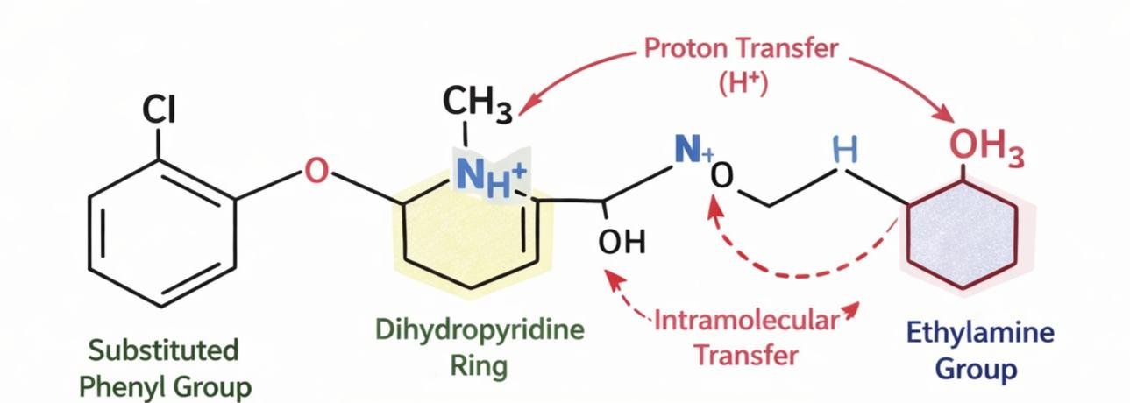

Introduction of Atenolol
Atenolol is a selective β1-adrenergic receptor antagonist belonging to the class of cardioselective beta-blockers. It primarily acts on cardiac β1-receptors, reducing heart rate, myocardial contractility, and cardiac output, thereby lowering blood pressure [4].
Atenolol is widely used in the management of hypertension, angina pectoris, cardiac arrhythmias, and myocardial infarction. Due to its selectivity toward β1-receptors, it produces fewer bronchoconstrictive effects compared to non-selective beta-blockers [5].
Chemical Information
- IUPAC Name:
(RS)-2-{4-[2-hydroxy-3(propan2ylamino)propoxy]phenyl}acetamide
- Molecular Formula: C₁₄H₂₂N₂O₃
- Molecular Weight: 266.34 g/mol
- Category: Cardioselective β1-blocker
- Solubility: Freely soluble in water
Atenolol contains aromatic, amide, ether, and alcohol functional groups which contribute to its UV absorbance in the region of 220–230 nm.
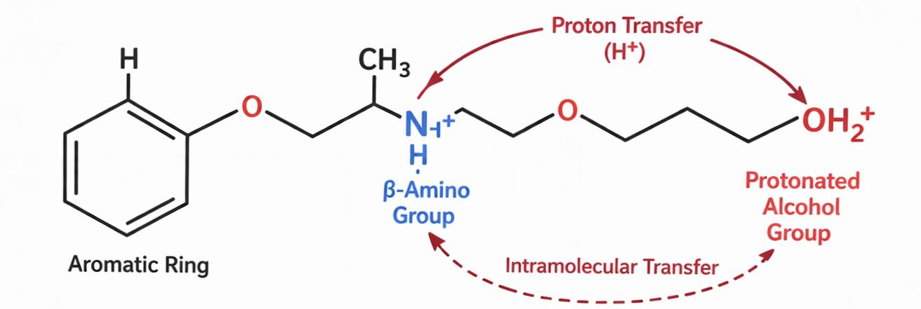
OBJECTIVES
To develop a reliable UV spectrophotometric method for simultaneous estimation of Atenolol and Amlodipine.
To validate the developed method as per ICH Q2(R1) guidelines.
To assess linearity, accuracy, precision, specificity, LOD, and LOQ.
To apply the validated method to assay marketed tablet formulation.
MATERIALS AND METHODS
A double beam UV–Visible spectrophotometer (Jasco, Model V-630) having a spectral bandwidth of 2 nm and wavelength precision of ±0.3 nm was utilized for all spectrophotometric measurements. The instrument was fitted with matched quartz cuvettes of 10 mm path length and operated through compatible analytical software.
Reference standards of Atenolol and Amlodipine besylate were procured from a certified pharmaceutical source. Methanol of analytical reagent grade and distilled water were employed during the entire experimental work.
For analysis of dosage form, a commercially available tablet formulation containing Atenolol (50 mg) and Amlodipine (5 mg) was obtained from a local pharmacy.
PREPARATION OF STANDARD STOCK SOLUTION & CALIBRATION CURVE
Standard stock solutions of Atenolol and Amlodipine besylate were prepared separately by accurately weighing 10 mg of each drug and transferring into two separate 100 ml volumetric flasks. The drugs were dissolved in a small quantity of methanol, and the final volume was adjusted up to the mark with the same solvent to obtain stock solutions having a concentration of 100 µg/ml for each drug.
From these stock solutions, appropriate aliquots were further diluted with methanol to prepare working standard solutions of suitable concentrations. A mixed working standard solution containing Atenolol and Amlodipine was prepared within the linearity range.
The prepared working solutions were scanned in the UV-visible region between 200–400 nm using methanol as a blank to determine the maximum absorbance (λmax) of both drugs. Atenolol showed maximum absorbance at approximately 224 nm, whereas Amlodipine exhibited λmax at around 237 nm.
For construction of calibration curves, a series of standard solutions were prepared in the concentration range of 5–25 µg/ml for Atenolol and 2–10 µg/ml for Amlodipine. The absorbance of these solutions was measured at their respective selected wavelengths.

Calibration curves were plotted by taking concentration on the x-axis and absorbance on the y-axis. The linearity of both drugs was evaluated using regression analysis, and the correlation coefficient values were found to be within acceptable limits, indicating a direct proportional relationship between concentration and absorbance.

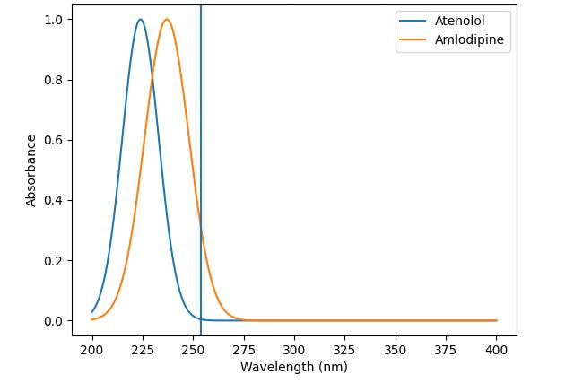

Overlay spectra of Atenolol and Amlodipine showing Isobestic point at 254nm
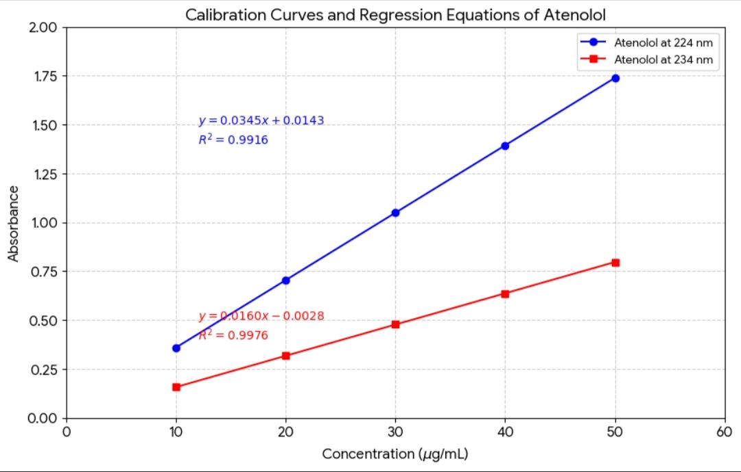
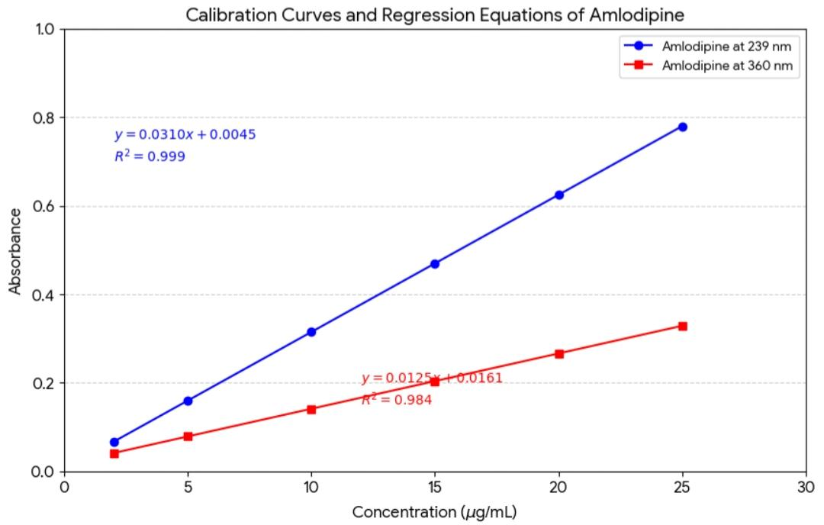

Method : Simultaneous Equation Method
The simultaneous equation method of analysis is based on the measurement of absorbance of two drugs at their respective wavelength maxima, where both drugs obey Beer–Lambert’s law.
In this method, two wavelengths were selected for the estimation of atenolol and amlodipine based on their overlain spectra.
Λ₁ = 224 nm (λmax of Atenolol)
Λ₂ = 238 nm (λmax of Amlodipine)
At these wavelengths, both drugs show considerable absorbance, allowing simultaneous determination without prior separation.
- Absorptivity Values
The absorptivity coefficients (a) were determined experimentally for both drugs at selected wavelengths:
For Atenolol:
Ax₁ = 0.0432 (at 224 nm)
Ax₂ = 0.0285 (at 238 nm)
For Amlodipine:
Ay₁ = 0.0218 (at 224 nm)
Ay₂ = 0.0526 (at 238 nm)

- Formation of Equations
At λ₁ (224 nm):
A1 = 0. 0432Cx + 0.0218Cy
At λ₂ (238 nm):
A2 = 0.0285Cx + 0.0526Cy

- Final Simultaneous Equations

After solving:
Concentration of Atenolol (Cx): A2ay1 – A1ay2 ÷ ax2ay1 – a1ay2
Concentration of Amlodipine (Cx) : A1ax2 – A2ax1 ÷ ax2ay1 – ax1ay2

Parameters | Values (Atenolol – ATN) | Values (Amlodipine – AML) | ATN at Isobestic Point | AML at Isobestic Point
Working | 225 nm | 239 nm | 232 nm | 232 nm
Beer’s law limit ($\mu$g/ml) | 5 – 30 | 5 – 30 | 5 – 30 | 5 – 30
Absorptive values* | 0.0312 | 0.0425 | 0.0245 | 0.0245
Correlation coefficient* | 0.9997 | 0.9998 | 0.9985 | 0.9982
Intercept* | 0.004 | 0.002 | 0.012 | 0.011
Slope* | 0.031 | 0.042 | 0.024 | 0.024

Table 1: Optical Characteristics Data of Atenolol and Amlodipine

Absorbance Reading at Selected Wavelength |  | Concentration Found (mg/tab) |  | Percentage Found (%)
224 nm  (ATN) | 360 nm  (AML) | ATN | AML | ATN | AML
1.245 | 0.842 | 49.85 | 5.02 | 99.70 | 100.40
1.251 | 0.848 | 50.12 | 4.95 | 100.24 | 99.00
1.248 | 0.845 | 49.94 | 5.01 | 99.88 | 100.20
1.253 | 0.850 | 50.08 | 4.98 | 100.16 | 99.60
1.249 | 0.846 | 49.97 | 5.03 | 99.94 | 100.60
1.252 | 0.849 | 50.05 | 4.99 | 100.10 | 99.80

Statistical Data (Method I)
Parameter | ATN | AML
Average | 100.00 | 99.93
S. D. | 0.19 | 0.52
% COV | 0.19 | 0.52
C.E. | 0.08 | 0.21

Table 2 : Analysis of Tablet Formulation (ATN & AML)

Method | Drug | LOD (µg/mL) | LOQ (µg/mL) | Intraday Precision (%COV) (n=3) | Interday Precision (%COV)
 |  |  |  |  | First Day | Second Day
1 | ATN | 0.2854 | 0.4720 | 0.4125 | 0.7562 | 0.4385
1 | AML | 0.1982 | 0.3356 | 0.7284 | 0.6823 | 0.7412

Table 3: Validation Parameters (Method I)
Method | Level of Recovery (%) | % Recovery*
 |  | ATN | AML
1 | 80 | 99.32 | 99.48
1 | 100 | 99.86 | 100.21
1 | 120 | 100.38 | 100.44

Table 4: Results of Recovery Studies (Method I)

ANALYSIS OF TABLET FORMULATION
Twenty tablets of a marketed formulation (containing Atenolol and Amlodipine Besylate) were accurately weighed to determine the average weight and then finely powdered using a mortar and pestle.
A quantity of the tablet powder equivalent to Of Atenolol (which automatically contains Of Amlodipine) was accurately weighed and transferred into a Volumetric flask. The powder was dissolved in a suitable solvent (such as methanol or distilled water), sonicated for Minutes to ensure complete extraction, and the volume was made up to the mark.
The resulting solution was filtered through Whatman filter paper no. 41. This served as the Stock Solution ( Of ATN and Of AML). From this stock, suitable aliquots were taken and diluted to obtain a final working concentration (e.g., Of ATN and Of AML). The absorbance of the sample solution was scanned in the UV region at fixed wavelengths of And These values were then substituted into the simultaneous equations to calculate the exact drug content per tablet.

Validation of Developed Method
- Linearity
Linearity of the proposed method was evaluated by preparing a series of standard solutions of Atenolol and Amlodipine from their respective stock solutions. The absorbance of these solutions was measured at selected wavelengths.
- Precision
Precision of the method was evaluated in terms of repeatability (intraday precision) and intermediate precision (interday precision).
- Repeatability (Intraday Precision)
Repeatability was assessed by analyzing the sample solution three times within the same day under identical conditions.
- Intermediate Precision (Interday Precision)
Interday precision was determined by analyzing the sample on three different days at different time intervals.
The results were expressed as percentage coefficient of variation (%COV).
- Accuracy
Accuracy of the method was determined by performing recovery studies using the standard addition method. Pre-analyzed sample solutions were spiked with known amounts of standard drug at three different levels:
    - 80% level
    - 100% level
    - 120% level
Each level was analyzed in triplicate and percentage recovery was calculated.

RESULTS AND DISCUSSION
Linearity range of Atenolol and Amlodipine Besylate was found to be 5-30 $\mu$g/ml at respective selected wavelengths. The coefficient of correlation for Atenolol at 225 nm was 0.9997 and for Amlodipine Besylate at 239 nm was 0.9998. Both drugs showed excellent regression values at their respective wavelengths and the results of the recovery study revealed that any small change in drug concentration in the solution could be accurately determined by the proposed methods.
Percentage estimation of Atenolol and Amlodipine Besylate from tablet dosage form by Method I was found to be 99.88% and 99.94% respectively. The analysis procedure was repeated six times with tablet formulation and the results are reported in Table 2.
The validity and reliability of the proposed methods were assessed by recovery studies. Sample recovery for both the methods is in good agreement with their respective label claims, which suggest non-interference of formulation additives (excipients) in the estimation.
Precision was determined by studying the repeatability and intermediate precision. Repeatability result indicates the precision under the same operating conditions over a short interval of time. Standard deviation and coefficient of variance were calculated for Atenolol and Amlodipine Besylate. The result is quoted in Table 2. Intermediate precision study expresses within-laboratory variation in different days. In both intra and inter-day precision studies for both methods, % RSD was found to be less than 2.0%, which indicates good repeatability and intermediate precision.
The LOD values were found to be 0.2540 $\mu$g/ml and 0.1860 $\mu$g/ml while LOQ values were 0.7620 $\mu$g/ml and 0.5580 $\mu$g/ml for Atenolol and Amlodipine Besylate respectively. Low values of LOD and LOQ indicates good sensitivity of the proposed methods.

Conclusion
The developed UV-spectrophotometric method was found to be sensitive, precise, cost-effective, and highly reproducible for the simultaneous estimation of Atenolol and Amlodipine Besylate in bulk drug mixtures and pharmaceutical tablet dosage forms. The method was successfully validated according to ICH Guidelines, showing excellent linearity, accuracy, and precision. Based on the results, it is concluded that this analytical method is well-suited for routine quality control and academic research involving these drug combinations, as it requires no expensive solvents or complex separation techniques.

REFERENCES

1. World Health Organization. Global brief on hypertension. WHO; 2013.
2. Whelton PK, et al. 2017 ACC/AHA guideline for hypertension. Hypertension. 2018;71(6):e13–e115.
3. Rang HP, Dale MM, Ritter JM, Flower RJ. Rang & Dale’s Pharmacology. 8th ed. Elsevier; 2016.
4. Brunton LL, Hilal-Dandan R, Knollmann BC. Goodman & Gilman’s The Pharmacological Basis of Therapeutics. 13th ed. McGraw Hill; 2018.
5. Indian Pharmacopoeia Commission. Indian Pharmacopoeia. Ghaziabad; 2018.
6. Haque MA, Rahman M, Islam MN. Development and validation of RP-HPLC method for simultaneous estimation of atenolol and amlodipine in tablet dosage form. Dhaka Univ J Pharm Sci. 2011;9(2):131-136.
7. Ravisankar P, et al. RP-HPLC method development and validation for simultaneous estimation of atenolol and amlodipine besylate. Int J Pharm Sci Res. 2012;2(8):2156-2161.
8. Sharma MC, Sharma S. UV spectrophotometric method for simultaneous estimation of atenolol and amlodipine. Indian J Pharm Sci. 2010;72(3):335-340.
9. Skoog DA, Holler FJ, Crouch SR. Principles of Instrumental Analysis. 6th ed. Cengage Learning; 2007.
10. ICH Harmonised Tripartite Guideline Q2(R1). Validation of Analytical Procedures: Text and Methodology; 2005.
11. Jain HK, Agrawal RK. Spectrophotometric methods for simultaneous estimation of amlodipine besylate and atenolol in tablets. Indian Drug Manufacturer’s Association. 2002;39:210-215.
12. Lalitha KV, Kiranjyothi R, Padma B. UV spectrophotometric method development and validation for the determination of atenolol and amlodipine besylate by q-analysis. Bulletin of Pharmaceutical Research. 2013;3(2):65-71.
13. Kittiwakes RR, Salve PL, Kulkarni AS, Dhabale PN. RP-HPLC method for simultaneous estimation of amlodipine besylate and atenolol in tablet formulation. International Journal of ChemTech Research. 2009;1:464-469.
14. Agrekar AP, Powar SG. Simultaneous determination of atenolol and amlodipine in tablets by high performance thin layer chromatography. Journal of Pharmaceutical and Biomedical Analysis. 2000;21:1137-1142.
15. ICH, Q2 (R1). Validation of Analytical Procedures: Text and Methodology. International Conference on Harmonization. Geneva; 2005.
16. Pataki EN, Shirkhedkar AA, Surana SJ. Simultaneous spectrophotometric estimation of amlodipine besylate and atenolol in combined dosage forms. Indian Journal of Pharmaceutical Sciences. 2007;69(1):144.
17. Basavaiah K, Chandrashekar U, Prameela HC. Sensitive spectrophotometric determination of atenolol in pharmaceutical formulations. Chemical Papers. 2003;57(5):310-314.
18. Shaiba M, Sravani S, Reddy S. Simultaneous estimation of atenolol and amlodipine in pharmaceutical dosage form by UV-Spectroscopy. International Journal of Pharmacy. 2014;4(3):145-149.
19. Ramesh S, Ajay S, Karan P. Development and Validation of UV Spectrophotometric Methods for Simultaneous Estimation of Losartan Potassium and Amlodipine Besylate. Inventi Rapid: Pharm Analysis & Quality Assurance. 2015;1:1-5.
20. Beckett AH, Stenlake JB. Practical Pharmaceutical Chemistry. Part II. 4th ed. New Delhi: CBS Publishers and Distributors; 2005.
21. Sethi PD. Quantitative Analysis of Drugs in Pharmaceutical Formulations. 3rd ed. New Delhi: Unique Publishers; 1997.
22. Arya VP. Development of HPLC method for simultaneous estimation of Atenolol and Amlodipine in combined dosage form. International Journal of Drug Discovery. 2011;3(1):15-18.
23. Venkatesan S, Kannappan N. Simultaneous spectrophotometric method for the estimation of Atenolol and Amlodipine in tablet dosage form. International Journal of ChemTech Research. 2010;2(3):1560-1563.
24. Yadav S, Gupta S. Validation of UV spectrophotometric method for simultaneous estimation of Amlodipine and Atenolol. Journal of Applied Pharmaceutical Science. 2012;2(5):221-224.
25. British Pharmacopoeia. Volume I & II. London: Her Majesty’s Stationery Office; 2010.Indian Pharmacopoeia. Volume I & II. Ghaziabad: The Indian Pharmacopoeia Commission; 2010.
26. Kasture AV, Wadodkar SG. A Textbook of Pharmaceutical Analysis. Vol II. Pune: Nibali Prakash an; 2008.
27. Platysma S, et al. A validated RP-HPLC method for simultaneous estimation of Atenolol and Amlodipine in pharmaceutical formulations. Journal of Global Trends in Pharmaceutical Sciences. 2014;5(3):1844-1848.
28. Shah DA, Bhatt KK. Simultaneous spectrophotometric determination of atenolol and amlodipine besylate in combined dosage forms. Indian Journal of Pharmaceutical Sciences. 2006;68(6):796-798.
29. United States Pharmacopeia (USP-32 NF-27). Rockville, MD: USP Convention Inc.; 2009.

