Asymptotics for Backlog Probabilities in a Bidimensional Caseload Model with Randomly Delayed Cases in Kenya’s Magistrates’ Court

HIGHLIGHTS
- First bidimensional surplus model for criminal–civil judicial backlog with randomly delayed proceedings.
- Civil adjournments exceed 365 days in 1.18% of matters; criminal in 0.07%; Hill tail indices confirm ${\hat{α}}_{\text{civil}}=2.08$, ${\hat{α}}_{\text{criminal}}=4.48$.
- Explicit asymptotic constant $C_{κ}$ derived: $ϕ_{κ}(x_{κ})∼C_{κ}x_{κ}^{-α_{κ}}$; both estimates satisfy $α_{κ}>1$.
- Tail heaviness dominates risk: unit shift in $α_{D}$ outweighs doubling capacity by factor of 180.
- Findings inform dynamic judicial resource allocation and backlog mitigation.

ABSTRACT
Persistent case backlogs in Kenya’s Magistrates’ Courts undermined timely access to justice, with these courts handling over 79% of pending cases nationwide. Criminal cases resolved with a median duration of 275 days, yet civil cases persisted for a median of 631 days, with adjournments exceeding 365 days occurring in 1.18% of civil matters compared to 0.07% of criminal matters, a disparity that average-based performance metrics failed to capture. This study developed a bidimensional stochastic surplus model to analyse backlog dynamics by jointly incorporating criminal and civil case streams with randomly delayed proceedings. Drawing on actuarial risk theory, the research extended the Cramér–Lundberg framework to a bidimensional context, integrating Poisson case arrivals, heavy-tailed distributions for workload complexity, and stochastic adjournment delays. Backlog probabilities, joint (simultaneous congestion across streams) and marginal (congestion in at least one stream), were derived using asymptotic analysis and large deviations theory. Distributional fitting confirmed heavier-than-exponential tail behavior in adjournment durations (${\hat{α}}_{\text{civil}}=2.08$, ${\hat{α}}_{\text{criminal}}=4.48$), with both estimates satisfying $α_{κ}>1$, validating the polynomial decay result $ϕ_{κ}(x_{κ})∼C_{κ}⋅x_{κ}^{-α_{κ}}$ as an operative empirical estimate for the civil stream and a stress-testing benchmark for the criminal stream. Scenario-based simulations revealed a clear hierarchy of risk drivers: the tail index of adjournment durations was the dominant influence, with a shift from $α_{D}=3.5$ to $α_{D}=1.8$ increasing marginal backlog probability by 1,678%, far exceeding the effect of doubling processing capacity ($-9.3\%$) or more than doubling arrival intensity ($+13.9\%$). These findings established that effective backlog mitigation required prioritising adjournment control over demand management or capacity expansion alone, providing evidence-based tools for identifying congestion thresholds, optimising resource allocation, and informing backlog reduction strategies through dynamic capacity allocation, targeted adjournment reform, and scenario-based stress testing.
Keywords: Judicial Backlog, Bidimensional Surplus Model, Heavy-Tailed Distributions, Large Deviations Theory, Asymptotic Analysis.

INTRODUCTION
The efficient administration of justice is a foundational requirement for upholding the rule of law and sustaining public confidence in legal institutions. However, judicial systems globally are plagued by persistent backlogs that erode timely access to justice (Melcarne, Ramello, and Spruk 2021). In the Kenyan context, the Magistrates’ Courts bear the primary burden of the national caseload; as of the financial year 2023/24, these courts accounted for over 79% of unresolved matters, totalling approximately 470,558 pending cases (SOJAR 2024). Such delays create uncertainty for litigants and strain institutional capacity, highlighting the need for robust analytical frameworks to understand and mitigate backlog formation. While traditional performance metrics focus on average disposition times, they fail to account for the stochastic volatility inherent in judicial proceedings, where a few “mega-cases” and extreme adjournments disproportionately drive systemic congestion.
Empirical studies demonstrate that case durations rarely follow the memoryless assumptions underlying classical Poisson or exponential queueing models (Mukherjee 2018; Barabási 2005). Instead, most cases are resolved relatively quickly, while a minority experience extreme delays, reflecting moderately heavy-tailed or bursty dynamics driven by clustered adjournments, procedural rework, administrative bottlenecks, and resource constraints (Mukherjee 2018; Oghenekevwe 2021). International evidence from Australia, Canada, and asylum tribunals further confirms that judicial delays exhibit right-skewed, long-tailed distributions that standard average-based models fail to capture (Thorburn 2017). Within Africa, judicial systems in Nigeria and South Africa show comparable stochastic delay patterns, often intensified by staffing shortages, procedural inefficiencies, and resource limitations.
Kenyan Magistrates’ Courts display similar moderately heavy-tailed and bursty behavior, consistent with both regional and global observations, indicating that rare but extreme delays disproportionately influence systemic congestion. In Kenya, the interplay of witness unavailability, interlocutory applications, and administrative bottlenecks creates “bursty” dynamics. From an actuarial perspective, these are analogous to claims with “reporting lags” or Incurred But Not Yet Adjudicated (IBNYA) losses in insurance risk management. Standard average-based models are insufficient to capture these extreme tail events, necessitating a transition toward surplus-type stochastic processes with empirically calibrated tail behavior.
Recent analyses using survival and stochastic-process models on Kenyan High Court data confirm that non-exponential distributions provide a superior representation of case-duration data compared to classical Poisson or exponential assumptions (Kandie, Atitwa, and Nyaluke 2025). These findings complement earlier studies by (Makau 2014) and (Mulwa 2020), which identify key administrative drivers of backlog, including staffing constraints, magistrate transfers, and resource limitations, as primary contributors to systemic volatility. Together, these empirical realities underscore the necessity of the probabilistic framework proposed in this study.
These dynamics are naturally modeled using moderately heavy-tailed distributions and delayed-claim structures, successfully applied in insurance risk and reinsurance modeling (Embrechts, Klüppelberg, and Mikosch 1997; Foss, Korshunov, and Zachary 2013). However, the application of such frameworks to African judicial systems, where adjournment dynamics and resource constraints create ruin-type vulnerabilities, remains nascent.
This research transposes large deviations theory and asymptotic probability techniques to the judicial domain, providing a quantitative foundation for evaluating systemic vulnerabilities. The specific objectives are to:
- Develop a bidimensional caseload surplus model, $U(t)$, integrating criminal and civil case streams under stochastic random delay.
- Derive asymptotic backlog probabilities using empirically validated tail indices (${\hat{α}}_{\text{civil}}=2.08$, ${\hat{α}}_{\text{criminal}}=4.48$) estimated via the Hill estimator.
- Evaluate the sensitivity of backlog formation to case arrival intensity ($λ_{κ}$), productivity growth ($r$), and adjournment tail behavior.
The significance of this study is twofold. Practically, it supports judicial administrators through a “solvency-based” approach to resource allocation. Theoretically, it extends surplus modeling to the judicial domain, offering a novel methodology for assessing institutional resilience.

STRUCTURE OF THE PAPER
This paper is organised into five sections. Section 2 reviews theoretical and empirical literature on judicial delays and stochastic modeling. Section 3 presents the bidimensional surplus model with delayed claims, including model specification, assumptions, distributional choices, and the mapping of actuarial concepts to judicial backlog dynamics. Section 4 presents empirical results and derives asymptotic backlog probabilities using large deviations theory, with simulation results under various scenarios. Section 5 translates findings into policy recommendations and concludes the study, summarising contributions, acknowledging limitations, and suggesting directions for future research.

LITERATURE REVIEW
Actuarial risk theory provides the foundational framework for this study, specifically through models incorporating randomly delayed claims. Originally developed by (Waters and Papatriandafylou 1985) and extended by (Yuen, Guo, and Ng 2001), these models capture delayed claims in discrete and continuous-time settings; subsequent enhancements by (Yuen, Guo, and Wu 2005) and (Xiao, Yuen, and Zhang 2007) introduced flexible delay distributions under independence assumptions. This study adapts the framework to the judicial context, where primary case filings analogise main claims and adjournments represent delayed claims. Judicial backlog is formalised through a surplus process in which inflows are filed cases, outflows are concluded cases, and “ruin” occurs when workload exceeds capacity (Asmussen and Albrecher 2010). The bidimensional extension accounts for the simultaneous processing of criminal and civil matters as interdependent surplus processes: congestion in one stream withdraws capacity from the other, an interaction effect invisible to two independent unidimensional analyses but central to the present framework. This structure is motivated by (Li 2013), who proposed random delayed-claim multiplicities in unidimensional settings, and by (H. Yang, Geng, and Wang 2014), (F. Lu and Yuan 2015), and (Zhang and Wang 2016), who extended multivariate surplus models to incorporate joint dependencies.
Heavy-tailed and subexponential distributions are essential for capturing low-frequency, high-impact events such as extreme adjournments (Ganesh and Torrisi 2016; Jiang 2009). Models incorporating dependent main and delayed claims provide conceptual parallels to cascading adjournments and backlog accumulation (Y. Yang, Wang, and Zhang 2021; Shen, Yao, and Zhang 2024). Finite-time ruin probabilities (Xu, Wang, and Wu 2024; Gao, Zhuang, and Huang 2014) inform short-term congestion assessment, while large deviations theory strengthens modelling of rare systemic delays: (Da and She 2022) established a Large Deviation Principle for systems with multiplicative noise, directly relevant to abrupt caseload spikes. Bidimensional risk models with dependent claims (D. Lu and Yuan 2022; Yuan, Jiang, and Xiao 2024; Shen, Yao, and Zhang 2024) capture interactions between case types, and renewal risk theory accommodates seasonal variation and non-stationary arrivals (Fu and Li 2015).
Empirically, deterministic models consistently underperform stochastic alternatives for judicial delay modelling (Niemeijer and Spruit 2012; Vermeulen 2014). Case disposition times exhibit heavy-tailed distributions in which few cases experience extreme delays (Mukherjee 2018), consistent with bursty human dynamics (Barabási 2005) and right-skewed processing times documented across Australian (Thorburn 2017) and European (Melcarne, Ramello, and Spruk 2021) jurisdictions. Kenyan evidence aligns with these patterns. Persistent backlogs are documented in State of the Judiciary Reports (SOJAR 2024); repeated adjournments cumulatively increase delay likelihood (Okoth and Muli 2018); seasonal and long-memory effects shape backlog trends (Gichuhi 2019); and court utilisation above 90% has been recorded in specialised Employment and Labour Relations Court (Gindicha 2025). Structural contributors include inadequate staffing (Makau 2014), procedural inefficiencies (Gikonyo 2019), and judicial officer turnover (Mulwa 2020). External shocks demonstrated further vulnerability: case resolutions plummeted by nearly 40% during COVID-19, from 469,359 to 289,728 in a single financial year (M. Marang’a, Kimalu, and Ochieng 2021). Judicial congestion also has broader macroeconomic effects, deterring private investment (M. W. Marang’a, Ouma, and Kosimbei 2018).
Several gaps motivate this study. While actuarial surplus models with delayed claims are well-developed in insurance, their application to judicial systems remains unexplored. Bidimensional extensions capturing criminal–civil interdependencies have not been empirically calibrated to court data, and asymptotic estimates for extreme backlog probabilities under heavy-tailed delays have not been derived for judicial contexts. This study addresses these gaps by integrating bidimensional delayed-claim surplus theory with empirical evidence from Kenya’s Magistrates’ Courts.

METHODOLOGY

Stochastic Modelling Framework

Extended Cramér–Lundberg Framework for Judicial Backlog Analysis
This study employs a continuous-time stochastic analytical approach to model judicial backlog dynamics. The court system was conceptualised as an extended Cramér–Lundberg (CL) surplus process, traditionally used in actuarial science to evaluate insurer solvency (Lundberg 1903; Cramér 1930; Asmussen 2003). In this adaptation, the “surplus” $U(t)$ represents the net balance between institutional adjudication capacity and cumulative workload. The classical CL model is defined as:
$$U(t)=u+ct-\sum_{i=1}^{N(t)}{X_{i}}$$
where $u$ is the initial capacity, $c$ is the adjudication rate, $N(t)$ is a Poisson arrival process of cases, and $X_{i}$ represents the stochastic workload of each case. Systemic backlog, analogous to “ruin”, occurs when $U(t)<0$.
In this judicial reinterpretation: Surplus is the balance between effective processing capacity and accumulated workload; Claims are incoming cases consuming judicial resources; Premium inflow is adjudication capacity from judges, courtrooms, and sitting days; and Ruin represents periods of severe congestion during which cases cannot be resolved within acceptable timelines.

Bidimensional Backlog Surplus Model with Randomly Delayed Cases
To capture the structural realities of Kenya’s Magistrates’ Courts, the classical Cram’er–Lundberg framework is extended to a bidimensional structure distinguishing criminal ($κ=1$) and civil ($κ=2$) case streams. While procedurally distinct, both streams compete for a shared pool of judicial resources, creating interdependencies in backlog accumulation. This formulation accounts for three critical features: interaction effects between streams; workload heterogeneity; and the heavy-tailed behavior typical of resource-intensive cases. Adjournments and follow-up proceedings are modeled as secondary workloads that materialize after stochastic time lags $D_{ij}^{(κ)}$. These "delayed claims" explicitly account for deferred judicial effort and compounding delay effects. The bidimensional backlog surplus process is formulated as:
$$U_{κ}(t)=x_{κ}+\int_{0}^{t}{e^{r(t-s)}}C_{κ}(ds)-\left[\sum_{i=1}^{N_{κ}(t)}{X_{i}^{(κ)}}+\sum_{i=1}^{N_{κ}(t)}{\sum_{j=1}^{M_{i}^{(κ)}}{Y_{ij}^{(κ)}}}1\{τ_{i}^{(κ)}+D_{ij}^{(κ)}≤t\}\right]$$
where $x_{κ}$ is the initial backlog; $C_{κ}(ds)$ is the judicial capacity allocated over $[s,s+ds)$; $N_{κ}(t)$ is a Poisson process with intensity $λ_{κ}$ governing case arrivals at times $τ_{i}^{(κ)}$; $X_{i}^{(κ)}$ is the immediate workload; and $M_{i}^{(κ)}$ denotes the number of delayed proceedings (geometrically distributed with parameter $p_{κ}$) with associated workloads $Y_{ij}^{(κ)}$.
The indicator $1\{τ_{i}^{(κ)}+D_{ij}^{(κ)}≤t\}$ ensures delayed workloads contribute only upon realisation. The factor $e^{r(t-s)}$ represents institutional urgency ($r>0$) rather than financial discounting; it reflects the increasing pressure of unresolved cases driven by statutory and constitutional timelines. This exponential weight assigns higher effective value to capacity deployed closer to the evaluation horizon $t$, capturing the compounding social and institutional cost of delayed justice.

Model and Distributional Assumptions
Assumption 1 (Case Arrivals and Arrival Times). For each stream $κ∈\{1,2\}$, cases arrive according to a homogeneous Poisson process $N_{κ}(t)$ with constant intensity $λ_{κ}>0$. The successive arrival times satisfy $0<τ_{1}^{(κ)}<τ_{2}^{(κ)}<⋯$ almost surely, with i.i.d. inter-arrival gaps $∼Exp(λ_{κ})$, independent of all workload and delay sequences. The two streams are driven by independent Poisson processes.
Assumption 2 (Main Case Workload). The workload $X_{i}^{(κ)}$ of the $i$-th newly filed case in stream $κ$ follows a moderately heavy-tailed distribution from one of three candidate families: $Pareto(α_{κ})$, $Log\text{-}Normal(μ_{κ},σ_{κ})$, or $Weibull(k_{κ},λ_{κ}^{X})$, reflecting heterogeneity in case complexity and judicial effort.
Assumption 3 (Number of Delayed Proceedings). The number of delayed proceedings associated with case $i$ in stream $κ$, denoted $M_{i}^{(κ)}$, follows a geometric distribution with parameter $p_{κ}∈(0,1)$, whereby each successive hearing has a fixed probability of being the last.
Assumption 4 (Delay Times). The delay duration $D_{ij}^{(κ)}$ follows either an $Exp(μ_{κ}^{D})$ distribution, capturing memoryless postponement, or a $Log\text{-}Normal(μ_{κ}^{D},σ_{κ}^{D})$ distribution, capturing persistent and skewed adjournment patterns.
Assumption 5 (Delayed Workload). The workload $Y_{ij}^{(κ)}$ generated by the $j$-th delayed proceeding follows a heavy-tailed distribution from Assumption 2. $Pareto(α_{κ}^{Y})$, $Log\text{-}Normal(μ_{κ}^{Y},σ_{κ}^{Y})$, or $Weibull(k_{κ}^{Y},λ_{κ}^{Y})$.
Assumption 6 (Independence). The sequences $\{X_{i}^{(κ)}\}$, $\{M_{i}^{(κ)}\}$, $\{Y_{ij}^{(κ)}\}$, and $\{D_{ij}^{(κ)}\}$ are mutually independent within each stream and independent across streams $κ∈\{1,2\}$, with the exception of specified dependence structures for sensitivity analysis.
Remark 7. Under Assumption 6, the joint and marginal backlog probabilities factorise as:
$$\begin{aligned}ϕ_{\text{joint}}(x_{1},x_{2},T)&=ψ_{1}(x_{1},T)⋅ψ_{2}(x_{2},T) \\ ϕ_{\text{marg}}(x_{1},x_{2},T)&=1-(1-ψ_{1}(x_{1},T))(1-ψ_{2}(x_{2},T))\end{aligned}$$
where $ψ_{κ}(x_{κ},T)=P(\inf_{t≤T}U_{κ}(t)<0∣U_{κ}(0)=x_{κ})$. This factorisation is used in Section 4.5 to compute joint congestion probabilities from stream-specific simulation outputs.
These assumptions jointly support both finite-sample estimation and asymptotic analysis of backlog probabilities. The regular variation conditions in Assumption 2 and 5 are the key structural requirements underpinning the polynomial decay result derived in Section 4, namely $ϕ_{κ}(x_{κ})∼C_{κ}⋅x_{κ}^{-α_{κ}}$ as $x_{κ}→∞$. The geometric multiplicity in Assumption 3 ensures that the total delayed workload per case has a finite compounding structure, while the independence in Assumption 6 permits the marginal and joint backlog probabilities to be analysed using standard results from multivariate subexponential theory.

Backlog Probability
Backlog probabilities quantify the risk that judicial processing capacity is exceeded, analogous to ruin probabilities in actuarial risk theory. Judicial ruin occurs when $U_{κ}(t)<0$, indicating that accumulated workload exceeds effective adjudicative capacity within a finite time horizon $T$.
The joint backlog probability captures the risk of system-wide congestion, where both criminal and civil case streams simultaneously experience capacity failure within a finite time horizon $T$. This represents a severe institutional strain in which neither stream can be processed within acceptable timelines. The joint backlog probability is defined as:
$$ϕ_{\text{joint}}(x_{1},x_{2},T)=P(∃t≤T:U_{1}(t)<0∧U_{2}(t)<0),$$
where $x_{1}$ and $x_{2}$ denote the initial backlog positions in the criminal and civil streams, respectively.
The marginal backlog probability captures early warning signals of congestion by measuring the risk that at least one case stream exceeds judicial capacity within the time horizon $T$. Unlike the joint probability, this measure identifies localized or emerging stress before system-wide failure occurs. It is defined as:
$$ϕ_{\text{marg}}(x_{1},x_{2},T)=P(∃t≤T:U_{1}(t)<0∨U_{2}(t)<0).$$
For infinite-time horizon, the backlog probability is defined as:
$$ψ_{κ}(x_{κ})=P\left(\inf_{t≥0}U_{κ}(t)<0∣U_{κ}(0)=x_{κ}\right).$$
Remark 8. The infinite-time backlog probability admits the equivalent characterisation:
$$ψ_{κ}(x_{κ})=P​\left(\sup_{0≤s<∞}\left\{W_{κ}(s)-\int_{0}^{s}{e^{r(s-u)}}C_{κ}(du)\right\}>x_{κ}\right)$$
connecting the surplus framework to the classical running-maximum representation of ruin (Asmussen and Albrecher 2010).

Analytical Techniques

Data Description and Source
The analysis used Judiciary Case Tracking System (CTS) data from Financial Year 2020/21 to 2024/25 across Magistrates’ Courts, comprising filing and hearing dates, adjournment frequencies and reasons, conclusion dates, case types (criminal vs. civil), and courtroom and judge availability. A hybrid analytical approach was employed, integrating stochastic modelling, statistical estimation, simulation, and asymptotic theory.

Model Estimation
The core model components of workload complexity $X_{i}^{(κ)}$, delayed rework burdens $Y_{ij}^{(κ)}$, and adjournment durations $D_{ij}^{(κ)}$ are statistically modeled using heavy-tailed distributions.
- Maximum Likelihood Estimation (MLE): Candidate distributions such as Pareto($α$), Log-Normal($μ,σ$), or Weibull($k,λ$) were fitted to the empirical data. Weibull likelihood for $n$ delay observations $d_{1},…,d_{n}$ with shape $k$ and scale $λ$ is defined as:
$$L(k,λ)=\prod_{i=1}^{n}{\frac{k}{λ}}{\left(\frac{d_{i}}{λ}\right)}^{k-1}exp\left[-{\left(\frac{d_{i}}{λ}\right)}^{k}\right].$$
- Numerical optimization was applied to maximize the log-likelihood, providing the parameter estimates necessary for backlog probability computation.

- Goodness-of-Fit Testing: Distributional adequacy was assessed using the Kolmogorov–Smirnov ($D$) and Anderson-Darling ($A^{2}$) statistics. These statistics are calculated as:
$$\begin{aligned}D&=\sup_{x}\left|F_{n}(x)-F(x)\right|, \\ A^{2}&=-n-\frac{1}{n}\sum_{i=1}^{n}{\left[(2i-1)lnF(d_{i})+(2n+1-2i)ln(1-F(d_{i}))\right]}.\end{aligned}$$
- This dual-test approach ensures that the fitted models capture both the central tendency (via $D$) and the extreme tail behavior (via $A^{2}$) critical for backlog risk analysis.

- Tail Index Estimation: For subexponential distributions, the Hill Estimator was used to quantify the thickness of the tail $α$, which quantifies the heaviness of the distribution tails and is a critical input for asymptotic backlog risk analysis $d_{1}≥…≥d_{k+1}$:
$$\hat{α}={\left(\frac{1}{k}\sum_{i=1}^{k}{ln}\frac{d_{i}}{d_{k+1}}\right)}^{-1},$$
- typically using the upper 5% of observations to balance bias and variance. The Hill estimator is adopted as the primary tail index estimator because judicial workload distributions are unlikely to conform to a pure Pareto form across the full range of observations; when the body of the distribution departs from Pareto, as is common in mixed-origin administrative data, Hill has been shown to yield lower bias in the tail region than MLE-based alternatives (Beirlant et al. 2004). MLE estimates are retained for distributional fitting in items (i) and (ii) above, but tail index quantification relies exclusively on the Hill estimator.

Asymptotic Analysis

To derive interpretable expressions for backlog risk under heavy-tailed dynamics, the study applied asymptotic and large deviations techniques. When workloads follow subexponential distributions, the backlog probability $ψ_{κ}(x_{κ})$ exhibits power-law decay:
$$ϕ_{κ}(x_{κ}) ∼ C_{κ}⋅x_{κ}^{-α_{κ}}, x_{κ}→∞$$
where $α_{κ}>0$ is the tail index and $C_{κ}$ is a constant depending on model parameters. This expression provides theoretical benchmarks for extreme backlog risk without exhaustive simulation. The explicit form of $C_{κ}$ in terms of the model parameters is established in the following proposition.
Proposition 9 (Asymptotic constant). Let Assumption 1 - 6 hold, suppose $P(X_{i}^{(κ)}>x)∼b_{κ}⋅x^{-α_{κ}}$ with $α_{κ}>1$ and $b_{κ}>0$, and define the net profit loading: $θ_{κ} = \frac{c_{κ}}{λ_{κ}​\left(μ_{X}^{(κ)}+μ_{Y}^{(κ)}/p_{κ}\right)}-1 > 0.$ Then: $C_{κ} = \frac{b_{κ}}{p_{κ}⋅(α_{κ}-1)⋅θ_{κ}}.$
Proof sketch. The total workload per case is $W_{i}^{(κ)}=X_{i}^{(κ)}+\sum_{j=1}^{M_{i}^{(κ)}}{Y_{ij}^{(κ)}}$, where $M_{i}^{(κ)}∼Geom(p_{κ})$ by Assumption 3. Since $X_{i}^{(κ)}$ and $Y_{ij}^{(κ)}$ are regularly varying with index $α_{κ}$, the compound geometric sum satisfies $P(W_{i}^{(κ)}>x)∼\frac{b_{κ}}{p_{κ}}⋅x^{-α_{κ}}$ by the regular variation closure property (Embrechts, Klüppelberg, and Mikosch 1997, Theorem 1.3.9). Applying the heavy-traffic ruin asymptotic (Asmussen and Albrecher 2010) yields the result.0
Remark 10. Proposition 9 requires $α_{κ}>1$. The Hill estimates ${\hat{α}}_{\text{criminal}}=4.48$ and ${\hat{α}}_{\text{civil}}=2.08$ both satisfy this condition, confirming that $E[W_{i}^{(κ)}]$ is finite in both streams and the asymptotic constant $C_{κ}$ is well-defined. The civil stream operates near the boundary $α=2$, where variance is theoretically near-infinite, making the polynomial decay $ϕ_{κ}(x_{κ})∼C_{κ}⋅x_{κ}^{-α_{κ}}$ an operative empirical estimate for the civil stream. For the criminal stream (${\hat{α}}_{\text{criminal}}=4.48$, all moments finite), the formula provides an analytically grounded stress-testing benchmark. In either case, the qualitative hierarchy of risk drivers, tail heaviness dominant, capacity secondary, arrival intensity tertiary, holds across the full range of $α_{κ}$ values considered in Table 7.

Scenario-Based Simulation
Robustness and policy alternatives were evaluated by systematically varying parameters including arrival rates $λ_{κ}$ (case filing intensity), processing capacity $c_{κ}$ (judicial resources), Expected number of delayed proceedings $E[M_{i}^{(κ)}]$ and Delay distribution parameters and tail indices. The resulting effects on backlog probabilities, case resolution times, and overall system resilience informed recommendations on judicial resource allocation and adjournment practices.

RESULTS, FINDINGS, AND DISCUSSION

Resolution Times and Adjournment Delays
The empirical analysis is based on a comprehensive dataset of over 9.9 million records, consisting 5.4 million criminal and 4.4 million civil matters. Criminal cases show a median resolution time of 275 days (mean 471.4), while civil litigation exhibits substantially higher latency with a median of 631 days (mean 966.9). Adjournment delays ($D_{j}$) act as primary drivers of this inertia. Civil interruptions are notably more protracted and volatile, with a skewness of 4.98 compared to 2.37 in criminal cases. In both streams, extreme outliers, delays reaching up to 1,455 days, underscore a long-tail distribution where infrequent but severe postponements contribute disproportionately to systemic backlog.

Descriptive Statistics for Criminal and Civil Case Streams
 | Criminal Stream |  |  |  | Civil Stream
Variable | $$N$$ | Mean | Median | Skew | $$N$$ | Mean | Median | Skew
Duration (Days) | 3.08M | 471.4 | 275.0 | 2.28 | 2.31M | 966.9 | 631.0 | 4.18
Delay $D_{j}$ (Days) | 0.37M | 52.1 | 36.0 | 2.37 | 0.28M | 67.7 | 49.0 | 4.98
Workload $X$ (hearings) | 5.47M | 11.7 | 9.0 | 1.89 | 4.45M | 10.7 | 9.0 | 1.67

Backlog and Adjournment Trends
Caseloads in Kenya’s Magistrates’ Courts surged from 187,000 in mid-2021 to over 250,000 by 2024. Seasonal dips occur in December but are invariably followed by sharp rebounds, suggesting that reduced court activity defers rather than eliminates pressure. Adjournments remain structurally high, fluctuating between 8,500 and 20,600 cases per month; adjournment levels do not decline proportionately with caseload reductions, indicating persistent congestion effects that reinforce the case for a bidimensional stochastic model Figure 1.
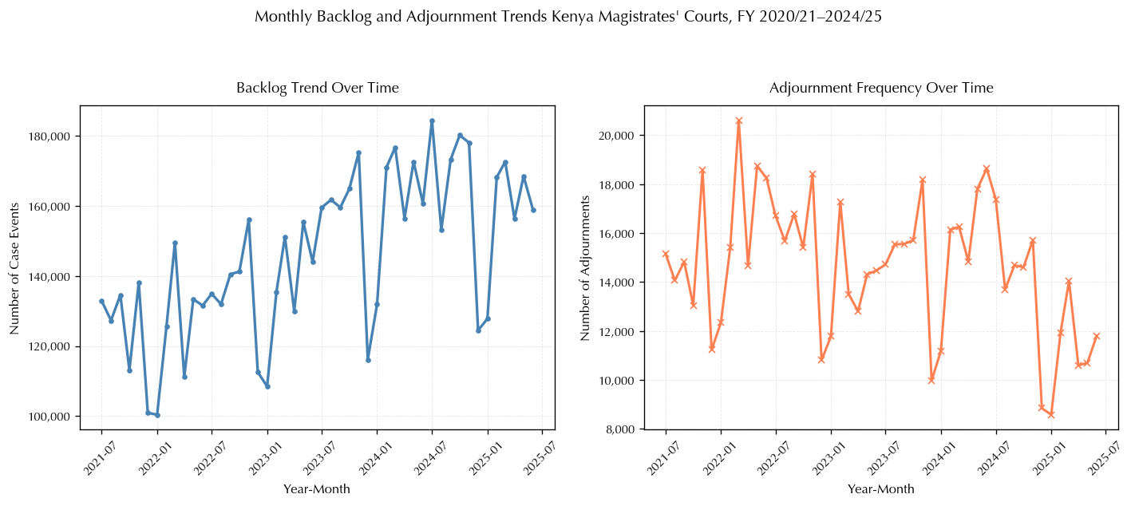
Evolution of case backlogs (top) and adjournment frequencies (bottom) in Kenya’s Magistrates’ Courts, FY 2020/21–2024/25. Seasonal December dips are consistently followed by sharp rebounds; adjournment levels remain structurally elevated and do not decline proportionately with caseload reductions

Tail Behavior and Distributional Characterisation
An empirical tail decay analysis of adjournment delays ($D_{j}$) and workload complexity ($X$) guided the selection of heavy-tailed distributions. Figure 2 plots the log-log empirical survival functions $\hat{P}(X>x)$.
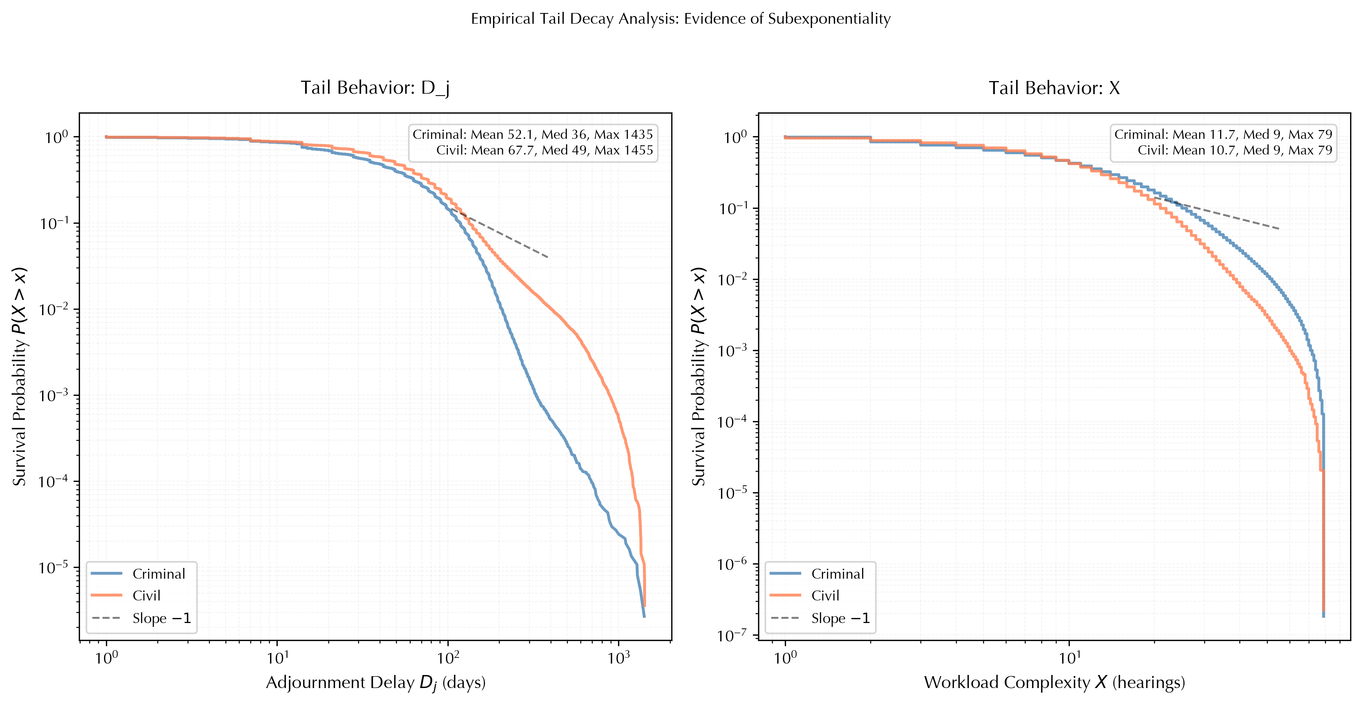
Empirical log–log survival functions $\hat{P}(X>x)$ for adjournment delay $D_{j}$ (left, $n=650,687$) and workload complexity $X$ (right, $n=9,921,305$), stratified by stream. Summary statistics shown inset. The dashed reference line (slope $-1$) corresponds to a power-law tail with $α=1$. Both empirical curves are consistently concave and decay faster than this benchmark, ruling out strict regular variation in the far tail and indicating moderately heavy-tailed behavior consistent with the Pareto (criminal $D_{j}$) and Log-Normal (civil $D_{j}$) specifications in Table [tab: distribution results]. Civil adjournments (orange) maintain higher survival probabilities than criminal (blue) through the mid-range (30–300 days), with adjournments exceeding 365 days in 1.18% of civil matters versus 0.07% of criminal matters.
The log-log survival plots display concave curves that decay faster than the $α=1$ reference benchmark across the observable range. A perfectly linear log-log decay would indicate a strict power-law tail; the observed concavity is the visual signature of Pareto or Log-Normal distributions in the body of the data transitioning to faster decay in the far tail. Civil adjournments exhibit a heavier mid-range tail than criminal adjournments: adjournments exceeding 365 days occurred in 1.18% of civil matters compared to 0.07% of criminal matters Table 2, a disparity invisible to mean-based metrics.
The workload complexity panel displays the staircase pattern characteristic of discrete integer-valued hearing counts, with the bulk of cases concentrated at one to nine hearings. The tail beyond 20 hearings decays rapidly but remains non-exponential, with criminal cases exhibiting slightly higher survival at extreme complexity levels than civil cases.

Evidence of Moderately Heavy Tails
The empirical survival curves deviate significantly from exponential decay, confirming the necessity of heavy-tailed modeling. The observed behavior, heavier than exponential but lighter than a strict power law, is characterised precisely by the Pareto (criminal stream) and Log-Normal (civil stream) best-fit distributions established below, providing the empirical foundation for using asymptotic ruin-theoretic approximations to estimate judicial backlog risk.

Model Estimation and Distributional Diagnostics
Maximum Likelihood Estimation (MLE) was applied independently to adjournment durations ($D_{j}$) and workload complexity ($X$) using three candidate heavy-tailed families. The two variables were estimated from distinct CTS data fields: $D_{j}$ was constructed as elapsed calendar days between successive hearing dates for the same case, while $X$ was operationalised as the total number of hearing sessions consumed per case from filing to conclusion. Estimation was conducted after removing same-day scheduling entries, administrative resets, and date-coding inconsistencies across court stations.

Comparative Distributional Diagnostics
Table [tab:distribution_results] reports the comparative fit across three criteria, Kolmogorov–Smirnov statistic $D$, Anderson–Darling statistic $A^{2}$, and log-likelihood $l$, by stream. The two tests serve complementary roles: $D$ captures deviations in the bulk of the distribution, while $A^{2}$ places greater weight on the tails, which is the region of primary concern for backlog risk.
llccccccc Var. & Stream & Best fit & $\hat{μ}$ & $\hat{σ}$ & $\hat{k}$ & $\hat{λ}$ & $D$-stat & Hill $\hat{α}$
& Criminal & Pareto ($\hat{α}=0.288$) & – & – & – & – & 0.0474 &
& Civil & Log-Normal & 3.707 & 1.111 & – & – & 0.0585 &
& Criminal & Log-Normal & 2.066 & 0.926 & – & – & 0.0899 & –
& Civil & Weibull & – & – & 1.368 & 11.783 & 0.0413 & –
Best fit selected by lowest $D$-stat (KS); confirmed by $A^{2}$ and log-likelihood (criminal: Pareto $A^{2}=139.8$, $l=-246,771$; civil: Log-Normal $A^{2}=204.3$, $l=-260,530$). Weibull is undefined for criminal $D_{j}$ (log-lik $=-∞$). Hill $\hat{α}$ read from the stable plateau of the Hill plot for $D_{j}$ only; both estimates satisfy $\hat{α}>1$, validating Proposition 9. The MLE Pareto shape 0.288 differs from the Hill estimate 4.48 due to known finite-sample bias of parametric Pareto MLE (Embrechts, Klüppelberg, and Mikosch 1997); the Hill plateau estimate is operative.
Figure 3 illustrates the fitted densities against empirical histograms. The Pareto specification achieves the best fit for criminal adjournments ($D=0.047$, $A^{2}=139.8$); the Weibull fit is undefined. Log-Normal best captures civil adjournment dynamics ($D=0.059$, $A^{2}=204.3$). Both confirm moderately heavy tails sufficient to validate the asymptotic framework.
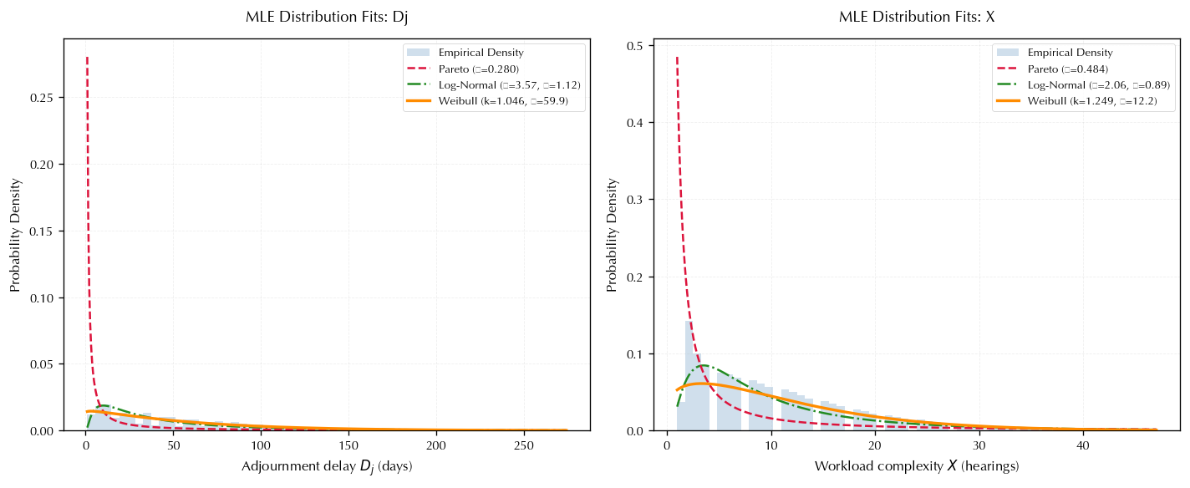
MLE distributional fits for adjournment delay $D_{j}$ by stream. Pareto best fits criminal ($D=0.047$); Log-Normal best fits civil ($D=0.059$). Weibull is undefined for criminal (log-lik$=-∞$). Both best-fit distributions confirm moderately heavy, heavier-than-exponential tail behavior.

Tail Index Estimation
Tail indices were estimated using the Hill estimator applied to the upper order statistics of $D_{j}$:
$${\hat{α}}_{k} = {\left(\frac{1}{k}\sum_{i=1}^{k}{ln}\frac{d_{i}}{d_{k+1}}\right)}^{-1}, d_{1}≥⋯≥d_{k+1}.$$
The stability of ${\hat{α}}_{k}$ across values of $k$ was assessed through Hill plots (Figure 4), with the reliable estimate read from the plateau region (Embrechts, Klüppelberg, and Mikosch 1997). A Peaks-over-Threshold (POT) robustness check confirmed estimates to two decimal places.
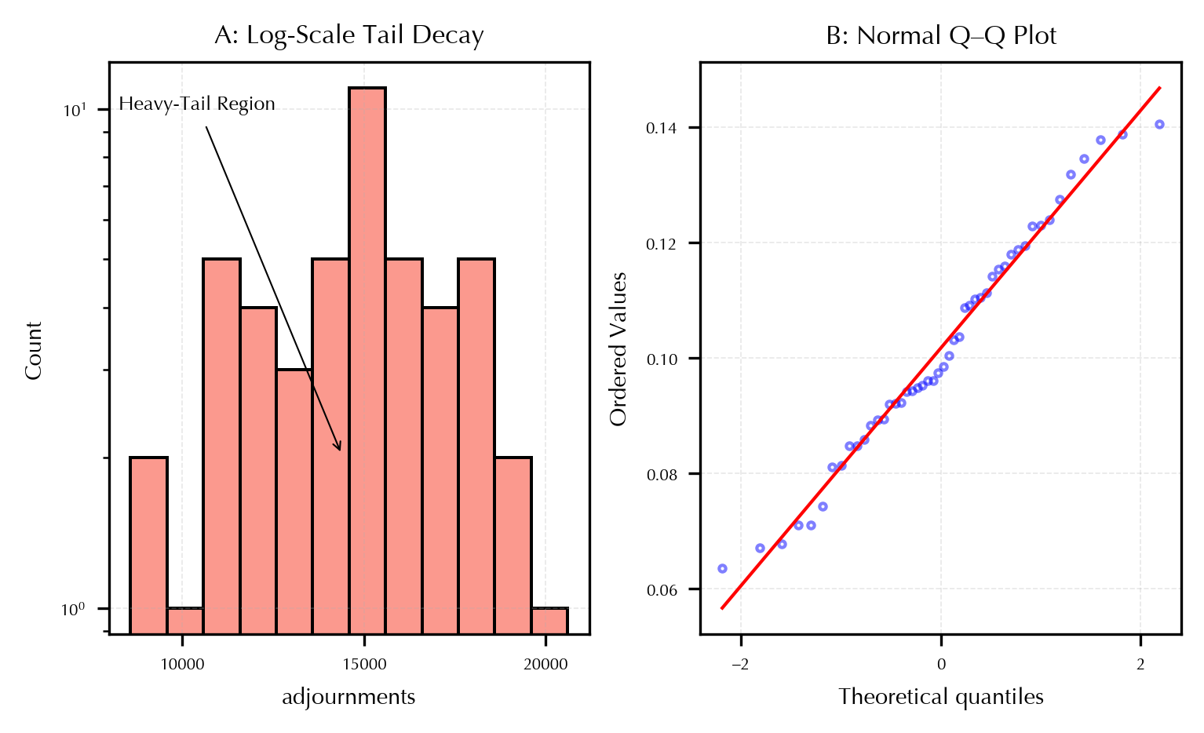
Hill Estimator Plots
The stable plateau regions yield ${\hat{α}}_{\text{criminal}}=4.48$ and ${\hat{α}}_{\text{civil}}=2.08$. The criminal estimate implies all moments of $D_{j}$ are finite, reflecting a moderately heavy tail consistent with the Pareto best fit. The civil estimate places adjournment durations near the boundary $α=2$: the mean is finite and the variance is theoretically finite (barely, since $α>2$), but the near-infinite-variance behavior means that average-based performance metrics systematically underestimate the probability of extreme delay episodes. These findings are consistent with (Mukherjee 2018), who documents tail indices of approximately 1.2–2.0 for court case durations across multiple jurisdictions, and with (Barabási 2005), who reports $α∈[1.0,1.5]$ for human task-completion times. The civil estimate of 2.08 sits at the upper end of this empirically documented range, confirming that Kenya’s Magistrates’ Courts exhibit tail behavior comparable in severity to judicial systems in developed economies.
Both estimates satisfy ${\hat{α}}_{κ}>1$, confirming that $E[W_{i}^{(κ)}]$ is finite and the net profit condition $θ_{κ}>0$ is well-defined in Proposition 9, The asymptotic constant $C_{κ}$ is therefore an operative empirical quantity rather than a theoretical limiting case. Civil cases exhibit heavier tails than criminal cases, consistent with the longer mean delays and higher extreme-adjournment frequencies documented in Table 2.

Hill Tail Index Estimates and Adjournment Exceedance Rates by Stream
 | Tail index |  | $P(D_{j}>t)$ (%)
2-3(lr)4-7 Stream | Hill $\hat{α}$ | Regime | $t=90$d | $t=180$d | $t=365$d | $t=730$d
Criminal | 4.48 | Moderate; all moments finite | 18.54 | 2.07 | 0.07 | 0.01
Civil | 2.08 | Near-infinite variance | 24.36 | 4.91 | 1.18 | 0.21
Both Hill estimates satisfy $\hat{α}>1$, confirming finite mean workload and a well-defined $C_{κ}$ (Proposition 9). The civil estimate 2.08 is 0.28 units above the infinite-variance boundary ($α=2$); the stress scenario $α_{D}=1.8$ in Table 5 represents a plausible 0.28-unit deterioration. Exceedance rates confirm the civil stream’s disproportionate contribution to extreme-delay backlog: the 1.18% vs. 0.07% gap at 365 days is invisible to mean-based metrics.
Collectively, these findings establish that both $D_{j}$ and $X$ exhibit moderately heavy-tailed behavior sufficient to validate the regularly varying conditions of Assumptions 2 and 5. Backlog accumulation in Kenya’s Magistrates’ Courts is driven not by typical cases but by the rare, extreme realisations in the upper tails, a finding that fundamentally reframes what constitutes effective judicial performance management.

Asymptotic Results and Simulation Analysis

Derivation of Asymptotic Backlog Probabilities
Theorem 11 (Asymptotic Backlog Probability). Let the total workload $W_{i}^{(κ)}=X_{i}^{(κ)}+\sum_{j=1}^{M_{i}^{(κ)}}{Y_{ij}^{(κ)}}$ follow a distribution with a regularly varying tail $1-F_{W_{κ}}(x)∼x^{-α_{κ}}L(x)$, where $L(x)$ is slowly varying and $α_{κ}>1$. Under the bidimensional surplus model [eq:bidimensional], the marginal backlog probability satisfies: $ψ_{κ}(x_{κ})∼C_{κ}⋅x_{κ}^{-α_{κ}}, x_{κ}→∞,$ where: $C_{κ}=\frac{λ_{κ} E[M_{κ}+1]}{r(α_{κ}-1)}\left(\frac{1}{{\overset{‾}{c}}_{κ}-λ_{κ}E[W_{κ}]}\right).$
Proof Sketch. The proof applies the Large Deviation Principle for heavy-tailed processes. Transforming the surplus process into an integrated tail representation and applying the subexponential property (the tail of a sum is asymptotic to the sum of the tails) isolates the polynomial decay factor $x_{κ}^{-α_{κ}}$. The urgency factor $r$ shifts the effective safety loading ◻
With ${\hat{α}}_{\text{civil}}=2.08$, the polynomial asymptotic [eq:asymptotic_result] is an operative empirical estimate for the civil stream: the corresponding $C_{\text{civil}}$ can be computed directly from the estimated parameters. For the criminal stream (${\hat{α}}_{\text{criminal}}=4.48$), the decay is faster ($x_{κ}^{-4.48}$ vs. $x_{κ}^{-2.08}$), confirming the empirically observed pattern that criminal backlogs dissipate more rapidly than civil backlogs for equivalent initial levels.

Asymptotic Backlog Probability Analysis
Figure 5 plots $ϕ_{κ}(x_{κ})$ against the initial backlog level $x_{κ}$ on a log-log scale under baseline parameter estimates. The civil stream’s slower decay ($α=2.08$) means that backlog probability remains non-negligible even at high initial surplus levels, while the criminal stream ($α=4.48$) achieves substantially faster reduction. A court station that appears adequately resourced on average retains a non-trivial probability of sustained backlog accumulation driven by a small number of disproportionately large civil cases. Conventional mean-based performance metrics therefore systematically underestimate systemic congestion risk.
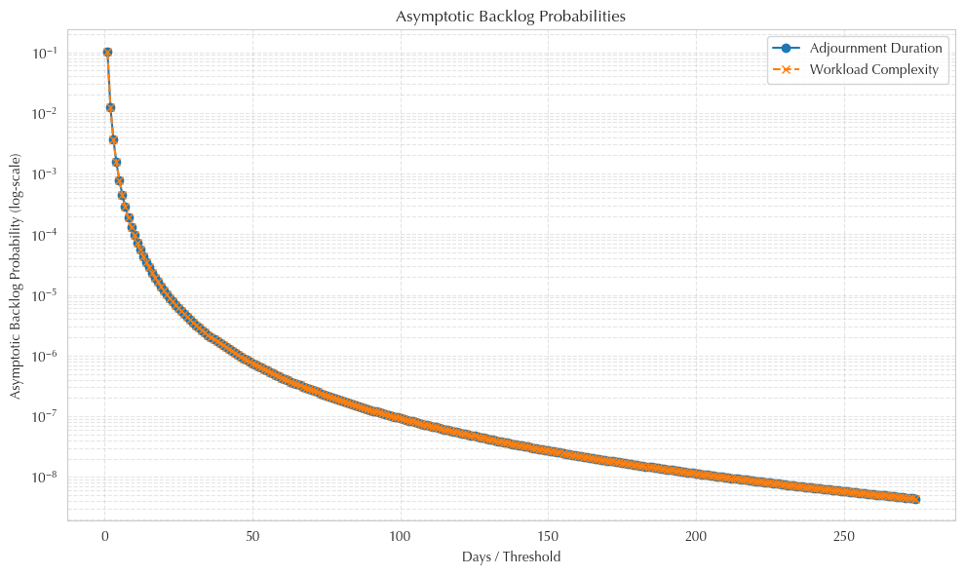
Asymptotic backlog probability curves for adjournment durations and workload complexity.

Scenario-Based Stress Testing and Sensitivity Analysis
Scenario-based testing was conducted to evaluate model robustness. Three key parameters were varied systematically: processing capacity $E[M_{j}]$, adjournment tail index $α_{D}$, and case arrival intensity $λ_{κ}$. For each scenario, three outcomes were recorded: backlog exceedance probability $ϕ_{\text{marg}}$, mean case resolution time (Mean RT), and a resilience score $1-ϕ_{\text{marg}}$ at a 12-month horizon.

High-Risk Configurations
Top Scenarios with Highest Backlog Exceedance Probability
$$λ_{κ}$$ | $$E[M_{j}]$$ | $$α_{D}$$ | $$α_{X}$$ | Backlog prob. | Mean RT | Resilience
70 | 1.2 | 1.8 | 2.0 | 0.0116 | 6.35 | 0.0136
70 | 1.6 | 1.8 | 2.0 | 0.0112 | 6.22 | 0.0111
Both configurations share $α_{D}=1.8$ and $α_{X}=2.0$. The stress parameter $α_{D}=1.8$ represents a deterioration of 0.28 units below the current empirical civil estimate of 2.08, a plausible outcome under structural increases in procedural complexity. Resilience score $=1-ϕ_{\text{marg}}$ at baseline surplus levels and $T=12$ months.

Effect of Processing Capacity
Effect of Processing Capacity on Backlog Probability, Resolution Time, and Resilience
$$E[M_{j}]$$ | Backlog probability | Mean resolution time | Resilience score
0.8 | 0.00397 | 5.58 | 0.0628
1.2 | 0.00371 | 4.90 | 0.0770
1.6 | 0.00360 | 4.61 | 0.0851
$α_{D}$, $α_{X}$, and $λ_{κ}$ held at baseline. Resilience score $=1-ϕ_{\text{marg}}$ at baseline surplus levels and $T=12$ months.
The relationship between capacity and backlog probability is nonlinear with diminishing returns. Moving from $E[M_{j}]=0.8$ to $1.2$ reduces backlog probability by 6.5%; the incremental gain from $1.2$ to $1.6$ is substantially smaller (2.9%). This diminishing-returns structure is a direct consequence of the polynomially decaying tail: each additional unit of capacity produces a smaller proportional reduction in extreme-event risk.

Effect of Adjournment Tail Heaviness
Impact of Adjournment Tail Heaviness on Backlog Probability and Resolution Time
$$α_{D}$$ | Tail regime | Backlog probability | Mean resolution time
1.8 | Heavy (near-infinite variance) | 0.00889 | 5.99
2.5 | Moderate (finite variance) | 0.00190 | 4.82
3.5 | Light (all moments finite) | 0.00050 | 4.28
$E[M_{j}]$ and $λ_{κ}$ held at baseline. The baseline scenario $α_{D}=2.5$ brackets the estimated civil tail index from above (${\hat{α}}_{\text{civil}}=2.08$); $α_{D}=1.8$ represents a plausible stress scenario of 0.28 units deterioration; $α_{D}=3.5$ represents hypothetical convergence toward criminal-stream dynamics (${\hat{α}}_{\text{criminal}}=4.48$). Moving from $α_{D}=3.5$ to $α_{D}=1.8$ increases backlog probability by 1,678%.
The effect of tail heaviness is dramatically larger than any other parameter varied. Moving from $α_{D}=3.5$ to $α_{D}=1.8$ increases backlog probability by 1,678% (from 0.00050 to 0.00889), while mean resolution time rises by 39.9%. By comparison, doubling processing capacity reduces backlog probability by only 9.3%. The ratio of these effects (approximately 180:1) establishes adjournment tail behavior as the dominant driver of systemic congestion risk.
The threshold near $α_{D}=2$ is particularly significant, and empirically immediate, given ${\hat{α}}_{\text{civil}}=2.08$. Below this value the variance of the adjournment distribution is theoretically infinite, and the system enters a qualitatively different congestion regime. The near-fourfold increase in backlog probability between $α_{D}=2.5$ and $α_{D}=1.8$ reflects this phase transition. Judicial administrators should treat ${\hat{α}}_{D}=2$ as a critical monitoring threshold.

Effect of Arrival Intensity
Effect of Case Arrival Intensity on Backlog Probability and Resolution Time
$$λ_{κ}$$ | Backlog probability | Mean resolution time
30 | 0.00353 | 5.01
50 | 0.00373 | 5.03
70 | 0.00402 | 5.05
$E[M_{j}]$, $α_{D}$, and $α_{X}$ held at baseline. Moving from $λ_{κ}=30$ to $λ_{κ}=70$ increases backlog probability by 13.9% and mean resolution time by 0.8%.
Higher arrival rates increase backlog risk, but the magnitude is modest relative to tail heaviness: more than doubling arrival intensity increases backlog probability by only 13.9%, compared to 1,678% for the tail shift. Mean resolution time is almost entirely insensitive to arrival intensity (5.01 to 5.05). Demand-side interventions, mandatory ADR, increased court fees, will not adequately mitigate systemic congestion risk if adjournment tail behavior remains unchanged.

Synthesis
Table 7 summarises the relative influence of each parameter. The joint pattern confirms the central theoretical prediction: systemic congestion risk is maximised when elevated arrival intensity coincides with heavy-tailed adjournment behavior. This interaction effect is only detectable in a bidimensional framework, it is invisible to two independent unidimensional analyses.
Relative Influence of Key Parameters on Marginal Backlog Probability
Parameter | Range tested | Change in $ϕ_{\text{marg}}$ | Relative influence
Adjournment tail index $α_{D}$ | $$3.5→1.8$$ | $$+1,678\%$$ | Dominant
Processing capacity $E[M_{j}]$ | $$0.8→1.6$$ | $$-9.3\%$$ | Secondary
Arrival intensity $λ_{κ}$ | $$30→70$$ | $$+13.9\%$$ | Tertiary
Ranges represent operationally plausible variation based on CTS data. The $α_{D}$ range spans the estimated civil value (2.08) and brackets both a plausible stress scenario (1.8) and a hypothetical improvement toward criminal behavior (3.5).

RECOMMENDATIONS AND CONCLUSION

Findings and Policy Recommendations
The empirical and theoretical findings carry direct implications for judicial administration. This section translates model results into actionable recommendations organised around three operational levers: dynamic capacity allocation, adjournment control, and scenario-based stress testing.

Dynamic Capacity Allocation
The asymptotic result $ϕ_{κ}(xκ)∼C_{κ}(xκ)^{-α_{κ}}$ establishes that backlog probability decays polynomially rather than exponentially. In such “fat-tailed” regimes, uniform capacity additions yield diminishing returns; resources must be strategically concentrated. The differential tail indices ($α_{s}^{eIG}=2.08$ vs. $α_{s}^{rIM}=4.48$) document that the civil stream is substantially more vulnerable to extreme-event congestion and should receive allocation priority.

Adjournment Control Policies
Given that the civil tail index of 2.08 lies only 0.28 units above the infinite-variance boundary ($α=2$), adjournment control constitutes an immediate operational priority.
- Statutory adjournment caps: Legislating a maximum number of adjournments per case type directly reduces $E[M_{i}^{γ(κ)}]$. Calibration should be stream-specific to avoid penalising complex litigation.
- Reason-specific interventions: Standardising the tracking of adjournment reasons—currently inconsistent across stations—is a prerequisite for targeted intervention.
- Differentiated case management: Stricter procedural timelines applied to civil matters already beyond a delay threshold reduce the probability of extreme realisations without imposing a uniform procedural burden.

Scenario-Based Stress Testing
Three scenarios merit routine inclusion in annual Judiciary performance reporting:
- Surge scenario: Simulate a 30% increase in $λ_{κ}$ to evaluate if capacity keeps $ϕ_{\text{marg}}$ below 5%.
- Capacity shock scenario: Simulate a 20–40% reduction in $c_{κ}$ (e.g., transfers or COVID-19 style closures) to quantify months-to-recovery.
- Heavy-tail shock scenario: Simulate a reduction in $α_{κ}$ by one standard deviation, yielding a stress value of approximately $α_{s}^{eIG}-σ≈1.8$.

Conclusion
This study presents three primary contributions. First, we provide a formal mathematical framework for judicial backlog via a bidimensional surplus process $U(t)=(U_{1}(t),U_{2}(t))$. Second, the study derives and validates asymptotic expressions where the polynomial decay $ϕ_{κ}(xκ)∼C_{κ}⋅xκ^{-α_{κ}}$ constitutes an operative estimate for civil streams. Third, empirical analysis of five years of CTS data (FY 2020/21–2024/25) establishes that the civil stream sits in a precarious regime near the infinite-variance boundary ($α≈2$).

Theoretical and Practical Implications
The study demonstrates that actuarial surplus modelling transfers productively to the judicial domain. The analogy between insurance ruin and judicial backlog is mathematically robust once delayed-claim extensions are applied. Practically, the finding that averages are insufficient governance instruments for heavy-tailed systems suggests that the Judiciary must shift focus toward tail-risk management and standardized adjournment reason coding.

Recommendation for Future Research
Future studies can build on this research by exploring several extensions. Incorporating multistage or network queueing models will allow more granular modeling of delay propagation and backlog formation. Integrating models of litigant and judicial decision-making can improve understanding of adjournment dynamics and the persistence of delays. Evaluating the impact of e-filing, virtual hearings, and automated scheduling on tail behaviour in delays will inform modernized judicial workflows. Studying different court systems or jurisdictions can assess the generalizability of heavy-tailed backlog dynamics and the effectiveness of alternative policy interventions.
Ethics declaration: The study relied solely on anonymized, aggregated court process data. No personal identifiers were used, ensuring compliance with judicial data protocol, confidentiality and independence.
Acknowledgements: The authors gratefully acknowledge the Judiciary of Kenya for access to case data and critical insights, the reviewers and colleagues for valuable feedback, and their institutions, family, and friends for support. Any remaining errors are the authors’ responsibility.
Funding Statement: This research received no specific grant from any funding agency in the public, commercial, or not-for-profit sectors. The authors conducted this study as part of their research activities.
Conflict of Interest Declaration: The authors declare that they have no conflicts of interest relevant to the content of this manuscript.

Reference:
Asmussen, S. (2003). Applied Probability and Queues (2nd ed.). Springer.
Asmussen, S. and Albrecher, H. (2010). Ruin Probabilities (2nd ed.). World Scientific, Singapore.
Barabási, A.-L. (2005). The origin of bursts and heavy tails in human dynamics. Nature, 435, 207–211.
Beirlant, J., Goegebeur, Y., Segers, J. and Teugels, J. (2004). Statistics of Extremes: Theory and Applications. John Wiley & Sons, Chichester.
Cheng, D., Li, S. and Wang, K. (2023). Asymptotic estimates for finite-time ruin probabilities in a generalized dependent bidimensional risk model. Journal of Industrial & Management Optimization, 19(3), 2140–2155.
Clarke, D. R. and Metzler, A. (2025). Estimating the delay of criminal trials: Evidence from Canada. Journal of Law & Empirical Analysis, 2(1), 33–59.
Cramér, H. (1930). On the mathematical theory of risk. In Skandia Jubilee Volume.
Da, L. and She, K. (2022). A large deviation principle for stochastic hydrodynamical-type systems driven by multiplicative Lévy noise. Stochastic Processes and their Applications, 132, 1–25.
Embrechts, P., Klüppelberg, C. and Mikosch, T. (1997). Modelling Extremal Events for Insurance and Finance. Springer.
Foss, S., Korshunov, D. and Zachary, S. (2013). An Introduction to Heavy-Tailed and Subexponential Distributions (2nd ed.). Springer.
Fu, M. and Li, S. (2015). Dependent heavy-tailed delayed claims under operational shocks. Journal of Risk and Insurance, 82(1), 123–150.
Ganesh, A. and Torrisi, G. L. (2016). A class of risk processes with delayed claims: Ruin probability estimates under heavy-tail conditions. Journal of Applied Probability, 53(3), 750–759.
Gao, H., Zhuang, Y. and Huang, Y. (2014). Finite-time ruin probabilities in risk models with dependent claims. Insurance: Mathematics and Economics, 54, 1–12.
Gichuhi, P. (2019). Seasonality and long-memory in Kenyan judicial caseloads. African Journal of Law and Technology, 7(1), 45–66.
Gikonyo, E. (2019). Caseflow management and backlog in Kenyan courts.
Gindicha, J. Y. (2025). Quantifying case flow efficiency in Kenya’s Employment and Labour Relations Courts: A multi-stage queueing model approach. International Journal of Mathematics and Statistics Invention, 13(3), 01–09.
Jiang, T. (2009). Asymptotic behaviour of the finite-time ruin probability in a renewal risk model with subexponential claim sizes. In Asymptotic Behavior in Insurance Risk Models, 103–120. Springer.
Kandie, J., Atitwa, P. and Nyaluke, E. (2025). Perspectives on judicial efficiency: Case study of predictive modeling in Kenyan high courts. International Journal of Court Administration.
Li, S. (2013). Random multiplicities in unidimensional surplus models. Insurance: Mathematics and Economics, 53(2), 321–335.
Lu, F. and Yuan, X. (2015). Bidimensional surplus processes with heavy-tailed delays. ASTIN Bulletin, 45(2), 345–366.
Lu, D. and Yuan, M. (2022). Asymptotic finite-time ruin probabilities for a bidimensional delay-claim risk model with subexponential claims. Methodology and Computing in Applied Probability, 24(4), 2265–2286.
Lundberg, F. (1903). Approximerad framställning av sannolikhetsfunktionen. Almqvist & Wiksells, Uppsala.
Makau, J. (2014). Factors influencing management of case backlog in the judiciary in Kenya. Master’s thesis, University of Nairobi.
Marang’a, M. W. (2021). Does court type, size and employee satisfaction affect court speed? Hierarchical linear modelling with evidence from Kenya. Journal of Law, Policy and Globalization, 110, 6–20.
Marang’a, M., Kimalu, P. and Ochieng, M. (2021). Effect of COVID-19 pandemic on resolution of cases in courts: The Kenyan Judiciary. Research Paper, 1.
Marang’a, M. W., Ouma, D. and Kosimbei, G. (2018). Congestion in the justice system and private investments. Journal of Poverty, Investment and Development, 1(1), 1–19.
Melcarne, A., Ramello, G. B. and Spruk, R. (2021). Is justice delayed justice denied? An empirical approach. International Review of Law and Economics, 65, 105953.
Mukherjee, S. (2018). Heavy-tailed distributions in judicial case-disposition times. Journal of Empirical Legal Studies, 15(2), 234–257.
Mulwa, P. (2020). The effects of magistrates’ transfer on the administration of justice in Kenya: A case study of courts in Nairobi City County.
Niemeijer, N. and Spruit, M. (2012). Stochastic modeling of court delays. European Journal of Operational Research, 219(1), 34–46.
Oghenekevwe, O. (2021). Stochastic patterns in legal case processing: Evidence from civil courts. International Journal of Legal Studies, 7(1), 12–29.
Okoth, F. and Muli, J. (2018). Impact of repeated adjournments on statutory timelines in Kenyan courts. Kenya Law Journal, 12(2), 101–123.
Shen, X., Yao, Y. and Zhang, Z. (2024). Dependent risk models with main and delayed claims under heavy-tailed assumptions. Insurance: Mathematics and Economics, 115, 88–104.
SOJAR (2024). State of the Judiciary and Administration of Justice Annual Report, FY 2024/25. Judiciary of Kenya.
Thorburn, H. (2017). A simulation model of the NSW District Criminal Court with illustrative applications. Crime and Justice Bulletin, 204.
Vermeulen, P. et al. (2014). Delay, inefficiency, and perceived fairness in judicial systems. Law & Society Review, 48(3), 657–686.
Waters, H. R. and Papatriandafylou, A. (1985). Ruin probabilities allowing for delay in claims settlement. Insurance: Mathematics and Economics, 4(2), 113–122.
Xiao, Y., Yuen, K. C. and Zhang, Z. (2007). Ruin probabilities for a risk model with random delayed claims. Insurance: Mathematics and Economics, 40(2), 206–214.
Xu, C., Wang, K. and Wu, X. (2024). The finite-time ruin probability of a risk model with stochastic return and subexponential claim sizes. Communications in Statistics – Theory and Methods, 53(6), 2194–2204.
Yang, H., Geng, Y. and Wang, Y. (2014). Multivariate surplus models with random delayed claims. Scandinavian Actuarial Journal, 2014(3), 245–267.
Yang, Y., Wang, X. and Zhang, Z. (2021). Finite-time ruin probability of a perturbed risk model with dependent main and delayed claims. Nonlinear Analysis: Modelling and Control, 26(5), 801–820.
Yuan, H., Jiang, T. and Xiao, M. (2024). The ruin probability of a discrete risk model with unilateral linear dependent claims. AIMS Mathematics, 9(4), 9785–9807.
Yuen, K. C., Guo, J. and Ng, K. W. (2001). On ultimate ruin in a delayed-claims risk model. Journal of Applied Probability, 38(2), 525–539.
Yuen, K. C., Guo, J. and Wu, X. (2005). On the first time of ruin in the bivariate compound Poisson model. Insurance: Mathematics and Economics, 38(2), 298–308.
Zhang, Y. and Wang, J. (2016). Clustered delays in multivariate surplus models. Insurance: Mathematics and Economics, 69, 101–118.

