Context-Aware Memory-Augmented Hierarchical Summarization of Long Legal Documents

Abstract—Judgments are characterized as lengthy with structural complexity, and context dependency, hence the difficulty in summarizing them automatically. Standard chunk-based Map Reduce approaches have the problems of lack of cross-sectional context, inconsistent entities, redundancy, and hallucination. In this paper, we present a novel Context-aware Memory Augmented Hierarchical Summarization framework which captures context via two stages: (1) extraction of global memory which contains critical pieces of information-like entities, legal issues, chronology, and statutes mentioned in the case; and (2) memory augmented hierarchical summarization which involves summarizing chunked sections of judgments in parallel by leveraging global memory. The generated summary structure is merged via entity normalization, duplication removal, and prioritized merging of sections along with light post-refinement. Our extensive experiments with long legal judgments validate the superiority of the proposed approach over
Index Terms—Legal Document Summarization, Long Document NLP, Hierarchical Summarization, Context Preservation, Memory-Augmented Summarization, Retrieval-Augmented Generation

- Introduction

The volume of legal system outputs such as decisions, orders, and other documents is enormous [1]. Legal professionals, scholars, and students may require brief and clear summaries in order to comprehend crucial information about the case, including its facts, problems, and outcomes. Automatic summarization of legal documents is difficult due to the document length, highly structured discourse, and cross-section dependency of legal texts.

Modern large language models (LLMs) show high text comprehension and summarization abilities [2]. But when long legal documents are directly summarized, it results in surpassing the context capacity of the model and thus causes cross-section dependency loss, inconsistency in entities, and hallucination [3].
The Map-Reduce style summary generation for long documents [4], which solves the problem of context limitation, summarizes each chunk independently without taking into account the document context as a whole.
In order to overcome these shortcomings, the authors suggest using a novel Context-Aware Memory-Augmented Hierarchical Summarization of Long Legal Documents that focuses on summarizing long legal documents. In contrast to the standard chunk approach, our framework begins with extracting the global memory which includes the most important information about the case like the participants, legal questions, facts of the case, and statute citation [5]. This memory will be added in each chunk while creating the summary. Finally, the structured chunk level summaries are aggregated deterministically with entity normalization, redundancy filtering, and priority-based section ordering.
The important contributions of the paper are:
1) The hierarchical summarization algorithm of the long legal document in a way that is consistent throughout the various sections of the document.
2) The chunk summarization technique, which is enhanced by memory and ensures lesser loss of context while achieving consistency.
3) The deterministic method of combining chunks that ensures minimal redundancy and coherence while still being computationally effective.
4) The scalable process of generating the summary, which is suitable for summarizing legal judgments and documents in bulk.
This improves the coherence and factual correctness of summaries in an efficient way.

- Related Work
- Long Document Summarization
Early summarization methods were mainly extractive methods like TextRank and LexRank, that extracted sentences by ranking the sentences using a graph-based ranking technique but failed to capture semantics. The neural models enabled the use of abstractive summarization through sequence-to-sequence models and transformers which enhanced semantic representation and fluency [2]. Abstractive models, however, have difficulty handling long texts owing to their limitation in terms of the length of context [6], [7]. This led to hierarchical and chunk-based summarization techniques [8] where the document was divided into several chunks.

- Retrieval-Augmented and Memory-Based Summarization

The concept of retrieval and generation was initially introduced in Retrieval Augmented Generation (RAG) [5], [9] Methods based on memory augmentation took a step forward in improving context management through the use of external memory models like entity lists, key facts, and knowledge graphs. Although these methods can help with factual accuracy, there is no significant work done using them in summarizing lengthy legal documents.
- Legal Document Processing and Summarization
The importance of summarizing legal texts has been rising because of their well-structured and domain-specific characteristics[1]. The previous research efforts in the field have focused on extractive summarization of legal documents, rhetorical roles in legal texts, and citation-aware summarization [10], Several studies have considered hierarchical models that can incorporate information about the structure of the documents, like facts, issues, and decisions. Others have taken into account domain-specific word embeddings and knowledge bases for legal data.
- Limitations of Existing Approaches
However, despite the advances made thus far, the following issues are some of the constraints currently encountered when using state-of-the-art long-document summarization methods in summarizing legal texts:
  - Loss of global context in chunk-level summarization
  - Inconsistencies in entities between different segments [11],
  - Redundancies in combined summaries, and
  - Scalability problems in handling legal text corpora.

Our proposed approach tackles these constraints through hierarchical summarization, global memory retention, and deterministic summary combination.

- System Architecture
- Overview
A new framework named Memory-Augmented Hierarchical Summary (MAHS) is proposed for long legal documents. Legal judgments are lengthy, hierarchical, and have semantic dependence among sections, thus rendering traditional chunk-based summary methods ineffective because of loss of context.
This design allows for contextual coherence, scalability, efficiency in computation, and minimizes hallucination.
Structural Parsing and Section-wise Chunking
Legal texts usually adhere to a semi-structured rhetorical format comprising segments like Facts, Issues, Arguments, Analysis, Judgment, and Order. Rather than simple token chunking, we resort to structure-aware chunking to maintain semantic continuity.
Section boundaries are recognized through lexical cues, numbered headings, and formatting. Denote the set of section types by:

S = {Facts, Issues, Arguments, Analysis, Judgment, Order}
Each document is broken down into parts, and big parts into small sub-parts while maintaining paragraph cohesion. Each chunk is represented by:
c_{i,j} = (text, sectiontype, position, metadata)
where text is the raw content, sectiontype is the rhetorical label, position denotes its relative order, and metadata contains citations and structural information.
- Global Memory Extraction
To maintain the context at the document level, we define a Global Case Memory extraction phase before performing chunk summarization. Entities and facts that are present in various parts of the legal document include parties, courts, legal issues, and laws.
Global case memory is defined as:

M = {E, I, T, P, C}
where E denotes entities, I represents core legal issues, T is timeline information, P contains statutory provisions, and C includes case metadata. This memory is extracted using a constrained language model with structured output and injected into all chunk-level summarization prompts to maintain consistency.

- Memory-Augmented Parallel Chunk Summarization

Each chunk c

i,j
is summarized independently using asyn-
To tackle these issues, the above architecture splits the summary formation procedure into a set of modules that clearly divide the structural parsing, extraction of the global context, chunk summarization, aggregation, and natural language generation procedures. The system contains the following modules:
  - Section-wise document parsing and chunking
  - Global memory extraction
  - Memory-augmented parallel chunk summarization
  - Deterministic structured merge
  - Compressed case memory construction
  - Final coherent summary generation
chronous parallel LLM calls. However, unlike conventional Map-Reduce summarization, each summarization call receives the global memory M as contextual input:
S_{i,j} = f (c_{i,j}, M )
where f (·) denotes the LLM-based summarization func-tion and S_{i,j} represents the structured JavaScript Object Notation (JSON) summary. The structured output includes key points, entities, legal provisions, citations, and an importance score. Parallel execution significantly reduces latency while memory injection preserves cross-section coherence.

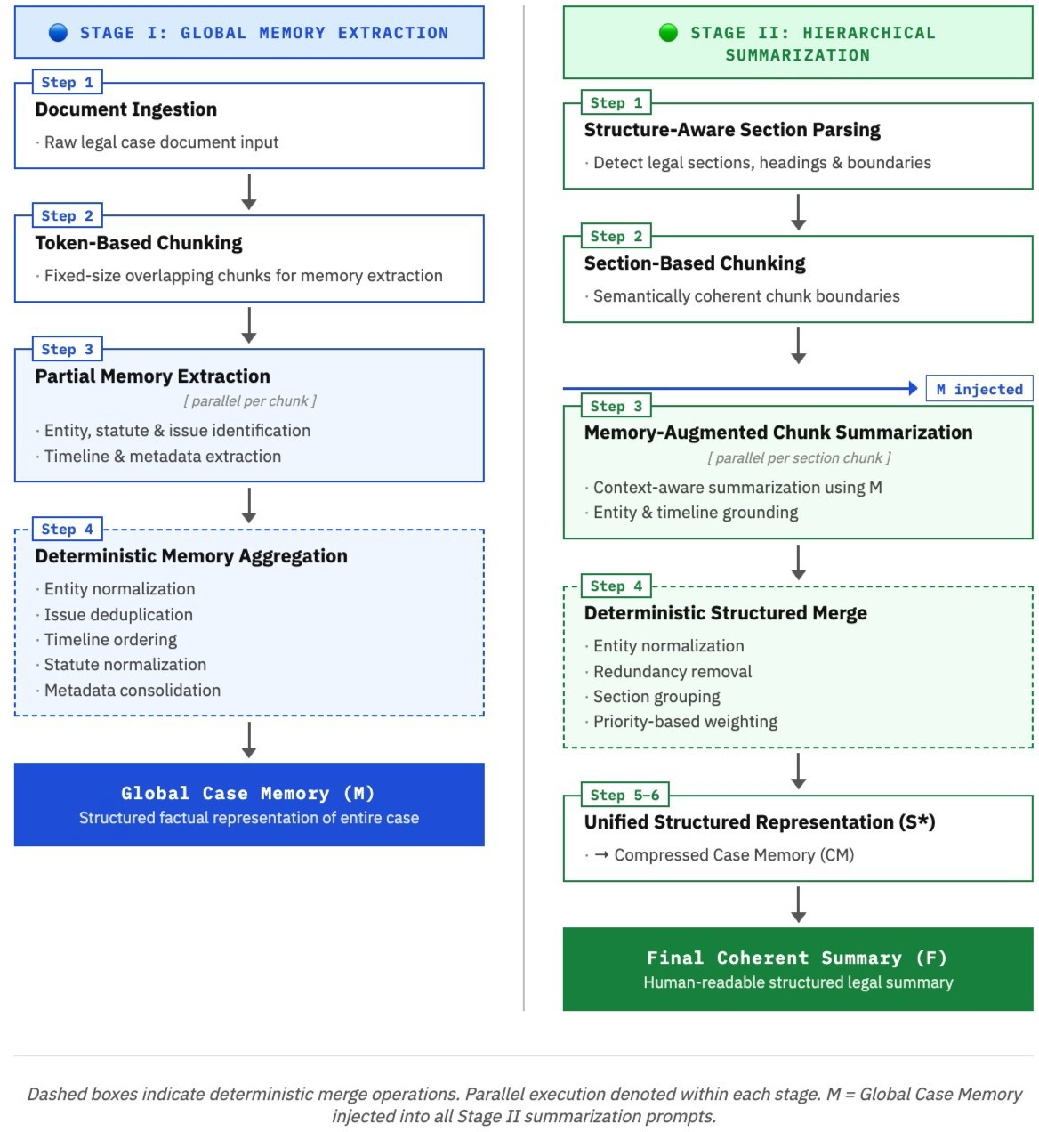
- Deterministic Structured Merge
Instead of using another large LLM call for merging, we apply a deterministic aggregation procedure over the set of chunk summaries {S₁, S₂, . . . , S_{n}} to produce a unified
representation S∗.
  - Entity Normalization: Entity variations are normalized
through lowercasing, punctuation removal, and alias mapping:
n
E∗ = ∪ normalize (E_{i})
i=1
  - Redundancy Removal: Key points are deduplicated us-ing lexical and semantic similarity:
n
K∗ = Deduplicate ( ∪ K_{i )}

i=1
  - Section-Priority Aggregation: Sections are aggregated using priority weights:

w(Judgment) > w(Issues) > w(Arguments) > w(Facts)
This preserves complete judgment reasoning while com-pressing less critical details.
- Compressed Case Memory Construction
The merged representation is transformed into a compact structured case memory:
CM = Format(S∗)
This step removes redundant information, limits key points per section, and organizes the content in logical legal order (Facts → Issues → Arguments → Judgment → Order). Compression reduces token size and improves efficiency for the final generation stage.
- Final Coherent Summary Generation
The final legal summary F is generated from compressed memory CM using a constrained language model:

F = g(CM )
The prompt enforces strict factual grounding, prevents hal-lucination, and maintains professional legal tone and logical flow.
- Computational Complexity
Let n denote the number of chunks and L the average chunk size. Parallel chunk summarization has complexity:

O(n · L)
but executes concurrently, reducing latency to approxi-mately the maximum single-call time. Deterministic merging requires O(n) time, and final generation depends on com-pressed memory size O(|CM|).

Fig. 1. Complete Pipeline Flow for Legal Document Summarization

- Design Advantages
The proposed architecture provides:
- Cross-section contextual consistency through global memory
- Reduced hallucination via structured grounding
- Efficient parallel processing for long documents
- Deterministic and reproducible intermediate outputs
- Scalable hierarchical summarization for legal corpora

- Experimental Setup and Evaluation
- Dataset
To assess the efficacy of the proposed Memory-Augmented Hierarchical Summarization (MAHS) model, a data set comprising long legal judgments drawn from open legal sources, such as Indian Kanoon and eCourts, was created. The data set contains judgments from diverse fields of law, including civil, criminal, constitutional, and administrative law.
The corpus comprises long legal judgments that vary in terms of their size, usually between 5,000 and 50,000 words. The documents were segmented into rhetorical sections, namely, Facts, Issues, Arguments, Judgment, and Order. Headnotes and summaries of judgments written by humans were used as reference summaries.

- Evaluation Metrics
We evaluate our framework using both automatic and quali-tative metrics to measure summary quality, factual consistency, and contextual coherence.

- ROUGE Score: ROUGE-1, ROUGE-2, and ROUGE-L are used to measure overlap between generated summaries and reference summaries.
- BERTScore: Captures semantic similarity between gen-erated and reference summaries using contextual embeddings [12].
- Entity Consistency: Measures correctness and preservation of key entities such as parties, statutes, and dates [11].
- Redundancy Score: Quantifies repetition in generated summaries.
- Factual Consistency: Evaluates whether generated summaries contain hallucinated or unsupported facts [13].
- Compression Ratio: Measures reduction from original document length to final summary.
- Latency: Measures total summarization time, including parallel chunk processing and final generation.

- Baselines
We compare the proposed method against the following baselines:
memory injection, reducing cross-section inconsistencies. Re-dundancy decreases to 6%, demonstrating the effectiveness of deterministic structured merging in eliminating repetitive information.
TABLE II
Performance Improvement of MAHS over Baselines

Metric vs Single vs Flat vs Hier.
ROUGE-L +48.8% +29.8% +17.3%
BERTScore +10.8% +7.0% +4.5%
Entity Acc. +21% +15% +9%
Redun. Red. -66% -57% -45%
The performance improvement results for the proposed method are presented in Table II. The most significant improvements can be noted in ROUGE-L and entity accuracy, which validate the improved contextual consistency and entity retention. The reduction in redundancy is by 66% when compared to the single-level summarization process.
- Single-pass LLM Summarization: Direct summariza-
TABLE III

tion of the entire document using a long-context language model [6].
- Flat Chunk Map-Reduce: Independent chunk summarization followed by single-stage merge [4].
- Hierarchical Summarization without Memory: Multi-level summarization without global memory injection.
- Extractive Summarization (TextRank): Graph-based extractive baseline [14].
- Results
From the experiment findings, it can be concluded that the MAHS framework proposed is more coherent and factually consistent than the baselines. Memory-augmented summarization greatly helps in minimizing the inconsistency of entities and redundancy without compromising on logical flow between sections. Parallel processing of chunks leads to lower latency when compared to the sequential processing of summaries. The framework achieves higher ROUGE and BERTScore values, indicating improved semantic and structural quality.
- Quantitative Results
Table I compares summarization quality across baseline methods and the proposed Memory-Augmented Hierarchical Summarization (MAHS) framework.

TABLE I
Summarization Performance Comparison

Method ROUGE-L BERTScore Entity Acc.
Single-pass LLM 0.41 0.83 72%
Flat Map-Reduce | 0.47 | 0.86 | 78%
Hierarchical | 0.52 | 0.88 | 84%
Proposed 0.61 0.92 93%
The proposed MAHS framework achieves the highest ROUGE-L and BERTScore values, indicating improved struc-tural coverage and semantic similarity with reference sum-maries. Entity accuracy improves significantly due to global
actual Consistency and Hallucination Rate

Method Factual Cons. Halluc. Rate
Single-pass LLM 68% 21%
Flat Map-Reduce 76% 15%
Hierarchical 84% 9%
Proposed 94% 4%
The evaluation is presented in Table III. Here we see that hallucinations are reduced from 21% to 4% when using the proposed approach [3]. This reduction is evidence of the successful reduction of unfounded facts by means of global memory grounding and structural merging.

TABLE IV
Latency Comparison (Average per Document)

Method Latency (s) Speedup
Sequential 42.5 –
Flat Map-Reduce 27.8 1.5x
Proposed 14.6 2.9x
Table IV shows the proposed framework gives the least average latency, owing to asynchronous parallel summarization of chunks and deterministic merging of the results. When compared with sequential execution, the framework provides about 2.9x speedup.
Discussion
- Effect of Memory-Augmented Summarization
The memory extraction is essential in preserving contextual information for cross sections It is vital to understand that memory extraction is essential in maintaining the contextual information of the cross sections [5], [9]. In the absence of memory injection, summarization by using chunks would normally result in drifts within entities and fragmented reasoning.

- Hierarchical Aggregation Benefits
Hierarchy-driven structured merging minimizes redundancy and enhances flow logic when compared with flat Map-Reduce summarization techniques. Section priority-based merging guarantees that crucial sections such as judgment reasoning sections are retained during compression.
Efficiency and Scalability
Parallel chunk summarization greatly cuts down on wall-clock latency, thus making the model scalable for longer legal documents. Another feature that helps improve the scalability of the model is deterministic merging, as this prevents the repetition of lengthy queries to the language model.
Limitations
However, there are some hurdles that still persist despite the progress achieved. First, there could be issues with legal reasoning complexity that involves implicit referencing, and mistakes in section recognition can affect further processing steps. Moreover, legal reasoning assessment depends partly on human interpretation.

- Conclusion
In this paper, a Memory Augmented Hierarchical Summarization (MAHS) model is proposed to tackle the above problems associated with the traditional summarization methods for long legal texts [6], [7]. Legal texts tend to be long, complex, and context-dependent, which poses significant challenges to traditional summarization models for achieving consistency across sections and factual correctness. Current methods are subject to entity inconsistence, redundancy, fragmented reasoning, and hallucinations [3] due to the absence of global contextual grounding.

In order to address these problems, the proposed approach combines global memory extraction [5], [9] with hierarchical parallel chunk summarization and deterministic structured merging. The global memory ensures that critical information regarding entities, legal issues, and statutory references is retained [1], and that the representation of this information remains uniform across independently summarized chunks.
Experiment-based assessment proves that the framework offers better summarization quality, higher consistency in entities, less redundancy, and a much smaller rate of hallucinations than existing baselines. Furthermore, since it involves the hierarchical parallel architecture, the summarization process is fast. Hence, the framework can be used for the actual summarization of legal documents on a large scale.
In conclusion, the MAHS framework ensures scalable, context-aware, and accurate summarization of legal documents. In the future, the next research step will involve further development of the section detection model, the use of the knowledge graph for reasoning, and expansion of the approach to multilingual and multi-document summarization of legal texts.
References
- I. Chalkidis, M. Fergadiotis, P. Malakasiotis, N. Aletras, and I. Androutsopoulos, “Legal-BERT: The muppets straight out of law school,” in Findings of EMNLP, 2020, pp. 2898–2904.
- J. Devlin, M.-W. Chang, K. Lee, and K. Toutanova, “BERT: Pre-training of deep bidirectional transformers for language understanding,” in Proc. NAACL-HLT, 2019, pp. 4171–4186.
- Z. Ji, N. Lee, R. Frieske, T. Yu, D. Su, Y. Xu, E. Ishii,
Y. J. Bang, A. Madotto, and P. Fung, “Survey of halluci-
nation in natural language generation,” ACM
Computing Surveys, vol. 55, no. 12, pp. 1–38, 2023.
- K. Zhou, Y. Zhang, Z. Chen, W. X. Zhao, and J.-R. Wen, “LLM×MapReduce: Simplified long-sequence processing using large language models,” in Proc. ACL, 2025, pp. 1341–1356.
- P. Lewis, E. Perez, A. Piktus, F. Petroni, V. Karpukhin, N. Goyal, H. Ku¨ttler, M. Lewis, W. Yih, T. Rockta¨schel, S. Riedel, and D. Kiela, “Retrieval-augmented generation for knowledge-intensive NLP tasks,” in Proc. NeurIPS, vol. 33, 2020, pp. 9459–9474.
- I. Beltagy, M. Peters, and A. Cohan, “Longformer: The long-document transformer,” arXiv preprint arXiv:2004.05150, 2020.
- M. Zaheer, G. Guruganesh, K. A. Dubey, J. Ainslie, C. Alberti, S. Ontanon, P. Pham, A. Ravula, Q. Wang, L. Yang, and A. Ahmed, “Big Bird: Transformers for longer sequences,” in Proc. NeurIPS, vol. 33, 2020, pp. 17283–17297.
- Y. Liu and M. Lapata, “Hierarchical transformers for long document summarization,” in Proc. ACL, 2019, pp. 5070–5081.
- K. Guu, K. Lee, Z. Tung, P. Pasupat, and M.-W. Chang, “REALM: Retrieval-augmented language model pre-training,” in Proc. ICML, 2020, pp. 3929–3938.
- P. Bhattacharya, S. Paul, K. Ghosh, S. Ghosh, and A. Wyner, “Identification of rhetorical roles in Indian legal judgments using neural models,” in Proc. SIGIR, 2019, pp. 1911–1914.
- T. Goyal and G. Durrett, “Entity-level factual consistency of abstractive text summarization,” in Proc. EACL, 2021, pp. 2727–2733.
- T. Zhang, V. Kishore, F. Wu, K. Q. Weinberger, and Y. Artzi, “BERTScore: Evaluating text generation with BERT,” in Proc. ICLR, 2020.
- J. Maynez, S. Narayan, B. Bohnet, and R. McDonald, “On faithfulness and factuality in abstractive summarization,” in Proc. ACL, 2020, pp. 1906–1919.
- S. Robertson and H. Zaragoza, “The probabilistic relevance framework: BM25 and beyond,” Foundations and Trends in Information Retrieval, vol. 3, no. 4, pp. 333–389, 2009.

