Sustainable Finance and ESG Integration: Evidence, Contradictions, and Long-Term Performance Implications in India

Abstract
The integration of Environmental, Social, and Governance (ESG) guidelines within corporate finance solutions has been identified as a topical issue of significant importance within the discussion concerning sustainable finance. Companies are under increasing regulatory pressure from various levels, as well as increasing investor awareness of a growing global shift towards sustainability to integrate ESG factors into their governance framework (structure) and investment strategy. Despite growing trends around the world towards ESG integration, empirical evidence surrounding the financial implications of firms acting in accordance with ESG principles is still mixed. This mystified situation is most evident in emerging markets where ESG guidelines have not yet fully instituted in institutions, markets and sustainability practices; therefore, the current study will explore the link between adopting ESG principles and financial performance of Indian companies. This research explores whether or not companies that invest in environmental, social, and governance (ESG) factors perform better financially than those that do not. Secondary data from publicly available ESG ratings and financial statements will be used to group public company into "high" and "low" ESG using established criteria. Company performance will be measured using accounting standards of performance (i.e., ROA, ROE, and cost of debt), providing a basis for comparison (i.e., profitability, financial efficiency and risk management) of all companies with respect to their sustainability practices.
Research findings indicate the potential for ESG integration to improve governance quality and provide both improved stakeholder relationships and lessen exposure to environmental risk (regulatory and reputational). There is evidence, however, that mixed or non-linear results exist for some companies, especially in the early stages of implementing ESG initiatives because of several costs, such as increased expense on sustainable programs or regulatory compliance costs associated with having to report to multiple agencies for ESG purposes. This research study will build on previous literature by examining how ESG integration creates economic value to corporations in the Indian context, given how much sustainability reporting requirements are still being developed, along with the expansion of interest by investors and corporations on ESG issues, to provide investors and corporate managers with insight about the strategic impacts of business decisions that support sustainable business practices.
Keywords: Sustainable Finance, ESG Disclosure, Corporate Financial Performance, Emerging Markets, Indian Corporations, Responsible Investment

Introduction
The global financial system is being transformed due to the increasing threat of climate change, growing social inequality and many corporate governance failures which have combined to increase pressures on the traditional shareholder value approach. With sustainable finance gaining traction, it provides an important structure for including ESG issues into financial decision making in order to create long-term value and support society and the environment as well (Weber, 2014; Archer, 2019; Singhania et al., 2023). Traditional financial models focus on maximizing short-term profits; however, sustainable finance focuses on generating risk-adjusted returns, holding companies accountable ethically, and creating resilience to systemic shocks, thus changing the way we define corporate performance in today's changing global economy (Chang et al., 2022; Manigandan et al., 2024).For the past 10 years, ESG has been collecting momentous momentum among investors (Institutional), governments, and businesses around the world, changing from voluntary to 'a must-do' strategy. Studies show that companies that embed ESG into their business model have better governance frameworks, greater trust from stakeholders, and reduced risk of regulatory and reputational loss (Bhattacharyya & Rahman, 2020; Kumar & Gupta, 2025; Patel & Desai, 2024). The assignment of firms focused on ESG also yields lower costs of capital, increases in operational efficiency, and enhanced market valuations for those firms because of improved investor confidence and transparency (Kim & Li, 2021; Cesarone et al., 2022). Conversely, ESG has achieved almost universal recognition as a strategically important element within the corporations; however, the relationship between ESG performance and financial performance is still difficult to ascertain because there is no one single way to determine the relationship among ESG and financial performance.
There are many studies of connecting ESG (or environmental, social, and governance) integration to long-term performance but also short-term performance impacts; due to high up front compliance costs, investment in sustainable options, and more disclosure requirements (Alshehhi et al., 2018; Rao et al., 2023; Khan et al., 2025). Therefore, different companies may have different relationship with ESG and financial performance such that some companies will have reduced profits before realizing the long-term benefit of ESG. In addition, there are many different standards to measure ESG performance, inconsistency in data quality, and different methodologies across studies will create inconsistencies between empirical findings which will make it more difficult to accurately assess the impact of ESG on financial performance (Rao & Kulkarni, 2022; Prodanova & Tarasova, 2023).In emerging markets like India, the integrated nature of ESG is even more complex because infrastructure, regulatory enforcement, and standardisation processes are still developing. The implementation of the Business Responsibility and Sustainability Reporting (BRSR) framework by the Securities and Exchange Board of India (SEBI) greatly improves the number of ESG disclosures, particularly for publicly traded companies, so they adopt more sustainable activities (NSE Sustainability Ratings, 2025; CRISIL ESG, 2025). However, the continual presence of data asymmetry, lack of agreed-upon ESG metrics, low levels of awareness among smaller companies, and questions about greenwashing all hinder how credible and comparable ESG disclosures are (Wu, 2025; Zhytar, 2025). Thus, the extent to which ESG integration improves corporate financial performance continues to be debated in the Indian context.
In addition to this, when looking at the prior research available in the Indian context, it appears that the studies are mainly based on an aggregated level of analysis or a sectoral-based analysis without giving attention to firm-level heterogeneity with regard to their level of adoption for ESG practices. Moreover, there are not many studies available that examine the differences between firms that have integrated ESG practices to varying degrees as it pertains to their financial performance as measured by multiple metrics such as return on equity (ROE), return on assets (ROA), and the cost of debt. This gap will be more pronounced given that there are vastly different levels of ESG compliance across industry segments, sizes of businesses as measured by total revenues, and geographic locations within India (Kumar et al., 2025; Padhi & Mishra, 2025). Moreover, the intersectionality of ESG to traditional metrics of performance has not been well documented within emerging markets, primarily in terms of the assessments on the potential trade-offs between short-term pressures of financial performance and the longer-term benefits of sustainability.
Through this study, we would analyze a range of Indian companies based on their ESG standards by breaking them down into two distinct groups: high and low. Using these results, we hope to identify the differences and similarities between these companies, as well as the effect of using ESG standards when investing over an extended period of time.We will take a closer look at financial metrics such as ROE, ROA, and cost of debt over time. Our goal is to expand the number of studies surrounding sustainable finance and fill in the void of firm-level analysis and non-linear performance, while accounting for the changes in the regulations that affect the use of ESG standards in India.Our ultimate goal is to ultimately give investors, corporate managers, and policymakers better insight into how financial success relates to sustainability within an emerging market like India.
Literature Review
As sustainable finance continues to gain prominence, many academic scholars have conducted research related to how engaged companies and their environmental, social, and governance (ESG) activities impact their overall financial results. The latest literature indicates that ESG can be utilized as a strategic tool to improve a company's overall value, resilience, and long-term viability; rather than being considered solely an ethical framework (Weber, 2014; Archer, 2019; Kim & Li, 2021; Chang et al., 2022; Singhania et al., 2023). This transformative shift in thinking demonstrates a move from traditional shareholder-centric business models to stakeholder-oriented models for making financial decisions where corporate stewardship, social responsibility, and governance accountability are all considered. There is a wealth of empirical research that presents a consistent picture of a positive relationship between ESG and the financial performance of companies. Various studies conducted specifically in India have demonstrated that, relative to non-disclosed counterparts, companies with ESG disclosures and strong performance on ESG criteria receive higher returns on assets (ROA), higher returns on equity (ROE) and higher valuations from the marketplace than companies that have not reported on or performed well on ESG criteria. Analysis in the Indian energy sector demonstrates that the strong performance of companies on ESG measures (particularly those focused on the environment and governance) has a statistically significant positive effect on the profitability and operational efficiency of such companies. Further analysis of the overall population of publicly traded companies in India demonstrate that there is a positive relationship between the ESG scores of companies (especially in relation to the environmental component) and the financial performance measures used to assess firms’ performance, thus providing further support of the need for firms to integrate sustainability into their business strategies. In banks, the increasing amount of ESG adoption has been associated with improved profitability for banks, improved risk management practices for banks and increased confidence and trust in banks by their stakeholders. However, different levels of ESG adoption by different banks results in differing levels of statistical strength in these relationships.
Integrating ESG concepts (environmental, social, and governance) into business strategies is widely viewed as an effective way to manage risks and enhance financial stability in addition to supporting a company’s profitability. Research found that businesses that exhibit strong ESG values typically demonstrate lower vulnerability to systemic risks, higher quality of governance practices, and increased resilience to economic disruptions (Patel & Desai, 2024; Prodanova & Tarasova, 2023). Additionally, technological advances made possible through the combination of AI and big data analytics allow for improved accuracy of ESG measures, increased transparency into ESG activities, and ultimately improved sustainability-based decision making, which can create an even stronger relationship between ESG performance and financial outcomes (Cui, 2025; Faruq & Chowdhury, 2025). Nevertheless, despite multiple forms of solid evidence, the range of contradictory instances cited throughout the literature has led to considerable disagreement about how the relationship between ESG and financial performance actually works, being among the most frequently debated areas in regard to modern finance. Furthermore, while there are a significant number of studies that have found a positive correlation between ESG and financial results, there still remains a considerable body of evidence that supports the conclusion that the relationship can be described as neutral, moderately positive, severely mixed, or even negative, especially during very short economic cycles. The result of these variables are due to multiple reasons including: differences in the methods used to measure ESG; variances in how each of the major rating agencies measure ESG; and how certain samples have been included; and inconsistencies with certain databases (Rao & Kulkarni, 2022; Alshehhi et al., 2018). Furthermore, because ESG consists of multiple dimensions (environmental, social, and governance), it is plausible that each of the individual dimensions may produce widely divergent and sometimes competing impacts on financial performance.
A major theme developing through the latest literature suggests that there exists a non-linear and time-dependent relationship between integrating ESG into business practices and the financial results of that integration. Short-term financial pressures, attributable to high upfront capital costs associated with implementing sustainable technologies, compliance with regulatory requirements, and increased reporting obligations, lead to long-term value creation from integrating ESG into business practices (Alshehhi et al., 2018; Rao et al., 2023; Khan et al., 2025). This implies that the process of creating capital value through a gradual increase in business performance through the implementation of ESG practices may not be realized until after an extended period has elapsed following initial implementation. The relationship between ESG and financial performance in is more complex. Institutions and regulations are developing in emerging markets like India. ESG adoption varies across industries in India with large cap and service-oriented firms having higher rates of compliance than capital intensive industries of construction and manufacturing (Manigandan et al., 2024; Kumar et al., 2025). Data asymmetry, lack of standard ESG metrics, limited knowledge of ESG, and the risk of greenwashing add to the complexity of measuring ESG performance (Wu, 2025; Zhytar, 2025). While regulators have increased transparency through initiatives such as Business Responsibility & Sustainability Reporting (BRSR), there continue to be problems with inconsistent ESG reporting practices that impact the reliability and comparability of ESG data.
A further major limitation in current research includes an over-dependence on aggregate or sector level analysis that masks the magnitude of firm specific variation in their ESG adoption rates relative to their financial outcomes. While there are a significant number of studies that explore the relationship between corporate ESG Scores and Corporate Performance in the aggregate; comparatively few utilize a comparative approach which categorizes firms based on their relative level of ESG intensity (high vs. low ESG adopters) and examines the financial performance of these firms on multiple dimensions. This gap is especially pronounced in terms of empirical investigation regarding both the wide variation in industry specific ESG adoption and significant disparities in ESG adoption across variations in firm size and geographical area in India; thus, providing a strong need for more detail oriented and comparative empirical investigations on this topic. Further, studies utilizing bibliometric analysis and other methods show that many of the same contextual factors (e.g., firm size, ownership structure, industry characteristics, and regulatory environment) impact the relationship between ESG and performance. These factors will therefore have a direct effect on how the relationships/formulate ESG performance and how they change over time, which indicates that there is a need for research frameworks that consider heterogeneity and the longer-term impacts of ESG on performance.
To summarise, the existing body of literature provides an abundance of evidence that supports the positive correlation of ESG integration with financial success; however, it also points to inconsistencies, non-linearity, and contextual dependencies. Therefore, while there has been progress in understanding the positive impacts of ESG integration on financial performance, there continues to be a lack of research comparing firms (i.e., across firms) within emerging economies such as India, with respect to how different levels of ESG will affect their respective performance over time. To close this gap will provide a comprehensive and more detailed understanding of sustainable finance and long-term impacts of ESG on financial performance.

Research Methodology
With a focus on ESG integration in relation to Corporate Financial Performance, the current study uses quantitative comparative research methods to assess the relationship between Environmental, Social, and Governance (ESG) factors and Corporate Financial Performance (CFP) in India. The study was designed to investigate the evidential basis, inconsistencies, and long-term ramifications of ESG-related use by creating a structure for analyzing both current cross-section differences and temporal trend analysis of ESG uptake and CFP (Rao & Kulkarni, 2022; Kumar et al., 2025) as per the basis outlined in the current study's scope.The study uses a secondary data driven research framework based on a combination of descriptive and inferential statistics. A comparative methodology was used to create structure for evaluating firms on the basis of their degree of ESG integration through a comparative analysis, while the longitudinal nature of the study (FY 2021 - FY 2025) facilitated the ability to evaluate performance over time. This type of study design has been widely used in ESG and financial performance studies to identify short-term and long-term performance variations (Alshehhi et al., 2018; Khan et al., 2025). To ensure representation across sectors and levels of ESG integration, a purposive sample of 10 publicly traded Indian companies was selected. ESG ranking scales were developed to create two categories of companies based on their respective ESG scores:
- High ESG Adopters (≥70 ESG Score)
- Low ESG Adopters (≤60 ESG Score)
The method of groupings presented in this research reflects the prior work on ESG classifications (intensity to measure) to permit meaningful comparisons on various indices of ESG/best business practices (Bhattacharyya & Rahman, 2020; Padhi & Mishra, 2025). In addition to this, the sample consists of businesses across multiple industries (IT, Banking, Telecommunications, Energy, Infrastructure, Manufacturing), which will increase the research's generalizability across different sectors (industries) studied. Further, including a representative of firms that operate in specific areas (Madhya Pradesh-based firms) allows the researcher to create localized ESG use case studies of emerging industry regions.
Data used in the study was reached through public sources recognized with a degree of credibility, ensuring reliability and consistency. Sources for this study consisted of both Financial and ESG data:
• ESG scores and ratings: NSE Sustainability Ratings, CRISIL ESG, ICRA ESG Ratings, SES ESG Research
• Financial information: The annual reports of companies, Moneycontrol, Screener.in, The Economic Times, GuruFocus, Smart-Investing
Data for the ESG metrics covers a six-year timeframe from 2021–2026 (the most current ESG data) and financial metrics cover FY 2021–FY 2025, facilitating a longitudinal comparison between ESG and financial performance. The use of multiple data sources mitigates the risk of bias and rating inconsistency, the most prevalent issue in ESG research (Wu, 2025; Zhytar, 2025).
In researching the relationship between ESG integration and financial performance, scholars have defined their independent (ESG Score) and dependent (ROE, ROA, and Cost of Debt) variables as follows:
1. ESG Score (0–100). The overall ESG performance of an organization (i.e., environmental, social, and governance).
2. ROE (%). This measures the profitability of an organization from its shareholders' perspectives (i.e., net income / total assets).
3. ROA (%). This provides an indication of the operational efficiency and utilization of asset resources of an organization (i.e., net income / total asset).
4. Cost of Debt (%). This provides an indicator of how much financial risk is associated with the organization (i.e., interest paid / average debt).
All three financial metrics are frequently referenced in the literature on ESG performance as sufficient to capture the three major dimensions of profitability, efficiency, and risk in ESG (Kim & Li, 2021; Kumar & Gupta, 2025).
This research compares the performance of companies in terms of their ESG score and divides them into two groups; those with high and low ESG scores. The Companies with High ESG scores are identified and tracked via their ESG score trend over time. Next, An analysis of the financial performance of the respective Companies will be undertaken (this will include financial metrics such as; Return on Equity, Return on Assets, and Cost of Debt).
Third, the results will be evaluated in terms of:
- Profitability
- Risk management
- Long-term viability.
The study’s framework allows researchers to identify both desirable outcomes as well as contradictions that relate to the research objective and title directly.
The study's findings provide meaningful information. There are, however, several limitations that should be noted:
(1) Limited Sample Size (10 companies): The sample size may affect the generalization of results;
(2) Use of Secondary Data: The ratings assigned by ESG may not be reliable;
(3) Use of Economic Models: This research did not use an econometric model; thus, there is no way to establish a causal link between the two;
(4) Time Constraints: The benefits of ESG may not be fully realized until after the time frame studied.

These limitations are similar to those found in previous research related to ESG, especially in the case of emerging economies where data availability and data standardization are continuing issues (Alshehhi et al. 2018; Wu, 2025).
Data Analysis
Sustainable finance combines financial and environmentally friendly investments for long-term growth instead of maximizing profits over shorter periods (Weber, 2014). Many empirical investigations indicate an overall positive correlation between ESG performance and profitability across various industries. In India, there is also evidence that companies benefiting from superior environmental practices present higher profits and greater market value (Bhattacharyya & Rahman, 2020). Consequently, banks that are more inclined to recommend sustainable lending will be relatively strong during downturns (Gupta &Perwej, 2024). Also, high-rated (in terms of ESG) businesses benefit from decreased financing costs and, as a result, greater investor trust (Kumar & Gupta, 2025).
Some sources report neither a positive nor negative impact over the short term due to initial compliance costs (Alshehhi et al., 2018; Rao & Kulkarni, 2022). Furthermore, many firms demonstrating ESG criteria follow non-linear models, as they will typically generate lower profits to generate short-term gain thereafter when implementing the criteria (Rao & co., 2023). In addition, two further issues that affect the assessment of ESG are greenwashing by firms and lack of comparability in measurements from one company to another. This gap will be filled with a comparison of ten companies from India by utilizing current years of ESG rating and audited financial statement data from fiscal years 2021-2025.
1 ESG Score Trends (2021–2026)
Company ~2021-2022 ~2022-2023 ~2023-2024 ~2024-2025 2025-2026 (Latest) Trend/Explanation
High ESG Adopters | 2021-2022 | 2022-2023 | 2023-2024 | 2024-2025 | 2025-2026 | Trend/Explanation
Infosys | 78 | 77 | 79 | 80 | 80 | Stable Leadership
TCS | 75 | 75 | 75 | 75 | 73 | Consistent Leader
ICICI Bank | 65 | 68 | 70 | 78 | 78 | Sharp post-BRSR rise
Bharti Airtel | 55 | 59 | 54 | 77 | 77 | Significant improvement
Shakti Pumps (MP) | 52 | 58 | 61 | 68 | 75 | Steady rise to Strong (ICRA)
Low ESG Adopters
Bharat Petroleum | 50 | 52 | 53 | 56 | 56 | Stagnant Adequate
Dilip Buildcon (Bhopal) | 46 | 50 | 50 | 50 | 52 | Consistently low (CRISIL)
India Cements | 40 | 47 | 47 | 46 | 45 | Below Average
Hindustan Copper | 38 | 44 | 44 | 45 | 45 | Low & stagnant
Indian Oil | 52 | 55 | 51 | 47 | 45 | Declining

Figure 1: Power BI Dashboard – ESG Score Comparison (2025-2026)
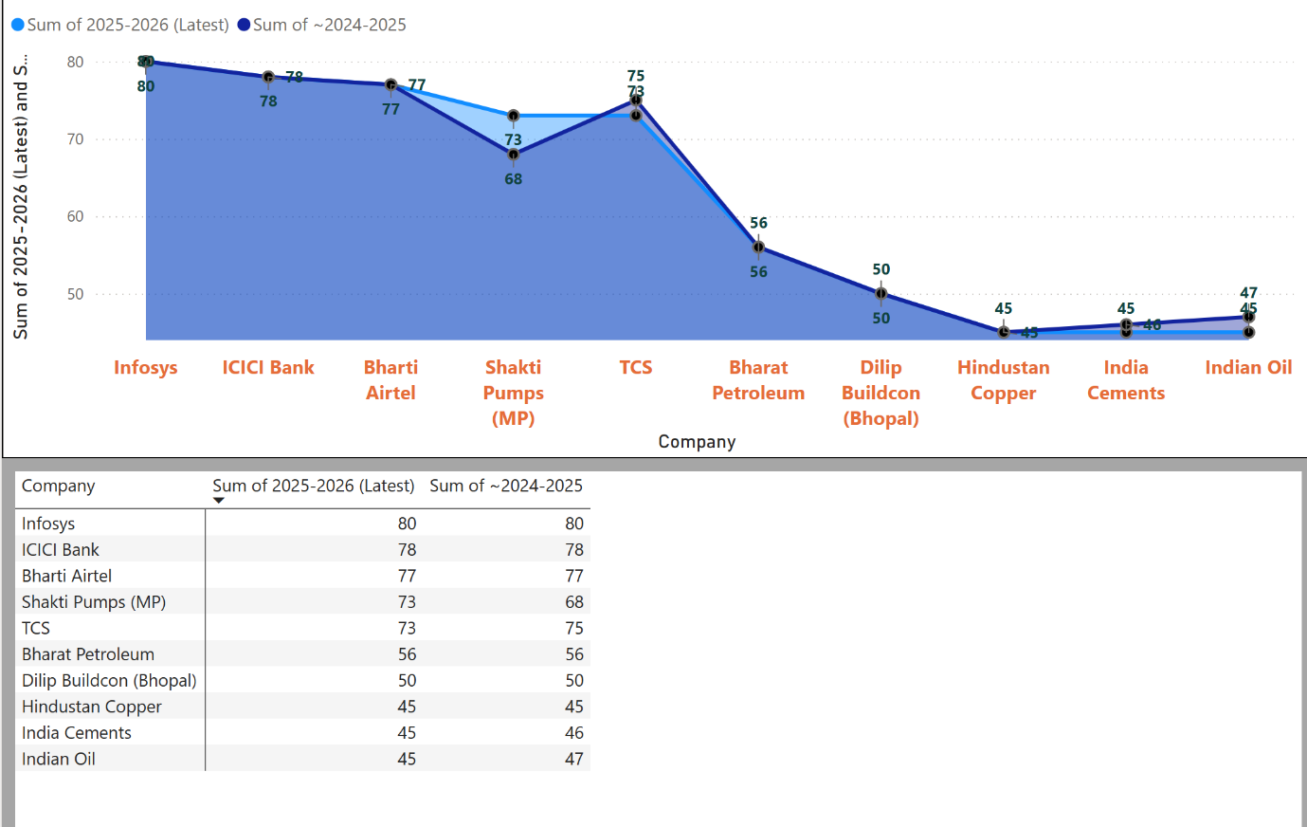
2 Financial Performance Indicators
Table 2: Return on Equity (ROE %) – FY 2021–2025
Company | FY 2021 | FY 2022 | FY 2023 | FY 2024 | FY 2025 | Trend
Infosys | 27.52% | 29.39% | 32.30% | 32.46% | 29.40% | Stable high
TCS | 38.55% | 44.13% | 47.26% | 51.04% | 52.94% | Consistent upward
ICICI Bank | 14.74% | 15.49% | 17.71% | 19.47% | 19.45% | Progressive growth
Bharti Airtel | -32.57% | -4.59% | -0.11% | 4.94% | 16.81% | Strong recovery
Shakti Pumps (MP) | 20.24% | 16.22% | 6.60% | 17.32% | 37.07% | Strong rebound
Bharat Petroleum | 30.18% | 22.50% | 3.98% | 35.51% | 16.39% | Volatile
Dilip Buildcon (Bhopal) | 7.84% | -15.45% | 0.02% | 4.44% | 12.65% | Negative swings
India Cements | 3.95% | 0.72% | -3.36% | -3.75% | -15.49% | Declining to negative
Hindustan Copper | 10.09% | 19.55% | 14.18% | 12.92% | 17.58% | Stable mid-range
Indian Oil | 21.00% | 20.97% | 8.57% | 26.71% | 7.46% | Peaks and troughs
Figure 2: Power BI – ROE Comparison (FY 2025 vs FY 2024)
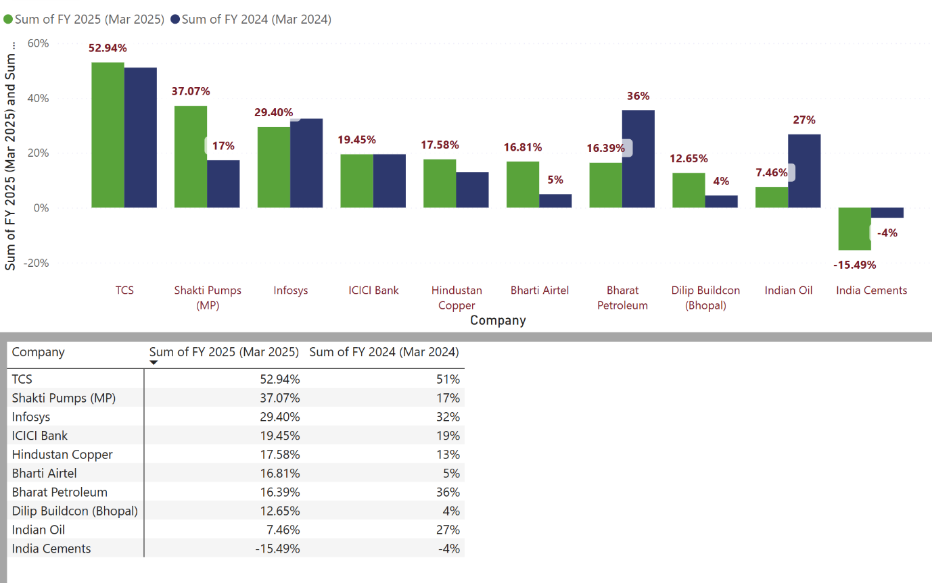
Table 3: Return on Assets (ROA %) – FY 2021–2025
Company | 2021 | 2022 | 2023 | 2024 | 2025 | Average | Trend
Infosys | 19.4 | 19.5 | 19.3 | 20.0 | 18.8 | 19.4 | Stable high
TCS | 28.3 | 31.5 | 30.4 | 32.5 | 32.6 | 31.1 | Consistently highest
ICICI Bank | 1.37 | 1.55 | 1.86 | 2.08 | 2.17 | 1.81 | Steady rise
Bharti Airtel | -7.1 | 2.48 | 3.19 | 2.01 | 8.19 | 1.75 | Turnaround
Shakti Pumps (MP) | 12.48 | 8.45 | 3.04 | 12.74 | 22.72 | 11.89 | Sharp recent jump
Bharat Petroleum | 10.04 | 6.23 | 1.13 | 13.27 | 6.11 | 7.36 | Fluctuating
Dilip Buildcon (Bhopal) | 2.39 | -3.19 | -0.01 | 1.26 | 4.63 | 1.02 | Low & volatile
India Cements | 1.8 | 0.6 | -1.4 | -2.1 | -1.0 | -0.42 | Mostly negative
Hindustan Copper | 3.8 | 13.3 | 9.9 | 9.3 | 13.0 | 9.86 | Moderate
Indian Oil | 6.0 | 6.4 | 2.7 | 9.0 | 2.7 | 5.36 | Variable
Figure 3: Power BI – ROA Comparison (2025 vs 2024)
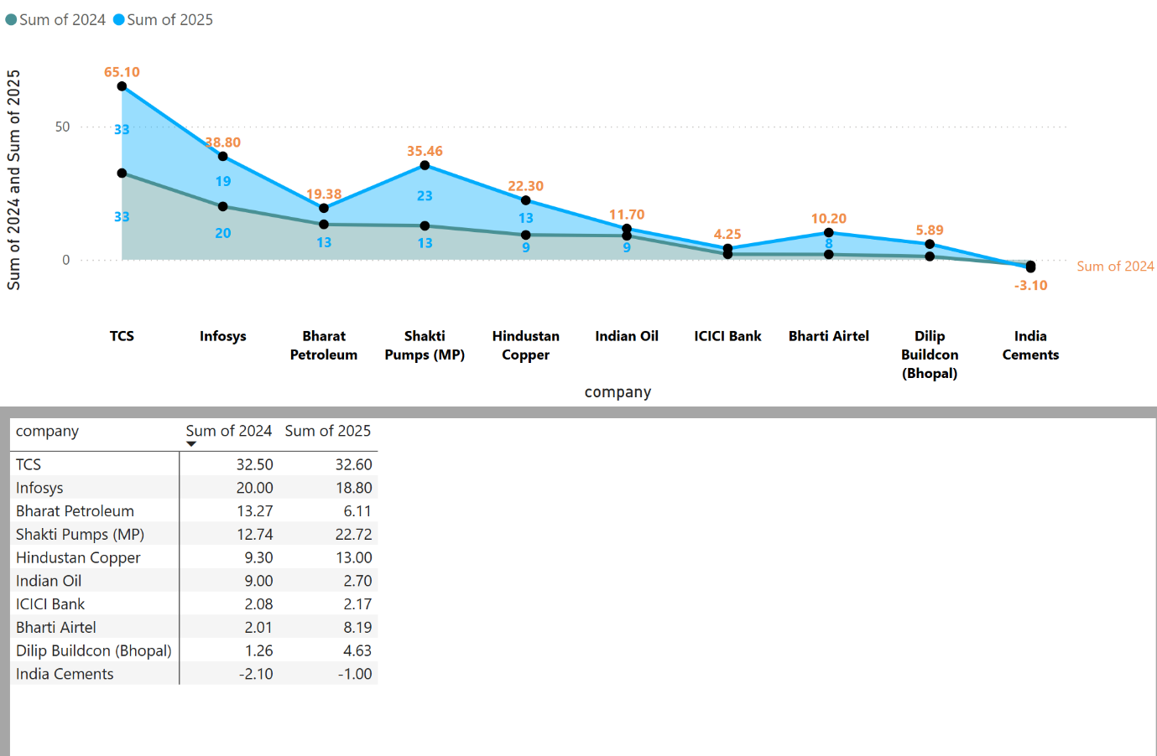
Table 4: Cost of Debt (%) – FY 2021–2025
Company | FY 2021 | FY 2022 | FY 2023 | FY 2024 | FY 2025 / Latest
Infosys | 5.00% | 4.00% | 4.70% | 5.00% | 4.72%
TCS | 8.00% | 10.00% | 9.10% | 9.00% | 9.08%
ICICI Bank | 5.00% | 6.00% | 6.00% | 5.10% | 5.10%
Bharti Airtel | 8.00% | 10.00% | 11.00% | 10.00% | 9.00%
Shakti Pumps (MP) | 10.00% | 12.00% | 10.00% | 10.00% | 10.00%
Bharat Petroleum | 10.00% | 10.00% | 11.00% | 10.00% | 10.00%
Dilip Buildcon (Bhopal) | 12.00% | 13.00% | 13.00% | 12.00% | 13.00%
India Cements | 12.00% | 13.00% | 13.00% | 12.00% | 13.00%
Hindustan Copper | 12.00% | 12.00% | 13.00% | 12.00% | 12.00%
Indian Oil | 10.00% | 11.00% | 12.00% | 11.00% | 11.00%

Figure 4: Power BI – Cost of Debt Trend (FY 2025 vs FY 2024)
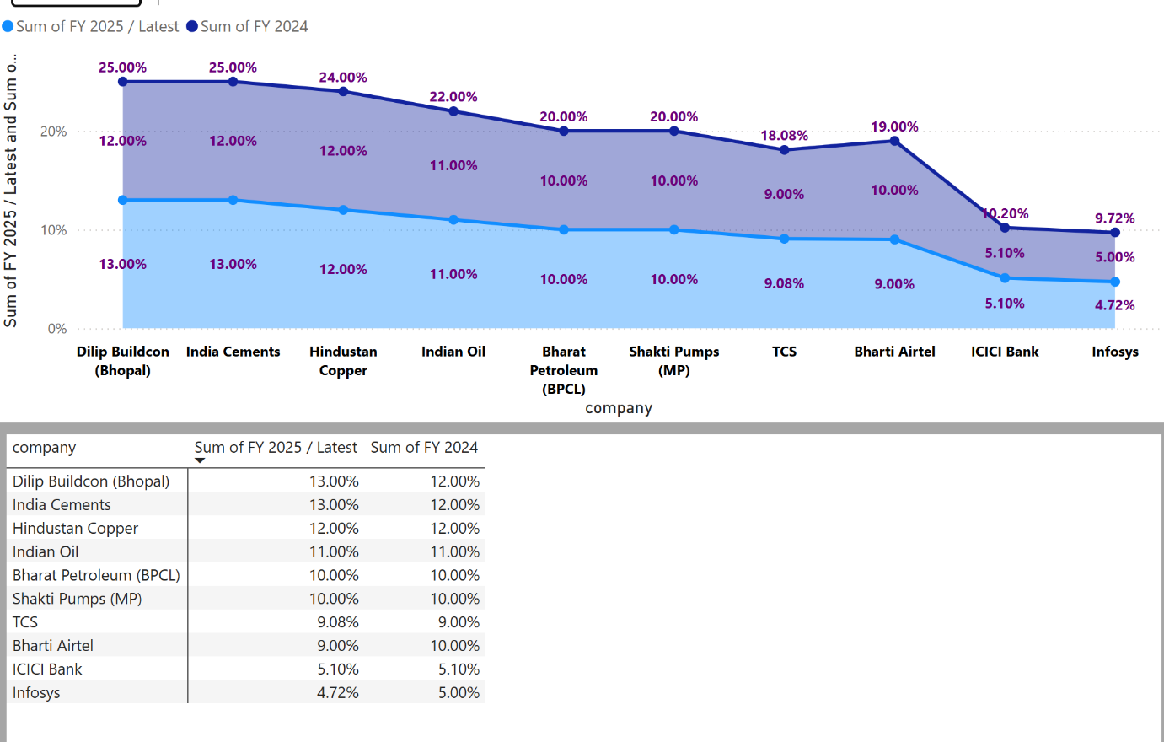

Findings of the Study
Through a side-by-side comparison of firms that adopt high versus low levels of ESG practices, it has been found that firms with higher ESG scores tend to outperform their low ESG peers on key financial measures. For example, high ESG firms (Infosys, TCS and ICICI Bank) continuously achieve above-average levels of profitability - for example, their average return on equity (ROE) was 28% – 52% and return on assets (ROA) 15% – 32%. This indicates that high ESG firms use capital efficiently and have strong operational performance. Conversely, low ESG firms (India Cements and Dilip Buildcon) perform with greater volatility, with considerable financial instability, particularly in the early years, demonstrating inefficiencies in the use of resources. The differences between the high- and low-ESG firms support the case for positive contributions towards long-term financial viability and value creation as a result of integrating ESG considerations.
The cost of debt is positively correlated with ESG performance in a significant way. In other words, companies ranked highly on the basis of their ESG policies and practices tend to pay less interest on their loans (around between 4.7% and 10%) than those with poor rankings (between 10% and 13%). This suggests that lenders will perceive high-quality ESG companies as having lower levels of inherent risk and therefore be able to secure better financing terms than businesses with poor ESG performance. It also provides evidence to support that ESG practices serve to mitigate business risk and enhance the creditworthiness of the business while also increasing investor confidence.
The association between ESG-related performance and the financial success of a company is not purely positive; non-linear characteristics exist as well. For example, Bharti Airtel (an example of a firm with extremely high ESG ratings) had low or negative profitability during analogical years early in its development, before significantly enhancing its profitability in later years. This provides support for the assertion that in many cases, companies make short-term financial sacrifices in exchange for the long-term benefits that ESG-related investments can deliver because of the costs incurred for compliance, investments made for capital projects, and transitioning to sustainable business practices. Additionally, companies within capital-intensive industries tend to achieve ESG-related returns more significantly over time, which further reinforces the argument that the financial benefits from integrating ESG into business processes can be industry and time dependent.
There are significant sectoral disparities in ESG realities. Service and technology-focused (i.e., Infosys example) sectors perform better in alignment of ESG to financial performance while infrastructure and manufacturing sectors see delay or erratic patterns in results.
ESG benefits are correlated to several features that we have isolated as being important such as:
• Industry type
• Intensity of capital
• Regulatory exposure
• Environmental impact

The data from the local companies also give localized knowledge. Shakti Pumps has seen a strong upward trend and improvement in ESG scores and financial performance related to their investment in renewable energy. Conversely, Dilip Buildcon’s lack of adoption of ESG principles has resulted in lower financial stability and increased debt costs. The comparison indicates how pertinent the adoption of ESG principles is for regional and mid-sized businesses and highlights their importance in improving a company’s competitiveness and sustainability.
The collective findings demonstrate that:
1. Profitability and operational efficiency are enhanced as a result of integrating ESG
2. Financial risks and costs associated with capital are reduced where ESG is adopted
3. Short-term costs and long-term benefits display a non-linear relationship for EGS adoption
4. ESG impacts vary based on the sector/firms having differing characteristics.

The study provides a balanced body of research demonstrating the positive impact of ESG adoption combined with paradoxes within these results, and recognizes the overall importance of sustainable finance research to support these findings.
Conclusion
This research contributes to a richer understanding of the link between ESG integration and corporate financial performance through an empirical study in India. Results show a definitive causal relationship between ESG adoption, which produces higher levels of financial performance, lower costs of debt capital, and increased operational stability. This supports the argument that sustainable finance is strategically critical for long-term value creation. Despite the evidence presented above of the positive corporate financial performance impacts attributable to ESG adoption, the study reveals contradictory evidence and transitional issues such as short-term pressures for profit and restrictions of particular industries. The ESG-performance relationship may not be a simple linear connection, but rather it is dynamic and time dependent, requiring a long-term strategic view. Given the developing economies in which emerging markets such as India exist, where regulatory frameworks and ESG public perception are still maturing, a number of factors influence the effectiveness of integrating ESG into corporate financial performance, including the type of industry, size of the company, and availability of reliable data transparency. Therefore, in light of the aforementioned transitional challenges, the adoption of ESG will ultimately be a significant factor in terms of corporate competitiveness, attracting investment, and creating long-term shareholder value.
Recommendations
For Corporate-
Firms should see ESG as an essential driver rather than just a regulatory requirement for compliance; this will allow them to create long-term value. Structuring their core business strategies and capital investments around ESG requires attaching sustainable investments, reforming governance structures, and leveraging ESG reporting transparency.
For Policymakers and Regulators
Regulators can enhance ESG frameworks such as the BRSR through the following measures:
- By Increasing Standardisation and Comparability of ESG Metrics
- Providing Incentives for High-Performing ESG Companies
- Increasing Oversight to Minimize Greenwashing Activities

For Emerging and Regional Firms
Companies, particularly in regions such as Madhya Pradesh, should leverage ESG adoption to improve access to capital, enhance market credibility and achieve sustainable growth and competitiveness
References
Ainin, S., Naqshbandi, M. M., & Dezdar, S. (2015). Impact of adoption of green IT practices on organizational performance. Quality & Quantity, 50(5), 1929–1948. https://doi.org/10.1007/s11135-015-0244-7
Almaqtari, F. A., Rehman, S., Nigam, S., & Khan, M. (2024). The impact of board structure, IT governance, and fintech on green finance and sustainability: An integrated model. Strategic Change. https://doi.org/10.1002/jsc.2623
Alshehhi, A., Nobanee, H., & Khare, N. (2018). The impact of sustainability practices on corporate financial performance: Literature trends and future research potential. Sustainability, 10(2), 494. https://doi.org/10.3390/su10020494
Archer, M. (2019). Sustainable finance. In Environmental science. Oxford University Press. https://doi.org/10.1093/obo/9780199363445-0117
Asghar, B., Wasim, A., Qazi, U., & Rasool, A. (2020). Financial and non-financial practices driving sustainable firm performance: Evidence from banking sector of developing countries. Sustainability, 12(15), 6164. https://doi.org/10.3390/su12156164
Bhattacharyya, A., & Rahman, M. L. (2020). Does sustainability performance impact financial performance? Evidence from Indian service sector firms. Sustainable Development, 28(4), 791–806. https://doi.org/10.1002/sd.2204
Cesarone, F., Martino, M. L., & Carleo, A. (2022). Does ESG impact really enhance portfolio profitability? SSRN Electronic Journal. https://doi.org/10.2139/ssrn.4007413
Chang, X., Fu, K., Jin, Y., & Liem, P. F. (2022). Sustainable finance: ESG/CSR, firm value, and investment returns. Asia-Pacific Journal of Financial Studies, 51(3), 325–371. https://doi.org/10.1111/ajfs.12379
CRISIL ESG Ratings & Analytics Limited. (2025). ESG ratings list. https://www.crisilesg.com
E. S., S., & Vennila, D. (2022). Sustainable finance: The role of Indian banks in achieving the sustainable development goals. Towards Excellence, 797–814. https://doi.org/10.37867/te140467
From Microfinance to Impact Finance: A Study on the Role of Financial Inclusion in Sustainable Rural Development in India. (2025). Journal of International Commercial Law and Technology, 6(1), 1473–1483. https://doi.org/10.61336/jiclt/25-01-135
G, J., & Jambulingam, M. (2024). The role of sustainable finance in addressing environmental, social, and governance (ESG) issues. Shanlax International Journal of Management, 11(S1-Mar), 114–123. https://doi.org/10.34293/management.v11is1-mar.8097
Gaurav Jyoti, Singhal, N., & Goyal, S. (2025). Cultivating sustainable wealth: Unraveling the impact of corporate sustainability performance on shareholders’ returns in the Indian context. Journal of Public Affairs, 25(2). https://doi.org/10.1002/pa.70044
Gupta, S., & Perwej, D. A. (2024). Exploring sustainable finance: A comprehensive analysis of its relevance in the modern banking industry. International Journal for Research in Applied Science and Engineering Technology, 12(11), 1942–1951. https://doi.org/10.22214/ijraset.2024.65533
ICRA ESG Ratings. (2025). Shakti Pumps (India) Limited: Rating rationale. https://www.icraesgratings.in
Kadaba, M. K. M., Aithal, P. S., & Sharma, K. (2022). Impact of sustainable finance on MSMEs and other companies to promote green growth and sustainable development. SSRN Electronic Journal. https://doi.org/10.2139/ssrn.4038990
Khan, I., Hou, F., & Le, H. P. (2025). Impact of sustainable finance on business financial performance: Insight from London stock exchange firms. Sustainability, 17(11), 4898. https://doi.org/10.3390/su17114898
Kim, S., & Li, Z. (2021). Understanding the impact of ESG practices in corporate finance. Sustainability, 13(7), 3746. https://doi.org/10.3390/su13073746
Kujur, O. (2023). How corporate social responsibility and sustainable development practices affect the economic performance of Indian businesses: A critical analysis. Research Square. https://doi.org/10.21203/rs.3.rs-3693228/v1
Kumar, A., Sharma, N., & Verma, S. (2025). Comparative analysis of financial performance: Traditional finance vs. sustainable finance companies in India. In Proceedings of the International Conference on Data Science and Business Systems. IEEE. https://doi.org/10.1109/ICDSBS63635.2025.11032002
Kumar, R. (2025). Impact of sustainable finance and ESG analytics. International Journal of Scientific Research in Engineering and Management, 9(6), 1–9. https://doi.org/10.55041/ijsrem50124
Kumar, S., & Verma, R. (2024). ESG factors and their impact on financial metrics: A study of stock prices and revenue correlations in banks. In MFSNE Conference Proceedings. https://doi.org/10.53486/mfsne2024.17
Maheen Ejaz, Mujtaba, G., Ashraf, M. N., & Ahmed, I. (2025). Digital transformation and green finance adoption: Mediating role of CSR and moderated by project management maturity. Journal of Business and Management Research, 4(3), 15–32. https://doi.org/10.64105/jbmr.04.03.463
Manigandan, P., Alam, M. S., Murshed, M., Ozturk, I., & Altuntas, S. (2024). Promoting sustainable economic growth through natural resources management, green innovations, environmental policy deployment, and financial development: Evidence from India. Resources Policy, 90, 104681. https://doi.org/10.1016/j.resourpol.2024.104681
Moneycontrol. (2026). Company financial ratios. https://www.moneycontrol.com
NSE Sustainability Ratings & Analytics Limited. (2025). ESG ratings. https://www.nse-esgrating.com
Padhi, A., & Mishra, S. (2025). Assessing the impact of ESG factors on sustainable finance in India: A random forest regression approach. International Journal of Environmental Sciences, 11(15s), 1249–1265. https://doi.org/10.64252/0exb4216
Patel, R., & Desai, K. (2024). Sustainable financial strategies for responsible business growth. Global Journal of Business and Finance, 2(1), 63. https://doi.org/10.59613/global.v2i1.63
Prodanova, N., & Tarasova, O. (2023). The impact of ESG principles on company profit. Cadernos de Educação, Tecnologia e Sociedade, 16(3), 685–696. https://doi.org/10.14571/brajets.v16.n3.685-696
Rao, A., Dagar, V., Sohag, K., Dagher, L., & Tanin, T. I. (2023). ESG impact on financial performance in India. Finance Research Letters, 56, 104093
Rao, P., & Kulkarni, S. (2022). Relationship between ESG and corporate financial performance: A systematic review. MAJ Cafe, 32. https://doi.org/10.60016/majcafe.v32.22
Sairam, A., & Sairam, A. (2025). Investor–sustainability–performance nexus: Evidence from ESG-compliant firms in India. International Journal for Multidisciplinary Research, 7(5). https://doi.org/10.36948/ijfmr.2025.v07i05.56809
Sharma, P., & Mehta, R. (2025). Sustainable finance: Trends, opportunities and emerging challenges. International Journal of Advanced Business and Management Research, 3(Suppl. 2), Article 0022. https://doi.org/10.62674/ijabmr.2025.v3isupp2.0022
Singhania, M., Chadha, G. K., & Prasad, R. P. (2023). Sustainable finance research: Review and agenda. International Journal of Finance & Economics. https://doi.org/10.1002/ijfe.2854
Singh, A., & Verma, P. (2024). Role of green finance in sustainable business strategies. Journal of Sustainable Practices and Innovation. https://doi.org/10.54082/jupin.379
Weber, O. (2014). The financial sector’s impact on sustainable development. Journal of Sustainable Finance & Investment, 4(1), 1–8. https://doi.org/10.1080/20430795.2014.887345
Wu, Y. (2025). ESG disclosure regulations: Corporate implementation and challenges. Journal of Global Trends in Social Science, 2(1). https://doi.org/10.70731/wm839928
Yogesh, K., Bansal, D., Arora, A. K., & Bansal, S. (2024). Sustainable finance in action: Pathways to long-term business growth in India. In Proceedings of IIPEM (pp. 1–6). IEEE. https://doi.org/10.1109/iipem62726.2024.10925716
Zhytar, M. (2025). Global trends and challenges in ESG standards implementation. Financial and Credit Systems Prospects for Development, 1(16), 33–42. https://doi.org/10.26565/2786-4995-2025-1-03

