Anti-Proxy Attendance Monitoring System with ERP Integration

Abstract : Attendance management is very important in schools to track student participation and discipline. Traditional systems use registers or roll calls which take up time and are often wrong. A big problem with these systems is attendance, where one student marks attendance for another. This results in records and damages the credibility of academic tracking. To tackle this issue we propose an AntiProxy Attendance Monitoring System integrated with ERP. The system uses biometric authentication that combines face recognition and fingerprint verification. A classroom device powered by Raspberry Pi captures students facial images with a camera and scans fingerprints with a sensor. The biometric data is checked against a registered database to ensure identification. If both biometric traits match the system records attendance automatically. The attendance data is then sent to a backend server built with Spring Boot. Stored in a MySQL database. This recorded data synchronizes with the schools ERP system for real-time monitoring. Automation reduces procedures and decreases the likelihood of proxy attendance. The system is designed to be cost-effective, scalable and easy to implement across classrooms. It also improves transparency, efficiency and trust in attendance management. This solution offers an smart approach to modern classroom attendance systems.

Keywords : Anti-Proxy Attendance System, Biometric Authentication, Face Recognition, Fingerprint Verification, Raspberry Pi, ERP Integration, Attendance Automation, MySQL Database, Spring Boot, Smart Classroom System.

Introduction

Tracking attendance is vital for institutions as it helps monitor student participation, discipline and engagement. Many colleges still depend on roll calls or paper registers. These methods take up time and are prone to errors often allowing unethical practices like proxy attendance, where one student answers for another who is absent. To address these issues automated systems using technologies have been created. Biometrics involve identifying individuals based on biological traits, such as fingerprints, facial features, iris patterns or voice recognition. Face recognition and fingerprint authentication are popular due to their reliability and ease of use. The proposed Anti-Proxy Attendance Monitoring System uses both face recognition and fingerprint verification to ensure that only the actual student can mark attendance. This system consists of a Raspberry Pi device placed in each classroom equipped with a camera and fingerprint sensor.
When a student attempts to mark their attendance both biometric traits are checked against the stored database. The system also links attendance records with the institution’s ERP system allowing real-time tracking, automated reporting and easy access for faculty and administrators. This method greatly enhances the accuracy, security and efficiency of attendance management systems in schools.

- Problem Statement

I. Attendance management systems in schools often have limitations. Manual methods require teachers to call student names and record attendance in registers or spreadsheets. This process eats into lecture time. Increases faculty administrative tasks.
II. A significant issue with attendance systems is proxy attendance. Students may answer for their friends during roll calls or alter attendance records leading to data. This undermines monitoring and damages the credibility of attendance records.
III. Many existing automated systems rely on authentication methods like RFID cards or fingerprint scanning. RFID cards can easily be passed among students facilitating attendance. Fingerprint systems alone can also encounter challenges to sensor errors worn fingerprints or improper scans.
IV. Additionally many attendance systems operate separately from ERP systems. This leads to data entry, duplicated records and delays in updating attendance reports. Thus there is a need for a automated and integrated attendance system that can eliminate proxy attendance reduce manual work and provide accurate real-time attendance tracking.

II . Novelty and Contributions

The major contributions of this work are:

* The proposed system features authentication using both face recognition and fingerprint verification greatly improving student identification accuracy and reducing proxy attendance compared to single biometric systems.
* Designed as a classroom device using Raspberry Pi, a camera and a fingerprint sensor one device at the classroom entrance can manage attendance for all students making it cost-effective and scalable.
* The proposed system automatically synchronizes attendance records with the ERP system allowing faculty and administrators to access data instantly without manual input.
* Marking attendance is fully automated and requires involvement from students.
Face recognition enables identification while fingerprint verification provides secure confirmation.
* The system boosts security by verifying two biometric traits before marking attendance ensuring that only authorized students can record their presence and enhancing the reliability of attendance records.

- Related Work

Several studies have examined automated attendance systems to address the shortcomings of traditional methods. Conventional attendance processes that rely on paper registers or roll calls are time-consuming and error-prone. Researchers have proposed technology-based solutions, including RFID, fingerprint systems and face recognition systems. One of the automated approaches used RFID technology, where students carry RFID cards scanned by a reader to record attendance. Although these systems reduce effort they still allow proxy attendance due to card sharing among students. This limits the reliability of RFID attendance systems.
Researchers later developed fingerprint biometric attendance systems capitalizing on the stable nature of fingerprints. Students enroll their fingerprints in the database and during attendance their fingerprints are compared to stored data. This method enhances security and addresses card-sharing issues seen in RFID systems. However fingerprint-only systems can still face sensor errors, hygiene issues or problems recognizing worn fingerprints. Another studied approach is face recognition attendance systems, which capture students faces using a camera and identify them with computer vision algorithms. Face recognition offers a contactless method of marking attendance in time without physical interaction with the device.
Various algorithms, including Haar Cascade and learning-based convolutional neural networks have been utilized. Although these systems minimize tasks and improve efficiency they can struggle with lighting variations or similar facial features. Recent research has focused on biometric systems combining different biometric traits to enhance accuracy and lower the chances of errors or proxy attendance. Some studies integrate attendance systems with IoT and cloud platforms for real-time monitoring and remote data access using microcontrollers and cameras to send attendance records to databases. Despite the number of proposed systems most rely on a biometric method or lack ERP integration. Therefore there remains a need for a automated and integrated attendance system that combines multiple biometric methods and supports ERP integration for efficient management.

- Proposed System

The Anti-Proxy Attendance Monitoring System with ERP Integration is designed to stop proxy attendance and automate attendance management in institutions.
This system uses two ways to check who students are: face recognition and fingerprint verification. By using both methods it becomes more reliable. Reduces the chances of someone marking attendance for another student.

- System Architecture

The system has a device in the classroom that connects to a server and database. This device has a computer called Raspberry Pi, a camera and a fingerprint sensor that collect student data. The Raspberry Pi processes this data sends it to a server built using Spring Boot, where it is stored in a MySQL database. The attendance data is then added to the ERP system for monitoring and record management.

- Working Principle

* Students first register with the system, which stores their student ID face image and fingerprint in the database.
* When a student enters the classroom the camera takes a picture of their face to identify them.
* After face recognition the system asks the student to scan their fingerprint.
* The system then compares both inputs with the stored data.
* If both biometric checks are successful the system automatically records the attendance with date and time.
* The attendance record is then sent to the server, updated in the ERP system.

C. Security and Reliability Features

* The system uses face recognition and fingerprint verification to ensure student identification.
* This method reduces the chances of attendance compared to systems.
* Biometric data is stored safely in the database improving data safety.
* Authorized students can mark attendance preventing access.
* ERP integration ensures storage, real-time monitoring and easy access to attendance records for faculty and administrators.

- Methodology

Proposed system starts with students registering. They give their details and the system The stores their images and fingerprints in the database. When a student walks into the classroom the camera takes a picture of their face checks it against the stored images to see who they are. Then the fingerprint sensor checks their fingerprint to make sure it is really them. If both the face and fingerprint match what is stored the system marks them as present.
This information is then sent to the server stored in the database and updated in the schools system so everyone can see it in time.

- Student Registration

First students sign up for the system before the semester starts. The person in charge enters the students information, like their student ID, name, department and class. The system takes a picture of the students face makes a code for it so it can tell who they are. At the time the fingerprint sensor scans the students fingerprint and makes a template for it. All of this information including the students details and biometric information is stored safely in the database.

B. Timetable Configuration

Next the system sets up the schedule for each classroom. This includes what time the lectures are, what subject is being taught and who the teacher is. The system uses this schedule to decide when to mark attendance. Students can only mark themselves present during the time they are supposed to be, in class, which stops them from marking themselves present when they are not supposed to be.

- Face Recognition Process

When a student comes up to the attendance device the camera takes a picture of their face. The system then looks at the picture. Finds the special features of the face.
* It uses an algorithm to do this.
* The system compares these features to the information stored in the database when the student registered. Next the system sets up the schedule for each classroom. This includes what time the lectures are, what subject is being taught and who the teacher is. The system uses this schedule to decide when to mark attendance. Students can only mark themselves present during the time they are supposed to be, in class, which stops them from marking themselves present when they are not supposed to be.

- Fingerprint Verification

After the system recognizes the students face it asks them to put their finger on the fingerprint sensor. The sensor scans the fingerprint. Turns it into a digital template. This template is then compared to the fingerprint data stored for the student. If the fingerprints match the system is sure it has the student.
The system uses the students images and fingerprints to verify their identity. This information is used to mark their attendance in the system.

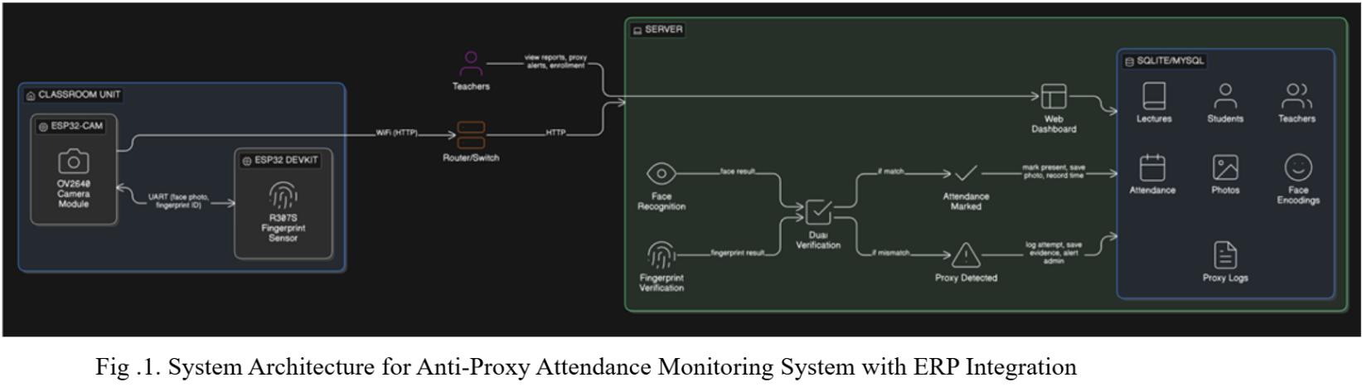
The Anti-Proxy Attendance System is made up of hardware, communication networks and a central server to manage attendance securely.
This system has three parts:
* The classroom unit
* The communication network
* The server-side processing system
These parts work together to verify the identity of students through face recognition and fingerprint verification.
This makes sure that attendance is recorded correctly and prevents someone from marking attendance for another student.

1. Classroom Unit

The classroom unit is used to capture the data of students when they mark their attendance.
* It has an ESP32-CAM module with a camera and an ESP32 DevKit connected to a fingerprint sensor. The camera takes a picture of the students face. The fingerprint sensor scans the students fingerprint.
* The ESP32 microcontroller processes this data. Sends it to the server to verify.
* Using both face and fingerprint data makes the attendance system more accurate and secure.

2. Communication Network

The communication network connects the classroom hardware unit to the server. The ESP32 module sends the data it captured like images and fingerprint identification through Wi-Fi using the HTTP protocol via a router or network switch. This network layer lets the classroom device. The server communicate in real-time allowing for fast verification and immediate attendance recording.

3. Server Processing Module
The server is the part of the system that does face recognition and fingerprint verification using the data it gets from the classroom unit.
* The server compares the data it received with the templates stored in the database.
* The system uses a dual verification mechanism where both face recognition and fingerprint authentication must match the stored records to confirm the students identity.

4. Dual Verification and Decision Module

The dual verification module looks at the results from face recognition and fingerprint verification.
* If both biometric inputs match the stored records the system marks the student as present. Records the attendance with a timestamp.
* If the biometric inputs do not match the system identifies it as someone trying to mark attendance for another student. Sends an alert.
* This mechanism really reduces the chances of someone marking attendance for another student without permission.

5. Database Management System

The system uses a SQLite or MySQL database to store and manage all the data related to attendance.
* The database keeps records like student details, teacher information, lecture schedules, attendance logs, facial encodings, fingerprint data and captured images.
* If the system detects someone trying to mark attendance for another student it logs the attempt. Stores the evidence for the administration to review.

6. Web Dashboard for Administration

There is a web-based dashboard for teachers and administrators to interact with the Anti-Proxy Attendance System.
* Through this dashboard teachers can view attendance reports monitor alerts about someone trying to mark attendance for another student and manage student enrollment.
* The dashboard also lets administrators access attendance records verify attempts to mark attendance for another student and maintain system data efficiently.
The Anti-Proxy Attendance System helps to make sure that attendance is recorded correctly and prevents someone from marking attendance for another student.
The Anti-Proxy Attendance System is a tool for schools and universities.

- Hardware Implementation

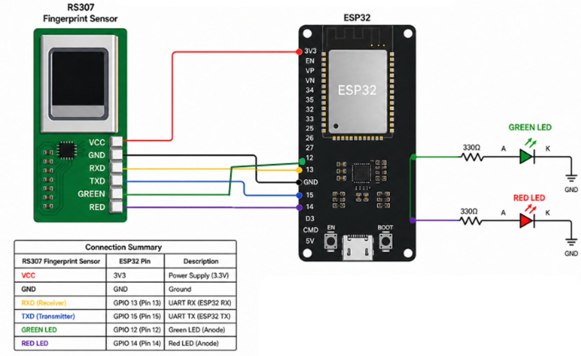

Fig .2. Hardware Implementation of Attendance System

The proposed system integrates an RS307 fingerprint sensor with the ESP32 microcontroller to perform biometric-based authentication. The hardware architecture is designed to ensure reliable communication, low power consumption, and real-time user feedback through visual indicators.

A. System Overview
The system is designed using three principal hardware elements:
1.Fingerprint Recognition Module (RS307)
2.Controller (ESP32)
3.Output Display (LEDs)
The RS307 sensor detects fingerprints, processes their information, and sends it to the ESP32 using UART communication. The ESP32 controls all operations and acts as an authentication controller.

B. Power Supply Configuration
The power supply of the RS307 fingerprint module is based on 3.3 volts, generated by the built-in power supply unit of the ESP32 board. A shared ground allows both components to communicate without signal interference.

C. UART Communication Interface
A connection of the fingerprint scanner to the controller is set up using UART interface that allows serial data transfer.
- RXD Pin of the RS307 Sensor is connected to the GPIO 13 of ESP32 to receive data.
- TXD Pin of the RS307 Sensor is connected to the GPIO 15 of ESP32 for sending commands.
Thus, a full-duplex communication system has been created.
C. UART Data Interface
UART protocol is used as the interface for communicating with the fingerprint sensor by the ESP32, which supports asynchronous serial data transfer.
Connection of RXD to GPIO 13 allows the ESP32 to communicate by receiving data from the sensor.
Meanwhile, connecting TXD of the sensor to GPIO 15 enables sending commands from the ESP32 to the sensor.
Such an arrangement ensures full-duplex communication where fingerprint data, authentication commands, and responses can be transferred.
D. Indicator Status System
Two LEDs are used to notify the user of authentication status in real-time:
- Green LED (success notification):
Connected to GPIO 12 via a current-limiting resistor of 330Ω, this LED will light up when a successful fingerprint matching occurs.
- Red LED (failure notification):
Connected to GPIO 14 via a resistor of 330Ω, this LED will light up when authentication fails.
Use of resistors is necessary as they prevent current overload and thus ensure safety of both LEDs and the GPIO ports.
F. Design Features
The design features of the hardware include:
Energy conservation: Through use of the ESP32's 3.3 volts power supply, external regulators will not be required.
Data reliability: Use of UART for communication ensures error-free information transmission.
Scalability: The design allows for easy connection of the device to the cloud ERP/IoT systems.
Compactness: Few components have been employed in the design.

VII . Result and Discussion
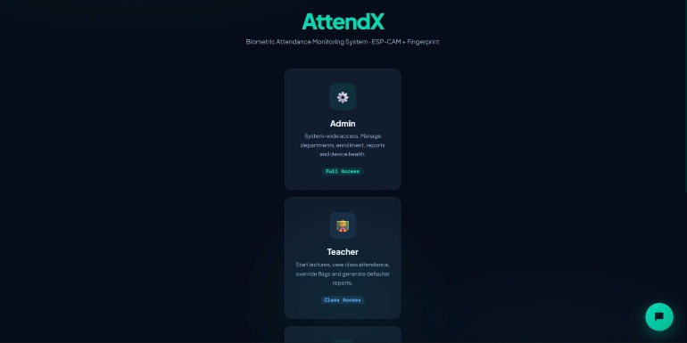

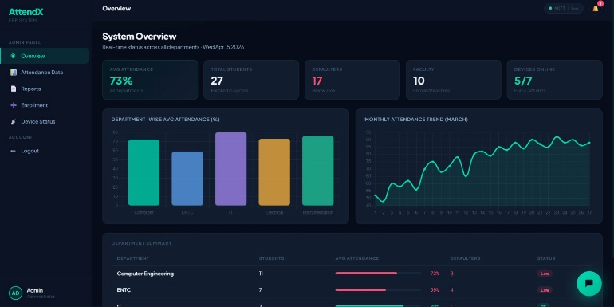Fig 3 . Result and software overview of the system
- Results
The proposed system got some results.
* Accurate Attendance Recording: The system uses two ways to check who is present. It looks at your face and your fingerprint. This means that only the real students can be marked as present.
* Elimination of Proxy Attendance: Since the system checks both face and fingerprint it is very hard for someone to attend a class for another student.
* Automation of Attendance Process: The Attendance system works automatically. It does not need anyone to do anything manually. This saves time during lectures.
* Real-time Data Synchronization: When a student attends a class the Attendance data is updated away in the ERP system. This means that teachers can see who is attending classes at any time.
* Improved Efficiency: The system helps teachers by reducing the work they have to do. It also means that they do not have to enter data.
* Secure Data Handling: The system stores the data like face and fingerprint in a place.
* Scalable System: The system can be used in classrooms. It can work with hardware like Raspberry Pi and ESP32.
The proposed system got some results.

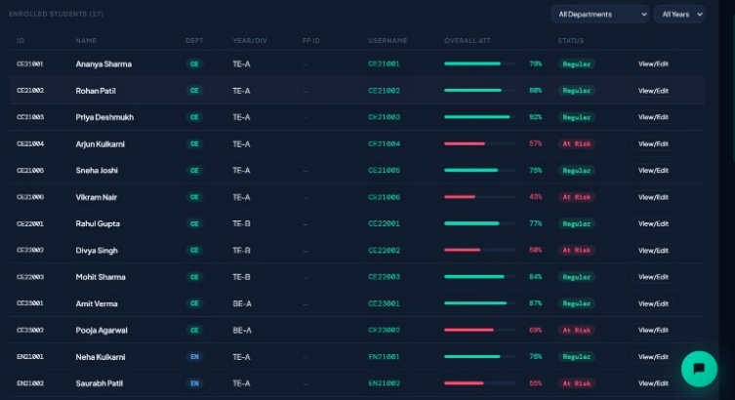
Fig .4. Overall attendance records of the students

- Discussion

System Type | Limitation
Manual | Time-consuming, error-prone
RFID | Proxy possible
Fingerprint | Sensor issues
Face Recognition | Environmental dependency
Proposed System | Highly secure & accurate

- Future Scope
Here are the features:
a. We have a system that uses artificial intelligence to recognize faces.
b. The information is stored on the internet so you can get to it from anywhere.
c. There is an app for attendance tracking, which is really helpful.
d. The system also works with campus systems, which is great, for schools and universities.

VI . Conclusion

The Anti-Proxy Attendance System is a way to stop people from attending classes for others in schools and colleges. It uses face recognition and fingerprint verification to make sure that the person attending the class is really who they say they are. This system has a device called the ESP32 module and some sensors that help to automatically record attendance and send the information to the server right away. The Anti-Proxy Attendance System is made up of a parts that work together really well. There is a part that is used in the classroom a server and a database. All of these parts work together to make sure that attendance records are stored and managed in a way. The Anti-Proxy Attendance System also has a web-based dashboard that makes it easy for teachers and administrators to check attendance look at reports and find out if someone is trying to attend a class for someone. The Anti-Proxy Attendance System is also very good at detecting when someone is trying to attend a class for someone. It keeps a record of these attempts. This helps to make sure that everything is fair and honest.
The Anti-Proxy Attendance System is a help because it reduces the amount of work that people have to do and it also reduces the number of mistakes that people make. It helps to make sure that attendance records are accurate and reliable. The Anti-Proxy Attendance System can be used in places, such as classrooms, laboratories and other academic environments.
It is also a system that can be made better in the future. For example it could use some techniques to recognize peoples faces. It could use cloud-based storage to make it even more secure and efficient. This would make the Anti-Proxy Attendance System a powerful tool for managing attendance in schools and colleges.

References

[1] S. Arya, H. Mesariya, and V. Parekh, “Smart Attendance System Using CNN,” arXiv preprint arXiv:2004.14289, Apr. 2020.
[2] S. Dev and T. Patnaik, “Student Attendance System Using Face Recognition,” in Proc. IEEE Int. Conf. Smart Electronics and Communication (ICOSEC), 2020, pp. 90–96.
[3] K. Preethi and S. Vodithala, “Automated Smart Attendance System Using Face Recognition,” in Proc. IEEE Int. Conf. Intelligent Computing and Control Systems (ICICCS), 2021, pp. 1552–1555.
[4] S. Verma and A. Singh, “Design of Automated Face Recognition Attendance System Using OpenCV,” Procedia Computer Science, vol. 167, pp. 259–267, 2022.
[5] K. Nguyen and T. Pham, “Edge Computing-Based Face Recognition Using Embedded Systems,” IEEE Access, vol. 10, pp. 45120–45130, 2022.
[6] A. Rao, “AttenFace: A Real-Time Attendance System Using Face Recognition,” arXiv preprint arXiv:2211.07582, 2022.
[7] T. Brown and S. Miller, “Face Recognition Based Smart Classroom Attendance System,” in Proc. IEEE Int. Conf. Computing and Communication, pp. 112–118, 2023.
[8] “An Automated Attendance System Using Facial Detection and Recognition Technology,” International Journal of Engineering Research, 2023.
[9] A. Choudhary et al., “Facial Recognition Based Attendance System Using Machine Learning Models,” in Proc. IEEE Int. Conf. Signal Processing and Advanced Research Computing (SPARC), 2024.
[10] S. Purnapatra et al., “Liveness Detection Competition—Noncontact-Based Fingerprint Algorithms and Systems (LivDet-2023),” arXiv preprint arXiv:2310.00659, 2023.

