Assessment of Motivational Factors as Correlates of Librarians’ Job Satisfaction
in Libraries of Two Federal Universities in South-South, Nigeria

Abstract
Purpose: This study investigated motivational factors as correlates of librarians’ job satisfaction in libraries of two federal universities in South-South, Nigeria. The study sought to establish the nature and strength of the relationship between two selected motivational factors — training and development, and salary/wages — and the job satisfaction of librarians.
Design/Methodology/Approach: A correlational research design was adopted for the study. The entire population of 60 librarians across the University of Calabar and the University of Benin constituted the study sample, using a census enumeration technique. Data were collected through a researcher-designed rating scale (RSMFCLIS) comprising 35 items rated on a four-point Likert scale. Mean scores, standard deviations, Pearson Product-Moment Correlation Coefficient, t-test statistics, and F-test multiple regression were used to answer the research questions and test the hypotheses at the 0.05 level of significance.
Findings: Results revealed a significant positive relationship between training and development and librarians’ job satisfaction (r = .61, R² = 0.37; tcal = 9.68 > tcrit = 1.96, p < 0.05). A significant positive relationship was also found between salary/wages and librarians’ job satisfaction (r = .67, R² = 0.45; tcal = 11.34 > tcrit = 1.96, p < 0.05). Both null hypotheses were rejected. Salary/wages emerged as the stronger correlate, accounting for 45% of the variation in librarians’ job satisfaction.
Implication: The findings imply that the adequacy of training and development opportunities and the timely disbursement of competitive salaries are critical determinants of librarians’ job satisfaction in federal university libraries. Where these motivational factors are inadequate, job dissatisfaction, declining service quality, and low morale are likely consequences, with negative implications for the academic mission of the university.
Originality/Value: This study contributes to the limited body of literature on motivational factors and librarian job satisfaction specific to the South-South geopolitical zone of Nigeria. It provides empirical evidence and practical recommendations for university library management and policy makers on the motivational strategies most likely to improve the job satisfaction and performance of academic librarians.
Keywords: Motivational Factors; Job Satisfaction; Training and Development; Salary/Wages.
Paper type: Empirical Research

Introduction
Motivation is widely recognised as a fundamental driver of employee productivity and organisational effectiveness. Akerele (2023) and Ramchandani (2024) affirmed that employee motivation is a critical factor in enhancing organisational performance, influencing productivity, job satisfaction, and employee retention. A motivated worker is not only happier but more committed and productive in their role. While financial incentives have traditionally been emphasised, recent research highlights the growing importance of non-financial motivators such as recognition, professional development, and organisational culture (Argyropoulou, 2023; Pandya, 2024). In the library context, Abdulraheem (2024) confirmed that motivational factors such as job security, opportunity to utilise abilities, and professional recognition significantly determine the job performance of library staff in Nigerian academic libraries.

Factors of Motivation among Librarians
For the purpose of this study, the two motivating factors examined are staff training and development, and salary/wages.

Staff Training and Development
Training and development is the process of systematically building work-related knowledge and expertise in employees for the purpose of improving performance. Saba, Udoudoh, and Babalola (2022) examined the influence of in-service training on the job performance of librarians in federal university libraries in South-South, Nigeria, and found that in-service training had a significant positive influence on librarians’ performance. Similarly, Osiesi. (2022) assessed professional development and training in Federal University Oye-Ekiti and confirmed that staff development programmes significantly enhance job performance, recommending that universities invest in conferences, workshops, study visits, and Tet-fund-sponsored programmes for library staff. Library management must design and implement robust training programmes that equip librarians with the skills to meet the demands of new technologies, emerging information management techniques, and evolving user needs.
Conferences: A conference remains a vital formal gathering where professionals converge to exchange knowledge and explore field-specific solutions. Recent evidence suggests that attendance is a significant predictor of initiative and proactivity within organizations, as it exposes participants to emerging trends and innovative practices (Babalola, 2025). Beyond information exchange, modern researchers emphasize that conferences facilitate "building belonging" through informal social means that are critical to career longevity (Hauss, 2020).
Seminars: A seminar is a form of structured academic instruction, offered either at an academic institution or through a professional or commercial organisation. Its primary function is to bring together small groups for focused discussions on specific subjects, often through Socratic dialogue or formal research presentations. Seminars enable employees to become conversant with current methodologies in their disciplines, examine practical problems in their field, and engage in critical debate.
Workshops: A modern training workshop is defined as an intensive, collaborative session where participants shift from passive recipients of information to active co-creators of knowledge (King & LaRocca, 2022). In the library and information science (LIS) sector, these workshops are essential for bridging the "skills gap" created by rapid technological shifts, such as AI integration and data management.

Salary/Wages
The view that a happy worker is a productive worker has long been held in the business world, and financial remuneration remains one of its key underpinnings. Adekunle and Gbadebo (2024) found that employees’ pay has a positive and significant relationship with job satisfaction in Nigerian enterprises, confirming that salary satisfaction directly motivates psychological well-being in the Nigerian employment context. Ogwu, Umeh, and Bako (2023) further demonstrated that compensation systems significantly influence employee commitment in Nigerian organisations, while Ohunakin and Olugbade (2022) established that employees’ perceived compensation system directly influences job performance and turnover intentions.
Salary administration is the process of compensating an organisation’s employees in accordance with accepted policies and procedures (Olatunji & Sarat, 2014).

Statement of the Problem
No university library can function optimally without a motivated and satisfied workforce. Librarians are the principal personnel who animate the library and make it functional as a hub of learning, teaching, and research. Motivation acts as a psychological force that directs a librarian’s behaviour and sustains their commitment to institutional goals. Despite its importance, the issue of librarian motivation is frequently marginalised by policy makers. Aim and Objectives of the Study
The main aim of this study is to assess motivational factors as correlates of librarians’ job satisfaction in two federal universities in South-South, Nigeria. The specific objectives are to:
- identify the relationship between training and development and librarians’ job satisfaction in libraries of federal universities in South-South, Nigeria.
- ascertain the relationship between salary/wages and librarians’ job satisfaction in the study area.
Research Questions
The following research questions guided the investigation:
- What is the relationship between training and development and librarians’ job satisfaction in libraries of federal universities in South-South, Nigeria?
- What is the relationship between salary/wages and librarians’ job satisfaction in the study area?

Conceptual and Empirical Review
The relationship between an institution and its workforce is fundamentally shaped by the factors that motivate employees and the level of satisfaction they derive from their work. Motivation determines the intensity, direction, and persistence of effort, and is therefore a critical driver of employee performance and organisational productivity. Dlamini (2022) affirmed that employee performance is essential for organisational growth, while Pandey (2024) emphasised that motivation plays a central role in enabling such growth. Recent scholarship has further expanded understanding of motivation in organisational settings. Ahmad (2024) reported that high motivation is associated with improved performance and innovation, while Chen and Kanfer (2024) highlighted the importance of situating motivation within cultural and organisational contexts. In the library sector, Oluwafemi(2025) found that both intrinsic and extrinsic motivational factors significantly influence librarians’ performance in Nigerian public universities.
Job Satisfaction: Concept and Definition
Job satisfaction is a central construct in organisational behaviour and refers to the extent to which employees feel positively or negatively about their jobs. It encompasses employees’ emotional responses, attitudes, and perceptions regarding various aspects of their work, including job tasks, work environment, compensation, and opportunities for advancement. Locke (1976) defined job satisfaction as a pleasurable or positive emotional state resulting from the appraisal of one’s job or job experiences. This definition underscores the psychological and affective nature of job satisfaction as an outcome of work-related experiences.
Within the library and information science context, job satisfaction reflects the degree to which librarians feel fulfilled in their professional roles. It includes satisfaction derived from service delivery, professional recognition, access to training opportunities, interpersonal relationships, and working conditions. Igbokwe (2011) identified salary, promotion opportunities, interpersonal relationships, and working conditions as key determinants of job satisfaction among librarians in Nigerian federal universities. Job satisfaction is multidimensional, encompassing both intrinsic factors (such as achievement, recognition, and responsibility) and extrinsic factors (such as salary, job security, and working conditions). Herzberg’s two-factor theory explains this distinction by categorising intrinsic factors as motivators and extrinsic factors as hygiene factors that prevent dissatisfaction.

Relationship between Motivation and Job Satisfaction
Motivation and job satisfaction are closely related but conceptually distinct constructs. Motivation refers to the forces that initiate and sustain work-related behaviour, whereas job satisfaction represents the emotional and attitudinal outcome of such behaviour. Theoretically, motivation is widely regarded as an antecedent of job satisfaction. When employees are adequately motivated through both intrinsic and extrinsic factors, they are more likely to experience higher levels of satisfaction. Herzberg’s two-factor theory posits that motivators such as achievement and recognition enhance satisfaction, while hygiene factors such as salary and working conditions prevent dissatisfaction. Similarly, Maslow’s hierarchy of needs suggests that fulfilment of employees’ needs leads to positive work attitudes, including job satisfaction. Empirical studies have consistently demonstrated a strong relationship between motivation and job satisfaction. Abdulraheem (2024) found that motivational factors such as salary, job security, and recognition significantly influence job satisfaction among library staff. Ajala (2023) also reported that motivation significantly predicts job satisfaction among librarians in Nigerian universities.

Empirical Review
Several empirical studies have examined motivation and job-related outcomes in organisational and library contexts. Igbokwe (2011) found that salaries, promotion opportunities, interpersonal relationships, and working conditions significantly determine librarians’ job satisfaction in federal university libraries in South-East Nigeria. Ajie, Soyemi, and Omotunde (2015) reported that personnel motivation correlates with organisational commitment among library staff in Lagos State.
Lamptey, Boateng, and Antwi (2013) identified low motivation as a major factor affecting the performance of librarians in Ghanaian universities. More recently, Ajala (2023) found that motivational factors such as responsibility, achievement, and job security significantly influence job satisfaction among librarians in Southern Nigeria. With specific reference to training and development, Osiesi (2022) confirmed that professional development programmes significantly improve job performance among library staff, while Saba (2022) found that in-service training has a strong positive influence on librarians’ performance in South-South Nigeria.
Regarding salary and compensation, Adekunle and Gbadebo (2024) established a positive relationship between employee pay and job satisfaction in Nigerian enterprises. Ogwu, Umeh, and Bako (2023) also found that compensation systems significantly influence employee commitment, while Ohunakin and Olugbade (2022) demonstrated that perceived compensation affects both job performance and turnover intentions. Collectively, these studies highlight the importance of both financial and non-financial motivational factors in shaping employee outcomes, including job satisfaction.

Research Design
A correlational research design was adopted for this study. As described by Nworgu (2006), a correlational design examines the co-variation between two or more variables, determining whether changes in one variable are systematically associated with changes in another. This quantitative approach was selected because it is appropriate for measuring the nature and extent of the relationship between motivational factors and librarians’ job satisfaction. Figure 1 below illustrates the sequential stages of the research design, from the identification of the research problem through to the generation of findings and conclusions.
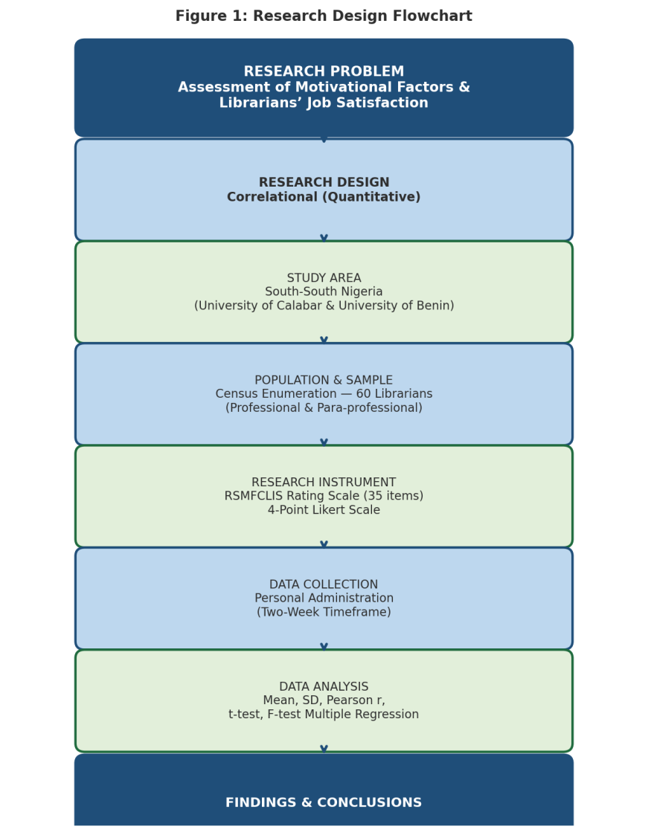
Figure 1: Research Design Flowchart

Area of the Study
The study was conducted in the South-South geopolitical zone of Nigeria, one of the country’s six geopolitical zones. The zone comprises six states: Akwa Ibom, Bayelsa, Cross-River, Delta, Edo, and Rivers State. Two federal universities in the zone were selected, as summarised in Table A below.
Table A: Selected Institutions in the Study Area
University | State | Zone | Library Type
University of Calabar (UNICAL) | Cross-River State | South-South Nigeria | Federal University Library
University of Benin (UNIBEN) | Edo State | South-South Nigeria | Federal University Library

Population of the Study
The study population comprised all librarians in the two selected federal university libraries. A total of 60 copies of the research instrument were administered across both institutions. Table B presents the full breakdown of the population by institution and staff category, while Figure 2 provides a visual representation of the distribution.
Table B: Population Distribution by Institution and Staff Category
Institution | Professional Librarians | Para-professional Librarians | Total
University of Calabar | 20 | 10 | 30
University of Benin | 21 | 9 | 30
Total | 41 | 19 | 60

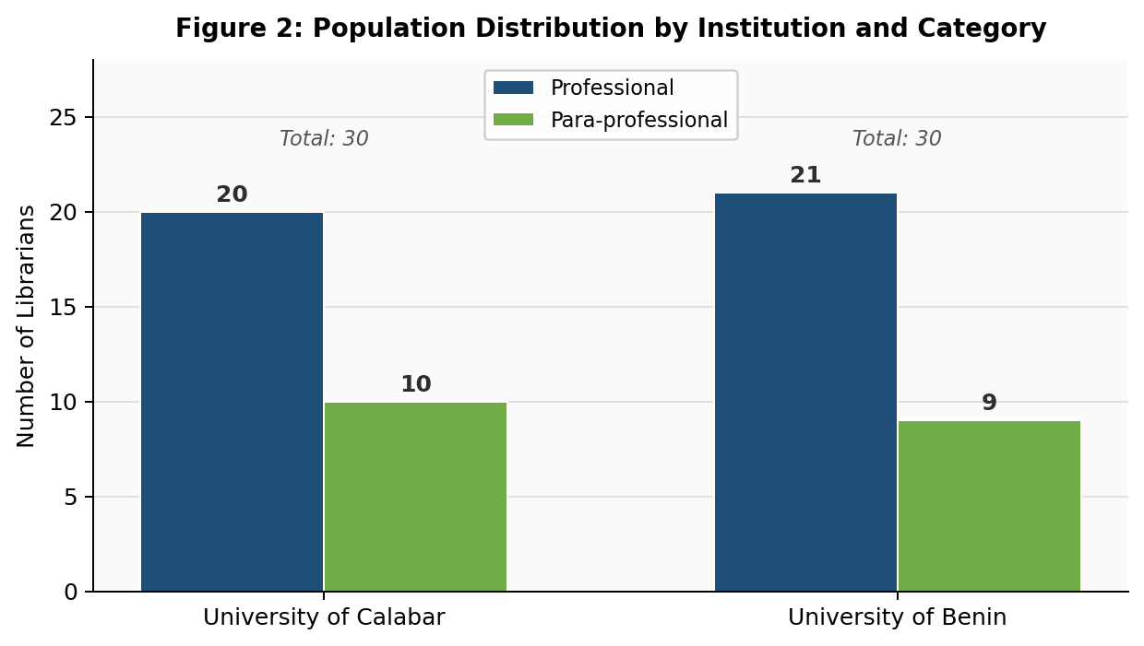
Figure 2: Population Distribution by Institution and Category

Sample and Sampling Technique
Given that the population was relatively small and manageable, a census enumeration technique was adopted, whereby the entire population of 60 librarians constituted the study sample. This approach ensures that findings are fully representative of all librarians in the selected institutions.
Table C summarises the sampling outcome.
Table C: Summary of Sample and Sampling Technique
Sampling Technique | Population Size | Sample Size | Sampling Ratio
Census Enumeration | 60 Librarians | 60 Librarians | 100%

3.5 Research Instrument
A researcher-designed rating scale titled “Rating Scale on Motivational Factors as Correlates of Librarians’ Job Satisfaction” (RSMFCLIS) was used for data collection. The instrument comprised 35 items arranged in two major sections. Section A elicited background information on respondents, while Section B captured responses on motivational factors and librarians’ job satisfaction. Items were rated on a four-point Likert scale: Strongly Agree (4), Agree (3), Disagree (2), and Strongly Disagree (1). Table D presents the structure of the instrument.
Table D: Structure of the Research Instrument (RSMFCLIS)
Section | Content Focus | Clusters/Subscales | No. of Items | Scale
A | Respondent Background Information | — | 5 | —
B — Part I | Motivational Factors | Training & Development / Salary/Wages | 15 | 4-Point Likert
B — Part II | Librarians’ Job Satisfaction | Clusters A–G (5 items each) | 35 | 4-Point Likert
Likert Scale Key: Strongly Agree (SA) = 4 Agree (A) = 3 Disagree (D) = 2 Strongly Disagree (SD) = 1

Method of Data Collection
The rating scale was administered personally by the researchers with the assistance of trained research assistants. Respondents were given a two-week window to complete the instrument, ensuring sufficient time for thoughtful and accurate responses. All completed copies were personally retrieved at the end of the stipulated period. Table E outlines the data collection procedure.
Table E: Data Collection Procedure
Stage | Activity | Responsible Party | Duration
1 | Instrument printing and packaging | Researchers | 1 week
2 | Administration to respondents at both universities | Researchers + Assistants | Day 1
3 | Completion by respondents | Librarians (respondents) | 2 weeks
4 | Personal retrieval of completed copies | Researchers + Assistants | Day 15
5 | Data entry and preparation for analysis | Researchers | 1 week

Method of Data Analysis
Mean scores and standard deviations were computed to answer the research questions. The Pearson Product-Moment Correlation Coefficient was used to determine the strength and direction of the relationships, and t-test statistics were used to test the significance of the correlation coefficients at the 0.05 level. Additionally, F-test multiple regression statistics were used to determine the coefficient of multiple regression (R) between the independent variables and the dependent variable. Table F provides a summary of the statistical tools matched to each research question and hypothesis.
Table F: Summary of Data Analysis Framework
Research Question / Hypothesis | Variable | Statistical Tool | Purpose
RQ 1 / H₀₁ | Training & Dev. vs. Job Satisfaction | Pearson r + t-test | Determine relationship & significance
RQ 2 / H₀₂ | Salary/Wages vs. Job Satisfaction | Pearson r + t-test | Determine relationship & significance
Both hypotheses | All independent variables combined | F-test Multiple Regression | Test coefficient of multiple regression (R)

Research Question One and Hypothesis One
Research Question One: What is the relationship between training and development and librarians’ job satisfaction in libraries of federal universities in South-South, Nigeria?
Table 1: Means (X), Standard Deviations (S), Coefficient of Correlation (r), and Coefficient of Determinant (R²) for the Relationship between Training and Development and Librarians’ Job Satisfaction
Variable | X̅ | S | r | R²
Job Satisfaction | 83.05 | 7.70 | .61 | .37
Training & Development | 16.95 | 2.33

Table 1 presents the means, standard deviations, and correlation coefficients for the relationship between training and development and librarians’ job satisfaction. The mean rating scores for librarians on job satisfaction and training are 83.05 and 16.95, with standard deviations of 7.70 and 2.33, respectively. The coefficient of relationship (r = .61) falls within the high relationship range (.61–.80), indicating a strong positive relationship between training and librarians’ job satisfaction. The coefficient of determinant (R² = 0.37) shows that 37% of the variation in librarians’ job satisfaction is accounted for by training.
Hypothesis One: There is no significant relationship between training and development and librarians’ job satisfaction in libraries of federal universities in South-South, Nigeria.
Table 2: Sample Size (n), Calculated t-value (tcal), p-value, Critical t-value (tcrit), Degrees of Freedom (df), and Decision for Hypothesis One
n | R | R² | tcal | p | tcrit | df | Decision
60 | .61 | 0.37 | 9.68 | 0.000 | 1.96 | 158 | Reject H₀₁
The calculated t-value of 9.68 exceeds the critical t-value of 1.96, and the p-value of 0.000 is less than the significance level of 0.05. This indicates that the relationship between training and librarians’ job satisfaction is statistically significant. Accordingly, H₀₁ is rejected, confirming a genuine and significant relationship between training and development and librarians’ job satisfaction.
Research Question Two and Hypothesis Two
Research Question Two: What is the relationship between salary/wages and librarians’ job satisfaction in the study area?
Table 3: Means (X), Standard Deviations (S), Coefficient of Correlation (r), and Coefficient of Determinant (R²) for the Relationship between Salary/Wages and Librarians’ Job Satisfaction
Variable | X̅ | S | r | R²
Job Satisfaction | 84.10 | 7.70 | .67 | 0.45
Salary/Wages | 15.90 | 2.60
Table 3 shows that the mean rating scores for job satisfaction and salary/wages are 84.10 and 15.90, with standard deviations of 7.70 and 2.60, respectively. The coefficient of relationship (r = .67) falls within the high relationship range (.61–.80), indicating a strong positive relationship between salary/wages and librarians’ job satisfaction. The coefficient of determinant (R² = 0.45) shows that 45% of the variation in librarians’ job satisfaction is explained by salary/wages.
Hypothesis Two: There is no significant relationship between salary/wages and librarians’ job satisfaction in libraries of federal universities in South-South, Nigeria.
Table 4: Sample Size (n), Calculated t-value (tcal), p-value, Critical t-value (tcrit), Degrees of Freedom (df), and Decision for Hypothesis Two
n | R | R² | tcal | p | tcrit | df | Decision
60 | .67 | 0.45 | 11.34 | 0.000 | 1.96 | 158 | Reject H₀₂
The calculated t-value of 11.34 exceeds the critical t-value of 1.96, and the p-value of 0.000 is below the 0.05 significance level. This confirms that the coefficient of relationship between salary/wages and librarians’ job satisfaction is statistically significant. H₀₂ is therefore rejected, establishing that there is a genuine and significant positive relationship between salary/wages and librarians’ job satisfaction.

Conclusion
This study assessed motivational factors as correlates of librarians’ job satisfaction in federal university libraries in South-South, Nigeria, focusing specifically on training and development and salary/wages. The findings established significant positive relationships between both motivational factors and librarians’ job satisfaction. These results imply that training and development and salary/wages jointly and individually influence the job satisfaction of librarians. Appropriate motivational strategies including competitive and timely remuneration, and robust staff training and development programmes are therefore prerequisites for a satisfied, motivated, and high-performing library workforce. Where such motivational factors are inadequate or absent, job satisfaction will inevitably decline, with negative consequences for service quality and the broader academic mission of the university.

References
Abdulraheem, N. O., Abdulrazaq, M. O., Nuhu, S. R., Yusuf, A. K. O., & Yahaya, I. O. (2024). Motivation as a determinant of job performance of library staff in selected academic libraries in Kwara State. Inkunabula: Journal of Library Science and Islamic Information, 3(1), 26–41. https://doi.org/10.24239/inkunabula.v3i1.2972
Abdulazeez, D., Ogunmodede, T., & Saka, K. (2022). Influence of staff training and motivation on job performance of academic librarians in Ogun State, Nigeria. Library Philosophy and Practice (e-journal).
Adekunle, A. O., & Gbadebo, A. D. (2024). Employee motivation and performance across small and medium scale enterprises in Nigeria. International Journal of Professional Business Review, 9(11), e05105.
Ahmad, M., Bashir, S., & Zafar, H. (2024). High motivation, innovation and performance: Evidence from organisational contexts. International Journal of Economic Practices and Theories, 14(1), 1–12.
Ajala, I. O. (2023). Mentoring, motivation and job satisfaction of librarians in federal and state university libraries in Southern Nigeria. International Journal of Advanced Research in Education and Rehabilitation, 5(2), 1–15.
Ajie, I. A., Soyemi, J., & Omotunde, O. I. (2015). Personnel motivation as correlate of organisational commitment in academic libraries in Lagos State, Nigeria. Double Blind Peer Reviewed International Research Journal, 15(12).
Akerele, O. (2023). Employee motivation and organisational performance: A critical review. Journal of Human Resource Management, 11(2), 34–45.
Argyropoulou, M., Masouras, A., & Valkanos, E. (2023). Non-financial motivators in the workplace: Recognition, professional development and culture. European Journal of Human Resource Management Studies, 7(1), 1–18.
Bandura, A. (1977). Self-efficacy: Toward a unifying theory of behavioral change. Psychological Review, 84(2), 191–215.
Bill, I. (1998). Academic library web team management: The role of leadership and authority. Issues in Science and Technology Librarianship. http://www.istl.org/98-spring/article4.html
Chandra, R., Mehta, S., & Verma, P. (2023). Self-efficacy: Implications for motivation, job satisfaction and performance in the workplace. International Journal of Management and Commerce Innovations, 12(2), 225–232.
Chen, G., & Kanfer, R. (2024). Motivation in cultural and sociological context: A multilevel review. Annual Review of Organisational Psychology and Organisational Behaviour, 11, 115–140.
Chukwudi, F. A., Odogwu, C. C., & Adedehibo, E. B. (2012). Motivation and employees’ performance in the public and private sector in Nigeria. International Journal of Business and Management, 7(4), 239–246.
Dlamini, N., Mkhize, S., & Buthelezi, Z. (2022). Employee performance and organisational growth: A review of the literature. Journal of Business Research and Management, 14(1), 55–68.
Guo, Y., Li, M., & Chen, F. (2025). The relationship between self-efficacy and job satisfaction: A meta-analysis from the perspective of teacher mental health. Frontiers in Psychology, 16, Article 1423817. https://pmc.ncbi.nlm.nih.gov/articles/PMC12294274/
Igbokwe, P. C. (2011). Job satisfaction and performance of librarians in federal university libraries in south-east Nigeria. University of Nigeria, Nsukka.
Ihensekien, O. A., & Joel, A. C. (2023). Abraham Maslow’s hierarchy of needs and Frederick Herzberg’s two-factor motivation theories: Implications for organisational performance. International Journal of Management Studies, 10(2), 45–60.
Jolles, R. L. (2005). How to run seminars and workshops (3rd ed.). John Wiley & Sons.
Lamptey, R. B., Boateng, M. S., & Antwi, I. K. (2013). Motivation and performance of librarians in public universities in Ghana. Library Philosophy and Practice, 911.
McConnell, A., & Metz, R. (2024). Work arrangements and the fulfilment of employee needs: A quantitative study of on-site, remote, and hybrid workers. Journal of Occupational and Organisational Psychology, 97(1), 1–22.
Nworgu, B. G. (2006). Educational research: Issues and methodology (Rev. & enlarged ed.). University Trust Publishers.
Ogwu, J., Umeh, A., & Bako, H. (2023). Effect of compensation systems on employee commitment in mortgage banks in Abuja. African Journal of Economics and Financial Management. https://journaleconomics.org/index.php/AJEFM/article/view/204
Ohunakin, F., & Olugbade, O. A. (2022). Do employees’ perceived compensation system influence turnover intentions and job performance? The role of communication satisfaction as a moderator. Tourism Management Perspectives, 42, 100970.
Olatunji, E. S., & Sarat, I. A. (2014). Wages and salaries administration as motivational tool in Nigeria organisations: A case study of Nestle Nigeria PLC. Journal of Business Theory and Practice, 2(2).
Olubola, F. V. (2007). Information management strategies for Nigerian libraries. Nigerbiblios, 18(182), 71–78.
Oluwafemi, A., Alegbeleye, G., & Adebayo, O. (2025). Motivation and job performance of librarians in Nigerian public universities: An empirical assessment. PLASU Journal of Library, Archival & Information Science, 2(2), 30–68.
Osiesi, M. P., Odobe, V. T., Sanni, K. T., Adams, A. B., Oke, C. C., Omokhabi, U. S., & Okorie, N. C. (2022). An assessment of the impact of professional development and training on job performance of library staff in Federal University Oye Ekiti libraries, Nigeria. Library Management, 43(3/4), 193–208. https://doi.org/10.1108/LM-10-2021-0091
Pandey, S. (2024). The role of motivation in organisational growth and employee productivity. Journal of Management and Business Strategy, 6(1), 1–15.
Pandya, A. (2024). Non-financial motivators and employee engagement: A systematic review. International Journal of Human Resource Studies, 14(2), 22–38.
Ramchandani, P. (2024). Employee motivation and its impact on productivity: A comprehensive review. Journal of Applied Business Research, 40(1), 11–25.
Saba, M., Udoudoh, S. J., & Babalola, G. A. (2022). Influence of in-service training on job performance of librarians in federal university libraries in South-South, Nigeria. Lafia Journal of Library and Information Science, 1(1).
Triansyah, F., Kusuma, A., & Wibowo, S. (2023). Worker performance and organisational goal achievement: An empirical analysis. Journal of Business and Management Research, 15(2), 77–89.
Vega, R. D., & Connell, R. S. (2007). Librarians’ attitudes towards conferences: A case study. College and Research Libraries, 68(6), 503–516.
Zou, L., & Phakdeephirot, N. (2023). Salary satisfaction and job engagement: A review of the social and economic dimensions of remuneration. International Journal of Economics and Finance Studies, 15(1), 1–14.

