IMPACT OF FAST FASHION
The Effects of Fast Fashion on The Environment
Abstract

Fast fashion has emerged as a major driver of global environmental harm, propelled by accelerated production timelines, reliance on inexpensive synthetic materials, and sustained consumer appetite for rapidly shifting style trends. This study investigates the environmental ramifications of fast fashion throughout production, consumption, and disposal phases. Utilising multidisciplinary scholarship, industry data, and theoretical frameworks, the research examines critical variables such as resource depletion, textile waste generation, toxic chemical release, microplastic contamination, carbon output, and the pronounced global inequalities woven into fashion supply networks. The study further considers consumer behaviour and environmental literacy to assess how buying patterns perpetuate the fast fashion paradigm. Evidence from existing literature demonstrates that notwithstanding extensive critique and proliferating sustainability assertions, the sector persists in expanding output at ecologically untenable rates, yielding intensified pollution and waste accumulation. Moreover, research confirms that fast fashion inflicts disproportionate damage on developing nations, which bear the burden of both manufacturing operations and textile waste disposal. This paper underscores the pressing necessity for fundamental transformation within the fashion system, encompassing sustainable design practices, circular economy models, and enhanced consumer education, to address the severe and enduring environmental consequences generated by the industry.

Keywords: fast fashion, microplastics, sustainability, carbon emissions, Consumer Behaviour

Introduction

. What is Fast Fashion?
The term fast fashion has become increasingly prominent in conversations surrounding fashion and sustainability. It refers to cheaply produced and priced clothing items that copy the latest fashion trends and are rapidly pushed through stores to maximise on current trends. Since fashion trends move very quickly, these products are mass produced at an extraordinary pace.
The process behind fast fashion involves rapid design, production, distribution and marketing. Retailers are often able to pull large quantities of product variety, allowing consumers to access more fashion and product differentiation at low prices. The fast fashion business model is centered on quickly mass producing trendy, inexpensive clothing to meet massive consumer demand, which not only leads to significant environmental damage but also involves widespread labour exploitation.
Fast fashion retailers operate differently from their traditional counterparts by compressing production cycles to maximise efficiency and deliver up-to-the-minute designs, enabling shoppers to expand and refresh their wardrobes quickly and cheaply. According to The State of Fashion 2024 report, published by The Business of Fashion and McKinsey, 40 percent of US consumers and 26 percent of UK consumers shopped at fast fashion giants like Shein and Temu in 2023, with those figures likely growing considerably by 2025.
The social impacts of the fast fashion industry are deeply concerning, with worker rights violations, poor working conditions, long hours, low wages, child labour, and health and safety issues remaining major areas of concern in many developing nations. The decrease in apparel prices, faster trend cycles, low quality, and planned obsolescence have collectively led to a dramatic increase in the volume of clothes consumed globally. As a result, the majority of clothing and textile waste ends up in landfills rather than being recycled or reused. In 2000, global clothing sales were worth US$1 trillion, with a third of sales in Western Europe, a third in North America and a quarter in Asia, which not only increased the breadth of environmental impacts but also exacerbated the challenges surrounding disposal of vast amounts of textile waste.
The fast fashion industry is no stranger to backlash. In the 1990s, it faced criticism for the lack of social responsibility and accountability of factories located in developing nations. Yet little has changed since then, as sweatshops continue to operate in countries like India and Bangladesh, with workers being exploited each year while large corporations face few to no consequences for their continued exploitative practices.
Who Are the Big Players of Fast Fashion?
Online fast fashion companies like Shein, Zaful, and Fashion Nova are among the leading brands and have grown exponentially since the early 2000s. The COVID-19 pandemic and the rise of TikTok and social media fuelled these brands immensely, creating a global market worth $33 billion. Compared to traditional fast fashion companies like H&M, Zara, and Uniqlo, these newer online retailers operate in a league of their own. Many consumers acknowledge the impacts of their fast fashion purchases; however, only some have committed to purchasing sustainable garments or limiting their fast fashion consumption, while others continue to buy from these brands due to their convenience, low prices, and trend-forward clothing.
Environmental Impact
In addition to garment waste, fast fashion raises a host of other serious environmental concerns, including excessive water usage, pollution, plastic microfibres in the ocean, and carbon emissions. According to the United Nations Conference on Trade and Development (UNCTAD), approximately 93 billion cubic metres of water enough to meet the needs of five million people is used by the fashion industry annually, equating to 2,700 litres of water to produce a single cotton T-shirt, sufficient water for one person for 900 days.
As fast fashion production continues to expand, its contribution to global pollution grows correspondingly. Synthetic fibres such as polyester, nylon, and acrylic, which have become staples of fast fashion brands, originate from petrochemicals and carry a substantial carbon footprint. Polyester alone accounts for a significant percentage of global fibre production and, because it resists biodegradation, persists in the environment for centuries. When washed, these synthetic fibres release microplastics that enter water systems and eventually accumulate in oceans, harming marine life and infiltrating the food chain particles so minuscule and abundant that wastewater treatment facilities can no longer filter them out entirely.
The environmental impact of fast fashion extends beyond manufacturing and laundry practices. The industry's global logistics system spans multiple countries across different production stages including fibre production, dyeing, stitching, and distribution and depends heavily on fossil fuels, further exacerbating greenhouse gas emissions. Once purchased, garments are worn fewer times and discarded at alarming rates due to constantly shifting trends, generating an overwhelming volume of waste that most cities and countries struggle to manage. The dyeing and finishing processes used in textile manufacturing present yet another major concern, involving thousands of chemical agents, many of which are hazardous. Untreated dye effluents are frequently discharged directly into nearby rivers and lakes, particularly in countries like Bangladesh, India, and Indonesia, where waterways near textile hubs have taken on unnatural colours due to chemical discharge, severely contaminating water sources, harming aquatic ecosystems, and contributing to long-term health problems among local populations.
Despite mounting criticism and growing environmental awareness, the fast fashion industry continues to expand rapidly, driven by social media, influencer culture, micro-trends, and targeted advertising that normalise overconsumption and impulse buying particularly among younger consumers. In response, some brands have launched "sustainable" or "conscious" collections promoting recycled materials or claiming carbon neutrality, but critics have widely condemned such initiatives as greenwashing, since the core issues of overproduction and overconsumption remain entirely unaddressed. Beyond environmental consequences, the relentless promotion of new trends has fundamentally shifted consumer attitudes, transforming clothing from durable goods into short-term disposable commodities valued for novelty rather than longevity or craftsmanship. This cultural shift, combined with a widespread lack of awareness about the true costs hidden within the supply chain including natural resources consumed, emissions generated, and labour exploited and the aggressive marketing strategies employed by fast fashion brands, makes promoting sustainable consumer behaviour on a large scale an increasingly difficult and urgent challenge.

Objectives of the Study

To examine the negative environmental impacts of fast fashion across the production, consumption and disposal stages.
To analyse customer awareness, contribution to the industry, purchasing behaviour.

To evaluate the disproportionate burden of environmental damage inflicted by the fast fashion industry on developing nations.

Significance of the Study
The significance of this study lies in understanding how an everyday act like buying clothes can create large-scale environmental consequences. Fast fashion has become integrated into modern lifestyles, where trends shift weekly, clothes are cheap, and overconsumption feels normal. Because purchasing has become so effortless, many people rarely consider what occurs behind the scenes. This research reveals the hidden environmental damage tied to the industry, showing that while fast fashion is affordable for consumers, it carries a high ecological cost. Massive amounts of water are used to produce single garments, chemical dyes pollute soil and waterways, and factories emit significant air pollution. Synthetic fabrics add to carbon emissions and release microplastics into the oceans. These impacts often go unnoticed in daily life, making it crucial to study and highlight the true cost of fast fashion so consumers can make informed and responsible choices.
Beyond consumer awareness, this study contributes valuable insights for policymakers, environmental organizations, and the fashion industry itself. Although governments aim to reduce pollution and protect natural resources, the fashion sector does not always receive adequate attention despite its global footprint. Research like this strengthens the foundation for creating regulations that limit textile waste, control harmful chemical use, and promote sustainable production practices. It also pushes brands to move beyond surface-level sustainability claims and genuinely evaluate their production processes. When companies understand the extent of environmental harm caused by fast fashion, they are more likely to adopt eco-friendly materials, design more durable garments, and reduce excessive waste. This study also strengthens environmental education by helping young people, students, and communities recognize how deeply fashion choices affect the planet. When people connect their buying habits with real environmental outcomes, they become more thoughtful and engaged in sustainability efforts.
The significance of this study also extends to the human and cultural dimensions of fast fashion. Many fast-fashion production sites are located near vulnerable communities that face polluted water sources, health issues, and environmental degradation without having contributed to the problem. By addressing these inequalities, the research highlights that sustainability is not just about nature it is about people’s rights and well-being. Additionally, the study emphasizes the growing crisis of textile waste, as large quantities of low-quality clothing end up in landfills, taking decades to decompose and releasing microplastics throughout the environment. By raising awareness of recycling, reuse, thrifting, and mindful consumption, the research encourages a cultural shift away from disposable fashion. It promotes valuing durability over trend chasing and supporting brands that genuinely prioritize sustainability. Ultimately, the study is significant because it reveals the environmental and social realities behind fast fashion, guides better policy and industry practices, and inspires individuals to adopt more responsible, environmentally conscious behavior.

Scope of the Study

This study focuses on examining the environmental consequences of the fast fashion industry, by analysing the various processes that contribute poorly to the environment, consumer behaviour, and post consumer waste. This includes investigating how the industry contributes to pollution, excessive water usage, carbon emissions, chemical discharge, microplastic release, and textile waste accumulation. The study also covers consumer awareness and how the general public can make better, more sustainable fashion choices. It also focuses on which consumer patterns now influence the scale of environmental damage caused by the industry.

The study focuses on these issues on a global scale while also highlighting countries with ,ajor fast fashion production and consumption like Bangladesh, India, China, the United States and the United Kingdom.

In terms of future direction, this study will extend its scope to exploring sustainable solutions such as thrifting, upcycling old clothes, eco-friendly materials, regulatory interventions on big corporations, and strategies to reduce the environmental footprint of the consumer.

Literature Review

The Environmental Price of Fast Fashion by K.Niinimaki (2020)

This paper maps the long term environmental impacts across the fashion value chain (raw materials, production, consumption). It synthesises the lifecycle assessments and data to show how fast fashion amplifies resource depletion and pollution. Relevance of this paper: it serves the purpose of a foundational, multi stage account of the environmental burden of the fast fashion industry and provides useful statistics to structure our study. (Niinimaki, 2020)

A New Textiles Economy: Redesigning fashion’s future by K. Fletcher (2017)

A detailed scholarly book that examines design practices, consumption patterns, and lifecycle thinking. The author links design choices and business models to environmental outcomes and stresses the role of product longevity and cultural shifts in reducing waste. The report situates the contemporary fashion industry within a historical context of dramatic transformation. Since the 20th century, clothing has been increasingly treated as disposable more than durable and the industry has become profoundly globalised. Now, garments follow complex production pathways, often times garments are designed in one country, manufactured in another and distributed worldwide at accelerating speeds. What makes this report valuable is its recognition that fashion is not inherently problematic, but that the production processes today have taken a problematic path.
Relevance of this paper: Excellent for framing how design influences disposability in garments although this report is less focused on hard quantitative environmental metrics it offers insight on how disposable design choices influence consumer behaviour.

Release of synthetic microplastic plastic fibres from domestic washing machines: Effects of fabric type and washing conditions by Imogen E Napper and Richard C Thompson (2016)

This study provides a pivotal contribution to our understanding of how domestic laundry practices contribute to microplastic pollution. A lot of studies and research papers fail to acknowledge microplastic pollution in the fashion industry. While previous research had identified textile washing as a potential source of microplastics in aquatic environments, this study provided the first rigorous, quantitative assessment of the scale and variability of fiber release under different washing conditions. This research bridges a critical gap in literature, earlier studies had established the presence of synthetic microfibres in marine sediments but the lack of quantitative data made it difficult to assess the relative importance of textile laundering compared to other microplastic sources. What makes this study even more valuable is that the researchers measured not only the number of fibres released but also their physical dimensions, these measurements are incredibly hard to trace and matter because fiber size influences environmental transport pathways, the likelihood of ingestion by marine life and effectiveness of wastewater treatment in capturing these particles.
Relevance of this paper: It provides concrete evidence connecting synthetic fibres common in fast fashion to microplastic pollution in marine spaces.

Post-Consumer textile waste and disposal: Differences by socioeconomic, demographic, and retail factors by Julia E Devoy, E Congiusta, D J Lundberg, S Findeisen, S Bhattacharya (2021)

This study examines post consumer textile waste across Florida counties, and although limited to Florida sheds an important light on post consumer environmental waste. The study reveals that of the total generated waste 66% ends up in landfills, 19% is incinerated with energy recovery and only 15% is recycled. These figures are extremely troubling given that textiles decomposing in landfills produce harmful leachates and greenhouse gases, including methane. The low recycling rate suggests that despite growing environmental awareness, infrastructure and systems for textile recovery and recycling still remain deeply underdeveloped. The most significant finding of this study concerns the dramatic disparities in waste generation across different communities. Florida counties with higher incomes generated 95.7 pounds of textile wast per person annually, while lower income communities generated only 54.7 pounds of waste per person.
Relevance of this paper: Sheds light on the disposal/waste phase of fast fashion production process and how much consumer waste is generated. The only limitation of this study is that it focuses only on waste generated in Florida counties, global patterns can be much greater. (Fletcher, 2017)

Destination Zero: seven years of detoxing the clothing industry by Greenpeace org

Greenpeace’s campaign reports represents one of the most influential bodies of investigative journalism on chemical pollution in the global textile industry. These reports were developed through years of environmental testing, factory audits, community interviews, and supply chain tracing in major textile producing regions particularly in China, India, Indonesia and Mexico. This report exposed the routine discharge of hazardous chemicals including nonylphenol ethoxylates (NPEs), heavy metals, azo dyes and more into local waterways by textile mill linked to well known apparel brands. Greenpeace collected water and sediment samples from rivers adjacent to textile factories and found concentrations of persistent, bioaccumulative substances far exceeding the safety levels. These findings were crucial in demonstrating the environmental impact of fast fashion and that it extends far beyond carbon emissions or waste and directly affects the ecological health and livelihoods of surrounding communities. A key contribution of Greenpeace’s initiative is the focus it creates on corporate accountability. They publicly named global gfast fashion brands whose supky chains were linked to toxic pollutionm pressuring these corporations to commit to zero discharge of hazardous chemicals. The brands they exposed include; Zara, H&M, Benetton, and Puma.
Relevance of this paper: The extraordinary work of Greenpeace provided some of ythe most pivotal information needed for our study. The reports provided us with names of harmful chemicals produced by fashion factories while also exposing the big name brands that are actively contributing to this damage. (Greenpeace, 2018)

Clothing Poverty: The Hidden World of Fast Fashion and Second-hand Clothes by Andrew Brooks

This is one of Brooks’ most influential works and he has also consistently updated his research on the same throughout the years. This study provides a comprehensive examination of global second-hand clothing markets and the hidden waste economies that are generated by fast fashion. The author does not treat textile waste solely as an environmental issue but also situates it in a broader political context. He does this by comparing economic systems of inequality, exploring how discarded garments from the Global North are exported to countries in Africa, Asia, and Latin America. The study documents how these markets are then oversaturated with low quality fast fashion items many items are often not even suitable for resale and ultimately end up in landfills. This unique perspective challenges the narrative that donating clothes is inherently sustainable, arguing that second hand trade often only shifts the responsibility of waste onto a third party from less developed economies and does not in fact reduce waste at all.
Relevance of this paper: It sheds light on how often times actions one may think are sustainable in reality are not. The study gives attention to the second hand market which can be interpreted as a more sustainable choice compared to fast fashion brands but the reality remains that the same waste is generated, just transported to different landfills. (Brooks, 2015)

The environmental price of fast fashion by K Niinimaki,

The authors of this paper present a comprehensive, system-wide review of the environmental footprint of the global fashion and textile industry with a strong emphasis on how fast fashion intensifies resource use and pollution at every stage of the supply chain. This study identifies all critical environmental impacts. It also argues that the rapid turnover of garments results in a linear take-make-dispose model that dramatically increases material throughput. The authors emphasise that resolving the environmental crisis driven by fast fashion requires deep fundamental structural changes; slowing down manufacturing cycles, extending garment lifespan, improving supply-chain transparency, and more.
Relevance of this paper: This study is foundational for any academic examination of fast fashion's environmental impacts; it touches on all aspects of this cycle, while others isolate the same issues. (Niinimaki, 2020)

The Vast Cost of Fast Fashion

Market analysis indicates that fibre production especially of synthetic fibres like polyester has surged worldwide due to increase in demand from fast fashion brands. Virgin synthetic fibre production continues to outpace recycled or sustainable alternatives, while carbon emissions and waste generation show sustained increases. This suggests that despite heightened environmental awareness, the fashion industry's overall ecological impact continues to worsen. The core issue, as analysts observe, lies in scale. The sheer volume of clothing now produced and consumed has grown so substantially that incremental improvements in recycling initiatives or eco-friendly product lines are effectively negated
Relevance of this paper: This data is useful for our research in current figures, it helps link the historic concerns surrounding fast fashion to present day industry dynamics. (Karlsson, 2020)

Pulse of the Fashion Industry by GFA

This report by the Global Fashion Agenda was published across several years and provides a comprehensive understanding of sustainability and related assessments in the fashion industry. These reports evaluate the environmental and social performance of brands across the full lifecycle and assign brands a score indicating their sustainability progress. Their findings show that although sustainability awareness has increased, progress remains slow and incremental especially among fast fashion corporations whose business models heavily rely on rapid production and overconsumption. The reports also highlight the paradox of sustainable innovation, many eco-lines or eco-friendly initiatives are often overlooked and shadowed by growing production volumes.
Relevance: These reports are ideal for illustrating the gap between sustainability and actual environment performance. This study also provides quantitative data on sarbon intensity per garment and water consumption metrics and more relevant data. (GFA, 2017)

Style that’s sustainable: A new fast-fashion formula by Remy, N. Speelman, etc

McKinsey's analytical report tackles fast fashion's growth model by exploring how sustainability might be integrated without undermining profitability. The authors recognise the sector's considerable environmental toll - excessive water consumption, chemical contamination, carbon output, and abbreviated product lifecycles - yet concentrate on practical interventions available to brands. These include closed-loop recycling systems, on-demand manufacturing processes, regenerative raw materials, and digital production methods. The analysis suggests that technological innovation, coupled with shifts in consumer behaviour, could potentially separate growth from resource dependency. However, the report acknowledges that current implementation of these measures remains marginal across the industry. The report's most significant finding exposes an inherent contradiction within fast fashion's business model: sustainability interventions simply cannot counterbalance the environmental consequences of overproduction.
Relevance of this paper: This source was particularly useful in our research for the future scope, and industry recommendations. It highlights practical, business oriented solutions to the existing issues discussed in the other papers. (Nathalie Remy, 2016)

Research Gap
1. Limited Focus on Consumer Awareness and Behavior
While the environmental impacts of fast fashion have been extensively documented, considerably less attention has been paid to understanding what consumers actually know about these issues. More critically, research rarely connects awareness to action do consumers who understand the environmental costs of fast fashion actually buy less of it? Without understanding this crucial link between knowledge and behaviour, efforts to promote sustainable fashion may continue to fall short.

2. Lack of Research on Fast Fashion in the Global South
A significant geographic bias persists throughout fast fashion literature, with the overwhelming majority of studies concentrating on Western countries while regions like India, Bangladesh, and Indonesia receive disproportionately little scholarly attention. This is deeply problematic given that these countries serve dual roles as both major production centers and rapidly growing consumer markets. Without research from these regions, the global narrative around fast fashion remains incomplete and Western-centric.

3. Insufficient Data on Long-Term Environmental Effects
The vast majority of studies focus on short-term impacts annual waste volumes, yearly emissions, and current pollution levels while cumulative, long-term consequences remain largely unexplored. Critical questions about microplastic persistence, soil toxicity accumulation, and chemical bioaccumulation in food chains go unanswered. Without longitudinal research, we risk dramatically underestimating the true and lasting environmental cost of fast fashion

Theoretical Framework
Theory of Planned Behaviour: Is a cognitive theory developed by Icek Ajzen that aims to understand and analyze an individual’s decision to engage in a specific behaviour, such as purchasing fast fashion clothing. The central premise of this theory is that human behaviour is most proximally and directly determined by a person’s behavioural intentions. Behavioural intention represents a persons readiness to perform a given behaviour. It acts as a sognitive predisposition. The theory talks about an individual’s attitude towards a specific behaviour as well, the attitude reflects the degree to which a person has a favourable or unfavourable evaluation of the behaviour in question. This theory also discusses subjective norms, focusing on perceived social pressure. This component captures how an individual believes significant others will view their performance of a behaviour. Significant others can be parents, peers, or any influential figure. If an individual’s social circle all shop from fast fashion brands, an individual feels higher pressure to also practice the same purchasing behaviours.

The theory argues that our perception of behavioural control has two effects: It affects our intentions to behave a certain way, and also affects our behaviour directly. If we perceive that we have a high sense of control, we will try harder to succeed in a certain behaviour.

According to this theory, consumers that regularly shop from fast fashion brands are influenced by their attitudes, social influences, and perceived control over their actions. People may continue to purchase trendy and cheap clothing because they view it positively, are influenced by peers and social media trends, and find fast fashion easily accessible and affordable even when they are aware of its negative effects on the environment.
Cognitive Dissonance Theory: Cognitive dissonance is the mental discomfort experienced when a person holds two conflicting beliefs or when their actions don’t align with their beliefs. Cognitive dissonance was first studied by Leon Festinger in 1957. According to the theory, naturally, people seek consistency in their beliefs and decisions. When an inconsistency does occur, individuals try to reduce dissonance by changing their behaviours, altering their beliefs or justifying their actions.

In the context of fast fashion, consmers may or may not be aware of the environmental damage and other unethical practices caused by fast fashion brands but they continue to purchase clothing from these brands. This creates a cognitive dissonance which leads consumers to justify their behaviour by saying that fast fashion is cheap, more accessible and harder to avoid.

This theory is highly relevant in terms of understanding why fast fashion is still preferred by so many consumers. Many of these consumers are also growing increasingly aware of the negative effects of fast fashion, despite this awareness they may continue to buy from these brands. To reduce the discomfort the consumers, feel when making these purchases, they justify their actions by believing that their individual purchase may not contribute to making a major difference.

Methodology
The research is based on a mixed method approach, employing quantitative primary data collection and qualitative secondary research in order to explore consumer awareness and behaviour concerning the environmental impact of fast fashion.
Primary Research Quantitative Survey
A structured questionnaire was administered to 188-191 respondents of varying age groups and gender. The survey comprised of 15 closed-ended questions in key areas including knowledge of fast fashion, knowledge of fast fashion’s environmental impact, frequency of purchase, disposal practices, social media influence and interest in adopting sustainable alternatives. Responses were recorded and analysed using percentage based distribution to identify and trends in consumer behaviours. The largest age group was 28 and above (45.2%) followed by the 19–23 age group (37.2%) thus providing a reasonably broad demographic spread, The data was presented using pie charts and frequency tables to allow for clear visual interpretation of findings.
Secondary research
The study uses a variety of peer reviewed journals, institutional reports and academic publications to support the primary data. Key sources include Lin, Wang and Dam (2023) in Social Sciences & Humanities Open on the impact of TikTok on sustainable apparel behaviour and research from the University of Nebraska Omaha on social media influencers and fast fashion consumption. Environmental data were obtained from the World Resources Institute, the United Nations Conference on Trade and Development, and the Boston University School of Public Health. Industry level insights were sourced from the State of Fashion 2024 report by McKinsey and Business of Fashion.
Together, these two approaches allow the study to connect real consumer attitudes with broader, evidence based environmental findings, offering a more complete and grounded analysis of fast fashion's impact.

DATA ANALYSIS

Age Distribution Analysis
Age Group |  | Respondents | Percentage
Below 18 |  | 17 | 9.0%
19 – 23 |  | 70 | 37.2%
24 – 27 |  | 16 | 8.5%
28 and above |  | 85 | 45.2%

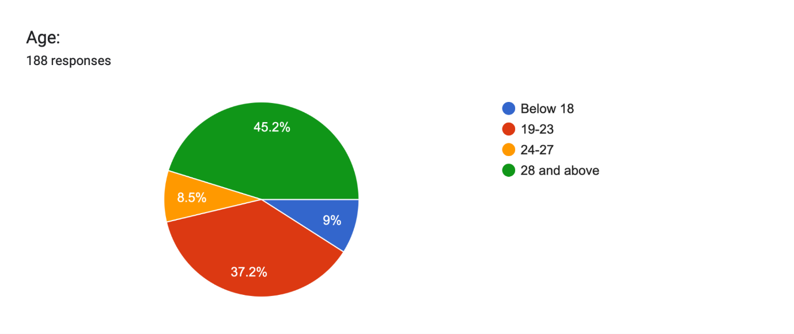

From the data analysis, it is quite clear that there is a high prevalence of participants aged above 28 years, making up to 45.2% of all participants, which shows their keen interest in the topic of fast fashion. Also, people who belong to age categories 19-23 make up to 37.2% of all participants, showing high involvement from students and other young professionals.
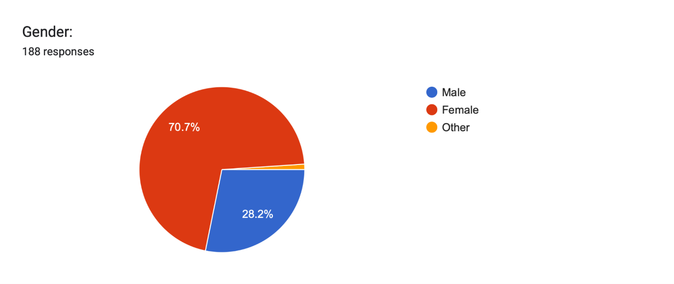
Rates of familiarity with fast fashion among respondents:
Familiarity Level | Respondents | Percentage
Very familiar | 69 | 36.7%
Somewhat familiar | 89 | 47.3%
Not familiar | 30 | 16.0%

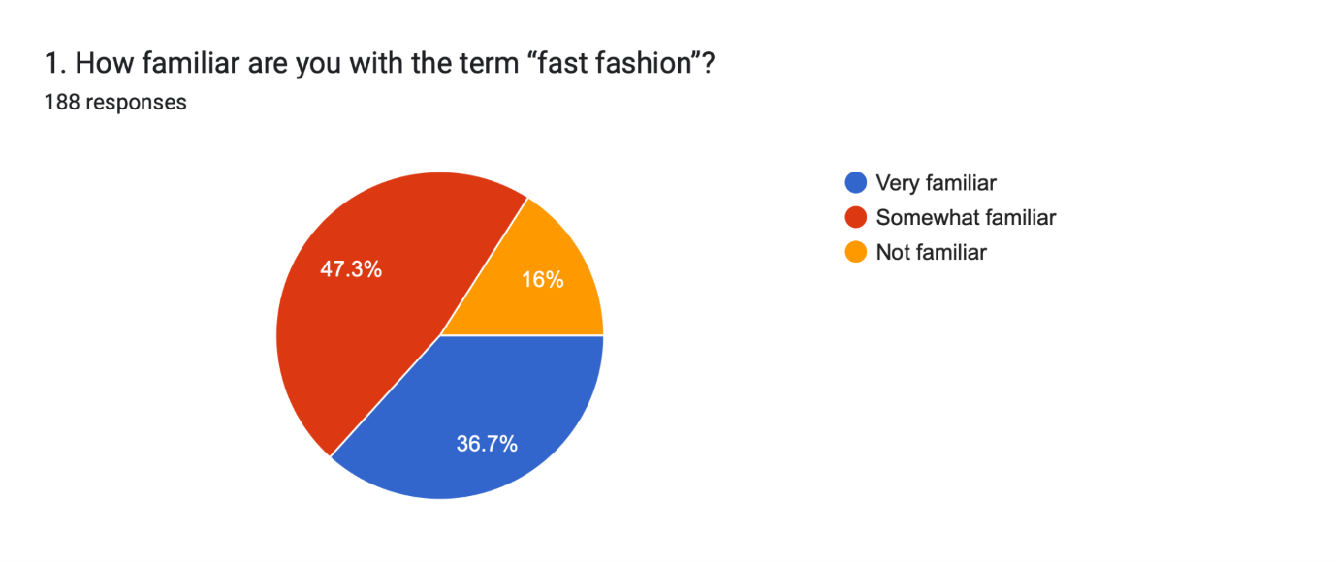
The analysis reveals that a significant majority of respondents demonstrate at least a moderate awareness of the term "fast fashion," with 47.3% identifying as somewhat familiar and 36.7% as very familiar. Together, over 84% of respondents possess meaningful knowledge of the concept, reflecting growing public discourse around fashion consumption in recent years. The remaining 16% who are not familiar highlight a persistent awareness gap, particularly among certain demographic segments.
Percentage of respondents that are aware of the impact of fast fashion on the environment:
Response | Respondents | Percentage
Yes | 119 | 62.6%
Not sure | 56 | 29.5%
No | 15 | 7.9%

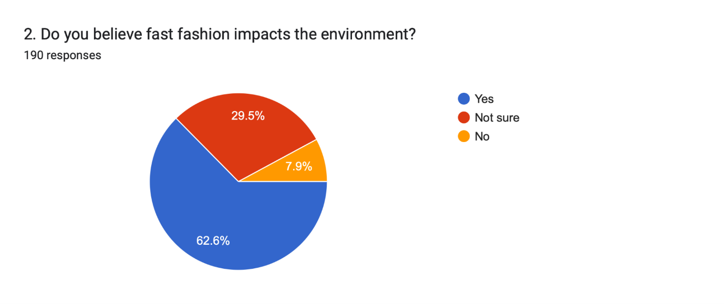
The analysis reveals a significant predominance of environmentally conscious respondents, with 62.6% firmly believing that fast fashion negatively impacts the environment, indicating a strong collective awareness of the industry's ecological footprint. Additionally, 29.5% of respondents expressed uncertainty, reflecting a considerable portion of the population that acknowledges the possibility of harm but lacks sufficient information to form a definitive opinion. While the majority lean toward environmental concern, the 7.9% who believe fast fashion causes no environmental harm highlight a segment that may be disengaged from sustainability conversations.
The level of awareness regarding environmental issues associated with fast fashion among respondents:
Environmental Issue | Respondents | Percentage
Waste and resource overuse | 110 | 57.9%
Pollution (water/air) | 38 | 20.0%
Not sure | 42 | 22.1%

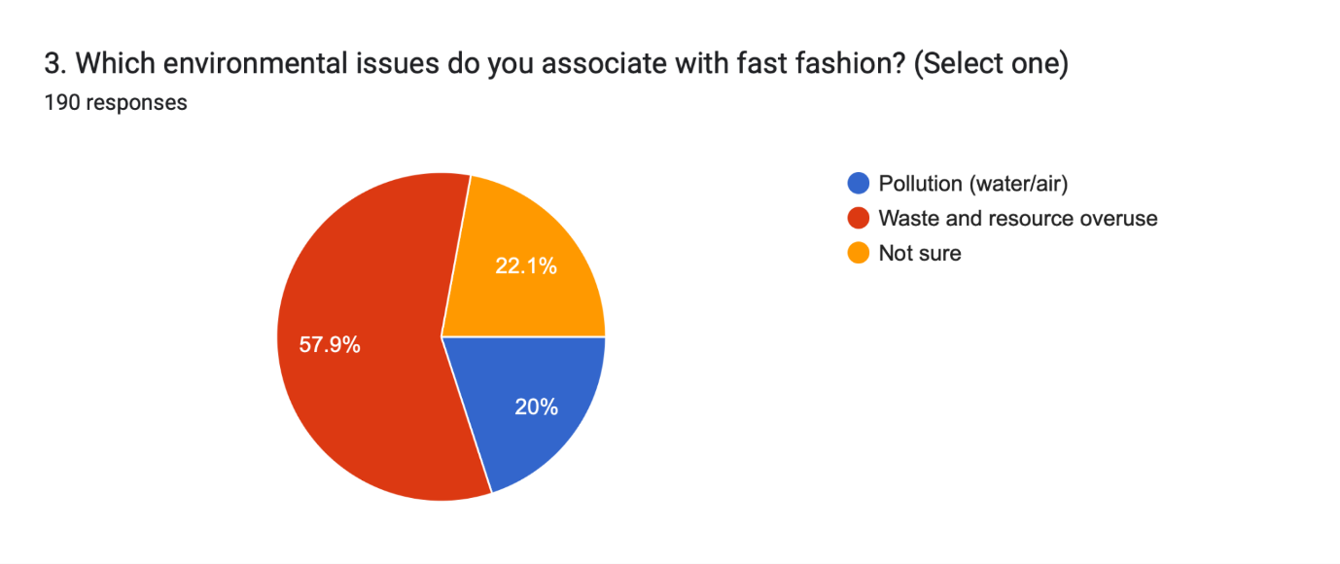
The analysis reveals that waste and resource overuse is the most prominently recognised environmental concern associated with fast fashion, constituting 57.9% of total responses, indicating that respondents are most visibly aware of the physical and tangible consequences of excessive clothing production and disposal. Pollution through water and air contamination, though equally significant in scientific literature, was identified by only 20% of respondents, reflecting a notable gap in public understanding of the chemical and industrial dimensions of fast fashion's environmental damage. The 22.1% who remained unsure further highlights the need for more comprehensive environmental education.
Frequency at which respondents purchase new clothing:
Frequency | Respondents | Percentage
Occasionally | 111 | 58.4%
Frequently | 51 | 26.8%
Rarely | 25 | 13.2%
Once in 3–4 months / As required | ~3 | ~1.6%

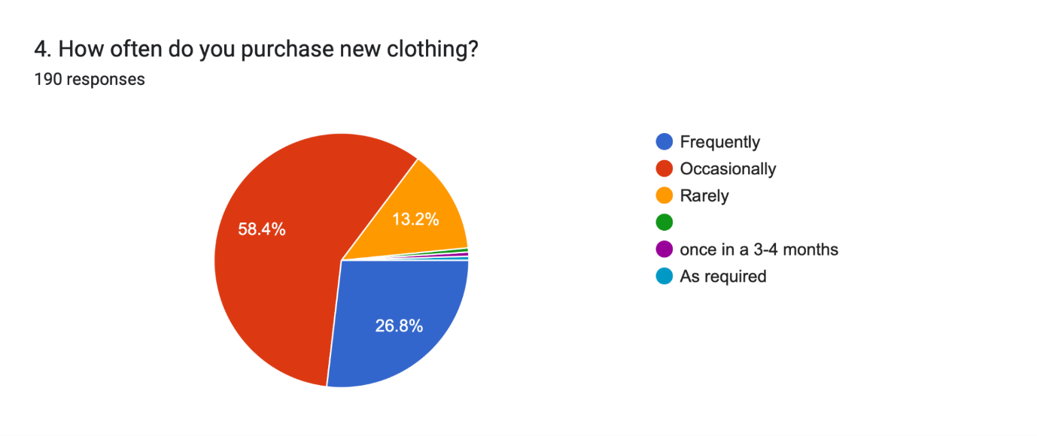
The analysis reveals that occasional clothing purchases dominate consumer behaviour, with 58.4% of respondents buying new clothes from time to time, suggesting a moderately engaged shopping pattern that falls between impulsive and restrained consumption. A substantial 26.8% purchase clothing frequently, representing over a quarter of the sample who are more actively participating in fast fashion cycles and contributing more significantly to consumption driven environmental pressures. Only 13.2% purchase rarely, reflecting a small but commendable segment of mindful consumers.
Factors that influence clothing purchases in respondents:
Influence Factor | Respondents | Percentage
Quality/sustainability | 91 | 47.9%
Trends/fashion | 71 | 37.4%
Price | 28 | 14.7%

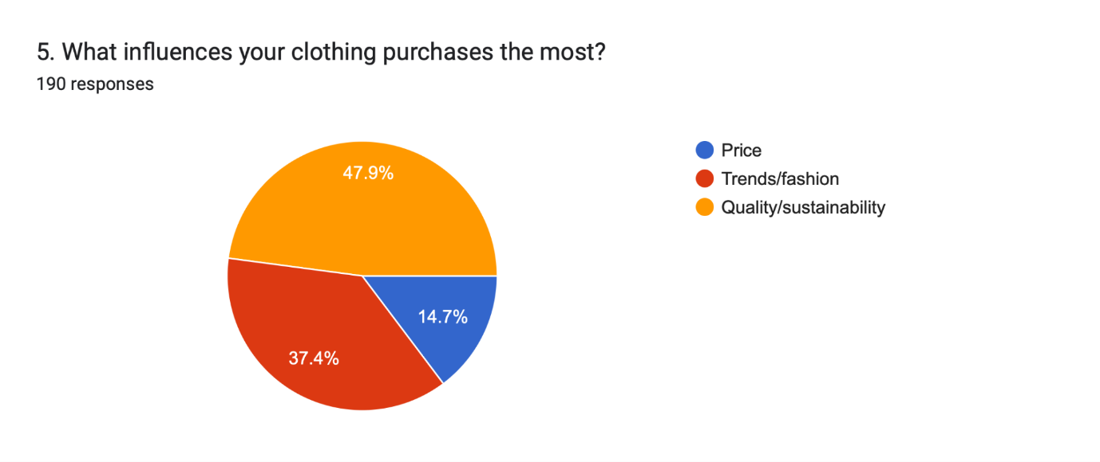
The analysis reveals an encouraging trend wherein quality and sustainability emerge as the most influential factors driving clothing purchases, constituting 47.9% of total responses, indicating a growing consumer consciousness around the longevity and ethical production of garments. Trends and fashion remain a powerful motivator for 37.4% of respondents, reflecting the enduring cultural influence of the fashion industry and social media in shaping individual purchasing decisions. Price, often assumed to be the primary driver of fast fashion consumption, was cited by only 14.7%, suggesting that affordability alone is not the dominant concern for this sample.
Preference of respondents on low-cost clothing over durable items:
Preference | Respondents | Percentage
No | 75 | 39.5%
Sometimes | 62 | 32.6%
Yes | 53 | 27.9%

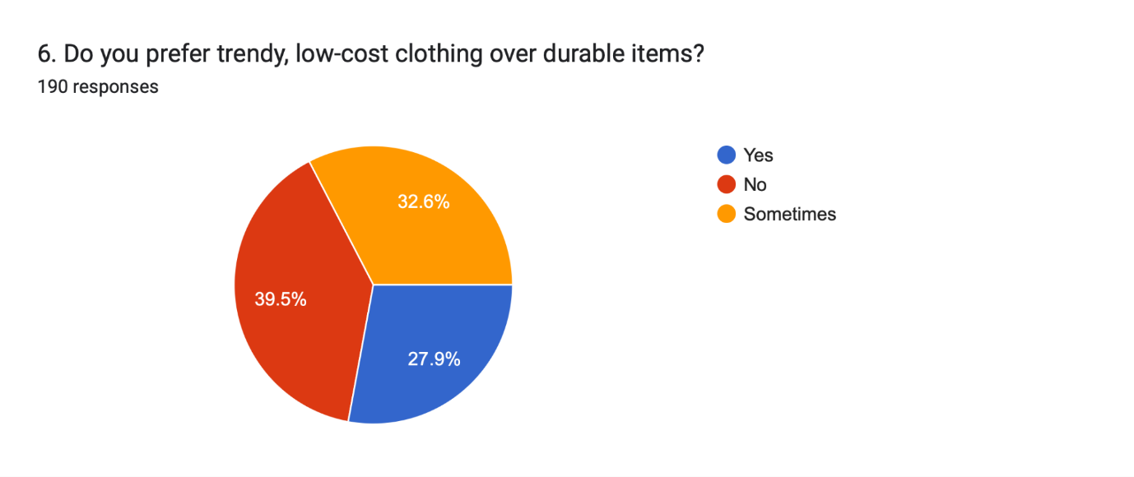
The analysis reveals that a plurality of respondents, comprising 39.5%, prefer durable items over trendy, low-cost alternatives, reflecting a meaningful segment of the population that consciously prioritises longevity and value in their clothing choices. However, a combined 60.5% of respondents either sometimes or consistently prefer trendy, low-cost clothing, underscoring the persistent appeal of fast fashion despite growing environmental awareness. The 32.6% who choose trendy items situationally suggest a conditional relationship with fast fashion, driven perhaps by occasions, budget constraints, or social pressures.
Disposal methods of used/old clothing in respondents:
Disposal Method | Respondents | Percentage
Donate/recycle | 156 | 82.1%
Throw away | 16 | 8.4%
Keep unused | 18 | 9.5%

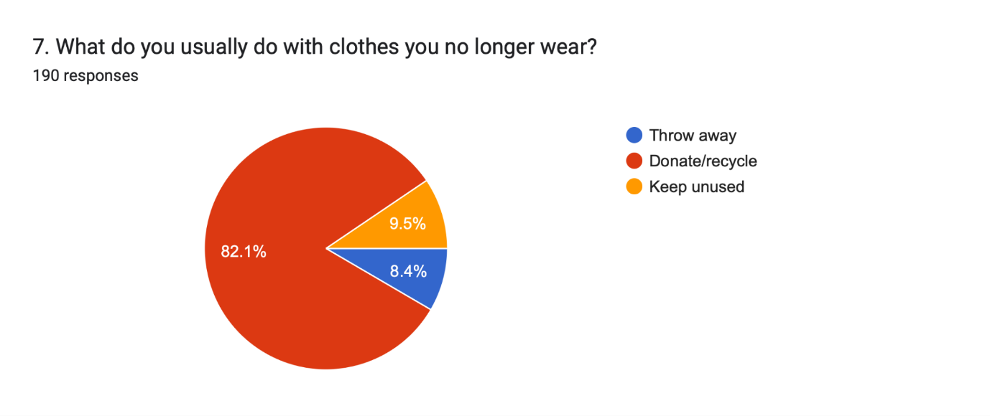
The analysis reveals a remarkably positive disposal behaviour among respondents, with an overwhelming 82.1% choosing to donate or recycle their unwanted clothing, indicating a strong collective inclination toward responsible end-of-life garment management. This finding is particularly encouraging in the context of fast fashion, where landfill disposal of clothing is a major environmental concern globally. Only 8.4% discard clothes by throwing them away, while 9.5% retain unused garments, reflecting relatively minor proportions of wasteful or passive behaviour.
Percentage of respondents that have purchased second hand and thrifted clothing:
Response | Respondents | Percentage
Never | 147 | 77.4%
Occasionally | 30 | 15.8%
Yes, regularly | 13 | 6.8%

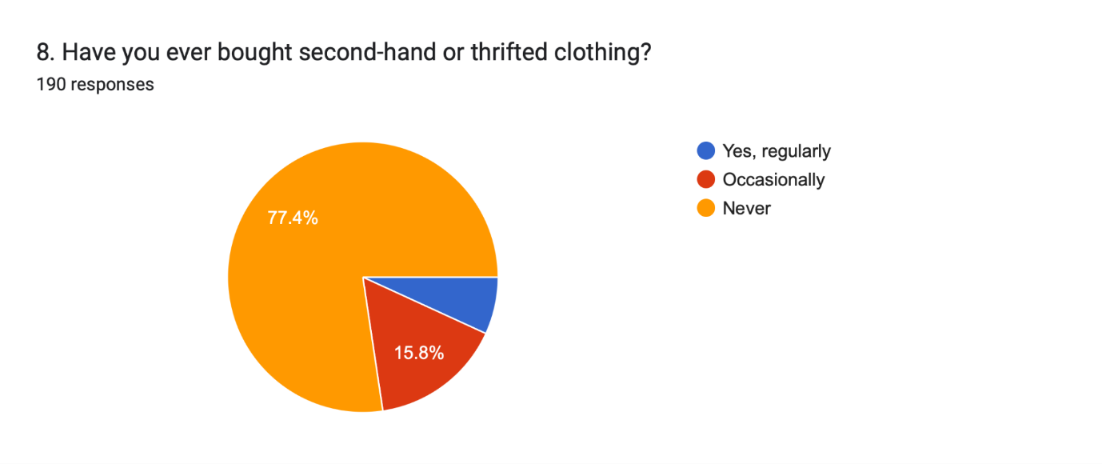
The analysis reveals that second-hand and thrifted clothing remains largely unexplored among respondents, with a striking 77.4% having never purchased pre-owned garments, indicating that the circular fashion economy has yet to gain significant mainstream traction within this sample. Only 15.8% have occasionally engaged in thrift shopping, and a mere 6.8% do so regularly, together representing a small but growing community of consumers who embrace second-hand fashion as a sustainable alternative.
Percentage of respondents willing to invest more in eco friendly clothing:
Response | Respondents | Percentage
Maybe | 89 | 46.8%
Yes | 77 | 40.5%
No | 24 | 12.6%

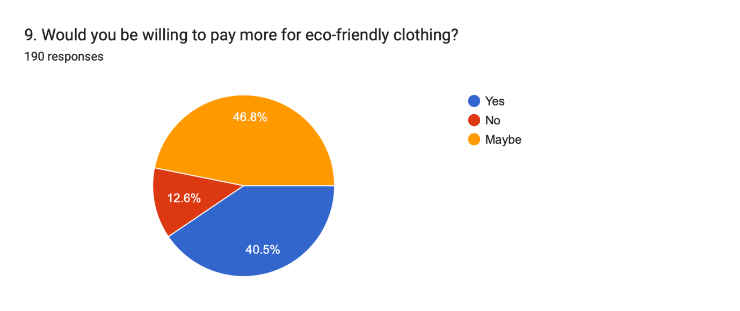
The analysis reveals a broadly positive willingness among respondents to invest in eco friendly clothing, with 40.5% expressing a definitive readiness to pay a premium for sustainable garments and an additional 46.8% remaining open to the possibility. Together, an encouraging 87.3% of respondents demonstrate some degree of financial willingness to support environmentally responsible fashion choices, reflecting a meaningful alignment between consumer values and purchasing intentions. Only 12.6% categorically declined, representing a relatively small segment resistant to price premiums for sustainability.
Proportion of respondents influenced by social media to purchase clothing:
Response | Respondents | Percentage
Sometimes | 101 | 52.9%
Never | 50 | 26.2%
Yes, often | 40 | 20.9%

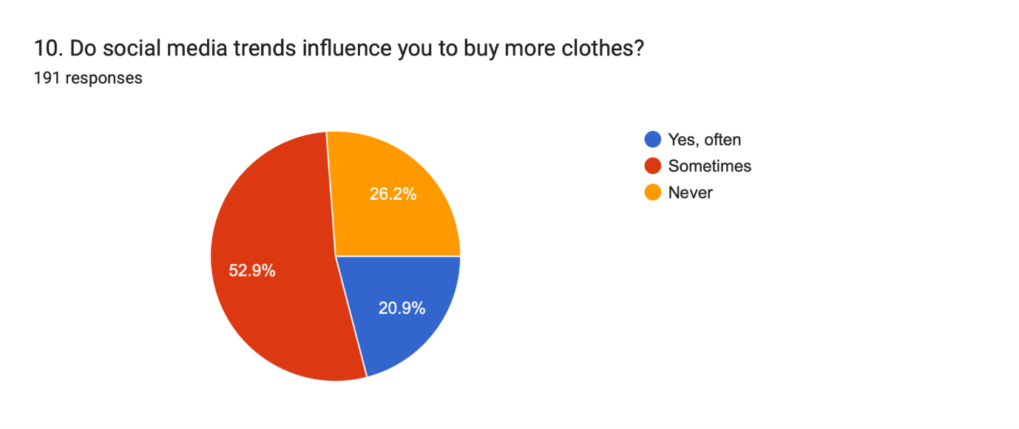
The analysis reveals that social media exerts a moderate but pervasive influence on clothing purchase behaviour, with 52.9% of respondents acknowledging that they are sometimes swayed by social media trends, and a further 20.9% admitting to being influenced often. Together, nearly 74% of respondents recognise social media as at least an occasional driver of their fashion consumption, underscoring the powerful role that digital platforms play in shaping consumer desires and normalising frequent clothing purchases. Only 26.2% claim immunity from social media's influence, representing a minority of respondents who maintain purchase decisions independent of online trends.
Factors that motivate consumers to purchase fast fashion items:
Motivation | Respondents | Percentage
Convenience | 97 | 52.4%
Latest trends | 64 | 34.6%
Low price | 24 | 13.0%

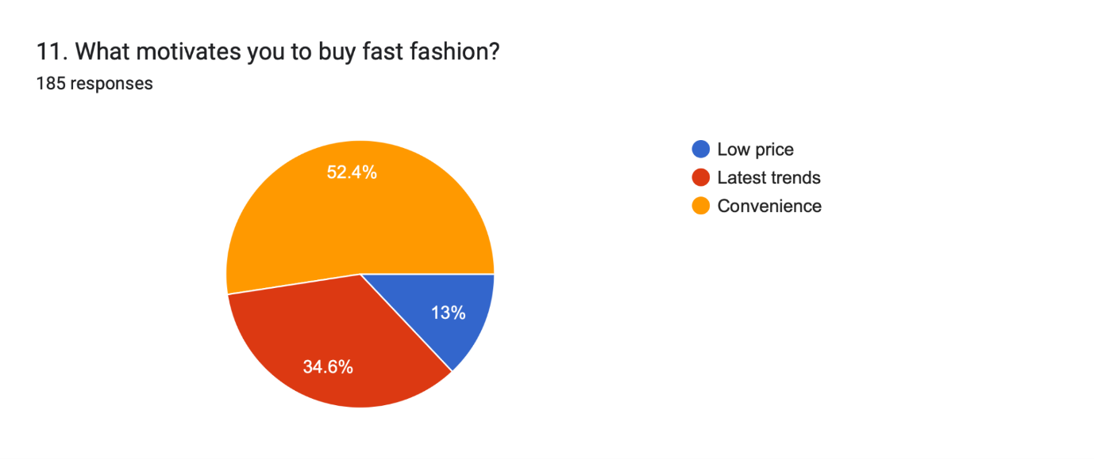
The analysis reveals that convenience is the single most powerful motivator behind fast fashion purchases, cited by 52.4% of respondents, indicating that ease of access, speed of delivery, and frictionless shopping experiences are the primary drivers of fast fashion consumption in this sample. The desire to follow latest trends motivates 34.6% of respondents, reflecting the ongoing cultural influence of fashion cycles and social validation on purchasing behaviour. Contrary to popular assumption, low price was cited by only 13%, suggesting that affordability, while relevant, is not the dominant motivator for this group. The predominance of convenience as a driver carries important implications for sustainable fashion brands, highlighting that making eco friendly options equally accessible, fast, and effortless to purchase could be far more effective than competing on price alone.
Frequency of respondents discarding or stopping the use of fast fashion clothing:
Frequency | Respondents | Percentage
Occasionally | 93 | 49.7%
Rarely | 69 | 36.9%
Frequently | 25 | 13.4%

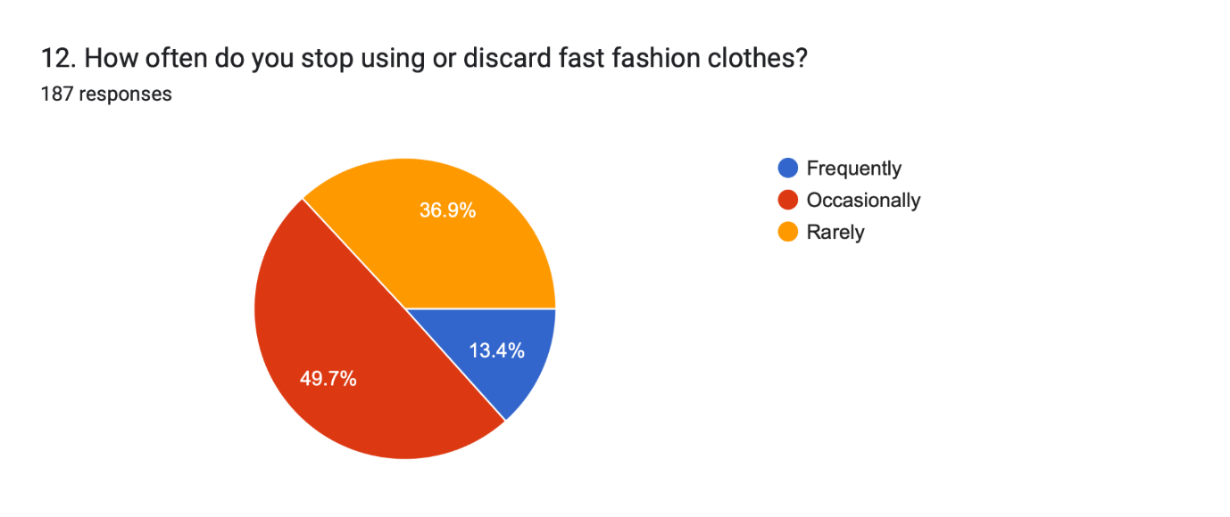
The analysis reveals that most respondents do not discard fast fashion clothing with high frequency, with 49.7% doing so only occasionally and 36.9% rarely discarding their garments at all, collectively suggesting that a significant majority over 86% tend to retain their clothing for extended periods before disposal. Only 13.4% frequently discard fast fashion items, representing the segment most closely aligned with the stereotypical "wear and throw" fast fashion cycle. The relatively low discard rates challenge the common narrative that fast fashion consumers are universally impulsive disposers, indicating instead that many individuals form some degree of attachment to or continued use of their purchases. The relatively smaller percentage of frequent discards underscores the importance of targeted education for this group, while also affirming that broader sustainable habits around garment retention are more prevalent than often assumed. Overall, these patterns suggest that extending garment lifespan awareness could be effectively built upon the existing moderate disposal behaviours of this sample.
Percentage of respondents that believe fast fashion helps them stay in trend:
Response | Respondents | Percentage
Somewhat | 100 | 52.9%
Yes | 48 | 25.4%
No | 41 | 21.7%

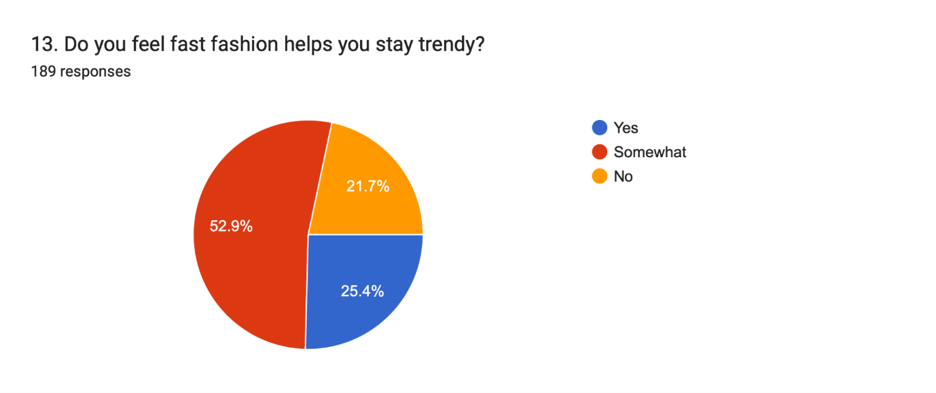
The analysis reveals that a majority of respondents perceive fast fashion as at least partially effective in keeping them stylistically current, with 52.9% indicating it somewhat helps them stay trendy and 25.4% affirming it definitively does. Together, nearly 78% of respondents associate fast fashion with trendiness to varying degrees, confirming that the industry's core value proposition delivering up-to-date styles rapidly and affordably continues to resonate strongly with consumers. Only 21.7% feel fast fashion does not help them stay trendy, suggesting a segment that either sources their style from alternative channels or does not prioritise trendiness as a fashion goal.
Level of concern about environmental impact of respondents’ purchasing habits in regards to fast fashion clothing:
Level of Concern | Respondents | Percentage
Yes | 93 | 48.9%
Somewhat | 74 | 38.9%
No | 23 | 12.1%

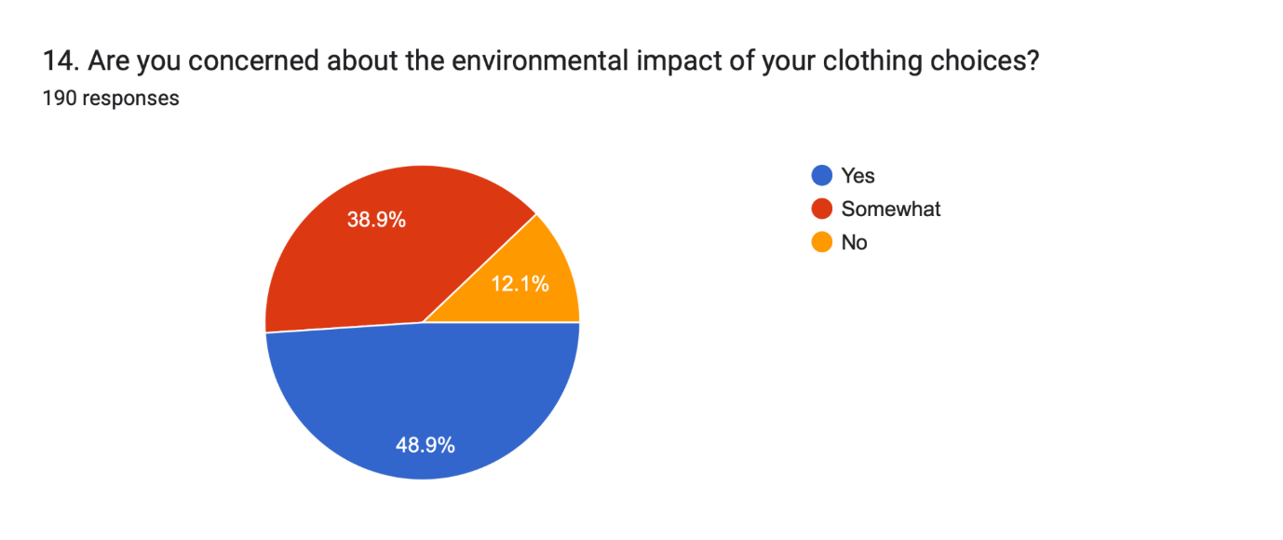
The analysis reveals a high degree of environmental consciousness among respondents, with 48.9% expressing definitive concern about the ecological impact of their clothing choices and an additional 38.9% acknowledging some level of concern. Together, nearly 88% of respondents demonstrate meaningful awareness of the environmental consequences embedded in their fashion decisions, reflecting a broadly conscience driven consumer base. Only 12.1% report no concern, representing a relatively small but important segment that may require more direct engagement and education. The substantial proportion of respondents in the "somewhat concerned" category suggests that while awareness exists, it has not yet translated into deep or urgent environmental commitment for all. The relatively small percentage of unconcerned individuals underscores the importance of building on this existing foundation of concern to drive more decisive and consistent sustainable behaviour. Overall, converting concern into concrete action remains the central challenge for sustainability advocates working within the fashion space.
Percentage of respondents who believe people should reduce fast fashion consumption:
Response | Respondents | Percentage
Yes | 89 | 46.6%
Maybe | 85 | 44.5%
No | 17 | 8.9%

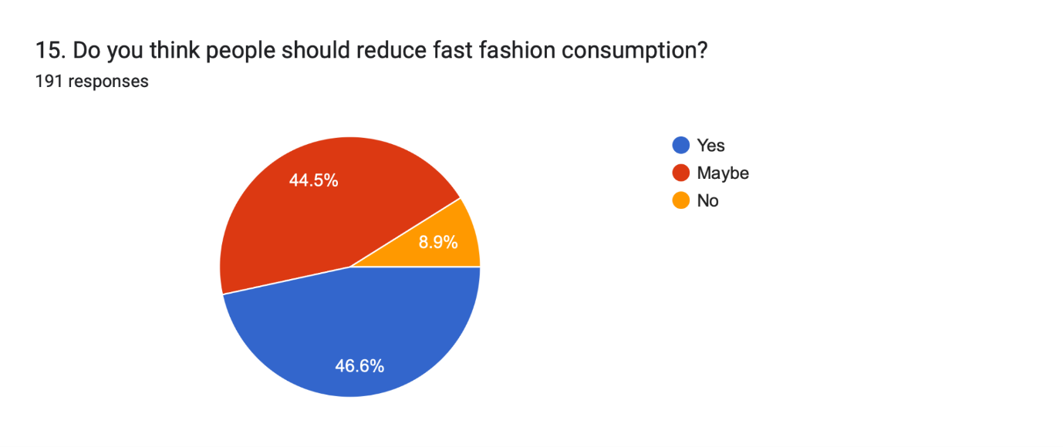
The analysis reveals a compelling consensus among respondents in favour of reducing fast fashion consumption, with 46.6% firmly agreeing that people should consume less fast fashion and an additional 44.5% expressing openness to the idea. Together, an overwhelming 91.1% of respondents support or are open to the notion of curbing fast fashion habits, reflecting a broadly shared recognition of the industry's unsustainable nature. Only 8.9% disagreed, representing a small minority resistant to behavioural change at a societal level. The near equal split between definitive "yes" responses and cautious "maybe" responses suggests that while moral conviction around the issue is widespread, uncertainty around personal responsibility, feasibility, or systemic change may be moderating stronger commitment.
Findings
Environmental Degradation during Production, Consumption, and Disposal From its very first stages until disposal, fast fashion leaves an extensive and environmentally damaging legacy. First of all, the fast fashion industry consumes an enormous amount of raw materials. To make one cotton t-shirt, about 2,700 litres of water need to be used. What's more, man made fibers such as polyester and nylon are produced using petrochemicals consequently, each item carries a considerable carbon footprint from the moment of manufacturing.
Next, factories emit harmful chemical dyes into local rivers and lakes. As a result, rivers and lakes in developing countries such as Bangladesh and India become colored by dyes. Moreover, the global supply chain of fiber and cloth production, dyeing, sewing, and transporting goods across several countries involves extensive use of fossil fuels at each stage.
However, even after the clothes have reached consumers, the problems don't cease. Due to the low cost and popularity of fast fashion, consumers tend to use the clothes less often and dispose of them quicker than ever. Whenever synthetic fabric is washed, microplastic fibres break off and find their way into the ocean, posing a threat to marine life.
The problem becomes more severe once the clothing items are disposed of. Approximately 66% of all textile waste goes to landfills where they gradually emit greenhouse gases and other harmful substances into the soil. Developing countries such as Ghana, Kenya, and Chile become burdened with the massive importation of secondhand clothes from richer nations.
There's a frustrating gap between what consumers know about fast fashion and what they actually do about it. Many people are aware, at least on some level, that fast fashion causes environmental harm. And yet, the industry keeps growing. In 2023 alone, 40% of US consumers and 26% of UK consumers shopped at fast fashion giants like Shein and Temu. That number has almost certainly risen since.
Part of the problem is social media. Platforms like TikTok have made fashion trends move faster than ever, with new micro-trends appearing and disappearing within weeks. Influencer culture and "haul" videos where people show off huge amounts of cheaply bought clothing have made overconsumption feel completely normal, even aspirational. Fast fashion brands use targeted advertising to keep people hooked, and it works.
Even consumers who genuinely care about sustainability often continue buying from fast fashion brands simply because the clothes are affordable and easily accessible. The psychological and cultural pull is strong. Clothing has shifted in people's minds from something durable and worth caring for, to something temporary and disposable.
Another major issue is a lack of transparency. Most consumers have no idea how many countries a single garment passes through before reaching them, or how much water, chemicals, and emissions were involved. When people don't see the full picture, it's easy to keep buying without guilt. Bridging the gap between awareness and action remains one of the biggest challenges in moving toward more sustainable fashion habits.
It is important to note that there are solutions to fast fashion, but their implementation remains a difficult task. There are many approaches that have been suggested by the article that can make a positive impact on the issue, although the current progress towards finding them has been very slow.
At the consumer level, choices like thrifting, upcycling, and buying second hand are often promoted as sustainable solutions. However, the paper raises an important caveat here. Donating clothes doesn't always solve the problem much of what gets donated ends up being shipped to developing countries, where it overwhelms local markets and still ends up in landfills. True sustainability requires buying less in the first place, not just shifting where the waste goes.
Within the industry itself, some brands have introduced "eco-friendly" or "conscious" collections using recycled materials. But critics rightly call most of these efforts greenwashing. For example, recycled polyester is made from plastic bottles, but once it becomes a garment, it can't be recycled again due to blended fibres and chemical treatments. These small initiatives don't come close to offsetting the damage caused by the industry's overall volume of production.
More meaningful change would require structural shifts circular economy models where clothes are designed to be repaired, reused, or recycled properly on demand manufacturing to reduce overproduction and genuine government regulation that holds corporations accountable for their environmental footprint. The research is clear that without these deeper changes, no amount of eco-branding will be enough to reverse the damage fast fashion continues to cause.

LIMITATIONS
The study provides valuable insights into the environmental impact of fast fashion, despite the fact that it is still subject to several limitations. One key limitation is the sample size and representation of the data collected in the survey conducted. The survey may not represent the broader population with its data, just the 190 respondents, and is also limited to the age groups and demographics gathered, and can influence the overall findings. The study heavily depends on secondary sources and existing literature, which may carry outdated data, regional biases and differing research methodologies This affects the consistency and applicability of the findings across different contexts.
Most of the information in the study is focused on western countries and ignores countries like India, Bangladesh and the Global South in general where fast fashion is a huge problem. The study also looks at the effects of fast fashion on a global scale, which prevents us from being able to look at how deeply specific areas might be affected. While the study talks about ways to make fashion more sustainable it does not acknowledge the challenges of making these changes happen in different cultures and economies. The study also does not deeply explore economic, affordability and availability factors when addressing sustainable alternatives. These factors significantly influence consumer behaviour and limit the practical application of sustainable consumption behaviour.

RECOMMENDATION
This study provides meaningful insights into the environmental impact of fast fashion, yet the limitations identified suggest several directions for future research. One of the main issues would be sample size and representation, thus, future studies should aim to collect data from a larger and more diverse pool of respondents. A sample of 180 participants isn’t enough to draw broad conclusions about consumer behaviour on a global scale. Researchers should organize sampling techniques to make sure different demographic groups like age, genders, income levels are represented according proportionally to the population. This change would ensure reliability of the findings and would be more applicable to the wider population.
Fast fashion industry is a dynamic industry which evolves rapidly, because of which, future research should reduce its dependance on secondary and outdated sources. Relying on older studies risks producing findings hat no longer apply to current standards and no longer reflect current realities. Researchers should gather primary data through surveys, interviews, and field studies, while carefully assessing existing studies for reliability and relevance.

There is major geographical imbalance present in this study which must be addressed in future research. Countries such as India, Bangladesh, Vietnam and other nations in the Global South are among the largest producers and consumers of fast fashion and yet they are significantly underrepresented in the current studies. Future studies should actively prioritize to include data from these regions, through collaborations with local researchers and governmental agencies. The damages and effects of fast fashion are not consistent across different geographies and thus, research should examine how specific communities and localities are affected.

Since sustainable options are often expensive and inaccessible to the lower-income consumers, future research should focus on affordable solutions rather than one size fits all approach. Brands should focus on region specific strategies that reflect local economies and market availability. Not everyone can afford sustainable options and thus, their problems must be taken into account. Future studies must implement more vigorous sampling frameworks to ensure an even distribution across age, gender and geographic backgrounds to correct the demographic imbalance which has been observed in survey responses. Certain groups are overrepresented which leads to the findings which reflect preferences and behaviours of dominant groups and cannot offer a truly inclusive picture. Studies should diversify respondent profiles, this would lead to richer findings and reduce the risk of irregular conclusions regarding consumer behaviours and attitudes towards fast fashion.

This study only identifies correlations, not causes, so future research should use stronger methods to understand the root causes of what actually drives fast fashion consumption. Controlled experiments or econometric modelling would help confirm whether external factors marketing, advertising and social media directly influence consumer behaviour. These techniques would enable our studies to give a better answer regarding the root causes and would help us identlify better and more effective solutions.

Finally, future studies should incorporate industry-side data and primary environmental measurements alongside consumer perspective. Relying just on consumer surveys and secondary research limits our understanding regarding the actual damage caused by fast fashion. Researchers must collaborate with fashion brands, textile manufacturers and even environmental agencies to gather actual and direct data on the carbon emissions, water usage and textile waste. This data combined with consumer behaviour data would give us a much broaden and accurate picture of the true environmental cost of fast fashion which will strengthen the case for industry wide change.

CONCLUSION
This study takes a close look at how fast fashion damages the environment from the moment clothes are made, to when they are worn, to when they are finally thrown away. The conclusion is simple: fast fashion is genuinely harmful. The pressure to produce cheap clothing at incredible speed has created a chain reaction of problems. Factories consume enormous amounts of water and release toxic chemicals. Synthetic fabrics shed microplastics every time they go through a wash cycle. And when people are done with their clothes which happens faster than ever most of it ends up in a landfill. To make things worse, the heaviest burden falls on developing countries, which deal with both the manufacturing pollution and the mountains of waste that wealthier nations send their way.
One of the most telling findings in this study is the gap between what people know and what they actually do. Most respondents were aware that fast fashion causes environmental harm. But awareness alone clearly is not enough. People keep buying because it is cheap, convenient, and because social media makes overconsumption feel exciting and completely normal. Influencers, haul videos, and nonstop trend cycles push people to buy without thinking twice. Even those who claimed to care about sustainability were not actually thrift shopping or choosing eco friendly brands. Good intentions exist, but real behaviour change does not seem to follow.
There were some positive signs many people said they were open to donating or recycling old clothes. But that alone cannot offset the staggering volume of waste this industry generates every year. Sustainable habits have not become part of everyday life for most people, largely because eco friendly options cost more, are harder to find, and most consumers simply do not know the full story behind the clothes they buy.
The study does have its limitations.The survey sample of 180 respondents was relatively small, and the spread across different age and gender groups was not balanced. This makes it hard to apply these findings to the wider population with confidence. The study was also geographically limited, which means it cannot fully speak to how consumers around the world think and behave. Another concern is that the research leans heavily on existing literature rather than freshly collected data, and most of that literature is centred around Western countries. This leaves a noticeable gap in understanding what is happening in places like India and Bangladesh countries that are on the front lines of fast fashion's damage, both in terms of production and waste.
The study also tends to show connections between things rather than proving that one thing directly causes another. Social media, for example, is clearly tied to rising consumption levels, but the study cannot pin down exactly how big that influence really is.
These are gaps that future research needs to take seriously. Studies with larger and more varied groups of people, broader geographic coverage, and hands on fieldwork involving real consumers and industry figures would paint a much clearer picture. There is also a pressing need to understand why people on lower incomes find it so difficult to make sustainable choices, even when they genuinely want to.
When everything is considered, fast fashion is far more than just an environmental issue. It is deeply social, economic, and cultural. Tackling it properly means everyone has a role to play consumers being more mindful about what they buy, companies operating with real honesty and accountability, and governments putting in place meaningful regulations instead of letting brands coast on hollow green promises. Change will not come quickly, but with sustained effort and open dialogue, a fashion industry that is both accessible and genuinely responsible is absolutely within reach.

References
Bick, R., Halsey, E., & Ekenga, C. C. (2018). The global environmental injustice of fast fashion. World Resources Institute. https://www.wri.org/insights/apparel-industrys-environmental-impact-6-graphics
European Parliament. (2020, December). Fast fashion: EU laws for sustainable textile consumption. https://www.europarl.europa.eu/topics/en/article/20201208STO93327/fast-fashion-eu-laws-for-sustainable-textile-consumption
Global Society. (n.d.). The hidden cost of a cotton T-shirt. https://www.globalsociety.earth/post/the-hidden-cost-of-a-cotton-t-shirt
Geographical. (n.d.). The hidden water footprint of fashion. https://geographical.co.uk/news/the-hidden-water-footprint-of-fashion
Earth.org. (n.d.). Fast fashion's detrimental effect on the environment. https://earth.org/fast-fashions-detrimental-effect-on-the-environment/
Sustainably Chic. (n.d.). How the fashion industry pollutes water. https://sustainably-chic.com/blog/how-the-fashion-industry-pollutes-water/
Boston University School of Public Health. (2022). The aftermath of fast fashion: How discarded clothes impact public health and the environment. https://www.bu.edu/sph/news/articles/2022/the-aftermath-of-fast-fashion-how-discarded-clothes-impact-public-health-and-the-environment/
Greenpeace Africa. (n.d.). How fast fashion is fuelling the fashion waste crisis in Africa. https://www.greenpeace.org/africa/en/blog/54589/how-fast-fashion-is-fuelling-the-fashion-waste-crisis-in-africa/
Nature. (2025). [Fast fashion and environmental impact]. https://www.nature.com/articles/d44148-025-00203-4
Arango, T. (2025). Ghana, Africa, fast fashion waste and pollution. Time. https://time.com/7307662/ghana-africa-fast-fashion-waste-pollution/
Earth Day Network. (n.d.). Global threads: How textiles shape economies worldwide. https://www.earthday.org/global-threads-how-textiles-shape-economies-worldwide/
McKinsey & Company. (n.d.). What is fast fashion? https://www.mckinsey.com/featured-insights/mckinsey-explainers/what-is-fast-fashion
Business of Fashion. (2024). The state of fashion 2024 report: Fast fashion, retail, customer experience, regulation, Shein, Temu. https://www.businessoffashion.com/articles/professional/the-state-of-fashion-2024-report-fast-fashion-retail-customer-experience-regulation-shein-temu/
SAGE Journals. (2023). [Fast fashion consumer behaviour study]. Emerging Adulthood. https://journals.sagepub.com/doi/10.1177/27523543231188279
University of Nebraska Omaha. (n.d.). [Fast fashion and consumer awareness]. Communication Studies Student Works. https://digitalcommons.unomaha.edu/cgi/viewcontent.cgi?article=1004&context=commstudent
Klean Industries. (n.d.). Fast fashion waste destinations: Market analysis. https://kleanindustries.com/insights/market-analysis-reports/fast-fashion-waste-destinations/
The Robin Report. (n.d.). Ghana's fast fashion graveyard. https://therobinreport.com/ghanas-fast-fashion-graveyard/

Kozlowski, A., Bardecki, M., & Searcy, C. (2012). Environmental Impacts in the Fashion Industry: A Life-cycle and Stakeholder Framework. The Journal of Corporate Citizenship, 45, 17–36. http://www.jstor.org/stable/jcorpciti.45.17

Williams, E. (2022, June 24). Appalling or Advantageous? Exploring the Impacts of Fast Fashion From Environmental, Social, and Economic Perspectives | Published in Journal for Global Business and Community. Journal for Global Business and Community. Retrieved December 10, 2025, from https://jgbc.scholasticahq.com/article/36873-appalling-or-advantageous-exploring-the-impacts-of-fast-fashion-from-environmental-social-and-economic-perspectives
Kozlowski, A., Bardecki, M., & Searcy, C. (2012). Environmental Impacts in the Fashion Industry: A Life-cycle and Stakeholder Framework. The Journal of Corporate Citizenship, 45, 17–36. http://www.jstor.org/stable/jcorpciti.45.17

Williams, E. (2022, June 24). Appalling or Advantageous? Exploring the Impacts of Fast Fashion From Environmental, Social, and Economic Perspectives | Published in Journal for Global Business and Community. Journal for Global Business and Community. Retrieved December 10, 2025, from https://jgbc.scholasticahq.com/article/36873-appalling-or-advantageous-exploring-the-impacts-of-fast-fashion-from-environmental-social-and-economic-perspectives

