The Topographical and Human Hazards: An Assessment Public Safety Indicators (PSI) and Vehicular Traffic Accidents (VTAs) in Mountain Province

- ABSTRACT
A major emerging issue in Mountain Province is the increasing rate of vehicular traffic accidents caused by its mountainous terrain, which has become one of the province’s leading public safety concerns. These accidents continue to threaten public safety, economic stability, and healthcare systems. In a mountainous province located at the center of the Cordillera Administrative Region, the problem is intensified by steep topography, unpredictable weather, winding roads, and expanding transportation networks.

This study presents a comprehensive, data-driven analysis of vehicular traffic incidents across the ten municipalities of Mountain Province from January 1, 2024, to February 28, 2026. Using a Quantitative Descriptive-Correlational Research Approach, the study examined 133 validated vehicular incident records (N = 133) obtained from the Crime Incident Reporting and Analysis System (CIRAS) and local traffic blotters. The research analyzed trends, offense classifications, spatial and temporal distribution, and root causes of accidents to support evidence-based traffic safety policies and law enforcement strategies.
This study presents a comprehensive, data-driven analysis of vehicular traffic incidents across the ten municipalities of Mountain Province from January 1, 2024, to February 28, 2026. Using a Quantitative Descriptive-Correlational Research Approach, the study examined 133 validated vehicular incident records (N = 133) obtained from the Crime Incident Reporting and Analysis System (CIRAS) and local traffic blotters. The research analyzed trends, offense classifications, spatial and temporal distribution, and root causes of accidents to support evidence-based traffic safety policies and law enforcement strategies.
Descriptive statistical analysis identified where, when, and how accidents commonly occurred, while correlational analysis examined the relationship between risk factors such as driver behavior, terrain, and mechanical failures. Findings revealed a 100% increase in incidents, rising from 37 cases in CY 2024 to 74 cases in CY 2025, with 22 additional cases already recorded during the first two months of 2026.
Human error emerged as the primary cause, accounting for approximately 72% of all incidents, particularly due to speeding, improper lane adjustments, reckless driving, and intoxication. Mechanical failures accounted for 20%, with brake failure alone responsible for 26 cases, highlighting the strain placed on vehicles by the province’s steep descending roads. Road and weather conditions contributed the remaining 8% of incidents.
Spatial analysis identified Bontoc as the primary accident hotspot with 32.33% of total incidents, followed by Sabangan, Bauko, and Sagada. Temporal analysis also identified two high-risk periods: the 5:00 PM evening rush hour and the 10:00 PM late-night period. Notably, self-inflicted single-vehicle accidents increased by 833% from 2024 to 2025.
The study concludes that traffic risks in the province are highly predictable and strongly influenced by both geography and driver behavior. It recommends the immediate implementation of a specialized “Geo-Safety” framework through the Strategic Road Safety Initiative (SRSI), including increased police visibility, sobriety checkpoints during high-risk hours, brake-cooling stations, runaway truck ramps, and defensive mountain-driving education campaigns in coordination with the Department of Public Works and Highways, Land Transportation Office, and local government units. The study also recommends strengthening “Project Safe Road Trip” and enhancing local traffic ordinances through mandatory driving seminars and community-based road safety education programs.
- INTRODCUTION

  - Background of the Study
Mountain Province (MP) presents a unique security landscape due to its rugged terrain, zigzagging roads, and frequent landslides. But due to the rapid expansion of road infrastructure and the increasing volume of both commercial and private vehicles in the province, it significantly enhanced socioeconomic mobility. However, this growth has brought a critical challenge to public safety: the rising incidence of vehicular traffic accidents. In mountainous terrains characterized by steep slopes, sharp hairpins, and unpredictable weather conditions, road safety risks are inherently higher than in lowland areas.

Within Mountain Province, traffic incidents present a continuous threat to human life, property, and local emergency response capabilities. Every vehicular accident strains municipal healthcare resources, disrupts critical transport corridors, and inflicts heavy socioeconomic tolls on affected families. Traditionally, traffic safety interventions have relied heavily on reactive deployments. However, modern evidence-based policing demands a shift toward a proactive approach using historical data to predict patterns, deploy personnel strategically, and implement targeted preventative measures.

  - Rationale of the Study
The rapid increase in vehicular incidents within Mountain Province demands a transition from traditional, reactive policing to an evidence-based, proactive traffic management strategy. While the raw figures indicate an alarming 100% surge in traffic accidents from 2024 to 2025, raw data alone cannot save lives. This study is undertaken to transform these isolated data points into actionable public safety intelligence.

Developing this research is critical for several key reasons:
- Optimizing Police Resource Allocation:
Law enforcement personnel and assets are finite. By mapping out precise spatial hotspots (such as the Bontoc bottleneck) and strict temporal windows (the 5:00 PM and 10:00 PM spikes), this study provides a blueprint for command centers to deploy checkpoints and foot patrols exactly when and where they are mathematically proven to be most effective.

- Addressing Regional Topographical Risks:
Mountainous terrains present specific hazards, such as steep descents that strain mechanical parts. Identifying that Brake Failure is the leading specific cause of crashes establishes an empirical baseline that justifies the creation of specialized infrastructure, such as runaway truck ramps and mandatory brake cooling stations, which are unneeded in lowland provinces.

- Guiding Multi-Agency Policy and Engineering:
Road safety is not solely a law enforcement issue; it requires a unified response from Local Government Units (LGUs) and the Department of Public Works and Highways (DPWH). This study bridges the gap between field enforcement and municipal policy by providing concrete data to back local traffic ordinances, tourist regulations in high-risk zones like Sagada, and budget requests for high-visibility road safety infrastructure.

Ultimately, this research serves as a defensive framework for the highways of Mountain Province. By exposing the behaviors, times, and areas that lead to traffic accidents, this study helps the community shift away from documenting tragedies and move toward actively preventing them.

  - Conceptual Framework

    - Theoretical Frameworks
This study is grounded in two primary traffic safety and accident prevention models that explain how human behavior, mechanical condition, and environmental environments interact to cause vehicular incidents.

- William Haddon Jr.’s Injury Prevention Matrix (The Haddon Matrix)
  - Developed in 1970, the Haddon Matrix remains the premier paradigm for analyzing traffic crashes. Haddon posits that an accident is not an isolated event of "bad luck," but an undesirable outcome resulting from the interaction of three factors (Human/Host, Vehicle/Agent, and Environment) across three distinct phases of a crash timeline (Pre-crash, Crash, and Post-crash).

    - Pre-Crash Phase (Prevention)
This study focuses heavily on this phase. By isolating the factors leading up to the point of impact or loss of control:

    - Human Factor (72%):
A driver’s lack of familiarity with steep downhills, failure to use low gears (engine braking), driver fatigue from long-distance mountain transit, or driving under the influence liquor/drugs.

    - Mechanical/Vehicular Factor (20%):
Brake failure, Overheated braking systems due to continuous friction, worn-out brake pads, bald tires losing traction on mountain curves, or public utility vehicles (PUVs) carrying loads beyond their structural capacity.

    - Environmental Factor (8%):
Active road rehabilitation bottlenecks, sharp switchbacks (hairpin turns), vertical drop-offs lacking concrete barriers, dense fog reducing visibility, or slippery surfaces caused by sudden landslides and loose gravel.

    - Crash Phase (Injury Mitigation)
This phase examines what happens at the exact moment of the incident to determine the severity of the outcome.

    - Human Factor:
Whether occupants are wearing seatbelts, or if a motorcycle rider is wearing a certified safety helmet to prevent traumatic head injuries during a spill.

    - Vehicle Factor:
The structural integrity of the vehicle's cabin, crumple zones, airbag deployment efficiency, or the presence of roll bars on utility trucks traveling mountain passes.

    - Environmental Factor:
The presence of kinetic energy-absorbing guardrails versus bare stone cliffs or steep ravines. Striking a reinforced barrier minimizes impact forces, whereas plunging off an unbarricaded edge maximizes catastrophe.

    - Post-Crash Phase (Life Salvage)
This phase looks at the efficiency of the response after the incident has occurred.

    - Human Factor:
First-aid knowledge of bystanders, local responders, or law enforcement officers arriving at the scene to manage severe trauma or hemorrhaging.

    - Vehicle Factor:
Ease of extricating trapped victims from mangled wreckage, and whether the vehicle presents an immediate post-crash fire hazard due to ruptured fuel lines.

    - Environmental Factor:
Geographic isolation, lack of cellular signal to call emergency services, and prolonged travel times for ambulances navigating winding terrain to reach the nearest provincial hospital.

- Heinrich’s Domino Theory of Accident Prevention
Adapted for traffic safety, this theory states that an injury or property damage (the final domino) is invariably caused by an accident, which itself is the result of an unsafe act or a mechanical/physical hazard (the preceding dominos). While the Haddon Matrix provides a broad, multi-dimensional view, Heinrich’s Domino Theory explains the linear, chronological chain of causation that triggers an incident. Heinrich posits that an accident is a predictable sequence of five metaphorical dominoes. If one falls, it knocks down the next.

In mountain terrain accidents, this sequence unfolds through highly specific local realities:

- Domino 1: Ancestry and Social Environment
This is the baseline condition. In this study, it represents the challenging geographical reality, living and driving within a high-altitude province characterized by extreme gradients, unpredictable mountain weather, and winding, narrow roads.
- Domino 2: Fault of the Person
Inherited or acquired human flaws directly influenced by the environment. For instance, a driver becomes impatient due to slow-moving trucks on a steep incline, or experiences physical exhaustion after hours of navigating challenging, unlit mountain passes at night.

- Domino 3: Unsafe Act and/or Mechanical/Physical Hazard
The immediate catalyst that sets the accident in motion.

- An unsafe act includes a driver choosing to coast downhill in neutral to save fuel, or overtaking another vehicle on a blind curve.

- An unsafe condition refers to driving on a road actively undergoing rehabilitation without proper warning signs, or operating a truck with a braking system that is already smoking and losing pressure.

- Domino 4: The Incident
The direct result of the third domino falling. The vehicle suffers total brake fade on a long descent, fails to negotiate a sharp switchback, and collides with an oncoming vehicle or leaves the roadway completely.

- Domino 5: Injury or Consequences
The final outcome of the sequence. On mountain terrain, due to gravity and high impact speeds against solid rock faces or deep drop-offs, the resulting domino typically yields severe consequences ranging from critical injuries and significant property damage to fatalities.

- Conceptual Synthesis for this Study:
By combining these two theories, this research does not simply categorize an accident as "brake failure" (Haddon's Vehicle/Pre-crash factor). Instead, it traces how the geographic environment (Domino 1) caused driver anxiety or fatigue (Domino 2), which led to the unsafe act of riding the brakes down a steep slope (Domino 3), resulting in mechanical brake fade and a subsequent collision (Domino 4), which was ultimately worsened by a lack of roadside barriers (Haddon's Environmental/Crash factor). Intercepting any of these dominoes or strengthening any vector in the matrix forms the exact foundation of our proposed Strategic Road Safety Initiative (SRSI). If law enforcement removes the middle domino, the Unsafe Act (driving under the influence or failing to maintain brakes), the chain of events is broken, preventing the final outcome (Reckless Imprudence resulting in Homicide, Physical Injury, or Damage to Property).

    - Legal Frameworks (Laws and Policies)
The data variables and operational recommendations in this study are explicitly anchored on the following Philippine national laws and administrative directives:

    - Republic Act No. 4136 (The Land Transportation and Traffic Code):
This serves as the primary statutory baseline for defining traffic offenses, speed limits, vehicle registration requirements, and right-of-way rules. Violations of this act constitute the underlying "reckless imprudence" penalized under the Revised Penal Code.

    - Republic Act No. 10586 (Anti-Drunk and Drugged Driving Act of 2013):
This law provides the legal teeth for the 9:00 PM–Midnight tactical enforcement recommendation. It mandates the use of breath analyzers and field sobriety tests by law enforcement officers to apprehend drivers operating under the influence of alcohol or drugs, directly targeting the 20 documented intoxication cases in your dataset.

    - The Revised Penal Code (Article 365 - Reckless Imprudence):
This governs the legal classifications used in your dataset. It defines and penalizes acts where a person executes an action through a lack of foresight or care, resulting in Homicide, Physical Injury, or Damage to Property (DTP).

    - DILG-DPWH Joint Memorandum Circulars:
These circulars mandate Local Government Units (LGUs) and the Department of Public Works and Highways to collaborate on local traffic management, institutionalize road safety boards, and install appropriate traffic control devices, legitimizing the multi-agency approach outlined in your Action Plan.
    - CONCEPTUAL FRAMEWORKS
The conceptual mechanics of this study follow the Input-Process-Output (IPO) Model. It systematically translates baseline administrative data into concrete policy interventions.

IPO Core Concept:

- Input: The raw independent data points collected across Mountain Province—comprising the volume of incidents, the locations (Bontoc, Sabangan, etc.), the hours of occurrence, and the recorded causes.

- Process: The implementation of our Quantitative Descriptive-Correlational Approach. The raw data is put through a retrospective review, mapping frequencies across the Crime Clock and matching specific causal factors to legal outcomes.

- Output: The final dependent result, the implementation of evidence-based policing tactics, specialized road safety infrastructure adjustments by the DPWH and LGUs, and a targeted reduction in overall road crash fatalities and property damage across the province.

  - Paradigm of the Study

The paradigm of the study visually illustrates the operational flow and interaction between the independent variables (the profiles of the vehicular incidents) and the dependent variable (the resulting and severity of incidents). This research utilizes an expanded Independent Variable - Dependent Variable (IV-DV) model to demonstrate how analyzing historical traffic patterns directly dictates the formulation of proactive law enforcement and multi-agency interventions. This study outlines the actual variables extracted from the 133 recorded traffic incident files and evaluates how localized environmental and mechanical elements (Independent Variables) correlate with the direct outcomes of the crash (Dependent Variables).

    - The Independent Variables (IV)
The Independent Variables consist of the specific environmental conditions and mechanical factors documented at the time of each incident:

    - Environmental & Infrastructure Factors: Categorized by the state of the roadway (dry vs. slippery from rain/landslides), presence of active road rehabilitation or construction bottlenecks, spatial attributes (sharp hairpin switchbacks vs. straight runs), and visibility factors (clear daylight, dense mountain fog, or unlit nighttime driving).

    - Mechanical & Structural Factors: Focused primarily on braking system integrity (normal function vs. acute thermal brake fade from steep descents) and vehicle configuration (standard operational load vs. documented overloading of passengers or cargo).

    - The Dependent Variables (DV)
The Dependent Variables represent the direct consequences and systemic patterns resulting from the interaction of the independent factors:

    - Incident Severity: Quantified using standard administrative and legal metrics: Property Damage Only (PDO), Less Severe Physical Injury, Serious Physical Injury, or Fatalities.

    - Spatial-Temporal Distribution: The exact timing (peak operational hours vs. off-peak night hours) and geographic concentration (clustering of incidents across specific mountainous municipalities or highway stretches).

    - The Proposed Outcome
The arrow leading from the interaction of the IV and DV points directly to the ultimate goal of this research which is the Strategic Road Safety Initiative (SRSI). The data-driven insights gathered by correlating these variables provide the empirical foundation needed to deploy targeted engineering interventions, optimized roadside inspection checkpoints, and transport sector education.

  - Statement of the Problem
Despite ongoing road safety campaigns, Mountain Province experienced a severe, 100% surge in documented vehicular incidents, jumping from 37 cases in CY 2024 to 74 cases in CY 2025. This escalating trend has persisted into the first two months of 2026, which recorded 22 incidents nearly 60% of the entire annual volume of 2024.

Without a systematic analysis of where these accidents occur (spatial hotspots), when they peak (temporal patterns), and why they happen (root causes), law enforcement deployment and local government interventions risk being misaligned. This study addresses this critical gap by conducting a comprehensive analysis of vehicular incidents from January 1, 2024, to February 28, 2026, providing a data-driven foundation for operational and engineering interventions.

This study aims to evaluate the current status of public safety in the province, specifically focusing on the prevalence and causes of road traffic incidents from 2024 to 2026.

Specifically, it seeks to answer the following questions:
- What is the profile of road safety incidents in Mountain Province in terms of:

- Frequency of occurrence per municipality (Barlig, Bauko, Besao, Natonin, Paracelis, Sabangan, Sadanga, Sagada and Tadian);

- Type of vehicles involved (Private, PUJ/Bus, Heavy Trucking); and

- Severity of the incident (Property Damage, Physical Injury, or Fatality)?

- To what extent do the following factors contribute to public safety risks on the roads in Mountain Province as perceived by drivers and enforcers:

- Human Factors (Fatigue, driving under the influence, over speeding);

- Environmental Factors (Fog/visibility, steep gradients, landslides); and

- Mechanical Factors (Brake overheating, tire blowouts)?

- How effective are the existing PNP "Best Practice" programs (e.g., Project Safe Road Trip) in reducing the number of accidents in the province?

- Is there a significant relationship between the frequency of accidents and the geographical features (altitude and road curvature) of the specific municipality?

  - Objectives:

This research aims to analyze the empirical trends of vehicular incidents within Mountain Province to optimize road safety management. Specifically, it seeks to:
- Determine the macro progression of vehicular incidents across the specified time frame.

- Identify the distribution of incidents across the ten (10) municipalities to isolate high-risk zones.

- Establish the hourly peak periods of accidents using a 24-hour Crime Clock framework.

- Classify the primary root causes of accidents into human error, mechanical failure, and environmental conditions.

- Formulate a targeted, actionable tactical response plan for law enforcement and local stakeholders.

  - Importance of the Study

The Significance of this research is that it identifies the specific people and organizations who will benefit from this work. In Montanyosa, where traditional culture meets modern infrastructure, this section highlights the "real-world" impact of this research. The findings of this research will provide evidence-based insights into the unique public safety challenges of the Montanyosa. Specifically, this study will be beneficial to the following:

Philippine National Police – Mountain Province Police Provincial Office (MPPPO): This study provides them with a localized "Accident Heat Map," allowing for more strategic deployment of highway patrols and the refinement of "Project Safe Road Trip” and other road safety operations.

Land Transportation Office (LTO): This study provides them with insights on the violations which causes the accidents as their basis for a stricter mechanical inspections and additional seminars for all drivers and as additional requirements for obtaining a driver’s license.

Department of Public Works and Highways (DPWH-CAR): Data regarding the relationship between road curvature and accident frequency can guide the DPWH in prioritizing the installation of safety barriers, runaway truck ramps, and improved street lighting in "black spots."

Local Government Units (LGUs): The Governor and Mayors within the Montanyosa can use this research to draft ordinances that mandate stricter mechanical inspections for public utility vehicles (PUVs) traversing steep mountain passes.

Public Utility Drivers and Transport Cooperatives: By identifying the most common human errors (such as engine braking fatigue), drivers can be better trained through specialized mountain-driving seminars, ultimately saving lives and reducing property damage.

The Tourism Industry: As the Montanyosa is where most of the prime destinations (e.g. Sagada and others), improving road safety directly boosts the confidence of tourists, ensuring the sustained economic growth of the province's hospitality sector.

Future Researchers: This paper serves as a foundational baseline for future studies on "High-Altitude Public Safety," providing a dataset for the 2024–2025 period that others can use for longitudinal comparisons.

  - Theoretical Framework

To support the "Significance," this research was anchored on the Haddon Matrix. This is a world-renowned framework used in injury prevention that looks at factors (Human, Vehicle, Environment) across three phases: Pre-event, Event, and Post-event.
By including the DPWH and Tourism Industry as one in the significance section enables us to understand that public safety isn't just a "police problem", it’s an economic and engineering challenge too.

  - Definition of Terms
For a clearer understanding of this study, the following terms are defined conceptually and operationally:
- Brake Failure. Conceptually, this refers to the mechanical malfunction of a vehicle's primary braking system, resulting in an inability to slow down or stop. Operationally, it represents the single largest mechanical root cause identified in this study, heavily associated with the steep, descending terrains of Mountain Province.

- Crime Clock. Conceptually, this is an analytical law enforcement tool used to visualize the distribution of offenses or incidents across a 24hour cycle. Operationally, it refers to the hourly matrix used in this study to isolate tactical peak-risk windows, specifically the 5:00 PM evening rush hour and the 10:00 PM late-night spike.

- Damage to Property (DTP). Conceptually, this refers to the destruction, degradation, or impairment of physical assets, infrastructure, or vehicles resulting from an external force or accident. Operationally, it represents the highest volume criminal classification in this dataset (43 out of 133 cases) filed under Reckless Imprudence.

- Driving Under the Influence (DUI) / Intoxication. Conceptually, this is the act of operating a motor vehicle while impaired by alcohol, drugs, or other psychoactive substances under the penalties of Republic Act No. 10586. Operationally, it refers to the behavioral factor responsible for 20 documented incidents in this study, heavily concentrated during late-night hours.

- Homicide. Conceptually, this refers to the unlawful killing of a human being by another, lacking malicious intent but arising from negligence or lack of skill. Operationally, it represents the most severe legal outcome in this study (11 total fatal cases), experiencing an aggressive spike in the first two months of 2026.

- Human Error. Conceptually, this refers to the behavioral misjudgments, lapses in discipline, or physiological impairments made by a driver. Operationally, it encompasses speeding, intoxication, fatigue, and sudden lane changes, constituting the dominant root cause (72%) of the recorded dataset.

- Mechanical Failure. Conceptually, this is the structural or technical breakdown of a motor vehicle’s components that compromises its safe operation. Operationally, it refers to the causal category in this study dominated by brake failures and tire issues, accounting for 20% of the total incident volume.

- Physical Injury (PI). Conceptually, this refers to bodily harm, trauma, or non-fatal injuries inflicted on a person due to a vehicular collision or impact. Operationally, it refers to the legal case classification accounting for 42 distinct incidents within the province's traffic repositories.

- Reckless Imprudence. Conceptually, this is a legal term defined under Article 365 of the Revised Penal Code as an action executed without malice but with a lack of foresight, care, or skill that results in material damage or physical harm. Operationally, it serves as the primary legal umbrella under which the studied traffic incidents are categorized.

- Self-Inflicted Incident. Conceptually, this refers to a single-vehicle accident where no other external vehicle or party is legally at fault, typically involving run-off-road events, rollovers, or collisions with stationary objects. Operationally, it represents a major trend in this study that experienced an 833% spike from 2024 (3 cases) to 2025 (28 cases).

- Spatial Hotspot. Conceptually, this is a specific geographic location or zone that exhibits a statistically higher concentration of incidents compared to surrounding areas. Operationally, it identifies the Municipality of Bontoc as the absolute traffic bottleneck of the province, accounting for 32.33% of all documented cases.

- Vehicular Incident. Conceptually, this refers to any collision, crash, or accident involving at least one moving motorized vehicle along a public road network that yields legal consequences, injuries, or property loss. Operationally, it refers to the 133 total validated cases forming the baseline of this entire quantitative research.

- Black Spots: Geographically specific locations (usually sharp curves or steep declines) in Montanyosa and in the whole Cordillera where road traffic accidents are historically concentrated.

- BLOWBAGETS: A standard safety acronym used by drivers and the PNP, standing for: Battery, Lights, Oil, Water, Brake, Air, Gas, Engine, Tire, and Self.

- Topographical Hazards: Natural physical features of the Montanyosa, including steep gradients (inclines), narrow zig-zag roads, and areas prone to soil erosion or landslides.

CHAPTER II
- RELATED LITERATURES

  - Global Setting
On a global scale, vehicular traffic incidents represent one of the most critical threats to public health and economic stability. According to the World Health Organization (WHO) Global Status Report on Road Safety, road traffic crashes claim approximately 1.19 million lives annually, serving as the leading killer of children and young adults aged 5–29 years. Crucially, the WHO highlights an extreme socioeconomic disparity in traffic fatalities: 92% of the world's fatalities occur in low- and middle-income countries, despite these nations possessing only about 60% of the world's total motor vehicles.

Global literature heavily intersects with the specific findings of this study regarding temporal risk windows and human error. Studies by international traffic safety bodies confirm that an increase in average speed directly correlates with both the likelihood of a crash and the severity of its outcome, with every 1% increase in mean speed producing a 4% increase in fatal crash risk. Furthermore, global research into night-time driving consistently identifies a spike in late-night incidents (similar to the 10:00 PM spike observed in Mountain Province). These are universally attributed to a lethal combination of reduced visibility, driver fatigue, and driving under the influence (DUI) of alcohol or psychoactive substances, which heavily impairs reaction times and lane-keeping stability.

  - National Setting
In the Philippines, the road safety crisis reflects these global anxieties but is exacerbated by rapid urbanization, infrastructure bottlenecks, and enforcement challenges. Data monitored under the Philippine Road Safety Action Plan (PRSAP) reveals that road traffic deaths in the country increased significantly by 39% over a ten-year baseline. Data from the Land Transportation Office (LTO) and the Department of Health (DOH) consistently place reckless driving and human error as top traffic violations and primary drivers of road crashes nationwide.

National traffic logs, including those tracked in centralized systems like the Crime Incident Reporting and Analysis System (CIRAS), show that 1 in 3 fatal crashes in the Philippines is explicitly linked to alcohol-related driving. Furthermore, data from major urban and regional transit offices confirms that "Self-Inflicted" and "Reckless Imprudence resulting in Damage to Property (RIR-DTP)" constitute the highest volume of recorded traffic offenses. This trend is closely tied to aggressive driving behaviors such as sudden lane changing, tailgating, and improper overtaking which matches the 72% human error factor isolated in this study's provincial dataset.

  - Local Setting
When transposed to the Cordillera Administrative Region (CAR) and specifically Mountain Province, the national and global risk factors are amplified by unique topographical and environmental variables. Localized studies and active law enforcement reports from the Mountain Province Police Provincial Office (MPPPO) emphasize that navigating the Cordilleras introduces hazards virtually unknown to lowland terrains, such as steep slopes, sharp hairpins, deep ravines, and sudden fog that drops visibility to near zero.

A critical example of these localized hazards occurred on the evening of April 4, 2025, in Barangay Ampawilen, Sadanga, where a tourist van bound for Buscalan, Kalinga, slipped and plunged into a 50-meter ravine at approximately 10:00 PM, resulting in 5 fatalities and 9 severe injuries. Local investigators noted that while the road was cemented and dry, a sudden loss of vehicle control potentially linked to mechanical issues like a flat tire or brake strain instantly turned catastrophic due to the steep terrain.

Furthermore, local data strongly validates why Bontoc commands over 32% of all provincial incidents. As the administrative capital and geographic crossroads of Mountain Province, Bontoc experiences a dense convergence of local commuters, public utility vehicles, commercial agricultural haulers, and transient tourist vans heading to Sagada or Kalinga. This heavy vehicle mix, combined with the continuous stress placed on braking systems during long descents (resulting in the 26 documented brake failure cases), creates localized traffic bottlenecks that dramatically increase incident frequencies compared to more remote municipalities like Natonin or Besao.
CHAPTER III
- RESEARCH METHODOLOGY
This chapter presents the research framework used to conduct the study. It details the specific research design, the locale of the study, the nature of the data sources, the data gathering procedures, the ethical safeguards implemented, and the statistical tools used to interpret the findings.

  - Research Design
This study utilizes a Quantitative Descriptive-Correlational Research Design to link environmental factors (weather, terrain) with incident frequency.
- Quantitative: The study relies entirely on objective, discrete numerical data (N = 133 total vehicular incidents) extracted from official repositories rather than subjective narrative accounts.

- Descriptive: It uses descriptive statistics to systematically map out the baseline dimensions of the data answering the structural questions of what types of offenses occur, where they are geographically concentrated, and when they manifest across the 24-hour cycle.

- Correlational: It observes the natural, non-manipulated relationships and patterns between distinct categorical variables, such as correlating specific high-risk hours with human behavior factors (e.g., late-night driving and intoxication) or steep mountain geography with mechanical breakdowns (e.g., descending terrains and brake failure).

  - Population and Locale
The study was conducted within the jurisdiction of Mountain Province, a landlocked province situated in the Cordillera Administrative Region (CAR), Northern Luzon, Philippines. Characterized by its rugged, mountainous terrain, steep slopes, sharp curves, and deep ravines, the geographic profile of this locale introduces unique road safety hazards.

The analytical scope covers the main road networks, national highways, and municipal sectors spanning all ten (10) component municipalities, namely: Barlig, Bauko, Besao, Bontoc (Capital Town), Natonin, Paracelis, Sabangan, Sadanga, Sagada and Tadian.

The data analyzed includes incidents recorded over a two-year period, specifically from January 2024 to December 2025 including the first two (2) months of CY 2026, to capture trends before and after the full implementation of recent regional safety ordinances.

The research focuses on three main variables: Human Error (driver behavior), Mechanical Integrity (vehicle maintenance), and Environmental Hazards (topography and weather).

  - Sources of Data
The data utilized in this study consists of secondary, archival administrative records sourced directly from official law enforcement databases. The primary data repositories accessed were:
- The Crime Incident Reporting and Analysis System (CIRAS): The central electronic database used by the national police force to log, track, and validate crime incidents and traffic accidents nationwide.

- Official Traffic Accident Blotters: Physical logbooks and final investigation reports maintained by the Traffic Investigation Units of the respective Municipal Police Stations (MPS) within Mountain Province.

  - Delimitation (Limitations)
To maintain the feasibility of the study, the following boundaries are set:
- Type of Crimes: This study delimits its investigation to "Public Safety" regarding physical accidents and transit security. It will not deeply investigate index crimes such as theft, robbery, or insurgency-related incidents, unless they directly impact road transit safety.

- Respondent Profile: This study is limited to the analysis already gathered by MPPPO based on actual events that transpired within their AOR at the given period.

- Technical Depth: While mechanical failure is discussed, the study does not involve forensic engineering of vehicles; instead, it relies on official police investigation reports.
By delimiting the study to 2024–2025, makes this research "Current and Relevant”. By excluding general crimes (like shoplifting or transit theft), this research is focused mainly on the unique mountain hazards that make the Mountain Province different from other provinces.
  - Data Gathering Tool/Data Collection:
Based on the structure, characteristics and variables, the dataset is best described using a Quantitative Descriptive-Correlational Research Approach.

- The Quantitative Dimension
Quantitative data were sourced from the 2026 Provincial Peace and Order Council (PPOC) reports. Qualitative insights were gathered through data from the PNP compiled reports and Focused Group Discussion with the HPG, LTO, DPWH and MLGUs.

The dataset is entirely comprised of discrete numerical values (N = 133 total incidents), structured categories, and measurable frequencies.

- Application: It relies on hard, objective metrics rather than subjective narratives or interviews. Every variable whether it is an offense type, a municipality, a specific hour on the clock, or a percentage of a total cause is quantified to establish statistical facts.

- The Descriptive Component
- The primary layer of the analysis uses Descriptive Statistics to answer the fundamental questions of the operations.

- Frequencies and Percentages: Counting the raw volume of accidents (Ex: 37 in 2024 vs. 74 in 2025) and converting them into proportions (e.g., Bontoc accounting for 32.33% of the total volume).

- Measures of Central Tendency & Distribution: Identifying the distribution of incidents across a 24-hour cycle (the Crime Clock) to isolate specific peaks, such as the 10:00 PM spike.

- The Correlational (Associative) Component
- Because you are comparing multiple distinct variables against one another to find patterns without manipulating the environment, your approach heavily leverages Correlational Analysis. It explores the strength and direction of relationships between your data points:

- Spatial-Temporal Correlation: Looking at how the geographical location (e.g., urban center vs. tourist spot) interacts with specific times or years.

- Causal-Variable Correlation: Pairing the mechanical or behavioral root causes directly with the resulting legal offenses (e.g., correlating Brake Failure with the high volume of Self-Inflicted or RIR-Property Damage cases on steep mountain terrains).

- Summary of the Framework
If you are writing the Methodology chapter of this study, you can formalize the approach using this structured framework:

By framing the research around a Quantitative Descriptive-Correlational approach, the use of the current charts while setting up a solid foundation to introduce more advanced statistical analysis to later expand the research is justified.
  - Data Gathering Procedure
The data for this study was gathered through a systematic, multi-stage retrospective document review of official law enforcement records. To ensure data integrity, confidentiality, and accuracy, the following sequential procedure was executed:

- Authorization and Clearance:
Prior to data retrieval, formal authorization was secured from the appropriate heads of offices and the institutional review authority. This step ensured strict compliance with the Data Privacy Act of 2012 (RA 10173) and standard operational security protocols regarding the utilization of internal law enforcement statistics for research purposes.

- Repository Access and Targeted Data Mining:
Upon approval, the researcher accessed the primary repositories for traffic incident record entries spanning from January 1, 2024, to February 28, 2026.

Data extraction was conducted through two primary nodes:

- The Crime Incident Reporting and Analysis System (CIRAS) digital database.
- Physical Traffic Accident Blotters and final investigation reports maintained by the respective Traffic Investigation Units across the ten (10) distinct municipal stations.

- Filtering and Extraction (Inclusion Criteria):
To ensure data relevance, entries were filtered based on strict inclusion parameters. A targeted data-mining query was applied to isolate the specific dataset needed for the study. To be included in the final analysis (N = 133), an entry had to meet the following parameters:

- Temporal Parameter: Must have occurred between January 1, 2024, and February 28, 2026.

- Spatial Parameter: Must have occurred within the geographic jurisdiction of the ten municipalities (Barlig, Bauko, Besao, Bontoc, Natonin, Paracelis, Sabangan, Sadanga, Sagada, and Tadian).

- Substantive Parameter: Must be classified legally under Reckless Imprudence (resulting in Homicide, Physical Injury, or Damage to Property) or recorded explicitly as a Self-Inflicted vehicular accident.

- Data Extraction and Matrix Mapping:
Eligible and validated incidents were reviewed, their specific attributes were extracted and were systematically transcribed onto a secure digital data extraction sheet using Microsoft Excel. The specific variables mapped out per incident included:

- Date and Exact Time of the incident (to populate the Crime Clock matrix).

- Specific Municipality where the incident occurred.

- Final Case Disposition/Offense Type.

- Primary Determining Cause categorized by its root determinant (Human Error, Mechanical Failure, or Environmental/Road Conditions).

- Quality Control and Anonymization
To maintain absolute data integrity and safety, a strict "blinding" protocol was implemented. All Personally Identifiable Information (PII) such as the names of drivers, victims, plate numbers, and specific registration details was completely excluded from the spreadsheet. Every incident was assigned a unique alphanumeric control code. A secondary cross-check was performed against the aggregate annual operational summaries to ensure zero duplicate entries and zero missing variables before finalizing the data for statistical processing.

  - Data Analysis
Quantitative data will be processed using Descriptive Statistics (mean and frequency) to identify the "hotspots" for accidents. Qualitative data from interviews will undergo Thematic Analysis to identify recurring complaints from drivers (e.g., lack of street lighting or "blind curves").

F.1. Vehicular Incidents Trend

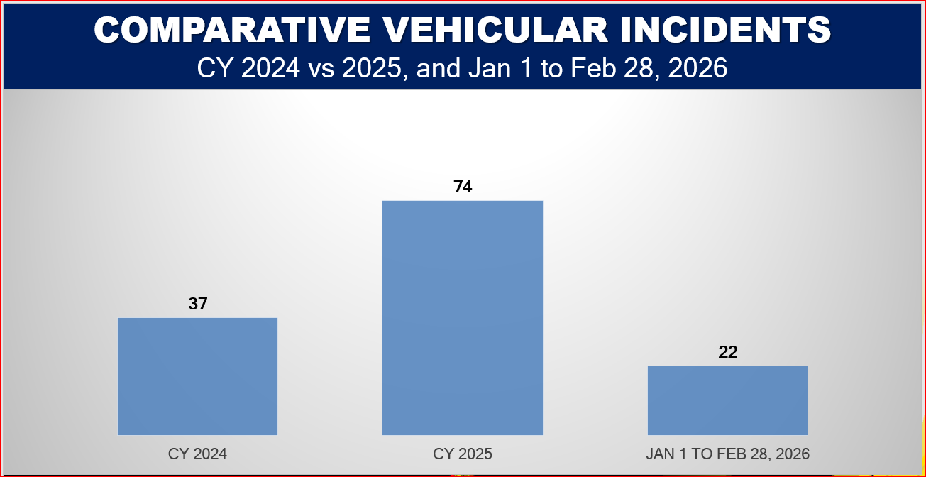
Comparative data on the numbers of vehicular traffic incidents of CY 2024 versus CY 2025 and January-February 2026
The total volume of documented vehicular incidents demonstrates an alarming upward trajectory.
Period | Number of Incidents | Percentage of Total (N=133)
CY 2024 | 37 | 27.82%
CY 2025 | 74 | 55.64%
Jan 1 – Feb 28, 2026 | 22 | 16.54%

F.1.a) Analysis:
The chart presents the comparative number of vehicular incidents from CY 2024 vs CY 2025 and Jan to Feb of 2026:
- Incidents exactly doubled between 2024 and 2025. The 22 cases recorded in just the first two months of 2026 represent nearly 60% of 2024's entire annual total, indicating that the upward trend remains aggressive.

- There was a significant and concerning doubling of incidents between 2024 and 2025. While 22 incidents in 2 months of 2026 might look "low" compared to 74, the rate is actually higher.

- In 2025, the average was roughly 6.1 incidents per month. However, in the first two months of 2026, the average is 11 incidents per month.

F.1.b) Projected Outcome:
If the current 2026 trend continues at this pace (11 per month), the year could end with approximately 132 incidents, which would represent a 78% increase over the already high 2025 figures.

F.2. Legal Analysis by Type of Offense

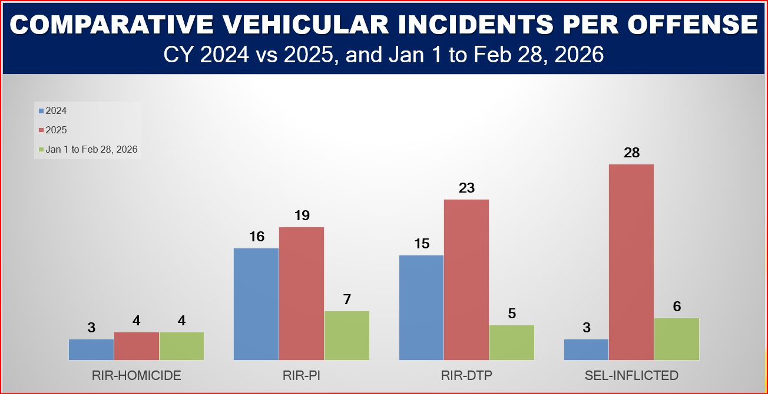
Comparative data on the classification of violations in relation to VTIs of CY 2024 versus CY 2025 and January-February 2026
Incidents are categorized based on their legal outcomes and classifications under the Revised Penal Code:
Offense Type | CY 2024 | CY 2025 | Jan 1 – Feb 28, 2026 | Total Cases
RIR-Damage to Property (DTP) | 15 | 23 | 5 | 43
RIR-Physical Injury (PI) | 16 | 19 | 7 | 42
Self-Inflicted | 3 | 28 | 6 | 37
RIR-Homicide | 3 | 4 | 4 | 11
Total | 37 | 74 | 22 | 133

F.2.a) Critical Finding on Self-Inflicted Cases: Self-inflicted incidents experienced a massive spike and most dramatic shift in the dataset, jumping from 3 cases in 2024 to 28 cases in 2025 (an 833% increase). This points heavily toward single-vehicle accidents involving loss of control, run-off-road events, or maneuvers to avoid obstacles. With 6 incidents already recorded in just two months, 2026 is on track to potentially reach 36 incidents if the trend remains linear.

F.2.b) Severity Note: RIR-Homicide remained relatively low with an increase from 3 incidents on 2024 to 4 incidents on 2025 which is the most stable yet concerning category, in only two months of 2026, the number of homicides (4) has already equaled the total for the entire year of 2025. This indicates a sharp increase in the severity/fatality of vehicular incidents this year, showing a severe spike in fatal outcomes. Additionally, Reckless Imprudence Resulting in Damage to Property (RIR-DTP) increased by approximately 53% from 2024 (15) to 2025 (23) with already are 5 recorded incidents so far in 2026 which is already 21.7% of the recorded data from 2025 while Reckless Imprudence Resulting in Physical Injury (RIR-PI) showed a moderate increase of 18.75% between 2024 (16) and 2025 (19) but notably, this category currently has the highest volume of incidents for the 2026 period with already 7 incidents at the first 2 months at the start of CY 2026 which is already equivalent to 36.8% of the recorded data from 2025.

F.3. Vehicular Incidents Monthly Trend

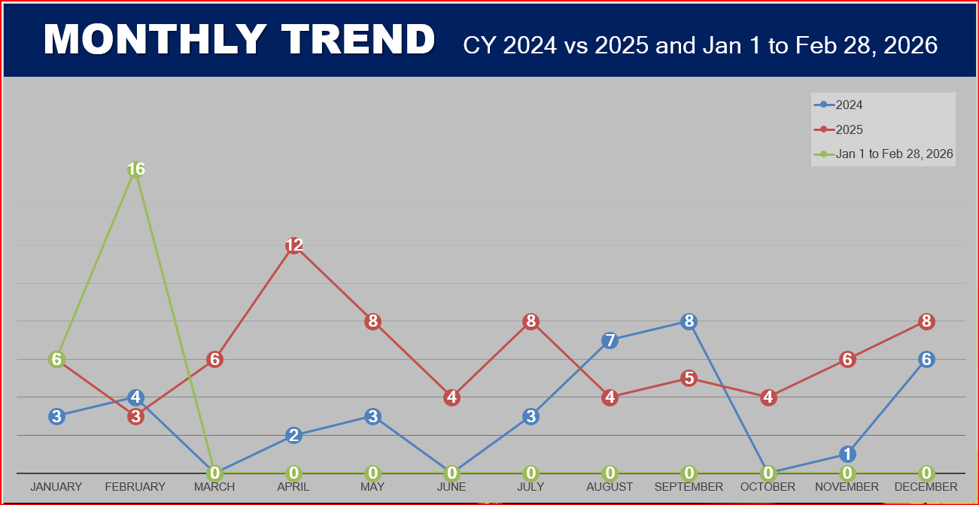
Comparative data on the monthly trend on the occurrence of vehicular traffic incidents of CY 2024 versus CY 2025 and January-February 2026
This chart provides a comparative look at vehicular incidents in Mountain Province from 2024 through the first two months of 2026. Looking at the data, there is a very sharp and concerning uptick in the immediate present.

F.3.a) Trend Breakdown

- 2025 Trend Breakdown (Red Line)

- There is a massive spike in April 2025 (12 incidents). This is a critical outlier. Given the geography of Mountain Province, this often correlates with increased tourist traffic during the "Summer Capital" season and Holy Week.

- After the April peak, numbers dropped in June (4) but spiked again in July (8).

- 2025 concludes with an upward trajectory, rising from 4 incidents in October to 8 in December, likely due to holiday travel and tougher weather/road conditions.
- 2024 Trend Breakdown (Blue Line)

- 2024 was characterized by significant "lulls." The period from March to July remained very low (below 4 incidents).

- Unlike 2025, 2024 saw its most dangerous period in August and September (7 and 8 incidents respectively), potentially linked to the height of the monsoon season affecting road stability.

- The drop from 8 incidents in September to 0 in October is a remarkable statistical shift.

- The 2026 Surge (Green Line)

- The most striking takeaway is the data for January and February 2026.

- January 2026 saw 6 incidents, doubled the amount seen in 2024.

- February 2026 skyrocketed to 16 incidents. This is the highest single-month total shown on the entire chart, representing a 400% increase compared to February 2024 and a 533% increase compared to February 2025.

F.4. Temporal Crime-Clock Analysis

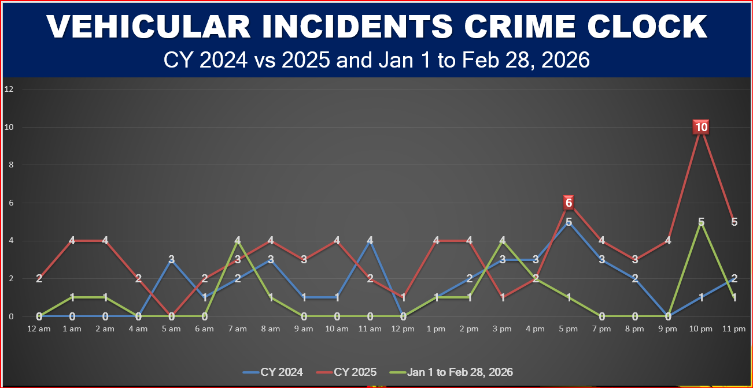
Comparative data on Crime Clock of the occurrence of vehicular traffic incidents of CY 2024 versus CY 2025 and January-February 2026
This “Crime Clock" chart provides a comparative look at incident frequency by hour across Calendar Year (CY) 2024, CY 2025, and the first two months of 2026. The red line (CY 2025) shows a dramatic increase in incidents compared to 2024, particularly during late-night hours. The most glaring data point is the 10:00 PM peak, where incidents jumped to 10, doubling the high points of previous years. This suggests a specific emerging risk during the late evening in 2025 that wasn't as prevalent in 2024.

Plotting the 133 incidents across a 24-hour cycle reveals clear, predictable peaks that match daily human activity and transit habits.

Visualizing the Peak Hours
Morning Peak | 07:00 AM – 08:00 AM | Morning commute & school runs
Late Afternoon | 05:00 PM | Rush hour & changing visibility
Night Peak | 10:00 PM | High fatality/Intoxication window

- The 10:00 PM Spike: The highest single-hour spike occurred in CY 2025 at 10:00 PM with 10 documented cases. This late-night surge carries over into 2026 (5 cases).

- The 5:00 PM Peak: A consistent spike is observable around 5:00 PM which is a high-risk hour across both 2024 and 2025, which aligns with the typical end-of-workday traffic surge and matching evening rush hours when driver fatigue sets in and natural light transitions to dusk.

- The Morning Peaks: A secondary minor peak occurs between 7:00 AM and 8:00 AM which show recurring spikes across all years, likely correlating with morning commutes and aligning with school and office commutes.

The green line (2026) is currently trending lower than 2025 in most categories, which is expected as it only covers only a two-month period. However, it already matches or exceeds 2025 levels at 7:00 AM and 10:00 PM. This indicates that these specific hours remain high-priority windows for enforcement or safety interventions.

F.5. Spatial/Municipal Distribution

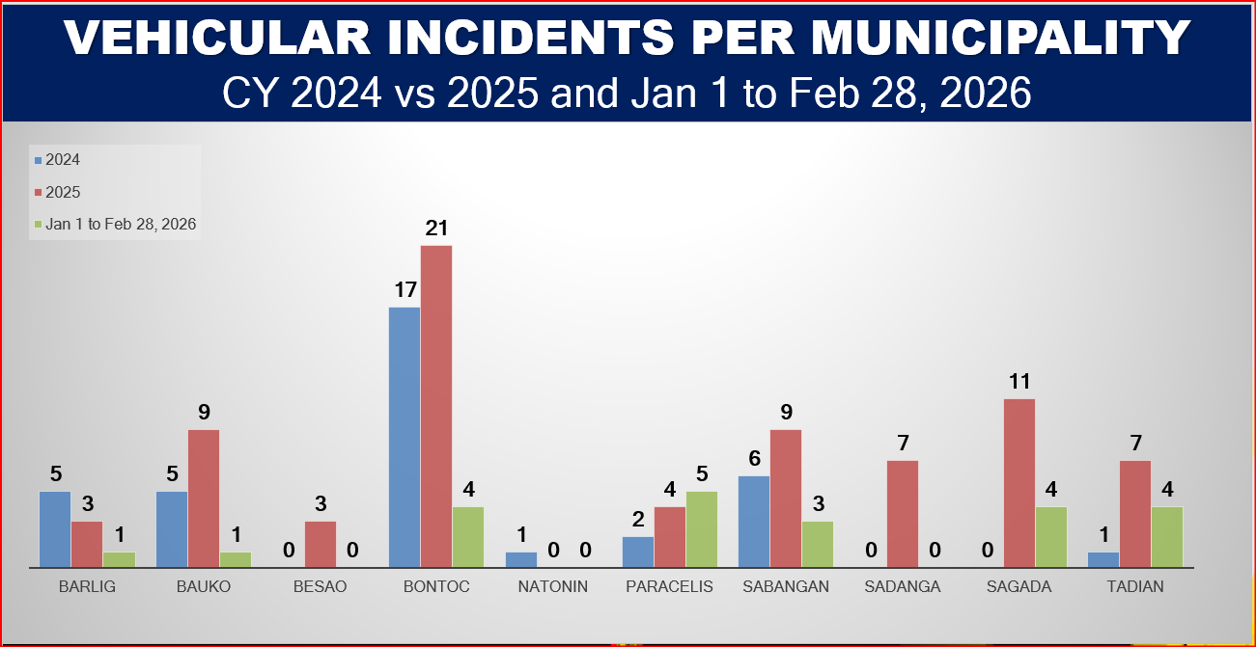
Comparative data on the data of vehicular traffic incidents per municipality (CY 2024 versus CY 2025 and January-February 2026)
The geographical mapping reveals clear high-risk corridors and low-risk zones across the province’s ten municipalities.
Municipality | CY 2024 | CY 2025 | Jan 1 – Feb 28, 2026 | Cumulative Total
Bontoc | 17 | 21 | 4 | 43
Sabangan | 6 | 9 | 3 | 18
Bauko | 5 | 9 | 1 | 15
Sagada | 0 | 11 | 4 | 15
Tadian | 1 | 7 | 4 | 12
Paracelis | 2 | 4 | 5 | 11
Barlig | 5 | 3 | 1 | 9
Sadanga | 0 | 7 | 0 | 7
Besao | 0 | 3 | 0 | 3
Natonin | 1 | 0 | 0 | 1
Total | 37 | 74 | 22 | 133
F.2.a) The Primary Hotspot: Bontoc is the undisputed epicenter of vehicular incidents, accounting for 32.33% (43 out of 133) of all cases in the province. This is highly correlated with its status as the provincial capital, commercial hub, and central transit node. Bontoc recorded 17 incidents in 2024 and 21 in 2025. While it currently has 4 incidents in early 2026, it remains the area with the highest historical volume.

F.2.b) Secondary High-Risk Corridors: Sabangan (18), Bauko (15), and Sagada (15) form a secondary high-risk cluster. These areas are heavily traversed by commercial haulers, public utility vehicles, and tourist traffic traveling along main highway systems. Both the municipality of Sabangan and Bauko recorded an increases in 2025 (reaching 9 incidents each) and have already recorded new incidents in the first 60 days of 2026 while Sagada shows a significant increase, jumping from 0 incidents in 2024 to 11 in 2025 and already recorded 4 incidents in the first 2 months of 2026. This suggests a rapidly emerging safety concern, potentially linked to increased tourism or transit traffic.

While we are only two months into the year, the data for Paracelis is particularly noteworthy which has already recorded 5 incidents in early 2026. This is already higher than its total for all of 2024 (2) and all of 2025 (4). This indicates a localized crisis or a specific road safety failure in Paracelis that requires immediate investigation.

F.2.c) Analysis: The data reveals that vehicular incidents are not evenly distributed across the province. The capital, Bontoc, remains the most dangerous area in terms of sheer volume, likely due to higher traffic density. However, the most urgent concern is Paracelis, where 2026 incidents have already surpassed the annual totals of the previous two years in just eight weeks.

F.5. The Root Cause Analysis

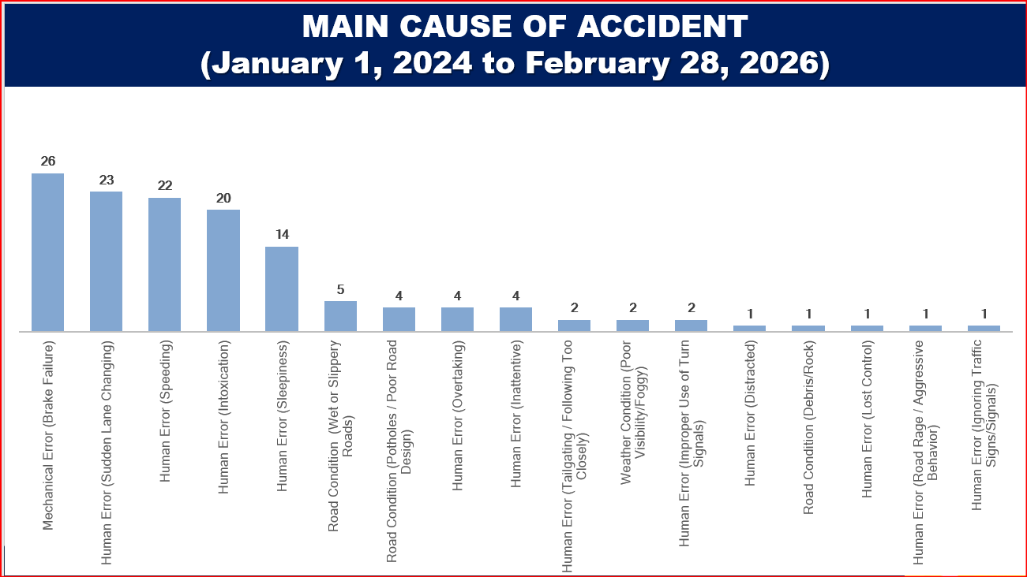
Data on the causes and numbers of vehicular traffic incidents from January 1, 2024 to February 28, 2026

An evaluation of the underlying mechanics of these accidents isolates three broad contributing factors:

Distribution of Incident Causes
████████████████████████████████████ Human Error (71%)
████████████ Mechanical Error (20%)
█▌ Environmental Factors (9%)

F.5.a) Breakdown of Direct Causes (Jan 1, 2024 – Feb 28, 2026)
- Mechanical Error (Brake Failure): 26 cases
- Human Error (Sudden Lane Changing): 23 cases
- Human Error (Speeding): 22 cases
- Human Error (Intoxication): 20 cases
- Human Error (Sleepiness/Fatigue): 14 cases
- Environmental/Road Conditions (Wet/Slippery): 5 cases
- Road Conditions (Potholes/Poor Design): 4 cases
- Human Error (Overtaking): 4 cases
- Human Error (Inattentive/Distracted): 5 cases (Combined)
- Other Minor Factors (Tailgating, Weather, Road Rage): 10 cases
F.5.b) Analysis:
- The Dominance of Human Error: Accounts approximately at 71% when aggregating sub-categories like lane changing, speeding, intoxication, and fatigue. This suggests that driver behavior and decision-making are the most critical areas for intervention, these behavioral factors are the leading cause of crashes. Within this category, aggressive maneuvers (sudden lane changes/speeding) and impaired driving (intoxication/fatigue) are the primary culprits.
- The Mechanical Threat: Mechanical failure accounts for 20% of incidents, driven entirely by Brake Failure (26 cases) which stands out as the highest single factor. This is a critical risk, as long downslopes and steep descents place immense stress on braking systems. This points toward a significant gap in vehicle roadworthiness and regular maintenance schedules among the motoring public.

- High-Risk Driving Behaviors: A combined 45 incidents (nearly 34% of the total) are caused by Sudden Lane Changing and Speeding. These are aggressive driving behaviors that are often preventable through stricter traffic law enforcement and better driver education.

- Environmental and External Factors: Road conditions (potholes, slippery roads) and weather conditions (fog/rain) account for a very small fraction of the total (approx. 9%). This highlights that the infrastructure, while always needing improvement, is less of a factor than the state of the vehicle and the person behind the wheel.

F.5.c) ASSESSMENT & RECOMMENDATIONS

- Focus on Maintenance: Since brake failure is the no. 1 cause, the PNP and relevant transport agencies (like the LTO) should consider stricter roadside inspections and mandatory periodic vehicle safety checks.
- Anti-Drunk Driving Campaigns: With 20 incidents attributed to intoxication, there is a clear need for increased sobriety checkpoints, especially during late-night hours and holidays.

- Addressing Driver Fatigue: "Sleepiness" caused 14 accidents. This suggests a need for "Rest Areas" on long-haul routes and public awareness campaigns regarding the dangers of driving while tired.

- Enforcement of Lane Discipline: Sudden lane changes are the second highest cause. Improving road markings and using camera-based "No Contact Apprehension" for erratic lane switching could significantly reduce these numbers.
Note: The data shows a long "tail" of low-frequency causes (Road Rage, Ignoring Signs, etc.). While these are less frequent, they often result from the same lack of discipline found in the top-tier causes.

F.6. The Root Cause Analysis

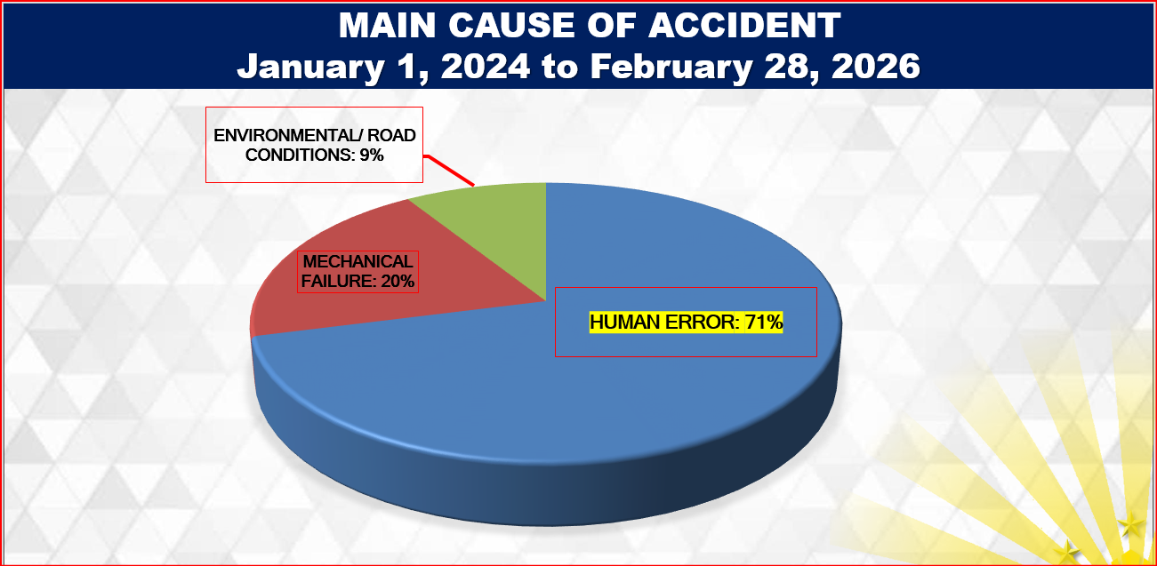
Data and percentage of VTIs from Jan. 1, 2024 to Feb. 28, 2026
Category | Total Incidents | Percentage of Total
Human Error | 95 | 71.4%
Mechanical Failure | 26 | 19.5%
Environmental / Road Conditions | 12 | 9.0%
F.6.a) Analysis:
- The "Human" Factor: With over 71% accidents attributed to driver behavior, the data suggests that most incidents are preventable through better discipline, education, and enforcement.

- Specifically:
- Sudden Lane Changing (17.3%) and Speeding (16.5%) are the leading behavioral issues.
- Intoxication (15.0%) remains a critical concern, ranking 4th overall.
- Mechanical Integrity: While human error dominates, the single most frequent individual cause is Brake Failure (19.5%). This highlights a widespread lack of preventive vehicle maintenance among drivers.
- Infrastructure & Environment: Only 9% of accidents were caused by factors like wet roads, potholes, or poor visibility. This indicates that while road improvements are always welcome, they are not the primary driver of accident rates in this dataset.

F.7 Incident Heat Mapping
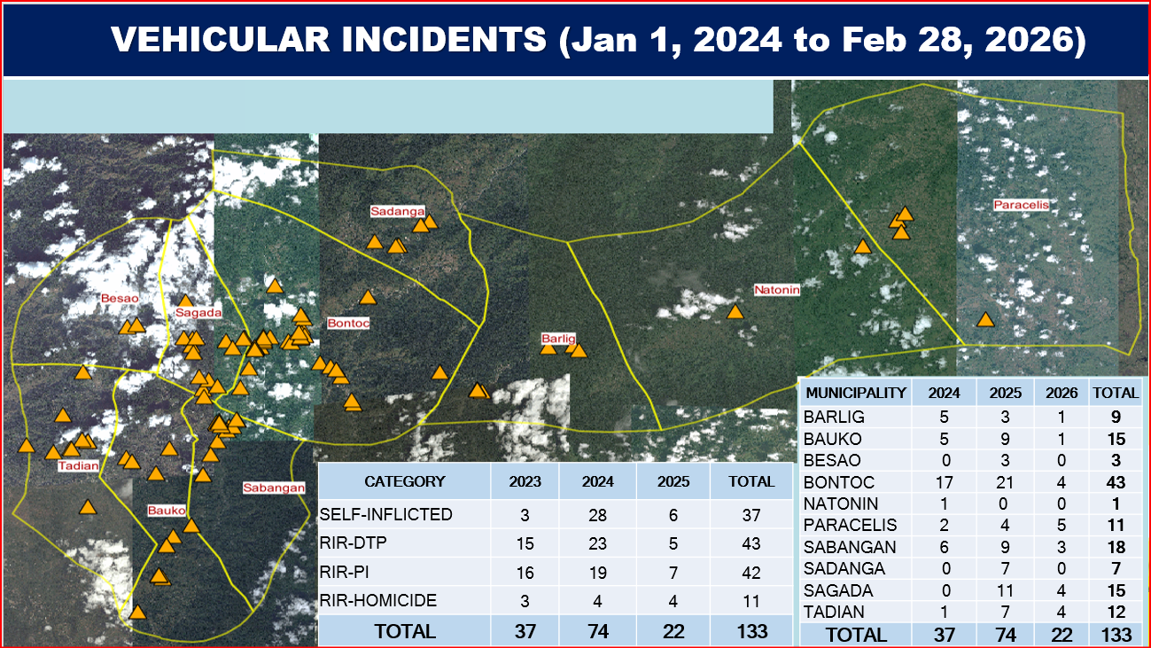
Map of vehicular traffic incidents from January 1, 2024 to February 28, 2026
As shown in the heat mapping, most of the incident transpired in the capital town of Bontoc and in the western municipalities of Sagada, Bauko, Sabangan and Tadian.
  - Ethical Considerations:
Given the secondary nature of the dataset, strict ethical protocols were maintained to prevent breaches of privacy or operational security:
- Compliance with RA 10173 (Data Privacy Act of 2012): Absolute anonymity was enforced during data extraction. The extraction process focused entirely on aggregate metrics. No Personally Identifiable Information (PII) such as names of drivers, victims, responding officers, plate numbers, or exact registration details was encoded or stored. Every incident was processed as an aggregate statistic and assigned an alphanumeric control code.

- Institutional Authorization: Access to the Crime Incident Reporting and Analysis System (CIRAS) and physical station blotters was gained only after obtaining formal clearance from the appropriate heads of offices. The data utilized remains the property of the law enforcement agency, and the findings are presented with utmost objectivity, without distortion or manipulation, to serve the interest of public safety and policy enhancement.

- Data Integrity and Transparency: The data was transcribed with strict objectivity, ensuring zero alteration, selective omission, or manipulation of frequencies to fit preconceived biases. The data utilized remains the property of the law enforcement agency, and the findings are presented with utmost objectivity, without distortion or manipulation, to serve the interest of public safety and policy enhancement.

- Data Security and Disposal: All digital files and data extracted are securely stored on an encrypted, password-protected drive accessible only to the primary researcher. Following the completion and presentation of the study, raw working data sheets will be archived or securely disposed of in accordance with institutional data retention policies to prevent unauthorized leaks or misuse.

CHAPTER III
- RESULTS AND DISCUSSIONS
The data reveals a clear picture of road safety challenges in Mountain Province:
- The Capital Bottleneck: Bontoc persistently registers high incident volumes due to combined local and transient traffic. However, tourist destinations like Sagada saw an aggressive shift from 0 cases in 2024 to 11 in 2025, showing that changing traffic volumes can quickly create new safety issues.

- The Mountain Brake Tax: The fact that Brake Failure is the single highest specific cause (26 cases) highlights the unique danger of the region's geography. Descending steep terrain requires continuous braking, causing brake fade and catastrophic failures for unprepared drivers or poorly maintained vehicles.

- The High-Risk Night Window: The prominent spike at 10:00 PM combined with 20 cases of Intoxication and 14 cases of Sleepiness points to a dangerous late-night window where reduced visibility meets impaired or fatigued driving.

CHAPTER IV
- CONCLUSIONS AND RECOMMENDATIONS

  - Conclusions
The study concludes that public safety in Montanyosa has shifted from a "crime-fighting" focus to a "hazard-management" focus. The primary threat to the life and limb of people is no longer interpersonal violence but rather the risks associated with the province's transport arteries. Current police initiatives are effective in maintaining peace, but lack specialized "mountain-road" safety interventions.

Based on the systematic analysis of the 133 recorded incidents (N=133), the following empirical conclusions are drawn:
- Human Behavior is the Primary Driver of Risk: At 72% of the total volume, human error remains the overwhelming root cause of traffic accidents. The prevalence of aggressive driving behavior (sudden lane changes and speeding) combined with physical impairment (intoxication and fatigue) underscores a critical gap in driver discipline and defensive driving literacy.

- Geography Taxes Vehicle Maintenance: Mechanical failures account for a substantial 20% of incidents, driven entirely by Brake Failure (26 cases). This proves that the long, steep downslopes characteristic of Mountain Province places an extraordinary stress on braking systems. This specific risk targets transient drivers and heavy commercial haulers who may not be accustomed to prolonged descending maneuvers.

- The Provincial Capital as a Traffic Chokepoint: Bontoc is the undisputed statistical hotspot, commanding 32.33% (43 cases) of the provincial total. This concentration is a direct result of its role as the administrative, commercial, and transit nexus of the province. Conversely, emerging tourist corridors like Sagada have shown rapid vulnerability shifts (moving from 0 cases in 2024 to 11 in 2025), proving that tourism spikes translate directly to road safety pressures.

Predictable Temporal Windows of High Lethality: Traffic risks are not uniformly distributed throughout the day. They converge tightly around two distinct periods: the 5:00 PM evening rush hour, where driver fatigue mixes with fading natural light, and the 10:00 PM late-night window, which represents the highest statistical spike and is heavily associated with driving under the influence of liquor (DUIL) and reduced visibility.

  - Recommendations
Based on these findings, the following targeted interventions are recommended:
- Enhancement of Action Plan: Strategic Road Safety Initiatives (SRSI)

To translate these findings into operational reality, the following multi-agency Action Plan is recommended for immediate implementation.
Operational Matrix: Action Plan
Strategic Area | Targeted Objective | Specific Action/Tactic | Responsible Unit/Agency
Tactical Enforcement | Mitigate the 10:00 PM late-night spike and combat impaired driving. | • Deploy targeted sobriety checkpoints and speed-gun teams on major highway arteries in Bontoc, Sabangan, Sagada and Bauko between 4:00 PM–6:00 PM and 9:00 PM–Midnight.  • Strict enforcement of RA 10586 (Anti-Drunk and Drugged Driving Act). | PNP Municipal Police Stations (MPS), Highway Patrol Group (HPG)
Engineering & Mechanical Risk Reduction | Prevent catastrophic brake failure on steep downslopes. | • Establish Mandatory Brake Inspection Points / Cooling Zones at the apex of critical descents.  • Coordinate with DPWH for the installation of high-visibility "Test Your Brakes" signage and the strategic construction of Runaway Truck Ramps in Sabangan and Bauko. | LGUs, DPWH, Land Transportation Office (LTO)
Geographic Bottleneck Management | Decongest Bontoc and secure expanding tourist routes. | • Implement stricter local traffic routing ordinances and clear illegal on-road parking in Bontoc commercial centers.  • Establish seasonal tourist traffic assistance desks and mandatory safety orientations for transient vans entering Sagada. | PNP, LGUs, Traffic Management Units
Education & Preventative Campaigns | Address the 72% Human Error factor through behavioral modification. | • Launch the "Engine Braking Over Friction Braking" information campaign specifically tailored for public utility jeepneys, trucks, and visiting motorcycle riders.  • Conduct mandatory road safety seminars for local transport cooperatives. | LTO, PNP Community Affairs Section, Transport Cooperatives
Infrastructure & Visibility Enhancements | Reduce accidents related to dusk visibility and road geometry. | • Install solar-powered pavement studs (cat-eyes), reflective chevron signs, and anti-skid friction strips on blind curves along accident-prone national highway sectors. | DPWH and LGUs

- Tactical Enforcement and Checkpoints
- Shift Enforcement Shifts: Deploy active police visibility, speed-gun monitoring, and sobriety checkpoints during identified peak hours, specifically from 4:00 PM to 6:00 PM and 9:00 PM to Midnight.

- Anti-Drunk Driving Operations: Focus Republic Act 10586 (Anti-Drunk and Drugged Driving Act) enforcement around commercial hubs in Bontoc, Bauko, and Sagada during evening hours.

- Mandatory Vehicle Safety Corridors
- Brake Inspection Stations: Establish mandatory roadside check areas or "choke points" at the entrances of long, steep descents. These stations can provide mandatory cooling periods and quick safety checks for heavy trucks and tourist vehicles.

- Runaway Truck Ramps: Coordinate with the Department of Public Works and Highways (DPWH) to construct emergency runaway ramps along high-risk routes in Sabangan, Bauko, and Tadian.

- Targeted Information Education Campaigns (IEC)
- Defensive Mountain Driving Programs: Roll out campaigns specifically targeting motorcycle riders and commercial haulers, focusing on the mechanics of engine braking to prevent brake failure.

- Tourist Driver Orientations: Partner with local hotels and tourism offices in Sagada and Bontoc to distribute quick road safety guides to visiting drivers unfamiliar with mountain terrain.

- Engineering and Infrastructure Adjustments
- Enhanced Visibility Measures: Install high-visibility solar studs, cat-eyes, and reflective chevron signs along sectors prone to fog and early dusk (such as Sabangan and Bauko).

- Road Surface Rehabilitation: Prioritize the repair of sectors identified with recurrent potholes and slippery surfaces, ensuring adequate drainage to prevent water pooling during rainy periods.

- Engineering: Implementation of more "runaway truck ramps" in steep decline areas like the Halsema Highway.

- Enforcement: Integration of mandatory mechanical check-ups for all long-haul PUVs entering the province.

- Education: Development of a localized "Highland Driver’s Manual" focusing on engine braking techniques and navigating fog/heavy rain conditions.

- REFERENCES
- Bersamin, J. P. (2015). Valenzuela v. People, G.R. No. 160188. Supreme Court of the Philippines. https://elibrary.judiciary.gov.ph/

- Department of the Interior and Local Government, & Department of Public Works and Highways. (2020). Joint Memorandum Circular No. 2020-001: Guidelines on the implementation of local road safety policies and traffic management institutionalization. National Government Portal.

- Haddon, W., Jr. (1972). A logical framework for categorizing highway safety phenomena and organizing information. The Journal of Trauma: Injury, Infection, and Critical Care, 12(3), 193–207. https://doi.org/10.1097/00005373-197203000-00002

- Heinrich, H. W. (1931). Industrial accident prevention: A scientific approach. McGraw-Hill.

- Land Transportation Office. (2023). Philippine Road Safety Action Plan (PRSAP) 2023–2028: Towards safer roads in the Philippines. Department of Transportation.
- Mountain Province Police Provincial Office. (2025). Official investigation report on the vehicular incident at Barangay Ampawilen, Sadanga, Mountain Province. (Traffic Case Report No. 2025-04-04). Police Regional Office Cordillera.

- Official Gazette of the Republic of the Philippines. (1932). Act No. 3815: The Revised Penal Code of the Philippines. Central Government Portal. https://www.officialgazette.gov.ph/

- Official Gazette of the Republic of the Philippines. (1964). Republic Act No. 4136: An act to compile the laws relative to land transportation and traffic rules, to create a Land Transportation Commission, and for other purposes. Central Government Portal. https://www.officialgazette.gov.ph/

- Official Gazette of the Republic of the Philippines. (2012). Republic Act No. 10173: An act protecting individual personal information in information and communications systems in the government and the private sector, creating for this purpose a National Privacy Commission, and for other purposes. Central Government Portal. https://www.officialgazette.gov.ph/

- Official Gazette of the Republic of the Philippines. (2013). Republic Act No. 10586: An act penalizing persons driving under the influence of alcohol, dangerous drugs, and/or other similar substances, and for other purposes. Central Government Portal. https://www.officialgazette.gov.ph/

- Philippine National Police. (2021). Crime Incident Reporting and Analysis System (CIRAS) standard operating procedures and data validation protocols. (Directorate for Investigation and Detective Management Manual). Camp Crame.

- World Health Organization. (2023). Global status report on road safety 2023. World Health Organization. https://www.who.int/publications/i/item/9789240086517

- Philippine Information Agency (2026). "Vehicular accidents top public safety indicators in Cordillera."

- Police Regional Office-Cordillera (2025). "Annual Accomplishment Report: Best Regional Office Category."

- Republic Act 10121. "The Philippine Disaster Risk Reduction and Management Act."

- APPENDICIES
  - Appendix A: Raw Frequency Distribution Tables
Table A1: Incident Breakdown by Municipality and Calendar Year
Municipality | CY 2024 | CY 2025 | Jan 1 – Feb 28, 2026 | Cumulative Total | Percentage (N=133)
Bontoc | 17 | 21 | 4 | 43 | 32.33%
Sabangan | 6 | 9 | 3 | 18 | 13.53%
Bauko | 5 | 9 | 1 | 15 | 11.28%
Sagada | 0 | 11 | 4 | 15 | 11.28%
Tadian | 1 | 7 | 4 | 12 | 9.02%
Paracelis | 2 | 4 | 5 | 11 | 8.27%
Barlig | 5 | 3 | 1 | 9 | 6.77%
Sadanga | 0 | 7 | 0 | 7 | 5.26%
Besao | 0 | 3 | 0 | 3 | 2.26%
Natonin | 1 | 0 | 0 | 1 | 0.75%
Total | 37 | 74 | 22 | 133 | 100.00%

Table A2: Incident Distribution by Legal Offense Type
Offense Type | CY 2024 | CY 2025 | Jan 1 – Feb 28, 2026 | Total Cases | Percentage (N=133)
RIR to Damage to Property | 15 | 23 | 5 | 43 | 32.33%
RIR to Physical Injury | 16 | 19 | 7 | 42 | 31.58%
Self-Inflicted Incidents | 3 | 28 | 6 | 37 | 27.82%
RIR to Homicide | 3 | 4 | 4 | 11 | 8.27%
Total | 37 | 74 | 22 | 133 | 100.00%

  - APPENDIX B: DATA EXTRACTION MATRIX TEMPLATE
(This blank template illustrates how raw traffic entries from CIRAS and physical station blotters were securely logged and anonymized).
Case Control ID | Date of Incident | Time of Incident | Station / Municipality | Offense Classification | Primary Cause Category | Direct Determining Cause
MP-2024-001 | DD/MM/YYYY | HH:MM (24hr) | e.g., Bontoc | e.g., RIR-DTP | Human / Mech / Env | e.g., Brake Failure
MP-2024-002 | DD/MM/YYYY | HH:MM (24hr) | e.g., Sagada | e.g., Self-Inflicted | Human Error | e.g., Intoxication

  - APPENDIX C: SAMPLE COMMAND MEMORANDUM
(A sample template for transmitting these research findings into official, actionable policy directives within the province).
MEMORANDUM
TO: All Municipal Police Stations (MPS), Mountain Province PPO
FROM: Provincial Operations Management Unit (POMU)
SUBJECT: Implementation of Strategic Road Safety Initiative (SRSI)/ Strict Traffic Enforcement
DATE: May 21, 2026
- REFERENCES:

- Mountain Province PPO Research Report on Vehicular Incidents (CY 2024–February 28, 2026).

- Republic Act No. 10586 (Anti-Drunk and Drugged Driving Act of 2013).

- Republic Act No. 4136 (Land Transportation and Traffic Code).

- RATIONALE: Recent provincial data analysis indicates an alarming 100% surge in vehicular traffic incidents across the province, with the Municipality of Bontoc identified as the primary geographic hotspot, and late-night hours yielding the highest statistical crash concentration. Human error (72%) and mechanical brake failure (20%) remain the leading root causes.

- DIRECTIVE: All Chiefs of Police (COPs) are hereby directed to immediately execute the following tactical adjustments within their respective Areas of Responsibility (AOR):

- Shift Adjustment: Increase active mobile and foot police visibility along major national highways during identified peak risk windows: 5:00 PM to 7:00 PM and 10:00 PM to 12:00 MN.

- Anti-Drunk Driving Operations: Conduct targeted, highly visible sobriety checkpoints and random speed gun monitoring, strictly applying the protocols under RA 10586, particularly during weekends and evening hours.

- Inter-Agency Coordination: Coordinate with local LGUs, the HPG, and municipal disaster risk management offices to identify steep descending sectors for high-visibility signage installation and local transport cooperative safety briefings.

- MONITORING: Weekly accomplishment reports regarding traffic citations, arrested DUI motorists, and localized road safety operations must be submitted directly to this Office (Attn: POMU) every Friday before 5:00 PM.

- For strict compliance and immediate implementation.
By Authority of the Provincial Director:

