Duration-Dependent Effects of 5G Mobile Phone Radiation Exposure on Anxiety-Like Behaviors Using the Swiss Mouse Model

ABSTRACT
The widespread use of 5G mobile phones has raised concerns about potential health risks, particularly regarding their impact on anxiety-like behaviors. This study aimed to investigate the effects of 5G mobile phone radiation on anxiety- related behaviors using the Swiss Mouse Model. Four groups of mice were exposed to varying durations of 5G radiation (Control, 20 minutes, 40 minutes, and 60 minutes). Mice behaviors were assessed using the Elevated Plus Maze (EPM), measuring head dipping, rearing, time spent in the open arms, time spent in the closed arms, and the number of entries into both the open and closed arms. A one-way ANOVA and Tukey HSD post hoc analysis were employed to analyze the data. Results revealed that longer exposure to 5G radiation significantly increased anxiety- like behaviors, as evidenced by a decrease in the time spent in the open arms and the number of entries into the open arms. Furthermore, the number of entries into the closed arms increased with longer exposure. Additionally, behaviors such as head dipping and rearing were also affected by exposure duration, with the greatest changes occurring in the 40 and 60-minute exposure groups. These findings suggest a dose-response relationship, where increased radiation exposure correlates with heightened anxiety-like behavior. This study contributes to understanding the health implications of 5G technology.

Keywords: electromagnetic radiation; elevated plus maze; mice behavior

INTRODUCTION
Mobile phones emit radiation widely, raising public concerns about possible health effects (National Institutes of Health, 2024). Among the body's systems, the central nervous system is recognized as one of the most important targets for radiation exposure. However, in both human and animal models, the majority of research so far links electromagnetic fields (EMFs) to a broad range of disruptions at the anatomical, physiological, cellular, and molecular levels. Further assessment of the effects of new technologies on the human body is necessary to clarify this issue as such disputes are still not solved and vivid (Fragopoulou et al., 2009). Cellphones use is rapidly growing, especially among young adults, which raises concerns about long-term radiation exposure and potential health hazards (Hasan et al., 2022). This aligns with the Sustainable Development Goal for Good Health and Well-Being (SDG3), which stresses the importance of examining the health effects associated with pervasive technologies such as 5G networks.

As the 5G technology evolves and is implemented at higher frequencies, it is increasingly important to evaluate how its effects might interfere with brain function. Altun et al. (2017) exposed participants to radiation and observed that they suffered losses of both pyramidal and granule neurons—two fundamental components of the information storage system within the brain’s cortex. These studies highlight a worrying risk for exposure to RF-EMR radiation and its possible enduring impacts on an individual’s neurological health. Zheng et al. (2023) observed that irradiated mice in a different study became more anxious and less mobile. However, some behavioral parameters like spatial memory and depressive-like behavior did not change at all. Qin et al. (2022), on the other hand, took a more specific route by exposing mice to 4.9 GHz radiation. They had a non-exposed control group, which was compared with the exposed group. With regards to body weight and anxiety-like behavior, there were no observable changes for the stated exposure frequency and level in these mice. As a follow-up to these concerns, Zheng (2023) assessed anxiety with the EPM and OFT methods and additional studies concluded that EMR exposure is likely to significantly impair one’s neurological and psychiatric health. Moreover, the exposed mice showed reduced mobility and exploratory behaviors, which are commonly associated with heightened anxiety. Other studies have also highlighted possible effects on the nervous system. For example, EMF's impact on some ion channels, nerve myelin, and even neuronal cell death in the central nervous system was demonstrated by Kim et al. (2018). Electromagnetic field (EMF) radiation may also induce stress on biological systems. Most of the studies relied on cells or animal models, which offered a basic understanding of how RF radiation and EMF fields might impact biological systems.

The global public concern surrounding mobile phones and their health risks due to electromagnetic radiation (EMR) has significantly increased over the past decade. While abundant literature exists regarding the health effects of older generations of mobile technology, studies addressing the newest mobile technology, 5G and its EMR, are very limited as they undergo preliminary exploration. To address this gap, this study examined the effects of radiation from 5G mobile phones on behavior in the context of health using the Swiss mouse model, which was the primary objective of the study.

Specifically, this study: (1) determined the anxiety levels of Swiss mice exposed to 5G radiation at varying durations (0, 20 minutes, 40 minutes, and 60 minutes); (2) compared the anxiety-related behaviors of Swiss mice exposed to 5G radiation at varying durations. With the increasing use of 5G technology, this study seeks to provide data that could influence safety standards and contribute to a deeper understanding of electromagnetic radiation's effect on health.

MATERIALS AND METHODS

Materials
The materials for this study comprised 20 Swiss mice, which possessed a range of traits and, therefore, genetic diversity, which made them appropriate for a number of experimental studies. Along with these mice, the materials needed for the experiment included a rectangular plastic cage, an EPM (elevated plus-maze) with 4 arms (two open and without walls and two enclosed by walls 16 cm high and 30 cm long and 5 cm wide Pellow et al. 1985), two Techno Spark 20 5G and 30 5G mobile phones, closed circuit television camera, and other items which were tailored in accordance with the specific aim of the experiment were also added.

Research Design
The study used a quantitative experimental research design to analyze the effects of 5G radiation on the anxiety-related behavioral characteristics of Swiss mice. It manipulated the independent variable, 5G radiation exposure, to observe its effects on the dependent variables, which were the mice's anxiety-like behaviors. This study involved comparing four different experimental groups of mice, which were divided into 5 per group, exposed to 5G radiation over a specified period with behavioral observations. Specifically, the mice exposed to 5G modulated RF- EMR at varying durations, the controlled group (no radiation exposure), and the three exposed groups (20 minutes, 40 minutes, and 60 minutes) each day for one month (30 days).

Procedures

Construction of Elevated-plus Maze (EPM)
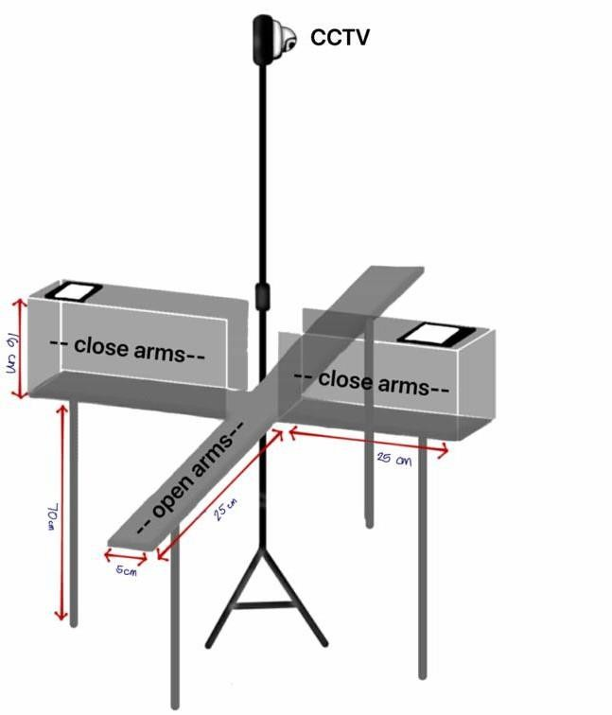
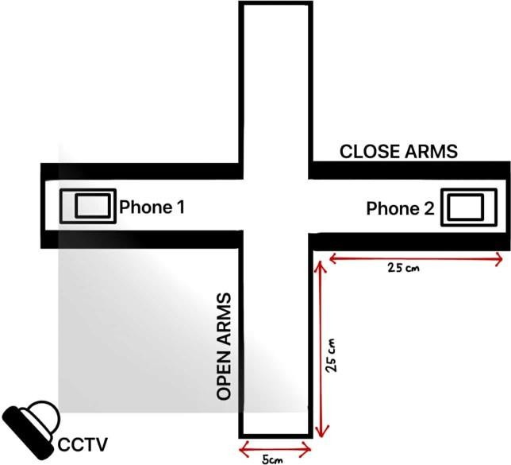
The Elevated-plus maze was composed of four arms, each 30 cm long and 5 cm broad, two of which were open without walls and two of which were enclosed by walls that were 16 cm high. It was constructed of mahogany wood and painted matte black. The maze was supported by strong mahogany wood legs that were raised 70 cm from the table it was placed on. A CCTV camera mounted above the maze captured the movements, which video tracking software then converted and stored on the computer (Ghassemi et al., 2022). Additionally, a camera was placed on a tripod to monitor the model's action in the closed arms due to the CCTV’s lack of perspective from above.

Figure 1. Elevated-Plus Maze (Top View) Figure 2. Elevated-Plus Maze (Isometric View)
Acclimation of Swiss Mice
The study involved 20 male mice, two weeks old, categorized into four groups. After one week of acclimatization, during which the mice were fed with pellets and mineral water that underwent an ad libitum diet, they had constant access to high-energy food in their cage (Keenan et al., 2005). The mice were fed once daily on a 24- hour schedule, ensuring they received their food at the same time each day (Ritske-Hoitinga et al., 2012). Each group contained five mice (n=5), along with 10 additional mice for acclimatization, bringing the overall total to thirty mice. The average mean was calculated each day over a month to assess the behavioral characteristics of the mice. If any mice died and the average number of mice was not reached, the group underwent a week of acclimatization from the 10 extra mice. Each group was tested in separate trials, consisting of one mouse per trial, with each mouse kept apart in rectangular plastic cages separated by wire mesh partitions. The body weight of the mice was recorded before radiation exposure began.
Radiofrequency electromagnetic radiation (RF-EMR) exposure system
Two 5G interconnected mobile phones operating at 3500 MHz, were exposed to radiation at a Specific Absorption Rate (SAR) of 2.7 W/kg in this experiment. The three-power- meter method for measuring SAR calculated the energy difference between an empty and occupied chamber, divided by the total weight of the mice inside (Marshall et al., 1983). The animal was positioned in the middle of the maze and given about ten minutes to explore before the test began during the exposure period. The exposure room from the control room free of electronic devices such as PCs, laptops, and cameras, prevented additional EMF sources from influencing behavioral studies. To ensure uniform radiation exposure, the mobile phones with automatic answer mode were placed at the top of the closed arm (Kumar et al., 2009; Narayanan et al., 2009). To start the test, the Swiss mice were placed into the intersection of the open and closed arms of the maze. The Swiss mouse can spend time in an open space (open arms) or a safe, enclosed space (closed arms). The treatment groups consisted of a control group (no exposure) and three experimental groups: Group 1 (20 minutes), Group 2 (40 minutes), and Group 3 (60 minutes). The exposure was conducted over one month to assess the effects of varying radiation levels (Hasan et al., 2021; Hasan & Islam, 2023; Narayanan et al., 2009; Saikhedkar et al., 2014; Sokolovic et al., 2008).
Behavioral Assessment
The EPM was cleaned and dried before a Swiss mouse was placed into it. After that, the video-tracking system was prepared for use. The observation was conducted for durations of 20 minutes, 40 minutes, and 60 minutes, depending on the experimental group. Individual housing in a single plastic container covered with wire mesh or a plastic hamster cage with a secure mesh cover allows five mice to thrive with adequate ventilation. The data sheets were filled out, including the date, coded condition, animal subject number, and the experimenter's initials. The mouse was brought into the behavioral testing laboratory in a makeshift transport cage. After this, it was taken out of its cage and positioned facing the open arm across from the researcher at the intersection of the maze closed and open arms. In the elevated-plus maze (EPM), every mouse should be handled uniformly and placed in the same location. When the mouse was positioned facing an open arm as opposed to a closed arm, different behaviors were seen (Pellow et al., 1985).

Before a new Swiss mouse was tested, the Elevated-plus Maze (EPM) was cleaned thoroughly with 20 percent alcohol to remove any impure odor index and wait for 5-10 minutes to reduce the smell of the alcohol. Monitoring the environment was also crucial to preventing stresses, which could be caused by hidden, broken climate controls.

During the radiofrequency application, the Swiss mice may behave differently, as indicated in the following:

Table 1. Measurement of Anxiety-related Behavior
Behavioral Metrics | Indicator | Interpretation
Head-Dipping | Each instance where a mouse dips its head over the edge of an open arm toward the floor is counted. | Increased head-dipping often indicates reduced anxiety and increased exploratory behavior
Rearing | This will be scored by counting each time a mouse stands on its hind legs, usually with front paws against the maze walls. | Higher rearing frequency can indicate comfort and reduced anxiety
Time Spent in Open and Closed Arms | Open Arm Entries: This will be counted each time a mouse fully enters (all four paws) an open arm anxiety Closed Arm Entries: This will be counted similarly and used to assess general movement. | Higher entries suggest lower anxiety A balanced ratio of open to closed-arm entries helps differentiate anxiety from general activity level.
Number of Entries in Open and Closed arms | Open Arm Duration: This will be recorded as the total time the mouse spends in the open arms Closed Arm Duration: Recorded as time spent in closed arms. | More time in open arms typically indicates lower anxiety.  Mice tend to spend more time here if anxious
Source: Hasan et al. (2022)

Data Analysis
Anxiety levels in the control groups and the three exposed groups were analyzed using One-way ANOVA for durations of 20, 40, and 60 minutes to determine differences between the experimental control and exposed groups. The analysis was performed using JASP, with results visualized through tables and bar graphs to illustrate mean values and standard errors. This approach provides a comprehensive understanding of the behavioral effects of 5G radiation on Swiss mice.

Ethical Consideration
The researchers observed regulatory requirements and obtained the necessary approvals from the administration before experimenting. To ensure the integrity and ethical compliance of the study, guidance from experts and mentors was requested during the experiment's implementation. The researchers adhered to national guidelines concerning animal welfare, ensuring that the requirements for responsible care and ethics were considered. A letter was sent to the veterinarian for approval to experiment, and the researchers sought permission from the city veterinarian. To ensure compliance with local and municipal regulations on animal welfare, including appropriate housing, care, and humane treatment of the Swiss mice before, during, and after the experiment. With the help of a mentor and a licensed veterinarian, the researchers ensured that the experiment followed safety standards regarding animal health, confining all risks to an absolute minimum, as stated by the Animal Welfare Act of 1998 (Republic Act. 8485). It required the researchers to secure authorization and follow ethical guidelines to prioritize animal welfare.

RESULTS AND DISCUSSION

Effects of RF-EMR Exposure on Anxiety-like Behavior of Swiss Mouse Model
This study examined the mice's behavior after one month of exposure to radiation. The frequency of entries and the amount of time spent in the open and closed arms were utilized to evaluate the presence of anxiety-related behavior. Throughout the trial, no significant behavioral changes were observed. However, fatalities were distinguished across all experimental groups. In the control group, 2 out of 5 mice died two weeks before data collection. Similarly, fatality was recorded in the exposed groups, with 2 mice in the 1-hour group, 2 mice in the 40- minute group, and 1 mouse in the 20-minute group. Despite these losses, daily monitoring ensured that the mice's health and consumption were closely observed throughout the experimentation.

Mice's anxiety was measured by how often they entered and how long they stayed in the open and closed arms of EPM. Throughout the mice experiment period, every mouse in the control group was active and healthy, and there were no odd behavioral changes. Every day of the trial, the mice's food and water intake, as well as overall health, were monitored.

In this table, the results were displayed as the mean and standard deviation for the control group as well as the exposure groups (20, 40, and 60 minutes). The data were presented based on their behavioral features after being calculated to p-values and η².

Table 3. Results of Frequencies of Behavior in Mice under various durations under 5G Mobile Radiation
 | Mice Exposure Duration
Behavioral Metrics | Control | 20 Min | 40 Min | 60 Min | F |  |  | η²
Head dipping | 10.90 ± 1.98 | 12.93 ± 3.26 | 13.22 ± 1.83 | 5.39 ± 2.41 | 6.645* |  |  | 0.714 (71%)
Rearing | 7.39 ± 0.97 | 6.93 ± 0.37 | 6.93 ± 2.59 | 8.96 ± 3.45 | 0.566 |  |  | 0.175 (17.5%)
Time Spent in Open Arms | 15.27 ± 1.93 | 16.25 ± 0.44 | 15.27 ± 1.93 | 11.99 ± 0.89 | 21.806** |  |  | 0.891 (89.1%)
Time Spent in Closed Arms | 9.46 ± 3.30 | 10.03 ± 0.98 | 20.16 ± 3.59 | 31.00 ± 3.10 | 35.981** |  |  | 0.931 (93.1%)
Number of Entries in  Open Arms | 10.33 ± 1.59 | 8.63 ± 1.20 | 8.36 ± 0.90 | 6.03 ± 1.06 | 6.350* |  |  | 0.704 (70.4%)
Number of Entries in Closed Arms | 5.60 ± 1.22 | 6.78 ± 0.82 | 7.51 ± 0.95 | 7.75 ± 0.75 | 3.064 |  |  | 0.535 (53%)
note. *p<0.05; **p<0.001
Table 3 presents the results of an analysis investigating the impact of various time exposures on Swiss mice performed in EPM observing their anxiety-like behavior. The behavioral characteristics assessed include number of entries in open and closed arms, time spent in open and closed arms, head dipping, and rearing, observed at specific groups of control, 20 minutes, 40 minutes, and 60 minutes with the average of 3 mice in each group. To evaluate the variation in the mean values of each behavioral characteristic across different time exposures, a one-way ANOVA was used. The results indicated a significant difference for head dipping (F = 6.645, *p < 0.015, η² = 0.714), time spent in open arms (F = 22.806, **p < 0.001, η² = 0.891), time spent in closed arms (F = 35.981, **p < 0.001, η² = 0.931), and number of entries in open arms (F = 6.350, *p < 0.016, η² = 0.704). No significance (NS) was observed in the number of entries in closed arms (F = 3.064, p < 0.091, η² = 0.535) and rearing (F = 0.566, p < 0.652, η² = 0.175).

In addition to the significant findings from the One-Way ANOVA, a post hoc analysis was conducted to further elucidate the specific differences between various duration exposure of mobile radiation on the behavioral characteristics of the Swiss mouse model. The Tukey HSD test was employed for pairwise comparisons. The post hoc analysis revealed that there were significant differences in behavioral characteristics between the control group (no exposure) and the treatment groups (20 minutes, 40 minutes, and 60 minutes).

Head dipping
The results of the post hoc analysis showed a significant decline with increasing exposure duration. There was a significant difference between the 60-minute group and the control group (t = -3.932, p = 0.018) in the reduction of head dipping, which may be an indication of increasing anxiety in 60 minutes following prolonged radiation exposure. Significant differences also existed between the 20- and 60-minute groups (t = 3.786, p = 0.022). Intermediate exposure did not significantly alter this behavior, either, as no significant differences were observed across other pairs, such as the 20-minute vs. 40-minute groups (t = 1.017, p = 0.745) or the 40-minute compared control groups (t = -1.162, p = 0.665). According to Heinz et al. (2008), the study supports the findings that extended radiation exposure reduces head-dipping behavior, indicating increased anxiety in rodents. Exposure to head-only gamma radiation resulted in notable neurobehavioral deficits, such as increased impulsivity and decreased performance accuracy. Similarly, Hasan et al. (2022) stated that a decrease in head-dipping behavior indicates reduced exploratory activity. This reduction in exploratory behavior is associated with heightened anxiety levels. These findings align with the current study results, which suggest that longer exposure significantly lowers exploratory behaviors, leading to anxiety and cognitive changes induced by radiation.

Rearing
A measure of exploration in rearing behavior showed no significant changes across groups, suggesting that radiation exposure had no effect on exploratory activity. No observable group differences were found by the post-hoc analysis. Though it was still not significant, the comparison between the 60-minute and control groups had the highest t-value (t = 0.868, p = 0.821). Other comparisons that failed to achieve statistical significance were the 20-minute versus 40-minute groups (t = 0.000, p = 1.000) and the 40-minute versus 60-minute groups (t = -1.122, p = 0.687).

Since 5G exposure did not significantly alter rearing behavior, these findings suggest that this metric may be less susceptible to radiation-induced anxiety. Additionally, a low rearing frequency in the EPM could indicate that certain mouse strains have innately lower rearing rates due to genetic predispositions to anxiety-like behavior (Cryan & Sweeney, 2011). Similarly, Salunke et al. also found no significant impact of radiation exposure on rearing behavior, further supporting the notion that certain exploratory activities may remain unaffected even with prolonged exposure.

Time Spent in Open Arms and Closed Arms
The time spent in open and closed arms in the EPM further supports the anxiogenic effects of longer exposure, as mice in the control group spent the most time in open arms, while those exposed for 60 minutes spent significantly less time in arms. There is a significant difference between the 60-minute and control groups, according to the post hoc analysis (t = -7.974, p < 0.001), demonstrating that increased anxiety was caused by longer exposure, which led to a considerably shorter open-arm time. The 40-minute group spent less time with open arms than the control group (t = -5.158, p = 0.004). Additionally, there was a significant difference between the 20-minute and 60-minute groups (t = 3.655, p = 0.027). Nonetheless, there was no significant difference between the 20-minute and 40-minute groups (t = 0.839, p = 0.835), indicating that this behavior was not significantly affected by intermediate exposure. Rats exposed to electromagnetic radiation over an extended period of time have also been demonstrated to exhibit anxiety- like behavior, as indicated by a decrease in the number of times they enter and remain in the Elevated Plus Maze open arms (Gupta et al., 2019). Compared to the control group, the 60-minute group was in closed arms for a considerably longer period of time (t = 8.462, p < 0.001). This indicates that the 60-minute exposure group spent the most time in closed arms compared to the control group, demonstrating a strong preference for enclosed spaces, a behavior indicating increased anxiety. However, it demonstrates that it dramatically increased with extended radiation exposure in the closed arms. Similarly, the 40-minute group closed-arm time was significantly longer than the control (t = 4.206, p = 0.013), and the 60 and 40-minute group differences were similarly significant (t = -4.257, p = 0.012). There was also a significant difference between the 20 and 40-minute comparisons (t = -4.373, p = 0.010). These findings support a dose-response connection in which anxiety increases with higher radiation exposure and align with previous research by Tarsaei et al., 2022, showing that exposure to non-ionizing radiation decreased entries and time spent in the open arms of the Elevated Plus Maze, indicating heightened anxiety-like behavior

Number of Entries in Open Arms and Closed Arms
The number of entries in open arms decreased significantly with increased radiation exposure, with the control group recording the highest entries and the 60-minute group the lowest. The 60-minute and control groups showed the largest significant difference in the post-hoc analysis (t = -4.332, p = 0.011), suggesting that longer exposure led to less exploratory behavior. This implies that this behavior was only significantly affected by prolonged exposure, which is 60 minutes, as the control group experienced induced anxiety. Gupta et al. (2019) examined the impact of long-term exposure to 2450 MHz electromagnetic radiation on rats and observed a significant decrease in open-arm entries in the EPM, indicating induced anxiety-like behavior. Other comparisons failed to achieve statistical significance, including the 20-minute compared to 40-minute groups (t = 0.269, p = 0.993) and the 40-minute compared to control groups (t = -1.978, p = 0.272).

Meanwhile, entries into the closed arms remained relatively stable across all groups indicating that locomotor activity was unaffected and the observed behavioral changes were primarily anxiety-related behavior. These findings suggest that prolonged 5G radiation exposure leads to increased anxiety-like behavior, as evidenced by reduced exploratory activity and an increased preference for closed spaces. Although there was a trend toward more entry with longer exposure, the number of entrances into the closed arms did not differ statistically significantly between the majority of groups. The 60-minute over-control comparison had the greatest t-value (t = 2.757, p = 0.094), which was close to but not exactly significant. Additional comparisons were likewise not significant, including the 20 -minute compared to 40-minute groups (t = -0.929, p = 0.791) and the 40-minute compared to control groups (t = 2.447, p = 0.145). These findings show that, in comparison to other measures, higher radiation exposure is not a reliable indicator of anxiety-like behavior, even though it may have a minor impact on closed-arm entries. Overall activity levels remain consistent across all experimental settings, as evidenced by the absence of noticeable fluctuation in open-arm entry; any observed variations in close-arm exploration are most likely the consequence of anxiety-related behavioral shifts (Komada et al., 2008).

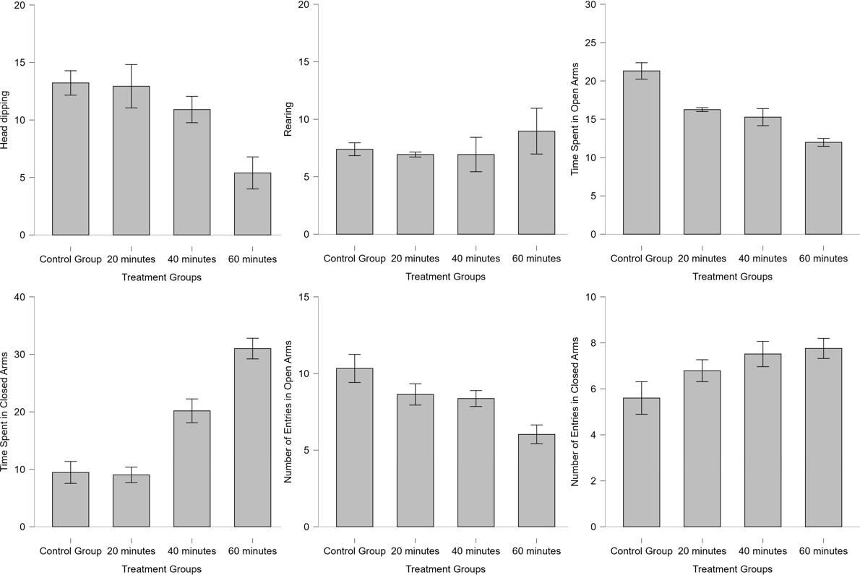
Histogram measuring anxiety-like behavior

Figure 3. Histograms of various behavioral metrics on Swiss mice

CONCLUSIONS
This study indicates that Swiss mice's anxiety-like behavior was greatly affected by 5G radiation exposure, with longer exposure times resulting in increased anxiety. The mice exposed to 60 minutes of radiation spent more time in closed arms. The mice showed fewer active behaviors, indicating higher anxiety. As exposure time increased, anxiety- related behaviors became more visible, such as fewer open-arm entries and less head dipping, indicating a clear dose- response relationship. The preference for enclosed spaces in longer-exposure groups suggests that 5G radiation affects anxiety levels rather than overall activity, which remained stable. Furthermore, the findings of this study indicate that exposure to 5G mobile radiation for 60 minutes significantly increased anxiety-like behavior in the model, suggesting a strong relationship between prolonged exposure and behavioral changes. In contrast, shorter exposure durations of 40 and 20 minutes had only minimal effects, implying that the impact of radiation may be dose- dependent. Additionally, the control group, which was not exposed to radiation, exhibited no anxiety-like behavior, reinforcing the notion that the observed effects were specifically induced by radiation exposure rather than other external factors.
RECOMMENDATIONS
It is important to examine the long-term effect of 5G radiation on brain function and behavior. Since prolonged exposure to radiation causes potential mental health risks, it is recommended to minimize radiation exposure as further studies about the similarities between mice and human brains when exposed to mobile radiation to lower the risks. Additionally, researchers should consider adding the time duration of exposure of Swiss mice and the use of other devices that can induce 5G radiation to know more about the potential risks of radiation.

REFERENCES
Aldad, T. S., Gan, G., Gao, X., & Taylor, H. S. (2019). Fetal radiofrequency radiation exposure from 800-1900 MHz- Rated cellular telephones affects neurodevelopment and behavior in mice. Scientific Reports, 2(1). https://doi.org/10.1038/srep00312
Altun, G., Kaplan, S., Deniz, O., Kocacan, S., Canan, S., Davis, D., & Marangoz, C. (2017). Protective effects of melatonin and omega-3 on the hippocampus and the cerebellum of adult Wistar albino rats exposed to electromagnetic fields. Journal of Microscopy and Ultrastructure, 5(4), 230. https://doi.org/10.1016/j.jmau.2017.05.006
Cryan, J. F., & Sweeney, F. F. (2011). The age of anxiety: Role of animal models of anxiolytic action in drug discovery. British Journal of Pharmacology, 164(4), 1129-1161. https://doi.org/10.1111/j.1476- 5381.2011.01362
Department of Health & Human Services. (2024). Mobile phones and your health.
https://www.betterhealth.vic.gov.au/health/healthyliving/mobile-phones-and-your-health
Fragopoulou, A. F., Samara, A., Antonelou, M. H., Xanthopoulou, A., Papadopoulou, A., Vougas, K., Koutsogiannopoulou, E., Anastasiadou, E., Stravopodis, D. J., Tsangaris, G. T., & Margaritis, L. H. (2012). Brain proteome response following whole body exposure of mice to mobile phone or wireless DECT base radiation. Electromagnetic Biology and Medicine, 31(4), 250–274. https://doi.org/10.3109/15368378.2011.631068
Gupta, S. K., Patel, S. K., Tomar, M. S., Singh, S. K., Mesharam, M. K., & Krishnamurthy, S. (2019). Long- term exposure of 2450 MHz electromagnetic radiation induces stress and anxiety like behavior in rats. Neurochemistry International, 128, 1–13. https://doi.org/10.1016/j.neuint.2019.04.001
Hasan, I., Jahan, M. R., Islam, M. N., & Islam, M. R. (2022). Effect of 2400 MHz mobile phone radiation exposure on the behavior and hippocampus morphology in Swiss mouse model. Saudi Journal of Biological Sciences, 29(1),102–110.https://doi.org/10.1016/j.sjbs.2021.08.063
Hienz, R. D., Brady, J. V., Gooden, V. L., Vazquez, M. E., & Weed, M. R. (2008). Neurobehavioral effects of head- only gamma-radiation exposure in rats. Radiation Research, 170(3), 292–298. https://doi.org/10.1667/rr1222.
Islam, M., & Hasan, I. (2023). Effects of chronic exposure of 4G cell phone radiation on the behavior and hippocampus in swiss albino mice. IBRO Neuroscience Reports,15 https://doi.org/10.1016/j.ibneur.2023.08.090
Jackson, S.J., Andrews, N. Ball, D. Bellantuono, I. Gray, J. Hachoumi, L. Holmes, A. Latcham, J. Petrie, A. Potter,
P. Rice, A. Ritchie, A. Stewart, M. Strepka, C. Yeoman, M. Chapman, K. (2016). Does age matter? The impact of rodent age on study outcomes. Lab Anim. https://doi.org/10.1177/0023677216653984
Joy, T., Rao, M. S., & Madhyastha, S. (2018). N-Acetyl cysteine supplement minimizes TAU expression and neuronal loss in animal models of Alzheimer’s disease. Brain Sciences, 8(10), 185. https://doi.org/10.3390/brainsci8100185
Katano, M., Kajimoto, K., Iinuma, M., Azuma, K., & Kubo, K. (2020). Tooth loss early in life induces hippocampal morphology remodeling in senescence-accelerated mouse prone 8 (SAMP8) mice. International Journal of Medical Sciences, 17(4), 517–524. https://doi.org/10.7150/ijms.40241
Keenan, K. P., Hoe, C., Mixson, L., Mccoy, C. L., Coleman, J. B., Mattson, B. A., Ballam, G. A., Gumprecht, L. A., & Soper, K. A. (2005). Diabesity: A polygenic model of dietary-induced obesity from ad libitum overfeeding of sprague–dawley rats and its modulation by moderate and marked dietary restriction. Toxicologic Pathology, 33(6), 650–674.https://doi.org/10.1080/01926230500311222
Kim, J. H., Lee, J., Kim, H., Kim, K., & Kim, H. R. (2018). Possible effects of radiofrequency electromagnetic field exposure on central nerve system. Biomolecules & Therapeutics, 27(3), 265–275. https://doi.org/10.4062/biomolther.2018.152
Komada, M., Takao, K., & Miyakawa, T. (2008). Elevated plus maze for mice. Journal of Visualized Experiments,
22. https://doi.org/10.3791/1088
Kraeuter, A.K., Guest, P.C., Sarnyai, Z. (2019). The elevated plus maze test for measuring anxiety-like behavior in rodents. Methods in Molecular Biology, 1916. https://doi.org/10.1007/978-1-4939-8994-2_4
Marshall, S.V., Brown, R.F., & University of Missouri-Rolla. (1983). Experimental determination of whole body average specific absorption rate (SAR) of mice exposed to 200-400 MHz CW. Bioelectromagnetics, 267– 279.https://doi.org/10.1002/bem.2250040307
Massand, A., Rai, R., Rai, A. R., Joy, T., Murlimanju, B., & Marathe, A. (2020). Effect of methanolic leaf extract of ficus religiosa on neuronal degeneration: A pilot study in male albino wistar rats. Indian Journal of Public Health Research & Development, 11(2), 685. https://doi.org/10.37506/v11/i2/2020/ijphrd/194888
Melatonin Reduces Oxidative Stress Induced by Chronic Exposure of Microwave Radiation from Mobile Phones in Rat Brain. (2008, November 1). OUP Journals & Magazine | IEEE Xplore. https://ieeexplore.ieee.org/abstract/document/8154845/
Narayanan, P., & Trouvé, A. (2008). Radiation-driven flame weakening effects in sooting turbulent diffusion flames. Proceedings of the Combustion Institute, 32(1), 1481–1489. https://doi.org/10.1016/j.proci.2008.06.056
National Library of Medicine. (2022). Scientific evidence invalidates health assumptions underlying the FCC and ICNIRP exposure limit determinations for radiofrequency radiation: Implications for 5G. International Commission on the Biological Effects of Electromagnetic Fields (ICBE- EMF).https://doi.org/10.1186/s12940-022-00900-9
Parihar, V. K., & Limoli, C. L. (2013). Cranial irradiation compromises neuronal architecture in the hippocampus.
Proceedings of the National Academy of Sciences, 110(31), 12822–12827. https://doi.org/10.1073/pnas.1307301110
Pellow, S., Chopin, P., File, S. E., & Briley, M. (1985). Validation of open : closed arm entries in an elevated plus- maze as a measure of anxiety in the rat. Journal of Neuroscience Methods, 14(3),149–
167.https://doi.org/10.1016/0165-0270(85)90031-7
Qin, T., Wang, X., Du, J., Lin, J., Xue, Y., Guo, L., Lai, P., Jing, Y., Zhang, Z., & Ding, G. (2022). Effects of radiofrequency field from 5G communications on the spatial memory and emotionality in mice.
International Journal of Environmental Health Research, 34(1), 316– 327.https://doi.org/10.1080/09603123.2022.2149708
Radiation:5G mobile networks and health (2014). https://www.who.int/news-room/questions-and- answers/item/radiation-5g-mobile-networks-and-health#content
Ritskes-Hoitinga, M., Tobin, G., Jensen, T. L., & Mikkelsen, L. F. (2012). Nutrition of the Laboratory Mouse
[Book-chapter]. In Nutrition of the Laboratory Mouse. https://doi.org/10.1016/B978-0-12-382008-2.00024- 6
Saikhedkar, N., Bhatnagar, M., Jain, A., Sukhwal, P., Sharma, C., & Jaiswal, N. (2014). Effects of mobile phone radiation (900 MHz radiofrequency) on structure and functions of rat brain. Neurological Research, 36(12), 1072–1079. https://doi.org/10.1179/1743132814y.00
Steru, L., Chermat, R., Thierry, B., & Simon, P. (1985). The tail suspension test: A new method for screening antidepressants in mice. Psychopharmacology, 85(3), 367–370. https://doi.org/10.1007/bf00428203
Tarsaei, M., Peyrovan, Z. S., Mahdavi, S. M., Chahardehi, A. M., Vafaee, R., & Haidari, M. H. (2022). Effects of 2.45 GHz Non-Ionizing radiation on Anxiety-Like behavior, gene expression, and corticosterone level in male rats. Journal of Lasers in Medical Sciences, 13, e56. https://doi.org/10.34172/jlms.2022.56
Tucker, L. B., & McCabe, J. T. (2021). Measuring Anxiety-Like behaviors in rodent models of traumatic brain injury.Frontiers in Behavioral Neuroscience,15.https://doi.org/10.3389/fnbeh.2021.682935
Zheng, R., Zhang, X., Gao, Y., Gao, D., Gong, W., Zhang, C., Dong, G., & Li, Z. (2023). Biological effects of exposure to 2650 MHz electromagnetic radiation on the behavior, learning, and memory of mice. Brain and Behavior,13(6).https://doi.org/10.1002/brb3.3004
Zhu, R., Wang, H., Xu, X., Zhao, L., Zhang, J., Dong, J., Yao, B., Wang, H., Zhou, H., Gao, Y., & Peng, R. (2021). Effects of 1.5 and 4.3 GHz microwave radiation on cognitive function and hippocampal tissue structure in Wistar rats. ScientificReports,11(1).https://doi.org/10.1038/s41598-021-89348-4

