CHARACTERIZATION OF INSECT POLLINATOR DIVERSITY IN AGROCHEMICAL-CONTAMINATED AGRICULTURAL AREAS IN KORONADAL CITY, PHILIPPINES

ABSTRACT

Pollinators are essential for sustaining biodiversity, ecosystems stability, and plant yields. They contribute significantly to natural regeneration of plants, conservation of habitats, pollination of crops, and productivity in agriculture. The aim of this study was to help determine the effect of agrochemical use on pollinators using comparative diversity between the protected and agrochemical-contaminated areas in Koronadal City. A field experiment was conducted over selected locations from protected to agrochemical-contaminated locations using pan traps and sweep nets for insect collection. Pollinator diversity was analyzed through diversity indices like Simpson's Diversity Index (D'), Shannon-Wiener's Diversity Index (H'), and Margalef's Richness Index (R) for species richness. Statistical comparison was carried out by conducting a t-test using Shannon-Weiner's and Simpson's Diversity Index with the help of Rarefaction in comparing diversity between locations through sample size analysis. Statistical difference among sites using a t-test showed that the pollinator richness of Brgy. Carpenter Hill was significantly less than the protected site (p<0.05), showing that exposure to agrochemicals negatively impacts the richness of insect pollinators. However, no difference was found between the protected site and Brgy. San Roque or Brgy. Saravia, perhaps due to other environmental conditions keeping biodiversity intact in these sites. The study also found that the majority of the pollinator species are not on the IUCN Red List, and therefore there is a need for more studies and conservation. The finding calls for the application of sustainable agriculture to maintain pollinator populations for ecosystem resilience and agricultural sustainability. Statistical comparison between sites through a t-test revealed that pollinator diversity in Brgy. Carpenter Hill was significantly lower than that of the protected site (p<0.05), which suggests that exposure to agrochemicals has an adverse effect on the diversity of insect pollinators. No significant difference, however, was observed between the protected site and Brgy. San Roque or Brgy. Saravia, perhaps due to the fact that other ecological requirements are sustaining the diversity in such locations. It further established that most of the species of the pollinators do not have any classification on the IUCN Red List and thus a call for more conservation and research. These results point to the significance of sustainable agriculture practices in order to ensure pollinator populations for ecosystem resilience and agricultural sustainability.

Keywords: pollinators, pollinator diversity, conservation, protected areas, agrochemical-contaminated areas

INTRODUCTION

The diversity of insect pollinators is very important in sustaining ecosystem resilience, enhancing plant genetic diversity, and providing global food security (Maggi et al., 2023). Numerous management practices and application of pesticides, however, may have significant impacts on pollinator diversity and numbers, leading to long- term ecological implications that can negatively affect ecosystems and lower pollinator efficiency. Pollinators are central in achieving conserved environment-conservation and sustainable agriculture balance. They enhance crop yield, plat reproduction, enhance biodiversity, crop pollination, ecosystem restoration, and diversification of income (Cordis, 2023). This study advances the Sustainable Development Goal 15 (Life on Land) through assessing the impacts of agrochemical pollution on pollinator diversity towards building a more sustainable agriculture, leading to the conservation and restoration of natural ecosystems that are essential for biodiversity.
Due to the imperative position of pollinators in sustaining ecosystem health and food, various studies have triggered increased debates on how agrochemicals impact insect-pollinator diversity. For example, Hladik et al. (2015) were among the initial studies to come up with proof that agrochemicals occur within pollinator populations, registering 18 pesticides across 54 samples. The prevalence of contamination was also shown by Botías et al. (2017), who found that 60.7% of 150 bees had at least one pesticide, some of them having more, reflecting extensive of contamination. Drummond et al. (2018) found 25 pesticides in plant pollens in 32 sites in 2015. Main et al. (2020) further added that all 43 wild bee samples were from the area with at least one operational part of insecticides, fungicides, herbicides, and a plant growth regulator. More recently, Ojija & Bacaro (2024) pointed out remarkable differences in the community structure of insect-pollinator diversities in different habitats, reporting that protected areas harbored a higher number of insect-pollinators (N = 912) than agricultural systems (N = 684). These studies point toward the extensive alarming distribution of various agrochemicals that have negative effects on pollinator populations, suggesting an impending threat to ecological balance and biodiversity. This highlights the imperative for further studies on the implications of agrochemical application on insect pollinators and developing effective management controls to help curtail these impacts on key pollinator species.

Studies on insect pollinator richness in Koronadal City are limited, especially in areas damaged by agrochemicals compared to protected areas, despite the pollinators' vital role in agriculture and the ecosystem. Determining the possible damage that chemicals like pesticides pose to biodiversity is difficult because their effects on pollinator abundance are still poorly understood. By comparing pollinator communities across protected sites and pesticide-contaminated farmlands, this study aimed to examine how agrochemical application affected insect pollinator diversity in Koronadal City.

Specifically, this study: (1) determine the species richness and diversity of insect pollinators in agrochemical-contaminated and protected sites in Koronadal City; (2) determine the pollinator populations in these two habitats; and (3) determine the conservation status of the pollinators obtained. Knowing how agrochemicals impact these essential species is not only important for healthier crops but for the balance of our ecosystems as well. By examining the variations in pollinator diversity in protected areas and farmlands, this study is hoping to provide insights that can aid in enhancing farm practices and enhancing conservation efforts that can benefit agricultural productivity as well as biodiversity in the long term.

MATERIALS AND METHODS

Materials

The study used 25 pan traps, five of each color blue, white, green, orange, and yellow that held 300 mL of water and 4 mL of dish soap without any aroma. To supplement trapping, the researchers also used 35 cm-diameter sweep nets, ten 3 × 3 meter transects each 60 meters in length, and timing devices. For the preservation and processing of specimens, 95% ethanol, collection containers or vials, and drying materials were employed.

Research Design
This study used a field-based experimental approach to explore the diversity of insect pollinators in both agrochemical-exposed farmlands and protected natural areas in Koronadal City, Philippines. The Researchers implemented a randomized sampling approach using the quadrat sampling technique, selecting 10 × 10- meter transects for systematic data collection.

Procedure

Study Sites
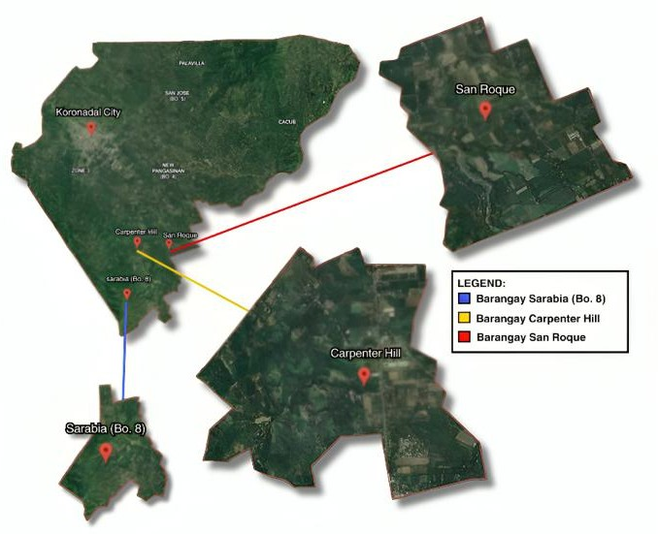
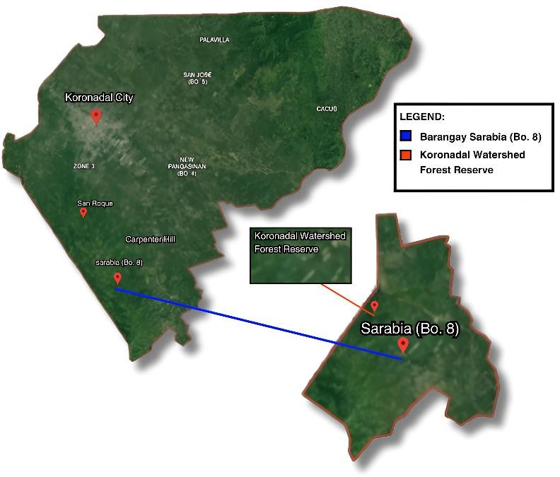
Koronadal City was selected as the study site for encompassing both agricultural farmlands and protected natural area, making it an ideal location to assess pollinator diversity. The agrochemical-contaminated areas, as seen in figure 1, in Koronadal City consist of rice fields located particularly in Brgy. Carpenter Hill, Brgy. Saravia, and Brgy. San Roque, each covering approximately 1 hectare of land. These fields depend on the regular use of pesticides in order to manage pests and maintain crop productivity, which contributes to the contamination of the surrounding environments. The protected area, as observed in figure 2, within Koronadal City, is the El Gawel Watershed Forest Reserve at Brgy. Saravia, as verified by the City Environment and Natural Resources Office (CENRO), is a forest environment supporting a high degree of both flora and fauna diversity. It has dense vegetation, rich water sources, and minimal human disturbance, providing a suitable living environment for a number of pollinator species.

Figure 1. Agrochemical-Contaminated Areas Figure 2. Protected Area in Koronadal City

in Koronadal City

Entry Protocol and Permits
Informed consent was obtained from the local government of Koronadal City for the entry and conduct of the study on pollinator biodiversity in agricultural and protected areas. This cautious process made sure that all the required permits were obtained from the City Environmental and Natural Resources Office (CENRO) and various Barangays of Koronadal City, specifically Brgy. Saravia, Brgy. Carpenter Hill, and Brgy. San Roque, to ensure compliance with regulatory requirements. Safety protocols were strictly adhered to, and open communications were established with local stakeholders.

Quadrat Sampling
This study employed the quadrat sampling method to collect data and assess pollinator diversity within the designated locations. The method was widely applied to estimate population density, abundance, frequency, and distribution within study sites (Islam, 2021). Each quadrat measured 10 × 10 meters and were randomly selected three times with a random selector for every one of the three sites. In addition, pan traps with water and a small amount of dish soap were utilized to capture pollinators along transects. Traps were replaced every three days in order to have a continuous data collection.

Collection of Specimen
INPOs were collected in agricultural and protected areas. Each habitat of the same size was sampled using pan traps and sweep nets. The collection took place in January 2025 under optimal weather conditions (sunny, no wind) from 8 A.M. to 4 P.M. Pan traps were placed in every habitat. INPO collection was carried out every after three days for two weeks. Specimens retrieved from the traps were dried and placed into vials or containers for proper identification and preservation.

Identification of Specimen
The researchers utilized a Picture Insect application for initial species identification. Manderfield (2022) reports that Picture Insect is an insect identification app and proposes to identify more than 4,000 species with species- level identification. The researchers then used a dichotomous key to validate and further complete the identification of pollinator species from the results of the Picture Insect app.

Biodiversity Indices
This study used descriptive statistics to summarize the diversity, abundance, and species richness of pollinators. The indices were calculated and compared between the different study sites to provide a more comprehensive understanding of pollinator diversity and richness.

Shannon–Wiener Diversity Index (H')
Shannon–Wiener Diversity Index measures species diversity by considering both richness (number of species) and evenness (distribution of individuals among species). This index was used to measure the species diversity within the areas.

Simpsons’ Diversity Index (D’)
Simpson’s Diversity Index is used to measure the dominance or diversity of species within the community by accounting for the probability that two randomly selected individuals belong to the same species. This index was used to determine the proportion of a diversity within the protected and agrochemical-contaminated areas.

Margalef Species Richness Index (R’)
Margalef’s Species Richness Index measures species richness without considering evenness. The index was used to determine the species richness of pollinators between the protected area and Agrochemical-contaminated areas without adjusting for sample size differences.

Rarefaction
Rarefaction standardizes species richness across different sample sizes, ensuring fair comparisons. This index was used to determine the species richness of pollinators between the protected area and agrochemical- contaminated areas while standardizing the species count based on the smallest sample size.

Preservation of Specimens
Pollinators must first be collected from their natural habitats using ethical methods that were approved and permitted. Once collected, the pollinators were transported to the laboratory to be cleaned and dried before being immersed in a 95% Ethanol solution. For accurate documentation, the specimens were labeled using the voucher specimen data including scientific name, common name, taxonomic classification, location, habitat, and date of collection.

Data Analysis

To determine the pollinator diversity of agrochemical-contaminated and protected areas, this study used PAST software for calculating the diversity and richness of species of different habitat locations using Shannon- Weiner and Simpson’s diversity indices for species diversity, and Margalef’s species richness and rarefaction for species richness. The researchers further utilized a biodiversity t-test to check whether the difference between the two habitats was statistically significant. It is used routinely while comparing performance, measurements, or outcomes of two distinct groups under different conditions (Sedgwick, 2010). These interpretations facilitate equal and meaningful comparisons of ecological information between sites across Koronadal City.

Table 1: Biodiversity Metrics and Interpretation
Interpretation | Shannon-Wiener Diversity Index (H’) | Simpson’s Diversity Index  (D’) | Margalef’s Species Richness Index  (R’) | Rarefaction (λ)
Very High | 3.50 and above | 0.90 and above | >5.00 | 3.50 and above
High | 3.00 - 3.49 | 0.70 - 0.89 | 2.50-4.99 | 3.00 - 3.49
Moderate | 2.50 - 2.99 | 0.50 - 0.69 | 1.00-2.49 | 2.50 - 2.99
Low | 2.00 - 2.49 | 0.30 -m 0.49 | 0.50-0.99 | 2.00 - 2.49
Very Low | 1.99 and below | 0.29 and below | <0.49 | 1.99 and below
Sources: Shannon-Wiener (Baliton et al., 2020); Simpson (Guajardo, 2015); Margalef (Napaldet 2023); Rarefaction (Bashir et al., 2018)

Ethical Consideration

This study was done ethically with precise focus on safeguarding surrounding ecosystems as well as pollinator communities. All required permissions were received and the study was performed under the supervision of a trained professional in the subject area. Local permits like from the City Environmental and Natural Resources Office (CENRO) and Barangay permits from all three Barangays were secured in order to abide by regulations permitting the study in the given areas. Safety guidelines for precautions were strictly observed in order to ensure researchers' health and that of the environment as a whole, with species treated humanely and with the minimum amount of invasion required. Open communication with the local stakeholders were also made to promote sustainable agriculture and biodiversity conservation, sharing the findings responsibly to ensure accurate interpretation. Furthermore, the researchers respected the local practices and traditions to avoid any harm to the environment and to be in a good standing with the community.

RESULTS AND DISCUSSION

Pollinator Biodiversity and Species Richness of Protected and Agrochemical-contaminated Areas
Table 1 records the pollinator species found in protected and agrochemical-contaminated areas, detailing their order, scientific name, abundance (N), and percentage (%).

The data in Table 1 shows notable differences in insect pollinator diversity and abundance between protected and agrochemical-contaminated areas, suggesting that environmental conditions significantly influence pollinator abundance. Although the general abundance of pollinators was greater in the agrochemical-contaminated areas (94 individuals) compared to the protected area (34 individuals), this is not necessarily an indication of a healthier pollinator community. The relative abundance of Musca domestica, 32.98%, in the agrochemical-contaminated areas, a species most likely linked to human activity and waste, indicate that exposure to agrochemicals could be shifting the neutral equilibrium of pollinators (Goulson et al., 2015). For instance, the pesticides can impact an insects' gut microbiota, which can be favorable to species like Musca domestica that do well in such conditions (Ali & AlHussaini, 2024). On the other hand, the protected area had Tetragonula laeviceps and Teleopsis quadriguatata, which may be more vulnerable to exposure to agrochemicals, and that is why they were not found in the contaminated sites (Rundlöf et al., 2015).

Table 1. Species inventory and percent abundance of insect pollinators across habitats
 | Protected Area |  |  | Agrochemical-contaminated Areas
Order | El Gawel Watershed  Forest Reserve
 | El Gawel Watershed  Forest Reserve | N | RA | Brgy. Carpenter Hill | Brgy. Saravia | Brgy. San Roque | N | RA
Lepidoptera |  | 0 | 0.00% | Catochrysops  strabo |  |  | 1 | 1.06%
 |  | 0 | 0.00% |  | Eurema Brigitta |  | 1 | 1.06%
 |  | 0 | 0.00% |  |  | Hipparchia Semele | 1 | 1.06%
 | Melanitis leda | 1 | 2.94% |  |  |  | 0 | 0.00%
Hymenoptera | Apis cerana | 6 | 17.65% | Apis cerana | Apis cerana |  | 9 | 9.57%
 |  | 0 | 0.00% |  | Apis dorsata |  | 1 | 1.06%
 |  | 0 | 0.00% | Chelostoma campanularum |  |  | 1 | 1.06%
 | Eumenes spp. | 7 | 20.59% | Eumenes spp. |  | Eumenes spp. | 16 | 17.02%
 |  | 0 | 0.00% |  |  | Megachile rotundata | 3 | 3.19%
 |  | 0 | 0.00% |  |  | Parapolybia nodosa | 1 | 1.06%
 |  | 0 | 0.00% |  | Polistes spp. |  | 8 | 8.51%
 | Tetragonula lacviceps | 2 | 5.88% |  |  |  | 0 | 0.00%
 |  | 0 | 0.00% |  |  | Xylocopa micans | 4 | 4.26%
Coleoptera |  | 0 | 0.00% |  |  | Cocinella transversalis | 5 | 5.32%
 |  | 0 | 0.00% | Phyllopertha horticola |  |  | 1 | 1.06%
Diptera | Ceroxys latiusculus | 2 | 5.88% |  | Ceroxys latiusculus |  | 1 | 1.06%
 |  | 0 | 0.00% |  |  | Henusepilachna argus | 1 | 1.06%
 |  | 0 | 0.00% | Musca domestica | Musca domestica | Musca domestica | 31 | 32.98%
 | Phaonia pallida | 11 | 32.36% |  | Phaonia pallida |  | 3 | 3.19%
 |  | 0 | 0.00% |  | Rainieria Antennapes |  | 6 | 6.38%
 | Teleopsis quadriguattata | 1 | 2.94% |  |  |  | 0 | 0.00%
 | Xenox tigrinus | 4 | 11.76% |  |  |  | 0 | 0.00%
Total Abundance |  | 34 |  |  |  |  | 94
 |  |  | 100 |  |  |  |  | 100%
note. RA= Relative Abundance

Additionally, the study by Potts et al. (2010) created serious concerns regarding the low incidence of almost all agrochemical contaminants like Apis cerana and other critical pollinators, which suggests a likely decline in pollination activities that can lead to the decline in ecosystem stability and plant reproduction. Biesmeijer et al. (2006) noted that the diminished abundance of bees has also been associated with decreased fruit and seed production on various plants. The presence of Hipparchia semele and Eurema brigatta exclusively in polluted locations indicates that some species are more resilient to altered conditions, yet cannot compensate for the loss of more efficient pollinators (Samanta et al., 2023). This implies that some agrochemicals in infested areas may be more tolerable to some species, as evidenced by a study by Pisa et al. (2014), who contends that agrochemicals kill pollinator populations and also disrupt the behavior, reproduction, and general survival of pollinator species.

Diversity Assessment
This section presents the diversity results of insect pollinators across different habitat locations, highlighting significant variations in species composition between protected areas and agrochemical-contaminated sites.

Table 2: Species Richness and Diversity Data in Various Sampling Sites in Agrochemical-Contaminated and Protected Areas in Koronadal City
Diversity Indices
^{Habitat}Location | No. of Species | No. of Individuals | Shannon-Wiener Diversity Index  (H’) | Simpson’s Diversity Index  (D’) | Margalef’s Species Richness Index  (R’)
^{A}Brgy. Carpenter Hill | 6 | 28 | 1.17^{VL} | 0.57 ^{H} | 1.50 ^{M}
^{A}Brgy. Saravia | 9 | 44 | 1.90 ^{VL} | 0.80 ^{H} | 2.33 ^{M}
^{A}Brgy. San Roque | 8 | 38 | 1.56 ^{VL} | 0.72 ^{H} | 1.76 ^{M}
^{P}El Gawel Watershed  Forest Reserve | 8 | 34 | 1.78 ^{VL} | 0.79 ^{H} | 1.98 ^{M}
Note. P= protected area; A= Agrochemical-contaminated area
Note. VL=Very Low, L=Low, M=Moderate, H=High, VH=Very High

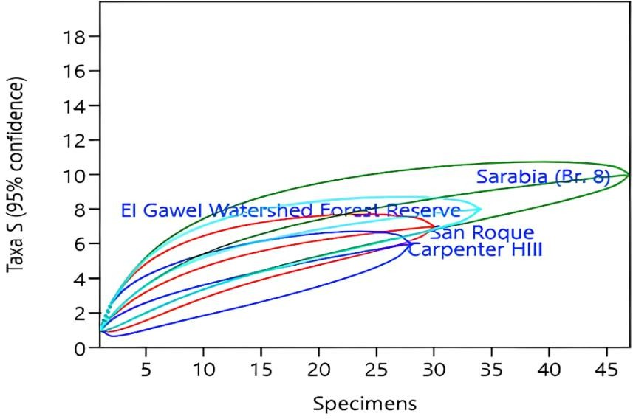
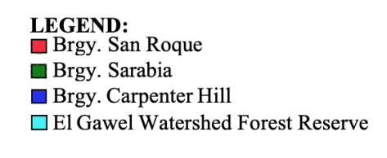

Figure 6. Rarefaction Species Richness

Table 2 presents the species richness and diversity values among various sampling sites with comparisons between agrochemical-contaminated and a protected site. The Shannon-Wiener Diversity Index (H') was highest in Brgy. Saravia (H'= 1.90) with relatively high diversity but with agrochemical exposure. Brgy. Carpenter Hill had the lowest value (H'=1.17), which indicates a decrease in diversity, likely due to pesticide application lowering species evenness. The value of the protected area was H'=1.78, indicating conservation activities that favor biodiversity, although not the highest among the sites investigated. The Simpson's Diversity Index (D') also confirms these results, with Brgy. Saravia yielding the highest value (D'=0.80), showing a more uniform distribution of species, and Brgy. Carpenter Hill the lowest (D'=0.57), which means that few species dominate, most likely those that are tolerant to agrochemical exposure Krebs, C.J. (1999). The value of the protected area was D'=0.79, indicating comparatively high evenness. Finally, Margalef's Species Richness Index (R') exhibited the same trend, with the highest richness being Brgy. Saravia (R'=2.33) and the lowest being Brgy. Carpenter Hill (R'=1.50). The protected area's richness index was R'=1.98, indicating that while conservation habitats support adequate living environments, areas with agrochemical contamination offer diversities at levels varying according to factors such as land use, habitat quality, and conditions in the environment (Tscharntke et al., 2005).

Figure 6 further supports these findings through rarefaction curves, which illustrate that Brgy. Saravia consistently maintains higher species richness across different specimen counts, with its curve levelling off, meaning most pollinators in the area have already been sampled. Followed by the protected area, with its curve approaching a plateau suggesting that most species have been recorded but a few more may still be found. While the agrochemical- contaminated areas, such as Brgy. Carpenter Hill and Brgy. San Roque, exhibit lower richness, as their curves are still rising indicating that further sampling could reveal more pollinators. Which can be further supported by a study made by Goulson et al. (2015) indicating that agrochemical exposure and habitat disturbance could potentially result to a decrease and loss in pollinator diversity. The generally very low diversity indices across all locations suggest that even the protected area may not be entirely free from environmental stressors, potentially including drift of agrochemicals or edge effects (Tscharntke et al., 2005). The findings highlight the detrimental impact of agrochemical contamination on species diversity while emphasizing the role of protected areas in conserving biodiversity.

Table 3: Diversity T-test of Shannon and Simpson’s Species Diversity Index for Protected (El Gawel Watershed Forest Reserve) and Agrochemical-contaminated Areas (Brgy. Carpenter Hill, Brgy. Saravia, and Brgy. San Roque)
HabitatLocation | Shannon-Weiner Diversity Index (H’) | Simpson’s Diversity index (D’)
PEl Gawel  ACarpenter | 1.54VL±0.16  0.88VL±0.37 t=2.621 df=50.508  p<0.011 | 0.75H±0.05  1.48VH±0.18 t=-2.273 df=37.589  p<0.029
PEl Gawel  ASan Roque | 1.54VL±0.16  1.49VL±0.16  t=1.095  df=59.055 p<0.278 | 0.75H±0.05  0.74H±0.03  t=-1.029  df=47.567 p<0.309
PEl Gawel  ASaravia | 1.54VL±0.16  1.47VL±0.22  t=-0.637 df=78.354  p<0.526 | 0.75H±0.05  0.73H±0.04  t=0.161 df=76.984  p<0.873
Note. P= protected area; A= Agrochemical-contaminated area
Note. VL=Very Low, L=Low, M=Moderate, H=High, VH=Very High

The results in Table 3 indicate the varying impacts of agrochemical exposure on pollinator biodiversity between agrochemical-contaminated and protected areas in Koronadal City. A significant difference in Shannon- Weiner Diversity Index (H') between El Gawel and Brgy. Carpenter Hill, with Brgy. Carpenter Hill exhibiting a lower H', indicative of reduced species diversity, while Simpson’s Diversity Index (D’) shows a significant difference between El Gawel and Brgy. Carpenter Hill, with Brgy. Carpenter Hill having a higher Simpson’s Diversity Index, suggesting a dominance of fewer pollinator species in this agrochemical-contaminated area. However, the comparisons between El Gawel and the other agrochemical-contaminated sites, Brgy. San Roque and Brgy. Saravia, show no significant differences in either Shannon-Weiner Diversity Index or Simpson’s Diversity Index. These results indicate that while Brgy. Carpenter Hill demonstrates a marked decline in pollinator diversity compared to the protected area, Brgy. San Roque and Brgy. Saravia maintain relatively similar diversity levels to El Gawel, at least in terms of the measured indices.

Conservation Status According to IUCN Red List
IUCN Red List (International Union for Conservation of Nature Red List of Threatened Species) is a tool used to assess the conservation status of different species worldwide. The species were evaluated based on criteria such as population size, rate of decline, geographic range, and habitat fragmentation. The list raises awareness about species at risk, conservation efforts, policy information, and the prioritization of resources for biodiversity conservation. The IUCN Red List categorizes species based on the various levels of threat, ranging from “Least Concerned”, species that are stable and not at risk of extinction to “Critically Endangered” which are species facing an extremely high risk of extinction.

Table 7: IUCN Red List
Species | Conservation Status | Date Published
Apis cerana | No Record | N/A
Apis dorsata | No Record | N/A
Catochryspos strabo | No Record | N/A
Ceroxys latiusculus | No Record | N/A
Chelostoma campanularum | No Record | N/A
Cicadella virdis | No Record | N/A
Coccinella transversalis | No Record | N/A
Eumenes spp. | No Record | N/A
Eurema brigatta | Least Concerned | 2020
Hipparchia semele | Least Concerned | 2023
Hyllopertha horticola | No Record | N/A
Hylobittacus apicalis | No Record | N/A
Itenosepilachua argus | No Record | N/A
Lucilia sericata | No Record | N/A
Megachille rotundata | No record | N/A
Melanitis leda | Least Concerned | 2020
Minettia longipennis | No Record | N/A
Musca domestica | No Record | N/A
Paraploybia nodesa | No Record | N/A
Parapolubia nodosa | No Record | N/A
Phaonia padilla | No Record | N/A
Polistes spp. | No Record | N/A
Polybia scutellaris | No Record | N/A
Rainieria antennaepes | No Record | N/A
Teleopsis quadriguattata | No Record | N/A
Xenox tigrinus | No Record | N/A
Xylocopa micans  Source: https://www.iucnredlist.org/ | No Record | N/A

Table 7 indicates different species of gathered pollinators in Koronadal City and its respective conservation status up to March 2025 based on the IUCN Red List. Many species fall under "No Record," which means no official conservation assessment has been done or data is not accessible. This indicates that these species are not assessed or are not yet in the IUCN Red List database. Conversely, not many species are listed as "Least Concerned", which indicates that the populations of the following species are stable at present and are not under imminent threat for survival.

Most of the species labeled as "No Record", show little or no recorded information that emphasizes an important deficiency in conservation evaluations, indicating the requirement for further research and data gathering. Lack of information prevents successful conservation planning because it limits the ability to establish species that could require attention or are sensitive to shifts in the environment. Conversely, the species identified as "Least Concerned" are those species that have a stable population and are not in immediate danger at present. However, the conservation status does change, depending on a number of reasons, including habitat loss or climate change. Continuous observation and re-examination vital in order to ensure that the species continue remains protected and identify those emerging hazards that may call for conversation action near the future.

CONCLUSIONS
This study assessed the impact of agrochemical contamination on insect pollinator diversity in Koronadal City by comparing protected and agrochemical-contaminated areas. The results revealed that pollinator diversity and species richness were significantly lower in agrochemical-contaminated sites, with Brgy. Carpenter Hill showing the most notable decline. In contrast, Brgy. Saravia exhibited the highest diversity and species richness, suggesting that certain agrochemical-exposed areas may still support diverse pollinator communities, possibly due to habitat conditions. The protected area, El Gawel Watershed Forest Reserve, had relatively high diversity, reflecting conservation efforts that support biodiversity, though not the highest among the sites studied. The statistical analysis confirmed a significant difference between the protected site and Agrochemical-contaminated areas, reinforcing the negative impact of Agrochemicals on pollinator diversity. However, no significant differences were found between El Gawel and Brgy. San Roque or Brgy. Saravia, implying that other environmental factors may help sustain insect- pollinator diversity in the locations. Additionally, the study highlighted a lack of conservation data, with most identified species having “No record” status in the IUCN Red List.

RECOMMENDATIONS
While the study successfully identified pollinator species, several were categorized as "No Record" in the IUCN Red List, highlighting a critical lack of species-specific ecological and conservation data, which limits the researchers’ ability to assess pollinator vulnerability effectively, and directly responding to the observed declines in biodiversity. Additionally, data collection should span longer periods and be conducted on multiple days to capture a broader range of species and better understand brief changes in pollinator numbers and activity. Further research is essential to monitor the long-term effects of agrochemicals on pollinator health, abundance, and species composition in both Agricultural and protected areas, particularly given the observed negative impacts.

REFERENCES

- Ali, A., & AlHussaini, K. I. (2024). Pesticides: Unintended impact on the hidden world of gut microbiota. Metabolites, 14(3), 155. https://doi.org/10.3390/metabo14030155
- Baliton, R., Landicho, L., Cabahug, R. E., Paelmo, N. R. F., Laruan, K., Rodriguez, R., Visco, N. R. G., & Castillo, N. a. K. A. (2020). Ecological services of agroforestry systems in selected upland farming communities in the Philippines. Biodiversitas Journal of Biological Diversity, 21(2). https://doi.org/10.13057/biodiv/d210237
- Bartling, M., Brandt, A., Hollert, H., & Vilcinskas, A. (2024). Current Insights into Sublethal Effects of Pesticides on Insects. International Journal of Molecular Sciences, 25(11), 6007. https://doi.org/10.3390/ijms25116007
- Bashir, M. A., Saeed, S., Sajjad, A., Khan, K. A., Ghramh, H. A., Shehzad, M. A., Mubarak, H., Mirza, N., Mahpara, S., Rehmani, M. I. A., & Ansari, M. J. (2018). Insect pollinator diversity in four forested ecosystems of southern Punjab, Pakistan. Saudi Journal of Biological Sciences, 26(7), 1835–1842. https://doi.org/10.1016/j.sjbs.2018.02.007
- Biesmeijer JC, Roberts SP, Reemer M, Ohlemüller R, Edwards M, Peeters T, Schaffers AP, Potts SG, Kleukers R, Thomas CD, Settele J, Kunin WE. Parallel declines in pollinators and insect-pollinated plants in Britain and the Netherlands. Science. 2006 Jul 21;313(5785):351-4. doi: 10.1126/science.1127863. PMID: 16857940.
- Botías, C., David, A., Hill, E. M., & Goulson, D. (2017). Quantifying exposure of wild bumblebees to mixtures of agrochemicals in agricultural and urban landscapes. Environmental Pollution, 222, 73–82. https://doi.org/10.1016/j.envpol.2017.01.001
- Cordis, C. (2023). Pollinators, biodiversity and sustainable development go hand in hand. https://cordis.europa.eu/article/id/442752pollinators-biodiversity-and-sustainabledevelopment-go-hand- in-hand dichotomous key
- Drummond, F. A., Ballman, E. S., Eitzer, B. D., Du Clos, B., & Dill, J. (2018). Exposure of Honey Bee (Apis mellifera L.) Colonies to Pesticides in Pollen, A Statewide Assessment in Maine. Environmental Entomology, 47(2), 378–387. https://doi.org/10.1093/ee/nvy023
- Goulson D, Nicholls E, Botías C, Rotheray EL. Bee declines driven by combined stress from parasites, pesticides, and lack of flowers. Science. 2015 Mar 27;347(6229):1255957. doi: 10.1126/science 1255957. Epub 2015. Feb 26. PMID: 25721506.
- Goulson, D., Nicholls, E., Johnson, N. E., & Rotheray, E. L. (2015). https://www.academia.edu/103410234/Pesticides_and_Pollinators. Journal of Applied Ecology, 52(4), 882-893.
- Guajardo, S. A. (2015). Measuring diversity in police agencies. Journal of Ethnicity in Criminal Justice, 13(1), 1– 15. https://doi.org/10.1080/15377938.2014.893220
- Hladik, M. L., Vandever, M., & Smalling, K. L. (2015). Exposure of native bees foraging in an agricultural landscape to current-use pesticides. The Science of the Total Environment, 542, 469–477. https://doi.org/10.1016/j.scitotenv.2015.10.077
- Khan, H. a. A. (2023). Monitoring resistance to methomyl and synergism in the non-target Musca domestica from cotton fields of Punjab and Sindh provinces, Pakistan. Scientific Reports, 13(1). https://doi.org/10.1038/s41598-023-34331-4
- Kitikidou, K., Milios, E., Stampoulidis, A., Pipinis, E., & Radoglou, K. (2024). Using biodiversity indices effectively: Considerations for forest management. Ecologies, 5(1), 42–51. https://doi.org/10.3390/ecologies5010003
- Krebs, C.J. (1999) Ecological Methodology. Addison-Wesley Educational Publishers, Inc., Menlo Park. - References-Scientific Research Publishing. https://www.scirp.org/reference/referencespapers?referenceid=1915865
- Lankika, M., Karunaratne, M., & Conniff, K. (2012). Species composition of odonate fauna in Meegahawatta, a wetland area in Hanwella, Sri Lanka. Journal of Tropical Forestry and Environment, 2(2). https://doi.org/10.31357/jtfe.v2i2.593 Latumahina, F., Mardiatmoko, G., & Sahusilawane, J. (2020). Richness, Diversity and Evenness of Birds in Small Island. Journal of Physics Conference Series, 1463(1):012023. https://doi.org/10.1088/1742- 6596/1463/1/012023
- Maggi, T., Pardo, L., & Chreil, R. (2023). Pollinator diversity: a key to ecosystem resilience and food security. Insects, 12(8), 688. https://doi.org/10.3390/insects12080688
- Main, AR et al., (2020). Beyond neonicotinoids - wild pollinators are exposed to a range of pesticides while foraging in agroecosystems. https://doi.org/10.1016/j.scitotenv.2020.140436
- Manderfield, M. (2022). Seek, Picture Insect, Google Lens: An Analysis of Popular Insect Identification Apps Using Photos of Realistic Quality. Master of Science Degree Project, Department of Entomology, University of Nebraska-Lincoln.https://doi.org/10.32873/unl.dc.libsci465
- Mineau, P., & Whiteside, M. (2013c). Pesticide Acute Toxicity Is a Better Correlate of U.S. Grassland Bird Declines than Agricultural Intensification. PLoS ONE, 8(2), e57457. https://doi.org/10.1371/journal.pone.0057457 Napaldet, Jones. (2023). Plant species and ecosystem diversity along national road in mountain sites: The case of Kennon Road in Cordillera Central Range, Philippines. 68. 339-348.10.6165/tai.2023.68.339.
- Ojija, F., & Bacaro, G. (2024). Characterization of Insect-Pollinator biodiversity in Agrochemical-Contaminated agricultural habitats. Diversity, 16(1), 33. https://doi.org/10.3390/ d16010033
- Pisa, L. W., Amaral-Rogers, V., Belzunces, L. P., Bonmatin, J. M., Downs, C. A., Goulson, D., Kreutzweiser, D. P., Krupke, C., Liess, M., McField, M., Morrissey, C. A., Noome, D. A., Settele, J., Simon-Delso, N., Stark, J. D., Van Der Sluijs, J. P., Van Dyck, H., & Wiemers, M. (2014). Effects of neonicotinoids and fipronil on non-target invertebrates. Environmental Science and Pollution Research, 22(1), 68–102. https://doi.org/10.1007/s11356-014-3471-x
- Potts SG, Biesmeijer JC, Kremen C, Neumann P, Schweiger O, Kunin WE. Global pollinator declines: trends, impacts and drivers. Trends Ecol Evol. 2010 Jun;25(6):345-53. doi: 10.1016/j.tree.2010.01.007. Epub 2010 Feb 24. PMID: 20188434.
- Quon, C., Lam, T. Y., & Lin, H.-T. (2020). Designing cluster plots for sampling local plant species composition for biodiversity management. Forest Systems, 29(1), e002. https://doi.org/10.5424/fs/2020291-15888
- Rundlöf, M., Andersson, G. K. S., Bommarco, R., Fries, I., Hederström, V., Herbertsson, L., Jonsson, O., Klatt, B. K., Pedersen, T. R., Yourstone, J., & Smith, H. G. (2015). Seed coating with a neonicotinoid insecticide negatively affects wild bees. Nature, 521(7550), 77–80. https://doi.org/10.1038/nature14420
- Samanta, S., Maji, A., Sutradhar, B., Banerjee, S., Shelar, V. B., Khaire, P. B., Yadav, S. V., & Bansode, G. D. (2023). Impact of pesticides on beneficial insects in various agroecosystem: a review. International Journal of Environment and Climate Change, 13(8), 1928–1936. https://doi.org/10.9734/ijecc/2023/v13i82149
- Tan, K., Chen, W., Dong, S., Liu, X., Wang, Y., & Nieh, J. C. (2015). A neonicotinoid impairs olfactory learning in Asian honey bees (Apis cerana) exposed as larvae or as adults. Scientific Reports, 5(1). https://doi.org/10.1038/srep10989
- The IUCN Red List of Threatened Species. (n.d.). IUCN Red List of Threatened Species. https://www.iucnredlist.org/
- Tscharntke, T., Klein, A. M., Kruess, A., Steffan‐Dewenter, I., & Thies, C. (2005). Landscape perspectives on agricultural intensification and biodiversity – ecosystem service management. Ecology Letters, 8(8), 857– 874. https://doi.org/10.1111/j.1461-0248.2005.00782.x
- Woodcock BA, Bullock JM, Shore RF, Heard MS, Pereira MG, Redhead J, Ridding L, Dean H, Sleep D, Henrys P, Peyton J, Hulmes S, Hulmes L, Sárospataki M, Saure C, Edwards M, Genersch E, Knäbe S, Pywell RF. Country-specific effects of neonicotinoid pesticides on honey bees and wild bees. Science. 2017 Jun 30;356(6345):1393-1395. doi: 10.1126/science.aaa1190. PMID: 28663502.

