ZARA'S RESPONSIVE SUPPLY CHAIN NETWORK DESIGN: A CASE STUDY

Abstract
This case study examines the organisation of Zara's supply chain network and how it helps to achieve the company's fast-fashion business approach. The report states that the way Zara competes is not the lowest possible unit cost of the product, but speed, market responsiveness, information visibility, frequent replenishment and close control of the important activities in the supply chain. The case demonstrates how Zara "centralises coordination with selective nearshore and offshore sourcing" using the concepts of strategic fit, responsiveness, agility, risk pooling, resilience and sustainability.
The supply chain map depicts a two-way process, as products are delivered to the customer, but sales and trend data are returned to the designer, planner and suppliers. The major result is that the design is highly consistent with Zara's strategy as it minimises the risk of markdown and mismatch in demand, and allows for a quick lead time. However, design also introduces risks, such as increased logistics costs, reliance on consolidating distribution, carbon pressure, and governance issues with suppliers. The report calls on Zara to make their supply chain more efficient, but not completely overhaul it, by implementing more supplier diversification, logistics that reduce carbon emissions, circular fashion systems, visibility in sourcing processes and advanced demand analytics.

Introduction
Supply chain network design is a strategic decision that will define the structure of the chain of suppliers, production facilities, warehouses, distribution channels, information systems, and customers. It is important because network impacts costs, speed, flexibility, service quality, risk exposure, and long-term competitiveness. In MGMT3017 terms, supply chain strategy must align with the firm's competitive strategy: If a firm is competing primarily on speed and flexibility, it will have a different strategy from one that competes primarily on low cost. In this paper, this relationship is analysed through the case company Zara, Inditex's main brand of fashion.
Zara is an appropriate brand for this case due to the short product life cycles, demand fluctuations and the high uncertainty of consumers' tastes in fast fashion. (Fisher 1997, 105) proposed a framework of product-supply chains that implies that innovative and unpredictable products need a responsive chain, not just an efficient chain. The key to Zara's competitive advantage is its ability to take signals from the market and produce new designs quickly, followed by small batches of the product, and a rapid turnaround of products in the stores, more often than traditional clothing manufacturers. The aim is to identify Zara's strategy and to sketch a map of its network, examine its logic and make comparisons with literature, and suggest improvements.

Literature Review

2.1 Supply chain design and strategic importance
Supply chain network design is the structure of the supply chain nodes and links, such as suppliers, plants, distribution centres, transport links, retail outlets and information systems. It is strategically relevant to understanding the compromises a company can make on the dimensions of cost efficiency, responsiveness, flexibility, resilience and sustainability. Chopra and Meindl claim that supply chain strategy should align with the customer needs and the company's competitive position (Chopra and Meindl 2016, 22–24). Likewise, research on supply chain management states that the decision to make a network cannot be changed once made, because facilities, relationships, and technologies are costly investments (Jodlbauer 2023, 70). The concept of strategic fit is key. (Fisher 1997, 108) recognises two types of product: functional products that must be supplied efficiently and innovative products that must be supplied responsively. In apparel, products that are sensitive to fashion come closer to innovative products, as customers' needs are unpredictable, margins may be high at the launch, and products can quickly become obsolete. Hence, the supply chain has to not only reduce the cost of supplies, but it also has to act in real-time to the customer's demand and react before the products become worthless. (Lee 2004, 102) further argues that a good supply chain must be agile, adaptable and aligned to react to short-term changes, adjust to market demands and give incentives from one partner to the next.

2.2 Types of supply chain design
Efficient supply chain design is concerned with minimising costs, high utilisation, standardisation, economies of scale, full truck loads and low inventories. It is suitable for goods that have a consistent demand. Responsive supply chain design is all about speed, flexibility, buffers in capacity, frequent replenishment and quick market feedback. Agile supply chains take things one step further by adding agility by being able to reconfigure resources when demand and supply are uncertain (Christopher 2000, 37–38). Lean supply chains reduce waste and the unnecessary holding of inventories, and agile designs involve a mix of lean efficiency for predictable demand and agile response after a decoupling point (Naylor, Naim, and Berry 1999, 107–110).
The network can also be centralised or decentralised. While centralisation can have advantages such as better control, visibility, consistency, and inventory pooling, it can also lead to bottlenecks and logistical challenges with long-distance transportation. Decentralisation has the potential to bring inventory closer to customers and enhance local responsiveness, but may also lead to duplication and less coordination. The concept of sustainable supply chain design takes the environmental and social considerations into account when deciding on the structure of the supply chain; it includes carbon footprint, ethical procurement, product circularity, and supply chain resilience, among others (Brandenburg et al. 2014, 300; Fu et al. 2022, 1080).
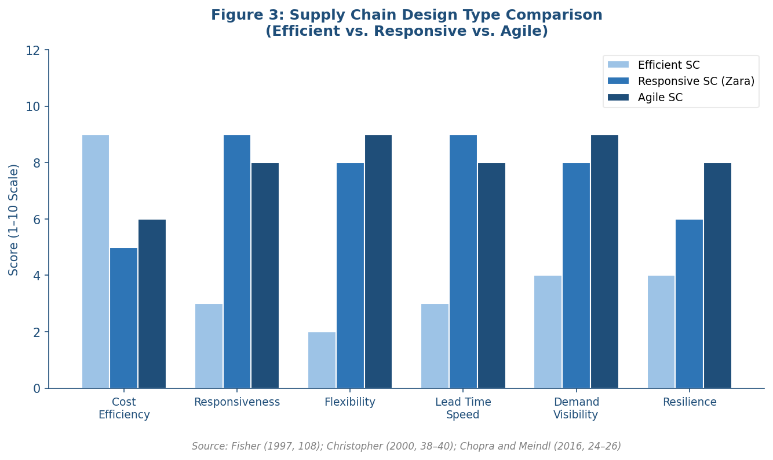
Figure 1: Supply Chain Design Comparison – Efficient vs. Responsive vs. Agile (Fisher 1997, 108; Christopher 2000, 38–40; Chopra and Meindl 2016, 24–26)

2.3 Risks associated with supply chain designs
All designs have risk. Utilisation of low buffers and low utilisation in efficient designs can make them susceptible to changes in demand. Responsive designs minimise the demand mismatch, but can lead to higher production, transportation and coordination costs. Centralised designs offer control, but also introduce a risk of disruption to the single hub of the company. Global sourcing reduces the cost of purchasing goods, but can also result in longer lead times, political risk, emissions from transport activities and problems with supplier control. The literature on supply chain risk management emphasises that firms need to be aware of the sources of supply chain disruptions and become resilient by relying on the tools of supply chain visibility, collaboration, flexibility and redundancy in an economically feasible way (Ivanov and Dolgui 2020, 2906; Emrouznejad, Abbasi, and Khalili-Damghani 2023, 5).
The biggest danger for the fashion retailer is the uncertainty of demand. The traditional seasonal model generates massive quantities months ahead of time, allowing for the risk of overstocking and markdowns/waste. It would be best practice in this context to integrate demand sensing, rapid replenishment, postponement, small batch production and supplier cooperation, with the use of an integrated information system. Therefore, besides low cost, responsiveness becomes the strategic priority for Zara, and that is why this is considered a case of supply chain responsiveness (Ferdows, Lewis, and Machuca 2004, 106; Aftab, Yuanjian, and Kabir 2018, 213).
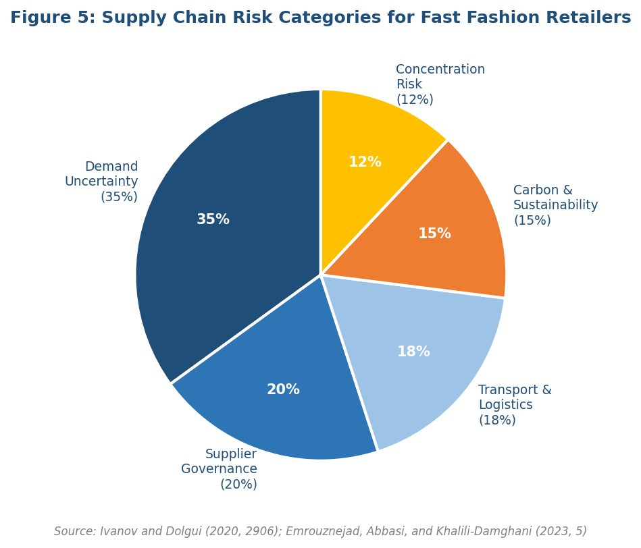
Figure 2: Supply Chain Risk Categories for Fast Fashion Retailers (Ivanov and Dolgui 2020, 2906; Emrouznejad, Abbasi, and Khalili-Damghani 2023, 5)

Case Study: Zara

3.1 Company background and organisational strategy
Zara is the main brand of the Spanish multinational retail company Inditex. Inditex's approach, according to its own description, is integrated, customer-centric and based on the union of physical means, Internet platforms, design, logistics, and technology (Inditex 2025, 6). Additional case evidence suggests that Zara's model is one that relies on speed of design to store cycles and tight linkages between commercial and operational decisions (Ghemawat and Nueno 2003, 5). The way that Zara organises their business is at a quick pace to offer fashionable designs at affordable prices and to be responsive to customers' tastes. Whereas some seasons are based on a couple of bigger collections, Zara changes its collections on a regular basis. This can lead to increased consumer visits to the store, decreased need for advertising and scares because the customer will know that the product may not last long.
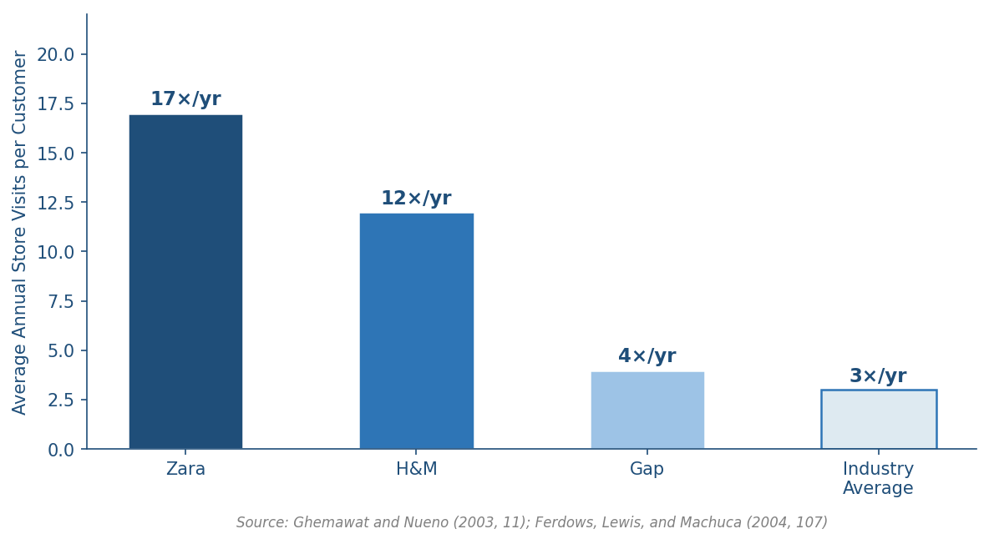
Figure 3: Customer Store Visit Frequency – Annual Visits per Customer (Ghemawat and Nueno 2003, 11; Ferdows, Lewis, and Machuca 2004, 107)
The strategic objectives for this model are to be quick to market, flexible, have inventory discipline, and have a strong relevance to brand and continuous customer feedback. However, in terms of courses, Zara's strategy is not to compete on the lowest possible production cost, but on time, flexibility, quality of fashion interpretation and customer value (Reklitis et al. 2021, 8734). Therefore, its supply chain approach must have the characteristics of fast response and regular replenishment. A network that is completely low-cost is not the right type of offshore network because long lead times would not allow for a quick response to fashion trends.

3.2 Zara supply chain strategy and network design
Zara's chain of supply is: Centralised, Responsive and Agile—close coordination of critical activities like design, planning and logistics from Spain. Meanwhile, trend-based production is fragmented into near-sourcing suppliers and basic and predictable production to more distant suppliers. This differentiated design enables the brand to prioritise speed and agility for high-demand uncertainty products, where the lower-cost sourcing for less time-sensitive products is also suitable. (Yang 2025, 3) also noted that the implementation of Zara's product response model can be analysed from the aspects of flexibility, information flow and cost control. The method is consistent with the agile concept: lean practices work well for basic, predictable products, and agile practices are used for products that are fashion-driven and require responsiveness to add value.
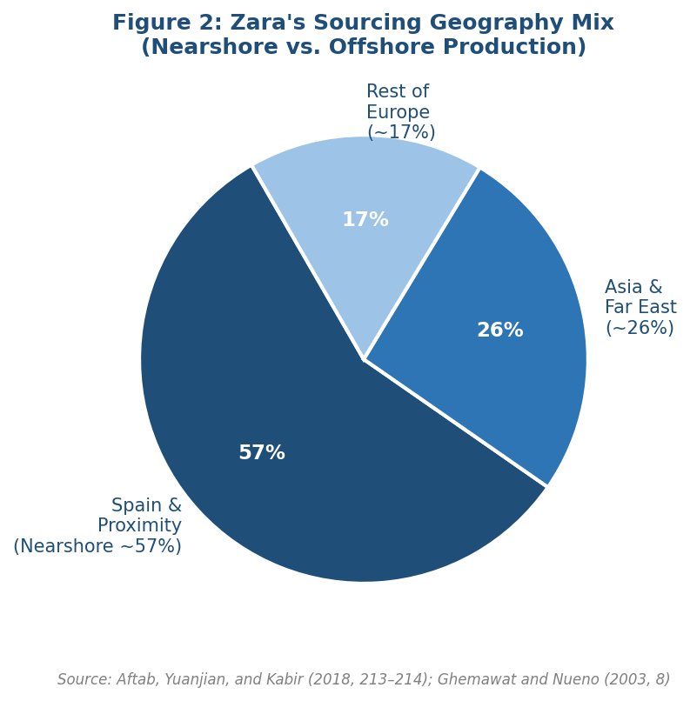
Figure 4: Zara’s Sourcing Geography Mix – Nearshore vs. Offshore Production (Aftab, Yuanjian, and Kabir 2018, 213–214; Ghemawat and Nueno 2003, 8)
As well as physical flow, information flow is important. Demand information and trends from store managers, point-of-sale systems, and online channels are used by designers and planners. Designers use this feedback to make adjustments to styles, colours and quantities. Small batch production and distribution then pass through central logistical centres to stores and online fulfilment centres. This network will help minimise the amount of unwanted clothing produced and boost the levels of clothing that sell. The design is not just a way to move goods, it is a system to rapidly learn from the market.

3.3 Supply chain network map

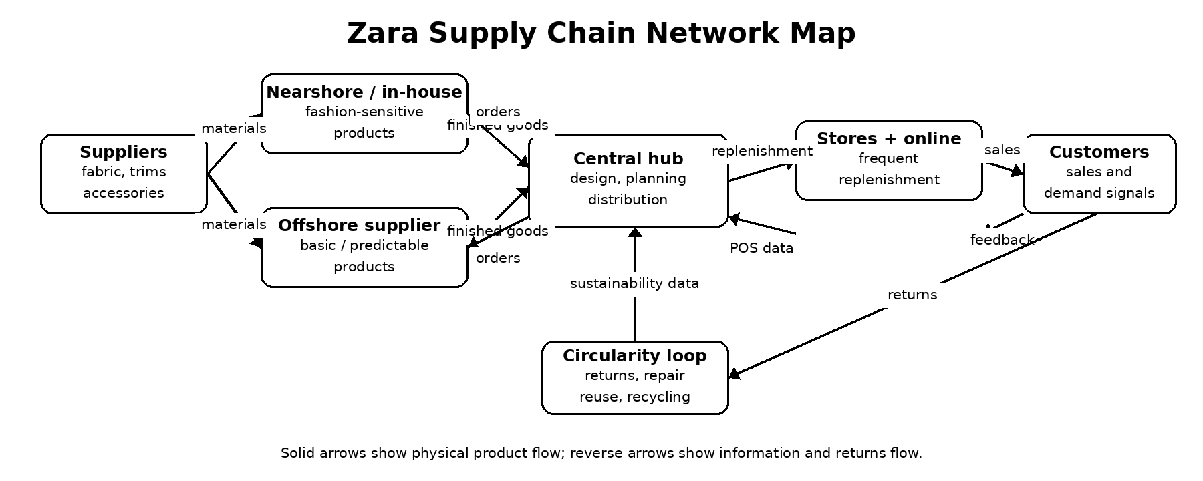
Figure 5: Zara's supply chain network map can be seen as a map of the flow of physical products and the reverse flow of information.
Zara's network contains two connected flows (as shown in Figure 5). Stores, online fulfilment points and customers are the end of the physical flow. In contrast, the beginning is fabric and accessory suppliers, followed by nearshore and/or offshore production, where there is some uncertainty around the product, then central design, planning and logistics coordination. The flow from the customer to the store is opposite: Customers and stores create sales data, trend feedback and return data, which are returned to the headquarters and suppliers. This reverse flow helps to facilitate responsiveness as Zara can adjust production and replenishment throughout the selling season.
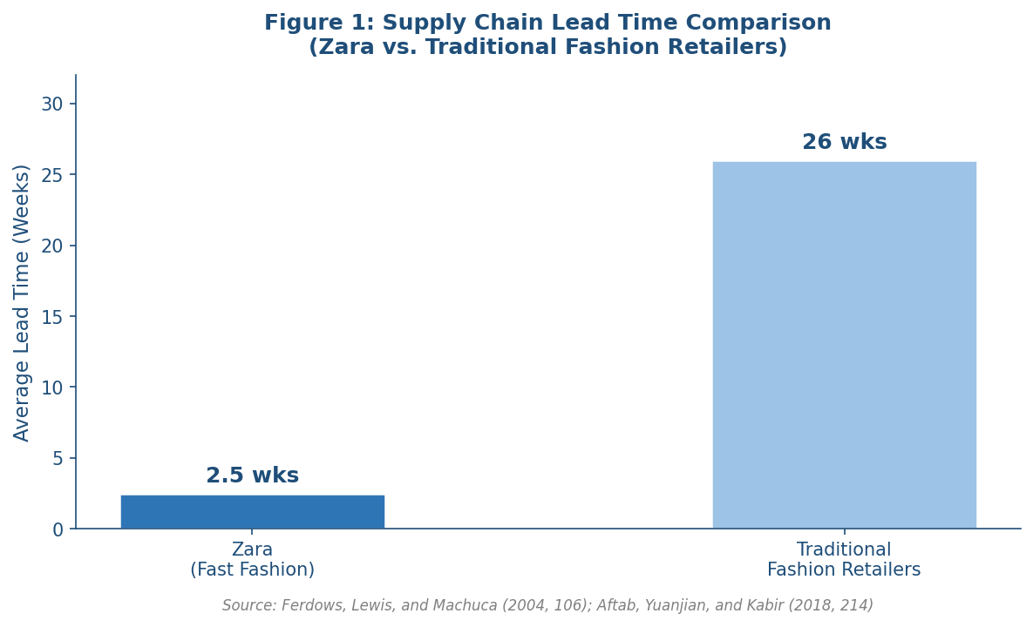
Figure 6: Supply Chain Lead Time Comparison – Zara vs. Traditional Fashion Retailers (Ferdows, Lewis, and Machuca 2004, 106; Aftab, Yuanjian, and Kabir 2018, 214)

Analysis and Discussion

4.1 Alignment between organisational strategy and supply chain design
It is clear that Zara's supply chain design is strongly connected with organisation's strategy.Zara's supply chain design is certainly in accordance with their organization's strategy. Fashion speed necessitates the company to spot the trends, understand them and create garments and deliver them before the consumers' interest wanes. This is facilitated by the network, who are based on centralised decision making, rapid information exchange, small batch production and frequent replenishment. Fisher's theory suggests a product that is often innovative is one that has uncertain demand and brief life cycles, like Zara's products. A responsive supply chain design is therefore more appropriate than an efficient supply chain design (Fisher 1997, 108).
Centralised hub enhances strategic control. It enables designers, merchandisers, buyers, logistics and data teams to make decisions in a timely fashion. This reinforces the coursework idea of strategic fit – Supply chain processes, resources and capabilities shape around the competitive priorities of time and flexibility. Zara also incentives its employees by taking into account the feedback from its stores to make replenishment decisions rather than just relying on long-range forecasts. This limits the reliance on faulty forecasts, which can be useful as demand for fashion products is hard to forecast.

4.2 Why Zara chooses a responsive/agile design
The responsiveness and agility of the design outweighs the cost of being reactive, for Zara. A producer that produces large numbers of items months earlier than the season could be able to benefit from low unit costs, while incurring economic damages from markdowns and unsold inventory. The advantage is Zara's ability to match the demand more closely, replenishing quickly and having fewer risks of obsolescence due to the higher production and logistics cost. It is a measure of total supply chain thinking: the most values chain is after the production, inventory, markdown, service, and responsiveness.
The design is also customer valuing. New products are released on regular basis and it gives a feeling of freshness and urgency. Customers are motivated to shop more frequently due to rapid changing assortment. This strengthens Zara's brand image and position and enables the company to compete without a heavy investment on advertising. Responsiveness is a marketing and revenue capability from a supply chain perspective.

4.3 Advantages of Zara's design
The first advantage is the fastness. Zara can make quicker decisions based on market signals, which means they can make decisions before they become irrelevant. The second is a fall in the reduced demand mismatch. Smaller batches will minimize exposure if it does not pass or if it does pass it can be replaced. The third one is better visibility on information. The new store and online data provide planners with insight into customer buying trends, not just forecasted. The 4th is the capacity to exert more control over the flow of brand and product; centralised coordination ensures there is a strong connection between design, distribution and restocking.
The other advantage is the flexibility. Zara can allocate capacity to different product categories to different regions. The flexibility brought by nearshore production for fashion sensitive products versus offshore production, for cost efficiency with basics. This hybrid strategy is the best practice since it doesn't apply the same treatment to all products. In addition, there is a risk pooling, as the central logistics can distribute its stock according to the market demand without having to invest all at once in a specific market.
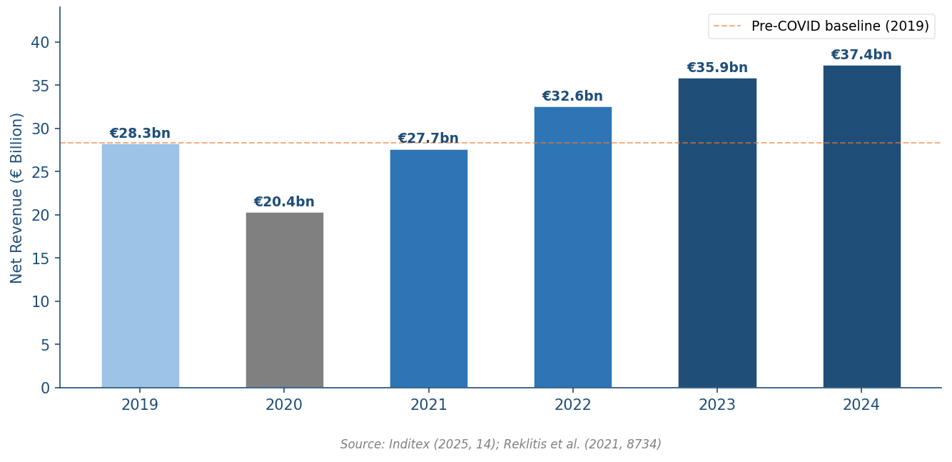
Figure 7: Inditex Group Net Revenue 2019–2024 – Demonstrating Supply Chain Resilience and Growth (Inditex 2025, 14; Reklitis et al. 2021, 8734)

4.4 Disadvantages and possible risks
Although Zara's design is good, it has drawbacks. First, it is costly to be responsive. Fast and near shore production might be more expensive than traditional offshore bulk. Secondly, there is a concentration risk with centralised distribution. A great logistical disruption, an IT system or transport route may be affected and many markets are affected. Third, the industry of fast fashion is under sustainability scrutiny as its fast product turn-over can lead to over-consumption and textile waste. Fourth, global apparel supply chains have risks with respect to supplier governance, such as labour standards and risks concerning traceability.
Also risk from transport emissions. During disruption, recent public reporting and media analysis reveals that pressure is being placed on fashion retailers to decrease logistics emissions and dependence on air freight. Inditex has made sustainability targets and investments, but it is necessary to further refine the responsiveness model, which must further enhance environmental performance (Inditex 2025, 22). The challenge is to maintain the benefits of speed and have lower carbon intensity, waste and supplier risk.

4.5 Comparison with best practice and literature
Zara's design is strong in terms of strategic fit, information sharing, responsiveness and differentiated sourcing when compared to best practice. It is in line with Fisher's suggestion that for innovative products, the supply chain needs to be responsive and with Lee's suggestion that the supply chain should be agile, adaptable, and aligned. It also demonstrates agility: basic products can be handled efficiently, fashion sensitive products, responsively. But best practice has developed and matured beyond the speed factor. In recent times, the focus in the current supply chain is on increasing resilience and sustainability. For this reason, Zara must increase transparency, broaden risks, lower its emissions and enhance its circularity, and maintain its responsiveness, which is a major advantage of the brand.

Conclusion and Recommendations
According to this report, Zara's network design of the supply chain is one of the key things that gives them a competitive advantage. The company's network is a responsive, agile network backed by centralized coordination, quick information exchange, selective near shore production, offshore sourcing for basic products and frequent replenishment. The design matches Zara's business strategy due to the need for speed, flexibility and market sensing for fast fashion. The supply chain map makes it clear that this is not a pipeline, but rather a feedback loop in which the customer's data influences the design, production and reorder decisions for Zara.
A complete redesign is not suggested because the current design is in line with Zara's strategy. But there is need for specific redesign and enhancement. Zara needs to increase the diversification of suppliers and contingency planning to minimise disruption. Second, it should invest in further developing AI-powered demand forecasting and inventory optimization. Third, it is supposed to lower transport emissions by optimizing routes, using less polluting fuel and better utilization of containers, and by choosing specific regional fulfillment. Fourth, Zara needs to increase its circular fashion initiatives, such as repair, resale, recycling, and designing for durability.
Fifth, it should enhance transparency through the provision of greater clarity with respect to suppliers, labour and environmental performance.In conclusion, Zara's case is a testament to the importance of strategic fit in the design of a supply chain network. Responsiveness and agility are essential for a fast fashion firm, not just a desirable characteristic. The next challenge is to keep this responsiveness but at the same time achieve sustainability, resilience and transparency of the network.

References
Aftab, Muhammad Ali, Qin Yuanjian, and Nazia Kabir. 2018. “Super Responsive Supply Chain: The Case of Spanish Fast Fashion Retailer Inditex-Zara.” International Journal of Supply Chain Management 7 (5): 212–218 https://www.iberglobal.com/files/2018/zara_case_supply_chain.pdf
Brandenburg, Marcus, Kannan Govindan, Joseph Sarkis, and Stefan Seuring. 2014. “Quantitative Models for Sustainable Supply Chain Management: Developments and Directions.” European Journal of Operational Research 233 (2): 299–312 https://doi.org/10.1016/j.ejor.2013.09.032
Chopra, Sunil, and Peter Meindl. 2016. Supply Chain Management: Strategy, Planning, and Operation. 6th ed. Boston: Pearson https://www.pearson.com/en-us/subject-catalog/p/supply-chain-management-strategy-planning-and-operation/P200000003235
Christopher, Martin. 2000. “The Agile Supply Chain: Competing in Volatile Markets.” Industrial Marketing Management 29 (1): 37–44 https://doi.org/10.1016/S0019-8501(99)00110-8
Emrouznejad, Ali, Sara Abbasi, and Mina S. S. Khalili-Damghani. 2023. “Supply Chain Risk Management: A Content Analysis-Based Review.” Decision Analytics Journal 8: 100287 https://doi.org/10.1016/j.dajour.2023.100287
Ferdows, Kasra, Michael A. Lewis, and Jose A. D. Machuca. 2004. “Rapid-Fire Fulfillment.” Harvard Business Review 82 (11): 104–110 https://hbr.org/2004/11/rapid-fire-fulfillment
Fisher, Marshall L. 1997. “What Is the Right Supply Chain for Your Product?” Harvard Business Review 75 (2): 105–116 https://econspace.net/teaching/MGT-528/Fisher-HBR-1997.pdf
Fu, Qian, Md. M. Rahman, Huaibin Jiang, and Yunlong Zhang. 2022. “Sustainable Supply Chain and Business Performance: The Impact of Strategy, Network Design, Information Systems, and Organisational Structure.” Sustainability 14 (3): 1080 https://doi.org/10.3390/su14031080
Ghemawat, Pankaj, and Jose Luis Nueno. 2003. “ZARA: Fast Fashion.” Harvard Business School Case 9-703-497 https://didierdiaz.com/wp-content/uploads/2019/10/Zara-fast-fashion-Case-study-HVR.pdf
Inditex. 2025. Inditex Group Annual Report 2024. Arteixo: Industria de Diseño Textil, S.A https://www.inditex.com/itxcomweb/api/media/604197b9-50de-4f4f-ab84-c1e379cb3fd0/Inditex_Group_Annual_Report_2024.pdf
Ivanov, Dmitry, and Alexandre Dolgui. 2020. “Viability of Intertwined Supply Networks: Extending the Supply Chain Resilience Angles towards Survivability.” International Journal of Production Research 58 (10): 2904–2915https://doi.org/10.1080/00207543.2020.1750727
Jodlbauer, Herbert. 2023. “Supply Chain Management: A Structured Narrative Review of Current Challenges and Future Directions.” Logistics 7 (4): 70 https://doi.org/10.3390/logistics7040070
Lee, Hau L. 2004. “The Triple-A Supply Chain.” Harvard Business Review 82 (10): 102–112 https://hbr.org/2004/10/the-triple-a-supply-chain
Naylor, J. Ben, Mohamed M. Naim, and Danny Berry. 1999. “Leagility: Integrating the Lean and Agile Manufacturing Paradigms in the Total Supply Chain.” International Journal of Production Economics 62 (1–2): 107–118 https://doi.org/10.1016/S0925-5273(98)00223-0
Reklitis, Panagiotis, Dimitrios Sakas, Panagiotis Trivellas, and Panagiotis Tsoulfas. 2021. “Performance Implications of Aligning Supply Chain Management Practices with Competitive Advantage.” Sustainability 13 (16): 8734 https://doi.org/10.3390/su13168734
Yang, Binglin. 2025. “Analysis of Zara’s Fast Fashion Supply Chain Rapid Response Model.” Advances in Economics, Management and Political Sciences https://www.atlantis-press.com/article/126013644.pdf

