Supply Chain Technology & Systems

Abstract
In the current paper, the supply chain network design process at Amazon will be analyzed comprehensively as an illustrative example. Thus, the goals stated by Amazon will be revealed within the framework of the supply chain and distribution design process. Amazon uses a mixed approach when designing its supply chain network, taking into account both efficient and responsive supply chains using Amazon’s decentralized fulfillment center network, analytical forecasts, and advanced logistics centers. In the paper, several levels of supply chain design are discussed – from the supplier and vendor level, to fulfillment centers, sortation centers, and last-mile logistics concepts; their roles are also considered within the customer value proposition concept. Finally, this analysis concerns the combination between the strategic orientation of the company and its supply chain strategy. It considers the benefits associated with increased processing speed, scalability, and innovations. At the same time, it takes into account possible cybersecurity threats, labor strikes, political, and environmental challenges. On the basis of scientific sources and practical experience, this paper draws conclusions and suggests several ways for the reorganization of the supply chain, such as fast decarbonization, supplier diversification, and circular economy adoption..

1. Introduction
The design of supply chain network is perhaps the most strategic decision-making process that a multinational company can undertake because the ramifications on cost structures, responsiveness, resilience, and competitive advantage are interrelated (Chopra & Meindl, 2016). The greater the level of globalization and consumer expectation, especially during the age of e-commerce, the more companies are expected to design supply chains that are not only efficient but also resilient (Christopher, 2016).
This paper discusses one of the world's most complicated supply chains of Amazon.com Inc., to analyze the impact of organizational strategy on the supply chain network design. In this respect, the supply chain of Amazon is remarkable due to its hybrid nature, as it incorporates efficient supply chain features of minimizing costs through standardization and scale benefits, along with utilizing responsive design principles to deliver orders in the same day and the next day (Mentzer et al., 2001). The continuous use of technologies such as robots, automated order fulfillment systems, and even intelligent prediction of the location of inventory using machine learning algorithms makes the company's supply chain one of the most analyzed subjects by scholars and benchmarks for other firms.
The objectives of this paper are as follows: (1) reviewing existing literature on supply chain network design and importance of strategy for supply chain design; (2) describing and mapping Amazon supply chain; (3) analyzing the match between the supply chain design of Amazon and its organizational strategy; and (4) evaluating strengths and weaknesses of Amazon's supply chain network design.

2. Literature Review

2.1 Supply Chain Design and Its Strategic Importance
Designing the supply chain network involves all types of decisions concerning the structure and flows of material, information, and funds among the various nodes such as suppliers, manufacturing facilities, warehouses, and distribution centers (Melo et al., 2009). Supply chain design is an extremely critical aspect because research indicates that about 80% of the total costs and environmental impacts associated with any product are made during its design phase (Seuring & Müller, 2008).
In line with Fisher's (1997) approach to supply chain design, one needs to understand the type of demands associated with a product before proceeding. A product whose demand is stable and predictable will benefit most from supply chains that have been designed for efficiency to minimize costs. On the other hand, a product with unstable demands requires a supply chain that is flexible and fast. This pioneering approach/framework still holds true today, and subsequent researchers have built upon it to include digital, circular, and platform models of supply chain architectures (Gereffi & Lee, 2012).
In terms of strategy, supply chain network configurations affect a company’s ability to deliver its value proposition. Firms pursuing cost leadership should consider supply chains that are efficient, have assets well-utilized, and operate on large batches; those seeking differentiation based on speed or customization need responsive and flexible networks (Porter, 1985). The fit between organizational strategy and supply chain strategy is known as ‘strategic fit’ in Chopra & Meindl (2016), who cite strategic mismatch as one of the main reasons for poor performance in international supply chains.
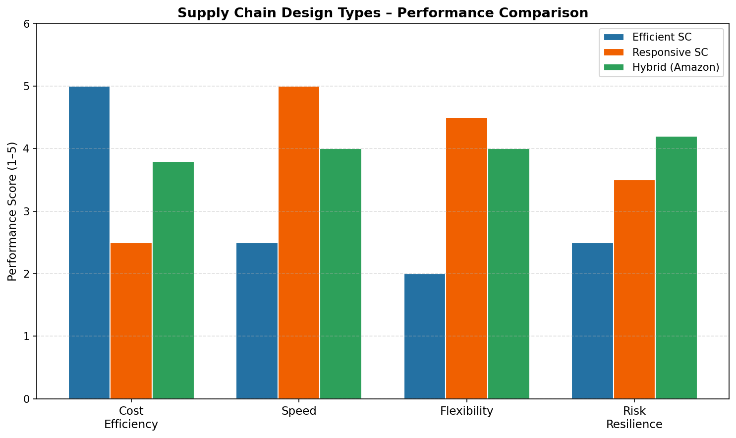
Figure 1: Supply Chain Design Types – Performance Comparison (Efficient vs. Responsive vs. Hybrid)

2.2 Types of Supply Chain Design
Several prominent models exist for the development of the supply chain design. According to Fisher (1997), the efficient supply chain design focuses on minimizing costs through the economy of scales, standardization of process, large-scale production, and high resource utilization. On the other hand, the responsive supply chain design focuses on flexibility and speed by maintaining excess capacity as well as strategic inventory. These are relevant when dealing with fashion, technology, and other areas where there is high innovation (Christopher, 2016).
While the centralized supply chain design seeks to consolidate the facilities in few large centers to exploit economies of scale and streamline coordination efforts, the decentralized design involves locating the facilities across geographic regions to cut down transportation costs and reduce delivery time (Melo et al., 2009). In recent times, researchers have come up with the idea of sustainable supply chain design that factors in sustainability parameters along with economic considerations, owing to mandatory regulations and growing stakeholder demand for social accountability (Seuring & Müller, 2008; Touboulic & Walker, 2015). Another design concept is that of the platform-based or digital supply chain design (Ivanov & Dolgui, 2020).

2.3 Risks Associated with Supply Chain Design
All supply chain designs entail some degree of risk. Very efficient supply chains, which are designed for maximum efficiency with lean inventories and single sourcing, pose a high risk of disruption, which was evident during the coronavirus pandemic (Ivanov, 2020). On the other hand, very decentralized or flexible supply chains pose a higher level of coordination risk, higher fixed costs, and redundancy.
According to Hohenstein et al. (2015), supply chain resilience is critical in supply chain design after the coronavirus pandemic, involving the ability to anticipate, adapt, and recover from any disruptions. Tang (2006) highlights robustness, which involves performance under different scenarios, and resilience, which involves recovering from disruptions, and argues that designing an efficient supply chain involves both concepts. There are other risks associated with digital supply chains, such as cybersecurity attacks, data sovereignty issues, and technological obsolescence (Ivanov & Dolgui, 2020). A sustainable supply chain design reduces environmental risks, but it increases cost risks in the short run and demands considerable change management within an organization (Touboulic & Walker, 2015).
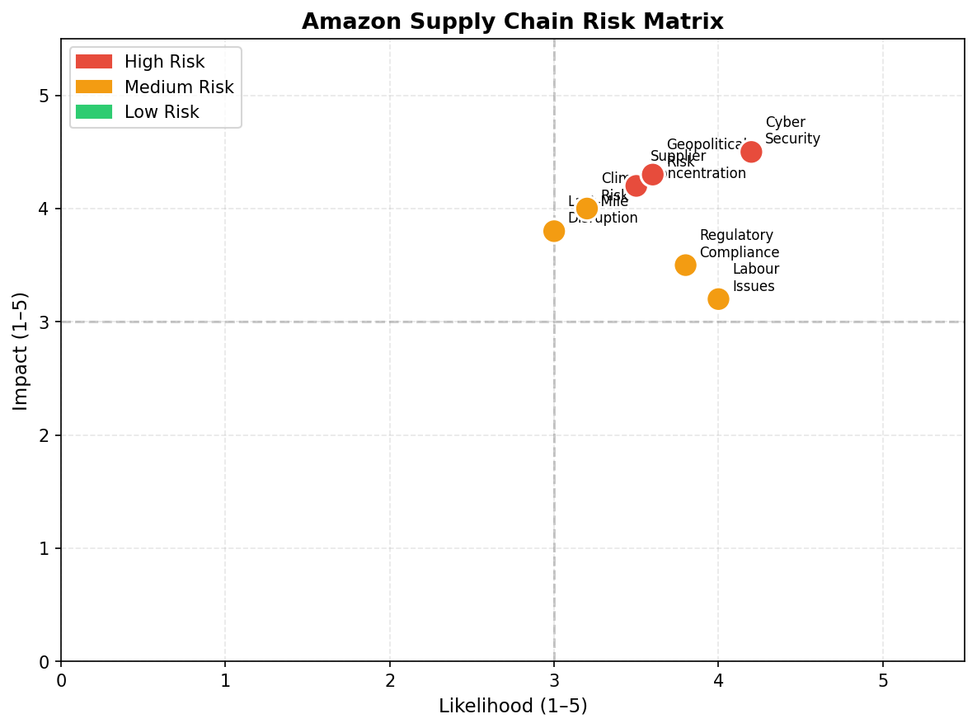
Figure 2: Amazon Supply Chain Risk Matrix – Likelihood vs. Impact Assessment

3. Case Study: Amazon

3.1 Company Overview
Founded in 1994 by Jeff Bezos, Amazon began as a bookselling website but has grown into the largest international e-commerce platform and one of the most successful companies in the world, generating over USD 620 billion annually in 2024 (Amazon Annual Report, 2024). The corporate mission statement of Amazon is stated as follows: "To be Earth's most customer-centric company; where customers can come to find and discover anything that they might wish to purchase online." The corporate vision of Amazon is "to be Earth's best employer and Earth's safest place to work." The main organizational strategies of Amazon include: customer-oriented as opposed to competitor-oriented, long-term versus short-term focus, operational excellence through continual improvement, and technology integration as an important core competence (Bezos, 2018).
Supply chain strategies employed by Amazon in connection to this concept include hybrid of efficient and responsive approach, mass customization of fulfillment, logistics verticalization, automation, and forecasting driven by data. These strategies have been applied to the development of a supply chain network characterized by extensive geographic coverage, depth in product line, and fast delivery capability.
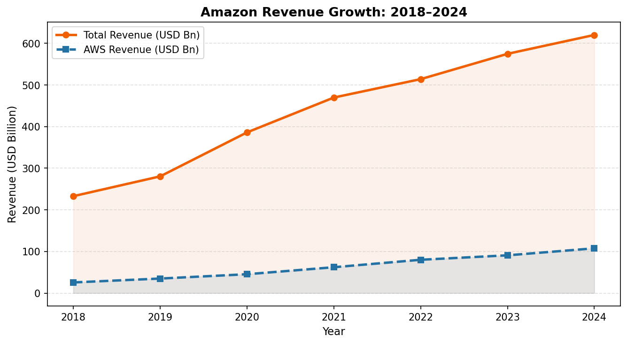
Figure 3: Amazon Revenue Growth 2018–2024 (Total Revenue vs. AWS)
Dimension | Description
Mission | Earth's most customer-centric company; enabling customers to find and buy anything online
Vision | Earth's best employer and safest place to work, pioneering technological innovation
Org. Strategy | Customer obsession, long-term investment, operational excellence, technology integration
SC Strategy | Hybrid efficient-responsive model; vertical integration of logistics; AI-driven forecasting
Design Type | Decentralized fulfillment network + centralized data architecture (AWS backbone)
Table 1: Amazon Strategic Profile Summary

3.2 Supply Chain Network Map and Explanation
Supply chain network structure of Amazon includes six levels (See Figure 4): raw materials (Level 3); OEM component suppliers like Foxconn (Level 2); nine million suppliers (Level 1) (Amazon, 2024); one hundred eighty-five plus fulfillment centers along with AWS and Prime Air (Chopra & Meindl, 2016; Mentzer et al., 2001); last mile deliveries through Amazon Flex and Prime Now, and reverse logistics - Hybrid Efficient-responsive supply chain design (Christopher, 2016).
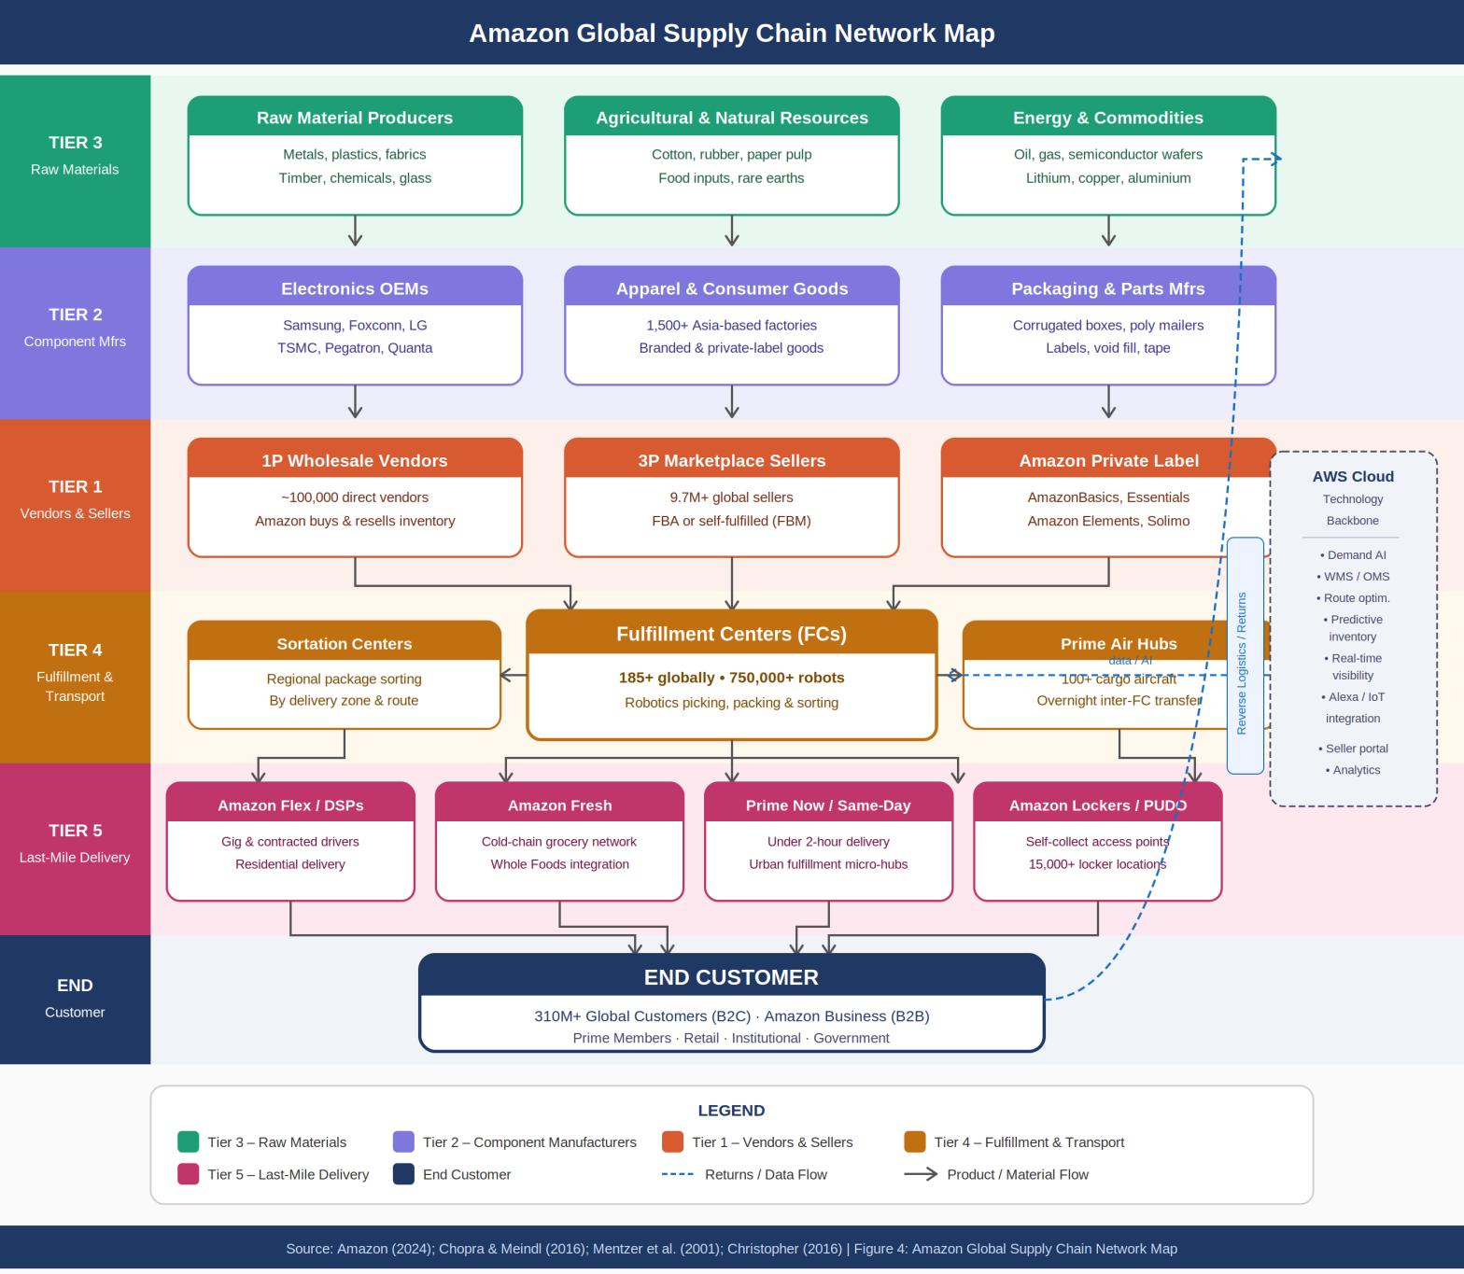
Figure 4: Amazon Global Supply Chain Network Map – Multi-Tier Flow Architecture

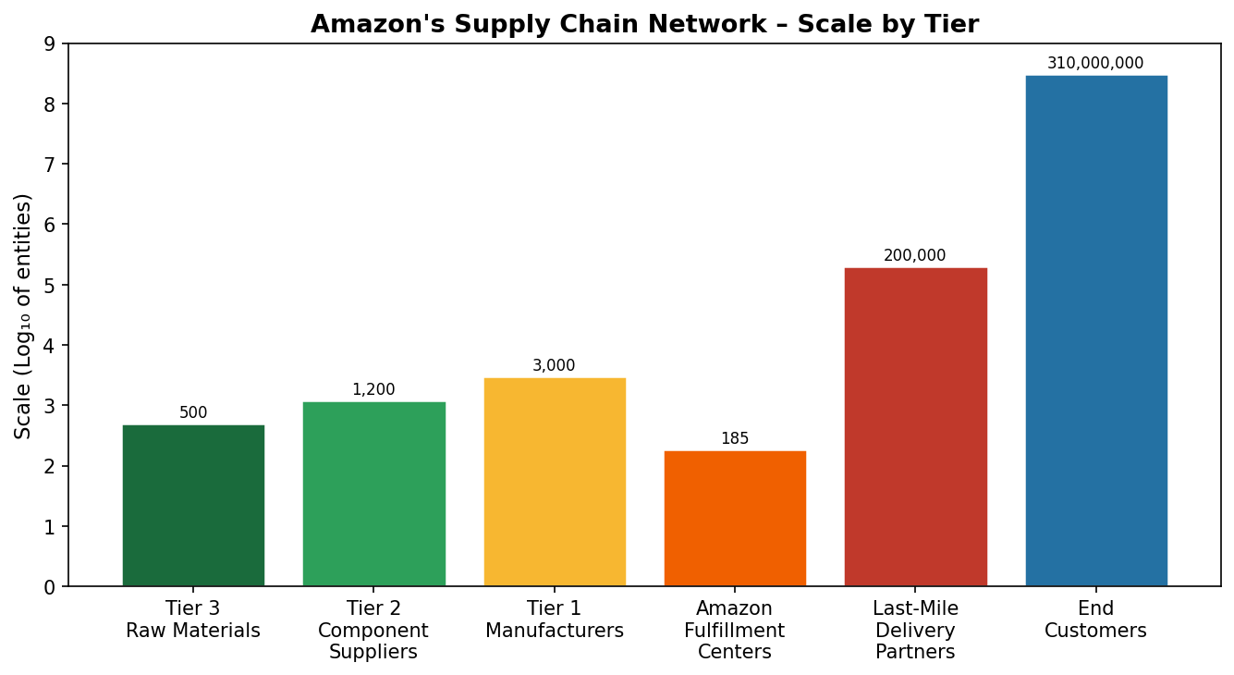
Figure 5: Amazon Supply Chain Network – Scale of Entities by Tier (Log Scale)
Third tier suppliers provide raw material such as metals, plastics, and agriculture input to second tier suppliers of components which further supply to first tier manufacturers comprising brands/OEM who sell to Amazon either directly (first party vendors) or through Amazon marketplace as third party vendors. As of 2024, Amazon's marketplace had in excess of 9.7 million sellers world-wide (Amazon, 2024).
Amazon has more than 185 Fulfilment Centers (FC) world-wide which are strategically placed close to major population clusters so that last mile distance is minimized. FCs at Amazon are highly automated with more than 750,000 robots world-wide (Amazon Robotics, 2024). Sortation Centers unpack the bulk shipment received from FCs and repack the shipment according to geographic zones of deliveries. The air fleet of Amazon (Prime Air) in excess of 100 airplanes along with delivery stations help Amazon in offering same day and next day deliveries in urban centers while groceries are handled through Amazon Fresh in cold chain logistics.
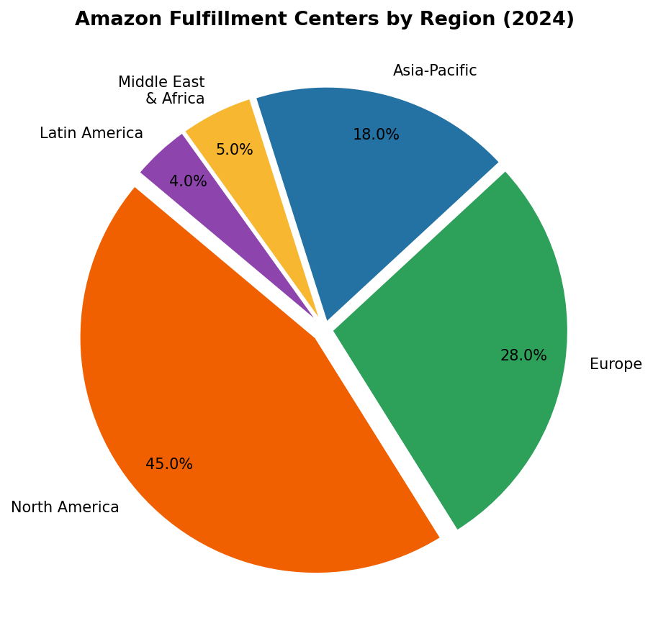
Figure 6: Amazon Fulfillment Centers by Region (2024) – Global Distribution

4. Analysis

4.1 Strategic Alignment
The supply chain architecture at Amazon demonstrates a high degree of congruence between the supply chain and the organizational strategies at various levels. The customer-centric strategy pursued by the organization finds reflection in the responsiveness of its supply chain components through its focus on same-day delivery, predictive positioning of inventory, and its large network of fulfillment centers, which ensure proximity to customers (Chopra & Meindl, 2016). At the same time, the supply chain helps Amazon achieve its objective of cost leadership through economies of scale in fulfillment and automation.
Fit strategy for the highly uncertain demand of the Amazon's ecommerce business and the hybrid approach of its supply chain is well recognized. According to Fisher (1997), innovations that involve high variety are suited to response chains, whereas those that are standardized have efficiency chains. For Amazon, having to deal with commodities and innovative electronics concurrently, it has been apt to adopt the hybrid approach. This is because of the efficiency created by the AWS technology platform, which not only benefits itself but third-party customers as well (Ivanov & Dolgui, 2020).
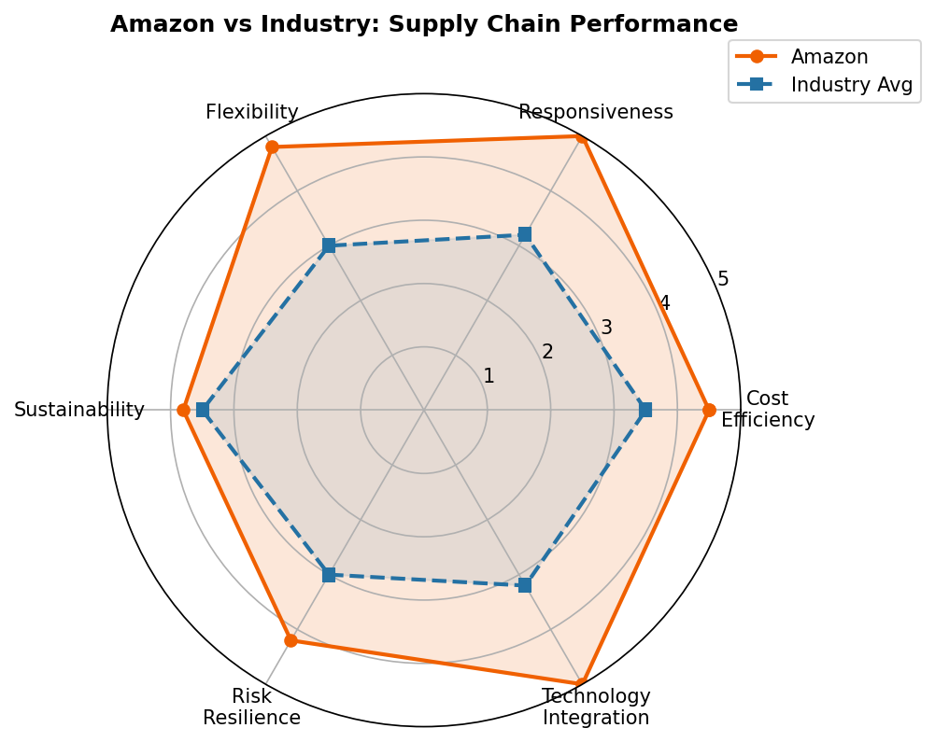
Figure 7: Amazon vs. Industry Average – Supply Chain Performance Radar (2024)

4.2 Advantages and Disadvantages of Amazon's Supply Chain Design
Advantages:
Decentralized fulfillment centers at Amazon offer unprecedented delivery times and allow for same-day delivery to 72% of the US population in 2024. Anticipatory shipping, made possible by predictive analytics, involves positioning inventory close to areas with projected demand even before orders are placed (Manyika et al., 2013). Economies of scale from its large size give Amazon substantial competitive advantages through procurement, logistics, and information technology. Vertical integration of the company's logistical functions including fulfillment, air transport, and delivery removes the need to rely on third-party carriers (Christopher, 2016). In addition, the Amazon Web Services (AWS)-driven platform gives Amazon an advantage in terms of real-time monitoring of its logistics operation (Ivanov & Dolgui, 2020).
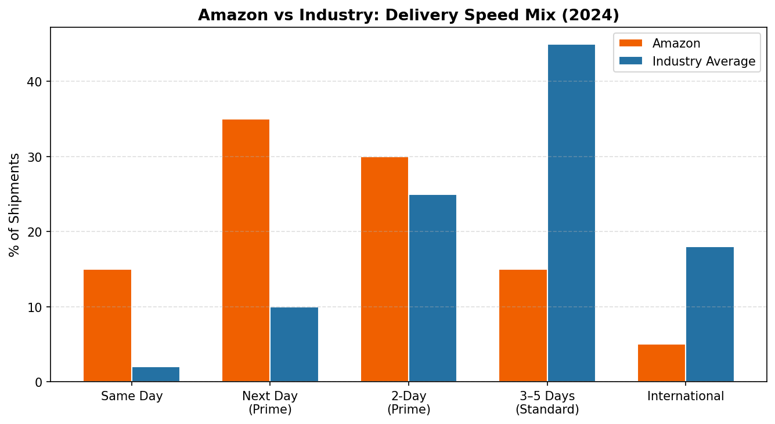
Figure 8: Amazon vs. Industry – Delivery Speed Mix Comparison (2024)
Disadvantages and Risks:
Although many positives exist for Amazon's supply chain structure, there are also some potential downsides for the organization. The complexity involved in a globalized and decentralized supply chain structure is a potential drawback as it results in increased costs of coordination and increased vulnerability. Issues such as the high number of workplace injuries in Amazon's fulfillment centers are a major risk factor for Amazon, considering the many investigations against them for such issues in the US, UK, and EU (Brower, 2021). Amazon faces cybersecurity risks due to the reliance of the network on digital infrastructure for operations; a successful hack at AWS could result in a successful hack of all operations of Amazon and its millions of third-party customers (Ivanov & Dolgui, 2020). Amazon is vulnerable to geopolitical risks because of tensions between the US and China, which affect the supplier base from which the company purchases significant amounts of consumer electronics. Environmental sustainability is a major concern, as Amazon has committed itself to achieve carbon neutrality by 2040 through the Climate Pledge (Amazon, 2023), but this comes with many challenges.
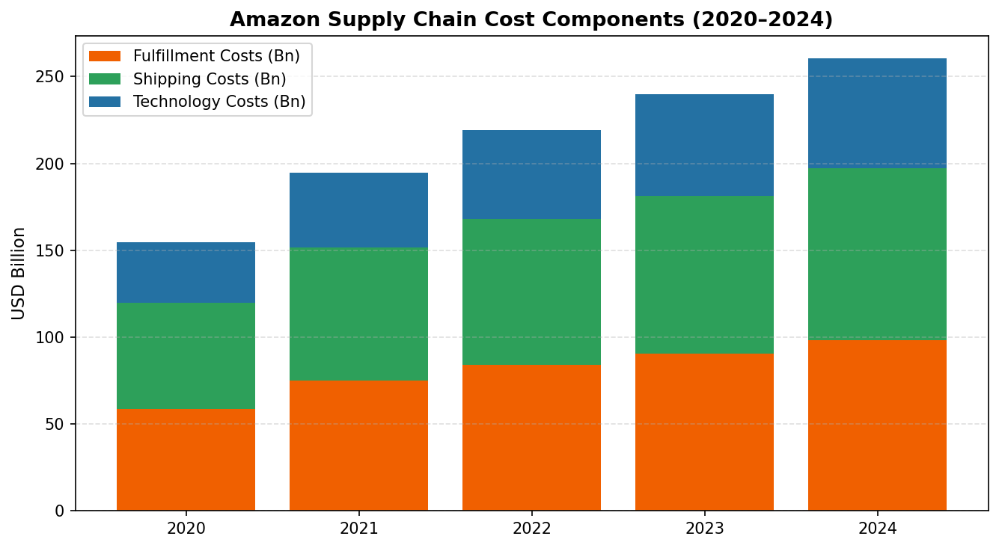
Figure 9: Amazon Supply Chain Cost Components 2020–2024 (USD Billion)

4.3 Comparison with Best Practices and Literature
Technology utilization, speed, and scalability are some of the factors in which Amazon is performing above the benchmarked standards set by the industry in all respects (Gartner Supply Chain Top 25, 2024). On the other hand, with regards to sustainability, Amazon might not perform better compared to other companies such as IKEA and Unilever since their supply chains include technologies related to circular economy and renewable energy sources (Touboulic & Walker, 2015). Although there has been progress in this area, Amazon faces issues regarding supplier diversification, in which having at least two suppliers for essential materials is desirable (Tang, 2006). When it comes to supply chain transparency, Amazon underperforms firms such as Apple, which publishes annual reports on its supplier responsibility, a factor associated with increased regulatory oversight and ESG investing (Gereffi & Lee, 2012). Gartner's model of maturity of supply chains puts Amazon at level 4 (demand-driven supply chains) with the opportunity to reach level 5 (self-healing supply chains) (Gartner, 2024).

5. Conclusion and Recommendations
In conclusion, this essay shows that the supply chain network design by Amazon is a very complex and coherent one when compared to other modern businesses. As Amazon uses the hybrid efficient and responsive model, with a decentralized fulfillment strategy and centralized technologies in the company, this allows the organization to be highly competitive in terms of speed, cost, and variety, which according to Fisher (1997) and Chopra & Meindl (2016), is a challenging feat. There is a high degree of strategic congruence between Amazon's supply chain design and its organizational strategy, which contributes greatly to its competitive success.
However, there are weaknesses within the design of Amazon's supply chain. These include risks associated with cybersecurity issues, criticisms concerning sustainability, labor issues, as well as geopolitical risks, all of which are likely to continue to increase.
Below are the suggestions for redesign:
1. Accelerated Decarbonization: Amazon should accelerate its journey towards zero-emission deliveries and renewable energy for fulfillment centers before the 2040 target date set by the Climate Pledge in line with increased regulations and investor interest in ESG criteria (Seuring & Müller, 2008).
2. Supplier Diversification: In order to minimize geopolitical risks and concentration risks, Amazon should focus on nearshoring projects and establish supplier networks across multiple regions for strategic product categories as suggested by Tang's (2006) resilience model.
3. Circular Economy Integration: Amazon must invest more in its reverse logistics system, allowing it to recycle, remanufacture, and repurpose products on a massive scale, thereby minimizing waste and establishing sustainable competitive advantage, based on IKEA and Unilever standards (Touboulic & Walker, 2015).
4. Supply Chain Transparency: The release of comprehensive supplier accountability and environmental reports will enhance Amazon’s ESG and regulatory standing, in line with the emerging EU supply chain due diligence requirements (Gereffi & Lee, 2012).
5. Autonomous AI Advancement: Self-healing, artificial intelligence-enabled supply chains including autonomous inventory management and disruptions predictions would bring Amazon one step closer to the Level 5 Supply Chain Maturity Model by Gartner (Gartner, 2024).
Amazon has one of the best supply chains in the world, but to continue dominating the market, it needs to be more proactive about its environmental, social, and resilience shortcomings. This paper provides feasible recommendations to create a more sustainable and resilient supply chain ecosystem.

References
Amazon. (2023). Amazon Sustainability Report 2023. Amazon.com, Inc. https://sustainability.aboutamazon.com/
Amazon. (2024). Amazon Annual Report 2024. Amazon.com, Inc. https://ir.aboutamazon.com/annual-reports
Amazon Robotics. (2024). Amazon robotics: Transforming fulfillment. Amazon.com, Inc. https://www.aboutamazon.com/news/operations/amazon-robotics-robots-fulfillment-center
Bezos, J. (2018). Letter to shareholders: 2018 annual report. Amazon.com, Inc. https://ir.aboutamazon.com
Brower, T. (2021). Amazon's treatment of workers: What the research shows. Forbes. https://www.forbes.com/sites/tracybrower/2021/
Chopra, S., & Meindl, P. (2016). Supply chain management: Strategy, planning, and operation (6th ed.). Pearson Education.
Christopher, M. (2016). Logistics and supply chain management (5th ed.). Pearson Education.
Fisher, M. L. (1997). What is the right supply chain for your product? Harvard Business Review, 75(2), 105–116. https://hbr.org/1997/03/what-is-the-right-supply-chain-for-your-product
Gartner. (2024). Gartner supply chain top 25 for 2024. Gartner, Inc. https://www.gartner.com/en/supply-chain/research/supply-chain-top-25
Gereffi, G., & Lee, J. (2012). Why the world suddenly cares about global supply chains. Journal of Supply Chain Management, 48(3), 24–32. https://doi.org/10.1111/j.1745-493X.2012.03271.x
Hohenstein, N. O., Feisel, E., Hartmann, E., & Giunipero, L. (2015). Research on the phenomenon of supply chain resilience: A systematic review and paths for further investigation. International Journal of Physical Distribution & Logistics Management, 45(1/2), 90–117. https://doi.org/10.1108/IJPDLM-05-2013-0128
Ivanov, D. (2020). Predicting the impacts of epidemic outbreaks on global supply chains: A simulation-based analysis on the coronavirus outbreak (COVID-19/SARS-CoV-2) case. Transportation Research Part E: Logistics and Transportation Review, 136, 101922. https://doi.org/10.1016/j.tre.2020.101922
Ivanov, D., & Dolgui, A. (2020). A digital supply chain twin for managing the disruption risks and resilience in the era of Industry 4.0. Production Planning & Control, 32(9), 775–788. https://doi.org/10.1080/09537287.2020.1768450
Manyika, J., Chui, M., Bughin, J., Dobbs, R., Bisson, P., & Marrs, A. (2013). Disruptive technologies: Advances that will transform life, business, and the global economy. McKinsey Global Institute. https://www.mckinsey.com/business-functions/mckinsey-digital/our-insights/disruptive-technologies
Melo, M. T., Nickel, S., & Saldanha-da-Gama, F. (2009). Facility location and supply chain management: A review. European Journal of Operational Research, 196(2), 401–412. https://doi.org/10.1016/j.ejor.2008.05.007
Mentzer, J. T., DeWitt, W., Keebler, J. S., Min, S., Nix, N. W., Smith, C. D., & Zacharia, Z. G. (2001). Defining supply chain management. Journal of Business Logistics, 22(2), 1–25. https://doi.org/10.1002/j.2158-1592.2001.tb00001.x
Porter, M. E. (1985). Competitive advantage: Creating and sustaining superior performance. Free Press.
Seuring, S., & Müller, M. (2008). From a literature review to a conceptual framework for sustainable supply chain management. Journal of Cleaner Production, 16(15), 1699–1710. https://doi.org/10.1016/j.jclepro.2008.04.020
Tang, C. S. (2006). Perspectives in supply chain risk management. International Journal of Production Economics, 103(2), 451–488. https://doi.org/10.1016/j.ijpe.2005.12.006
Touboulic, A., & Walker, H. (2015). Theories in sustainable supply chain management: A structured literature review. International Journal of Physical Distribution & Logistics Management, 45(1/2), 16–42. https://doi.org/10.1108/IJPDLM-05-2013-0106

