LINGUA VILLOSA NIGRA (BLACK HAIRY TONGUE) IN A 3‑MONTH‑OLD INFANT FOLLOWING ANTIBIOTIC EXPOSURE: A CASE REPORT

ABSTRACT
Background: Lingua villosa nigra (black hairy tongue) is a benign and self‑limiting condition that is rare in infancy. It is often associated with antibiotic exposure, altered oral microbiota, and inadequate desquamation of the filiform papillae.
Case Presentation: We report a case of a 3‑month‑old male presented with persistent black discoloration of the dorsal tongue following prior antibiotic therapy for staphylococcal scalded skin infection. The lesion was initially misdiagnosed as oral candidiasis and treated with nystatin with no improvement. Clinical examination revealed black, elongated filiform papillae on the dorsal tongue with no systemic illness. A diagnosis of lingua villosa nigra was made. And conservative management with gentle tongue brushing was initiated.
Outcome: Progressive improvement was noted on follow-up, with near-complete resolution with three weeks and complete resolution in two months.
Conclusion: Awareness of lingua villosa nigra in infants is important to prevent misdiagnosis and unnecessary antifungal therapy. Conservative oral hygiene measures remain the gold-standard of treatment.
Keywords: Lingua villosa nigra, black hairy tongue, infant, antibiotic exposure, case report.

INTRODUCTION
Lingua villosa nigra (LVN), commonly referred to as black hairy tongue, is a benign oral condition characterized by elongation and discoloration of the filiform papillae. The discoloration is attributed to keratin accumulation and chromogenic organisms (Gurvits & Tan, 2014). While common in adults, it is rare in infants and may lead to diagnostic uncertainty. Predisposing factors include herbal infusions, vitamin supplements such as C and D which create a low pH in the oral cavity and further presidposing one to have the condition. Other notable presidposing factors include; antibiotic use, altered oral microbiota, and reduced mechanical desquamation (Owczarek-Drabińska, J. E., & Radwan-Oczko, M, 2020)..This case highlights a rare presentation of LVN in early infancy and emphasises adherence to evidence-based, conservative management.

PATIENT INFORMATION
Age: 3 months
Sex: male
Setting: Chawama Mini Hospital, Chingola.
Caregiver: mother
BIRTH AND FEEDING HISTORY
The 3‑month‑old male infant, was born at term via caesarean section due to fetal macrosomia in a primegravida mother, the birth weight was 4,500 g. He was exclusively breastfed and had received all vaccinations according to the Zambian Expanded Program on Immunisation.

PAST MEDICAL HISTORY
At approximately one month of age, the infant was treated for staphylococcal scalded skin infection with systemic antibiotic therapy. No other illnesses, hospital admissions, or chronic conditions were reported.

CLINICAL FINDINGS
The mother reported gradual onset of dark discoloration of the tongue, which persisted despite antifungal treatment. The infant was otherwise well, feeding normally and gaining weight appropriately.
Oral Examination: Black discoloration of elongated filiform papillae, predominantly involving the median anterior dorsalsurface of the tongue, no inolvement of the buccal mucosa, gums or palate
General examination: Normal vital signs, no skin lesions or systemic abnormalities. The infant was otherwise healthy with normal growth parameters as evidenced by the under-five growth monitoring chart.

TIMELINE
September 2025: Treated with antibiotics for staphylococcal scalded skin infection.
November 2025: Onset of tongue discoloration
Initial visit: Misdiagnosed as oral candidiasis; nystatin initiated.
3 weeks later: No improvement, re-evaluation conducted and diagnosis of Lingua Villosa Nigra made.
Management: Discontinuation of antifungal therapy and initiation of gentle tongue brushing.

DIAGNOSTIC ASSESSMENT
The Diagnosis of Lingua Villosa Nigra was made clinically based on characteristic appearance, history of prior antibiotic exposure, and lack of response to antifungal therapy.
Differential diagnoses included oral candiasis and pigmented oral lesions, which were excluded based on clinical features and treatment response.

THERAPEUTIC INTERVENTION
Discontinuation of nystatin therapy
Gentle tongue brushing twice a day
Caregiver reassuarance and education on the bening nature of the condition
(No Pharmacological intervention was required)

FOLLOW-UP AND OUTCOMES
Improvement within three weeks and complete resolution in two months .
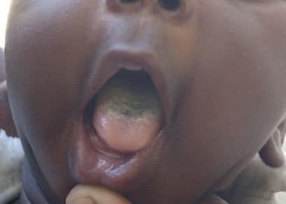
Initial presentation to the hospital

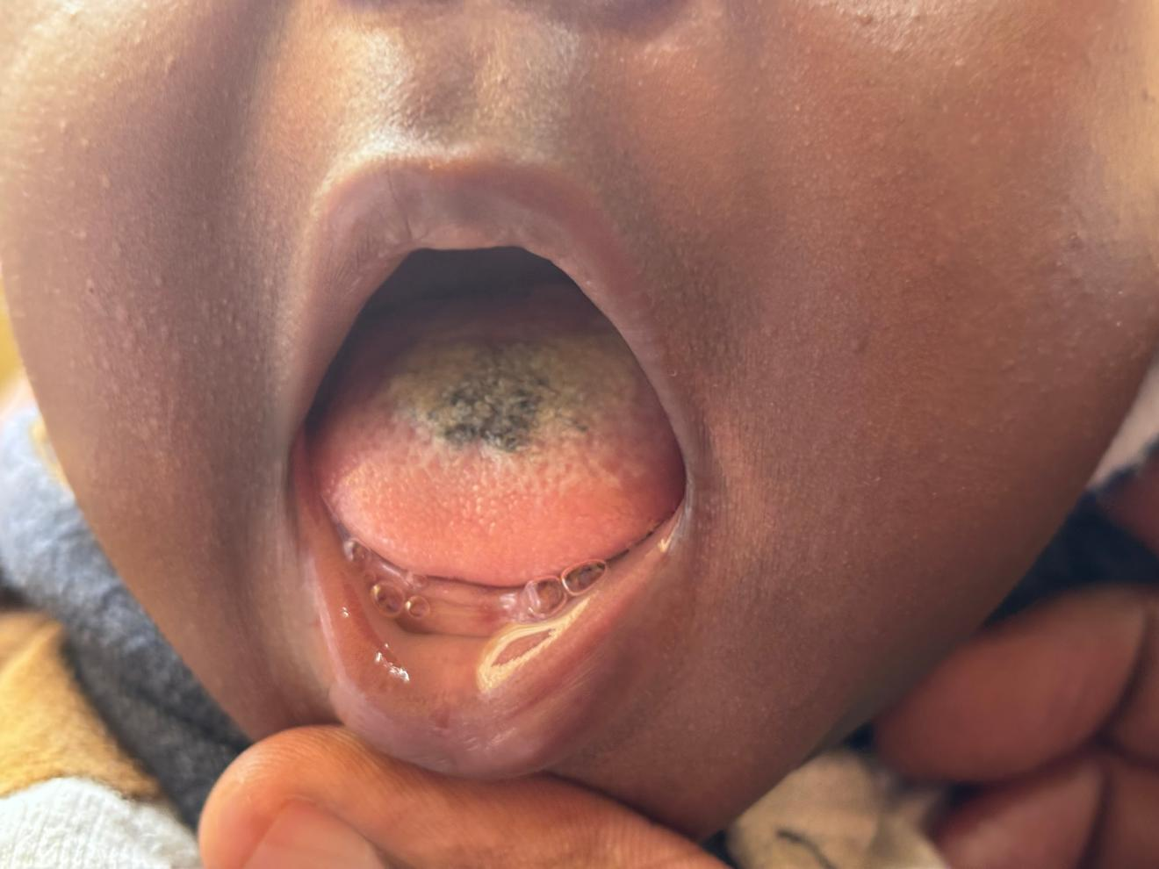
Three weeks after initiation of anti fungal treatment, lesions still present, no response to medical treatment.

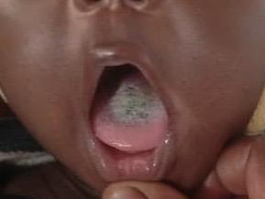
One week after discontinuaton of anti fungal treament and initation of gentle tongue brushing.

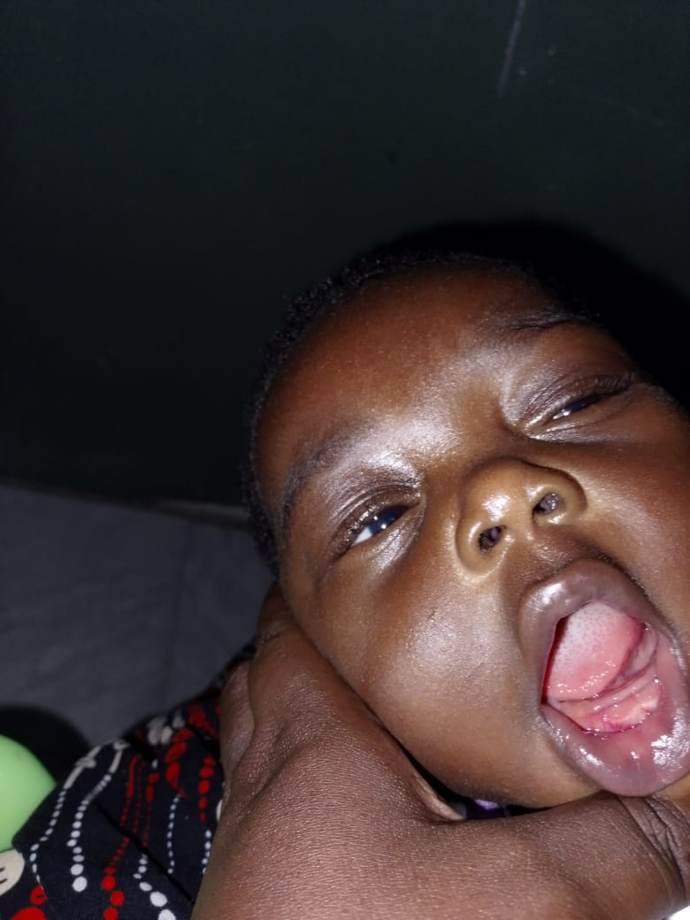
Two months post-conservative management, lesions resolved.

DISCUSSION
LVN is rare in infants but associated with antibiotic use disrupting oral microbiota. It must be remembered that antifungal treatment should not be the first option for treating this disorder. Although Candida may sometimes be identified in the swab taken from lingua villosa nigra, however, it is not a primary fungal infection, and will therefore not respond to antifungal treatment (Owczarek-Drabińska, J. E., & Radwan-Oczko, M, 2020), as was the case in this 3 month old infant. Management is conservative involving oral hygiene measures which are effective and constitute the gold-standard of care. The prognosis is excellent with spontaneous resolution expected.

PATIENT PERSPECTIVE
The mother expressed relief following clarification of the diagnosis and reassurance regarding the benign nature of the condition.

INFORMED CONSENT
Informed consent was obtained from the caregiver for publication of this case report in accordance with the Helsinki declaration.
CONCLUSION
This case underscores the importance of recognising lingua illosa nigra in infancy and adhering to gold standard conservatie management. Increased clinician awareness can prevent misdiagnosis and inappropriate treatment.
LEARNING POINTS
- Lingua villosa nigra, though rare, can occur in infants.
- Antibiotic exposure is a key predisposing factor.
- Clinical diagnosis is sufficient in typical cases.
- Conservative oral hygiene is the gold-standard treatment.

REFERENCES
Gurvits, G. E., & Tan, A. (2014). Black hairy tongue syndrome. World journal of gastroenterology, 20(31), 10845–10850. https://doi.org/10.3748/wjg.v20.i31.10845
Owczarek-Drabińska, J. E., & Radwan-Oczko, M. (2020). A Case of Lingua Villosa Nigra (Black Hairy Tongue) in a 3-Month-Old Infant. The American journal of case reports, 21, e926362. https://doi.org/10.12659/AJCR.92636

