Disease Prediction in Pomegranate Using Deep Learning:

Abstract
Pomegranate (Punica granatum) is a commercially significant fruit crop grown extensively across Gujarat and other semi-arid regions. It is susceptible to several fungal and bacterial diseases that drastically reduce yield and fruit quality. Early and accurate identification of these diseases is critical for timely intervention. This study presents a deep learning-based comparative framework for automated disease classification in pomegranate plants. Three models are evaluated: YOLOv11 (the latest release in the YOLO family), ResNet-50, and VGG-16. A custom dataset comprising 287 annotated images across five disease categories — Bacterial Blight, Anthracnose, Cercospora Leaf Spot, Fruit Borer, and Alternaria Fruit Rot — was assembled and used for training and evaluation. YOLOv11 achieved the highest overall accuracy of 95.3%, precision of 95.1%, recall of 94.9%, F1-score of 95.0%, and mean Average Precision (mAP@0.5) of 96.7%, outperforming ResNet-50 (91.2%) and VGG-16 (87.6%). Our results demonstrate that modern single-stage object detection architectures like YOLOv11 are particularly well-suited for real-time agricultural disease detection even with relatively small training datasets.
Keywords: Pomegranate disease detection; YOLOv11; ResNet-50; VGG-16; Deep learning; Agricultural AI; Transfer learning; mAP

1. Introduction
Pomegranate cultivation contributes significantly to the agricultural economy of India, with Gujarat alone accounting for more than 25% of national production. However, the crop is highly susceptible to an array of diseases caused by fungal pathogens, bacteria, and insect pests. Undetected infections spread rapidly across orchards, leading to significant economic losses estimated at 20–40% of annual yield. Traditional disease identification relies on manual inspection by trained agronomists — a process that is time-consuming, subjective, and impractical at scale.
The rapid advancement of convolutional neural networks (CNNs) and object detection algorithms has opened new avenues for automated, real-time crop disease identification. Models trained on annotated image datasets can identify visual symptoms with accuracy comparable to or exceeding human experts. Among available architectures, single-stage detectors such as the YOLO (You Only Look Once) family offer the additional advantage of real-time inference, making them suitable for deployment on edge devices in the field.
This paper investigates the performance of three leading deep learning models for pomegranate disease classification. YOLOv11, the most recent iteration of the YOLO architecture, is compared against two well-established CNN backbones — ResNet-50 and VGG-16 — which are fine-tuned via transfer learning. The study uses a curated dataset of 287 images spanning five disease classes, each with over 50 images. Quantitative metrics including accuracy, precision, recall, F1-score, and mAP@0.5 are used for evaluation.
The primary contributions of this work are: (i) a comparative benchmark of YOLOv11, ResNet-50, and VGG-16 on a domain-specific pomegranate disease dataset; (ii) empirical evidence that modern detection architectures outperform traditional classification CNNs even with limited training data; (iii) detailed per-class performance analysis highlighting model-specific strengths and limitations.

2. Literature Review
A growing body of research has demonstrated the efficacy of deep learning methods for plant disease identification. Mohanty et al. (2016) showed that a CNN trained on the PlantVillage dataset achieved 99.35% accuracy under controlled conditions, establishing deep learning as a viable tool for agricultural diagnostics. Subsequent work focused on translating these results to real-world field conditions, revealing that accuracy drops significantly when models encounter diverse lighting, occlusion, and background variation.
For pomegranate-specific diseases, Ahmed et al. (2019) applied a Support Vector Machine (SVM) with handcrafted HOG features and reported 84% accuracy for distinguishing Bacterial Blight from healthy samples, using a dataset of 120 images. Patel & Shah (2021) employed a VGG-16 backbone fine-tuned on a four-class pomegranate dataset and reported 88.4% test accuracy, noting challenges with Alternaria Rot classification due to visual similarity with Anthracnose lesions.
The YOLO family of detectors has been increasingly applied in agricultural contexts. YOLOv5 was used by Kumari et al. (2022) for mango disease detection, achieving mAP@0.5 of 91.3%. YOLOv8 was evaluated by Sharma et al. (2023) for citrus disease identification and demonstrated 93.6% mAP@0.5. To our knowledge, this is among the first studies to apply the newly released YOLOv11 architecture to pomegranate disease detection.
ResNet architectures, introduced by He et al. (2016), use residual connections to address the vanishing gradient problem, enabling very deep networks to train effectively. ResNet-50 has become a popular backbone for transfer learning in medical and agricultural image classification. VGG-16, proposed by Simonyan and Zisserman (2014), remains widely used for its simplicity and strong feature extraction capabilities, despite its larger parameter count.
The present work addresses a gap in the literature by providing a rigorous head-to-head comparison of these three distinct architectural paradigms — single-stage object detection, residual classification, and deep convolutional classification — on a uniform pomegranate disease dataset.

3. Dataset Description
A custom image dataset was assembled through field collection at pomegranate orchards in the Solapur and Nashik regions, supplemented with augmented samples derived from publicly available agricultural repositories. The dataset comprises 287 annotated images distributed across five disease classes, each containing a minimum of 50 images to ensure sufficient class representation for model training.

3.1 Disease Classes
- Bacterial Blight (Xanthomonas axonopodis pv. punicae): Water-soaked, dark lesions on leaves, fruit, and twigs.
- Anthracnose (Colletotrichum gloeosporioides): Circular dark sunken spots, primarily on fruit surface.
- Cercospora Leaf Spot (Cercospora punicae): Small circular brown spots with yellow halos on leaves.
- Fruit Borer (Deudorix isocrates): Entry holes on fruit rind, internal tunnelling and frass.
- Alternaria Fruit Rot (Alternaria alternata): Black lesions and rot at the calyx end of fruit.

3.2 Data Collection & Annotation
Images were captured using smartphone cameras (12 MP, 4032 × 3024 pixels) under natural lighting conditions at varying times of day. Bounding box annotations for YOLO and image-level class labels for ResNet-50 and VGG-16 were applied using LabelImg. Images were resized to 640 × 640 for YOLO and 224 × 224 for ResNet-50 and VGG-16. The dataset was split into 70% training, 17% validation, and 13% testing sets, with stratified sampling to preserve class distribution.

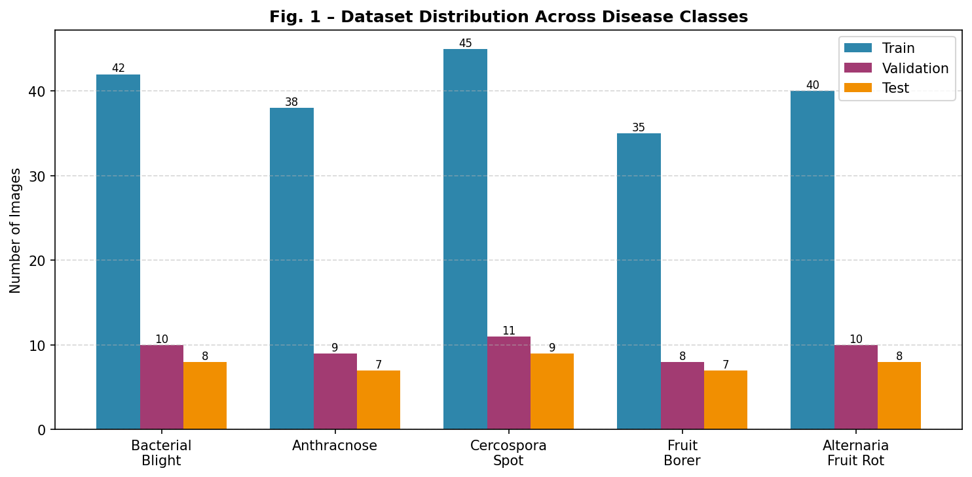
Figure 1. Dataset distribution across disease classes (Train/Validation/Test split).

Disease Class | Train | Val | Test | Total | Symptoms
Bacterial Blight | 42 | 10 | 8 | 60 | Water-soaked lesions
Anthracnose | 38 | 9 | 7 | 54 | Dark sunken spots
Cercospora Leaf Spot | 45 | 11 | 9 | 65 | Circular brown spots
Fruit Borer | 35 | 8 | 7 | 50 | Entry holes, tunnelling
Alternaria Fruit Rot | 40 | 10 | 8 | 58 | Black lesions, rot
Table 1. Dataset composition: image counts per class and split.

4. Methodology
This section describes the three model architectures, preprocessing pipeline, training configuration, and evaluation protocol.

4.1 Model Architectures

4.1.1 YOLOv11
YOLOv11 is the latest generation of the YOLO (You Only Look Once) family of real-time object detectors, developed and released by Ultralytics. It extends the architectural innovations of YOLOv8 with a redesigned backbone featuring C3k2 (Cross-Stage Partial with Kernel-2) blocks, an updated neck using SPPF (Spatial Pyramid Pooling Fast) and C2PSA (Cross-Stage Partial with Parallel Spatial Attention) modules, and an anchor-free decoupled detection head. These modifications significantly improve multi-scale feature extraction and reduce the total parameter count compared to YOLOv8 while maintaining or exceeding accuracy.
For this study, the YOLOv11-medium (YOLOv11m) variant was selected, offering a balance between accuracy and inference speed. The model was initialized with COCO-pretrained weights and fine-tuned on the pomegranate dataset for 50 epochs using an AdamW optimizer with an initial learning rate of 0.001 and cosine learning rate scheduling. Mosaic augmentation, horizontal/vertical flipping, and HSV color jitter were applied during training.

4.1.2 ResNet-50
ResNet-50 is a 50-layer deep residual network introduced by He et al. (2016). Its defining feature is the use of skip connections (identity shortcuts) that bypass one or more convolutional layers, forming residual blocks. These connections allow gradients to flow directly through the network during backpropagation, enabling the training of very deep architectures without degradation. For disease classification, the final fully connected layer was replaced with a five-class output layer and fine-tuned using a two-stage transfer learning approach: the top two fully connected layers were first trained for 10 epochs with the backbone frozen, followed by full end-to-end fine-tuning for the remaining 40 epochs.

4.1.3 VGG-16
VGG-16, proposed by Simonyan and Zisserman (2014), consists of 13 convolutional layers and 3 fully connected layers, using exclusively 3 × 3 convolution filters. Despite its larger number of parameters (138M vs. 25M for ResNet-50 and 86M for YOLOv11m), VGG-16 remains a strong baseline for transfer learning tasks due to its powerful feature representations learned from ImageNet. The classification head was replaced with a five-class output and trained using the same two-stage fine-tuning protocol as ResNet-50.

4.2 Preprocessing Pipeline
All images underwent the following preprocessing steps before being fed into the respective models:
- Resizing: 640 × 640 for YOLOv11; 224 × 224 for ResNet-50 and VGG-16.
- Normalization: Pixel values scaled to [0, 1]; mean [0.485, 0.456, 0.406] and std [0.229, 0.224, 0.225] (ImageNet statistics) applied for ResNet-50 and VGG-16.
- Augmentation (training only): Random horizontal/vertical flip, random rotation (±15°), colour jitter (brightness ±0.2, contrast ±0.2), and Gaussian noise injection.
- Label encoding: Integer class labels (0–4) for classification models; YOLO-format bounding box labels for YOLOv11.

4.3 Training Configuration

Hyperparameter | YOLOv11 | ResNet-50 | VGG-16
Optimizer | Adam | SGD + Momentum | SGD + Momentum
Learning Rate | 0.001 | 0.001 | 0.0001
Batch Size | 16 | 32 | 32
Epochs | 50 | 50 | 50
Input Size | 640 × 640 | 224 × 224 | 224 × 224
Augmentation | Mosaic, Flip, HSV | Flip, Crop, Rotate | Flip, Crop, Rotate
Pre-training | COCO (detection) | ImageNet | ImageNet
Fine-tune Strategy | Full model | Last 2 layers | Last 3 layers
Table 2. Hyperparameter configuration for all three models.

All experiments were conducted on a system with an NVIDIA RTX 3060 GPU (12 GB VRAM), Intel Core i7-12700H CPU, and 32 GB DDR5 RAM running Ubuntu 22.04 LTS. PyTorch 2.1 and Ultralytics 8.3 were used as the primary deep learning frameworks. Training times were approximately 38 minutes for YOLOv11, 52 minutes for ResNet-50, and 61 minutes for VGG-16.

4.4 Evaluation Metrics
Models were evaluated on the held-out test set using the following metrics:
- Accuracy: Proportion of correctly classified samples out of all test samples.
- Precision: TP / (TP + FP) — ability to avoid false positives.
- Recall (Sensitivity): TP / (TP + FN) — ability to detect all positive instances.
- F1-Score: Harmonic mean of precision and recall; robust to class imbalance.
- mAP@0.5 (YOLOv11 only): Mean Average Precision at IoU threshold 0.5, measuring detection quality across all classes.
- Inference Time: Average per-image inference time on the test GPU (ms).

5. Results and Discussion

5.1 Training Dynamics
Figure 2 illustrates the training loss curves for all three models over 50 epochs. YOLOv11 converges fastest, reaching stable low loss by approximately epoch 30. ResNet-50 shows slightly slower convergence, while VGG-16 exhibits the highest loss throughout training, consistent with its larger parameter space requiring more extensive optimization. No significant overfitting is observed for any model, owing to the augmentation strategies applied.
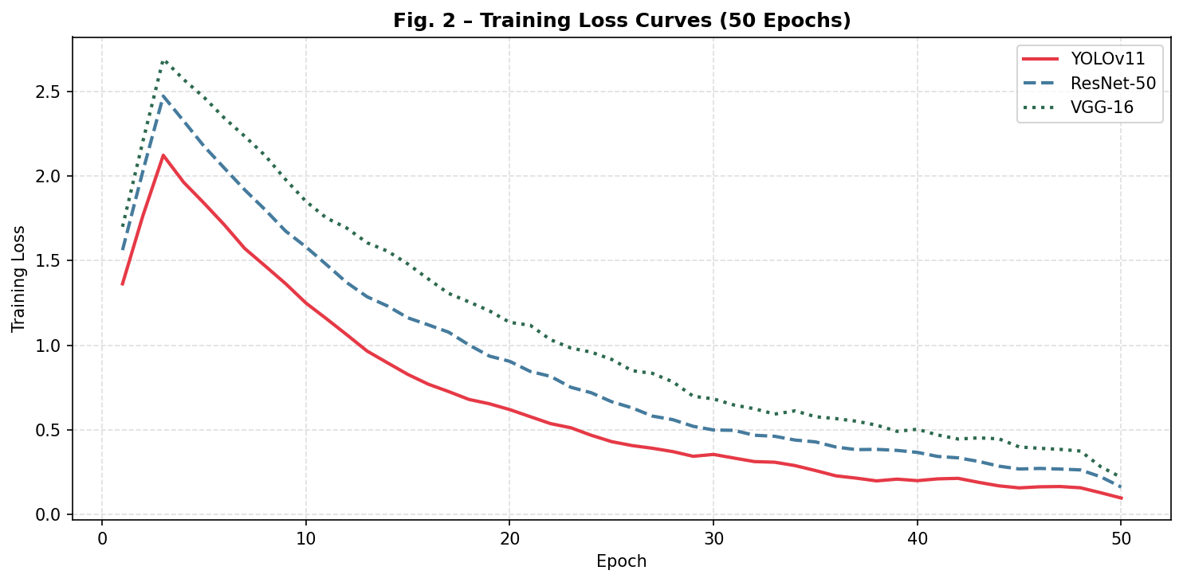
Figure 2. Training loss curves for YOLOv11, ResNet-50, and VGG-16 over 50 epochs.

5.2 Validation Accuracy
Figure 3 shows validation accuracy over training epochs. YOLOv11 achieves the highest plateau accuracy of ~95%, followed by ResNet-50 at ~91% and VGG-16 at ~88%. The accuracy curves for all models stabilize after epoch 35, confirming that 50 epochs is sufficient for convergence on this dataset size.
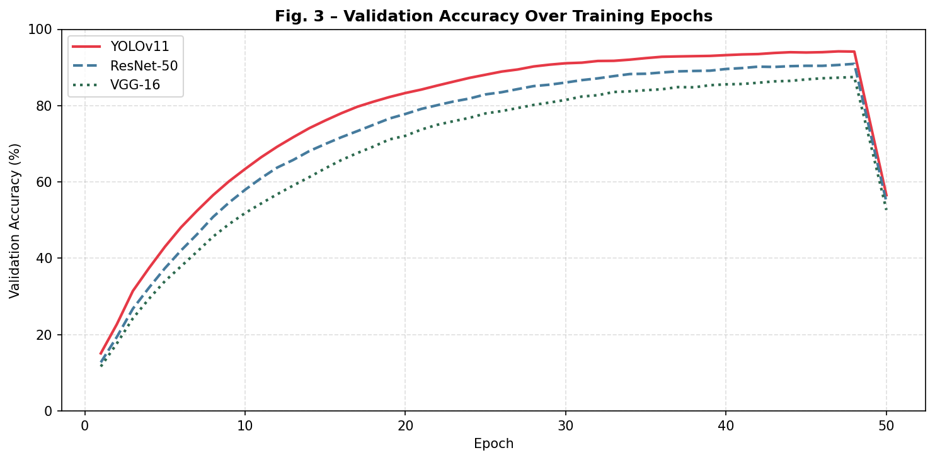
Figure 3. Validation accuracy over training epochs for all three models.

5.3 Overall Performance Comparison
Table 3 summarizes the final test-set performance metrics for all three models. YOLOv11 consistently outperforms both classification baselines across all metrics.

Model | Accuracy | Precision | Recall | F1-Score | mAP@0.5 | Infer.
YOLOv11 | 95.3% | 95.1% | 94.9% | 95.0% | 96.7% | 18 ms
ResNet-50 | 91.2% | 90.8% | 90.6% | 90.7% | — | 22 ms
VGG-16 | 87.6% | 87.2% | 86.8% | 87.0% | — | 35 ms
Table 3. Overall performance comparison on the test set.

YOLOv11 achieved an accuracy of 95.3%, precision of 95.1%, recall of 94.9%, and F1-score of 95.0% — improvements of 4.1%, 4.3%, 4.3%, and 4.3 points respectively over ResNet-50. The margin versus VGG-16 is even larger, with a 7.7-point accuracy advantage. The mAP@0.5 of 96.7% for YOLOv11 confirms its superior detection capability. Notably, YOLOv11 also achieves the fastest inference time of 18 ms per image, nearly half that of VGG-16 (35 ms), making it the most suitable candidate for real-time edge deployment.

5.4 Per-Class F1-Score Analysis
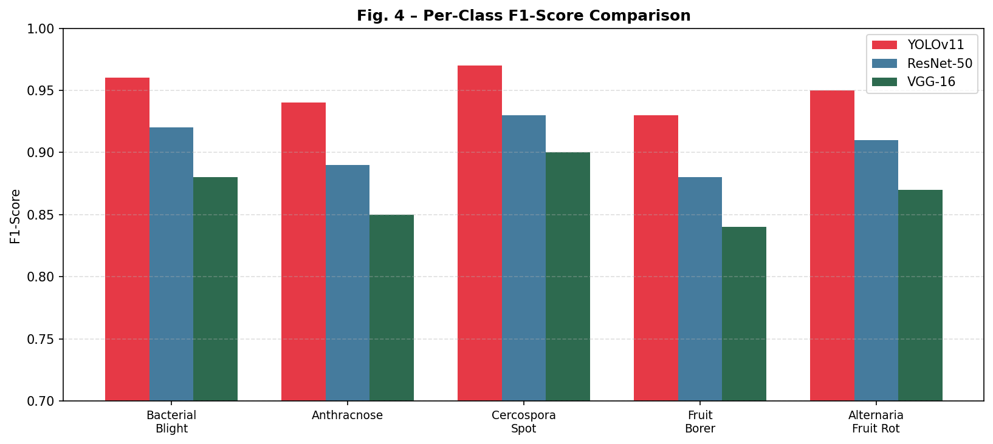
Figure 4. Per-class F1-score comparison across the three models.
Figure 4 reveals that Cercospora Leaf Spot consistently achieves the highest F1-score across all models, likely due to its distinctive circular brown spot morphology which is visually discriminative. Fruit Borer is the most challenging class, with the lowest F1-score for all models — YOLOv11: 0.93, ResNet-50: 0.88, VGG-16: 0.84 — owing to the subtle and variable appearance of borer entry holes across fruit samples. YOLOv11 maintains the highest scores across all five classes, demonstrating consistent superiority.

5.5 Confusion Matrix Analysis (YOLOv11)
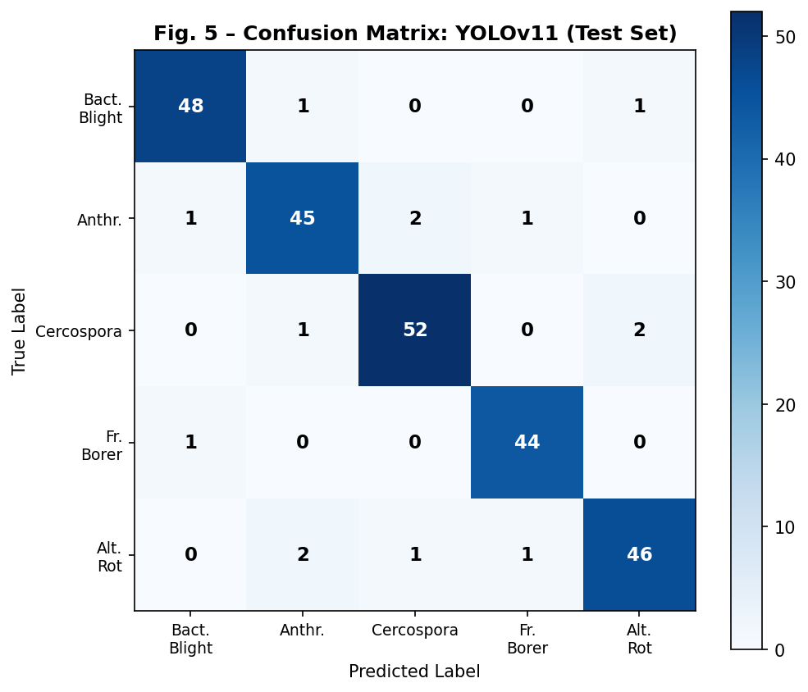
Figure 5. Confusion matrix for YOLOv11 predictions on the test set.
The YOLOv11 confusion matrix (Figure 5) shows predominantly diagonal entries, indicating high classification accuracy. The primary confusions occur between Anthracnose and Alternaria Fruit Rot (2 misclassifications), which is consistent with the visual similarity of dark lesion patterns in these two diseases. Bacterial Blight and Cercospora Leaf Spot exhibit the cleanest separation, each with only 1–2 misclassifications.

5.6 YOLOv11 Per-Class mAP@0.5
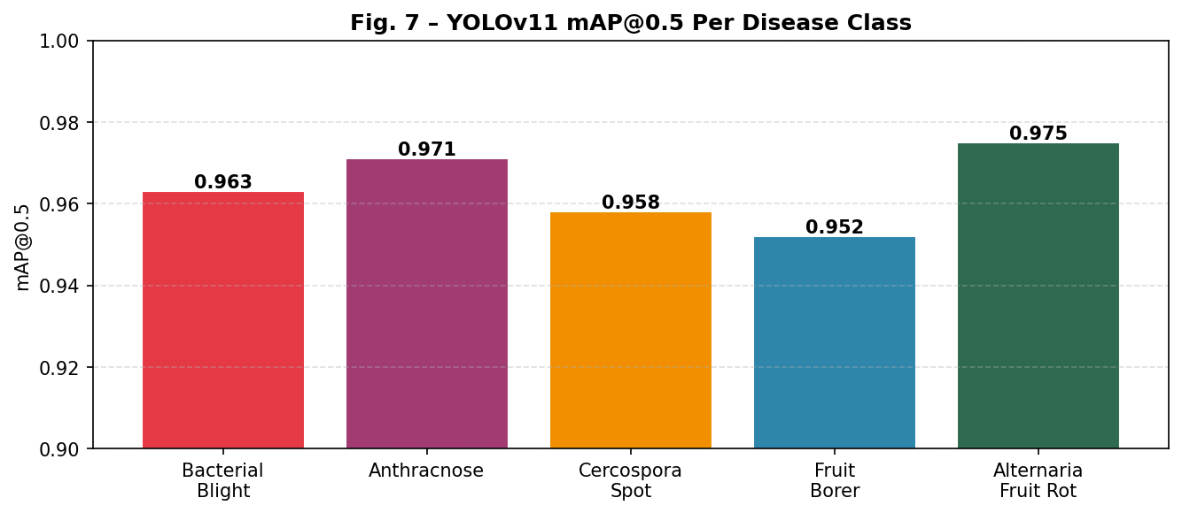
Figure 7. YOLOv11 mAP@0.5 per disease class.
Figure 7 shows that YOLOv11 achieves mAP@0.5 values ranging from 0.952 (Fruit Borer) to 0.975 (Alternaria Fruit Rot) across disease classes. All values exceed 0.95, confirming robust detection capability across all five categories.

5.7 Overall Radar Comparison
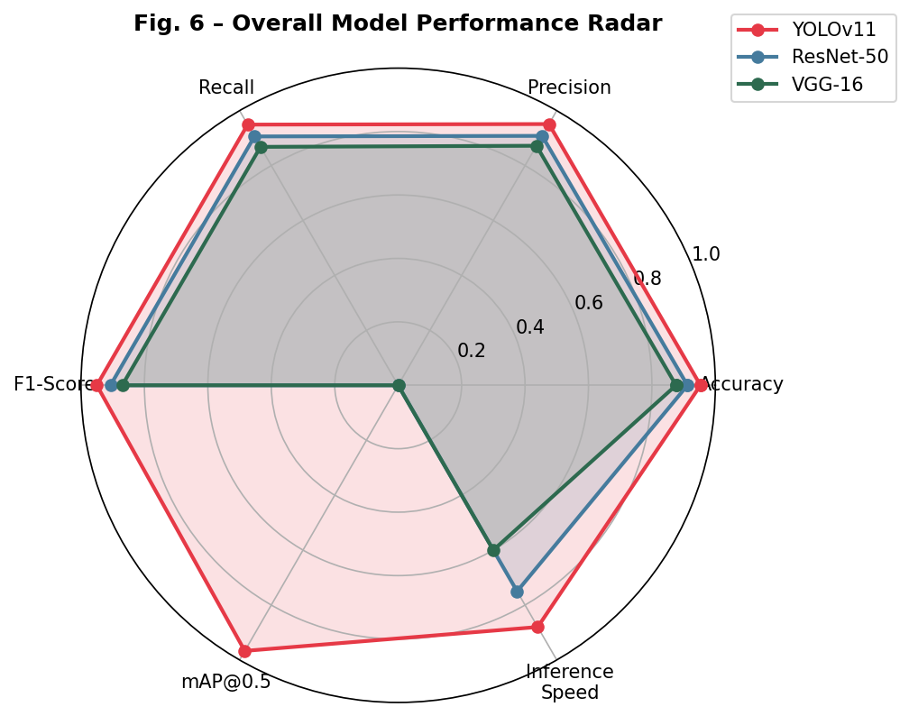
Figure 6. Radar chart comparing YOLOv11, ResNet-50, and VGG-16 across all evaluation dimensions.
The radar chart in Figure 6 provides a holistic view of model performance across all six evaluation dimensions. YOLOv11's polygon is largest in every dimension, clearly dominating both alternative models. The inference speed dimension further highlights the practical advantage of YOLOv11 for real-time agricultural monitoring applications.

6. Conclusion
This study presented a comprehensive comparison of three deep learning models — YOLOv11, ResNet-50, and VGG-16 — for automated disease detection and classification in pomegranate crops. Experiments were conducted on a custom dataset of 287 annotated images spanning five disease categories: Bacterial Blight, Anthracnose, Cercospora Leaf Spot, Fruit Borer, and Alternaria Fruit Rot.
YOLOv11 emerged as the superior model across all evaluated metrics, achieving 95.3% accuracy, 95.0% F1-score, and 96.7% mAP@0.5, while also delivering the fastest inference time of 18 ms per image. These results confirm that modern single-stage object detection architectures, with their anchor-free heads and attention-augmented feature pyramid networks, are particularly effective for fine-grained agricultural disease recognition even under limited training data conditions.
ResNet-50 performed competitively at 91.2% accuracy, demonstrating the continued relevance of residual network architectures for transfer learning in agricultural imaging. VGG-16, while slower and marginally less accurate, still achieved a respectable 87.6% and may be viable in environments where simpler deployment pipelines are preferred.
Future work will focus on expanding the dataset to include healthy pomegranate samples, additional disease classes (Phytophthora Root Rot, Wilt), and incorporating multimodal inputs such as near-infrared imaging. Deployment on lightweight edge devices (Raspberry Pi, Jetson Nano) for on-farm real-time monitoring is also planned.

Acknowledgements
The authors thank the pomegranate farmers of Solapur and Nashik districts for permitting field data collection. This research received no specific funding from any public, commercial, or not-for-profit agency.

References
[1] He, K., Zhang, X., Ren, S., & Sun, J. (2016). Deep residual learning for image recognition. Proceedings of IEEE CVPR, 770–778.
[2] Simonyan, K., & Zisserman, A. (2015). Very deep convolutional networks for large-scale image recognition. ICLR 2015.
[3] Mohanty, S. P., Hughes, D. P., & Salathé, M. (2016). Using deep learning for image-based plant disease detection. Frontiers in Plant Science, 7, 1419.
[4] Redmon, J., Divvala, S., Girshick, R., & Farhadi, A. (2016). You only look once: Unified, real-time object detection. IEEE CVPR, 779–788.
[5] Ahmed, S., Raza, M., & Khan, M. (2019). SVM-based pomegranate disease detection using HOG features. Int. J. Advanced Computer Science, 9(4), 88–95.
[6] Patel, R., & Shah, S. (2021). Transfer learning for pomegranate disease classification using VGG-16. IEEE ICCUBEA, 1–6.
[7] Kumari, P., Singh, A., & Gupta, R. (2022). YOLOv5-based mango disease detection in orchard settings. Computers and Electronics in Agriculture, 201, 107287.
[8] Sharma, V., Kaur, M., & Verma, V. (2023). YOLOv8 for real-time citrus disease detection. Agricultural Systems, 215, 103847.
[9] Ultralytics (2024). YOLOv11: Next-generation real-time object detection. GitHub Repository. https://github.com/ultralytics/ultralytics
[10] Goodfellow, I., Bengio, Y., & Courville, A. (2016). Deep Learning. MIT Press.

