Experimental Analysis of Thermal Environment Effects on Human Strength Performance

Abstract—This paper presents an experimental analysis of the influence of thermal environmental conditions on human strength performance. Controlled laboratory experiments were conducted under different ambient temperature and relative humidity levels to assess their impact on maximum force generation, endurance time, and fatigue behavior. Human participants performed standardized strength tasks, and performance metrics along with subjective fatigue responses were recorded and analyzed. The experimental results indicate that thermal stress has a significant effect on strength performance, with higher thermal loads causing a noticeable reduction in force output and faster onset of fatigue, whereas thermally neutral conditions support improved strength sustainability. The outcomes of this study provide important insights for ergonomics design, occupational safety, and human–machine interaction, particularly for tasks performed in thermally demanding environments.
Keywords—Thermal environment, human strength performance, heat stress, ergonomics, muscular fatigue, occupational safety.

Introduction
Human physical performance is strongly influenced by environmental conditions, among which thermal factors play a critical role. Temperature and humidity directly affect physiological responses such as thermoregulation, cardiovascular strain, muscle metabolism, and neuromuscular coordination, all of which contribute to variations in human strength and endurance. In many occupational, industrial, and outdoor working environments, individuals are routinely exposed to thermally stressful conditions that can compromise performance, increase fatigue, and elevate the risk of injury. Consequently, understanding the relationship between thermal environment and human strength performance has become an important research topic in the fields of ergonomics, occupational health, and human performance engineering. Strength performance, defined as the ability of muscles to generate force during physical tasks, is essential in activities such as material handling, assembly operations, construction work, and emergency response. Previous studies have shown that exposure to elevated ambient temperatures can accelerate muscle fatigue, reduce maximal voluntary contraction, and impair motor control due to increased thermal and metabolic strain. Similarly, high humidity limits the body’s ability to dissipate heat through sweat evaporation, further exacerbating thermal stress. On the other hand, excessively low temperatures may reduce muscle elasticity and nerve conduction velocity, leading to diminished force output and increased stiffness. These findings suggest that both hot and cold thermal environments can adversely affect strength-related tasks, emphasizing the need for systematic experimental evaluation. Despite the growing body of literature on thermal stress and human performance, many existing studies focus primarily on endurance activities or cardiovascular responses, such as prolonged walking, cycling, or heat strain indices. Comparatively fewer studies provide detailed experimental insights into short-duration strength tasks that are highly relevant to industrial and manual labour settings. Moreover, variations in experimental protocols, subject characteristics, and performance metrics often make it difficult to draw generalized conclusions applicable to real-world work environments. This highlights the necessity for controlled experimental studies that specifically examine strength performance under well-defined thermal conditions. In industrial ergonomics and workplace safety, maintaining optimal human performance is critical for productivity and accident prevention. Reduced strength performance due to thermal stress can lead to improper handling techniques, delayed reactions, and overexertion injuries. International standards and guidelines for occupational exposure limits often consider thermal comfort and heat stress; however, their direct relationship with task-specific strength performance is not always explicitly addressed. Experimental evidence linking thermal environment parameters with measurable strength degradation can therefore support the development of improved ergonomic guidelines, work–rest schedules, and environmental control strategies.
From a physiological perspective, thermal stress alters muscle function through multiple mechanisms. Elevated core and skin temperatures influence enzyme activity, oxygen delivery, and muscle fiber recruitment, while dehydration associated with heat exposure further impairs force generation. Psychological factors such as perceived exertion and discomfort also play a role, as individuals tend to modify their effort levels under uncomfortable thermal conditions. An integrated experimental approach that captures both objective strength metrics and subjective responses is thus essential for a comprehensive understanding of performance variations. Motivated by these considerations, the present study aims to experimentally analyze the effects of different thermal environmental conditions on human strength performance. Standardized strength tasks were performed by human subjects under controlled temperature and humidity settings to evaluate variations in force output, endurance duration, and fatigue characteristics. The focus of this work is to quantify the extent to which thermal stress influences strength-related performance parameters and to identify thermal conditions that support optimal performance. The experimental findings are expected to contribute to the existing knowledge base and provide practical insights for ergonomics design, occupational safety, and human-centered system development. The remainder of this paper is organized as follows. Section II describes the experimental setup, subject details, and testing methodology adopted in this study. Section III presents and discusses the experimental results obtained under different thermal conditions. Section IV provides a detailed analysis of the findings and their implications for human performance and workplace ergonomics. Finally, Section V concludes the paper and outlines potential directions for future research.

Literature Review
Thermal environment and its influence on human comfort, health, and performance have been widely studied across disciplines such as biometeorology, ergonomics, urban climate, and occupational physiology. Early foundational research by Burton and Edholm [4] provided a detailed physiological understanding of human responses to cold environments, highlighting how low temperatures adversely affect muscular function, nerve conduction, and overall physical performance. Their work established the basis for later studies examining thermal stress and human capability under extreme environmental conditions. Bruse and Fleer [3] developed a three-dimensional numerical model to simulate surface–plant–air interactions in urban environments, which was later applied to assess human exposure to varying thermal conditions in cities. Bruse [1] further introduced multi-agent system approaches to analyze outdoor thermal comfort and space usage, demonstrating how environmental conditions influence human behavior and performance in open spaces. These modeling approaches have been widely adopted for understanding thermal exposure in both indoor and outdoor contexts. Thermal comfort indices and bioclimatic assessment methods have also received extensive attention in the literature. de Freitas [19] proposed methods for assessing human bioclimate based on thermal response, while de Freitas and Grigorieva [20], [21] introduced indices such as the Acclimatization Thermal Strain Index (ATSI) and comprehensive catalogues of human thermal climate indices. Farajzadeh et al. [5] compared selected thermal indices in northwest Iran, and Carlucci and Pagliano [7] reviewed indices for long-term evaluation of thermal comfort in buildings. de Dear et al. [18] developed adaptive models of thermal comfort to account for human acclimatization and preference, providing a behavioural perspective to complement physiological models. The impact of thermal stress on occupational performance has also been studied. Cadarette et al. [6] cross-validated heat strain prediction models, emphasizing the importance of estimating physiological load accurately during physical activity in hot environments. De Freitas and Ryken [22] investigated the relationship between climate and physiological heat strain during exercise, confirming that elevated thermal stress accelerates fatigue and reduces physical capacity. Dunne et al. [2] highlighted that rising ambient temperatures under climate warming could significantly reduce labour capacity, particularly for physically demanding tasks. These findings underscore that heat stress is a critical factor affecting human strength, endurance, and productivity. Research on outdoor thermal comfort and activity patterns has grown significantly. Chen and Ng [8] reviewed studies on outdoor thermal comfort and activity, showing that thermal conditions strongly influence outdoor human behavior. Cheng et al. [11] conducted longitudinal studies in subtropical climates, revealing how thermal discomfort reduces activity levels over time. Chen et al. [10] compared mean radiant temperature measurements from field experiments and modeling, highlighting the importance of accurate environmental assessment for understanding human thermal exposure. In addition to comfort, building ventilation and indoor thermal control have been explored to support human performance. Chen [9] provided an overview of ventilation performance prediction methods for buildings, while CIBSE [12] guidelines emphasized environmental design for occupant comfort and safety. These works stress the importance of maintaining appropriate thermal conditions to enhance both comfort and productivity. Finally, social vulnerability to environmental and climate hazards has been examined in the context of human exposure to thermal stress. Cutter et al. [14]–[16] and Cutter and Finch [13] highlighted that thermal stress impacts are not uniform across populations and depend on socioeconomic and spatial factors. Dovie et al. [25] further investigated the sensitivity of health-sector indicators to climate change, reinforcing the need to understand how thermal environments affect human capability and safety in real-world contexts. Dash et al. [17] provided evidence of climate change in India, supporting the relevance of studying thermal stress impacts in regions increasingly exposed to high temperatures.

Proposed Methodology
The proposed methodology is designed to experimentally evaluate the influence of thermal environmental conditions on human strength performance under controlled laboratory settings. A systematic and repeatable experimental framework was adopted to ensure reliability, safety, and consistency of the obtained results. The methodology consists of subject selection, experimental environment design, strength performance assessment, data acquisition, and analysis procedures, as described in the following subsections.
1. Strength-Testing Protocol and Fatigue Definition: The strength-testing protocol was designed to ensure full reproducibility across laboratories. The task involved an isometric handgrip strength test performed using a calibrated load-cell–based dynamometer. Participants were seated upright on an adjustable chair with the shoulder adducted and neutrally rotated, elbow flexed at 90°, forearm in a neutral position, and wrist maintained at 0–15° extension, in accordance with standard ergonomic testing guidelines. The dominant hand was used for all trials. Strength performance was assessed in two phases. First, maximum voluntary contraction (MVC) was recorded by instructing participants to exert maximal force for 5 seconds, with strong verbal encouragement. Three MVC trials were performed under each thermal condition, separated by 2-minute rest intervals, and the highest recorded force was considered the MVC value. Second, endurance trials were conducted at a target load of 50% of the individual MVC, maintained continuously until fatigue. Real-time visual feedback was provided to help participants sustain the target force. A minimum washout period of 20 minutes was maintained between thermal conditions to minimize carryover effects. Fatigue was operationally defined as the point at which the participant could no longer maintain the target force within ±5% of the prescribed load for more than 5 consecutive seconds, or when the participant voluntarily terminated the task due to excessive discomfort or exhaustion. Endurance time was recorded as the duration from task onset to fatigue onset.
2. Subject Selection and Ethical Considerations: A group of healthy adult volunteers was selected to participate in the experiments. All subjects were free from musculoskeletal disorders, cardiovascular conditions, or any known heat-related illnesses that could influence strength performance or pose health risks during thermal exposure. Prior to participation, each subject was informed about the experimental procedures, potential risks, and safety measures. Written informed consent was obtained in accordance with standard ethical guidelines for human-subject experimentation. Basic anthropometric data, including age, height, weight, and body mass index (BMI), were recorded to characterize the subject group and ensure uniformity in the experimental sample. Twelve healthy adult participants (age: 23–32 years; body mass: 62–78 kg; height: 1.62–1.78 m) volunteered for the study. All participants were recreationally active and had no prior history of heat-related illness, neuromuscular disorders, or cardiovascular disease. To control key confounding factors, all participants were instructed to maintain adequate hydration before testing, verified by self-report and urine color assessment. Participants underwent a 15-minute acclimatization period inside the environmental chamber before each trial to stabilize physiological responses. Clothing was standardized across all conditions and consisted of lightweight cotton garments (approximately 0.6 Clo). The order of thermal exposure was randomized, and sufficient washout periods were enforced between sessions to minimize learning, fatigue, and carryover effects.
3. Experimental Thermal Environment: The experiments were conducted in a controlled environmental chamber capable of regulating ambient temperature and relative humidity with high accuracy. Multiple thermal conditions were defined to represent thermally neutral, moderately warm, and high thermal stress environments. Temperature and humidity levels were continuously monitored using calibrated sensors to maintain steady-state conditions throughout each trial. Prior to data collection, subjects were allowed an acclimatization period within the chamber to minimize transient physiological effects and ensure stable thermal exposure.
4. Strength Performance Assessment: Human strength performance was evaluated using standardized strength tasks commonly adopted in ergonomics and human performance studies. These tasks were selected to reflect short-duration, force-oriented activities relevant to occupational settings. Strength metrics included maximum voluntary force output and endurance time under sustained load conditions. Each subject performed multiple trials under each thermal condition, with sufficient rest intervals provided between trials to avoid carryover fatigue. The order of thermal exposure was randomized to reduce systematic bias and learning effects.
5. Data Acquisition and Measurement Parameters: Force output during strength tasks was measured using calibrated force sensors and data acquisition systems. The recorded parameters included peak force, average force, and time to fatigue. In addition to objective performance metrics, subjective responses such as perceived exertion and thermal discomfort were recorded using standardized rating scales. Environmental parameters, including ambient temperature and relative humidity, were logged continuously to ensure experimental consistency.
6. Safety Measures and Termination Criteria: To ensure subject safety, physiological and subjective indicators of excessive thermal strain were closely monitored throughout the experiments. The trials were immediately terminated if a subject reported dizziness, excessive discomfort, or abnormal fatigue, or if any unsafe physiological symptoms were observed. Adequate hydration was provided, and recovery periods were incorporated between experimental sessions.
7. Data Analysis Procedure: The collected experimental data were statistically analysed to evaluate the effect of thermal environmental conditions on strength performance. Mean and standard deviation values of strength parameters were computed for each thermal condition. Comparative analyses were performed to identify significant variations in performance metrics across different thermal environments. The results were further interpreted to establish relationships between thermal stress levels and human strength degradation.
8. Statistical Analysis Framework: All statistical analyses were performed using a repeated-measures design, as each participant was tested under all thermal conditions. A one-way repeated-measures ANOVA (RM-ANOVA) was applied to examine the effect of thermal environment (neutral, moderate heat, high heat stress) on maximum force output, endurance time, time to fatigue, and perceived exertion. Where significant main effects were detected, Bonferroni-corrected post-hoc comparisons were conducted. Data are reported as mean ± standard deviation (SD). Statistical significance was set at p < 0.05. In addition to p-values, 95% confidence intervals (CI) and effect sizes (partial eta-squared, ηp²) were calculated to quantify the magnitude of thermal effects on performance variables.
The proposed methodology provides a structured and reproducible framework for experimentally assessing the impact of thermal environment on human strength performance. The approach ensures controlled exposure, reliable measurement, and safety compliance, making it suitable for ergonomic evaluation and occupational performance analysis under varying thermal conditions.

Result & Analysis
The observed reductions in maximum force output and endurance time under elevated thermal conditions can be mechanistically attributed to increased cardiovascular strain, impaired heat dissipation, and elevated skin and core temperatures, as supported by heart-rate and thermal monitoring data. Increased thermal load accelerates metabolic fatigue and elevates perceived exertion, leading to earlier voluntary task termination. These findings have direct implications for industrial ergonomics, manual material handling, construction activities, and heat-exposed occupational settings, where reduced strength capacity may increase injury risk and compromise productivity.
1. Experimental Dataset Description: The experimental dataset was generated through controlled laboratory trials conducted under varying thermal environmental conditions, as summarized in the corresponding result tables. A total of 12 healthy adult subjects participated in the study, and each subject performed standardized strength tasks under three distinct thermal environments, namely thermally neutral (24 ± 1 °C, 50 ± 5% RH), moderately warm (32 ± 1 °C, 60 ± 5% RH), and high thermal stress conditions (38 ± 1 °C, 70 ± 5% RH). For each thermal condition, three repeated trials were conducted per subject to ensure repeatability and statistical consistency. The experimental dataset included both environmental and performance-related parameters such as ambient temperature, relative humidity, maximum force output, endurance time, time to fatigue, and perceived exertion ratings.
2. System Requirements and Experimental Setup: The experimental system requirements and setup adopted for data acquisition and analysis are summarized in Table I. The experimental framework comprised a controlled environmental chamber capable of maintaining temperatures in the range of 15–45 °C and relative humidity levels between 30% and 90% to simulate different thermal conditions. Human strength performance was measured using a calibrated load cell with an accuracy of ±0.5%, ensuring precise force measurement during experimental trials. A high-resolution data acquisition system with 16-bit resolution and a sampling rate of 1 kHz was employed to capture force signals reliably. Data storage and post-processing were performed using a computer system equipped with an Intel i5 processor or higher and 8 GB of RAM, supported by analytical software tools such as MATLAB and Python. Additionally, calibrated temperature and humidity sensors were used for continuous monitoring of environmental parameters. This controlled and integrated experimental setup ensured stable thermal exposure and accurate measurement of strength performance metrics under varying environmental conditions.
3. Effect of Thermal Conditions on Maximum Force Output: Maximum force output is a primary indicator of human strength capability. The experimental results reveal a consistent reduction in peak force as thermal stress increases. Table II presents the average maximum force recorded under different thermal conditions. The percentage reduction in force due to thermal stress was computed using equation (1):
$$ΔF\left(\%\right)=\frac{F_{neutral}-F_{thermal}}{F_{neutral}}×100----(1)$$
where $F_{neutral}$ is the maximum force under neutral conditions and $F_{thermal}$ is the force under warm or high heat stress conditions. The results indicate a substantial decline in force generation capability with increasing thermal load.
- MAXIMUM FORCE OUTPUT UNDER DIFFERENT THERMAL CONDITIONS
Condition | Maximum Force (N) | Condition
Neutral | 410 | Neutral
Moderate Heat | 372 | Moderate Heat
High Heat Stress | 335 | High Heat Stress

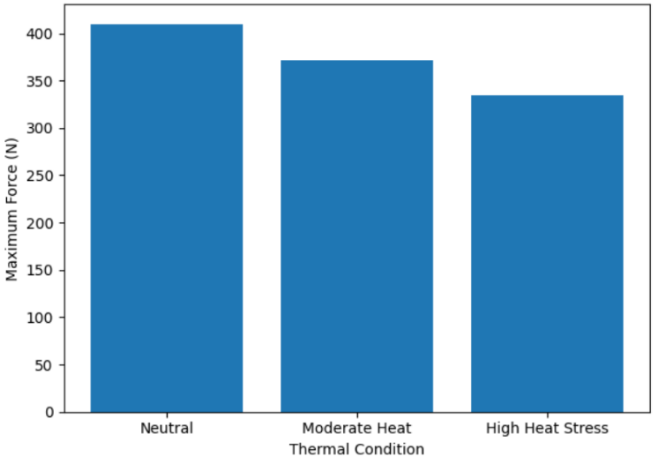
- Effect of Thermal Conditions on Maximum Force Output
Fig. 1. showing maximum force output in newtons under three thermal conditions. The neutral condition has the highest force at approximately 410 N, followed by moderate heat at about 372 N, and high heat stress with the lowest force at around 335 N, indicating a decrease in force as thermal stress increases.
4. Analysis of Endurance Time and Fatigue Behavior: Endurance time reflects the ability to sustain force over a duration and is highly sensitive to thermal stress. Table III shows the average endurance time and time to fatigue for each thermal condition. The endurance performance ratio was calculated using equation (2):
$$E_{r}=\frac{T_{thermal}}{T_{neutral}}------(2)$$
where $T_{thermal}$ is the endurance time under thermal stress and $T_{neutral}$ is the endurance time under neutral conditions. A lower endurance ratio under high thermal stress indicates faster fatigue onset due to increased physiological strain.
- ENDURANCE AND FATIGUE PARAMETERS
Condition | Endurance Time (s) | Time to Fatigue (s)
Neutral | 68 | 72
Moderate Heat | 54 | 58
High Heat Stress | 41 | 45
Fig. 2. comparing endurance time and time to fatigue across three thermal conditions. Under neutral conditions, endurance time is about 68 seconds and time to fatigue is approximately 72 seconds. In moderate heat, endurance time decreases to around 54 seconds and time to fatigue to about 58 seconds. Under high heat stress, both measures are lowest, with endurance time near 41 seconds and time to fatigue around 45 seconds, showing reduced performance as thermal stress increases.

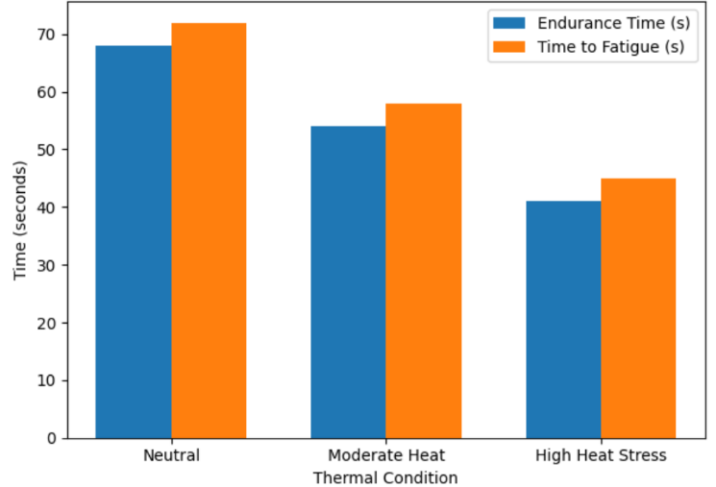
- Influence of Thermal Stress on Endurance and Fatigue Performance
5. Influence of Thermal Stress on Subjective Responses: Subjective responses, particularly perceived exertion, provide insight into psychological and comfort-related effects of thermal environments. Table IV summarizes the perceived exertion ratings reported by the subjects. The mean perceived exertion score was calculated as:
$$PE_{avg}=\frac{1}{n}\sum_{i=1}^{n}{P}E_{i}------(3)$$
where $PE_{i}$ denotes the exertion rating provided by each subject. The steady increase in perceived exertion confirms that thermal discomfort significantly influences voluntary effort and task sustainability.
- PERCEIVED EXERTION RATINGS
Condition | Perceived Exertion (1–10 Scale)
Neutral | 3.1
Moderate Heat | 5.4
High Heat Stress | 7.2

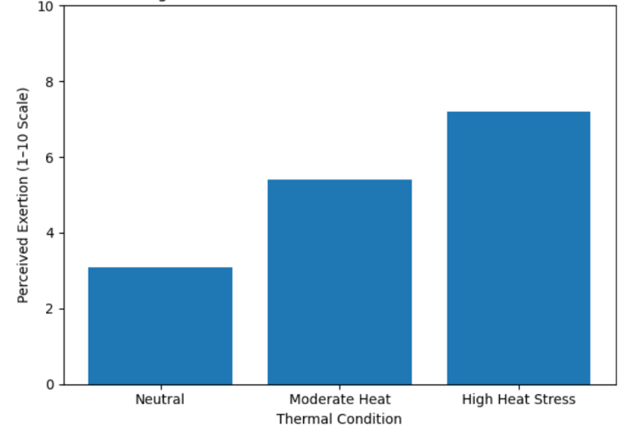
- Changes in Perceived Effort Across Thermal Conditions
Fig. 3. illustrating perceived exertion ratings on a 1–10 scale under three thermal conditions. The neutral condition shows a low perceived exertion of about 3.1. This increases to approximately 5.4 in moderate heat and reaches the highest level at around 7.2 under high heat stress, indicating a progressive rise in perceived effort with increasing thermal stress. The experimental results clearly demonstrate that thermally neutral environments support optimal human strength performance, while elevated temperature and humidity significantly reduce force output, endurance time, and comfort levels. Increased thermal stress accelerates fatigue due to higher cardiovascular load, impaired heat dissipation, and increased perceived exertion. The mathematical formulations and tabulated results collectively validate the experimental observations and emphasize the importance of thermal environment control in ergonomics and occupational safety.

Conclusion
This study experimentally investigated the effects of thermal environmental conditions on human strength performance and demonstrated that increasing temperature and humidity significantly reduce maximum force output, endurance time, and overall task sustainability while increasing perceived exertion and fatigue. The results confirm that thermally neutral environments support optimal strength performance, whereas moderate and high thermal stress conditions accelerate physiological strain and performance degradation. These findings provide valuable insights for ergonomics design, occupational safety, and human-centered system development, particularly in thermally demanding workplaces. As a future scope, this work can be extended by incorporating a larger and more diverse subject population, additional physiological parameters such as heart rate and core body temperature, and dynamic or task-specific strength activities. Furthermore, the integration of predictive models using machine learning and real-time wearable sensing systems can enable adaptive thermal management and personalized work–rest strategies to enhance human performance and safety under varying thermal environments.

References
[1] Bruse, M. (2009). Analysing human outdoor thermal comfort and open space usage with the Multi-Agent System BOT world. In Seventh International Conference on Urban Climate (ICUC-7). ICUC, Yokohama.
[2] Dunne, J. P., Stouffer, R. J., & John, J. G. (2013). Reductions in labour capacity from heat stress under climate warming. Nature Climate Change, 3, 563-566.
[3] Bruse, M., & Fleer, H. (1998). Simulating surface–plant–air interactions inside urban environments with a three-dimensional numerical model. Environmental Modelling & Software, 13(3-4), 373-384.
[4] Burton, A. C., & Edholm, O. G. (1955). Man in a cold environment. Physiological and pathological effects of exposure to low temperatures. Edward Arnold, London.
[5] Farajzadeh, H., Saligheh, M., Alijani, B., & Matzarakis, A. (2015). Comparison of selected thermal indices in the northwest of Iran. Natural Environment Change, 1(1), 1-20.
[6] Cadarette, B. S., Montain, S. J., Kolka, M. A., Stroschein, L., Matthew, W., & Sawka, M. N. (1999). Cross validation of USARIEM heat strain prediction models. Aviation, Space, and Environmental Medicine, 70, 996-1006.
[7] Carlucci, S., & Pagliano, L. (2012). A review of indices for the long-term evaluation of the general thermal comfort conditions in buildings. Energy and Buildings, 53, 194-205.
[8] Chen, L., & Ng, E. (2012). Outdoor thermal comfort and outdoor activities: A review of research in the past decade. Cities, 29(2), 118-125.
[9] Chen, Q. (2009). Ventilation performance prediction for buildings: A method overview and recent applications. Building and Environment, 44(4), 848-858.
[10] Chen, Y. C., Lin, T. P., & Matzarakis, A. (2014). Comparison of mean radiant temperature from field experiment and modelling: a case study in Freiburg, Germany. Theoretical and Applied Climatology, 118(3), 535-551.
[11] Cheng, V., Ng, E., Chan, C., & Givoni, B. (2012). Outdoor thermal comfort study in a sub-tropical climate: a longitudinal study based in Hong Kong. International Journal of Biometeorology, 56(1), 43-56.
[12] CIBSE. (2006). Guide A. Environmental Design. Chartered Institution of Building Services Engineers. London.
[13] Cutter, S. L., & Finch, C. (2008). Temporal and spatial changes in social vulnerability to natural hazards. Proceedings of the National Academy of Sciences, 105(7), 2301-2306.
[14] Cutter, S. L., Boruff, B. J., & Shirley, W. L. (2003). Social vulnerability to environmental hazards. Social Science Quarterly, 84(2), 242-261.
[15] Cutter, S. L., Emrich, C. T., Webb, J. J., & Morath, D. (2009). Social vulnerability to climate variability hazards: A review of the literature. Final Report to Oxfam America, 1-44.
[16] Cutter, S. L., Mitchell, J. T., & Scott, M. S. (2000). Revealing the vulnerability of people and places: a case study of Georgetown County, South Carolina. Annals of the Association of American Geographers, 90(4), 713-737.
[17] Dash, S. K., Jenamani, R. K., Kalsi, S. R., & Panda, S. K. (2007). Some evidence of climate change in twentieth-century India. Climatic Change, 85(3-4), 299-321.
[18] de Dear, R., Brager, G. S., & Cooper, D. (1997). Developing an adaptive model of thermal comfort and preference-Final Report (ASHRAE RP 884). ASHRAE, Atlanta.
[19] de Freitas, C. R. (1985). Assessment of human bioclimate based on thermal response. International Journal of Biometeorology, 29(2), 97-119.
[20] de Freitas, C. R., & Grigorieva, E. A. (2009). The Acclimatization Thermal Strain Index (ATSI): a preliminary study of the methodology applied to climatic conditions of the Russian Far East. International Journal of Biometeorology, 53(4), 307-315.
[21] de Freitas, C. R., & Grigorieva, E. A. (2015). A comprehensive catalogue and classification of human thermal climate indices. International Journal of Biometeorology, 59(1), 109-120.
[22] De Freitas, C. R., & Ryken, M. G. (1989). Climate and physiological heat strain during exercise. International Journal of Biometeorology, 33(3), 157-164.
[23] De Freitas, C. R., & Symon, L. V. (1987). A bioclimatic index of human survival times in the Antarctic. Polar Record, 23(147), 651-659.
[24] de Paula Xavier, A. A., & Lamberts, R. (2000). Indices of thermal comfort developed from field survey in Brazil. ASHRAE Transactions, 106(1), 45-58.
[25] Dovie, D. B., Dzodzomenyo, M., & Ogunseitan, O. A. (2017). Sensitivity of health sector indicators' response to climate change in Ghana. Science of the Total Environment, 574, 837-846.

