Rural Health Unit–Bani Talaan System: A Digital Record

INTRODUCTION

The healthcare sector in the Philippines plays a vital role in ensuring community well-being, particularly in rural areas where access to medical services is often limited. Rural Health Units (RHUs) serve as the primary providers of basic healthcare services and preventive programs at the municipal level. In these settings, effective record management is essential to ensure accurate patient tracking, continuity of care, and compliance with healthcare standards (Dadlani & Yadava, 2023). However, many RHUs across the country continue to rely on manual, paper-based record-keeping systems, which are prone to errors, data loss, delayed retrieval, and security risks (Kumar, 2023; Bautista et al., 2023).
Barangay Health Workers (BHWs) play a critical role in the Philippine healthcare system by serving as frontline providers of community-based health services. Their responsibilities include household profiling, child and maternal health monitoring, health screenings, and submission of reports to the RHU. Despite their importance, BHWs often manage large volumes of records manually, resulting in challenges such as unreadable handwriting, duplicated entries, inconsistent data formats, and time-consuming consolidation of reports (Hartigan-Go et al., 2024). These issues are further exacerbated by inadequate storage facilities and the absence of standardized digital systems in rural healthcare environments.
In response to these challenges, digital health technologies such as electronic health records (EHRs) and community health information systems have been introduced in various healthcare settings. Studies have shown that digital systems can significantly improve data accuracy, accessibility, and security while reducing administrative workload (Manyazewal et al., 2021; Meier-Diedrich et al., 2025). In the Philippines, initiatives such as CHITS and BHW Connect demonstrate the potential of ICT-enabled healthcare solutions; however, their adoption in remote rural areas remains limited due to infrastructure constraints, low digital literacy, and insufficient training (Torres et al., 2020; De Mesa et al., 2024).
The Municipality of Bani, Pangasinan, faces similar challenges in managing health records within its Rural Health Unit. Existing manual procedures often lead to delays in accessing patient information, difficulty in generating accurate reports, and increased risk of data loss. These challenges highlight the need for a localized, user-friendly, and secure digital system that aligns with the specific workflows of BHWs and RHU personnel in a rural setting (Ojo, 2022).
With the increasing availability of internet connectivity and gradual improvements in digital infrastructure in rural communities, the implementation of a web-based health record management system has become more feasible. Digital transformation in rural healthcare settings has been shown to enhance service efficiency, support evidence-based decision-making, and improve overall healthcare delivery when appropriate training and infrastructure support are provided (Antipuesto, 2021; Umar et al., 2024).
In response to these needs, this paper presents the development of the RHU Bani Talaan System, a digital record-keeping and health information management system designed to address the limitations of manual documentation in the Rural Health Unit of Bani, Pangasinan. The system aims to support Barangay Health Workers and RHU staff by providing a centralized platform for managing household profiles, health records, and reports. Through the adoption of digital technology, the RHU Bani Talaan System seeks to improve efficiency, accuracy, and data security, thereby strengthening healthcare service delivery in rural communities.

METHODOLOGY

This study employed a developmental and descriptive research design to design, develop, and evaluate the RHU Bani Talaan System, a digital record-keeping system for Barangay Health Workers (BHWs) and Rural Health Unit (RHU) personnel in Bani, Pangasinan. The developmental approach focused on building a functional information system based on user requirements, while the descriptive approach was used to analyze existing record-keeping practices and assess system acceptability.
The system was developed using the Agile Software Development Methodology, which allows iterative development, continuous user feedback, and flexibility in responding to changing requirements. This approach was particularly suitable for rural healthcare settings, where workflows, technical capacity, and connectivity constraints require adaptive system design.
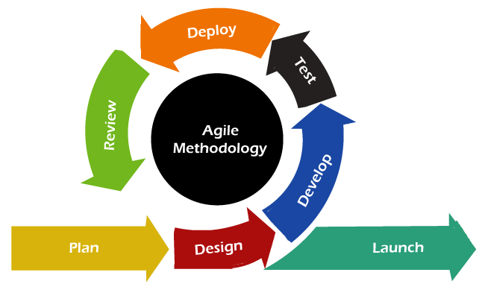
Figure 1: Agile Development Cycle
An Input–Process–Output (IPO) framework guided the overall conduct of the study. The framework defines the resources and requirements used (input), the system development activities undertaken (process), and the expected system output.
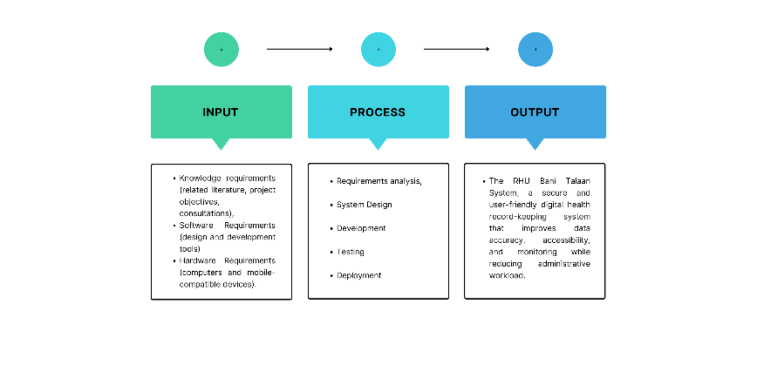
Figure 2. (IPO) Framework of the Study

The study was conducted at the Rural Health Unit of Bani, Pangasinan, which oversees health services across 27 barangays. The respondents were selected using purposive sampling, focusing on individuals directly involved in health record-keeping and system use. The participants included the Municipal Health Officer, Barangay Health Worker Presidents, and BHW representatives from selected barangays. Their participation provided first-hand insights into current record-keeping practices, challenges, and system requirements.

Respondents | Number
Municipal Health Officer | 1
BHW Presidents | 2
BHW Representatives | 20
Total | 23
Table 1: List of the Respondents.

Multiple data collection methods were employed to ensure comprehensive system analysis and evaluation:
- Unstructured Interviews were conducted with BHWs and RHU staff to identify existing workflows, challenges, and user needs.
- Questionnaires were administered to evaluate system acceptability in terms of functionality, usability, efficiency, and reliability.
- Observation was used to document actual record-keeping practices and data flow during routine health activities.
- Document Analysis involved reviewing existing RHU forms such as family profiles, accomplishment reports, and screening records.
- Internet and Literature Review supported system design by identifying best practices in rural health information systems.

RESULTS AND DISCUSSION

This section presents and discusses the results obtained from the implementation and evaluation of the RHU Bani Talaan System. The findings are derived from interviews, observations, documentation analysis, and system usability evaluation conducted among stakeholders of the Rural Health Unit (RHU) of Bani, Pangasinan. The discussion focuses on the existing record-management practices, identified challenges, system features, and the system’s usability based on the ISO/IEC 25010 software quality model.

Existing Record Management Practices
Results from interviews and observations revealed that RHU Bani primarily relies on a manual, paper-based record-keeping system. Barangay Health Workers (BHWs) collect household and individual health data through house-to-house visits across 27 barangays: each subdivided into seven zones. The collected data are written on family profile forms and later consolidated at the RHU.
The process of gathering resident information, where BHWs manually record demographic and health-related details during household visits.

Table 2 Gathering of Resident Information
- Start the process.
- Identify the list of all residents to be visited.
- Visit the house of the current resident.
- Check whether the resident is available.
- If the resident is available, then:
- Conduct an interview with the resident.
- Gather the required information from the resident.
- Record all collected information.
- Verify that the recorded information is correct and complete.
- End of process

After data collection, records are verified and submitted to the Municipal Health Officer for encoding into the Bani Household Profiling system. However, the original paper records are still archived in physical file racks, making retrieval time-consuming and prone to errors.

Table 3 Consolidation of Gathered Resident Data
- Start the process.
- Barangay Health Worker (BHW) gathers resident information.
- Barangay Health Worker Coordinator consolidates all gathered information.
- Submit the consolidated information to the Municipal Health Office (MHO).
- Municipal Health Office checks and verifies the submitted data.
- Municipal Health Office encodes the verified data into the Bani Household Profiling system.
- Compile all completed forms and file them in the Rural Health Unit (RHU) file rack.
- Submit the finalized documents to the Provincial Health Office.
- End the process.

Screening of catchments and child health monitoring are also conducted manually. As shown in Tables 4 and 5, vital signs, growth indicators, and nutritional status are handwritten in monitoring forms, which are later retrieved during follow-up consultations. These practices significantly affect efficiency, accuracy, and continuity of healthcare services.

Table 4 Screening of Catchments
- Start the process.
- Residents arrive at the Rural Health Unit for screening.
- The on-duty Barangay Health Worker conducts the screening.
- The Barangay Health Worker measures and records the resident’s vital signs, including:
- Weight and height
- Body temperature
- Heart rate and pulse rate
- Respiratory rate
- Blood pressure
- Blood oxygen level
- Hip and waist measurements
- Abdominal, head, and limb circumference
- Visual assessment
- Mid-Upper Arm Circumference (MUAC)
- Skin-fold thickness
- After completing all measurements, the Barangay Health Worker refers the resident to the doctor.
- End the process.

Table 5 Consolidation of Gathered Resident Data
- Start the process.
- Parent/resident brings 0–59-month-old child to Health Center
- BHW retrieves and reviews previous records
- BHW updates the child’s monitoring information
- BHW interviews the parent/resident
- BHW measures the child’s weight and height
- BHW computes/assesses the child’s BMI and nutrition status
- Determine if parents are able to visit the Health Center
- If yes, proceed to step 10
- If no, BHW conducts house-to-house visit
- BHW records results in the 0-59 months monitoring form
- End the process.

Challenges in the Existing System
The analysis of the current record-management system identified several challenges affecting RHU operations. Using a fishbone diagram, the study categorized these challenges into security, people, process, technology, environment, and management.
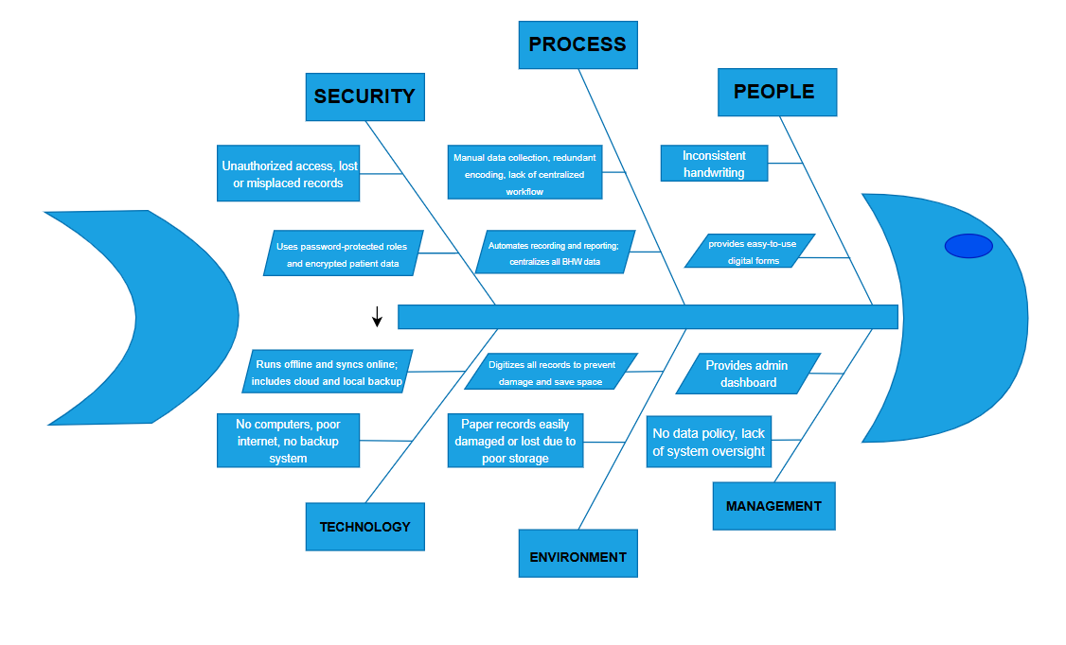
Figure 3 Fishbone Diagram
Security-related issues stem from unsecured physical file storage, exposing sensitive health records to unauthorized access. Human-related challenges include illegible handwriting and inconsistent documentation formats, leading to misinterpretation of data. Process inefficiencies arise from fragmented workflows and delayed consolidation of records. Technological limitations such as lack of computers, internet connectivity, and digital backups prevent real-time updates and increase the risk of data loss. Environmental factors, including humidity and pests, further threaten the integrity of paper records, while management gaps result in inconsistent monitoring and absence of standardized data policies.
These findings highlight the urgent need for a centralized and digital record-management system to improve data security, accuracy, and operational efficiency.

Features of the RHU Bani Talaan System
The RHU Bani Talaan System was developed to address the operational and documentation challenges identified in the existing manual record-keeping process at the Rural Health Unit of Bani. The system is composed of several interconnected functional modules, each designed to support a specific task within RHU operations. These modules work together to ensure accurate data collection, efficient monitoring, and timely reporting of health information.
The Household Profiling module enables BHWs to electronically record and manage household and family information within their assigned barangays. This module allows users to create new household records by entering demographic details such as family members, age, sex, address, and health status. Existing records can be updated as changes occur, ensuring data accuracy over time. The system also allows quick searching and retrieval of household profiles, reducing the time spent locating physical documents.
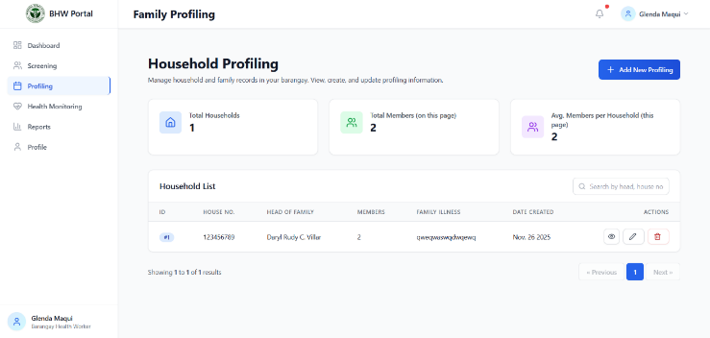
Figure 4 Household Profiling

The Child Health Monitoring module focuses on tracking the health status of children aged 0–59 months. BHWs can record growth indicators such as weight, height, and nutritional status during regular health visits. The module supports longitudinal tracking, allowing users to monitor child development over time and identify potential health risks early. Digital recording eliminates manual errors and ensures that child health data are readily available during follow-up consultations.
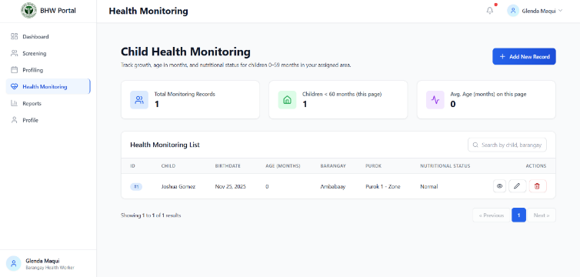
Figure 5 Child Health Monitoring

The Barangay Management module organizes barangay-level data by maintaining records of barangays, puroks, and assigned BHWs. This module allows administrators to manage geographic and organizational information efficiently, ensuring proper assignment of health workers to their respective areas. By structuring data according to barangays and puroks, the system supports organized reporting and simplifies monitoring of health activities across different locations.
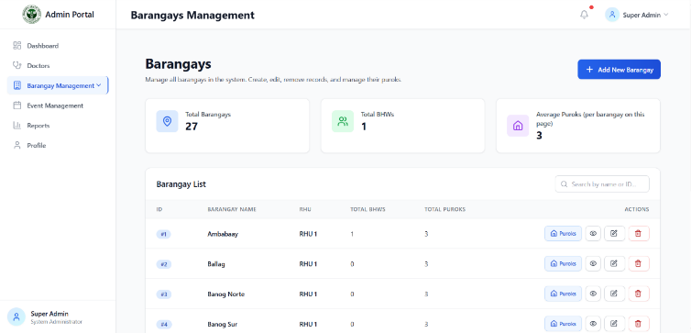

Figure 6 Barangay Management

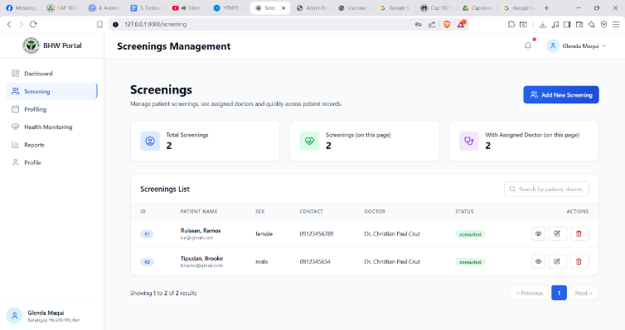
The Screening Management module enables the electronic recording of patient screening information, including vital signs, initial assessments, and assigned medical personnel. BHWs and RHU staff can encode screening results directly into the system during patient visits. The module supports doctor assignment and tracks screening history, ensuring continuity of care. This digital approach minimizes data redundancy and improves the accuracy of screening records.
Figure 7 Screening Management
The Reports and Analytics module generate real-time summaries and statistical reports based on encoded data. Users can view, filter, and export reports related to household profiles, child health monitoring, screenings, and barangay-level activities. This module supports evidence-based decision-making by providing timely and accurate health information to RHU administrators and local government officials.
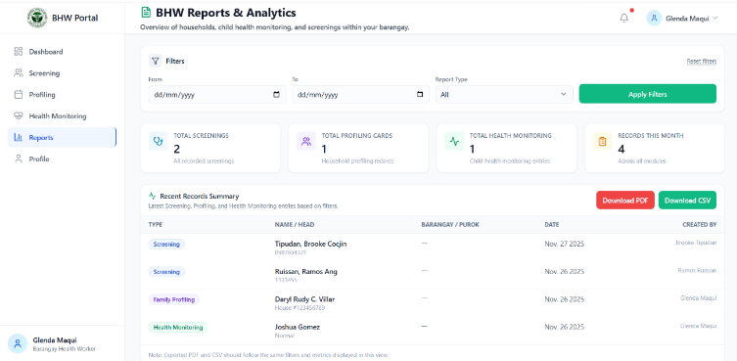
Figure 8. Reports and Analytics

This module manages BHW profiles, including personal information, barangay assignments, and activity records. Administrators can add, update, or deactivate BHW accounts as needed. The module ensures proper monitoring of workforce assignments and supports accountability in health service delivery.
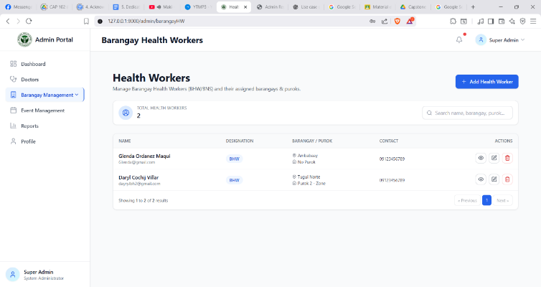
Figure 9. Barangay Health Workers Management

The Doctor Management module maintains records of physicians assigned to the RHU. It allows administrators to manage doctor profiles, schedules, and screening assignments. This module facilitates coordination between BHWs and medical professionals, ensuring efficient allocation of healthcare services. Figure 10 presents the Doctor Management interface.
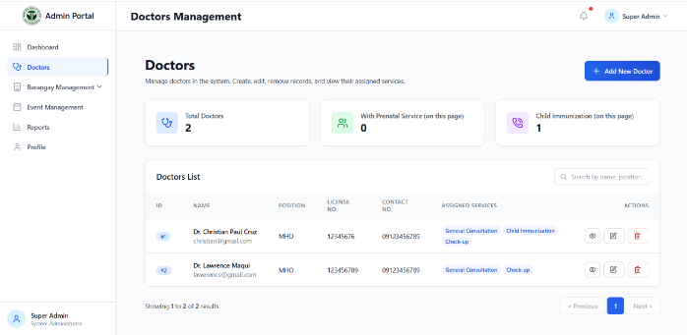

The Event Management module allows RHU personnel to schedule and manage health-related activities such as immunization drives, medical missions, and community health programs. Events can be recorded, updated, and monitored within the system, enabling better planning and documentation of public health initiatives.
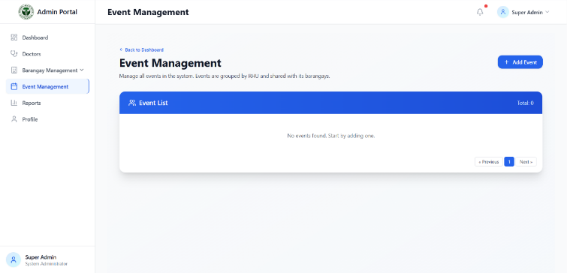
Figure 11. Event Management

Overall, the integration of these functional modules enables the RHU Bani Talaan System to streamline health record management, improve coordination among healthcare workers, and enhance the quality of healthcare services delivered at the community level.

Usability Evaluation of the System
The usability evaluation was conducted using the ISO/IEC 25010 software quality model, covering functionality, reliability, usability, efficiency, maintainability, and portability. Respondents included RHU personnel, BHWs, doctors, and patients.
As shown in Table 4, the system achieved an average weighted mean (AWM) of 4.00, interpreted as Very Good. Users confirmed that the system provides essential features, performs as expected, and improves healthcare service quality.

Table 4. System Evaluation Functionality
Functionality | Mean | Description
1. The system provides the features I need.  2. The functions of the system work as expected.  3. The system improves health service quality.  4. The information shown is accurate and useful. | 4.02  4.04  3.00  4.00 | Very Good  Very Good  Good  Very Good
Average Weighted Mean | 4.00 | Very Good

Table 5 indicates an AWM of 3.69 (Very Good), suggesting that the system operates consistently, saves data accurately, and maintains stable performance during peak usage.

Table 5. System Evaluation Reliability
Functionality | Mean | Description
1. The system works without unexpected errors.  2. The system loads properly every time.  3. Data is saved correctly  4. The system performs well even during busy hours. | 4.02  4.04  3.00  4.00 | Very Good  Very Good  Good  Very Good
Average Weighted Mean | 3.69 | Very Good

The usability evaluation Table 6 yielded an AWM of 4.01 (Very Good). Respondents found the system easy to learn, intuitive to navigate, and suitable for the local healthcare context.

Table 6. System Evaluation Usability
Functionality | Mean | Description
1. The system is easy to learn.  2. The layout is easy to navigate.  3. I can complete tasks without confusion.  4. The system is user-friendly for our locale. | 4.16  4.05  3.50  4.34 | Very Good  Very Good  Good  Very Good
Average Weighted Mean | 4.01 | Very Good

Efficiency results in Table 7 show an AWM of 3.94 (Very Good), demonstrating that the system reduces paperwork, speeds up task completion, and improves workflow.

Table 7. System Evaluation Efficiency
Functionality | Mean | Description
1. The system helps in finishing work faster.  2. The system responds quickly.  3. The system reduces paperwork.  4. The system’s performance is smooth. | 4.04  3.09  4.08  3.74 | Very Good  Good  Very Good  Very Good
Average Weighted Mean | 3.94 | Very Good

Table 8 presents an AWM of 3.86 (Very Good), indicating that the system can be easily updated, maintained, and adapted to evolving RHU requirements.

Table 8. System Evaluation Maintainability
Maintainability | Mean | Description
1. The system is easy to update or improve.  2. Issues can be fixed quickly.  3. The system can adapt to RHU needs.  4. The system is organized and manageable. | 3.64  3.38  3.92  4.02 | Very Good  Good  Very Good  Very Good
Average Weighted Mean | 3.86 | Very Good

Portability scored the highest among the criteria, with an AWM of 4.08 (Very Good) Table 9. The system can be accessed across devices, browsers, and locations, even with limited internet connectivity

Table 8. System Evaluation Portability
Portability | Mean | Description
1. The system works on my device.  2. The system works across different browsers and phones.  3. The system can be used in different locations.  4. The system is usable even with limited internet. | 4.18  3.96  4.01  4.18 | Very Good  Very Good  Very Good  Very Good
Average Weighted Mean | 4.08 | Very Good

The overall evaluation recorded an AWM of 4.75 (Very Good), reflecting high user satisfaction and strong acceptance of the RHU Bani Talaan System. A summary of all criteria is presented in Table 11, confirming the system’s effectiveness across all quality attributes
Criteria | AWM | Interpretation
Functionality  Reliability  Usability  Efficiency  Maintainability  Portability | 4.00  3.69  4.01  3.94  3.86  4.08 | Very Good  Very Good  Very Good  Very Good  Very Good  Very Good
Overall | 3.93 | Very Good

Discussion and Findings
The results demonstrate that transitioning from a manual to a digital record-management system significantly improves RHU operations. The RHU Bani Talaan System addresses key challenges identified in the existing process by enhancing data accessibility, security, accuracy, and efficiency. The high usability ratings indicate that the system aligns well with user needs and operational workflows.
Overall, the findings confirm that the RHU Bani Talaan System is a viable and effective solution for modernizing health record management in rural healthcare settings.

CONCLUSION

This study successfully designed and developed the RHU Bani Talaan System as a digital record-keeping solution for Barangay Health Workers and Rural Health Unit personnel in Bani, Pangasinan. The findings showed that the existing manual record-management process was time-consuming, prone to errors, and vulnerable to data loss due to issues such as unreadable handwriting, inconsistent entries, and misplaced records. These challenges affected the efficiency, accuracy, and timeliness of healthcare service delivery at the community level. The developed system addressed these limitations by providing a centralized and organized digital platform for household profiling, child health monitoring, screening records, and report generation. Through the use of appropriate development tools and methodologies, the system improved data accessibility, reduced record-retrieval time, and enhanced the accuracy and security of health information. The integration of key features aligned with the actual workflows of BHWs and RHU staff contributed to a more streamlined and reliable record-management process. Based on the system evaluation, the RHU Bani Talaan System was found to be highly acceptable in terms of functionality, reliability, usability, efficiency, maintainability, and portability. These results indicate that the system met user requirements and demonstrated strong potential to support more efficient healthcare operations. Overall, the study confirmed that the adoption of a localized digital record-keeping system can significantly improve health information management and strengthen healthcare service delivery in rural communities.

REFERENCE
- (P. Dadlani and A. Yadava, “Digital Health Management in Rural Areas,” Journal of Rural Healthcare, vol. 12, no. 3, pp. 45-59, 2023. [Online]. Available: https://www.jrhjournal.org/articles/digital-health-management-rural-areas. [Accessed 30 January 2024].)
- (S. Kumar, “Challenges of Paper-Based Health Records in Developing Countries,” International Journal of Medical Informatics, vol. 98, pp. 112-120, 2023. [Online]. Available: https://www.ijmi.org/articles/challenges-paper-records. [Accessed 30 January 2024].)
- (J. R. Bautista, M. L. Santos, and C. G. Reyes, “Data Loss and Security Risks in Manual Health Systems,” Philippine Journal of Health Research, vol. 15, no. 2, pp. 78-89, 2023. [Online]. Available: https://www.pjhr.ph/articles/data-loss-manual-systems. [Accessed 30 January 2024].)
- (K. Hartigan-Go, E. M. Cruz, and P. D. Alvarez, “Workflow Challenges of Barangay Health Workers in the Philippines,” Asian Pacific Journal of Health Systems, vol. 8, no. 1, pp. 33-47, 2024. [Online]. Available: https://www.apjhs.org/articles/bhw-workflow-challenges. [Accessed 30 January 2024].)
- (T. Manyazewal, M. B. M. Woldeamanuel, and D. Z. Teklu, “Impact of Electronic Health Records on Data Accuracy,” BMC Health Services Research, vol. 21, no. 450, 2021. [Online]. Available: https://bmchealthservres.biomedcentral.com/articles/impact-ehr-accuracy. [Accessed 30 January 2024].)
- (L. Meier-Diedrich, S. Fischer, and J. P. Müller, “Community Health Information Systems for Administrative Efficiency,” Global Health Action, vol. 18, no. 1, 2025. [Online]. Available: https://www.globalhealthaction.org/articles/community-health-systems-efficiency. [Accessed 30 January 2024].)
- (R. B. Torres, A. S. Dela Cruz, and F. G. Lim, “Adoption of ICT Solutions in Remote Philippine Healthcare,” Journal of Community Informatics, vol. 16, no. 2, pp. 101-115, 2020. [Online]. Available: https://www.ci-journal.org/articles/ict-adoption-ph-remote. [Accessed 30 January 2024].)
- (R. De Mesa, A. T. Lorenzo, and C. Y. Sy, “Infrastructure and Literacy Barriers to Digital Health in Rural Philippines,” Health Technology in the Developing World, vol. 5, no. 4, pp. 200-214, 2024. [Online]. Available: https://www.htdwjournal.org/articles/infrastructure-barriers-ph. [Accessed 30 January 2024].)
- (A. I. Ojo, “Designing User-Friendly Health Systems for Rural Settings,” Journal of Biomedical Informatics, vol. 125, 2022. [Online]. Available: https://www.jbiomedinformatics.com/articles/user-friendly-rural-systems. [Accessed 30 January 2024].)
- (D. J. Antipuesto, “Digital Transformation in Rural Healthcare Delivery,” Philippine Journal of Public Health, vol. 67, no. 1, pp. 22-35, 2021. [Online]. Available: https://www.pjph.org/articles/digital-transformation-rural-health. [Accessed 30 January 2024].)
- (A. B. Umar, C. D. N. Oladele, and S. K. Mensah, “Enhancing Service Efficiency through Digital Infrastructure,” International Journal of Healthcare Management, vol. 17, no. 2, pp. 155-167, 2024. [Online]. Available: https://www.ijhcm.org/articles/efficiency-digital-infrastructure. [Accessed 30 January 2024].)

