AgriConnect: A Mobile Application Linking Farmers and Businesses in Western Pangasinan

- INTRODUCTION

Agriculture remains one of the primary pillars of the Philippine economy, providing food security, employment, and livelihood to millions of Filipinos. Despite its importance, farmers often face persistent issues such as unstable income, lack of direct market access, and dependence on middlemen who reduce their profit margins. Rural farmers benefit from improved access to local and international markets because it increases product diversity, income opportunities, and food security (Ma et al., 2024). However, many smallholder farmers continue to experience difficulties in accessing fair and reliable markets due to inefficient trading systems and limited bargaining power (Ali et al., 2025). The government has been encouraging modernization and digital transformation in agriculture, yet technology adoption among local farmers remains slow because of limited resources, technological literacy, and access to digital tools (Shoaib, 2025). With the rise of mobile technology and e-commerce platforms, opportunities to improve agricultural marketing and communication have become more accessible. Mobile applications and digital platforms now provide innovative ways to connect farmers directly with buyers while improving transparency and efficiency in agricultural transactions (Arunkamar & Manida, 2024).

The lack of efficient connections between farmers and businesses not only affects farmers’ livelihoods but also hinders businesses such as restaurants, stores, and markets from accessing fresh produce consistently. Traditional agricultural trading processes still rely heavily on middlemen, verbal negotiations, handwritten records, and informal communication methods, which often lead to delays, misunderstandings, and reduced profit opportunities for farmers (Odsinida et al., 2023). The lack of reliable market information contributes to unstable pricing and poor decision-making among farmers. Similarly, Sudrajat et al. (2021) explained that middlemen often gain greater control over pricing and profit margins, leaving farmers with weaker bargaining power. These inefficiencies highlight the need for technology-driven systems that can improve communication, organization, and transparency in agricultural trading.

In recent years, digital platforms have emerged as effective tools for improving agricultural marketing, supply chain coordination, and direct market access. Direct Market Access (DMA) allows farmers to bypass intermediaries and directly connect with buyers, increasing profit margins and improving supply chain efficiency (Ali et al., 2025). Digital platforms also provide farmers with access to market information, product monitoring, communication tools, and online trading opportunities (Akinwale et al., 2023). Mobile applications improve efficiency in managing product listings, transactions, and market accessibility while also enhancing user experience through responsive and user-friendly interfaces. Furthermore, Kenny and Regan (2021) stated that mobile technologies help farmers improve communication, decision-making, and productivity through accessible digital tools.

In the Philippines, agriculture remains a major contributor to rural livelihood and regional economic activity. Pangasinan, one of the country’s largest agricultural provinces, produces rice, corn, root crops, fruits, vegetables, coconut, and mangoes that support both local consumption and regional trade. However, despite its agricultural productivity, many farmers in Pangasinan still experience financial struggles due to fluctuating prices, limited market access, and dependence on middlemen. Western Pangasinan, including Alaminos City, Bolinao, and nearby municipalities, is recognized as an important agricultural area in Region I. The province has a total of 257,052 farmers, although the exact number in Western Pangasinan continuously changes because many small-scale farmers remain unregistered (PPDO, 2023). The area also contributes significantly to coconut production, with Bolinao accounting for a large percentage of the province’s output (PPDO, 2023).

Local businesses such as restaurants, resorts, food establishments, and agribusinesses in Western Pangasinan require a stable and reliable supply of fresh agricultural products to sustain their operations. In Alaminos City, there are 371 food and beverage establishments, while Bolinao has 176 hotels, resorts, and restaurants that depend on agricultural products from local farmers (Municipality of Bolinao, 2021). Despite the strong agricultural and business potential of the area, the connection between farmers and businesses remains limited and inefficient. Many transactions are still conducted manually through phone calls, text messages, and verbal agreements, resulting in communication delays, inconsistent pricing, and poor transaction monitoring.

To address these issues, the proponents developed AgriConnect, a mobile application designed to directly connect farmers and businesses in Western Pangasinan. The application aims to improve communication, market accessibility, transaction management, and transparency while reducing farmers’ dependence on middlemen. AgriConnect integrates features such as product listings, direct messaging, notifications, sales monitoring, and transaction history to support more organized and efficient agricultural trading activities. By integrating digital technology into the agricultural trading process, the study seeks to empower farmers, improve income opportunities, strengthen business connections, and contribute to agricultural modernization and economic development in Western Pangasinan.

This study aims to develop AgriConnect, a mobile application that directly connects farmers and businesses in Western Pangasinan to improve agricultural trading processes and reduce dependence on middlemen. Specifically, the study seeks to examine the existing processes used by farmers and businesses in selling and supplying agricultural products, identify the challenges and inefficiencies present in the current trading system, determine the key features needed to provide an efficient and user-friendly mobile application, and evaluate the usability and acceptability of the developed system among farmers and business owners in Western Pangasinan.

- METHODOLOGY

This study utilized a descriptive-developmental research approach to assess the challenges experienced by farmers and business owners in Western Pangasinan regarding the marketing and supply of agricultural products. The study combined qualitative and quantitative methods through interviews and survey questionnaires to gather relevant information from the target users. The gathered data served as the basis for the design and development of AgriConnect, a mobile application intended to improve communication, transaction management, and market accessibility between farmers and businesses while reducing dependence on traditional middlemen.

The Agile methodology was used as the primary software development model of the study. Agile promotes iterative and flexible development, allowing continuous improvement of the system through regular feedback from users and stakeholders. The methodology was selected because it supports collaboration, adaptability, and progressive enhancement throughout the development process (Bhimanapati et al., 2024). The development process was divided into several phases including requirements gathering, design, development, testing, and review.

During the requirements phase, interviews and consultations with farmers, business representatives, and agriculture office personnel were conducted to identify the current agricultural trading practices, common challenges, and system requirements. In the design phase, interface prototypes, layouts, and system structures were created using design tools to visualize the proposed application. The development phase focused on building the application using Flutter, Dart, Firebase, and Android Studio. The testing phase involved usability testing and evaluation of the system to identify issues and improvements. Lastly, the review phase collected user feedback to refine the system and ensure that the application met the needs of the target users. Figure 1 shows the Agile methodology used in the development process of the AgriConnect mobile application.

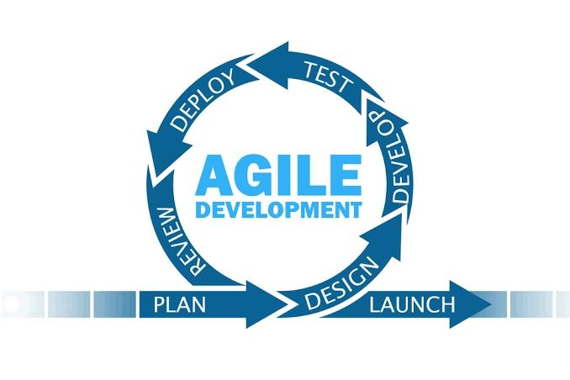
Fig. 1 Agile Methodology
This research was conducted in District I of Western Pangasinan, Philippines, an area known for its agricultural productivity and crop diversity such as rice, corn, vegetables, root crops, and fruits. Agriculture serves as one of the primary sources of livelihood in the area, making it an appropriate location for the study. The respondents of the study consisted of local farmers, business representatives, agriculture office personnel, and IT experts. Farmers and business owners participated as the primary users of the system, while agriculture office personnel provided insights regarding agricultural practices and local trading conditions. IT experts assisted in evaluating the technical functionality and usability of the developed application. Table I presents the respondents involved in the conduct and evaluation of the study.

TABLE I.
Respondents of the Study

Respondents | Number of Respondents
Head of Agriculture Office | 1
Farmers | 13
Business Representatives | 8
IT experts | 2
Total | 24

The selection of Western Pangasinan as the study area was based on the need for a more accessible and organized trading platform that can directly connect farmers and businesses. Traditional agricultural trading practices in the area remain largely manual and dependent on middlemen, limiting farmers’ market access and income opportunities. Through the development of AgriConnect, the study aimed to provide a localized digital solution that improves communication, transparency, and efficiency in agricultural transactions.

To collect the necessary data for the study, the researchers utilized interviews and survey questionnaires. Interviews were conducted with selected farmers, business representatives, and agriculture office personnel to identify the existing trading processes, challenges encountered, and expectations for the proposed system. Survey questionnaires were used during the system evaluation phase to assess the usability and acceptability of the developed application.

For data analysis, the weighted mean was used to determine the average responses of the participants regarding the usability and functionality of the system. The formula for weighted mean was applied to interpret the responses gathered from the survey questionnaires and evaluate the level of user satisfaction with the developed application. Table II presents the scale of measurement used in interpreting the usability evaluation results of the developed system.

TABLE II.
The Scale of Measurement for Usability Test

Scale | Statistical limits | Rating | Interpre-tation
5 | 4.21 – 5.00 | StronglyAgree | Usable
4 | 3.41 – 4.20 | Agree | Usable
3 | 2.61 – 3.40 | Fair | Usable
2 | 1.81 – 2.60 | Disagree | Not Usable
1 | 1.00 – 1.80 | Strongly Disagree | Not Usable

Several development tools and technologies were utilized in building the AgriConnect mobile application. Figma was used for interface design and prototyping, while Flutter and Dart were used for developing the cross-platform mobile application. Firebase served as the backend database and authentication platform of the system. Android Studio was utilized as the integrated development environment for coding, testing, and debugging the application. Additionally, Git was used for version control and project collaboration during the development process.

The developed system underwent usability testing with selected respondents to evaluate its functionality, reliability, accessibility, and overall user experience. Feedback gathered from the respondents was analyzed and used to improve the application further. Through the integration of appropriate research methods, development tools, and user-centered testing, the study was able to develop a functional and localized mobile application designed to improve agricultural trading transactions between farmers and businesses in Western Pangasinan.

- RESULTS AND DISCUSSION

This section presents the findings gathered from
interviews, surveys, and system evaluation conducted for the development of AgriConnect: A Mobile Application Linking Farmers and Businesses in Western Pangasinan. It discusses the existing agricultural trading processes, the challenges encountered by farmers and business owners, the developed system architecture, and the usability and acceptability evaluation results of the proposed application.
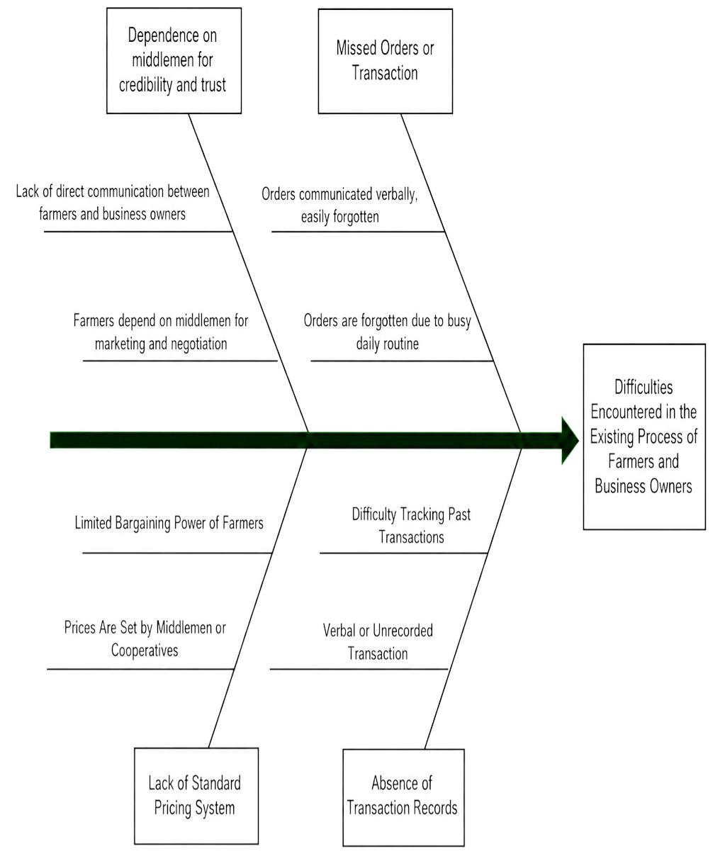
Existing Processes of Farmers and Businesses in Agricultural Trading

Based on the interviews conducted with farmers, business owners, and representatives from local agriculture offices in Western Pangasinan, the proponents identified that agricultural trading processes are still commonly performed through manual and traditional methods. Most transactions rely on verbal agreements, personal connections, handwritten records, and middlemen for communication and coordination between farmers and buyers.

Farmers often depend on middlemen to market and sell their agricultural products to business owners. In cases where buyers are unavailable, products are delivered to trading posts or bagsakan centers where wholesalers purchase goods at lower prices before reselling them to businesses. Some farmers also seek assistance from cooperatives for transportation and delivery services, while others personally deliver products using their own vehicles based on existing customer relationships and verbal negotiations.

These traditional methods lack organized transaction management, proper documentation, and efficient communication channels, resulting in difficulties for both farmers and business owners in monitoring transactions and maintaining reliable trading operations.

Challenges and Inefficiencies in the Existing Trading System

The study identified several major challenges affecting the current agricultural trading system in Western Pangasinan. To analyze the root causes of these issues, the proponents utilized a Fishbone Diagram based on the data gathered during interviews and observations. Figure 2 illustrates the Fishbone Diagram used to identify the challenges and inefficiencies in the existing agricultural trading process.

Fig. 2 Fishbone Diagram of Challenges in Agricultural Trading

One of the primary problems identified was the absence of proper transaction records. Most agreements between farmers and buyers are conducted verbally without written or digital documentation, making it difficult to verify orders, monitor deliveries, and track payments accurately.

Another issue identified was the lack of a standardized pricing system. Farmers frequently rely on prices offered by middlemen or buyers, resulting in inconsistent pricing and reduced profit opportunities. Due to limited bargaining power and market access, farmers are often forced to accept lower prices for their products.
Missed orders and communication delays were also common problems. Since most transactions are handled through phone calls, text messages, or verbal communication, important transaction details are sometimes forgotten or misunderstood. This often leads to delivery delays, incomplete orders, and confusion between parties.

The study also revealed the strong dependence of farmers on middlemen for market access and buyer connections. While middlemen assist in facilitating transactions, they also gain greater control over product pricing and profits, reducing farmers’ income and limiting direct interaction between producers and buyers.

These findings demonstrate the need for a centralized digital platform that can improve communication, organize transactions, and provide a more transparent and efficient agricultural trading process.

Development of AgriConnect System

To address the identified problems, the proponents developed AgriConnect, a mobile application designed to directly connect farmers and business owners in Western Pangasinan. The system aims to improve communication, reduce dependence on middlemen, and provide a more organized and transparent trading environment.

The AgriConnect system utilizes a three-tier architecture composed of the presentation layer, application layer, and database layer to ensure efficient system operation, secure data management, and reliable communication between users. Figure 3 presents the three-tier architecture utilized in the development of the AgriConnect mobile application.

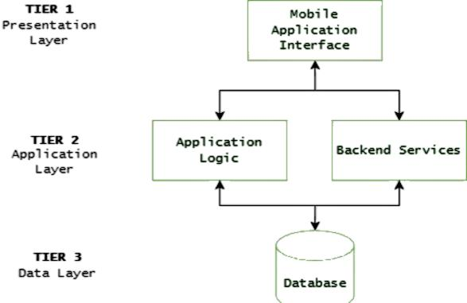
Fig. 3 Three-Tier Architecture
The presentation layer serves as the user interface where farmers and business owners interact with the system through mobile devices. The application layer processes user requests, messaging functions, and transaction-related activities, while the database layer securely stores user information, product details, transaction history, and other system records.

Through the integration of these components, AgriConnect provides a centralized platform that improves communication, transaction organization, and accessibility between farmers and businesses in Western Pangasinan.

System Features of AgriConnect

The developed AgriConnect mobile application includes several features designed to address the challenges identified in the existing agricultural trading system of Western Pangasinan. These features were developed based on the needs gathered from farmers, business owners, and agriculture office representatives during interviews and surveys. The system aims to improve communication, transaction management, product accessibility, and market connectivity between farmers and businesses. Figure 4 presents the product listing interface used for managing and browsing agricultural products.

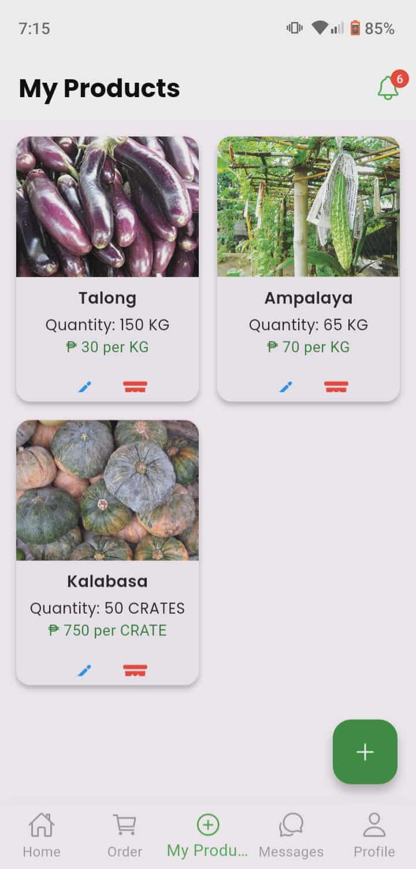
Fig. 4 Product Listing Interface

The product listing feature enables farmers to upload, manage, and update information about available agricultural products. Business owners can browse product listings, check product availability, and identify suppliers based on their needs. This feature addresses the problem of limited market access by providing farmers with a direct platform to showcase their products without relying heavily on middlemen. It also improves product visibility and strengthens direct farmer-business connections. Figure 5 shows the messaging and transaction interface used for communication and transaction coordination between users.

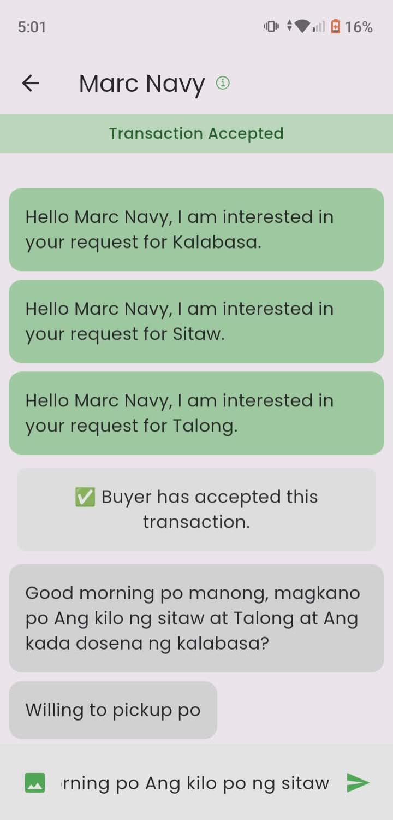
Fig. 5 Messaging and Transaction Interface

The messaging and transaction feature allows farmers and business owners to communicate directly regarding product inquiries, pricing, delivery schedules, and transaction details. This feature addresses the communication delays and misunderstandings identified in the traditional trading process. By providing direct and organized communication within the application, the system improves coordination, minimizes missed orders, and supports more transparent transactions between users. Figure 6 presents the sales monitoring and notification interface of the application.

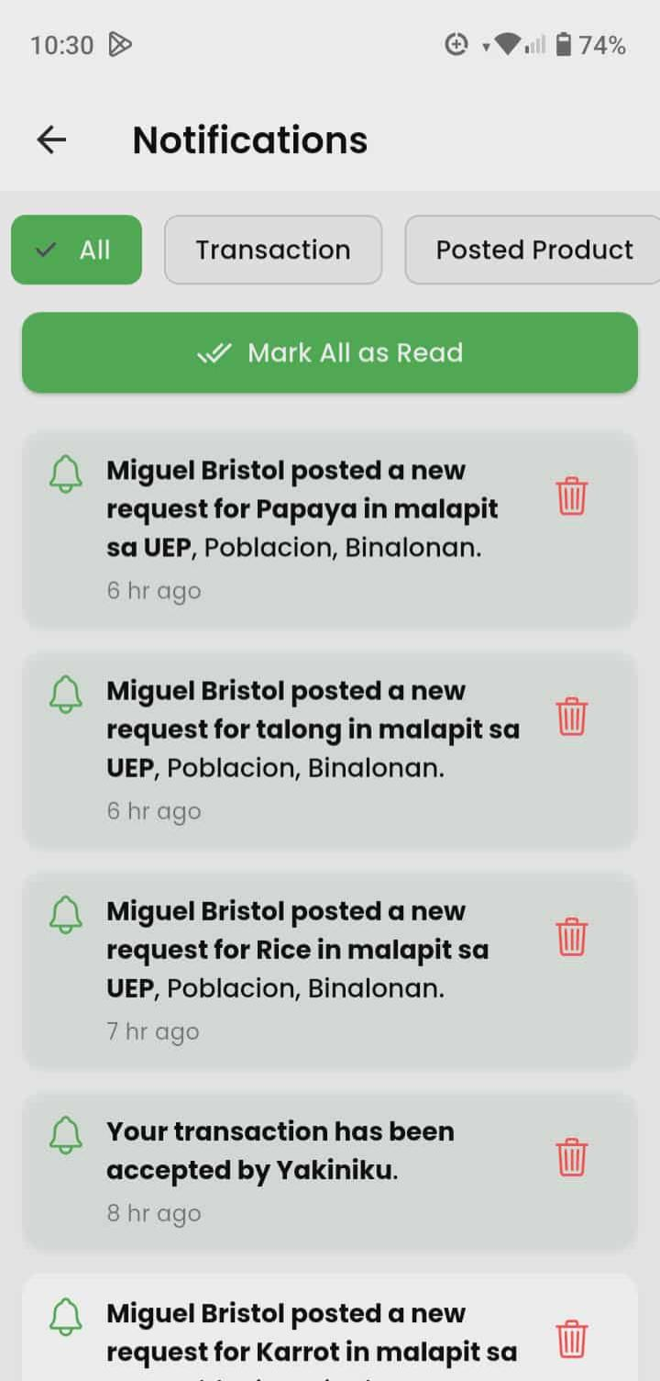
Fig. 6 Sales Monitoring and Notification Interface

The sales monitoring and notification feature helps users monitor ongoing transactions, track sales activities, and receive updates regarding orders and product requests. This feature addresses the lack of proper documentation and transaction records observed in the existing trading system. Through digital monitoring and notifications, users are able to maintain organized records, improve transaction tracking, and make better decisions regarding agricultural trading activities.

System Evaluation and Acceptability

The developed AgriConnect mobile application was evaluated by farmers and business owners to determine its usability and acceptability. The evaluation focused on Appropriateness Recognizability, Learnability, Operability, User Error Protection, User Interface, Accessibility, Usefulness, and Satisfaction using a five-point Likert scale. Table III presents the overall system evaluation results of the AgriConnect mobile application based on respondents’ assessments.

TABLE III.
Overall System Evaluation of AgriConnect Mobile Application

 | Criteria | Mean | Interpretation
1. | Appropriateness Recognizability | 4.78 | Strongly Agree
2. | Learnability | 4.73 | Strongly Agree
3. | Operability | 4.63 | Strongly Agree
4. | User Error Protection | 4.53 | Strongly Agree
5. | User Interface | 4.88 | Strongly Agree
6. | Accessibility | 4.73 | Strongly Agree
7. | Usefulness | 4.78 | Strongly Agree
8. | Satisfaction | 4.88 | Strongly Agree
 | Weighted Mean= | 4.75 | Strongly Agree

The overall evaluation results indicate that AgriConnect achieved a high level of usability and acceptability among farmers and business owners in Western Pangasinan. The system obtained an overall weighted mean of 4.75, interpreted as Strongly Agree, indicating that respondents found the application easy to use, reliable, accessible, and beneficial in improving agricultural trading activities.

The highest evaluation result was obtained in User Interface with a weighted mean of 4.88, indicating that respondents strongly agreed that the system’s design, layout, text, and visual appearance were clear and user-friendly.

Appropriateness Recognizability and Usefulness both received weighted means of 4.78, showing that users clearly understood the purpose of the system and found it valuable for improving communication and transactions between farmers and businesses.

Learnability and Accessibility both received weighted means of 4.73, indicating that respondents were able to understand and use the application easily regardless of their technical skill level. Operability obtained a weighted mean of 4.63, while User Error Protection received 4.53, demonstrating that the system functions properly and effectively assists users in preventing and correcting mistakes during operation.

Overall, the findings indicate that AgriConnect successfully addresses the communication, transaction management, and documentation problems present in the traditional agricultural trading process. The system demonstrates strong potential for implementation as a reliable and user-friendly digital platform for agricultural trading in Western Pangasinan.

- CONCLUSIONS

This study successfully developed AgriConnect, a mobile application designed to directly connect farmers and businesses in Western Pangasinan. The findings revealed that the existing agricultural trading system still relies on manual processes, verbal agreements, handwritten records, and middlemen, which often lead to communication gaps, inconsistent pricing, undocumented transactions, and limited market access for farmers. These challenges highlighted the need for a more organized, transparent, and technology-based trading platform.

To address these issues, the proponents developed AgriConnect using the Agile methodology and integrated features such as direct messaging, notifications, transaction history, and sales monitoring. The system evaluation showed a high level of usability and acceptability, with respondents rating the system as Strongly Agree in terms of usability and acceptability. Therefore, the study concludes that AgriConnect is an effective and user-friendly mobile application that can improve agricultural trading processes and strengthen direct connections between farmers and businesses in Western Pangasinan.

- ACKNOWLEDGEMENT

This capstone project would not have been possible without the people who contributed to its completion through their guidance, support, and encouragement. With utmost appreciation, the proponents would like to acknowledge the following:

First and foremost, to Almighty God, for granting the strength, wisdom, and perseverance needed to fulfill every task and overcome every challenge throughout this study.

To Sir Carlo Genster P. Camposagrado, our subject adviser and our research adviser, for his insightful mentorship, valuable recommendations, and unwavering support throughout the development of this study. His commitment, patience, and dedication in both instruction and research supervision greatly contributed to the success of this project.

To the chairman and panel members, for their insightful suggestions, thorough evaluation, and valuable recommendations that significantly improved the technical and research aspects of this work.

To the Municipal/City Agriculture Office of Western Pangasinan, along with the farmers, business owners, and respondents who generously participated in interviews, surveys, and system testing. Their cooperation played a vital role in ensuring that this project addresses real needs in the agricultural community.

Finally, to everyone who extended support in any form, no matter how big or small, thank you. Your contribution has made this achievement possible.

- REFERENCES

- Akinwale, J. A., Wole-Alo, F. I., & Oluwole, B. O. (2023). Digital Platforms for linking agriculture investors with smallholder farmers in Nigeria. Journal of Agricultural Extension. https://doi.org/10.4314/jae.v27i2.6

- Ali, H. M., Deivasigamani, A., Karn, A. L., Beluguru, V., Kabaleeswaran, K. K., Satyanarayana, R., & Sengan, S. (2025). The influence of direct market access on profit margins, supply chain efficiency, and economic resilience for small-scale dairy farmers of Asian country. Research on World Agricultural Economy. https://doi.org/10.36956/rwae.v6i1.1530

- Arunkamar, V. M., & Manida, M. (2024). Harnessing digital platforms For sustainable agri-commerce: Challenges and opportunities. https://www.researchgate.net/publication/384285468

- Kenny, U., & Regan, Á. (2021). Co-designing a smartphone app for and With farmers: Empathising with end-users’ values and needs. Journal of Rural Studies.https://doi.org/10.1016/j.jrurstud.2020.12.009

- Municipality of Bolinao. (2021). Municipal Profile.https://www.bolinaopangasinan.gov.ph/about-us-2/municipal-profile/markets-through-agricultural-cooperatives-and-e-commerce-in-asia/

- Pangasinan Provincial Planning and Development Office (PPDO) (2023). Local Economy 2023. https://ppdo.pangasinan.gov.ph/local-economy-2023/

- Ma, W., Rahut, D. B., Sonobe, T., & Gong, B. (2024). Linking farmers to markets: Barriers, solutions, and policy options. https://www.asiapathways-adbi.org/2024/07/linking-farmers-to-markets-through-agricultural-cooperatives-and-e-commerce-in-asia/

- Odsinida, A., Hermosura, J. D., Vigonte, F. G., & Abante, M. V. (2023). The impact of middlemen on the livelihood and income of rice farmers in selected barangay of Guimba, Nueva Ecija. http://dx.doi.org/10.2139/ssrn.4459104

- Shoaib, H. (2025, February 6). Adoption of agricultural technology in the developing world – Challenges and barriers. Folio3 AgTech. https://agtech.folio3.com/blogs/agricultural-technology-adoption-barriers/

- Sudrajat, J., Isytar, I., & Arifin, N. (2021). Farmers’ perception and engagement with the role of middlemen: A case study of the vegetable farmers. Makara Human Behavior Studies in Asia. https://doi.org/10.7454/hubs.asia.1070220⁠

- Bhimanapati, V. B. R., Jain, S., & Aggarwal, A. (2024). Agile methodologies in mobile app development for real-time data processing. Universal Research Reports, 11(4), 211–231. https://doi.org/10.36676/urr.v11.i4.1350⁠

