SualPoint: A Sual Task Monitoring System

ABSTRACT
The Department of Interior and Local Government of the Municipality of Sual monitors and supervises its activities and tasks manually, but sometimes the reliance on manual processes leads to inefficiencies and delays in completing tasks. Hence, to resolve this issue, we designed and developed a web and mobile- based task monitoring system named SualPoint – A Sual Task Monitoring System. It has been created by making use of the best technologies related to the World Wide Web and mobile platforms to support task assignment, task management, and task reporting in real-time. The Agile methodology was adopted to support iterative development, continuous stakeholder feedback, and user-centered design. The tools used to develop this web application were HTML, Laravel, CSS, JavaScript, Tailwind CSS, PHP, MySQL, XAMPP, and Visual Code. These features are provided in a way that the system allows user authentication, task creation, task assignment, progress monitoring, sending notifications automatically, and generating reports. These features were evaluated under the ISO/IEC 25010 standard for software quality, which involved functionality, usability, reliability, efficiency, and security. Evaluators of the features included DILG personnel and information technology experts. The results showed that the developed system is helpful in improving the monitoring of tasks, reducing manual record maintenance, improving personnel communications, and increasing transparency in the management of tasks. In general, the developed system was rated very well in terms of its acceptability and appropriateness for use in the DILG office.

Keywords: SualPoint, Web and Mobile-Based, DILG, ISO/IEC 25010.

INTRODUCTION
Digital transformation is an important aspect in achieving efficiency, transparency, and accountability in public service delivery or governance. The Department of the Interior and Local Government (DILG) is at the forefront in ensuring the implementation of national policy programs at the local level, particularly in disaster preparedness, public safety, and governance support in LGUs. Despite the progress in implementing E-Governance projects at the national level, it appears most DILG offices implement manual and paper-based systems in maintaining records, not only in spreadsheets but also in traditional oral reporting.

The challenges identified above are very much mirrored in the task monitoring and reporting practices of the Municipality of Sual in Pangasinan. In an interview with the MLGOO VI, it was disclosed that task documentation and progress monitoring are done in a non-centralized and manual manner. This setup hampers timely report generation, verification of task completion, and accountability of attached agencies like the PNP, BFP, and BJMP.

Therefore, a study of this nature aims at providing recommendations and coming up with a concept of development of a Sual Task Monitoring System, which can help in monitoring activities in a systematic way.

Based on the discussion, there is a need to create a centralized digital monitoring system, which can help in tracking, verifying, and reporting tasks in an automated manner. By integrating web and mobile technologies, such a project can easily comply with the Philippine E-Government Master Plan and the United Nations’ Sustainable Development Goal 9, which is Industry, Innovation, and Infrastructure.

METHODOLOGY
The research method used in this research was developmental and descriptive in nature, which dictated the way this research was designed, developed, and evaluated in terms of its application to the SualPoint. About its developmental characteristics, it needed to be developed in relation to the identified needs of the Department of Interior and Local Government (DILG) in Sual, Pangasinan.

The use of the descriptive portion was also made to assess the system's usability, performance, and effectiveness even after its implementation. In this process, it attempted to describe the way the user interacts with the system in terms of its ease of use, efficiency, and satisfaction. In this way, not only were the technical aspects of the system tested, but also its user experience was observed, making a perfect balance in terms of its functionality in improving the monitoring and coordination of tasks with the DILG and its attached agencies

Figure 1. Agile Model

Note. Adapted from Understanding the Software Development Life Cycle (SDLC),by S. Adebayo, 2025
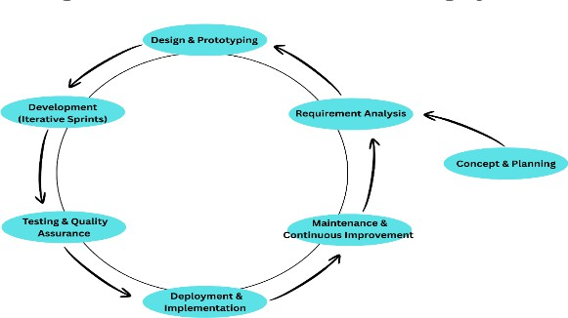

The system was developed under an Agile methodology. Agile is an iterative development methodology that emphasizes rapid development, flexibility, collaboration, and customer feedback. The system development process was broken down into small development cycles referred to as ‘sprints.’ Under these development cycles, various important system features, including user authentication, task handling, progress tracking, and reporting, among others, were conceptualized, implemented, and tested.

At the conclusion of each sprint, a limited review activity took place involving the selected personnel from the DILG and the representatives from the attached agencies to gather their feedback, particularly regarding the function, interface, and flow of the systems, to guide the updates for the next development iteration.

The SualPoint uses a standard three-tier system architecture consisting of a presentation layer, application layer, and data layer. Such a systematic architecture allows for better separation of system functions.

The presentation layer was developed using technologies such as HTML, CSS, JavaScript, Tailwind CSS, and Bootstrap to create a user-friendly interface that enables access on different devices. The application layer was developed by using different technologies such as PHP with Laravel for handling different logic for users, authenticating users, handling different roles for access control, handling different tasks for users, and many more. In addition to that, the data layer was developed using MySQL for handling different user records centrally.

Figure 2. Conceptual Framework
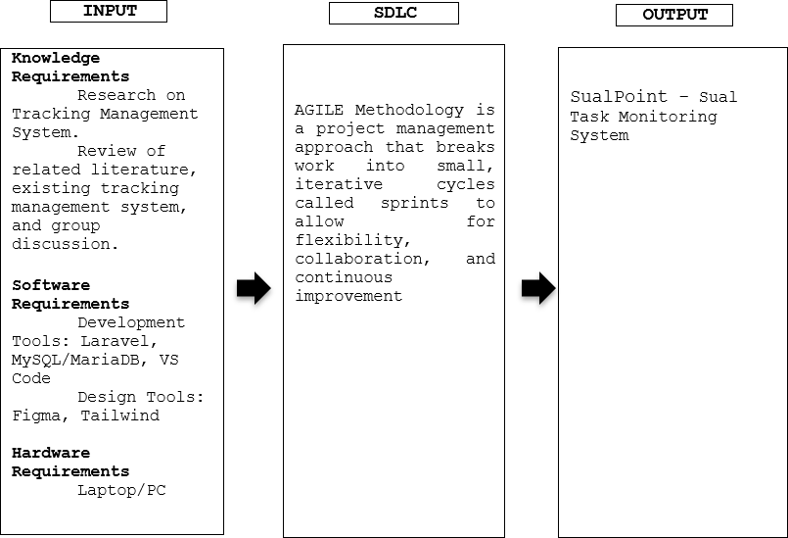

The setting of this study was conducted in the Municipality of Sual, Pangasinan, at the office of the DILG. The office was selected as it can be considered as almost too ordinary in terms of setting and nature, since in most cases, tasks are being monitored and recorded in almost a manual or semi-digital fashion. The respondents consist of the head admin, admin, and the employees who are directly involved in the implementation and monitoring of the tasks assigned to them.

These are the respondents to the study because this group is directly involved in the implementation of the coordination activity and the workflow for the reporting functions.

Table 1. Respondents of the Study

Respondents | Number of Respondents
Head Admin | 1
Admin | 1
Employees | 3
Total Respondents | 5

An interview guide was used. This was aimed at discovering existing practices, challenges, and requirements concerning task monitoring. The interview consisted of various open-ended questions concerning reporting workflow, coordination among offices, and challenges that existed.

Moreover, it was observed that a five-point Likert scale-based survey questionnaire was utilized in testing the developed system based on various aspects such as suitability, efficiency, usability, reliability, and satisfaction, which provided quantitative data in measuring the acceptability of a developed system in relation to the perspective of the user.

Table 2. Likert Scale

Likert Scale Description | Likert Scale Interval
Strongly Agree | 4.21-5.00
Agree | 3.41-4.20
Neutral | 2.61-3.40
Disagree | 1.81-2.60
Strongly Disagree | 1.00-1.80

Quantitative data from the usability survey were analyzed using the Average Weighted Mean to determine the level of system acceptability. Qualitative data from interviews were summarized and grouped into common themes related to efficiency, transparency, and coordination to support the quantitative findings. Participation in the study was voluntary, and respondents were informed of the purpose of the research. All collected data were treated with confidentiality and used solely for academic and system improvement purposes

RESULTS AND DISCUSSION
The developed SualPoint was then evaluated to assess its overall software quality and acceptability through the ISO/IEC 25010 Software Quality Model evaluation approach. From the evaluation results, it was observed that the developed SualPoint scored high marks on all its software qualities, which include functional suitability, performance efficiency, compatibility, usability, reliability, security, maintainability, and portability. The overall average weighted mean measure was 4.44, which indicates Excellent as per the guidelines and interpretations of the evaluation approach. It was observed from the results that functional suitability, reliability, and maintainability were assigned the highest marks among the software qualities, which indicates effective functional performance, high reliability, and better maintainability of the SualPoint in the future.

The results have also indicated that the system is used efficiently, delays are minimal, it can be used simultaneously with other applications, and it has a user-friendly interface. The respondents strongly agreed that the system ensures data security, restricting any unauthorized access, thereby indicating sufficient security tools within the system. The system has also been identified as portable, such that it can function efficiently in multiple operating environments, enabling its use by different organizations within an organizational setup.
The scores, though a little lower, on learnability and time behavior indicated that a little work needs to be done on enhancing the performance of such a system.

Overall, the results validate that the developed system was highly acceptable to users as an effective solution for task management. The automation of these processes enhances efficiency, accountability, and transparency compared to other forms of manual keeping. These results prove that SualPoint achieved the objectives of this study as a feasible technological solution for improving task management processes within an organization. Moreover, they support its preferred inclusion among other technological solutions for

improving general performance. The results validated that they confirmed they were highly acceptable to users as an effective solution to support Task Management processes.

Table 3. Overall Weighted Mean of System Evaluation

Domain | Average Weighted Mean | Description
Functional Suitability | 4.66 | Excellent
Performance Efficiency | 4.26 | Excellent
Compatibility | 4.4 | Excellent
Usability | 4.3 | Excellent
Reliability | 4.55 | Excellent
Security | 4.4 | Excellent
Maintainability | 4.6 | Excellent
Portability | 4.4 | Excellent
Overall Weighted Mean | 4.44 | Excellent

CONCLUSION
The objectives of this research were accomplished, which were to design, develop, and evaluate the SualPoint – A Sual Task Monitoring System. The system was developed to overcome some of the drawbacks in task monitoring systems, which can be characterized by inefficient task monitoring, time constraints, and monitoring task performance.

The evaluation outcomes according to the ISO/IEC 25010 Software Quality Model indicate that the system received an overall rating of Excellent, implying a very high rating regarding user acceptability and software quality. The system exhibited excellent performance regarding functional suitability, usability, reliability, security, maintainability, and portability, implying that the system can carry out its functions effectively.

Furthermore, these findings reveal that efficiency, accountability, and coordination among the users can also be promoted, especially when task assignment, tracking, and reporting programs are incorporated. Moreover, task tracking, scheduling, and reporting aspects promote an effective workflow. In conclusion, the SualPoint is an effective and feasible technological intervention for improving task management and tracking, suggesting that information systems can greatly enhance organizational productivity

REFERENCES
  - Adebayo, S. (2025, April 22). Understanding the software development life cycle (SDLC). LinkedIn. https://www.linkedin.com/pulse/understanding-software-development-life-cycle-sdlc-simisade- adebayo-1xzof
  - Al Ajeeli, A. T. & Al-Bastaki, Y. A. (Eds.). (2011). Handbook of Research on E-Services in the Public Sector: E-Government Strategies and Advancements. IGI Global Scientific Publishing. https://doi.org/10.4018/978-1-61520-789-3

  - Baghdadi, Y., & Harfouche, A. (Eds.). (2019). ICT for a Better Life and a Better World: The Impact of Information and Communication Technologies on Organizations and Society. Springer. https://doi.org/10.1007/978-3-030-10737-6
  - Chen, Y. C., & Ahn, M. J. (Eds.). (2017). Routledge handbook on information technology in government. London: Routledge. https://www.routledge.com/Routledge-Handbook-on-Information-Technology-in- Government/Chen-Ahn/p/book/9780367873653
  - Kö, A., Francesconi, E., Asemi, A., Anderst-Kotsis, G., Tjoa, A. M., & Khalil, I. (Eds.). (2023). Electronic Government and the Information Systems Perspective. Springer. https://doi.org/10.1007/978-3-031- 39841-4
  - OECD (2021), The E-Leaders Handbook on the Governance of Digital Government, OECD Digital Government Studies, OECD Publishing, Paris, https://doi.org/10.1787/ac7f2531-en
  - OECD (2022), Digital Government Review of Luxembourg: Towards More Digital, Innovative and Inclusive Public Services, OECD Digital Government Studies, OECD Publishing, Paris, https://doi.org/10.1787/b623803d-en.
  - United Nations. (2022). Goal 9: Industry, innovation and infrastructure. https://www.un.org/sustainabledevelopment/infrastructure-industrialization/
  - United Nations. (2024). United Nations E-Government Survey 2024: Accelerating digital transformation for sustainable development. https://desapublications.un.org/publications/un-e-government-survey-2024
  - United Nations Department of Economic and Social Affairs. (2022). United Nations E-Government Survey 2022: The Future of Digital Government. United Nations. https://publicadministration.un.org/egovkb/en-us/reports/un-e-government-survey-2022
  - Wohlers, T. E., & Bernier, L. L. (2016). Setting Sail into the Age of Digital Local Government. Public Administration and Information Technology: Springer. https://link.springer.com/book/10.1007/978-1- 4899-7665-9
  - World Bank. (2023). World Bank supports reforms for increasing digital technology adoption in the Philippines. https://www.worldbank.org/en/news/press-release/2023/09/30/world-bank-supports- reforms-for-increasing-digital-technology-adoption-in-the-philippines

