Climate Change & Urban Poverty in India

Abstract:
This research paper seeks to explore the effects of climate change on urban poverty in India. It aims to gain an understanding of the vulnerabilities experienced by the urban poor in the face of climate change, while also analysing the challenges they encounter in adapting to and coping with evolving climatic conditions. Furthermore, this paper evaluates the policy interventions implemented by the government to address the challenges posed by climate change.
Key Words: Climate change, Heatwave, Resilient Infrastructure, Urban Poverty, Urbanisation, Vector-borne illnesses, Sustainable livelihoods

Introduction
Climate change has become a global crisis, posing significant challenges to countries around the world (Byravan, 2014). These challenges are particularly pronounced in urban areas, where a large percentage of the world's population resides (Agrawal, 2020). The impact of climate change on the urban poor in India is a critical issue that demands urgent attention and comprehensive solutions. As temperatures increase and extreme weather events become more common, urban areas in India are confronting various challenges, including water scarcity, heatwaves, and vulnerabilities in infrastructure. These challenges disproportionately affect the urban poor, exacerbating their already precarious living conditions. These challenges are further compounded by inadequate access to basic services and resources, lack of affordable housing, limited employment opportunities, and insufficient social protection mechanisms for the urban poor in India (Alakshendra et al., 2020). As a result, the urban poor are particularly vulnerable to the adverse effects of climate change.
In recent years, several studies have highlighted the intersection of climate change and urban poverty in India, shedding light on the complex dynamics at play. Understanding the nuances of this intersection is crucial for developing effective policies and interventions to mitigate the adverse effects of climate change on urban poverty.

Background and context
India is experiencing rapid urbanisation, with a significant portion of its population moving to cities in search of better economic opportunities and improved living conditions. However, this rapid urbanisation is not accompanied by adequate infrastructure development and planning, resulting in the emergence of slums and informal settlements with inadequate access to basic services. These urban poor communities are highly vulnerable to the impacts of climate change due to their limited resources and precarious living conditions (Sahasranaman & Bettencourt, 2021). The overlapping risks of climate change and urban poverty in India are a cause for concern. The impact of climate change on the urban poor in India is multifaceted and profound. It affects their health and well-being, as extreme heatwaves can lead to heat-related illnesses and deaths, while inadequate access to clean water exacerbates the spread of waterborne diseases (Revi, 2008). Furthermore, the urban poor often lack the financial means to adapt to climate change, such as investing in resilient infrastructure or relocating to safer areas. As a result, they are more likely to suffer the consequences of climate change, such as increased flooding or damage from extreme weather events, which can further exacerbate their poverty and displacement. In addition, climate change also disrupts the livelihoods of the urban poor in India. For example, an increase in warm days reduces the working hours and reduces the efficiency, which impacts the per day earnings of households that rely on informal and precarious employment in the urban areas. At the same time, due to changes in rainfall patterns, slum dwellers in low-lying areas are at higher risk of flooding and displacement, which can result in the loss of assets and belongings, further deepening their poverty.
The increase in temperature also increases the risk of vector-borne diseases, such as dengue fever and malaria, which disproportionately affect the urban poor due to their lack of access to adequate healthcare and sanitation facilities.

Climate Change Impacts on Urban Areas in India
One of the main impacts of climate change on the urban poor in India is the exacerbation of existing inequalities and vulnerabilities. Climate change exacerbates existing inequalities and vulnerabilities in urban areas, particularly among the urban poor in India.
Urban areas in India, characterised by rapid urbanisation and burgeoning populations, are particularly vulnerable to the impacts of climate change.
  - Rising Temperatures and Heatwaves:
One of the most pronounced impacts of climate change on urban areas in India is rising temperatures. According to the Intergovernmental Panel on Climate Change (IPCC), global warming is contributing to increased heatwaves. Cities like Delhi and Mumbai have experienced a notable rise in average temperatures, exacerbating health risks, particularly for vulnerable populations. Studies such as the National Disaster Management Authority's report (2010) emphasise the need for adaptive strategies to cope with extreme heat events.
Fig 1 Number of Accidental deaths due to Heat/Sun Stroke 1992-2021
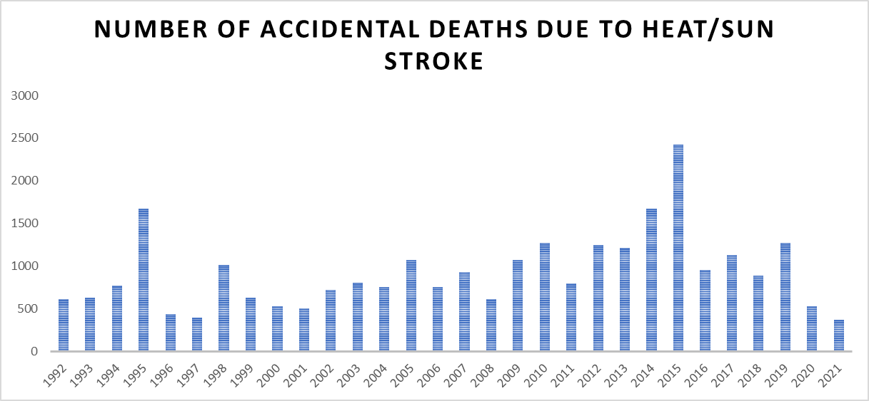
Source: Data derived from the National Crime Records Bureau (NCRB) & Vadodara City Heat Wave Action Plan 2020-21
  - Changing Rainfall Patterns and Flooding:
Climate change has altered precipitation patterns in India, leading to more intense and unpredictable rainfall events. Urban areas face the challenge of managing water resources efficiently, especially during the monsoon season. The Indian Institute of Tropical Meteorology (IITM) highlights an increase in extreme rainfall events, which are causing urban flooding. Cities like Chennai and Kolkata have witnessed devastating floods, underscoring the urgency of resilient urban planning (IITM, 2019).
  - Sea Level Rise and Coastal Cities:
India has a vast coastline with many cities situated along it. The rising sea levels, attributed to climate change, pose a significant threat to coastal urban areas. The World Bank's report on sea-level rise (2021) indicates that cities such as Mumbai and Kolkata are at risk of inundation. Adaptation measures, including robust coastal zone management and infrastructure development, are imperative to safeguard these cities (World Bank, 2021).
Fig 2: Sea Level Change 1900-2020
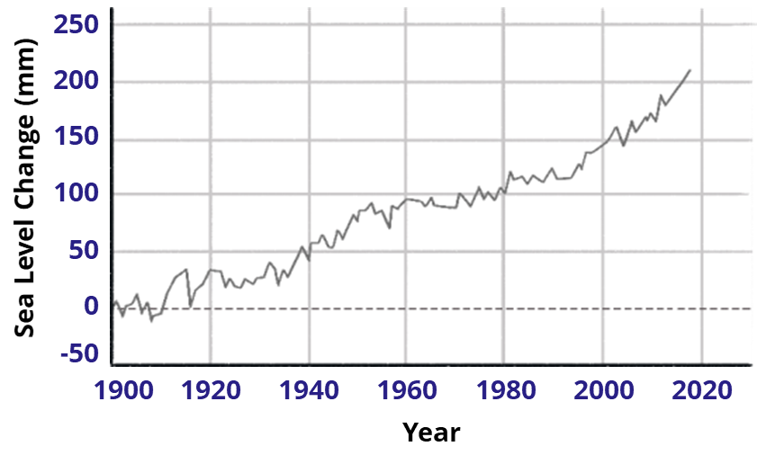
Data source: NASA (GISS)
  - Impact on Urban Biodiversity:
Urbanisation and climate change collectively affect biodiversity in urban areas. The Indian Institute of Science (IISc) notes that altered climatic conditions disrupt ecosystems and lead to changes in the distribution of flora and fauna. Urban green spaces are crucial for maintaining biodiversity, and their preservation becomes pivotal in the face of climate change (IISc, 2018).
  - Energy and Infrastructure Challenges:
Changing climate conditions necessitate adjustments in urban infrastructure and energy systems. The Indian government's National Action Plan on Climate Change (NAPCC) emphasises the importance of sustainable urban development and energy efficiency. The need for resilient infrastructure is underscored by research from the Centre for Science and Environment (CSE), advocating for climate-resilient urban planning to mitigate the impacts on energy and infrastructure (NAPCC, 2008; CSE, 2020)

Intersection of Climate Change and Urban Poverty
The intersection of climate change and urban poverty in India poses additional challenges for the urban poor population. As climate change intensifies, the urban poor in India are disproportionately affected by its impacts.
Climate change and urban poverty represent two pressing global challenges that intersect in a complex and symbiotic relationship. The adverse impacts of climate change exacerbate existing vulnerabilities in urban areas, disproportionately affecting impoverished communities. As cities expand and face the brunt of climate-related hazards, it is imperative to understand the interconnected dynamics between climate change and urban poverty to formulate effective and equitable mitigation and adaptation strategies.
Climate change exacerbates the challenges faced by the urban poor in India, intensifying their vulnerability to extreme weather events such as floods, heatwaves, and droughts.
  - Urbanisation and Vulnerability
The rapid urbanisation witnessed in recent decades has led to the concentration of populations in cities, often resulting in informal settlements and inadequate infrastructure. According to the United Nations, over half of the global population resides in urban areas, with projections indicating a continual rise. This urban expansion places a considerable strain on resources and increases vulnerability, as impoverished communities tend to settle in areas prone to environmental risks such as floods, storms, and heatwaves (UN DESA, 2018).
India's rapid urbanisation has led to the concentration of people in cities, creating densely populated areas that are particularly susceptible to the impacts of climate change. According to the World Bank, approximately 34% of India's population resides in urban areas, and this trend is expected to rise further (World Bank, 2021). The urban poor, living in informal settlements with inadequate infrastructure, are disproportionately affected by extreme weather events, such as floods, cyclones, and heatwaves.
  - Impacts of Climate Change on Livelihoods
Climate change poses a direct threat to the livelihoods of the urban poor in India, who often engage in vulnerable occupations such as street vending, waste picking, and informal labour. Rising temperatures, changes in precipitation patterns, and extreme weather events disrupt these informal livelihoods, pushing already marginalised communities deeper into poverty. A study by the International Labour Organisation (ILO) emphasises the susceptibility of informal workers to climate-induced shocks and stresses in urban areas (ILO, 2018).
  - Health Implications
The intersection of climate change and urban poverty in India also manifests in adverse health outcomes. Increased temperatures, along with inadequate access to clean water and sanitation in informal settlements, contribute to the spread of waterborne diseases and vector-borne illnesses. The World Health Organisation (WHO) underscores the health risks associated with climate change, particularly for vulnerable urban populations (WHO, 2018).
  - Urban Planning and Adaptation
In addressing the intersection of climate change and urban poverty, effective urban planning and adaptation strategies are crucial. However, India faces challenges in implementing resilient infrastructure and sustainable urban development. The Intergovernmental Panel on Climate Change (IPCC) highlights the importance of integrating climate-resilient policies into urban planning to safeguard vulnerable communities (IPCC, 2014). These policies should prioritise the provision of adequate housing, access to essential services, and relocation plans for vulnerable communities in high-risk areas.

Policy Responses and Adaptation Strategies
As the impacts of global warming intensify, the Indian government has adopted various policy responses and adaptation strategies to mitigate the adverse effects. These initiatives aim to safeguard vulnerable communities, ensure sustainable development, and build resilience in the face of changing environmental conditions.

Policy Responses:
- National Action Plan on Climate Change (NAPCC)
One of the most important policy efforts is the National Action Plan on Climate Change (NAPCC), which was introduced in 2008. The NAPCC offers a comprehensive framework for India's climate policy and aligns climate issues with the Sustainable Development Goals. It comprises eight national missions that concentrate on renewable energy, water conservation, sustainable habitats, energy efficiency, and sustainable agriculture. Notably, NAPCC highlights both mitigation and adaptation measures to safeguard vulnerable communities from climate-related risks.
- National Mission on Sustainable Habitat
The National Mission on Sustainable Habitat is particularly relevant to urban poor communities. The mission promotes energy-efficient urban planning, improved public transport systems, waste management, and climate-resilient infrastructure. It also encourages sustainable housing and urban mobility, which are essential for reducing the vulnerability of slum dwellers and low-income households. The mission recognises that urban climate resilience must be integrated with poverty alleviation and inclusive urban governance.
- Smart City Mission
The Government of India has also implemented the Smart Cities Mission to improve urban infrastructure and promote sustainable urbanisation. Although primarily designed for urban modernisation, the mission incorporates climate-sensitive measures, including intelligent water management, renewable energy, green public spaces, non-motorised transport, and disaster-resilient infrastructure. Several smart city projects include flood management systems, heat mitigation measures, and improved drainage systems, all of which indirectly benefit vulnerable urban populations.
- Atal Mission for Rejuvenation and Urban Transformation (AMRUT)
Another important initiative is the Atal Mission for Rejuvenation and Urban Transformation (AMRUT), launched in 2015. AMRUT focuses on providing basic urban services, such as water supply, sewerage, green spaces, and sustainable transportation. These services are crucial for the urban poor because inadequate access to clean water, sanitation, and drainage significantly increases vulnerability to climate-related diseases and disasters. By improving urban infrastructure and promoting environmentally sustainable urban planning, AMRUT contributes to climate adaptation in Indian cities.
- Pradhan Mantri Awas Yojana
Pradhan Mantri Awas Yojana (PMAY-Urban) aim to provide affordable housing for economically weaker sections and low-income groups. Climate-resilient housing reduces exposure to floods, heat stress, and extreme weather events. Through improved housing quality and access to basic services, the programme enhances adaptive capacity among the urban poor. To date, 125.36 lakh housing units have been sanctioned by the government. Out of these, 119.58 lakh housing units are grounded, 98.35 lakh housing units are completed, and 95.84 lakh have been occupied (PMAY, 11th May 2026).
- State Action Plans on Climate Change
India has also strengthened decentralised climate governance through State Action Plans on Climate Change (SAPCCs). States and Union Territories are encouraged to prepare localised climate adaptation strategies aligned with national objectives. These plans increasingly incorporate urban resilience, disaster preparedness, public health protection, and sustainable infrastructure development. Recent revisions of SAPCCs emphasise low-carbon and climate-resilient urban development pathways.
In recent years, the government has focused on urban climate resilience through measures like heat action plans, flood management systems, rainwater harvesting, and early warning systems. New drainage plans and infrastructure projects aim to mitigate flooding and extreme rainfall in cities.

Adaptation Strategies:
India has recognised the importance of adaptation strategies to cope with the unavoidable impacts of climate change. The National Adaptation Fund for Climate Change (NAFCC), established in 2015, supports projects and programs that enhance resilience in vulnerable sectors. The NAFCC finances initiatives such as water resource management, afforestation, and climate-resilient agriculture to reduce the vulnerabilities of communities dependent on these sectors.

Future outlook and recommendations for mitigating climate change effects on urban poverty in India
The future outlook for mitigating climate change effects on urban poverty in India requires a multi-faceted approach that addresses both the immediate and long-term impacts. Climate change poses significant challenges to urban areas in India, exacerbating existing issues of poverty, inequality, and vulnerability. As the impacts of climate change become more pronounced, particularly in urban centres, it is imperative to understand the future outlook and devise effective strategies for mitigating these effects on urban poverty. This essay explores the projected scenarios, along with recommendations for addressing climate change impacts on urban poverty in India.

Future Outlook:
According to the Intergovernmental Panel on Climate Change (IPCC), India is expected to face increasingly severe climate-related events, including heatwaves, floods, and cyclones, due to rising global temperatures (IPCC, 2018). Urban areas, characterised by high population density and inadequate infrastructure, are particularly vulnerable to these impacts. By 2050, it is estimated that India's urban population will reach 814 million, further exacerbating the challenges of urban poverty and climate vulnerability (UN DESA, 2018). The compounding effects of climate change on urban poverty are evident in the form of reduced access to clean water, increased food insecurity, displacement due to extreme weather events, and heightened health risks.

Recommendations for Mitigation:
- Investment in Resilient Infrastructure: Prioritise investments in resilient infrastructure, including nature-based solutions for drainage systems, water supply networks, and housing, to withstand the impacts of climate change. This can help reduce the vulnerability of urban populations to floods, heatwaves, and other extreme events.
- Promotion of Sustainable Urban Planning: Adopt sustainable urban planning practices that integrate climate resilience and poverty alleviation objectives. This includes promoting green spaces, mixed land-use development, and affordable housing options to enhance urban liveability and reduce vulnerability.
- Enhanced Social Protection Measures: Strengthen social protection measures to support vulnerable urban populations, including low-income households and informal workers, during climate-related disasters. This may involve expanding social safety nets, providing targeted financial assistance, and ensuring access to healthcare and education services.
- Capacity Building and Awareness: Enhance capacity building and awareness-raising efforts at the community level to improve resilience to climate change impacts. This includes training programs on disaster preparedness, sustainable livelihoods, and environmental conservation, empowering communities to cope with and adapt to changing climatic conditions.
- Integration of Climate Adaptation and Poverty Alleviation Policies: Integrate climate adaptation and poverty alleviation policies at the national, state, and local levels to ensure synergies and coherence in addressing both challenges. This requires coordinated action across sectors, including urban development, environment, health, and social welfare.

Conclusion
Addressing the intersection of climate change and urban poverty is essential for building sustainable and resilient cities in India. By adopting a multi-dimensional approach that combines investments in infrastructure, sustainable urban planning, social protection measures, capacity building, and policy integration, India can mitigate the adverse effects of climate change on urban poverty and create more inclusive and equitable urban environments for all residents.
In conclusion, tackling climate change and its impact on urban poverty in India requires a comprehensive and integrated approach that addresses the vulnerabilities of the urban poor.

References
- Agrawal, M. (2020, July 22). Multisector exposure and vulnerability to climate change in India: Case of National Capital Territory of Delhi, India. https://doi.org/10.1108/dpm-04-2020-0125
- Agrawal, M. (2020, July 22). Multisector exposure and vulnerability to climate change in India: Case of National Capital Territory of Delhi, India. https://doi.org/10.1108/dpm-04-2020-0125
- Ahmedabad Heat Action Plan 2019, www.nrdc.org/sites/default/files/ahmedabad-heat-action-plan-2019-update.pdf
- Enabling Private Investment in Climate Adaptation & Resilience, The World Bank; https://documents1.worldbank.org/curated/en/566041614722486484/pdf/Enabling-Private-Investment-in-Climate-Adaptation-and-Resilience-Current-Status-Barriers-to-Investment-and-Blueprint-for-Action.pdf
- Global warming of 1.5°C, An IPCC Special Report on the impacts of global warming of 1.5°C; https://www.ipcc.ch/site/assets/uploads/sites/2/2019/06/SR15_Full_Report_High_Res.pdf
- Government of India. National Action Plan on Climate Change (NAPCC), Ministry of Environment, Forest and Climate Change, 2008.
- Government of India. National Action Plan on Climate Change (Updated Information), Press Information Bureau, 2021.
- Government of India. Smart Cities Mission Guidelines.
- IPCC, Special Report on 1.5°C “Summary for Policy Makers”, 2018. www.ipcc.ch/sr15/chapter/summary-for-policy-makers/ (Accessed 28 May 2019).
- IPCC. (2018). Special Report on Global Warming of 1.5°C. Retrieved from https://www.ipcc.ch/sr15/
- National Crime Records Bureau (NCRB), India https://ncrb.gov.in/uploads/nationalcrimerecordsbureau/custom/1702014971Table10.pdf
- Pandve, H. T. “India’s National Action Plan on Climate Change.” Indian Journal of Occupational and Environmental Medicine, 2009.
- R. K. Chaturvedi, A. Gangopadhyay, A. Seshadri, and M. Hiremath (2018, January) Co-benefits of power sector decarbonisation for air quality and human health in India: http://dccc.iisc.ac.in/assets/pdf/Policy_Brief_January_2018.pdf
- Revi, A. (2008, April 1). Climate change risk: an adaptation and mitigation agenda for Indian cities. https://doi.org/10.1177/0956247808089157
- Revi, A. (2008, April 1). Climate change risk: an adaptation and mitigation agenda for Indian cities. https://doi.org/10.1177/0956247808089157
- Sahasranaman, A., & Bettencourt, L M A. (2021, June 1). Life between the city and the village: Scaling analysis of service access in Indian urban slums. https://doi.org/10.1016/j.worlddev.2021.105435
- Sahasranaman, A., & Bettencourt, L M A. (2021, June 1). Life between the city and the village: Scaling analysis of service access in Indian urban slums. https://doi.org/10.1016/j.worlddev.2021.105435
- UN DESA. (2018). World Urbanization Prospects: The 2018 Revision. Retrieved from https://population.un.org/wup/
- Vadodara City Heat Wave Action Plan 2020-21 https://vmc.gov.in/pdf/Annoucement/2020/Heat%20Wave%20action%20Plan%202020-21.pdf
- WRI India. Climate Resilient Cities: Assessing Differential Vulnerability to Climate Hazards in Urban India, 2024. wri-india.org

