The Price–Experience Trade-off in Organized Retail: A Comparative Study of Consumer Satisfaction, Store Choice, and Brand Advocacy in D-Mart and Competing Retail Chains

ABSTRACT
Consumer preferences, satisfaction, and store choice factors of organized retail in Bhopal were the subjects of this study. Using a descriptive research design, primary survey data was collected and analyzed at various levels to compare the prominent discount retailer, D-Mart, with alternative retailers. The results indicate that D-Mart's strong preference in the market is due to both aggressive pricing and product mix but does not correlate with a commitment to brand loyalty (high overall recommendation scores). There were operational bottlenecks that created friction between customers (crowd control/billing). Therefore, the cost-experience trade-off suggests that even though value-based pricing would attract customers and ultimately drive sales, for continued customer loyalty businesses will need to find a combination of affordability with the operational excellence of providing great experiences. This study suggests that the increasing importance of experience-driven variables affects how customers view and recommend products and services to others. This research extends knowledge on organized retail by examining Tier-2 urban markets rather than larger metropolitan markets. Retailers should be aware of the implications for their ability to provide both a low-cost and exceptional service or customer-centric operation.
Keywords: Organized Retail, Consumer Satisfaction, Store Choice, D-Mart, Brand Advocacy, Customer Loyalty, Price–Experience Trade-off, Consumer Behaviour.
INTRODUCTION
Background of the Study
Retail is an essential link between producers and final consumers in the current economy. In India, the evolution of retail has been tremendous, as the retail industry has shifted from traditional methods (such as “Kirana” stores in unorganised markets) into streamlined and standardised formats with branded supermarkets, hypermarkets and discount retailing (Sinha & Banerjee, 2004). The change toward organised retailing has occurred due to rapid urbanisation, increased awareness of digitisation, increased consumer purchasing power and an increased demand from consumers for convenience, variety and affordable prices (Mukherjee et al., 2011). Modern retailing in India is composed of a unique dual structure. On one hand there are traditional, unorganised retail formats (gang stores or street vendors), and on the other, modern corporate retail giants (Maruyama & Tiwari, 2016). With the increased reliance on digital ecosystems through high-speed networks connecting many Consumers through eCommerce, the Consumer has come to expect significantly higher levels of cleanliness, systematic billing processes, transparent pricing policies and ethics in pricing (Thomas & Sebastian, 2021).
As a result, purchasing patterns are transitioning from credit-based transactions with local businesses to more systematic, value-driven purchasing environments (Prasad & Aryasri, 2011). Bhopal, the capital of Madhya Pradesh, is a key urban consumption hub and a city where this retail transformation is occurring. This area is becoming an increasing target for market researchers and retailers due to its significant middle class demographic population, large student population and the increasing number of dual income households that reside in the capital. D-Mart (run by Avenue Supermarts Limited), which is one of the many retail chains in Bhopal, is garnering considerable attention through their everyday-low-cost (EDLC) and everyday-low-price (EDLP) formats (Hoch et al., 1994; Srivastava, 2018), having leveraged all of their operational and structural savings from visual merchandising onto the Consumers. Yet, there are many competitors within Bhopal that are challenging D-Mart's dominance using a variety of different business strategies, such as superior customer service, digital loyalty programs or superior spatial aesthetics to entice Consumers to their stores. (Srivastava & Thomas, 2010).
Statement of the Problem
In Bhopal, there is a wide variety of options when it comes to grocery and household item shopping. Because of this variety and the need for Bhopal consumers to determine price vs. convenience when making a purchase, it can be challenging for them to choose an option to purchase an item from. D-Mart is one of the dominant players within the organized retail sector, but there is apparent tension around the desire to drive prices to the lowest level possible, balanced with providing a satisfactory level of service to the customer. High-volume volume discount retailers often face operational hurdles that include crowded/over-crowded aisles, excessive wait times, and little or no assistance from staff in the store. It is very important to understand how much the presence of these operational hurdles impacts customer loyalty and the potential for active brand ambassadors. Or if they can overlook the operational barriers, they experience to see significant savings.
Objectives of the Study
- To construct a demographic profile of organized retail shoppers in a Tier-2 urban setting.
- To isolate and analyze the primary determinants driving retail store selection.
- To comparatively evaluate consumer satisfaction across operational dimensions (value, assortment, service environment) between D-Mart and rival chains.
- To assess the impact of operational stressors (e.g., waiting times, crowd density) on overall store advocacy and recommendation likelihood.
LITERATURE REVIEW
Conceptual Review
“Organized retail” refers to the large, commercialized stores we see in malls, shopping centers and other traditional retail outlets. They are regulated by the government through laws and regulations and also have professional management practices, clearly identified by brand name and/or logo, and have generally uniform operational policies. They typically have a structured physical environment; use a consistent, publicly available pricing system; and use a defined assortment of merchandise categories to drive sales. Organized retail has changed the way in which consumers purchase products from an independent/storefront retailer to an organized retailer. Consumers now choose to purchase from organized retailers primarily because they are providing a more reliable and convenient shopping environment than independent/storefront retailers. In the organized shopping environment, a consumer will be influenced not only by price, but also by their perception of value, convenience, accessibility, product variety, and overall shopping experience. Unlike an independent/storefront, where the consumer has built a level of trust through personal interaction and/or relationship with the owner or shopkeeper, the consumer builds their trust of an organized retail store through product assortment consistency, fixed pricing policies, and the overall cleanliness and maintenance of the store. Given that modern consumers are increasingly judging the overall total value of a store based on the entire experience (monetary cost, time spent, efforts expended, and satisfaction derived) associated with making a purchase, factors such as cleanliness, availability of products, customer service, checkout efficiency, store ambiance, available parking, and crowding could all play important roles in the consumer’s ultimate satisfaction with the store. While the majority of consumers are still attracted by lower prices, many modern consumers are also seeking a total experience that emphasizes the balance of price versus convenience and quality of service. If retailers fail to meet consumer expectations along any of these dimensions, they may see lower levels of consumer satisfaction and loyalty, even if they offer products at lower prices. Thus, the evolving consumer mindset supports the multidimensional nature of value and highlights that organized retailing must provide both economic (monetary) and experiential benefits.
Review of Recent Studies
Research studies carried out recently have shown evidence that Indian consumers are becoming more reliant on organized retail formats due to their perceived ability to deliver both financial savings and regular quality (Kumar & Mishra, 2023). Price-sensitive consumers tend to use discount format stores as their shopping choice, particularly in urban/semiurban markets (Gupta & Saxena, 2025). Furthermore, younger consumers are willing to experiment with new modern retail formats and place great importance on selection breadth, as well as efficiency within the shopping experience. In addition, the current retail literature has highlighted the increasing emphasis on the entire customer experience. While price is usually the primary motivator for purchasing at a specific retailer, there are several other variables that will influence a customer's intention to repurchase, including the store's physical environment; billing ease; and ease of navigation (Singh & Tiwari, 2024).
Once again, the issue of density within stores — in combination with long checkout lines — leads to decreased satisfaction with a store despite it being known for its low prices. Research studies that specifically examine Indian organized retail indicate that although D-Mart has a reputation for providing low prices and bulk shopping options, competing chains provide differentiated images based on convenience and their upscale store environments (Patel & Jain, 2025; Sharma & Verma, 2024). Ultimately, both cognitive and emotional assessments play a large role in influencing whether someone will recommend shopping at a specific location. As an example, an individual may find great value in purchasing items at a discount, but do not want to recommend that store if their physical experience in that store is extremely difficult.
Research Gap
While Tier-1 metropolitan cities like Delhi, Mumbai, Bangalore and Chennai have been the focus of much previous research into organized retail, there is little empirical evidence on consumer behaviour in Tier-2 cities. The emphasis of most previous studies has been primarily on factors such as retail format preference, service quality and customer satisfaction; however, little attention has been directed towards the consumer's trade-off between financial benefits and the experience of shopping. The unique characteristics of developing urban markets – i.e., varying income levels, price sensitivity and changing retail expectations – have similarly not been adequately investigated. Very little exists in terms of research that analyses operational elements including crowd management, billing efficiency, store cleanliness, staff responsiveness, etc., in relation to store selection or consumer advocacy. Consequently, this research aims to fill these gaps by examining the factors affecting store selection and satisfaction in Bhopal (a Tier-2 city in India), with the primary focus on consumer perceptions of balancing retail operational quality with their assessment of the economic advantages of shopping at those stores.
RESEARCH METHODOLOGY
Research Design and Sampling
A descriptive research design is used in the current study to explore consumer attitudes, preferences, and perceptions toward retail chains in Bhopal. This exploratory study utilized primary data collected from 2026 through a structured questionnaire. A non-probability convenience sampling approach was utilized which resulted in a final sample of 218 respondents.
Hypotheses
- H1: Primary store choice drivers significantly vary depending on the specific retail chain a consumer frequents.
- H2: Consumers perceive significant differences in core operational factors (product variety, staff behavior, cleanliness, and crowd management) between D-Mart and competing retail formats.
- H3: There is no significant difference in brand advocacy (overall recommendation score) between frequent shoppers of D-Mart and shoppers of competing chains.
- H4: Demographic variables, specifically age and household income, significantly moderate overall customer recommendation scores for organized retail chains.
Limitations of the Study
The limitations of this study are that the sample consisted Only of individuals who participated in a convenience sample in Bhopal, India therefore; it may not be possible to generalize these findings beyond local residents. The majority of respondents were 18 or 25 years which may not reflect younger individuals who have the ability to move from their hometown to find work.
DATA ANALYSIS AND INTERPRETATION
Demographic Profile
Analyzing the sample shows that almost three out of four participants are between 18 and 25 years old (76.61%). Therefore, the results will be dominated by feedback from young people and early careers that are very aware of prices and frequently compare values across multiple retailers. The changing nature of retailing can be viewed through the lens of the demographic composition of organized retailers. With the increased purchasing power of Generation Z, it is evident that these consumers are having an impact on retail shopping behaviour, as evidenced by the increase in vigour with which they respond to price discounts, promotions and product availability when purchasing products from various retail locations. Therefore, this information is critical to retailers who are targeting consumers that are value-oriented and digitally oriented.
Figure 1
Age Distribution of Survey Respondents
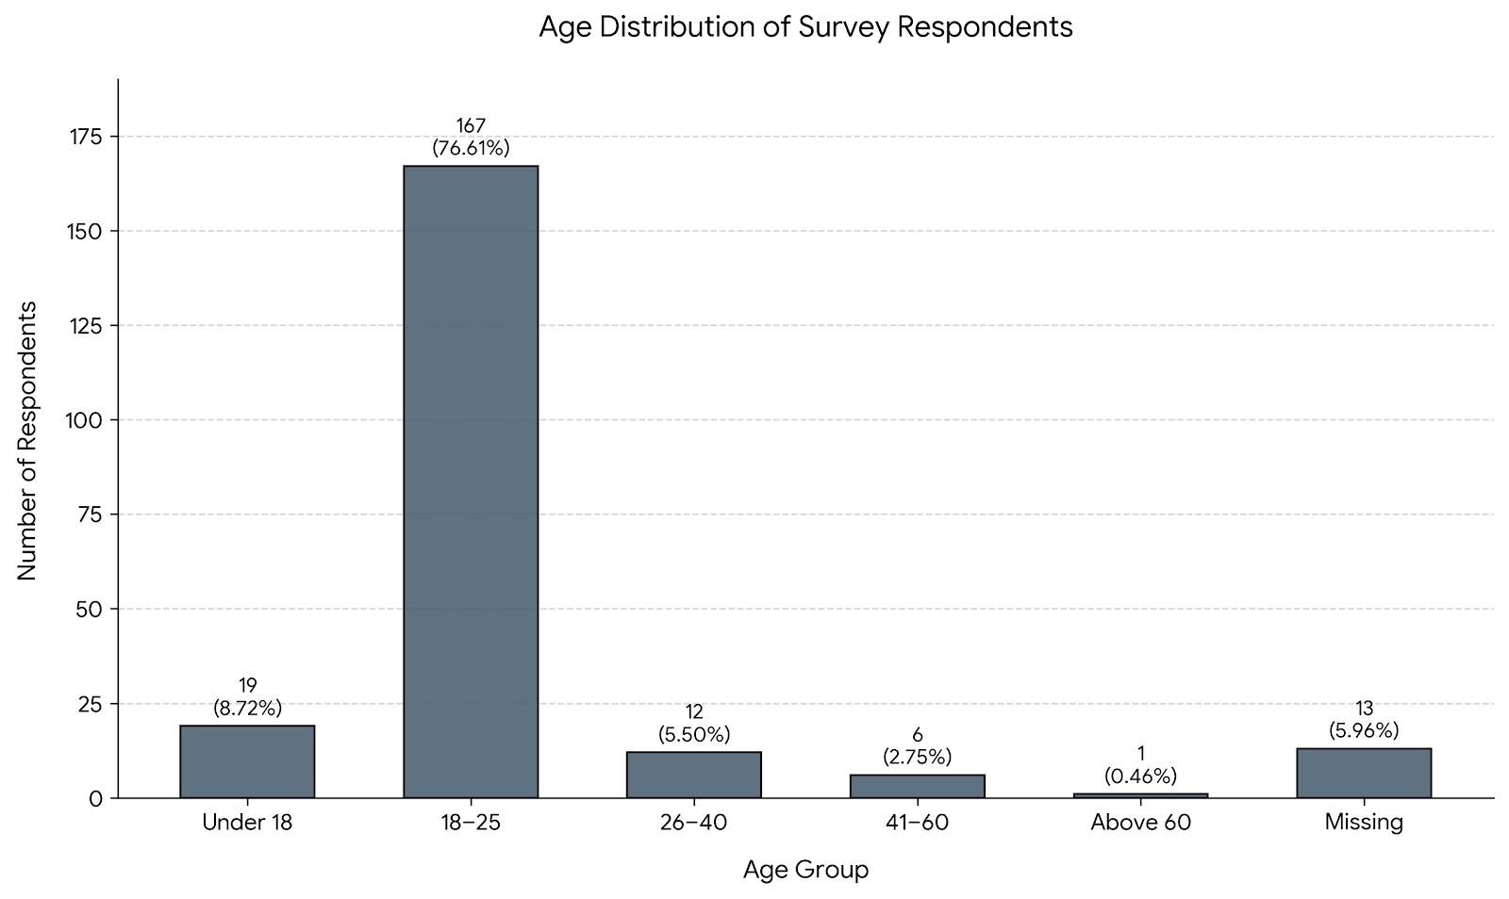
Note. The sample is predominantly youth-skewed, with the 18–25 demographic representing 76.61% of the total valid responses (N = 218).
Table 4.1: Monthly Household Income of Respondents
Income Group (INR) | Frequency | Percentage (%)
Below 25,000 | 85 | 39.17%
25,000–50,000 | 47 | 21.66%
50,001–1,00,000 | 34 | 15.67%
Above 1,00,000 | 30 | 13.82%
Missing | 21 | 9.68%
Total | 217 | 100.00%
(Note: Excludes 1 anomalous unclassifiable text entry)
The income distribution shows a robust presence of lower and middle-income households, perfectly aligning with the target market of discount-driven hypermarkets.
Retail Chain Preferences and Store Choice Drivers
Table 4.2: Retail Chain Most Frequently Visited
Retail Chain | Frequency | Percentage (%)
D-Mart | 153 | 70.18%
Reliance Smart / Smart Bazaar | 22 | 10.09%
Star Market / Local Supermarkets | 20 | 9.17%
Vishal Mega Mart | 9 | 4.13%
Missing | 14 | 6.42%
Total | 218 | 100.00%

Figure 2
Most Frequently Visited Retail Chain in Bhopal
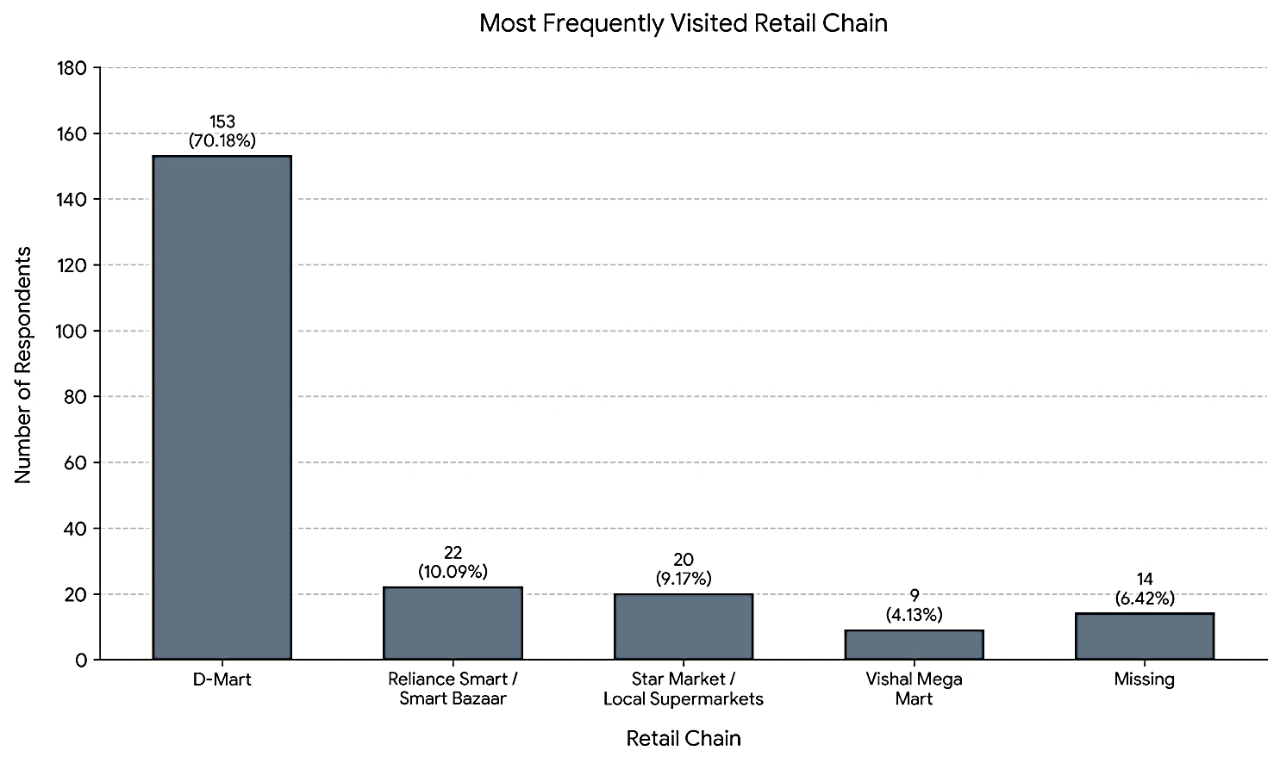
Note. The data illustrates a strong market concentration, with D-Mart capturing the significant majority (70.18%) of frequent store visitations compared to alternative retail formats (N = 218).
D-Mart has a clear lead in the Bhopal area, where it accounts for more than 70% of all people who go there regularly. The responses from shoppers as to why they shop at a certain store were overwhelmingly in favour of "Low Prices / Discounts" and "Variety of Products" - 78 respondents each. The next best reasons were 'Proximity to Home' (27 respondents) and 'Store Ambience' (18 respondents).
Hypothesis Testing
Testing H1: Store Selection Drivers
A Chi-square test of independence was conducted to examine the relationship between the primary reason for store selection and the most frequently visited retail chain.
- Result: Chi-square = 21.015, p = 0.0126.
- Inference: The null hypothesis is rejected. There is a statistically significant relationship between the primary reason for choosing a store and the actual chain visited. D-Mart captures the vast majority of price- and variety-seeking shoppers, while competitors draw more heavily on proximity and ambience.
Testing H2: Consumer Perceptions (D-Mart vs. Others)
Independent samples t-tests evaluated consumer perceptions of D-Mart against other chains.
Table 4.3: T-Test Results for Consumer Perceptions
Attribute | t-statistic | p-value | Conclusion
Product Variety | 3.91 | < 0.001 | Significant difference
Staff Behaviour | 2.1 | 0.037 | Significant difference
Cleanliness | 2.89 | 0.004 | Significant difference
Crowd Management | 2.07 | 0.04 | Significant difference
- Inference: The null hypothesis is rejected across all attributes. D-Mart shows distinct statistical differences in how consumers rate its operational environment compared to competitors.
Figure 3
Mean Consumer Perception Scores: D-Mart vs. Competitors
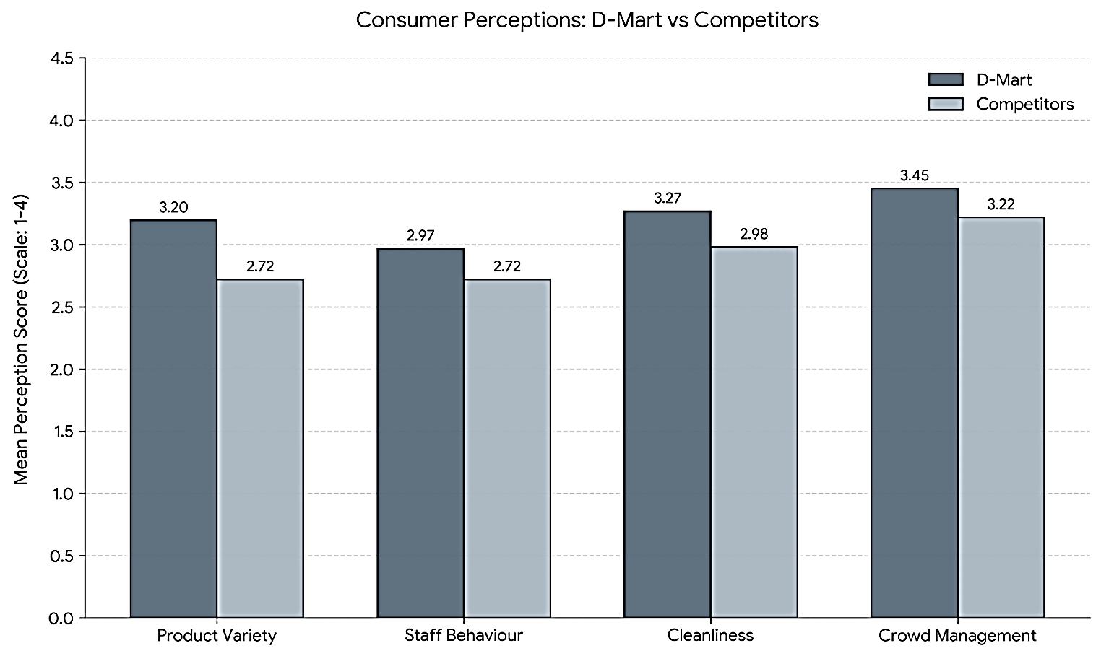
Note. Mean perception scores are measured on a 4-point scale (where 1 = Poor/Dissatisfied and 4 = Excellent/Much Better). Independent samples t-tests confirmed that D-Mart scored significantly higher across all four measured operational dimensions (p < .05).
Testing H3: Overall Recommendation Scores
An independent samples t-test compared the brand advocacy (out of 10) of frequent D-Mart shoppers versus those who frequent other stores.
- Result: t = -0.016, p = 0.987.
- Inference: Null hypothesis cannot be rejected. Even though D-Mart has more than enough footfalls and pricing perceptions, they are no more likely to have a customer recommend them than the other competing chains.
Table 4.4: Recommendation Score Summary
Metric | Value
Valid Sample Size | 203
Mean Recommendation Score | 5.58
Median Recommendation Score | 5
(Note: Score based on a 1-10 scale)

Testing H4: Influence of Demographic Factors
Analysis of Variance (ANOVA) tested the influence of demographics on recommendation scores.
- Age: F = 2.53, p = 0.042
- Income: F = 4.37, p = 0.005
- Inference: The null hypothesis is rejected. Both age and income significantly influence how highly consumers recommend an organized retail store, with high-income brackets demonstrating different loyalty thresholds than lower-income cohorts.
Operational Frictions and The Experience Trade-off
Correlation analysis among key satisfaction factors has identified structural correlations across operational attributes. Strong positive correlations exist between Cleanliness and Staff Behaviour (r = 0.361) and Product Variety and Crowd Management (r = 0.312). Interestingly, when reviewing these operational metrics individually, the correlation between their rating and the final Recommendation Score has a near-zero linear correlation. Thus, it suggests that there is an emotional complexity to the evaluation of customer advocacy that is not merely based on individual in-store attributes.Although qualitative sentiment and data indicate that D-Mart is the perceived leader in terms of discounts and product variety, the presence of significant crowd management difficulties and long wait times at billing counters highlights a massive “cost vs. experience” tradeoff. Since many customers experience such intense operational stressors from a retail outlet with high volume sales, they will stand in long queues for discounts; however, this same type of friction will strongly negatively impact customers' willingness to provide future recommendations for D-Mart.
CONCLUSION AND SUGGESTIONS
Conclusion
D-Mart has an impressive competitive edge in the organized retail sector in Bhopal, based mainly on a combination of competitive pricing and very large type of products offered. Consumers that shop in this Tier-2 city are extremely economic rational and will choose to purchase things based on lower cost than premium appearance, further solidifying D-Mart's low cost business model.However, this research identifies one major point of vulnerability for D-Mart; although they offer a great value proposition, it does not ensure that customers are loyal to and will advocate for the D-Mart brand. D-Mart received an overall recommendation rating of only 5.58 out of 10. This suggests that the significant operational challenges at D-Mart (i.e., crowding within the stores and long lines to checkout) can negatively impact the overall shopping experience. Therefore, shoppers tend to view D-Mart as a utility service provider, rather than a favoured brand. Customers only visit to save money, however their experience results in reluctance to recommend the store. Because of this, organized discount retailers need to implement strategies that will allow them to maintain a competitive position in the market. They need to find the right balance between absolute affordability and providing basic levels of operational excellence in their stores. Consumers choose D-Mart for value, but they recommend retailers for experience; therefore, sustainable retail success depends on balancing affordability with operational excellence.
Suggestions for Retail Managers
- Re-engineer Billing Efficiency: The checkout line often makes shoppers feel exhausted, retailers should consider using a dynamic queue management system, and use mPOS card readers in peak hours, and have a dedicated express line for customers with small purchases.
- Optimize Crowd Flow: High footfall shouldn't feel claustrophobic. Reevaluating store layouts to implement one-way aisles in high-demand grocery sections can prevent bottlenecks and improve physical comfort.
- Capitalize on Youth Demographics: With Gen Z consumers aged 18-25 being the most significant segment of customers visiting retail stores, retailers must incorporate technology-driven solutions into their locations, such as mobile apps that enable instant payment through bar code scans, so that they can streamline their payment process and decrease the need for physical cash registers. Retailers who implement and adopt these types of self-service payment applications will have fewer traditional checkout stations in their stores.
- Targeted Advocacy Building: When it comes to retail management, deep discounting isn't enough for generating high recommendation rates, so managers need to also make an investment in 'delight factors'. An example would be rapidly recovering from a service failure. By providing clearer overhead signage to make it easier for customers to navigate the store and by being proactive and restocking shelves before they run out, the cognitive perception of the brand can change from 'cheap' to 'valuable and reliable'.
REFERENCES
- Berman, B., Evans, J. R., & Chatterjee, P. (2022). Retail Management: A Strategic Approach. Pearson.
- Gupta, S., & Saxena, R. (2025). Consumer shopping behaviour and discount retailing in emerging urban markets. Journal of Contemporary Retail Research, 7(4), 201-219.
- Hoch, S. J., Drèze, X., & Purk, M. E. (1994). EDLP, hi-lo, and margin arithmetic. Journal of Marketing, 58(4), 16-27.
- Kotler, P., Keller, K. L., & Chernev, A. (2022). Marketing Management. Pearson.
- Kumar, R., & Mishra, S. (2023). Consumer preference in organized retail grocery markets in urban India. Journal of Retail and Consumer Studies, 18(2), 45-61.
- Levy, M., Weitz, B., & Grewal, D. (2023). Retailing Management. McGraw-Hill.
- Maruyama, M., & Tiwari, M. (2016). The evolving retail landscape in India: From unorganized to organized formats. Asian Business Review.
- Mukherjee, A., Satija, D., Goyal, T. M., Mantrala, M. K., & Zou, S. (2011). Are Indian consumers brand conscious? Insights for global retailers. Asia Pacific Journal of Marketing and Logistics, 23(3), 284-299.
- Patel, D., & Jain, R. (2025). Comparative study of organized grocery retail chains in tier-2 Indian cities. Indian Journal of Commerce and Management, 14(1), 67-83.
- Prasad, C. J., & Aryasri, A. R. (2011). Effect of shopper attributes on retail format choice behaviour for food and grocery retailing in India. International Journal of Retail & Distribution Management, 39(1), 68-86.
- Sharma, P., & Verma, A. (2024). Price perception and customer loyalty in Indian value retail. International Journal of Business and Management Research, 12(1), 88-104.
- Singh, N., & Tiwari, M. (2024). Store atmosphere, service quality, and purchase intention in Indian supermarkets. Asian Journal of Marketing Studies, 9(3), 122-139.
- Sinha, P. K., & Banerjee, A. (2004). Store choice behaviour in an evolving market. International Journal of Retail & Distribution Management, 32(10), 482-494.
- Srivastava, R. K. (2018). Discount retailing in India: The D-Mart model. Journal of Business Strategy.
- Thomas, J., & Sebastian, S. (2021). Digital transformation in Indian retail: E-commerce and payments integration. Technology & Market Trends.

