A Case Study on Using Samana Chikitsa and Virechana to Effectively Manage Mandala Kushtha
Abstract: With a frequency of 0.44%–2.8% in India, psoriasis is a global health burden that primarily affects people between the ages of 30 and 40. Males are twice as likely as females to be affected. The ancient book states that "Kushtha Roga" (Skin illnesses) is used as a general term for the greatest number of skin conditions, which are referred to be "Achikitasa" (Untreatable) and "Mahagada" and are said to be Tridoshaja (three body humors). According to Acharya Charaka's Vyadhi (illness), psoriasis and Mandala Kushtha are connected depending on how the symptoms manifest. A 40-year-old housewife visited the outpatient department of Kayachikitsa at Rajkiya Ayurved Hospital Motichohhta, Udaipur, in 2020. Her main concerns were purplish red areas with scaling and itching all over her body. The entire body had purplish reddish scaly spots when the skin was examined. The patches have clear boundaries. The patches were hard, high, dry, and had rough surfaces. The diagnosis of Mandala Kushtha was made based on the symptoms that were seen.
Patient was advised for virechana and shamana aushadi along with pathya-apathya advice. Following virechana treatment, the patient saw great improvements in the objective (psoriasis area), total cessation of new lesions, and significant relief from itching, scaling, and healing of previous lesions.
KEYWORDS: Mandal kustha, Psoriasis, Virechana, Maanibhadra yoga, Trivrita avaleha, Kaisor guggulu, Navakarshik Kwath. case study.
INTRODUCTION: The biggest organ in the body, the skin is constantly in contact with the outside world. It acts as an essential barrier to keep the inside organs safe from biological, chemical, mechanical, and physical harm. Numerous illnesses can either directly impact the skin or show up as interior abnormalities. Any skin condition or injury frequently becomes a huge concern for a person since it is visible. What Skin can interact with and endure environmental elements thanks to a number of natural protection systems. However, a variety of skin disorders may develop when these defence mechanisms are unable to handle excessive or damaging stimulation.
With a prevalence of 0.44%–2.8% in India, psoriasis is a global health burden that primarily affects people between the ages of 30 and 40. It is a persistent, inflammatory, and proliferative skin disorder that is linked to systemic manifestations involving various organs and typically forms red, scaly, strongly delineated, indurated plaques, mostly on the scalp and extensor surfaces of the body. According to Acharya Charaka, psoriasis can be linked to Mandala Kushtha based on symptom presentation. The aetiology of Mandala Kushtha can be understood based on the general aetiology of Kushtha, with the clinical presentation of Swetarakta (faint reddish white), Utsanna Mandalam (raised patches), Snigdham (unctuous), and Annyonyasansaktm (patches joined with each other) primarily involving Kapha Dosha.
Shodhana and Shamana therapies are used to treat Kushtha. The purpose of this study is to assess the impact of Shamana Chikitsa on Mandala Kushtha.
Case Report
A 40 year-old widow Hindu female patient is a Housewife, came to the Rajkiya Ayurved Hospital Motichohhta, Udaipur in the outpatient department of kayachikitsa with chief complaints of erythematous patches, scales presented with generalized itching and burning sensation since 2020. Taking detailed history revealed that she had a known case of psoriasis, the patient stated that, initially he experienced a tiny red circular spot over the epigastric region and forehead in November 20. The spots gradually developed hat subsequently took on a silvery look. The patient initially took allopathic or modern drugs (corticosteroids and methotrexate) on worsening of the condition for about 1 year and got relieved with no further dermatological-related complaints for about 2 years. In 2023, she experienced a relapse but found no relief from the previous treatment.
Ashtasthana Pariksha
- Nadi (Pulse) – Vata Pradhana kapha
- Mala (Stool) - Samyak
- Mutra (Urine) - Samyak
- Jivha (Tongue) - Lipta
- Shabda (Speech) - Prakrita
- Sparsha (Tactilation) - Ushna
- Druka (Eyes) - Prakruta
- Akriti (Anthropometry) – Madhyama
Physical Examination
- Blood pressure – 128/82 mm of Hg.
- Pulse rate – 78 beats/min.
- Respiratory rate – 16/min.
- Temperature – 98.60 F
- Bowel – Constipated
- Appetite – Decreased (Less intake of food)
- Micturition – 2-3 times/ day
- Sleep – Normal

Systemic Examination:
- Respiratory system - on auscultation, normal sounds heard and no abnormality detected.
- Cardiovascular system - S1 S2 heard and no abnormality detected.
- Gastrointestinal system - Soft, non-tender, no organomegaly detected.

Examination of Skin Inspection
- Size & shape – Large and Irregular.
- Nature of skin - Dry purplish red patches on forehead and trunk.
- Color – Purplish red
- Thickness – 1 mm to 1.4 mm thick
- Nature of Lesion - Purplish red elevated lesions
- Discharge - Powdery discharge.
- Color of Discharge – Silvery color.
Treatment Underwent
The patient was advised for Virechana Karma and internal medication for 1 month. The details of the therapy are given below:
The details of the therapy are given below:
1. Purva karma
2. Pradhana karma
3. Paschat karma
Purva karma
Purvakarma comprises of Deepana & Pachana, Snehana followed by Abhyanga and Swedana.
Sr. no | Karma | Ayurvedic Yoga | Dose, Frequency and Time | Duration
 | Deepana Pachana | Panchkola churna | 3gm before food twice a day for 5 days | 04/01/2026 to 15/01/2026
2. | Snehapana | Mahatiktaka ghrita | 30ml at 7.20 am with lukewarm water | 08/01/2026
2. | Snehapana | Mahatiktaka ghrita | 30ml at 7.20 am with lukewarm water | 09/01/2026
2. | Snehapana | Mahatiktaka ghrita | 30ml at 7.20 am with lukewarm water | 10/01/2026
2. | Snehapana | Mahatiktaka ghrita | 30ml at 7.20 am with lukewarm water | 11/01/2026
2. | Snehapana | Mahatiktaka ghrita | 30ml at 7.20 am with lukewarm water | 12/01/2026
3. | Sarvanga Abhyanga | Psoria oil | Between 9am to 10am for minimum 20 minutes for 3 days | 13/01/2026 to 15/01/2026
4. | Sarvanga Swedana | Dashmoola Kwatha | Between 9am to 10 am for minimum 20 minutes for 3 days | 13/01/2026 to 15/01/2026

Pradhana Karma:
On the day of administration of Virechana Yoga (15/01/2026), Abhyanga followed by Swedana was performed. Vital parameters such as pulse, blood pressure, temperature, and respiration rate were recorded at regular intervals during Pradhana Karma. Virechana Yoga was administered at 10:00 a.m. on an empty stomach. It was prepared using 150 ml of Triphala Kwatha (decoction) and 60 g of Trivrit Avaleha. The patient was given hot water and advised to sip it repeatedly as needed. The patient was kept under strict observation to prevent any complications. The total number of Vegas (motions) was 26, counted until the appearance of the proper symptoms of Virechana, such as the passage of stool with mucus in the last two motions and subsequent signs and symptoms. The type of shuddhi achieved was pradhana shuddhi.
Paschata Karma:
After Samyaka Virechana, Samsarjana Krama was planned for 7 days from 15/01/2026 to 22/01/2026, with three meal timings explained to the patient in the form of Peya, Vilepi, Yusha, and Kruta–Akruta Yusha, followed by a normal diet. Considering the involved Dosha and Dushya, the patient was prescribed Shamana Chikitsa along with dietary restrictions, avoiding excessive salty, spicy, junk, and packaged foods, as well as curd. Medicines for both oral and topical application were advised.
Internal Medication
Sl.No | Name of Medicine | Dose | Time | Anupana
 | Navakarsheeka Kwath  +  Kushthagna mahakashaya | 10gm | BD (Before food) | -
 | Kaishor Guggulu | 2 tabs | BD (Before food) | Lukewarm water
 | Maanibhadra yoga | 3gm | BD (After food) | Lukewarm water
 | Tab Triphala | 1 tab | BD (After food) | Lukewarm water
 | Psoria oil | L/A | - | -

Pathya Ahara
Acharya Charaka defines pathya as dietary and lifestyle choices that are good for the body and mind, have no negative repercussions, and promote general well-being. The recommended the diet consists of aged grains (Purana Dhaanya, or old cereals), bitter-tasting vegetables (Tikta Shaaka, or bitter greens), and quickly digested foods (Laghu Anna, or light meal). Green gram (Mudga), snake gourd (Patola), and lean meat (Jaangala Maamsa—meat from animals living in arid regions) are also advised.
It is thought to be best to use wheat (Godhuma), barley (Yava), Shashtika Shaali (a unique species of rice specified in Ayurveda), and ancient preserved rice (Purana Shaali). Due to its medicinal and cleansing properties, food and ghee made with Nimba (neem) and Triphala (a blend of three fruits: Amalaki, Bibhitaki, and Haritaki) are recommended. Drinks like Aushadha and Khadira Jala (a decoction of Acacia catechu wood) Samskruta Takra, or medicated buttermilk, is good for preserving doshic balance and digestive health.

Subjective scoring (ayurvedic symptom score)
Symptoms | Score
Kandu (Itching) | 0 - No itching
Kandu (Itching) | 1 - Mild itching comes occasionally, duration - 2–3 min
Kandu (Itching) | 2 - Moderate itching occurs frequently, 3–4 times in a day, duration - 3–10 min
Kandu (Itching) | 3 - Severe itching occurs frequently, more than 4 times in a day, each  episode lasting more than 10 min
Mandala Roopa (Oval/ Round shape) | 0 - No Mandala
Mandala Roopa (Oval/ Round shape) | 1-2–4 Mandala, smaller than a rupee coin
Mandala Roopa (Oval/ Round shape) | 2-2–4 Mandala, larger than a rupee coin
Mandala Roopa (Oval/ Round shape) | 3 - >4 Mandala, smaller than a rupee coin
Mandala Roopa (Oval/ Round shape) | 4 - >4 Mandala, bigger than a rupee coin
Daha (Burning) | 0 - No burning
Daha (Burning) | 1 - Mild burning, no intervention required
Daha (Burning) | 2 - Moderate burning, 3–4 times in a day; cream or emollients soothes burning
Daha (Burning) | 3 - Severe burning, more than four times in a day; cream or emollients required many times to soothe burning
Vedana (Pain) | 0 - No pain
Vedana (Pain) | 1 - Mild pain, no intervention required
Vedana (Pain) | 2 - Moderate pain
Vedana (Pain) | 3 - Severe pain

Assessment of Ayurvedic symptom score
Symptom | BT score | AT score
Kandu (Itching) | 3 | 0
Mandala Roopa (Oval/ Round shape) | 4 | 2
Daha (Burning) | 2 | 0
Vedana (Pain) | 2 | 0

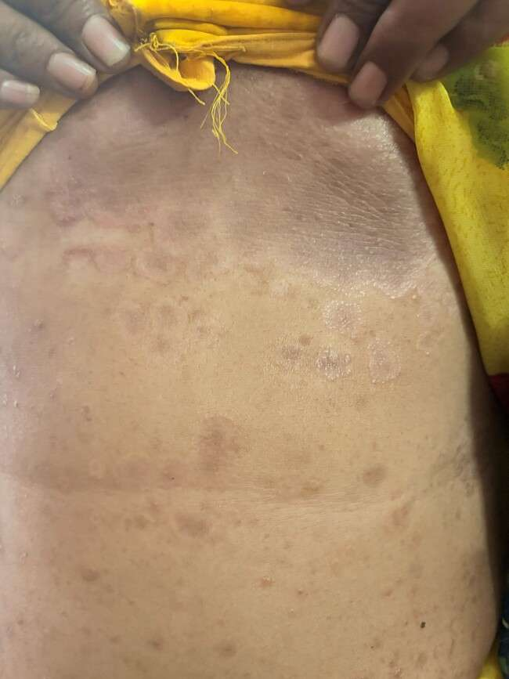
After

After
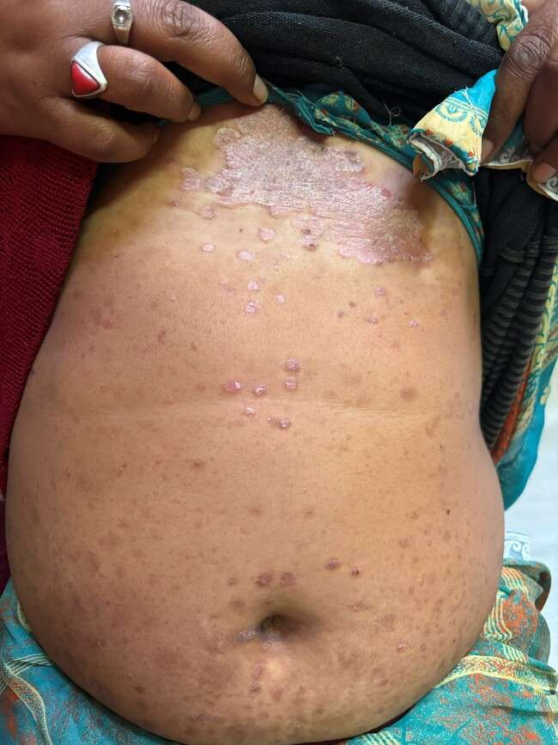
Before

Before

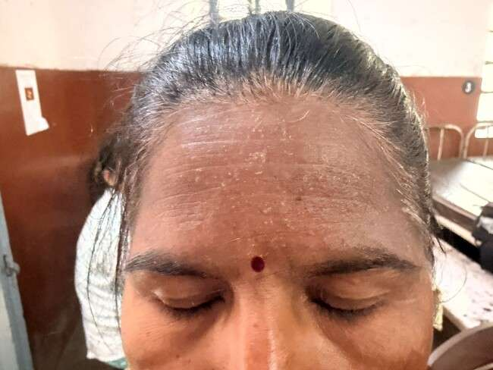
After

After

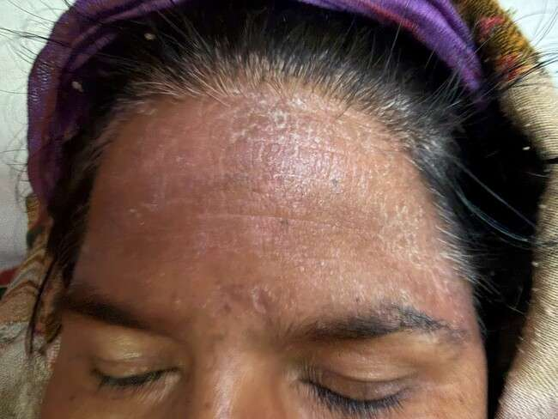
Before

Before

DISCUSSION
The predominance of Kapha among the Tridosha, which results in the vitiation of Twaka (skin), Rakta (blood), Mamsa (muscle), and Lasika (lymph), is the main cause of Mandal Kushtha. Consuming Nidana (causative elements) aggravates Doshas concurrently and causes these Dhatus exhibit laxity (Shaithilyata). Kushtha is the result of the aggravated Doshas further influencing the weakened Dhatus. For the treatment of Kushtha, Ayurveda suggests both Shamana (palliative) and Shodhana (purification) therapies. Based on distinctive indications and symptoms, the patient in this instance was diagnosed with Mandal Kushtha. Virechana is regarded as one of the Shodhana processes. the most popular and successful treatment because it effectively eliminates the vitiated Doshas, is comparatively simple to give, causes less discomfort, and has fewer side effects than Vamana. To aid in the digestion and removal of Ama, Deepana and Pachana medications should be used before to Snehapana. Mahatiktaka Ghrita was chosen for Snehapana. Acharya Charaka originally discussed this formulation in the Kushthachikitsa Adhyaya. In terms of its therapeutic effectiveness, According to Acharya Charaka, this formulation can treat serious illnesses (Mahavikara) that are otherwise incurable despite hundreds of formulations.Saptaparna, Prativisha, Shampaka, Tiktarohini, Patha, Musta, Ushira, Haritaki, Vibhitaki, Amalaki, Patola, Pichumarda, Parpataka, Dhanvayasa, Chandana, Pippali, Pippalimula, Padmaka, Haridra, Daruharidra, Sadgrantha, Vishala, Shatavari, Sariva, Krishnasariva, Vatsakabija, Vasa, Murva, Amruta, Kiratatikta, Yashtimadhu, Trayamana, and Murchita Gogritha. Numerous conditions, including Kushta, Raktapitta, Visarpa, Amlapitta, Visphota, Pama, Pandu, and Vatarakta, are among those for which it is recommended. Their main purpose was to extract the Doshas from the body as a whole and bring them into Koshtha [18] Sarvanga Abhayanga and Swedana clear the obstruction in Srotas, moving the vitiated Dosha from Shakha to Kostha. For virechana in Kushtha, Trivrit, Danti, and Triphala are to be employed. In this instance, Virechana Triphala Kwatha (100ml) was the primary decoction used in Karma (purgation therapy), along with (60gm) as the purgative agent; the patient's condition will determine the combination and dosage. These substances have laxative, blood-purifying, and anti-inflammatory qualities.A biological purifying process is likely the mechanism of Virechana Karma. It aids in clearing the Kostha (gastrointestinal tract) and eliminate the body's stored morbid Doshas. In addition to cleansing the Srotas (body channels), this process supports homeostasis, tissue renewal, and improved immunity by helping to maintain the balance of Doshas and Dhatus (bodily humors and tissues).Consequently, A crucial therapeutic strategy in the treatment of Mandal Kushtha is Virechana Karma.The seven medicines of Kushthaghna Mahakashya—Amalatasha, Khadir, Bhallatak, Haridra, Amalaka, Haritakai, and Vidanga—that are described in Kushtaghna Mahakashaya highlight the herbal combination's distinctiveness and suggest its significance as a medication for all skin conditions. The primary ingredient of Kaisor Guggulu is Guduchi along with Dravyas like Triphala, Guggulu, Tryushana, Sunthi, Trivrita etc. It has Raktasodhaka, Rasayana, Vatahara and Dahaprasamana property (anti-inflammatory action). Guggulu has an excellent Balya, Rasayana, Varnya, Vatabalasjita property, being Tridosaghna in action it relieving from pain (analgesic) and inflammation (anti-inflammatory).
CONCLUSION
There are notable clinical and pathological similarities between Tinea corporis in contemporary dermatology and Mandala Kustha as described in Ayurveda, especially in their distinctive circular, erythematous, and scaly lesions linked to itching. Ayurveda attributes Mandala Kustha to the vitiation of Rakta dushti and Kapha and Pitta doshas, resulting in localized skin conditions.A comprehensive framework for successful and long-lasting treatment is provided by an integrative management approach that includes Shodhana (purificatory therapies), Shamana (palliative measures), and Rasayana (rejuvenative therapy).
This method lowers the recurrence rates frequently observed with traditional antifungal treatments by treating the underlying doshic imbalance in addition to relieving symptoms. promote more holistic, patient-centered, and sustainable therapeutic strategies for managing fungal skin infections.

References
1. Poluri LV, Indugula JP, Kondapaneni SL. Clinicomycological Study of Dermatophytosis in South India. J Lab Physicians. 2015 Jul Dec; 7(2): 84-v89.
2. Nigam PK. Antifungal drugs and resistance: Current concepts. Our Dermatol Online 2015; 6(2):212- 221
3. S. Tripathy. Rising prevalence of dermatophytosis in India: A matter of concern. International Journal of Infectious Diseases 2016; 45(Supplement 1):318.
4. El-Gohary M, van Zuuren EJ, Fedorowicz Z, Burgess H, Doney L, Stuart B et al.,. Topical antifungal treatments for tinea cruris and tinea corporis (Review). The Cochrane Collaboration. Published by John Wiley & Sons, Ltd. 2014.
5. Management of tinea corporis, tinea cruris, and tinea pedis: A comprehensive review. Indian Dermatol Online J. 2016; 7(2): 77-86.
6. Dogra S, Uprety S. The menace of chronic and recurrent dermatophytosis in India: Is the problem deeper than we perceive? Indian Dermatol Online J 2016; 7:73-6.
7. Relapse after Oral Terbinafine Therapy in Dermatophytosis: A Clinical and Mycological Study. Indian J Dermatol. 2016; 61(5):52-533.
8. Agnivesha, Charak, Dridhabala, Charak Samhita, chikitsa Sthana, Kushthachikitsa adhyaya 7/ 10 edited by Prof. Priyavrat Sharma, 9th edition, Chowkhamba Orientalia Varanasi, 2005. 9. Kaviraj Atridev Gupta, Astangahrdayam, Nidansthana, Kusthshvitrakriminidan adhyay edited by Vaidya Yadunandana Upadhyaya, Chowkhamba Sanskrit sansthan, Varanasi,2005; 14/3-4.
10. Kaviraj Atridev Gupta, Astangahrdayam, Nidansthana, Kusthshvitrakriminidan adhyay edited by Vaidya Yadunandana Upadhyaya, Chowkhamba Sanskrit sansthan, Varanasi,2005;14/16-17.
11. Agnivesha, Charak, Dridhabala, Charak Samhita, chikitsa Sthana, Kushthachikitsa adhyaya 7/4-8 edited by Prof. Priyavrat Sharma, 9th edition, Chowkhamba Orientalia Varanasi, 2005.
12. Khopkar U,Bhalani Book Depot, skin disease and sexual transmitted infections, 4th edition,2001;91- 94.
13. J.S.Pasricha, Treatment of skin disease, oxford & IBH publishing co. pvt. Ltd.2001;111-114.
14. Agnivesha, Charaka Samhita, Elaborated by charaka and Dridhabala, Vaidyamanorama Hindi Commentary by Acharya Vaidyadhara Shukla, Prof. Ravi Dutt Tripathi, Chaukhamba Sanskrit Pratishthan, Delhi, 2006.Vol-1 Sutrasthana 25/45-46, p-347.

