Detection of Anomalies in smart factory Industrial plant using Machine learning Algorithms

Abstract— With the continuous increase in IoT Technology, Safeguarding the IoT system plays a very vital role for the devices[1],[5]. It is essential to provide end-to-end security for these devices[5]. This Article presents a method to provide security to Smart IoT Machinery plants by using Machine Learning Models[14],[17]. Majority of the Machine learning models are used for Real time monitoring the detection in IoT devices[18],[24]. The work involves collecting data from Sensor devices and control systems from Machinery Plant[5]. This data is used for training the Machine learning models to detect the anomalies[9],[21]. After the Models are trained there was a significant improvement found in accuracy and decrease in False positive rate[8],[17]. Both Supervised and Unsupervised Machine learning thiniking was used to classify the unusual data. An improved Anomaly detection was found in Supervised learning compared to unsupervised thereby increasing security and efficiency[6],[7]. In Addition, infrastructure of IoT and Enhanced algorithm reduction gives better efficiency in operation by reducing unscheduled downtime and improving resource utilization. This study encompasses the importance of machine learning-based approach for security solutions by comparing the end results with the previous research on security for IoT and unusual detection in industrial atmosphere[17],[18],[21],[25].

Keywords—Anomaly Detection IoT, Machine Learning, Supervised Learning, Unsupervised Learning

- Introduction
Homogenization of IoT into Machineries has enabled Autonomous property in Smart factories[1],[2],[3]. But there is a threat of Anomalies in the machinery part which when not addressed leads to serious damages and breakdown of the entire unit. These smart factories have a combination Cyber and Physical system[4],[5]. Providing the security is most crucial in Cyber Physical System[4],[5]. Because of this advancement in technology there is a demand to bring a revolution by combining IoT and Machine learning. Earlier work focuses on customary Machine learning practical skill for Anomaly detection[13], but this technique lacks accuracy and efficiency[21]. Labeled data learning skill like random forest provides better accuracy[6] and efficiency whereas on the other hand unsupervised learning techniques like isolation forest gives better solutions for detecting novel anomaly[7],[8]. Several Research as undertaken in finding the best techniques[17],[23] that overcomes the problem and provides best solution[18]. Highly Robust and flexible machinery parts, tools and equipment’s are manufactured in smart machinery plants. Each of this module plays a very crucial role in development of industry and infrastructure. The data/information produced by the machinery is highly important for data processing. One of the most machinery parts is the sensors connected onto the input end.
Even with an IoT device sensors are a vital component for sensing the data from the environment and collecting the data. Machine sensors capture data such as temperature, vibration, speed and pressure[5]. Data collected via this sensor flows to the System through networks which are capable of interpreting the data, recognizing the patterns and taking proper decisions. However smart manufacturing is not only about efficiency and accuracy but also includes how secure the system is.
Smart manufacturing has entered suddenly into industrial use. This practice has the ability to make a major or positive change where it can be redefined the way of manufacturing machine operate and deliver a qualified product to market. In this highly advanced environment ,even a small mistakes in the sensor reading can also lead to the critical situation sometimes. But then to to monitor the readings and heterogeneous data manually its highly for the longer practical is very difficult[10],[17]. Existing studies show that IoT ecosystems generate the streams of readings[9],[17],[18] few of them are i.e. temperature, pressure, vibration, and power consumption data and the tradition manual method include purely statistical methods and struggle with the complexity. Recent research turns to the machine learning to automate anomaly detection and improve the safety of the machinery[12],[15],[20],[18],[24].
To get know about these challenges , necessary programmed machine that which is not needed to a person to watch it every-time and rarely makes the mistake. And even it can read the amount of information which are provided by the machines instantly, so detecting the anomalies could be done before it breaks. For this the Machine Learning provides a suitable solution, as it can learn from the features and patterns from the historical data and
identifying the faults without depending upon the predefined rules[16],[22],[9].
In particular, when the sensor recognises the new changing patterns they get fix to themselves and adapting for the environment, without no human to fix them, where system conditions may vary over time[17],[19].
In this project, a Machine Learning based approach is given for the anomaly detection in the smart factory using the sensor data. The main focus is about analyzing the streams or parameters such as temperature, vibrations, power consumption, humidity to understand the machine behaviour and detecting the abnormal condition[12],[14]. Where the machine itself can look after it .Here both supervised and unsupervised learning techniques are implemented to evaluate their differences in them and identifying the anomalies. The supervised model, Random forest, is used to differentiate the faults depends on the labeled data[6]. It is best suitable when you already know the group of problem and have the information from the past. While in unsupervised model, Isolation Forest, it is used to determine the unknown data or unexpected data faults without any prior labeling[7],[8],[23],[21]. It is most appropriate when a new problem arrives that have never happened.
The most important goal is to find differences in the performances and difference of two approaches and understand their strength and limitations in real world example. By doing this ,the one get to know the aims to select an appropriate models for anomaly detection industries. Additionally, this proposed approach helps to improve the system programmed way and enabling for the early detection in the machinery. So, it therefore reduces the unexpected errors and downtime, and by supporting predictive maintenance strategies[12],[14].
To make the factory in smarter and safer in anomaly detection in factory environments, it is also matters to consider how often a model correctly predicts and even the the practically in real time application. In many industrial scenarios, system operates continuously and even they respond quickly in machine behaviour. Therefore, models used for abnormal detection should be fast, smart, and the data today & huge amount of data tomorrow without slowing down and capable of handling real-time data streams[15],[16],[25].
Overall, this study help us to make the growth of practical useful and easy to use for the unusual determination techniques for the smart factory environments. It is very important to combine the methods using information and number to make decisions with factory machines to enhance both by making faster ,cheaper and keeping it less waste and system security.
- METHODOLOGY
This work builds and compares two machine‑learning models, Random Forest (supervised) and Isolation Forest (unsupervised), to detect anomalies in smart factory sensor data containing temperature, pressure, vibration, speed, and a fault label. The goal is to support predictive maintenance by automatically flagging abnormal machine behavior instead of relying on manual checks or fixed thresholds Sensor features used are temperature, pressure, vibration, speed, and a fault indicator label for supervised learning .

Two models are implemented in Python/Colab with scikit-learn:
1. Random Forest (supervised): ensemble classifier trained on labeled fault data (Fault_Machine = 1) to identify known faults with high robustness .
2. Isolation Forest (unsupervised): trained on scaled multivariate sensor data; learns to isolate anomalous points without labels, using scores and a percentile-based threshold to mark top ~3% as anomalies.

Unsupervised results are visualized via PCA scatter plots with anomalies highlighted .
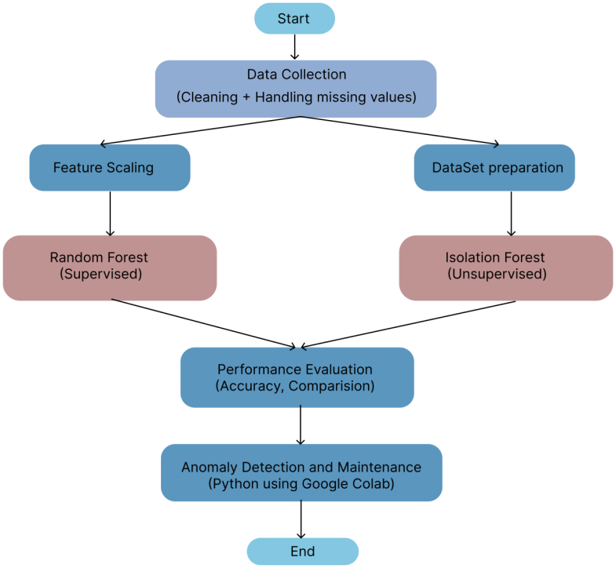
This model works step by step as shown like :
1.Start : The process starts with defining the objective like teaching with the normal looks like collecting the data from sensors such as temperature,vibration etc, of detecting anomalies in smart factory environments using machine learning techniques.
2.Data collection (cleaning +handling missing values):
Data is collected from smart factory sensors that continuously monitor machine conditions. The dataset includes parameters such as:
- Temperature
- Pressure
- Vibration
- Speed

Data Preprocessing: Before model training, the collected data undergoes cleaning:
Handling Missing Values
Missing sensor readings are treated using:
- Mean/median imputation
- Forward/backward filling (for time-series data)
- Noise Removal
Noisy values caused by faulty sensors are filtered.
- Data Consistency
Ensures all sensor readings are in a uniform format.

3.Feature Scaling: Feature scaling is applied to normalize the range of independent variables.

Why it is needed:
- Sensor data has different units (e.g., temperature vs vibration)
- Prevents bias toward larger magnitude features

Techniques used:
- Standardization (Z-score normalization)
Mean = 0, Standard deviation = 1
- OR Min-Max scaling (0 to 1 range)
This step is especially important for the Isolation Forest model, which relies on distance-based splitting.

4. Dataset Preparation
The dataset is prepared differently for supervised and unsupervised learning:

For Random Forest:
- Input features: Sensor values
- Output label: Fault Machine (0 = normal, 1 = fault)
- Dataset is split into:
- Training set (e.g., 80%)
- Testing set (e.g., 20%)

For Isolation Forest:
- Only input features are used (no labels)
- Additional categorical features (like Machine Type) are: Encoded using label encoding or one-hot encoding
- Data is scaled before training

5. Random Forest Model (Supervised)
Random Forest is a learning process that construct various choice trees and unites their outputs.

Working:
- Each tree is skilled on a random subset of data
- Final prediction is rooted on majority voting

Advantages:
- High accuracy
- Handles non-linear relationships
- Robust to noise and over-fitting

6. Isolation Forest Model (Unsupervised)
Isolation Forest is used to detect anomalies without labeled data.

Working Principle:
- Anomalies are “few and different”
- The model isolates anomalies using fewer splits in trees

Steps:
- Train model on sensor data
- Compute anomaly scores
- Define threshold (e.g., top 3% anomalies)

Key Parameters:
- Number of trees (e.g., 200)
- Contamination factor (expected anomaly percentage)

Output:
- -1 → anomaly
- 1 → normal

7. Performance Evaluation
The models are validated using arrangement metrics:

For Random Forest:
- Accuracy → Overall correctness
- Precision → Correct anomaly predictions
- Recall → Ability to detect actual faults
- F1-score → Balance of precision and recall
- ROC-AUC → Model discrimination ability

For Isolation Forest:
- Compared using:
- Detected anomalies vs actual faults
- ROC-AUC score
- False positives

8. Anomaly Detection and Maintenance
The trained models are deployed in a simulated environment.

Tools Used:
- Scikit-learn → Model building
- Pandas → Data handling
- NumPy → Numerical operations
- Matplotlib → Visualization

Implementation:
- Models predict anomalies on incoming data
- Results are visualized using:
- Graphs
- PCA plots (for dimensionality reduction)

The process concludes with identifying the best-performing model and analyzing in real-world industrial scenarios. The final system can be used to increase the machine optimize maintenance strategies in smart factories.
Data Features
- Smart factory sensor data: temperature, pressure, vibration, speed, plus Fault_Machine (1 = fault) .
- For unsupervised modeling, extra fields like Machine_Type, Power_Usage, Humidity are encoded and scaled before training .
Model 1: Random Forest(Supervised)
- Uses labeled Fault_Machine to learn the connection between sensor readings and known faults .
- Ensemble of decision trees improves accuracy, robustness, and generalization for known fault types .
Model 2: Isolation Forest(Unsupervised)
- Trained only on sensor features (no fault labels).

ii. Learns to isolate anomalies based on the idea that abnormal points are easier to separate from the majority .
Steps:
- Train Isolation Forest with 200 trees and automatic contamination setting .

ii. Compute anomaly scores and set threshold at 97th percentile, treating top ~3% scores as anomalies .
Iii. Visualize results via PCA 2D scatter plot, coloring anomalies vs normal points .

Implementation Tools:
Implemented in Python on Google Colab using Scikit‑learn, NumPy, Pandas, and Matplotlib for model training, scaling, and plotting .
Core detection performance metrics
Confusion‑matrix based metrics: Many works use Precision, Recall, F1‑score, Accuracy, sometimes with MCC and Kappa, for cyber/IIoT and process anomalies 1234+3 MORE.
- Precision: fraction of alarms that are real anomalies.
- Recall: fraction of true anomalies that are detected; often emphasized to avoid missed failures.
- F1‑score: Balance mean of Exactness and Recall, widely used to summarize trade‑offs.
- Accuracy: overall correctness, but can be misleading with class imbalance.
AUC‑ROC and AUC‑PR are also used for aggregate discrimination performance, focusing on minority data .
Time‑series–aware metrics: For ICS and KPI time series, point‑wise metrics (Accuracy, F1) can be inappropriate because attack/ fault intervals have fuzzy start/end times. Range‑based metrics such as time‑series aware precision and recall (TaPR) and an improved variant that handles “ambiguous instances” per attack are proposed for more realistic evaluation of temporal intervals.
Extended evaluation dimensions:
- Real‑time and resource constraints: Real‑time IIoT studies include latency per record, processing rate, and execution time as Quality‑of‑Service metrics for scalability and responsiveness. Memory footprint and detection delay are also assessed in streaming CPS settings.
- Environmental and hardware impact: Several benchmarks jointly consider model energy consumption, CO₂ equivalent, training/inference time, and hardware complexity, alongside Accuracy, AUC, Precision, Recall, F1, MCC, and Kappa, to support “Green AI” trade‑offs.
- Explainability‑focused frameworks: Explainable AI frameworks for IoT anomaly detection introduce metrics such as correctness, simplicity, reality, speed, generalization, completeness, fidelity, coverage, and sometimes precision of explanations, to judge XAI methods layered on top of detectors.
- Bench marking and selection frameworks: Industry‑specific benchmarks rank anomaly detectors using context‑dependent criteria such as timeliness, threshold setting, qualitative classification, and suitability for real‑time production data. Image‑based industrial benchmarks (IM‑IAD) add supervision level, robustness to noisy labels, memory use, and inference speed across many datasets.

- RESULTS & DISCUSSION
Random Forest achieves perfect classification (no false positives or negatives) on the labeled dataset, while Isolation Forest detects no true faults and produces false positives, reflecting poor recall in this setting.
Random Forest’s main limitation is dependence on labeled data; Isolation Forest’s strength is operating without labels but with weaker fault detection here.
Tested a new way to detect the irregularities in system was collecting both supervised and unsupervised ML model on industrial sensor data. The Random Forest model showed excellence in the performance by detecting the machine faults, and achieving high accuracy along with the strong precision. This tells that the model was capable of correctly classifying the difference between both normal and abnormal conditions, when it is trained with labeled data. The results were clearly shown and demonstrated that supervised learning is highly effective for identifying the known anomalies in industrial environments.
The ROC curve comparison between the two models is shown in Figure I.
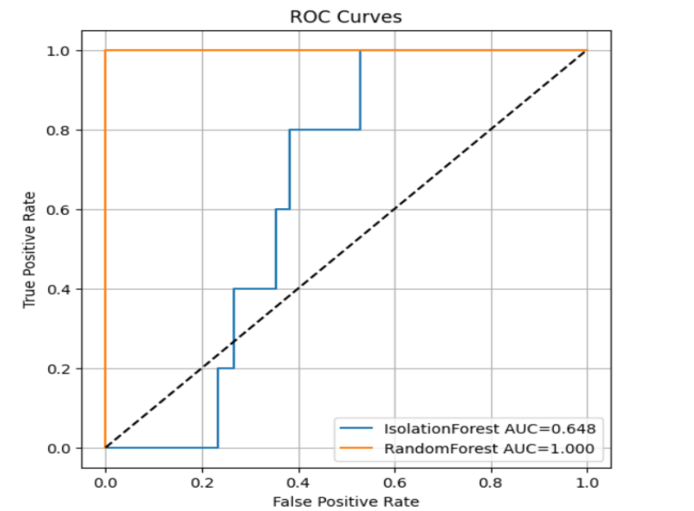
Figure I: ROC Curve Comparison between Random Forest and Isolation Forest
Figure I compares the ROC-AUC accuracy of the supervised RF model and the unsupervised Isolation Forest model. The RF model achieved an ROC-AUC score of 1.000, which indicated perfect classification among performance on the labeled dataset. In contrast, the Isolation Forest model achieved an ROC-AUC score of 0.648, showing lower anomaly detection. The comparison highlights the effectiveness of supervised learning when labeled industrial fault data is available.
Table 1 compares the accuracy of RF and Isolation Forest models assessed evaluation metrics such as ROC-AUC, precision, recall, and confusion outcomes.
Table 1: Performance Comparison of Supervised and Unsupervised Models
Aspect | Random Forest | Isolation Forest
Key metrics | ROC-AUC 1.000, Precision 1.0, Recall 1.0, F11.0 | ROC-AUC 0.648, Precision 0.0, Recall 0.0
Confusion Outcomes | TP 5, FP 0, FN 0 | TP 0, FP 8, FN 5
Strengths | Perfect classification; no miss classification | Works without labels; detects few anomalies
Weaknesses | Needs labeled data, poor for unseen faults | Fails to detect faults; many false positives
On the other hand ,the Isolation Forest model comparatively gave the lower performance. Even thought it was built to find the strange faults without knowing the data-set beforehand.The model made higher number of errors and incorrect predictions which was not able to achieve the same level of accuracy as the Random Forest model. This highlights the limitation of the unsupervised approaches when applied to the complicated industrial datasets.
The top anomalies detected by the Isolation Forest model are shown in Figure II.
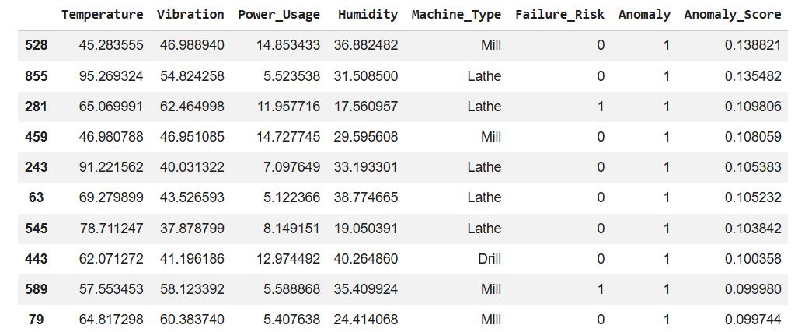
Figure II: Top Detected Anomalies with Anomaly Scores
Figure II presents the top anomalies detected by the Isolation Forest model along with their anomaly scores. The table contains sensor readings such as temperature, vibration, power usage, humidity, and machine type. Higher anomaly scores indicate abnormal machine behavior that varies operating conditions. These detected anomalies can help industries identify potential machine faults and perform predicted maintenance before critical failures occur.
Further analysis of the results revealed that the Isolation Forest model found the unusual data form of anomaly in the Industries by giving them strangeness scores, but it failed to differentiate clearly between the normal and abnormal data points.A Visualization Techniques such as Principal Component Analysis (PCA) to understand and map how the data form is grouped. Because of the mix-up the plotted results were in bad/different data points are blended in normal data in the feature space, making the model hard to detect the anomalies accurately.
The PCA-based visualization of detected anomalies is shown in Figure III.
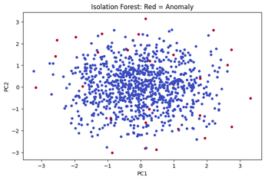
Figure III: PCA Visualization of Isolation Forest Anomaly Detection
Figure III shows the PCA-based visualization of anomalies detected using the Isolation Forest algorithm. The red-colored points represent anomalous machine conditions, while blue points indicate normal operating conditions. Principal Component Analysis (PCA) was used to reduce the high-dimensional sensor data into two dimensions for visualization. The figure illustrates that Isolation Forest identifies only a few data points as anomalies, but several anomalies overlap with normal data regions, indicating weaker separation capability compared to supervised learning approaches.
The literature review notes many existing approaches (LSTM, hybrid RF+IF, ensembles, auto-encoders, clustering), with common issues of high complexity, demand for substantial labeled datasets, or limited real-world validation.
Within this context, the work shows that a simpler supervised Random Forest can perform extremely well when labels are available, while unsupervised Isolation Forest may struggle on this particular dataset but remains useful where labels are scarce or new fault types arise .
Interpretation
Random Forest perfectly separates faulty vs non‑faulty cases on this dataset, showing that with reliable labels and clear signal patterns, a simple supervised ensemble can deliver very high accuracy for known fault types .
Isolation Forest fails to detect actual faults (zero true positives) and instead marks several normal points as anomalous, giving low ROC‑AUC and zero recall .This suggests its anomaly scores do not align well with the true fault labels in this small dataset.
Context vs Existing Work
The literature table shows that:
Deep learning (LSTM, CNN, auto-encoders) often needs large datasets, high computation, and GPUs, making the difficult for some factories .
Hybrid and ensemble methods (e.g., RF + IF) may be accurate but are complex and harder to deploy at the edge .
Within this context, the work shows that:
Simple supervised Random Forest can be highly effective when labeled data is available.
Smart and IoT-driven factories use machine learning to detect abnormal sensor or network behavior that may indicate faults, security incidents, or process deviations. Results are usually reported with accuracy, precision, recall, F1-score, and ROC-AUC, and often compare supervised vs. unsupervised models.
Effectiveness and Performance Metrics
Factory / IIoT sensor anomalies
- In an IoT-driven factory with 15,000 sensor instances, Logistic Boosting reached AUC 0.992, 96.6% accuracy, 93.5% precision, 94.8% recall, F1 = 0.941, outperforming Random Forest (AUC 0.982) and SVM on imbalanced data 1.
- A transformer + Logistic Boosting hybrid on similar smart-factory data improved to 98.2% accuracy, 96.7% precision, 97.1% recall, F1 = 0.969, AUC 0.996 2.
- In a smart manufacturing plant, ML-based models increased anomaly detection rate by 13% and reduced false positives by 3%, improving safety and response time 3.
Device / network-level anomalies in factories
Gradient boosted decision trees achieved 99.997% accuracy and 99.995% F1 for emulated attacks on smart-factory devices, after ML-based device identification (XGBoost: 97.6% accuracy, F1 97.6%) 4.
Comparative and cross-domain evidence
- Across IoT/Industry 4.0 datasets, Random Forest and Autoencoders often emerge as top performers among supervised and unsupervised methods, respectively, with high accuracy and F1 scores 56.
- In industrial time-series systems, supervised RF and SVM reached ~89–91% accuracy, while unsupervised Auto encoder and Isolation Forest achieved ~84–89% where labels are scarce.
Practical Impacts in Manufacturing
Machine-learning anomaly detectors have been associated with: Downtime reduction up to 29% and repair cost reduction ~20% in manufacturing systems 6.
Improved safety and fewer critical incidents in smart plants due to earlier detection and lower false positives 3.
Across smart factories and industrial IoT, ML-based anomaly detection routinely reaches >90% accuracy and strong F1/ROC-AUC, with boosting ensembles and Random Forest often leading among supervised models and autoencoder/Isolation-Forest–style models effective when labels are limited. These gains translate into less downtime, lower costs, and higher safety in manufacturing environments.
Unsupervised Isolation Forest remains conceptually valuable where labels are scarce or new faults appear, but may need careful tuning or combination with other methods on real industrial data .
Overall, the results suggest that while unsupervised models provide Flexible for detecting new data or unknown data, However they are tricky to use because they need some corrected parameter to use. And their performance depends on the on data characteristics and parameter selection. On other hand, supervised models like Random Forest offer more dependable and more steady result data when it is available. This study highlights the importance of choosing the appropriate model depending on the characteristics of the datasets and requirements.
IV.CONCLUSION
Machine learning can effectively detect anomalies in smart factory sensor data and support predictive maintenance. Supervised Random Forest delivers excellent accuracy on known faults, whereas Isolation Forest offers a label-free option but with weaker performance on this data; together they illustrate trade-offs between supervised and unsupervised strategies for Industry 4.0 systems. Methodologically, the work follows a clear pipeline: select key machine health sensors, pre-process and scale data, train a supervised Random Forest and an unsupervised Isolation Forest, then evaluate them with classification metrics and visualizations. The discussion emphasizes a tradeoff: Random Forest gives excellent performance when faults are well labeled, while Isolation Forest offers label free anomaly detection but showed limited effectiveness on this particular smart factory dataset.
V.REFERENCES
[1] L. Da Xu, W. He, and S. Li, “Internet of Things in Industries: A Survey,” IEEE Transactions on Industrial Informatics, vol. 10, no. 4, pp. 2233–2243, 2014.
[2] J. Wan, M. Yi, D. Li, C. Zhang, S. Wang, and K. Zhou, “Mobile services for customization manufacturing systems: An example of Industry 4.0,” IEEE Access, vol. 4, pp. 8977–8986, 2016.
[3] K. Zhou, T. Liu, and L. Zhou, “Industry 4.0: Towards future industrial opportunities and challenges,” in Proc. Fuzzy Systems and Knowledge Discovery, 2015, pp. 2147–2152.
[4] E. A. Lee, “Cyber Physical Systems: Design Challenges,” in Proc. IEEE International Symposium on Object/Component/Service-Oriented Real-Time Distributed Computing (ISORC), 2008, pp. 363–369.
[5] H. Boyes, B. Hallaq, J. Cunningham, and T. Watson, “The Industrial Internet of Things (IIoT): An analysis framework,” Computers in Industry, vol. 101, pp. 1–12, 2018.
[6] L. Breiman, “Random Forests,” Machine Learning, vol. 45, no. 1, pp. 5–32, 2001.
[7] F. T. Liu, K. M. Ting, and Z. Zhou, “Isolation Forest,” in Proc. IEEE International Conference on Data Mining (ICDM), 2008, pp. 413–422.
[8] M. Goldstein and S. Uchida, “A comparative evaluation of unsupervised anomaly detection algorithms,” Pattern Recognition, vol. 47, no. 9, pp. 2971–2983, 2014
[9] S. S. Khan, A. Madden, “One-class classification: taxonomy and challenges,” IEEE Transactions on Knowledge and Data Engineering, 2023.
[10] S. Yin, X. Li, H. Gao, and O. Kaynak, “Data-based techniques for fault detection and diagnosis in industrial systems,” IEEE Transactions on Industrial Electronics, vol. 61, no. 11, pp. 6418–6428, 2014.
[11] C. C. Aggarwal, Outlier Analysis, 2nd ed. Springer, 2017.
[12] A. Carvalho, E. Nascimento, R. Chaves, et al., “A systematic literature review of machine learning methods applied to predictive maintenance,” Computers & Industrial Engineering, vol. 137, 2019.
[13] V. Chandola, A. Banerjee, and V. Kumar, “Anomaly Detection: A Survey,” ACM Computing Surveys, vol. 41, no. 3, 2009.
[14] J. Lee, H. Davari, J. Singh, and V. Pandhare, “Industrial AI and predictive analytics for smart manufacturing systems,” Manufacturing Letters, vol. 18, pp. 20–23, 2018.
[15] S. Zhang, S. Wang, and Q. Ji, “Deep learning-based anomaly detection in industrial IoT,” IEEE Access, vol. 7, pp. 124–135, 2019.
[16] S. Yin, H. Luo, and S. X. Ding, “Real-time implementation of fault-tolerant control systems,” IEEE Transactions on Industrial Electronics, vol. 61, no. 11, pp. 6409–6417, 2014.
[17] A. A. Cook, G. Misirli, and Z. Fan, “Anomaly detection for IoT time-series data: A survey,” IEEE Internet of Things Journal, vol. 7, no. 7, pp. 6481–6494, 2020.
[18]Y. Liu, C. Chen, “Deep anomaly detection for industrial IoT: A review,” IEEE Internet of Things Journal, 2023.
[19] P. Malhotra, L. Vig, G. Shroff, and P. Agarwal, “Long short term memory networks for anomaly detection in time series,” ESANN, 2015.
[20] R. Chalapathy and S. Chawla, “Deep learning for anomaly detection: A survey,” arXiv preprint arXiv:1901.03407, 2019.
[21] M. Ahmed, A. Mahmood, “Recent advances in anomaly detection techniques for high-dimensional data,” IEEE Access, 2022.
[22] I. Goodfellow et al., “Generative adversarial nets,” in Proc. Advances in Neural Information Processing Systems (NeurIPS), 2014.
[23] M. A. F. Pimentel, D. A. Clifton, L. Clifton, and L. Tarassenko, “A review of novelty detection,” Signal Processing, vol. 99, pp. 215–249, 2014.
[24] J. Zhang, X. Wang, “Machine learning-based predictive maintenance in Industry 4.0: Recent developments,” Journal of Manufacturing Systems, 2023.
[25] H. Ding, Y. Zhou, “Explainable AI for anomaly detection in industrial IoT systems,” IEEE Access, 2023.
[26] R. Li, Q. Liu, “Real-time anomaly detection in smart manufacturing using edge AI,” IEEE Transactions on Industrial Informatics, 2024.
[27] P. Zhao, L. Tang, “A hybrid deep learning framework for anomaly detection in cyber-physical systems,” IEEE IoT Journal, 2022.
[28] S. Kumar, R. Singh, “Time-series anomaly detection using LSTM and autoencoders in industrial systems,” Sensors, 2023.
[29] A. Verma, S. Patel, “Energy-efficient anomaly detection in IIoT using lightweight ML models,” IEEE Access, 2024.
[30] T. Nguyen, D. Pham, “Unsupervised anomaly detection in IoT networks: A survey of recent trends,” Future Generation Computer Systems, 2022

