A Machine Learning–Based Inventory Optimization Framework for Predictive Inventory Replenishment

Abstract
An effective inventory management system in for relief aid distribution requires an accurate demand forecasting and proactive replenishment strategies. However, existing approaches often address these demand predictions, safety stock computation, and restock decisions as separate processes that resulting in limited operational integration. This study proposes a machine learning–based inventory optimization framework for predictive inventory replenishment that addresses this gap by integrating forecasting and automated decision-making into a unified system. The framework utilizes a Gradient Boosting Regressor to predict continuous demand scores based on historical inventory data and engineered features. A priority classification mechanism is applied using the weighted demand index followed by priority-based safety factor mapping to differentiate inventory control policies. Safety stock is computed using forecast standard deviation, service factor, and lead time, while the reorder point (ROP) is calculated to determine replenishment thresholds. The automated restock decisions are generated by comparing inventory levels with the computed ROP. The framework was evaluated using a community dataset that comprises more than 76,000 records, resulting a small proportion of items (105 out of 16,200) were flagged for restocking and indicating an effective and targeted replenishment. The priority-based analysis further confirms that high-priority items are well-protected against demand variability, while low-priority items are managed efficiently to minimize excess inventory. Overall, the proposed framework demonstrates its capability to support data-driven and proactive inventory management that makes it suitable for relief operations and other dynamic supply chain environments.
Keywords: Machine Learning, Inventory Optimization, Demand Forecasting, Inventory Replenishment, Supply Chain Management, Decision Support Systems

Introduction
Efficient inventory control is ever-instrumental in ensuring that the needed items are availed whilst in the process avoiding the extravagant expenses), and operational non-productiveness. The response to moving needs like relief aid delivery and management Community inventory are struggling with issues like the dynamics of demand and resource scarcity [1] – [3]. There exists a tendency of the traditional inventory control systems to use set reorder levels that cannot respond to the changing operating environments which lead to either stockouts or stockpile [4], [5].
The newer improvements in machine learning and the use of data-driven methods have made it possible to have more predictive controls of demand and stock prediction. As research has demonstrated, the historical demand, the occurrence of disasters, and the characteristics of consumption examples observed, interfering with the use of the ML-based approach have shown better results as compared to the classic statistical models [6] – [8]. Gradient Boosting, XGBoost, and LightGBM are some of the algorithms that have been shown to be very accurate when it comes to predicting continuously demanded influences of dynamic and high-variable settings [9], [10]. Also, the desire to combine priority-based inventory and safety stock calculation continued to be one of the most popular trends that optimize stocks without providing any compromise to service [11], [12].
Although they have made this progress, a broad gap in the inventory optimization framework is relative to application areas where machine learning techniques can help predictively company inventory loads, differentiate between the company inventory items based on their respective priorities or operational criticality, select safety stocks alternatives in the face of demand variability as well as an automated restocking decision that is inclined in the predicted demand.
Current strategies are simply isolated parts where one looks at materials forecasting and the other makes use of safety stock computation [13] – [16]. Besides, the majority of research takes the predefined models of AI without implementing the algorithms based on the operational situation without making them operational in the context of relief aid or other resources-constrained settings.

Methodology
The methodology follows a six-stage computational framework, which systematically converts historical demand data into automated restocking decisions.
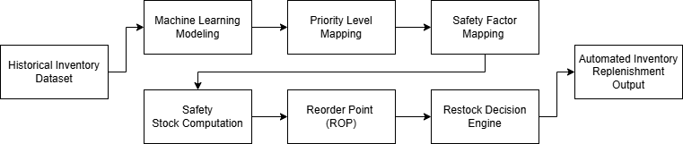
Figure 1. Proposed Machine Learning–Based Inventory Optimization Framework
Figure 1 shows the stages included on the proposed framework, the stages are machine learning modeling, priority level mapping, safety factor mapping, safety stock computation, reorder point, and restock decision engine.
Historical Inventory Dataset
In this case, a community dataset retrieved through a disaster relief logistics and inventory management dataset was used. The data set includes over 76,000 records and 10 variables which affect relief supply needs in various districts. The original data contains the columns of the following items: id, district, inventory, relief aid, re-ordered inventory, calamities, simple ratio approach, index of weighted demand, normalized score and total demand score.
Data Transformation and Feature Engineering
Along with categorical encoding, a number of engineered characteristics were developed in order to represent operational relations between subject availability and demand states. These derived features increase the predictive quality of the machine learning model by including contextual dynamics of inventory. Stock Coverage where the degree to which the current inventory can be used to meet predicted demand,
$$StockCoverage=\frac{InventoryLevel}{OverallDemandScore+1}$$
Formula 1. Formula of Stock Coverage.
demand pressure of the level of intensity of demand relative to available inventory,
$$DemandPressure=\frac{OverallDemandScore}{InventoryLevel+1}$$
Formula 2. Formula of Demand Pressure.
emergency flag that use a binary value to denote whether emergency relief aid was needed,
$$EmergencyFlag=\left\{\begin{matrix}1, & \text{if ReliefAid > 0} \\ 0, & \text{otherwise}\end{matrix}\right.$$
Formula 3. Formula of Emergency Flag.
district risk that average the value of all of the demand score of all items in a district, reorder gap where the difference between the current inventory level and the historical average reorder quantity of a given item.
Machine Learning Modeling
The initial process of the framework entails the forecasting of the future demand of the inventory based on a machine learning regression model under supervision [17]. This stage aims at estimating the overall demand score that is the continuous demand indicator applied in the processes of subsequent inventory optimization.
Feature Selection and Target Variable
The forecasting model had inputs that were input variables consisting of a set of operational and engineered features, such characteristics take inventory, demand, emergency, and geographical risk variables, and their impact on the demand of relief supply. The input characteristics that are selected are the inventory level, relief aid, simple ratio method, weighted demand index, normalized score, stock coverage, demand pressure, emergency flag, district risk, encoded district identifier, and encoded calamity type. All these features are the conditions of operational environment that are the inventory distribution and disaster response.
The regression model target variable is the overall demand score that is a continuous measure of demand intensity of relief supply items. This variable is the one that trains the model in order to predict the demand levels that will be in the future, relying on the past operation indicators.
Dataset Partitioning
In order to measure predictive power of the model, the data was split into training and testing dataset in ratio of 80:20. Eighty percent of the data were employed on training the machine learning model and the test and performance evaluation part was allocated to twenty percent. This will make the predictive ability of the model accessible through the use of hidden data [17].
Forecasting Model
The framework uses Gradient Boosting Regression algorithm which is an ensemble learning a model that involves building predictive models by building on the work of several weak learners which are decision trees. Gradient boosting has found a lot of application in predictive analytics because it can be used to model nonlinear interactions between input variables and target outputs.
Standard hyperparameters were optimized to make the Gradient Boosting Regressor more predictive [18], [19]. The last model settings of number of estimators (200), learning rate (0.1), maximum tree depth (3), and random state (42). These parameters enable the model to repeatedly revise its error of prediction but keeping the complexity of the model under control to avoid overfitting.
Forecast Output
The trained model will make predictions on the aggregate demand score that are then discussed to obtain the standard deviation forecast. This statistical indicator is an indicator of variability of the predicted demand, which is an important input to safety stock calculation at the following phase of the inventory management model. The framework further allows it to estimate the extent of variability in the amount of demand to be forecasted before establishing how to set their levels of safety stocks so that they can reduce the risk of stock-outs in times of uncertain demand.
Priority Level Mapping
Following the production of demand projections given by the machine learning framework, it allocates one of the levels of priority to each inventory record to aid the differentiated inventory control measures. The estimated demand values are then included in the decision data set as another variable that is the expected level of demand at any given time of the item [20]. The predicted demand is denoted as
$$PredictedDemand=\hat{y}$$
Formula 4. Formula of Predicted Demand.
where:
$\hat{y}$- The output of the trained Gradient Boosting regression model.
The framework also uses the weighted demand index as the evaluation of the relativity of value and demand pressure of item in the dataset to determine items that demand greater inventory control. To classify the inventory records according to priority, a thresholding technique that uses quantile is used.
Priority Determination
In particular, those items with weighted demand index above the 75th percentile (third quartile) of the distribution will be considered as High Priority whereas the others will be considered as Low Priority. This method will make sure that goods of a much greater demand indicator will be given more priority in the inventory replenishment procedure [21].
$$Priority=\left\{\begin{matrix}High, & \text{if }WDI>Q_{0.75} \\ Low, & \text{otherwise}\end{matrix}\right.$$
Formula 5. Formula of Priority.
where:
WDI - Weighted Demand Index, and
Q0.75 - 75th percentile of the WDI distribution.
Role in Inventory Optimization
The given priority level is the most important input into the safety factor mapping step of the framework. Items that are of high priority are also coupled with larger safety factors to ensure higher service levels and minimize the shortage of stocks when the demand is at an emergency level. On the other hand, items that have lower priority are given relatively smaller value of safety in consideration of inventory availability and storage efficiency.
Through the focus classification of inventory as part of the inventory optimization framework, the framework will allow differentiating inventory policies that are guided by the demand intensity and operational priority that consequently enhance the effectiveness of automated replenishment decisions.
Safety Factor Mapping
The framework then establishes a factor of safety of each item in the inventory to ensure that the variability in demand and supply is accounted as per the assignment of the level of priority [22]. The safety factor is just a number multiplier used in calculating the safety stock so that it cushions against the variation in the forecast demand. High Priority items will have a factor of safety consideration of 2.5 to ensure higher service level and also mitigating the occurrence of stockouts in case of the high demand. The safety factor that Low Priority items were establishing is 1.5 since it is possible to create inventory that fulfils the inventory needs, but storage can be optimized. The safety factor mapping is realized with the help of a simple assignment rule,
$$SafetyFactor=\left\{\begin{matrix}2.5, & \text{if Priority = High} \\ 1.5, & \text{if Priority = Low}\end{matrix}\right.$$
Formula 6. Formula of Safety Factor.
This measurable mapping process enables the framework to enforce differentiated inventory control policies and make sure that items of strategic operation in demanding variability receive a greater degree of protection and items of lesser strategic value enjoy a sufficient degree of coverage without excess stockings. The given safety factors are then applied in the safety stock result step in which they amplify the standard deviation of the forecasted demand to decide what level of buffer inventory to apply to ensure trustworthy replenishment.

Safety Stock Computation
Safety stock keeps a buffer stock to counter the variability in demand and variations in the lead time [22]. Here, the safety stock is computed with the forecast standard deviation of estimated demand, a priority-based safety factor, a service factor, and estimated lead time. Each item safety stock is calculated in the following formula,
$$\text{SafetyStock}=SF×σ_{f}×\sqrt{L}×Z$$
Formula 7. Formula of Safety Stock.
where:
SF - the service factor (the desired service level),
σf - the forecast standard deviation of the forecasted demand
L - the lead time expressed in the same time units as the forecast,
Z - the priority-based safety factor to be used in the previous stage.
This computation is the one that provides enough inventory to satisfy unforeseen spikes in demand during the replenishment interval. The framework, integrating the priority-based safety factor, as well as the variability of the forecast, changes the buffer inventory dynamically based upon an item priority and a predicted demand uncertainty. The calculated safety stock is then included in the reorder point (ROP) calculation to estimate the best levels of inventory replenishment points.
Reorder Point (ROP)
The reorder level is defined as the stock level at which the order level must be replenished to avoid stockout [23]. Because it is computed as a sum of the anticipated demand in the lead time and the stock that is established as the safety stock at the previous stage. Each inventory item ROP is calculated by the formula,
$$ROP=\hat{D}×L+\text{SafetyStock}$$
Formula 8. Formula of Reorder Point.
where:
$\hat{D}$ - the forecast is obtained by the machine learning model,
L - the lead time is the same time units as the forecast,
Safety Stock - the buffer stock is determined depending on the variability of the forecast and the safety factor by priority.
With the forecasted demand and the safety stock allocation, the ROP ensures that order to replenish is prepared compared to inventory levels that are below the critical point as well as a proactive inventory management in consideration of both forecast uncertainty and item priority. This ROP threshold is used to base the automated restock decision during the last phase of the structure.
Restock Decision Engine
The last phase of the framework will produce automatic restocking decisions by comparing the amount of inventory on hand with the computed reorder point of each item. This measure is taken so that the granary measures are instigated in advance before the stocks reach the dangerously low stage. When the stock in a specific inventory falls below the reorder quantity, a restock recommendation will be issued. Restock Decision formula as follows,
$$RestockDecision=\left\{\begin{matrix}True, & \text{if Inventory Level < ROP} \\ False, & \text{otherwise}\end{matrix}\right.$$
Formula 9. Formula of Restock Decision.
The ones marked as True will be replenished, whereas the ones marked as False will not need attention at that moment. This automation process also makes it possible to use data to manage inventory and minimizes the need to execute decisions manually, eliminate the risk of stockouts.
When combined with the steps above, the demand prediction, priority classification, the safety factor mapping, the safety stock calculation, and ROP calculation of the framework offers a complete machine learning based pipeline of predictive inventory replenishment.

Results
In order to analyze the effectiveness of the suggested framework, the historical inventory data was selected as a test group. This step tests the capability of the frameworks to provide proactive restocking actions depending on the earlier observed demand trends, inventory and priority groupings.
Restock Decision | Number of Items
False | 16,095
True | 105
Table 1. Restock decisions generated by the framework on historical testing data.
Table 1 presents the outcomes and demonstrates that of the total inventory records (i.e., 16,200) only 105 were reported as requiring restocking, and that most items that 16,095 were at an adequate inventory level when compared to their restocking point (ROP).
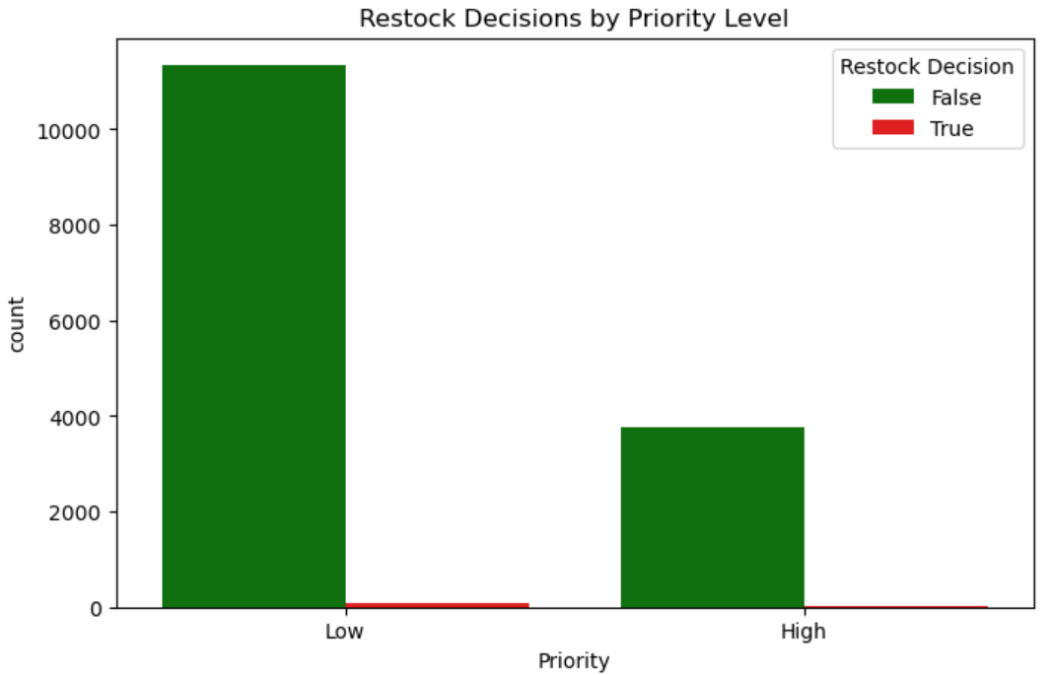
Figure 2. Restock Decision Outcomes by Priority
Figure 2 demonstrates the framework is effective in distinguishing high and low priority items when creating restock recommendations. Only 16 high-priority items were indicated as in need of restocking and most of 3,751 appeared to have enough inventory compared to their ROP. This means that the framework will have more inventory stock of the essential items since the safety factors are higher, which reduces the chances of a stockout. Finally, low priority, of 12,344 low priority items, 89 were identified to be replenished. This demonstrates lower-priority items as having lower safety factors and are restocked only when needed and not to avoid unnecessary overstocking.
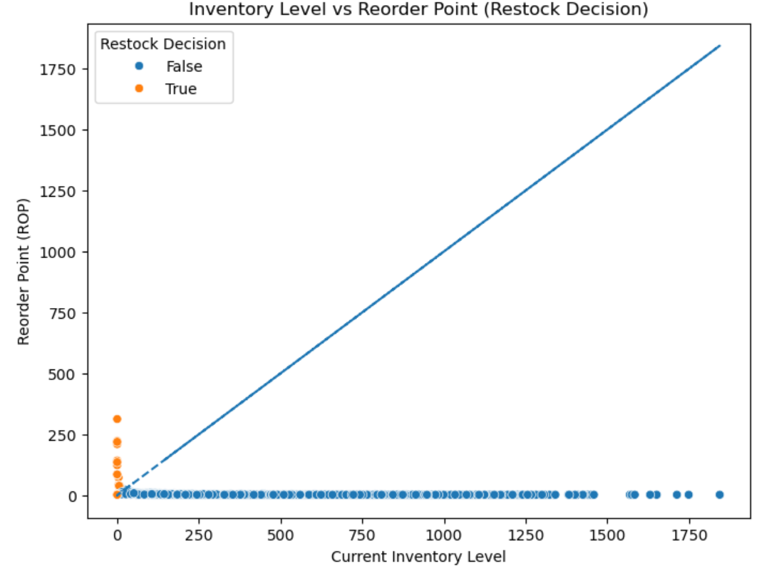
Figure 3. Inventory Level vs Reorder Point (Decision Boundary)
Figure 3 uses the current inventory level and reorder point, which compare the level to the point to determine whether an item is required to be restored. True (orange) marks show that the items need to be restocked and False (blue) means that the items have adequate inventory. The diagonal is the point at which inventory level = reorder point; anything less than this will open up the restocking process.
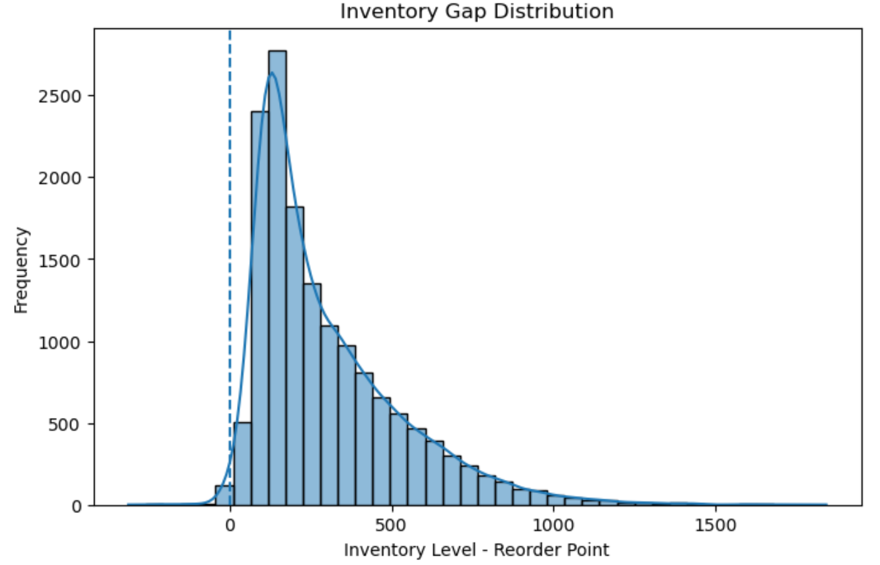
Figure 4. Inventory Risk Distribution
Figure 4 shows the distribution of the gap in inventory and is calculated as the inventory level - reorder point. The dashed vertical line at the 0 signifies the critical point at which the current inventory is precisely equal to the reorder point. Negative values represent possible shortages of stock that may need to be replenished and positive values represent excess stock held over reorder threshold.

Discussions
The findings of the framework test, show the usefulness of the proposed Machine Learning-Based Inventory Optimization Framework to the support of proactive and differentiated inventory control. The framework is effective in parsing the anticipated item priority, demand, and safety factor predicts into effective restock decisions that verify the relevance in operations within the framework to relief aid inventory management and other dynamic supply chains.
The framework is effective in prioritizing the critical items in terms of expected demand and weighted index of demand. Safety factors of larger concern are equipped with high-priority items and therefore the items are highly secure in regard to the demands. The importance of the safety factors causes the low-priority items to be replenished at the time of necessity only and to be stored more intelligently, and less overstocked. This distinction shows that the model is able to strike the optimal balance between inventory adequacy and operational efficiency without compromising on the levels of services.
The framework comes up with automated restock decisions by doing a comparison of current inventory quantities with computed reorder points. Products with a low value of their reorder level will be automatically entered into the replenishment list whereas products with sufficient supplies will not be changed. This automation will reduce redundant replenishment, lower operational expenses, and make sure that the decisions will be data-based and coordinated with the demand trends of history. The small percentage of its items, which need replenishment, proves that this structure is conservative but effective and only activates the replenishment in case there is a real threat of a stockout.
This is shown in the inventory levels as majority of the items are still at their reorder points and only a small portion of the inventory is below the critical level. This goes to show that the framework has a balanced inventory location, which offers adequate buffers to factor in the variability in demand and lead time uncertainty. This also means that the system facilitates the targeted restocking activities which minimize chances of stockouts without the development of excessive stock.

Conclusions
This study shows that the suggested framework of Machine Learning-Based Inventory Optimization is efficient in the process of aiding proactive and differentiated inventory management. The framework allows the organizations to make a data-driven inventory management by systematically combining demand forecasting, priority classification, safety factor mapping, safety stock calculation, and reorder point calculation.
The findings point to the frameworks as having the potential to increase the efficiencies of operation, resource distribution, and reliability of services in complex inventory systems. It applies especially in the distribution of relief aids and other supply chain activities that require a high rate of demand forecasting and re-supply, thus timeliness is important. Generally, the framework offers a powerful and evidence-based method of optimal decision-making in dynamic operational settings in terms of inventory optimization.

Recommendations
Upon the results and conclusions of the study, the following are the suggested recommendations as a way of improving the inventory management and practical use of the framework:
- Employ Inventory Policies that are based on priorities - Companies are advised to utilize varying, inventory management strategies to apply more safety aspects to the critical or high demand products. This means that necessary supplies can be procured when the demand is at a fluctuating point or when there is an emergency.
- Install Automated Restock Decision Systems - Inventory systems must employ data-driven and automated processes of restocking to minimize the use of manual monitoring. Automated decision making serves the purpose of ensuring that timely replenishment practices are in place, insensitive orders are limited and operational efficiency is optimized.
- Check Forecast Accuracy and Safety Stock Lotions - It is advisable to have continuous check and comparing the demand forecast of demand. Constant observation can be used to adjust safety factors and reorder points in order to maintain the optimum stock level without having to change the changeable conditions of operations.
- Use Framework on Dynamic and Time-Sensitive Supply Chains - The proposed framework is especially applicable when it comes to relief assistance delivery and other high-variability settings. All the organizations that work in similar situations are invited to use this approach to achieve the responsiveness and essence of reliability of the services.
- Increase Data Collection and Feature engineering - To further refine the accuracy of prediction, organizations may want to add more operational and environmental variables like real-time alerts on disasters, transportation delays, and consumption patterns to the machine learning model.
Acknowledgement
The authors express their sincere appreciation to the communities in the National Capital Region (NCR), Philippines, for their cooperation and for granting access to the datasets essential to this study. Their valuable contributions significantly supported the completion of this research. The authors also extend their heartfelt gratitude to the Graduate School of La Consolacion University Philippines for its unwavering support, academic guidance, and constructive insights throughout the entire research process.

Ethical Considerations
This study did not involve human participants, animals, or sensitive personal data. All information was obtained from publicly available sources and used solely for academic purposes, with proper citation and acknowledgment of referenced materials.

Conflict of Interest
The authors declare no conflicts of interest related to this research.

Data Availability Statement
The dataset used in this study is owned by the participating community and is not publicly available. Data may be made available upon reasonable request and with the permission of the community, subject to applicable and compliance with the Philippine Data Privacy Act of 2012 (Republic Act No. 10173).

References
[1] SCHROEDER., R., & Goldstein, S. M. (2024). Operations management in the supply chain. McGraw-Hill US Higher Ed ISE.
[2] Ivanov, D., Dolgui, A., & Sokolov, B. (2022). Cloud supply chain: Integrating Industry 4.0 and digital platforms in the “Supply Chain-as-a-Service”. Transportation Research Part E: Logistics and Transportation Review, 160, 102676.
[3] Kaur, A., Singh, G., Kukreja, V., Sharma, S., Singh, S., & Yoon, B. (2022). Adaptation of IoT with blockchain in Food Supply Chain Management: An analysis-based review in development, benefits and potential applications. Sensors, 22(21), 8174.
[4] Ben-Ammar, O., Dolgui, A., Hnaien, F., & Ould-Louly, M. A. (2022). Supply planning and inventory control under lead time uncertainty: a literature review and future directions. IFAC-PapersOnLine, 55(10), 2749-2754.
[5] Eiselt, H. A., & Sandblom, C. L. (2022). Operations research: A model-based approach. Springer Nature.
[6] Makridakis, S., Spiliotis, E., Assimakopoulos, V., Semenoglou, A. A., Mulder, G., & Nikolopoulos, K. (2023). Statistical, machine learning and deep learning forecasting methods: Comparisons and ways forward. Journal of the Operational Research Society, 74(3), 840-859.
[7] Zohdi, M., Rafiee, M., Kayvanfar, V., & Salamiraad, A. (2022). Demand forecasting based machine learning algorithms on customer information: an applied approach. International Journal of Information Technology, 14(4), 1937-1947.
[8] Rathore, S. P. S., Kaushik, P., Rathore, R., & Sikarwar, S. S. (2023, December). Predictive Analytics for Inventory Management in Multi-Vendor E-Commerce. In International Conference on Business Data Analytics (pp. 132-143). Cham: Springer Nature Switzerland.
[9] Aswanandini, R. (2025, November). Cloud-based XGBoost Framework: Enhancing Scalability and Performance in Machine Learning. In 2025 5th International Conference on Evolutionary Computing and Mobile Sustainable Networks (ICECMSN) (pp. 178-183). IEEE.
[10] Syafei, R. M., & Efrilianda, D. A. (2023). Machine learning model using extreme gradient boosting (XGBoost) feature importance and light gradient boosting machine (LightGBM) to improve accurate prediction of bankruptcy. Recursive Journal of Informatics, 1(2), 64-72.
[11] Mustajab, D. (2023). Effective Production Planning and Scheduling: Literature Review. Vifada Management and Social Sciences, 1(2), 54-72.
[12] Som, J. O., & Anyigba, H. (2022). Examining the effects of information systems usage and managerial commitment on supply chain performance: the mediating role of supply chain integration. Sage Open, 12(2), 21582440221091251.
[13] Bhavikatta, N. B. (2025). AI-Driven inventory optimization in supply chains: A comprehensive review on reducing stockouts and mitigating overstock risks. Journal of Computer Science and Technology Studies, 7(7), 01-13.
[14] Adem, M. K., & Virdi, S. S. (2024). The structural link between TQM practices and financial performance: the mediating role of operational performance. International Journal of Quality & Reliability Management, 41(1), 392-422.
[15] Rolf, B., Jackson, I., Müller, M., Lang, S., Reggelin, T., & Ivanov, D. (2023). A review on reinforcement learning algorithms and applications in supply chain management. International Journal of Production Research, 61(20), 7151-7179.
[16] Siddiqui, M., Kalwar, H. A., Khan, M. Z., Khan, M. A., Imroz, A., Kalwar, M. A., & Marri, H. B. (2023). Performance Analysis for the Diagnosis of COVID-19 Prediction by Mathematical Modeling & Simulation. International Journal of Artificial Intelligence & Mathematical Sciences, 2(1), 1-28.
[17] Ahmed, N., Ameer, R., Khan, A., SN, N., & Gull, S. (2024). Data Mining in Healthcare: An Overview of Applications, Techniques, and Challenges. International Journal of Artificial Intelligence & Mathematical Sciences, 3(1), 1-10.
[18] Ahmad, M., Ali, T., Khan, N. A., Afzal, A., Sohail, T. B., & Kashif, H. (2024). Enhanced Sketch Recognition via Ensemble Matching with Structured Feature Representation. International Journal of Artificial Intelligence & Mathematical Sciences, 3(1), 44-56.
[19] Javed, R., Wasi, S., Mughal, M. H., & Bhutto, Z. A. (2025). Machine Learning-based Smart Students' Complaint Resolution System. International Journal of Artificial Intelligence & Mathematical Sciences, 4(1), 36-55.
[20] Richards, C. A., Brumley, C., Graves, J. M., Parker, M. M., Khot, L. R., & Postma, J. (2025). Mapping Research Priorities for Climate Change Adaptation in Agriculture: A One Health Perspective. Workplace Health & Safety, 73(9), 454-465.
[21] Sun, J., Zhao, M., Huang, J., Liu, Y., Wu, Y., Cai, B., ... & Fan, Z. (2022). Determination of priority control factors for the management of soil trace metal (loid) s based on source-oriented health risk assessment. Journal of Hazardous Materials, 423, 127116.
[22] Siraj, M., Naseem, A., Maryam, M., & Asad, J. (2024). Optimizing inventory management: A comprehensive analysis of economic order quantity, lot size, safety stock, and reordering quantity strategies. Journal of business administration and management sciences (JOBAMS), 6(1), 8-16.
[23] Mashetty, S., & Valiki, S. (2025). AI-Powered Data Engineering for Intelligent Retail Stock Management. International Journal of Research and Applied Innovations, 8(6), 13096-13109.

