Aeroelastic Flutter Suppression Using Embedded Smart Material Sensors in UAV Wings

Abstract
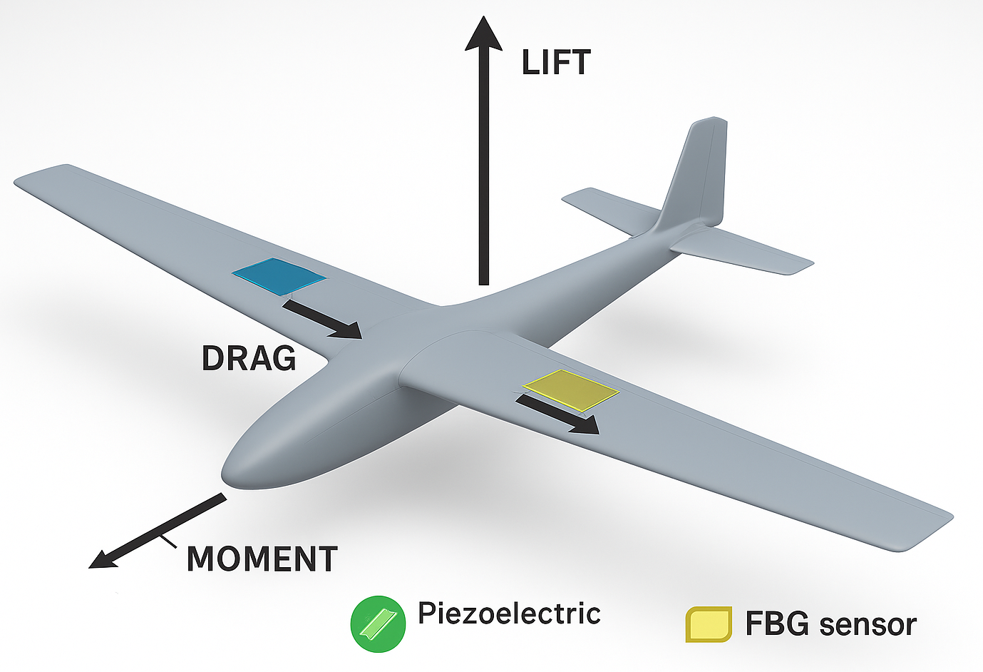
This paper takes a close look at aeroelastic flutter—a major challenge for lightweight UAV wings—and explores how embedded smart material sensors can spot and dampen those vibrations as they happen, like a pulse felt through the thin skin of the wing. It starts by laying out the core ideas of aeroelasticity, showing how aerodynamic forces, flexible structures, and inertia can combine—like wind twisting a wing—to trigger destructive vibrations. Next, the paper explores several smart sensing technologies—like piezoelectric sensors, fiber Bragg gratings (FBG), and piezocomposite actuators—and shows how they track wing motion and vibration, even the faint tremor of metal under stress. The focus is on integrating these sensors into UAV wings so they can actively suppress flutter through feedback control, adjusting in real time like a steady hand correcting a trembling wingtip. These methods prove their effectiveness in real UAV flight tests and detailed computer simulations, where each data set hums with precise, repeatable results. The discussion dives into real-world hurdles—weight limits, energy demands, electrical noise, sensor reliability—and wraps up by looking ahead to predictive flutter control and flexible wing designs that could shift shape like metal catching sunlight.

1. Introduction

1.1 Background: The Rise of Lightweight UAVs

Over the past twenty years, unmanned aerial vehicles have taken off fast, powered by jobs that span from reconnaissance and surveillance to tracking forest health and scanning damage after a storm. Modern UAVs stay light, quick on the turn, and stingy with power, often flying on slim, flexible wings that slice through the air to cut weight and boost performance. These designs boost flight efficiency, but they also make the aircraft more vulnerable to aeroelastic effects—especially flutter, that sharp vibration through the wings that can threaten both structure and safety.

1.2 Definition and Importance of Aeroelastic Flutter

Aeroelastic flutter happens when aerodynamic, elastic, and inertial forces start feeding off each other in a flexible structure, making it vibrate wildly—like a wing trembling in a sudden gust. When aerodynamic forces pump in more energy than the structure can shed through damping, the vibrations start to build—fast and wild—until the whole frame shudders toward failure. This issue matters most in UAVs with long, narrow wings—those slender spans flex more easily and carry higher aspect ratios than typical aircraft.

1.3 Smart Materials in Structural Health Monitoring

Smart materials can sense shifts around them, react, and even adjust—like bending slightly when the air warms. In UAV wings, built-in smart sensors—like piezoelectric patches, fiber Bragg grating sensors, and piezocomposite actuators—pick up tiny shifts and vibrations, turning them into electrical or optical signals that feed real-time analysis, much like feeling a faint tremor through metal skin. This setup actively suppresses flutter by using sensor data to move the actuators and steady the surface before tiny vibrations build into full-blown oscillations.

1.4 Thesis Statement and Scope

This paper looks at the core principles behind aeroelastic flutter, reviews how smart materials can sense and respond within a structure, and shows how those ideas come together in the design of a UAV wing flexing lightly in flight. The research explores ways to detect and control flutter in real time, backed by hands-on experiments and computer simulations that capture the quick vibration of a wing under stress. The discussion covers implementation challenges—like power demands, extra weight, and toughness—then moves on to future research in AI-guided control and flexible, morphing wings that shift shape like thin metal under stress.

2. Fundamentals of Aeroelastic Flutter

2.1 Fluid–Structure Interaction

Flutter happens when aerodynamic forces and the structure’s own flexing start to move together—like a wing shivering in a sudden gust. Air flowing over the wing creates lift that can make it wobble slightly, and that motion changes the aerodynamic load, feeding the cycle all over again. If left unchecked, this self-exciting system can drive limit cycle oscillations (LCO) that swell until they shake the structure apart.
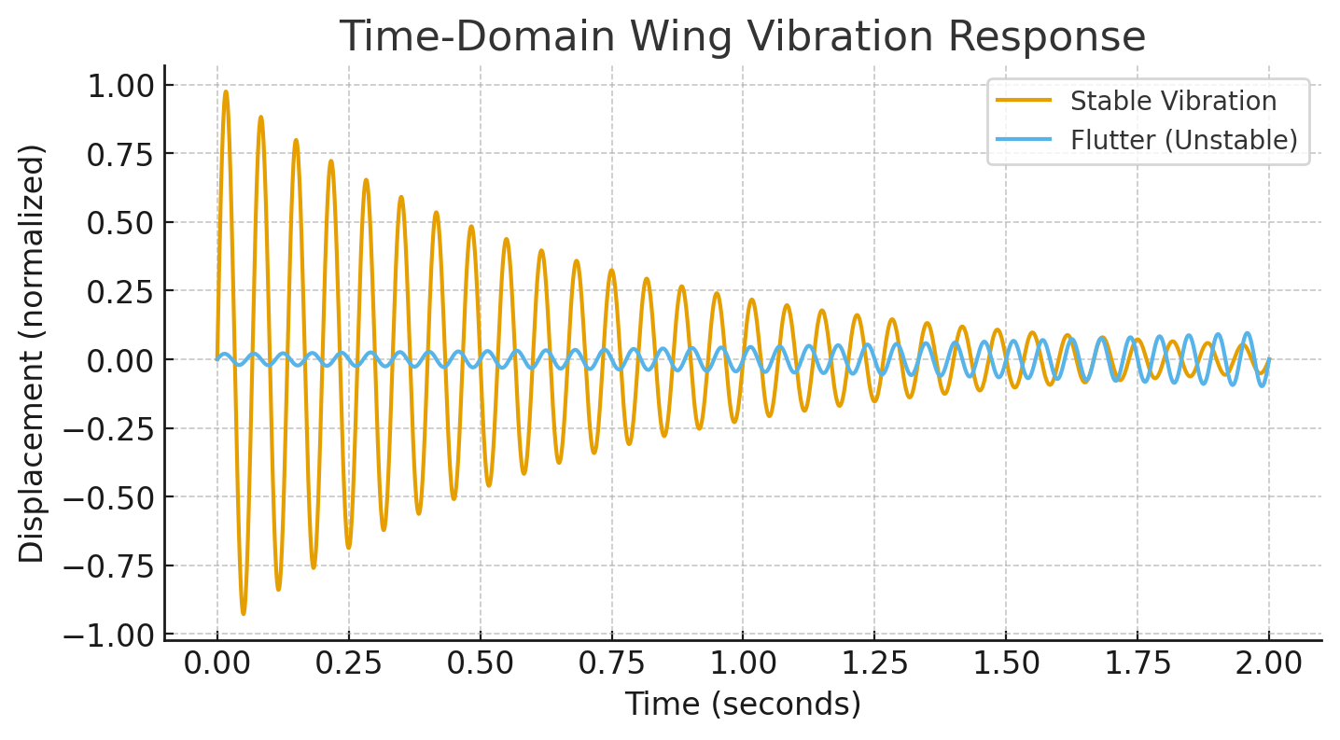

2.2 Mathematical Characterization

The governing equations of motion for a simple wing section can be expressed as:

Where (m) is mass, (c) damping coefficient, (k) stiffness, (y) displacement, and the aerodynamic load. Flutter occurs when the aerodynamic forcing exceeds damping, resulting in divergent oscillations. Modal analysis can predict the critical flutter speed, beyond which the wing becomes unstable.
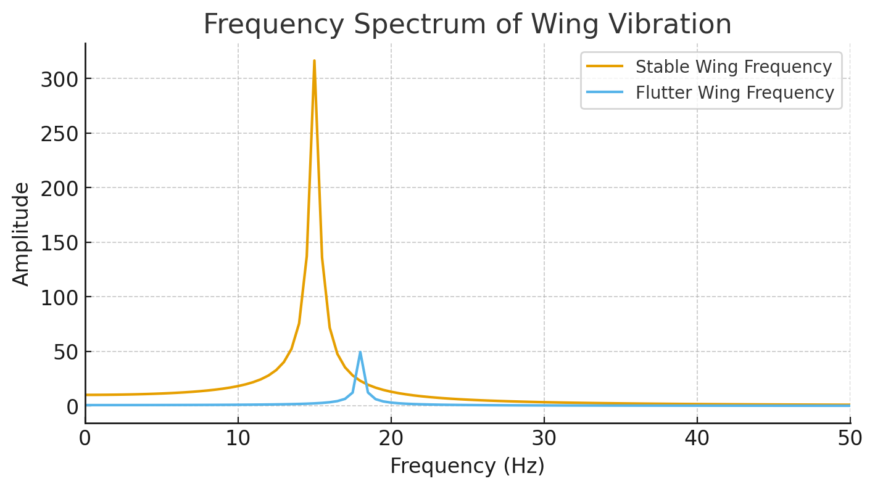

2.3 Historical Examples

Flutter has a notorious history of bringing down aircraft, from early experimental gliders to the de Havilland Comet, sometimes tearing wings apart mid‑flight. Flutter is still a major hurdle for UAVs, whose light, flexible frames—like the long, slender wings on reconnaissance drones—can quiver under even a sharp gust.

3. Smart Materials for Flutter Sensing and Actuation

3.1 Piezoelectric Sensors

Piezoelectric materials produce a voltage that rises and falls with mechanical strain—like a crystal giving off a faint spark when pressed. Slim sensor patches built into UAV wings track vibration patterns and deliver sharp, fast feedback to the control system—each one tuned finely enough to catch even a faint tremor.

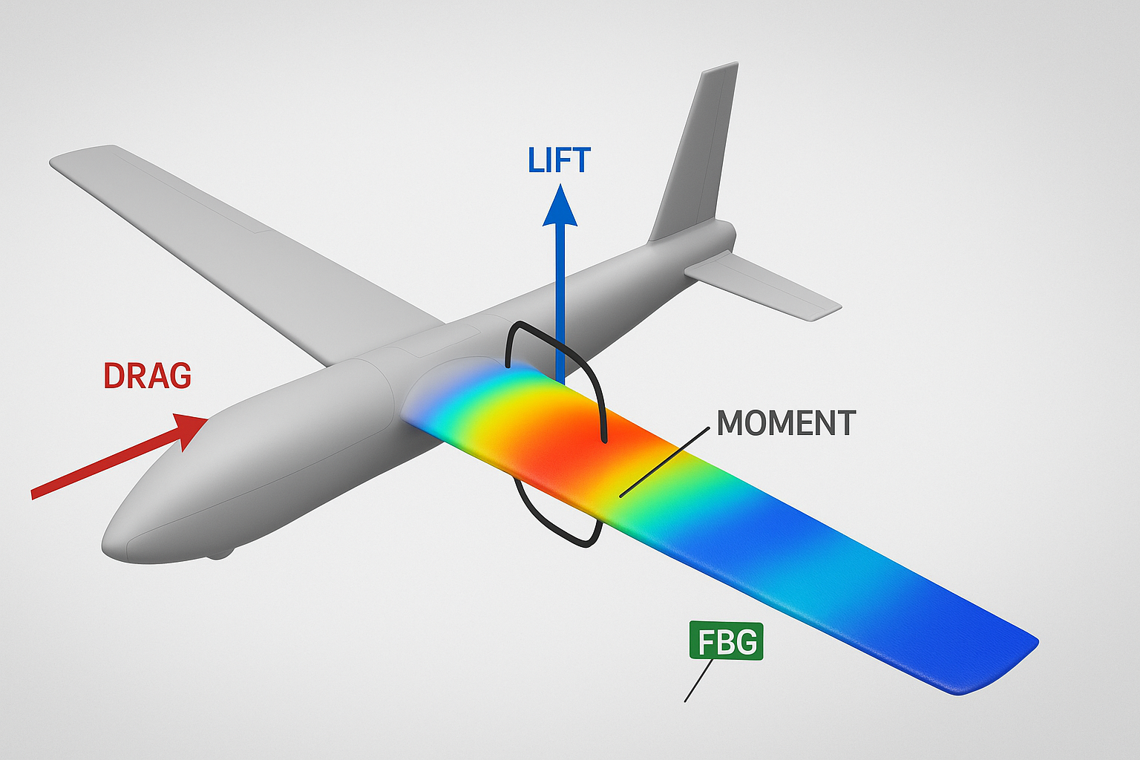

3.2 Fiber Bragg Grating (FBG) Sensors
FBG sensors use optical fibers to spot strain by tracking how the reflected wavelength shifts—like watching a thin line of light stretch and change color under pressure. They’re lightweight and resist electromagnetic interference, slipping easily into composite wings like thin silver threads, which lets sensors spread their reach across the entire structure.

3.3 Piezoelectric Composite Actuators
Multifunctional composite actuators can detect strain and instantly push back, tightening like a muscle under load. This built‑in dual function lets the system actively suppress flutter in a closed loop, trimming away extra control surfaces and saving precious weight—like shaving off an unnecessary bolt from the wing.

4. Integration Strategies

- Optimal placement at wing root and high-stress zones
- Lamination within composite skins to prevent delamination
- Data acquisition and signal processing for real-time control

5. Flutter Detection and Suppression Techniques
- Time-domain vibration monitoring
- Frequency-domain modal analysis
- AI-based prediction using neural networks or SVM
- Actuation strategies: piezoelectric patches, servo-driven control surfaces, morphing wing shapes

6. Challenges
- Power consumption for small UAVs
- Weight and aerodynamic penalty
- Sensor durability and calibration drift
- Real-time computational requirements
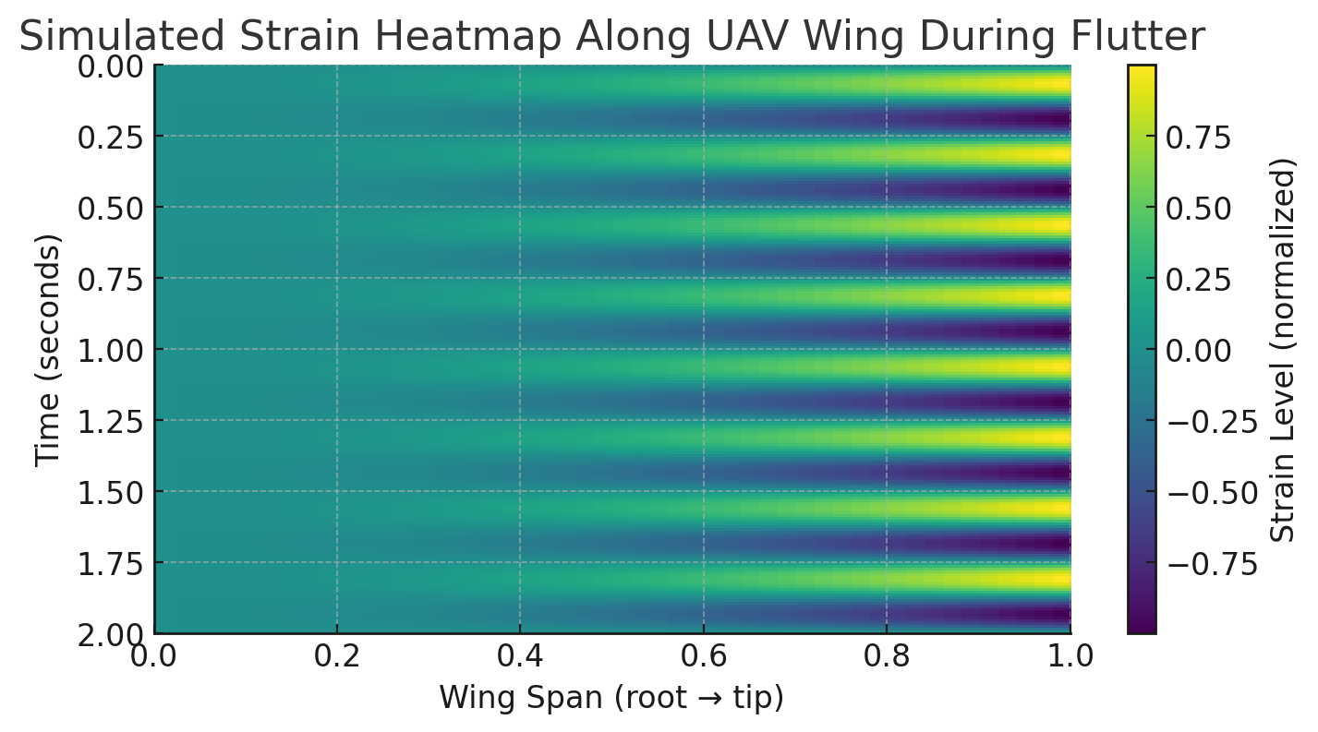

7. Future Directions
- AI-assisted predictive flutter suppression
- Self-powered sensor-actuator networks
- Adaptive, morphing wings with distributed smart materials
- Integration with digital twin simulations for pre-flight analysis

8. Conclusion
Smart materials with builtin sensors could transform how UAV wings handle aeroelastic flutter, spotting it in real time and damping the motion before it rattles through the frame. When high-sensitivity sensors work with active motion control and smart prediction, UAVs fly more safely, turn more sharply, and shed extra weight from their frames. Ongoing work on new materials, sharper sensors, and AI-driven control will be key to building the next wave of adaptive, tough UAVs that can steady themselves even in a gust of wind.

9. References

Dowell, E. H., et al. (2004). A modern course in aeroelasticity. Springer.

Inman, D. J. (2014). Engineering vibration. Pearson.

Hong, S Y. "Active vibration control of adaptive flexible structures using piezoelectric smart sensors and actuators", Dec. 1991.

Livne, E. (2018). Aircraft active flutter suppression: State of the art and technology maturation needs. Journal of Aircraft, 55(1), 410‑452.

Kinet, D., Mégret, P., Goossen, K. W., Qiu, L., Heider, D., & Caucheteur, C. (2014). Fiber Bragg grating sensors toward structural health monitoring in composite materials: Challenges and solutions. Sensors, 14(4), 7394‑7419.

Tang D, Chen L, Tian ZF, Hu E. A neural network approach for improving airfoil active flutter suppression under control-input constraints. Journal of Vibration and Control. 2020;27(3-4):451-467.

DOI :10.1177/1077546320929153

Z.F. Pan, L. An, C.Y. Wen, Recent advances in fuel cells-based propulsion systems for unmanned aerial vehicles, Applied Energy, Volume 240, 2019. Pages 473-485,

https://doi.org/10.1016/j.apenergy.2019.02.079.

Guo Q, Li X, Zhou Z, Ma D, Wang Y. Neural network-based aeroelastic system identification for predicting flutter of high flexibility wings. Sci Rep. 2025 Jan 3;15(1):623.

DOI: 10.1038/s41598-024-82573-7.

NASA Technical Reports Server (NTRS). (2021). Active control of aeroelastic response in UAV wings. (https://ntrs.nasa.gov/api/citations/20205010291/downloads/jwaite_scitech2021_delta.pdf)

Hodges, D. H., & Pierce, G. A. (2011). Introduction to structural dynamics and aeroelasticity. Cambridge University Press. (https://scispace.com/pdf/introduction-to-structural-dynamics-and-aeroelasticity-43ce9fxz1b.pdf)

