WasteWatch: Architecture and Design of Vehicle Monitoring and MRF-Integrated Waste Collection for CENRO Alaminos City

ABSTRACT
Effective waste collection monitoring remains a significant challenge for the City Environment and Natural Resources Office (CENRO) of Alaminos City due to its heavy reliance on manual monitoring processes, limited real-time vehicle tracking capabilities, delayed response and coordination in collection activities, and room for enhancement in complaint reporting mechanisms. Consequently, these concerns present opportunities for improvement in delivering timely and organized waste management services. Although various technology-driven waste management solutions have been explored in different contexts worldwide, localized systems specifically designed for LGU-level operations in the Philippine context remain limited. To address this gap, the researcher proposes WasteWatch, a web and mobile-based system designed to support vehicle monitoring and MRF-integrated waste collection management. The Agile Prototyping Model was utilized by the researcher to guide the system development process through continuous refinement based on user feedback. WasteWatch was structured using a Three-Tier Architecture composed of the presentation, application, and data tiers. Relevant information and system requirements were gathered through interviews, observation, document analysis, and purposive sampling of 85 respondents from CENRO personnel, garbage truck drivers, MRF representatives, landfill representatives, and residents of Alaminos City. The proposed system integrates several critical functions: GPS-based vehicle monitoring, complaint reporting, MRF hauling coordination, digital landfill recording, and centralized administrative oversight. Its usability and acceptability will be assessed through stakeholder feedback to determine how well the system supports the needs of its intended users. Overall, WasteWatch aims to provide CENRO Alaminos City with a more organized, responsive, and technology-driven approach to waste management operations, replacing informal coordination methods with structured digital processes.
Keywords – Waste Management, Vehicle monitoring, Responsive, GPS-based
INTRODUCTION
Waste collection plays an important role in maintaining a clean, safe, and healthy community. As municipal solid waste generation continues to increase, there is a growing need for organized, responsive, and sustainable waste management systems [9, 10]. This need is also consistent with the Philippine policy framework, which assigns local government units an important role in planning and implementing solid waste management programs. In Alaminos City, the City Environment and Natural Resources Office (CENRO) is responsible for managing waste collection operations. However, its current process faces several challenges, including manual monitoring, delayed coordination, the absence of real-time garbage truck tracking, and the lack of a centralized complaint reporting mechanism. Because of these concerns, a technology-based system is needed to support more organized, responsive, and efficient waste management operations [1, 3].
WasteWatch was designed as a web and mobile-based system to address these challenges. It combines GPS-based truck monitoring, MRF hauling coordination, complaint reporting, digital landfill recording, and an administrative dashboard into one platform [6]. It will use Global Positioning System (GPS) technology to support location-based monitoring, a web dashboard for CENRO administrators and landfill personnel, mobile access for drivers, MRF personnel, and residents, and a database for storing and managing system records. Previous studies have emphasized that real-time monitoring, digital data collection, and smart waste management technologies can support more efficient and responsive waste collection operations [4].
The study had four objectives: (1) determine the current waste collection and management processes of CENRO, (2) analyze problems in its operations, (3) design a system that improves waste reporting, vehicle tracking, and coordination between residents and local authorities, and (4) evaluate the usability of the proposed system. These goals guided WasteWatch's development and ensured it addressed the actual needs of its users.
This paper presents WasteWatch's architecture and design as a response to the challenges at CENRO Alaminos City. It covers the development approach, core technologies, and three-tier architecture consisting of web and mobile clients, an application server, and a database layer. The paper also explains how the system addresses problems in manual monitoring, coordination delays, complaint reporting, MRF hauling requests, and landfill documentation.
METHODOLOGY
The study is situated at the City Environment and Natural Resources Office (CENRO) of Alaminos City, Pangasinan, which serves as the primary locale of the project. This office was selected by the researcher on the basis of direct institutional responsibility over the city's waste collection operations, making it the most appropriate setting for identifying the actual needs, existing processes, and operational challenges that the proposed system seeks to address. At present, the office manages a workforce of 109 employees and operates a fleet of seven garbage trucks dedicated to citywide waste collection services. Moreover, despite this operational capacity, the office continues to encounter persistent difficulties in its day-to-day functions, including reliance on manual monitoring procedures, delayed coordination among field personnel, dependence on informal messaging platforms for operational updates, and insufficient real-time visibility over garbage truck movements and activities. These prevailing conditions establish CENRO Alaminos City as a fitting and well-justified setting for the development and proposed implementation of WasteWatch [2, 5]
Purposive sampling was employed by the researcher as the primary technique for selecting respondents who were directly involved in waste collection, route monitoring, landfill operations, and community reporting. This approach was considered appropriate because the study required information from individuals who possessed relevant knowledge and direct experience with the current waste management process.
Table 1. Respondents of the Study
Respondent | Number of Respondents
Sanitary Engineer of CENRO | 2
Truck Drivers | 9
Landfill Representative | 3
MRF Representative | 24
Resident | 45
IT Expert | 2
Total Respondents | 85
To gather the necessary data, the proponents created a structured interview guide containing relevant questions pertaining to garbage collection procedures, daily route schedules, operational challenges, and existing monitoring practices. Interviews were conducted with selected CENRO personnel and other concerned stakeholders to obtain firsthand information that would directly inform the design and development of the system. Alongside this, observation was employed to examine actual collection procedures and route scheduling as they occur in practice, while document analysis was carried out through a review of existing forms, records, and operational documents currently used in the office to determine the required inputs for the system. A structured questionnaire was likewise prepared to gather evaluative feedback from the intended users and IT experts concerning the acceptability, usability, technical feasibility, and overall effectiveness of WasteWatch.
SYSTEM DEVELOPMENT LIFE CYCLE
WasteWatch was developed using the Agile Prototyping Model. This model was chosen because it supports iterative, user-centered development [8] — an early version of the system is built, tested by users, and refined based on their feedback. Unlike waterfall approaches that follow a fixed sequence, Agile Prototyping allows continuous revision, which suited WasteWatch's multiple modules and diverse user roles. This flexibility helped the team align the design with actual operational needs identified during data gathering. Figure 1 shows the model as applied in this study.
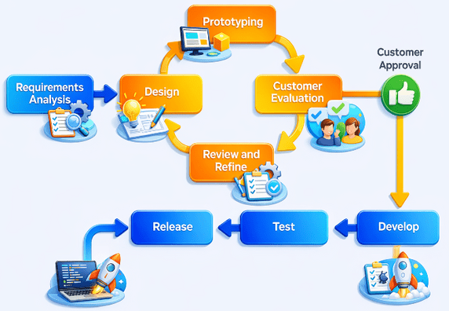
Figure 1 Agile Prototyping Model

The model follows a structured sequence of phases beginning with the identification of initial system requirements, during which the proponents gathered relevant data through interviews, observation, and document analysis to define both the functional and non-functional specifications of the proposed system. This was followed by the design phase, wherein the system architecture, database structure, interface layout, and process workflows were planned and organized. An initial prototype was subsequently developed and presented to intended users for evaluation, after which feedback was analyzed and used as the basis for revising the system. The refined prototype then proceeded to full development, testing, and final maintenance. Through this iterative process, the Agile Prototyping Model provided a systematic and responsive framework for guiding the design and development of WasteWatch.

SYSTEM ARCHITECTURE AND DESIGN
WasteWatch uses a Three-Tier Architecture with three layers: Presentation, Application, and Data [7]. This structure separates responsibilities while keeping all components connected as a unified platform. Figure 2 shows the system architecture.
Figure 2- System Architecture Model of WasteWatch
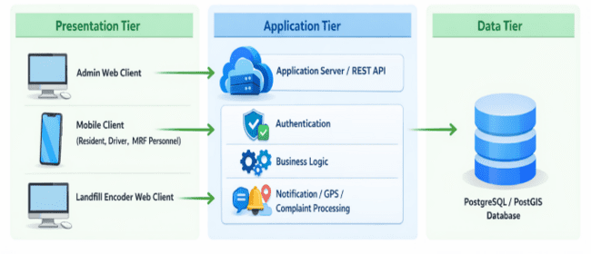
The Presentation Tier consists of the user-facing interfaces accessible through both web and mobile platforms, including the dashboards for administrators and landfill encoders, as well as the mobile screens designated for residents, garbage truck drivers, and MRF personnel. The Application Tier functions as the processing layer of the system through a REST API, which handles incoming requests, validates user access, applies system logic, and coordinates communication between the interface and the database. The Data Tier utilizes a PostgreSQL database with the PostGIS extension to store and manage all system records, following patterns established in GPS-based waste tracking systems , including user accounts, complaints, GPS tracking data, duty logs, hauling transactions, and waste slips. In operation, user actions initiated through the presentation layer are processed by the application layer, and the corresponding data is retrieved from or saved to the data layer before results are returned to the user.
PROTOTYPE OVERVIEW
An initial prototype of WasteWatch was developed to validate the proposed system design prior to full development. The mobile prototype provides shared authentication screens and role-specific interfaces for residents, drivers, and MRF personnel. The web prototype covers the administrator dashboard and the landfill encoder interface. Selected prototype screens are presented below to illustrate the layout and key functions of the proposed system.
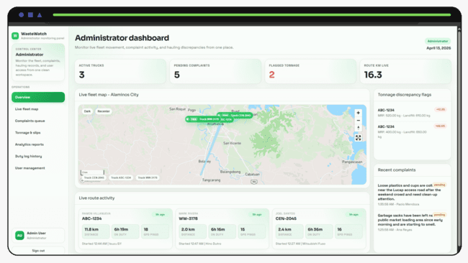
Figure 3- Administrator Dashboard
The administrator dashboard displays a summary of active fleet status, pending complaints, hauling requests, and operational data, giving administrators a centralized view of ongoing waste collection activities.
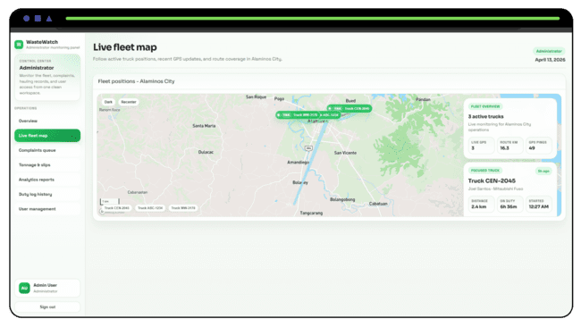
Figure 4. Live Fleet Map
The live fleet map shows the real-time location of garbage trucks on an interactive map, allowing administrators and other authorized users to monitor vehicle movement during active duties.
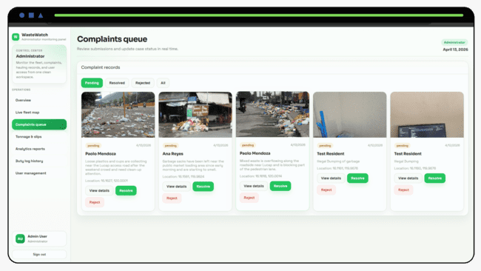
Figure 5- Complaints Queue
The complaints queue presents a list of resident-submitted waste concerns with their current status, enabling administrators to review, act on, and resolve each report in an organized manner.
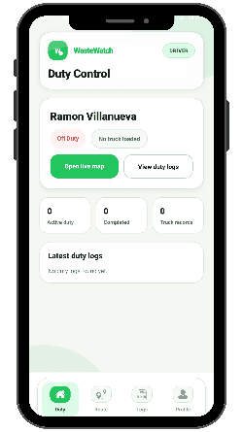
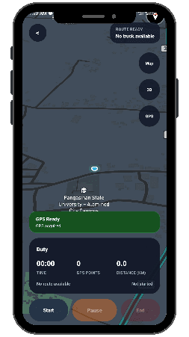
Figure 6 - Driver Duty Control Screen
The duty control screen allows drivers to start, manage, and end their duty sessions while the system records GPS data continuously throughout the collection route.
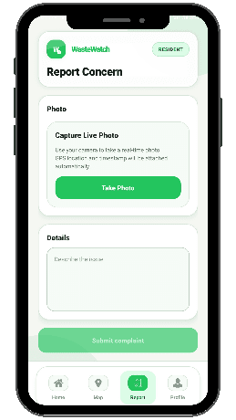
Figure 7 - Resident Report Concern Screen
The report concern screen enables residents to submit a waste-related complaint by providing a description, photo, and location, which is then forwarded to the administrator for action.
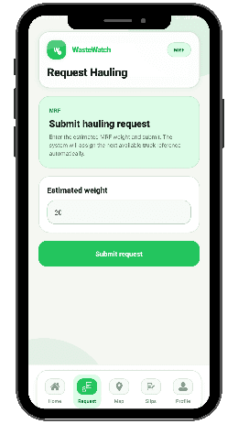
Figure 14. MRF Hauling Request Screen
The hauling request screen allows MRF personnel to formally submit a collection request with the estimated waste weight, replacing the previous practice of coordinating through informal messaging.
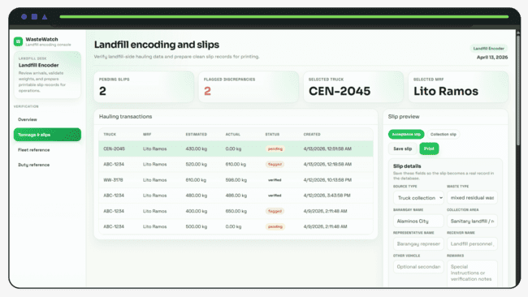
Figure 15. Landfill Encoding and Slips Page
The landfill encoding page provides landfill encoders with a workspace for reviewing incoming hauling records, verifying transaction details, and generating official waste slips digitally.

CONCLUSION
This paper presented the proposed architecture and design of WasteWatch, a web and mobile-based system for vehicle monitoring and MRF-integrated waste collection management. The system was designed using a Three-Tier Architecture composed of the presentation, application, and data tiers, developed through the Agile Prototyping Model to allow iterative refinement based on user feedback. The proposed design addresses the key challenges identified at CENRO Alaminos City: manual monitoring, delayed coordination, lack of real-time vehicle tracking, and the absence of a centralized complaint reporting mechanism. Through its integrated features—including GPS-based monitoring, complaint reporting, MRF hauling coordination, digital landfill recording, and an administrative dashboard—WasteWatch provides a structured, technology-driven framework for improving local waste collection operations. Future work will involve full system implementation and usability evaluation with the identified stakeholders.
REFERENCES
1. Alvarico, E. A. M., Arricivita, F. A. I., et al. (2024). Real-time tracking and monitoring system with geofence notification for garbage collection vehicles. 2024 6th International Conference on Electronics and Communication, Network and Computer Technology (ECNCT).
2. Camarillo, M. E. C., & Bellotindos, L. M. (2021). A study of policy implementation and community participation in the municipal solid waste management in the Philippines. Applied Environmental Research, 43(2), Article 2. https://doi.org/10.35762/AER.2021.43.2.3
3. Cruz, C. C., Villafuerte, H. C. R., Avila, R. B., et al. (2024). Mobile application for monitoring trash collection schedules and promote efficient solid waste management. Cognizance Journal of Multidisciplinary Studies, 4(3), 22–31. https://doi.org/10.47760/cognizance.2024.v04i03.003
4. Kannan, D., Khademolqorani, S., Janatyan, N., & Alavi, S. (2024). Smart waste management 4.0: The transition from a systematic review to an integrated framework. Waste Management, 174, 1–14. https://doi.org/10.1016/j.wasman.2023.08.041
5. Langit, E. R., Parungao, C. A., Gregorio, E. T. A., Sabo-o, A. J. M., et al. (2024). Feasibility study of an integrated waste management technology system for a circular economy in the Philippines. SSRN Electronic Journal. https://doi.org/10.2139/ssrn.4742843
6. Mapa-Madlos, J. S., Tapdasan, J., et al. (2022). Sensor-based garbage monitoring system and application development in Magallanes Agusan Del Norte. 2022 IEEE 14th International Conference on Humanoid, Nanotechnology, Information Technology, Communication and Control, Environment, and Management (HNICEM).
7. Newman, S. (2021). Building microservices: Designing fine-grained systems (2nd ed.). O'Reilly Media.
8. Obaid, A. (2024). Using prototypes in agile software development. International Journal of Computer Informatics, 12(1), 45–58.
9. Sosunova, I., & Porras, J. (2022). IoT-enabled smart waste management systems for smart cities: A systematic review. IEEE Access, 10, 104334–104355. https://doi.org/10.1109/ACCESS.2022.3188308
10. United Nations Environment Programme. (2024). Global Waste Management Outlook 2024: Beyond an age of waste — Turning rubbish into a resource. United Nations Environment Programme. https://doi.org/10.59117/20.500.11822/44939

