Developing an Active Learning–Based Conceptual Framework for Moral Character Education in Chinese Higher Education

Abstract
Moral education is a core mission of Chinese higher education, but its pedagogical effectiveness is often limited by abstract, teacher-centered, and transmissive forms of instruction. In response to these limitations, this article examines the potential of active learning as a pedagogical orientation for supporting university students’ moral development. Although active learning and moral education have each been widely discussed, research integrating the two within the context of Chinese higher education remains limited, and a clear framework for module development is still lacking. Drawing on a conceptual review of literature, the article examines scholarship on active learning and moral education in Chinese higher education and identifies five major areas of theoretical alignment between them: agency, inquiry, social interaction, reflection, and practice. On this basis, it proposes a conceptual framework for the development of active learning moral education modules. The framework brings together contextual conditions, design inputs, core learning processes, mediating mechanisms, and developmental outcomes to explain how module-based active learning may support moral development. The article argues that active learning is not simply a collection of classroom techniques, but a pedagogical logic that aligns closely with the developmental aims of moral education. By integrating two previously disconnected strands of literature, the review contributes a structured foundation for module design and future empirical research in Chinese higher education.
Keywords: active learning; moral education; Chinese higher education; module development; conceptual framework; moral development
1. Introduction
Moral education has long occupied a central place in Chinese higher education. Universities are expected not only to cultivate students’ academic and professional competence, but also to foster sound values, social responsibility, and moral character. Within the broader mission of lide shuren (fostering virtue through education), moral development is regarded as a core dimension of students’ holistic growth. Yet the conditions under which university students develop morally have become increasingly complex. Contemporary Chinese students live in a rapidly changing social and digital environment shaped by value pluralism, expanding online interaction, ethical ambiguity, and growing expectations for civic participation and public responsibility. These changes place new demands on moral education and call for pedagogies that are more responsive to students’ lived realities.
Despite its recognized importance, moral education in higher education has often been criticized for remaining overly abstract, teacher-dominated, and weakly connected to students’ real-life concerns. In many settings, it continues to rely heavily on explanation, normative assertion, and knowledge-oriented instruction, while offering limited space for students to question, deliberate, reflect, and practice. Under such conditions, students may understand moral principles at a cognitive level without developing deeper identification with those values or translating them into ethical conduct. The persistent gap between moral understanding and moral action suggests that traditional pedagogical approaches may be insufficient for supporting richer forms of moral development in contemporary universities.
Against this backdrop, active learning offers a promising direction for rethinking moral education in Chinese higher education. Active learning emphasizes student participation, inquiry, interaction, collaboration, reflection, and the application of learning in authentic contexts. Rather than positioning students as passive recipients of moral content, it engages them as participants in meaning-making and value formation. These qualities make active learning especially relevant to moral education, whose aims extend beyond knowledge acquisition to include moral understanding, value identification, ethical judgment, responsibility, and morally informed action.
Although substantial research exists on active learning and on moral education, studies that bring these two areas into sustained dialogue within the specific context of Chinese higher education remain limited. Work on active learning tends to focus on academic achievement, engagement, or generic skill development, whereas research on moral education often emphasizes policy, ideological orientation, or curricular goals without giving sufficient attention to pedagogy and instructional design. As a result, there remains a shortage of integrative review work that connects the two fields, and an even greater lack of conceptual frameworks that can inform the development of active learning-based moral education modules for university students.
This article addresses that gap by reviewing literature on active learning and moral education, examining their theoretical alignment in Chinese higher education, and proposing a conceptual framework for the development of active learning moral education modules. By synthesizing insights across these two bodies of scholarship, the article seeks to provide a clearer foundation for curriculum design, module development, and future empirical research on how active learning may support university students’ moral development in Chinese higher education.
To clarify the analytical logic of the article, Figure 1 presents the overall structure of the argument.
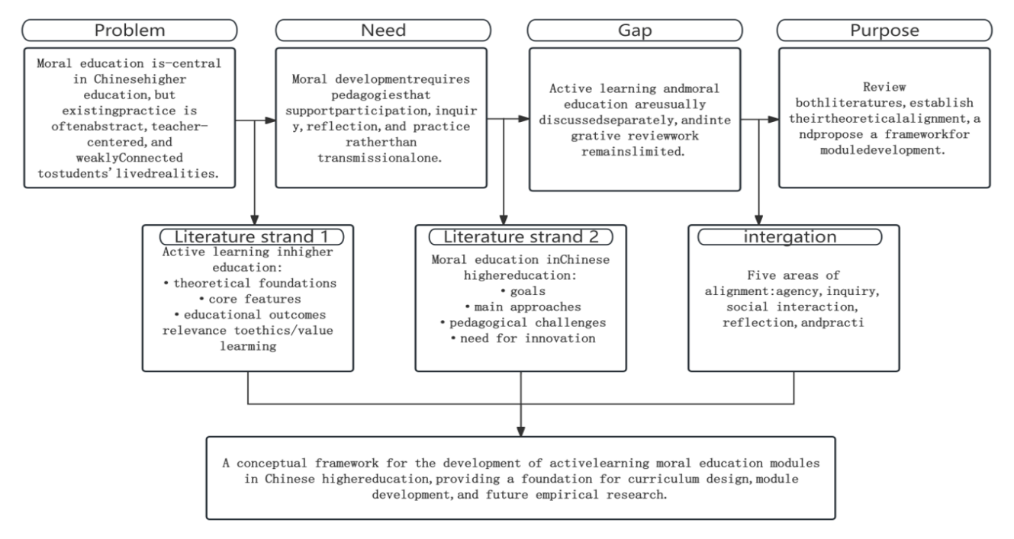
Figure 1. Overall Logic of the Article
2. Conceptual Clarification
Clarifying the key concepts underlying this review is necessary before examining the relationship between active learning and moral education in Chinese higher education. A coherent conceptual framework depends on clear definitions, workable conceptual boundaries, and an explicit account of how the main constructs relate to one another. Four concepts are especially central to this article: active learning, moral education, moral education modules, and the Chinese higher education context(Cao et al., 2021). On the basis of these clarifications, a working definition of active learning moral education modules is proposed to guide the remainder of the review.
Figure 2 summarizes the key concepts and presents the working definition used in this review.
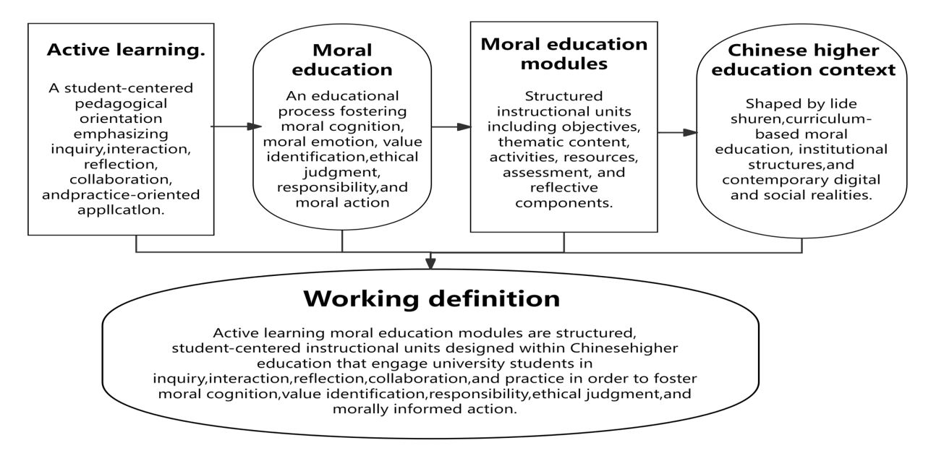
Figure 2. Conceptual Clarification and Working Definition
2.1 Active Learning
Active learning should not be understood simply as visible classroom activity or frequent student participation in tasks. Rather, it refers to a student-centered pedagogical orientation in which learners engage meaningfully in knowledge construction, inquiry, interaction, reflection, and application(Rieger et al., 2020). In active learning environments, students do not merely receive ready-made knowledge; they interpret ideas, examine problems, collaborate with others, and connect learning with authentic situations.
This understanding highlights several core characteristics of active learning, including learner agency, meaning-making, inquiry into questions and dilemmas, social interaction, reflection, and practice-oriented application(Denis et al., 2024a). Common forms of active learning include discussion, case analysis, problem-based learning, project-based learning, reflective writing, service learning, role play, debate, and scenario-based tasks. In this review, active learning is treated not as a loose collection of techniques, but as a coherent pedagogical orientation that can support deeper forms of moral engagement and development(Mortality Salience and Moral Dilemmas: The Impact of Stress on Regret in Trolley Problem Decision-Making, 2021).
2.2 Moral Education
In this review, moral education is understood in a broad and academically grounded sense rather than as a narrow synonym for ideological instruction. It refers to the educational process through which students develop moral cognition, moral emotion, value identification, ethical judgment, responsibility, and habits of moral action(Kruijtbosch, 2021). Moral education is concerned not only with whether students know what is right, but also with whether they care about moral issues, can reason through complex situations, and are willing and able to act responsibly.
This definition reflects the integration of knowing, feeling, willing, and acting. Moral education therefore extends beyond the transmission of moral principles or behavioral norms(Brinson, 2024). It also involves the cultivation of empathy, commitment, self-discipline, responsibility, and practical moral competence(Jones Bsc Neuropsychology, 2022). In higher education, moral education should be understood as both a developmental and a pedagogical process, since students’ moral growth is shaped not only by experience and social interaction but also by how learning is designed and organized(Ochoa et al., 2023).
2.3 Moral Education Modules
Because this review is concerned with instructional design as well as theory, the concept of moral education modules requires separate clarification(Sawah & Kusaka, 2023). In this article, moral education modules refer to relatively complete and structured instructional units designed around specific moral education aims. They typically include learning objectives, thematic content, learning activities, teaching resources, assessment strategies, and reflective components(Mokhtar et al., 2024).
The value of the module concept lies in its ability to connect broad educational aims with concrete teaching practice. A moral education module translates general goals such as responsibility, integrity, empathy, or civic engagement into teachable, adaptable, and evaluable instructional units. For the purposes of this review, modules should be sufficiently structured to be implemented in university settings and sufficiently clear to allow their processes and outcomes to be examined and refined(Hashim et al., 2022).
2.4 Chinese Higher Education Context
This review is situated specifically in Chinese higher education rather than in a general international setting. Its discussion is grounded in the educational, cultural, and institutional realities of Chinese universities. One defining feature of this context is the mission of lide shuren, which places moral cultivation at the center of university education(Tsui et al., 2024). Moral education is also shaped by the coexistence of dedicated ideological and political theory courses and the broader agenda of curriculum-based moral education across disciplines.
At the same time, Chinese higher education reflects distinctive value orientations, including collectivism, social responsibility, public ethics, and a strong emphasis on family, society, and nation(Taylor et al., 2025a). Yet contemporary Chinese university students are also living in an increasingly digitalized, individualized, and pluralistic environment. Their moral experiences are shaped not only by institutional discourse, but also by online media, social networks, platform culture, consumer values, and public controversies(Elez et al., 2025). Moral education in Chinese universities must therefore respond both to national educational goals and to students’ everyday ethical realities(Chung, 2023).
2.5 Working Definition for This Review
Based on the above clarifications, this review adopts the following working definition: active learning moral education modules are structured, student-centered instructional units designed within the context of Chinese higher education that engage university students in inquiry, interaction, reflection, collaboration, and practice in order to foster moral cognition, value identification, responsibility, ethical judgment, and morally informed action(Jadhav et al., 2025).
This definition serves as the conceptual anchor of the review. It integrates the pedagogical orientation of active learning with the developmental aims of moral education, makes clear that the focus is on modular and designable forms of moral education, and provides a basis for the subsequent review of literature and framework development.
3. Review of Literature on Active Learning in Higher Education
Literature on active learning in higher education provides an important foundation for this review. To develop active learning moral education modules in a meaningful way, it is first necessary to clarify why active learning has become influential in contemporary higher education, what its core characteristics are, and what kinds of educational outcomes it tends to support. Existing research suggests that active learning is not merely a set of classroom techniques, but a broader pedagogical orientation associated with participation, deeper understanding, collaboration, reflection, and learner autonomy(Fredriksen et al., 2025). At the same time, its relevance to value- and ethics-related learning deserves more explicit attention than it has typically received(Jalani et al., 2023a).
3.1 Theoretical Foundations of Active Learning
The educational value of active learning is supported by several major learning theories, each of which points to the importance of engagement over passive reception.
Constructivist learning theory emphasizes that learners construct understanding through interaction with content, prior knowledge, and social context. This perspective supports pedagogies that require students to interpret, question, connect, and negotiate meaning rather than merely absorb information(Zhang et al., 2024).
Experiential learning theory highlights the importance of experience, reflection, conceptualization, and application. It suggests that students learn more deeply when they encounter situations, reflect on them, and use those reflections to inform future understanding and action.
Social learning theory stresses that learning is socially mediated through observation, interaction, modeling, and participation(“Character Education In An Effort to Build Ethics and Morals on Campus,” 2023). From this perspective, discussion, collaboration, and exposure to multiple viewpoints are central to the development of understanding.
Reflective learning theory further explains the significance of active learning. Reflection enables learners to examine assumptions, reinterpret experience, and transform activity into deeper understanding.
Student-centered learning theory shifts attention from what teachers deliver to how students learn. It emphasizes participation, responsibility, and autonomy, and positions active learning as a practical expression of this broader educational orientation(Al Abri & Al-Mekhlafi, 2025).
Viewed together, these traditions suggest that active learning is educationally powerful because it aligns with the ways meaningful learning develops: through participation, experience, interaction, reflection, and self-directed engagement.
3.2 Core Features of Active Learning
Although active learning includes a wide range of methods, the literature consistently identifies several features that distinguish it from transmissive instruction.
First, active learning emphasizes learner participation and agency. Students are expected to take an active role in the learning process rather than simply receive and reproduce information. Second, it is inquiry-oriented, often organized around questions, cases, problems, or dilemmas that require interpretation and judgment. Third, it is socially interactive, involving dialogue, collaboration, feedback, and shared meaning-making. Fourth, it is reflective, requiring students to examine what they do and how understanding develops through experience(Lewo et al., 2023). Fifth, it is often situated or practice-based, connecting learning with authentic tasks, real-world concerns, or simulated contexts. Finally, active learning tends to strengthen self-regulation by encouraging students to manage participation, respond to feedback, and assume greater responsibility for learning(Hein Wainggai et al., 2024a).
These features indicate that active learning is best understood as a multidimensional pedagogical orientation whose central concern is meaningful student engagement at cognitive, social, reflective, and practical levels.
3.3 Active Learning in Higher Education Practice
A substantial body of higher education research associates active learning with several positive outcomes. One frequently reported benefit is stronger student engagement. When students are invited to discuss, solve problems, collaborate, and reflect, they are more likely to participate actively and sustain effort in learning(Wati et al., 2025a).
Active learning is also commonly linked to stronger critical thinking and problem-solving ability. Because students must interpret evidence, confront complexity, and make reasoned judgments, they are encouraged to move beyond rote learning toward more analytical and evaluative forms of thinking(Yunzal et al., 2024).
A further benefit concerns collaboration and communication. Many active learning approaches require students to exchange ideas, negotiate meaning, and present their views, thereby supporting interpersonal and cooperative capacities that are difficult to cultivate through one-way instruction alone.
Research also suggests that active learning can strengthen motivation and learner autonomy. When learning is experienced as meaningful, relevant, and participatory, students are more likely to develop intrinsic motivation and a stronger sense of ownership over their learning.
These outcomes are not automatic; they depend on the quality of task design, teacher support, and the wider learning environment(Wati et al., 2025b). Even so, the literature consistently indicates that active learning can make higher education more participatory, intellectually demanding, collaborative, and developmentally significant.
3.4 Active Learning and Value/Ethics-Related Learning
Although active learning is often discussed in relation to academic knowledge and skills, its relevance extends beyond conventional disciplinary learning(Guo et al., 2025). It is also well suited to educational areas concerned with ethics, citizenship, responsibility, character, and service. This is because value-related learning cannot be reduced to passive reception of norms; it requires students to engage with moral issues, conflicting viewpoints, difficult judgments, and the relationship between values and action(Bond & Bedenlier, 2019).
In ethics- and values-related contexts, real issues and contested situations are especially important. Students are more likely to develop morally meaningful understanding when they are invited to grapple with ambiguity, deliberate with others, and reflect on the implications of different choices. Dialogue and collaborative deliberation are particularly valuable because moral understanding is often deepened through hearing others’ perspectives and articulating one’s own reasoning. Reflection is equally central, since students need opportunities to examine assumptions, clarify values, and connect judgment with responsibility.
Practice-based forms of active learning, such as service learning, role play, scenario analysis, and community engagement, also matter because they link abstract moral principles with lived ethical action. For these reasons, active learning holds particular promise for moral education: it brings cognition, interaction, reflection, and practice into a pedagogical relationship that is directly relevant to ethical formation(Mahrlamova & Chabanovych, 2022).
3.5 Summary of Active Learning Literature
The literature reviewed above shows that active learning has a strong theoretical foundation and substantial educational value in higher education. Across different traditions and applications, it is consistently associated with deeper engagement, stronger thinking, richer collaboration, greater autonomy, and more meaningful learning processes.
At the same time, its application to moral education remains comparatively underdeveloped, especially in the specific context of Chinese higher education. Even where active learning has been discussed in relation to ethics, citizenship, or service learning, these insights have not been sufficiently integrated into a coherent framework for module development(Hanafy et al., 2021). This gap leads to the second strand of literature reviewed in this article: moral education in Chinese higher education(Singh et al., 2023).
This gap leads to the second strand of literature reviewed in this article: moral education in Chinese higher education.
Figure 3 summarizes the theoretical foundations, core features, and educational value of active learning discussed in this section.
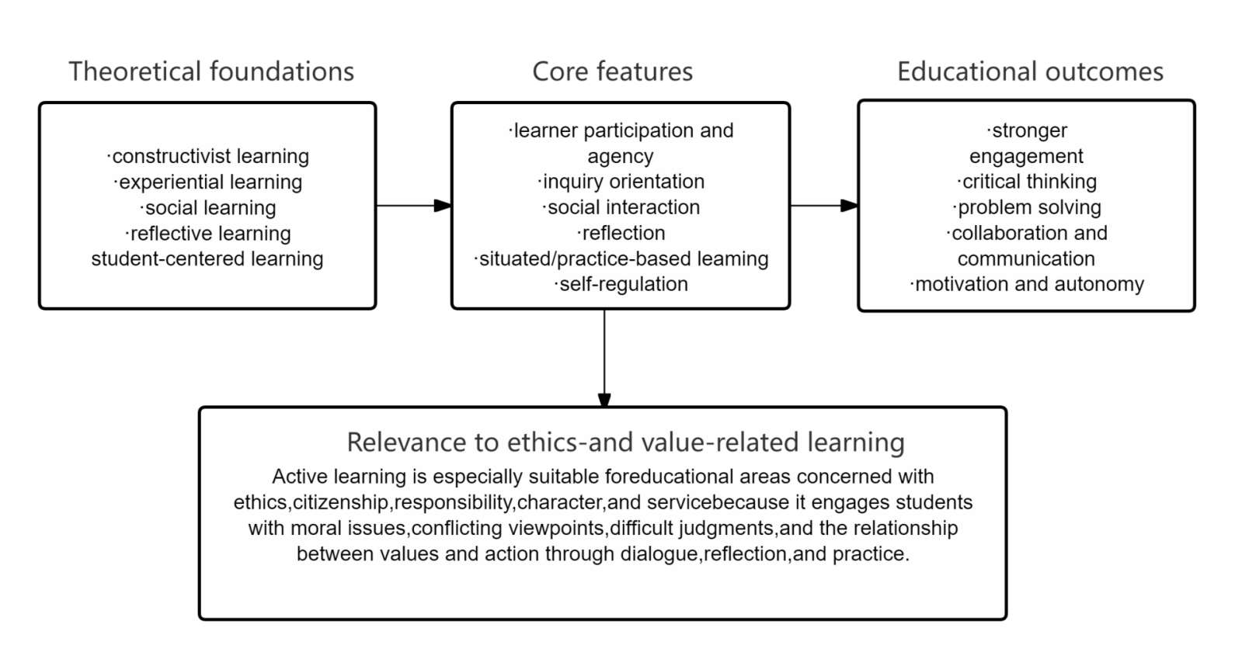
Figure 3. Synthesis of the Active Learning Literature
4. Review of Literature on Moral Education in Chinese Higher Education
If active learning provides the pedagogical foundation for this review, moral education in Chinese higher education provides its central educational domain. To develop active learning moral education modules meaningfully, it is necessary to understand what moral education in Chinese universities aims to achieve, how it is commonly implemented, and where its major pedagogical limitations lie(Dipasupil et al., 2019). Existing literature shows that moral education in Chinese higher education has a clear value orientation and strong institutional support, but also reveals substantial room for innovation in relation to student participation, reflection, and practice.
4.1 Goals of Moral Education in Chinese Higher Education
The goals of moral education in Chinese higher education are broad and multi-dimensional. At a general level, moral education seeks to support students’ value formation and moral development as part of the university’s educational mission(M. Li, 2024). It is concerned not only with what students know, but also with how they understand themselves, relate to others, and act within society.
A central goal is value cultivation. Universities are expected to foster socially responsible orientations such as integrity, responsibility, respect for others, and commitment to the common good. Moral education also aims to strengthen moral cognition by helping students understand moral norms, ethical principles, and social responsibilities, while developing the ability to identify moral issues in personal, academic, and social life(Muslim & Rohi, 2023).
In addition, moral education is concerned with character formation. It seeks to cultivate relatively stable dispositions such as honesty, self-discipline, empathy, and perseverance. It also emphasizes public responsibility and social participation by encouraging students to understand morality not only as a private matter but also as a social and civic commitment(Respati et al., 2022). Finally, a longstanding expectation is the unity of knowing and acting: students should not only understand moral values conceptually, but also be able to enact them in concrete situations.
Taken together, these goals suggest that moral education in Chinese higher education is a comprehensive developmental project involving cognition, values, character, responsibility, and action(Sanpanich, 2021). This breadth implies a need for pedagogies capable of connecting understanding with reflection and practice.
4.2 Main Approaches to Moral Education
Moral education in Chinese higher education is pursued through multiple pathways rather than through a single course forma(Chen, 2021)t. The most visible and institutionalized approach is the system of ideological and political theory courses, which provide explicit curricular space for value education and moral cultivation.
Curriculum-based moral education across disciplines has also become increasingly important. This approach emphasizes that moral education should not be confined to specialized courses, but should be integrated across the wider curriculum so that different subjects contribute to student development in different ways(Xu et al., 2023).
Beyond the formal curriculum, campus culture serves as an important channel of moral education through institutional norms, cultural activities, and the broader educational climate of the university. Social practice and volunteer service are also widely emphasized because they connect moral learning with students’ lived experience and create opportunities to cultivate responsibility, empathy, and civic awareness(Feraco et al., 2023). Student organizations and extracurricular associations provide further spaces for developing commitment, cooperation, and participatory awareness. In the digital era, online ideological and moral education has likewise become increasingly important, reflecting the fact that students’ moral experiences are now shaped not only by classroom instruction but also by digital platforms, media environments, and online discourse(Md Rashid et al., 2024).
These pathways show that moral education in Chinese higher education is already understood as a multi-channel system. However, institutional breadth does not in itself guarantee pedagogical depth or meaningful student transformation(Sumarmi et al., 2020).
4.3 Challenges in Existing Moral Education Practice
Although Chinese higher education has established a relatively clear moral education system, the literature also identifies several persistent challenges in practice. One major issue is the dominance of knowledge transmission over student subject formation. Moral education often focuses on communicating principles and expected values, while giving insufficient attention to how students actively interpret, negotiate, and internalize those meanings.
A related challenge is the emphasis on normative instruction over situated experience(Chankob & Hdouch, 2024). Students may be told which values they should uphold, yet they are not always given opportunities to encounter moral tension, ambiguity, or real-life ethical complexity. As a result, moral education may remain abstract rather than experientially meaningful(Brooks, 2024).
Another problem is the prioritization of outcome display over reflective process. Greater attention is often paid to whether students express expected attitudes or complete required activities than to how their thinking develops, how they reflect, or how they work through moral questions over time. In addition, classroom reasoning is often privileged over authentic practice(Morris, 2020a). Without adequate opportunities for participation, action, and reflective application, students may struggle to connect moral concepts with real decision-making and behavior(Habib et al., 2021).
Finally, moral education content may become disconnected from students’ everyday realities. Contemporary university students face issues related to digital life, online ethics, academic integrity, interpersonal responsibility, public discourse, and civic participation(Wang & Song, 2024). If moral education does not engage with such realities, students may perceive it as distant, formulaic, and weak in personal relevance.
These challenges suggest that the central issue is not simply whether moral education exists institutionally, but whether it is pedagogically capable of shaping students in developmentally meaningful ways.
4.4 Need for Pedagogical Innovation in Moral Education
The challenges outlined above indicate that moral education in Chinese higher education cannot rely on explanation and exhortation alone if it aims to influence students in deeper and more lasting ways(Kesumawati et al., 2024). To support genuine moral development, pedagogy must engage students as participants in moral inquiry rather than as passive recipients of moral conclusions.
This points to the need for more participatory, reflective, and practice-oriented forms of instructional design. Students need opportunities to question, discuss, deliberate, experience, and reflect. They need to encounter authentic issues, work through conflicting perspectives, and connect value discourse with concrete action(Giday & Perumal, 2024).
Within this context, active learning emerges as a particularly promising direction. Its emphasis on learner involvement, inquiry, collaboration, reflection, and practice aligns closely with the demands of moral development. Active learning does not replace the value orientation of moral education, but offers a more pedagogically robust way of enacting it(Ferrer et al., 2022). This provides a strong rationale for bringing the two fields into closer theoretical dialogue.
4.5 Summary of Moral Education Literature
The literature on moral education in Chinese higher education shows that this field has clear goals, strong institutional support, and an established value orientation. It seeks to cultivate students’ values, moral understanding, character, public responsibility, social participation, and the unity of knowing and acting through multiple formal and informal pathways(J. Li & Wu, 2023).
At the same time, moral education continues to face important pedagogical limitations, especially in relation to student agency, situated experience, reflective process, and authentic practice. These limitations suggest that the development of active learning moral education modules is not only a theoretical possibility, but also a practical response to a recognizable educational need(Niu, 2023). The next section therefore brings the two strands of literature into direct dialogue.
Figure 4 summarizes the major goals, approaches, and pedagogical challenges identified in the literature on moral education in Chinese higher education.
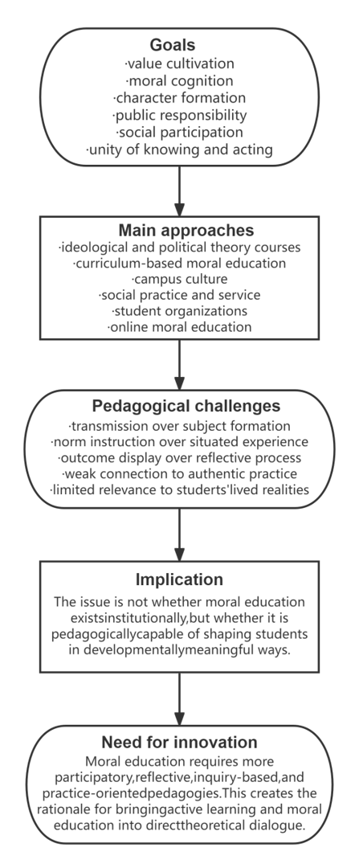
Figure 4. Synthesis of the Moral Education Literature in Chinese Higher Education
5. Linking Active Learning and Moral Education
The preceding sections have reviewed two bodies of literature that are often discussed separately: active learning in higher education and moral education in Chinese universities. The central task of this section is to explain why these two fields are theoretically aligned(Yang, 2021). Active learning should not be seen merely as a set of teaching techniques that can be inserted into moral education. More fundamentally, the two share a developmental logic grounded in student participation, reflective understanding, social engagement, and responsible action. For this reason, their relationship is best understood as pedagogically coherent rather than incidental.
5.1 Agency
One of the clearest points of convergence between active learning and moral education lies in the question of student agency. Active learning rests on the assumption that students learn more meaningfully when they participate actively in the learning process, make sense of ideas for themselves, and assume responsibility for inquiry, discussion, and application. It therefore challenges models of teaching that position students mainly as passive recipients of information(Tsvyk & Tsvyk, 2021).
Moral education similarly depends on the development of internal commitment rather than mere external compliance. Moral values cannot be genuinely formed when students simply repeat expected norms or conform to authority without personal understanding and identification. For moral education to achieve developmental depth, students must come to recognize, interpret, and endorse moral meanings as their own(Suciati et al., 2023). Morality, in this sense, requires subject formation rather than simple behavioral regulation.
Agency is therefore not only a pedagogical issue but also a moral one. A student who is unable to think, judge, and respond as a moral subject is unlikely to develop stable moral responsibility. By creating space for students to question, express views, make choices, and take ownership of learning, active learning supports the emergence of self-aware and responsible learners(Wong, 2023). This aligns closely with moral education’s concern with self-conscious moral development.
5.2 Inquiry into Moral Issues
Active learning also aligns with moral education through its emphasis on inquiry. In active learning environments, students are often asked to explore questions, cases, problems, and dilemmas that require interpretation, analysis, and judgment. Knowledge is treated not as fixed and complete, but as something that must be worked through in relation to complexity and uncertainty(Wong, 2023).
This orientation is especially relevant to moral education because moral life is often shaped by ambiguity, conflict, and competing claims rather than simple certainty(Tsvyk & Tsvyk, 2021). Students do not encounter only straightforward distinctions between right and wrong; they also face conflicting responsibilities, unclear consequences, competing values, and socially contested issues. Moral education that relies solely on rule transmission may not prepare them adequately for such realities.
Inquiry-based learning supports moral education by enabling students to confront moral issues as questions to be understood and judged rather than as conclusions to be memorized. Through questioning, case interpretation, dilemma analysis, and critical examination of viewpoints, students can develop deeper moral cognition and more nuanced ethical judgment(Wati et al., 2025b). Inquiry therefore functions not merely as a cognitive method, but as a necessary condition for substantive moral understanding.
5.3 Social Interaction
Another important area of convergence lies in social interaction. Active learning consistently emphasizes peer collaboration, dialogue, shared problem solving, and teacher-student exchange. Learning is understood not only as an individual process of cognition, but also as a socially mediated activity in which understanding is shaped through communication, feedback, and collective meaning-making(Guo et al., 2025).
Moral development is likewise deeply relational. Students do not form values in isolation. Dialogue with others, negotiation of differences, assumption of roles, recognition of perspectives, and participation in communities all shape the growth of moral understanding and responsibility(Sai et al., 2025). Through interaction, students encounter other people not merely as abstract categories, but as subjects whose experiences, needs, and claims require attention and response.
This gives social interaction special significance in moral education. When students discuss controversial issues, deliberate with peers, listen to disagreement, and justify their positions, they are not only learning content; they are also practicing perspective-taking, respect, responsibility, and public reasoning(Saputri et al., 2025). Teacher-student interaction can likewise model ethical dialogue, supportive guidance, and moral seriousness in ways that formal content alone cannot achieve. The dialogic dimension of active learning therefore corresponds closely to the relational character of moral education(Jalani et al., 2023a).
5.4 Reflection
Reflection provides perhaps the clearest bridge between participation and moral growth. In active learning, reflection allows students to make sense of experience, question assumptions, connect ideas with practice, and transform activity into deeper understanding. Without reflection, participation may remain superficial and fragmented(Jadhav et al., 2025).
Reflection is equally central to moral education. Moral growth requires more than behavioral adjustment or verbal agreement; it requires self-examination, value clarification, and awareness of responsibility. Students need opportunities to consider why they hold certain beliefs, how their actions affect others, what tensions exist between values, and what kind of person they aim to become. Reflection makes these questions educationally visible(Zhao et al., 2025).
Through reflective writing, guided dialogue, self-assessment, or post-experience discussion, students can process moral experiences more deeply and begin to internalize moral learning. Reflection also supports continuity in development because it allows students to connect isolated classroom events with broader patterns of identity and responsibility(X. He et al., 2025). In this respect, the reflective dimension of active learning aligns strongly with the introspective and developmental demands of moral education(Lu, 2025).
5.5 Practice and Action
A final and especially significant point of alignment concerns practice and action. Active learning is often associated with learning through doing(Elez et al., 2025). Its educational value lies partly in the fact that students are asked to apply ideas, engage in tasks, participate in real or simulated situations, and test understanding through practice(Talwar et al., 2022).
This resonates directly with one of the most enduring principles of moral education: the unity of knowing and acting. Moral education remains incomplete if students understand values conceptually while lacking opportunities to enact them in practice(Gashi et al., 2024). Values become morally formative when they are embodied in decisions, relationships, responsibilities, and patterns of conduct.
Practice is therefore not an optional supplement to moral education, but one of its essential conditions. Service activities, community engagement, role enactment, scenario simulation, and participation in collective tasks can all help students experience the practical demands of morality. Through such experiences, students may begin to see how responsibility, empathy, honesty, and commitment operate in real situations rather than as abstract ideals(Jalani et al., 2023b). Active learning strengthens this connection by making practice part of the pedagogical design and by creating pathways through which practice may develop into morally informed action(X. He et al., 2025).
Taken together, these five areas of convergence show that active learning and moral education are not merely compatible; they are mutually reinforcing at a deep pedagogical level, as summarized in Figure 5.
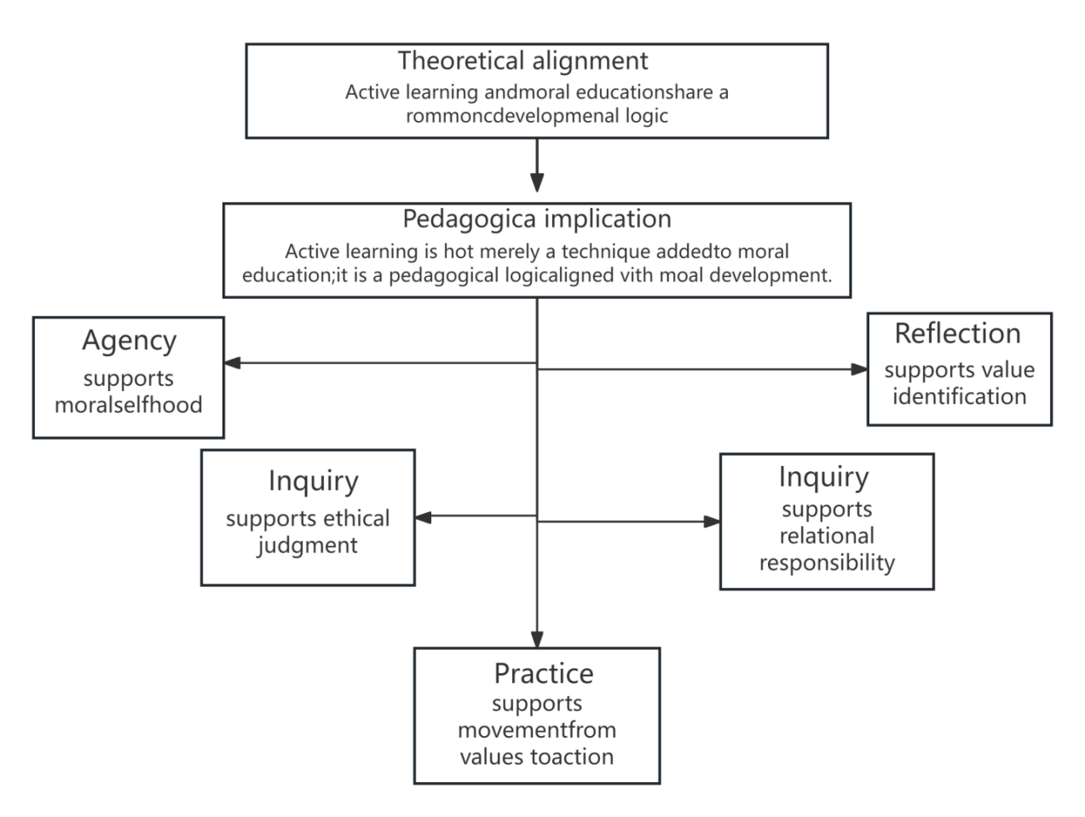
Figure 5. Five Areas of Theoretical Alignment
Accordingly, active learning should not be understood merely as a teaching method for moral education. It represents a pedagogical logic that aligns with how moral understanding, value identification, responsibility, and ethically informed action are likely to develop(De Pessemier et al., 2025). This theoretical alignment provides the basis for the conceptual framework proposed in the next section.
6. Toward the Development of Active Learning Moral Education Modules: A Conceptual Framework
Building on the preceding conceptual clarification, literature review, and theoretical alignment, this section proposes a conceptual framework for the development of active learning moral education modules in Chinese higher education(Chung, 2023). The framework is intended not simply as a descriptive summary, but as an organizing structure that explains how active learning can be translated into module design for moral education, how contextual and pedagogical factors relate to one another, and how these processes may contribute to students’ moral development over time(Jadhav et al., 2025). In this sense, it performs a role similar to that of conceptual review models that synthesize literature into a structured account of contextual influences, core processes, mediating mechanisms, and developmental outcomes(Xiong et al., 2025).
The framework consists of six interrelated components: principles for framework development, a contextual layer, an input layer for module development, core active learning processes, mediating mechanisms, and outcomes(X. He et al., 2025). Together, these components explain how active learning moral education modules can be designed in ways that are pedagogically coherent, contextually appropriate, and developmentally meaningful for Chinese university students(Lu, 2025).
Figure 6 presents the proposed conceptual framework.
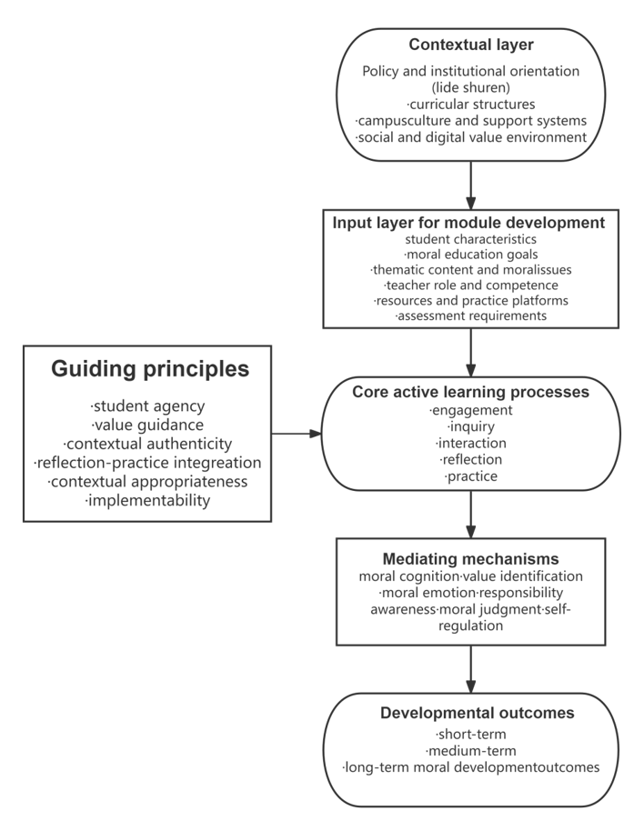
Figure 6. Detailed Conceptual Framework
6.1 Principles for Framework Development
Several principles guide the proposed framework and shape both its theoretical orientation and its practical relevance.
The first is student agency. Because both active learning and moral education depend on students’ meaningful participation, the framework positions students not as passive recipients of moral content but as active constructors of moral understanding and responsibility(Taylor et al., 2025b). Module design should therefore create room for inquiry, expression, decision-making, and ownership of learning(Elez et al., 2025).
The second is value guidance. Moral education is not morally neutral instruction; it is oriented toward the cultivation of socially and ethically significant values(Taylor et al., 2025a). The framework therefore preserves the value-guiding function of moral education while avoiding the reduction of values to static slogans or declarative content. Value guidance should be embedded in the design of learning processes rather than confined to verbal transmission alone(Tsui et al., 2024).
A third principle is contextual authenticity. Moral learning becomes more educationally powerful when it is connected to recognizable issues, real dilemmas, and students’ lived social worlds. Module development should therefore be grounded in students’ actual experiences, including digital life, interpersonal relationships, academic ethics, social responsibility, and public participation(Hashim et al., 2022).
A fourth principle is the integration of reflection and practice. Since moral development requires both inner examination and outward enactment, modules should not separate reflection from practice. Students need opportunities not only to analyze moral questions, but also to act, experience consequences, and reflect on those experiences(Mokhtar et al., 2024).
A fifth principle is contextual appropriateness for Chinese higher education. The framework must align with the educational mission, institutional structures, and value orientations of Chinese universities, including lide shuren, curriculum-based moral education, and the broader moral aims of higher education in China(Jalani et al., 2023b). At the same time, it must remain responsive to the contemporary experiences of Chinese university students.
The final principle is implementability. A conceptual framework for module development should not remain purely theoretical. It should be capable of informing actual instructional design, including objectives, content selection, activity structure, teacher support, and assessment(Jones Bsc Neuropsychology, 2022). This principle ensures that the framework can serve as a practical guide for curriculum development and future empirical work.
6.2 Contextual Layer
The outer layer of the framework consists of the broader contextual conditions within which active learning moral education modules are developed and implemented. This layer shapes what is institutionally supported, culturally meaningful, and pedagogically possible, even though it is not identical to classroom activity itself.
In the present framework, the contextual layer includes national and institutional policy orientations, especially the overarching educational commitment to lide shuren(Ochoa et al., 2023). It also includes the curricular structures through which moral education is pursued in Chinese higher education, including ideological and political theory courses and curriculum-based moral education across disciplines(Brinson, 2024). These arrangements influence how moral education is positioned within university teaching and how module development may be supported or constrained.
The contextual layer further includes campus culture and institutional support systems. A university’s educational climate, organizational norms, value discourse, and practical support structures all shape the conditions under which moral education can take place(Kruijtbosch, 2021). Modules do not operate in isolation; they are embedded in a wider institutional environment that may either strengthen or weaken their educational impact.
In addition, this layer includes the broader social and digital value environment in which students live. Contemporary university students encounter moral questions not only in formal curricula but also in online interaction, social media discourse, platform culture, public controversies, and rapidly changing social expectations(Deepa et al., 2022a). These realities form part of the environment within which modules must be designed. The contextual layer therefore establishes the wider conditions that shape subsequent design inputs and implementation possibilities.
6.3 Input Layer for Module Development
Within the broader contextual layer lies the input layer, which refers to the immediate design conditions and resources required for module development. This layer provides the starting point for instructional planning and determines the extent to which a module is educationally coherent and practically viable(Deepa et al., 2022b).
One important element concerns learner characteristics. Chinese university students differ in developmental stage, disciplinary background, learning habits, digital experience, and moral sensitivity. Module design therefore needs to take account of students’ cognitive maturity, social concerns, prior experiences, and likely patterns of engagement(Denis et al., 2024b). Without such attention, moral education risks becoming generic and disconnected from actual student needs.
A second element is moral education goals. Modules should be developed with clearly articulated aims, such as strengthening moral understanding, promoting value identification, cultivating empathy, enhancing responsibility, or supporting ethically informed action(Cao et al., 2021). These aims provide direction for content selection and activity design(Rieger et al., 2020).
A third input concerns thematic content and moral issues. Modules need to be organized around specific themes that are educationally meaningful and morally relevant, such as academic integrity, digital ethics, interpersonal respect, civic responsibility, social justice, environmental responsibility, or public participation. Thematic clarity helps translate broad moral goals into teachable units(Zhao et al., 2025).
A fourth element involves teacher role and competence. Teachers are not merely transmitters of moral conclusions; in active learning settings, they serve as facilitators, organizers of discussion, providers of feedback, and guides for reflection(Xiong et al., 2025). Their pedagogical competence, moral sensitivity, and ability to manage inquiry-based learning significantly influence module quality.
A fifth element is the availability of teaching resources and practice platforms. Case materials, scenarios, multimedia resources, community connections, service opportunities, and digital platforms all shape the richness and feasibility of module activities(J. He et al., 2025). Moral education modules are more likely to succeed when they are supported by appropriate pedagogical resources and spaces for practice.
A final input concerns assessment requirements. Since moral education cannot be reduced to factual recall, module design should consider forms of assessment capable of capturing participation, reflection, ethical reasoning, collaboration, and practical engagement(Jalani et al., 2023a). In this way, the input layer channels broader contextual conditions into concrete design decisions.
6.4 Core Active Learning Processes
At the center of the framework are five core active learning processes: engagement, inquiry, interaction, reflection, and practice. These processes form the pedagogical engine of the module and represent the main pathways through which students move from participation in learning activities toward moral development(Hein Wainggai et al., 2024a). They should not be understood as rigid linear stages, but as mutually reinforcing dimensions of learning.
Engagement refers to students’ active involvement in learning activities. It includes attention, participation, willingness to contribute, and readiness to invest effort in moral learning tasks(Hein Wainggai et al., 2024b). Without engagement, moral education is likely to remain externally imposed and educationally weak.
Inquiry refers to the exploration of moral questions, dilemmas, and issues through analysis, interpretation, and judgment. It invites students to examine complexity, think critically, and consider competing values rather than accept moral conclusions unreflectively(Wati et al., 2025a).
Interaction refers to communication and collaboration with peers, teachers, and wider communities. Through dialogue, discussion, and shared work, students encounter different perspectives, test their own views, and negotiate moral meaning in social settings(Wati et al., 2025b).
Reflection refers to the process through which students examine experience, clarify values, evaluate assumptions, and connect learning with self-understanding(Sinaga & Sinaga, 2023). Reflection is what allows participation and inquiry to deepen into moral insight.
Practice refers to action in authentic or simulated situations. It includes service, scenario enactment, community tasks, role engagement, and other forms of applied participation. Practice gives students opportunities to test moral commitments under conditions that resemble or directly involve real responsibility(Nugroho, 2021).
Together, these five processes provide the central pedagogical structure of active learning moral education modules(Mahrlamova & Chabanovych, 2022). They also serve as a direct guide for module design: a well-developed module should make visible provision for each of these processes rather than relying on content delivery alone.
6.5 Mediating Mechanisms
Between active learning processes and developmental outcomes lies a set of mediating mechanisms. This layer explains how participation in active learning may gradually contribute to moral growth(Ayal et al., 2022). Including such mechanisms makes the framework more analytically precise because it avoids treating educational activities and outcomes as if they were directly or automatically connected.
A first mediating mechanism is the deepening of moral cognition. Through inquiry, discussion, and reflection, students may develop a more differentiated understanding of moral concepts, ethical principles, and social responsibility(Chuang et al., 2021). This deepened cognition goes beyond memorizing norms and involves interpretive understanding.
A second mechanism is value identification. Moral learning becomes developmentally meaningful when students begin to recognize certain values as personally significant rather than merely externally imposed(Mesnan et al., 2023). Active learning supports this process by giving students opportunities to examine, discuss, and endorse values in relation to their own reasoning and experience.
A third mechanism is the activation of moral emotion. Encountering real issues, hearing others’ perspectives, and participating in authentic situations can evoke empathy, concern, moral unease, or a sense of care(Ahamed et al., 2022). Such emotional engagement often plays an important role in motivating ethical attention and commitment.
A fourth mechanism is the strengthening of responsibility awareness. Through collaborative work, practice tasks, and social participation, students may become more aware of the consequences of action and of their obligations toward others, communities, and public life(Xu et al., 2023).
A fifth mechanism is the development of moral judgment. Active engagement with dilemmas and contested issues can help students become more capable of weighing alternatives, reasoning through complexity, and making ethically informed decisions.
A final mechanism concerns self-regulation and behavioral internalization. As students repeatedly engage in reflection and practice, they may gradually develop habits of self-monitoring, value-guided decision-making, and more consistent moral conduct(L. Huang & Wang, 2023). This mechanism is particularly important for linking learning experiences to longer-term character formation.
Taken together, these mediating mechanisms explain how active learning processes may be translated into morally significant developmental change.
6.6 Outcomes
The final part of the framework concerns outcomes, which may be understood across short-term, medium-term, and long-term time horizons(Abdelrahman, 2020). This layered treatment is useful because moral development is unlikely to occur all at once; rather, it unfolds gradually through cumulative learning processes and repeated engagement.
Short-term outcomes include increased participation in learning, improved understanding of moral issues, enhanced reflective capacity, and stronger peer collaboration and expression(Chankob & Hdouch, 2024). These outcomes are closely linked to students’ immediate experiences within a module and can often be observed during or shortly after implementation.
Medium-term outcomes include stronger value identification, increased empathy and responsibility, and improved moral judgment and ethical decision-making(Mahmood et al., 2024). These outcomes suggest that students are not only participating in moral learning activities, but are also beginning to internalize their significance and apply them more thoughtfully(Lai et al., 2024).
Long-term outcomes involve more stable character development, sustained social responsibility and public participation, habitual alignment between knowing and acting, and continuing self-directed moral growth(Sathe & Yu, 2021). These outcomes represent the broader developmental aspirations of moral education and are less likely to emerge from a single activity alone. Rather, they depend on repeated, meaningful, and well-supported experiences over time(Zhu et al., 2024).
The relationships among these outcomes should be understood developmentally rather than mechanically. Short-term gains in engagement and reflection may support medium-term shifts in value identification and judgment, which in turn may contribute to longer-term character formation and ethical practice(Wang & Song, 2024). In this sense, the framework conceptualizes module development not as the delivery of fixed content, but as the design of conditions that support ongoing moral growth.
Taken together, the proposed framework can be summarized as follows: within the context of Chinese higher education, active learning moral education modules are developed on the basis of student characteristics, moral goals, thematic issues, teacher capacities, resources, and assessment requirements(Kesumawati et al., 2024). These inputs are shaped by wider institutional, policy, cultural, and digital contexts. Within this environment, students engage in five core active learning processes—engagement, inquiry, interaction, reflection, and practice—which activate mediating mechanisms including moral cognition, value identification, moral emotion, responsibility awareness, moral judgment, and self-regulation(Giday & Perumal, 2024). Through these mechanisms, students may gradually achieve short-, medium-, and long-term moral development outcomes(X. Huang & Huang, 2025).
This framework is intended to provide a conceptual basis for module design rather than a finalized empirical model. Its value lies in clarifying the relationships among context, design, process, mechanism, and outcome, thereby offering a structured foundation for future curriculum development and empirical study in Chinese higher education(Ong & Quek, 2023).
7. Implications for Module Development and Practice
The framework proposed above is useful only insofar as it can inform actual educational design and practice. In the context of Chinese higher education, the development of active learning moral education modules requires attention not only to what students should learn, but also to how such learning should be designed, facilitated, assessed, and institutionally supported(Kvamme, 2020). This section therefore considers the practical implications of the framework for module design, teachers, assessment, and institutions.
Figure 7 summarizes the main practical implications of the framework for module design, teachers, assessment, and institutional support.
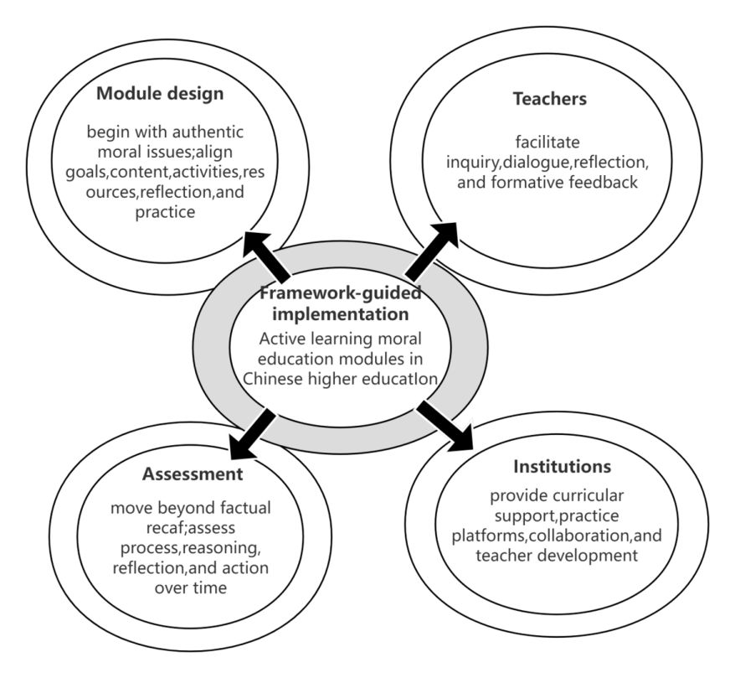
Figure 7. Practical Implications of the Framework
7.1 Implications for Module Design
Module design should begin with authentic moral issues rather than abstract moral slogans alone. If active learning is to contribute meaningfully to moral education, modules need to be organized around themes and dilemmas that students are likely to encounter in university and social life, such as academic integrity, online conduct, interpersonal responsibility, public participation, social justice, or professional ethics(Balakrishnan, 2021). Designing around such issues helps students perceive moral education as relevant to their own lives rather than as a purely formal requirement(Marples, 2022).
Instructional activities should also be structured around inquiry and practice rather than one-way explanation. Moral education modules should provide opportunities for students to explore cases, discuss dilemmas, analyze competing viewpoints, and engage in situation-based tasks(Miller, 2021). Such activities allow students to work through moral meaning instead of merely receiving normative conclusions.
Each module should further include explicit opportunities for reflection and applied participation. Reflection enables students to process experience, clarify values, and deepen understanding. Practice allows them to connect moral ideas with responsibility in action(Indriyani & Ishomuddin, 2022). A module that contains explanation but little reflective or practical work is unlikely to support substantial moral development.
More broadly, module design should be understood as the structuring of a developmental pathway. Well-designed modules should align goals, thematic content, learning activities, resources, and assessment in ways that support students’ movement from initial engagement with moral issues toward value identification and ethically informed action(Suciati et al., 2023).
7.2 Implications for Teachers
The framework also has important implications for the role of teachers. Within active learning moral education modules, teachers cannot function only as transmitters of knowledge or announcers of correct values. They need to act as facilitators of learning, guides of moral inquiry, organizers of dialogue, and providers of formative feedback(Wong, 2023). Their role is to create the conditions under which students can think, interact, reflect, and act meaningfully.
This shift has several practical consequences. Teachers need to be able to design discussion-rich and inquiry-oriented activities rather than rely solely on explanation(Wang & Song, 2024). They also need the capacity to guide students through morally sensitive or contested issues without reducing discussion too quickly to predetermined answers. This requires not only subject knowledge, but also pedagogical judgment, moral sensitivity, and confidence in facilitating open yet purposeful dialogue(Ismiyani et al., 2024).
Teachers also need strong competence in organizing reflection. Reflection does not arise automatically simply because students have participated in an activity. It requires prompts, structured questions, supportive feedback, and appropriate opportunities for self-examination. Teachers must therefore know how to scaffold reflective learning so that students can connect experience with moral understanding and personal responsibility(Ji & Zhernovnykova, 2024).
In addition, teachers should be able to provide formative feedback that supports students’ moral and developmental learning rather than merely checking factual comprehension. Such feedback may focus on reasoning, perspective-taking, participation, responsibility, and reflective depth(Morris, 2020b). Teacher development therefore becomes a key condition for the successful implementation of active learning moral education modules.
7.3 Implications for Assessment
Assessment should also be reconsidered in light of the framework. If moral education modules are designed according to active learning principles, evaluation cannot be limited to the recall of concepts, slogans, or normative statements. Such approaches may capture whether students remember content, but they are insufficient for judging whether students have engaged meaningfully, reflected critically, developed ethical judgment, or connected values with action(Mayer & Schwemmle, 2023).
Assessment in active learning moral education should therefore be broader, process-oriented, and multi-dimensional. Possible approaches include reflective journals, case analyses, project outputs, peer assessment, discussion contributions, scenario responses, and evidence of practical participation(Morris, 2020c). These forms of assessment can better capture the kinds of outcomes that moral education aims to promote, including reflection, collaboration, ethical reasoning, and responsible action.
Assessment should also recognize development over time. Some important outcomes of moral education, such as value identification or responsibility awareness, may not be fully visible in a single test or one-time performance. For this reason, assessment strategies should combine immediate evidence of learning with more continuous and formative evaluation(Aithal & Mishra, 2024). This may include portfolios, repeated reflective tasks, or cumulative project documentation.
In this sense, assessment is not merely a mechanism for judging whether students have learned, but also part of the learning process itself(Chankob & Hdouch, 2024). Well-designed assessment can encourage students to take moral inquiry seriously, articulate their thinking, and remain engaged with ethical development beyond short-term classroom requirements(Novitasari & Subekti, 2024).
7.4 Implications for Institutions
The framework further suggests that universities themselves play a crucial role in implementation. Even well-designed modules cannot be sustained if institutions do not provide an environment that supports them. Active learning moral education modules require more than individual teacher effort; they also depend on curricular structures, organizational support, and access to meaningful practice opportunities(Mayombe, 2024).
First, institutions need to provide curricular support. This includes making room within formal teaching arrangements for modular, participatory, and practice-based moral learning rather than treating moral education only as a fixed content requirement(Bayer et al., 2024). Timetabling, curriculum coordination, and interdisciplinary collaboration all affect whether module-based innovation can occur.
Second, institutions need to provide practice platforms and resource support. Community partnerships, volunteer opportunities, service-learning sites, digital platforms, and case resources can all strengthen implementation(Wagner & Intindola, 2024). Without such supports, it may be difficult to connect moral learning with authentic practice.
Third, institutions need cross-departmental collaboration. Moral education modules often cut across teaching, student affairs, community engagement, digital education, and campus culture(Quibrantar & Ezezika, 2023). A fragmented institutional approach may weaken their impact, whereas coordinated support can make them more coherent and sustainable.
Finally, institutions need to build support systems aligned with module implementation. This includes teacher training, evaluation reform, resource sharing, and mechanisms for reflecting on implementation quality(Sumarmi et al., 2020). Active learning moral education should therefore not be treated as an isolated classroom technique, but as part of a broader educational ecology within Chinese higher education.
Taken together, these implications suggest that developing active learning moral education modules is not simply a matter of changing classroom activities(Abdelrahman, 2020). It requires coordinated attention to module design, teacher development, assessment reform, and institutional support. The practical value of the framework lies in showing that moral education innovation depends on the alignment of these multiple dimensions(L. Huang & Wang, 2023).
8. Directions for Future Research
Although this review has proposed a conceptual framework for developing active learning moral education modules in Chinese higher education, that framework should be treated as a starting point rather than an endpoint(Xu et al., 2023). Conceptual integration helps clarify key relationships, but it does not by itself show how such modules can be designed, implemented, adapted, and evaluated in real educational settings(Nawaiseh et al., 2023). Future research should therefore move beyond conceptual discussion and pursue a more systematic agenda in at least five directions.
Figure 8 outlines the main directions for future research identified in this review.
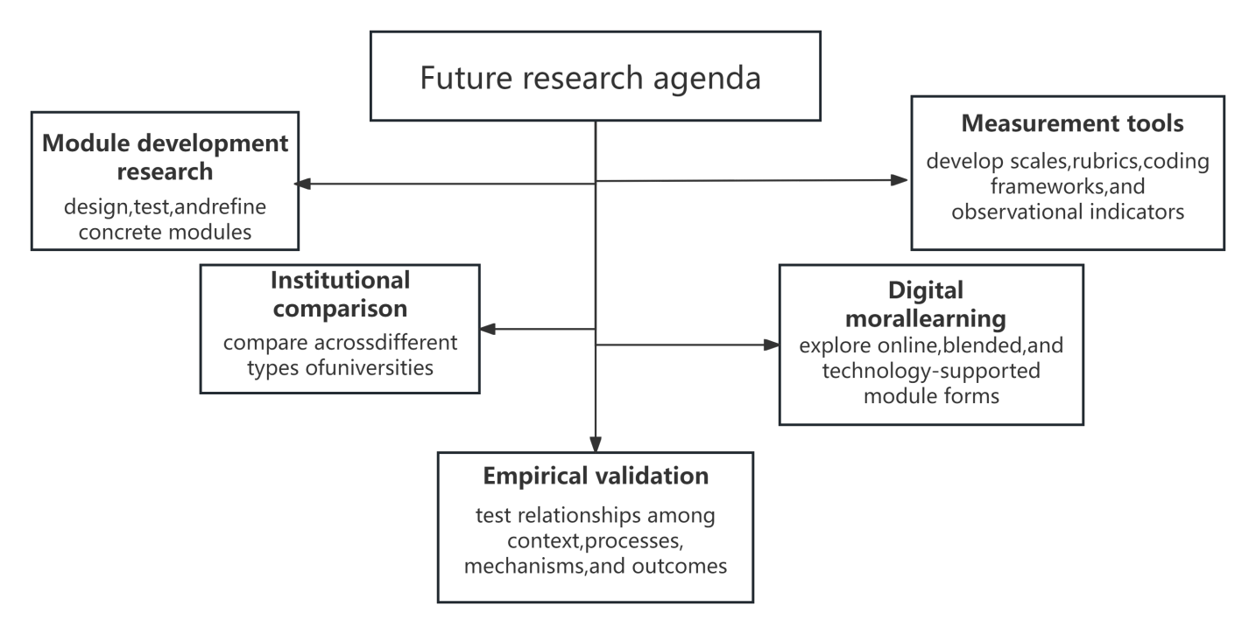
Figure 8. Future Research Agenda
8.1 Module Development Research
A first priority is the development of concrete active learning moral education modules. Existing discussion often remains at the level of general pedagogical principles, while relatively few studies translate these principles into teachable units with clear themes, objectives, activity sequences, and assessment strategies(Patra et al., 2022). Future work should therefore focus on design-oriented research that develops, tests, and refines modules around specific moral issues while also considering duration, disciplinary adaptability, and practical feasibility in university settings(Muslim & Rohi, 2023).
8.2 Empirical Validation of the Framework
A second direction is the empirical validation of the proposed framework. Although the framework is theoretically grounded, the relationships it proposes among context, inputs, active learning processes, mediating mechanisms, and outcomes still need to be examined in practice. Future studies should investigate whether these relationships can be observed in actual module implementation and which mechanisms are most influential under different conditions(Moosa, 2019). Qualitative, quantitative, and mixed-methods research may all contribute to this task.
8.3 Development of Measurement Tools
A third area concerns measurement. Research on active learning and moral education is often constrained by the difficulty of assessing complex constructs such as value identification, moral reflection, responsibility awareness, and ethical action(Mazumder et al., 2020). Future research should therefore develop more suitable measurement tools, including scales, performance rubrics, reflective coding frameworks, and observational indicators. Because moral education involves cognitive, affective, and behavioral dimensions, multi-method approaches will be especially important(Ahamed et al., 2022).
8.4 Differences Across Types of Universities
A fourth direction is to examine how active learning moral education modules function across different types of higher education institutions. Chinese universities are not homogeneous, and variation in institutional mission, disciplinary structure, student population, regional setting, and available resources may all affect how such modules are designed and implemented(Dipasupil et al., 2019). Future studies should therefore compare the applicability of the framework across comprehensive universities, normal universities, vocational colleges, applied universities, and research-intensive institutions(Singh et al., 2023). Such work can help distinguish common design principles from those that require local adaptation.
8.5 Moral Learning in Digital Contexts
A fifth and increasingly important direction concerns moral learning in digital contexts. Contemporary university students encounter many moral issues through digital media, online platforms, and networked public discourse, including questions of online civility, privacy, misinformation, cyberbullying, and digital responsibility(Karaoglan Yilmaz & Yilmaz, 2024). Future research should therefore explore how active learning moral education modules can respond to these realities through online discussion, blended module design, digital case-based learning, technology-supported reflection, and online community engagement. Attention to digital contexts is essential if moral education is to remain relevant to students’ everyday ethical experience(Mesnan et al., 2023).
Taken together, these directions suggest that future research should move beyond broad calls for innovation toward a more systematic agenda combining module design, framework validation, measurement development, contextual comparison, and digital adaptation(Chuang et al., 2021). The future development of this field depends not only on stronger theory, but also on sustained design work and empirical investigation.
9. Conclusion
This review has argued that active learning and moral education in Chinese higher education are highly compatible at the level of pedagogical and developmental logic. Active learning emphasizes agency, inquiry, interaction, reflection, and practice, while moral education seeks to cultivate moral understanding, value identification, responsibility, and ethically informed action(Mahrlamova & Chabanovych, 2022). When these two fields are considered together, active learning appears not simply as a supplementary instructional technique, but as a pedagogical orientation aligned with how moral development is likely to occur among university students(Nugroho, 2021).
On this basis, the article has further argued that moral education in Chinese higher education needs more participatory, reflective, and practice-oriented forms of pedagogy. Although Chinese universities have clear moral education goals and strong institutional support, existing practice still faces important limitations in relation to abstraction, limited student involvement, insufficient reflection, and weak connections with authentic experience(Sinaga & Sinaga, 2023). These limitations suggest that pedagogical innovation is central rather than peripheral to the effectiveness of moral education.
To address this issue, the review has proposed a conceptual framework for developing active learning moral education modules in Chinese higher education. By organizing the relationships among contextual conditions, module inputs, active learning processes, mediating mechanisms, and developmental outcomes, the framework provides a foundation for future module design and empirical research(Guo et al., 2025). More broadly, it offers a structured basis for rethinking moral education in Chinese universities as a process of meaningful participation, reflective engagement, and ethical practice, while identifying module development as a concrete pathway for pedagogical transformation.

References
Abdelrahman, R. M. (2020). Metacognitive awareness and academic motivation and their impact on academic achievement of Ajman University students. Heliyon, 6(9). https://doi.org/10.1016/j.heliyon.2020.e04192
Ahamed, F., Abdul Jabar, N. A. B., Harun, N. H. B., Nazrei, N. A. Z. B., & Mohd Suffian, N. A. S. B. (2022). Identifying the Determinants of Students’ Classroom Engagement. Malaysian Journal of Social Sciences and Humanities (MJSSH), 7(8). https://doi.org/10.47405/mjssh.v7i8.1649
Aithal, P. S., & Mishra, N. (2024). Integrated Framework for Experiential Learning: Approaches & Impacts. International Journal of Case Studies in Business, IT, and Education. https://doi.org/10.47992/ijcsbe.2581.6942.0340
Al Abri, J. S., & Al-Mekhlafi, A. M. (2025). Think-Pair-Share: An Active Learning Strategy to Enhance EFL Learners’ Oral Communication Skills. World Journal of English Language, 15(3), 165–181. https://doi.org/10.5430/wjel.v15n3p165
Ayal, C. S., Rohmawati, B., & Talib, T. (2022). VARIATIONS IN THE USE OF MAKE A MATCH LEARNING MODELS, SCRAMBLE LEARNING MODELS, AND CONVENTIONAL LEARNING MODELS TO IMPROVE STUDENT LEARNING OUTCOMES. Science Map Journal, 4(2). https://doi.org/10.30598/jmsvol4issue2pp74-81
Balakrishnan, V. (2021). Humanizing Education through Moral Education. In A Human Values Pathway for Teachers: Developing Silent Sitting and Mindful Practices in Education. https://doi.org/10.1007/978-981-16-0200-9_8
Bayer, N., Fishman, E. K., Rowe, S. P., Chu, L. C., & Lugo-Fagundo, E. (2024). The Importance of Experiential Learning in Inspiring and Preparing the Next Generation. Journal of the American College of Radiology. https://doi.org/10.1016/j.jacr.2023.12.019
Bond, M., & Bedenlier, S. (2019). Facilitating student engagement through educational technology: Towards a conceptual framework. Journal of Interactive Media in Education, 2019(1). https://doi.org/10.5334/jime.528
Brinson, S. A. (2024). Igniting Students’ Advanced Moral Development through the Theory of Moratherapy. International Journal for Cross-Disciplinary Subjects in Education, 15(1), 4939–4945. https://doi.org/10.20533/ijcdse.2042.6364.2024.0608
Brooks, R. M. (2024). Integrity Through Experience: Fostering a Culture of Academic Integrity Through an Experiential Learning Approach. In Springer International Handbooks of Education: Part F2304. https://doi.org/10.1007/978-3-031-54144-5_94
Cao, J. W., Mukherjee, S., Pham, T., Wang, Y., Wang, T., Zhang, T., Jiang, X., Tang, H. J., Forrest, K. A., Space, B., Zaworotko, M. J., & Chen, K. J. (2021). One-step ethylene production from a four-component gas mixture by a single physisorbent. Nature Communications, 12(1). https://doi.org/10.1038/s41467-021-26473-8
Chankob, A., & Hdouch, Y. (2024). Investigating the Impact of Experiential Learning on Vocabulary Memorization and Language Production: A Quantitative Study among Moroccan Young English as Foreign Language Learners. International Journal of Linguistics, Literature and Translation, 7(1). https://doi.org/10.32996/ijllt.2024.7.1.13
Character Education In An Effort to Build Ethics and Morals on Campus. (2023). Journal of Law, Policy and Globalization. https://doi.org/10.7176/jlpg/135-05
Chen, C. C. (2021). Effects of flipped classroom on learning outcomes and satisfaction: An experiential learning perspective. Sustainability (Switzerland), 13(16). https://doi.org/10.3390/su13169298
Chuang, H. M., Band, S. S., Sookhak, M., & Pinandhito, K. (2021). The value co-creation behavior in learning communities: Comparing conventional learning and e-learning. Mathematical Biosciences and Engineering, 18(6). https://doi.org/10.3934/mbe.2021358
Chung, F. M. Y. (2023). Implementing moral and character education policy through music integration: Perspectives of school leaders in Hong Kong. Cogent Education, 10(2). https://doi.org/10.1080/2331186X.2023.2286416
De Pessemier, T., Willems, B., & Martens, L. (2025). Active learning algorithm for alleviating the user cold start problem of recommender systems. Scientific Reports, 15(1). https://doi.org/10.1038/s41598-025-09708-2
Deepa, V., Sujatha, R., & Mohan, J. (2022a). Unsung voices of technology in school education-findings using the constructivist grounded theory approach. Smart Learning Environments, 9(1). https://doi.org/10.1186/s40561-021-00182-7
Deepa, V., Sujatha, R., & Mohan, J. (2022b). Unsung voices of technology in school education-findings using the constructivist grounded theory approach. Smart Learning Environments, 9(1). https://doi.org/10.1186/s40561-021-00182-7
Denis, C., Hebiri, M., Ndjia Njike, B., & Siebert, X. (2024a). Active learning algorithm through the lens of rejection arguments. Machine Learning, 113(2), 753–788. https://doi.org/10.1007/s10994-023-06494-8
Denis, C., Hebiri, M., Ndjia Njike, B., & Siebert, X. (2024b). Active learning algorithm through the lens of rejection arguments. Machine Learning, 113(2), 753–788. https://doi.org/10.1007/s10994-023-06494-8
Dipasupil, S. R., Lee, H. J., & Ham, J. H. (2019). Students perception on the level of classroom engagement at a Korean University. International Journal of Emerging Technologies in Learning, 14(20). https://doi.org/10.3991/ijet.v14i20.11469
Elez, K., Hempel, T., Shrimp, J. H., Moor, N., Raich, L., Rocha, C., Winter, R., Le, T., Pöhlmann, S., Hoffmann, M., Hall, M. D., & Noé, F. (2025). Simulations and active learning enable efficient identification of an experimentally-validated broad coronavirus inhibitor. Nature Communications , 16(1). https://doi.org/10.1038/s41467-025-62139-5
Feraco, T., Resnati, D., Fregonese, D., Spoto, A., & Meneghetti, C. (2023). An integrated model of school students’ academic achievement and life satisfaction. Linking soft skills, extracurricular activities, self-regulated learning, motivation, and emotions. European Journal of Psychology of Education, 38(1). https://doi.org/10.1007/s10212-022-00601-4
Ferrer, J., Ringer, A., Saville, K., A Parris, M., & Kashi, K. (2022). Students’ motivation and engagement in higher education: the importance of attitude to online learning. Higher Education, 83(2). https://doi.org/10.1007/s10734-020-00657-5
Fredriksen, P. M., Bjerva, T., & Mamen, A. (2025). The effect of active learning on academic performance in a Norwegian primary school setting–the Health Oriented Pedagogical Project (HOPP). Frontiers in Education, 10. https://doi.org/10.3389/feduc.2025.1562387
Gashi, E., Deng, J., & Elezi, I. (2024). Deep Active Learning: A Reality Check. http://arxiv.org/abs/2403.14800
Giday, D. G., & Perumal, E. (2024). Students’ perception of attending online learning sessions post-pandemic. Social Sciences and Humanities Open, 9. https://doi.org/10.1016/j.ssaho.2023.100755
Guo, H., Chai, H., Xue, R., & Yao, L. (2025). Development of a Sports Moral Character Scale for Primary and Secondary School Learners Based on the Key Competencies of Physical Education and Health. SAGE Open, 15(3). https://doi.org/10.1177/21582440251343818
Habib, M. K., Nagata, F., & Watanabe, K. (2021). Mechatronics: Experiential learning and the stimulation of thinking skills. Education Sciences, 11(2). https://doi.org/10.3390/educsci11020046
Hanafy, S. M., Jumaa, M. I., & Arafa, M. A. (2021). A comparative study of online learning in response to the coronavirus disease 2019 pandemic versus conventional learning. Saudi Medical Journal, 42(3). https://doi.org/10.15537/SMJ.2021.42.3.20200741
Hashim, A. T. M., Mohd Jamil, M. R., Othman, M. S., & Ariffin, A. (2022). Development of Active E-Learning Model and Application (Mye-Mik) to Develop The Creative Imagination Skills of Preschool Students: Pilot Study. International Journal of Academic Research in Business and Social Sciences, 12(12). https://doi.org/10.6007/ijarbss/v12-i12/16104
He, J., Wang, Z., & Xu, S. (2025). How legal motivation buffers the effects of moral disengagement on school bullying among Chinese college students. Frontiers in Psychology, 16. https://doi.org/10.3389/fpsyg.2025.1583706
He, X., Zhang, H., Hu, Z., & Han, Y. (2025). Mediating role of self-efficacy and moral identity in volunteer service and public service motivation among Chinese college students. Scientific Reports, 15(1). https://doi.org/10.1038/s41598-025-95266-6
Hein Wainggai, H., Mangolo, E. W., & Qomarrullah, iy. (2024a). Improving Students’ Physical Literacy Through an Active Learning Approach in Elementary Schools. Journal of Physical Education, Sport, Health and Recreation, 13(3), 570–576. https://journal.unnes.ac.id/journals/peshr
Hein Wainggai, H., Mangolo, E. W., & Qomarrullah, iy. (2024b). Improving Students’ Physical Literacy Through an Active Learning Approach in Elementary Schools. Journal of Physical Education, Sport, Health and Recreation, 13(3), 570–576. https://journal.unnes.ac.id/journals/peshr
Huang, L., & Wang, D. (2023). Teacher Support, Academic Self-Efficacy, Student Engagement, and Academic Achievement in Emergency Online Learning. Behavioral Sciences, 13(9). https://doi.org/10.3390/bs13090704
Huang, X., & Huang, C. (2025). Analysis of the Effectiveness of online Learning based on the number of Eye Movement Regression. International Journal of Mobile Learning and Organisation, 19(1). https://doi.org/10.1504/ijmlo.2025.10062489
Indriyani, D., & Ishomuddin, I. (2022). Moral Education in View of Al-Ghazali and Emile Durkheim. Salam International Journal of Islamic Education, 1(1). https://doi.org/10.22219/sinjie.v1i1.21002
Ismiyani, N., Suparjan, & Timmis, I. (2024). Students’ Voices on Online Learning: Constraints, Dissatisfactions, and Expectations. International Journal of Interactive Mobile Technologies, 18(3). https://doi.org/10.3991/ijim.v18i03.42221
Jadhav, H. R., Sethi, D., Subrahmanyam, N., Sharmila, P., Tamang, R., Surendran, S., Nelavala, A. D., R., D. N., & Umar, M. (2025). Approaches to fostering active learning techniques for generation Z in nursing education: concept review article. International Journal of Research in Medical Sciences, 13(8), 3608–3613. https://doi.org/10.18203/2320-6012.ijrms20252444
Jalani, E. A., Omar, M. K., & Perumal, T. (2023a). Exploring Active Learning Patterns of Technical and Vocational Education Training Students in Practical Activities Based on Internet of Things. International Journal of Academic Research in Business and Social Sciences, 13(12). https://doi.org/10.6007/ijarbss/v13-i12/20376
Jalani, E. A., Omar, M. K., & Perumal, T. (2023b). Exploring Active Learning Patterns of Technical and Vocational Education Training Students in Practical Activities Based on Internet of Things. International Journal of Academic Research in Business and Social Sciences, 13(12). https://doi.org/10.6007/ijarbss/v13-i12/20376
Ji, Y., & Zhernovnykova, O. (2024). Research on the Evaluation Method of Online Learning Satisfaction of College Students Based on Hierarchical Analysis Approach. Applied Mathematics and Nonlinear Sciences, 9(1). https://doi.org/10.2478/amns.2023.2.01552
Jones Bsc Neuropsychology, B. (2022). Exploring moral dilemmas in simulated traffic situations involving the use of automated vehicles while measuring neuropsychological correlates of driver intervention performance.
Karaoglan Yilmaz, F. G., & Yilmaz, R. (2024). Understanding the relationship between digital game addiction, academic motivation, classroom engagement and selfishness. Journal of Psychologists and Counsellors in Schools, 34(2). https://doi.org/10.1177/20556365231210971
Kesumawati, N., Fuadiah, N. F., & Utomo, B. (2024). The students’ perceptions of their online learning. International Journal of Evaluation and Research in Education , 13(2). https://doi.org/10.11591/ijere.v13i2.25683
Kruijtbosch, M. (2021). Title Moral dilemmas of community pharmacists: Reflection on professional values. https://www.uu.nl/organisatie/
Kvamme, O. A. (2020). Situating Moral Education in a Globalized World. Environmental Ethical Values and Student Experiences. https://doi.org/10.1007/978-3-030-49524-4_4
Lai, L., She, L., & Li, C. (2024). Online teaching model in the context of blended learning environment: Experiential learning and TAM. Education and Information Technologies. https://doi.org/10.1007/s10639-024-12465-w
Lewo, R., Wafirah, M., & Fitriyani, Y. (2023). Moral Formation and Character Education of Children Through Discussion Method in Donorejo Village. ABDIMAS: Jurnal Pengabdian Masyarakat, 6(4), 4738–4743. https://doi.org/10.35568/abdimas.v6i4.4073
Li, J., & Wu, C. H. (2023). Determinants of Learners’ Self-Directed Learning and Online Learning Attitudes in Online Learning. Sustainability (Switzerland), 15(12). https://doi.org/10.3390/su15129381
Li, M. (2024). Modeling the role of rapport and classroom climate in EMI students’ classroom engagement. Acta Psychologica, 245. https://doi.org/10.1016/j.actpsy.2024.104209
Lu, Y. C. (2025). The compatibility of character education and citizenship education in Aristotelian approaches to moral development. Journal of Moral Education, 54(4), 710–724. https://doi.org/10.1080/03057240.2024.2354746
Mahmood, A., Hashim, H. N. M., & Zakuan, Z. Z. A. (2024). Utilizing Experiential Learning Methods to Teach Substantive Law Courses to Undergraduate Students. Asian Journal of Legal Education, 11(1). https://doi.org/10.1177/23220058231175984
Mahrlamova, K., & Chabanovych, N. (2022). Implementation of Interactive Methodology in Medical Education: Blended Learning Approach, e-Learning, and Conventional Learning. Health Education and Health Promotion, 10(2).
Marples, R. (2022). Moral sensitivity: The central question of moral education. Journal of Philosophy of Education, 56(2). https://doi.org/10.1111/1467-9752.12633
Mayer, S., & Schwemmle, M. (2023). Teaching university students through technology-mediated experiential learning: Educators’ perspectives and roles. Computers and Education, 207. https://doi.org/10.1016/j.compedu.2023.104923
Mayombe, C. (2024). Promoting youths’ skills acquisition through experiential learning theory in vocational education and training in South Africa. Higher Education, Skills and Work-Based Learning, 14(1). https://doi.org/10.1108/HESWBL-10-2022-0216
Mazumder, Q. H., Sultana, S., & Mazumder, F. (2020). Correlation between classroom engagement and academic performance of engineering students. International Journal of Higher Education, 9(3). https://doi.org/10.5430/IJHE.V9N3P240
Md Rashid, S. N., Makhtar, N., Jaafar, N. F., & Abdullah, S. Z. (2024). Improving Students’ Understanding in Physics Using Experiential Learning. International Journal of Academic Research in Progressive Education and Development, 13(1). https://doi.org/10.6007/ijarped/v13-i1/20625
Mesnan, M., Manalu, N., & Supriadi, A. (2023). The Impact of Applying Scientific Learning with Conventional Learning on Creativity and Physical Education Learning Outcomes of High School Students. International Journal of Education in Mathematics, Science and Technology, 11(6). https://doi.org/10.46328/ijemst.3832
Miller, D. E. (2021). MORAL EDUCATION and RULE CONSEQUENTIALISM. Philosophical Quarterly, 71(1). https://doi.org/10.1093/pq/pqaa023
Mokhtar, M. H. M., Yasin, M., & Mokhtar, M. M. (2024). Formation of Student Character through the Use of the form Four Moral Education Textbook in the Learning and Facilitation Process (PDPC). International Journal of Academic Research in Business and Social Sciences, 14(12). https://doi.org/10.6007/ijarbss/v14-i12/24263
Moosa, R. (2019). Critical Attributes of Effective Classrooms. Insights from Classroom Engagement. Perspectives in Education, 37(1). https://doi.org/10.18820/2519593X/pie.v37i1.7
Morris, T. H. (2020a). Experiential learning–a systematic review and revision of Kolb’s model. In Interactive Learning Environments (Vol. 28, Number 8). https://doi.org/10.1080/10494820.2019.1570279
Morris, T. H. (2020b). Experiential learning–a systematic review and revision of Kolb’s model. In Interactive Learning Environments (Vol. 28, Number 8). https://doi.org/10.1080/10494820.2019.1570279
Morris, T. H. (2020c). Experiential learning–a systematic review and revision of Kolb’s model. In Interactive Learning Environments (Vol. 28, Number 8). https://doi.org/10.1080/10494820.2019.1570279
Mortality salience and moral dilemmas: The impact of stress on regret in trolley problem decision-making. (2021). [Fort Hays State University]. https://doi.org/10.58809/IURD7282
Muslim, S., & Rohi, S. (2023). English Departments Students’ Attitudes toward Learning English Language at Paktia University. Integrated Journal for Research in Arts and Humanities, 3(2). https://doi.org/10.55544/ijrah.3.2.9
Nawaiseh, S. J. A.-, Ahmad, F. B., Nawaiseh, A. J. A.-, & Nawaiseh, A. M. A.-. (2023). Investigating Students’ Attitudes Toward Learning based on Metaverse. International Journal of Membrane Science and Technology, 10(3). https://doi.org/10.15379/ijmst.vi.1205
Niu, J. (2023). The Influence of Internet Environment Health on College Pupils’ Ideological and Moral Education and Its Promotion. International Journal of Web-Based Learning and Teaching Technologies, 19(1), 1–17. https://doi.org/10.4018/IJWLTT.335080
Novitasari, C., & Subekti, H. (2024). Developing a Mutually Cooperative Attitude and Science Process Skills Through Experiential Learning. Jurnal Pijar Mipa, 19(1). https://doi.org/10.29303/jpm.v19i1.6167
Nugroho, Y. S. (2021). Comparison of student learning outcomes that given online learning and conventional learning in electrical measurement course. IOP Conference Series: Materials Science and Engineering, 1098(4). https://doi.org/10.1088/1757-899x/1098/4/042078
Ochoa, K. D., Mills, K. L., & Moses, L. J. (2023). The Interplay of Theory of Mind and Moral Development: Children’s and Adults’ Attributions of Intent, Praise and Blame, and Deserved Consequences in False Belief Contexts. Collabra: Psychology, 9(1). https://doi.org/10.1525/collabra.89933
Ong, S. G. T., & Quek, G. C. L. (2023). Enhancing teacher–student interactions and student online engagement in an online learning environment. Learning Environments Research, 26(3). https://doi.org/10.1007/s10984-022-09447-5
Patra, I., Alazemi, A., Al-Jamal, D., & Gheisari, A. (2022). The effectiveness of teachers’ written and verbal corrective feedback (CF) during formative assessment (FA) on male language learners’ academic anxiety (AA), academic performance (AP), and attitude toward learning (ATL). Language Testing in Asia, 12(1). https://doi.org/10.1186/s40468-022-00169-2
Quibrantar, S. M., & Ezezika, O. (2023). Evaluating student engagement and experiential learning in global classrooms: A qualitative case study. Studies in Educational Evaluation, 78. https://doi.org/10.1016/j.stueduc.2023.101290
Respati, T. K., Hatip, M., & Devanti, Y. M. (2022). STUDENTS’ ATTITUDE TOWARD ACTIVE LEARNING. International Social Sciences and Humanities, 2(1). https://doi.org/10.32528/issh.v2i1.159
Rieger, K. L., Chernomas, W. M., McMillan, D. E., & Morin, F. L. (2020). The arts as a catalyst for learning with undergraduate nursing students: findings from a constructivist grounded theory study. Arts and Health, 12(3), 250–269. https://doi.org/10.1080/17533015.2019.1608569
Sai, Y., Zheng, M., Tang, Y., Sai, L., & Liu, X. (2025). Moral Stories Can Promote Honesty in Chinese Young Children. Behavioral Sciences, 15(6). https://doi.org/10.3390/bs15060733
Sanpanich, N. (2021). Investigating Factors Affecting Students’ Attitudes toward Hybrid Learning. REFLections, 28(2). https://doi.org/10.61508/refl.v28i2.253093
Saputri, D. A., Chotimah, C., & Amanda, H. (2025). An Analysis of Moral Values and Character Education Depicted in The Film Wonderid 3 * is Corresponding Author. Universitas Islam Lamongan E-Link Journal, 12(01).
Sathe, R., & Yu, W. (2021). Experiential learning in the classroom: An accounting cycle simulation project. Journal of Higher Education Theory and Practice, 21(7). https://doi.org/10.33423/JHETP.V21I7.4496
Sawah, K. O., & Kusaka, S. (2023). Analysing Teachers’ Perception of the Try-Understand-Apply-Mastered Discovery Learning Processes in Vanuatu Using the Constructivist Grounded Theory Approach. International Journal of Educational Methodology, 9(1), 123–138. https://doi.org/10.12973/ijem.9.1.123
Sinaga, A. A., & Sinaga, B. (2023). Differences of Blended Learning Assisted by Videoscribe Learning Media and Conventional Learning on Mathematics Learning Outcomes of Class X Students of SMA Negeri 1 Kualuh Leidong. Formosa Journal of Science and Technology, 2(2). https://doi.org/10.55927/fjst.v2i2.2854
Singh, M., Bangay, S., Grossek, H., & Sajjanhar, A. (2023). Forest Classroom: A Case Study of Educational Augmented Reality Design to Facilitate Classroom Engagement. Multimodal Technologies and Interaction, 7(5). https://doi.org/10.3390/mti7050046
Suciati, I., Idrus, I., Hajerina, H., Taha, N., & Wahyuni, D. S. (2023). Character and moral education based learning in students’ character development. International Journal of Evaluation and Research in Education, 12(3). https://doi.org/10.11591/ijere.v12i3.25122
Sumarmi, Bachri, S., Irawan, L. Y., Putra, D. B. P., Risnani, & Aliman, M. (2020). The effect of experiential learning models on high school students learning scores and disaster countermeasures education abilities. Journal for the Education of Gifted Young Scientists, 8(1). https://doi.org/10.17478/jegys.635632
Talwar, S., Kaur, P., Kumar, S., Salo, J., & Dhir, A. (2022). The balancing act: How do moral norms and anticipated pride drive food waste/reduction behaviour? Journal of Retailing and Consumer Services, 66. https://doi.org/10.1016/j.jretconser.2021.102901
Taylor, N. T., Pitfield, J., Davies, F. H., & Hepplestone, S. P. (2025a). RAFFLE: active learning accelerated interface structure prediction. Npj Computational Materials, 11(1). https://doi.org/10.1038/s41524-025-01749-5
Taylor, N. T., Pitfield, J., Davies, F. H., & Hepplestone, S. P. (2025b). RAFFLE: active learning accelerated interface structure prediction. Npj Computational Materials, 11(1). https://doi.org/10.1038/s41524-025-01749-5
Tsui, J. L. H., Zhang, M., Sambaturu, P., Busch-Moreno, S., Suchard, M. A., Pybus, O. G., Flaxman, S., Semenova, E., & Kraemer, M. U. G. (2024). Toward optimal disease surveillance with graph-based active learning. Proceedings of the National Academy of Sciences of the United States of America, 121(52). https://doi.org/10.1073/pnas.2412424121
Tsvyk, V. A., & Tsvyk, I. V. (2021). Moral education of students in the contemporary society. RUDN Journal of Sociology, 21(2). https://doi.org/10.22363/2313-2272-2021-21-2-340-353
Wagner, B., & Intindola, M. (2024). An Experiential Learning Approach to the Introduction to Business Course. Information Systems Education Journal, 22(2). https://doi.org/10.62273/ewdy7020
Wang, H., & Song, Y. (2024). Portrait of College Students’ Online Learning Behavior Based on Artificial Intelligence Technology. IEEE Access, 12. https://doi.org/10.1109/ACCESS.2024.3349448
Wati, M. L. K., Supriyanto, T., Doyin, M., & Pristiwati, R. (2025a). A Mother’s Sacrifice as a Manifestation of Moral Values for Strengthening Character Education in Indonesia in the Book of Poems Collection of Ibu Menanak Nasi hingga Matang Usia Kami by Emi Suy. Theory and Practice in Language Studies, 15(3), 889–897. https://doi.org/10.17507/tpls.1503.24
Wati, M. L. K., Supriyanto, T., Doyin, M., & Pristiwati, R. (2025b). A Mother’s Sacrifice as a Manifestation of Moral Values for Strengthening Character Education in Indonesia in the Book of Poems Collection of Ibu Menanak Nasi hingga Matang Usia Kami by Emi Suy. Theory and Practice in Language Studies, 15(3), 889–897. https://doi.org/10.17507/tpls.1503.24
Wong, M. Y. (2023). University students’ perceptions of learning of moral education: a response to lifelong moral education in higher education. Teaching in Higher Education, 28(3). https://doi.org/10.1080/13562517.2020.1852201
Xiong, S., Si, Y., Zhang, G., Wang, B., Zheng, G., & Si, H. (2025). DDSUD: Dynamically detecting subsequence uncertainty and diversity for active learning in imbalanced Chinese sentiment analysis. PeerJ Computer Science, 11. https://doi.org/10.7717/peerj-cs.3091
Xu, Z., Zhao, Y., Liew, J., Zhou, X., & Kogut, A. (2023). Synthesizing research evidence on self-regulated learning and academic achievement in online and blended learning environments: A scoping review. In Educational Research Review (Vol. 39). https://doi.org/10.1016/j.edurev.2023.100510
Yang, C. (2021). Moral education in mainland China today: A bio-ecological systems analysis. Journal of Moral Education, 50(4). https://doi.org/10.1080/03057240.2020.1847054
Yunzal, A. N., Rallos, A. G., Nanud, M. N., Ondoy, M. L., Ares, J. M., & Picardal, M. (2024). Exploring Active Learning Strategies in Science among Senior High School STEM Learners and Teachers. Science Education International, 35(4), 369–381. https://doi.org/10.33828/sei.v35.i4.8
Zhang, Y., Yu, X., & Li, D. (2024). Study on the Curriculum of Kindergarten Character Education Under the Background of Strengthening Moral Education and Cultivating Individuals. The Educational Review, USA, 8(4), 619–623. https://doi.org/10.26855/er.2024.04.023
Zhao, X., Zhang, Y., Luan, J., Luan, Z., & Zhang, J. (2025). Current status and influencing factors of empathy and moral decision-making among Chinese clinical intern nurses — a cross-sectional study. BMC Nursing, 24(1). https://doi.org/10.1186/s12912-025-03352-x
Zhu, M., Berri, S., Koda, R., & Wu, Y. J. (2024). Exploring students’ self-directed learning strategies and satisfaction in online learning. Education and Information Technologies, 29(3). https://doi.org/10.1007/s10639-023-11914-2

