MINIMIZING MOBILE AND WIRELESS ELECTRONIC NUISANCE IN CLASSES AND AFFILIATED MALPRACTICES IN EXAMINATION CENTRES THROUGH A TRI-BAND DETECTION SYSTEM

ABSTRACT

This research outlines the creation of a tri-band radio-frequency (RF) detection and monitoring system aimed at addressing the increasing abuse of mobile phones and other wireless electronic gadgets in classrooms and exam venues. The system employs a passive detection method to ensure compliance with regulatory standards while safeguarding vital communication services, especially during emergencies. The system constantly monitors the surroundings to identify RF signals from devices functioning within the cellular, Wi-Fi, and Bluetooth frequencies. Detected signals are analyzed using parameters such as Received Signal Strength Indicator (RSSI), spectral occupancy, and temporal features to enable precise categorization of wireless activity. The hardware setup includes a microcontroller system, NRF24 transceiver modules for detecting 2.4 GHz Wi-Fi and Bluetooth, and a 1N34A germanium diode-based RF detector for sensing cellular signals in the 900 MHz to 2.4 GHz spectrum. A TFT display interface, along with an alert system, enables real-time tracking and alerts. The system is developed to encompass standard classroom and exam hall settings (150 m² to 450 m²) and accommodates adjustable sensitivity and time-controlled functionality. Experimental findings showed that Wi-Fi signals display consistent behavior, Bluetooth signals manifest as sporadic spikes, and cellular signals present as burst transmissions, facilitating dependable classification. The proposed solution provides an affordable, flexible, and unobtrusive system for improving academic honesty and minimizing wireless examination misconduct.

Keywords: Transceiver, Germanium diode, Radio frequency, RSSI, Detector

INTRODUCTION

The growing presence and misuse of wireless-enabled devices in classrooms and examination settings pose a serious threat to academic discipline and integrity. Current solutions are often inadequate, as they cannot reliably detect and classify multiple types of wireless signals in real time without introducing interference. This highlights the need for a cost-effective, intelligent RF monitoring system that can accurately distinguish among wireless technologies and provide actionable insights for academic authorities. Furthermore, the widespread adoption of devices such as smartphones, tablets, and wearable technologies in educational settings has intensified these challenges, making effective monitoring and control mechanisms increasingly essential. Studies show that ubiquitous wireless connectivity in educational settings often leads to distraction, reduced student engagement (Eserinune, 2015), and potential misuse, particularly during assessments when unauthorized communication may occur (Educause Review, 2009; Elma Fe E. Gupit). While wireless-enabled devices can enhance learning when appropriately regulated, their unregulated use is widely acknowledged as a significant source of distraction and academic misconduct, thereby necessitating effective monitoring and control strategies. Students increasingly exploit these technologies during examinations to gain unfair advantages by accessing unauthorized materials, notes, or digital resources (Nyamawe & Mtonyole; Madara & Namango, 2016). In addition, these devices are often used to enable covert communication with peers within or outside examination venues, thereby facilitating cheating and collaborative malpractice (Saka, Ologun, & Nelson, 2022; Selwyn, 2016). Traditional strategies for mitigating wireless device misuse in academic environments have relied on policy enforcement, manual supervision, and, in some cases, signal jamming. However, the open and shared nature of wireless communication makes monitoring inherently challenging, while jamming-based approaches introduce significant drawbacks, including indiscriminate interference with legitimate and emergency communications, reduced signal-to-noise ratios, and serious ethical, legal, and safety concerns (Ratna & Ravi, 2022; Jasim et al., 2023; Vadlamani et al., 2016). As a result, recent research has shifted toward passive RF detection and intelligent classification techniques. Approaches based on fuzzy inference systems and machine learning models—such as support vector machines and random forests—have demonstrated high detection accuracy and reduced false alarms (Misra et al., 2010; Arjoune et al., 2020). Nevertheless, these methods are often computationally intensive and data-dependent, limiting their suitability for low-cost, real-time embedded applications. Additionally, the increasing sophistication of modern wireless technologies, including encryption and MAC address randomization, has reduced the effectiveness of traditional network-based monitoring, necessitating physical-layer sensing methods such as RSSI analysis, spectral occupancy estimation, and temporal signal characterization (Sharma & Kalekar, 2026). Despite these advances, many existing systems remain limited to single-band operation or specific technologies and fail to provide a comprehensive, real-time view of the RF environment. There is therefore a clear need for a cost-effective, non-intrusive, and multi-band RF monitoring system capable of simultaneously detecting and classifying Wi-Fi, Bluetooth, and cellular signals. The proposed tri-band RF detection system addresses this gap by integrating low-cost hardware with efficient temporal-spectral analysis, offering a practical and scalable solution for minimizing wireless device misuse and enhancing academic integrity without disrupting communication systems.

REVIEW OF LITERATURES

Wireless communication technologies like Wi-Fi, Bluetooth, and cellular networks have become essential parts of contemporary educational settings, facilitating e-learning, digital collaboration, and smart classroom solutions. Nevertheless, the broad use of these technologies has also amplified chances for exam misconduct via illicit internet access, hidden device-to-device communication, and distant information sharing (Singh & Sharma, 2024). The growing prevalence of smartphones, smartwatches, wireless earbuds, and other compact wireless gadgets has made detection and monitoring more challenging, as these devices can function subtly and avoid traditional surveillance techniques (Selwyn, 2016; Eryenyu, Atibun, & Biira, 2025). Different methods have been suggested to manage unapproved wireless communication in educational settings. Conventional techniques, such as manual oversight, stringent supervision, and enforcement of institutional policies, are still commonly utilized but are frequently limited by human factors and the growing complexity of wireless technologies (Abiebhode & Ifechukwu, 2024). RF jamming methods have been researched and proven effective in disrupting cellular and Wi-Fi communications; nonetheless, their use is constrained by legal limitations, ethical issues, interference with emergency communications, and significant power demands (Xing, Peccoud, Li, Li, & Yang, 2025). Consequently, passive RF monitoring systems have developed into a more feasible and regulation-adhering option for detecting wireless activity. Numerous RF detection systems have been documented in the literature. For instance, (Shinde et al., 2024) implemented an affordable mobile phone detection system utilizing capacitive RF sensing, whereas software-driven monitoring solutions have been suggested to identify unauthorized entry into institutional Wi-Fi networks (Satar et al., 2024). Nevertheless, these methods are usually confined to basic detection and lack sophisticated features like multi-band observation, RSSI measurement, spectral occupancy assessment, temporal behavior analysis, and intelligent signal categorization. Recent research has investigated spectrum sensing, deep learning, and software-defined radio (SDR)-based architectures to enhance detection precision (Zhang & Luo, 2024). While these systems showed potential effectiveness, their reliance on costly hardware and intricate setups restricts their applicability for broad use in educational settings (H et al., 2025; Bajic et al., 2012; Ismail et al., 2024). Received Signal Strength Indicator (RSSI) is widely acknowledged as a valuable metric for detecting and classifying wireless signals. RSSI offers an effective assessment of received signal strength and facilitates the analysis of wireless signal patterns over time (Mohsin, Abdulameer, & Khudhair, 2017). Earlier research has shown that Wi-Fi, Bluetooth, and cellular technologies possess unique RSSI profiles and temporal features, where Wi-Fi demonstrates consistent transmission patterns, Bluetooth reveals sporadic variations due to frequency hopping, and cellular networks exhibit bursty communication characteristics (Liu et al., 2017). These traits offer essential attributes for signal categorization and wireless activity tracking. Despite these improvements, current systems continue to be limited by single-band functionality, expensive implementation, restricted portability, and inadequate real-time analytical features. These constraints highlight a notable research void in creating affordable, mobile, and smart multi-band RF monitoring systems that can concurrently identify and categorize Wi-Fi, Bluetooth, and cellular signals without causing communication disruption. To fill this void, the current research created an RF monitoring system based on ESP32 that incorporates NRF24L01 modules for sensing Wi-Fi and Bluetooth, a 1N34A germanium diode-based RF detector for detecting cellular signals, and MATLAB-based visualization for analyzing RSSI, evaluating spectral occupancy, characterizing temporal behavior, and generating heatmaps. The proposed system offers a low-cost, passive, scalable, and regulation-adhering solution for wireless activity tracking, aiding in decreasing examination misconduct and improving academic integrity within educational settings.

METHODOLOGY

The system integrates embedded signal processing, intelligent classification, real-time data acquisition, and multi-band RF sensing into a compact, energy- efficient framework. The ESP32 microcontroller serves as the system's central control and processing unit. It synchronizes data collection from two sensing subsystems, the 1N34A germanium diode-based RF detector and the NRF2401 transceiver module. The NRF24L01 interfaces with the ESP32 via SPI, enabling precise control and fast communication for scanning the 2.4 GHz ISM band (2.400–2.525 GHz). It uses its Received Power Detector (RPD) feature to continuously scan 125 channels for RF energy. To estimate approximate RSSI values, calculate spectral occupancy, and examine temporal patterns, all crucial for differentiating between intermittent Bluetooth transmissions resulting from frequency hopping and continuous Wi- Fi signals, the ESP32 aggregates these detection results over time. For cellular signal detection, the 1N34A germanium diode-based RF detector was connected to the ESP32 via its ADC input, enabling analog signal acquisition. The diode transforms high- frequency RF signals between 900 MHz and 2.3 GHz into a proportionate DC voltage using the envelope detection principle. An RC filter conditions this signal before the ESP32' s ADC digitizes it. The system can identify burst- type cellular activity, typical of time- scheduled mobile communication, by mapping the resulting digital values to equivalent RSSI levels. To distinguish between Wi- Fi, Bluetooth, and cellular signals based on their distinct behavioral patterns, the ESP 32 processes all collected data from both sensing units, calculates important parameters like RSSI, spectral occupancy, and temporal variations, and uses a threshold- based classification algorithm. Additionally, MATLAB implements a real- time RSSI acquisition and processing framework via serial communication with the ESP32. The microcontroller continuously streams processed signal strength data, which MATLAB then further processes using filtering techniques. RSSI plots, heatmaps, and performance graphs display the data in real time after analysis to extract spectral occupancy and temporal characteristics. This makes it possible to clearly distinguish and categorize cellular, Bluetooth, and Wi- Fi signals, enabling precise RF activity monitoring. The system is powered by a 2000 mAh rechargeable battery, ensuring portability and 6–7 hours of operation. The TFT display and buzzer, integrated for real- time monitoring and alerting, improve situational awareness for users, making it an effective, affordable, and non- intrusive solution for wireless signal monitoring.

SYSTEM DESIGN AND IMPLEMENTATION

The system design and implementation involved hardware integration, firmware development, RF signal acquisition, real-time processing, visualization, calibration, and performance evaluation. The ESP32 microcontroller, as depicted in Figures 1 and 2, served as the main control and processing unit because of its high computational capacity, integrated ADC channels, support for SPI communication, and low power consumption. In addition to processing RF data, implementing classification algorithms, and coordinating communication between sensing modules, the ESP32 also sent processed data to MATLAB for real-time analysis and visualization. The power level of a received wireless signal is represented by the Received Signal Strength Indicator (RSSI). The system uses the NRF24L01 Received Power Detector (RPD) counts and the ADC output of the 1N34A germanium diode detector to estimate RSSI values.
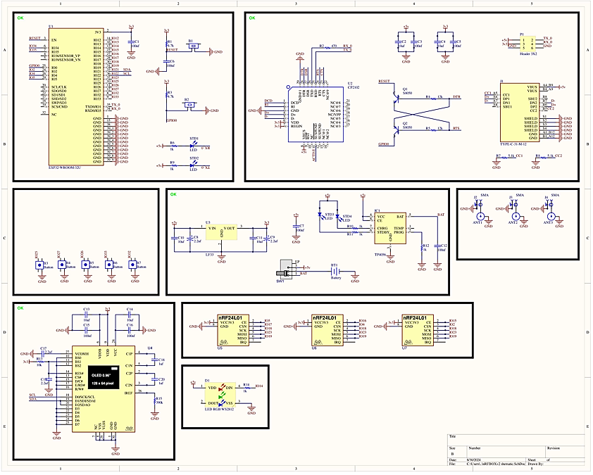
Figure 1: Schematic diagram of WiFi/Bluetooth detector
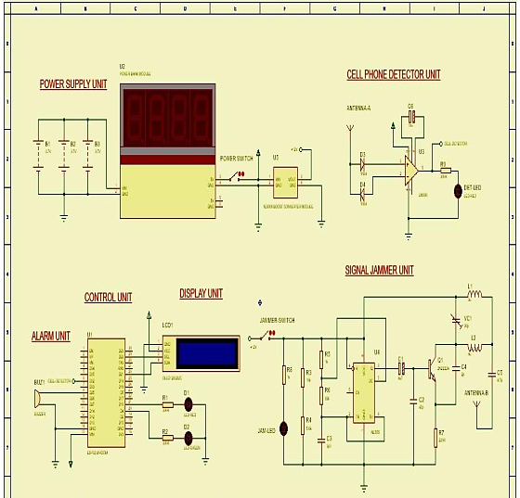
Figure 2: 1N34A germanium diode detector

For Wi-Fi and Bluetooth sensing, the NRF24L01 transceiver module was interfaced with the ESP32 via the SPI protocol to enable high-speed communication during spectral scanning. The NRF24L01 continuously scanned 125 channels within the 2.4 GHz ISM band, using its Received Power Detector (RPD) to detect RF activity above a predefined threshold. Detection counts accumulated across channels and over time samples, and were used to estimate RSSI values and evaluate spectral occupancy using:
$RSSI\left(dBm\right)={RSSI}_{min}+{(Nd/Nt}_{m})\left({RSSI}_{max}-{RSSI}_{min}\right)$ (Equation 1)
The subsystem successfully distinguished continuous Wi-Fi transmissions from intermittent Bluetooth hopping activity using temporal RSSI and occupancy analysis. See Figure 3
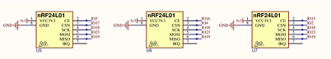
Figure 3: NRF24 connections with the microcontroller

Cellular signal detection was developed using an RF detector based on a 1N34A germanium diode, which included an antenna input, an RC smoothing circuit, a coupling capacitor, and an ESP32 ADC interface. The detector functioned through envelope detection, converting incoming RF signals in the 900 MHz–2.3 GHz range into corresponding DC voltages. The ESP32 ADC converted the filtered analog signal into digital form and correlated it with corresponding RSSI values using:
$RSSI\left(dBm\right)={20log}_{10}{(V}_{out})+C$ (Equation 2)
This enabled effective detection of burst-type cellular communication activities. See Figure 4
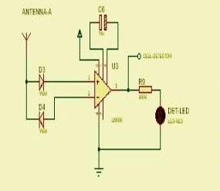
Figure 4: IN34A Germanium diode detector

A subsystem of antennas was incorporated, featuring two 2.4 GHz dipole antennas for Wi-Fi/Bluetooth sensing and a separate one for cellular detection, enhancing RF sensitivity, signal stability, and detection range. The firmware was developed in Arduino IDE, which included channel scanning, ADC sampling, RSSI estimation, spectral occupancy analysis, temporal assessment, threshold-based signal classification, serial communication, and alert management. Spectral occupancy was assessed using:

$$SO\%=\frac{No}{Ntotal} x 100$$
while temporal signal variation was computed using:
$T_{sv}=\frac{1}{N-1}\sum_{i=1}^{N-1}{\left(|{RssI}_{i+1}-{RSSI}_{i}|\right)}$ (Equation 3)
Processed RSSI data were transmitted continuously to MATLAB via USB serial communication at 115200 baud for visualization, filtering, logging, and analysis. MATLAB-generated plots of RSSI behavior, spectral occupancy graphs, Wi-Fi/Bluetooth heatmaps, cellular heatmaps, and temporal analysis plots clearly visualized wireless activity patterns and spectral behavior. The TFT display and buzzer alert subsystem, incorporated for local real-time monitoring and notification of detected wireless activity, provided immediate visualization of RSSI levels and signal classifications. The buzzer generated audible alerts whenever RF activity exceeded predefined thresholds and upon each detection. The complete system was powered by a rechargeable 2000 mAh lithium-ion battery, integrated with voltage regulation and charging circuitry, providing stable 3.3 V and 5 V outputs to all subsystems. Figure 5 shows the PCB of the system. Experimental evaluation demonstrated that the system operated continuously for approximately 6–7 hours under normal monitoring conditions, confirming its portability, energy efficiency, and suitability for real-time wireless monitoring applications in academic environments.
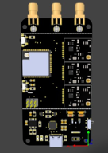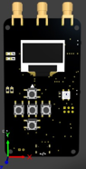
Figure 5: System PCB
TESTING

To assess the detection capability, dependability, and real-time operational performance of the tri-band RF monitoring system, system testing was carried out in examination halls and classrooms. In order to replicate realistic wireless activity conditions frequently found in academic settings, several wireless-enabled devices—such as smartphones, Bluetooth headsets, smartwatches, Wi-Fi hotspots, and cellular-enabled devices—were purposefully introduced into the monitored environment during the testing process. The system successfully detected burst-type cellular transmissions, continuous Wi-Fi occupancy, and intermittent Bluetooth frequency-hopping activity within the monitored area. The Experimental evaluation demonstrated stable operation within the designed voltage range and an effective detection coverage of up to 50 m under normal environmental conditions. The system further provided real-time notification via the integrated buzzer alert mechanism, while concurrently transmitting processed RF data to the TFT display and MATLAB interface for visualization and analysis. Figures 6 and 7 show the entire experimental setup, system operation, and testing outcomes.

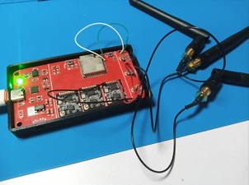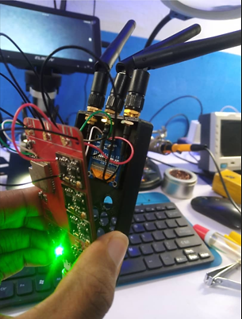
Figure 6: The system in Operation
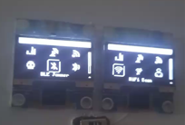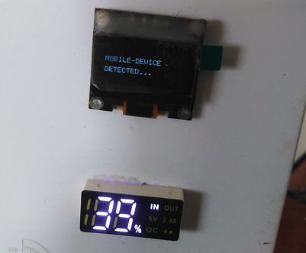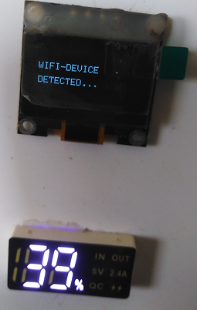
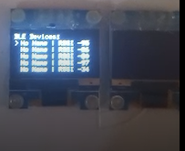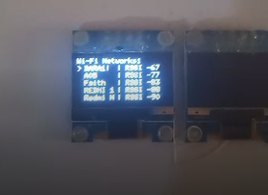
Figure 7:Testing result
RESULT AND DISCUSSION

Results of testing and evaluation, as shown in the tables below, demonstrated the system's capability to effectively detect, monitor, and classify Wi-Fi, Bluetooth, and cellular wireless activity in classroom and examination hall environments using passive radio frequency (RF) sensing techniques. The integration of Received Signal Strength Indicator (RSSI) analysis, spectral occupancy measurement, temporal behavior characterization, RF heatmap visualization, and intelligent classification enabled comprehensive, real-time monitoring of wireless activity without interfering with existing communication systems. The system successfully identified the unique operational characteristics of the monitored wireless technologies, thereby validating the effectiveness of the proposed monitoring architecture.

Table 1: RSSI Measurement
 | RSSI Measurement
TIME(s) | 1 | 2 | 3 | 4 | 5 | 6 | 7 | 8 | 9 | 10
RSSI WIFI (dBm) | -65 | -63 | -66 | -64 | -62 | -61 | -60 | -59 | -58 | -57
RSSI Bluetooth (dBm) | -82 | -85 | -80 | -83 | -86 | -88 | -84 | -79 | -77 | -75
RSSI Cellular(dBm) | -75 | -78 | -72 | -74 | -79 | -81 | -76 | -70 | -68 | -66
TIME(s) | 11 | 12 | 13 | 14 | 15 | 16 | 17 | 18 | 19 | 20
RSSI WIFI (dBm) | -56 | -55 | -54 | -53 | -52 | -51 | -50 | -49 | -48 | -47
RSSI Bluetooth (dBm) | -78 | -81 | -85 | -87 | -82 | -79 | -76 | -74 | -73 | -72
RSSI Cellular(dBm) | -69 | -73 | -77 | -80 | -74 | -71 | -67 | -65 | -64 | -63
TIME(s) | 21 | 22 | 23 | 24 | 25 | 26 | 27 | 28 | 29 | 30
RSSI WIFI (dBm) | -49 | -51 | -53 | -55 | -57 | -59 | -61 | -63 | -65 | -67
RSSI Bluetooth (dBm) | -75 | -78 | -81 | -84 | -87 | -85 | -82 | -80 | -78 | -76
RSSI Cellular(dBm) | -66 | -69 | -72 | -75 | -79 | -77 | -74 | 72 | -70 | -68
TIME(s) | 31 | 32 | 33 | 34 | 35 | 36 | 37 | 38 | 39 | 40
RSSI WIFI (dBm) | -69 | -71 | -73 | -75 | -74 | -72 | -70 | -68 | -66 | -64
RSSI Bluetooth (dBm) | -79 | -83 | -86 | -88 | -85 | -81 | -78 | -75 | -73 | -71
RSSI Cellular(dBm) | -71 | -75 | -78 | -82 | -79 | -74 | -70 | -67 | -65 | -63
TIME(s) | 41 | 42 | 43 | 44 | 45 | 46 | 47 | 48 | 49 | 50
RSSI WIFI (dBm) | -62 | -60 | -58 | -56 | -54 | -52 | -50 | -48 | -46 | -45
RSSI Bluetooth (dBm) | -74 | -77 | -80 | -83 | -86 | -84 | -81 | -78 | -75 | -72
RSSI Cellular(dBm) | -66 | -69 | -72 | -75 | -78 | -76 | -73 | -69 | -66 | -63
TIME(s) | -51 | 52 | 53 | 54 | 55 | 56 | 57 | 58 | 59 | 60
RSSI WIFI (dBm) | -47 | -49 | -51 | -53 | -55 | -57 | -59 | -61 | -63 | -65
RSSI Bluetooth (dBm) | -74 | -77 | -80 | -83 | -86 | -88 | -85 | -82 | -79 | -76
RSSI Cellular(dBm) | -65 | -68 | -71 | -74 | -77 | -80 | -78 | -75 | -72 | -69
TIME(s) | 61 | 62 | 63 | 64 | 65 | 66 | 67 | 68 | 69 | 70
RSSI WIFI (dBm) | -67 | -69 | -71 | -73 | -75 | -74 | -72 | -70 | -68 | -66
RSSI Bluetooth (dBm) | -78 | -81 | -84 | -87 | -85 | -82 | -79 | -76 | -73 | -71
RSSI Cellular(dBm) | -71 | -74 | -77 | -80 | -78 | -75 | -72 | -68 | -65 | -63
TIME(s) | 71 | 72 | 73 | 74 | 75 | 76 | 77 | 78 | 79 | 80
RSSI WIFI (dBm) | -64 | -62 | -60 | -58 | -56 | -54 | -52 | -50 | -48 | -46
RSSI Bluetooth (dBm) | -74 | -77 | -80 | -83 | -86 | -84 | -81 | -78 | -75 | -72
RSSI Cellular(dBm) | -66 | -69 | -72 | -75 | -78 | -76 | -73 | -70 | -67 | -64
TIME(s) | 81 | 82 | 83 | 84 | 85 | 86 | 87 | 88 | 89 | 90
RSSI WIFI (dBm) | -47 | -49 | -51 | -53 | -55 | -57 | -59 | -61 | -63 | -65
RSSI Bluetooth (dBm) | -74 | -77 | -80 | -83 | -86 | -88 | -85 | -82 | -79 | -76
RSSI Cellular(dBm) | -65 | -68 | -71 | -74 | -77 | -81 | -78 | -75 | -72 | -69
TIME(s) | 91 | 92 | 93 | 94 | 95 | 96 | 97 | 98 | 99 | 100
RSSI WIFI (dBm) | -67 | -69 | -71 | -73 | -75 | -74 | -72 | -70 | -68 | -66
RSSI Bluetooth (dBm) | -78 | -81 | -84 | -87 | -85 | -82 | -79 | -76 | -73 | -71
RSSI Cellular(dBm) | -71 | -74 | -77 | -80 | -78 | -75 | -72 | -69 | -66 | -64
Table 2: System Performance Measurement
Metric | Wi-Fi | Bluetooth (BLE) | Cellular
Total Detections | 142 | 98 | 52
True Positives (Correct Identifications) | 130 | 85 | 45
False Positives (Mistaken Alerts) | 12 | 13 | 7
Detection Accuracy (%) | 91.55% | 86.73% | 86.54%
False Alarm Rate (%) | 8.45% | 13.27% | 13.46%
Average RSSI (dBm) | –60.9 dBm | –80.0 dBm | –72.4 dBm
Minimum RSSI (dBm) | –75 dBm | –88 dBm | –82 dBm
Maximum RSSI / Peak RSSI (dBm) | –45 dBm | –71 dBm | –63 dBm
RSSI Variation Range (dB) | 30 dB | 17 dB | 19 dB
Strong Burst Count (Events) | 6 | 5 | 5
Estimated Spectral Occupancy (%) | 91% | 76% | 64%
Average Localization Error (m) | 1.7 m | 2.3 m | 3.4 m
Average Time to Alert (s) | 3.9 s | 3.5 s | 5.8 s
Estimated Device Density (per Hall) | High | Medium | Low
Dominant Temporal Behaviour | Continuous Transmission | Frequency Hopping / Intermittent | Burst-Type Communication
Primary Detection Band | 2.4 GHz ISM Band | 2.4 GHz ISM Band | 900 MHz – 2.3 GHz
Common Devices Detected | Smartphones, Wi-Fi hotspots, laptops, smartwatches | BLE earpieces, beacons, wireless headsets | Mobile phones, cellular-enabled devices
Detection Hardware Used | NRF24L01 + ESP32 | NRF24L01 + ESP32 | 1N34A RF Detector + ESP32
Signal Classification Basis | Continuous High RSSI & High Occupancy | Intermittent RSSI Fluctuations | Burst RSSI Activity
Monitoring Reliability | Excellent | Very Good | Very Good
Table 3: NRF24 Channel
Channel (MHz) | RPD | Interpretation
2400 | 1 | Some RF signal present
2401 | 0 | Quiet
2402–2417 | 1 | Continuous → likely WiFi
2418 | 0 | Quiet
2440 | 1 | Occasional spikes → maybe BT
The RSSI measurements in Table 1 and Figure 8a and b revealed distinct signal strength characteristics for Wi-Fi, Bluetooth, and cellular communications. Wi-Fi signals exhibited the strongest and most stable RSSI values, ranging approximately from −75 dBm to −45 dBm, with an average close to −60 dBm. The RSSI profile remained relatively smooth and continuous throughout the observation period, indicating persistent channel occupancy and continuous packet exchange between access points and connected devices. Several prominent peaks around samples 20, 50, and 80 corresponded to periods of increased wireless activity and higher network utilization. Conversely, lower RSSI values around samples 33–35 and 93–95 suggested temporary reductions in network traffic or increased attenuation from environmental factors and device movement. The observed Wi-Fi behavior is consistent with the continuous transmission of beacon frames, management packets, acknowledgments, and user data that characterize wireless local area networks. When compared to Wi-Fi, Bluetooth RSSI measurements exhibited significantly different characteristics from Wi-Fi RSSI measurements. The RSSI values fluctuated between approximately −88 dBm and −71 dBm, reflecting the low-power and intermittent nature of Bluetooth communication. Frequent peaks and troughs were observed throughout the monitoring period due to the Frequency-Hopping Spread Spectrum (FHSS) mechanism used by Bluetooth devices. Stronger Bluetooth activity was observed around samples 18–20, 48–50, and 78–80, whereas weaker activity occurred around samples 6, 34, 56, and 86. These variations correspond to changes in packet transmission rates, device activity, propagation conditions, and channel hopping behaviour. The observed fluctuations clearly demonstrate the capability of the system to distinguish Bluetooth communications from Wi-Fi based on RSSI dynamics and temporal characteristics. In contrast to both Wi-Fi and Bluetooth transmissions, the cellular RSSI measurements showed burst-oriented behavior. Cellular RSSI readings showed periodic peaks linked to active communication events such as network synchronization, paging activities, voice calls, SMS exchanges, and mobile data transmissions. These readings ranged roughly from −82 dBm to −63 dBm. Samples 18–20, 39–40, 49–50, 69–70, 79–80, and 99–100 showed strong cellular activity, whereas intervals with few network transactions showed lesser activity. The efficacy of the 1N34A germanium diode-based RF detector in recording fleeting cellular activity throughout the monitored frequency range of roughly 900 MHz to 2.3 GHz is confirmed by these burst-type transmission patterns. The unique RSSI signatures displayed by cellular, Bluetooth, and Wi-Fi technologies show that signal strength measurements are a crucial component for wireless signal classification.
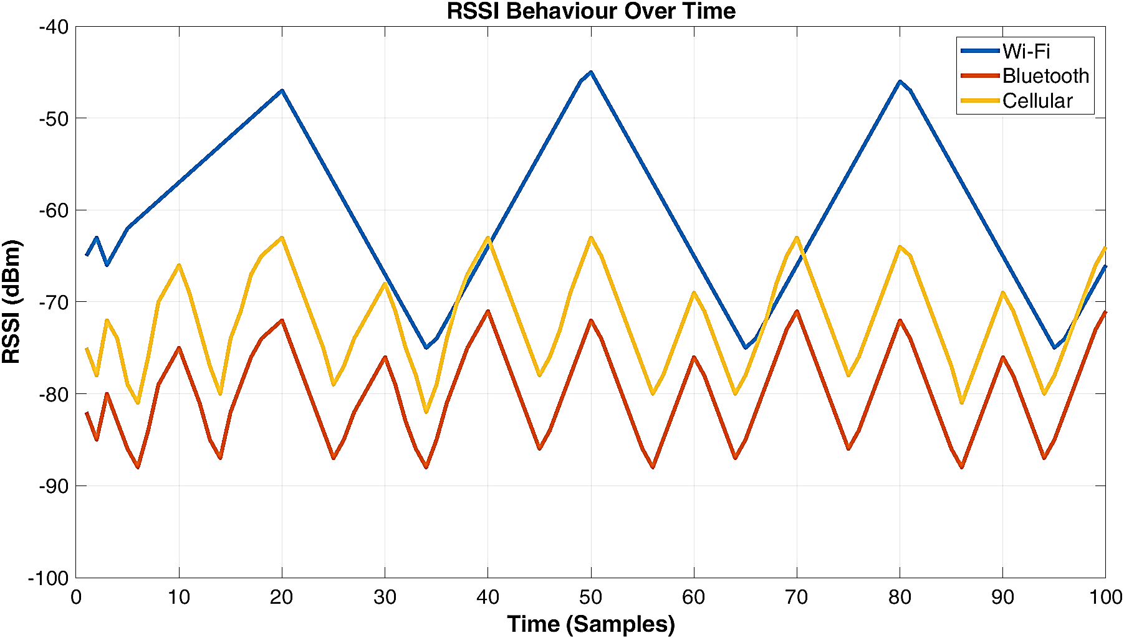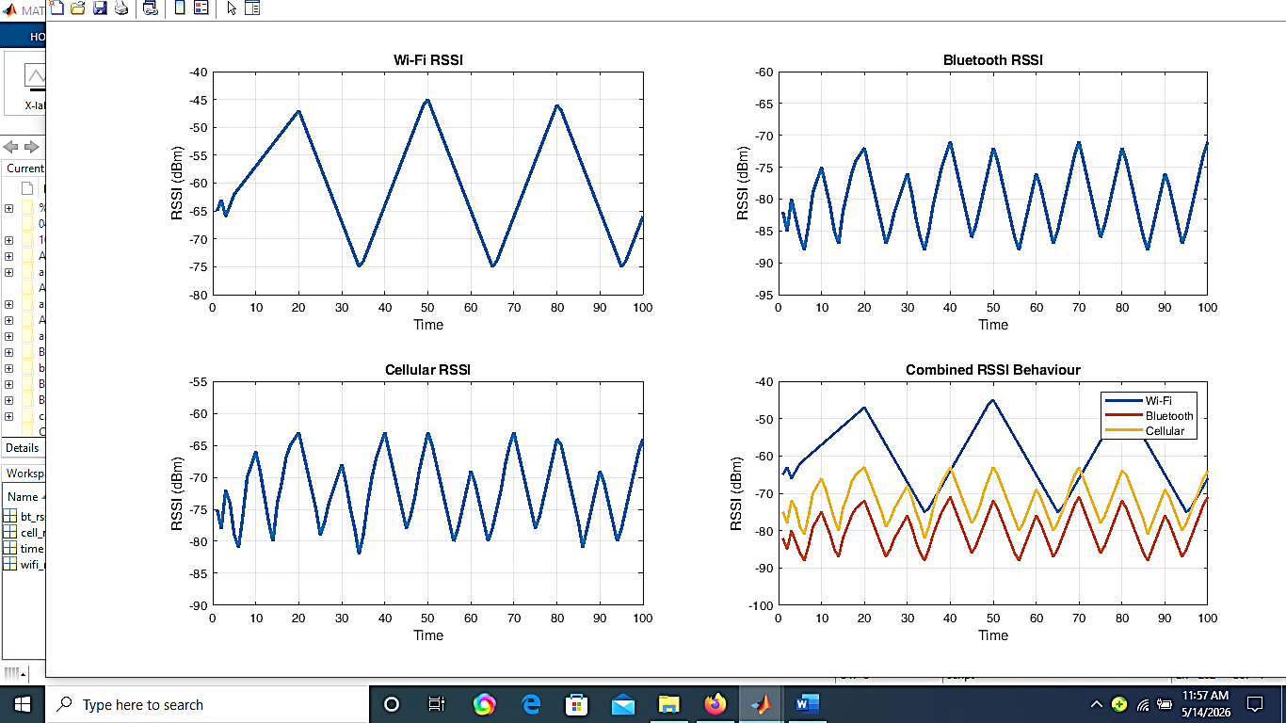
Figure 8a: Combined RSSI variations Output Figure 8b: Wi-Fi, Bluetooth, and Cellular RSSI variations
Output
The distinct communication features of the wireless technologies under observation were further emphasized by the spectrum occupancy results displayed in Figure 9. Wi-Fi exhibited the highest spectral occupancy, remaining near 100% throughout most of the observation period, with only brief reductions to about 80% at a few intervals. This behavior reflects the continuous transmission nature of Wi-Fi communication and confirms persistent utilization of the 2.4 GHz ISM band. In contrast, Bluetooth spectral occupancy appeared as intermittent bursts separated by periods of low activity. Occupancy periodically increased to about 40–65% before returning to lower levels, reflecting the adaptive frequency-hopping operation of Bluetooth devices. The most dynamic behavior was observed in cellular spectral occupancy, which ranged from approximately 20% to 100%, with several peaks indicating active communication sessions. The patterns of habitation demonstrate that Wi-Fi communication employs continuous spectrum, Bluetooth communication uses intermittent hopping-based occupancy, and cellular communication relies on burst-oriented spectrum access. Since intervals with higher RSSI values were consistently linked to higher spectrum occupancy and increased wireless activity, the relationship between spectral occupancy and RSSI behavior further supports the efficacy of the proposed categorization technique.

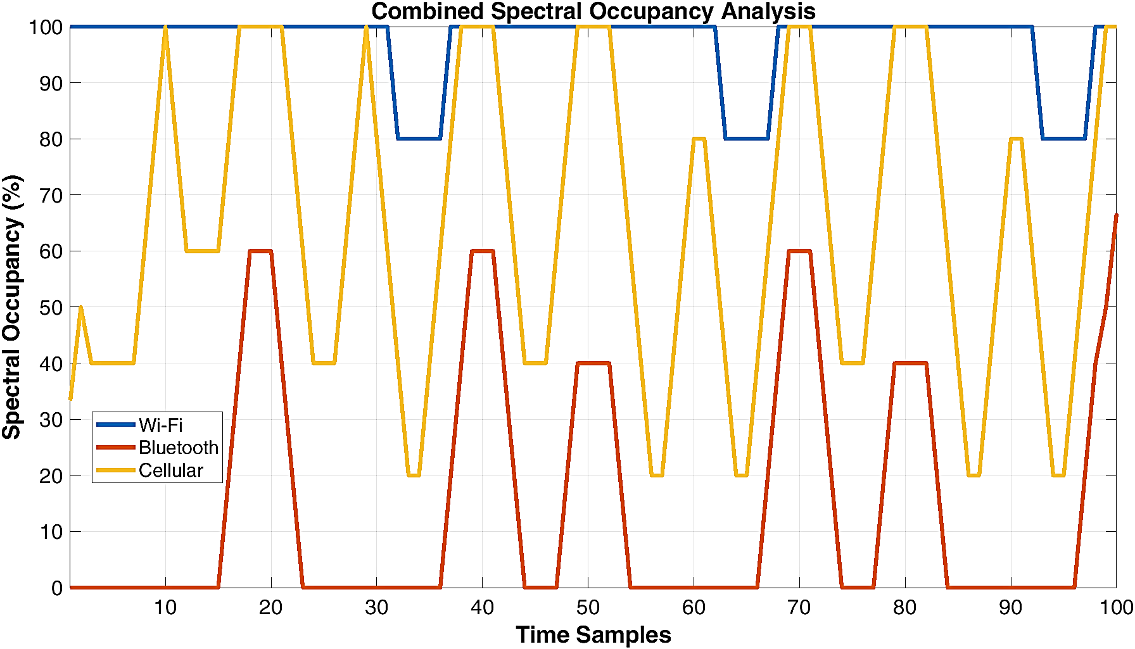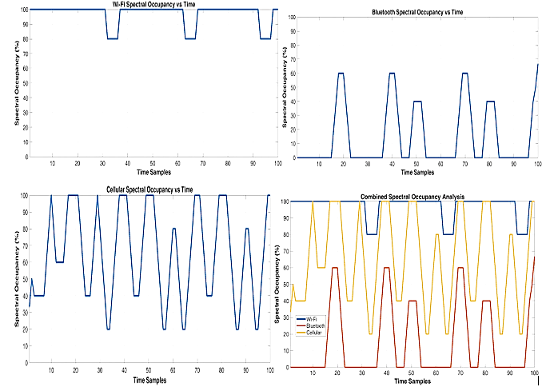
Figure 9a: Combined spectral occupancy analysis Figure 9b: Wi-Fi, Bluetooth, and Cellular spectral occupancy
Analysis

Temporal behaviour analysis presented in Figure 10 provided additional insight into the dynamic characteristics of the monitored wireless signals. Wi-Fi exhibited the lowest temporal variation throughout the monitoring period, with RSSI changes remaining relatively stable at approximately 2 dBm between consecutive samples. This stability reflects continuous communication and persistent channel occupancy resulting from regular packet exchange between access points and connected devices. Bluetooth signals exhibited moderate temporal variation, with fluctuations ranging from approximately 1 dBm to 5 dBm. These repeated oscillations resulted from rapid frequency hopping and intermittent transmission behaviour, which continuously altered the received signal strength. Cellular communication exhibited the highest temporal variation, ranging approximately from 1 dBm to 6 dBm, with numerous prominent peaks corresponding to burst-type communication events controlled by the cellular network infrastructure. The clear differences observed among the temporal profiles of Wi-Fi, Bluetooth, and cellular communications demonstrate that temporal variation constitutes a powerful feature for wireless signal discrimination and significantly improves classification accuracy when combined with RSSI and spectral occupancy measurements.

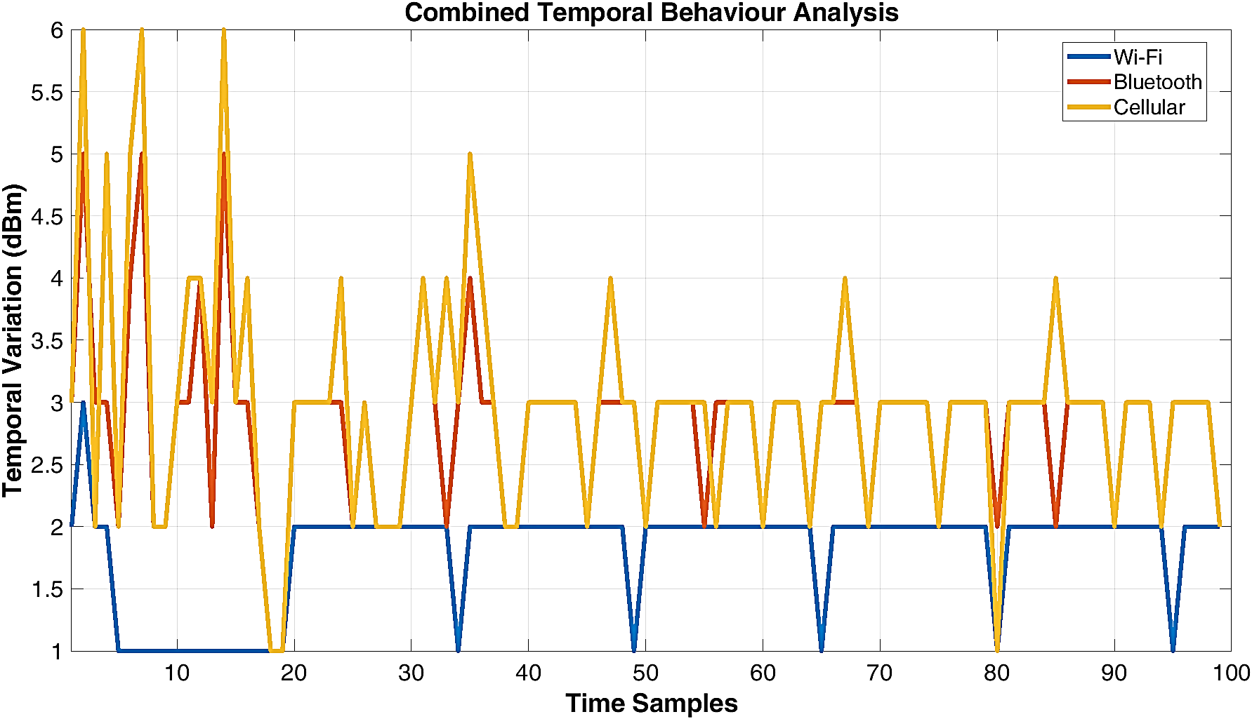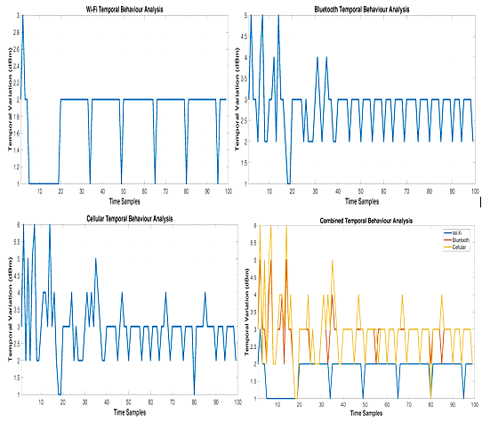
Figure 10a: Combined Temporal behaviour analysis Figure 10b: Wi-Fi, Bluetooth, and Cellular Temporal behaviour
Analysis
The RF heatmap results shown in Figures 11a and 11b provide a comprehensive visualization of wireless activity across both the time and frequency domains. The RF energy heatmap generated using the NRF24L01 transceiver revealed distinct spectral occupancy patterns within the 2.4 GHz ISM band. Continuous RF activity observed between approximately 2402 MHz and 2417 MHz, as shown in Table 3, indicated sustained Wi-Fi communication resulting from continuous packet exchange and beacon transmissions. In contrast, intermittent activity distributed across scattered channels corresponded to Bluetooth transmissions and clearly illustrated the adaptive frequency-hopping behaviour of Bluetooth devices. Regions exhibiting little or no activity indicated periods of spectral inactivity and confirmed the sensing subsystem's ability to identify both occupied and unoccupied spectral regions. The Wi-Fi/Bluetooth heatmap revealed extensive activity across the monitored channels, with persistent high-intensity areas indicating continual Wi-Fi use and scattered localized spots representing Bluetooth hopping activity. These findings confirm that the NRF24L01 sensing subsystem effectively detected both ongoing Wi-Fi transmissions and intermittent Bluetooth communications. In contrast, the cellular heatmap displayed a distinctly different pattern, with periodic vertical bands of high intensity separated by intervals of lower activity. These vertical patterns correspond to burst transmissions related to synchronization, paging, call setup, and mobile data transfer. Overall, the heatmaps visually demonstrated the clear differences among the wireless technologies and validated the system's ability to differentiate them based on their spectral and temporal signatures.
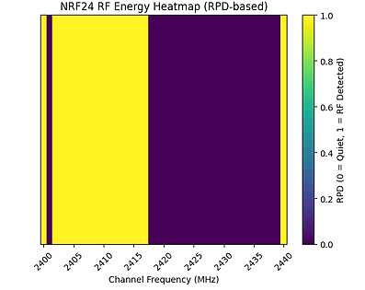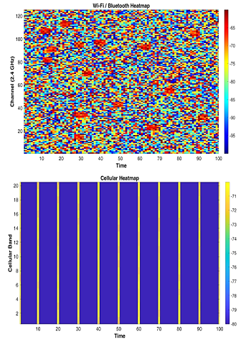
Figure 11a: NRF 24 Energy Heatmap Figure 11b: Wifi/Bluetooth and Cellular Heatmap

The performance metrics outlined in Table 2 additionally confirmed the efficacy of the suggested monitoring platform. Wi-Fi attained the peak detection accuracy and occupancy rates because of its ongoing transmission characteristics and constant presence in the observed area. Bluetooth displayed a somewhat diminished detection performance due to its sporadic hopping mechanism, which at times lowered signal visibility during scanning periods. Cellular communication demonstrated adequate detection reliability even with the lowest average occupancy since burst transmissions were successfully identified by the RF detector subsystem. The minimal false alarm rates observed across all monitored technologies suggest that the threshold-based classification algorithm applied on the ESP32 effectively distinguished signal types by leveraging RSSI, spectral occupancy, and temporal behavior features. Moreover, the brief average time-to-alert metrics illustrate the system's ability to conduct real-time monitoring and swift wireless activity identification, while the minimal localization error figures suggest that the system can accurately assess the closeness of active wireless devices within the observed area.
CONCLUSION
A significant outcome of this research is the effective execution of a passive wireless monitoring method. In contrast to traditional RF jamming systems that deliberately interfere with communication channels, the suggested system functions solely by observing and analyzing current RF activity. As a result, it maintains valid communication services, adheres to regulatory and ethical standards, and prevents the operational difficulties linked to signal interference. The combination of the ESP32 microcontroller, NRF24L01 transceiver, 1N34A RF detector, TFT display, buzzer alert subsystem, and MATLAB visualization system led to a compact, affordable, portable, and energy-efficient monitoring solution that operates in real time.
In summary, the findings indicate that the tri-band RF monitoring system effectively accomplished its design goals. The system successfully identified and categorized Wi-Fi, Bluetooth, and cellular wireless activities by utilizing RSSI measurements, spectral occupancy evaluation, temporal behavior analysis, and heatmap representation. The impressive detection accuracy, minimal false alarm rates, quick response times, low localization inaccuracies, and passive monitoring ability validate the system's effectiveness in reducing wireless device abuse, curbing examination dishonesty, and improving academic integrity in educational settings without disrupting legitimate wireless communication services.
RECOMMENDATION
Future enhancements to the tri-band RF monitoring system must emphasize the incorporation of artificial intelligence and machine learning methods to improve signal classification precision and facilitate automatic recognition of wireless devices through their RF signatures. The system can be enhanced to accommodate new wireless technologies like 5G, ZigBee, LoRa, and Internet of Things (IoT) networks by adding more RF sensing modules. Improving localization precision through the use of several sensing nodes and triangulation methods is advised to boost device positioning abilities. Additionally, cloud integration ought to be taken into account to enable remote surveillance, centralized data oversight, real-time alert creation, and prolonged wireless activity assessment. Future studies ought to explore adaptive thresholding and smart spectrum analysis techniques to enhance detection accuracy in changing RF environments while minimizing false alarms. Extensive implementation and assessment in varied settings are essential to determine scalability and durability. Utilizing Software-Defined Radio (SDR) technology would enable a more extensive frequency range and enhanced signal analysis features, while incorporating it with institutional security and exam management systems could facilitate automated reporting and decision-making functions. These improvements would additionally boost the efficiency, scalability, and real-world applicability of the system for wireless activity tracking and academic integrity oversight.
FUNDING INFORMATION
This study was funded by the Tertiary Education Trust Fund (TETFund, Nigeria) through the Institution-Based Research (IBR) of the Federal Polytechnic, Ile-Oluji, Nigeria.

References
- Abiebhode, I. F., & Ifechukwu, E. R. (2024). AI-Driven Smart Examination Invigilation System Using. Nigerian Journal of Engineering Science Research. doi:https://doi.org/10.5281/zenodo.14961473
- Arjoune, Y., Salahdine, F., Islam, M. S., Ghribi, E., & Kaabouch, N. (2020). A Novel Jamming Attacks Detection Approach Based on Machine Learning for Wireless Communication. arxiv. doi:https://doi.org/10.1109/ICOIN48656.2020.9016462
- Bajic, J. S., Milosavljevic, V., Rajs, V., Slankamenac, M., & Zivanov, M. (2012). Universal wireless communication detector (UD-100) - preventing high-tech cheating methods. Proceedings of the 35th International Convention MIPRO (pp. 237 - 240). Opatija, Croatia.
- Commsweek. (2014). Nigeria Communications Week. Retrieved from nigeriacommunicationsweek.com.ng: https://www.nigeriacommunicationsweek.com.ng/ncc-to-sanction-frequency-jammers/
- Educause Review. (2009). From Distraction to Engagement: Wireless Devices in the Classroom. Retrieved from net.educause.edu: https://er.educause.edu/articles/2009/12/from-distraction-to-engagement-wireless-devices-in-the-classroom
- Elma Fe E. Gupit, J. F. (2023). Academic Dishonesty in the Digital Era: A Case Study. International Journal of Research and Innovation in Social Science (IJRISS), 864-874. Retrieved from https://rsisinternational.org/journals/ijriss/articles/academic-dishonesty-in-the-digital-era-a-case-study/
- Eryenyu, C., Atibun, D. Z., & Biira, S. (2025). Technology-Driven Examination Malpractices: Empirical Evidence and. East African Journal of Education, 8(4). doi:https://doi.org/10.37284/eajes.8.4.4121
- Eserinune, M. M. (2015). Mobile phone usage among Nigerian university students. Global Journal of Arts Humanities and Social Sciences, 3(1), 29 - 38. Retrieved from http://www.eajournals.org/
- H, K. V., Aradhyamatt, G. M., K, B., S, B., & Routh, S. (2025). AI-BASED RF JAMMING AND MITIGATION. International Journal of Creative Research Thoughts, 13(12). Retrieved from www.ijcrt.org/papers/IJCRT2512356
- Ismail, A., Ponniran, A., Choon, C. C., Kan, C. U.-L., Ahmadon, M. A., & Yamaguchi, S. (2024, October). Mobile Phone Detector in Restricted Area. IEEE 13th Global Conference on Consumer Electronics (GCCE). Kitakyushu, Japan: IEEE. doi:https://doi.org/10.1109/GCCE62371.2024.10760667
- JammerMaster. (n.d.). Signal Jammers in Nigeria: Laws and Regulations in Force. Retrieved from jammermaster.com: https://jammermaster.com/regulations/signal-jammers-in-nigeria-laws-and-regulations-in-force
- Jasim, S. I., Hamid, O. K., & Alhyani, N. J. (2023, February). A Review of Jamming Attacks in Wireless Systems. International Journal Of Latest Technology In Engineering & Management (IJLTEM), 16 - 22. Retrieved from https://www.researchgate.net/publication/368471343
- Liu, W., Kulin, M., Kazaz, T., Shahid, A., Moerman, I., & Moerman, I. (2017). Wireless Technology Recognition Based on RSSI Distribution at Sub-Nyquist Sampling Rate for Constrained Devices. Sensor, 17(9). doi:https://doi.org/10.3390/s17092081
- Madara, D. S., & Namango, S. S. (2016). Faculty Perceptions on Cheating in Exams in Undergraduate. Journal of Education and Practice, 7(30), 70 -86. Retrieved from https://www.iiste.org/Journals/index.php/JEP/article/view/33621
- Misra, S., Singh, R., & Mohan, S. V. (2010, 4 8). Information Warfare-Worthy Jamming Attack Detection Mechanism for Wireless Sensor Networks Using a Fuzzy Inference System. Sensors, 10(4), 3444-3479. doi: https://doi.org/10.3390/s100403444
- Mohsin, H. F., Abdulameer, K., & Khudhair, Z. N. (2017). Study and performance analysis of received signal strength indicator (RSSI) in wireless communication systems. International Journal of Engineering and Technology, 6(4), 195 - 200. doi:10.14419/ijet.v6i4.29558
- Nyamawe, A. S., & Mtonyole, N. (n.d.). The Use of Mobile Phones in University Exams Cheating: Proposed Solution. International Journal of Engineering Trends and Technology (IJETT), 17(1), 14 - 17. doi:https://doi.org/10.14445/22315381/IJETT-V17P203
- Ratna, S. R., & Ravi, R. (2022, July). Survey on Jamming Wireless Networks: Attacks and. International Journal of Computer and Information Engineering, 9(2), 642 - 648. Retrieved from https://www.researchgate.net/publication/362044124_Survey_on_Jamming_Wireless_Networks_Attacks_and_Prevention_Strategies
- Saka, O. N., Ologun, C., & Nelson, A. (2022). Smartphones and examination malpractice in Nigerian tertiary institutions. International Journal of Sociology and Anthropology Research, 8(1), 1 - 9. doi:https://doi.org/10.37745/ijsar.
- Satar, S. D., Hamid, N. A., Nik, W. N., Mohamad, Z., & Bongsu, R. H. (2024, 8). Wireless Fidelity (Wi-Fi) Traffic Analysis: A Systematic Review. Journal of Advanced Research in Applied, 50(2), 143 - 154. doi:https://doi.org/10.37934/araset.50.2.143154
- Selwyn, N. (2016). Digital downsides: exploring university students’ negative engagements with digital

technology. Teaching in Higher Education, 21(8), 1006–1021. doi: https://doi.org/10.1080/13562517
22. Sharma, U., & Kalekar, S. M. (2026). Unmasking wi-fi misuse: forensic. International Journal of Computer
Engineering and Technology (IJCET), 17(1), 56 - 63. doi: https://doi.org/10.34218/IJCET_17_01_005

23. Shinde, R., Gadhave, S., Swami, S., Kulkarni, R., & Patil, A. K. (2024, 11). Real-Time Mobile Phone

Detection System. International Journal of Creative Research Thoughts, 12(11). Retrieved from www.ijcrt.org

24. Singh, S. K., & Sharma, H. (2024). Importance and Possibilities of Technology in Education. Importance and Possibilities of Technology in Education (pp. 35 - 50). New Delhi: Anang Prakashan. Retrieved from https://www.researchgate.net/publication/383568060

25. Vadlamani, S., Eksioglu, B., & Hugh Medal, A. N. (2016). Jamming attacks on wireless networks: A taxonomic survey. International Journal of Production Economics, 172, 76 - 94. doi:https://doi.org/10.1016/j.ijpe.2015.11.008
26. Xing, S., Peccoud, S., LI, S., LI, S., & YANG, T. (2025). IEEE Access. Robust Communication-Aware Jamming, 200431 - 200445. doi:10.1109/ACCESS.2025.3630211
27. Zhang, Y., & Luo, Z. (2024). A Deep-Learning-Based Method for Spectrum Sensing. MDPI, 13(14). doi: https://doi.org/10.3390/electronics13142705

