Ethical Hacking as Strategic Cyber Defense: A Rule-of-Law Framework for National Security and Digital Resilience

Abstract
Cyber power has become a defining instrument of national security, economic stability, and democratic resilience (Hathaway, 2012; Young, 2007). Yet the ethical status of hacking remains contested because the same technical act—unauthorized system access—may be used either to steal, sabotage, coerce, expose vulnerabilities, or defend critical infrastructure (Rezazadehsaber, 2015; Simpson, 2010). The study model argues that prevailing legal systems often fail to distinguish adequately between malicious hacking, white-hat security research, hacktivism, and state-sponsored cyber operations. This article reframes that argument for a United States defense-oriented context. It proposes that hacking may be ethically defensible only when it satisfies five conditions: legitimate authority, defensive necessity, non-malicious intent, proportionality, and accountable disclosure. Ethical hacking is not cyber vigilantism; it is disciplined, bounded, documented, and directed toward preventing greater harm. For the U.S. defense ecosystem, this distinction is strategically important. The nation requires a strong cyber workforce capable of vulnerability discovery, red-team assessment, adversary emulation, and infrastructure hardening. However, such capability must remain anchored in law, oversight, and democratic accountability. This article therefore advances a Defense Ethical Cyber Operations Framework to separate protective cyber activity from criminal intrusion and politically motivated disruption. Ethical hacking, properly governed, is not a threat to national security; it is one of its necessary safeguards.
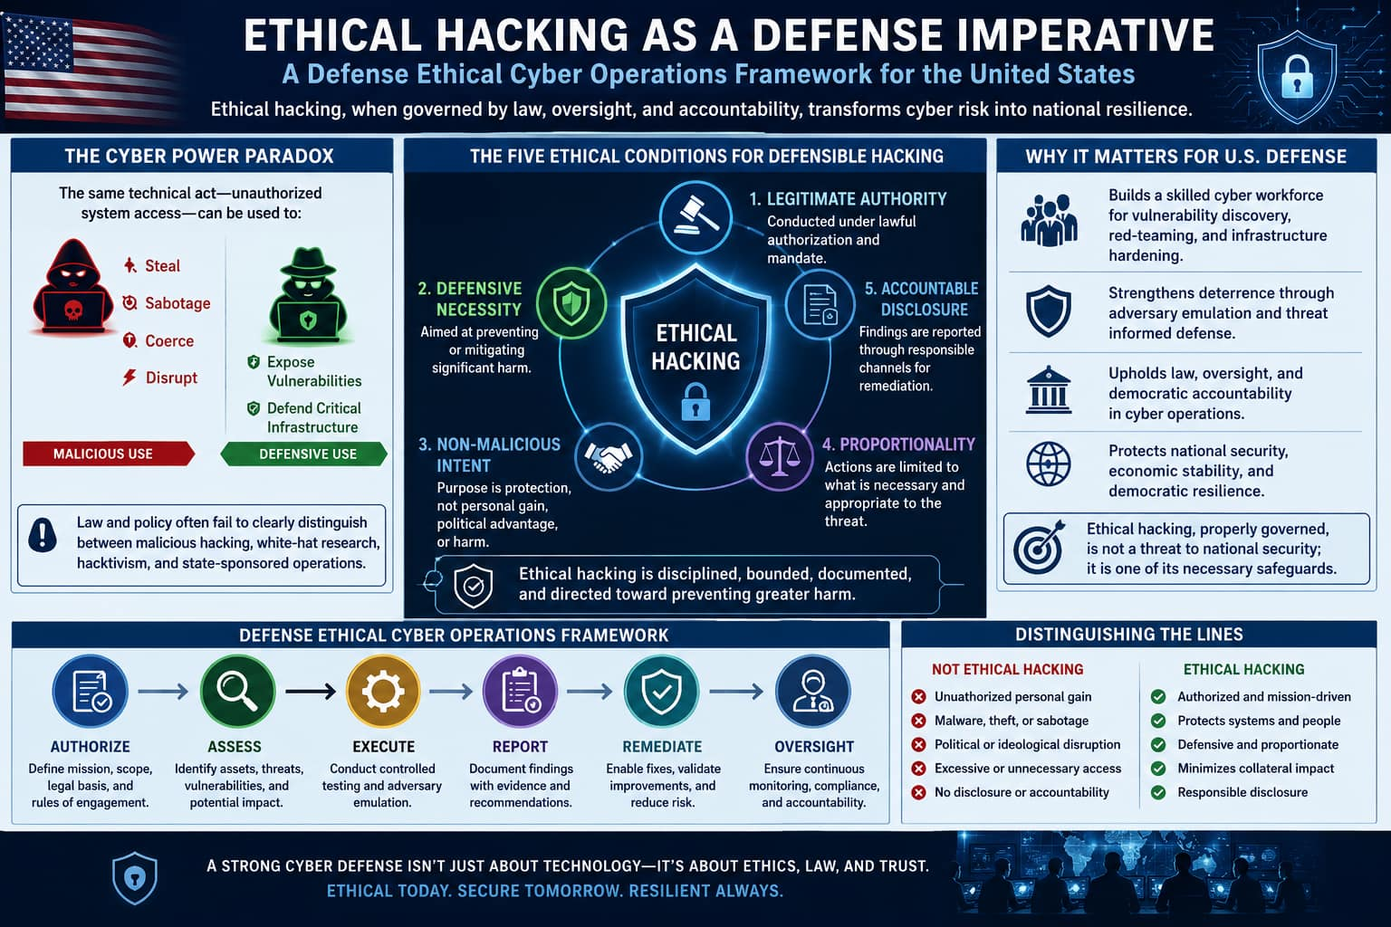
Graphical abstract: This figure illustrates ethical hacking as a regulated defensive cyber strategy guided by authority, necessity, proportionality, disclosure, and accountability.
Keywords: ethical hacking, cyber defense, white-hat hackers, national security, cyber ethics

Introduction: From Criminal Intrusion to Cyber Defense
The digital battlespace has expanded beyond military networks into hospitals, banks, energy grids, transportation systems, satellites, elections, and civilian data ecosystems. In this environment, the ethical question is no longer simply whether hacking is legal or illegal, but whether certain forms of cyber intrusion may be morally justified when directed toward defense, resilience, and public protection (Hathaway, 2012).
The article observes that computer hacking has evolved from the early “old school” hacker culture of technical curiosity and system improvement into a complex ecosystem involving criminal hackers, white-hat researchers, hacktivists, patriotic hackers, and state-sponsored cyber actors (Levy, 2001; Leeson, 2005). It also notes that many Western legal systems tend to treat unauthorized access as illegal without always differentiating the actor’s motive, target, method, or social consequence.
For the United States defense community, this distinction matters. A nation cannot protect its networks without people who can think like adversaries. Red teams, penetration testers, vulnerability researchers, and cyber threat hunters perform controlled forms of adversarial testing to detect weaknesses before hostile actors exploit them. Yet the same technical skill, when detached from authorization, proportionality, and accountability, becomes espionage, sabotage, extortion, or cybercrime.
Therefore, the core argument of this article is clear: hacking becomes ethically defensible only when it is converted from unauthorized self-directed intrusion into accountable defensive action governed by law, legitimate authority, and harm prevention.

Historical Evolution of the Hacker
The strategic blueprint traces hacking from World War II cryptography and code-breaking to the rise of computer programmers at Berkeley, Stanford, and MIT in the 1960s. These early hackers viewed hacking as an intellectual challenge and a means to improve computer systems rather than destroy them.
Over time, however, the hacker identity fragmented. The thesis identifies several categories:
White-hat hackers use technical skill to identify vulnerabilities and improve security (Jose, 2013). Their motivation is often intellectual challenge, creativity, competence, and system protection.
Black-hat hackers or crackers use similar tools but with malicious intent—stealing information, committing fraud, sabotaging systems, or seeking money and fame.
Hacktivists use cyber techniques to advance political or ideological causes (Samuel, 2004; Himma, 2007), often claiming moral justification through freedom of expression, anti-censorship, or resistance to perceived injustice.
Patriot hackers operate in the name of national loyalty, but may conduct aggressive cyber activity against foreign states or institutions. The thesis highlights the risks posed by such actors, especially when patriotic motivation is used to justify attacks against U.S., NATO, or allied infrastructure.
This classification demonstrates that cyber ethics cannot be evaluated by technique alone. The same exploit may be used for national defense, criminal theft, ideological disruption, or hostile intelligence collection. Ethical judgment must therefore examine authority, intent, target, method, harm, and accountability.

The Ethical Boundary: Intention Is Necessary but Not Sufficient

The model emphasizes that hackers and crackers may use the same tools, but non-malicious motivation distinguishes ethical hackers from criminal actors (Simpson, 2010). White-hat hackers search for vulnerabilities, conduct penetration testing, and recommend corrective action to strengthen systems (Jose, 2013; Conran, 2014).
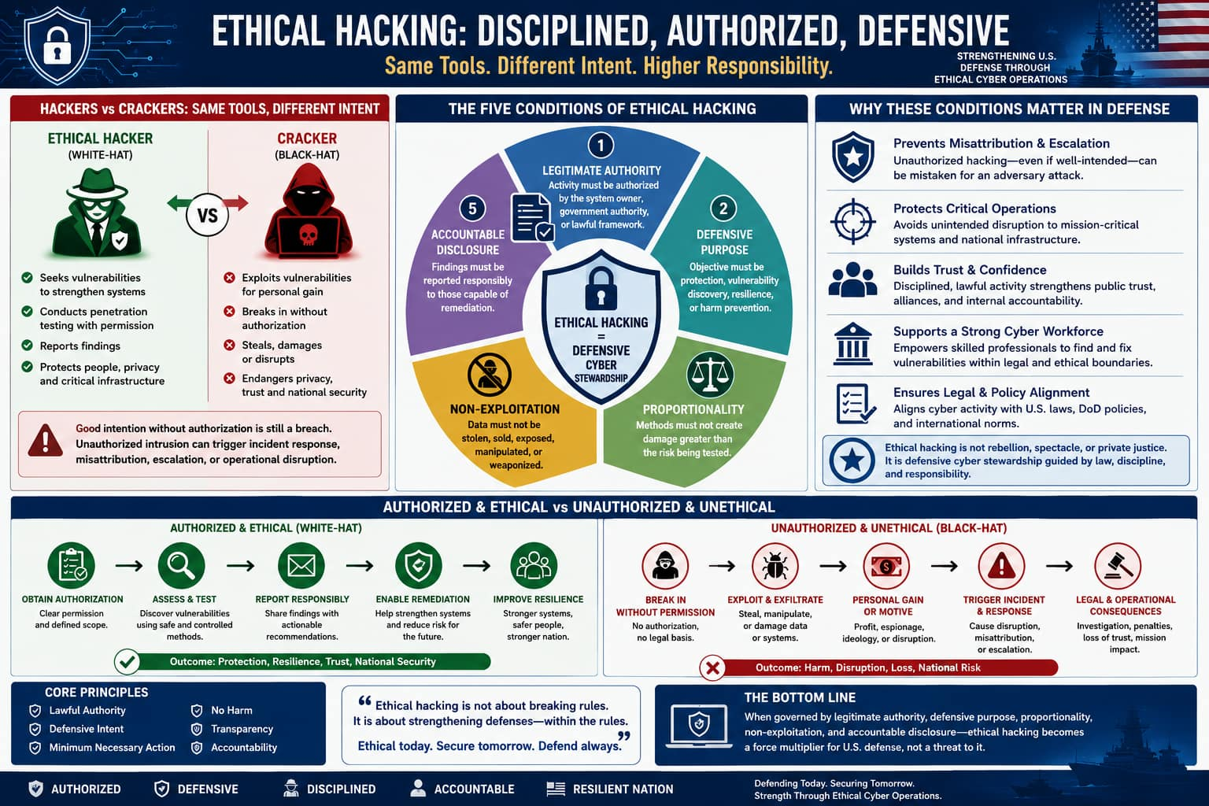
Figure1: This figure contrasts ethical hackers and criminals, showing five essential conditions that make hacking lawful, defensive, accountable, and protective.
However, good intention alone is insufficient. Unauthorized intrusion into hospitals, banks, or defense networks may still endanger privacy, continuity, and trust (Rawls, 1971; Pike, 2013).
Ethical hacking therefore requires disciplined conditions:
- Legitimate authority — the activity must be authorized by the system owner, government authority, or lawful framework.( (Rawls, 1971)
- Defensive purpose — the objective must be protection, vulnerability discovery, resilience, or harm prevention.( (Hathaway, 2012)
- Proportionality — the method must not create damage greater than the risk being tested. (Caltagirone, 2003)
- Non-exploitation — data must not be stolen, sold, exposed, manipulated, or weaponized. (Conran, 2014)
- Accountable disclosure — findings must be reported responsibly to those capable of remediation. (Jose, 2013)
Under this standard, ethical hacking is not rebellion, spectacle, or private justice. It is defensive cyber stewardship.

U.S. Defense-Friendly Framework: The DECO Model
To translate the framework into a defense-oriented policy contribution, this article proposes the DECO Framework: Defense Ethical Cyber Operations.

D — Defensive Necessity
Cyber activity must address a real or reasonably anticipated threat. Testing must be tied to mission assurance, infrastructure protection, or risk reduction.

E — Ethical Constraint
Cyber operators must avoid unnecessary harm, protect civilian systems, minimize data exposure, and preserve human rights.

C — Command Accountability
Operations must occur under legitimate command, contract, institutional approval, or defined legal authority. Lone-wolf cyber action cannot be considered defense.

O — Operational Transparency After Action
Findings, methods, scope, and remediation recommendations must be documented. Ethical hacking ends not with access, but with repair.
This framework (figure2) distinguishes lawful red-team operations from vigilantism and separates democratic cyber defense from authoritarian cyber aggression.
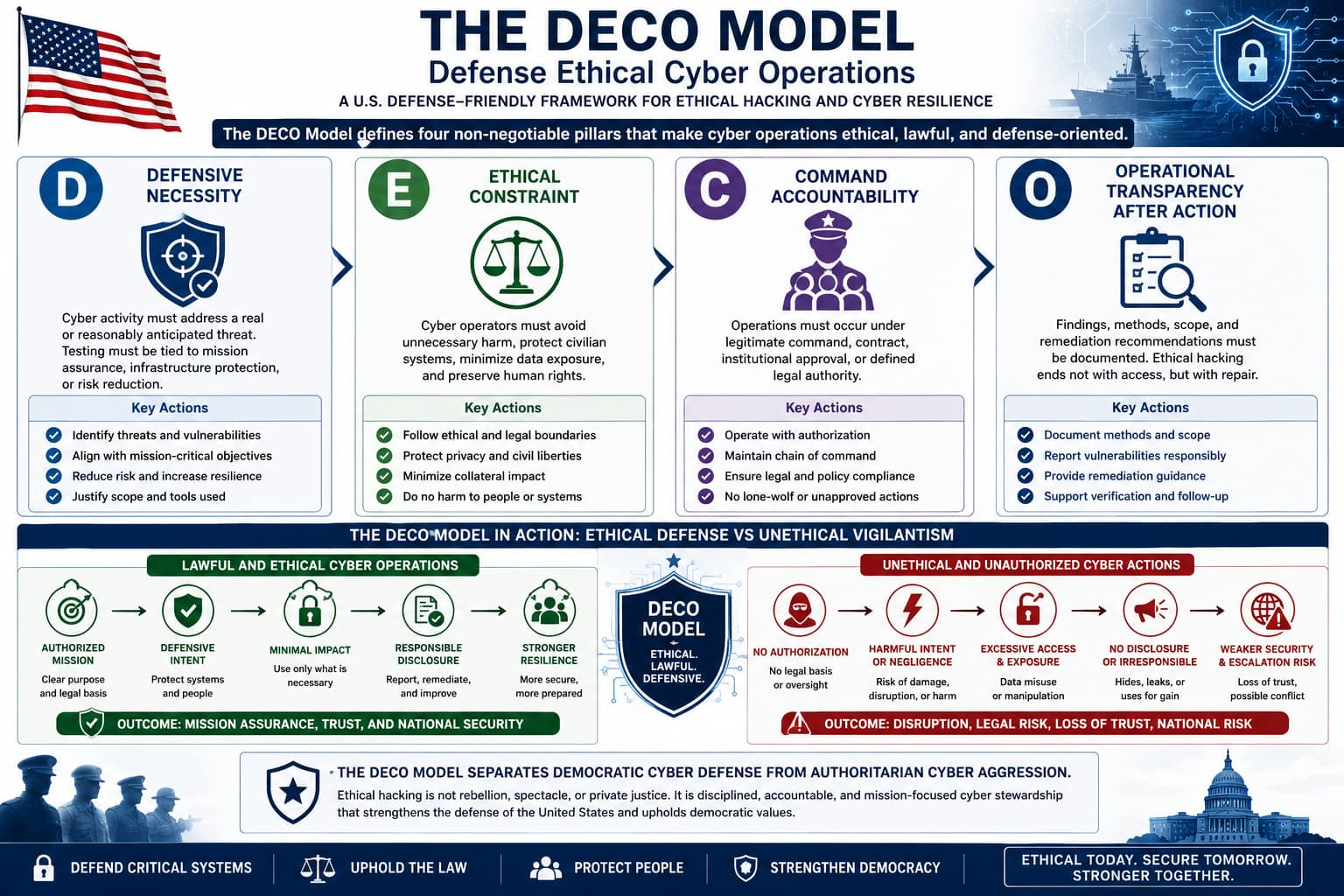
Figure2: The DECO model establishes four pillars—Defensive Necessity, Ethical Constraint, Command Accountability, and Operational Transparency—to ensure cyber operations remain lawful, ethical, resilient, and defense-oriented.

Hacktivism and the Problem of Cyber Vigilantism
The study paradigm gives significant attention to hacktivism, including groups such as Anonymous, which claimed to act for freedom of speech, anti-censorship, and political justice. Hacktivists often describe their actions as a form of digital civil disobedience (figure3) ((Himma, 2007).
From a U.S. defense perspective, this is ethically unstable. Civil disobedience traditionally involves public, nonviolent, accountable protest (Rawls, 1971). Cyber disruption, by contrast, may be anonymous, cross-border, opaque, and harmful to innocent third parties (Himma, 2007).A denial-of-service attack against a financial, government, or defense-related entity can affect innocent users, emergency services, supply chains, or public trust.
Thus, hacktivism may possess moral language but still fail ethical defense criteria. It lacks legitimate authority, often lacks proportionality, and can create collateral harm. The model of study itself recognizes the danger that criminal hackers may exploit ideological movements as cover for theft, sabotage, and cyber-trespassing.
For democratic societies, this distinction is essential: justice cannot be defended by normalizing unaccountable digital coercion.
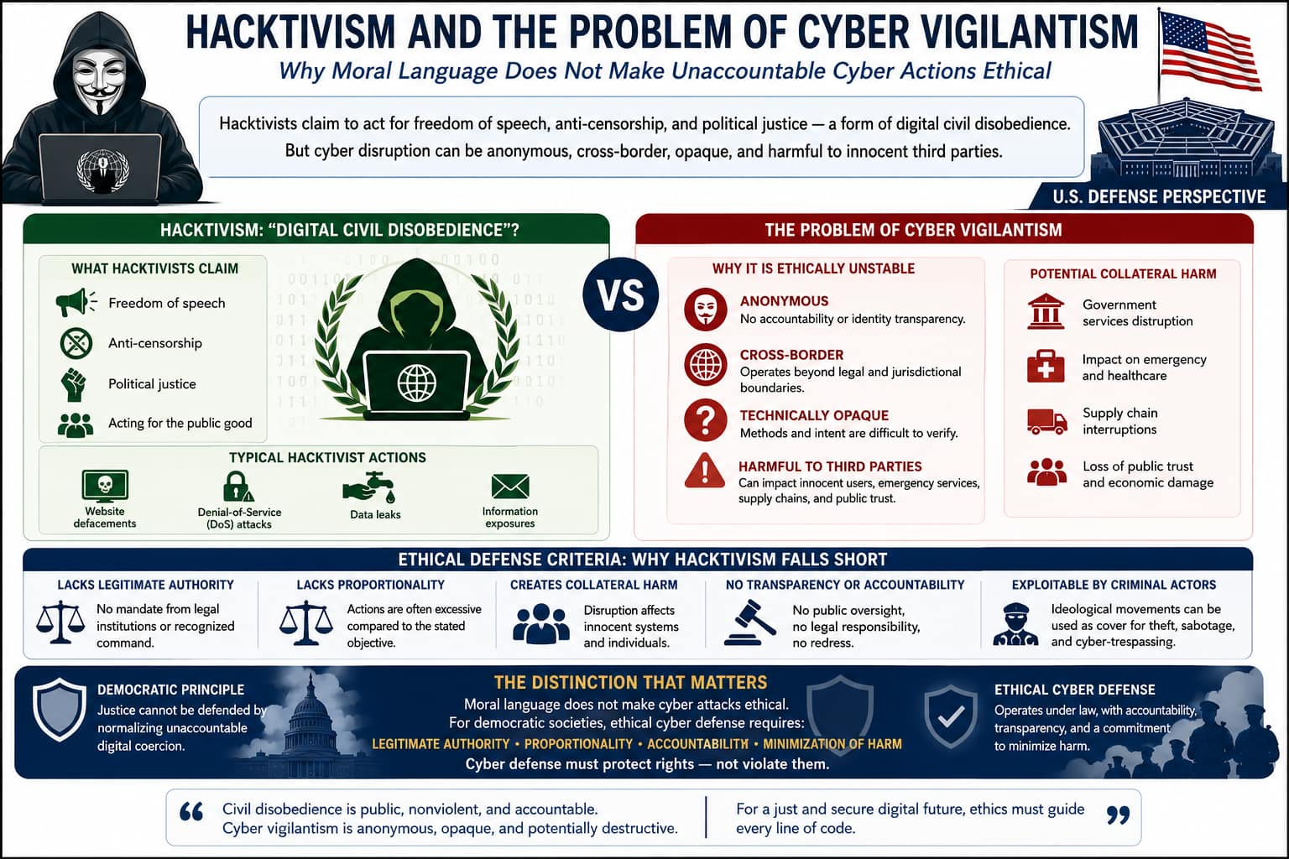
Figure3: The figure contrasts hacktivism with cyber vigilantism, showing that ethical cyber defense requires legality, accountability, transparency, proportionality, and protection of innocent systems.

State-Sponsored Cyber Operations and Just Defense
The framework also addresses government-sponsored cyberattacks, defining cyberattack as action taken to undermine computer network functions for political or national security purposes. It notes that cyberattacks may be used as strategic weapons and that their ethical status resembles broader debates about military action (Hathaway, 2012).
For the United States, the ethical use of cyber capability must align with the principles of just defense: legitimate authority, necessity, discrimination, proportionality, and last resort. Cyber operations may be defensible when used to prevent terrorism, disrupt hostile command systems, defend military networks, or protect critical infrastructure (Rezazadehsaber, 2015; Simpson, 2010). However, they become unethical when they target civilians indiscriminately, steal private data for coercion, or degrade essential civilian services without lawful military necessity.
The defense-friendly conclusion is not that all state cyber operations are justified. Rather, it is that cyber capability must be governed by the same moral discipline expected of kinetic military power.

Legal Reform: Distinguishing Research From Crime
The study reveals that legal systems often fail to differentiate sufficiently between ethical hackers and malicious crackers. It specifically discusses U.S. legal treatment of unauthorized access and notes that harsh punishment alone may not deter cybercrime if certainty of detection remains low (Young, 2007).
A defense-oriented legal reform agenda (figure4) should not decriminalize reckless intrusion. Instead, it should create clearer safe channels for authorized security research:
- Responsible vulnerability disclosure programs-These programs provide structured channels for security researchers to privately report software or system vulnerabilities to the affected organization. They help ensure flaws are fixed before attackers can exploit them, reducing public risk.( (Conran, 2014)
- Bug bounty frameworks-Bug bounty programs reward ethical hackers financially or through recognition for discovering valid security weaknesses. They encourage proactive security testing while creating incentives for lawful participation. (Jose, 2013)
- Clear authorization boundaries-Authorization boundaries define exactly which systems, networks, applications, and testing methods are legally permitted during security assessments. This prevents ambiguity and protects researchers from accidental legal violations or unauthorized intrusion. (Pike, 2013)
- Safe harbor for good-faith security testing-Safe harbor provisions offer legal protection to researchers who conduct security testing ethically and within approved rules. This reduces fear of prosecution when the intent is defensive rather than malicious. (Conran, 2014)
- Mandatory non-disclosure of sensitive data-Researchers must not access, retain, share, or publish confidential data such as personal, financial, or classified information found during testing. Non-disclosure safeguards privacy, organizational security, and national interests. (NASEM, 2020)
- Escalation channels for critical infrastructure vulnerabilities-These are emergency reporting pathways for vulnerabilities affecting critical sectors such as healthcare, energy, banking, defense, or transportation. Rapid escalation enables immediate response and minimizes potential large-scale disruption. (FEMA, 2025)
- Strong penalties for extortion, sabotage, espionage, and data theft-Severe legal penalties deter malicious actors who intentionally exploit cyber systems for financial gain, disruption, or intelligence theft. Strong enforcement reinforces accountability and protects national security and public trust. (Young, 2007)
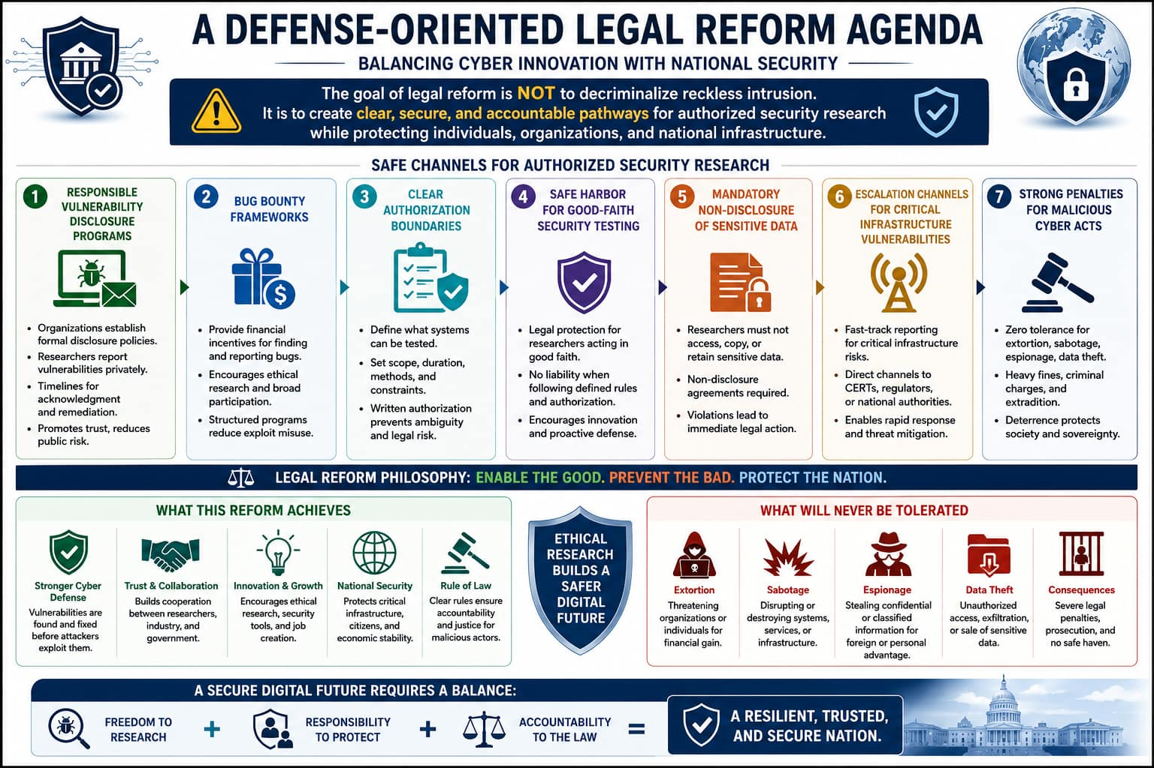
Figure4: The figure illustrates legal cyber reform promoting safe, authorized security research through accountability, disclosure, and protection, while strictly penalizing malicious cybercrime.
Such reform strengthens national defense by recruiting technical talent into lawful service rather than pushing skilled individuals into adversarial or underground communities.

Case Studies

Case Study 1: Microsoft Zero-Day Vulnerability Disclosure (figure5)
Between 2021 and 2023, independent security researchers identified several critical zero-day vulnerabilities affecting Microsoft Exchange Server and other Microsoft systems. Rather than publicly disclosing exploit methods, ethical researchers followed responsible vulnerability disclosure protocols, privately reporting these security flaws to enable remediation before adversarial exploitation(Conran, 2014).
Microsoft supports a structured bug bounty framework, providing financial rewards and formal recognition to security researchers who responsibly identify valid vulnerabilities. These programs establish clear authorization boundaries, defining which systems, tools, and testing methods are legally permissible during security assessments. Such boundaries reduce ambiguity and help prevent accidental unauthorized access.
Additionally, safe harbor protections provide legal reassurance to researchers conducting good-faith security testing within approved guidelines. Given the potential exposure of sensitive enterprise, healthcare, and government data, mandatory non-disclosure played a critical role in preventing premature publication of exploit details or confidential information(Jose, 2013).
Because some vulnerabilities affected critical sectors, dedicated escalation channels for critical infrastructure enabled rapid reporting, coordinated incident response, and accelerated patch deployment, thereby minimizing systemic cyber risk.
This case illustrates how legal and institutional frameworks can simultaneously strengthen cybersecurity and protect ethical research through responsible disclosure, lawful testing, and accountable remediation.
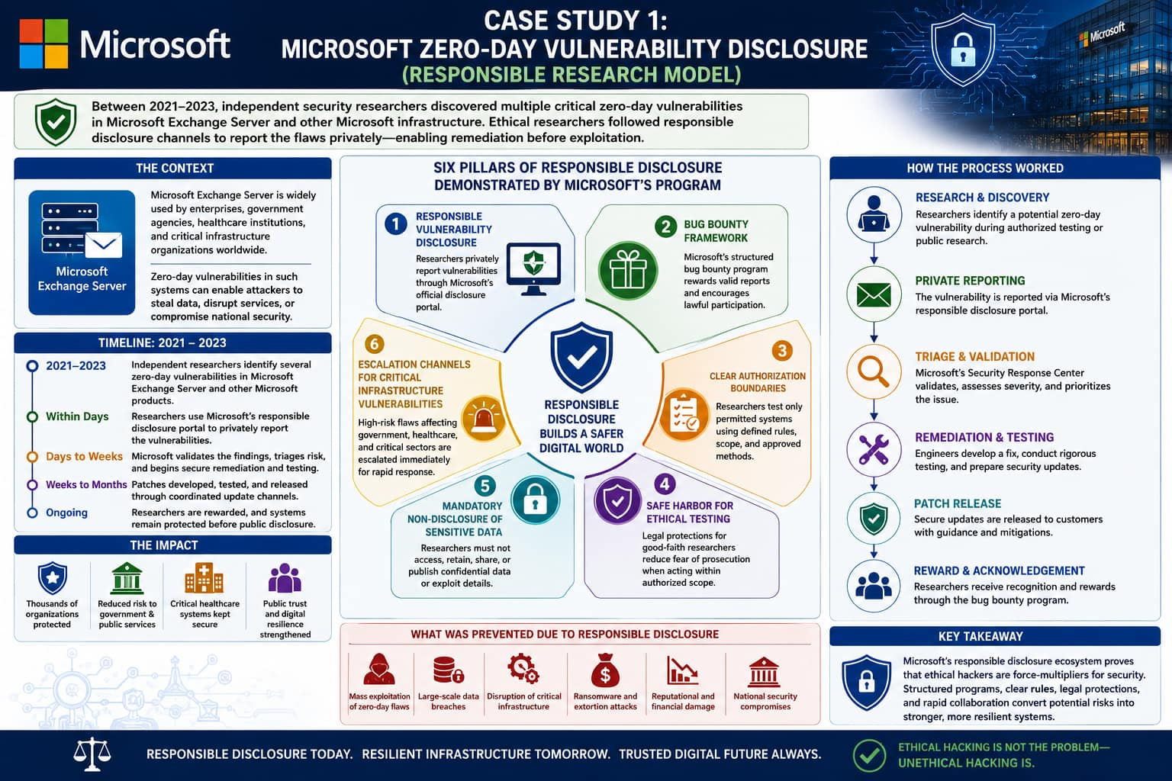

Figure 5: Case study1: good-faith cybersecurity research requires legal protection

Case Study 2: Colonial Pipeline ransomware attack (figure7)
The 2021 ransomware attack on Colonial Pipeline by the cybercriminal group DarkSide represents a clear example of malicious cyber intrusion conducted without ethical, legal, or operational constraints. Attackers obtained unauthorized access to the company’s network, encrypted critical operational systems, and demanded ransom payment, forcing the temporary shutdown of one of the largest fuel pipeline networks in the United States. The incident disrupted fuel transportation across the U.S. East Coast, triggering widespread panic buying, fuel shortages, economic disruption, and heightened public concern regarding infrastructure vulnerability(Office of Inspector General [OIG], 2026).
This attack demonstrates the severe consequences of cyber operations conducted without authorization or accountability. Unlike ethical hackers, the attackers had no legitimate authority to access the system and acted with explicit malicious intent for financial extortion. Their intrusion weaponized stolen access to disrupt essential services, thereby threatening public welfare, economic stability, and national resilience. The attack also eroded public trust in the security of critical infrastructure and highlighted how cybercrime can produce real-world societal harm extending far beyond digital systems(FEMA, 2025; NASEM, 2025).
The incident further emphasized the urgent need for dedicated escalation channels for vulnerabilities affecting critical infrastructure sectors such as energy, transportation, healthcare, and defense. Rapid detection, reporting, and coordinated response mechanisms are essential to minimize cascading disruption in such high-risk sectors. Recognizing the gravity of the event, the Federal Bureau of Investigation and other U.S. security agencies treated the attack as a national security threat requiring immediate federal attention(OIG, 2026).
From a legal perspective, the Colonial Pipeline attack reinforces why cyber laws must impose strong penalties for extortion, sabotage, espionage, data theft, and cyber-enabled coercion. Severe legal consequences serve both punitive and deterrent functions by discouraging malicious actors from exploiting critical systems for financial or strategic gain. This case illustrates that malicious hacking is not merely unauthorized access—it is a direct threat to public safety, economic continuity, and national security, demanding robust legal enforcement and resilient cyber defense mechanisms.

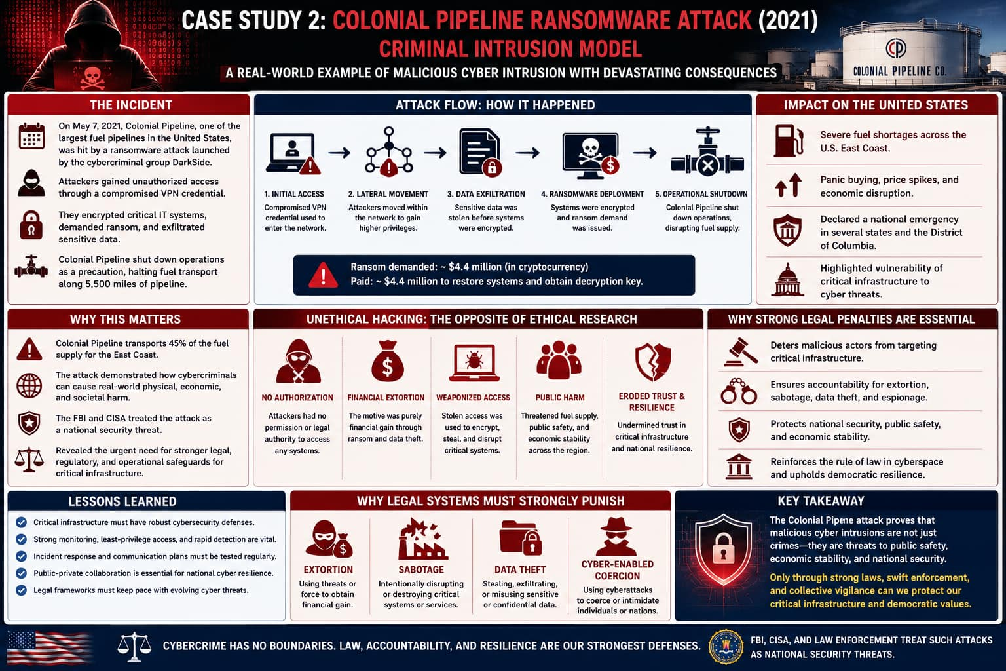
Figure 6: Case2 : criminal cyber exploitation demands strong enforcement

Policy Recommendations for the U.S. Defense Ecosystem
First, the U.S. should expand ethical cyber talent pipelines through universities, defense fellowships, cyber ranges, and public-private partnerships.
Second, every defense contractor and critical infrastructure operator should maintain authorized red-team and vulnerability disclosure programs.
Third, legal safe harbor should be tied to strict conduct: no persistence, no data exfiltration, no public dumping, no extortion, no operational disruption.
Fourth, cyber ethics should be taught alongside technical training. A skilled operator without ethical discipline is a strategic liability.
Fifth, hacktivism and patriotic hacking should not be romanticized. Unaccountable cyber aggression can undermine deterrence, attribution, diplomacy, and civilian trust.
Sixth, cyber defense must remain democratic. The legitimacy of U.S. cyber power depends not only on capability, but on accountability.
Therefore, U.S. should expand ethical cyber talent pipelines through universities, defense fellowships, cyber ranges, and public-private partnerships (NASEM, 2025). Cyber ethics must be taught alongside technical training because a skilled operator without ethical discipline becomes a strategic liability (Ryan & Deci, 2000; Pike, 2013).

Conclusion
This study provides a valuable foundation for distinguishing between malicious intrusion and socially beneficial security research. Its central insight is that hacking cannot be judged by technique alone. The decisive variables are purpose, authority, proportionality, transparency, and consequence.
For a United States defense-friendly interpretation, ethical hacking should be understood as authorized adversarial testing in service of national resilience. It is ethical when it protects systems, prevents harm, strengthens institutions, and operates under lawful accountability. It is unethical when it becomes theft, sabotage, vigilantism, coercion, or ideological disruption.
In the twenty-first century, cyber defense requires people who can penetrate systems—but democracy requires that they do so under rules. The gold-medal argument is therefore this: ethical hacking is not the opposite of national security; it is national security disciplined by law, morality, and public trust.

References
Bodhani, A. (2013). Ethical hacking and white-hat security practice.
Caltagirone, S. (2003). Ethical hacking and moral justification in emergency contexts.
Conran, M. (2014). Security testing and vulnerability remediation.
Fadia, A. (2006). Ethical hacking.
Federal Emergency Management Agency. (2025, October). FEMA Region 2 preparedness and resilience bulletin (Vol. 10, Issue 4).
Hathaway, O. A. (2012). Cyberattacks and the law of armed conflict.
Himma, K. E. (2007). Hacking as politically motivated information ethics.
Jose, J. (2013). Ethical hacking and penetration testing.
Leeson, P. (2005). The economics and sociology of hacker communities.
Levy, S. (2001). Hackers: Heroes of the computer revolution.
National Academies of Sciences, Engineering, and Medicine. (2020). Cryptographic agility and interoperability: Proceedings of a workshop. The National Academies Press. https://doi.org/10.17226/25088
National Academies of Sciences, Engineering, and Medicine. (2025). Cyber hard problems: Focused steps toward a resilient digital future. The National Academies Press. https://doi.org/10.17226/29056
National Academies of Sciences, Engineering, and Medicine. (2025, December 2–4). Fall 2025 meeting of the Forum on Cyber Resilience [Virtual meeting].
Office of Inspector General. (2026, June 15). A small southeastern hospital had effective cybersecurity controls to prevent, detect, and respond to cyberattacks (Report No. OAS-25-18-033). U.S. Department of Health and Human Services.
Pike, G. H. (2013). Rule of law and ethical frameworks in hacking communities.
Rawls, J. (1971). A theory of justice. Harvard University Press.
Rezazadehsaber, S. (2015). When is hacking ethical? [Master’s thesis, University at Albany, State University of New York].
Ryan, R. M., & Deci, E. L. (2000). Intrinsic motivation and self-determination theory.
Samuel, A. (2004). Hacktivism and digital civil disobedience.
Simpson, M. T. (2010). Ethical hacking and computer security.
Young, R. (2007). Deterrence, punishment, and cybercrime.
Disclosures
Acknowledgement
The University of Fairfax accredited by the Accrediting Commission of the Distance Education and Training Council (DETC).
Conflicts of interest
The author declares no conflicts of interest.
Funding
No external funding was received.

