Self-Care, Psychological Well-Being and Team Cohesion Among NGO Workers and Partner Staff: A Pre-Post Study

ABSTRACT
Organisational well-being programmes are increasingly needed in community-based and service-oriented settings where staff members are required to manage emotional, interpersonal, and operational demands. This pre-post study examined short-term changes following MindCare Solution, a one-day organisational counselling intervention developed from a preliminary needs analysis with a confidential community welfare NGO and a hospitality-based programme partner. The programme integrated stress and burnout psychoeducation, self-care reflection, recreation, team-based problem solving and nature-based environmental engagement. Thirty participants completed pre- and post-assessments using the Depression Anxiety Stress Scales-21 (DASS-21), the WHO-5 Well-Being Index, and the Team Effectiveness Questionnaire (TEQ). Descriptive statistics and paired-samples t-tests showed significant reductions in stress, depression and anxiety, alongside significant increases in subjective well-being and perceived team effectiveness. The findings suggest that a brief, experiential, and context-responsive counselling intervention can support short-term psychological well-being and team functioning among NGO workers and partner staff. However, the one-group design and immediate post-assessment mean that the findings should be interpreted as short-term associated changes rather than long-term causal effects.
Keywords: self-care, organisational counselling, psychological well-being, pre-post intervention, team effectiveness

ARTICLE INFO
Corresponding author: Mohd Jazil Nazrin Bin Mohd Rosley
Email Address: 97544@siswa.unimas.my

1 INTRODUCTION
Workers in community welfare and service-based organisations often carry responsibilities that require emotional involvement, coordination with others, and continuous response to changing situational demands. These demands may not always appear as formal occupational stressors, yet they can still influence psychological well-being, self-care practices, and the quality of teamwork. In non-governmental and partner-based service contexts, workers may also be expected to balance organisational goals, community expectations, programme delivery, and interpersonal responsibilities. When these demands accumulate without sufficient coping resources, they may contribute to psychological distress and reduced team functioning.
present intervention was developed from the understanding that stress is not produced by demand alone, but by the way individuals appraise those demands in relation to their coping resources (Lazarus & Folkman, 1984). Burnout theory further suggests that prolonged exposure to unmanaged work demands may affect energy, motivation, and perceived accomplishment (Maslach & Leiter, 2016). Within group settings, social support can buffer the negative effects of stress by providing emotional, informational, and practical resources (Cohen & Wills, 1985). Therefore, an organisational counselling intervention that combines psychoeducation with active participation may be useful for helping participants recognise stress, strengthen self-care awareness, and experience supportive group processes.
MindCare Solution was designed as a brief experiential programme that integrated stress and burnout psychoeducation, guided reflection, recreation, team-building, and environmental engagement. The programme was implemented with a confidential community welfare NGO and a hospitality-based programme partner. These organisations are described generally to protect institutional and participant confidentiality. The intervention was designed not only to increase awareness of stress and self-care, but also to encourage communication, cooperation, and team cohesion through structured activities.
The study focused on three measurable outcomes. Psychological distress was assessed through stress, depression, and anxiety scores using the DASS-21. Subjective well-being was assessed using the WHO-5 Well-Being Index, while perceived team effectiveness was measured using the TEQ. Based on the intervention design, it was expected that participants would report lower psychological distress and higher well-being and team effectiveness after completing the programme.

1.1 Programme Description
MindCare Solution was a one-day organisational counselling intervention grounded in transactional stress and coping theory, burnout theory, social support theory, experiential learning theory, and attention restoration theory. Experiential learning theory emphasises the importance of learning through concrete experience, reflection, conceptual understanding, and active application (Kolb, 1984). Attention restoration theory supports the use of natural settings as environments that may assist mental recovery and direct attention (Kaplan & Kaplan, 1989). In this programme, these theoretical ideas were translated into five submodules that moved from rapport building, to psychoeducation, sharing, team simulation, and environmental engagement.
Submodule | Main activity | Targeted learning outcome
Banker ice-breaking session | Participants formed groups based on changing monetary values announced by facilitators. | Rapport, communication, adaptability, and initial social comfort.
Grounding beach talk | Facilitator-led psychoeducation and reflection on stress, burnout, and self-care. | Stress awareness, burnout recognition, coping strategies, and self-care planning.
Sharing and recreation session | Beach ball activity using guided prompts related to stress, support, and self-care. | Emotional expression, respectful listening, peer support, and positive interaction.
Save the water balloon | Teams protected a water-filled balloon using limited resources and changing instructions. | Communication, role distribution, problem-solving, and teamwork under pressure.
Clean the coast, clear the mind challenge | Participants worked together to collect and sort waste in a beach environment. | Shared responsibility, environmental engagement, nature connection, and team cohesion.
Table 1: Content of the MindCare Solution Intervention
2. METHODS

2.1 Design
This study used a quantitative one-group pre-test and post-test design to examine short-term changes following the intervention. All participants received the same intervention and outcomes were assessed before and after programme completion. This design allowed direct comparison of pre-intervention and post-intervention scores. Therefore, the results are interpreted as short-term changes associated with the intervention rather than definitive evidence of causal effectiveness.

2.2 Needs Analysis and Organisational Context
Before implementation, a preliminary needs analysis was conducted with the organisational partners to clarify the programme focus, participant needs and practical implementation requirements. The need analysis indicated that participants were managing work and community-related responsibilities that required communication, emotional regulation, teamwork and sustained self-care. These findings informed the selection of programme content and assessment outcomes. For confidentiality, the organisations are reported only as a community welfare NGO and a hospitality-based programme partner, while all participant responses were coded and analysed in aggregate form.

2.3 Participants
The final analytic sample comprised 30 participants from a confidential community welfare NGO and a hospitality-based programme partner. All participants completed both the pre-assessment and post-assessment. Participation was voluntary and all responses were coded using participant identification numbers to maintain confidentiality. The names of the organisations are not reported in the manuscript to protect institutional and participant privacy.
Variable | Category | n | %
Age range | 22–25 years | 12 | 40.0
 | 26–29 years | 8 | 26.7
 | 30 years and above | 10 | 33.3
Gender | Male | 14 | 46.7
 | Female | 16 | 53.3
Origin | Sarawakian | 30 | 100.0
 | Non-Sarawakian | 0 | 0.0

Table 2: Demographic Characteristics of Participants (N = 30)

2.4 Procedure
Participants were briefed on the programme objectives, confidentiality procedures, and assessment process before the intervention began. The briefing was based on the earlier needs analysis and explained that the assessment was used to evaluate the programme in aggregate form rather than to identify individual participants. They completed the DASS-21, WHO-5, and TEQ as pre-assessment measures before joining the intervention activities. The programme then proceeded through five submodules: Banker Ice-Breaking Session, Grounding Beach Talk, Sharing and Recreation Session, Save the Water Balloon, and Clean the Coast, Clear the Mind Challenge. After completing all activities, participants completed the same assessment instruments as post-assessment measures, followed by a short debriefing session.

2.5 Instruments
The Depression Anxiety Stress Scales-21 (DASS-21) was used to assess psychological distress. The DASS-21 contains 21 items divided into three subscales: stress, depression, and anxiety. Each subscale contains seven items rated from 0 to 3, and subscale scores are multiplied by two for interpretation using conventional DASS severity categories. Evidence supports the use of the DASS-21 as a mental health screening tool among Malaysians (Thiyagarajan et al., 2022).
The WHO-5 Well-Being Index was used to assess subjective psychological well-being. It contains five positively worded items rated from 0 to 5. Raw scores range from 0 to 25, and percentage scores are obtained by multiplying the raw score by four. The WHO-5 has been widely used as a brief outcome measure of well-being (Topp et al., 2015), and Malay validation evidence has also been reported (Suhaimi et al., 2022).
The Team Effectiveness Questionnaire (TEQ) was used to assess perceived team functioning. The TEQ contains 40 statements grouped into eight domains labelled A to H: clarifying vision and boundaries, empowerment, praise and acknowledgement, internal communication, divergence and innovation, external championing, learning and improvement, and diversity. A response of 4 or 5 contributes one positive count to the relevant domain, while ratings of 1 or 2 indicate negative responses and 3 is neutral. Each domain contains five statements; therefore, total positive scores range from 0 to 40 (Kemp, n.d.). Higher scores indicate stronger perceived team effectiveness.

2.6 Data Analysis
Data were analysed using descriptive statistics and paired-samples t-tests. Minimum, maximum, mean, and standard deviation were calculated for each pre-assessment and post-assessment score. Paired-samples t-tests were then conducted to examine whether changes from pre-assessment to post-assessment were statistically significant. The significance level was set at p < .05. For DASS-21, positive mean differences indicated reductions in psychological distress. For WHO-5 and TEQ, positive mean differences indicated increases in well-being and perceived team effectiveness.

3 RESULTS

3.1 DASS-21 Assessment
Table 3 presents the descriptive statistics for DASS-21 stress, depression, and anxiety scores. Mean scores decreased across all three domains from pre-assessment to post-assessment. Stress decreased from M = 20.67 to M = 18.27, depression decreased from M = 19.87 to M = 11.87, and anxiety decreased from M = 14.40 to M = 12.00. Depression showed the largest mean reduction.
Domain | Assessment | N | Minimum | Maximum | M | SD
Stress | Pre-assessment | 30 | 14 | 28 | 20.67 | 3.73
Stress | Post-assessment | 30 | 10 | 24 | 18.27 | 3.51
Depression | Pre-assessment | 30 | 12 | 28 | 19.87 | 4.42
Depression | Post-assessment | 30 | 8 | 14 | 11.87 | 2.10
Anxiety | Pre-assessment | 30 | 8 | 22 | 14.40 | 3.91
Anxiety | Post-assessment | 30 | 6 | 18 | 12.00 | 2.41
Table 3: Descriptive Statistics for DASS-21 Scores

Outcome | MD | SD | SE | 95% CI LL | 95% CI UL | t | df | p
Stress | 2.40 | 4.56 | 0.83 | 0.70 | 4.10 | 2.88 | 29 | .007
Depression | 8.00 | 2.78 | 0.51 | 6.96 | 9.04 | 15.77 | 29 | < .001
Anxiety | 2.40 | 3.84 | 0.70 | 0.97 | 3.83 | 3.42 | 29 | .002
Table 4: Paired-Samples t-Test for DASS-21 Scores
The paired samples t-tests in Table 4 showed statistically significant reductions in all three DASS-21 domains. Stress scores decreased significantly, t(29) = 2.88, p = .007. Depression scores also decreased significantly, t(29) = 15.77, p < .001. Anxiety scores decreased significantly as well, t(29) = 3.42, p = .002. These findings indicate that participants reported significantly lower psychological distress after the intervention.

3.2 WHO-5 Well-Being Assessment
Table 4 shows the descriptive statistics for WHO-5 well-being scores. The mean raw score increased from M = 15.90 at pre-assessment to M = 16.80 at post-assessment. In percentage form, the mean increased from 63.60% to 67.20%. The increase was small, but the overall direction suggested improved subjective well-being after the intervention.

Score | Assessment | N | Minimum | Maximum | M | SD
Raw score | Pre-assessment | 30 | 12 | 20 | 15.90 | 2.23
Raw score | Post-assessment | 30 | 11 | 22 | 16.80 | 2.35
Percentage score | Pre-assessment | 30 | 48 | 80 | 63.60 | 8.94
Percentage score | Post-assessment | 30 | 44 | 88 | 67.20 | 9.42
Table 5: Descriptive Statistics for WHO-5 Scores Before and After the Intervention
As shown in Table 5, the paired-samples t-test indicated a statistically significant increase in WHO-5 raw scores from pre-assessment to post-assessment, t(29) = 2.65, p = .013. This suggests that participants reported higher subjective well-being after completing the programme.
Outcome | MD | SD | SE | 95% CI LL | 95% CI UL | t | df | p
WHO-5 raw | 0.90 | 1.86 | 0.34 | 0.20 | 1.60 | 2.65 | 29 | .013
Table 6: Paired-Samples t-Test for WHO-5 Raw Scores

3.3 Team Effectiveness Questionnaire Assessment
Table 6 presents the descriptive statistics for TEQ team effectiveness scores. The mean total score increased from M = 34.97 at pre-assessment to M = 35.73 at post-assessment. In percentage form, the mean increased from 87.42% to 89.33%. The relatively high baseline scores indicate that participants already reported positive team functioning before the programme, but a further increase was still observed after the intervention.
Score | Assessment | N | Minimum | Maximum | M | SD
Total score /40 | Pre-assessment | 30 | 31 | 39 | 34.97 | 2.08
Total score /40 | Post-assessment | 30 | 32 | 40 | 35.73 | 2.00
Percentage score | Pre-assessment | 30 | 77.5 | 97.5 | 87.42 | 5.19
Percentage score | Post-assessment | 30 | 80.0 | 100.0 | 89.33 | 5.00
Table 7: Descriptive Statistics for TEQ Scores Before and After the Intervention
The paired-samples t-test in Table 7 showed a statistically significant increase in TEQ total scores, t(29) = 3.10, p = .004. This indicates that participants reported stronger perceived team effectiveness after the intervention.
Outcome | MD | SD | SE | 95% CI LL | 95% CI UL | t | df | p
TEQ total | 0.77 | 1.36 | 0.25 | 0.26 | 1.27 | 3.10 | 29 | .004
Table 8: Paired-Samples t-Test for TEQ Total Scores

4 DISCUSSIONS
The findings show that MindCare Solution was associated with significant short-term improvements across all measured outcomes. The DASS-21 results indicated reductions in stress, depression, and anxiety after the intervention. Depression showed the largest reduction, suggesting that the combination of psychoeducation, emotional expression, supportive interaction, and nature-based activities may have helped participants feel more emotionally settled after the programme. The decrease in stress and anxiety scores also suggests that participants experienced lower tension and worry by the end of the intervention.
These findings are consistent with the theoretical basis of the programme. The Grounding Beach Talk encouraged participants to recognise personal stressors and understand the importance of coping resources, which reflects the transactional view of stress and coping (Lazarus & Folkman, 1984). The discussion of burnout warning signs also helped participants connect emotional exhaustion and reduced motivation with the need for consistent self-care (Maslach & Leiter, 2016). The psychoeducational component therefore provided a clearer language for participants to understand distress before applying the ideas through activities.
The WHO-5 results showed a small but significant increase in subjective well-being. This pattern is reasonable because well-being may require repeated practice and longer-term support before large changes can occur. However, even a modest improvement is meaningful because the programme was brief and the post-assessment was conducted immediately after implementation. The result suggests that participants felt slightly more positive, calm, active, or engaged after the intervention. Workplace mindfulness and well-being interventions have been found to support aspects of employee health, although effect sizes may vary depending on design and follow-up period (Michaelsen et al., 2023).
The nature-based component may also have contributed to the positive pattern of results. The programme was conducted in a beach environment and included an environmental activity that required participants to work together while engaging with the surrounding natural setting. Nature-based interventions and social prescribing approaches have been associated with improved mental health and psychological outcomes (Menhas et al., 2024). In the present programme, nature was not used as a passive setting only; it became part of the intervention through reflection, movement, cooperation, and environmental contribution.
The TEQ results showed a significant increase in perceived team effectiveness despite the high baseline score. This is important because a high pre-assessment score leaves limited space for improvement. The increase suggests that participants experienced slightly stronger team functioning after taking part in structured group activities. Banker, Save the Water Balloon, and Clean the Coast, Clear the Mind required communication, role distribution, decision-making, and adaptation to changing demands. These elements are consistent with team intervention research, which suggests that structured activities can strengthen team functioning when they create opportunities for practice and reflection (Buljac-Samardzic et al., 2020; McGuier et al., 2023).
Overall, the findings suggest that the intervention responded well to the needs of NGO workers and partner staff. Participants were not only exposed to concepts such as stress, burnout, self-care, and teamwork; they also applied these concepts through shared activities. This matters because organisational counselling interventions should not only provide information but also create experiences that allow participants to practise new ways of coping and working together. The programme therefore has practical value as a brief model for promoting self-care awareness, psychological well-being, and team cohesion in small organisational and community-based settings.

4.1 Limitations and Future Directions
Several limitations should be considered. First, the study used a one-group pre-test and post-test design without a comparison group. As a result, the findings cannot fully rule out alternative explanations such as testing effects, group atmosphere, or immediate positive mood following programme completion. Second, the post-assessment was conducted immediately after the intervention, so the findings reflect short-term perceived change rather than sustained behavioural change. Third, the measures were self-report instruments, which may be influenced by social desirability or participants’ immediate reactions to the programme.
Future studies should include a follow-up assessment to determine whether changes in distress, well-being, and team effectiveness are maintained over time. A comparison group would also strengthen the design and allow stronger conclusions about intervention effects. Future implementations may also include qualitative feedback so that the numerical results can be supported by participants’ own experiences of the programme. For practice, organisations may consider repeating the programme or adding short follow-up sessions on self-care, coping skills, communication, and team support.

5 CONCLUSIONS
This study examined short-term changes following MindCare Solution, a needs-informed organisational counselling intervention for NGO workers and partner staff. The findings showed significant reductions in psychological distress and significant increases in subjective well-being and perceived team effectiveness. These outcomes suggest that a brief intervention combining psychoeducation, self-care reflection, teamwork activities, and nature-based engagement can provide meaningful short-term support for organisational well-being. At the same time, the findings should be interpreted within the limits of a one-group pre-post design and immediate post-assessment. Future applications should include follow-up sessions and longer-term evaluation to determine whether the changes are sustained.

ACKNOWLEDGEMENTS
The authors would like to thank the confidential community welfare NGO and the hospitality-based programme partner for their cooperation and participation in this study. Appreciation is also extended to the participants and facilitators involved in the implementation of MindCare Solution.

AUTHOR CONTRIBUTIONS
All authors contributed to the planning and implementation of the intervention. The student authors contributed to programme delivery, data organisation, analysis, and manuscript preparation. Mohd. Shahrul bin Kamaruddin provided academic supervision and guidance throughout the development and reporting of the study.

CONFLICT OF INTEREST
The authors declare no conflict of interest.

DATA AVAILABILITY STATEMENT
The data supporting the findings of this study are available from the corresponding author upon reasonable request, subject to confidentiality restrictions.

NEEDS ANALYSIS AND CONFIDENTIALITY STATEMENT
The programme was developed following a preliminary needs analysis with the participating organisations. Participation in the assessment process was voluntary, and participants were informed that their responses would be used only for aggregate programme evaluation and manuscript preparation. Participant identities and organisational details were anonymised to maintain confidentiality.

FUNDING
This study received no external funding.

REFERENCES
Buljac-Samardzic, M., Doekhie, K. D., & van Wijngaarden, J. D. H. (2020). Interventions to improve team effectiveness within health care: A systematic review of the past decade. Human Resources for Health, 18, Article 2. https://doi.org/10.1186/s12960-019-0411-3
Cohen, S., & Wills, T. A. (1985). Stress, social support, and the buffering hypothesis. Psychological Bulletin, 98(2), 310-357. https://doi.org/10.1037/0033-2909.98.2.310
Kaplan, R., & Kaplan, S. (1989). The experience of nature: A psychological perspective. Cambridge University Press.
Kemp, T. (n.d.). Team effectiveness questionnaire. http://www.timkemp.co.uk
Kolb, D. A. (1984). Experiential learning: Experience as the source of learning and development. Prentice Hall.
Lazarus, R. S., & Folkman, S. (1984). Stress, appraisal, and coping. Springer.
Maslach, C., & Leiter, M. P. (2016). Burnout. In G. Fink (Ed.), Stress: Concepts, cognition, emotion, and behavior (pp. 351-357). Academic Press. https://doi.org/10.1016/B978-0-12-800951-2.00044-3
McGuier, E. A., Kolko, D. J., Stadnick, N. A., Brookman-Frazee, L., Wolk, C. B., Yuan, C. T., Burke, C. S., & Aarons, G. A. (2023). Advancing research on teams and team effectiveness in implementation science: An application of the Exploration, Preparation, Implementation, Sustainment (EPIS) framework. Implementation Research and Practice, 4, 26334895231190855. https://doi.org/10.1177/26334895231190855
Menhas, R., Yang, L., Saqib, Z. A., Younas, M., & Saeed, M. M. (2024). Does nature-based social prescription improve mental health outcomes? A systematic review and meta-analysis. Frontiers in Public Health, 12, 1228271. https://doi.org/10.3389/fpubh.2024.1228271
Michaelsen, M. M., Graser, J., Onescheit, M., Tuma, M. P., Werdecker, L., Pieper, D., & Esch, T. (2023). Mindfulness-based and mindfulness-informed interventions at the workplace: A systematic review and meta-regression analysis of RCTs. Mindfulness, 14, 1271-1304. https://doi.org/10.1007/s12671-023-02130-7
Suhaimi, A. F., Makki, S. M., Tan, K.-A., Silim, U. A., & Ibrahim, N. (2022). Translation and validation of the Malay version of the WHO-5 Well-Being Index: Reliability and validity evidence from a sample of Type 2 diabetes mellitus patients. International Journal of Environmental Research and Public Health, 19(7), Article 4415. https://doi.org/10.3390/ijerph19074415
Thiyagarajan, A., James, T. G., & Marzo, R. R. (2022). Psychometric properties of the 21-item Depression, Anxiety, and Stress Scale (DASS-21) among Malaysians during COVID-19: A methodological study. Humanities and Social Sciences Communications, 9, Article 220. https://doi.org/10.1057/s41599-022-01229-x
Topp, C. W., Ostergaard, S. D., Sondergaard, S., & Bech, P. (2015). The WHO-5 Well-Being Index: A systematic review of the literature. Psychotherapy and Psychosomatics, 84(3), 167-176. https://doi.org/10.1159/000376585

APPENDICES
APPENDICES A (Completed Module Details)
Submodules and Their Implementation
SUBMODULE 1: BANKER ICE-BREAKING SESSION
(30 Minutes)
Goal | To establish rapport and prepare participants for active involvement in the programme.
Objectives | 1. Communicate with other participants to form groups according to the values announced by the facilitator.  2. Demonstrate cooperation and adaptability under time pressure.  3. Reflect on how teamwork and social support assist individuals when responding to changing demands.
Rationale and Impact | The activity creates a positive and engaging atmosphere at the beginning of the programme. The changing group requirements introduce mild time pressure and require participants to communicate quickly, adjust their decisions and cooperate with others. Guided by Experiential Learning Theory, the activity allows participants to experience the value of adaptability and social support before connecting these experiences to stress management and teamwork.
Materials Required | Prepared monetary-value labels or cards and facilitator instructions.
Implementation Method | Introduction  1. The facilitator welcomes participants and briefly explains the purpose of the ice-breaking session.  2. Each participant is assigned a monetary value and the facilitator explains that participants must form groups that match the amount announced.
Implementation Method | Main Activity  3. The facilitator announces a target amount and participants communicate with one another to form the correct group.  4. The activity is repeated using different amounts and changing conditions so that participants must adapt their decisions.  5. Facilitators observe communication, participation and cooperation while ensuring that all participants remain involved.
Implementation Method | Closing and Debriefing  6. The facilitator asks participants how they responded to time pressure and changing instructions.  7. Participants discuss how communication, cooperation and flexibility supported their performance.  8. The facilitator links the activity to everyday stress and explains how teamwork and social support can strengthen coping.
SUBMODULE 2: GROUNDING BEACH TALK - UNDERSTANDING STRESS, BURNOUT AND SELF-CARE
(2 HOURS)
Goal | To increase participants’ understanding of stress, burnout and sustainable self-care practices.
Objectives | 1. Explain the concepts, causes, symptoms and consequences of stress and burnout.  2. Identify personal warning signs associated with stress and burnout.  3. Select practical coping and self-care strategies that can be applied in daily life.
Rationale and Impact | The session provides participants with a structured understanding of stress, burnout and self-care. It is guided by the Transactional Theory of Stress and Coping, which emphasises the relationship between situational demands and available coping resources. Burnout Theory supports the discussion of emotional exhaustion, cynicism and reduced accomplishment. Conducting the session in a beach environment also supports relaxation, reflection and engagement with nature.
Materials Required | Psychoeducational materials, guided reflection prompts and writing materials for self-reflection and self-commitment activities.
Implementation Method | Introduction  1. The facilitator establishes a respectful and supportive atmosphere for discussion.  2. Participants are introduced to the purpose of the session and encouraged to reflect on their own experiences without being required to disclose information that causes discomfort.
Implementation Method | Main Activity  3. The facilitator explains the concepts of stress and burnout, including common causes, warning signs and consequences.  4. Participants discuss examples of stressors and consider how individual appraisal and coping resources influence their responses.  5. The facilitator introduces healthy coping and self-care practices that support emotional, mental and physical well-being.  6. Participants complete guided reflection and self-commitment activities to identify personal warning signs and practical actions they can apply after the programme.
Implementation Method | Closing and Debriefing  7. Participants are invited to share selected coping or self-care strategies identified during reflection.  8. The facilitator reinforces the importance of recognising warning signs early and practising self-care consistently.  9. The session concludes with a summary of the relationship between stress awareness, coping resources and burnout prevention.
SUBMODULE 3: SHARING AND RECREATION SESSION (BEACH BALL ACTIVITY)
(1 HOUR AND 30 MINUTES)
Goal | To encourage emotional expression, peer support and positive social interaction through guided sharing and recreation.
Objectives | 1. Share experiences or perspectives related to stress, burnout or self-care in a supportive setting.  2. Demonstrate respectful listening and peer support during group interaction.  3. Explain how recreation and social connection contribute to psychological well-being.
Rationale and Impact | The session combines guided sharing with recreation so that participants can express themselves in a less formal environment. Social Support Theory explains how emotional, informational and practical support can reduce the negative effects of stress. The Beach Ball Activity also promotes enjoyment and positive interaction, helping participants strengthen empathy, interpersonal relationships and a sense of connection.
Materials Required | Beach ball and guided sharing prompts.
Implementation Method | Introduction  1. The facilitator explains the purpose of the sharing and recreation session and reminds participants to respect confidentiality and individual boundaries.  2. Participants form a group arrangement suitable for passing or throwing the beach ball safely.
Implementation Method | Main Activity  3. The beach ball is passed or thrown among participants according to the facilitator’s instructions.  4. Participants respond to guided prompts related to stress, self-care, teamwork or supportive relationships when selected during the activity.  5. The facilitator encourages balanced participation, respectful listening and positive responses from peers.  6. The recreational element continues to promote enjoyment, movement and informal interaction among participants.
Implementation Method | Closing and Debriefing  7. Participants reflect on how it felt to share and listen within the group.  8. The facilitator highlights the value of peer support, recreation and social connection in maintaining well-being.  9. The session concludes with a reminder that seeking and providing support are healthy coping practices.
SUBMODULE 4: TEAM-BUILDING ACTIVITY - SAVE THE WATER BALLOON
(2 HOURS)
Goal | To strengthen teamwork, communication, adaptability and problem-solving under pressure.
Objectives | 1. Plan and construct a protective structure through collaborative decision-making.  2. Apply communication, role distribution and problem-solving skills under changing conditions.  3. Evaluate the team strategies and coping resources used during the activity.
Rationale and Impact | The activity simulates pressure through limited resources, time demands and unexpected changes introduced by facilitators. Experiential Learning Theory supports direct participation followed by reflection. The water balloon symbolises personal well-being while the protective structure represents coping resources and support systems. The activity helps participants experience how communication, trust, adaptability and collective problem-solving support resilience.
Materials Required | Water-filled balloons, construction materials supplied by facilitators and a timing device.
Implementation Method | Introduction  1. The facilitator divides participants into teams and explains the objective, rules and safety requirements.  2. Each team receives a water-filled balloon and the available construction materials.
Implementation Method | Main Activity  3. Teams discuss their design, distribute roles and construct a protective structure for the balloon.  4. Facilitators monitor participation and introduce changing conditions or disruptions that require teams to adapt.  5. Teams revise their strategies through communication and collective decision-making.  6. At the end of the construction period, each structure is tested to determine whether it protects the water balloon.
Implementation Method | Closing and Debriefing  7. The facilitator asks teams to explain their planning, role distribution and response to unexpected changes.  8. Participants identify strategies that supported or limited their teamwork.  9. The facilitator connects the balloon and protective structure to personal well-being, coping resources and support systems.
SUBMODULE 5: BEACH CLEANING INTERVENTION - CLEAN THE COAST, CLEAR THE MIND CHALLENGE
(2 HOURS)
Goal | To promote environmental responsibility while strengthening teamwork, mindfulness and awareness of the relationship between environmental and personal well-being.
Objectives | 1. Work collaboratively to collect and sort waste within designated beach areas.  2. Demonstrate communication, role distribution and shared responsibility during the challenge.  3. Reflect on how engagement with nature and environmental contribution support well-being and social connectedness.
Rationale and Impact | The activity combines community service, teamwork and direct engagement with nature. Attention Restoration Theory supports the use of natural environments to reduce mental fatigue and encourage psychological restoration. The point-based challenge motivates participation while shared responsibility strengthens communication, cooperation and a sense of accomplishment. The activity also reinforces the connection between caring for the environment and caring for personal and collective well-being.
Materials Required | Waste-collection bags, sorting materials and facilitator instructions for designated beach areas.
Implementation Method | Introduction  1. The facilitator explains the environmental purpose of the activity, the point-based challenge and the boundaries of the designated beach areas.  2. Participants are divided into teams and receive instructions on role distribution, waste collection, sorting and safe participation.
Implementation Method | Main Activity  3. Teams collect waste from their designated sections of the beach and communicate to distribute responsibilities effectively.  4. Participants sort the collected waste according to the instructions provided by facilitators.  5. Facilitators observe teamwork, encourage mindful engagement with the environment and monitor the progress of each team.  6. Teams complete the challenge by bringing the collected and sorted waste to the designated collection point.
Implementation Method | Closing and Debriefing  7. The facilitator reviews the teams’ contributions and acknowledges their cooperation and environmental responsibility.  8. Participants reflect on their feelings after contributing to the cleanliness of the beach and working towards a shared goal.  9. The facilitator summarises the relationship between environmental well-being, psychological restoration, teamwork and sustainable self-care.

APPENDICES B (Blank Dass-21, Who-5 And Team Effectiveness Questionnaire)
DASS-21
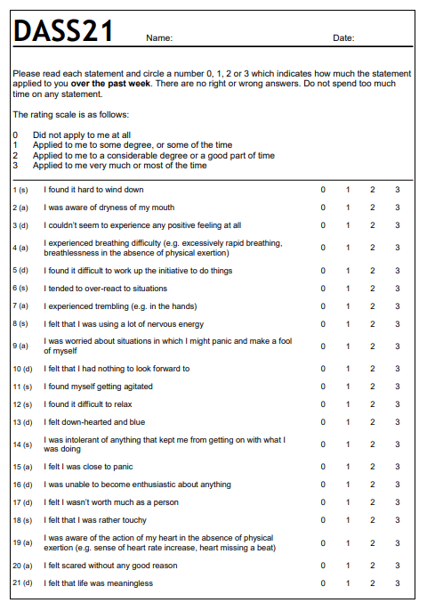
WHO-5
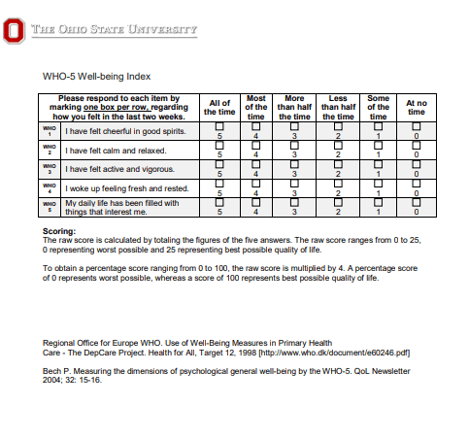
Team Effectiveness Questionnaire
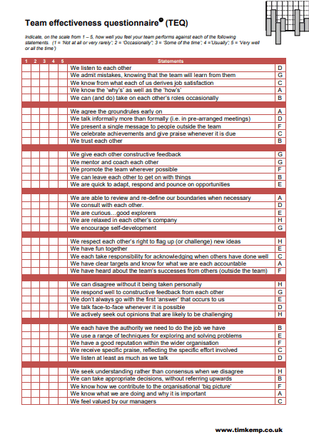
APPENDICES C (Pre And Post Data In Spss Format And Output)
https://drive.google.com/drive/folders/1U_82Mu2OI1uhnFhg3ziBttk6L8AMNAow?usp=sharing
APPENDICES D (Montage Of Consultation Programme)
https://youtu.be/udqYXIp6nqI?si=mHIkTDhV-rPVgxE-
APPENDICES E (MindCare Solution with PERKEPIS and Lance Court Resort Pictures)
Figure 1. Programme activities and beach-cleaning intervention.
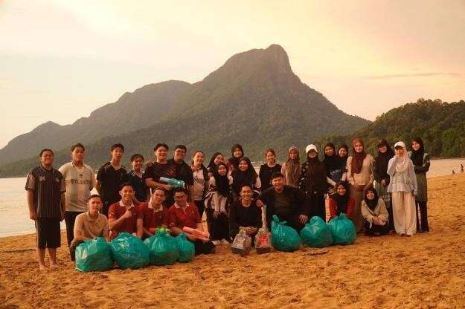 | 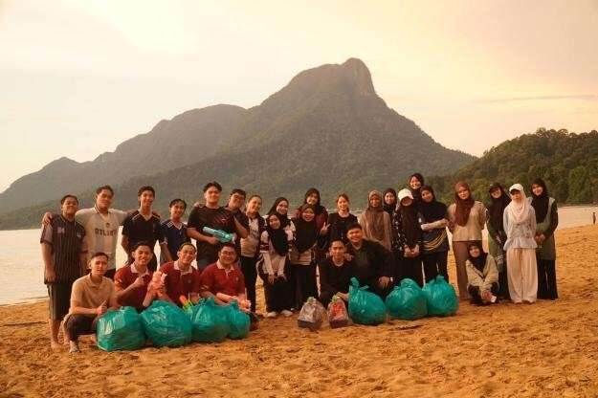
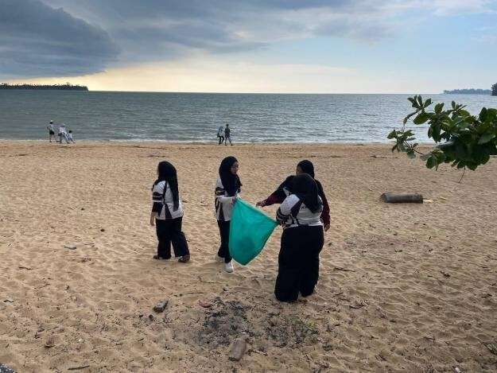 | 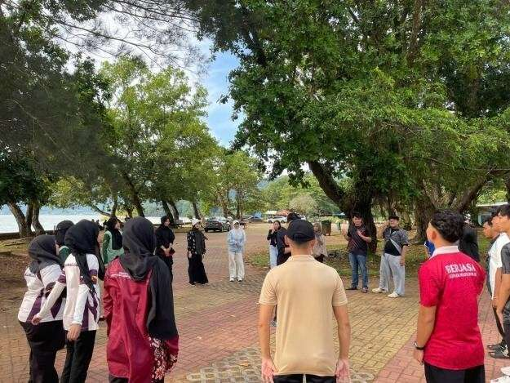
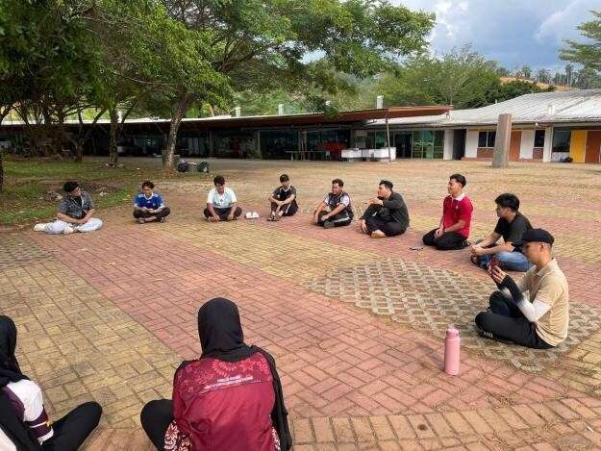 | 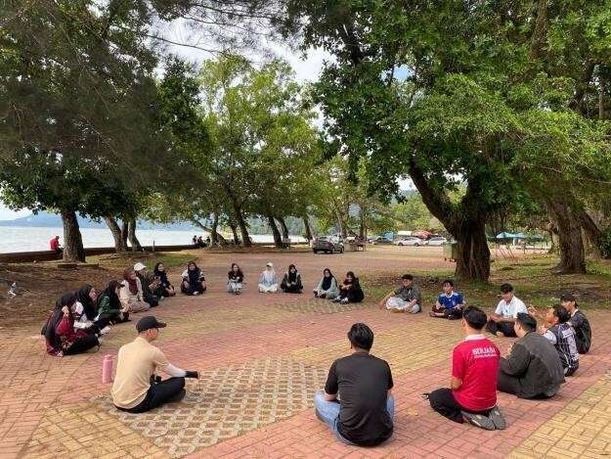

Figure 2. Reflection, recreation and team-building activities.
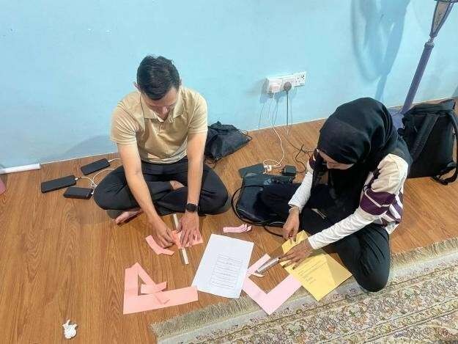 | 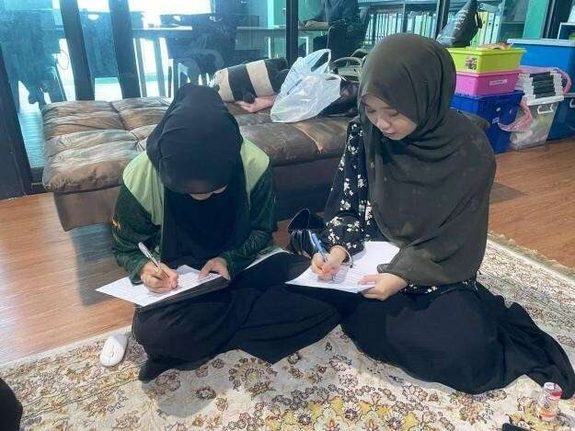
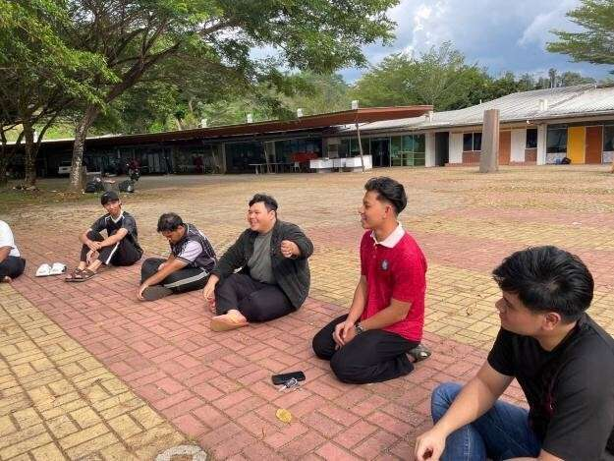 | 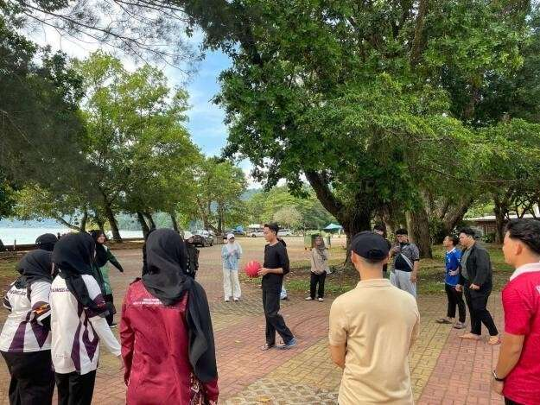
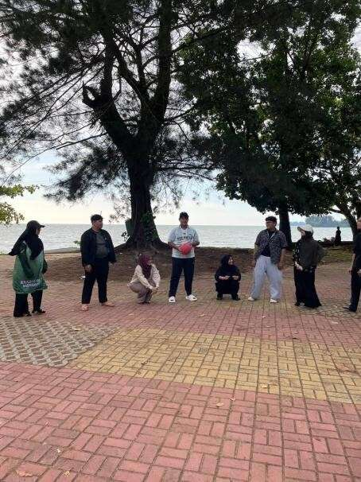 | 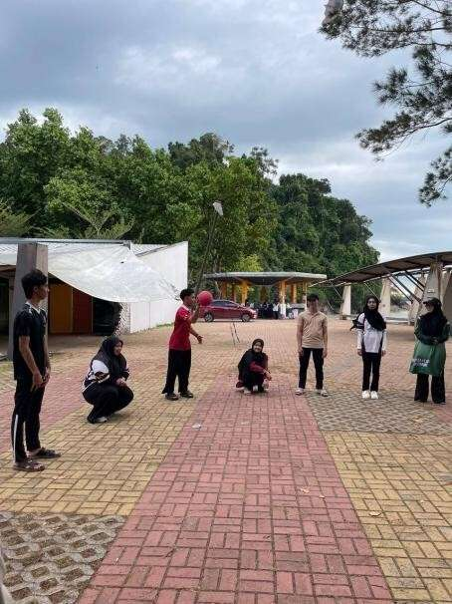

Figure 3. Environmental activities and stakeholder engagement.
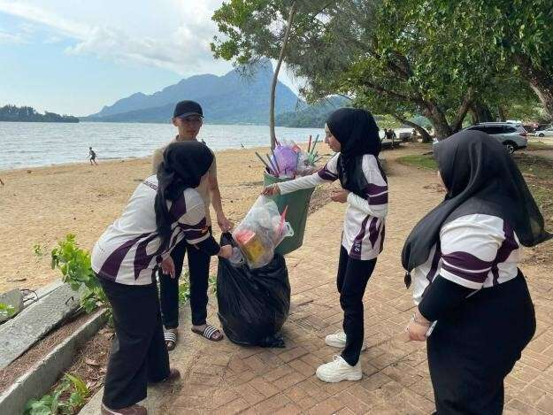 | 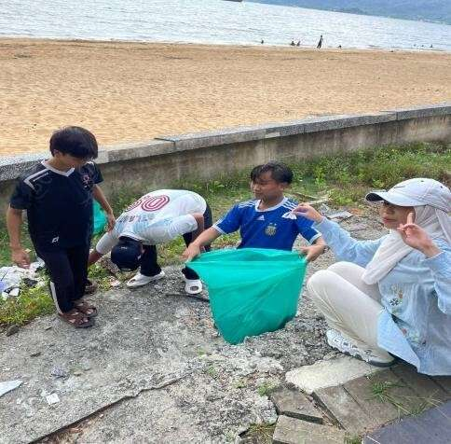
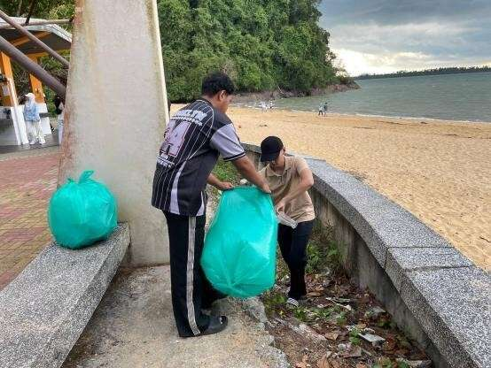 | 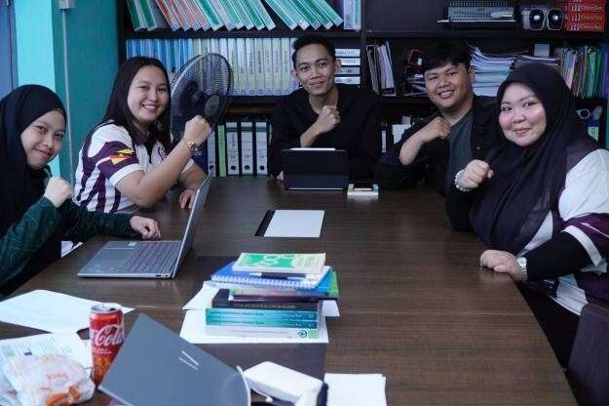
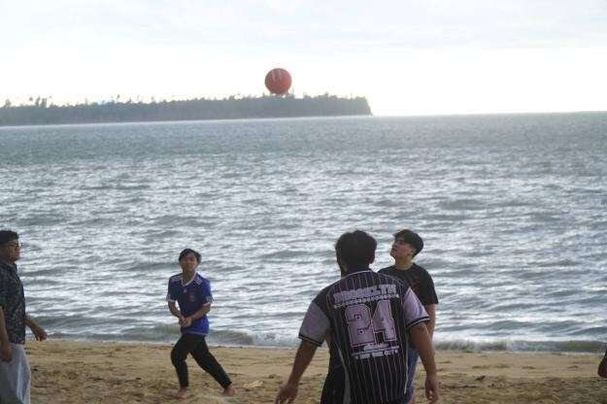 | 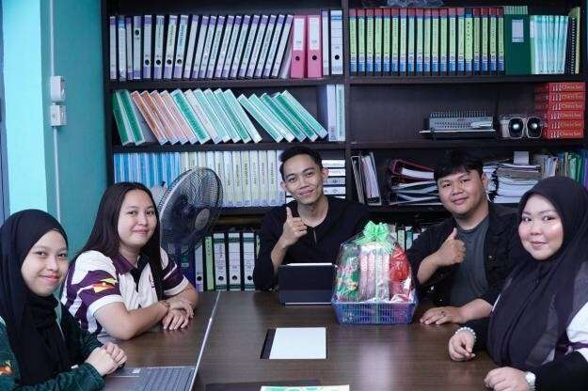
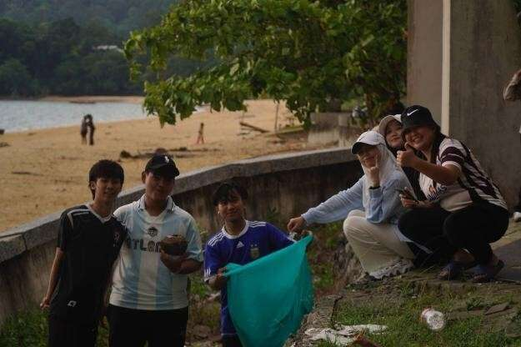 | 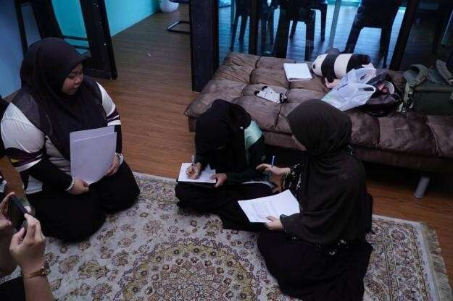

Figure 4. Programme preparation, consultation, need analysis and participant engagement.
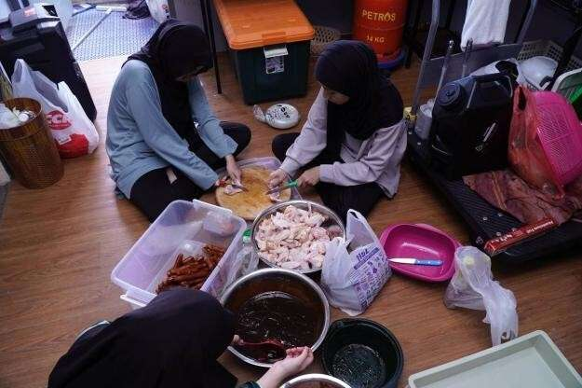 | 
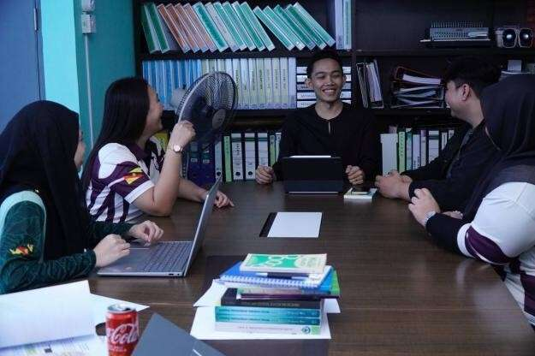 | 
 | 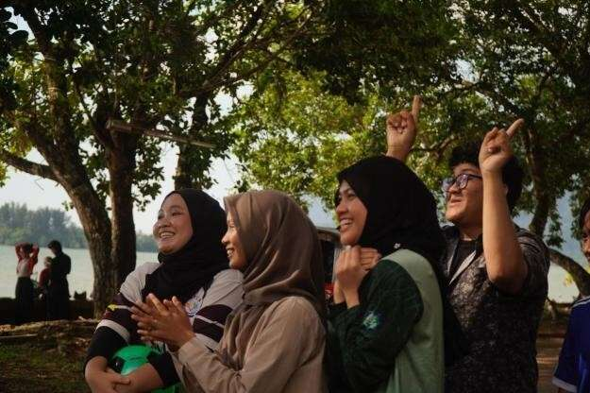

APPENDICES F (Pre and Post Actual Respondent Assessment Result)
On side notes of the result, all actual identity will be hidden to protect privacy and will be swapped with participant identification number such as P1 till P27. All the data inside the drive link isn’t in orderly manner.
https://drive.google.com/drive/folders/1U_82Mu2OI1uhnFhg3ziBttk6L8AMNAow?usp=sharing

