Architectural Geometric Configuration as a Determinant of Acoustic Performance in Interdenominational Worship Centres.
ABSTRACT
Acoustic performance is a fundamental consideration in the design of worship centres because these spaces must effectively accommodate speech communication, musical expression, and auditory comfort. Among the architectural factors influencing acoustic quality, architectural geometric configuration plays a significant role in determining sound propagation, speech intelligibility, reverberation behavior, and sound distribution. Despite advances in acoustic materials and electroacoustic reinforcement systems, comparatively little attention has been given to evaluating how alternative architectural geometric configurations influence the acoustic performance of contemporary interdenominational worship centres. This study comparatively evaluated the influence of architectural geometric configuration on the acoustic performance of interdenominational worship centres using a mixed-methods comparative case study approach. Three worship facilities representing centralized, irregular, and fan-shaped configurations were purposively selected for analysis. Qualitative data comprised architectural drawings, floor plans, photographs, and published case-study documentation, while quantitative data comprised documented acoustic performance indicators reported in the literature, including speech intelligibility, reverberation behavior, sound distribution characteristics, and acoustic comfort. The comparative analysis revealed that architectural geometric configuration significantly influences acoustic performance in interdenominational worship centres. Centralized configurations promoted broad sound distribution but were more susceptible to prolonged reverberation in large enclosed spaces. Irregular configurations enhanced sound diffusion and produced more balanced listening conditions, whereas fan-shaped configurations provided the most balanced acoustic performance through improved sound coverage, enhanced speech intelligibility, and controlled reverberation. The study concludes that architectural geometric configuration is a fundamental determinant of acoustic performance and recommends that geometric considerations be integrated into the earliest stages of architectural design, alongside appropriate acoustic treatments, to achieve acoustically responsive contemporary interdenominational worship centres.
Keywords: Architectural geometric configuration; acoustic performance; interdenominational worship centres; reverberation time; worship acoustics.
INTRODUCTION
Worship centres are among the most acoustically demanding building types because they must effectively support both speech and music within the same enclosed environment. Effective communication during sermons, scriptural readings, prayers, and congregational singing depends largely on the acoustic quality of the worship space. Consequently, poor acoustic conditions can reduce speech intelligibility, impair listener engagement, and diminish the overall worship experience, making acoustic performance a critical consideration in contemporary worship-centre design (Algargoosh et al., 2022).
The acoustic performance of an enclosed space is influenced by several architectural and environmental factors, including room volume, surface materials, ceiling configuration, sound reinforcement systems, and architectural geometry (Mehta et al., 2021). Among these, architectural geometry is particularly important because it governs sound propagation, reflection, diffusion, and decay, thereby influencing sound distribution, reverberation behaviour, speech intelligibility, and acoustic comfort (Kuttruff, 2017). Since geometric decisions are established during the conceptual design stage, they are considerably more difficult and costly to modify after construction than finishes or electroacoustic systems.
Contemporary interdenominational worship centres present additional acoustic challenges because they accommodate diverse activities, including preaching, congregational singing, musical performances, conferences, and community events within a single architectural enclosure (Buratti et al., 2022). Although advances in acoustic materials and electroacoustic technologies have improved acoustic performance, they cannot fully compensate for limitations created by inappropriate spatial geometry during the design stage (Badino et al., 2020).
Existing studies have largely focused on acoustic materials, reverberation control, computer simulation, and sound reinforcement systems, while comparatively less attention has been given to evaluating how alternative architectural geometric configurations influence acoustic performance in contemporary interdenominational worship centres (Mehta et al., 2021). This gap limits the availability of evidence-based guidance for architects during the conceptual design stage, where geometric decisions have the greatest influence on subsequent acoustic performance. Accordingly, this study comparatively evaluates centralized, irregular, and fan-shaped architectural geometric configurations to determine their influence on acoustic performance in contemporary interdenominational worship centres.
STATEMENT OF THE PROBLEM
Despite advances in acoustic materials, sound reinforcement systems, and performance-based acoustic design, many contemporary interdenominational worship centres continue to experience excessive reverberation, uneven sound distribution, and reduced speech intelligibility, thereby limiting effective communication during worship activities (Badino et al., 2020).
Because architectural geometry governs how sound propagates and is distributed within an enclosure, decisions regarding room configuration made during the conceptual design stage have a lasting influence on acoustic performance (Kuttruff, 2017). However, existing research has devoted comparatively less attention to evaluating alternative architectural geometric configurations as an architectural design strategy for improving acoustic performance in contemporary interdenominational worship centres. Consequently, architects have limited comparative evidence to support geometry-based design decisions during the early stages of worship-centre design (Mehta et al., 2021).
This study addresses this gap by comparatively evaluating centralized, irregular, and fan-shaped architectural geometric configurations to determine their influence on acoustic performance in interdenominational worship centres and to provide evidence-based guidance for acoustically responsive architectural design.
Aim of the Study
The aim of this study is to comparatively evaluate the influence of architectural geometric configurations on the acoustic performance of contemporary interdenominational worship centres.
Objectives of the Study
The objectives of this study are to:
1. Compare the acoustic performance of centralized, irregular, and fan-shaped architectural geometric configurations in selected interdenominational worship centres.
2. Examine how architectural geometric configuration influences speech intelligibility, sound distribution, reverberation behaviour, and acoustic comfort within worship spaces.
3. Determine the architectural geometric configuration that provides the most favourable acoustic performance for contemporary interdenominational worship centres.

LITERATURE REVIEW
Historical Development of Worship Spaces and Acoustic Considerations
The relationship between worship architecture and acoustics has evolved alongside the development of Christian worship spaces. As worship practices and congregational sizes changed over time, worship buildings became larger and more spatially complex, making sound distribution, reverberation, and speech intelligibility increasingly important considerations in architectural design.
Early Christian basilicas were characterized by elongated floor plans, high ceilings, and expansive interior volumes that enhanced liturgical music but often produced prolonged reverberation, reducing speech intelligibility during sermons and scriptural readings (Iannace et al., 2020). During the medieval period, Gothic cathedrals introduced vaulted ceilings and pronounced verticality, creating acoustically rich environments for choral music but frequently compromising spoken communication because of excessive reverberation (Barron, 2019). Renaissance and Baroque churches later incorporated domes and curved architectural forms that enriched spatial expression but could also generate sound-focusing effects and uneven sound distribution (Álvarez-Morales et al., 2021).
Contemporary worship centres differ from these historical forms by accommodating a wider range of activities, including preaching, congregational singing, musical performances, conferences, and multimedia presentations within a single space. Although advances in sound reinforcement technologies have improved acoustic control, architectural geometry remains a fundamental determinant of sound distribution, reverberation behaviour, and speech intelligibility (Badino et al., 2020).
The historical evolution of worship architecture demonstrates that changes in architectural geometry have consistently influenced acoustic performance. This continuing relationship highlights the need to examine how alternative geometric configurations affect the acoustic performance of contemporary interdenominational worship centres.
Architectural Geometry and Acoustic Performance
Architectural geometry refers to the shape, configuration, and spatial arrangement of a building and its interior elements. Beyond its visual and spatial qualities, architectural geometry governs sound propagation and its interaction with enclosing surfaces, making it a fundamental determinant of acoustic performance (Kuttruff, 2017).
Previous studies consistently indicate that different architectural geometric configurations produce distinct acoustic responses. Parallel wall arrangements generate repeated reflections, commonly known as flutter echoes, which reduce speech intelligibility and listener comfort (Cox & D’Antonio, 2017). Similarly, concave surfaces may concentrate reflected sound, creating sound-focusing effects that result in uneven sound distribution within enclosed worship spaces (Álvarez-Morales et al., 2021).
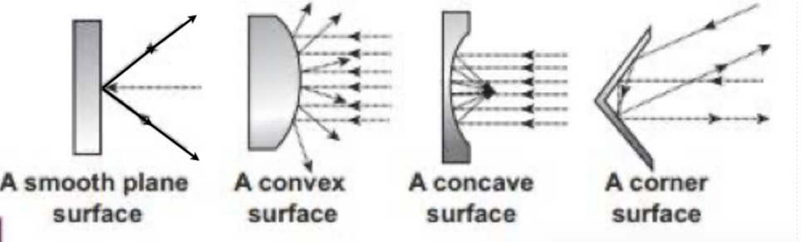
Figure 1: Influence of surface geometry on sound reflection patterns.
Source: Brainkart (n.d.)

In contrast, irregular and non-parallel configurations generally improve sound diffusion by scattering reflected sound more uniformly throughout an enclosure, thereby creating more balanced listening conditions. Recent systematic evidence further demonstrates that geometric design variables significantly influence acoustic quality and should therefore be considered during the conceptual design stage of building design (Leksono et al., 2026). Ceiling geometry also contributes to acoustic performance because its height, slope, and profile influence the direction and coverage of reflected sound reaching occupants (Sakuma & Hidaka, 2021).
Collectively, the reviewed studies establish architectural geometry as a primary determinant of acoustic performance. The consistent relationship between geometric configuration and sound behaviour provides the theoretical basis for the comparative evaluation of centralized, irregular, and fan-shaped worship-centre configurations undertaken in this study.
Acoustic Performance in Worship Centres
Acoustic performance describes how effectively sound is transmitted, distributed, and perceived within an enclosed environment. In worship centres, acoustic quality directly influences the effectiveness of preaching, scriptural readings, congregational singing, musical performances, and other worship activities that depend on clear and balanced sound (Buratti et al., 2022).
Speech intelligibility is widely regarded as one of the most important indicators of acoustic performance because it determines the extent to which spoken messages are clearly understood by congregants, particularly in large worship spaces (Algargoosh et al., 2022). Reverberation time is another critical parameter. While moderate reverberation enhances musical richness, excessive reverberation causes reflected sound to overlap with direct sound, thereby reducing speech clarity (Mehta et al., 2021).
Uniform sound distribution is equally important in ensuring that listeners experience consistent acoustic conditions throughout a worship space. Architectural geometry significantly influences this distribution by governing the propagation and reflection of sound within an enclosure (Pätynen & Lokki, 2016).
Contemporary interdenominational worship centres present additional acoustic challenges because they accommodate diverse worship activities within large, multifunctional spaces. These varying functional requirements demand architectural solutions capable of balancing speech intelligibility, reverberation behaviour, and listening conditions without relying solely on electroacoustic systems (Badino et al., 2020).
Collectively, the reviewed studies establish the principal acoustic performance criteria through which the influence of architectural geometric configuration can be comparatively evaluated. These criteria provide the analytical basis for assessing the centralized, irregular, and fan-shaped configurations examined in this study.
Theoretical Framework
This study is underpinned by established theories in architectural acoustics that explain the relationship between architectural form and sound behaviour within enclosed spaces. The selected theories provide the conceptual basis for understanding how architectural geometric configuration influences acoustic performance in worship environments. Specifically, Sabine’s Reverberation Theory explains the relationship between room volume, sound absorption, and reverberation time, while Geometrical Acoustics Theory explains how sound propagates and interacts with architectural surfaces. Together, these theories provide the analytical framework for evaluating the acoustic implications of centralized, irregular, and fan-shaped architectural configurations in contemporary interdenominational worship centres.
Sabine’s Reverberation Theory
Sabine’s Reverberation Theory, developed by Wallace Clement Sabine, is one of the foundational theories in architectural acoustics. The theory explains the relationship between room volume, sound absorption, and reverberation time within enclosed environments (Sabine, 1922).
According to the theory, reverberation time increases with room volume and decreases as the total sound absorption within a space increases (Kuttruff, 2017). Consequently, large worship spaces with limited sound-absorbing surfaces are more likely to experience prolonged reverberation, which may compromise speech intelligibility while enhancing musical richness.
The theory is particularly relevant to this study because the selected worship centres differ in their geometric configuration and spatial volume. It therefore provides a theoretical basis for understanding how these architectural characteristics influence reverberation behaviour and, consequently, overall acoustic performance.
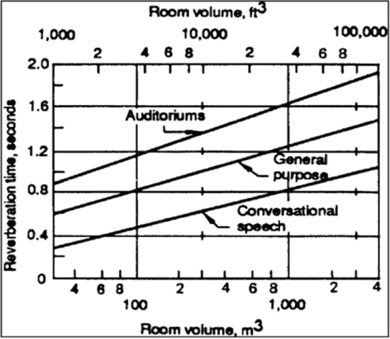
Figure 2: Relationship between spatial volume and reverberation time.
Source: Quartieri et al. (2008)
Geometrical Acoustics Theory
Geometrical Acoustics Theory explains sound propagation by representing sound as rays that travel in straight paths and interact with surrounding architectural surfaces through reflection. The theory is particularly applicable to large enclosed spaces where room dimensions are considerably greater than the wavelength of sound (Kuttruff, 2017).
The theory further explains that the configuration of walls, ceilings, floors, and other enclosing elements determines the reflection and distribution of sound energy within an enclosure. Consequently, different architectural geometric configurations produce distinct sound fields that influence speech intelligibility, sound coverage, and overall acoustic performance (Mehta et al., 2021).
This theory provides the principal analytical framework for the present study because it directly explains how centralized, irregular, and fan-shaped configurations influence sound propagation and distribution within interdenominational worship centres. It therefore supports the comparative evaluation of the selected case studies.
RESEARCH METHODOLOGY
This study adopted a mixed-methods research approach using a comparative case study strategy to examine the influence of architectural geometric configuration on the acoustic performance of interdenominational worship centres. The mixed-methods approach integrated qualitative analysis of architectural characteristics with quantitative analysis of documented acoustic performance indicators derived from secondary sources.
Three worship centres were purposively selected to represent the geometric configurations investigated in this study: the National Ecumenical Centre, Abuja, Nigeria (centralized configuration); Knarvik Church, Norway (irregular configuration); and Durban Christian Centre, South Africa (fan-shaped configuration). The case studies were selected based on the distinctiveness of their architectural geometric configurations, the availability of documented architectural and acoustic information, and their relevance to the study objectives.
Qualitative data comprised architectural drawings, floor plans, photographs, and published case-study documentation obtained from peer-reviewed literature and architectural publications. Quantitative data comprised documented acoustic performance indicators reported in the literature, including speech intelligibility, reverberation behaviour, sound distribution characteristics, and acoustic comfort. The qualitative and quantitative data were integrated through comparative case study analysis to evaluate how variations in architectural geometric configuration influence acoustic performance across the selected worship centres.
DISCUSSION
Case Studies, Results and Data Analysis
National Ecumenical Centre, Abuja, Nigeria (Centralized Configuration)
The National Ecumenical Centre, Abuja, is an interdenominational worship facility designed with a centralized, cross-shaped plan in which the altar serves as the focal point of the worship space. Seating is arranged around the central altar, promoting congregational unity while allowing sound to radiate in multiple directions throughout the auditorium.
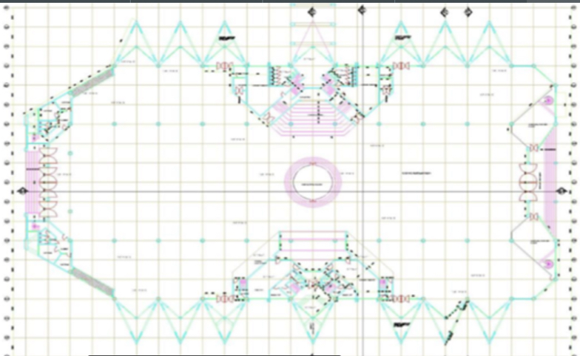
Figure 3: Ground floor plan of the National Ecumenical Centre, Abuja.
Source: Courtesy of Arc. (Dr.) Dele Adeyemi, CAN Secretariat Abuja, as cited in Jamila and Brisibe (2022).
The building is characterized by a large interior volume, vaulted roof, and high ceiling, all of which influence its acoustic behaviour. The centralized geometry promotes broad sound distribution and minimizes acoustic shadow zones. However, the large enclosed volume and predominantly hard interior surfaces increase the likelihood of prolonged reverberation, reducing speech intelligibility if not adequately controlled (Sabine, 1922). The vaulted ceiling also contributes to reflected sound distribution across the congregation, making the integration of appropriate acoustic treatments essential for maintaining acoustic quality (Buratti et al., 2022).
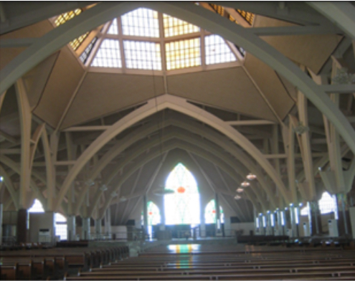
Figure 4: Interior view of the National Ecumenical Centre, Abuja.
Source: Jamila and Brisibe (2022).

Figure 5: Perspective view of the National Ecumenical Centre, Abuja.
Source: Jamila and Brisibe (2022).
Knarvik Church, Norway (Irregular Configuration)
Knarvik Church, located in Alver Municipality, Norway, and designed by Reiulf Ramstad Arkitekter, is a contemporary worship facility distinguished by its irregular architectural form. The building incorporates inclined roof planes, asymmetrical geometry, non-parallel walls, and extensive timber finishes, creating a worship space with distinctive architectural and acoustic characteristics.
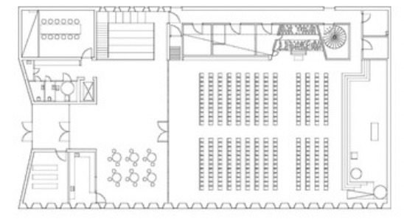
Figure 6: Ground floor plan of the Knarvik Church.
Source: ArchDaily (2014). Photograph by Hundven Clements Photography.

The irregular configuration enhances acoustic performance by promoting sound diffusion. Unlike parallel surfaces that encourage repeated reflections, the inclined walls and roof scatter reflected sound in multiple directions, reducing flutter echoes and improving sound distribution (Cox & D’Antonio, 2017). The articulated interior geometry also minimizes sound concentration, creating more balanced listening conditions (Jeon et al., 2018). Timber finishes moderate sound reflections while preserving sufficient acoustic energy for both speech and music, thereby supporting speech intelligibility and overall acoustic quality (Buratti et al., 2022).
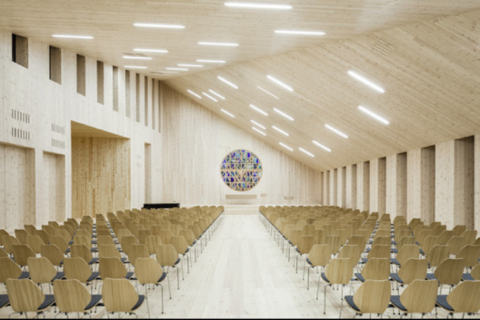
Figure 7: Interior view of Knarvik Church.
Source: ArchDaily (2014). Photograph by Hundven Clements Photography.
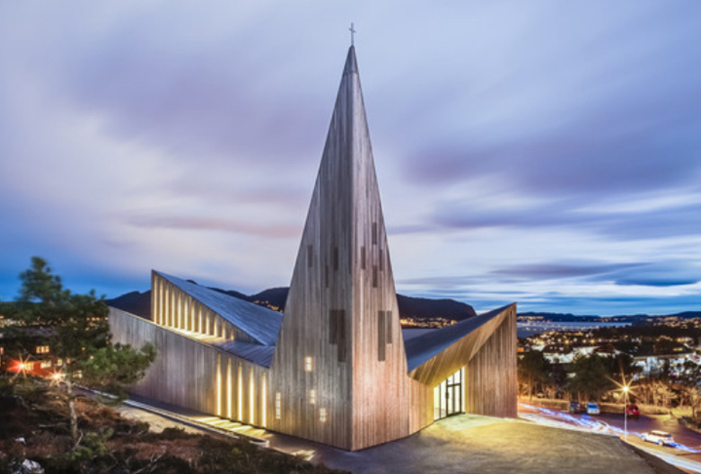
Figure 8: Perspective view of Knarvik Church.
Source: ArchDaily (2014). Photograph by Hundven Clements Photography.
4.3 Durban Christian Centre, South Africa (Fan-Shaped Configuration)
Durban Christian Centre (DCC), also known as the Jesus Dome, is a large non-denominational worship facility in Durban, South Africa. The building adopts a fan-shaped auditorium configuration in which seating expands outward from the worship platform, maintaining clear sightlines while accommodating a large congregation. The interior incorporates acoustic ceiling panels and articulated wall treatments, reflecting the integration of architectural and acoustic design.
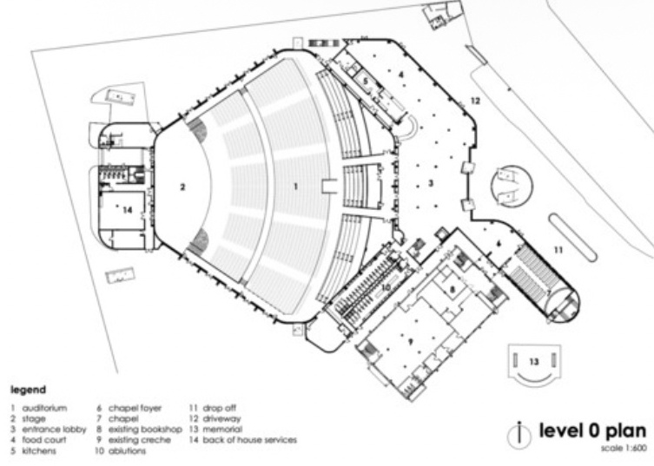
Figure 9: Ground floor plan of Durban Christian Centre.
Source: ArchDaily (2022). Drawing by Elphick Proome Architects.
The fan-shaped configuration enhances acoustic performance by directing sound from the worship platform towards the congregation. By reducing the distance between the sound source and listeners, the layout improves speech intelligibility and provides more uniform sound coverage (Mehta et al., 2021). Acoustic ceiling panels and wall treatments further control unwanted reflections and reverberation, supporting both speech and music (Badino et al., 2020).
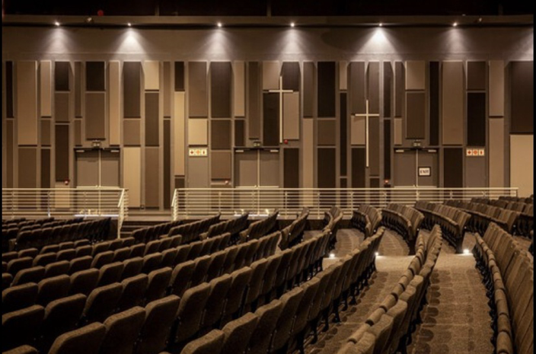
Figure 10: Interior view of Durban Christian Centre.
Source: ArchDaily (2022). Photograph by Karl Beath.
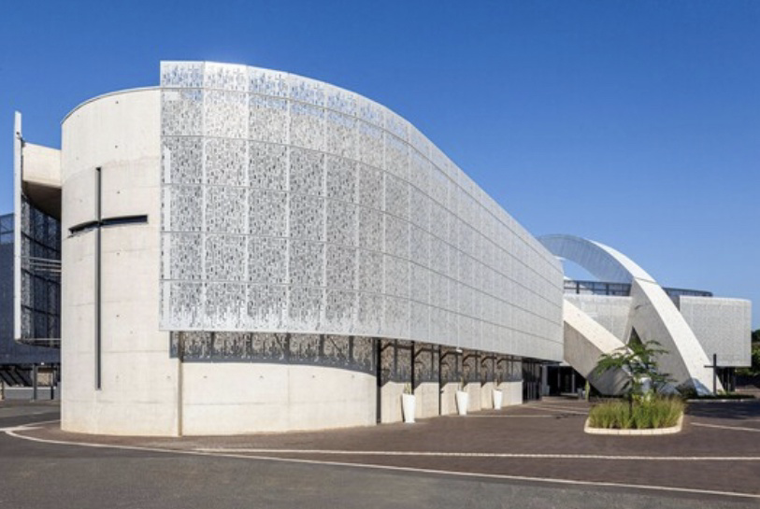
Figure 11: Perspective view of Durban Christian Centre.
Source: ArchDaily (2022). Photograph by Karl Beath.
Comparative Analysis
Table 1: Comparative assessment of acoustic performance of the selected worship centres.
Acoustic Parameter | National Ecumenical Centre (Centralized) | Knarvik Church (Irregular) | Durban Christian Centre (Fan-Shaped)
Sound Distribution | Broad multidirectional distribution | Even distribution through diffusion | Wide and controlled coverage toward congregation
Speech Intelligibility | May be affected by extended reverberation | Generally improved due to controlled reflections | Enhanced by reduced listener distance and focused layout
Reverberation Behaviour | Higher reverberation potential because of large volume and vaulted interior | More controlled reverberation due to irregular geometry and material finishes | Moderately controlled through acoustic treatments and auditorium design
Acoustic Comfort | Variable across different seating locations | Relatively balanced listening conditions | Consistent listening conditions across large seating areas
Congregational Capacity | Large | Moderate | Large
Source: Author’s synthesis (2026).

The comparative analysis indicates that architectural geometric configuration significantly influences acoustic performance in worship environments. The centralized configuration of the National Ecumenical Centre promotes broad multidirectional sound distribution but presents reverberation-related challenges because of its large interior volume. The irregular configuration of Knarvik Church enhances sound diffusion and produces more balanced listening conditions through the use of non-parallel surfaces and articulated interior geometry. The fan-shaped configuration of Durban Christian Centre combines effective sound coverage, improved speech intelligibility, and controlled reverberation through reduced listener distance and the integration of acoustic treatments. Although each configuration demonstrates distinct acoustic advantages, the fan-shaped arrangement provides the most balanced overall acoustic performance for large contemporary interdenominational worship centres.
Discussion of Findings
The findings demonstrate that architectural geometric configuration is a significant determinant of acoustic performance in contemporary interdenominational worship centres, confirming its importance as a fundamental architectural design variable. This finding is consistent with the established role of architectural geometry in governing sound propagation within enclosed spaces (Kuttruff, 2017).
The findings further support the theoretical framework underpinning this study. In accordance with Sabine’s Reverberation Theory, the National Ecumenical Centre exhibited a greater tendency towards prolonged reverberation because of its large interior volume and centralized configuration. Similarly, the improved sound diffusion observed in Knarvik Church and the effective sound coverage achieved by the fan-shaped configuration of Durban Christian Centre are consistent with the principles of Geometrical Acoustics Theory, which explain how architectural form influences sound reflection and distribution (Mehta et al., 2021).
Although all three configurations adequately support worship activities, each exhibited distinct acoustic characteristics. The centralized configuration promoted congregational unity and broad sound distribution but required greater reverberation control. The irregular configuration enhanced sound diffusion and produced more balanced listening conditions through non-parallel surfaces, whereas the fan-shaped configuration provided the most balanced acoustic performance by combining effective sound coverage, improved speech intelligibility, and controlled reverberation.
The findings indicate that architectural geometric configuration should be considered during the earliest stages of worship-centre design because it establishes the acoustic conditions within which other design interventions operate. Integrating appropriate geometric configurations with suitable acoustic treatments therefore provides a more effective strategy for achieving acoustically responsive contemporary interdenominational worship centres.
CONCLUSIONS AND RECOMMENDATIONS
Conclusion
This study examined the influence of architectural geometric configuration on the acoustic performance of interdenominational worship centres through a comparative analysis of three case studies representing centralized, irregular, and fan-shaped spatial configurations. The findings demonstrate that architectural geometric configuration significantly influences sound distribution, speech intelligibility, reverberation behaviour, and acoustic comfort within worship environments.
The National Ecumenical Centre showed that centralized configurations can promote broad sound distribution and congregational unity but may experience reverberation-related challenges because of their large interior volumes. Knarvik Church demonstrated how irregular geometric configurations improve sound diffusion and contribute to more balanced acoustic conditions. Durban Christian Centre illustrated the benefits of fan-shaped configurations in accommodating large congregations while maintaining effective sound coverage and strong visual and auditory connections between worshippers and the worship platform.
The study further revealed that although all three geometric configurations effectively support worship activities, the fan-shaped arrangement provided the most balanced relationship between congregational capacity, sound coverage, speech intelligibility, and acoustic comfort. The findings therefore confirm that architectural geometric configuration should be regarded as a fundamental architectural design consideration in the planning and design of contemporary interdenominational worship centres.
Recommendations
Based on the findings of this study, the following recommendations are proposed:
1. Architectural geometric configuration should be considered from the earliest stages of worship-centre design because it significantly influences acoustic performance.
2. Designers of large interdenominational worship centres should consider fan-shaped configurations where project requirements prioritise broad sound coverage, high speech intelligibility, and large congregational capacity.
3. Centralized worship spaces should incorporate appropriate acoustic treatments and sound-control measures to minimise the effects of excessive reverberation.
4. Irregular and non-parallel surface configurations should be integrated where appropriate to improve sound diffusion and reduce undesirable sound reflections.
5. Acoustic considerations should be integrated with architectural design decisions relating to room volume, ceiling configuration, and interior surface treatments rather than relying solely on electroacoustic sound reinforcement systems.
6. Future studies should incorporate direct acoustic measurements and acoustic simulation techniques to validate the influence of architectural geometric configuration on acoustic performance in worship environments.
REFERENCES
Algargoosh, A., Soleimani, B., O’Modhrain, S., & Navvab, M. (2022). The impact of the acoustic environment on human emotion and experience: A case study of worship spaces. Building Acoustics, 29(1), 85–106. https://doi.org/10.1177/1351010X211068850
Álvarez-Morales, L., Zamarreño, T., Girón, S., & Galindo, M. (2021). Acoustic behaviour in domed religious spaces and sound focusing effects. Applied Acoustics, 174, 107771.
ArchDaily. (2014, October 15). Community Church Knarvik / Reiulf Ramstad Arkitekter. https://www.archdaily.com/557944/community-church-knarvik-reiulf-ramstad-arkitekter
ArchDaily. (2022, July 25). Durban Christian Centre / Elphick Proome Architects. https://www.archdaily.com/985406/durban-christian-centre-elphick-proome-architects
Badino, E., Shtrepi, L., & Astolfi, A. (2020). Acoustic performance-based design: A brief overview of the opportunities and limits in current practice. Acoustics, 2(2), 246–278.
Barron, M. (2019). Auditorium acoustics and architectural design (2nd ed.). Routledge.
Beranek, L. L. (2016). Concert halls and opera houses: Music, acoustics, and architecture (2nd ed.). Springer.
BrainKart. (n.d.). Reflection of sound waves. Retrieved July 7, 2026, from https://www.brainkart.com/article/Reflection-of-Sound-Waves_36332/
Buratti, C., Belloni, E., Merli, F., Ambrosi, M., Shtrepi, L., & Astolfi, A. (2022). From worship space to auditorium: Acoustic design and experimental analysis of sound absorption systems for the new auditorium of San Francesco al Prato (Italy). Applied Acoustics, 195, 108822. https://doi.org/10.1016/j.apacoust.2022.108822
Cox, T. J., & D’Antonio, P. (2017). Acoustic absorbers and diffusers: Theory, design and application (3rd ed.). CRC Press.
Iannace, G., Trematerra, A., & Masullo, M. (2020). Acoustic behaviour of basilica-style religious buildings. Applied Acoustics, 170, 107533.
Jamila, S., & Brisibe, W. (2022). Ecclesiastical architecture in Nigeria: Exploring unifying elements in the design of worship centers. International Journal of Research – Granthaalayah, 10(5), 162–175. https://doi.org/10.29121/granthaalayah.v10.i5.2022.4626
Jeon, J. Y., Lee, P. J., & You, J. (2018). Sound focusing characteristics of concave architectural surfaces. Journal of Sound and Vibration, 419, 181–193.
Kuttruff, H. (2017). Room acoustics (6th ed.). CRC Press.
Leksono, E. T., Purnomo, A. B., & Widiarso, T. (2026). The effect of geometric variable design configuration on the acoustic quality of the auditorium: A systematic literature review. E3S Web of Conferences, 685, 02007.
Mehta, M., Johnson, J., & Rocafort, J. (2021). Architectural acoustics: Principles and design (2nd ed.). Pearson.
Quartieri, J., D’Ambrosio, S., Guarnaccia, C., & Iannone, G. (2008). Room acoustics experimental study: Characterization of the sound quality in a newly built church. In Proceedings of the 10th WSEAS International Conference on Acoustics & Music: Theory & Applications (pp. 108–115).
Sabine, W. C. (1922). Collected papers on acoustics. Harvard University Press.
Sakuma, T., & Hidaka, T. (2021). Ceiling geometry and sound diffusion in large assembly halls. Applied Acoustics, 178, 107958.

