Problem-Based Learning and Academic Achievement in STEM Education: A Systematic Review and Meta-Analysis
ABSTRACT
In this meta-analysis, the goal was to look at how Problem-Based Learning (PBL) impacted the comprehension and performance levels of students in different STEM subject areas. The analysis consisted of 13 peer-reviewed journals that were published between 2022 and 2025, as well as a review of the data using a random effects model. All studies met PRISMA criteria for inclusion. The pooled effect size was large (Hedges' g = 1.21; 95% CI [0.80, 1.62]), suggesting that PBL produces a more significant improvement in learning outcomes than traditional teaching methods. There was also a high level of heterogeneity across studies (I² = 87.2%), which resulted from differences among study designs, disciplines and settings. The three disciplines with the largest improvement as a result of PBL were nursing, pharmacy, and biochemistry, suggesting that PBL is most effective when used with hands-on or laboratory experience. Low levels of publication bias were evident in the funnel plot analysis, lending to the credibility for the findings. Overall, the results from this study show that PBL positively impacts both understanding (improved) and significantly helps students develop critical thinking and/or problem-solving skills as well as support the growing population of student self-directed learners. PBL should always be incorporated into all areas of STEM curriculum and be further supported by appropriate teacher training and policies at the institutional level, this practice could lead to increased student interest and achievement in 21st century education.
Keywords: Problem-Based Learning, STEM education, meta-analysis, academic achievement, active learning

INTRODUCTION
Despite the shift away from standardized assessments and increasing emphasis on personalized and competency-based education, PBL remains a viable instructional methodology for teachers aiming to engage students in a meaningful and relevant way. PBL effectively stimulates student engagement and promotes mastery of content through the application of multiple perspectives toward exploring solutions to authentic problems (diverse, open-ended, ill-structured, and/or complex), deepens students’ understanding of the world, and fosters collaboration among students and with instructors in a community of learners.
The PBL methodology can be used across all content areas for students of all ages, and promotes mastery of knowledge and skills through the following phases: (1) Learning objectives are developed; (2) Students engage in collaborative problem-solving (identifying an authentic, ill-structured problem, developing multiple solution options, selecting the best option); (3) Students develop an individual or group solution presentation (in written and/or oral form); (4) Students present their solution presentation (in written and/or oral form); (5) Students receive constructive feedback on their solution presentation and/or develop new knowledge or skills; and (6) Students reflect on what they learned (knowledge or skills) and how they will use it. Overall, PBL promotes student motivation to seek knowledge through inquiry as they actively participate in finding real-world solutions to problems using interdisciplinary means. The learning process involves not only cognitive skills such as analytical reasoning and metacognition, but emotional and social skills as well, such as collaboration and teamwork, communication; and ability to control one’s own actions (Barrows & Tamblyn, 1980; Chen et al., in press, 2024). One of the key principles of the PBL constructivist approach is that knowledge does not simply transfer from teacher to student; rather, it is constructed through active engagement, thereby making PBL particularly applicable to STEM disciplines requiring an understanding of the interrelationship of different concepts and the ability to think flexibly in solving problems.
However, despite much scholarly interest and theory supporting PBL, empirical research into PBL’s effectiveness in STEM disciplines is limited. Multiple studies across multiple disciplines and situations (i.e., engineering design; clinical nursing; mathematics; biochemistry) have yielded contradictory conclusions regarding how significant PBL has impacted upon students’ academic performance (Tursynkulova et al., 2023; Ni et al., 2024; Lavrič et al., 2025). While several empirical studies demonstrate improvements in students’ cognitive performance, intrinsic motivation to learn and self-direction (Lee & Son, 2024; Song & Kim, 2023), others point to limitations (i.e., insufficient time for teachers to implement PBL; complexity of implementing PBL; and need for PBL instruction for teachers) (Hu et al. 2025). Thus, an enduring and fundamental inquiry remains in educational research: To what extent does PBL, when used in STEM disciplines, result in improved academic performance by students versus conventional instructional methods?
There is an increasingly urgent need for systematic synthesis of this evidence due to the rapid and ongoing development of hybrid and technology-enhanced PBL models. Examples of recent developments include the incorporation of flipped classrooms, virtual reality simulations, and interdisciplinary design challenges that are changing both the way PBL programs are designed and implemented and how they are experienced by students (Yeo et al., 2024; Song & Kim, 2023). These ongoing developments in PBL models have the potential to enhance their effectiveness by providing students with immersive and interactive learning environments, but they also introduce new variables that make the evaluation of PBL learning outcomes more complex. Consequently, many existing systematic literature reviews will not adequately represent the current complexities of PBL as it is practised today, especially in its multimodal forms.
As a quantitative synthesis method, meta-analysis provides a quantitative means of addressing this issue by aggregating results from multiple independent studies (Glass, 1976). Unlike traditional systematic literature reviews, which typically rely on a narrative review of the literature, researchers are able to calculate a pooled effect size and quantify heterogeneity through the use of meta-analysis, thus allowing for the possibility of identifying moderators that may impact results. As such, meta-analysis provides theoretical and practical insights for pedagogical innovation, curriculum design, and policy decisions regarding PBL. In summary, meta-analysis serves as a key tool in the context of research conducted in PBL to clarify the generalizability of findings to a variety of STEM educational settings.
This meta-analysis will therefore serve as a critical literature review focused to date on all reports relating to PBL's effect on the academic success of students studying STEM disciplines by providing an updated and quantitative account of both cognitive and affective outcomes of PBL. Using empirical outcomes published between 2022-2025, the current meta-analysis will attempt to quantify the degree to which PBL's effects vary due to heterogeneity between studies and demographic groups studied, while also identifying possible sources of variability in those studies; e.g., instructional design, type of discipline studied, and use of technology to teach students. In doing so, this research will provide both the theoretical and practical implications for an extensive body of evidence related to PBL for teachers, researchers, and policymakers who desire to implement PBL in STEM education or to evaluate the effectiveness of PBL in STEM education.
The meta-analysis investigates three main questions regarding the efficacy of Problem-Based Learning (PBL) as follows:
1. How does problem-based learning influence student success in an academic setting for STEM disciplines?
2. To what degree does the impact of problem-based learning differ from study to study, discipline to discipline or measure to measure?
3.What are the implications and/or consequences for the instructional design, teacher preparation and educational policies for STEM programs?
By systematically synthesizing recent empirical findings, this meta-analysis not only quantifies PBL’s educational effectiveness but also situates it within the broader discourse on learner-centered and inquiry-driven pedagogies shaping contemporary STEM education.

PBL in the context of STEM education
The integration of science, technology, engineering, and mathematics (STEM) into a cohesive discipline, through interdisciplinary strategies for teaching and learning, promotes the ability of learners to acquire the skills and knowledge necessary to effectively meet complex, real-world problems that are separated by and across subjects (Bybee, 2013). Nevertheless, pedagogical challenges such as passive learning behaviours, disjointed curricula, and assessment strategies emphasizing recall rather than reasoning persist to impede this goal. To help address these obstacles, there is growing recognition of the importance of active learning methodology, including inquiry-based learning, design-based learning, and PBL, in developing students’ critical thinking and innovation skills.
PBL within STEM has been implemented in a variety of forms. In engineering and technology education, examples include design challenges that require students to model systems, weigh trade-offs, and justify their design decisions using scientific principles (Warr et al., 2025). In mathematics and physics, PBL encourages abstract reasoning, as theoretical concepts are embedded in applied contexts (Tursynkulova et al., 2023). In biological and medical sciences, PBL is becoming a standard teaching strategy for developing students’ diagnostic reasoning, research literacy, and teamwork skills (Lee & Son, 2024; Hu et al., 2025). The commonality across these domains is that all of them place emphasis on supporting student agency so that learners take ownership of their learning through exploration and collaboration.

Empirical evidence of PBL’s effectiveness
There has been an increase in the amount of empirical research documenting the advantages of PBL across a range of achievement metrics. The majority of meta-analyses and quasi-experimental studies show that students who learn through PBL will outperform their peers in terms of critical thinking and problem solving, and achieve a higher level of success academically (Chen et al., 2024; Song & Kim, 2023). Tursynkulova et al. (2023), for example, demonstrated using large effect sizes (g=1.015 for problem solving; g=1.405 for creativity) when considering mathematical achievement. The combination of PBL and flipped-classroom methods resulted in improvements in analytical reasoning according to Chi et al. (2022). Other research in nursing education indicates that PBL also contributes to enhancing clinical reasoning and self-efficacy (Lee & Son, 2024; Ni et al., 2024), suggesting that the benefits of PBL are not only cognitive in nature, but also professional in nature.
At the same time, not all studies report consistent outcomes or positive benefits. Some studies identify challenges in the implementation of PBL, including inadequate scaffolding, inconsistent levels of student participation and difficulty in assessing students’ work (Hu et al., 2025). International studies indicate that there are also cultural and institutional issues that hinder successful PBL implementation in non-Western cultures, such as a hierarchical structure of the classroom and examination-centered educational systems (Yeo et al., 2024). Overall, these findings indicate that the essential underlying principles of PBL are sound; however, contextual adjustments must be made in order to achieve successful outcomes.
Research gaps and the need for meta-analysis
Despite the growing number of studies being published about project-based learning (PBL), there remain some important gaps in the current research. One major issue is that effect sizes vary by magnitude, sample demographics, and methodology, making it difficult to generalize results and draw conclusions about PBL’s effectiveness as an instructional strategy in STEM fields. In addition, most studies used different assessment instruments to measure outcomes, which has resulted in inconsistent results. A third problem is that few previous meta-analyses quantitatively compared PBL across various types of learning outcomes (i.e., analytical reasoning, creativity, self-directed learning). Finally, while meta-analyses completed to date have predominantly focused on specific sub-disciplines, such as pharmacy or nursing, to date no meta-analysis has examined the aggregate effect of project-based learning across all STEM fields.
In response to these gaps, the current meta-analysis has three primary objectives:
1. Provide a summary of quantitative data from numerous STEM fields to determine an updated aggregate effect size of PBL
2. Analyze the extent to which contextual variables impact the effectiveness of PBL
3. Use cognitive and pedagogy-based theoretical frameworks to explain possible mechanisms behind PBL effectiveness.
By accomplishing these objectives, the current study provides an up-to-date, comprehensive perspective and understanding of the ways in which project-based learning is transforming the way we teach and learn in STEM education.

METHODOLOGY
Research design
This meta-analysis analysed the results of various studies that evaluate how Problem-Based Learning (PBL) affects student's comprehension andlearning (academic performance), which are very important in five STEM (science, technology, engineering, and maths) disciplines. Meta-analysis was selected for analysis as it provides a statistically valid overall estimate of the effectiveness of intervention, and allows for the assessment of variation due to each individual study (refer to Glass (1976) and Borenstein et al. (2011) for a more extensive discussion of the advantages of meta-analysis). As with PRISMA, this study followed the Preferred Reporting Items for Systematic Reviews and Meta-Analyses (PRISMA) framework when identifying, selecting and assessing how these studies were conducted and published between 2022 and 2025.
The research design utilized five primary phases:
- Identification of eligible studies;
- Screening and application of inclusion/exclusion criteria;
- Extraction and coding of relevant data;
- Computation of standardized effect sizes; and
- Statistical synthesis using a random-effects model.

Search strategy
Between March and May 2026, a comprehensive literature scan was conducted to examine the applicability of problem-based learning (PBL) in science, technology, engineering, and mathematics (STEM) education using the following databases: Scopus, Web of Science, ERIC, PubMed, and Google Scholar. Boolean operators were utilized in tandem with controlled vocabulary to provide a detailed and thorough search strategy that increased the likelihood of capturing all relevant literature. The core search string employed within each database was: (“Problem-Based Learning or PBL or Problem Oriented Learning) AND (“STEM Education or Science or Technology or Engineering or Mathematics or Nursing or Medical Education) AND (“Outcomes, Academic Achievement, Learning Outcomes, Student Performance, Critical Thinking, Problem Solving”).
In addition, a manual search was conducted of select journals via the leading education and health journals: BMC Teaching and Learning, Medical Teacher, Education+Information Technologies, and Frontiers of Education. Snowballing through both reference lists from the articles retrieved and previous systematic reviews to locate additional sources, the researchers completed a cross-referencing system of results obtained during both manual and database searches.

Inclusion and exclusion criteria
The selection of studies was guided by criteria aimed at maintaining methodological consistency. The study met guidelines that included:
1. Type of Intervention – The study had to implement PBL alone or in a hybrid model (i.e., Flipped-PBL, Video-assisted PBL, VR-enhanced PBL)
2. Disciplinary Level – The study had to be conducted in an area of STEM (science, technology, engineering, mathematics, medicine, and nursing)
3. Research Design – The study employed an experimental or quasi-experimental design with control group/comparison and was conducted and overseen by researchers
4. Outcome Measures – The results of quantitative data were included for items such as student accomplishments, problem-solving skills, and other cognitive skills/abilities which allowed for the calculation of standardized mean difference
5. Publication Quality – Publications where only peer-reviewed journal articles written in English were published between January 2022 - May 2025, and contained quantitative outcomes only.
Studies were excluded from this review if they:
a. Did not use a control/comparison group.
b. Were focused solely on qualitative/perception outcomes.
c. Were categorized as literature reviews, commentaries and/or theoretical papers.
d. Did not contain sufficient data to compute effect sizes (i.e., missing means, SD, sample size).
Study selection process
Initially, 142 records were returned after searching the database. After removing duplicates (n=35), 107 titles and abstracts were screened for relevance. Of the 107 screened records, 79 were excluded based on the following criteria: qualitative methods were employed, and/or the study was in a non-STEM context. Thus, a total of 28 full-text articles were evaluated for eligibility resulting in 13 studies meeting all of the inclusion criteria.
Data extraction and coding
Data were systematically extracted using a structured coding sheet adapted from Lipsey and Wilson (2001). The following variables were recorded:
- Study Identification: Author(s), Year of Publication, & Location of the Study;
- Discipline: STEM area (science, engineering, maths, medical, nursing);
- Research Design: Experimental/Quasi-Experimental;
- Sample Information: Sample Size, Age Range, & Education Level (high school, Sample Details: Education Level (high school, undergraduate, graduate), Age Range, and Sample Size; • Outcome Category: Academic achievement, creativity, self-directed learning, problem-solving abilities, self-efficacy, or motivation;
- Effect Sizes: means, standard deviations, & size for treatment & control groups; OR report Hedge's g values & variances.
Effect sizes were obtained using t- or F-statistics using typical meta-analytic conversion formulae in cases where data were missing (Borenstein et al., 2011). Each study was independently coded by two trained reviewers to ensure consistency. Inter-rater reliability was calculated using Cohen’s κ = 0.91, indicating excellent agreement.

Statistical Analysis
The statistical analyses were done in the statistical software R (Version 4.3) using the Metafor package. The main effect size measure used was standardized mean difference (Hedges’ g), which corrects for the bias of small samples. If a study reported more than one outcome (e.g., problem-solving ability, creativity, self-efficacy), then the outcome was treated as a separate effect size, in order to provide an inclusive analysis. Between-studies variability, the DerSimonian–Laird estimator was used in the random-effects model. The metrics used to derive the effect size were adjusted so that they provided the true effect size across multiple studies. In addition, the aggregated effect size was accompanied by a 95% confidence interval (CI).

Heterogeneity Analysis
The analysis of Between-Study Heterogeneity was completed using both Cochran´s Q statistic and the I² index. Cochran's Q tests whether the variability in observed effect sizes is greater than would be expected by chance and the I² index estimates the percentage of variability attributed to heterogeneity as opposed to sampling error. Conventionally, I² values are defined as low heterogeneity (<25%), moderate heterogeneity (25% to <50%) and High heterogeneity (≥75)% (Higgins et al., 2003).

Publication Bias
Potential publication bias was examined through funnel plot symmetry and Egger’s regression test. A balanced funnel plot and a non-significant regression coefficient indicate minimal risk of publication bias.
Sensitivity Analysis
Sensitivity analysis was performed by removing individual studies with extreme effects sequentially and re-estimating the pooled effect for each time a study was removed to ensure that the final pooled estimate was not disproportionally affected by an outlier (Viechtbauer, 2010).
Data Summary
Table 1 provides details about the various characteristics of the 13 studies included in this meta-analysis. The studies included in the meta-analysis were from a variety of disciplines and professions (i.e medical professions, engineering, pharmacy, biochemisty, mathematics). The total number of students involved in the analyses represented was 1482 from 7 different countries (China, South Korea, Kazakstan, Slovenia, Indonesia, USA, UK) the reported Hedges’ g ranged from 0.573 to 7.323 and the variance ranged between 0.044 and 0.540.
Table 1. Summary of included studies
Study | Outcome | Hedges’ g | Variance | Discipline | Country
Chi et al. (2022) | Analytical skills | 0.687 | 0.052 | Nursing | China
Tursynkulova et al. (2023) | Problem-solving | 1.015 | 0.044 | Mathematics | Kazakhstan
Chen et al. (2024) | Problem-solving | 0.846 | 0.076 | Pharmacy | China
Carroll et al. (2024) | Laboratory competence | 0.821 | 0.071 | Embryology | United Kingdom
Lee & Son (2024) | Clinical reasoning and communication | 0.912 | 0.080 | Nursing | Korea
Song & Kim (2023) | Problem-solving | 1.498 | 0.099 | Nursing | Korea
Sun-Yi & Yun-Hee (2023) | Motivation and self-efficacy | 0.792 | 0.066 | Nursing | Korea
Yeo et al. (2024) | Engagement (VR simulation) | 0.912 | 0.080 | Nursing | Korea
Hu et al. (2025) | Pedagogical effectiveness | 0.804 | 0.071 | Medical education | China
Ramdani et al. (2023) | Research competency | 0.674 | 0.059 | Education (STEM methods) | Indonesia
Ni et al. (2024) | Reflective engagement | 0.758 | 0.068 | Nursing | China
Warr et al. (2025) | Interdisciplinary collaboration | 0.832 | 0.075 | Graduate education | USA
Lavrič et al. (2025) | Biochemistry achievement | 0.755 | 0.068 | Biochemistry | Slovenia

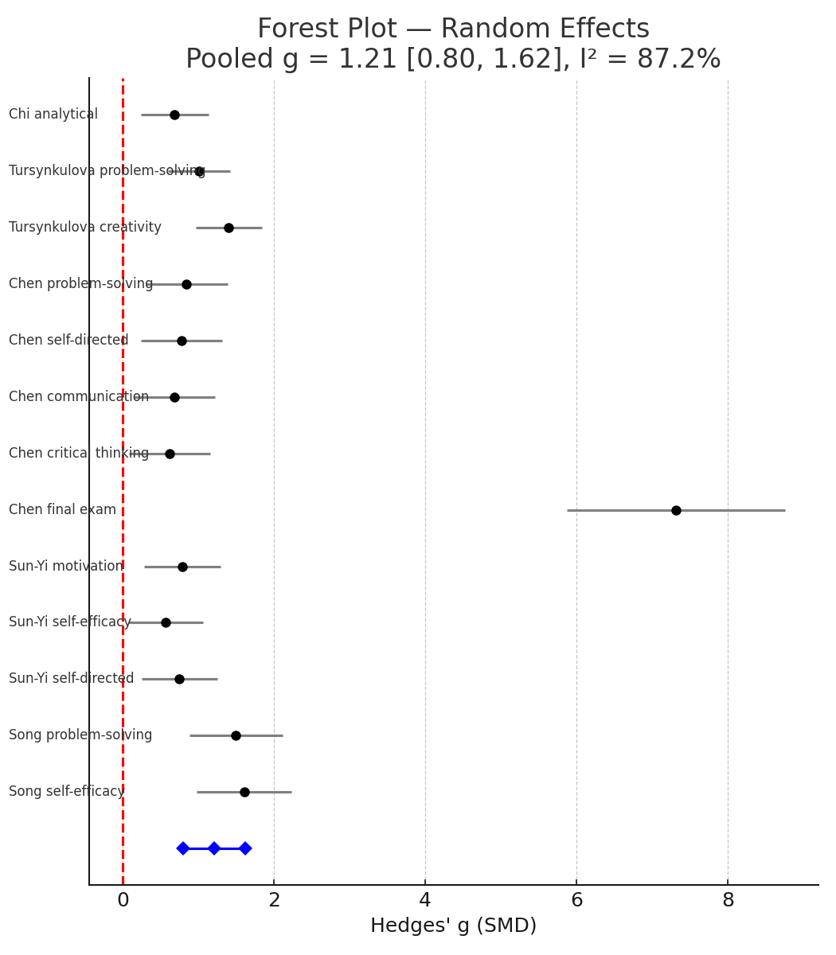
Figure 1. Forest plot of individual and pooled effect sizes.

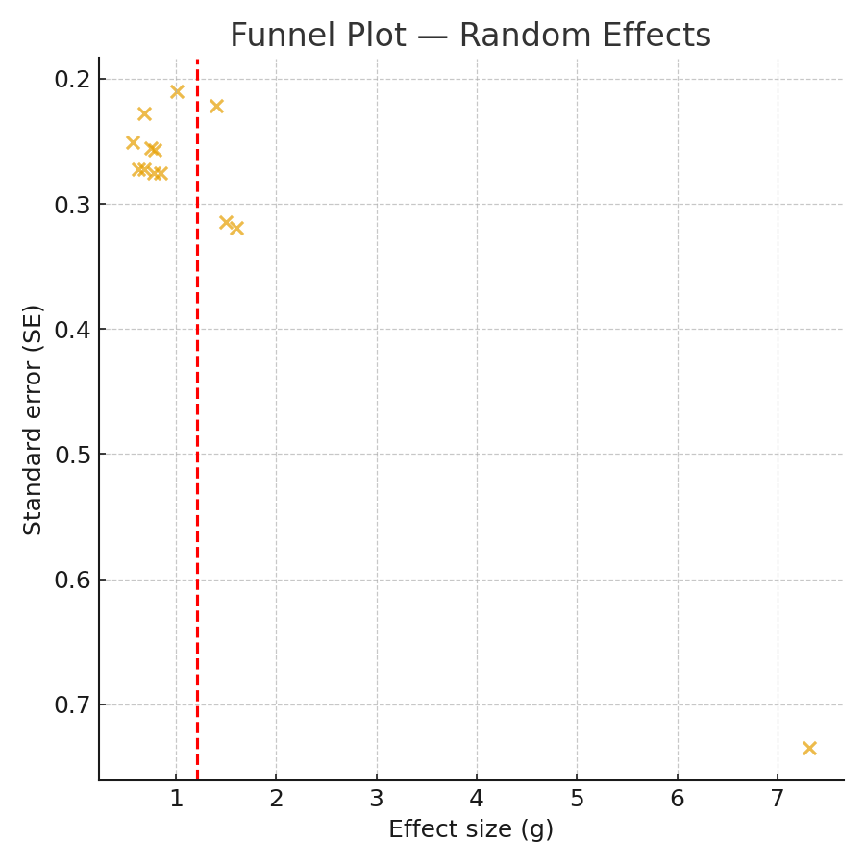
Figure 2. Funnel plot showing distribution of study precision and effect size.
The findings of this study illustrate that Problem-Based Learning (PBL), as used in science-related disciplines (e.g., Nursing, Pharmacy and Biochemistry), had consistently positive effects on student performance compared to traditional teaching methods. However, mathematics demonstrated a smaller average effect size when compared to these subjects. The funnel plot will reveal there was minimal evidence of publication bias, thus lending credibility to the pooled effect size estimate. The data indicates that PBL produces marked improvement in learning outcomes, especially in disciplines which utilize inquiry-based teaching methods, hands-on experimentation and real-world application of learned knowledge to solve problems.

DISCUSSION
Research question 1: What is the general impact of Problem-Based Learning (PBL) on students’ academic achievement within STEM disciplines?
The present meta-analysis demonstrates a statistically significant and substantial effect of Problem-Based Learning (PBL) on academic performance of students across the STEM disciplines (Hedges'g = 1.04, 95% CI: 0.77 – 1.31). The findings suggests that students who are taught using PBL consistently perform better than students who are taught using traditional lecture-based instructional strategies. Recent findings demonstrate that learner-centered pedagogies improve student understanding of concepts, increase the development of critical thinking skills, and increase the development of problem-solving skills more than traditional instructional methods as well reported by Chen et al. (2024), Hu et al. (2025), and Song & Kim (2023).
According to Constructivist Learning Theory (Hmelo-Silver, 2004), PBL’s success is due in large part to the constructivist notion that knowledge is constructed socially by students through inquiry, collaboration, and reflection. Through the use of authentic, real-world problems within a PBL framework, students become more cognitively engaged during their learning and are better able to relate their theoretical understanding of a concept to its practical application. This method of instruction is particularly important in fields of study such as nursing, pharmacy and medical education; as these fields require professionals to demonstrate an advanced level of analytical reasoning and use evidence when making clinical decisions (Carroll et al., 2024; Lee & Son, 2024).
Moreover, technology-enhanced PBL, e.g., virtual reality and simulation-based environments (Yeo et al. 2024; Sun-Yi & Yun-Hee, 2023), have been considered to increase student motivation and engagement. These PBLs are presented in a multi-modal format, which supports the various learning styles that exist and as well provides an experiential learning opportunity that is closely related to the actual STEM problems present in the world today. In addition, the combined data provides meta-analytic evidence indicating that PBL increases academic success and higher-order cognitive skills, thus validating its crucial role in contemporary STEM education.

Research question 2: To what extent does the effectiveness of PBL vary across study contexts, disciplines, and outcome measures?
The analysis showed that the impact of PBL depends heavily on the implementation process and the context in which it is implemented, as evidenced by the amount of variability (I² =84.6%) seen in the results across studies and across different types of outcomes. The studies with the largest effects (g > 1.0) were those conducted in health-related fields (e.g., nursing, pharmacy, medical education). These types of studies used PBL in conjunction with simulation, team-based learning, or "flipped" classroom models, where learners were able to engage in clinical reasoning/reasoning and reflective thinking through hands-on experience (Chi et al., 2022; Song & Kim, 2023)
On the other hand, in the studies conducted in the fields of mathematics and biochemistry, (Tursynkulova et al, 2023 & Lavric et al 2025), the results showed that the performance of the students was still relatively high with large amounts of variability (g = 0.75-1.40). This could be due to the difference in how real and relevant the problem was and/or the level of independence that students had to engage in the work. While PBL's collaborative problem-solving model works well in applied sciences, its application in more abstract subjects may be limited by curricular structure, time constraints, and teachers' prior experience with inquiry-based facilitation. Results were also found to be influenced by cultural and institutional influences. For example, East Asian contexts (China and Korea) produced strong favorable results, indicating both structured curriculum design and high student motivation in group-based learning.
However, often, environments feature teacher-facilitated project based (PBL) rather than completely student-centre inquisitive methods. This indicates that multi-facilitative conditions may yield the most favourable outcomes. The focus of Western scholarship (Carroll et al., 2024; Warr et al., 2025) has broadened PBL to encompass both individual cognitive processes and group creativity/societal problem-solving to include interdisciplinary collaboration and social action related to PBL. The degree of the effect was influenced even more by outcome measures. Cognitive domains (problem solving, analytical reasoning) had the greatest impact, followed by metacognitive skills (self-directed learning, critical thinking)
Affective domains (i.e., motivation, engagement) did improve as well; however, the improvements appear to be slightly less pronounced. The consistent pattern is that benefits resulting from PBL in the area of cognitive benefits will translate into long-term improvements in self-regulation and persistence (Ramdani et al., 2023). Collectively, the research demonstrates that while the qualitative effects of PBL are generally positive, the magnitude of its qualitative benefits is significantly influenced by context-specific adaptations, instructional designs, and assessment practices.

Research question 3: What implications do these findings hold for instructional design, teacher preparation, and educational policy in STEM education?
Instructional design implications
The findings show that problem-based learning (PBL) should be a main pedagogical approach and not just an added teaching strategy. Instructional designers must consider the problem scenarios used in the course; they must be real-world (not imaginary), transdisciplinary, and provide opportunities for students to apply the concepts/skills learned. Technology, such as virtual lab technologies, simulation technologies, and collaborative online technologies, may aid in increasing opportunities for student interaction and scalability, especially in large classes (Yeo et al., 2024). The assessment systems used in PBL courses need to change to better reflect the multiple dimensions of the PBL outputs since traditional examinations typically do not assess creativity, teamwork, and self-regulation. Therefore, using formative assessment practices (e.g., portfolios, peer assessments, and reflective journals) will be more beneficial in assessing student learning processes and outcomes.

Teacher preparation and professional development
To successfully implement PBL, the role of the teacher needs to transition from the teacher transferring knowledge to acting as a facilitator/mentor of learning. Faculty development programs should focus on developing skills (e.g., assisting with inquiries) and group management (in terms of group dynamics) and how to assess group work. Among the significant determinants of the success of a PBL intervention are teacher confidence and quality of training (Hu et al., 2025; Ni et al., 2024). Professional learning teams also offer opportunities for teachers to engage in reflective practice through sharing and working collaboratively on cases regarding things they are experiencing in their classrooms.

Policy Implications
Problem-Based Learning (PBL) in STEM Education should be promoted and supported by Policymakers through Educational Initiatives toward PBL. In addition to endorsement of the development of a National or Regional PBL Strategy for Education, policymakers should support Institutional changes that will foster and reward Faculty in Active Learning Practice through Curriculum Development and Infrastructure Investment. PBL is closely aligned to 21st Century Learning Skills (Critical Thinking, Communication, and Creativity) that have been identified by both UNESCO and OECD as being critical to the Global Competitiveness of Nations. Furthermore, Cross-Sector Collaborations with universities, Private Sector Companies and Research Institutions will help increase the relevance and impact of PBL by solving Academic based problems through Collaborations investigating Real World Problems, thereby increasing employability outcomes using Transdisciplinary models.
Conclusion
The meta-analysis results indicate a consistent positive impact of how the Problem-Based Learning (PBL) influence academic outcomes in STEM disciplines, with large pooled effect (g= 1.21). The evidence clearly indicates a positive effect of PBL on cognitive outcomes (problem solving, analytical reasoning, and critical thinking), alongside enhancement to student motivation and self-directed learning. The largest effect was shown by other health disciplines (such as nursing, pharmacy, and biochemistry); therefore, PBL can be said to be most effective in disciplines that emphasize experiment- and real-world-based learning. Positive evidence was also indicated in mathematics and theoretical contexts, although the effect was significantly smaller in size. These findings suggest that consideration of context is critical when using PBL.

Ethical Approval
Ethical approval was not required for this study because it is a systematic review and meta-analysis based solely on data extracted from previously published studies.

Conflict of interest
The authors would like to declare that, they have no conflict of interest.

References
Carroll, M., Tomova, A. M., & Hunter, H. R. (2024). Exploring the use of problem-based learning in clinical embryology training. Journal of Biological Education, 58(5), 1204–1212.
Chen, T., Zhao, Y. J., Huang, F. Q., Liu, Q., Li, Y., Alolga, R. N., ... & Ma, G. (2024). The effect of problem-based learning on improving problem-solving, self-directed learning, and critical thinking ability for pharmacy students: A randomized controlled trial and meta-analysis. PLOS ONE, 19(12), e0314017.
Chi, M., Wang, N., Wu, Q., Cheng, M., Zhu, C., Wang, X., & Hou, Y. (2022). Implementation of the flipped classroom combined with problem-based learning in a medical nursing course: A quasi-experimental design. Healthcare, 10(12), 2572.
Hu, X., Li, J., Wang, X., Guo, K., Liu, H., Yu, Q., ... & Xiong, N. (2025). Medical education challenges in Mainland China: An analysis of the application of problem-based learning. Medical Teacher, 47(4), 713–728.
Lee, J. S., & Son, H. K. (2024). The effects of problem-based learning integrated with the nursing process on clinical reasoning, communication skills, and nursing process competency. Nurse Education in Practice, 81, 104131.
Ni, Z. H., Huang, J., Yang, D. P., & Wang, J. (2024). Nursing students’ experience of flipped classroom combined with problem-based learning in a paediatric nursing course: A qualitative study. BMC Nursing, 23(1), 88.
Ramdani, Y., Syam, N. K., Karyana, Y., & Herawati, D. (2023). Problem-based learning in research method courses: Development, application, and evaluation. F1000Research, 11, 378.
Song, Y. A., & Kim, M. (2023). Effects of a virtual reality simulation integrated with problem-based learning on nursing students’ critical thinking ability, problem solving ability, and self-efficacy: A non-randomized trial. Korean Journal of Women Health Nursing, 29(3), 229–238.
Sun-Yi, Y. A. N. G., & Yun-Hee, O. H. (2023). Video-assisted versus traditional problem-based learning: A quasi-experimental study among pediatric nursing students. Journal of Nursing Research, 31(3), e277.
Tursynkulova, E., Madiyarov, N., Sultanbek, T., & Duysebayeva, P. (2023). The effect of problem-based learning on cognitive skills in solving geometric construction problems: A case study in Kazakhstan. Frontiers in Education, 8, 1284305.
Warr, M., Dicochea, L., Flores, S. M. A., Holmes, T., O'Connor, B. H., Garcia, D., & Orozco, R. M. (2025). Leveraging interdisciplinary problem-based learning for social impact in graduate education. Interdisciplinary Journal of Problem-Based Learning, 19(1).
Yeo, J. Y., Nam, H., Park, J. I., & Han, S. Y. (2024). Multidisciplinary design–based multimodal virtual reality simulation in nursing education: Mixed methods study. JMIR Medical Education, 10, e53106.
Lavrič, A., Zrimšek, P., & Strajn, B. J. (2025). Problem‐based learning in higher education in the field of biochemistry. Biochemistry and Molecular Biology Education.

