Enhancing Library User Experience through Queuing Theory: A Performance Analysis of OPAC Systems
Manisha Naidu^{#1} Vineeta Dewangan^{#2}
#MATS University, Raipur
Abstract: Libraries have evolved from traditional repositories of books into complex service-oriented systems that cater to diverse user needs. With the growth of digital catalogues and electronic services, ensuring efficiency in user interactions has become increasingly important. Queuing theory, a mathematical approach to analyzing waiting lines and service congestion, provides a valuable framework for understanding and optimizing library processes. This paper examines the application of queuing theory in library management systems, with a special focus on Online Public Access Catalogue (OPAC) searching. By exploring theoretical models such as M/M/1 queues, Little’s Law, and system utilization measures, the research highlights how performance indices like average waiting time, queue length, and service rate can be leveraged to improve the user experience. Through case-based illustrations, this study demonstrates how queuing models can guide decision-making in resource allocation, technological upgrades, and service delivery. The findings suggest that a systematic application of queuing principles can reduce congestion, improve user satisfaction, and ensure sustainable service delivery in modern libraries.
Keywords— Queuing theory, Library management systems, OPAC searching, Service optimization, Performance analysis

- Introduction

Libraries have long been recognized as central hubs of knowledge, information access, and cultural exchange. From early cataloguing systems to the digital interfaces of today, the evolution of library services reflects a continuous attempt to meet user demands effectively. As library systems expand in both physical and digital dimensions, managing user traffic and ensuring smooth service delivery has become a critical concern. One of the most persistent challenges in library operations is service congestion—whether at circulation counters, reference desks, or digital interfaces such as Online Public Access Catalogues (OPAC).
Queueing theory offers a scientific lens through which such congestion problems can be analyzed and managed. Originally developed in the early 20th century by Agner Krarup Erlang for analyzing telephone traffic, queueing theory has since been applied across multiple domains, including computer networks, manufacturing, healthcare, and transportation. Its adoption in library science, although relatively less explored, holds significant potential. Libraries, like other service systems, often involve unpredictable user arrivals, varying service times, and limited resources—all of which are characteristic features of queueing systems.
The OPAC has emerged as a vital access point for library users to search, retrieve, and interact with bibliographic records. However, OPAC systems are not immune to congestion problems. With increasing numbers of simultaneous users and growing complexity of search queries, issues such as long response times, server overloads, and user dissatisfaction may arise. Applying queueing models to OPAC services allows library administrators to evaluate system performance and determine whether resources are sufficient to meet demand.

- Literature Review

The application of mathematical models to library systems is not entirely new. Early work by Morse (1968) introduced the idea of analyzing library operations using systems theory, emphasizing efficiency and performance measurement. This marked one of the first attempts to view libraries as structured service systems rather than purely academic institutions [6].
Later, Warwick (1994) developed a queueing network model to analyze book circulation processes, demonstrating how borrowing and returning patterns could be understood using probabilistic models. In a subsequent study, Warwick (1998) extended this approach to reservation systems, showing that queueing models could effectively capture user demand and predict system performance [9].
Acharya and Ravindran (1999) further explored the application of queueing theory in libraries and information centers, highlighting its usefulness in managing service counters and optimizing staff allocation. Their work emphasized that libraries, much like other service organizations, must balance efficiency with user satisfaction [1].
In more recent years, researchers such as Shanmugasundaram and Umarani (2015) and Somvanshi et al. (2012) have discussed the broader applicability of queueing theory in everyday systems, including libraries. These studies reinforce the idea that queueing models are versatile and can be adapted to various service environments [7].
However, despite these contributions, there remains a noticeable gap in the literature regarding the application of queueing theory to digital library services, particularly OPAC systems. Given the increasing reliance on digital platforms, this gap represents a critical area for research.
- Methodology
The present study adopts a conceptual and analytical research design, focusing on the theoretical application of queueing models to OPAC systems rather than relying exclusively on empirical datasets. This approach is particularly appropriate because OPAC environments differ significantly across institutions in terms of infrastructure, user behavior, and technological capacity. Instead of restricting the analysis to a single dataset, the study develops a generalized framework that can be adapted to multiple library contexts [1].
At a broader level, the methodology integrates mathematical modeling with interpretive analysis. Queueing theory is treated not merely as a computational tool but as a conceptual lens for understanding how digital library services operate under varying levels of demand. By translating user-system interactions into measurable variables—such as arrival rates and service times—the study constructs a structured approach to performance evaluation [3].
Furthermore, the study incorporates illustrative case scenarios to bridge the gap between theoretical abstraction and real-world application. These scenarios are designed to simulate typical OPAC usage conditions, allowing for a clearer understanding of how system parameters influence performance outcomes.

3.1 Queueing Model Selection
The selection of an appropriate queueing model forms the foundation of the analysis. In this study, the M/M/1 queueing model is employed as the primary framework due to its simplicity and analytical clarity. Despite its basic structure, the model captures the essential dynamics of many service systems, including OPAC environments [4].
The M/M/1 model is based on three fundamental assumptions. First, it assumes a single service channel, which in the OPAC context can be interpreted as a central processing unit or server responsible for handling search queries. While modern OPAC systems often operate on distributed architectures, analyzing a single-server model provides a useful baseline for understanding system behavior.
Second, the model assumes that user arrivals follow a Poisson distribution, meaning that queries occur randomly but at a consistent average rate. This assumption aligns reasonably well with OPAC usage patterns, where users access the system independently and without coordination [3].
Third, the model assumes exponentially distributed service times, suggesting that the time required to process each query varies but remains statistically predictable. Although real-world query processing times may differ due to variations in search complexity, this assumption provides a practical approximation for theoretical analysis.
Within this framework:
- The arrival rate (λ) represents the average number of user queries entering the system per unit time.
- The service rate (μ) represents the system’s capacity to process those queries efficiently.

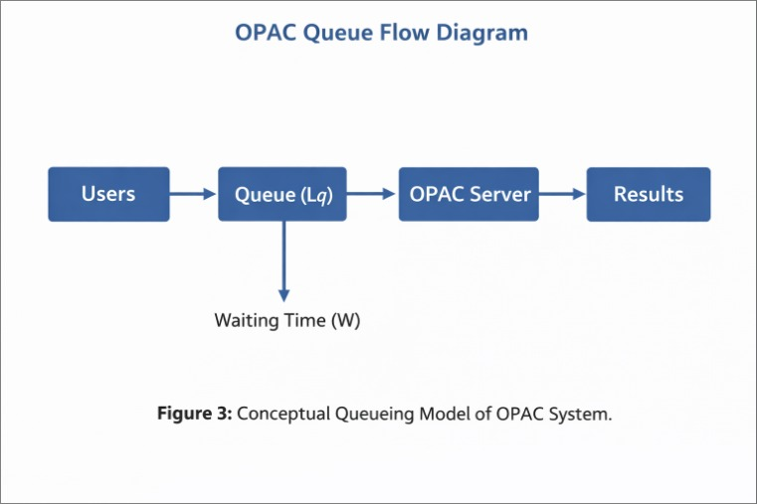
The relationship between these two parameters determines the overall stability and efficiency of the system.

3.2 Performance Measures
To evaluate the performance of OPAC systems, several key indicators derived from queueing theory are utilized. These metrics provide a quantitative basis for assessing system efficiency and identifying potential bottlenecks. One of the primary measures is the average number of users in the system (L), which includes both users being served and those waiting in the queue. A high value of L often indicates congestion and reduced system efficiency.
Another important metric is the average waiting time (W), which represents the total time a user spends in the system. In the context of OPAC services, even minor increases in waiting time can negatively impact user satisfaction and perceived system quality. The queue length (Lq) is also a critical parameter, as it reflects the number of users waiting for service at any given moment. This measure is particularly useful for identifying operational inefficiencies and delays.
Finally, the utilization factor (ρ = λ/μ) indicates the proportion of system capacity being used. When ρ approaches unity (i.e., ρ → 1), the system becomes increasingly congested, leading to longer waiting times and potential service breakdowns [4].
These variables are interconnected through Little’s Law, expressed as:
L=λWL = λWL=λW
This fundamental relationship provides a powerful tool for analyzing system performance and has been widely validated across various service systems [5].

3.3 Case Illustration
To illustrate the practical application of the theoretical framework, consider a hypothetical OPAC system operating under moderate demand conditions. Suppose the system receives an average of 30 user queries per minute (λ = 30), while its processing capacity is 40 queries per minute (μ = 40).
In this scenario, the utilization factor is calculated as:
ρ=λμ=3040=0.75ρ = \frac{λ}{μ} = \frac {30}{40} = 0.75ρ=μλ​=4030​=0.75
A utilization level of 0.75 indicates that the system is operating efficiently, with sufficient capacity to handle incoming queries without significant delays.
However, if the arrival rate increases to 38 queries per minute, the utilization factor rises to:
ρ=3840=0.95ρ = \frac {38}{40} = 0.95ρ=4038​=0.95
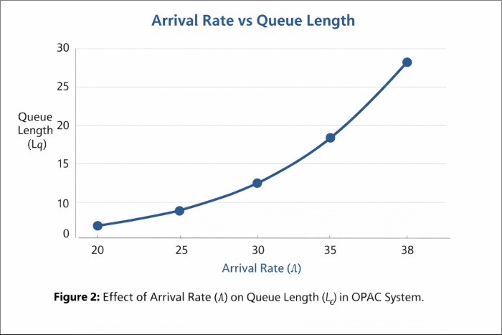

At this level, the system approaches saturation. Even small fluctuations in demand can result in disproportionately large increases in waiting time and queue length. This phenomenon illustrates the non-linear behavior of queueing systems, where performance deteriorates rapidly as utilization approaches its maximum limit [3].

4. Findings and Discussion
The analysis reveals several important insights regarding the performance of OPAC systems.
First, system efficiency is highly dependent on maintaining a balance between arrival rate and service rate. When this balance is disrupted, particularly under high utilization conditions, the system becomes vulnerable to congestion. This finding is consistent with classical queueing theory, which emphasizes the importance of maintaining utilization levels below critical thresholds [4].
Second, queueing models provide a systematic method for identifying bottlenecks within the system. For example, frequent delays in OPAC responses may indicate insufficient server capacity or inefficient database structures. By quantifying these issues, queueing theory enables evidence-based decision-making rather than reliance on intuition [1].
Third, the study highlights the effectiveness of multi-server queueing models (M/M/c) in high-demand environments. By distributing user queries across multiple servers, libraries can significantly reduce waiting times and improve service reliability. This approach is particularly relevant for large academic institutions with heavy OPAC usage.
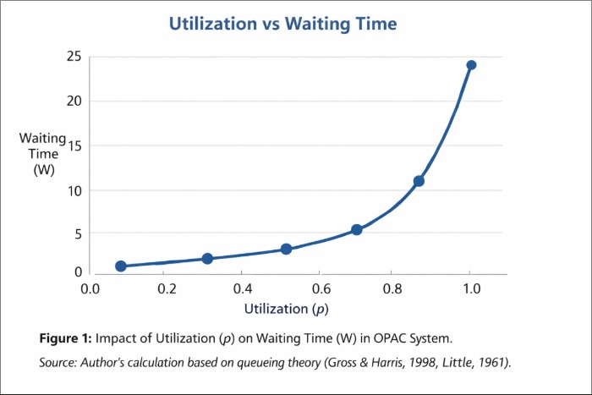
Finally, the findings emphasize the importance of user perception in evaluating system performance. Research suggests that perceived waiting time often has a greater impact on user satisfaction than actual waiting time. Therefore, improving system responsiveness and providing real-time feedback are essential for enhancing the overall user experience.

5. Challenges and Future Prospects
Despite its analytical strengths, the application of queueing theory in OPAC systems presents several challenges. One major limitation lies in the simplifying assumptions of classical models, particularly the assumption of exponential service times. In reality, OPAC queries vary widely in complexity, making it difficult to accurately model service time distributions [3].
Another challenge is the variability of user behavior. Unlike mechanical systems, human users exhibit unpredictable patterns influenced by factors such as search habits, time of day, and academic schedules. This variability complicates the modeling of arrival processes and reduces the accuracy of theoretical predictions.
Data availability also remains a significant constraint. Many libraries lack detailed usage data, which is essential for calibrating queueing models and validating theoretical assumptions. Without reliable data, the practical application of these models may be limited.
Looking forward, the integration of artificial intelligence (AI) and machine learning (ML) offers promising opportunities for overcoming these challenges. By analyzing historical usage patterns, AI-driven systems can predict demand fluctuations and dynamically adjust system resources. Additionally, simulation techniques can complement traditional queueing models by providing more flexible and realistic representations of system behavior [7].

6. Conclusion
This study demonstrates that queueing theory provides a robust and versatile framework for analyzing and improving OPAC systems in modern libraries. By translating user interactions into quantifiable parameters, it becomes possible to evaluate system performance, identify inefficiencies, and implement targeted improvements.
One of the key contributions of this research is its emphasis on the integration of technical efficiency and user experience. While optimizing system performance is essential, the ultimate goal is to enhance the user’s interaction with library services. Queueing theory facilitates this by offering insights into both operational dynamics and user perception.
The findings suggest that even relatively simple models, when applied thoughtfully, can yield valuable insights. As libraries continue to evolve in response to digital transformation, the adoption of analytical tools such as queueing theory will become increasingly important.
In conclusion, improving OPAC systems requires not only technological upgrades but also a deeper understanding of system behavior and user needs. Queueing theory provides the necessary foundation for achieving this balance, ensuring that libraries remain efficient, responsive, and user-centered in the digital era.
- References
- Acharya, U. H., & Ravindran, G. (1999). Application of queueing theory to libraries and information centers.
- Erlang, A. K. (1909). The theory of probabilities and telephone conversations.
- Gross, D., & Harris, C. M. (1998). Fundamentals of queueing theory (3rd ed.). Wiley.
- Kendall, D. G. (1953). Stochastic processes occurring in the theory of queues and their analysis by the method of the imbedded Markov chain. The Annals of Mathematical Statistics, 24(3), 338–354.
- Little, J. D. C. (1961). A proof for the queuing formula: L = λW. Operations Research, 9(3), 383–387.
- Morse, P. M. (1968). Library effectiveness: A systems approach. MIT Press.
- Shanmugasundaram, S., & Umarani, P. (2015). Queueing theory applied in everyday systems.
- Somvanshi, T. V. S. S., et al. (2012). Application of queueing models in library management.
- Warwick, J. P. (1994). A queueing network model for book circulation. Collection Management.
- Warwick, J. P. (1998). Queueing theory model for book reservations and circulation. Collection Management.
- Chen Jiang, Xilin Yuan, Li Liu (2017). “Research on the Configuration Model of Circulation Service Desk in University Library.” Library and Information Service 61(20): 97-104.
- Yao Cui (2013). “Research on customer queuing problems of postal agency financial business hall--Taking Fanrong Street outlets as an example.” Guangxi: Industrial Engineering, Guilin University of Electronic Technology.
- Sun, Y. P. Li, G. H. Huang (2012). “A queuing-theory-based interval-fuzzy robust two-stage programming model for environmental management under uncertainty.” Engineering Optimization 44(6):707-724.
- CaoNgocNguyen, SoonwookHwang, Jik-SooKim(2017). “Making a case for the on-demand multiple distributed message queue system in a Hadoop cluster.” Cluster Computing 20(3):2095–2106.

