MATERIAL CULTURE AND HISTORICAL HERITAGE IN THE BAMOUN KINGDOM OF CAMEROON

ABSTRACT
The Bamoun Kingdom of Cameroon possesses a rich cultural and historical heritage expressed through its royal palace, museums, monuments, symbolic artifacts, writing system, and cultural festivals. However, these heritage resources have not been sufficiently studied as an integrated system of historical memory and identity formation. This study examines Bamoun material culture using a qualitative historical and ethnographic approach. Data was collected through oral interviews with traditional authorities, elders, artisans, museum curators, and cultural practitioners, alongside field observations, archival sources, royal chronicles, and literature review. Findings show that Bamoun heritage functions as a connected system for preserving history, political authority, and cultural identity. The Royal Palace, museums, and monuments act as living institutions of memory, while symbols such as the double-headed snake, spider, and double bell express ideas of power, wisdom, and unity. The Shümom writing system is identified as a major intellectual achievement, and the Nguon Festival remains a living tradition that supports cultural continuity and traditional governance. The study concludes that Bamoun material culture is a valuable source for understanding African state formation and indigenous knowledge systems, and it highlights the need for stronger preservation, documentation, and cultural promotion efforts.
KEYWORDS: Bamoun Kingdom, Material Cultural Heritage, Monuments, Shümom Script, Nguon Festival, Foumban Cameroon.

- INTRODUCTION
Material culture refers to the physical manifestations of a people’s history, beliefs, values, and social organization. These manifestations include monuments, architecture, museums, sacred sites, ceremonial objects, artistic works, and historical artifacts that preserve collective memory and identity (UNESCO, 2003). Across Africa, material culture has served as a medium through which societies transmit historical knowledge, political traditions, and cultural values from one generation to another. Among the most remarkable examples of African civilization is the Bamoun Kingdom located in the West region of Cameroon. Established around the fourteenth century by King Nchare Yen, the kingdom evolved into a centralized political entity characterized by military organization, artistic excellence, technological innovation, and strong cultural institutions (Njapdunke 2026, interviewed). The kingdom’s capital, Foumban, remains one of the most important cultural centers in Cameroon and serves as the seat of the Bamoun Sultanate.
The Bamoun people have developed a rich heritage reflected in royal palaces, museums, monuments, symbolic sculptures, indigenous writing systems, sacred sites, and ceremonial institutions. These cultural resources embody centuries of political authority, artistic creativity, and historical experience. They constitute not only symbols of Bamoun identity but also valuable sources for understanding African history and indigenous systems of governance. This article examines the material culture and historical heritage of the Bamoun Kingdom, focusing on key monuments and cultural institutions such as the Royal Palace of Foumban, the Bamoun Museums, the monumental entrance to Foumban, the double-headed snake monument, the Shümom writing system, and the Nguon Festival.

2. METHODOLOGY
This study employs a qualitative historical and ethnographic research approach. Such an approach is appropriate for investigating cultural heritage because it allows for an in-depth understanding of historical meanings, cultural symbols, and local interpretations. Data was collected through oral interviews with traditional authorities, palace notables, museum curators, artisans, cultural practitioners, historians, and elderly custodians of Bamoun traditions. Oral testimonies provided valuable insights into the historical significance of monuments, artifacts, and ceremonial practices. Field observations were conducted at major heritage sites in Foumban, including the Royal Palace, museums, ceremonial grounds, and symbolic monuments. These visits enabled direct examination of architectural structures, museum collections, and cultural landscapes. The study also relied on archival documents, palace records, historical manuscripts, royal chronicles, and published literature on Bamoun history and culture. The triangulation of oral evidence, field observations, and documentary sources enhanced the credibility and reliability of the findings.
3. HISTORICAL BACKGROUND OF THE BAMOUN PEOPLE
The Bamoun people are a major Grassfields group in Cameroon, based in the Noun Plain with Foumban as their capital. Their language belongs to the Benue-Congo branch of the Niger-Congo family and remains central to cultural identity (Nji 2026, interviewed). Oral traditions trace the origin of the kingdom to Nchare Yen, a prince of Tikar descent who migrated in the late fourteenth century and established the kingdom around 1394. He unified several local chiefdoms through conquest, diplomacy, and alliance-building, laying the foundation for a centralized state that would become a major political power in the region (Mohamed 2026, interviewed).
The Bamoun Kingdom developed a strong centralized political system led by the Mfon (king or sultan), who exercised political, judicial, military, and religious authority. Governance was supported by palace officials, nobles, military leaders, and the Queen Mother, who played an advisory role. Over time, these institutions enabled territorial expansion, administrative organisation, and long-term political stability. The kingdom’s authority was also reflected in its material culture, including palaces, regalia, monuments, and ceremonial objects that symbolized royal legitimacy (Fouapon 2026, interviewed).
A major turning point in Bamoun history occurred under Sultan Ibrahim Njoya (c. 1889–1933), widely regarded as the most innovative ruler of the kingdom. During a period marked by European colonial expansion, he adopted a strategy of cultural preservation combined with selective adaptation to external influences. His most significant achievement was the creation of the Shümom writing system, developed around 1895, which evolved into a functional script used for recording history, administration, law, medicine, and religion (Idrissou 2026, interviewed). He also established schools to promote literacy and supervised the documentation of Bamoun history and customs, contributing to one of Africa’s most important examples of indigenous writing systems.
Njoya’s reign also marked a cultural and artistic renaissance. Royal workshops flourished, producing advanced works in sculpture, metalwork, textiles, beadwork, and pottery. These works often featured symbolic motifs such as serpents, spiders, and royal animals, reflecting political and spiritual meanings (Njikam 2026, interviewed). Many of these artifacts are now preserved in Bamoun museums and the Royal Palace, forming an important part of the kingdom’s cultural heritage.
The Bamoun Kingdom experienced German colonial rule, followed by French administration after the First World War. While Njoya initially maintained cooperation with the Germans, relations with the French deteriorated, leading to restrictions on Bamoun institutions, the decline of Shümom literacy, and his eventual exile in 1931 (Njimalou 2026, interviewed). Despite these disruptions, Bamoun cultural life remained resilient. Oral traditions, rituals, art, and royal institutions continued to sustain collective identity and historical continuity.
In the contemporary period, the Bamoun Kingdom remains an influential cultural institution within Cameroon. Although it no longer holds sovereign political power, the Sultanate continues to play an important symbolic and cultural role. Foumban has become a major heritage and tourism centre, with sites such as the Royal Palace, museums, monuments, and the Nguon Festival attracting national and international attention. These institutions preserve and showcase a long historical legacy that spans over six centuries.
Overall, the history of the Bamoun people reflects a trajectory of state formation, political organisation, intellectual innovation, cultural creativity, colonial disruption, and enduring resilience. Their heritage remains a living expression of identity and historical consciousness in contemporary Cameroon.
4-THE ROYAL PALACE OF FOUMBAN: THE HEART OF BAMOUN CIVILIZATION
The Royal Palace of Foumban is the most significant monument of the Bamoun Kingdom and a central symbol of African kingship, authority, and cultural identity. Far beyond being a royal residence, it has historically functioned as the political, judicial, religious, and cultural centre of the Bamoun state for over six centuries (Idrissou 2026, interviewed). Since the founding of the kingdom by Nchare Yen around 1394, successive rulers used royal compounds as institutions of governance where decisions were made, disputes settled, and traditions preserved. The present palace was built under Sultan Ibrahim Njoya and completed in 1917 after the destruction of an earlier structure. Njoya personally supervised its construction, producing a unique architectural synthesis that combines Bamoun building traditions with Islamic and European colonial influences. Its design, including towers, arched galleries, and decorative elements, reflects a deliberate fusion of external styles with indigenous identity, illustrating Njoya’s philosophy of cultural adaptation without cultural loss.
Plate 1: The Royal Palace of the Bamoun kingdom in Foumban
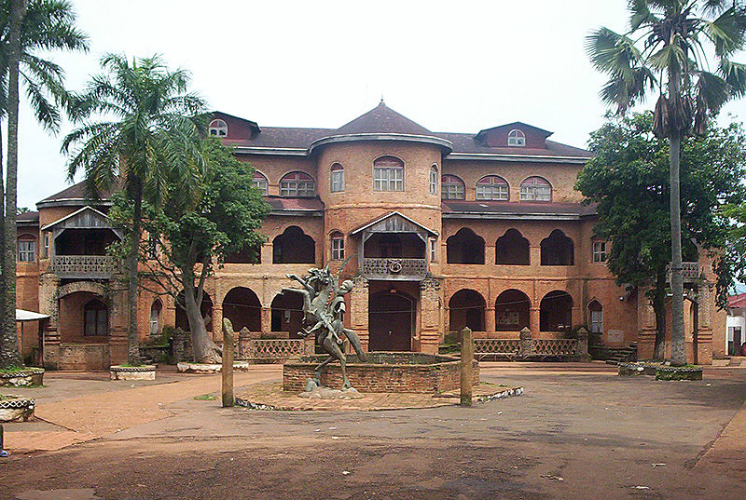
Source: Source: Authors collection, March, 2025
Politically, the palace served as the seat of the Mfon, the supreme ruler of the Bamoun Kingdom. It was the centre of administration where councils of elders, military leaders, and officials met to govern the kingdom (Nji 2026, interviewed). It also hosted diplomatic, judicial, and ceremonial activities, symbolizing the concentration of state power and institutional organisation within the Bamoun political system. Beyond governance, the palace functions as a major repository of Bamoun historical memory. Its architectural features, carvings, courtyards, and symbolic motifs communicate narratives of royal authority, conquest, spirituality, and dynastic continuity (Njoya 2026, interviewed). It therefore acts as a historical text in physical form, preserving the identity and legacy of the kingdom.
The palace is also closely associated with Sultan Ibrahim Njoya, under whose reign it became a centre of intellectual and cultural innovation. It was from the palace that he developed the Shümom writing system, established schools, documented Bamoun history, and promoted artistic production. As a result, it became one of the most important centres of knowledge in Central Africa during the precolonial and early colonial periods. Today, the Royal Palace remains a living institution, still serving as the residence of the Bamoun Sultan and hosting cultural, ceremonial, and governance activities. Its continued use distinguishes it from many historical monuments and reinforces its role as a bridge between past and present. Overall, the Royal Palace of Foumban stands as a powerful example of indigenous statecraft, architectural creativity, and cultural resilience, demonstrating the continuity and adaptability of Bamoun civilisation across centuries.
5: THE BAMOUN MUSEUMS: PRESERVING HISTORICAL MEMORY
The Bamoun Museums play a vital role in preserving and transmitting the history and cultural heritage of the Bamoun Kingdom. They act as custodians of collective memory by safeguarding artifacts, manuscripts, regalia, and artistic works that document more than six centuries of Bamoun civilisation (Njikam 2026, interviewed). In a context where oral tradition has long been central to knowledge transmission, the museums provide an essential institutional framework for preserving tangible evidence of historical development. The origins of museum preservation in the Bamoun Kingdom are closely linked to Sultan Ibrahim Njoya, who initiated systematic efforts to collect and conserve royal objects, manuscripts, ceremonial items, and military artifacts (Njapdunke 2026, interviewed). His vision transformed the palace into one of the earliest indigenous heritage institutions in Africa, predating formal museum culture in many other regions (Geary, 1984).
The Palace Museum, located within the Royal Palace complex, is among the oldest museums associated with an African monarchy. It presents the historical evolution of the Bamoun dynasty from its foundation under Nchare Yen in 1394 to the present. Its collections include royal crowns, thrones, weapons, musical instruments, sculptures, ritual objects, and Shümom manuscripts (Njimolu 2026, interviewed). These artifacts provide valuable insight into Bamoun political organisation, military history, religious life, and artistic traditions. Royal thrones and military artifacts are among the most significant objects preserved in the museum. The thrones symbolize authority and legitimacy, often decorated with motifs of strength, wisdom, and ancestral continuity (Balkisou 2026, interviewed). Military objects such as spears, shields, and weapons illustrate the kingdom’s history of expansion, defence, and interaction with neighbouring societies, highlighting the importance of military organisation in state formation.
Plate 2: The Bamoum Museum
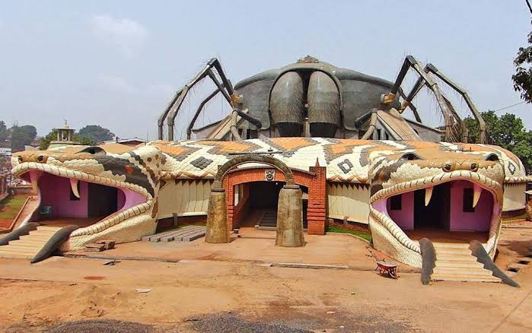Source: Source: Authors collection, March, 2025
The Bamoun Kings Museum represents a modern development in heritage preservation. Designed as a cultural institution, it preserves and interprets Bamoun history for contemporary audiences. Its architecture incorporates key royal symbols: the double-headed snake (military strength), the spider (wisdom and creativity), and the double bell (unity and authority), reflecting core principles of Bamoun political philosophy.
Plate 3: Opening Ceremony of the Bamoum Museum
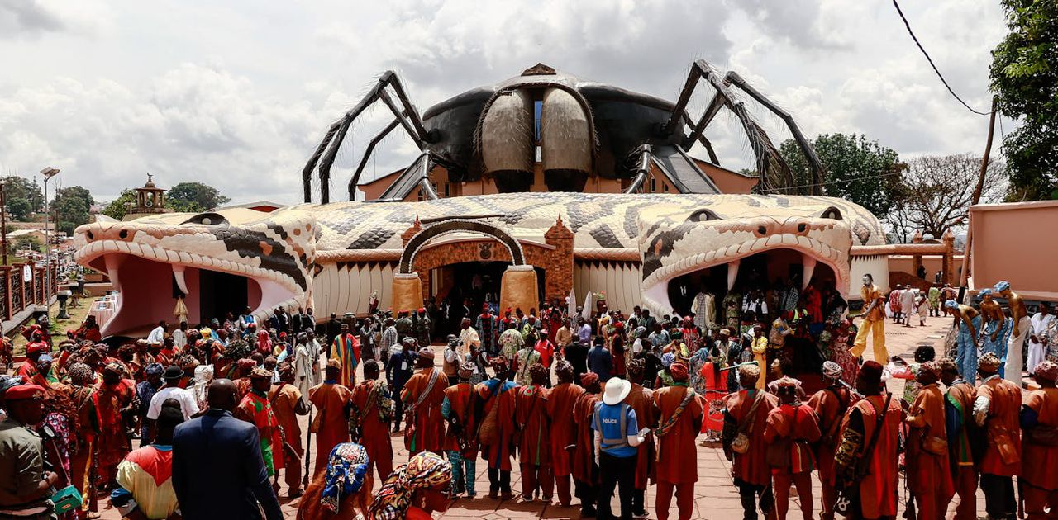
Source: Source: Authors collection, March, 2025
The museum houses extensive collections of royal regalia, manuscripts, sculptures, and ceremonial objects, while also serving educational and research functions. It engages younger generations, scholars, and international visitors, contributing to cultural continuity and academic study of African heritage. Overall, the Bamoun Museums serve a dual purpose: preserving material evidence of the past and transforming it into educational and cultural resources. They are not only repositories of artifacts but also active institutions that sustain historical consciousness and reinforce Bamoun identity (Geary, 1984).

6. THE MONUMENTAL ENTRANCE TO FOUMBAN: A GATEWAY TO BAMOUN HISTORY AND IDENTITY
The monumental entrance to Foumban serves as a symbolic gateway into the Bamoun Kingdom, introducing visitors to its long-standing historical, political, and cultural heritage. Unlike a functional urban entrance, it operates as a cultural monument that marks the transition into a historically significant royal space, reflecting broader African traditions where gateways signify entry into sacred or politically important territories (Yaya 2026, interviewed). In this sense, the entrance asserts Foumban’s identity as the historic capital of the Bamoun Kingdom and the seat of its Sultanate for over six centuries.
Plate 4: Monumental Entrance to the Foumban Town

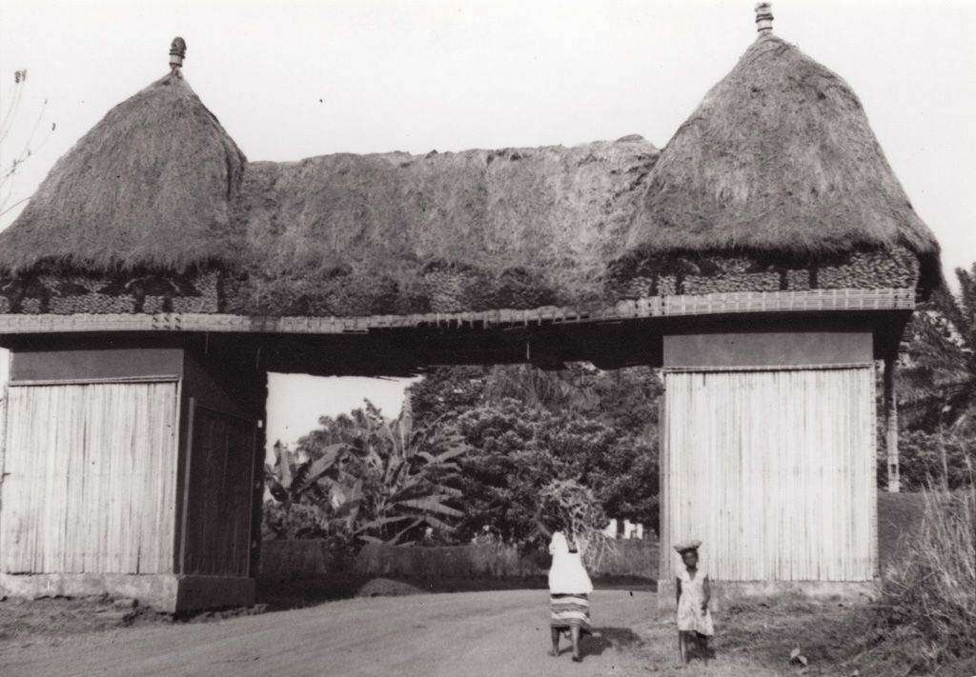
Source: Extracted from palace archives, 22 February, 2026.
Plate 4 indicates the period it was first constructed. It was latter rehabilitated in 2021 by sultan Njoya after a fire incident as presented by plate. It also reflects the Bamoun tradition of using architecture and public art as a medium of historical memory. The structure is decorated with powerful Bamoun royal symbols, most notably the double-headed snake, which represents military strength, sovereignty, and dynastic continuity. These motifs communicate key narratives of Bamoun history, ensuring that visitors immediately encounter visual expressions of power and identity upon entering the city. The entrance therefore functions not only as decoration but as a statement of historical authority and cultural pride. By integrating symbolic motifs into the urban landscape, the entrance becomes an open-air cultural space that preserves and communicates collective memory.
Plate 5: Monumental Entrance to the Foumban Town Rehabilitated in 2021
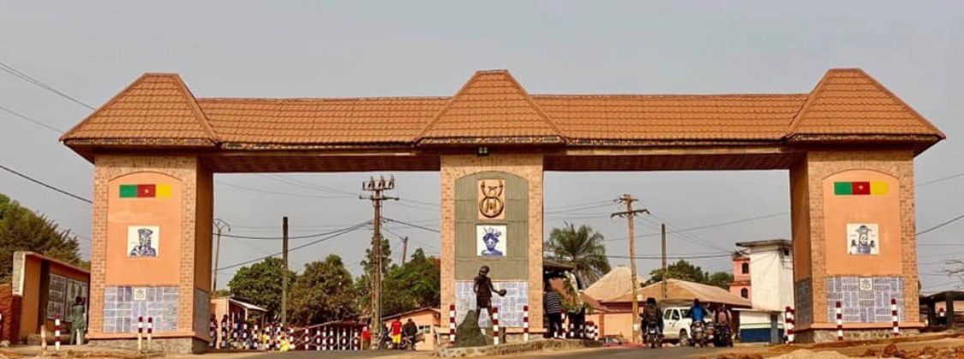
Source: Source: Authors collection, March, 2025
It continuously reminds both residents and visitors of the kingdom’s origins, achievements, and resilience. Beyond symbolism, the entrance plays an important role in heritage tourism. As a primary landmark, it shapes visitors’ perceptions of Foumban and directs attention toward other major heritage sites such as the Royal Palace, museums, and craft centres. It thus functions as an introduction to the broader cultural landscape of the kingdom.
The continuity of symbolic motifs across Foumban’s monuments, palaces, and museums creates a unified cultural identity system. This visual consistency reinforces ideas of kingship, legitimacy, and collective belonging, while linking traditional heritage with modern urban development. Ultimately, the monumental entrance to Foumban acts as a symbolic preface to Bamoun civilisation, encapsulating its values, history, and identity. It demonstrates that heritage is not confined to institutions but is actively embedded in the lived environment, shaping how Bamoun history is experienced in everyday life.
7. THE DOUBLE-HEADED SNAKE: SYMBOL OF ROYAL POWER, MILITARY PROWESS, AND BAMOUN IDENTITY
The double-headed snake is the most prominent and enduring symbol of the Bamoun Kingdom, deeply embedded in its royal iconography, political thought, public monuments, and collective memory. It represents royal authority, military strength, vigilance, and the resilience of the Bamoun state, and remains a central marker of Bamoun cultural identity (Fouponyiyi 2026, interviewed). Its origin is linked to the reign of King Mbuembue, a celebrated warrior ruler of the late eighteenth and early nineteenth centuries. Accordingly, the symbol emerged after a military campaign in which Bamoun forces successfully defended the kingdom against simultaneous attacks from different directions. This achievement was immortalized in the image of a snake with two heads, each capable of facing an enemy independently, symbolizing strategic victory and military resilience (Tardits, 1980).
Beyond its historical foundation, the symbol carries strong political meaning. The two heads represent vigilance, foresight, and effective leadership, reflecting the ideal qualities of Bamoun rulers (Yaya 2026, interviewed). It expresses the expectation that the king must remain attentive to all threats and govern with wisdom in complex and changing conditions. The double-headed snake also symbolizes unity within diversity. The single body with two heads reflects the integration of different groups and regions under one authority, reinforcing the idea of cohesion and shared identity within the kingdom. This interpretation highlights its role as a political philosophy of unity and collective strength (Warnier, 2009).
Plate 6: The Double-Headed Snake
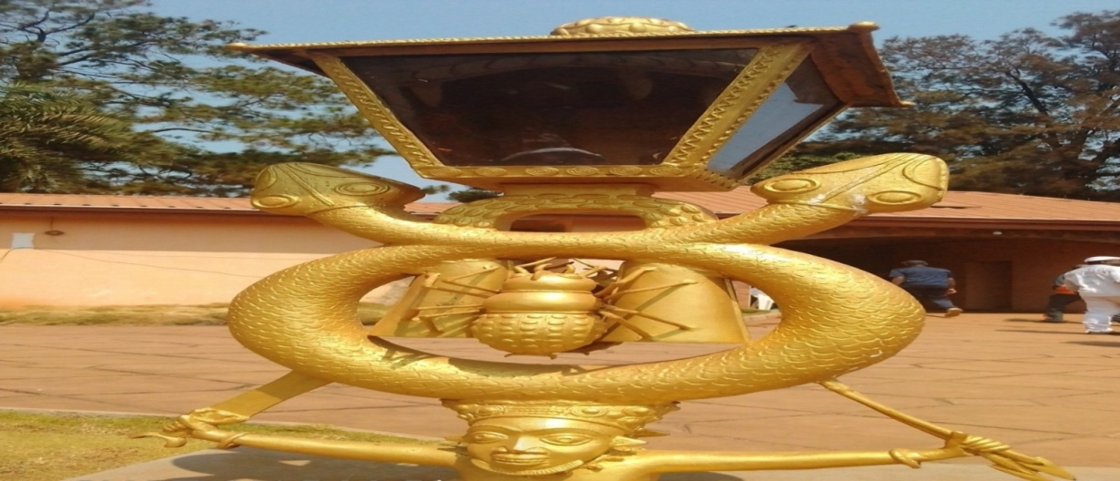
Source: Source: Authors collection, March, 2025
Over time, the symbol became an official royal emblem widely used in palace architecture, thrones, regalia, sculptures, textiles, and ceremonial objects. In the Royal Palace of Foumban, its repeated presence reinforces dynastic legitimacy and commemorates historical continuity (Balkisou 2026, interviewed). It also became a major feature of Bamoun artistic production, appearing in woodcarving, bronze work, embroidery, and other crafts, demonstrating how art served as a vehicle for transmitting political memory and cultural values (Geary, 1981).
In contemporary Foumban, the double-headed snake remains highly visible, particularly in heritage institutions such as the Bamoun Kings Museum, where it forms part of architectural design. Its continued use in modern settings demonstrates the adaptation of traditional symbols within contemporary cultural expression. The symbol has also become a key marker of Bamoun identity both locally and within the diaspora. It appears during festivals, ceremonies, and public celebrations, reinforcing collective belonging and historical consciousness. Additionally, it plays an important role in heritage tourism, serving as an entry point for understanding Bamoun history and political tradition (Mefire 2026, interviewed).
More broadly, the double headed snake functions as a condensed form of historical memory, combining narratives of military success, political authority, unity, and resilience. It bridges history, art, politics, and identity, making it more than a royal emblem, it is a symbolic monument of Bamoun civilisation (Aisatou 2026, interviewed). Ultimately, the double-headed snake remains a powerful expression of Bamoun heritage, embodying centuries of cultural continuity and serving as a lasting representation of the kingdom’s strength, unity, and enduring legacy.
8. THE SHÜMOM WRITING SYSTEM: A MONUMENT OF KNOWLEDGE AND INTELLECTUAL INNOVATION
The Shümom writing system is one of the most significant intellectual achievements in African history and a defining expression of Bamoun civilisation. Developed in the late nineteenth century by Sultan Ibrahim Njoya, it emerged as a deliberate response to the need to preserve Bamoun history, strengthen administration, and systematize indigenous knowledge during a period of internal transformation and colonial pressure. It represents a rare case in Africa of a fully functional indigenous writing system created to record and manage a complex state structure (Geary & Ross, 1994).
The script developed progressively from early pictographic forms to a more refined syllabic system capable of accurately representing the Bamoun language. This evolution reflects advanced linguistic and cognitive innovation, as well as a structured approach to knowledge organisation (Tardits, 1980). Shümom functioned as both a linguistic tool and a state technology, used in administration, law, diplomacy, genealogy, taxation, and historical documentation (Mbuombuo 2026, interviewed). It contributed to the development of a more bureaucratic and structured system of governance, marking a shift from purely oral traditions to a combined oral-written political system.
Plate 7: The Shümom Writing
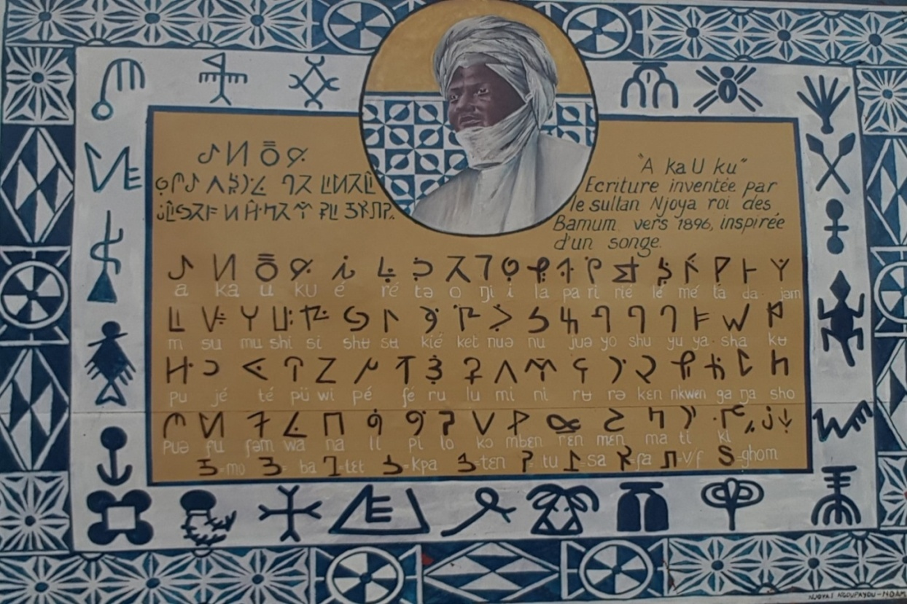
Source: Source: Authors collection, March, 2025
Education was central to its dissemination, as Sultan Njoya established schools to train scribes and administrators in reading and writing the script. This created a series of literate elites within the kingdom and positioned the palace as a centre of intellectual and administrative production (Adamou 2026, interviewed). The Bamoun Kingdom thus became one of the few precolonial African states with an indigenous system of formal literacy and institutionalized learning (Geary, 1981). Shümom manuscripts reveal a broad intellectual landscape, covering history, medicine, agriculture, law, religion, and governance. These texts form an important archive of Bamoun knowledge systems and demonstrate the depth of precolonial African intellectual traditions. The script also symbolized cultural autonomy and intellectual sovereignty, challenging colonial assumptions that African societies lacked written traditions and reinforcing the idea of indigenous epistemic agency (Mefire 2026, interviewed).
However, the system declined under French colonial rule, which restricted its use in administration and education and led to the dismantling of many Shümom schools. Despite this, it survived in archives, museums, and cultural memory (Warnier, 2009). In the contemporary period, there has been renewed interest in preserving and revitalizing Shümom through scholarly research and cultural initiatives. Institutions such as the Bamoun Kings Museum and the Royal Palace of Foumban play a key role in safeguarding surviving manuscripts and promoting awareness of its historical importance.
Today, Shümom is recognised not only as a historical writing system but as a monument of knowledge representing Bamoun intellectual creativity and cultural resilience. It stands alongside the kingdom’s monuments, symbols, and artistic traditions as evidence of a sophisticated civilisation. Ultimately, the Shümom script embodies the intersection of language, governance, and cultural identity, reflecting Sultan Njoya’s vision of preserving Bamoun civilisation while asserting intellectual independence in a changing world.
9-NGUON FESTIVAL AND UNESCO RECOGNITION: HERITAGE STATUS AND ITS SIGNIFICANCE FOR THE BAMOUN PEOPLE
The Nguon Festival is one of the oldest and most important institutions of the Bamoun Kingdom, with origins deeply rooted in the political and social history of the kingdom’s formation and consolidation. Historically, Nguon developed as a traditional mechanism of governance that combined ritual, public assembly, and political accountability within the Bamoun state (Njapdunke 2026, interviewed). It is generally traced to the early periods of the kingdom’s centralization, particularly as Bamoun rulers sought to manage a growing and diverse population spread across multiple chiefdoms and territories.
Plates 8: Celebrations of the Nguon Festival in Foumban
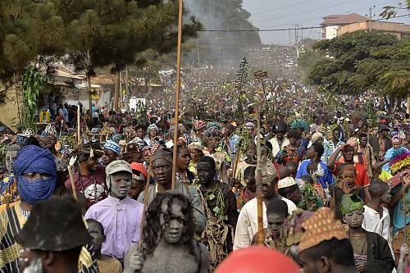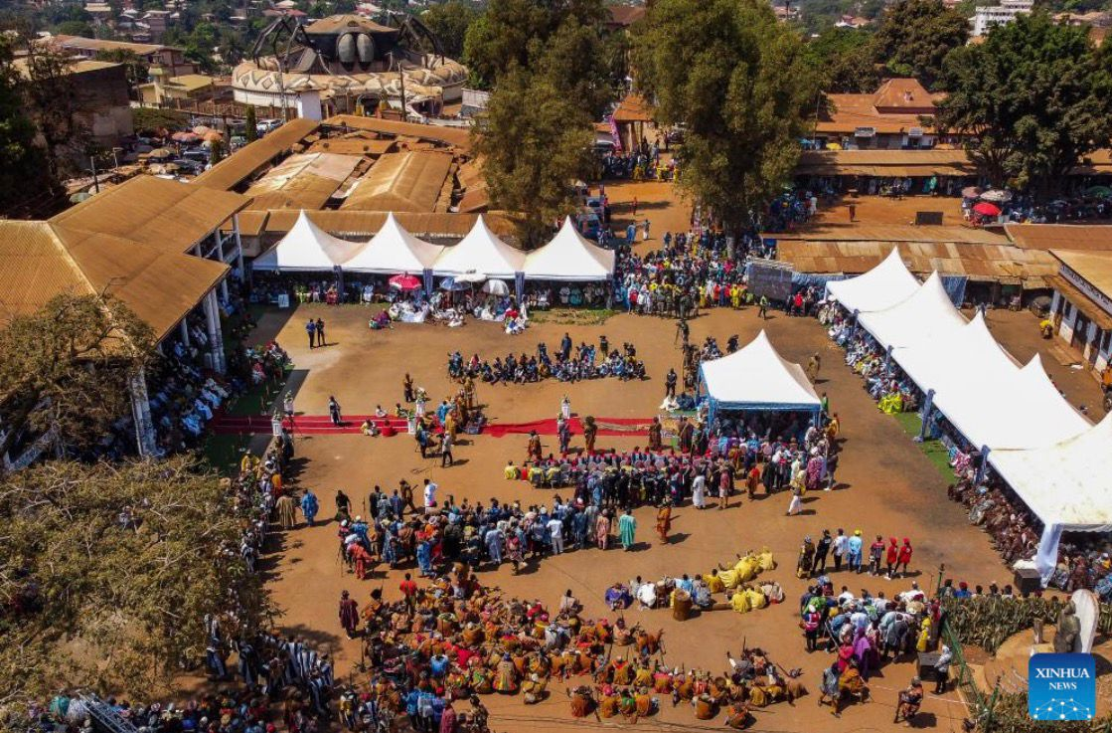
Source: Source: Authors collection, April, 2025
In its historical form, Nguon functioned as a periodic assembly where the king (Mfon) met with representatives of different lineages, administrative officials, and traditional notables. During these gatherings, issues affecting the kingdom were openly discussed, including governance practices, justice, taxation, security, and social grievances (Idrissou 2026, interviewed). This system created a structured space where subjects could express concerns and where the ruler’s leadership could be publicly evaluated. In this sense, Nguon operated as an indigenous institution of political accountability embedded within Bamoun customary law and royal tradition (Tardits, 1980).
The festival also had a strong ritual and symbolic dimension. It was not only a political council but also a sacred event that reaffirmed the spiritual legitimacy of the monarchy. Through ceremonies, ancestral invocations, and cultural performances, Nguon reinforced the belief that kingship was both a political and spiritual institution rooted in continuity with ancestors (Fouapon 2026, interviewed). This dual function, governance and ritual made Nguon central to the stability of the Bamoun political system. Over time, especially during the reigns of influential rulers such as Mfon Mbuembue and later Sultan Ibrahim Njoya, the Nguon institution became more structured and prominent. It evolved into a highly organized festival combining judicial review, cultural celebration, military display, and communal gathering. Under Njoya, who also promoted written documentation and institutional reform, the festival’s role as a platform for consultation and social cohesion became even more formalized within the kingdom’s political system.
Despite disruptions during the colonial period, when traditional institutions were weakened and administrative authority was partially restructured under German and French rule, the Nguon Festival survived as a key expression of Bamoun identity. It continued to be practiced under the authority of the Bamoun Sultanate, although with adjustments to its political functions. In the contemporary period, Nguon has been transformed into a major cultural festival while retaining its historical meaning as a symbol of unity, accountability, and continuity of Bamoun tradition. Its significance was internationally recognized in 2023 when UNESCO inscribed the Nguon Festival on the Representative List of the Intangible Cultural Heritage of Humanity under the 2003 Convention for the Safeguarding of Intangible Cultural Heritage (UNESCO, 2023).

Plate 9: UNESCO Recognition of the Ngoun Cultural Festival in 2023
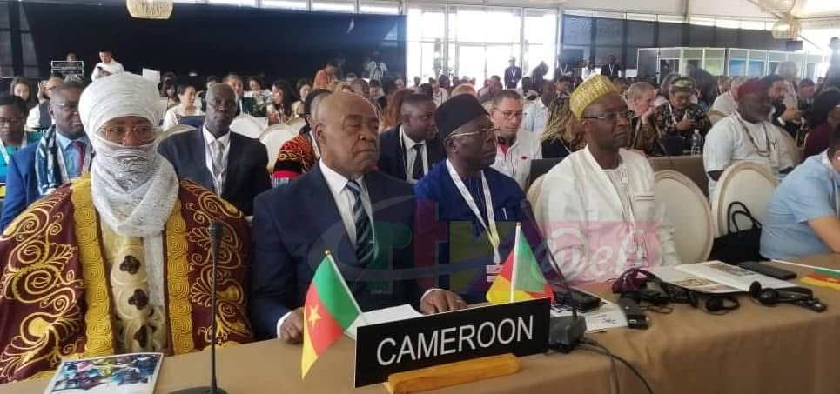Source: Source: Authors collection, April, 2025
Plate 7 represents Cameroon delegation headed by the Minister of arts and culture and the Sultan of the Bamoun during the UNESCO recognition ceremony. This recognition affirmed Nguon not only as a cultural celebration but also as a living institution of traditional governance and a vital expression of the Bamoun people’s historical heritage.
10-HERITAGE PRESERVATION CHALLENGES
The preservation of Bamoun material culture and historical heritage faces a range of interrelated challenges that affect monuments, artifacts, oral traditions, and living cultural practices. One of the most pressing challenges is the impact of urbanization and modern development in Foumban and surrounding areas. As the city expands, historical landscapes are increasingly under pressure from construction, road development, and changing land use patterns. In some cases, traditional spaces that once held ceremonial or historical significance are altered or encroached upon, weakening the spatial integrity of heritage sites and disrupting their cultural meanings (Tardits, 1980).
Another major challenge concerns the conservation of physical monuments and artifacts. Structures such as the Royal Palace, museums, and symbolic monuments require continuous maintenance due to aging materials, environmental exposure, and climatic conditions (Mefire 2026, interviewed). Humidity, heavy rainfall, and temperature fluctuations contribute to the deterioration of wood, textiles, metal objects, and architectural surfaces. However, limited financial and technical resources often constrain systematic conservation efforts. This results in uneven preservation conditions, where some heritage objects are carefully maintained while others remain vulnerable to decay.
Illicit trafficking and unauthorized circulation of cultural objects constitute another serious concern. Like many African heritage sites, Bamoun artifacts have historically attracted external interest, leading to the removal of objects during colonial periods and, in some cases, continued informal circulation in private and international collections (Fouponyiyi 2026, interviewed). This has resulted in gaps within local heritage collections and complicates efforts to reconstruct the full historical narrative of the kingdom. The absence of complete artifact inventories also makes it difficult to monitor and protect cultural property effectively.
Oral tradition, which remains a vital component of Bamoun historical transmission, is also under pressure. As younger generations become more influenced by formal education systems, digital media, and urban lifestyles, the intergenerational transmission of oral histories, rituals, and indigenous knowledge systems is weakening (Aisatou 2026, interviewed). This gradual erosion of oral heritage threatens the continuity of cultural memory, particularly in areas where written documentation is limited or incomplete.
Institutional limitations further complicate heritage preservation efforts. While the Bamoun Sultanate and cultural institutions such as museums play an important role in safeguarding heritage, they often operate with constrained budgets, limited technical capacity, and insufficient access to conservation technology. Training in modern museum practices, conservation science, and digital archiving remains limited, which affects the long-term sustainability of preservation initiatives (Njikam 2026, interviewed).
Despite these challenges, there have been growing efforts at both national and international levels to support Bamoun heritage preservation. Increased recognition of sites such as the Nguon Festival by UNESCO has helped raise awareness of the importance of safeguarding intangible cultural heritage. However, ensuring the long-term protection of Bamoun monuments, artifacts, and traditions requires sustained investment, community engagement, and stronger collaboration between traditional authorities, government institutions, and international partners. Thus, the preservation challenges facing Bamoun heritage are multifaceted, combining environmental, institutional, social, and economic factors. Addressing these issues is essential not only for protecting historical artifacts and monuments but also for maintaining the cultural identity and historical continuity of the Bamoun people.
11. CONCLUSION
The material culture and historical heritage of the Bamoun Kingdom constitute one of the most enduring and sophisticated cultural systems in Central Africa. Over centuries, the Bamoun developed a rich civilisation expressed through architecture, symbolic art, indigenous writing, ritual practices, and structured governance. Key heritage elements such as the Royal Palace of Foumban, museums, the monumental city entrance, and symbols like the double-headed snake, spider, and double bell reflect an integrated worldview where politics, spirituality, art, and knowledge are deeply interconnected. The kingdom’s historical development, from its foundation under Nchare Yen, through expansion under rulers such as Mbuembue, to intellectual transformation under Sultan Ibrahim Njoya, illustrates a continuous tradition of political organisation and cultural innovation. In particular, the creation of the Shümom writing system demonstrates a major contribution to African intellectual history, highlighting the Bamoun capacity for independent systems of literacy and knowledge production.
Living cultural institutions such as the Nguon Festival further demonstrate the ongoing vitality of Bamoun heritage. Its UNESCO recognition in 2023 underscores its global importance and affirms the continued relevance of Bamoun traditions in contemporary discussions of governance, culture, and identity. These practices remain dynamic and actively shape community life rather than simply preserving the past. However, Bamoun heritage faces significant preservation challenges, including urban expansion, environmental degradation, limited conservation capacity, and weakening oral transmission. These issues threaten both tangible and intangible heritage, making stronger preservation strategies essential. Overall, the Bamoun Kingdom stands as a powerful example of cultural resilience and historical continuity. Its heritage remains a living system that continues to evolve while preserving its identity. Studying Bamoun material culture therefore enriches both African historiography and global understandings of heritage, identity, and cultural continuity.

SOURCES CONSULTED
- Oral Interview
Adamou, Alasa. Age 57. Artisan. Foumban, 22 January 2026.
Aisatou, Njikam. Age 75. Artisan. Foumban, 28 January 2026.
Balkisou, Njikam. Age 56. Traditional Authority. Foumban, 19 February, 2026.
Fouapon Nji. Age 65. Cultural Practitioner. Foumban, 28 January 2026.
Fouponyiyi, Pierre. Age 65. Artisan. Foumban, 27 January 2026.
Idrissou Mamouda. Age 66. Cultural Practitioner. Foumban, 19 March, 2026.
Idrissou, Njimolu. Age 56. Traditional Authority. Foumban, 19 March, 2026.
Mbuombuo Mariama. Age 61. Cultural Practitioner. Foumban, 28 January 2026.
Mefire, Aisha. Age 55. Museum Curators. Foumban, 14 January 2026.
Mohammed. Njoya. Age 76. Quarter Head. Foumban, 19 February, 2026.
Njapdunke, Ahmadou. Age 55. Palace Guide. Foumban, 12 February 2026.
Njapdunke, Alasa. Age 55. Traditional Authority. Foumban, 22 January 2026.
Nji, Adamu. Age 67. Traditional Authority. Foumban, 22 January 2026.
Njimolu, Hassan. Age 56. Museum Curators. Foumban, 3 January 2026.
Njoya, Abdul-Aziz Oumarou. Age 55. Elderly Custodians of Bamoun Traditions. Foumban, 5 March 2026.
Yaya Hassan. Age 56. Artisan and Traditional leader, 19 March, 2026.
- Secondary Sources
Duala-M’bedy, L. J. B. The significance of N’joya for the cultural history of the Bamum country. Vestiges: Traces of Record, 2025.
Fomine, F. L. M. A concise historical survey of the Bamum dynasty and the influence of Islam in Foumban, Cameroon, 1390–Present. 2012.
Fowler Museum. Art and kingship among the Bamoun of Cameroon. Fowler Museum of Cultural History, 1990.
Geary, C. M. Bamum Kingdom and the Arts. Smithsonian: Institution Press, 1981.
Geary, C. M. The things of the palace: Catalog of the Bamoum Palace Museum in Foumban. Franz Steiner Verlag, 1984.
Geary, C. M., & Ross, S. D. Images from Bamum: German colonial photography at the court of King Njoya, Cameroon, West Africa, 1902–1915. Smithsonian: Institution Press, 1994.
Global South World. The giant two-headed snake entrance of Cameroon’s fascinating Bamoun Kings Museum, 2024.
Hicks, D., & Beaudry, M. C. The Oxford Handbook of Material Culture Studies. Oxford: Oxford University Press, 2010.
Ki-Zerbo, J. General History of Africa I: Methodology and African prehistory. UNESCO, 1981.
Tardits, C. Le Royaume Bamoun. Armand Colin, 1980.
UNESCO. Convention for the Safeguarding of the Intangible Cultural Heritage. UNESCO: UNESCO Publishing, 2003.
UNESCO. Nguon cultural festival of the Bamoun people: Representative List of the Intangible Cultural Heritage of Humanity. UNESCO, 2023.
Warnier, J.-P. The Pot-King: The body and technologies of power. Brill, 2009.
Yenshu, E. V. “Cultural heritage and identity in the Bamoun Kingdom”. African Study Monographs, 24(3), (2003):113–136.

