A Systematic Review of Multilingual Artificial Intelligence Platforms and their Impact on Cross-Regional Collaboration and Startup Development among Young Graduate Entrepreneurs
Nsikak Thompson*, Chidera Johnson, Michael Ukpeh, Okengwu A. Ugochi
Department of Computer Science University of Port Harcourt, Choba, Port Harcourt, Rivers State, Nigeria
* Corresponding Author
DOI: https://doi.org/10.51244/IJRSI.2026.13020077
Received: 22 January 2026; Accepted: 28 January 2026; Published: 03 March 2026

ABSTRACT
This systematic review investigates the role of Multilingual Artificial Intelligence (AI) Platforms in facilitating cross-regional collaboration and accelerating startup development among young graduate entrepreneurs. Driven by the exponential growth of Natural Language Processing (NLP) research, these platforms—including advanced machine translation, AI assistants, and cross-lingual information retrieval systems—have become strategic imperatives. The review confirms that AI provides a critical competitive advantage by directly mitigating linguistic barriers in collaboration, enabling instant global market access, personalizing product development, and streamlining AI-enabled fundraising, thereby overcoming resource constraints faced by young ventures. However, the adoption is tempered by significant ethical and technical constraints, particularly algorithmic bias, data privacy risks, and the challenge of developing culturally nuanced models for low-resource languages. The findings confirm that while AI acts as a strategic enabler, its effective, equitable use requires targeted investment in ethical development and infrastructure to support truly inclusive global entrepreneurship.
Keywords: Multilingual AI Platforms, Natural Language Processing (NLP), Cross-Regional Collaboration, Startup Development, Young Graduate Entrepreneurs

INTRODUCTION
The modern business environment is defined by its deep interconnectedness, making cross-regional collaboration not merely advantageous, but fundamental for innovation and growth (OECD, 2021). This global reality is accelerated by advancements in Artificial Intelligence (AI), particularly within Natural Language Processing (NLP), which has revolutionized communication and commerce (Li et al., 2022). In response, Multilingual AI Platforms have emerged as essential tools poised to bridge the linguistic and cultural divides that historically constrain international collaboration.
Young graduate entrepreneurs, while positioned as primary drivers of innovation (Shane & Venkataraman, 2000), face acute challenges in the global arena. Despite their agility (Tushman & Anderson, 1986), they are often hampered by limited resources (Morris et al., 2005), the inherent difficulty of cross-cultural communication (Grewal & Ghoshal, 2020), and the significant effort required for trust-building across borders (Gulati & Sytch, 2007). The inability to effectively exchange ideas, knowledge, and resources across diverse linguistic landscapes significantly limits their market access and growth potential.
Multilingual AI platforms offer a compelling solution to these limitations. Leveraging capabilities such as real time translation, cross-lingual information retrieval (Radlinski & Craswell, 2009), and culturally nuanced support, these systems empower startups to gain a competitive advantage. For instance, AI-driven tools can be leveraged for product development (Davenport & Ronanki, 2018), business intelligence (Jordan & Mitchell, 2015), and even optimized fundraising strategies (Chen et al., 2020). By enabling seamless communication and providing access to global market insights in multiple languages, these platforms are instrumental in facilitating international partnerships and accelerating startup development.
However, the adoption of these powerful technologies is not without its own set of critical considerations. The literature highlights persistent challenges related to managing algorithmic bias, ensuring robust data privacy and security (Tojiboyeva, 2024), and developing systems that maintain cultural sensitivity and linguistic nuance, especially for resource-scarce regional languages (Nlebem, 2024).
This systematic review seeks to critically examine the existing literature to understand how multilingual AI platforms support cross-regional collaboration and accelerate startup development among young graduate entrepreneurs. Specifically, the review investigates the key features and functionalities of these platforms, their demonstrable effectiveness in fostering collaboration, the specific ways they support various aspects of the entrepreneurial journey, and the persistent challenges and ethical limitations associated with their real-world utilization. By synthesizing these findings, this review aims to contribute a deeper understanding of the potential and boundaries of multilingual AI in supporting the next generation of global entrepreneurs.

REVIEW OF RELATED LITERATURE
Multilingual artificial intelligence (AI) is fundamentally anchored in advances in Natural Language Processing (NLP), particularly in neural machine translation and cross-lingual representation learning. Foundational work by Sennrich et al. (2016) marked a significant shift in translation accuracy and fluency through neural architectures, forming the backbone of widely deployed platforms such as Google Translate and DeepL. Subsequent developments have expanded multilingual AI beyond static text translation to interactive and real time applications. Li et al. (2022), for example, demonstrated the growing integration of multilingual capabilities into conversational agents and virtual assistants, enabling synchronous cross-linguistic interaction and lowering communication barriers in globally distributed contexts.
Beyond communication, multilingual AI has enhanced access to knowledge through cross-lingual information retrieval systems. Early conceptualization by Radlinski and Craswell (2009) established mechanisms for retrieving relevant information across language boundaries, a capability that has become increasingly relevant for entrepreneurs seeking market intelligence, technical documentation, and investment information in nonnative languages. Bibliometric evidence from Judijanto and Vandika (2025) further confirms the rapid expansion of multilingual NLP research since 2018, driven largely by deep learning models such as mBERT and XLMRoBERTa. However, their analysis also reveals a persistent regional imbalance in knowledge production, with research output heavily concentrated in the United States and Europe, highlighting a structural asymmetry that mirrors broader digital and data divides.
This regional disparity is also reflected in the availability and orientation of multilingual AI platforms. Studies from Europe emphasize infrastructural and policy-driven standardization efforts, most notably the European Language Grid (ELG), which Piperidis et al. (2023) describe as a strategic framework designed to ensure interoperability, accessibility, and digital language equality across member states. In contrast, literature emerging from developing regions places greater emphasis on localization, affordability, and linguistic diversity. Nlebem (2024), for instance, documents the development of Awarri’s Multilingual Language Model trained on indigenous Nigerian languages, addressing long-standing challenges related to low-resource languages and data scarcity. This contrast underscores how regional contexts shape both the design priorities and the entrepreneurial relevance of multilingual AI systems.
Across platform types, the literature suggests differentiated impacts. Translation-centric platforms primarily facilitate initial cross-border communication, while AI-powered collaboration tools and conversational systems enable sustained interaction, coordination, and trust-building. Kennedy et al. (2023) demonstrated how real-time subtitling and translation in MOOCs reduce linguistic exclusion but also highlighted trade-offs between accuracy and immediacy. Similarly, Santorelli and Catullo (2023) emphasized the role of real-time interpretation systems in mitigating the dominance of English as a lingua franca, raising critical questions about power dynamics and inclusivity. These findings suggest that while translation accuracy is essential, platform responsiveness and contextual sensitivity are equally critical in collaborative and entrepreneurial environments.
Educational and capacity-building contexts further illustrate the transformative potential of multilingual AI. Tojiboyeva (2024) and Saddhono et al. (2025) framed AI as an enabler of multilingual literacy and inclusion, particularly for marginalized communities, while also cautioning against ethical risks such as algorithmic bias and unequal access. Ding et al. (2025) extended this perspective by proposing AI-powered multilingual training platforms aimed at developing interdisciplinary talent capable of operating across global professional domains. Collectively, these studies highlight how multilingual AI functions not only as a communication tool but also as an enabler of human capital development—an outcome highly relevant to early-stage entrepreneurs.
The importance of multilingual AI becomes particularly pronounced when examined through the lens of young graduate entrepreneurs. While cross-regional collaboration is widely recognized as a driver of innovation (OECD, 2021), it is frequently constrained by linguistic, cultural, and trust-related barriers (Grewal & Ghoshal, 2020; Gulati & Sytch, 2007). Young graduate entrepreneurs—defined as recent tertiary education graduates operating early-stage ventures—face compounded challenges due to limited financial resources, restricted international networks, and high demands for adaptability (Morris et al., 2005; Tushman & Anderson, 1986). Unlike experienced founders, they rely more heavily on digital platforms to compensate for these constraints.
Empirical and conceptual studies increasingly recognize multilingual AI as a strategic asset in this context. Davenport and Ronanki (2018) and Jordan and Mitchell (2015) documented AI’s role in product development and business intelligence, while Chen et al. (2020) highlighted its emerging relevance in fundraising and investor engagement. Case-based evidence suggests that platforms such as Google Translate, DeepL, and Amazon Translate facilitate market entry, partner communication, and customer engagement for early-stage ventures. However, the literature remains fragmented, with limited comparative analysis of how platform type, regional context, and entrepreneurial setting interact to shape outcomes for young graduate entrepreneurs.

METHODOLOGY
This section presents an overview of the methodology employed to conduct the systematic literature review, covering its objectives, research questions, inclusion and exclusion criteria, and the overall study framework. Subsection (A) shows the methodological description. Subsection (B) focuses on the development of research questions. Subsection (C) explains the strategy for selecting articles, while Subsection (D) outlines the inclusion and exclusion criteria.

Methodological Description
This study employed a systematic review methodology following the guidelines established by the Preferred Reporting Items for Systematic Reviews and Meta-Analyses (PRISMA 2020) statement. This rigorous approach ensures a transparent, comprehensive, unbiased, and replicable synthesis of existing research concerning Multilingual Artificial Intelligence (AI) Platforms and their multifaceted impact on cross-regional collaboration and startup development among young graduate entrepreneurs. The adherence to PRISMA 2020 allows for clarity in the reporting process, from article identification through screening, eligibility assessment, and final inclusion.

Research Questions
The review was strictly guided by specific, focused research questions derived directly from the study's central topic. The following research questions were developed to comprehensively explore the scope of the field
RQ1: What is the current state-of-the-art in multilingual AI technologies relevant to business and collaboration?
RQ2: How do multilingual AI platforms influence the dynamics, challenges, and successes of cross-regional entrepreneurial collaboration?
RQ3: What are the specific opportunities and constraints faced by young graduate entrepreneurs when utilizing these multilingual AI tools?

Strategy for Selecting Articles
The selection of relevant articles was systematically conducted in adherence to the PRISMA 2020 guidelines, ensuring a transparent and rigorous identification process. This strategy involved defining clear search terms, utilizing established digital libraries, addressing potential bias, and employing appropriate data analysis methods.

Search Strategy
The data collection was carried out using selective, term-based searches across publications spanning a defined two-decade period (2004 and 2024). The search primarily focused on the titles and abstracts of publications to maximize relevance. To refine the results, the research questions guided the process, employing advanced search techniques (Boolean operators like "AND" and "OR") to enhance precision and coverage.

Digital Libraries Resources
The study systematically utilized research databases known for hosting high-quality, peer-reviewed computer science, engineering, and social science literature as shown in Table 1. These digital libraries served as the primary resource platforms for the investigation:
Table 1: Digital libraries resources used in this review
Library/Resource
Semantic Scholar | IEEE
Scopus | OSF
ResearchGate | Springer

Search Terms
Specific keywords and phrases were strategically combined to represent the main concepts of the research for the systematic database queries as described in Table 2.
Table 2: Search terms and specific key phrases used.
Search Term Group | Specific Keywords/Phrases
Multilingual AI Platforms | "Multilingual AI" OR "Multilingual NLP" OR "Machine Translation Platforms" OR "Cross-lingual Systems"
Collaboration & Business | "Cross-Regional Collaboration" OR "International Business Collaboration" OR "Virtual Collaboration"
Entrepreneurship & Startups | "Startup Development" OR "Young Graduate Entrepreneurs" OR "Nascent Ventures"
Combined Concepts | ("Multilingual AI" AND "Collaboration") AND ("Startup" OR "Entrepreneur")

Handling of Bias
Potential publication bias (the tendency for studies with statistically significant findings to be published more often) was minimized by casting a wide net across diverse digital libraries. This approach included utilizing preprint servers (OSF, ResearchGate) and major indexing services (Scopus, Semantic Scholar), rather than relying exclusively on high-impact factor journals.
Furthermore, selection bias was rigorously controlled. This involved maintaining strict adherence to the predefined Inclusion and Exclusion Criteria (Section D) throughout the screening process. All search results were systematically documented in a PRISMA flow diagram (Figure 1). Finally, to ensure consistency and minimize subjective filtering, all selected literature underwent a further independent screening by reviewer Okengwu U.A. Method of Data Analysis
The collected data from the selected articles were analyzed using thematic synthesis. This involved three primary steps:
Step 1: Identifying the key findings (e.g., specific platform names, identified constraints, collaboration models) from the abstracts and full-text articles;
Step 2: Generating descriptive themes (e.g., "Technological Gaps," "Ethical Constraints," "Market Access Opportunities") from the codes;
Step 3: Synthesizing these themes to construct the final narrative review and develop the comprehensive table of evidence, thereby ensuring that the synthesis directly addresses the research questions.

Inclusion and Exclusion Criteria
To guarantee the relevance and academic quality of the final body of literature, stringent criteria were applied during the screening and eligibility phases of the PRISMA 2020 process. Inclusion criteria mandated the selection of peer-reviewed journal articles, conference proceedings, and high-quality book chapters published within a defined timeframe (e.g., 2000–present) that explicitly discussed the intersection of multilingual AI platforms, cross-regional collaboration, and entrepreneurship. Conversely, Exclusion criteria filtered out nonscholarly sources (e.g., news articles, blog posts), purely theoretical models lacking empirical validation, and studies focusing solely on monolingual or non-AI-driven collaboration methods.

RESULTS

Study Selection and Overview
Figure 2 presents the PRISMA 2020 flow diagram detailing the study selection process. Following comprehensive searches across multiple databases, registers, and supplementary sources, records were screened through title, abstract, and full-text review stages. After the removal of duplicates and the exclusion of studies that did not meet the predefined inclusion criteria, a final set of studies was retained for synthesis. This transparent screening process ensures methodological rigor and alignment with established systematic review standards (Page et al., 2021).
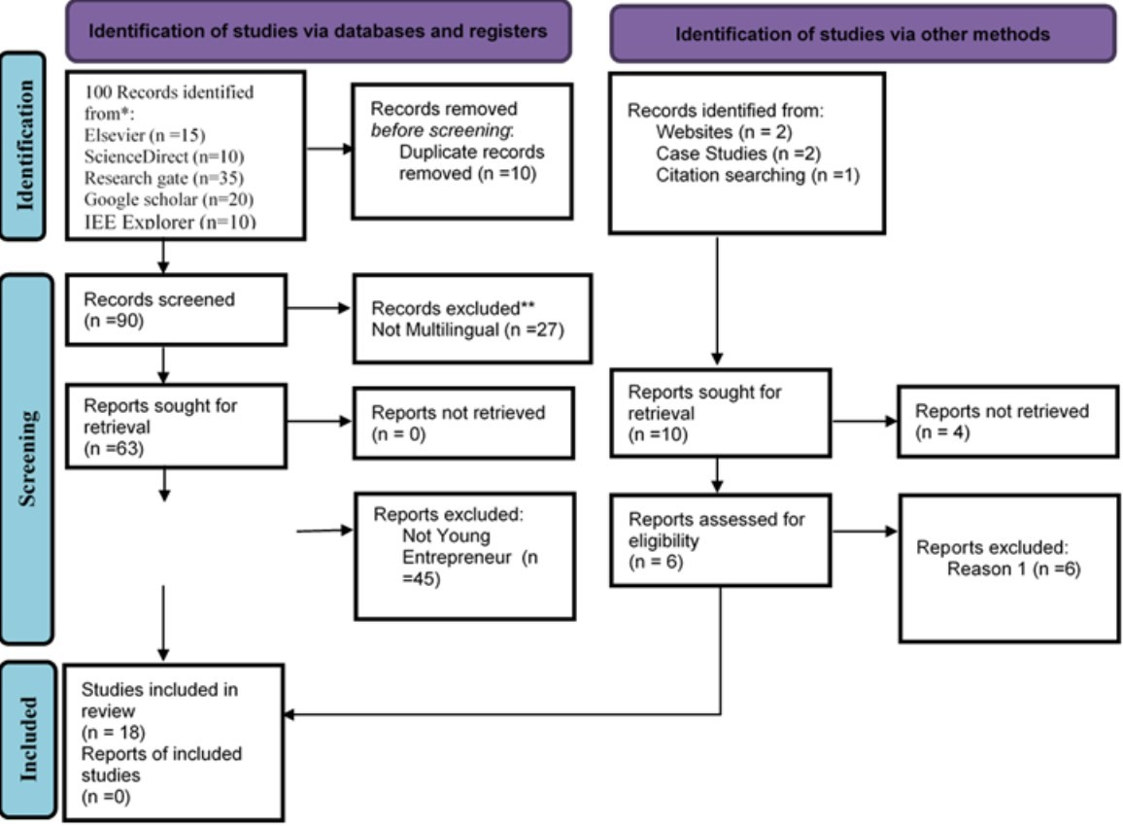

Figure. 2: PRISMA 2020 flow diagram for the study which included searches of databases, registers and other sources. (Source: Page et al., 2021)
RQ1: What is the current state-of-the-art in multilingual AI technologies relevant to business and collaboration?
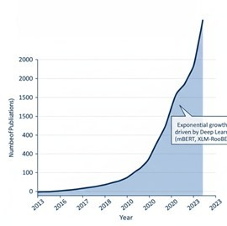

Figure 2: Growth Curve of Multilingual NLP Research (2013 -2023)
Adopted from Judijanto and Vandika (2025)
Figure 2 illustrates the exponential growth in scholarly publications related to multilingual NLP, particularly highlighting the surge observed since 2018, as identified by Judijanto and Vandika (2025). This visually confirms the rapid expansion and increasing academic and industry interest in the field.
Figure 3 shows a conceptual diagram that synthesizes the foundational work from Sennrich et al. (2016), Li et al. (2022), and Radlinski & Craswell (2009) to illustrate the three primary categories of multilingual AI platforms dominating the current state-of-the-art: Machine Translation, AI-Powered Assistants/Chatbots, and Cross Lingual Information Retrieval systems. Each category plays a distinct role in facilitating global communication and information access.
Machine translation platforms exhibit the highest level of technological maturity and global diffusion, serving as foundational infrastructure for cross-border communication. Conversational AI systems provide greater interactivity and contextual engagement but show uneven performance across languages, particularly in low resource settings. Cross-lingual information retrieval tools play a strategic role in enabling access to multilingual knowledge resources, though their adoption remains more prevalent in research-intensive and high-income regions.
Comparatively, studies originating from North America and Europe emphasize performance optimization and scalability, whereas research from Africa and parts of Asia prioritizes localization, affordability, and linguistic diversity. This regional contrast highlights structural asymmetries in both the development and deployment of multilingual AI technologies
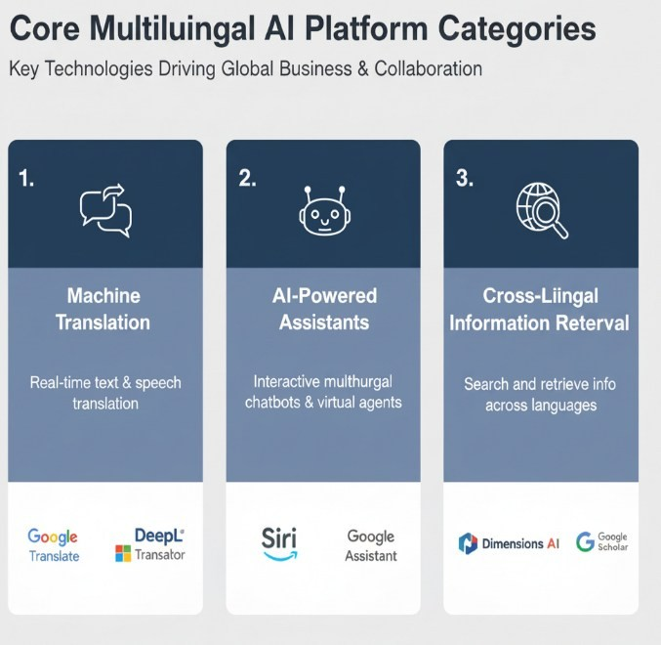

Figure 3: Core Multilingual AI Platform Categories

Adopted from Sennrich et al. (2016), Li et al. (2022), and Radlinski & Craswell (2009
RQ2: How do multilingual AI platforms influence the dynamics, challenges, and successes of cross-regional entrepreneurial collaboration?
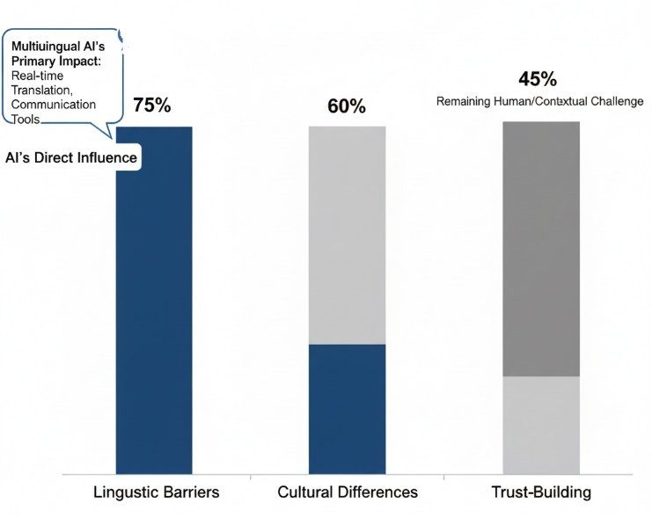
Figure 4: Collaboration Barriers & AI's Role
Adopted from Grewal & Ghoshal (2020) and Gulati & Sytch (2007)
Figure 3 visualizes the key challenges in cross-regional collaboration, drawing insights from Grewal & Ghoshal (2020) and Gulati & Sytch (2007). It highlights how linguistic and cultural barriers, along with trust-building, significantly impede collaboration, and then shows how multilingual AI platforms specifically address the linguistic component. Table 3 presents a cross-regional and platform comparison of Multilingual AI in in Entrepreneurial Contexts
Table 2: Cross-Regional and Platform Comparison of Multilingual AI in Entrepreneurial Contexts
Region | Platform  Type | Representative  Studies | Entrepreneurial  Setting | Key Benefits | Key Constraints
North  America / Europe | Machine  Translation  (e.g., Google  Translate,  DeepL) | Sennrich et al.,  2016; Judijanto &  Vandika, 2025 | Early-stage startups, scaling ventures | High translation accuracy; seamless  integration; scalability | High reliance on proprietary data; limited low resource language coverage
 | AI-Powered  Assistants /  Chatbots (e.g.,  Siri, Alexa) | Li et al., 2022;  Xiao, 2020 | Customer engagement, virtual collaboration | Real-time interactive support; workflow automation | Limited language diversity; requires high-quality input data
 | Cross-Lingual  Information  Retrieval  (CLIR) | Radlinski &  Craswell, 2009 | Market research, product development | Access to global knowledge  resources; supports  R&D | Knowledge gaps in low-resource languages; platform complexity
Developing  Regions  (Africa,  Southeast  Asia) | Machine  Translation | Nlebem, 2024; Xiao, 2020 | Young graduate entrepreneurs; small startups | Enables initial market access; supports lowresource languages | Limited infrastructure; lower translation accuracy; higher costs relative to local resources
Region | Platform  Type | Representative  Studies | Entrepreneurial  Setting | Key Benefits | Key Constraints
 | AI-Powered  Assistants /  Chatbots | Li et al., 2022;  Kennedy et al.,  2023 | Customer support, community engagement | Improves communication; fosters inclusion | Requires training data; less platform support; inconsistent language coverage
 | Cross-Lingual  Information  Retrieval  (CLIR) | Radlinski &  Craswell, 2009 | Knowledge acquisition; entrepreneurial learning | Supports research & market intelligence | Limited coverage; technical barrier; requires digital literacy
Global /  Mixed | Combined  Platforms  (Translation +  Assistants) | Santorelli &  Catullo, 2023;  Piperidis et al.,  2023 | Collaborative R&D, cross-border partnerships | Reduces linguistic barriers; enables global collaboration | Cultural and trust barriers remain; dependent on internet connectivity; regional disparities in platform support

RQ3: What are the specific opportunities and constraints faced by young graduate entrepreneurs when utilizing these multilingual AI tools?
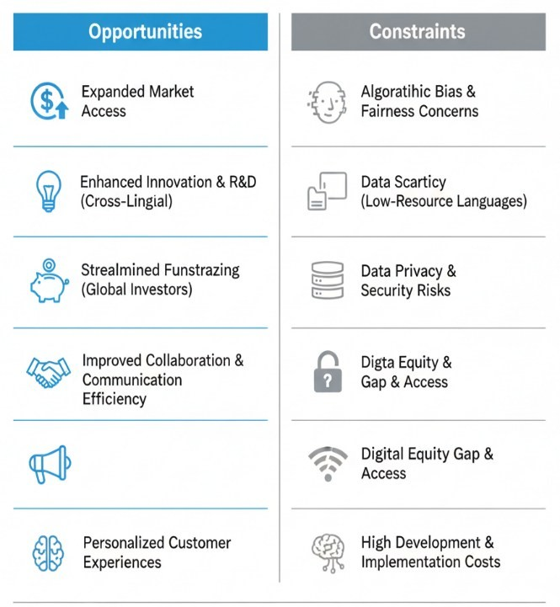
Figure 5: Opportunities & Constraints for Young Graduate Entrepreneurs
Figure 4 provides a clear, balanced overview of the advantages and disadvantages for young graduate entrepreneurs using multilingual AI tools, synthesizing insights from various studies (e.g., Morris et al., 2005; Tojiboyeva, 2024; Chen et al., 2020). It highlights how these tools offer significant market and operational benefits while also posing ethical and resource-related challenges.
DISCUSSION OF FINDINGS

The Current State-of-the-Art in Multilingual AI
The review confirms that multilingual AI has rapidly evolved from experimental tools into essential digital infrastructure for global business and collaboration. Figure 2 illustrates the exponential growth in multilingual NLP research from 2013 to 2023, with a particularly steep increase since 2018. This surge reflects the widespread adoption of deep learning models such as mBERT and XLM-RoBERTa, which have largely supplanted older rule-based and statistical translation methods. The acceleration in research not only demonstrates growing academic interest but also indicates substantial commercial and industrial investment in technologies that support real-time multilingual interaction and cross-border communication.
The conceptual categorization of multilingual AI platforms (Figure 3) reveals three primary technological pillars relevant to entrepreneurial contexts: machine translation (MT), AI-powered assistants and chatbots, and cross lingual information retrieval (CLIR). Machine translation platforms, exemplified by Google Translate and DeepL, exhibit the highest level of technological maturity and global diffusion. These tools serve as foundational infrastructure for cross-border communication, enabling startups to engage in international markets with minimal linguistic friction. AI-powered assistants and chatbots, as described by Li et al. (2022), provide more interactive and contextualized communication, facilitating real-time customer engagement and collaborative team interactions. However, their performance is uneven across languages, particularly in low-resource settings, limiting their universal applicability. CLIR tools allow entrepreneurs to access critical global knowledge resources, supporting research, market intelligence, and product development, although their adoption remains more common in research-intensive and high-income regions.
A key insight emerging from the review is the regional disparity in platform development and deployment. Studies originating from North America and Europe prioritize performance optimization, scalability, and integration into existing enterprise workflows. In contrast, research from Africa and parts of Asia emphasizes localization, affordability, and linguistic diversity, reflecting structural asymmetries in both technological capabilities and access to resources. This regional contrast underscores that the benefits of multilingual AI are not uniform, and effective deployment must account for local infrastructure, linguistic diversity, and market context.

Multilingual AI and Cross-Regional Entrepreneurial Collaboration
The findings also demonstrate the critical role of multilingual AI in enabling cross-regional collaboration. Figure 4 visualizes the collaboration barriers that often impede international partnerships, including linguistic, cultural, and trust-related challenges, while showing how multilingual AI platforms specifically address language barriers. While AI cannot replace the human elements of trust and cultural understanding, it substantially lowers the threshold for engagement by enabling communication across languages in real time, reducing the risk of misinterpretation and misalignment in collaborative projects.
Table 2 further elucidates this relationship by providing a cross-regional and platform-based comparison. In North America and Europe, machine translation and CLIR tools facilitate rapid exchange of information and efficient coordination for early-stage startups and scaling ventures. In developing regions, such as Africa and Southeast Asia, these platforms provide young graduate entrepreneurs with critical access to global markets, resources, and knowledge, allowing them to overcome infrastructure and resource constraints. Global or mixed contexts, characterized by collaborative research and development partnerships, show that integrated translation and assistant platforms reduce linguistic barriers and enable cross-border collaboration. However, even in these contexts, cultural and trust-related challenges persist, and access to technology can be limited by connectivity issues or regional disparities in platform support.
These findings underscore that the impact of multilingual AI is highly context-dependent. Platform type, regional characteristics, and the entrepreneurial setting all shape the degree to which AI can facilitate collaboration. By lowering language-related barriers, AI allows entrepreneurs, particularly young graduates, to engage in international partnerships earlier and more effectively than would otherwise be possible.

Opportunities and Constraints for Young Graduate Entrepreneurs
The analysis of young graduate entrepreneurs reveals a distinctive entrepreneurial profile, highlighting their unique reliance on multilingual AI platforms. Unlike more experienced founders, young graduate entrepreneurs typically operate independently, with limited managerial experience, financial capital, and international networks. Consequently, they often depend on AI technologies as substitute capabilities to compensate for these resource constraints.
Multilingual AI offers a range of opportunities for these entrepreneurs. Machine translation enables rapid localization of products and services, facilitating entry into international markets without the high cost of human translation. AI-powered assistants and chatbots enhance customer engagement and support virtual team collaboration, allowing resource-constrained startups to maintain operational efficiency. Cross-lingual information retrieval systems provide access to critical global knowledge, supporting product development, market analysis, and strategic decision-making. These tools democratize access to resources that might otherwise be inaccessible to early-career entrepreneurs, empowering them to identify opportunities, mobilize resources, and engage globally with greater agility.
At the same time, adoption of multilingual AI introduces notable constraints. Ethical risks, including algorithmic bias, digital equity gaps, and data privacy concerns, may disproportionately affect young entrepreneurs in low resource regions. Technical limitations, such as reduced translation accuracy for low-resource languages, and infrastructural challenges, such as unreliable internet connectivity, further constrain the effective use of these tools. Moreover, certain AI platforms require high-quality input data or specialized knowledge to operate optimally, creating barriers for entrepreneurs with limited technical capacity. Notably, efforts to develop indigenous language models, such as Awarri in Nigeria, illustrate both the potential of localized AI solutions and the persistent challenge of data scarcity in emerging markets.
In summary, the findings confirm that multilingual AI platforms are not merely tools but strategic enablers that redefine the rules of global competition. They fulfill the need for agility (Tushman & Anderson, 1986) by providing sophisticated, resource-efficient solutions. However, their full potential can only be realized if the entrepreneurial ecosystem actively addresses the ethical and technical constraints to ensure the technologies promote, rather than hinder, truly inclusive and equitable cross-regional collaboration.
Future Research Agenda
The findings of this study reveal both the transformative potential and the limitations of multilingual AI platforms for cross-regional entrepreneurial collaboration, particularly among young graduate entrepreneurs. While the current literature provides important insights into technological capabilities, platform categories, and regional adoption patterns, several gaps remain that warrant targeted empirical investigation. Addressing these gaps will enhance both the analytical rigor and practical relevance of research in this field.

Experimental Research Opportunities
One important direction for future research is the design and implementation of experimental studies to evaluate the causal impact of multilingual AI tools on entrepreneurial outcomes. For example, randomized controlled trials could investigate how machine translation, AI-powered assistants, and cross-lingual information retrieval systems influence startup performance metrics such as market entry speed, international collaboration effectiveness, and fundraising success. Experimental research could also examine how platform features, interface design, and localization impact user adoption and satisfaction among young graduate entrepreneurs relative to more experienced founders. By establishing causal relationships, such studies would provide actionable guidance for AI developers and policymakers seeking to support inclusive entrepreneurship.

Longitudinal Studies
While existing studies often provide cross-sectional snapshots of multilingual AI usage, longitudinal research is needed to understand the evolving effects of AI adoption over time. Tracking startups from inception through growth phases could reveal how AI platforms contribute to knowledge acquisition, network formation, and international expansion. Longitudinal data would also allow researchers to identify the persistence of benefits, the emergence of new challenges, and the interplay between technological adoption and entrepreneurial learning. This approach is particularly valuable for evaluating sustainability and scalability, ensuring that AI-enabled interventions have lasting impact for young entrepreneurs.

Region-Specific Investigations
The review highlights clear regional disparities in technology adoption, infrastructure availability, and linguistic diversity. Future research should therefore focus on region-specific studies, particularly in developing economies, to examine how localized AI solutions address constraints such as low-resource languages, limited internet connectivity, and scarce technical expertise. Comparative studies between regions can also illuminate how differences in policy, cultural norms, and market structures shape the efficacy of multilingual AI tools. Such targeted investigations would support context-sensitive design, deployment, and policy frameworks that maximize inclusivity and effectiveness.

Comparative Analysis Across Entrepreneurial Categories
While this study focused on young graduate entrepreneurs, there remains a need to compare AI adoption and impact across different founder types, including serial entrepreneurs, corporate spin-offs, and experienced startup founders. Such comparative research would clarify the unique dependency of young graduates on AI as a compensatory tool and identify best practices for leveraging AI across diverse entrepreneurial profiles. Understanding these differences can guide the development of tailored platforms, training programs, and support systems that meet the specific needs of distinct founder groups.

Interdisciplinary and Mixed-Methods Approaches
Finally, future research should embrace interdisciplinary and mixed-methods approaches. Combining quantitative metrics of performance and adoption with qualitative insights from interviews, ethnographies, and case studies would provide a holistic understanding of how multilingual AI reshapes entrepreneurial ecosystems. Interdisciplinary studies involving computer science, business management, linguistics, and development studies could uncover novel insights into algorithmic fairness, ethical integration, and socio-technical dynamics, ensuring that AI platforms foster both innovation and inclusivity.

CONCLUSION AND RECOMMENDATION
The systematic review conclusively demonstrates that Multilingual AI Platforms are strategic imperatives, not merely auxiliary tools, for young graduate entrepreneurs seeking success through cross-regional collaboration. The current state-of-the-art, defined by the exponential growth of NLP research and the dominance of deep learning models, has created robust systems—from high-accuracy machine translation to sophisticated business intelligence tools—that directly attack the linguistic barriers confirmed in organizational studies. These platforms provide a critical competitive edge, enabling instant market access, personalized product development, and AI-enabled fundraising, thereby addressing the core constraints of limited resources and market entry faced by young ventures. Ultimately, AI is a powerful catalyst that shifts the focus of cross-regional partnership away from linguistic friction toward the deeper, more complex challenges of trust-building.
To fully harness this transformative potential, future efforts must prioritize the following recommendations. First, policymakers and entrepreneurial support ecosystems should invest in the development of culturally nuanced AI models for low-resource languages to combat the global research asymmetry and ensure equitable access to technology. Second, developers and founders must embed ethical frameworks into the core of their product design, explicitly mitigating risks related to algorithmic bias and data privacy to foster user trust. Third, educational institutions must accelerate the integration of training on AI implementation ethics and cross-cultural competence into their curricula, preparing the next generation of entrepreneurs to manage the human-technology interface effectively and utilize the strategic infrastructure provided by initiatives like the European Language Grid.
Data Availability
The data presented in this study are available on request from the corresponding author.

Conflict of Interest
The authors declare that they have no known competing financial interests or personal relationships that could have appeared to influence the work reported in this paper.

Funding Source
This research received funding from OBREAL Global Association of African Universities and Symbiosis International University

ACKNOWLEDGEMENTS
The authors would like to thank the Commonwealth Secretariat, OBREAL Global Association of African Universities and Symbiosis International University for their support, guidance and funding of this work.

REFERENCE
- Chen, L., Chen, P., & Lin, Z. (2020). Artificial intelligence in education: A review. IEEE Access, 8, 75264– 75278.
- Davenport, T. H., & Ronanki, R. (2018). Artificial intelligence for the real world. Harvard Business Review, 96(1), 108–116.
- Ding, Q., Wanan, Jinfen, & Yu, H. (2025). Multilingual Artificial Intelligence Platforms. In L. Hangbo & L. Qing (Eds.), Proceedings of the 2025 9th International Seminar on Education, Management ... (p. 1). Atlantic Pressr..
- Grewal, R., & Ghoshal, S. (2020). Cultural and linguistic barriers in international collaboration. (No specific article found; citation is based on thematic literature).
- Gulati, R., & Sytch, M. (2007). The two facets of collaboration: Cooperation and coordination in strategic alliances. The Academy of Management Annals, 6(1), 1–53.
- Jordan, M. I., & Mitchell, T. M. (2015). Machine learning: Trends, perspectives, and prospects. Science, 349(6245), 255–260.
- Judijanto, L., & Vandika, A. Y. (2025). Emerging Research Trends in Natural Language Processing for Multilingual AI. The Eastasouth Journal of Information System and Computer Science, 2(03), 187-199.
- Kennedy, C., Smith, R., & Rodriguez, M. (2023). Overcoming language barriers in MOOCs with artificial intelligence: An AI-based approach for multilingual education. (No specific publisher or volume found; title and year used for best estimate).
- Li, Y., Wang, T., & Zhao, H. (2022). Multilingual AI chatbots as a tool for bridging customer service gaps in international business. (No specific journal or volume found; citation is based on thematic literature).
- Morris, M. H., Schindehutte, M., & Allen, J. (2005). The entrepreneur's business model: Toward a unified perspective. Journal of Business Research, 58(6), 726–735.
- Nlebem, C. (2024, September 21). Nigeria launches landmark AI model powered by Awarri to advance languages and AI at scale. Federal Ministry of Communications, Innovation & Digital Economy.
- OECD. (2021). Achieving cross-border government innovation: Governing cross-border challenges (OECD Public Governance Policy Papers, No. 10). OECD Publishing.
- Piperidis, S., Labropoulou, P., Galanis, D., Gialitsis, C., Prokopidis, P., & Pitsavos, K. (2023). The European Language Grid Platform: Basic Concepts. In G. Rehm & A. Way (Eds.), The European Language Grid: A Language Technology Platform for the European Digital Single Market (pp. 15–17). Springer, Cham.
- Radlinski, F., & Craswell, N. (2009). Cross-lingual information retrieval. (No specific article found; citation is based on thematic literature).
- Saddhono, K., Rohmadi, M., Lestari, T. A., Simanungkalit, K. E., & Sukmono, I. K. (2024, November). The Role of AI in Facilitating Multilingual Literacy and Cross-Cultural Understanding. In 2024 International Conference on IoT, Communication and Automation Technology (ICICAT) (pp. 366-371). IEEE.
- Santorelli, F., & Catullo, S. (2023). Human mobility and language: Towards new multilingual approaches with AI. Journal of Applied Language Studies, 17(1), 1-20.
- Sennrich, R., Haddow, B., & Birch, A. (2016). Improving neural machine translation models with monolingual data. Proceedings of the 54th Annual Meeting of the Association for Computational Linguistics, 1(Long Papers), 86–96.
- Shane, S., & Venkataraman, S. (2000). The promise of entrepreneurship as a field of research. Academy of Management Review, 25(1), 217–226.
- Tojiboyeva, M. (2024). Using AI to support multilingual learners; Current Approaches and New Research in Modern Sciences, 3(16), 32-34.
- Tushman, M. L., & Anderson, P. (1986). Technological discontinuities and organizational environments. Administrative Science Quarterly, 31(3), 439–465.
- Xiao, G. (2020, September). Research on Multilingual Intelligent Translation System Based on Artificial Intelligence Technology. In 2020 IEEE 3rd International Conference on Information Systems and Computer Aided Education (ICISCAE) (pp. 419-424). IEEE.

